Vocabulary in context
Stage 5

Overview

Purpose
This literacy teaching strategy supports teaching and learning for Stage 4 students across all key learning areas. It targets specific literacy skills and suggests a learning sequence to build skill development. Teachers can select individual tasks, or a sequence, and embed into their teaching and learning program according to their students’ needs. While exemplar texts are provided throughout this resource, it is recommended that teachers select texts which are relevant to their students and curriculum.

Learning intention
Students explore and use precise vocabulary in a wide range of academic contexts. Students examine vocabulary elements such as morphology, and how nuance and connotation can impact meaning.

Syllabus outcomes
The following teaching and learning strategies will assist in covering elements of the following outcomes:
- EN5-RVL-01: uses a range of personal, creative and critical strategies to interpret complex texts
- EN5-URA-01: analyses how meaning is created through the use and interpretation of increasingly complex language forms, features and structures
- EN5-2A: effectively uses and critically assesses a wide range of processes, skills, strategies and knowledge for responding to and composing a wide range of texts in different media and technologies
- EN5-3B: selects and uses language forms, features and structures of texts appropriate to a range of purposes, audiences and contexts, describing and explaining their effects on meaning
NSW English Syllabus K-10 (2022)
Visit the Leading curriculum K-12 website for more information on the syllabus implementation timeline.

Success criteria
The following Year 9 NAPLAN item descriptors may guide teachers to co-construct success criteria for student learning.
- Interprets a technical term in an information text
- Interprets the meaning of vocabulary from context in an information text
- Interprets the meaning of vocabulary in an information text
- Interprets the meaning of vocabulary in a narrative
- Interprets the meaning of vocabulary in a text
- Interprets the meaning of vocabulary in an imaginative text

National Literacy Learning Progression Guide

Understanding Texts (UnT9-UnT11)
Key: C=comprehension P=process V=vocabulary

UnT9
- identifies language used to create tone or atmosphere (V)
- analyses language and visual features in texts using metalanguage (e.g. cohesion, interpretation, figurative) (V)
- applies knowledge of root words and word origins to understand the meaning of unfamiliar, discipline specific words (V)
- uses a range of context and grammatical cues to understand unfamiliar words (V)

UnT10
- demonstrates an understanding of nuances and subtleties in words of similar meaning (e.g. frustrated, discouraged, baffled) (V)

UnT11
- interprets complex, formal and impersonal language in academic texts (V)
- demonstrates self-reliance in exploration and application of word learning strategies (V)
National Literacy Learning Progression

Evidence base
- Beck, I., McKeown, M. & Kucan, L. (2013). Bringing words to life: Robust vocabulary instruction. Guilford Press. New York.
- Centre for Education Statistics and Evaluation (2017). Effective reading instruction in the early years of school, literature review.
- Oakhill, J., Cain, K. & Elbro, C. (2015). Understanding and teaching reading comprehension: A handbook. Routledge.
- Quigley, A. (2018). Closing the vocabulary gap. Routledge.
- Scarborough, H.S. (2001). Connecting early language and literacy to later reading (dis)abilities: Evidence, theory and practice. In S. Neuman & D. Dickson (Eds.), Handbook for research in early literacy (pp. 97-110). New York, NY: Guilford Press.
Alignment to system priorities and/or needs: Five priorities for Literacy and Numeracy, Our Plan for NSW Public Education, School Excellence Policy (nsw.gov.au).
Alignment to School Excellence Framework: Learning domain: Curriculum, Teaching domain: Effective classroom practice and Professional standards
Consulted with: Strategic Delivery, Teaching Quality and Impact
Author: Literacy and Numeracy
Reviewed by: Literacy and Numeracy, Teaching Quality and Impact
Created/last updated: March 2024
Anticipated resource review date: January 2025
Feedback: Complete the online form to provide any feedback

Copyright
Section 113P Notice
Texts, Artistic Works and Broadcast Notice
Some of this material has been copied and communicated to you in accordance with the statutory licence in section 113P of the Copyright Act. Any further reproduction or communication of this material by you may be the subject of copyright protection under the Act. Do not remove this notice.

Teaching strategies
Task | Appendices
SEEC
Morphology | Appendix 1- ‘Word play’ prefix, suffix, root cards
Synonyms and antonyms | Appendix 2 - Synonym and antonym pairs  Appendix 3 - What in the word?
Nuance
Word clines | Appendix 4 - Word cline organiser  Appendix 5 - Word clines  Appendix 6 – Word cline Images
Connotation
Using the clues | Appendix 7 - Context clues  Appendix 7 – Context clues worksheet  Appendix 8 - Using clues in text ‘The Sea’  Appendix 9 - Using context clues
Vocabulary in context | Appendix 10 - Vocabulary check-in  Appendix 11 - Vocabulary in context text extract  Appendix 12 - Word graphic organiser

Background information

The three tiers of vocabulary
The three-tiered model of vocabulary development, described by Beck, McKeown and Kucan in ‘Bringing words to life’ (2013) is a framework to classify words.
Tier 1: These are common, everyday words that most children enter school knowing already, either in English or their first language. These words will continue to be acquired from everyday life including through school. These words are readily learned as they are used frequently in conversation and are concrete. For example, book, girl, sad, baby, clock, dog and orange.
Tier 2: These words appear more frequently in text than in oral language, so children are less likely to learn them without assistance. They add precision by providing new ways to express concepts that are already understood. (for example, stale, awful, snuggle, twitch). These words require explicit teaching as they may not be part of children’s everyday oral language.
Tier 2 words:
- usually have multiple meanings.
- are essential for building formal academic language across subject areas.
- are necessary for reading comprehension
- are characteristic of a mature language user, and
- are descriptive words that add detail.
Tier 3: These have a low user frequency often limited to specific topics and domains. Tier 3 words are likely to be new for all students. Some examples of Tier 3 words might be filibuster, pantheon and epidermis. These words are probably best learned when there is a specific need in a subject area. (Beck, McKeown and Kucan, (2013) Bringing words to life, page 9.)

Vocabulary and culture
Including Aboriginal language or Aboriginal English vocabulary, as well as reflecting cultural language from student ethnic backgrounds, adds significance and meaning to the learning. Contact your local Aboriginal Education Consultative Group (AECG) representatives and Aboriginal community members for information about the local language or Aboriginal English.
The following list of strategies may help to build vocabulary:
- Oral language – a strong foundation in oral language assists students with reading.
- Explicit teaching with repeated exposure– targeted teaching at the right level. Students need to see, hear and use the words repeated many times, in different contexts.
- Word Consciousness – building a classroom culture of “awareness and interest in words and their meaning” (Graves & Watts-Taffe, 2008).
- Link words to images – introduce new vocabulary with visual representations.
- Reading a range of books – read a range of texts that include a range of Tier 2 and 3 vocabulary.
- Morphology – A critical element of vocabulary development that looks at the structure of the word according to base word, roots, prefixes and suffixes.
- Word walls – displaying and building upon Tier 2 and Tier 3 words from discussions and text exposure. Additionally, using colour coding to highlight parts of word such as suffixes/prefixes.
- Glossaries, dictionaries and thesaurus –using these as part of daily practice and sharing.

Everyday strategies:
- Brainstorm and predict vocabulary with each text or concept and further build understanding.
- Accountable talk - introduce phrases for students to use in discussions “building on to that idea…” and “I agree with …but would like to add another point of view.”
- Cloze – students need to use contextual clues to determine an appropriate word choice or choose from a selection of vocabulary presented.
- Word clines – select words that have similar meanings and have students arrange the words in graduating intensity according to the word that is being used and the scale being used.
- Word maps – students use four quadrant questions to build an understanding of a word.
- Make a word - students are given a group of consonants and vowels to create words.
- Six-word skit – students are given six ‘target’ words to devise a skit to present to class.
- Words in words- students are given a long word to find smaller words within it.
- Word chains – students offer word associations as a chain for example, eating, health, exercise.
- Lexical chains – identify repeated words and connected vocabulary within a text

Where to next?
- Literary devices
- Text structures and features
- Inference

Overview of teaching strategies

Purpose
These literacy teaching strategies support teaching and learning from Stage 2 to Stage 5. They are linked to NAPLAN task descriptors, syllabus outcomes and literacy and numeracy learning progressions.
These teaching strategies target specific literacy and numeracy skills and suggest a learning sequence to build skill development. Teachers can select individual tasks or a sequence to suit their students.
Access points
The resources can be accessed from:
- NAPLAN App in Scout using the teaching strategy links from NAPLAN items
- NSW Department of Education literacy and numeracy website.
What works best
Explicit teaching practices involve teachers clearly explaining to students why they are learning something, how it connects to what they already know, what they are expected to do, how to do it and what it looks like when they have succeeded. Students are given opportunities and time to check their understanding, ask questions and receive clear, effective feedback.
This resource reflects the latest evidence base and can be used by teachers as they plan for explicit teaching.
Teachers can use classroom observations and other assessment information to make decisions about when and how they use this resource as they design teaching and learning sequences to meet the learning needs of their students.
Further support with What works best is available.
Differentiation
When using these resources in the classroom, it is important for teachers to consider the needs of all students, including Aboriginal and EAL/D learners.
EAL/D learners will require explicit English language support and scaffolding, informed by the EAL/D enhanced teaching and learning cycle and the student’s phase on the EAL/D Learning Progression. Teachers can access information about supporting EAL/D learners and literacy and numeracy support specific to EAL/D learners.
Learning adjustments enable students with disability and additional learning and support needs to access syllabus outcomes and content on the same basis as their peers. Teachers can use a range of adjustments to ensure a personalised approach to student learning.
Assessing and identifying high potential and gifted learners will help teachers decide which students may benefit from extension and additional challenge. Effective strategies and contributors to achievement for high potential and gifted learners helps teachers to identify and target areas for growth and improvement. A differentiation adjustment tool can be found on the High potential and gifted education website.
Using tasks across learning areas
This resource may be used across learning areas where it supports teaching and learning aligned with syllabus outcomes.
Literacy and numeracy are embedded throughout all syllabus documents as general capabilities. As the English and mathematics learning areas have a particular role in developing literacy and numeracy, NSW English and Mathematics syllabus outcomes aligned to literacy and numeracy skills have been identified.
Text selection
Example texts are used throughout this resource. Teachers can adjust activities to use texts which are linked to their unit of learning.
Further support with text selection can be found within the National Literacy Learning Progression Text Complexity appendix.
The NESA website has additional information on text requirements within the NSW English syllabus.

Teaching strategies
The following SEEC process can be used to explicitly teach vocabulary:
S  Select | Select 2-4 words to specifically target during teaching and learning.
E  Explain | Define and explain the words.
E  Explore | Explore words with a range of teaching strategies.
C  Consolidate | Contextualise and consolidate knowledge of the new vocabulary.
Adapted from the work of Quigley, A. Closing the vocabulary gap (2018).

Select
Selecting words in texts is an important part of vocabulary teaching and learning. Prior to learning, preview material and identify 2-4 target words for explicit instruction. Teachers need to be able to revoice these terms into student-friendly definitions for students to understand word meaning in different contexts.
Some considerations:
- Which words are most important to understanding the text or situation?
- Which words will help build important concept knowledge?
- Which words will be encountered frequently outside this particular context?
- Which words have multiple meanings?
- Which words can be figured out from the context?
- Which words provide an opportunity to use morphology to determine the meaning?
(Konza, D., 2011)

Explain
After selecting words to target, teachers move into explicit instruction and explanation of the word. Strategies to explain can include: using word walls, using graphic organisers and modelling how to define a word.
When introducing new words, teachers might:
Say | - Say the word carefully and with clear articulation.  - Say the word individually and in a sentence.  - Draw attention to syllables.  - Notice the phonemes
Write | - Write the word  - Notice suffixes, prefixes and root words  - Notice common graphemes and phonemes
Define | - Provide a definition  - Provide a student-friendly definition
Demonstrate | - Give meaningful examples in different contexts
Clarify | - Ask students to provide further examples  - Clarify meanings  - Clarify misconceptions
Adapted from the work of I. Beck et al Bringing words to life (2013) and Quigley, A. Closing the vocabulary gap (2018).

Explore
Some graphic organisers and strategies to explore and define words include:
- Frayer model
- Word web (Appendix 12)
- Vocabulary map (Appendix 12)
- Highlighting key vocabulary and using dictionaries and glossaries to define
- Reword definition into own words
- Word graphic organiser (Appendix 12)

Morphology
- Review and model key terms in morphology:
Affix – Any part that is added to a word; a prefix or a suffix
Prefix – A word part that is attached to the beginning of a word
Suffix – A word part that is attached to the end of a word
Base and root words– Roots/Base words are morphemes that form the base of a word, and usually carry its meaning. Generally, base words are free morphemes that can stand by themselves), for example, cycle as in bicycle/cyclist, and form as in transform/formation. Whereas root words are bound morphemes that often cannot stand by themselves (for example, -ject as in subject/reject, and -volve as in evolve/revolve). (education.vic.gov.au)
prefix | base word | suffix
un | comfort | able
ir | regular | ly
dis | respect | fully
dis | honest | ly
- Word play: Students work in teams with a base word in ‘word play’ – determine as many new words as possible using the base words, prefixes, suffixes and Greek and Latin root guides (Appendix 1- ‘Word play’ prefix, suffix, root cards).
- Structured word inquiry: Students use a ‘structured word inquiry’ approach when representing their words, for example:
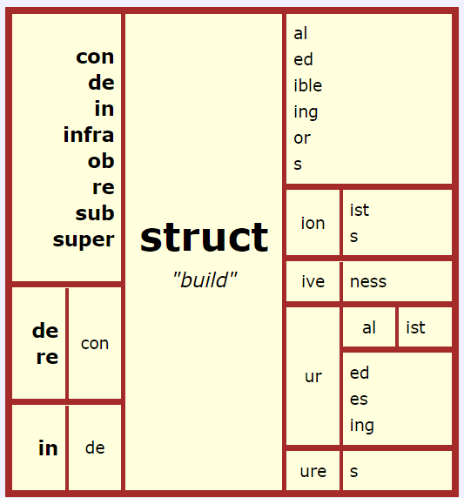
Created with Mini Matrix-Maker, at www.neilramsden.co.uk/spelling/matrix

Synonyms and antonyms
- Revise the term ‘synonym’ as: a word or phrase that has the same or a similar meaning to another word or phrase. For example, sick and ill. NSW English K-10 Syllabus glossary (2022).
- Synonym heads: Two students face the class and a word is written on the board behind them in view of the class. Scribe three words that cannot be used by the class to give clues to the students. In the following example, the two students are trying to guess the word ‘repugnant’, but the class cannot use the words ‘abhorrent’, ‘disgusting’ or ‘distasteful’ when giving clues. Students take turns to give clues and vocabulary is written on the board in a different colour to build a word map. Students may give synonyms, antonyms, morphology, syllables and parts of speech.

repugnant
abhorrent disgusting distasteful

- Headlines: Students read the headlines below and consider ways to enhance with vocabulary.
- Coffee no longer available in Australia
- Cosmetic surgery unavailable for those under 21
- Basketball declared national sport
- Birds don’t exist
- Meat pies now with meat
- Synonym and antonym pairs: Students are each given a card from a selection of synonyms and antonyms (Appendix 2 - Synonym and antonym pairs). Allocate time for students to define their word with a partner and use a dictionary, applying the ‘What in the word?’ word guide (Appendix 3 - What in the word?). Once students are comfortable with the definition of their word, students are given tasks to find people meeting criteria:

Find someone who has a synonym for your word. |  | Find someone who is your word’s antonym. |  | Make a sentence that is complementary with your partner’s and your own word.
Find someone who has a personal experience with your word. |  | Make a joke that is woeful with your partner’s and your own word. |  | Create three freeze frames to act out a scenario with both your words.
Convince your partner why your word is more important to learn. |  | Make a sentence that elicits emotion with your partner’s and your own word. |  | Find someone with the same amount of syllables.
Find someone who has the same part of speech as you…adjective, noun, verb |  | Find someone who has a different part of speech as you…adjective, noun, verb. |  | Create a newspaper headline using both yours and your partner’s words.
- Not such a nursery rhyme: Students are given a copy of familiar nursery rhymes, they work in teams to rewrite using politically correct vocabulary, for example: Three blind mice = a trio of visually impaired rodents. Students read out their compositions and their peers guess which nursery rhyme they are re-wording. Focus on language choices, including nominalisation, to target the purpose and audience of the text.

Nuance
- Explain to students that there are many words in the English language that are used to convey precise meaning and whilst a lot of words have similar meanings to other words, there are slight and subtle differences in meaning. This is called a ‘nuance’.
- Ask students to brainstorm different words for the word ‘walk’. Write their responses on the board. Discuss the differences between the words on the board. Ask students to consider when they would use particular words over other words.

Word clines
- Word clines: Teacher leads brainstorm for synonyms for the word ‘walk’:
amble  roam  saunter  shuffle  step  stride | stroll  canter  lumber  slog  meander  perambulate | parade  traverse  advance  strut  trudge  promenade
- Place words on sticky notes and have students assist in ordering words along an incline (Appendix 4 - Word cline organiser) :
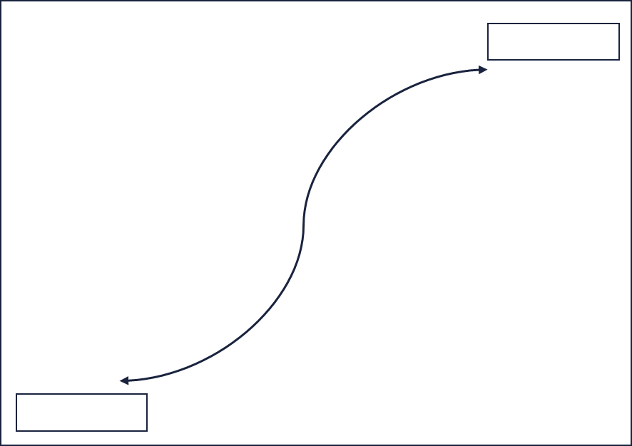
- Students work in small groups to rotate between word collections (Appendix 5 - Word clines ) and place terms along an incline representing the subtle differences between words. The bold word indicates the theme.
Challenge: Students can make their own examples by brainstorming synonyms and placing these along a continuum. Using images linked to the words may support students.
- Place a range of images linked to current unit of learning in workstations around the classroom. Students brainstorm vocabulary using sticky notes. Students rotate around the posters and add more ideas. When students are back at their original poster, students work together to categorise words then place on an incline as a word cline.
Alternate task: Students use Appendix 6 – Word cline Images as visual stimulus to brainstorm a progression of words.

Connotation
- Word association ping pong: Students are paired and given 30 seconds to ping-pong back and forth with their partner with word associations. Pairs report back to the class the final two words they finished with. Students debrief on how different the class’ words are by the end, showing how people make different word associations. Some words for word association ping pong might include: friendship, candle or suitcase.
- Discuss how people attach feelings and experiences, cultural backgrounds and generational contexts to how they imagine a word. We call this ‘connotation’. Connotation can differ between a reader depending on their own personal backgrounds and experiences. Some other words to explore connotation may include: clown, school, game, family, power. Have students create a visual representation of their understanding of connotation.
- Discuss with students that connotation can be more subjective, while many words have widely held connotations or associations, you may associate a word with a pleasant memory or feeling but the next person may have a negative response; it is a situation where the reader brings some of the meaning beyond the literal meaning or definition.
- Discuss where the concept of connotation might impact meaning and why this could affect the reader. Students use a range of headlines and circle any terms that might have connotation attached to it. These can be displayed around the classroom with students adding ideas and different ways the vocabulary might be interpreted.

Using the clues
- Pineapple: Working in pairs, students are each given a copy of a different text linked to current unit of learning. Individually, students highlight words that are unfamiliar. Taking turns, each student poses a question to their partner, substituting the target word with the word ‘pineapple’. The partner then needs to use context clues and a dictionary to guess the word.
Challenge: To support learners, students may use the same text when quizzing each other and discuss possible synonyms.
- Which word?: Give students a text to read and design a quiz with questions such as: “which word…?” Some examples might be: “which word shows the character is annoyed? Which words show the matter was urgent?”
- Distribute the ‘using context clues’ task (Appendix 7 - Context clues) and read through the extract as a class. Students use context clues in the extract to help them determine the meaning of unknown words. The extract could provide clues about the meaning of word through:
- a definition or restatement of the word
- an example of the word
- a synonym of the word
- a contrast of the word
- cause and effect
- the topic and subject of the text
- how the word is used in the text
- Students identify the context clues they used to help them understand the meaning of the words and write down the meaning of the word sharing and discussing with a partner or small team using Appendix 7 – Context clues worksheet.
- Engage in a Think-Pair-Share activity where students share their work with a partner. Students should discuss and edit their work as necessary.
- Teacher models how to guess word meaning from context. Write or project this sentence fragment:
Target word is plimsoll.
‘…he stuck the toe of his plimsoll into the gravel to stop the swinging gate.’
How do we know what this is? What words around the target word help us to know this?
Students practise predicting word meaning based on context.
Target word is indigo.
‘The beach at the foot of the hill was a fawn shimmer under indigo.’
What is the meaning of indigo in the context of this sentence? Explain your reasons.
Students practise predicting word meaning based on context.
Target word is circumspectly.
‘I approached the Cedars circumspectly.’
The character is approaching a place called The Cedars. So, what does the adverb ‘circumspectly’ indicate about the attitude of the character?
- Students apply same process in a text from a current unit of learning or, alternatively, using ‘The Sea’ (Appendix 8 - Using clues in text ‘The Sea’) and accompanying graphic organiser (Appendix 9 - Using context clues).

Consolidation

Vocabulary in context
- Introduce the process of a ‘Vocabulary check in’ (Appendix 10 - Vocabulary check-in) or a class-determined process for reviewing vocabulary in text.
- Students read ‘Iconoclast: a neuroscientist reveals how to think differently’ (Appendix 11 - Vocabulary in context text extract) and apply the same process using the Vocabulary Check-in.
- Model process and demonstrate alongside students with any suitable text. A range of graphic organisers have been provided to support student understanding of vocabulary in context. (Refer to Appendix 12 - Word graphic organiser.)

Appendix 1

‘Word play’ – suffixes
Photocopy onto coloured paper and cut out.
ac  (pertaining to) | acity/ocity  (quality of) | ant  (a person who) | ary  (of or relating to)
s  (plural) | ion  (act or process) | al  (having characteristics of) | en  (made of)
ed  (past tense) | tion  (act or process) | ial  (having characteristics of) | ic  (having characteristics of)
ing  (present tense) | ible  (can be done) | ness  (state of) | ive  (adjective form of noun)
ly  (characteristic of) | able  (can be done) | ous  (having qualities of) | eous  (having qualities of)
er  (person) | y  (characterised by) | ious  (having qualities of) | ative  (adjective form of noun)
or  (person) | ful  (full of) | ment  (action or process) | itive  (adjective form of noun)
cy  (state/condition of) | est  (most) | ward  (in the direction of) | ine  (relating to)
ian  (relating to) | ing  (materials or action/process) | ist  (a person/one who performs an action) | ant  (a person who)

‘Word play’ – prefixes
Photocopy onto coloured paper and cut out.
hyper  (over) | hypo-hyp  (below/under) | omni  (all) | syn  (same time/together)
un  (not, opposite of) | dis  (not, opposite of) | im  (in or into) | trans  (across)
re  (again) | en  (put into, cover with) | in  (in or into) | super  (above)
in  (not) | em  (cause to) | mis  (wrongly) | semi  (half)
im  (not) | non  (not) | sub  (under) | inter  (between, among)
ir  (not) | under  (too little) | pre  (before) | mid  (middle)
il  (not) | over  (too much) | inter  (between) | mono  (one)
a, an-  (without) | anti  (opposite of) | bi  (two) | mono  (one)
ante  (before) | auto  (self) | super  (more, better) | post  (after)
ex  (out of) | de  (down, off, away from) | dis  (not, apart, away) | tri  (three)

‘Word play’ – base words
Photocopy onto coloured paper and cut out.
rely | vent | private | sight
establish | care | break | tempt
judge | hate | vantage | sent
under | comfort | connect | thought
fear | hope | port | send
agree | learn | polite | heat
use | clear | mature | comfort
order | act | employ | manage

‘Word play’ – Greek roots
A root is a part of a word that carries meaning but may not always stand alone. Roots such as ‘graph’ and ‘photo’ are examples of these roots that can stand alone.
mania  (madness/frenzy) | ast  (star) | aqua  (water) | auto  (self)
hemo/hema  (blood) | bio  (life) | chrome  (colour) | doc  (teach)
crat/cracy  (rule/strength/power) | geo  (earth) | graph  (write) | hydr  (water)
logos  (study of) | spect  (see – Latin) | tele  (from afar – Greek) | tract  (pull – Latin)
logos  (together) | tele  (far) | photo  (light) | path  (feel)

‘Word play’ – Latin roots
A root is a part of a word that carries meaning but may not always stand alone. Roots such as ‘graph’ and ‘photo’ are examples of these roots that can stand alone.
bene  (well/good) | cardi  (heart) | ego  (self) | don/donat  (give/gift)
duc  (lead/make) | fund  (bottom) | gen  (to birth) | jur  (law)
luc/lum  (light) | log/logue  (thought) | loc/loqu  (to speak/talk) | manu  (hand)
mis/mit  (send) | omni  (all) | belli  (war) | cogn  (to know)
cred  (to believe) | terr  (earth) | vac  (empty) | vid/vis  (to see)

Appendix 2

Synonym and antonym pairs
Cut up cards and allocate one per student.
intricate | simple | convoluted | straightforward
ornate | austere | acquisition | forfeit
ambiguous | certain | belligerent | cooperative
colloquial | academic | euphoric | unperturbed
grandeur | insignificance | humanitarian | egoist
iridescent | matte | misconstrue | comprehend
pessimistic | optimistic | reminiscent | unreminiscent
rigorous | slapdash | ubiquitous | scarce
waive | expedite | abjure | emphasise
acumen | ignorance | churlish | pleasant
feckless | competent | loquacious | subdued

Appendix 3

What in the Word? Word guide
Word | Found in | Sentence used

I think it means
Clues I used
Dictionary definition
It makes me think of
New sentence

Word | Found in | Sentence used

I think it means
Clues I used
Dictionary definition
It makes me think of
New sentence

Appendix 4

Word cline organiser

Vocabulary brainstorm

Appendix 5

Word clines
powerful | forceful
authoritative | potent
capable | robust
compelling | vigorous
dominant | impressive
dynamic | energetic

repugnant | abhorrent
abominable | contradictory
disgusting | distasteful
incompatible | odious
revolting | vile
horrid | nauseating

Word clines
condescending | arrogant
patronising | snooty
complaisant | disdainful
egotistic | supercilious
lofty | snobbish
superior | uppity

delightful | alluring
amusing | beautiful
captivating | delectable
ambrosial | congenial
ineffable | rapturous
gratifying | darling

Appendix 6

Word cline images
- Create a word cline that describes the following images
- Think about what the images convey and the different ways you could express it
- Organise the words into an order that shows the progression of that vocabulary so that the final word in the word cline best represents the image.
Image 1
Photo by Photo Boards on Unsplash.com

Image 2
Photo by Leo Rivas on Unsplash.com

Word cline images
- Create a word cline that describes the following images
- Think about what the images convey and the different ways you could express it
- Organise the words into an order that shows the progression of that vocabulary so that the final word in the word cline best represents the image.
Image 1
Photo by Tom Pumford on Unsplash.com
Image 2
Photo by Louis Galvez on Unsplash.com

Appendix 7

Background information: Context clues
There are many words in the English language that may be unfamiliar to us. To understand a word and its meaning, we need to consider the context that the word is used in.
Context refers to the information provided around the use of the word. That means we need to look at the sentences or paragraphs surrounding an unfamiliar word and look for clues that can help us understand the meaning of a word.
Context clues such as the ones below can help us understand an unfamiliar word.
- Definition or restatement of the word
- An example of the word
- A synonym of the word
- A contrast/antonym of the word
- Cause and effect
- The topic and subject of the text
- How the word is used in the text
Have a look at the words in the list below. Do you know what they mean? Highlight or put a tick next to the words that you know the meaning of.
olfactory | estranged | unassuming | inert
tranche | albeit | ephemeral | fallibility
brusque | disgorging | terminus | simulacrum
abutted | tussocky | skittering

Worksheet: Context clues
Use the ‘context clues’ to help you understanding the meaning of each word and complete the table.
Context | What I think the word means | What context clues I used
Dogs live in an olfactory world, while ours is chiefly visual. So, while TVs may offer a visual feast for humans, parks and beaches are an olfactory banquet for dogs.
Melissa Starling & Paul McGreevy (University of Sydney) ‘8 things we do that really confuse our dogs, The conversation, 2020.
He became estranged from both his parents and siblings.
Camilla Nelson (University of Notre Dame, Australia) ,Looking on the bright side, The Leunig fragments film skips dark truths The conversation, 2020,
Although it was physically unassuming, it had an air of significance about it.
Clare Pooley, The Authenticity Project, Penguin Publishing, 2020
That is unquestionably the most astounding thing about us – that we are just a collection of inert components, the same stuff you would find in a pile of dirt.
Bill Bryson, The Body: A Guide for Occupants, Penguin Publishing, 2020
Nancy, like her bedbound sister, Jean, back in the tiny log cabin at Red Lick, cannot countenance even a chance that she will miss the next tranche of stories.
Jojo Moyes, The Giver of Stars, Penguin Publishing, 2022
Along the way, we’ll see that being smart is overrated, that showing fallibility is crucial, and that being nice is not nearly as important as you might think.
Daniel Coyle The Culture Code: The Secrets of Highly Successful Groups, Penguin Publishing, 2019
‘Mr President.’ Kennedy returned his own boyish smile, albeit a little tightly.
Judy Nunn, Khaki Town, Penguin Publishing, 2019

It’s hard to think of a more ephemeral artefact of a civilization than a breath. But it’s impossible to think of a more enduring one.
Jonathan Safran Foer, We are the Weather: Saving the Planet Starts at Breakfast, Penguin Publishing, 2019
The great snorting and smoking brute that had paused with brusque impatience at the meek little village station and suffered her to take her place in one of its lattermost compartments— her fingertips still retained the impression of hot plush and greasy leather— now stood gasping after its mighty efforts under the high, soot-blackened glass canopy of the throbbing terminus, disgorging on to the platform its complement of dazed, bedraggled travellers and their jumbles of baggage. Well, she told herself, she had arrived somewhere, at least.
John Banville, Mrs Osmond, Penguin Publishing, 2018
Sometimes, watching him, I thought of Dr Frankenstein’s monster, a simulacrum of the human that entirely failed to express any true humanity.
Salman Rushdie, The Golden House, Penguin Publishing, 2018
Two dry and tussocky home paddocks yet to be planted with vines had been set aside for parking and for those who’d chosen camping as an alternative to motel accommodation in town.
Robert Drewe, Whipbird, Penguin Publishing, 2018
Topped by a modest dome, the courthouse abutted the police station, which crouched behind a high, stone wall.
Catherine Jinks, Charlatan, Penguin Publishing, 2017
During the flight she watched the GPS on the headrest screen, the numbers rising and steadying, the plane skittering over the cartoon sea.
Tara June Winch, The Yield, Penguin Publishing, 2019
Resources copied under the statutory licence in s 113P of the Copyright Act.
Section 113P Warning Notice

Appendix 8

Text extract: using context clues
The Sea – John Banville, Pan McMillan (p.10-11)
I walked down Station Road in the sunlit emptiness of afternoon. The beach at the foot of the hill was a fawn shimmer under indigo. At the seaside all is narrow horizontals, the world reduced to a few long straight lines pressed between earth and sky. I approached the Cedars circumspectly. How is it that in childhood everything new that caught my interest had an aura of the uncanny, since according to all the authorities the uncanny is not some new thing but a thing known returning in a different form, become a revenant? So many unanswerables, this the least of them. As I approached I heard a regular rusty screeching sound. A boy of my age was draped on the green gate, his arms hanging limply down from the top bar, propelling himself with one foot slowly back and forth in a quarter circle over the gravel. He had the same straw-pale hair as the woman in the car and the man’s unmistakable azure eyes. As I walked slowly past, and indeed I may even have paused, or faltered, rather, he stuck the toe of his plimsoll into the gravel to stop the swinging gate and looked at me with an expression of hostile enquiry. It was the way we all looked at each other, we children, on first encounter. Behind him I could see all the way down the narrow garden at the back of the house to the diagonal row of trees skirting the railway line – they are gone now, those trees, cut down to make way for a row of pastel-coloured bungalows like dolls’ houses – and beyond, even, inland, to where the fields rose and there were cows, and tiny bright bursts of yellow that were gorse bushes, and a solitary distant spire, and then the sky, with scrolled white clouds. Suddenly, startingly, the boy pulled a grotesque face at me, crossing his eyes and letting his tongue loll on his lower lip. I waked on, conscious of his mocking eyes following me.
Copied under the statutory licence in s 113P of the Copyright Act.
John Banville, The Sea, 2010. Pan McMillan. 9780330483292.
Section 113P Warning Notice

Appendix 9

Student graphic organiser: using context clues
Word/sentence | What I think the word means | Context clues I used | Meaning in my own words

Appendix 10
Vocabulary Check-in
- Predict vocabulary you think will be in this text. Use your background knowledge to help. | Photo by Jon Tyson
- Read the whole text, including headings, sub-headings and images. | Photo by Thought Catalog
- Re-read text and highlight any words that are repeated.  - Re-read text and highlight 6-8 words you think might be important to understand in this text – it might be a technical term or an unfamiliar word. | Photo by Kasturi Roy
- Add a potential synonym above the unfamiliar words | 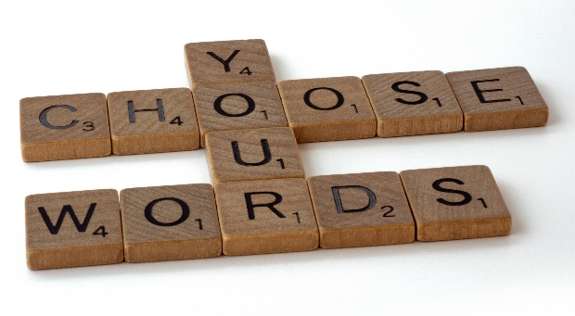  Photo by Brett Jordan
- Discuss with a partner the unfamiliar word and your synonym swap. Is there a more suitable option? Is the meaning maintained? | Photo by Alexis Brown
- Use a thesaurus and dictionary to help.  Add to word wall or on sticky notes to use again! | 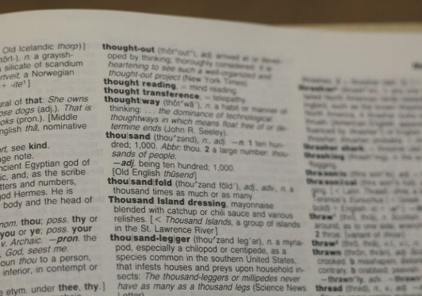  Photo by Joshua Hoehne
Photos from Unsplash.com

Appendix 11

Vocabulary in context

Iconoclast: a neuroscientist reveals how to think differently - Gregory Berns
Harvard Business Press - 2010

From Perception to Imagination
CHAPTER TWO
Humans depend on vision, more than any other sense to navigate through the world. Mostly we take the visual process for granted. And rightly so, for if we had to think too much about what we see from moment to moment, scarce brain power would remain for doing anything else. Most of the time, the efficiency of our visual systems work to our advantage. Hitting a major league fastball, for example, requires the precise coordination of eyes and body. A 90-mil-per-hour fastball reaches the plate in about 0.4 seconds, but the batter must decide whether to hit it when it gets halfway. The limit of human reaction time is about 0.2 seconds, which means that the task of hitting a fastball pushes the vision and motor systems to their limits. There is no time for thought. The connection between eye and body must be seamless. This automaticity lets us accomplish anything that requires hand-eye coordination, but this automaticity comes with a price. In the interests of crafting an efficient visual system, the brain must make guesses about what it is actually seeing. Most of the time this works, but these automatic processes also get in the way of seeing things differently Automatic thinking destroys the creative process that forms the foundation of iconoclastic thinking.
The brain is fundamentally a lazy piece of meat. It doesn’t like to waste energy. This is not too surprising given that all animals must conserve energy, so the brain, lie every other organ, has evolved to be as efficient as possible for what it does. There’s a myth that we only use 10 or 5 per cent of our brains. Although only a fraction of the brain is active at any moment in time, the real truth is that we use all of our brains – just not all at the same time. At any instant, a battle wages between the different parts of the brain. Each piece of the brain serves its own particular set of functions, but in order to carry out these functions, it needs energy. The parts of the brain that accomplish their tasks with the least amount of energy carry the moment. The neuroscientist Gerald Edelman, called this neural Darwinism, meaning that the brain has evolved, and continues to evolve, y principles of resource competition and adaptation. Energy is precious; so efficiency reigns about all else.
Copied under the statutory licence in s 113P of the Copyright Act. Gregory Berns, ‘Iconoclast: a neuroscientist reveals how to think differently’, 2010, Harvard Business Press. ‎1422133303. Section 113P Warning Notice

Appendix 12

Word graphic organiser

Purpose | Audience | Example

Vocabulary map
(Guided Comprehension, McLaughlin & Allen, 2009)
- 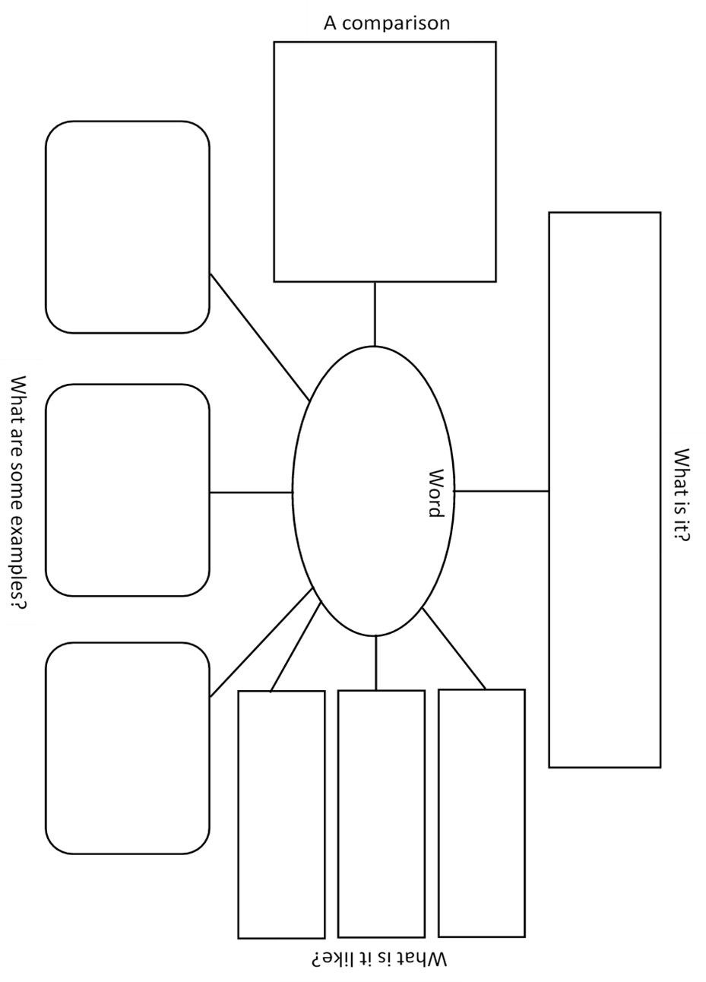
Copied under the statutory licence in s 113P of the Copyright Act. Maureen McLaughlin; Mary Beth Allen, ‘Guided Comprehension: A Teaching Model for Grades 3-8’, International Reading Association (2001) ISBN 10: 0872071723 . Section 113P Warning Notice

Vocabulary map examples
(Guided Comprehension, McLaughlin & Allen, 2009)
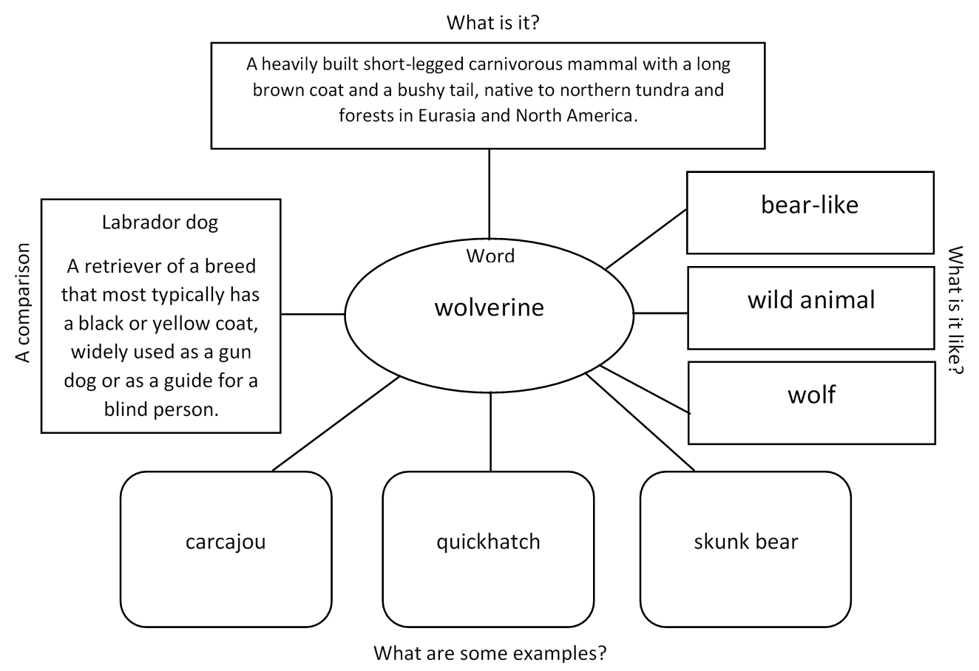
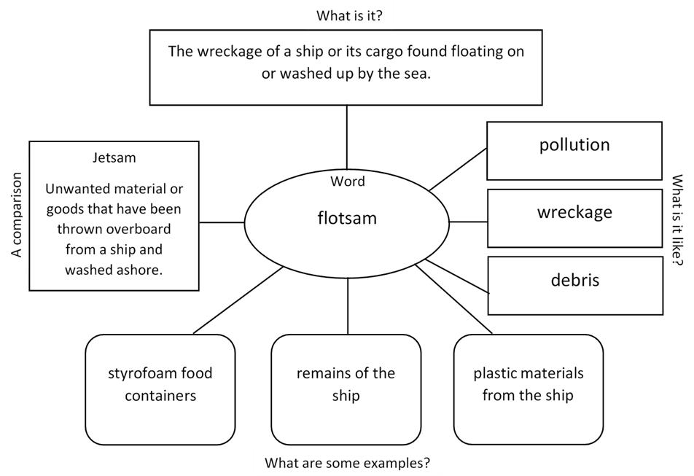
Copied under the statutory licence in s 113P of the Copyright Act. Maureen McLaughlin; Mary Beth Allen, ‘Guided Comprehension: A Teaching Model for Grades 3-8’, International Reading Association (2001) ISBN 10: 0872071723 . Section 113P Warning Notice

Alternative to Vocabulary map: Word webs
Word
Definition
Synonyms
Parts of word
Part of speech
Antonym

