Text structure and features
Stage 5

Overview

Purpose
This literacy teaching strategy supports teaching and learning for Stage 5 students across all key learning areas. It targets specific literacy skills and suggests a learning sequence to build skill development. Teachers can select individual tasks, or a sequence, and embed into their teaching and learning program according to their students’ needs. While exemplar texts are provided throughout this resource, it is recommended that teachers select texts which are relevant to their students and curriculum.

Learning intention
Students will learn to identify specific structural and stylistic components that combine to construct meaning and achieve purpose within different types of texts.

Syllabus outcomes
The following teaching and learning strategies will assist in covering elements of the following outcomes:
- EN5-RVL-01: uses a range of personal, creative and critical strategies to interpret complex texts
- EN5-URA-01: analyses how meaning is created through the use and interpretation of increasingly complex language forms, features and structures
- EN5-2A: effectively uses and critically assesses a wide range of processes, skills, strategies and knowledge for responding to and composing a wide range of texts in different media and technologies
- EN5-3B: selects and uses language forms, features and structures of texts appropriate to a range of purposes, audiences and contexts, describing and explaining their effects on meaning
NSW English K-10 Syllabus (2022)
Visit the Leading curriculum K-12 website for more information on the syllabus implementation timeline.

Success criteria
The following Year 9 NAPLAN item descriptors may guide teachers to co-construct success criteria for student learning.
- analyses the use of a persuasive device in an information text
- identifies the significance of a description in a narrative extract
- identifies the use of persuasive devices in a persuasive text
- analyses an argument in a persuasive text
- identifies the genre of a narrative
- analyses the structure of a narrative
- analyses the structure of a persuasive email
- analyses the structure of a persuasive text
- identifies the purpose of an exclamation mark in an information text
- identifies the purpose of inverted commas in an information text
- identifies the purpose of italicised text in a narrative
- identifies the purpose of a rhetorical question in a text
- identifies the purpose of an example in an information text

National Literacy Learning Progression guide

Understanding Texts (UnT9-UnT11)
Key: C=comprehension P=process V=vocabulary

UnT9
- builds meaning by actively linking ideas from a number of texts or a range of digital sources (C)
- distils information from a number of texts according to task and purpose (e.g. uses graphic organisers) (C)
- evaluates text features for relevance to purpose and audience (C)
- identifies techniques used to obscure author’s purpose (e.g. inclusion or omission of content) (C)
- uses knowledge of a broader range of cohesive devices to track meaning (e.g. word associations) (see Grammar) (P)
- analyses language and visual features in texts using metalanguage (e.g. cohesion, interpretation, figurative) (V)

UnT10
- analyses how text features are used to support or conflate the point of view in the text (e.g. the strategic use of images such as a cartoon in an editorial) (C)
- applies and articulates criteria to evaluate the language structures and features for relevance to purpose and audience (C)
- evaluates the reasoning and evidence in a persuasive text (C)
- explains how context (e.g. time, place, situation) influences interpretations of a text (C)
- analyses the author’s perspectives in complex or some highly complex texts (C)
- analyses the techniques authors use to position readers (C)
- recognises when ideas or evidence have been omitted from a text to position the reader (C)

UnT11
- analyses the credibility and validity of primary and secondary sources (C)
- analyses the cumulative impact of use of language features and vocabulary across texts (C)
- explains assumptions, beliefs and implicit values in texts (e.g. economic growth is always desirable) (C)
- evaluates the social, moral and ethical positions taken in texts (C)
National Literacy Learning Progression

Evidence base
- Centre for Education Statistics and Evaluation (2017). Effective reading instruction in the early years of school, literature review.
- Oakhill, J., Cain, K. & Elbro, C. (2015). Understanding and teaching reading comprehension: A handbook. Routledge.
- Quigley, A. (2020). Closing the reading gap. Routledge.
- Scarborough, H.S. (2001). Connecting early language and literacy to later reading (dis)abilities: Evidence, theory and practice. In S. Neuman & D. Dickson (Eds.), Handbook for research in early literacy (pp. 97-110). New York, NY: Guilford Press.
Alignment to system priorities and/or needs: Five priorities for Literacy and Numeracy, Our Plan for NSW Public Education, School Excellence Policy (nsw.gov.au).
Alignment to School Excellence Framework: Learning domain: Curriculum, Teaching domain: Effective classroom practice and Professional standards
Consulted with: Strategic Delivery, Teaching Quality and Impact
Author: Literacy and Numeracy
Reviewed by: Literacy and Numeracy, Teaching Quality and Impact
Created/last updated: January 2024
Anticipated resource review date: January 2025
Feedback: Complete the online form to provide any feedback

Copyright
Section 113P Notice
Texts, Artistic Works and Broadcast Notice
Some of this material has been copied and communicated to you in accordance with the statutory licence in section 113P of the Copyright Act. Any further reproduction or communication of this material by you may be the subject of copyright protection under the Act. Do not remove this notice.

Teaching strategies
Task | Appendices
Analysing persuasive texts
Analysing nonfiction texts | Appendix 1 - Match and sort  Appendix 2 - Features in non-fiction texts
Analysing text features in a nonfiction text | Appendix 3 - Analysing the effects of text features  Appendix 4 - Purpose and structure of non-fiction texts
Analysing a website | Appendix 5 - Hierarchy chart
Analysing narrative texts | Appendix 6 - Match and sort  Appendix 7 - Identifying structure in narrative texts
Structuring language in an imaginative text | Appendix 8 - Key grammatical terms  Appendix 9 - Close analysis of a paragraph in an imaginative text
Compile an annotated ‘Reading Magazine’ | Appendix 10 - Identifying structural and language features of a narrative

Background information

Types of text
Classifications of text are made according to the particular purposes texts are designed to achieve. These purposes influence the characteristic features the texts employ. In general, texts can be classified as belonging to one of three types (imaginative, informative or persuasive), although it is acknowledged that these distinctions are neither static nor finite and particular texts can belong to more than one category.

Imaginative texts
Texts that represent ideas, feelings and mental images in words or visual images. Imaginative texts entertain or provoke thought through their creative use of literary elements and make connections between ideas and experiences. These texts include novels, traditional tales, poetry, stories, plays, fiction for young adults and children, including picture books and multimodal texts such as film.

Informative texts
Texts whose primary purpose is to provide information through explanation, description, argument, analysis, ordering and presentation of evidence and procedures. These include texts which are valued for their informative content, as a store of knowledge and for their value as part of everyday life. For example, information reports, news articles and reference materials.

Persuasive texts
A text designed to convince a reader of a particular opinion or way of thinking on an issue. A persuasive text
may express an opinion while discussing, analysing and/or evaluating an issue. These include student essays, debates, arguments, discussions, polemics, advertising, propaganda, influential essays and articles.

Theme
An overarching or recurring idea that describes attitudes or values that are perceived in a text. A theme may range from the understood ‘moral’ of a text to philosophical observations that the audience makes about the events, characters and experiences depicted in a text. A text may have more than one theme.

Genre
The categories into which texts are grouped based on similarities in premise, structure and function. The ‘genre’ of a text describes larger recurring patterns of subject matter and textual structures observable between texts, such as typical plots, characters and setting. ‘Genre’ can also describe categories of form and structure in texts.
The term has a complex history within literary and linguistic theory and is often used to distinguish texts on the basis of, for example, their subject matter (detective fiction, romance, science fiction, fantasy fiction) and form and structure (poetry, novels, short stories).

Text structure
The ways information is organised in different types of texts, for example chapter headings, subheadings, tables of contents, indexes and glossaries, overviews, introductory and concluding paragraphs, sequencing, topic sentences, taxonomies, cause and effect. Choices in text structures and language features together define a text type and shape its meaning (see language features).

Textual form
The conventions specific to a particular type of text, often signaling content, purpose and audience, for example letter form, drama script or blogs.

Language features
The features of language that support meaning, for example sentence structure, vocabulary, illustrations, diagrams, graphics, punctuation, figurative language. Choices in language features and text structures together define a type of text and shape its meaning (see structures of texts). These choices vary according to the purpose of a text, its subject matter, audience and mode or media of production.
Reference: ‘English K-10 Syllabus © NSW Education Standards Authority (NESA) for and on behalf of the Crown in right of the State of New South Wales, 2012 and 2022.’

Where to next?
- Audience and purpose
- Author bias and perspective
- Main idea and theme

Overview of teaching strategies

Purpose
These literacy teaching strategies support teaching and learning from Stage 2 to Stage 5. They are linked to NAPLAN task descriptors, syllabus outcomes and literacy and numeracy learning progressions.
These teaching strategies target specific literacy and numeracy skills and suggest a learning sequence to build skill development. Teachers can select individual tasks or a sequence to suit their students.

Access points
The resources can be accessed from:
- NAPLAN App in Scout using the teaching strategy links from NAPLAN items
- NSW Department of Education literacy and numeracy website.
What works best
Explicit teaching practices involve teachers clearly explaining to students why they are learning something, how it connects to what they already know, what they are expected to do, how to do it and what it looks like when they have succeeded. Students are given opportunities and time to check their understanding, ask questions and receive clear, effective feedback.
This resource reflects the latest evidence base and can be used by teachers as they plan for explicit teaching.
Teachers can use classroom observations and assessment information to make decisions about when and how they use this resource as they design teaching and learning sequences to meet the learning needs of their students.
Further support with What works best is available.
Differentiation
When using these resources in the classroom, it is important for teachers to consider the needs of all students, including Aboriginal and EAL/D learners.
EAL/D learners will require explicit English language support and scaffolding, informed by the Enhanced EAL/D enhanced teaching and learning cycle and the student’s phase on the EAL/D Learning Progression. Teachers can access information about supporting EAL/D learners and literacy and numeracy support specific to EAL/D learners.
Learning adjustments enable students with disability and additional learning and support needs to access syllabus outcomes and content on the same basis as their peers. Teachers can use a range of adjustments to ensure a personalised approach to student learning.
Assessing and identifying high potential and gifted learners will help teachers decide which students may benefit from extension and additional challenge. Effective strategies and contributors to achievement for high potential and gifted learners helps teachers to identify and target areas for growth and improvement. A differentiation adjustment tool can be found on the High potential and gifted education website.

Using tasks across learning areas
This resource may be used across learning areas where it supports teaching and learning aligned with syllabus outcomes.
Literacy and numeracy are embedded throughout all syllabus documents as general capabilities. As the English and mathematics learning areas have a particular role in developing literacy and numeracy, NSW English and Mathematics syllabus outcomes aligned to literacy and numeracy skills have been identified.

Text selection
Example texts are used throughout this resource. Teachers can adjust activities to use texts which are linked to their unit of learning.
Further support with text selection can be found within the National Literacy Learning Progression Text Complexity appendix.
The NESA website has additional information on text requirements within the NSW English syllabus.

Teaching strategies

Analysing persuasive texts
- Discuss the purpose of a persuasive text: to persuade an audience to agree with a point of view or opinion. Where do we find these? What forms do they take? What clues do you look for to determine whether a text is trying to persuade or just inform? Discuss how persuasive texts can use elements of informative and imaginative texts.
- Discuss how composers persuade – what techniques do they use? Some suggestions might include: rhetorical questions, modal language, causal connectives and conjunctions, title/headline, using references (quotes, statistics, and experts), repetition, emotive language, visual features – images, graphs, diagrams, font size and style, layout. Students are provided with a range of texts, then split into teams with one of the elements of persuasive texts to research, summarise and present findings using a Frayer model to the class.
- Review structural elements of a typical persuasive text: title, opening statement, arguments, conclusion and concluding statement. Students explore a range of persuasive texts linked to current unit of learning and colour-code these elements. Additional Task: Students design their own graphic organiser to represent the structure of a persuasive text.
- As a class, explore some examples of persuasive texts and discuss what features make them persuasive. Teacher models how to annotate a text, identifying the author’s position, beliefs and values on an issue, as well as any text features used to persuade an audience to the author’s particular view. (Teachers could select a range of texts relevant to a current unit of learning, including advertisements, speeches, editorials, opinion pieces and so on)
To encourage higher order thinking, provide a range of texts which take different positions on the same issue. Discuss with the class how each author has explored the issue or topic, noting similarities and/or differences between the text features and structures used to persuade. As a class use a graphic organiser to collate findings.
- Think Pair Share: In pairs, students analyse a persuasive text for key elements and features. Students develop a set of questions based on the persuasive elements in the text. For example: How do the images on the page support the authors’ point of view? Do they position the audience to think in a particular way? How does the author use language devices to further their line of argument? What evidence does the author used to persuade the audience, and has any evidence been omitted for effect? What sources has the author referred to and are they credible?

Analysing nonfiction texts
- Review types of nonfiction texts, their purpose and audience. Discuss style and tone of writing and how they differ from that of a persuasive news article or a medical fact sheet. Students use two informative texts linked to current unit of learning and complete a Venn diagram to compare and contrast language and structure. Teachers can also show ‘Mind your reflection’ and ‘Auroras’ from Appendix 4 to consolidate the concept of non-fiction texts.
- Students use Appendix 1 - Match and sort and complete a match and sort for nonfiction texts.
- Students use Appendix 2 - Features in non-fiction texts to guide an analysis of a range of nonfiction texts.
Additional Task: Students create a range of multiple-choice questions based on the texts for a peer to answer.

Analysing text features in a nonfiction text
- Review types of nonfiction texts and their purpose and audience (refer to ‘Analysing nonfiction texts’).
- Review text features of inverted commas, brackets, rhetorical questions and italics and discuss the various purpose and effect of using such features.
- Advise students that they will be using a table to analyse the effect of using certain text features, not just identifying the purpose. This could include how it positions the reader, how it makes the reader aware of added information, what it shows, or even how text features can help students make connections within and outside of texts.
- Students use Appendix 3 - Analysing the effects of text features to complete an analysis of text features in ‘Auroras: neon signs in the sky’ (Appendix 4 - Purpose and structure of non-fiction texts).
- Teacher discusses student responses upon completion of task.

Analysing a website
- Locate a website rich in multimodal elements and choose a page from within that website. For example, the United Nations (UN) website - ‘Make this the century of women’s equality: UN chief.’
- Use the Hierarchy Chart (Appendix 5 - Hierarchy chart) to deconstruct the website page into the following three elements: words/images, interactivity and context.
- Break down each category into its components:

Category | Components
Words/ Images | Persuasive and narrative elements: emotive words, adjectives, call to action, imagery, rhetorical questions.  Image: colour, composition, symbols, vectors, gaze, shot size, shot angle, gesture.  Structural elements: headline, captions, breadcrumbs, hyperlinks, colour, composition
Interactive | Podcasts, interviews, videos, tweets, Instagram.
Context | What is the structure and purpose of the main website? Who is the audience? How do you navigate to this page from the home page of the website? How many clicks does it take? What breadcrumbs do you have to follow from the home page?
- Using the information in the Hierarchy Chart evaluate other websites, addressing the following (ensure websites are appropriate).
- What is the purpose and audience for the specific webpage, for example, “Make this the century of women’s equality” from UN News: news.un.org/en/story/2020/02/1058271
- Evaluate its significance within the context of the main website, for example, the front page of News UN website. Is the website page given equal weight to other webpages within the main website? Is it given prominence within the overall structure of the main website? Why? Why not?

Analysing narrative texts
- Discuss the science fiction genre with the class (or any other genre relevant to a current unit of learning.) What texts have they explored? What makes them instantly recognisable as science fiction? Why do you think this genre is enjoyed by huge fan bases? Brainstorm features and display on board. Some examples might be ‘Stranger Things’ or ‘Star Wars’.
- Provide students with a range of book covers or film posters and identify any typical features of the genre. This may include characters, plot, setting, themes and vocabulary. As a class, discuss and evaluate the purpose and audience of each text, and how language and visual features have been used to appeal to a science fiction audience.
- Students work in teams to complete a match and sort for narrative texts (Appendix 6 - Match and sort).
- Think Pair Share: In pairs, review and discuss ihe structural and language features of imaginative texts (Refer to Appendix 6 for guidance). Students could create a ‘must have’ and a ‘may have’ list.
- Provide students with separated, de-identified copies of the three excerpts. (Appendix 7 - Identifying structure in narrative texts.) Students read the excerpts and highlight vocabulary/phrases, characters, setting and plot details that identify it with the science fiction genre.
- Students then sequence the extracts and link each one to a component of the narrative structure (orientation, complication, series of events, resolution) and provide reasons for their choices.
- Students need to predict a plot for the story using the extracts and their knowledge of the structure of a narrative.

Structuring language in an imaginative text
The purpose of this task is for students to closely examine the language forms and features, and structural choices an author makes in order to create meaning within an imaginative text.
- Explain the following concept to students:
Imaginative texts are created for the purpose of engagement, entertainment and to communicate different ideas. Authors carefully construct imaginative texts to ensure audiences are able to immerse themselves in the world of the story. We can understand HOW they accomplish this when we examine a part of the text more closely.
- Before examining the text, students recall their knowledge of the following grammatical terms: adverb, conjunction, conjunctive adverb, clause, independent clause, dependent clause. (Appendix 8 - Key grammatical terms)
- Using Appendix 9 - Close analysis of a paragraph in an imaginative text. students read the text and complete the questions. The teacher might choose to project the paragraph onto the board and guide students as they closely examine language and sentence structure. Parts of this extract have been highlighted to help students identify the different grammatical elements being examined.
- After completing the task, students discuss what they have learnt from closely analysing the paragraph. Some suggested ideas include:
- Authors make deliberate choices at a sentence and word level in order to create meaning in an imaginative text.
- The meaning of a text depends on the language chosen by the author and how it used.
- Texts are shaped by the choices an author makes regarding the type of sentences and arrangement of language.
- Language and structural choices affect the way an audience feels about a text.
- Language and structural choices affect the way an audience imagines characters and events in texts.

Compile an annotated ‘Reading Magazine’.
- Students apply their knowledge of the structural and language features of persuasive, non-fiction, and narrative texts by sourcing one of each text type. This can be done individually or in pairs. Students could use the NAPLAN Reading magazines online, or locate an appropriate webpage or use their own or a peer’s writing (refer to Appendix 10 - Identifying structural and language features of a narrative).
- Students annotate the reading pieces that they have chosen for structural features specific to each type of text.
- Students annotate the reading pieces that they have chosen for language features specific to each type of text.
- Extension: students rewrite one of their chosen texts, changing language structures and features so that, for example, a persuasive text becomes an informative text.

Appendix 1

Match and sort: purpose and structural elements of non-fiction
Purpose | To inform
Examples | Newspaper articles, brochures, reports, explanation of how things work, magazine articles, blogs, websites, recipe, instructions and so on
Layout features | Titles, tables, headings, diagrams, subheadings, graphics, bold, italics, inverted commas, contents, glossary, index
Organisation | Can be organised in many structures.
Organisation style 1: Description/categorisation | - The author describes the topic by listing characteristics, features and examples.  - There is a focus on one thing and its components.  - May focus on how something looks, moves, works and so on
Organisation style 2: Sequence | - The author introduces items or events in numerical order or in chronological order (think a method in a recipe or science experiment).  - The author then describes the order of events or how to do something or make something.
Organisation style 3: Compare and contrast | The author describes how 2 or more things are alike or different.
Organisation style 4:  Cause and effect | - Effect = what happened Cause = What made it happen  - The author lists one or more causes and the resulting effect/s.  - The purpose is to explain why or how something happened, works or exists
Organisation style 5: Problem-solution | - The author states one or more problems and one or more possible solutions to the problem.  - What’s wrong and how to fix it  - It may also include the advantages or disadvantages of each solution
Organisation style 6: Position-reason | - State an opinion, theory or hypothesis and offer evidence to support it.  - Why a point of view should be supported/what’s wrong with an idea
Copied and adapted under the statutory licence in s 113P of the Copyright Act. NSW Centre for Effective Reading Comprehension Handbook. Section 113P Warning Notice.

Appendix 2

Purpose of features in non-fiction texts
What is the purpose of each of these components in the text?
Summary of main idea of text
Title
Introductory statement
Images, diagrams, maps
Captions
Introductory paragraph
Body paragraphs
Concluding paragraph
Layout features (for example. website links)
Quotes
Italics, bold, inverted commas, bracketed information

Appendix 3

Analysing the effect of text features
Text Feature | Explain its purpose | Analyse the effect of using this feature
Inverted commas around ‘excited’ | Used to | This shows
Brackets around (reddish) and (greenish)

solar wind is italicised

Brackets around (protons and electrons)

The question mark in the final paragraph.

Appendix 4

Purpose and structure of nonfiction texts
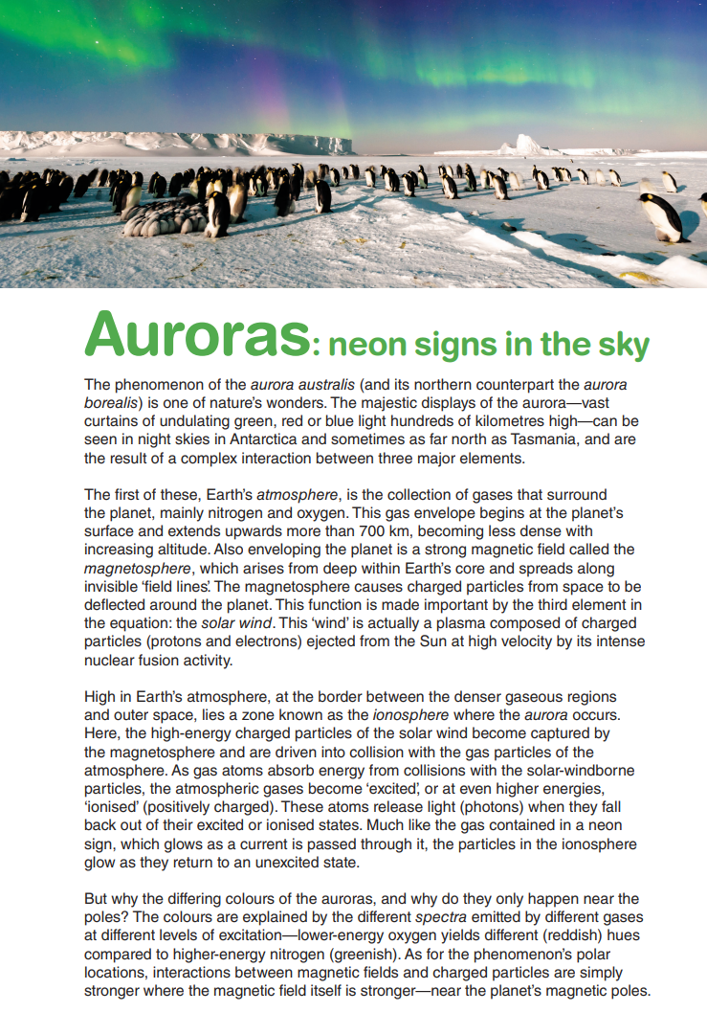
NAPLAN Reading Magazine Year 9, ACARA, 2015

Appendix 4

Purpose and structure of nonfiction texts: accessible version

Auroras: neon signs in the sky
The phenomenon of the aurora australis (and its northern counterpart the aurora borealis) is one of nature’s wonders. The majestic displays of the aurora—vast curtains of undulating green, red or blue light hundreds of kilometres high—can be seen in night skies in Antarctica and sometimes as far north as Tasmania, and are the result of a complex interaction between three major elements.
The first of these, Earth’s atmosphere, is the collection of gases that surround the planet, mainly nitrogen and oxygen. This gas envelope begins at the planet’s surface and extends upwards more than 700 km, becoming less dense with increasing altitude. Also enveloping the planet is a strong magnetic field called the magnetosphere, which arises from deep within Earth’s core and spreads along invisible ‘field lines’. The magnetosphere causes charged particles from space to be deflected around the planet. This function is made important by the third element in the equation: the solar wind. This ‘wind’ is actually a plasma composed of charged particles (protons and electrons) ejected from the Sun at high velocity by its intense nuclear fusion activity.
High in Earth’s atmosphere, at the border between the denser gaseous regions and outer space, lies a zone known as the ionosphere where the aurora occurs. Here, the high-energy charged particles of the solar wind become captured by the magnetosphere and are driven into collision with the gas particles of the atmosphere. As gas atoms absorb energy from collisions with the solar-windborne particles, the atmospheric gases become ‘excited’, or at even higher energies, ‘ionised’ (positively charged). These atoms release light (photons) when they fall back out of their excited or ionised states. Much like the gas contained in a neon sign, which glows as a current is passed through it, the particles in the ionosphere glow as they return to an unexcited state.
But why the differing colours of the auroras, and why do they only happen near the poles? The colours are explained by the different spectra emitted by different gases at different levels of excitation—lower-energy oxygen yields different (reddish) hues compared to higher-energy nitrogen (greenish). As for the phenomenon’s polar locations, interactions between magnetic fields and charged particles are simply stronger where the magnetic field itself is stronger—near the planet’s magnetic poles.
NAPLAN Reading Magazine Year 9, ACARA, 2015

Appendix 5

Hierarchy Chart
Hierarchy chart from: English Textual Concepts
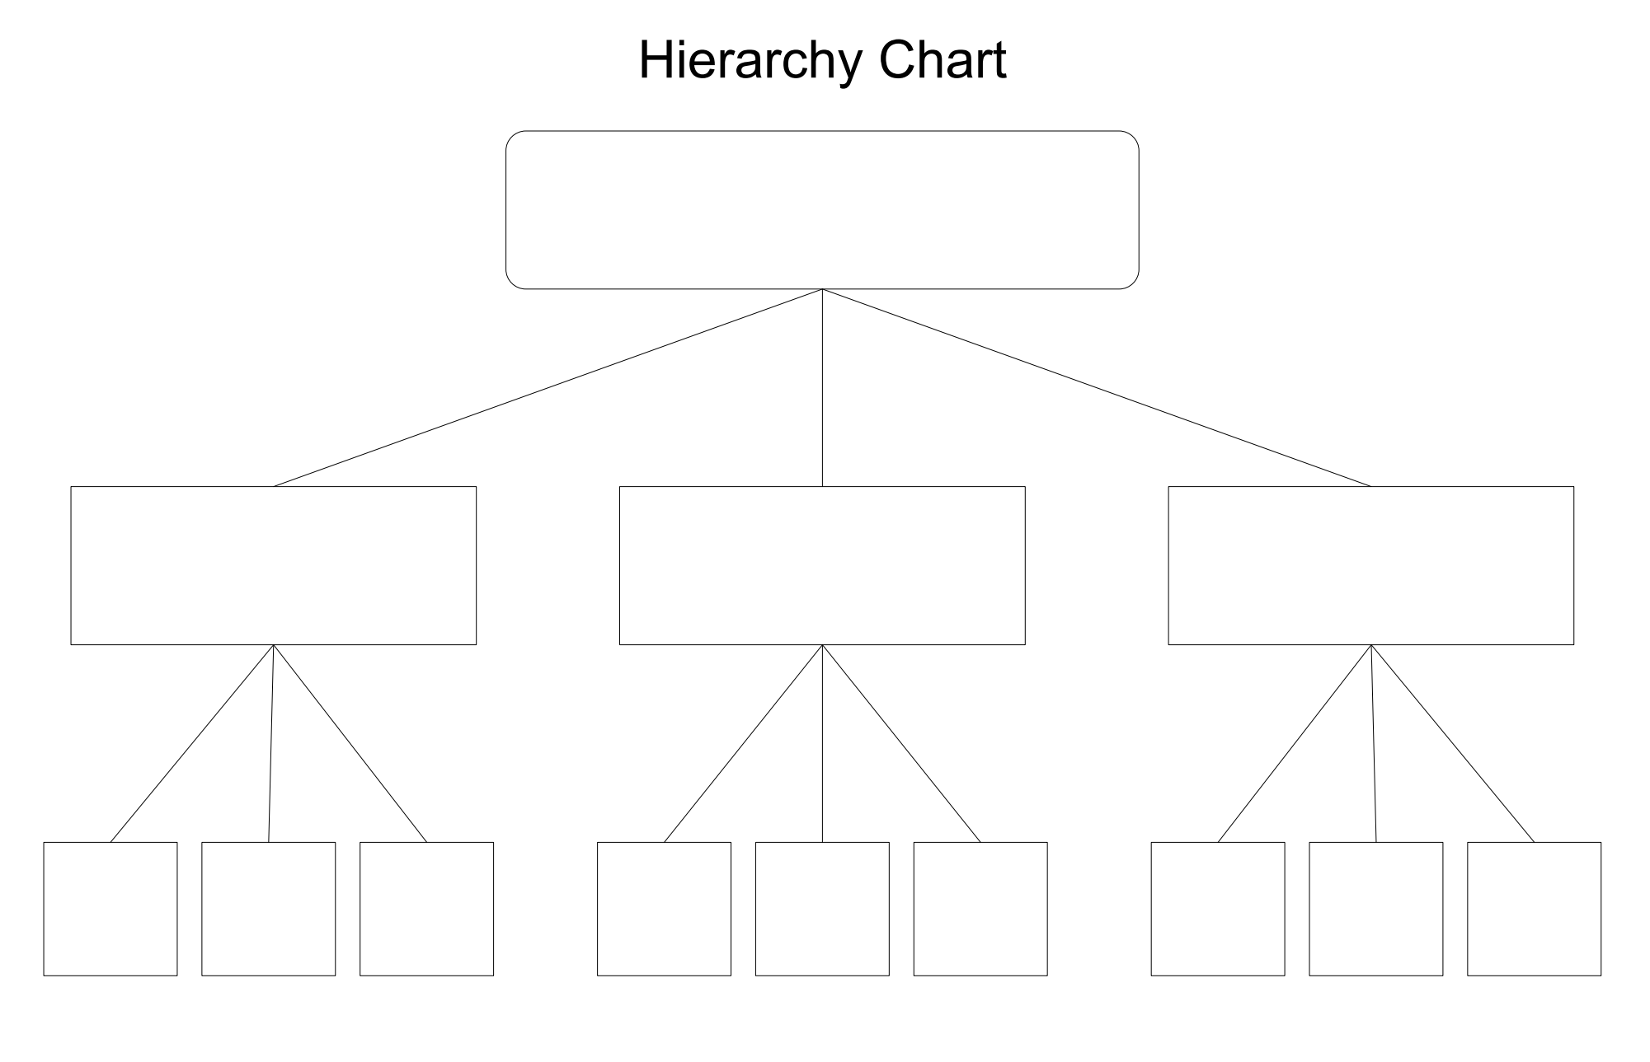
Access a range of graphic organisers through the NSW Department of Education’s Digital Learning Selector tool.

Appendix 6

Match and sort: purpose and structural elements of narratives
Purpose of imaginative texts | To entertain and or inform
Examples of imaginative texts | Fables, legends, fantasies, folktales, plays, mysteries, myths, fiction, historical fiction
Title | A short phrase of word that captures the theme or premise of the text.
Orientation or beginning | Introduces characters, setting and background
Setting | Sets the time and place, the historical, physical and or geographical location
Characters | People, animals or other entities in the text. Minor and major. Protagonist and antagonist.
Plot | Sequence of events with an orientation and crisis or complication to be resolved.
Complication or crisis | Problem, rising action and climax – moment of high tension.
Internal conflict | A character’s struggle with themselves
External conflict | A character’s struggle with another character or situation.
Rising action | Events leading to the climax - trying to solve the problem.
Climax | Point in the story with most tension – the conflict or complication is addressed and decisive action is planned.
Falling action | Consequences or events in the story which are caused by the climax.
Resolution | Final outcome
Copied and adapted under the statutory licence in s 113P of the Copyright Act. NSW Centre for Effective Reading Comprehension Handbook. Section 113P Warning Notice.

Appendix 7

Identifying structure in narrative texts
‘Human Is’ by Phillip K Dick, first published in ‘Startling Stories’, Winter 1955.
Extract 1 - (Opening)
Jill Herrick’s blue eyes filled with tears. She gazed at her husband in unspeakable horror. ‘You’re - you’re hideous!’ she wailed.
Lester Herrick continued working, arranging heaps of notes and graphs in precise piles.
‘Hideous,’ he stated, ‘is a value judgement. It contains no factual information.’ He sent a report on Centauran parasitic life whizzing through the desk scanner. ‘Merely an opinion. An expression of emotion, nothing more.’
Jill stumbled back to the kitchen. Listlessly, she waved her hand to trip the stove into activity. Conveyor belts in the wall hummed to life, hurrying the stove into activity. Conveyor belts in the wall hummed to life, hurrying the food from the underground storage lockers for the evening meal.
Extract 2 - (Complication)
It was late afternoon. Frank drove his surface cruiser slowly along. Neither he nor Jill spoke.
‘So that’s it,’ Jill said at last. Her face was grey. Her eyes dry and bright without emotion. ‘I knew it was too good to be true.’ She tried to smile. It seemed so wonderful.’
‘I know,’ Frank said. ‘It’s a terrible damn thing. If only -’
‘Why?’ Jill said. ‘Why did he - did it do this? Why did it take Lester’s body?’
‘Rexor IV is old. Dead. A dying planet. Life is drying out.’
Extract 3 - (Resolution)
Jill was silent as they walked along, deep in thought. The city lights were coming on all around them. Bright yellow spots in the gloom.
‘What are you thinking?’ the man asked.
‘I was thinking perhaps I will still call you Lester,’ Jill said, ‘If you don’t mind.’
‘I don’t mind,’ the man said. He put his arm around her, drawing her close to him. He gazed down tenderly as they walked through the thickening darkness, between the yellow candles of light that marked the way. ‘Anything you wish. Whatever will make you happy.’
Copied under the statutory licence in s 113P of the Copyright Act. Phillip K Dick, ‘Human Is’ in ‘Startling Stories’ Winter 1955. Section 113P Warning Notice.

Appendix 8

Key grammatical terms
Grammatical term | Meaning
Adverb | Adverbs are words that modify and describe verbs, adjectives or other adverbs. These words give us more information about how, where, when, how much and what frequency. (quickly, actually, especially, highly, now, yesterday, quietly, always, sometimes, outside, backwards, rarely, never)
Conjunction | A word used to connect clauses or sentences or to coordinate words in the same clause (for, but, and, yet, so, or).  A coordinating conjunction is a word or group of words that function to link two independent clauses within a sentence. A subordinating conjunction is a word or group of words that function to link a dependent clause to an independent clause.
Conjunctive adverb | A conjunctive adverb connects two independent clauses or sentences and gives information regarding when, what frequency, how much, and so on (accordingly, also, besides, consequently, finally, however, indeed, instead, likewise, meanwhile, moreover, nevertheless, next, otherwise, still, therefore, then, and so on.)
Clause | A clause is a group of words which form part of a sentence. It must have a subject (who) and a verb (what).
Independent clause (also known as a principal or main clause) | An independent clause expresses a complete thought and can stand on its own.
Dependent clause (also known as a subordinate clause) | A dependent clause does not express a complete thought and cannot stand on its own. It must be linked to an independent clause through a coordinating conjunction and/or the appropriate punctuation.

Appendix 9

Close analysis of a paragraph in an imaginative text
Anne of Green Gables by L.M Montgomery, Harper Collins Australia, 2017
Paragraph four extract:
And yet here was Matthew Cuthbert, at half-past three on the afternoon of a busy day, placidly driving over the hollow and up the hill; moreover, he wore a white collar and his best suit of clothes, which was plain proof that he was going out of Avonlea; and he had the buggy and the sorrel mare, which betokened that he was going a considerable distance. Now, where was Matthew Cuthbert going and why was he going there?
Examine the text to complete the following questions:
- Grammatically speaking, the conjunction ‘And yet’ and conjunctive adverb ‘Now’ are redundant within this paragraph (highlighted in pink). The addition of ‘And yet’ and ‘Now’ tell us nothing about Matthew Cuthbert and what he is doing in this section of the text. So why does the author include this language? Read the paragraph aloud, paying close attention to how you believe the narrator should sound. Read the paragraph a second time, leaving these particular words out. Answer the following two questions:
  - How does the tone of the text change?
  - How do these words create and/or enhance the narrative voice?
- All the independent clauses are highlighted in blue. Read the paragraph again, but this time, only read the independent clauses. How does the text change? Answer the following two questions:
  - Does anything happen to the tone and/or pace of the story?
  - What information is lost and how does this impact your understanding of the text?
- Have a close look at all the dependent clauses (yellow).
  - What additional pieces of information does the author provide through these clauses?
  - How does this information impact/enhance your understanding of the story?
- ‘Moreover’ (green) is a conjunctive adverb because it is a word that is used to connect two clauses while also emphasising the importance of the information in the sentence proceeding it. Read the paragraph again, removing the word ‘moreover’. What happens to the meaning of the text if you remove the word ‘moreover’? Answer the following two questions:
  - How does removing ‘moreover’ impact the narrator’s voice/tone?
  - How does it affect the flow and pace of the story?
Copied under the statutory licence in s 113P of the Copyright Act. L.M Montgomery, Anne of Green Gables. Harper Collins Australia, 2017Section 113P Warning Notice.

Appendix 10

Identifying structural and language features of a narrative

Going somewhere
The man in the suit was going somewhere. That was how he strode into Laurie’s mind the first time, ten months before — a man going somewhere. Laurie took in the coppery hair and beard — were they stylish or unkempt? The eyes were disconcertingly blue, not settling on anything near, focused only on something distant — the place he was going. His suit was unmistakably good. To Laurie — at fifteen, transplanted by his parents from the country to the inner suburbs, wandering his new streets, marvelling at the unearthly blue of the jacarandas and the fleshiness of the suspended mangoes — the man appeared as a sign. He was going somewhere.
Laurie continued to explore his streets in those early months, even as school took over and friendships developed. The deep, damp shade, the searing light, the older houses slumping in the green shadows — it all became his own. But not his alone. He shared it with the man in the suit. He met him at every corner. While Laurie studied the lichen-encrusted palings of a collapsing fence, or the blood-red flowers of a flame tree, the man would stride past, going somewhere. But the hair and beard were now definitely unkempt; the eyes were brighter.
Laurie felt a kind of fellow feeling. By now he was convinced that he was going somewhere too. The move to the city had been a success. He felt he should acknowledge his friend, his fellow explorer — just a nod of the head. But he never did.
The man continued to change. Were those twigs in his hair? Whatever the eyes were fixed upon was more distant. The suit became dirty; then ragged. Laurie had admired the man’s sense of purpose. Now he seemed like a frantic insect in a mango tree, tossed between light and shade. And now, whenever he was tossed into the light of Laurie’s vision, Laurie looked away.
After almost a year in his new city, Laurie was sitting on a seat in the park, reading. It was the smell he noticed first. He looked up. The man in the suit was in front of him, standing still — but somehow standing with the same concentrated energy with which he always walked. His ravaged eyes were focused on Laurie.
Was there any recognition there? There was no sign of it. Laurie and the man looked at each other. The blue of the man’s eyes was like a strange, brittle mineral. Laurie was sickened by the animal smell. Animal? No, he realised, as a sense of menace thickened, it was not an animal smell. It must be human. And the light in the eyes too?
The man spoke. Just one wordless noise. Then his concentrated energy drained from him, and he slumped onto the seat beside him. Wherever the man had been going, he seemed to have arrived.
They sat side by side, Laurie wondering how he could leave, how he could stay. Finally he got to his feet and without looking back said, ‘Um … I’ve … somewhere to go.’ And he walked off, quickly. If the man made any response, Laurie didn’t hear it. He kept walking, faster, faster. But he had nowhere to go
Year 9 NAPLAN Reading Magazine, ACARA, 2013

Identifying structural and language features of a narrative
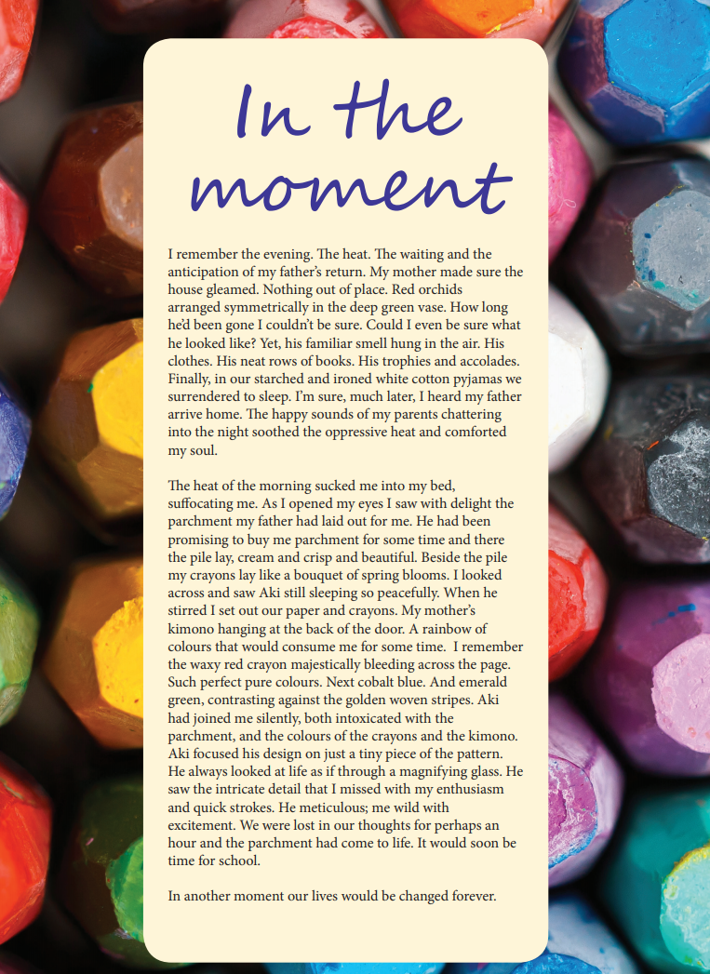
Year 9 NAPLAN Reading Magazine, ACARA, 2013

Identifying structural and language features of a narrative – accessible version

In the moment
I remember the evening. The heat. The waiting and the anticipation of my father’s return. My mother made sure the house gleamed. Nothing out of place. Red orchids arranged symmetrically in the deep green vase. How long he’d been gone I couldn’t be sure. Could I even be sure what he looked like? Yet, his familiar smell hung in the air. His clothes. His neat rows of books. His trophies and accolades. Finally, in our starched and ironed white cotton pyjamas we surrendered to sleep. I’m sure, much later, I heard my father arrive home. The happy sounds of my parents chattering into the night soothed the oppressive heat and comforted my soul.
The heat of the morning sucked me into my bed, suffocating me. As I opened my eyes I saw with delight the parchment my father had laid out for me. He had been promising to buy me parchment for some time and there the pile lay, cream and crisp and beautiful. Beside the pile my crayons lay like a bouquet of spring blooms. I looked across and saw Aki still sleeping so peacefully. When he stirred I set out our paper and crayons. My mother’s kimono hanging at the back of the door. A rainbow of colours that would consume me for some time. I remember the waxy red crayon majestically bleeding across the page. Such perfect pure colours. Next cobalt blue. And emerald green, contrasting against the golden woven stripes. Aki had joined me silently, both intoxicated with the parchment, and the colours of the crayons and the kimono. Aki focused his design on just a tiny piece of the pattern. He always looked at life as if through a magnifying glass. He saw the intricate detail that I missed with my enthusiasm and quick strokes. He meticulous; me wild with excitement. We were lost in our thoughts for perhaps an hour and the parchment had come to life. It would soon be time for school.
In another moment our lives would be changed forever.
Year 9 NAPLAN Reading Magazine, ACARA, 2013

