Literal comprehension
Stage 5

Overview

Purpose
This literacy teaching strategy supports teaching and learning for Stage 5 students across all key learning areas. It targets specific literacy skills and suggests a learning sequence to build skill development. Teachers can select individual tasks, or a sequence, and embed into their teaching and learning program according to their students’ needs. While exemplar texts are provided throughout this resource, it is recommended that teachers select texts which are relevant to their students and curriculum.

Learning intention
Students will learn to interpret directly stated information in a range of texts.

Syllabus outcome
The following teaching and learning strategies will assist in covering elements of the following outcomes:
- EN5-RVL-01: uses a range of personal, creative and critical strategies to interpret complex texts
- EN5-2A: effectively uses and critically assesses a wide range of processes, skills, strategies and knowledge for responding to and composing a wide range of texts in different media and technologies
NSW English K-10 Syllabus (2022)
Visit the Leading curriculum K-12 website for more information on the syllabus implementation timeline.

Success criteria
The following Year 9 NAPLAN item descriptors may guide teachers to success criteria for student learning.
- applies information to a scenario in an information text
- interprets directly stated information from different sections of a narrative
- interprets directly stated information in a narrative
- interprets directly stated information in a persuasive text
- interprets directly stated information in an information text
- links directly stated information across paragraphs in a narrative
- locates directly stated information in a narrative
- locates directly stated information in a text
- locates directly stated information in an information text

National Literacy Learning Progression guide

Understanding Texts (UnT9-UnT11)
Key: C=comprehension P=process V=vocabulary

UnT9
- reads and views complex texts (see Text complexity) (C)
- summarises the text identifying key details only (C)
- uses processes such as predicting, confirming predictions, monitoring, and connecting relevant elements of the text to build or repair meaning (P)
- selects reading/viewing strategies appropriate to reading purpose (e.g. scans text for evidence) (P)

UnT10
- reads and views complex or some highly complex texts (see Text complexity) (C)
- integrates automatically a range of processes such as predicting, confirming predictions, monitoring, and connecting relevant elements of the text to build meaning (P)
- navigates extended texts including complex digital texts (P)

UnT11
- reads and views highly complex texts (see Text complexity)
- strategically adjusts the processes of reading and viewing to build meaning according to the demands of tasks and texts (P)
National Literacy Learning Progression

Evidence base
- Centre for Education Statistics and Evaluation (2017). Effective reading instruction in the early years of school, literature review.
- Oakhill, J., Cain, K. & Elbro, C. (2015). Understanding and teaching reading comprehension: A handbook. Routledge.
- Quigley, A. (2020). Closing the reading gap. Routledge.
- Scarborough, H.S. (2001). Connecting early language and literacy to later reading (dis)abilities: Evidence, theory and practice. In S. Neuman & D. Dickson (Eds.), Handbook for research in early literacy (pp. 97-110). New York, NY: Guilford Press.
Alignment to system priorities and/or needs: Five priorities for Literacy and Numeracy, Our Plan for NSW Public Education, School Excellence Policy (nsw.gov.au).
Alignment to School Excellence Framework: Learning domain: Curriculum, Teaching domain: Effective classroom practice and Professional standards
Consulted with: Strategic Delivery, Teaching Quality and Impact
Author: Literacy and Numeracy
Reviewed by: Literacy and Numeracy, Teaching Quality and Impact
Created/last updated: January 2024
Anticipated resource review date: January 2025
Feedback: Complete the online form to provide any feedback

Copyright
Section 113P Notice
Texts, Artistic Works and Broadcast Notice
Some of this material has been copied and communicated to you in accordance with the statutory licence in section 113P of the Copyright Act. Any further reproduction or communication of this material by you may be the subject of copyright protection under the Act. Do not remove this notice.

Teaching strategies
Task | Appendices
Skimming and scanning | Appendix 1 - ‘Any Udder Ideas’ text  Appendix 2 - Energy Drinks and Caffeine Factsheet  Appendix 3 - Informative text: Discovery of how cells sense oxygen levels earns Nobel Prize
Responding to and applying literal comprehension questions
Responding to literal comprehension questions | Appendix 4 - Literal comprehension  Appendix 5 - Who, what, when, where, how chart
Applying literal comprehension skills: imaginative text | Appendix 6 - ‘The Sea’: applying literal comprehension skills

Background information

Literal comprehension
Literal comprehension is often referred to as the ‘on the page’ comprehension; it is what the reader can see and hear from the page. Surface level comprehension is the simplest form of comprehension and requires students to locate directly stated information. Finding the main idea, summarising, key facts and understanding vocabulary are key building blocks of literal comprehension.
Questioning before, during and after reading a text is the key component of building comprehension skills (Singer, 1978). Literal comprehension questions are the “how, what, who, when, where” types of questions in their most basic form. The answer is clearly evident, for example, who did Little Red Riding Hood visit? Where did her grandmother live? What was in Little Red Riding Hood’s basket? Readers will use decoding skills, as well as syntax and semantic skills to recognise and remember directly stated information.

Reading
To process written words, to derive and/or construct meaning. It is the product of word reading and language comprehension.

Skimming
Skimming happens when the reader is unfamiliar with a text and skims to find out what type of text it is to get the general idea of the text’s topic. Some strategies to use include:
- read the first and last paragraphs
- look for general information
- use headlines, page layout, graphs, diagrams and charts, pictures, highlights.

Scanning
Scanning happens when the reader knows the topic of a text and wants to find out more by scanning to find specific information and key words. Strategies to use include:
- look over the text quickly to locate words and sentences that link to what you need to find out
- use contents pages, first and last sentences in a paragraph, subheadings, captions, bold key words, hyperlinks and so on.
Reference: English K-10 Syllabus © NSW Education Standards Authority (NESA) for and on behalf of the Crown in right of the State of New South Wales, 2012 and 2022.

Where to next?
- Inference
- Main idea and theme
- Text structure and features

Overview of teaching strategies

Purpose
These literacy teaching strategies support teaching and learning from Stage 2 to Stage 5. They are linked to NAPLAN task descriptors, syllabus outcomes and literacy and numeracy learning progressions.
These teaching strategies target specific literacy and numeracy skills and suggest a learning sequence to build skill development. Teachers can select individual tasks or a sequence to suit their students.

Access points
The resources can be accessed from:
- NAPLAN App in Scout using the teaching strategy links from NAPLAN items
- NSW Department of Education literacy and numeracy website.
What works best
Explicit teaching practices involve teachers clearly explaining to students why they are learning something, how it connects to what they already know, what they are expected to do, how to do it and what it looks like when they have succeeded. Students are given opportunities and time to check their understanding, ask questions and receive clear, effective feedback.
This resource reflects the latest evidence base and can be used by teachers as they plan for explicit teaching.
Teachers can use classroom observations and assessment information to make decisions about when and how they use this resource as they design teaching and learning sequences to meet the learning needs of their students.
Further support with What works best is available.
Differentiation
When using these resources in the classroom, it is important for teachers to consider the needs of all students, including Aboriginal and EAL/D learners.
EAL/D learners will require explicit English language support and scaffolding, informed by the Enhanced EAL/D enhanced teaching and learning cycle and the student’s phase on the EAL/D Learning Progression. Teachers can access information about supporting EAL/D learners and literacy and numeracy support specific to EAL/D learners.
Learning adjustments enable students with disability and additional learning and support needs to access syllabus outcomes and content on the same basis as their peers. Teachers can use a range of adjustments to ensure a personalised approach to student learning.
Assessing and identifying high potential and gifted learners will help teachers decide which students may benefit from extension and additional challenge. Effective strategies and contributors to achievement for high potential and gifted learners helps teachers to identify and target areas for growth and improvement. A differentiation adjustment tool can be found on the High potential and gifted education website.

Using tasks across learning areas
This resource may be used across learning areas where it supports teaching and learning aligned with syllabus outcomes.
Literacy and numeracy are embedded throughout all syllabus documents as general capabilities. As the English and mathematics learning areas have a particular role in developing literacy and numeracy, NSW English and Mathematics syllabus outcomes aligned to literacy and numeracy skills have been identified.

Text selection
Example texts are used throughout this resource. Teachers can adjust activities to use texts which are linked to their unit of learning.
Further support with text selection can be found within the National Literacy Learning Progression Text Complexity appendix.
The NESA website has additional information on text requirements within the NSW English syllabus.

Teaching strategies

Skimming and scanning
- Teacher to review student understanding of literal questions by creating and referring to a KWL chart: what we know, what we want to know and what we learnt. After reading a text, we use skimming and scanning to locate information.
- Teacher explicitly teaches students how to skim using a text relevant to a current unit of learning (or refer to Appendix 1 - ‘Any Udder Ideas’ text). Explain that skimming is used to identify the general idea and we do this by:
- reading the first and last paragraph
- looking for general information
- using structural features such as headings, sub-headings, diagrams and images
- Teacher displays the text for students to practise skimming to find the general idea or gist of the text. Students record the main idea of the text on whiteboards, A3 paper or sticky notes to display. Compare the main ideas identified by the students and sum up with a whole class collaboration on determining the main idea of the text.
- Teacher models scanning a text for the answer to a literal question, for example, ‘Why did milk pouches sell well in one part of the United Kingdom?’ Teacher models identifying key words: milk pouches and popular, and navigating text by using graphics, headings and sub-headings to locate and interpret information.
- Think-Pair-Share: Using a text relevant to a current unit of learning, students write their own literal comprehension questions. Students should include questions that require reading a table or graphic in the text or require navigation of an extended digital text which may include a variety of navigational pathways, for example, embedded hyperlinks to other texts. Swap questions with a partner. Students answer questions justifying responses by citing evidence from the text. (For example texts refer to Appendix 2 - Energy Drinks and Caffeine Factsheet or Appendix 3 - Informative text: Discovery of how cells sense oxygen levels earns Nobel Prize).

Responding to literal comprehension questions
- Students read an extract from ‘Pachinko Min-Jin Lee’ (Appendix 4 - Literal comprehension). Alternatively, teachers could choose any text relevant to a current unit of learning and adapt the following activities.
- Students construct a ‘who, what, when, where and how’ chart (Appendix 5 - Who, what, when, where, how chart) using details from the text.
- Students use a highlighter to colour code each question with the corresponding answer (refer to Appendix 4 for suggestions).
- Students check with a partner and encourage robust discussion on differences and similarities in responses using accountable talk “I can see you thought… I had actually thought the answer might be…because evidence from the text shows…”
- To increase challenge: in pairs, students use the same text and adapt existing questions to new ones which require literal and inferential comprehension skills to derive an answer. For example, ‘What did Hoonie do when meeting strangers?’ could become, ‘Why did Hoonie cover his mouth when meeting strangers?’ Students swap their question set with another pair. Students locate information which they will need to make an inference, linking evidence across the text. For example, Hoonie has a cleft palate. Students then discuss with the class the difference between finding information to answer a literal comprehension question and how to use the same information, as well as other clues from the text and background knowledge, to answer inferential questions.

Applying literal comprehension skills
- Teacher leads students to create a word chain using the word ‘sea’ as a starting word. For example, the teacher says ‘sea’, the next person might say ‘ocean’, the next person might say ‘marine’ or ‘biologist’ and so on.
Scribe words onto the board and review the connections. Discuss possible synonyms to build the vocabulary further. For words that are technical or more complex and unfamiliar, engage students in the ‘say, write, define, demonstrate and clarify’ process, as demonstrated in the ‘Stage 5 Vocabulary in context’ resource.
- Students independently read the extract ‘The Sea’ by John Banville (Appendix 6 - ‘The Sea’: applying literal comprehension skills). Teacher models reading aloud, ensuring fluency (rhythm, phrasing and intonation) and drawing attention to key vocabulary. Add vocabulary to the class display, showing how to use the word in a variety of contexts.
- Students use the guide below to annotate text. Discuss vocabulary and ideas in small groups, drawing comparisons.
What to look for | How to identify
topic-specific language | highlight with one colour
unknown terms | highlight with one colour
repeated words | circle
topic sentences | underline
key messages or ideas | highlight with one colour
cause and effect | circle with arrows connecting
- Students are split into 5 groups to determine possible who, what, when, where and how questions. Each group spends 3-5 minutes on each question area, rotating to the next one and continuing to add different ideas. Once all groups have rotated, teams return to their original question prompt to answer, citing evidence from the text.

Appendix 1

Student copy: Skimming and scanning texts
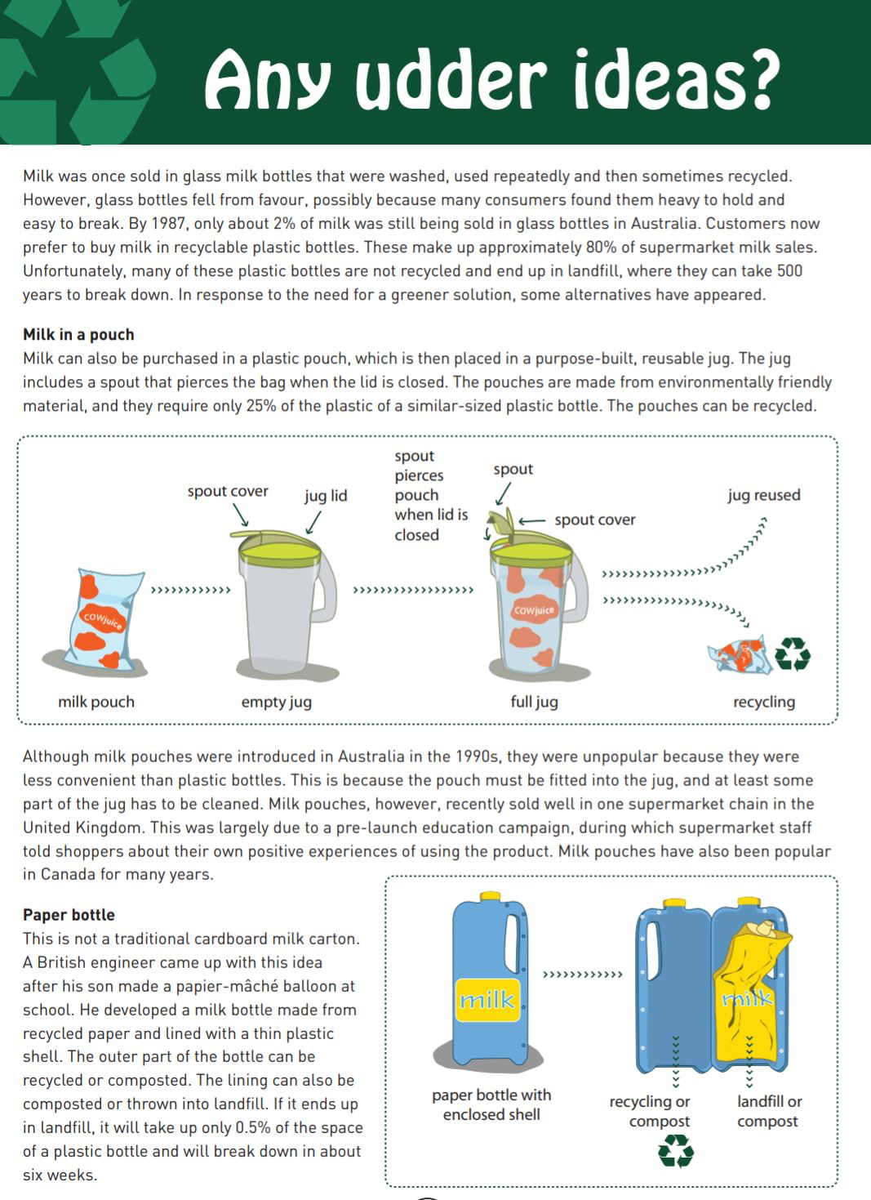
Year 9 NAPLAN Reading magazine, 2012 ACARA.

Skimming and scanning texts – accessible version

Any Udder Ideas
Milk was once sold in glass milk bottles that were washed, used repeatedly and then sometimes recycled. However, glass bottles fell from favour, possibly because many consumers found them heavy to hold and easy to break. By 1987, only about 2% of milk was still being sold in glass bottles in Australia. Customers now prefer to buy milk in recyclable plastic bottles. These make up approximately 80% of supermarket milk sales. Unfortunately, many of these plastic bottles are not recycled and end up in landfill, where they can take 500 years to break down. In response to the need for a greener solution, some alternatives have appeared.

Milk in a pouch
Milk can also be purchased in a plastic pouch, which is then placed in a purpose-built, reusable jug. The jug includes a spout that pierces the bag when the lid is closed. The pouches are made from environmentally friendly material, and they require only 25% of the plastic of a similar-sized plastic bottle. The pouches can be recycled.
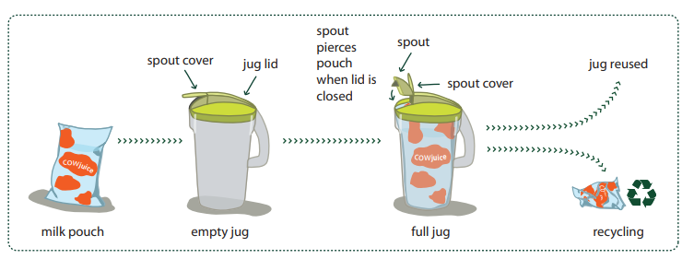
Although milk pouches were introduced in Australia in the 1990s, they were unpopular because they were less convenient than plastic bottles. This is because the pouch must be fitted into the jug, and at least some part of the jug has to be cleaned. Milk pouches, however, recently sold well in one supermarket chain in the United Kingdom. This was largely due to a pre-launch education campaign, during which supermarket staff told shoppers about their own positive experiences of using the product. Milk pouches have also been popular in Canada for many years.

Paper bottle
This is not a traditional cardboard milk carton. A British engineer came up with this idea after his son made a papier-mâché balloon at school. He developed a milk bottle made from recycled paper and lined with a thin plastic shell. The outer part of the bottle can be recycled or composted. The lining can also be composted or thrown into landfill. If it ends up in landfill, it will take up only 0.5% of the space of a plastic bottle and will break down in about six weeks.
Year 9 NAPLAN Reading magazine, 2012 ACARA.

Appendix 2

Energy drinks and caffeine: Factsheet NSW Health
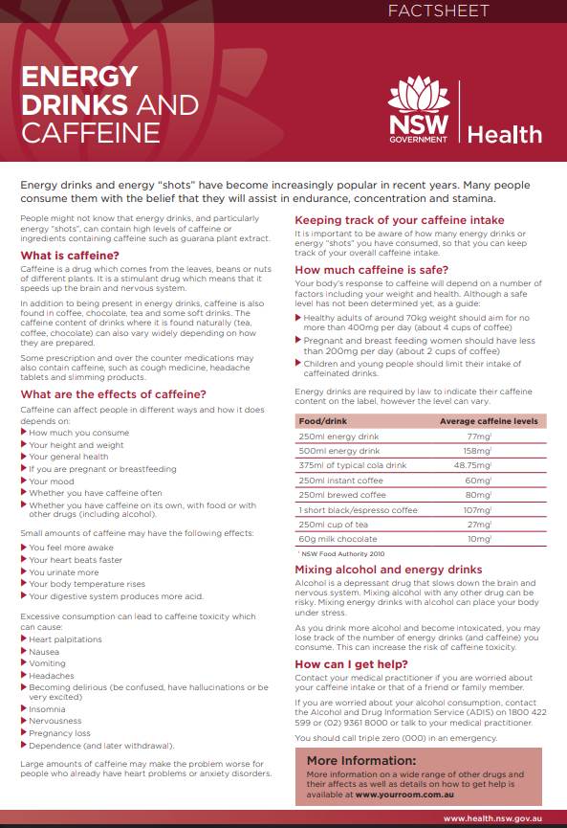
Copied under the statutory licence in s 113P of the Copyright Act. NSW Department of Health. Energy drinks and caffeine: factsheet. (Accessed 1/1/2022) Section 113P Warning Notice

Energy drinks and caffeine: Factsheet NSW Health- accessible version
Energy drinks and energy “shots” have become increasingly popular in recent years. Many people consume them with the belief that they will assist in endurance, concentration and stamina.
People might not know that energy drinks, and particularly energy “shots”, can contain high levels of caffeine or ingredients containing caffeine such as guarana plant extract.
What is caffeine?
Caffeine is a drug which comes from the leaves, beans or nuts of different plants. It is a stimulant drug which means that it speeds up the brain and nervous system.
In addition to being present in energy drinks, caffeine is also found in coffee, chocolate, tea and some soft drinks. The caffeine content of drinks where it is found naturally (tea, coffee, chocolate) can also vary widely depending on how they are prepared.
Some prescription and over the counter medications may also contain caffeine, such as cough medicine, headache tablets and slimming products

What are the effects of caffeine?
Caffeine can affect people in different ways and how it does depends on:
- How much you consume
- Your height and weight
- Your general health
- If you are pregnant or breastfeeding
- Your mood
- Whether you have caffeine often
- Whether you have caffeine on its own, with food or with other drugs (including alcohol).
Small amounts of caffeine may have the following effects:
- You feel more awake
- Your heart beats faster
- You urinate more
- Your body temperature rises
- Your digestive system produces more acid.
Excessive consumption can lead to caffeine toxicity which can cause:
- Heart palpitations
- Nausea
- Vomiting
- Headaches
- Becoming delirious (be confused, have hallucinations or be very excited)
- Insomnia
- Nervousness
- Pregnancy loss
- Dependence (and later withdrawal)
Large amounts of caffeine may make the problem worse for people who already have heart problems or anxiety disorders.

Keeping track of your caffeine intake
It is important to be aware of how many energy drinks or energy “shots” you have consumed, so that you can keep track of your overall caffeine intake.

How much caffeine is safe?
Your body's response to caffeine will depend on a number of factors including your weight and health. Although a safe level has not been determined yet, as a guide:
- Healthy adults of around 70kg weight should aim for no more than 400mg per day (about 4 cups of coffee)
- Pregnant and breast-feeding women should have less than 200mg per day (about 2 cups of coffee)
- Children and young people should limit their intake of caffeinated drinks.
Energy drinks are required by law to indicate their caffeine content on the label, however the level can vary.
Food/ Drink | Average caffeine levels
250ml energy drink | 77mg*
500ml energy drink | 158mg*
375ml of typical cola drink | 48.75mg*
250ml instant coffee | 60mg*
250ml brewed coffee | 80mg*
1 short black/espresso coffee | 107mg*
250ml cup of tea | 27mg*
60g milk chocolate | 10mg*
* NSW Food Authority 2010

Mixing alcohol and energy drinks
Alcohol is a depressant drug that slows down the brain and nervous system. Mixing alcohol with any other drug can be risky. Mixing energy drinks with alcohol can place your body under stress.
As you drink more alcohol and become intoxicated, you may lose track of the number of energy drinks (and caffeine) you consume. This can increase the risk of caffeine toxicity.

How can I get help?
Contact your medical practitioner if you are worried about your caffeine intake or that of a friend or family member.
If you are worried about your alcohol consumption, contact the Alcohol and Drug Information Service (ADIS) on 1800 422 599 or (02) 9361 8000 or talk to your medical practitioner.
You should call triple zero (000) in an emergency.

More Information:
More information on a wide range of other drugs and their affects as well as details on how to get help is available at www.yourroom.com.au
Copied under the statutory licence in s 113P of the Copyright Act. NSW Department of Health. Energy drinks and caffeine: factsheet. (Accessed 1/1/2022) Section 113P Warning Notice

Appendix 3

Informative text: Discovery of how cells sense oxygen levels earns Nobel Prize
By Sadeesh K. Ramakrishnan, University of Pittsburgh, The Conversation, Oct. 2019.
Full text with images/hyperlinks.
On the morning of Oct. 7, I woke up with the message from a colleague saying that “HIF got the 2019 Nobel Prize in Physiology or Medicine whoo hooo.” That’s exciting news for young researchers like me who are beginning our careers studying hypoxia, when the levels of oxygen are low in the cells.
If you are wondering what on Earth that means, HIF, or hypoxia-inducible factor, is a protein that increases inside the cell when the oxygen levels fall, helping the cell survive.
The recipients of this year’s Nobel Prize in Physiology or Medicine are William G. Kaelin of Harvard Medical School, Sir Peter J. Ratcliffe of Oxford University and Gregg L. Semenza of Johns Hopkins University. They won for their pioneering research into how the cells sense and adapt to low oxygen conditions.
I’m a biologist at the University of Pittsburgh, where my colleagues and I study how low levels of oxygen affect the way cells communicate and the impact this has on metabolic diseases like obesity, type 2 diabetes and cancer.
Understanding how cells talk to each other in a low oxygen environment – like a tumour – is critical for learning how cancers grow and progress. The pioneering work from these three eminent scientists laid the foundation for my research and that of many others studying disease.
Oxygen flux within the cells
Adapting to varying oxygen levels is one of the key evolutionary adaptations for most life forms on Earth. Every cell in the human body requires oxygen for its normal function.
Both the environment and the physiological status of the body determines how much oxygen is available to cells. For example, in higher altitudes, oxygen availability decreases. This is especially important for mountain climbers, who must adapt to altitude in order to help their body increase the oxygen carrying capacity in the blood. This is essential to avoid mountain sickness and other altitude-associated health issues such as pulmonary and cerebral diseases.
Oxygen levels in the human body are constantly fluctuating, depending on whether the individual is eating or fasting, exercising or resting and even whether they are stressed or calm. For example, during exercise, the oxygen supply to the muscles is increased to supply energy. This leaves less oxygen for other organs such as the liver.
In many diseases, damage to the blood vessels can drop blood supply, and thus oxygen supply, to the affected organ, which may make the patient even sicker. Thus, the oxygen levels within the cell are important to both healthy and sick people.
Sensing oxygen is vital in health and disease
If oxygen is such an important element for survival, how does the human body cope with these rapid and constant fluctuations?
In the early 1990s, Semenza and Ratcliffe independently discovered that cells adapt to changes in oxygen levels by making more of a protein called hypoxia-inducible factor-1 or HIF-1. When oxygen levels decrease, the HIF protein inhibits oxygen-consuming processes of the cells by altering the activity of numerous genes, thereby enabling the cells to adapt quickly and survive the low oxygen environment.
A few years later, Kaelin and Ratcliffe characterized how oxygen levels in the cells regulate the amount of HIF-1 produced.
After their seminal discovery, numerous studies from researchers around the world including ours uncovered this protein’s many roles in keeping the body healthy, and how disease can occur when the oxygen-sensing system is broken. HIFs are now known to control a diverse array of functions in many different types of cells, including immune, brain and cancer cells.
In the last decade, researchers have shown that HIFs have a pivotal role in promoting the growth of tumours. Cancer cells divide and grow rapidly and have a larger appetite for both nutrients and oxygen. But the blood vessels feeding the tumour cannot keep up with the cancer growth.
The clever cancer cells survive by producing higher quantities of HIF protein. The HIF proteins trigger changes in cancer cell metabolism, and switch them to a low oxygen and low energy mode. This helps the cancer cells to survive in oxygen- and nutrient-poor conditions, and keep growing and spreading.
Some research has even shown that the increase in HIF in cancer cells induces drug resistance to chemotherapy. Thus, pharmaceutical companies are now targeting HIF in the treatment of numerous cancers.
Numerous diseases such as fatty liver disease, metabolic and cardiovascular diseases are also associated with increased levels of HIF protein in various tissues. Animal studies have supported the strategy of removing HIF from specific tissues and the therapeutic value of targeting HIF in metabolic diseases.
As oxygen is involved in all cellular processes, the discovery of the mechanisms by which cells are able to detect and rapidly respond to changes in oxygen levels has revolutionised biomedical research and helped to identify novel targets for various diseases treatments.
Copied under the statutory licence in s 113P of the Copyright Act

Copied under the statutory licence in s 113P of the Copyright Act. Sadeesh K. Ramakrishnan, Discovery of how cells sense oxygen levels earns Nobel Prize, The Conversation, 8 October 2019. Section 113P Warning Notice

Appendix 4

Student copy: Literal comprehension

Text: Pachinko by Min-Jin Lee, Harper Collins, 2017
Your task:
- Scan the text to find the answers to the following questions.
- Highlight evidence for each answer in a different colour

History has failed us, but no matter.
At the turn of the century, an aging fisherman and his wife decided to take in lodgers for extra money. Both were born and raised in the fishing village of Yeongdo - a five-mile-wide islet beside the port city of Busan. In their long marriage, the wife gave birth to three sons, but only Hoonie, the eldest and the weakest one, survived. Hoonie was born with a cleft palate and a twisted foot; he was, however, endowed with hefty shoulders, a squat build, and a golden complexion. Even as a young man, he retained the mild, thoughtful temperament he'd had as a child. When Hoonie covered his misshapen mouth with his hands, something he did out of habit meeting strangers, he resembled his nice-looking father, both having the same large, smiling eyes. Inky eyebrows graced his broad forehead, perpetually tanned from outdoor work. Like his parents, Hoonie was not a nimble talker, and some made the mistake of thinking that because he could not speak quickly there was something wrong with his mind, but that was not true.

Questions:
- Is it important that History has failed us?
- Why did the fisherman and his wife take in lodgers?
- What is the name of the port city?
- How many children did the couple have?
- Have the couple been married for a long time?
- What are five things we know about Hoonie’s appearance?
- What did Hoonie do when meeting strangers?
- What is an assumption made about Hoonie?
Copied under the statutory licence in s 113P of the Copyright Act. Pachinko by Min-Jin Lee, Harper Collins, 2017 Section 113P Warning Notice

Teacher copy: colour coding answers – accessible table

Text: Pachinko by Min-Jin Lee, Harper Collins, 2017
The following table links the questions to evidence from the text. (This is an accessible version of the annotated text on the following page.)
Question | Evidence from the text to support literal comprehension answer
- Is it important that History has failed us? | History has failed us, but no matter.
- Why did the fisherman and his wife take in lodgers? | ‘…an aging fisherman and his wife decided to take in lodgers for extra money.’
- What is the name of the port city? | ‘…the port city of Busan.’
- How many children did the couple have? | ‘In their long marriage, the wife gave birth to three sons, but only Hoonie, the eldest and the weakest one, survived.’
- Have the couple been married for a long time? | ‘In their long marriage…’
- What are five things we know about Hoonie’s appearance? | ‘Hoonie was born with a cleft palate and a twisted foot; he was, however, endowed with hefty shoulders, a squat build, and a golden complexion.’
- What did Hoonie do when meeting strangers? | ‘When Hoonie covered his misshapen mouth with his hands, something he did out of habit meeting strangers…’
- What is an assumption made about Hoonie? | ‘Hoonie was not a nimble talker, and some made the mistake of thinking that because he could not speak quickly there was something wrong with his mind, but that was not true.’
Copied under the statutory licence in s 113P of the Copyright Act. Pachinko by Min-Jin Lee, Harper Collins, 2017 Section 113P Warning Notice

Teacher copy: colour coding answers

Text: Pachinko by Min-Jin Lee, Harper Collins, 2017
History has failed us, but no matter.
At the turn of the century, an aging fisherman and his wife decided to take in lodgers for extra money. Both were born and raised in the fishing village of Yeongdo - a five-mile-wide islet beside the port city of Busan. In their long marriage, the wife gave birth to three sons, but only Hoonie, the eldest and the weakest one, survived. Hoonie was born with a cleft palate and a twisted foot; he was, however, endowed with hefty shoulders, a squat build, and a golden complexion. Even as a young man, he retained the mild, thoughtful temperament he'd had as a child. When Hoonie covered his misshapen mouth with his hands, something he did out of habit meeting strangers, he resembled his nice-looking father, both having the same large, smiling eyes. Inky eyebrows graced his broad forehead, perpetually tanned from outdoor work. Like his parents, Hoonie was not a nimble talker, and some made the mistake of thinking that because he could not speak quickly there was something wrong with his mind, but that was not true.

Questions:
- Is it important that History has failed us?
- Why did the fisherman and his wife take in lodgers?
- What is the name of the port city?
- How many children do the couple have?
- Have the couple been married for a long time?
- What are five things we know about Hoonie’s appearance?
- What did Hoonie do when meeting strangers?
- What is an assumption made about Hoonie?
Copied under the statutory licence in s 113P of the Copyright Act. Pachinko by Min-Jin Lee, Harper Collins, 2017 Section 113P Warning Notice

Appendix 5

Who, what, when, where, how chart

Appendix 6

Student copy: Literal comprehension in text
‘The Sea’ – John Banville 2006, Pan McMillan
They departed, the gods, on the day of the strange tide. All morning under a milky sky the waters in the bay had swelled and swelled, rising to unheard-of heights, the small waves creeping over parched sand that for years had known no wetting save for rain and lapping the very bases of the dunes. The rusted hulk of the freighter that had run aground at the far end of the bay longer ago than any of us could remember must have thought it was being granted a relaunch. I would not swim again, after that day. The seabirds mewled and swooped, unnerved, it seemed, by the spectacle of that vast bowl of water bulging like a blister, lead-blue and malignantly agleam. They looked unnaturally white, that day, those birds. The waves were depositing a fringe of soiled yellow foam along the waterline. No sail marred the high horizon. I would not swim, no, not ever again.
Someone has just walked over my grave. Someone.
The name of the house is the Cedars, as of old. A bristling clump of those trees, monkey-brown with a tarry reek, their trunks nightmarishly tangled, still grows at the left side, facing across an untidy lawn to the big curved window of what used to be the living room but which Miss Vavasour prefers to call, in landladyese, the lounge. The front door is at the opposite side, opening on to a square of oil-stained gravel behind the iron gate that is still painted green, though rust has reduced its struts to a tremulous filigree. I am amazed at how little has changed in the more than fifty years that have gone by since I was last here. Amazed, and disappointed, I would go so far as to say appalled, for reasons that are obscure to me, since why should I desire change, I who have come back to live amidst the rubble of the past? I wonder why the house was built like that, sideways-on, turning a pebble-dashed windowless white end-wall to the road; perhaps in former times, before the railway, the road ran in a different orientation altogether, passing directly in front of the front door, anything is possible. Miss V. is vague on dates but thinks a cottage was first put up here early in the last century, I mean the century before last, I am losing track of the millennia, and then was added on to haphazardly over the years. That would account for the jumbled look of the place, with small rooms giving on to bigger ones, and windows facing blank walls, and low ceilings throughout. The pitchpine floors sound a nautical note, as does my spindle-backed swivel chair. I imagine an old seafarer dozing by the fire, landlubbered at last, and the winter gale rattling the window frames. Oh, to be him. To have been him.
Copied under the statutory licence in s 113P of the Copyright Act. John Banville, ‘The Sea’, 2006, Pan McMillan Section 113P Warning Notice

