Connecting ideas
Stage 5

Overview

Purpose
This literacy teaching strategy supports teaching and learning for Stage 5 students across all key learning areas. It targets specific literacy skills and suggests a learning sequence to build skill development. Teachers can select individual tasks, or a sequence, and embed into their teaching and learning program according to their students’ needs. While exemplar texts are provided throughout this resource, it is recommended that teachers select texts which are relevant to their students and curriculum.

Learning intention
Students will learn to identify devices that link information across and within texts and develop an understanding of how authors connect ideas.

Syllabus outcomes
The following teaching and learning strategy will assist in covering elements of the following outcomes:
- EN5-RVL01: uses a range of personal, creative and critical strategies to interpret complex texts
- EN5-URB-01: evaluates how texts represent ideas and experiences, and how they can affirm or challenge values and attitudes
- EN5-2A: effectively uses and critically assesses a wide range of processes, skills, strategies and knowledge for responding to and composing a wide range of texts in different media and technologies
- EN5-8D: questions, challenges and evaluates cultural assumptions in texts and their effects on meaning.
NSW English Syllabus K-10 (2022)
Visit the Leading curriculum K-12 website for more information on the syllabus implementation timeline.

Success criteria
The following Year 9 NAPLAN item descriptors may guide teachers to co-construct success criteria for student learning.

- identifies a cause in a persuasive text
- identifies a cause in an information text
- interprets a pronoun reference in a narrative extract
- interprets a pronoun reference in a persuasive text
- interprets a pronoun reference in a text
- links a description to a scenario in an information text
- links a diagram with information from an information text
- links a reference across paragraphs in a narrative
- links an image to information in an information text
- links events to the title in a narrative
- links information across paragraphs in an information text
- links information across sentences in a narrative
- links information across sentences in an information text
- sequences information from an information text
- sequences the order of events in a paragraph of an information text

National Literacy Learning Progression guide

Understanding Texts (UnT9-UnT11)
Key: C=comprehension P=process V=vocabulary

UnT9
- summarises the text identifying key details only (C)
- draws inferences, synthesising clues and evidence across a text (C)
- builds meaning by actively linking ideas from a number of texts or a range of digital sources (C)
- uses knowledge of a broader range of cohesive devices to track meaning (e.g. word associations) (see Grammar) (P)
- selects reading/viewing strategies appropriate to reading purpose (e.g. scans text for evidence) (P)
- analyses language and visual features in texts using metalanguage (e.g. cohesion, interpretation, figurative) (V)

UnT10
- draws inferences using evidence from the text and discounting possible inferences that are not supported by the text (C)
- integrates automatically a range of processes such as predicting, confirming predictions, monitoring, and connecting relevant elements of the text to build meaning (P)
- describes how sophisticated cohesive devices establish patterns of meaning (e.g. class-subclass) (P)

UnT11
- analyses the cumulative impact of use of language features and vocabulary across texts (C)
- strategically adjusts the processes of reading and viewing to build meaning according to the demands of tasks and texts (P)
National Literacy Learning Progression

Evidence base
- Centre for Education Statistics and Evaluation (2017). Effective reading instruction in the early years of school, literature review.
- Oakhill, J., Cain, K. & Elbro, C. (2015). Understanding and teaching reading comprehension: A handbook. Routledge.
- Quigley, A. (2020). Closing the reading gap. Routledge.
- Scarborough, H.S. (2001). Connecting early language and literacy to later reading (dis)abilities: Evidence, theory and practice. In S. Neuman & D. Dickson (Eds.), Handbook for research in early literacy (pp. 97-110). New York, NY: Guilford Press.
Alignment to system priorities and/or needs: Five priorities for Literacy and Numeracy, Our Plan for NSW Public Education, School Excellence Policy (nsw.gov.au).
Alignment to School Excellence Framework: Learning domain: Curriculum, Teaching domain: Effective classroom practice and Professional standards
Consulted with: Strategic Delivery, Teaching Quality and Impact
Author: Literacy and Numeracy
Reviewed by: Literacy and Numeracy, Teaching Quality and Impact
Created/last updated: January 2024
Anticipated resource review date: January 2025
Feedback: Complete the online form to provide any feedback

Copyright
Section 113P Notice
Texts, Artistic Works and Broadcast Notice
Some of this material has been copied and communicated to you in accordance with the statutory licence in section 113P of the Copyright Act. Any further reproduction or communication of this material by you may be the subject of copyright protection under the Act. Do not remove this notice.

Teaching strategies
Task | Appendices
Sequencing events | Appendix 1 - Sequencing deconstructed texts
Finding links within texts | Appendix 2 - Tracking ideas across texts: text samples
Pronoun referencing | Appendix 3: lexical chains -sample text
Lexical Chains | Appendix 3: lexical chains -sample text
Connectives

Background information

Connecting ideas
The deconstruction and reconstruction of text requires the students to have a deep knowledge of how and why texts have been written. The connection of ideas within a text requires the reader to use skills and strategies whilst reading or viewing the text.

Skimming and scanning
Skimming and scanning are reading strategies that can be used to track and connect ideas across a text. When skimming, readers quickly identify the main ideas in a text. When scanning, they move their eyes quickly down the page seeking specific words and phrase, making connections across the text.

Cohesion
Cohesion is achieved through shaping the form, creating a structure that the responder can recognise and use to navigate the text, and using features of language that link the various parts of the text into a complete whole. These features can include connectives such as 'furthermore' and 'therefore', cross-references to different parts of the text, and reiteration of the title or terms of the topic or question being addressed in the text

Cohesive devices
Words or phrases that indicate a relationship with other words, phrases, clauses or paragraphs across a text.

Cohesive links
Language features that help to develop unity within a text. Cohesion can involve referring words such as pronouns, for example 'Tony wanted to escape but he couldn't run', or content words that are related in various ways, for example 'Tony wanted to escape but was too tired to run'.

Connectives
Words which link paragraphs and sentences in logical relationships of time, cause and effect, comparison or addition. Connectives relate ideas to one another and help to show the logic of the information. Connectives are important resources for creating cohesion in texts. The logical relationships can be grouped as follows:
- temporal – to indicate time or sequence ideas, for example first, second, next
- causal – to show cause and effect, for example because, for, so
- additive – to add information, for example also, besides, furthermore
- comparative – for example rather, alternatively
- conditional/concessive – to make conditions or concession, for example yet, although
- clarifying – for example in fact, for example

Ellipsis
Ellipsis is the omission of words where:
- words repeat what has gone before and these terms are simply understood, for example 'The project will be innovative. To be involved (in the project) will be exciting.'
- a word like one is substituted for a noun or noun group, as in 'There are lots of apples in the bowl. Can I have one?' (of them)
- a cohesive resource binds text together and is commonly used in dialogue for speed of response, for example (Do you) 'Want a drink?'/'Thanks' (I would like a drink)
- three dots (also known as points of ellipsis) are used to indicate such things as surprise or suspense in a narrative text or that there is more to come in an on-screen menu
- the points of ellipsis take the place of sections of text when quoting from a source

Pronoun referencing
Tracking and tracing pronoun references across a text can support students to connect characters, events, opinions and ideas across a text. A pronoun is a word that is used in place of a noun. There are different types of pronouns:
- personal pronouns represent specific people or things, for example she, it, they, you, we
- demonstrative pronouns indicate a thing or things, for example this, these, that, those
- possessive pronouns refer to the belonging of one thing, person, etc, to another, for example his, theirs, yours, mine
- interrogative pronouns represent the things that we are asking questions about, for example who, whom, what, which
- reflexive pronouns refer back to the subject of the sentence or clause. Reflexive pronouns end in -self (singular) or -selves (plural). The reflexive pronoun myself is not a substitute for the personal pronouns I or me
- reciprocal pronouns are used when each of two or more subjects is acting in the same way towards the other, for example 'Jack and Jill love each other', 'The footballers were blaming one another'
- indefinite pronouns do not refer to any specific person, thing or amount, for example all, another, any, anybody/anyone, anything, each, everybody/everyone, everything, few, many, nobody, none, one, several, some, somebody/someone
- relative pronouns introduce a relative clause. They are called relative because they relate to the words they modify. There are five relative pronouns: who, whom, whose, which, that.
Reference: English K-10 Syllabus © NSW Education Standards Authority (NESA) for and on behalf of the Crown in right of the State of New South Wales, 2022

Where to next?
- Literal comprehension
- Inference
- Text structure and features

Overview of teaching strategies

Purpose
These literacy teaching strategies support teaching and learning from Stage 2 to Stage 5. They are linked to NAPLAN task descriptors, syllabus outcomes and literacy and numeracy learning progressions.
These teaching strategies target specific literacy and numeracy skills and suggest a learning sequence to build skill development. Teachers can select individual tasks or a sequence to suit their students.

Access points
The resources can be accessed from:
- NAPLAN App in Scout using the teaching strategy links from NAPLAN items
- NSW Department of Education literacy and numeracy website.

What works best
Explicit teaching practices involve teachers clearly explaining to students why they are learning something, how it connects to what they already know, what they are expected to do, how to do it and what it looks like when they have succeeded. Students are given opportunities and time to check their understanding, ask questions and receive clear, effective feedback.
This resource reflects the latest evidence base and can be used by teachers as they plan for explicit teaching.
Teachers can use classroom observations and assessment information to make decisions about when and how they use this resource as they design teaching and learning sequences to meet the learning needs of their students.
Further support with What works best is available.

Differentiation
When using these resources in the classroom, it is important for teachers to consider the needs of all students, including Aboriginal and EAL/D learners.
EAL/D learners will require explicit English language support and scaffolding, informed by the EAL/D enhanced teaching and learning cycle and the student’s phase on the EAL/D Learning Progression. Teachers can access information about supporting EAL/D learners and literacy and numeracy support specific to EAL/D learners.
Learning adjustments enable students with disability and additional learning and support needs to access syllabus outcomes and content on the same basis as their peers. Teachers can use a range of adjustments to ensure a personalised approach to student learning.
Assessing and identifying high potential and gifted learners will help teachers decide which students may benefit from extension and additional challenge. Effective strategies and contributors to achievement for high potential and gifted learners helps teachers to identify and target areas for growth and improvement. A differentiation adjustment tool can be found on the High potential and gifted education website.

Using tasks across learning areas
This resource may be used across learning areas where it supports teaching and learning aligned with syllabus outcomes.
Literacy and numeracy are embedded throughout all syllabus documents as general capabilities. As the English and mathematics learning areas have a particular role in developing literacy and numeracy, NSW English and Mathematics syllabus outcomes aligned to literacy and numeracy skills have been identified.

Text selection
Example texts are used throughout this resource. Teachers can adjust activities to use texts which are linked to their unit of learning.
Further support with text selection can be found within the National Literacy Learning Progression Text complexity appendix.
The NESA website has additional information on text requirements within the NSW English syllabus.

Teaching strategies

Sequencing events
- Students are given a deconstructed text to reconstruct (refer to Appendix 1 - Sequencing deconstructed texts). Discuss what assisted them in making choices with order (Teacher to review temporal connectives, text structural elements, introduction of characters, building of ideas and so on).
- Ask students to highlight the words in a text linked to current unit of learning which show the order in which the events took place. Students then list the events that occurred in chronological order, and write a series of sentences that combine this information using conjunctions of time such as before, previously, after, subsequently, when, just as, although, while, or adverbs such as later, afterwards, then, at that juncture, ensuing, next.
- Using a text linked to current unit of learning, students apply what they have learnt about sequencing events by completing the following tasks:
- Create a flow chart or story board of events in this text.
- Underline any phrases that helped you sequence. Why did they help?
- Choose one paragraph and highlight the pronouns. What are the challenges for an author when using pronouns instead of names?
- Design 2-3 questions to ask a student about the sequence of events from this text.
- If this text was to be produced into a movie, what would be the challenges for the script writer and producer to ensure the text is well-sequenced?

Finding links within texts
- Cause and effect: discuss how authors often use a ‘cause and effect’ structure to link ideas in a text. As readers we may need to be alert to this so that we can comprehend the meaning of a narrative, information or persuasive text. For example, ‘I ate a whole box of chocolates, so now I feel ill.’ Explain that in texts, the effect may precede the cause: ‘I feel ill because I ate a whole box of chocolates.’ Note that the words ‘so’ and ‘because’ signal this cause and effect relationship. Brainstorm with students a list of words that could be used to signal cause and effect, for example, results in, leads to, as a consequence of, due to, and so on.
- Using a text relevant to a current unit of learning, or the following example, model how to identify cause and effect structures. In this extract the effect is at the beginning of the paragraph, and there are no obvious signalling words.
‘The Australian Army recruited Sarbi in 2004 when she was only two years old. At that time, the black labrador had had no specific training, but the army felt that she had both the intelligence and the temperament to be of use to them.’
Cause: Sarbi showed intelligence and temperament to be useful the Army
Effect: Army recruited Sarbi in 2004
- Think-Pair- Share: issue students with a range of texts relevant to a current unit of learning. In pairs, students identify cause and effect structures and annotate how the ideas are connected within and across sentences. Students could record their findings on a graphic organiser that shows the relationship between the cause, signalling word (if any) and effect.
- Using a text relevant to a current unit learning, model how to find links to a topic within a text (or refer to Appendix 2 - Tracking ideas across texts: text samples) Discuss key features of the text and where text, layout elements (headings, sub-headings), navigation features and graphics connect ideas or information across the text.
- Using the ‘think aloud’ strategy, model how to track ideas across a text. It is helpful for students to see how a skilled reader approaches a text, so the teacher should annotate the text throughout the think aloud. The following discussion is based on the text ‘Icebergs’ from Appendix 2 - Tracking ideas across texts: text samples.
For example:
‘Our learning intention is to develop our skimming and scanning skills so that we can assess if a text will include relevant information for a research task. I need to find some resources to support a research project on climate change. I know that climate change has led to changes in sea temperature, and that is making the polar ice caps melt. I found this information text on Icebergs, so it might be useful. As a skilled reader, I rarely dive straight into reading, I skim a text to try and get a sense of the overall layout and structure; this helps me to understand what kind of text it is; is it imaginative, persuasive or informative, or perhaps a mix? I also gauge who it written for and why it is written (audience and purpose). I am skimming the document now and judging by the title, structure, images and headings it seems to be an information text.
Now let’s see if it has any useful information for my research project. First, I will skim through the text. The sub-headings are quite general, and I can’t see anything particular to climate change. The second sub-heading ‘The life cycle of an iceberg’ might have something in it, so I will scan the text and look for key words. The second paragraph in this section refers to ‘melting of the ice’ but I can’t see anything about climate change. When I look at the images I can see that there are pictures of different types of icebergs, and when I check the text I see that they support the information in the section on ‘Appearance.’ Unfortunately, this just seems to be a basic information text on icebergs and doesn’t add to my knowledge, but at least I didn’t spend ages reading it.’
- Think Pair Share: using a text relevant to a current unit of learning, or to a research topic determined by student choice, students skim and scan, tracking ideas across the text. Students should annotate their text, as per the guided think aloud above, using arrows and lines to show all the connections between text elements and information in the text. (This task could be completed using the scenario above, ‘assessing the relevance of a text to a particular research area.’) As a class, conduct a Gallery walk, where students display their annotated text, explain and discuss the connections across the text, and evaluate the text’s relevance to their chosen research area.

Pronoun referencing
- Review proper nouns, nouns and pronouns with the class, brainstorming a list of pronouns that could be used as a substitute for nouns. Explain that one way authors connect ideas across texts is to replace nouns with pronouns. Sometimes it can be challenging tracing the ideas, especially when there is more than one noun in the sentence. Pronouns can be used to refer back, but they can also direct a reader forward.
- Using a text relevant to a current unit of learning, or refer to the extract from Appendix 3: lexical chains -sample text below, model how to connect ideas within and across sentences by tracking pronominal references. The teacher could use colour-coding or arrows to track the ideas and show connections, one at a time.
The Australian Army recruited Sarbi in 2004 when she was only two years old. At that time, the black labrador had had no specific training, but the army felt that she had both the intelligence and the temperament to be of use to them.
The army put Sarbi to work straight away, assigning her a handler and putting her through a rigorous training program. Within a few months, she was a fully trained explosive detection dog. She was used in a number of operations across Australia, including at the 2006 Commonwealth Games in Melbourne, before being given her first tour of duty overseas.
For accessibility:
Australian Army – the army - them
Sarbi – she – black labrador – she – Sarbi – her – her – she – She – her
- Think aloud: use the think-aloud strategy to show students how to navigate the text. For example, in this text the word ‘handler’ and the following pronoun ‘her’ may cause some comprehension breakdown:
‘When I read the last paragraph I have to stop and think about who the author is referring to in ‘assigning her a handler and putting her through a rigorous training program.’ I will re-read the sentence and see if I can figure it out. The first ‘her’ refers back to Sarbi at the start of the sentence (I know she has already been described as a ‘she’ and it doesn’t make sense to connect ‘her’ to the ‘army’, the other noun in the sentence. But then I wonder who is being put through training? Is it Sarbi, or is it her handler? Maybe the handler needs to be trained so that she can train Sarbi? When I read forward I can gather some more clues, ‘Within a few months, she was a fully trained explosive detection dog…’. The ‘she’ in that section clearly refers to Sarbi, the dog, so it seems likely that the training program was for Sarbi. I can also assume that the army probably wouldn’t give an untrained dog to an untrained trainer to train!
- Think Pair Share: using a range of informative, persuasive and/or narrative texts relevant to a current unit of learning, students apply the same strategy of colour coding a proper noun/noun and its corresponding pronouns to follow the pronominal trail. Students discuss how and when pronouns feature in the text(s) and how they are used to connect ideas, sharing their observations with the class.

Lexical chains
- Many authors use word associations in their texts. This may include using synonyms, or groups of words related to a topic, across a text. As with pronoun referencing, using word associations can make texts more interesting, but also more challenging to read as ideas need to be connected across the text.
- Define lexical chain as a sequence of related words which we can use to track ideas across a text and build reader understanding. For example, in the following text extract note the word chain for ‘work’
‘The army put Sarbi to work straight away, assigning her a handler and putting her through a rigorous training program. Within a few months, she was a fully trained explosive detection dog. She was used in a number of operations across Australia, including at the 2006 Commonwealth Games in Melbourne, before being given her first tour of duty overseas.’
(Synonyms for work: rigorous training program, trained, used, operations, tour of duty.)
- Using a text relevant to a current unit of learning, model how to identify lexical chains in texts by highlighting a key word, then other words or word-groups that mean the same thing, drawing arrows to show the 'chain' that runs through the text.
- Introduce a word or concept relevant to a current unit of learning, and have students build a vocabulary bank of associated words. For example, for the word ‘illness’: pathogen, transmission, host, hospitalisation, vaccination. As a class discuss the different connotations of each word, and how they build additional information/context from the initial example word.
- Model how to identify and trace word associations in a text relevant to a current unit of learning. Annotate (arrows, highlighting, circles) how these associations connect ideas and build meaning across the text. You could identify pronoun referencing, synonyms or word associations based on topics or concepts. Refer to the following examples for guidance.
Extract 1: (Word associations for army: handler, rigorous training program, explosive detection dog, operations, tour of duty.)
‘The army put Sarbi to work straight away, assigning her a handler and putting her through a rigorous training program. Within a few months, she was a fully trained explosive detection dog. She was used in a number of operations across Australia, including at the 2006 Commonwealth Games in Melbourne, before being given her first tour of duty overseas.’
Extract 2: In the following extract we have to make connections across the text based on word associations. Some inference making is also required.
‘Sarbi was put on a flight to the Australian Army base in southern Afghanistan, where she was later reunited with her handler. In 2011, Sarbi was awarded the Purple Cross medal for bravery. No-one knows what happened to Sarbi during her time alone in the desert, but if dogs were able to talk, Sarbi’s story would make any soldier proud.’

Initial word/concept | Word associations | Connecting ideas
‘Australian Army base in southern Afghanistan’ | ‘desert‘ | Military operation in the desert region of southern Afghanistan, a dangerous foreign war zone.
‘later reunited with her handler’ | ‘alone in the desert’ | ‘reunited’ and ‘alone’ suggest that Sarbi was isolated or separated from her handler, perhaps during the operation.
‘Purple Cross  medal for bravery’ | ‘No-one knows what happened to Sarbi’s  ‘Sarbi’s story’  ‘would make any soldier proud’ | ‘What’ happened to Sarbi remains unknown. Her story is obviously one of bravery, survival and courage if she was awarded a top military honour and her experiences would make any soldier proud..
Extracts from ‘Sarbi’ Year 9 NAPLAN Reading Magazine, 2011 ACARA
- Think Pair Share: in pairs students annotate their own excerpt from a text, identifying the lexical chains and word associations across sentences and paragraphs. Discuss how they build meaning and provide reading comprehension challenges in a text. Share ideas through a class brainstorm or gallery walk activity.

Connectives
- Review what a connective is: words which link paragraphs and sentences in logical relationships of time, cause and effect, comparison or addition. Connectives relate ideas to one another and help to show the logic of the information. Connectives are important resources for creating cohesion in texts. The logical relationships can be grouped as follows:
- temporal – to indicate time or sequence ideas, for example first, second, next
- causal – to show cause and effect, for example because, for, so
- additive – to add information, for example also, besides, furthermore
- comparative – for example rather, alternatively
- conditional/concessive – to make conditions or concession, for example yet, although
- clarifying – for example in fact, for example.
- Students summarise what a connective is and share with a partner to clarify understanding.
- Students brainstorm connectives and categorise into the six themes: temporal, causal, additive, comparative, conditional and clarifying. Discuss how these work to sequence and connect parts of a text.
- Using colour coding, students explore a text related to a current unit of learning to identify and show connections and links within the text which are indicated with a connective.
- Discuss with a partner or small group how the connectives are used.
Reference: English K-10 Syllabus © NSW Education Standards Authority (NESA) for and on behalf of the Crown in right of the State of New South Wales, 2012.

Appendix 1

Teacher copy: Sequencing deconstructed texts
- Sequence these components (cut out if preferred)
- Give reasons for the sequence
Text: Sarbi (Year 9 NAPLAN Reading Magazine, 2011) | Order | Evidence
The Australian Army recruited Sarbi in 2004 when she was only two years old. At that time, the black labrador had had no specific training, but the army felt that she had both the intelligence and the temperament to be of use to them. | 1 | - Introductory statement  - Introduced Sarbi
The army put Sarbi to work straight away, assigning her a handler and putting her through a rigorous training program. Within a few months, she was a fully trained explosive detection dog. She was used in a number of operations across Australia, including at the 2006 Commonwealth Games in Melbourne, before being given her first tour of duty overseas. | 2 | - After introducing Sarbi, next is training.  - Year 2006 mentioned.  - Introduced first tour of duty.
In her second deployment to Afghanistan in 2008, Sarbi was given the very dangerous task of sniffing out landmines. While on a routine patrol one day, the unit to which Sarbi was attached came under fire. Sarbi’s leash snapped when a bomb blast tore through the unit, and Sarbi and her handler became separated. With no sign of the dog after the battle had ended, Sarbi was officially recorded as being missing in action. | 3 | - Built on first tour of duty with a second deployment.  - Sarbi declared missing in action
Fourteen months later, an American soldier made an unusual discovery in a remote area of northern Afghanistan. A local farmer had befriended a black labrador and had taken it in. The soldier, having heard the story of Sarbi, gave a series of army voice commands to the dog. The dog responded as the soldier had anticipated, and the soldier knew instantly that the dog was indeed Sarbi. | 4 | - “Fourteen months later” – adverbial indicating time  - Next event showing Sarbi had been found.
Sarbi was put on a flight to the Australian Army base in southern Afghanistan, where she was later reunited with her handler. In 2011, Sarbi was awarded the Purple Cross medal for bravery. No-one knows what happened to Sarbi during her time alone in the desert, but if dogs were able to talk, Sarbi’s story would make any soldier proud. | 5 | - Sarbi flown home  - Concluding statement about making a soldier proud.
Year 9 NAPLAN Reading Magazine, ACARA, 2011

Student copy: Sequencing deconstructed texts
- Sequence these components (cut out if preferred)
- Give reasons for the sequence
Text: Sarbi (Year 9 NAPLAN Reading Magazine, 2011) | Order | Evidence
The army put Sarbi to work straight away, assigning her a handler and putting her through a rigorous training program. Within a few months, she was a fully trained explosive detection dog. She was used in a number of operations across Australia, including at the 2006 Commonwealth Games in Melbourne, before being given her first tour of duty overseas.
Sarbi was put on a flight to the Australian Army base in southern Afghanistan, where she was later reunited with her handler. In 2011, Sarbi was awarded the Purple Cross medal for bravery. No-one knows what happened to Sarbi during her time alone in the desert, but if dogs were able to talk, Sarbi’s story would make any soldier proud.
Fourteen months later, an American soldier made an unusual discovery in a remote area of northern Afghanistan. A local farmer had befriended a black labrador and had taken it in. The soldier, having heard the story of Sarbi, gave a series of army voice commands to the dog. The dog responded as the soldier had anticipated, and the soldier knew instantly that the dog was indeed Sarbi.
The Australian Army recruited Sarbi in 2004 when she was only two years old. At that time, the black labrador had had no specific training, but the army felt that she had both the intelligence and the temperament to be of use to them.
In her second deployment to Afghanistan in 2008, Sarbi was given the very dangerous task of sniffing out landmines. While on a routine patrol one day, the unit to which Sarbi was attached came under fire. Sarbi’s leash snapped when a bomb blast tore through the unit, and Sarbi and her handler became separated. With no sign of the dog after the battle had ended, Sarbi was officially recorded as being missing in action.
Year 9 NAPLAN Reading Magazine, ACARA, 2011

Teacher copy: Sequencing deconstructed texts
Text: Multitasking (Year 9 NAPLAN Reading Magazine, 2011) | Order | Evidence
Multi-tasking – a feeble excuse for laziness, or a valid justification of a twenty-first century way of working? | 1
Perhaps the latter. Increasingly, the adult world of work is calling for people who can ‘demonstrate flexibility’ and ‘respond creatively to a range of competing demands’. | 2
To prepare for this, you probably feel that you have to fall into line – that you have to multi- task. You could always tell a potential employer that you don’t work this way, that you need to be left in peace to doggedly complete one task before beginning the next. But then your potential employer will perhaps remain just that – potential. Silent, dedicated absorption in a single task was all that was needed in the past, but today a frenetic clicking on multiple windows on a computer screen is more in sync with our fragmented, furiously expanding universe of knowledge. | 3
However, one section of this same expanding universe of knowledge – research into the workings of the brain – tells us a different story: we should slow down, shut out distractions and focus. | 4
How does the brain deal with simultaneous tasks? It doesn’t. According to Dr Edward Hallowell, director of the Hallowell Center for Cognitive and Emotional Health (in the USA), ‘What people really do is shift their attention from one task to the next in rapid succession. That reduces the quality of the work on any one task because they’re ignoring it for milliseconds at a time.’ This is why it is dangerous to talk on a mobile phone while driving, and why many people instinctively turn down the car radio while they are studying a roadmap. | 5
Doing four things simultaneously takes you longer than doing them sequentially – and you do not do them as well. | 6
Cognitive research has even more bad news for music-listening, message-sending, multi-tasking learners. Brain scans show that learning while multi-tasking involves the striatum, a part of the brain devoted to new skills; undistracted learning, however, involves the hippocampus, which is devoted to long-term storage and retrieval of what has been learned. | 7
Undistracted learning goes deeper and lasts longer; it improves problem-solving, creativity and the ability to integrate different ideas. In fact, it improves the very skills that those employers who think they want multi-taskers really need. | 8
Year 9 NAPLAN Reading Magazine, ACARA, 2011

Student copy: Sequencing deconstructed texts
Text: Multitasking (Year 9 NAPLAN Reading Magazine, 2011) | Order | Evidence
To prepare for this, you probably feel that you have to fall into line – that you have to multi- task. You could always tell a potential employer that you don’t work this way, that you need to be left in peace to doggedly complete one task before beginning the next. But then your potential employer will perhaps remain just that – potential. Silent, dedicated absorption in a single task was all that was needed in the past, but today a frenetic clicking on multiple windows on a computer screen is more in sync with our fragmented, furiously expanding universe of knowledge.
However, one section of this same expanding universe of knowledge – research into the workings of the brain – tells us a different story: we should slow down, shut out distractions and focus.
Doing four things simultaneously takes you longer than doing them sequentially – and you do not do them as well.
How does the brain deal with simultaneous tasks? It doesn’t. According to Dr Edward Hallowell, director of the Hallowell Center for Cognitive and Emotional Health (in the USA), ‘What people really do is shift their attention from one task to the next in rapid succession. That reduces the quality of the work on any one task because they’re ignoring it for milliseconds at a time.’ This is why it is dangerous to talk on a mobile phone while driving, and why many people instinctively turn down the car radio while they are studying a roadmap.
Multi-tasking – a feeble excuse for laziness, or a valid justification of a twenty-first century way of working?
Perhaps the latter. Increasingly, the adult world of work is calling for people who can ‘demonstrate flexibility’ and ‘respond creatively to a range of competing demands’.
Undistracted learning goes deeper and lasts longer; it improves problem-solving, creativity and the ability to integrate different ideas. In fact, it improves the very skills that those employers who think they want multi-taskers really need.
Cognitive research has even more bad news for music-listening, message-sending, multi-tasking learners. Brain scans show that learning while multi-tasking involves the striatum, a part of the brain devoted to new skills; undistracted learning, however, involves the hippocampus, which is devoted to long-term storage and retrieval of what has been learned.
Year 9 NAPLAN Reading Magazine, ACARA, 2011

Appendix 2

Tracking ideas across texts: text samples
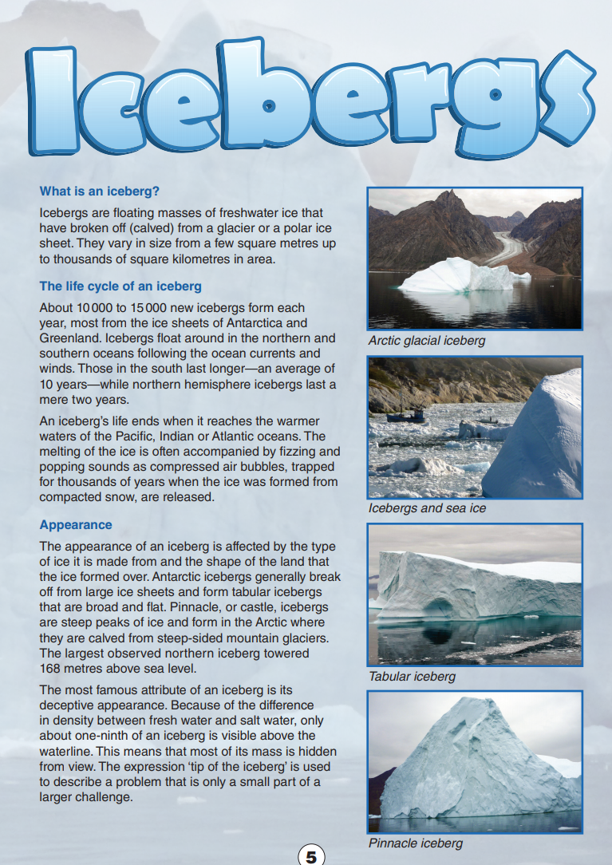
Year 9 NAPLAN Reading Magazine, ACARA, 2014

Tracking ideas across texts – accessible version

Icebergs – page 1

What is an iceberg?
Icebergs are floating masses of freshwater ice that have broken off (calved) from a glacier or a polar ice sheet. They vary in size from a few square metres up to thousands of square kilometres in area.

The life cycle of an iceberg
About 10000 to 15000 new icebergs form each year, most from the ice sheets of Antarctica and Greenland. Icebergs float around in the northern and southern oceans following the ocean currents and winds. Those in the south last longer—an average of 10 years—while northern hemisphere icebergs last a mere two years. An iceberg’s life ends when it reaches the warmer waters of the Pacific, Indian or Atlantic oceans. The melting of the ice is often accompanied by fizzing and popping sounds as compressed air bubbles, trapped for thousands of years when the ice was formed from compacted snow, are released.

Appearance
The appearance of an iceberg is affected by the type of ice it is made from and the shape of the land that the ice formed over. Antarctic icebergs generally break off from large ice sheets and form tabular icebergs that are broad and flat. Pinnacle, or castle, icebergs are steep peaks of ice and form in the Arctic where they are calved from steep-sided mountain glaciers. The largest observed northern iceberg towered 168 metres above sea level.
The most famous attribute of an iceberg is its deceptive appearance. Because of the difference in density between fresh water and salt water, only about one-ninth of an iceberg is visible above the waterline. This means that most of its mass is hidden from view. The expression ‘tip of the iceberg’ is used to describe a problem that is only a small part of a larger challenge.
Year 9 NAPLAN Reading Magazine, ACARA, 2014

Tracking ideas across texts – accessible version continued

Icebergs – page 2
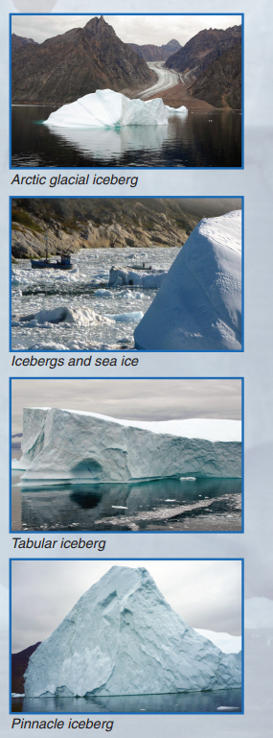
Year 9 NAPLAN Reading Magazine, ACARA, 2014

Tracking ideas across texts: text samples
Text extract: L Kaminsky & M Keneally (2020), ‘Animals make us human’, Penguin.

Foreword
From Bruce Pascoe
Sometimes I look at my dogs, their furry, clawy feet, their silly noses, their ridiculous tails, and I think, why? Why does a creature so different from me watch my every move, and why do I watch every move of theirs? Why do they smile so gooily at me in the morning, why in the dark of night do I smile so deeply when I hear them sigh? How can we, two such different forms of life, devote ourselves so completely to each other?
They could leave at any moment, but they don’t. When the dingoes call on the other side of the river, they cock their ears for a moment but then go back to sleep. Why are we together? It is true that we have removed some primary functions and motivations from their lives, but they could both swim the river, they do it often enough. Yet they don’t, they shut their eyes and squirm closer into our three-body plait.
We all crowd onto the same couch in front of the fire, shuffling and pushing until the assemblage accommodates six hips, ten legs, two tails and three heads. Why is it such bliss?
If I am sick, even though this happens rarely, why is it that one of my dogs chooses to place himself so that we face each other and he breathes his warm nuttiness directly onto my face, and she, terribly intimidated by her bossy brother, takes second position on the grid behind my knees?
We ought to be anathemas to each other, but we are not. The strangeness of a dog’s face should separate us as species but instead we kiss them between the eyes, and they squirm with delight. Why?
I think it is because we are fellow creatures and at a level deeper than our own ego we recognise the dignity of their life. If a pelican turns to look at me, if a king parrot swivels an eye towards me if I sneeze, if a scrubwren gets excited if I pick up a shovel, there is a delight in my soul which is unmatched. If a night heron stalks behind me while I am fishing at midnight, a volcanic astonishment thrills in me; I have been ignored by an animal, counted as an equal, so similar are our occupations.
None of these animals can open a can of baked beans, but that is the very least of our disparity. We are fellow creatures and notice each other. If only humans could show the same respect for the differences in our species.
Copied under the statutory licence in s 113P of the Copyright Act. L Kaminsky & M Keneally, (2020) ‘Animals make us human’, Penguin. Section 113P Warning Notice

Tracking ideas across texts: text samples
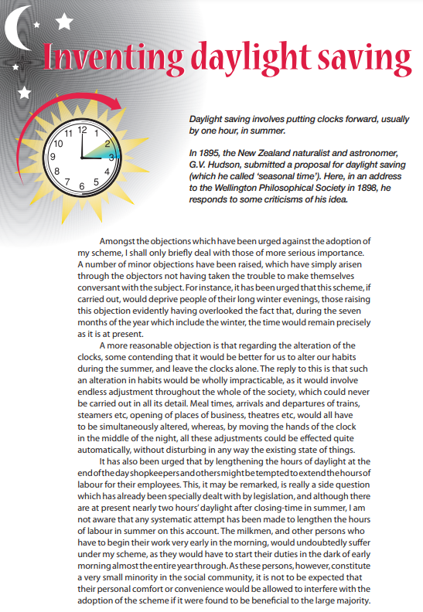
Year 9 NAPLAN Reading Magazine, ACARA, 2010.

Tracking ideas across texts – accessible version

Inventing daylight saving
Daylight saving involves putting clocks forward, usually by one hour, in summer.
In 1895, the New Zealand naturalist and astronomer, G.V. Hudson, submitted a proposal for daylight saving (which he called ‘seasonal time’). Here, in an address to the Wellington Philosophical Society in 1898, he responds to some criticisms of his idea.
Amongst the objections which have been urged against the adoption of my scheme, I shall only briefly deal with those of more serious importance. A number of minor objections have been raised, which have simply arisen through the objectors not having taken the trouble to make themselves conversant with the subject. For instance, it has been urged that this scheme, if carried out, would deprive people of their long winter evenings, those raising this objection evidently having overlooked the fact that, during the seven months of the year which include the winter, the time would remain precisely as it is at present.
A more reasonable objection is that regarding the alteration of the clocks, some contending that it would be better for us to alter our habits during the summer, and leave the clocks alone. The reply to this is that such an alteration in habits would be wholly impracticable, as it would involve endless adjustment throughout the whole of the society, which could never be carried out in all its detail. Meal times, arrivals and departures of trains, steamers etc, opening of places of business, theatres etc, would all have to be simultaneously altered, whereas, by moving the hands of the clock in the middle of the night, all these adjustments could be effected quite automatically, without disturbing in any way the existing state of things.
It has also been urged that by lengthening the hours of daylight at the end of the day shopkeepers and others might be tempted to extend the hours of labour for their employees. This, it may be remarked, is really a side question which has already been specially dealt with by legislation, and although there are at present nearly two hours’ daylight after closing-time in summer, I am not aware that any systematic attempt has been made to lengthen the hours of labour in summer on this account. The milkmen, and other persons who have to begin their work very early in the morning, would undoubtedly suffer under my scheme, as they would have to start their duties in the dark of early morning almost the entire year through. As these persons, however, constitute a very small minority in the social community, it is not to be expected that their personal comfort or convenience would be allowed to interfere with the adoption of the scheme if it were found to be beneficial to the large majority.
Year 9 NAPLAN Reading Magazine, ACARA, 2010.

Tracking ideas across texts: text samples
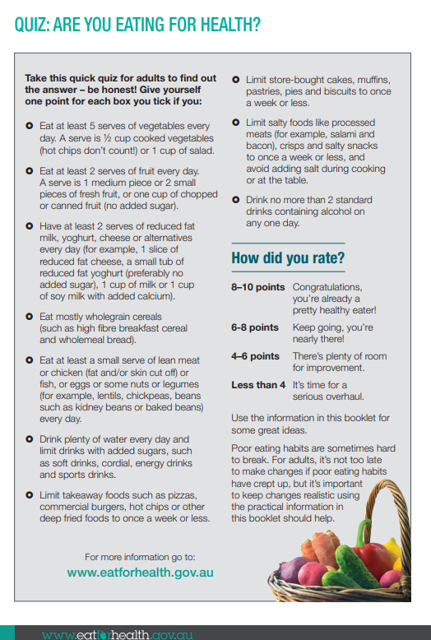
Source: eat for health website.
Copied under the statutory licence in s 113P of the Copyright Act, eatforhealth.gov.au, accessed 4 March, 2020 Section 113P Warning Notice.

Tracking ideas across texts – accessible version

Quiz: Are you eating for health?
Take this quick quiz for adults to find out the answer – be honest! Give yourself one point for each box you tick if you:
Eat at least 5 serves of vegetables every day. A serve is ½ cup cooked vegetables (hot chips don’t count!) or 1 cup of salad.
Eat at least 2 serves of fruit every day. A serve is 1 medium piece or 2 small pieces of fresh fruit, or one cup of chopped or canned fruit (no added sugar).
Have at least 2 serves of reduced fat milk, yoghurt, cheese or alternatives every day (for example, 1 slice of reduced fat cheese, a small tub of reduced fat yoghurt (preferably no added sugar), 1 cup of milk or 1 cup of soy milk with added calcium).
Eat mostly wholegrain cereals (such as high fibre breakfast cereal and wholemeal bread).
Eat at least a small serve of lean meat or chicken (fat and/or skin cut off) or fish, or eggs or some nuts or legumes (for example, lentils, chickpeas, beans such as kidney beans or baked beans) every day.
Drink plenty of water every day and limit drinks with added sugars, such as soft drinks, cordial, energy drinks and sports drinks.
Limit takeaway foods such as pizzas, commercial burgers, hot chips or other deep fried foods to once a week or less.
Limit store-bought cakes, muffins, pastries, pies and biscuits to once a week or less.
Limit salty foods like processed meats (for example, salami and bacon), crisps and salty snacks to once a week or less, and avoid adding salt during cooking or at the table.
Drink no more than 2 standard drinks containing alcohol on any one day

How did you rate?
8–10 points Congratulations, you’re already a pretty healthy eater!
6-8 points Keep going, you’re nearly there!
4–6 points There’s plenty of room for improvement.
Less than 4 It’s time for a serious overhaul
Use the information in this booklet for some great ideas.
Poor eating habits are sometimes hard to break. For adults, it’s not too late to make changes if poor eating habits have crept up, but it’s important to keep changes realistic using the practical information in this booklet should help.
Source: eat for health website.
Copied under the statutory licence in s 113P of the Copyright Act, eatforhealth.gov.au, accessed 4 March, 2020 Section 113P Warning Notice.

Appendix 3

Lexical chains: sample text
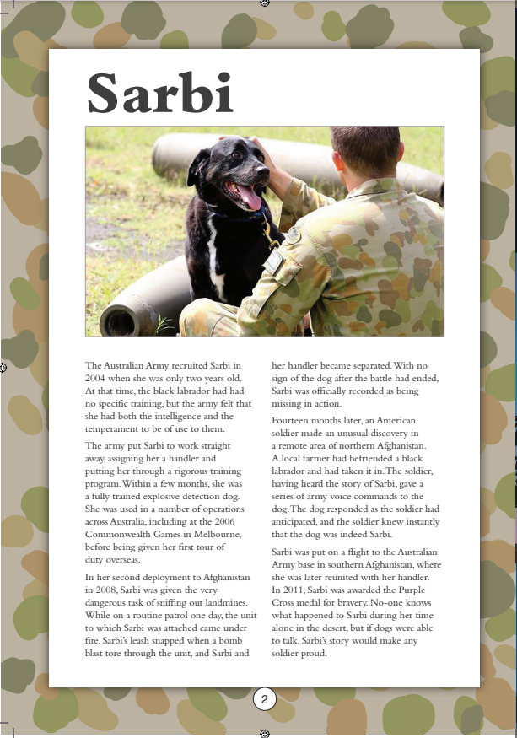
Year 9 NAPLAN Reading Magazine, ACARA, 2011

Lexical chains: sample text – accessible version
Sarbi
The Australian Army recruited Sarbi in 2004 when she was only two years old. At that time, the black labrador had had no specific training, but the army felt that she had both the intelligence and the temperament to be of use to them.
The army put Sarbi to work straight away, assigning her a handler and putting her through a rigorous training program. Within a few months, she was a fully trained explosive detection dog. She was used in a number of operations across Australia, including at the 2006 Commonwealth Games in Melbourne, before being given her first tour of duty overseas.
In her second deployment to Afghanistan in 2008, Sarbi was given the very dangerous task of sniffing out landmines. While on a routine patrol one day, the unit to which Sarbi was attached came under fi re. Sarbi’s leash snapped when a bomb blast tore through the unit, and Sarbi and her handler became separated. With no sign of the dog after the battle had ended, Sarbi was officially recorded as being missing in action.
Fourteen months later, an American soldier made an unusual discovery in a remote area of northern Afghanistan. A local farmer had befriended a black labrador and had taken it in. The soldier, having heard the story of Sarbi, gave a series of army voice commands to the dog. The dog responded as the soldier had anticipated, and the soldier knew instantly that the dog was indeed Sarbi.
Sarbi was put on a flight to the Australian Army base in southern Afghanistan, where she was later reunited with her handler. In 2011, Sarbi was awarded the Purple Cross medal for bravery. No-one knows what happened to Sarbi during her time alone in the desert, but if dogs were able to talk, Sarbi’s story would make any soldier proud.
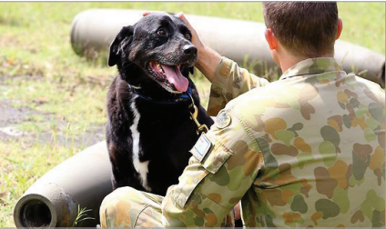
Year 9 NAPLAN Reading Magazine, ACARA, 2011

