Sequencing
Stage 4

Overview

Purpose
This literacy teaching strategy supports teaching and learning for Stage 4 students across all key learning areas. It targets specific literacy skills and suggests a learning sequence to build skill development. Teachers can select individual tasks, or a sequence, and embed into their teaching and learning program according to their students’ needs. While exemplar texts are provided throughout this resource, it is recommended that teachers select texts which are relevant to their students and curriculum.

Learning intention
Students will learn to sequence events in a range of texts. Students will connect contextual clues and grammatical elements to order ideas and events in imaginative and informative multimodal texts.

Syllabus outcomes
The following teaching and learning strategies will assist in covering elements of the following outcomes:
- EN4-RVL-01: uses a range of personal, creative and critical strategies to read texts that are complex in their ideas and construction
- EN4-URA-01: analyses how meaning is created through the use and response to language forms, features and structures
- EN4-1A: responds to and composes texts for understanding, interpretation, critical analysis, imaginative expression and pleasure
- EN4-2A: effectively uses a widening range of processes, skills, strategies and knowledge for responding to and composing texts in different media and technologies.
NSW English K-10 Syllabus (2022)
Visit the Leading curriculum K-12 website for more information on the syllabus implementation timeline.

Success criteria
The following Year 7 NAPLAN item descriptors may guide teachers to co-construct success criteria for student learning.
- sequences events from a narrative
- sequences events from an information text
- sequences the order of events from a text

National Literacy Learning Progression guide

Understanding Texts (UnT9-UnT11)
Key: C=comprehension P=process V=vocabulary

UnT9
- identifies the main themes or concepts in complex texts by synthesising key ideas or information (C)
- summarises the text identifying key details only (C)
- selects reading/viewing strategies appropriate to reading purpose (e.g. scans text for evidence) (P)
- analyses language and visual features in texts using metalanguage (e.g. cohesion, interpretation, figurative) (V)

UnT10
- reads and views complex or some highly complex texts (see Text complexity) (C)
- applies and articulates criteria to evaluate the language structures and features for relevance to purpose and audience (C)

UnT11
- judiciously selects and synthesises evidence from multiple texts to support ideas and arguments (C)
- analyses the cumulative impact of use of language features and vocabulary across texts (C)
- strategically adjusts the processes of reading and viewing to build meaning according to the demands of tasks and texts (P)
National Literacy Learning Progression

Evidence base
- Centre for Education Statistics and Evaluation (2017). Effective reading instruction in the early years of school, literature review.
- Oakhill, J., Cain, K. & Elbro, C. (2015). Understanding and teaching reading comprehension: A handbook. Routledge.
- Quigley, A. (2020). Closing the reading gap. Routledge.
- Scarborough, H.S. (2001). Connecting early language and literacy to later reading (dis)abilities: Evidence, theory and practice. In S. Neuman & D. Dickson (Eds.), Handbook for research in early literacy (pp. 97-110). New York, NY: Guilford Press.

Alignment to system priorities and/or needs: Five priorities for Literacy and Numeracy, Our Plan for NSW Public Education,, School Excellence Policy (nsw.gov.au).
Alignment to School Excellence Framework: Learning domain: Curriculum, Teaching domain: Effective classroom practice and Professional standards
Consulted with: Strategic Delivery, Teaching Quality and Impact
Author: Literacy and Numeracy
Reviewed by: Literacy and Numeracy, Teaching Quality and Impact
Created/last updated: January 2024
Anticipated resource review date: January 2025
Feedback: Complete the online form to provide any feedback

Copyright
Section 113P Notice
Texts, Artistic Works and Broadcast Notice
Some of this material has been copied and communicated to you in accordance with the statutory licence in section 113P of the Copyright Act. Any further reproduction or communication of this material by you may be the subject of copyright protection under the Act. Do not remove this notice.

Teaching strategies
Task | Appendices
Using vocabulary to sequence
Sequencing events | Appendix 1 - Sequencing graphic organisers
Sequencing informative texts | Appendix 2 – Text examples: sequencing  Appendix 3 - Timeline

Background information

Sequencing events
Sequencing is an important comprehension skill for students to organise and structure ideas and events in order of occurrence. Opportunities for sequencing can include using pictures, letters and numbers, recipes, pieces of music and dance steps. Students learn to sequence key parts which show a shift in events, behaviour, people and settings. Students may need to be able to summarise an event and find the main idea in a paragraph in order to sequence events.

Connectives
Words which link paragraphs and sentences in logical relationships of time, cause and effect, comparison or addition. Connectives relate ideas to one another and help to show the logic of the information. Connectives are important resources for creating cohesion in texts. The logical relationships can be grouped as follows:
- temporal – to indicate time or sequence ideas, for example first, second, next
- causal – to show cause and effect, for example because, for, so
- additive – to add information, for example also, besides, furthermore
- comparative – for example rather, alternatively
- conditional/concessive – to make conditions or concession, for example yet, although
- clarifying – for example in fact, for example.

Adverbials
An adverbial clause is a dependent clause that modifies a verb, adjective or another adverb. It includes words that provide information about the time, place, condition, reason, manner or purpose.
An adverbial phrase is a group of words that provides information about where, when, with what, how far, how long, with whom, about what, as what. Examples include:
- She swept the floor with an old broom.
- Throughout time people have attempted to halt old age.
An adverbial phrase or clause contributes additional information to the main clause. Generally, these will answer the questions:
- how, for example 'They walked to town very quickly.' The adverbial phrase is ‘very quickly’
- when, for example 'She had dinner after everyone had left.' The adverbial phrase is ‘after everyone had left’
- where, for example 'I spoke with him outside the house.' The adverbial phrase is ‘outside the house’
- why, for example 'Tom felt tired because he had run a marathon.' The adverbial phrase is ‘he had run a marathon’
An adverbial can also contribute evaluative interpersonal meaning to a clause, for example 'Frankly, I don't care'. Adverbs, adverb groups, prepositional phrases, nouns and noun groups can function as adverbials.
Reference: ‘English K-10 Syllabus © NSW Education Standards Authority (NESA) for and on behalf of the Crown in right of the State of New South Wales, 2012 and 2022.’

Where to next?
- Connecting ideas
- Literal comprehension
- Main idea
- Text structure

Overview of teaching strategies

Purpose
These literacy teaching strategies support teaching and learning from Stage 2 to Stage 5. They are linked to NAPLAN task descriptors, syllabus outcomes and literacy and numeracy learning progressions.
These teaching strategies target specific literacy and numeracy skills and suggest a learning sequence to build skill development. Teachers can select individual tasks or a sequence to suit their students.

Access points
The resources can be accessed from:
- NAPLAN App in Scout using the teaching strategy links from NAPLAN items
- NSW Department of Education literacy and numeracy website.
What works best
Explicit teaching practices involve teachers clearly explaining to students why they are learning something, how it connects to what they already know, what they are expected to do, how to do it and what it looks like when they have succeeded. Students are given opportunities and time to check their understanding, ask questions and receive clear, effective feedback.
This resource reflects the latest evidence base and can be used by teachers as they plan for explicit teaching.
Teachers can use classroom observations and assessment information to make decisions about when and how they use this resource as they design teaching and learning sequences to meet the learning needs of their students.
Further support with What works best is available.
Differentiation
When using these resources in the classroom, it is important for teachers to consider the needs of all students, including Aboriginal and EAL/D learners.
EAL/D learners will require explicit English language support and scaffolding, informed by the EAL/D enhanced teaching and learning cycle and the student’s phase on the EAL/D Learning Progression. Teachers can access information about supporting EAL/D learners and literacy and numeracy support specific to EAL/D learners.
Learning adjustments enable students with disability and additional learning and support needs to access syllabus outcomes and content on the same basis as their peers. Teachers can use a range of adjustments to ensure a personalised approach to student learning.
Assessing and identifying high potential and gifted learners will help teachers decide which students may benefit from extension and additional challenge. Effective strategies and contributors to achievement for high potential and gifted learners helps teachers to identify and target areas for growth and improvement. A differentiation adjustment tool can be found on the High potential and gifted education website.

Using tasks across learning areas
This resource may be used across learning areas where it supports teaching and learning aligned with syllabus outcomes.
Literacy and numeracy are embedded throughout all syllabus documents as general capabilities. As the English and mathematics learning areas have a particular role in developing literacy and numeracy, NSW English and Mathematics syllabus outcomes aligned to literacy and numeracy skills have been identified.

Text selection
Example texts are used throughout this resource. Teachers can adjust activities to use texts which are linked to their unit of learning.
Further support with text selection can be found within the National Literacy Learning Progression Text Complexity appendix.
The NESA website has additional information on text requirements within the NSW English syllabus.

Teaching strategies

Using vocabulary to sequence
- Fortunately, unfortunately: Students stand in a circle and verbally sequence a story one at a time, each student adding a detail as to what happened next. Teacher sets the scene. For example, It was 1930 in New York; the streets were empty… then the first student adds “fortunately…” for example, “fortunately, there was still a café open on 14th Street...” followed by the next student who uses “unfortunately…” and adds a negative sequence to the story. Discuss success of the story – what would have made this more cohesive? Pose: if each step or part of the sequence was on a piece of paper and cut up, how would we know the correct order?
- Introduce this sentence: Last night, it rained until about 3am and then cleared up by about 6am. What are the words in this sentence that show when something happened? Using temporal connectives such as “this morning” or “last night” or “on the weekend” allows the reader to sequence when events have taken place. Students brainstorm a list of further temporal connectives and may try to locate these in a text. Students brainstorm temporal connectives and conjunctions and identify these within any texts linked to current unit of learning, for example, next, first, secondly, after that and so on.
- Review causal connectives and conjunctions: these are words or phrases that link clauses or sentences that show there is a result of something happening. For example, “as a result”, “as a consequence of”, “because of” and “due to” and so on.
- Think Pair Share: issue students with a range of text excerpts relevant to a current unit of learning. In pairs, students read the text, identifying examples of temporal and/or causal connectives. Some examples of causal conjunctions include therefore, because, consequently, yet, even though. Students discuss their effect on meaning and how they are used to sequence the text. Students could record their findings on a simple graphic organiser or in a table.
- Students complete a barrier game where they sit back-to-back and instruct their partner to complete a drawing task. The first student draws an image and describes how their partner should replicate this without looking. The focus is to use temporal and causal connectives and conjunctions to sequence the events.

Sequencing events
- Discuss how author’s sequence events in a range of texts. For example, some texts such as a recipe are easy to follow; they usually use numbering as well as temporal connectives to separate each step of the process. A text outlining a science experiment may also follow a clear sequence which includes outlining the hypothesis, the method or steps taken in the experiment, then the results of the experiment. Language devices such as connectives may also be used to sequence narrative texts, such as short stories, novels and films. A shift in events, behaviour, people and settings can also be used as sequencing devices.
- Read aloud a text relevant to a current unit of learning. This may include informative, persuasive or imaginative texts. Teacher discusses and models how to identify the sequence of events in the text, as well as how authors signal the sequence of events. Throughout this modelling process:
  - Ask students to number the main events/ideas
  - Discuss how the main events/ideas relate to each other
  - Circle the elements the author has used to signal the sequence of events. For example, through connectives, vocabulary, headings and sub-headings, visuals/graphics, numbers or bullet points.
Students use storyboards, flow chart, sticky notes or digital recording to review the text before chronologically ordering events on a graphic organiser (refer to Appendix 1 - Sequencing graphic organisers).
For abstraction: in pairs, students add temporal and causal connectives and conjunctions to an excerpt from a complex text to make it easier to comprehend. Students then justify their language choices and explain how they thought those choices made the sequence of events in the text clearer and easier to understand.
- Text jumble activity: using a text relevant to a current unit of learning, divide and jumble each section of the text. This could involve separating a text into columns, individual paragraphs or even sentences depending on the length and complexity of the text. Students sequence the text and compare with a partner, discussing any differences and justifying why they made their choices. Students record which clues signalled their sequencing choices on a graphic organiser and share their findings with the class.
For challenge: remove any temporal and causal connectives and conjunctions before jumbling the text. In pairs, students sequence the text, filling in the missing text gaps with
- Think-Pair-Share: provide students with a range of texts in different forms on a topic relevant to a current unit of learning. In pairs, students analyse how the authors have sequenced their texts, noting similarities and differences between the text forms. For example, a narrative and a recipe may both feature temporal connectives, but a narrative usually doesn’t include step by step numbering. Students table their results using a Venn diagram if comparing two texts, or a graphic organiser if analysing more than two texts. Students share their observations with the class and as a group collate this evidence to create a class checklist of sequencing devices for future text analysis.

Sequencing informative texts
- Ask students to highlight the words in a text linked to current unit of learning or from Appendix 2 – Text examples: sequencing to show the order in which the events took place. Students might use a graphic organiser from Appendix 1 - Sequencing graphic organisers or record in dot points. Students then use their events and write a sequence of sentences that use temporal and causal connectives and conjunctions, for example, before, previously, after, subsequently, when, just as, although, while, or adverbs such as later, afterwards, then, at that juncture, ensuing, next.
- Students analyse sample texts (Appendix 3 - Timeline) to apply what they have learnt about sequencing events by completing the following tasks:
- Create a flow chart or story board of events in this text.
- Underline any phrases that helped you sequence. Why did they help?
- Choose one paragraph and highlight the pronouns (or highlight nouns and change to pronouns). What are the challenges for an author when using pronouns instead of names?
(For more on pronoun referencing refer to Stage 4 Connecting ideas.)
- Design 2-3 questions to ask a student about the sequence of events from this text.
- If this text was to be produced into a movie, what would be the challenges for the script writer and producer to ensure the text is well sequenced?
- Teacher advises class that they will be learning to sequence an information text about an Australian geographical landform. Topics to consider could include Uluru (NT), Kandimalal crater (WA) or the Mount Warning Shield Volcano (NSW). (The Australian Government’s ‘Geoscience Australia’ website may provide a useful starting point for research. The teacher could also choose any relevant information text connected to their current unit of learning.
- Teacher leads brainstorm on the topic with the class; prompting any background information they may know about the landform and the region it is located in. Teacher uses Google Earth images of landform to show size, location and other relevant context.
- Teacher models how to read an information text using the ‘think aloud’ strategy, noting headings, images, graphs, captions and how these contribute to our understanding of purpose and audience. Teacher reads aloud the information text, pausing to explain unfamiliar words or elaborating on key ideas about the geographical feature which may have been raised during the brainstorm.
- Teacher specifically discusses words (connectives) that indicate order (then, since, next) and references to dates, identifying their use as ‘time clues’ in the information text. Students use these time clues to sequence the formation of the landform. They could use a timeline (Appendix 3 - Timeline), visual timeline, or graphic organiser with minimal text. (Appendix 1 - Sequencing graphic organisers).

Appendix 1

Graphic organiser – Flow chart

Graphic organiser – Sequencing wheel

Storyboard scaffold
1. |  | 2. |  | 3.
6. |  | 5. | Down arrowDown arrow | 4.
7. |  | 8. |  | 9.

Appendix 2

Text examples: sequencing
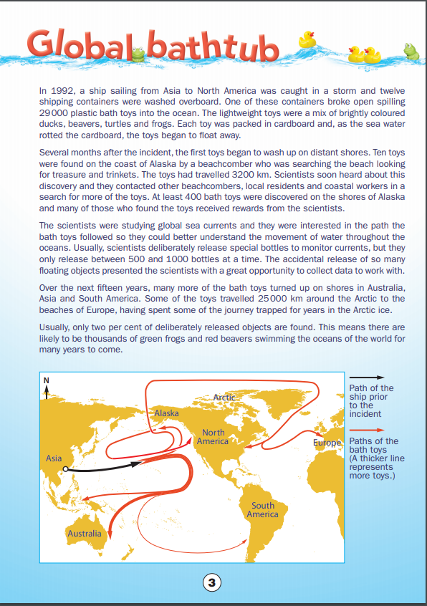
NAPLAN Year 7 reading magazine 2014, ACARA

Text examples: sequencing – accessible version
Global Bathtub
In 1992, a ship sailing from Asia to North America was caught in a storm and twelve shipping containers were washed overboard. One of these containers broke open spilling 29000 plastic bath toys into the ocean. The lightweight toys were a mix of brightly coloured ducks, beavers, turtles and frogs. Each toy was packed in cardboard and, as the sea water rotted the cardboard, the toys began to float away.
Several months after the incident, the first toys began to wash up on distant shores. Ten toys were found on the coast of Alaska by a beachcomber who was searching the beach looking for treasure and trinkets. The toys had travelled 3200 km. Scientists soon heard about this discovery and they contacted other beachcombers, local residents and coastal workers in a search for more of the toys. At least 400 bath toys were discovered on the shores of Alaska and many of those who found the toys received rewards from the scientists.
The scientists were studying global sea currents and they were interested in the path the bath toys followed so they could better understand the movement of water throughout the oceans. Usually, scientists deliberately release special bottles to monitor currents, but they only release between 500 and 1000 bottles at a time. The accidental release of so many floating objects presented the scientists with a great opportunity to collect data to work with.
Over the next fifteen years, many more of the bath toys turned up on shores in Australia, Asia and South America. Some of the toys travelled 25000 km around the Arctic to the beaches of Europe, having spent some of the journey trapped for years in the Arctic ice.
Usually, only two per cent of deliberately released objects are found. This means there are likely to be thousands of green frogs and red beavers swimming the oceans of the world for many years to come.
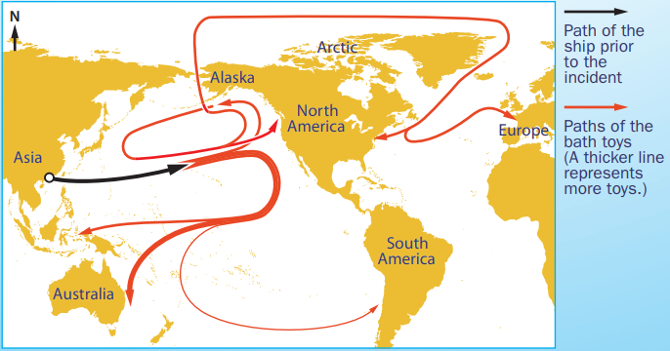
NAPLAN Year 7 reading magazine 2014, ACARA

Text examples: sequencing
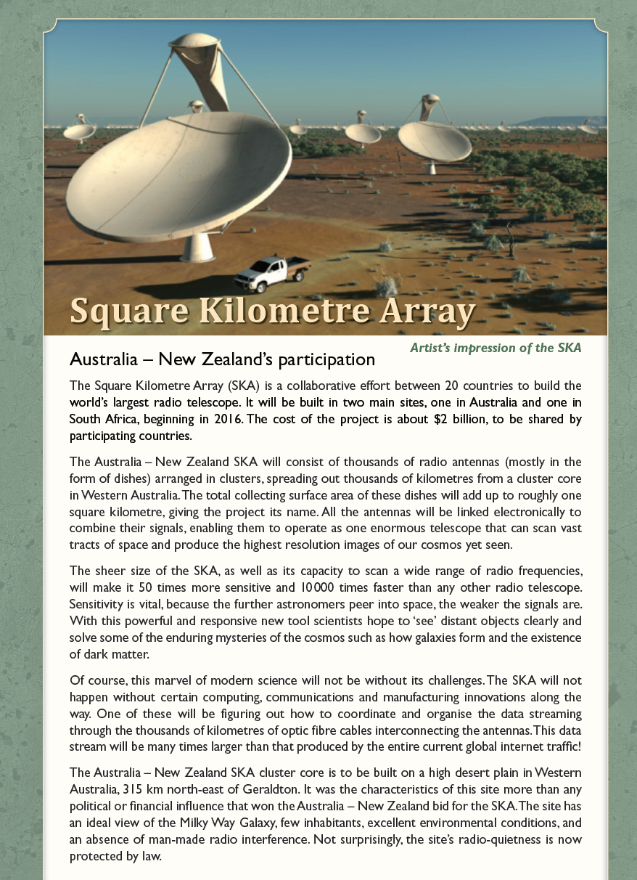
NAPLAN Year 7 reading magazine 2014, ACARA

Text examples: sequencing – accessible version
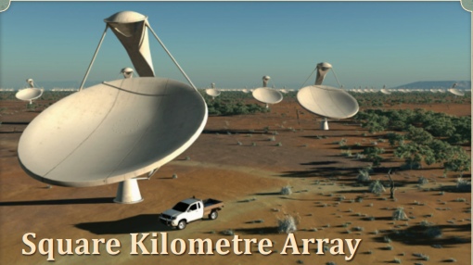
Artist’s impression of the SKA
Square Kilometre Array
Australia – New Zealand’s participation
The sheer size of the SKA, as well as its capacity to scan a wide range of radio frequencies, will make it 50 times more sensitive and 10000 times faster than any other radio telescope. Sensitivity is vital, because the further astronomers peer into space, the weaker the signals are. With this powerful and responsive new tool scientists hope to ‘see’ distant objects clearly and solve some of the enduring mysteries of the cosmos such as how galaxies form and the existence of dark matter.
Of course, this marvel of modern science will not be without its challenges. The SKA will not happen without certain computing, communications and manufacturing innovations along the way. One of these will be figuring out how to coordinate and organise the data streaming through the thousands of kilometres of optic fibre cables interconnecting the antennas. This data stream will be many times larger than that produced by the entire current global internet traffic!
The Australia – New Zealand SKA cluster core is to be built on a high desert plain in Western Australia, 315 km north-east of Geraldton. It was the characteristics of this site more than any political or financial influence that won the Australia – New Zealand bid for the SKA. The site has an ideal view of the Milky Way Galaxy, few inhabitants, excellent environmental conditions, and an absence of man
NAPLAN Year 7 reading magazine 2014, ACARA

Appendix 3

Timeline
Time | Events

