Connecting ideas
Stage 4

Overview

Purpose
This literacy teaching strategy supports teaching and learning for Stage 4 students across all key learning areas. It targets specific literacy skills and suggests a learning sequence to build skill development. Teachers can select individual tasks, or a sequence, and embed into their teaching and learning program according to their students’ needs. While exemplar texts are provided throughout this resource, it is recommended that teachers select texts which are relevant to their students and curriculum.

Learning intention
Students will learn to identify devices that link information across and within texts and develop an understanding of how authors connect ideas.

Syllabus outcome
The following teaching and learning strategies will assist in covering elements of the following outcomes:
- EN4-URA-01: analyses how meaning is created through the use of and response to language forms, features and structures
- EN4-2A: effectively uses a widening range of processes, skills, strategies and knowledge for responding to and composing texts in different media and technologies
NSW English Syllabus K-10 (2022)
Visit the Leading curriculum K-12 website for more information on the syllabus implementation timeline.

Success criteria
The following Year 7 NAPLAN item descriptors may guide teachers to co-construct success criteria for student learning.
- interprets a cohesive link across sentences in a text
- interprets a pronoun reference in a text
- interprets the use of ellipsis in a text
- links information across paragraphs in a narrative
- links information across sentences in an information text

National Literacy Learning Progression guide

Understanding Texts (UnT9-UnT11)
Key: C=comprehension P=process V=vocabulary

UnT9
- builds meaning by actively linking ideas from a number of texts or a range of digital sources (C)
- distils information from a number of texts according to task and purpose (e.g. uses graphic organisers) (C)
- evaluates text features for relevance to purpose and audience (C)
- uses knowledge of a broader range of cohesive devices to track meaning (e.g. word associations) (see Grammar) (P)
- selects reading/viewing strategies appropriate to reading purpose (e.g. scans text for evidence) (P)

UnT10
- applies and articulates criteria to evaluate the language structures and features for relevance to purpose and audience (C)
- integrates automatically a range of processes such as predicting, confirming predictions, monitoring, and connecting relevant elements of the text to build meaning (P)
- describes how sophisticated cohesive devices establish patterns of meaning (e.g. class-subclass) (P)

UnT11
- judiciously selects and synthesises evidence from multiple texts to support ideas and arguments (C)
National Literacy Learning Progression

Evidence base
- Centre for Education Statistics and Evaluation (2017). Effective reading instruction in the early years of school, literature review.
- Oakhill, J., Cain, K. & Elbro, C. (2015). Understanding and teaching reading comprehension: A handbook. Routledge.
- Quigley, A. (2020). Closing the reading gap. Routledge.
- Scarborough, H.S. (2001). Connecting early language and literacy to later reading (dis)abilities: Evidence, theory and practice. In S. Neuman & D. Dickson (Eds.), Handbook for research in early literacy (pp. 97-110). New York, NY: Guilford Press.

Alignment to system priorities and/or needs: Five priorities for Literacy and Numeracy, Our Plan for NSW Public Education, School Excellence Policy (nsw.gov.au).
Alignment to School Excellence Framework: Learning domain: Curriculum, Teaching domain: Effective classroom practice and Professional standards
Consulted with: Strategic Delivery, Teaching Quality and Impact
Author: Literacy and Numeracy
Reviewed by: Literacy and Numeracy, Teaching Quality and Impact
Created/last updated: January 2024
Anticipated resource review date: January 2025
Feedback: Complete the online form to provide any feedback

Copyright
Section 113P Notice
Texts, Artistic Works and Broadcast Notice
Some of this material has been copied and communicated to you in accordance with the statutory licence in section 113P of the Copyright Act. Any further reproduction or communication of this material by you may be the subject of copyright protection under the Act. Do not remove this notice.

Teaching strategies
Task | Appendices
Mapping it out | Appendix 1 - Bubble map
Connecting 3-2-1
Text recommendations | Appendix 2 - Non-fiction text example  Appendix 3 - Editor recommendations guide  Appendix 4 - Editor recommendations text
Pronoun referencing | Appendix 5 – Pronominal referencing text sample
Lexical chains | Appendix 6 – Identifying lexical chains
Ellipsis | Appendix 7 – Ellipsis match and sort  Appendix 8 – Ellipsis in context  Appendix 9 – Ellipsis in context guide
Linking ideas across text with connectives
Linking ideas across texts | Appendix 10 – Linking ideas in texts

Background information

Connecting ideas
The deconstruction and reconstruction of text requires the students to have a deep knowledge of how and why texts have been written. The connection of ideas within a text requires the reader to use skills and strategies whilst reading or viewing the text.

Skimming and Scanning
Skimming and scanning are reading strategies that can be used to track and connect ideas across a text. When skimming, readers quickly identify the main ideas in a text. When scanning, they move their eyes quickly down the page seeking specific words and phrase, making connections across the text.

Cohesion
Cohesion is achieved through shaping the form, creating a structure that the responder can recognise and use to navigate the text, and using features of language that link the various parts of the text into a complete whole. These features can include connectives such as 'furthermore' and 'therefore', cross-references to different parts of the text, and reiteration of the title or terms of the topic or question being addressed in the text

Cohesive devices
Words or phrases that indicate a relationship with other words, phrases, clauses or paragraphs across a text.

Cohesive links
Language features that help to develop unity within a text. Cohesion can involve referring words such as pronouns, for example 'Tony wanted to escape but he couldn't run', or content words that are related in various ways, for example 'Tony wanted to escape but was too tired to run'.

Connectives
Words which link paragraphs and sentences in logical relationships of time, cause and effect, comparison or addition. Connectives relate ideas to one another and help to show the logic of the information. Connectives are important resources for creating cohesion in texts. The logical relationships can be grouped as follows:
- temporal – to indicate time or sequence ideas, for example first, second, next
- causal – to show cause and effect, for example because, for, so
- additive – to add information, for example also, besides, furthermore
- comparative – for example rather, alternatively
- conditional/concessive – to make conditions or concession, for example yet, although
- clarifying – for example in fact, for example

Ellipsis
Ellipsis is the omission of words where:
- words repeat what has gone before and these terms are simply understood, for example 'The project will be innovative. To be involved (in the project) will be exciting.'
- a word like one is substituted for a noun or noun group, as in 'There are lots of apples in the bowl. Can I have one?' (of them)
- a cohesive resource binds text together and is commonly used in dialogue for speed of response, for example (Do you) 'Want a drink?'/'Thanks' (I would like a drink)
- three dots (also known as points of ellipsis) are used to indicate such things as surprise or suspense in a narrative text or that there is more to come in an on-screen menu
- the points of ellipsis take the place of sections of text when quoting from a source

Pronoun referencing
Tracking and tracing pronoun references across a text can support students to connect characters, events, opinions and ideas across a text. A pronoun is a word that is used in place of a noun. There are different types of pronouns:
- personal pronouns represent specific people or things, for example she, it, they, you, we
- demonstrative pronouns indicate a thing or things, for example this, these, that, those
- possessive pronouns refer to the belonging of one thing, person, etc, to another, for example his, theirs, yours, mine
- interrogative pronouns represent the things that we are asking questions about, for example who, whom, what, which
- reflexive pronouns refer back to the subject of the sentence or clause. Reflexive pronouns end in -self (singular) or -selves (plural). The reflexive pronoun myself is not a substitute for the personal pronouns I or me
- reciprocal pronouns are used when each of two or more subjects is acting in the same way towards the other, for example 'Jack and Jill love each other', 'The footballers were blaming one another'
- indefinite pronouns do not refer to any specific person, thing or amount, for example all, another, any, anybody/anyone, anything, each, everybody/everyone, everything, few, many, nobody, none, one, several, some, somebody/someone
- relative pronouns introduce a relative clause. They are called relative because they relate to the words they modify. There are five relative pronouns: who, whom, whose, which, that.
Reference: English K-10 Syllabus © NSW Education Standards Authority (NESA) for and on behalf of the Crown in right of the State of New South Wales, 2012 and 2022.

Where to next?
- Sequencing
- Literal comprehension
- Compare and contrast

Overview of teaching strategies

Purpose
These literacy teaching strategies support teaching and learning from Stage 2 to Stage 5. They are linked to NAPLAN task descriptors, syllabus outcomes and literacy and numeracy learning progressions.
These teaching strategies target specific literacy and numeracy skills and suggest a learning sequence to build skill development. Teachers can select individual tasks or a sequence to suit their students.

Access points
The resources can be accessed from:
- NAPLAN App in Scout using the teaching strategy links from NAPLAN items
- NSW Department of Education literacy and numeracy website.
What works best
Explicit teaching practices involve teachers clearly explaining to students why they are learning something, how it connects to what they already know, what they are expected to do, how to do it and what it looks like when they have succeeded. Students are given opportunities and time to check their understanding, ask questions and receive clear, effective feedback.
This resource reflects the latest evidence base and can be used by teachers as they plan for explicit teaching.
Teachers can use classroom observations and assessment information to make decisions about when and how they use this resource as they design teaching and learning sequences to meet the learning needs of their students.
Further support with What works best is available.
Differentiation
When using these resources in the classroom, it is important for teachers to consider the needs of all students, including Aboriginal and EAL/D learners.
EAL/D learners will require explicit English language support and scaffolding, informed by the EAL/D enhanced teaching and learning cycle and the student’s phase on the EAL/D Learning Progression. Teachers can access information about supporting EAL/D learners and literacy and numeracy support specific to EAL/D learners.
Learning adjustments enable students with disability and additional learning and support needs to access syllabus outcomes and content on the same basis as their peers. Teachers can use a range of adjustments to ensure a personalised approach to student learning.
Assessing and identifying high potential and gifted learners will help teachers decide which students may benefit from extension and additional challenge. Effective strategies and contributors to achievement for high potential and gifted learners helps teachers to identify and target areas for growth and improvement. A differentiation adjustment tool can be found on the High potential and gifted education website.

Using tasks across learning areas
This resource may be used across learning areas where it supports teaching and learning aligned with syllabus outcomes.
Literacy and numeracy are embedded throughout all syllabus documents as general capabilities. As the English and mathematics learning areas have a particular role in developing literacy and numeracy, NSW English and Mathematics syllabus outcomes aligned to literacy and numeracy skills have been identified.

Text selection
Example texts are used throughout this resource. Teachers can adjust activities to use texts which are linked to their unit of learning.
Further support with text selection can be found within the National Literacy Learning Progression Text Complexity appendix.
The NESA website has additional information on text requirements within the NSW English syllabus.

Teaching strategies

Mapping it out
- Ensure students preview the text, paying attention to the title, layout and any embedded visuals. This is a recommended step that should be undertaken with every new text as it assists students’ comprehension.
- Using mapping is a very effective way of visually organising key pieces of information. This activity can be completed on an individual, pair or group basis. Students working in pairs or groups have the opportunity to discuss aspects of the text, the importance of the information located and how this links in to the overall meaning of the text. Using a mind map or Appendix 1 - Bubble map can help with mapping out ideas from a text.

Connecting 3-2-1
- The 3–2–1 strategy assists students when working with texts to focus on locating and connecting ideas within a structured method. This strategy can be used when reading and viewing written and visual texts including films. This strategy also provides teachers with important information on students’ comprehension and knowledge of the subject matter. It is important that students have an opportunity to share their responses and discuss the information they have included and other aspects of the text they would like to explore. The following suggested 3–2–1 strategy can be further altered or modified to suit the learning needs of the students, the text that the students will be reading or viewing and/or the subject matter that is being addressed:
- After previewing and reading the selected text students need to address the following in their book or on a sheet of paper:
- 3- write three pieces of information that have been found to assist understanding of the text
- 2 - write two questions that will assist or clarify information found within the text to help understanding
- 1 - write one key aspect of the text that was interesting or previously unknown.
- Students can be paired or grouped to share their findings and seek clarification or this can be undertaken as a whole class feedback activity. If the students were paired or grouped the students then feedback to the class and highlight any aspects of the text they are still unsure about or found interesting.
Additional task: A content specific 3–2–1 can be used when working with texts that have key subject specific concepts and ideas that students need to consider and understand. It can be used to ask specific questions related to the text using the 3–2–1 format or can be used to compare and contrast the text with the students’ prior knowledge.

Text recommendations
- Introduce a factual text such as a website, information fact sheet or newspaper article (refer to Appendix 2 - Non-fiction text example). Discuss features of a factual text and where text, layout elements (headings, sub-headings), navigation features and graphics connect to each other. Use a think aloud strategy to demonstrate thinking, for example, ‘I can see this graphic shows the parts of a comet (the tail of gas and dust and the nucleus of a comet. When I read the text, I can see that the third paragraph is telling me about the tail and what it is made of, so I am going to draw an arrow to show this link.’ The think aloud then continues into identifying where the connections are weak or non-existent, or perhaps where additional features such as another diagram or heading would support understanding.
- Students act as an editor and through written annotations, advise suggestions to improve understanding of content and topic, using Appendix 3 - Editor recommendations guide to guide thinking. Students should be supported to suggest the addition of layout features such as headings, sub-headings, images, captions and so on, to help a reader understand the text (refer to Appendix 4 - Editor recommendations text for a sample text).
To increase, abstraction, students select and annotate a model text which could be used to support understanding/learning of peers.
- Students use the same resources and a series of arrows and lines to show all the connections between text elements and text.

Pronoun referencing
- Review student understanding of pronouns - what they are and how they are used to maintain meaning. A pronoun is a word that is used in place of a noun.
There are different types of pronouns:
- personal pronouns represent specific people or things, for example she, it, they, you, we
- demonstrative pronouns indicate a thing or things, for example this, these, that, those
- possessive pronouns refer to the belonging of one thing, person, etc, to another, for example his, theirs, yours, mine
- interrogative pronouns represent the things that we are asking questions about, for example who, whom, what, which
- reflexive pronouns refer back to the subject of the sentence or clause. Reflexive pronouns end in -self (singular) or -selves (plural). The reflexive pronoun myself is not a substitute for the personal pronouns I or me
- reciprocal pronouns are used when each of two or more subjects is acting in the same way towards the other, for example 'Jack and Jill love each other', 'The footballers were blaming one another'
- indefinite pronouns do not refer to any specific person, thing or amount, for example all, another, any, anybody/anyone, anything, each, everybody/everyone, everything, few, many, nobody, none, one, several, some, somebody/someone
- relative pronouns introduce a relative clause. They are called relative because they relate to the words they modify. There are five relative pronouns: who, whom, whose, which, that.
Reference: English K-10 Syllabus © NSW Education Standards Authority (NESA) for and on behalf of the Crown in right of the State of New South Wales, 2022.
- Teacher models tracking pronominal references within a text extract using colour-coding and arrows to show connections, one at a time. Use a text relevant to a current unit of learning or refer to Appendix 5a – Pronominal referencing text sample
- Students use texts linked to current unit of learning to colour code and track pronouns within imaginative, informative and persuasive texts. (Or refer to Appendix 5b – Pronominal referencing text samples).

Lexical chains
- Define lexical chain as a sequence of related words in writing (refer to example below) and how we can use these to track ideas in a text and how they build reader understanding on a topic.
- Introduce topic of ‘kangaroo meat’ and have students build a vocabulary bank of predicted words. Take a key word and have students build on each one, for example: kangaroo, mammal, tail.
- Model identifying lexical chains in texts by highlighting a key word, for example: ‘meat’, then highlight three other words or word-groups that mean the same thing, drawing arrows to show the 'chain' that runs through the text (refer to Appendix 6 – Identifying lexical chains.)
- Students then identify other lexical chains within the text. This can be done individually or in pairs. (Refer to Appendix 6 – Identifying lexical chains annotated copy.)
- Students use a sample text to highlight key words in a topic sentence of a paragraph. Students then continue to highlight any terms that link directly to the topic sentence within the paragraph, then across the text. Students use arrows and lines to show connections between the texts and how ideas are building and developing as follows:

Ellipsis
- KWL: Complete a KWL chart about ellipsis where students identify: What they know, what they would like to find out and what they have learnt (to be completed at the end of the learning). There are two main types of ellipsis; dot ellipsis or punctuation mark; and linguistically appropriate ellipsis.
- Dot ellipsis: Students hunt for ellipsis within text extracts linked to current unit of learning and discuss their role in shaping meaning of the text.
- Linguistically appropriate ellipsis: Display sentences for students to determine what could be omitted and it would still make sense:
- I went to the zoo yesterday and Johnno went to the zoo also.
If we omit, ‘to the zoo’, this sentence would still make sense.
- Students complete match and sort (refer to Appendix 7 – Ellipsis match and sort) activity to categorise the role of an ellipsis in different examples.
- Students analyse a suitable text from a current unit of learning, or refer to Appendix 8 – Ellipsis in context, finding examples of ellipsis in the text. Students scaffold their reflection in Appendix 9 – Ellipsis in context guide.

Linking ideas across text with connectives
- Teacher reads aloud example of where ideas are linked across a text using a connective:
- Exercise is an important part of staying healthy. Similarly, healthy eating is also a way to stay healthy.
In this example, the connective ‘similarly’ shows there are similarities between the two ideas and acts as a link between them.
- Teacher then models reading a sentence which uses a connective showing a different idea:
- Eating fruit and vegetables is important for a healthy diet. In contrast, eating too many foods with saturated fats can cause health issues.
In this example, the connective ‘In contrast’ shows there are differences between the two ideas and acts as a link between them.
- Students brainstorm connectives and categorise into the six themes: temporal, causal, additive, comparative, conditional and clarifying.
- Using colour coding, students use a text linked to current unit of learning to identify and show connections and links within the text being indicated with a connective.

Linking ideas across texts
- Students draw on pronominal referencing, ellipsis and connectives to analyse texts and track ideas across paragraphs and whole texts connected to current unit of learning (refer to Appendix 10 – Linking ideas in texts for support).

Appendix 1

Bubble map
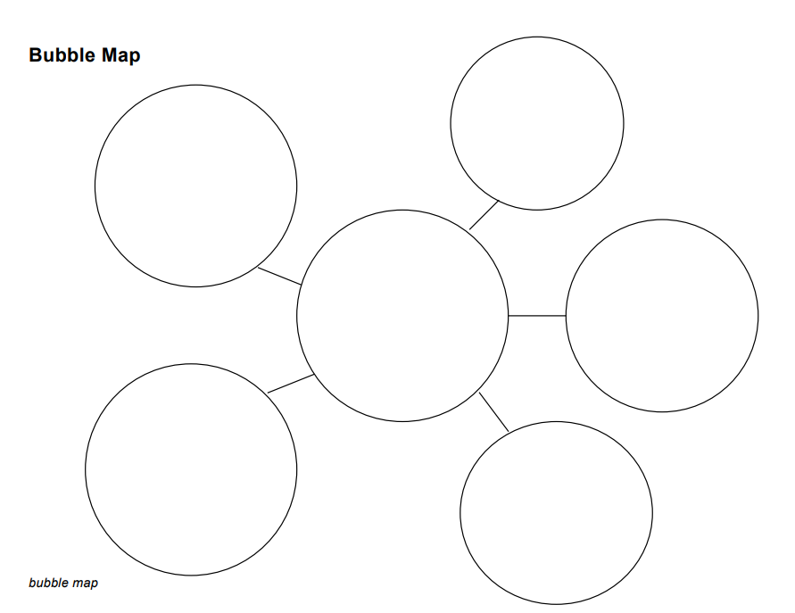

Appendix 2

Non-fiction text example
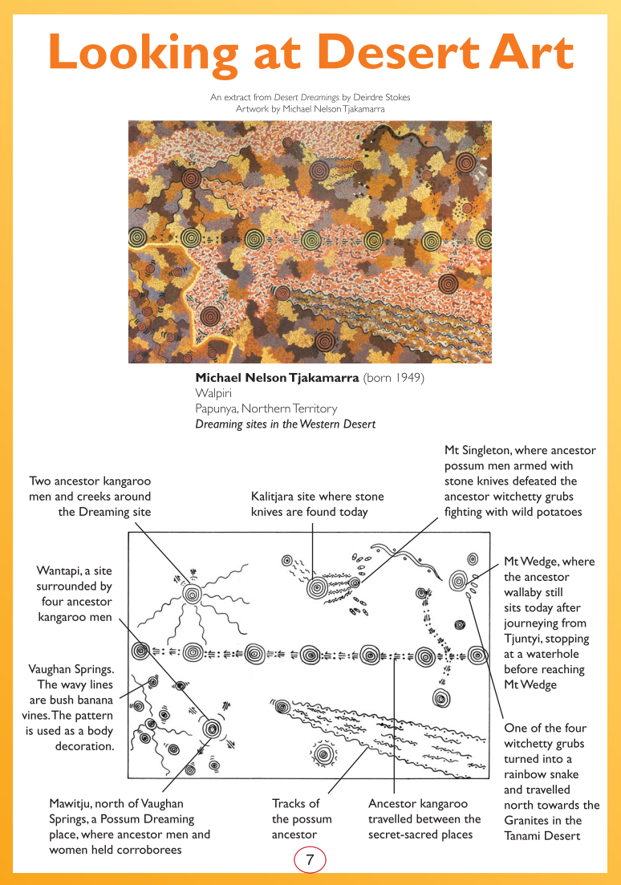
Year 7 Reading Magazine, 2009 ACARA

Non-fiction text example – accessible version
Looking at Desert Art
An extract from Desert Dreamings by Deirdre Stokes.
Artwork by Michael Nelson Tjakamarra
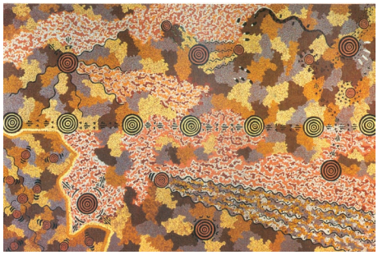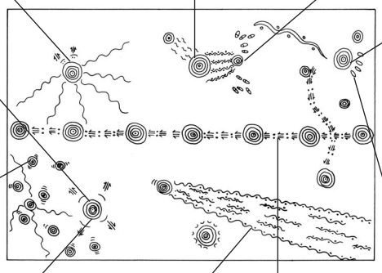
Michael Nelson Tjakamarra (born 1949)
Walpiri
Papunya, Northern Territory
Dreaming sites in the Western Desert
Two ancestor kangaroo men and creeks around the Dreaming site
Kalitjara site where stone knives are found today
Mt Singleton, where ancestor possum men armed with stone knives defeated the ancestor witchetty grubs fighting with wild potatoes.
Mt Wedge, where the ancestor wallaby still sits today after journeying from Tjuntyi, stopping at a waterhole before reaching Mt Wedge
One of the four witchetty grubs turned into a rainbow snake and travelled north towards the Granites in the Tanami Desert.
Ancestor kangaroo travelled between the secret-sacred places.
Tracks of the possum ancestor
Mawitju, north of Vaughan Springs, a possum Dreaming place, where ancestor men and women held corroborees.
Vaughan Springs. The wavy lines are bush banana vines. The pattern is used as a body decoration.
Wantapi, a site surrounded by four ancestor kangaroo men.
Year 7 Reading Magazine, 2009 ACARA

Non-fiction text example
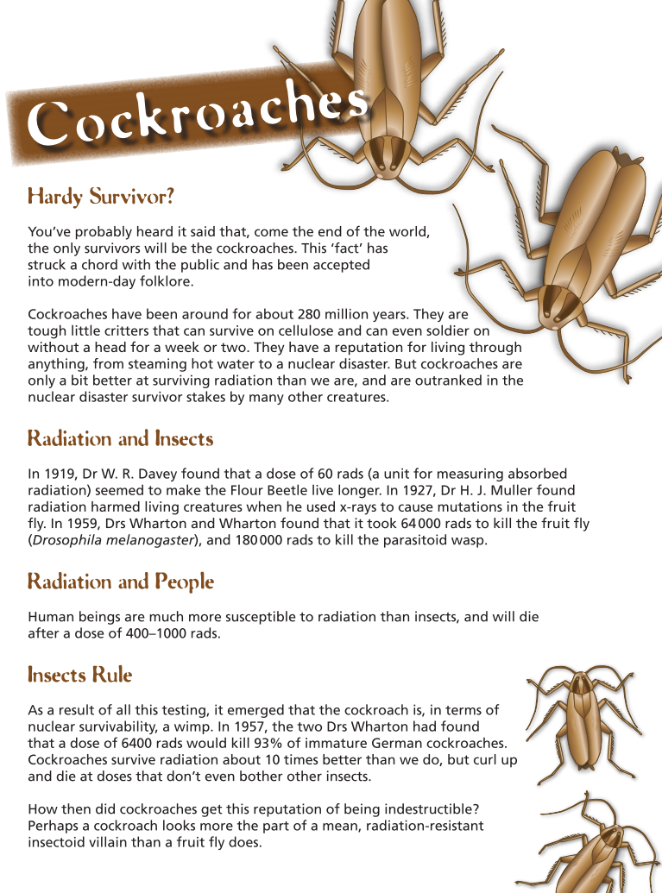
Year 7 Reading Magazine, 2009 ACARA

Non-fiction text example – accessible version
Cockroaches
Hardy Survivor?
You've probably heard it said that, come the end of the world, the only survivors will be the cockroaches. This ‘fact’ has struck a chord with the public and has been accepted into modern-day folklore.
Cockroaches have been around for about 280 million years. they are tough little critters that can survive on cellulose and can even soldier on without a head for a week or two. They have a reputation for living through anything, from steaming hot water to a nuclear disaster. But cockroaches are only a bit better at surviving radiation than we are, and are outranked in the nuclear disaster survivor stakes by many other creatures.
Radiation and Insects
In 1919, Dr W.R.Davey found that a dose of 60 rads (a unit for measuring absorbed radiation) seemed to make the Flour Beetle live longer. In 1927, Dr H.J.Muller found radiation harmed living creatures when he used x-rays to cause mutations in the fruit fly. In1959, Drs Wharton and Wharton found that it took 64 000 rads to kill the fruit fly (Drosophila melanogaster), and 180 000 rads to kill the parasitoid wasp.
Radiation and People
Human beings are much more susceptible to radiation than insects, and will die after a dose of 400-1000 rads.
Insects rule
As a result of all this testing, it emerged that the cockroach is, in terms of nuclear survivability, a wimp. In 1957, the two DRs Wharton had found that a dose of 6400 rads would kill 93% of immature German cockroaches. Cockroaches survive radiation about 10 times better than we do, but curl up and die at doses that don’t even bother other insects.
How then did cockroaches get this reputation of being indestructible? Perhaps a cockroach looks more the part of a mean, radiation-resistant insectoid villain than a fruit fly does.
Year 7 Reading Magazine, 2009 ACARA

Non-fiction text example
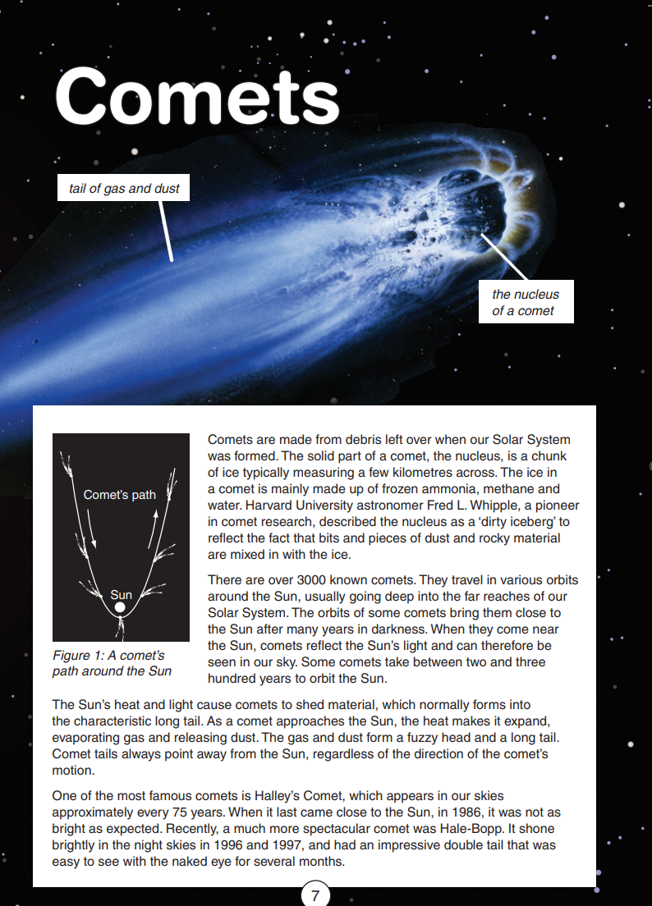
Year 7 Reading Magazine, 2009 ACARA

Non-fiction text example – accessible version

Comets
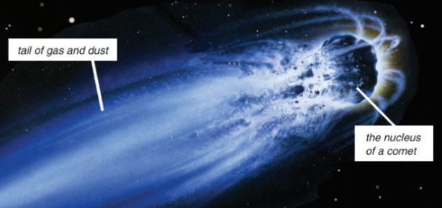
Comets are made from debris left over when our Solar System was formed. The solid part of a comet, the nucleus, is a chunk of ice typically measuring a few kilometres across. The ice in a comet is mainly made up of frozen ammonia, methane and water. Harvard University astronomer Fred L. Whipple, a pioneer in comet research, described the nucleus as a ‘dirty iceberg’ to reflect the fact that bits and pieces of dust and rocky material are mixed in with the ice.
There are over 3000 known comets. They travel in various orbits around the Sun, usually going deep into the far reaches of our Solar System. The orbits of some comets bring them close to the Sun after many years in darkness. When they come near the Sun, comets reflect the Sun’s light and can therefore be seen in our sky. Some comets take between two and three hundred years to orbit the Sun.
The Sun’s heat and light cause comets to shed material, which normally forms into the characteristic long tail. As a comet approaches the Sun, the heat makes it expand, evaporating gas and releasing dust. The gas and dust form a fuzzy head and a long tail. Comet tails always point away from the Sun, regardless of the direction of the comet’s motion.
One of the most famous comets is Halley’s Comet, which appears in our skies approximately every 75 years. When it last came close to the Sun, in 1986, it was not as bright as expected. Recently, a much more spectacular comet was Hale-Bopp. It shone brightly in the night skies in 1996 and 1997, and had an impressive double tail that was easy to see with the naked eye for several months.
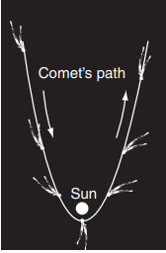
Figure 1: A comet’s path around the sun.
Year 7 Reading Magazine, 2011 ACARA

Appendix 3

Editor recommendations guide

Appendix 4

Editor recommendations text

Our body rhythms
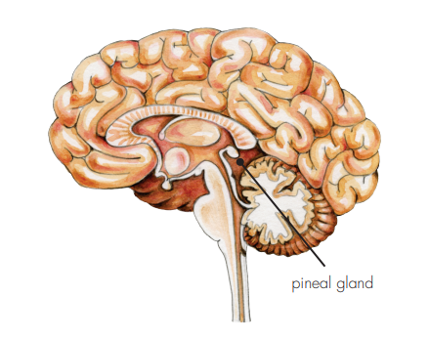
Pineal gland
Shortly before you wake up in the morning, hormones flow from your glands into your bloodstream to get you ready for your daily activities. As you get ready for school, your heartbeat speeds up, and your breathing becomes more intense.
Throughout the day, your body foes through other changes. By late afternoon your body temperature has gradually increased by about 0.5ºC. Your blood pressure, which is lowest during the early morning, fluctuates during the day until it reaches its peak by early evening.
Later at night, after the day’s activities, you start to feel tired. While you are sleeping, your body goes through even more changes. Deep within your brain, a structure called the pineal gland secretes a chemical called melatonin that flows into your brain to make you feel sleepy. The highest levels of melatonin occur at about 2.a.m, rising to about four to six times greater than during the day. If you woke up during this time of night it would be very difficult to do even simple tasks because the increased levels of melatonin would cloud your concentration and judgment.
Sleep also brings other changes. While your body is at rest, there is a decrease in respiration, heart rate and blood pressure, your overall metabolic rate – the rate of the chemical reactions that go on in the body – also dropped. The secretion of growth hormone, however, increases. About half the total day’s amount of growth hormone is released during the first few hours of sleep, and most of the growth and repair of your body tissues occurs during sleep. By morning the cycle starts all over again.
Year 7 NAPLAN Reading Magazine, 2010 ACARA

Appendix 5a

Pronominal referencing text sample
Tim Winton ‘The Boy Behind the Curtain’, 2017, Penguin Books
On the beach one day, as I was sliding my board back onto the tray of the ute and trying to clear my sinuses of salty water, an old neighbour who was passing by with his dog told me he didn’t know what people like me saw in surfing. He said, ‘I see youse blokes out there day and night. Any time I go past you’re just sittin’ there, bobbin around like moorin’ buoys. Tell me, Timmy, what’s the point?’ And I didn’t know how to answer. Almost every day of my life is shaped according to the weather, most acutely to swell, tide and wind direction. After surfing for fifty years, you’d think I’d be able to give a better account of myself. But there wasn’t much to tell him, because there is no point. Surfing is a completely pointless exercise. Perhaps that’s why I’m addicted to it. But he was right, my neighbour, God rest him. We go to the water every day and every hour we can. And most of what we do is wait.
Yellow = main character (Timmy)
Blue = neighbour
Pink = Timmy and his friends (group)

Copied under the statutory licence in s 113P of the Copyright Act.
Tim Winton, The Boy Behind the Curtain, 2017 Penguin Books
Section 113P Warning Notice

Pronominal referencing text sample – accessible version
Tim Winton ‘The Boy Behind the Curtain’, 2017, Penguin Books
On the beach one day, as I was sliding my board back onto the tray of the ute and trying to clear my sinuses of salty water, an old neighbour who was passing by with his dog told me he didn’t know what people like me saw in surfing. He said, ‘I see youse blokes out there day and night. Any time I go past you’re just sittin’ there, bobbin around like moorin’ buoys. Tell me, Timmy, what’s the point?’ And I didn’t know how to answer. Almost every day of my life is shaped according to the weather, most acutely to swell, tide and wind direction. After surfing for fifty years, you’d think I’d be able to give a better account of myself. But there wasn’t much to tell him, because there is no point. Surfing is a completely pointless exercise. Perhaps that’s why I’m addicted to it. But he was right, my neighbour, God rest him. We go to the water every day and every hour we can. And most of what we do is wait.
Pronominal referencing example 1 - main character (Timmy)
I, my, me, me, Timmy, I, my, I’d, I’m, my, We, we, we
Pronominal referencing example 1– neighbour
an old neighbour, his, he, He, I, I, me, him, he, neighbour, him
Pronominal referencing example 3 – Timmy and his friends (group)
youse blokes, you’re, We, we, we
Copied under the statutory licence in s 113P of the Copyright Act.
Tim Winton, The Boy Behind the Curtain, 2017 Penguin Books
Section 113P Warning Notice

Appendix 5b

Pronominal referencing text sample
Colour code and track the proper nouns, nouns and pronouns in this text.
Sue Williams, ‘The girl Who Climbed Everest: The inspirational story of Alyssa Aza, Australia’s Youngest Adventurer’, 2016, Penguin
It happens just three days into one of the world’s most gruelling treks.
Eight-year-old Alyssa Azar is almost halfway along the rugged Kokoda Track in the remote wilds of Papua New Guinea, and she knows that when she completes it – if she completes it – she’ll have the world record as the youngest person ever to do so. But suddenly, she stops dead. The mud beneath her walking boots oozes up over her ankle gaiters as she sinks into the quagmire and lifts first one foot, then the other, to try to free them, but makes no attempt to continue.
The local porters look at her curiously. Over the past week they’ve learnt to expect the unexpected from this tiny little white girl, with her gap-toothed grin and mop of blonde hair tied into a rough ponytail. When she’d first been introduced to them as the youngest member of a new expedition along the historic trail, they’d shaken their heads in disapproval. She was far too young, and much too small, to embark on such an arduous challenge.
But she’s already taken them by surprise many times, striding along the track through dense rainforest, heaving herself up giant steps hewn into the mountains that most fully grown adults have trouble with, scrambling up the steep sides of valleys and trotting down the other side. A couple of times, as they reach for her arms to try to guide her across a raging river crossing, or help her along a particularly precarious mountain ridge, she politely but firmly asks them to leave her be. She already has dark bruises on both elbows where the guides, terrified of losing such fragile cargo, grabbed her so hard she winced. She wants to do this with as little help as possible.
Copied under the statutory licence in s 113P of the Copyright Act.
Sue Williams, ‘The Girl Who Climbed Everest: The inspirational story of Alyssa Azar, Australia's Youngest Adventurer’, 2016, Penguin
Section 113P Warning Notice

Pronominal referencing text sample
Colour code and track the proper nouns, nouns and pronouns in this text.
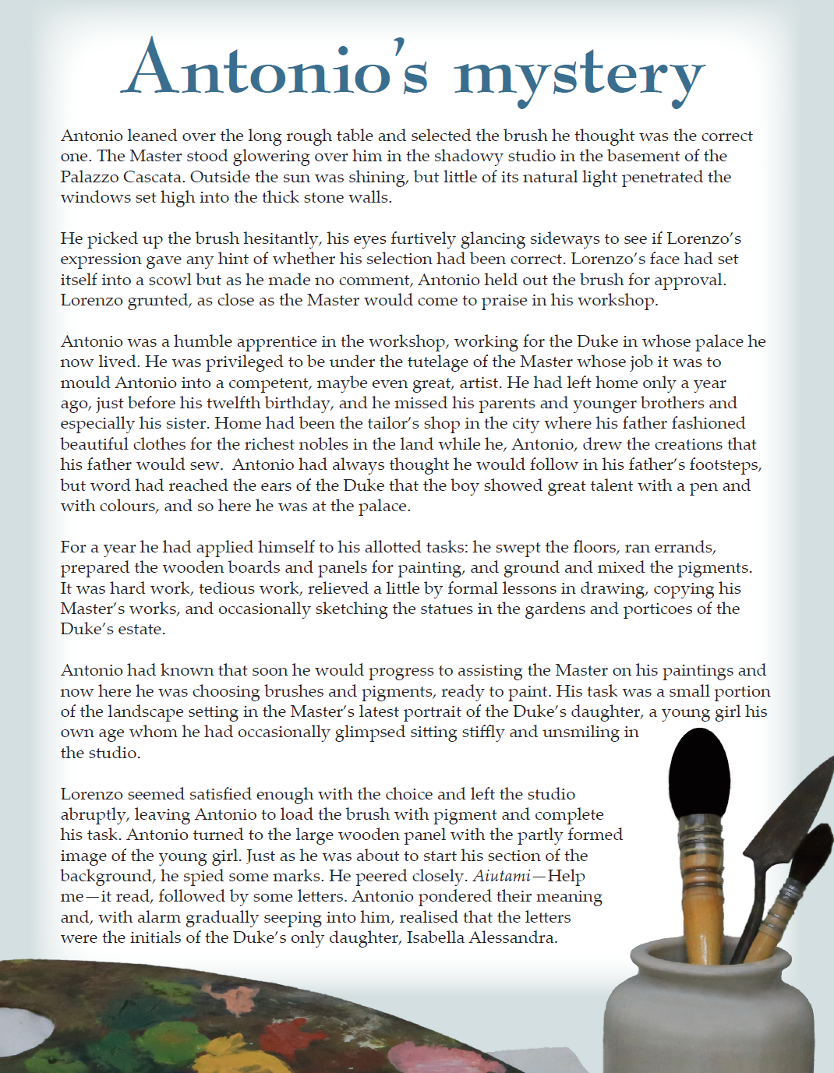
NAPLAN Year 7 Reading Magazine, 2016 ACARA

Pronominal referencing text sample – accessible version
Antonio’s mystery
Colour code and track the proper nouns, nouns and pronouns in this text.
Antonio leaned over the long rough table and selected the brush he thought was the correct one. The Master stood glowering over him in the shadowy studio in the basement of the Palazzo Cascata. Outside the sun was shining, but little of its natural light penetrated the windows set high into the thick stone walls.
He picked up the brush hesitantly, his eyes furtively glancing sideways to see if Lorenzo’s expression gave any hint of whether his selection had been correct. Lorenzo’s face had set itself into a scowl but as he made no comment, Antonio held out the brush for approval. Lorenzo grunted, as close as the Master would come to praise in his workshop.
Antonio was a humble apprentice in the workshop, working for the Duke in whose palace he now lived. He was privileged to be under the tutelage of the Master whose job it was to mould Antonio into a competent, maybe even great, artist. He had left home only a year ago, just before his twelfth birthday, and he missed his parents and younger brothers and especially his sister. Home had been the tailor’s shop in the city where his father fashioned beautiful clothes for the richest nobles in the land while he, Antonio, drew the creations that his father would sew. Antonio had always thought he would follow in his father’s footsteps, but word had reached the ears of the Duke that the boy showed great talent with a pen and with colours, and so here he was at the palace.
For a year he had applied himself to his allotted tasks: he swept the floors, ran errands, prepared the wooden boards and panels for painting, and ground and mixed the pigments. It was hard work, tedious work, relieved a little by formal lessons in drawing, copying his Master’s works, and occasionally sketching the statues in the gardens and porticoes of the Duke’s estate.
Antonio had known that soon he would progress to assisting the Master on his paintings and now here he was choosing brushes and pigments, ready to paint. His task was a small portion of the landscape setting in the Master’s latest portrait of the Duke’s daughter, a young girl his own age whom he had occasionally glimpsed sitting stiffly and unsmiling in the studio.
Lorenzo seemed satisfied enough with the choice and left the studio abruptly, leaving Antonio to load the brush with pigment and complete his task. Antonio turned to the large wooden panel with the partly formed image of the young girl. Just as he was about to start his section of the background, he spied some marks. He peered closely. Aiutami—Help me—it read, followed by some letters. Antonio pondered their meaning and, with alarm gradually seeping into him, realised that the letters were the initials of the Duke’s only daughter, Isabella Alessandra.
NAPLAN Year 7 Reading Magazine, 2016 ACARA

Pronominal referencing text sample
Colour-code and track the proper nouns, nouns and the corresponding pronouns in this text.
Adam MacDougall, ‘The 10-Minute Man’, 2016, Penguin
One of the biggest mistakes we make is underestimating how much the simple things have an impact on our health and fitness. We think losing weight and being healthy needs to be complicated and time-consuming because that’s what the people and companies selling the so-called solutions have taught us.
The health and fitness industry makes hundreds of millions of dollars every year from trendy diets and exercise programs; unfortunately, however, most of them promise the world but deliver an atlas. Who has an hour to train at the gym, let alone the hour to get there and back? Who can be bothered counting calories? And who can stick to a diet where you never get to eat the food you enjoy and can’t have a beer with your mates? It’s no wonder that 80 per cent of people with gym memberships don’t use them and 65 per cent of dieters end up putting the weight back on!
But it really doesn’t have to be that hard. No, you don’t need to take out an expensive gym membership or have a degree in maths to figure out how many calories are in that sandwich – just focus on something simple that you know is good for your health and start with that. It could be as basic as eating a high-protein breakfast, cutting out soft drinks or going for a walk at lunchtime. There’s nothing stopping you and the best time to start is now!
That one small change will have a positive impact on your health and fitness and flow on to other things, and that’s ultimately how you get results. In fact, with most things in life, we get 80 per cent of our results from 20 per cent of what we do – economists call this the 80/20 rule, and it applies to health and fitness too. The trick is finding the 20 per cent that will give you the biggest results, as I discovered when I was a footballer.

Consider:
- Who is the ‘we’ Adam McDougall refers to in the first sentence?
- Who promises the world but “…delivers an atlas”?
- In paragraph 3, what is the ‘it’ referring to when the author says “…it really doesn’t have to be that hard.”?
- Create sub-headings for each paragraph
- If you were the editor, what would be an effective diagram and caption you would recommend to improve understanding of content in this text?
Copied under the statutory licence in s 113P of the Copyright Act.
Adam MacDougall, ‘The 10-Minute Man’, 2016, Penguin
Section 113P Warning Notice

Appendix 6

Identifying lexical chains

From Moo to Roo – blank text
Some may turn up their nose at eating meat that was once more common in pet food than pies. Others may raise an eyebrow or even an objection to being served one half of their country’s coat of arms. Kangaroo may not be to everyone’s taste, but if some of the country’s leading scientists have their way, it could soon be leapfrogging beef as Australia’s favourite meat.
People have been eating kangaroo for some 40000 years, and in the last 10 years consumption has doubled. It is the ultimate organic meat: free-range, free of chemicals, and fed by a natural diet. It is also exceptionally low in fat; a kangaroo fillet has less than two per cent fat whereas a typical beef steak has between ten and twenty percent. It may not sizzle on a barbeque like a beef T-bone does, but it is rich in iron, full of protein, and high in Conjugated Linoleic Acids (CLAs) that can reduce heart disease and obesity. Research conducted by Clare Engelke at the University of Western Australia showed that kangaroo can have up to five times more CLAs than other meat.
Kangaroo farmers already harvest three million kangaroos each year and Dr Kelvin George, a leading wildlife consultant, is keen to see this figure increase. ‘Kangaroos are soft-footed animals that damage vegetation far less than cloven-hoofed cattle,’ he says. ‘They do not compact the all-important humus layer of the soil.’ Dr George is not the only expert to identify the environmental benefits of farming kangaroos. A report by economist Professor Ross Garnaut argues that Australia’s livestock industry is a greater contributor to climate change than the coal industry.
Methane emitted by sheep and cows accounts for about 11 percent of Australia’s greenhouse gases. A switch from cattle to kangaroo could change this; kangaroos produce negligible amounts of the gas. Many cattle farmers, however, are unimpressed by Garnaut’s report. A quick scan of farming websites reveals counter-arguments ranging from a perceived lack of consumer interest in kangaroo meat to the inaccuracy of the methane emission figures. Charlie McElhone from the National Farmers’ Federation argues that a switch from moo to roo could seriously damage Australia’s meat export industry.
Ultimately it will be left to consumers to determine whether kangaroo steaks are on or off the menu. If consumer demand fails to match the supply, this could cost proactive farmers millions of dollars each year. It could be argued, however, that the cost of ignoring kangaroo meat may be far greater.
Year 7 NAPLAN Reading Magazine, 2010 ACARA

Identifying lexical chains

From Moo to Roo – annotated copy
Some may turn up their nose at eating meat that was once more common in pet food than pies. Others may raise an eyebrow or even an objection to being served one half of their country’s coat of arms. Kangaroo may not be to everyone’s taste, but if some of the country’s lead scientists have their way, it could soon be leapfrogging beef as Australia’s favourite meat.
People have been eating kangaroo for some 40000 years, and in the last 10 years consumption has doubled. It is the ultimate organic meat: free-range, free of chemicals, and fed by a natural diet. It is also exceptionally low in fat; a kangaroo fillet has less than two per cent fat whereas a typical beef steak has between ten and twenty percent. It may not sizzle on a barbeque like a beef T-bone does, but it is rich in iron, full of protein, and high in Conjugated Linoleic Acids (CLAs) that can reduce heart disease and obesity. Research conducted by Clare Engelke at the University of Western Australia showed that kangaroo can have up to five times more CLAs than other meat

Year 7 NAPLAN Reading Magazine, 2010 ACARA

Identifying lexical chains – accessible version

From Moo to Roo – annotated copy
Some may turn up their nose at eating meat that was once more common in pet food than pies. Others may raise an eyebrow or even an objection to being served one half of their country’s coat of arms. Kangaroo may not be to everyone’s taste, but if some of the country’s leading scientists have their way, it could soon be leapfrogging beef as Australia’s favourite meat.
People have been eating kangaroo for some 40000 years, and in the last 10 years consumption has doubled. It is the ultimate organic meat: free-range, free of chemicals, and fed by a natural diet. It is also exceptionally low in fat; a kangaroo fillet has less than two per cent fat whereas a typical beef steak has between ten and twenty percent. It may not sizzle on a barbeque like a beef T-bone does, but it is rich in iron, full of protein, and high in Conjugated Linoleic Acids (CLAs) that can reduce heart disease and obesity. Research conducted by Clare Engelke at the University of Western Australia showed that kangaroo can have up to five times more CLAs than other meat.
Lexical chain 1: kangaroo
Meat, one half of their country’s coat of arms, Kangaroo, It, kangaroo fillet, It, it, kangaroo.
Lexical chain 2: People
Some, Others, everyone’s, Australia’s, People

Year 7 NAPLAN Reading Magazine, 2010 ACARA

Appendix 7

Ellipsis match and sort
- Categorise into: omitted information, omitted time, to build tension or to signal a pause in thoughts.
- Can you find another way to categorise these?
- Would these examples be found in formal or informal writing?
- What is omitted from each of these?
Examples:
“…he was still an active part of the group.” | The cricket player’s bat was broken… | …really? You are joking!
It was a stunning building, with glass walls, tall chimneys…and slate floors. | “Umm…I’m not sure about that.” | Only one more to go…
“I mean…not really.” | “…it was unbelievable…” | “Keep your hand off the lever!”  “I didn’t know it was on.” He said.
And still, there was no end in sight… | They moved silently through the paddock  …  The sun rose and the dew settled on the wheat. | Rain, rain, rain…surely no more could fall!
According to the magazine article, “The best remedy ... is to drink plenty of liquids.” | You know, after discussing, I still can’t decide ... but I hope to make a decision soon. | I grab an apple from the bowl. “Want one?”  “Thanks!” she said
'The project will be innovative. To be involved will be exciting.’ | I ordered the spaghetti, and he the pizza. | “Who ordered the water?”  “I did.”

“I, uh…forgot to put on the washing machine.” | The vast flapping sheet flattened itself out, and each shove of the brush revealed fresh legs, hoops, horses, glistening reds and blues, beautifully smooth, until half the wall was covered with the advertisement of a circus; a hundred horsemen, twenty performing seals, lions, tigers…Craning forwards, for she was short-sighted, she read it out… “will visit this town,” she read.  Extract from ‘To the Lighthouse’ by Virginia Woolf
Own examples:
Hesitation | Urgency | Part of a quote
Omitting time | Omitting scene | Building suspense

Appendix 8

Ellipsis in context

An extract from ‘Finders Keepers’ by Emily Rodda
On Saturday Patrick woke up with a little shock, knowing that this was a special day. For a moment he couldn’t think exactly why, and then, with an excited flutter of his stomach, he remembered. At ten o’clock today he was going to find out once and for all about Finders Keepers. He got dressed more carefully than usual, went downstairs and turned on the TV. Quickly, he switched channels. Cartoons, cartoons, advertisement men talking, snob, snow… and still nothing at all on Channel 8.
“Patrick, tune it in, darling, if you’re going to watch.” Judith wandered past with the newspaper under her arm and her eyes half closed. She headed for the kitchen. Patrick tuned off the TV and followed.
…
Patrick’s stomach lurched “We aren’t going out, are we?” he asked anxiously.
She began to make the tea, “Don’t say you’ve forgotten!” she said.
“I promised you, last Saturday. Your new sneakers, remember?”
“Oh –oh, but I can’t go out into this morning, Mum. There’s something I’ve got to watch on TV. At ten o’clock. I’ve got to! My sneakers’ll be all right for another week,” gabbled Patrick, panic-stricken.
Judith faced him, hands on hips. “Patrick,” she said wearily, “it’s all organised.”
…
Copied under the statutory licence in s 113P of the Copyright Act.
Emily Rodda, Finders Keepers, 1991 Greenwillow Books
Section 113P Warning Notice

Appendix 9

Ellipsis in context guide
Example | What is omitted? | Why do you think it was omitted?

Appendix 10

Linking ideas in texts
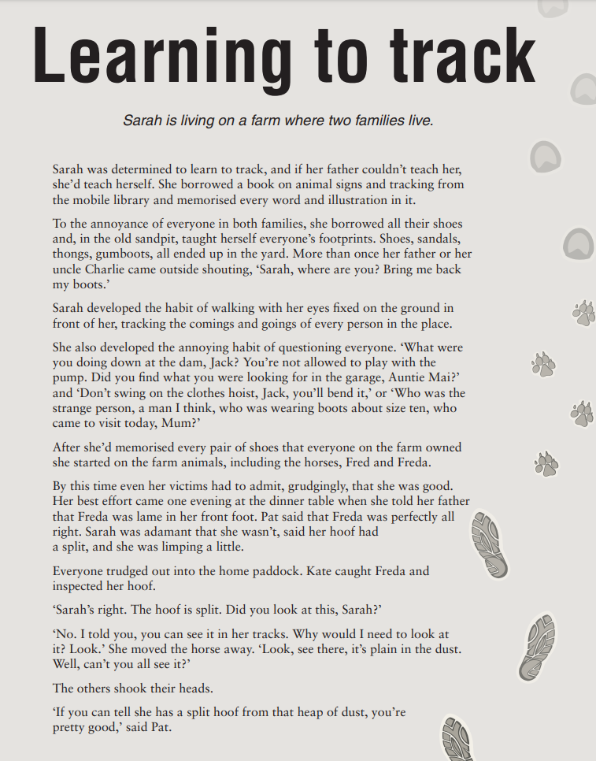
Year 7 NAPLAN Reading Magazine, 2010 ACARA

Linking ideas in texts – accessible version
Learning to track
Sarah is living on a farm where two families live.
Sarah was determined to learn to track, and if her father couldn’t teach her, she’d teach herself. She borrowed a book on animal signs and tracking from the mobile library and memorised every word and illustration in it.
To the annoyance of everyone in both families, she borrowed all their shoes and, in the old sandpit, taught herself everyone’s footprints. Shoes, sandals, thongs, gumboots, all ended up in the yard. More than once her father or her uncle Charlie came outside shouting, ‘Sarah, where are you? Bring me back my boots.’
Sarah developed the habit of walking with her eyes fixed on the ground in front of her, tracking the comings and goings of every person in the place.
She also developed the annoying habit of questioning everyone. ‘What were you doing down at the dam, Jack? You’re not allowed to play with the pump. Did you find what you were looking for in the garage, Auntie Mai?’ and ‘Don’t swing on the clothes hoist, Jack, you’ll bend it,’ or ‘Who was the strange person, a man I think, who was wearing boots about size ten, who came to visit today, Mum?’
After she’d memorised every pair of shoes that everyone on the farm owned she started on the farm animals, including the horses, Fred and Freda.
By this time even her victims had to admit, grudgingly, that she was good. Her best effort came one evening at the dinner table when she told her father that Freda was lame in her front foot. Pat said that Freda was perfectly all right. Sarah was adamant that she wasn’t, said her hoof had a split, and she was limping a little.
Everyone trudged out into the home paddock. Kate caught Freda and inspected her hoof.
‘Sarah’s right. The hoof is split. Did you look at this, Sarah?’
‘No. I told you, you can see it in her tracks. Why would I need to look at it? Look.’ She moved the horse away. ‘Look, see there, it’s plain in the dust. Well, can’t you all see it?’
The others shook their heads.
‘If you can tell she has a split hoof from that heap of dust, you’re pretty good,’ said Pat.
Year 7 NAPLAN Reading Magazine, 2010 ACARA

Linking ideas in texts
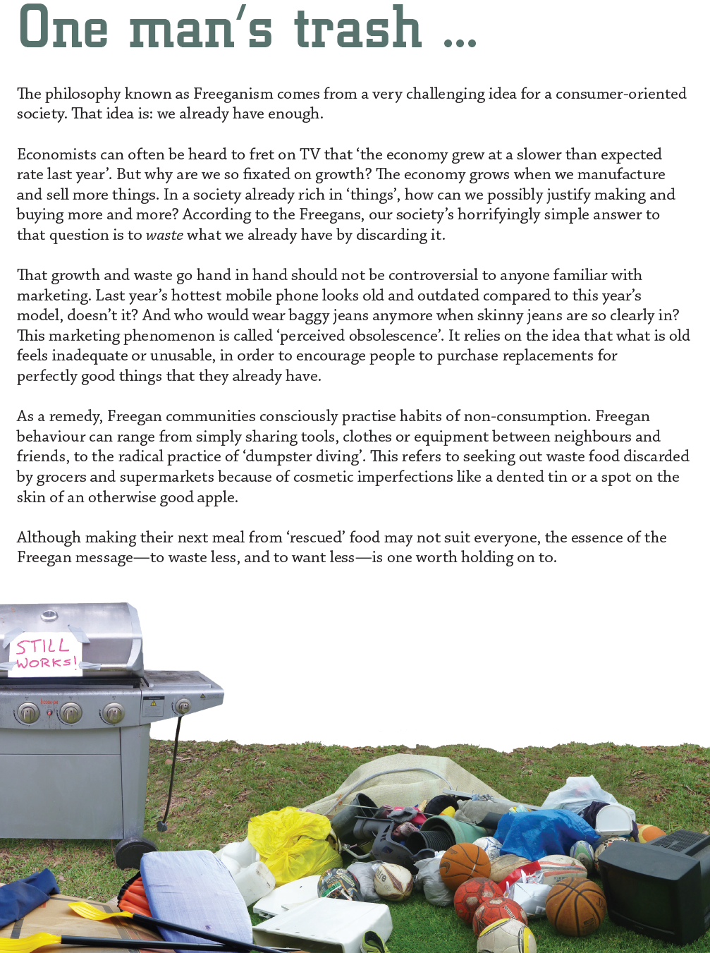
Year 7 NAPLAN Reading Magazine, 2016 ACARA

Linking ideas in texts – accessible version
One man’s trash...
The philosophy known as Freeganism comes from a very challenging idea for a consumer-oriented society. That idea is: we already have enough.
Economists can often be heard to fret on TV that ‘the economy grew at a slower than expected rate last year’. But why are we so fixated on growth? The economy grows when we manufacture and sell more things. In a society already rich in ‘things’, how can we possibly justify making and buying more and more? According to the Freegans, our society’s horrifyingly simple answer to that question is to waste what we already have by discarding it.
That growth and waste go hand in hand should not be controversial to anyone familiar with marketing. Last year’s hottest mobile phone looks old and outdated compared to this year’s model, doesn’t it? And who would wear baggy jeans anymore when skinny jeans are so clearly in? This marketing phenomenon is called ‘perceived obsolescence’. It relies on the idea that what is old feels inadequate or unusable, in order to encourage people to purchase replacements for perfectly good things that they already have.
As a remedy, Freegan communities consciously practise habits of non-consumption. Freegan behaviour can range from simply sharing tools, clothes or equipment between neighbours and friends, to the radical practice of ‘dumpster diving’. This refers to seeking out waste food discarded by grocers and supermarkets because of cosmetic imperfections like a dented tin or a spot on the skin of an otherwise good apple.
Although making their next meal from ‘rescued’ food may not suit everyone, the essence of the Freegan message—to waste less, and to want less—is one worth holding on to.
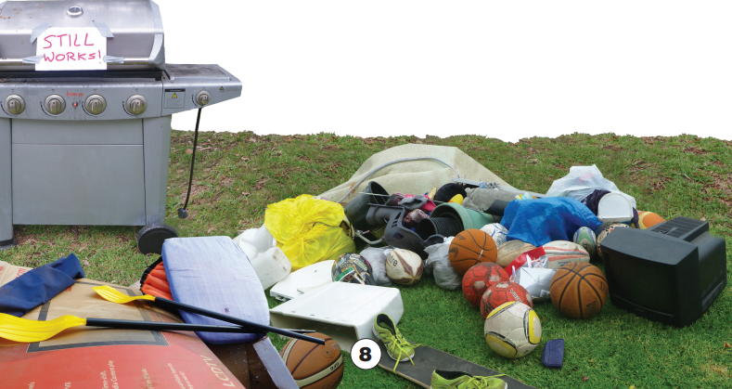
Year 7 NAPLAN Reading Magazine, 2016 ACARA

Linking ideas in texts

How the humble dung beetle engineers better ecosystems in Australia
Paul Weston, EH Graham Centre for Agricultural Innovation, Charles Sturt University & Theo Evans The University of Western Australia March 11, 2020. The Conversation.
Dung beetles play an important role helping clear up all the dung left by other animals in an environment.
In Australia there are approximately 475 native species of dung beetle.
But there’s a problem. Most of them are adapted to deal with marsupial dung. When British colonisers brought livestock down under, they introduced an entirely new type of dung that the native dung beetles were ill-equipped to handle.

Not touching that dung
Cattle dung is wet and bulky. It is very unlike marsupial dung – which is typically small, dry pellets – and so the native dung beetles largely left it alone. As a result, large deposits of cattle dung accumulated in the Australian agricultural landscape.
Besides fouling the land, the dung was an excellent breeding site for bush flies and other nuisance insects, as well as internal parasites that plague the digestive tracts of livestock.
So CSIRO embarked on an ambitious plan to introduce into Australia many dung beetles that were adapted to livestock dung. Starting in 1966, it imported and released 43 species of dung beetles over 25 years.
The beetles came from places such as South Africa, France, Spain and Turkey. The chosen beetles had similar climate requirements and were adapted to wild and domestic livestock, so they could live in Australia and process livestock dung.

What do dung beetles do?
When people think of dung beetles, the popular image that comes to mind is that of an industrious beetle labouring to roll a large ball of dung across the landscape.
These little engineers are actually trying to find a suitable spot to situate the ball, on which they will lay an egg. Their offspring will have food and a safe place to grow up, and generate more dung beetles.
Most species of dung beetles actually tunnel beneath piles of dung and drag bits of it into subterranean chambers, where they then lay their eggs.
The larvae develop over the following weeks to months, eventually emerging as adults and crawling to the surface in search of a mate and another pile of dung to colonise.

The introduced dung beetles
Of the 43 species introduced to Australia by CSIRO, 23 have become established and many are having a positive impact.
The activities of dung beetles helped remove dung from pastures and with it, the breeding site for nuisance flies and internal parasites.
They also improved pasture fertility. They increased the permeability of pasture soils to rainwater which decreased runoff of rainwater laden with nutrients that can pollute waterways.
But it is not known just how widely each of the introduced species has spread. There might be geographical and seasonal gaps in dung beetle activity that could be filled by other species yet to be introduced to Australia.

Working with farming
Dung beetles have been around for tens of millions of years, but their ability to survive in modern agricultural environments may be jeopardised by some farming practices.
Tilling paddocks used in cropping and livestock rotation systems may destroy the developing dung beetle larvae.
Some deworming agents, used by livestock producers to control intestinal parasites, may pass through the livestock and out in their faeces, and might poison the dung beetles colonising the dung.
It should be possible to manage tillage and deworming to minimise harm to the dung beetles, and so maximise their positive impact on the land.
That’s where Dung Beetle Ecosystem Engineers (DBEE) comes in.
In this project, a group of research institutions, producer groups, land management groups and dung beetle entrepreneurs are working together.
The project, now in its second year, is supported by Meat and Livestock Australia and funded by the Rural Research and Development for Profit Program of the Australian Department of Agriculture, Water and the Environment. Charles Sturt University leads the project, with cooperators at CSIRO, University of Western Australia, University of New England, Mingenew-Irwin Group, Warren Catchment Council, Dung Beetle Solutions International, and LandCare Research NZ.

Dung Beetle Ecosystem Engineers aims to:
- understand the distribution of dung beetle species previously introduced to Australia, and predict their ultimate spread
- evaluate new species of dung beetle for importation and release into Australia
- estimate the economic impact of dung beetles on farming systems
- develop a database of information on dung beetles in Australasia and educational materials for use by a range of users
- work with farming and land management groups to engage landholders in detecting dung beetles and modifying agricultural practices to enhance the success of dung beetles.
At the end of the DBEE project, we will have a better understanding of the role of dung beetles as a farming tool, helping farmers choose agricultural practices that will improve their bottom line.
New dung beetle species will be ready to work for Australia and New Zealand, and a distribution network will enhance their spread to new geographic areas.
DBEE aims bring economic and ecological benefits to the agricultural sector and wider Australian and New Zealand community.
Copied under the statutory licence in s113P of the Copyright Act. Paul Weston, EH Graham Centre for Agricultural Innovation, Charles Sturt University & Theo Evans, The University of Western Australia, ‘How the humble dung beetle engineers better ecosystems in Australia.’ The Conversation, March 11, 2020. Section 113P Warning Notice

