Evaluating sources
Stage 3

Overview

Purpose
This literacy teaching strategy supports teaching and learning for Stage 3 students across all key learning areas. It targets specific literacy skills and suggests a learning sequence to build skill development. Teachers can select individual tasks, or a sequence, and embed into their teaching and learning program according to their students’ needs. While exemplar texts are provided throughout this resource, it is recommended that teachers select texts which are relevant to their students and curriculum.

Learning intention
Students will learn to evaluate the accuracy of sources. Students will explore the tools and techniques used to add authority to texts and what to look for to assess credibility.

Syllabus outcomes
The following teaching and learning strategy will assist in covering elements of the following outcomes:
- EN3-RECOM-01: fluently reads and comprehends texts for wide purposes, analysing text structures and language, and by monitoring comprehension
- EN3-UARL-01: analyses representations of ideas in literature through narrative, character, imagery, symbol and connotation, and adapts these representations when creating texts
NSW English K-10 Syllabus (2022)

Success criteria
The following Year 5 NAPLAN item descriptors may guide teachers to co-construct success criteria for student learning.
- evaluates the accuracy of statements using information from a narrative
- evaluates the accuracy of statements using information from an information text
- evaluates the presence of information in a section of a persuasive text
- evaluates the presence of information in a text
- evaluates the validity of supporting evidence in a persuasive text

National Literacy Learning Progression Guide

Understanding Texts (UnT8-UnT10)
Key: C=comprehension P=process V=vocabulary

UnT8
- evaluates the accuracy within and across texts on the same topic (C)
- skims and scans texts for key words to track the development of ideas (P)

UnT9
- identifies the main themes or concepts in complex texts by synthesising key ideas or information (C)
- summarises the text identifying key details only (C)
- selects reading/viewing strategies appropriate to reading purpose (e.g. scans text for evidence) (P)

UnT10
- analyses the techniques authors use to position readers (C)
National Literacy Learning Progression

Evidence base
- Centre for Education Statistics and Evaluation (2017). Effective reading instruction in the early years of school, literature review.
- Konza, D. (2014). Teaching Reading: Why the “Fab Five” should be the “Big Six”. Australian Journal of Teacher Education, 39(12).
- Oakhill, J., Cain, K. & Elbro, C. (2015). Understanding and teaching reading comprehension: A handbook. Routledge.
- Quigley, A. (2020). Closing the reading gap. Routledge.
- Scarborough, H.S. (2001). Connecting early language and literacy to later reading (dis)abilities: Evidence, theory and practice. In S. Neuman & D. Dickson (Eds.), Handbook for research in early literacy (pp. 97-110). New York, NY: Guilford Press.

Alignment to system priorities and/or needs: Five priorities for Literacy and Numeracy, Our Plan for NSW Public Education, School Excellence Policy (nsw.gov.au).
Alignment to School Excellence Framework: Learning domain: Curriculum, Teaching domain: Effective classroom practice and Professional standards
Consulted with: Strategic Delivery, Teaching Quality and Impact
Author: Literacy and Numeracy
Reviewed by: Literacy and Numeracy, Teaching Quality and Impact
Created/last updated: January 2024
Anticipated resource review date: January 2025
Feedback: Complete the online form to provide any feedback

Copyright
Section 113P Notice
Texts, Artistic Works and Broadcast Notice
Some of this material has been copied and communicated to you in accordance with the statutory licence in section 113P of the Copyright Act. Any further reproduction or communication of this material by you may be the subject of copyright protection under the Act. Do not remove this notice.’

Teaching strategies
Task | Appendices
What is fact and what is opinion? | Appendix 1 - Is it credible?  Appendix 2 - Colour coding persuasive and informative elements
Behind the scenes | Appendix 1 - Is it credible?  Appendix 3 - Evaluating texts
Tools and techniques | Appendix 1 - Is it credible?  Appendix 3 - Evaluating texts
Through different lenses | Appendix 1 - Is it credible?  Appendix 3 - Evaluating texts

Background information

Fact and opinion
Facts can be based on an observation and can be validated through testing whereas opinion is an assumption or belief. Introduce terms of ‘subjective’ and ‘objective’ and how these connect with fact and opinion; encourage students to use this vocabulary where appropriate.
Objective language is language that is fact-based, measurable and observable, verifiable and unbiased. It does not include a speaker or writer’s point of view, interpretation or judgement.
Subjective language includes words used to communicate based on opinion, feelings or personal biases.

Evaluate
Make a judgement based on criteria; determine the value of.

Evaluative language
Positive or negative language that judges the worth of something. It includes language to express feelings and opinions, to make judgements about aspects of people such as their behaviour, and to assess the quality of objects such as literary works. It includes evaluative words. The language used by a speaker or writer to give a text a particular perspective (for example judgemental, emotional, critical) in order to influence how the audience will respond to the content of the text.
Reference: English K-10 Syllabus © NSW Education Standards Authority (NESA) for and on behalf of the Crown in right of the State of New South Wales, 2012 and 2022.

Where to next?
- Audience and purpose
- Understanding perspective
- Inference

Overview of teaching strategies

Purpose
These literacy teaching strategies support teaching and learning from Stage 2 to Stage 5. They are linked to NAPLAN task descriptors, syllabus outcomes and literacy and numeracy learning progressions.
These teaching strategies target specific literacy and numeracy skills and suggest a learning sequence to build skill development. Teachers can select individual tasks or a sequence to suit their students.

Access points
The resources can be accessed from:
- NAPLAN App in Scout using the teaching strategy links from NAPLAN items
- NSW Department of Education literacy and numeracy website.

What works best
Explicit teaching practices involve teachers clearly explaining to students why they are learning something, how it connects to what they already know, what they are expected to do, how to do it and what it looks like when they have succeeded. Students are given opportunities and time to check their understanding, ask questions and receive clear, effective feedback.
This resource reflects the latest evidence base and can be used by teachers as they plan for explicit teaching.
Teachers can use classroom observations and other assessment information to make decisions about when and how they use this resource as they design teaching and learning sequences to meet the learning needs of their students.
Further support with What works best is available.

Differentiation
When using these resources in the classroom, it is important for teachers to consider the needs of all students, including Aboriginal and EAL/D learners.
EAL/D learners will require explicit English language support and scaffolding, informed by the EAL/D enhanced teaching and learning cycle and the student’s phase on the EAL/D Learning Progression. Teachers can access information about supporting EAL/D learners and literacy and numeracy support specific to EAL/D learners.
Learning adjustments enable students with disability and additional learning and support needs to access syllabus outcomes and content on the same basis as their peers. Teachers can use a range of adjustments to ensure a personalised approach to student learning.
Assessing and identifying high potential and gifted learners will help teachers decide which students may benefit from extension and additional challenge. Effective strategies and contributors to achievement for high potential and gifted learners helps teachers to identify and target areas for growth and improvement. A differentiation adjustment tool can be found on the High potential and gifted education website.

Using tasks across learning areas
This resource may be used across learning areas where it supports teaching and learning aligned with syllabus outcomes.
Literacy and numeracy are embedded throughout all syllabus documents as general capabilities. As the English and mathematics learning areas have a particular role in developing literacy and numeracy, NSW English and Mathematics syllabus outcomes aligned to literacy and numeracy skills have been identified.

Text selection
Example texts are used throughout this resource. Teachers can adjust activities to use texts which are linked to their unit of learning.
Further support with text selection can be found within the National Literacy Learning Progression Text complexity appendix.
The NESA website has additional information on text requirements within the NSW English syllabus.

Teaching strategies

What is fact and what is opinion?
- Venn diagram: Teacher leads a discussion on the differences between fact and opinion. Students add ideas onto a Venn diagram to determine similarities and differences. Using this information, design a set of criteria to determine a fact or opinion (refer to Stage 2 Fact and Opinion resource). Make the connection between fact and informative, and opinion with persuasive types of texts.
- To increase abstraction, students use Appendix 1 - Is it credible? to assess the credibility of a resource relevant to a current unit of learning, justifying their conclusions to the class.
- Students use a nonfiction text that has elements of both informative and persuasive text features and colour-code what is fact and what is opinion (refer to Appendix 2 - Colour coding persuasive and informative elements). Students identify 5 key points from each text and find evidence to support each point.

Behind the scenes
- Show the ‘Save the Pacific Northwest Tree Octopus’ website and brainstorm vocabulary the students would expect to see. Discuss and display what they would expect to see in a website.
- Teacher models reading text from the website: Pacific Northwest Green Tree Octopus; this is a fictitious website which demonstrates how some sources can be misleading, yet feature key elements of a trustworthy source. Using the think-aloud strategy, teacher reinforces using the images, quotes and references and evaluates their impact on credibility.
Think aloud suggestion: I can see they have used the word ‘endangered’ as well as a location to find the Pacific Northwest Tree Octopus and its scientific name in the first sentence. This shows me this is an informative text, but I can also see elements of persuasive texts in that it is asking me to ‘help save’ the creature. I can see a rare photograph of the octopus with a caption underneath to add more detail.
- Discuss who can create information on the internet. Review looking at the URL to help determine credibility. Have students give these sources a ranking out of 5 and discuss possible bias and considerations regarding authority and validity.
.org: An advocacy website, such as a not-for-profit organization.
.com: A business or commercial site.
.net: A site from a network organization or an Internet service provider.
.edu: A site affiliated with a higher education institution.
.gov: A federal government site.
.au: Australia

Tools and techniques
- Discuss the importance of evaluating sources for credibility to ensure information is true and how we use this to form ideas and opinions. Discuss examples of when students have questioned the validity of texts they have encountered.
- Teacher models using the source evaluation checklist (Appendix 1 - Is it credible?) to evaluate statements in texts and the overall text. (Appendix 3 - Evaluating texts)
Differentiation: in groups, students determine their own criteria to determine credibility of a source.
- Mind map: Discuss and brainstorm a list of key features to ensure each list of criteria has these. The features might include:
- Author’s authority
- Text structure
- Currency (time published and updated)
- Syntax and punctuation
- Using quotes, references, experts, organisations
- Supporting images (diagrams, maps, photographs)
- Captions
- Students analyse a range of text samples to determine credibility using a different group’s criteria.
- Discuss the reliability and credibility of a review. Teacher explains the purpose of a review and specific considerations when assessing credibility and bias. For example, is it a paid /sponsored review? Did the reviewer receive the item for free? Students evaluate the reliability and credibility of a review using a text related to any current unit of learning or use Crawlin’ Kitten 2 in Appendix 3 - Evaluating texts.
To increase abstraction, students locate two reviews on the same topic, one they consider neutral and one biased. Evaluate the reviews using Appendix 2, or their own criteria, and justify their reasoning to the class.

Through different lenses
- Using Appendix 1 - Is it credible? students review an advertisement and recreate it from a different viewpoint. (Teacher could use any suitable text from a current unit of learning or refer to ‘Geronimo Zero’ in Appendix 3 - Evaluating texts.) For example, if the advertisement is linked to unhealthy food choices, the ad could be recreated from a doctor’s or nutritionist’s or dietician’s perspective, or perhaps from a retailer’s perspective using the previously explored tools and techniques. Alternately, students could debate the credibility of the advertisement with each team adopting an opposing viewpoint. For example, Team 1 could represent the advertiser while team 2 represents the doctor or nutritionist.

Appendix 1

Is it credible?
Accuracy
Does it have facts or statistics? Does it use quotes? Is it factual or an opinion piece?
Purpose
Is the purpose to inform, persuade/sell or to entertain?
Author
Who wrote the text? Are they an expert? Is there bias in the text? Who benefits from this text?
Currency
How recently was the text written? When was it last updated?
Authority
Are there spelling/grammar and punctuation errors? Is the layout and sentence structure correct?
How credible is it?

Is the source credible? Why/why not?

Is it credible? – accessible version

How credible is it?

Purpose
Is the purpose to inform, persuade/sell or to entertain?

Author
Who wrote the text? Are they an expert? Is there bias in the text? Who benefits from this text?

Authority
Are there spelling/grammar and punctuation errors? Is the layout and sentence structure correct?

Currency
How recently was the text written? When was it last updated?

Accuracy
Does it have facts or statistics? Does it use quotes? Is it factual or an opinion piece?

Is the source credible? Why/why not?

Appendix 2

Colour coding persuasive and informative elements
    - Colour code what is factual
    - Colour code what is an opinion
    - What is the purpose of the text?
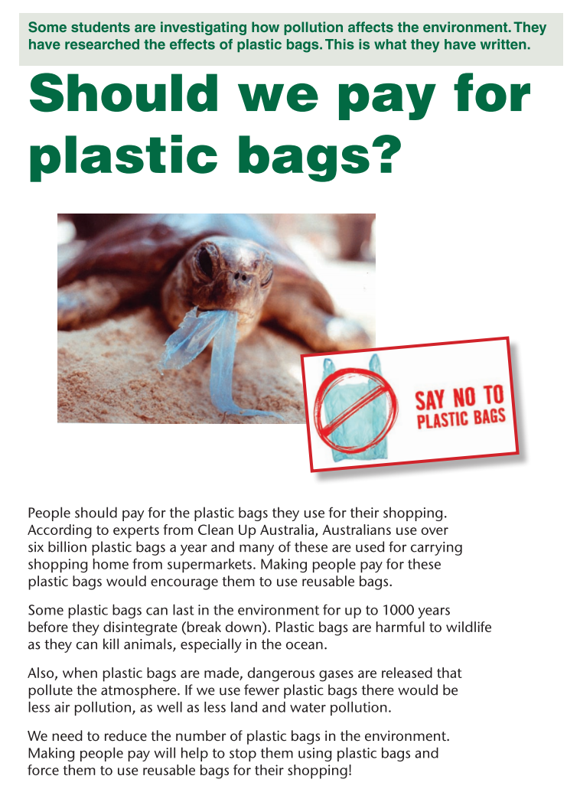
Year 5 NAPLAN Reading Magazine, 2009 ACARA

Appendix 2

Colour coding persuasive and informative elements – accessible version
- Colour code what is factual
- Colour code what is an opinion
- What is the purpose of the text?
Some students are investigating how pollution affects the environment. They have researched the effects of plastic bags. This is what they have written.
Should we pay for plastic bags?
People should pay for plastic bags they use for their shopping. According to experts from Clean up Australia, Australians use over six billion plastic bags a year and many of these are used for carrying shopping home from supermarkets. Making people pay for these plastic bags would encourage them to use reusable bags.
Some plastic bags can last in the environment for up to 1000 years before they disintegrate (break down). Plastic bags are harmful to wildlife as they can kill animals, especially in the ocean.
Also, when plastic bags are made, dangerous gases are released that pollute the atmosphere. If we use fewer plastic bags there would be less air pollution, as well as less land and water pollution.
We need to reduce the number of plastic bags in the environment. Making people pay will help to stop them using plastic bags and force them to use reusable bags for the shopping!
SAY NO TO PLASTIC BAGS

Year 5 NAPLAN Reading Magazine, 2009 ACARA

Appendix 3

Evaluating texts
Is the source credible? Why/why not?
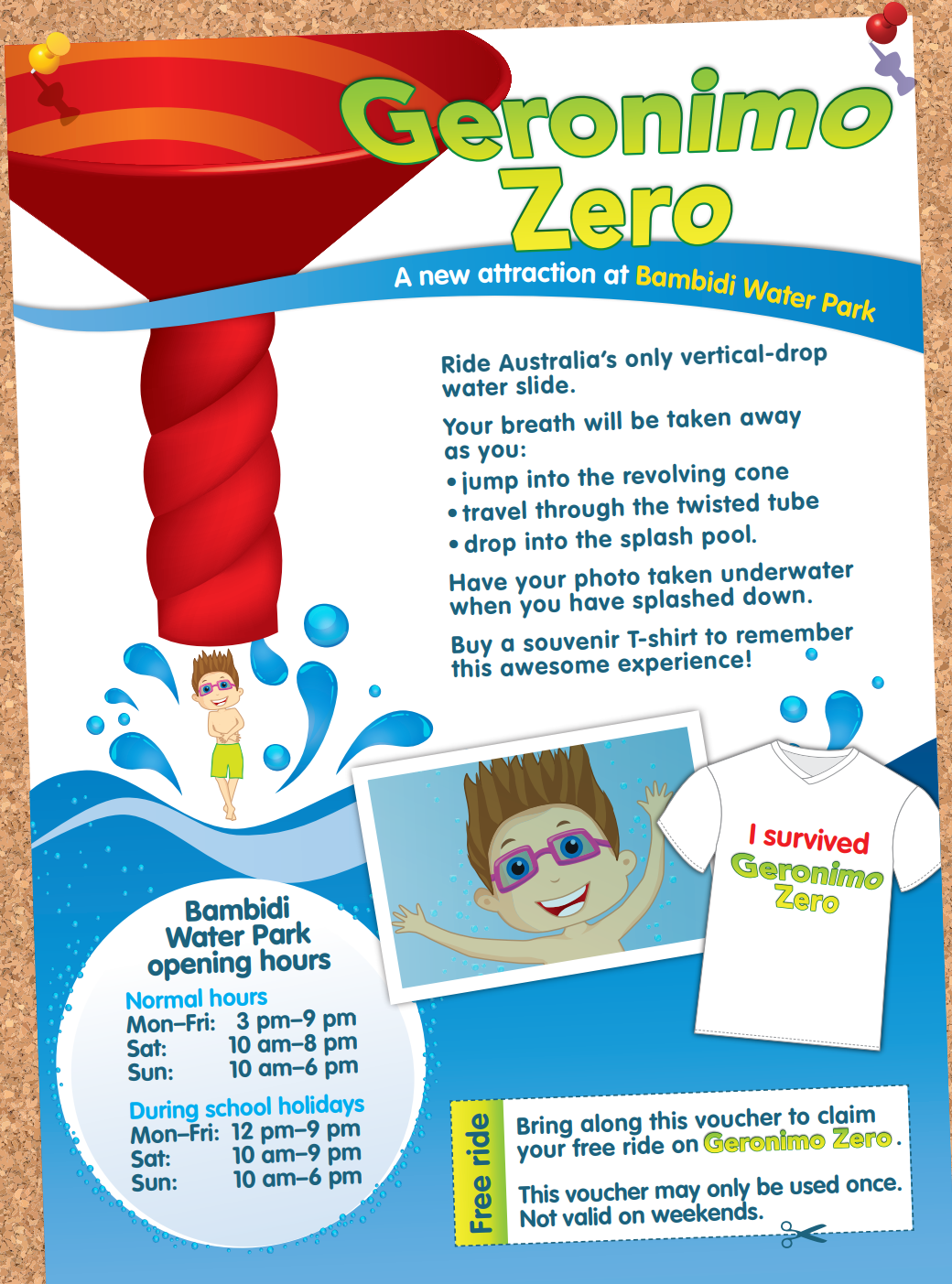
Year 5 NAPLAN Reading Magazine, 2014 ACARA
Appendix 3
Evaluating texts – accessible version
Is the source credible? Why/why not?
Geronimo Zero
A new Attraction at Bambidi Water Park
Ride Australia’s only vertical-drop water slide.
Your breath will be taken away as you:
- jump into the revolving cone
- travel through the twisted tube
- drop into the splash pool.
Have your photo taken underwater when you have splashed down.
Buy a souvenir T-shirt to remember this awesome experience!
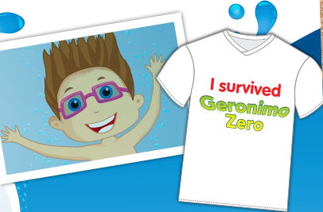
I survived Geronimo Zero
Bambidi Water Park opening hours
Normal hours
Mon–Fri: 3 pm–9 pm
Sat: 10 am–8 pm
Sun: 10 am–6 pm
During school holidays
Mon–Fri: 12 pm–9 pm
Sat: 10 am–9 pm
Sun: 10 am–6 pm
Free ride.
Bring along this voucher to claim your free ride on Geronimo Zero. This voucher may only be used once. Not valid on weekends.
Year 5 NAPLAN Reading Magazine, 2014 ACARA

Evaluating texts
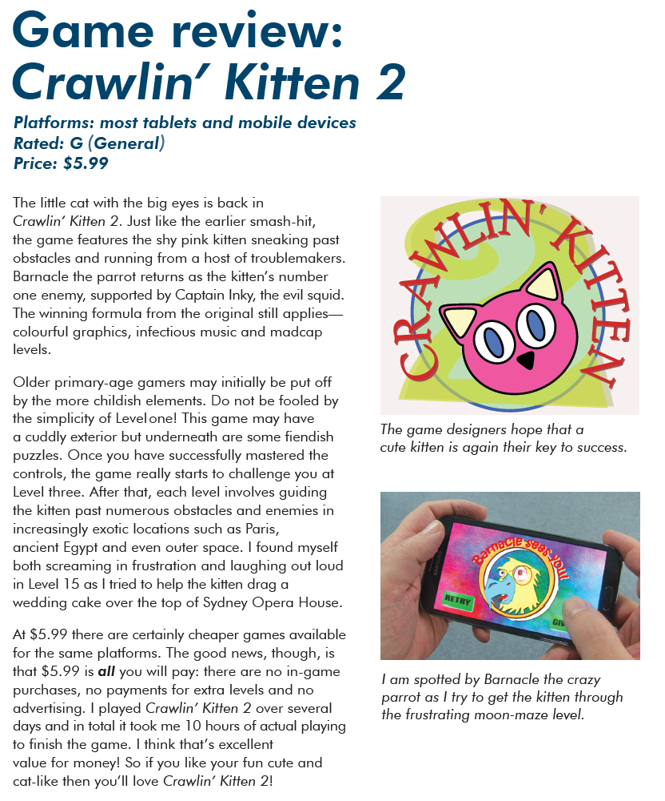
Year 5 NAPLAN Reading Magazine, 2015 ACARA

Evaluating texts - accessible version
Game review: Crawlin’ Kitten 2
Platforms: most tablets and mobile devices
Rated: G General Price: $5.99
The little cat with the big eyes is back in Crawlin’ Kitten 2. Just like the earlier smash-hit, the game features the shy pink kitten sneaking past obstacles and running from a host of troublemakers. Barnacle the parrot returns as the kitten’s number one enemy, supported by Captain Inky, the evil squid. The winning formula from the original still applies— colourful graphics, infectious music and madcap levels.
Older primary-age gamers may initially be put off by the more childish elements. Do not be fooled by the simplicity of Level one! This game may have a cuddly exterior but underneath are some fiendish puzzles. Once you have successfully mastered the controls, the game really starts to challenge you at Level three. After that, each level involves guiding the kitten past numerous obstacles and enemies in increasingly exotic locations such as Paris, ancient Egypt and even outer space. I found myself both screaming in frustration and laughing out loud in Level 15 as I tried to help the kitten drag a wedding cake over the top of Sydney Opera House.
At $5.99 there are certainly cheaper games available for the same platforms. The good news, though, is that $5.99 is all you will pay: there are no in-game purchases, no payments for extra levels and no advertising. I played Crawlin’ Kitten 2 over several days and in total it took me 10 hours of actual playing to finish the game. I think that’s excellent value for money! So if you like your fun cute and cat-like then you’ll love Crawlin’ Kitten 2!
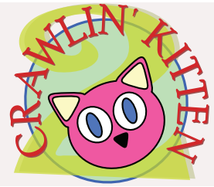
The game designers hope that a cute kitten is again their key to success.
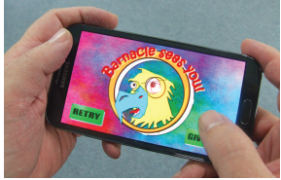
I am spotted by Barnacle the crazy parrot as I try to get the kitten through the frustrating moon-maze level.
Year 5 NAPLAN Reading Magazine, 2015 ACARA

Evaluating texts
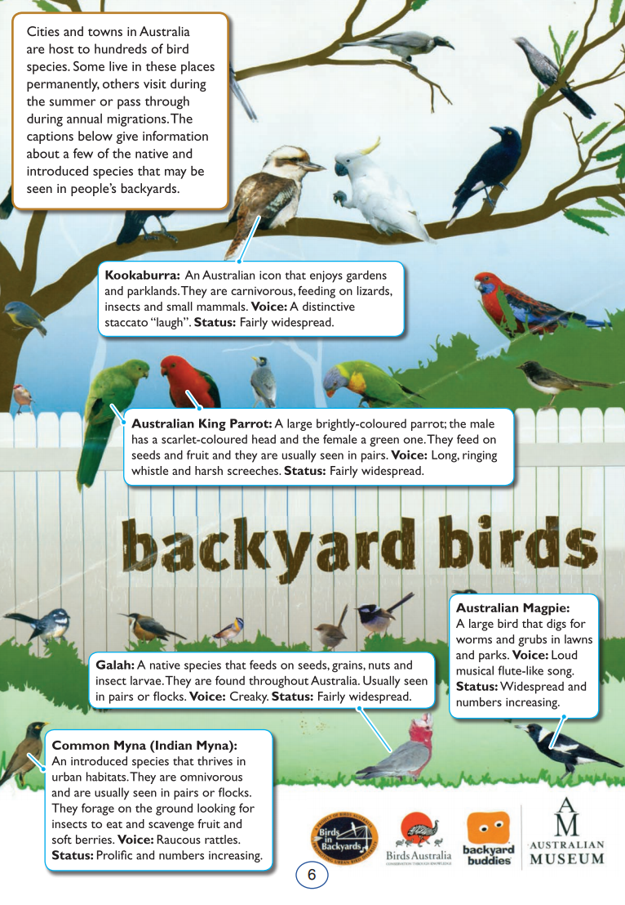
Year 5 NAPLAN Reading Magazine, 2009 ACARA

Evaluating texts - accessible version

backyard birds
Cities and towns in Australia are host to hundreds of bird species. Some live in these places permanently, others visit during the summer or pass through during annual migrations. The captions below give information about a few of the native and introduced species that may be seen in people’s backyards.
Kookaburra: An Australian icon that enjoys gardens and parklands. They are carnivorous, feeding on lizards, insects and small mammals. Voice: A distinctive staccato “laugh”. Status: Fairly widespread.
Australian King Parrot: A large brightly-coloured parrot; the male has a scarlet-coloured head and the female a green one. They feed on seeds and fruit and they are usually seen in pairs. Voice: Long, ringing whistle and harsh screeches. Status: Fairly widespread.
Galah: A native species that feeds on seeds, grains, nuts and insect larvae. They are found throughout Australia. Usually seen in pairs or flocks. Voice: Creaky. Status: Fairly widespread.
Australian Magpie: A large bird that digs for worms and grubs in lawns and parks. Voice: Loud and musical flute-like song. Status: Widespread and numbers increasing.
Common Myna (Indian Myna): An introduced species that thrives in urban habitats. They are omnivorous and are usually seen in pairs or flocks. They forage on the ground looking for insects to eat and scavenge fruit and soft berries. Voice: Raucous rattle. Status: Prolific and numbers increasing.

Year 5 NAPLAN Reading Magazine, 2009 ACARA

