Connecting ideas
Stage 3

Overview

Purpose
This literacy teaching strategy supports teaching and learning for Stage 3 students across all key learning areas. It targets specific literacy skills and suggests a learning sequence to build skill development. Teachers can select individual tasks, or a sequence, and embed into their teaching and learning program according to their students’ needs. While exemplar texts are provided throughout this resource, it is recommended that teachers select texts which are relevant to their students and curriculum.

Learning intention
Students will learn to identify devices that link information across and within texts.

Syllabus outcome
The following teaching and learning strategies will assist in covering elements of the following outcomes:
- EN3-RECOM-01: fluently reads and comprehends texts for wide purposes, analysing text structures and language, and by monitoring comprehension
NSW English K-10 Syllabus (2022)

Success criteria
The following Year 5 NAPLAN item descriptors may guide teachers to co-construct success criteria for student learning.
- links a map with information in an information text
- links an image to information in a text
- links an image to information in an information text
- links directly stated information across sentences in a text
- links directly stated information across sentences in an information text

National Literacy Learning Progression guide

Understanding Texts (UnT8-UnT10)
Key: C=comprehension P=process V=vocabulary

UnT8
- reads and views some moderately complex texts (see Text Complexity) (C)
- uses knowledge of cohesive devices to track meaning throughout a text
- connectives such as however, on the other hand) (see Grammar) (P)
- uses knowledge of the features and conventions of the type of text to build meaning (e.g. recognises that the beginning of a persuasive text may introduce the topic and the line of argument) (P)
- skims and scans texts for key words to track the development of ideas (P)

UnT9
- builds meaning by actively linking ideas from a number of texts or a range of digital sources (C)
- uses knowledge of a broader range of cohesive devices to track meaning (e.g. word associations) (see Grammar) (P)
- selects reading/viewing strategies appropriate to reading purpose (e.g. scans text for evidence) (P)

UnT10
- integrates automatically a range of processes such as predicting, confirming predictions, monitoring, and connecting relevant elements of the text to build meaning (P)
National Literacy Learning Progression

Evidence base
- Centre for Education Statistics and Evaluation (2017). Effective reading instruction in the early years of school, literature review.
- Konza, D. (2014). Teaching Reading: Why the “Fab Five” should be the “Big Six”. Australian Journal of Teacher Education, 39(12).
- Oakhill, J., Cain, K. & Elbro, C. (2015). Understanding and teaching reading comprehension: A handbook. Routledge.
- Quigley, A. (2020). Closing the reading gap. Routledge.
- Scarborough, H.S. (2001). Connecting early language and literacy to later reading (dis)abilities: Evidence, theory and practice. In S. Neuman & D. Dickson (Eds.), Handbook for research in early literacy (pp. 97-110). New York, NY: Guilford Press
Alignment to system priorities and/or needs: Five priorities for Literacy and Numeracy, Our Plan for NSW Public Education, School Excellence Policy (nsw.gov.au).
Alignment to School Excellence Framework: Learning domain: Curriculum, Teaching domain: Effective classroom practice and Professional standards
Consulted with: Strategic Delivery, Teaching Quality and Impact
Author: Literacy and Numeracy
Reviewed by: Literacy and Numeracy, Teaching Quality and Impact
Created/last updated: January 2024
Anticipated resource review date: January 2025
Feedback: Complete the online form to provide any feedback

Copyright
Section 113P Notice
Texts, Artistic Works and Broadcast Notice
Some of this material has been copied and communicated to you in accordance with the statutory licence in section 113P of the Copyright Act. Any further reproduction or communication of this material by you may be the subject of copyright protection under the Act. Do not remove this notice.

Teaching strategies
Task | Appendices
Pronoun referencing | Appendix 1 - Pronoun expert groups
Linking images to information | Appendix 2 - Linking information match and sort  Appendix 3 - Linking information across texts
Editor recommendations | Appendix 4 - Teacher guided editor recommendations  Appendix 5 - Editor recommendations

Background information

Pronoun
A word that is used in place of a noun. A pronoun may be personal (he, she, we, they), demonstrative (that/this) or relative (who).
There are different types of pronouns:
- personal pronouns represent specific people or things, for example she, it, they, you, we
- demonstrative pronouns indicate a thing or things, for example this, these, that, those
- possessive pronouns refer to the belonging of one thing, person, etc, to another, for example his, theirs, yours, mine
- interrogative pronouns represent the things that we are asking questions about, for example who, whom, what, which
- reflexive pronouns refer back to the subject of the sentence or clause. Reflexive pronouns end in -self (singular) or -selves (plural). The reflexive pronoun myself is not a substitute for the personal pronouns I or me
- reciprocal pronouns are used when each of two or more subjects is acting in the same way towards the other, for example 'Jack and Jill love each other', 'The footballers were blaming one another'
- indefinite pronouns do not refer to any specific person, thing or amount, for example all, another, any, anybody/anyone, anything, each, everybody/everyone, everything, few, many, nobody, none, one, several, some, somebody/someone
- relative pronouns introduce a relative clause. They are called relative because they relate to the words they modify. There are five relative pronouns: who, whom, whose, which, that.
Reference: English K-10 Syllabus © NSW Education Standards Authority (NESA) for and on behalf of the Crown in right of the State of New South Wales, 2012 and 2022.

Where to next?
- Sequencing events
- Literal comprehension
- Main idea

Overview of teaching strategies

Purpose
These literacy teaching strategies support teaching and learning from Stage 2 to Stage 5. They are linked to NAPLAN task descriptors, syllabus outcomes and literacy and numeracy learning progressions.
These teaching strategies target specific literacy and numeracy skills and suggest a learning sequence to build skill development. Teachers can select individual tasks or a sequence to suit their students.

Access points
The resources can be accessed from:
- NAPLAN App in Scout using the teaching strategy links from NAPLAN items
- NSW Department of Education literacy and numeracy website.

What works best
Explicit teaching practices involve teachers clearly explaining to students why they are learning something, how it connects to what they already know, what they are expected to do, how to do it and what it looks like when they have succeeded. Students are given opportunities and time to check their understanding, ask questions and receive clear, effective feedback.
This resource reflects the latest evidence base and can be used by teachers as they plan for explicit teaching.
Teachers can use classroom observations and other assessment information to make decisions about when and how they use this resource as they design teaching and learning sequences to meet the learning needs of their students.
Further support with What works best is available.

Differentiation
When using these resources in the classroom, it is important for teachers to consider the needs of all students, including Aboriginal and EAL/D learners.
EAL/D learners will require explicit English language support and scaffolding, informed by the EAL/D enhanced teaching and learning cycle and the student’s phase on the EAL/D Learning Progression. Teachers can access information about supporting EAL/D learners and literacy and numeracy support specific to EAL/D learners.
Learning adjustments enable students with disability and additional learning and support needs to access syllabus outcomes and content on the same basis as their peers. Teachers can use a range of adjustments to ensure a personalised approach to student learning.
Assessing and identifying high potential and gifted learners will help teachers decide which students may benefit from extension and additional challenge. Effective strategies and contributors to achievement for high potential and gifted learners helps teachers to identify and target areas for growth and improvement. A differentiation adjustment tool can be found on the High potential and gifted education website.

Using tasks across learning areas
This resource may be used across learning areas where it supports teaching and learning aligned with syllabus outcomes.
Literacy and numeracy are embedded throughout all syllabus documents as general capabilities. As the English and mathematics learning areas have a particular role in developing literacy and numeracy, NSW English and Mathematics syllabus outcomes aligned to literacy and numeracy have been identified.

Text selection
Example texts are used throughout this resource. Teachers can adjust activities to use texts which are linked to their unit of learning.
Further support with text selection can be found within the National Literacy Learning Progression Text Complexity appendix.
The NESA website has additional information on text requirements within the NSW English syllabus.

Teaching strategies

Pronoun referencing
- Discuss pronouns and how we use these to help a text flow and avoid repetition; that a mixture of a proper noun followed by a pronoun, then reaffirming the proper noun is a tool authors use. Pose the question- what if all the proper nouns were replaced with ‘they’ – how would we know who was being referred to?
- Students are given one section of Appendix 1 - Pronoun expert groups to become an ‘expert’ in. Students work in groups to create a student-friendly summary of each section, offer examples and find examples from a range of texts. Students share information with the class, with students taking notes for each section.
- Read aloud a text linked to a current unit of study, pausing at pronouns, proper nouns, and nouns and have students predict which word would fit.
- Model colour-coding pronouns with proper nouns and nouns, using lines and arrows to show connections. Students replicate the process using examples of texts linked to a current unit of learning.
She also knew an Indian couple in the neighbourhood, Saleen and Jacob, and we would visit them regularly to eat Indian food together. They would speak with me in my own language, Hindi, asking simple questions and translating instructions and things Mum and Dad wanted me to know about how we’d live our life together. Coming from a very basic background, I didn’t speak much Hindi either, but being understood by someone was a huge help in becoming comfortable about my new surrounds. Anything my new parents weren’t able to communicate through gestures and smiles we knew Saleen and Jacob could help us with, so we never got stuck.
‘A Long Way Home’ by Saroo Brierley, 2017 Penguin
To increase creative and critical thinking, teacher and students pose ‘What if’ questions. ‘What if we only used proper nouns in this text? What would this look like in a text?’ Students replace ‘them’/‘they’ and we/us with proper nouns – what impact does this have on the text?

Linking images to information
- Students are given a match and sort to connect images with their connecting text (Appendix 2 - Linking information match and sort).
- Model navigating a nonfiction text linked to a current unit of learning, moving from photographs, diagrams, headings and sub-headings and using a think-aloud strategy to show thinking. Show connections using arrows and lines.
- Students use a text or one of the samples from Appendix 3 - Linking information across texts and show their reading path, drawing connections between elements of the text.

Editor recommendations
- Model reading a nonfiction text extract (with no images – just text) and discuss what would help students to visualise and understand the content (refer to Appendix 4 - Teacher guided editor recommendations).
- Students use Appendix 5 - Editor recommendations to recommend features that add meaning and enhance reader understanding of content.

Appendix 1

Pronoun expert groups
Personal pronouns represent specific people or things, for example she, it, they, you, we  Additional information and examples: | Demonstrative pronouns indicate a thing or things, for example this, these, that, those  Additional information and examples:
Possessive pronouns refer to the belonging of one thing/person to another, for example his, theirs, yours, mine  Additional information and examples: | Interrogative pronouns represent the things that we are asking questions about, for example who, whom, what, which  Additional information and examples:
NSW K-10 English Syllabus, 2012 NESA

Pronoun expert groups - challenging
Reflexive pronouns refer back to the subject of the sentence or clause. Reflexive pronouns end in -self (singular) or -selves (plural). The reflexive pronoun myself is not a substitute for the personal pronouns I or me  Additional information and examples: | Reciprocal pronouns are used when each of two or more subjects is acting in the same way towards the other, for example 'Jack and Jill love each other', 'The footballers were blaming one another'  Additional information and examples:
Indefinite pronouns do not refer to any specific person, thing or amount, for example all, another, any, anybody/anyone, anything, each, everybody/everyone, everything, few, many, nobody, none, one, several, some, somebody/someone  Additional information and examples: | Relative pronouns introduce a relative clause. They are called relative because they relate to the words they modify. There are five relative pronouns: who, whom, whose, which, that.  Additional information and examples:

Appendix 2

Linking information match and sort
Photo by Honey Yanibel Minaya Cruz on Unsplash.com | The compass is used in orienteering to find north, east, south and west.
Photo by Dennis Kummer on Unsplash.com | This satellite image shows the key transport connections in the city.
Photo by Cedric Letsch on Unsplash.com | Lava from the Kilauea volcano hitting the ocean.
Photo by Benjamin Punzalan on Unsplash.com | Sea Cliff Bridge, Clifton, Australia
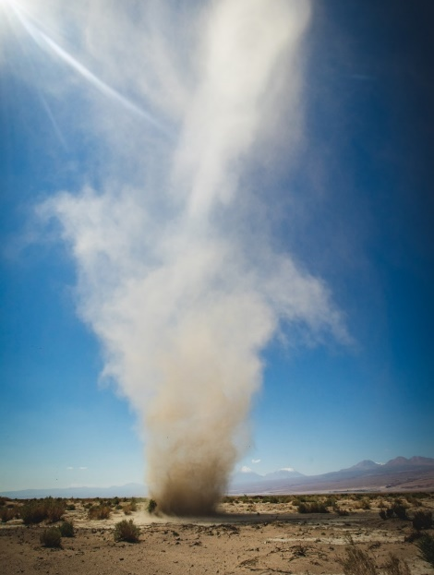  Photo by Ben Klea on Unsplash.com | A dust devil rolls across the Atacama Desert in Chile.
Photo by Holger Link on Unsplash.com | Sydney Harbour Bridge, Sydney, Australia

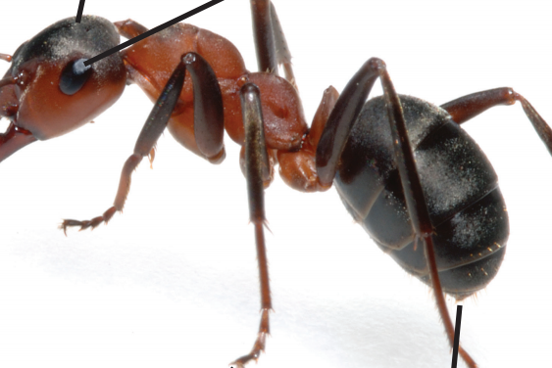  Image sourced from: Year 5 NAPLAN Reading Magazine, ACARA, 2010 | Ocelli (OH-SE-LI)  Ocelli are simple eyes on the top of ants’ heads. Ants use their ocelli to sense light.
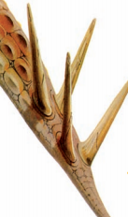  Image sourced from: Year 5 NAPLAN Reading Magazine, 2008 ACARA | Stabbing tail  To defend itself against a predator, Tuojiangosaurus uses its muscular tail, which is armed at the top with two pairs of sharp spikes.
Photo by Maud CORREA on Unsplash.com | Close up of dried soil

Appendix 3

Linking information across texts
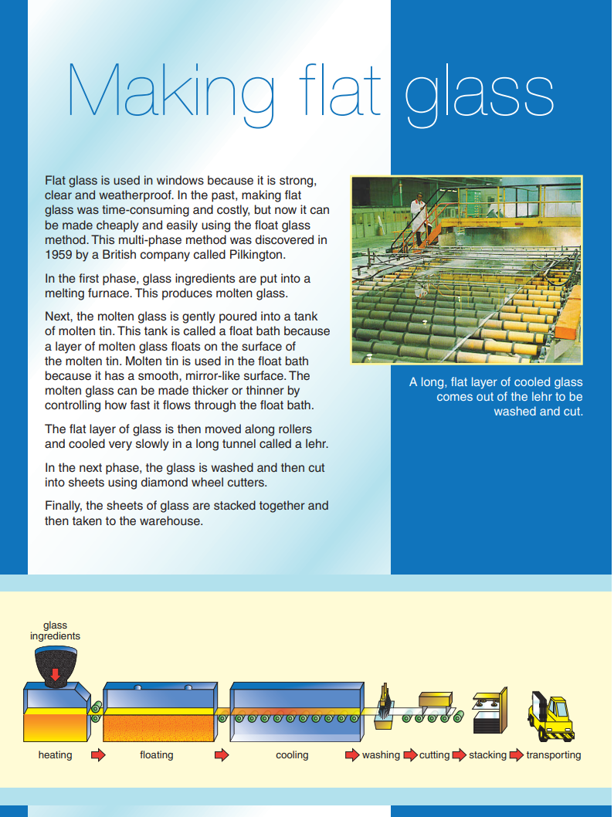
Year 5 NAPLAN Reading Magazine, 2010 ACARA

Appendix 3

Linking information across texts – accessible version

Making flat glass
Flat glass is used in windows because it is strong, clear and weatherproof. In the past, making flat glass was time-consuming and costly, but now it can be made cheaply and easily using the float glass method. This multi-phase method was discovered in 1959 by a British company called Pilkington.
In the first phase, glass ingredients are put into a melting furnace. This produces molten glass.
Next, the molten glass is gently poured into a tank of molten tin. This tank is called a float bath because a layer of molten glass floats on the surface of the molten tin. Molten tin is used in the float bath because it has a smooth, mirror-like surface. The molten glass can be made thicker or thinner by controlling how fast it flows through the float bath.
The flat layer of glass is then moved along rollers and cooled very slowly in a long tunnel called a lehr.
In the next phase, the glass is washed and then cut into sheets using diamond wheel cutters.
Finally, the sheets of glass are stacked together and then taken to the warehouse.
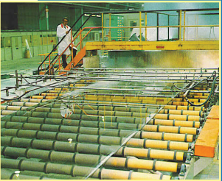
A long, flat layer of cooled glass comes out of the lehr to be washed and cut.
Glass ingredients
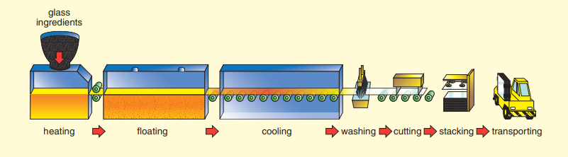
heating floating cooling washing cutting stacking transporting

Year 5 NAPLAN Reading Magazine, 2010 ACARA

Linking information across texts
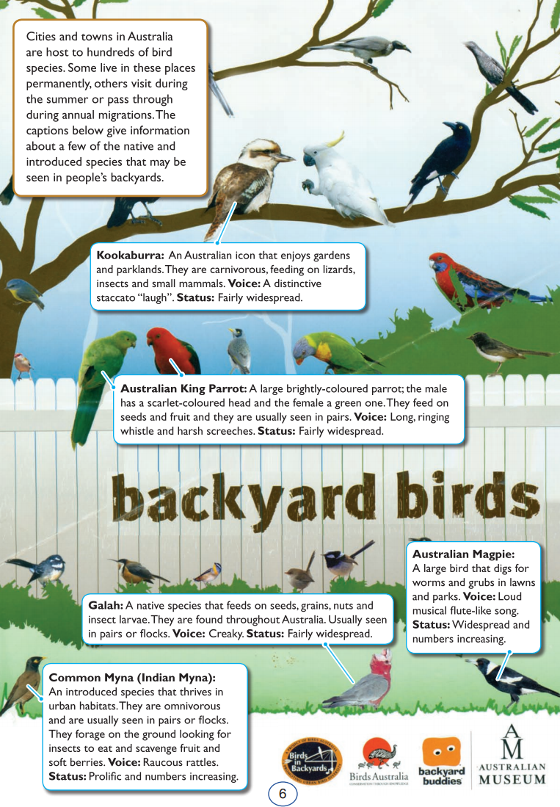
Year 5 NAPLAN Reading Magazine, 2009 ACARA

Linking information across texts – accessible version

backyard birds
Cities and towns in Australia are host to hundreds of bird species. Some live in these places permanently, others visit during the summer or pass through during annual migrations. The captions below give information about a few of the native and introduced species that may be seen in people’s backyards.
Kookaburra: An Australian icon that enjoys gardens and parklands. They are carnivorous, feeding on lizards, insects and small mammals. Voice: A distinctive staccato “laugh”. Status: Fairly widespread.
Australian King Parrot: A large brightly-coloured parrot; the male has a scarlet-coloured head and the female a green one. They feed on seeds and fruit and they are usually seen in pairs. Voice: Long, ringing whistle and harsh screeches. Status: Fairly widespread.
Galah: A native species that feeds on seeds, grains, nuts and insect larvae. They are found throughout Australia. Usually seen in pairs or flocks. Voice: Creaky. Status: Fairly widespread.
Australian Magpie: A large bird that digs for worms and grubs in lawns and parks. Voice: Loud and musical flute-like song. Status: Widespread and numbers increasing.
Common Myna (Indian Myna): An introduced species that thrives in urban habitats. They are omnivorous and are usually seen in pairs or flocks. They forage on the ground looking for insects to eat and scavenge fruit and soft berries. Voice: Raucous rattle. Status: Prolific and numbers increasing.

Year 5 NAPLAN Reading Magazine, 2009 ACARA
Appendix 3

Linking information across texts
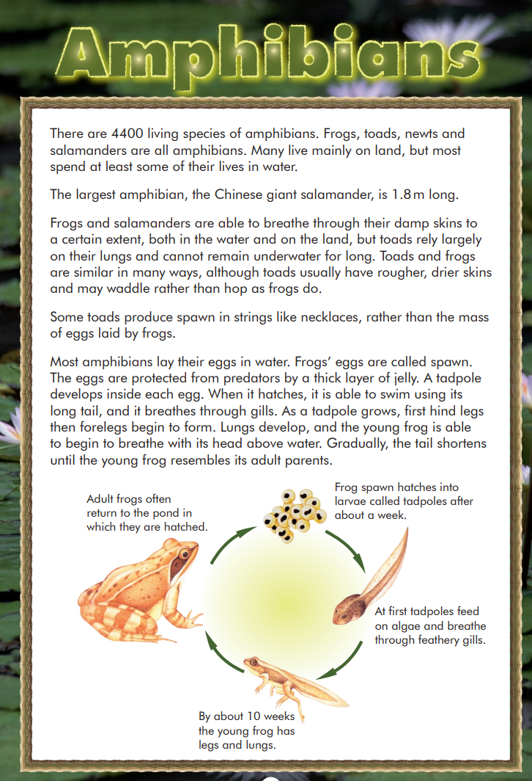
Year 5 NAPLAN Reading Magazine, 2008 ACARA
Appendix 3

Linking information across texts – accessible version
Amphibians
There are 4400 living species of amphibians. Frogs, toads, newts and salamanders are all amphibians. Many live mainly on land, but most spend at least some of their lives in water.
The largest amphibian, the Chinese giant salamander, is 1.8m long.
Frogs and salamanders are able to breathe through their damp skins to a certain extent, both in the water and on the land, but toads rely largely on their lungs and cannot remain underwater for long. Toads and frogs are similar in many ways, although toads usually have rougher, drier skins and may waddle rather than hop as frogs do.
Some toads produce spawn in strings like necklaces, rather than the mass of eggs laid by frogs.
Most amphibians lay their eggs in water. Frogs’ eggs are called spawn. The eggs are protected from predators by a thick layer of jelly. A tadpole develops inside each egg. When it hatches, it is able to swim using its long tail, and it breathes through gills. As a tadpole grows, first hind legs then forelegs begin to form. Lungs develop, and the young frog is able to begin to breathe with its head above water. Gradually, the tail shortens until the young frog resembles its adult parents.
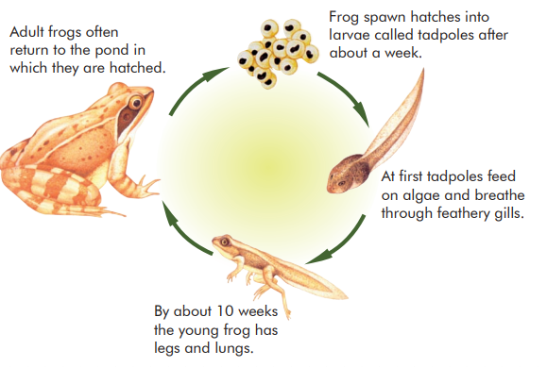
Adult frogs often return to the pond in which they are hatched.
Frog spawn hatches into larvae called tadpoles after about a week.
At first tadpoles feed on algae and breathe through feathery gills.
By about 10 weeks the young frog has legs and lungs.

Year 5 NAPLAN Reading Magazine, 2008 ACARA
Appendix 3

Linking information across texts
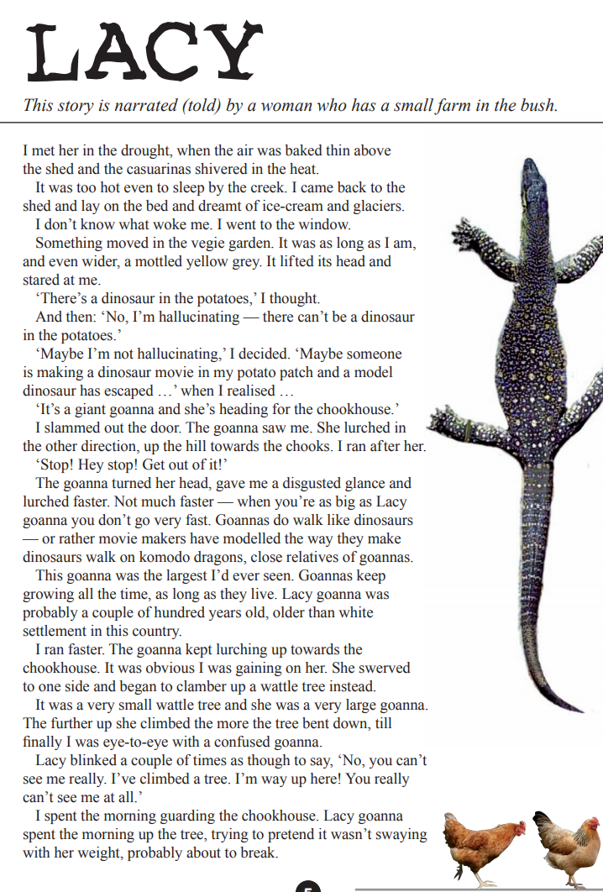
Year 5 NAPLAN Reading Magazine, 2008 ACARA

Linking information across texts - accessible version
LACY
This story is narrated (told) by a woman who has a small farm in the bush.
I met her in the drought, when the air was baked thin above the shed and the casuarinas shivered in the heat.
It was too hot even to sleep by the creek. I came back to the shed and lay on the bed and dreamt of ice-cream and glaciers.
I don’t know what woke me. I went to the window.
Something moved in the vegie garden. It was as long as I am, and even wider, a mottled yellow grey. It lifted its head and stared at me.
‘There’s a dinosaur in the potatoes,’ I thought.
And then: ‘No, I’m hallucinating — there can’t be a dinosaur in the potatoes.’ ‘Maybe I’m not hallucinating,’ I decided.
‘Maybe someone is making a dinosaur movie in my potato patch and a model dinosaur has escaped …’ when I realised …
‘It’s a giant goanna and she’s heading for the chookhouse.’
I slammed out the door. The goanna saw me. She lurched in the other direction, up the hill towards the chooks. I ran after her.
‘Stop! Hey stop! Get out of it!’
The goanna turned her head, gave me a disgusted glance and lurched faster. Not much faster — when you’re as big as Lacy goanna you don’t go very fast. Goannas do walk like dinosaurs — or rather movie makers have modelled the way they make dinosaurs walk on komodo dragons, close relatives of goannas.
This goanna was the largest I’d ever seen. Goannas keep growing all the time, as long as they live. Lacy goanna was probably a couple of hundred years old, older than white settlement in this country.
I ran faster. The goanna kept lurching up towards the chookhouse. It was obvious I was gaining on her. She swerved to one side and began to clamber up a wattle tree instead.
It was a very small wattle tree and she was a very large goanna. The further up she climbed the more the tree bent down, till finally I was eye-to-eye with a confused goanna.
Lacy blinked a couple of times as though to say, ‘No, you can’t see me really. I’ve climbed a tree. I’m way up here! You really can’t see me at all.’
I spent the morning guarding the chookhouse. Lacy goanna spent the morning up the tree, trying to pretend it wasn’t swaying with her weight, probably about to break.
Year 5 NAPLAN Reading Magazine, 2008 ACARA
Appendix 3

Linking information across texts
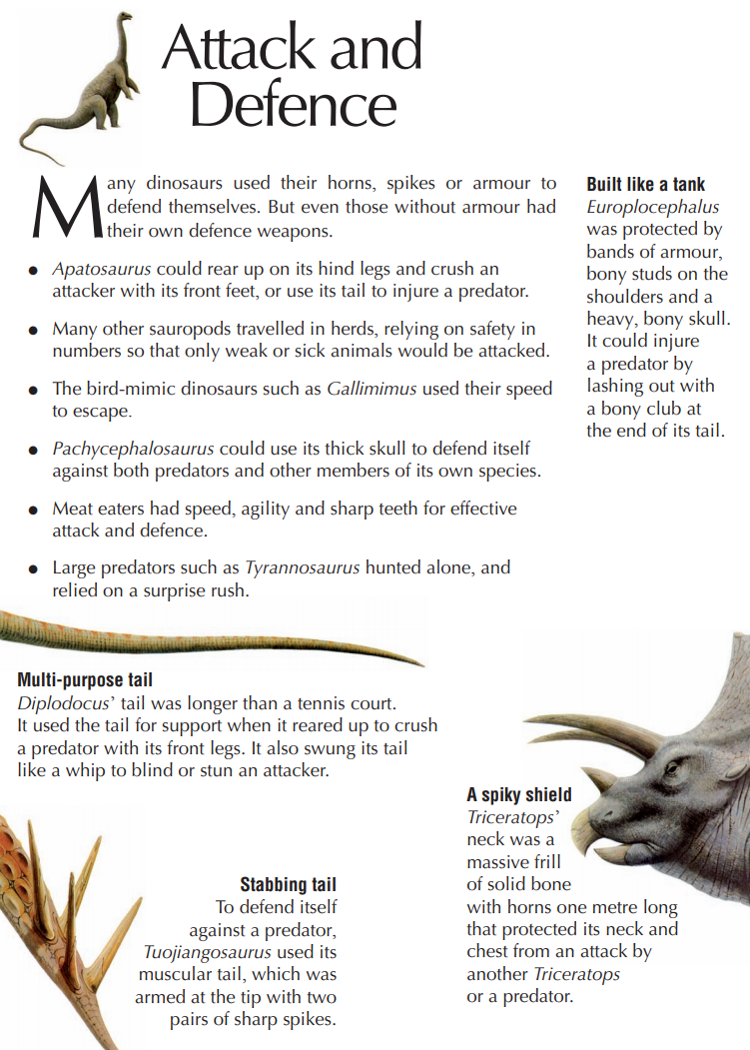
Year 5 NAPLAN Reading Magazine, 2008 ACARA

Linking information across texts - accessible version
Attack and Defence
Many dinosaurs used their horns, spikes or armour to defend themselves. But even those without armour had their own defence weapons.
- Apatosaurus could rear up on its hind legs and crush an attacker with its front feet, or use its tail to injure a predator.
- Many other sauropods travelled in herds, relying on safety in numbers so that only weak or sick animals would be attacked.
- The bird-mimic dinosaurs such as Gallimimus used their speed to escape.
- Pachycephalosaurus could use its thick skull to defend itself against both predators and other members of its own species.
- Meat eaters had speed, agility and sharp teeth for effective attack and defence.
- Large predators such as Tyrannosaurus hunted alone, and relied on a surprise rush.
Built like a tank
Europlocephalus was protected by bands of armour, bony studs on the shoulders and a heavy, bony skull. It could injure a predator by lashing out with a bony club at the end of its tail.
Multi-purpose tail
Diplodocus’ tail was longer than a tennis court. It used the tail for support when it reared up to crush a predator with its front legs. It also swung its tail like a whip to blind or stun an attacker.
Stabbing tail
To defend itself against a predator, Tuojiangosaurus used its muscular tail, which was armed at the tip with two pairs of sharp spikes.
A spiky shield
Triceratops’ neck was a massive frill of solid bone with horns one metre long that protected its neck and chest from an attack by another Triceratops or a predator.

Year 5 NAPLAN Reading Magazine, 2008 ACARA

Appendix 4

Teacher guided editor recommendations
Curious Kids: ‘Do wasps have a queen like bees do?’ Caralyn Zehnder (University of Massachusetts Amherst) at The Conversation, March 2020
A queen bee is a female bee that is the only bee in the hive to lay eggs. She is also the largest bee in the hive.
If you think that wasps have queens, as bees do, you are right. Wasps and bees are similar insects – they are both in the insect group called Hymenoptera, meaning their wings are clear and thin like a membrane. So it makes sense that they would share this kind of social structure.
But if you think that wasps do not have queens, then you are also right! Some wasp species have queens and others don’t.
The same is true for bees, actually: Not all bees live in a hive with a queen.
As an ecologist, I study how animals like bees and wasps interact with each other and their environment.
Wasp and bee species with queens are called social insects. They live together in large groups ranging from 100 to over 50,000 and work together to raise their young. Only one or a few members of the group lay eggs – the queens.
The others watch over the eggs and hunt for food like juicy caterpillars, which is what many wasp babies like to eat. The remaining bees and wasps in the hive do chores such as making wax and cleaning out the hive.
Paper wasps, hornets and yellow jackets are all social wasps. Honey bees and bumblebees are both social bee species. Most bees and wasps, however, are solitary insects who live alone. One female will lay her eggs and bring her offspring food, raising them until adulthood.
Though many people fear bees and wasps because they can sting, both are important for a healthy planet. Bees pollinate many flowers, including crops people eat, such as apples and almonds. And by hunting, wasps help keep down populations of pests like caterpillars and flies.
Unfortunately, these useful insects are in decline worldwide. Pesticides, which are chemicals used to kill pest insects, also kill necessary bugs like bees and wasps. There are also fewer places for wasps and bees to live these days because the cities and farmland that serve humans occupy ever more of their habitat.
If you want to help wasps and bees, make sure your family doesn’t use pesticides in your yard. Planting native plants that provide pollen and nectar will aid these amazing insects, too.

Appendix 5

Editor recommendations

