Compare and contrast
Stage 3

Overview

Purpose

This literacy teaching strategy supports teaching and learning for Stage 3 students across all key learning areas. It targets specific literacy skills and suggests a learning sequence to build skill development. Teachers can select individual tasks, or a sequence, and embed into their teaching and learning program according to their students’ needs. While exemplar texts are provided throughout this resource, it is recommended that teachers select texts which are relevant to their students and curriculum.

Learning intention
Students will learn the difference between comparing and contrasting texts as well as applying these understandings in text analysis.

Syllabus outcomes
The following teaching and learning strategies will assist in covering elements of the following outcomes:
- EN3-RECOM-01: fluently reads and comprehends texts for wide purposes, analysing text structures and language, and by monitoring comprehension
- EN3-UARL-01: analyses representations of ideas in literature through narrative, character, imagery, symbol and connotation, and adapts these representations when creating texts
- EN3-UARL-02: analyses representations of ideas in literature through genre and theme that reflect perspective and context, argument and authority, and adapts these representations when creating texts
NSW English K-10 Syllabus (2022)

Success criteria
The following Year 5 NAPLAN item descriptors may guide teachers to co-construct success criteria for student learning.
- analyses the interrelationship of two texts on a similar theme
- identifies the purpose of a comparison in a text
- links information across two texts on a similar theme

National Literacy Learning Progression guide

Understanding Texts (UnT8-UnT10)
Key: C=comprehension P=process V=vocabulary

UnT8
- evaluates the accuracy within and across texts on the same topic (C)
- explains how textual features support the text’s purpose (C)
- skims and scans texts for key words to track the development of ideas (P)
UnT9
- summarises the text identifying key details only (C)
- builds meaning by actively linking ideas from a number of texts or a range of digital sources (C)
- distils information from a number of texts according to task and purpose (e.g. uses graphic organisers) (C)
- selects reading/viewing strategies appropriate to reading purpose (e.g. scans text for evidence) (P)

UnT10
- applies and articulates criteria to evaluate the language structures and features for relevance to purpose and audience (C)
- integrates automatically a range of processes such as predicting, confirming predictions, monitoring, and connecting relevant elements of the text to build meaning (P)
National Literacy Learning Progression

Evidence base
- Centre for Education Statistics and Evaluation (2017). Effective reading instruction in the early years of school, literature review.
- Konza, D. (2014). Teaching Reading: Why the “Fab Five” should be the “Big Six”. Australian Journal of Teacher Education, 39(12).
- Oakhill, J., Cain, K. & Elbro, C. (2015). Understanding and teaching reading comprehension: A handbook. Routledge.
- Quigley, A. (2020). Closing the reading gap. Routledge.
- Scarborough, H.S. (2001). Connecting early language and literacy to later reading (dis)abilities: Evidence, theory and practice. In S. Neuman & D. Dickson (Eds.), Handbook for research in early literacy (pp. 97-110). New York, NY: Guilford Press.

Alignment to system priorities and/or needs: Five priorities for Literacy and Numeracy, Our Plan for NSW Public Education, School Excellence Policy (nsw.gov.au).
Alignment to School Excellence Framework: Learning domain: Curriculum, Teaching domain: Effective classroom practice and Professional standards
Consulted with: Strategic Delivery, Teaching Quality and Impact
Author: Literacy and Numeracy
Reviewed by: Literacy and Numeracy, Teaching Quality and Impact
Created/last updated: January 2024
Anticipated resource review date: January 2025
Feedback: Complete the online form to provide any feedback

Copyright
Section 113P Notice
Texts, Artistic Works and Broadcast Notice
Some of this material has been copied and communicated to you in accordance with the statutory licence in section 113P of the Copyright Act. Any further reproduction or communication of this material by you may be the subject of copyright protection under the Act. Do not remove this notice.

Teaching strategies
Task | Appendices
Contrasting texts | Appendix 1 – Contrasting Texts
Comparing texts | Appendix 2 - ‘Four corners’ graphic organiser  Appendix 3 - Comparison texts  Appendix 4 - ‘Four corners’

Background information

Contrast
Contrasting involves showing how things are different or opposite..

Compare
Comparing is showing how things are similar or different.
Reference: English K-10 Syllabus © NSW Education Standards Authority (NESA) for and on behalf of the Crown in right of the State of New South Wales, 2022.

Where to next?
- Fact and opinion
- Literal comprehension
- Main idea

Overview of teaching strategies

Purpose
These literacy teaching strategies support teaching and learning from Stage 2 to Stage 5. They are linked to NAPLAN task descriptors, syllabus outcomes and literacy and numeracy learning progressions.
These teaching strategies target specific literacy and numeracy skills and suggest a learning sequence to build skill development. Teachers can select individual tasks or a sequence to suit their students.

Access points
The resources can be accessed from:
- NAPLAN App in Scout using the teaching strategy links from NAPLAN items
- NSW Department of Education literacy and numeracy website.

What works best
Explicit teaching practices involve teachers clearly explaining to students why they are learning something, how it connects to what they already know, what they are expected to do, how to do it and what it looks like when they have succeeded. Students are given opportunities and time to check their understanding, ask questions and receive clear, effective feedback.
This resource reflects the latest evidence base and can be used by teachers as they plan for explicit teaching.
Teachers can use classroom observations and assessment information to make decisions about when and how they use this resource as they design teaching and learning sequences to meet the learning needs of their students.
Further support with What works best is available.

Differentiation
When using these resources in the classroom, it is important for teachers to consider the needs of all students, including Aboriginal and EAL/D learners.
EAL/D learners will require explicit English language support and scaffolding, informed by the EAL/D enhanced teaching and learning cycle and the student’s phase on the EAL/D Learning Progression. Teachers can access information about supporting EAL/D learners and literacy and numeracy support specific to EAL/D learners.
Learning adjustments enable students with disability and additional learning and support needs to access syllabus outcomes and content on the same basis as their peers. Teachers can use a range of adjustments to ensure a personalised approach to student learning.
Assessing and identifying high potential and gifted learners will help teachers decide which students may benefit from extension and additional challenge. Effective strategies and contributors to achievement for high potential and gifted learners helps teachers to identify and target areas for growth and improvement. A differentiation adjustment tool can be found on the High potential and gifted education website.

Using tasks across learning areas
This resource may be used across learning areas where it supports teaching and learning aligned with syllabus outcomes.
Literacy and numeracy are embedded throughout all syllabus documents as general capabilities. As the English and mathematics learning areas have a particular role in developing literacy and numeracy, NSW English and Mathematics syllabus outcomes aligned to literacy and numeracy skills have been identified.

Text selection
Example texts are used throughout this resource. Teachers can adjust activities to use texts which are linked to their unit of learning.
Further support with text selection can be found within the National Literacy Learning Progression Text Complexity appendix.
The NESA website has additional information on text requirements within the NSW English syllabus.

Teaching strategies

Contrasting texts
- Discuss how contrasting means to only look at the differences in a text. Discuss importance of identifying audience, vocabulary, purpose, audience and potential bias that may exist in the text when contrasting them.
- Students explore a range of suitable texts on the same topic relevant to a current unit of learning, or Appendix 1 – Contrasting Texts. In pairs, students identify the differences between texts, discussing why they think there are differences and providing evidence to support their findings. Students could contrast how language features, such as tone, are used differently in texts with a similar theme. To increase complexity, students could assess and justify which text communicates its message more effectively. Students then edit the less effective text, using language structures and features to increase its appeal and/or create their own text on the same topic for a target audience of their choice.
- To increase creative and critical thinking, have students use different graphic organisers to categorise information. Students could compare two representations and justify which adds more clarity.

Comparing texts
- Four Corners: Students compare and contrast two ideas being explored in the current unit of learning. Teacher models, using a range of sources, to build information and understanding on a topic using four corners graphic organiser (refer to Appendix 2 - ‘Four corners’ graphic organiser).
native Australian honey bees | European honey bee
Both native Australian honey bee and European honey bee | Neither native Australian honey bee nor European bee
- Teacher models skimming and scanning a section of text 1 (Appendix 3 - Comparison texts), drawing attention to:
- vocabulary
- main idea
- supporting details
- re-reading text to clarify understanding
- numbering paragraphs to organise where evidence is found
- Teacher models how to draw information from the text and enter onto the four corners graphic organiser using dot points and key vocabulary.
- Students are given one of the two texts from Appendix 3 - Comparison texts to read, summarise and annotate. Students partner with someone who has read the alternate text and share their summaries.
- Students work together to colour-code and track similar ideas across the two texts.
- Working together, students complete the four corners quadrant (Appendix 4 - ‘Four corners’) to compare the two texts, using evidence to justify their decision. The final quadrant requires students to research an additional source on the same topic to verify information.
To increase complexity: Students could present their findings to the class using a graphic organiser of their choice, explaining what each new source added to the main idea, outlining information that required verification from the third source, and assessing the importance of accessing more than one source for research.

Appendix 1

Contrasting texts
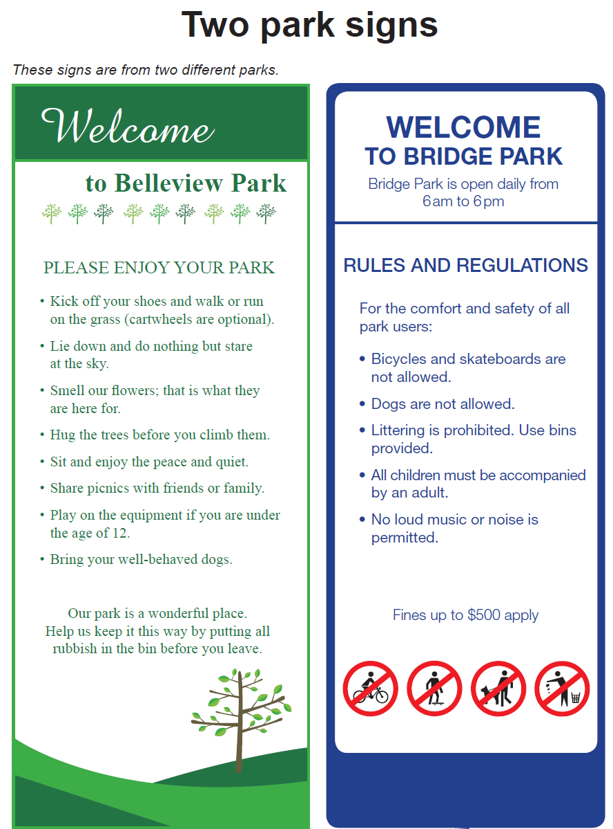
Year 5 NAPLAN Reading Magazine, 2015 ACARA

Compare texts - accessible version
Two park signs
These signs are from two different parks.
Sign 1- Welcome to Bellview Park
PLEASE ENJOY YOUR PARK
• Kick off your shoes and walk or run on the grass (cartwheels are optional).
• Lie down and do nothing but stare at the sky.
• Smell our flowers; that is what they are here for.
• Hug the trees before you climb them.
• Sit and enjoy the peace and quiet.
• Share picnics with friends or family.
• Play on the equipment if you are under the age of 12.
• Bring your well-behaved dogs.
Our park is a wonderful place. Help us keep it this way by putting all rubbish in the bin before you leave.
Sign 2- WELCOME TO BRIDGE PARK
Bridge Park is open daily from 6am to 6pm
RULES AND REGULATIONS
For the comfort and safety of all park users:
• Bicycles and skateboards are not allowed.
• Dogs are not allowed.
• Littering is prohibited. Use bins provided.
• All children must be accompanied by an adult.
• No loud music or noise is permitted.
Fines up to $500 apply
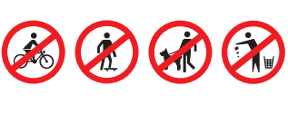
Year 5 NAPLAN Reading Magazine, 2015 ACARA

Appendix 2

Four corners
Concept 1 | Both Concept 1 and 2
Concept 2 | Neither Concept 1 nor 2

Appendix 3

Text comparison (Text 1)

Health check: how much sugar is ok to eat?
By Kacie Dickinson & Louisa Matwiejczyk (Flinders University) at The Conversation, May 23, 2016.
Consuming too much energy – whether from fat or carbohydrates, including sugar – will make you gain weight. If left unchecked, this excess weight increases your risk of lifestyle-related diseases such as diabetes, heart disease and some cancers.
In recognition of this, the World Health Organisation (WHO) recommends adults and children limit their intake of “free sugars” to less than 10% of their total energy intake. Below 5% is even better and carries additional health benefits.
Free sugars refer to monosaccharides (such as glucose) and disaccharides (sucrose or table sugar) added to foods and drinks by the manufacturer, cook or consumer. It also refers to sugars naturally present in honey, syrups, fruit juices and fruit juice concentrates.
Free sugars are different from sugars found in whole fresh fruits and vegetables. There is no scientific evidence that consuming these sugars leads to health problems. So the guidelines don’t apply to fresh fruit and vegetables.
If you’re an average-sized adult eating and drinking enough to maintain a healthy body weight (roughly 8,700 kilojoules per day), 10% of your total energy intake from free sugar roughly translates to no more than 54 grams, or around 12 teaspoons, per day.
But more than half of Australians (52%) usually exceed the WHO recommendations.
Most sugar we eat (around 75%) comes from processed and pre-packaged foods and drinks. The rest we add to tea, coffee and cereal, and other foods we cook.
Sugary drinks account for the largest proportion of Australians’ free sugar intake. A single can or 600ml bottle of soft drink can easily exceed the WHO recommendation, providing around 40-70g sugar. One teaspoon equates to 4.5g white sugar, so soft drinks range from 8.5 to 15.5 teaspoons.
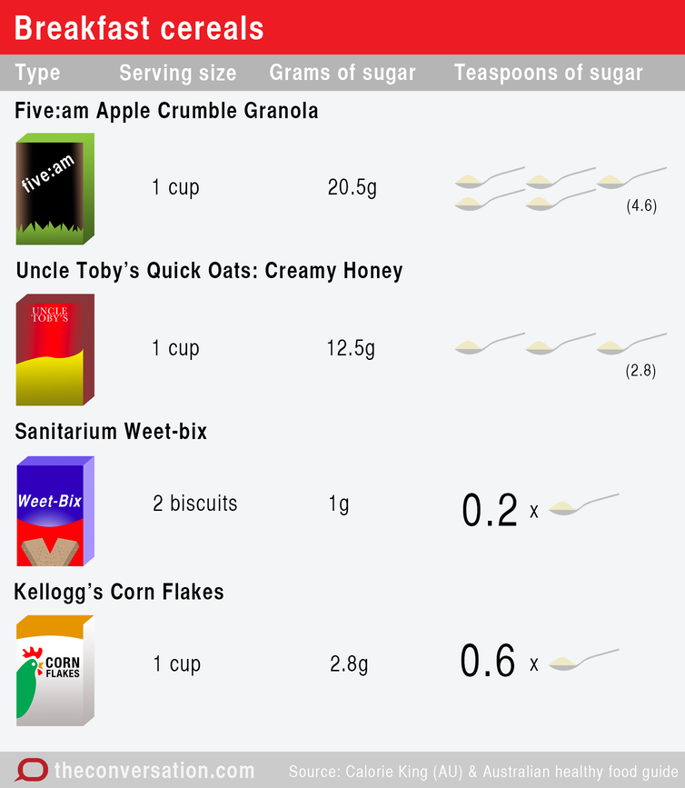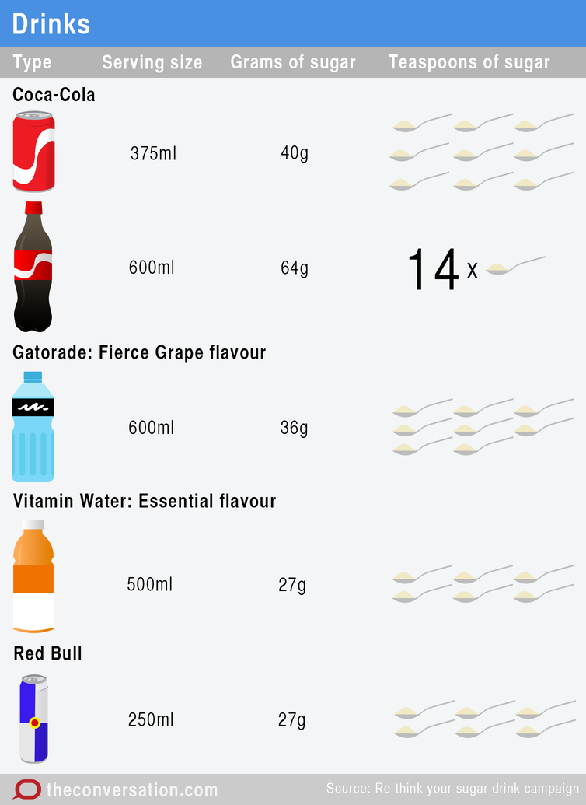
More insidious sources of sugar are drinks marketed as “healthier” options, such as iced teas, coconut water, juices and smoothies. Some medium-sized smoothies have up to 14 teaspoons of sugar (63.5g) in a 475ml drink.
Flavoured milks are also high in free sugars (11 teaspoons in a 500ml carton) but can be a good source of calcium.
Other foods high in sugar are breakfast cereals. While some sugar is derived from dried fruit, many popular granola mixes add various forms of sugar. Sugar content for one cup of cereal ranges from 12.5g for creamy honey quick oats to 20.5g for granola. A cup of some types of cereal can contain 30% to 50% of your daily free sugar allowance.
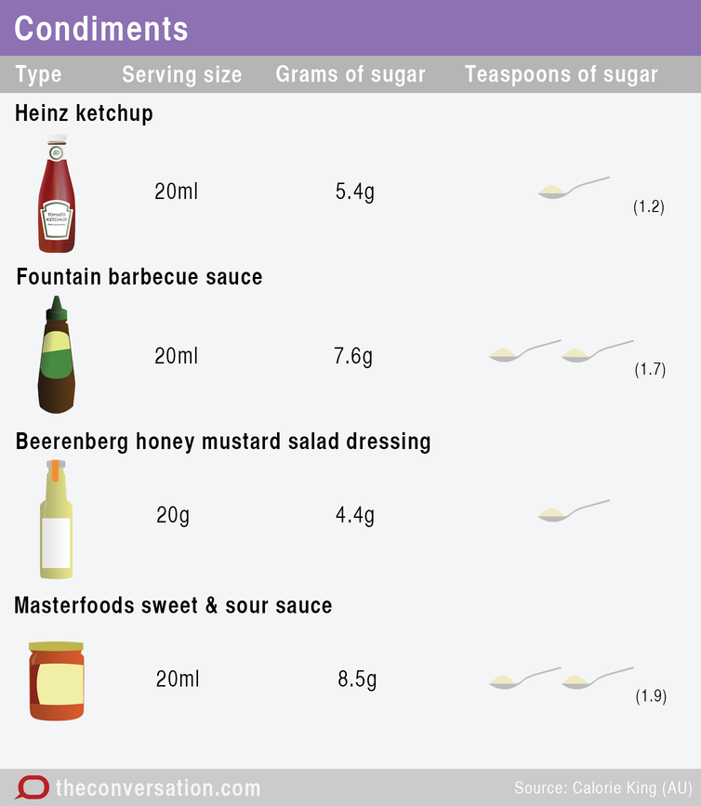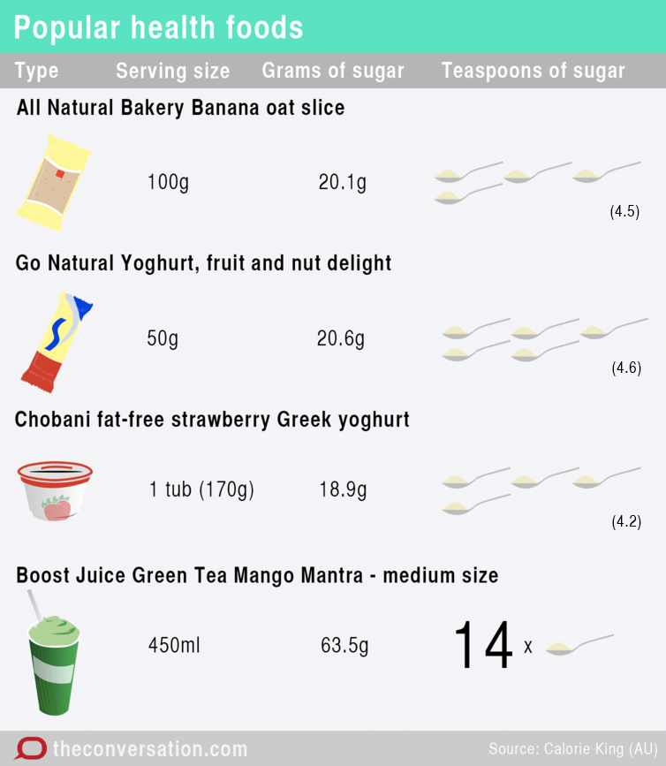
A surprise for many is the added sugars in savoury foods including sauces and condiments. Tomato and barbecue sauce, salad dressing and sweet 'n' sour stir-fry sauces contain one to two teaspoons of sugar in each tablespoon (20ml).
Popular “health foods” and sugar-free recipes can be particularly misleading as they can contain as much sugar as their sweet alternatives. Usually this is referring to “sucrose-free” (what we know as white sugar) and doesn’t exclude the use of other sugar derivatives such as rice malt syrup, agave or maple syrup, typical of popular sugar-free recipes. These are still forms of sugar and contribute to energy intake and unhealthy weight gain when consumed in excess.
We know treats such as chocolate, pastries and ice-cream do contain sugar, but just how much might surprise you. A chocolate-coated ice cream will contribute five teaspoons of sugar, or almost half the daily limit.
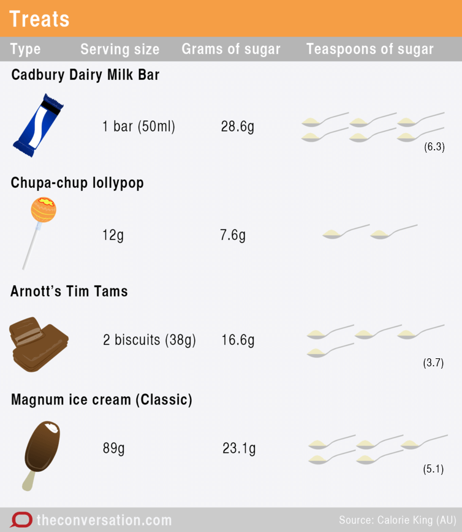
Sugar added to foods and drink can have different names depending on where it comes from. When reading labels, alternative names for sugar include:

- sucrose
- glucose
- corn syrup
- maltose
- dextrose
- raw sugar
- cane sugar
- malt extract
- fruit juice concentrate
- molasses.

The main ingredient is sugar if any of these are listed as the first three ingredients.
Note that products with “no added sugar” nutrition claims may still contain high levels of natural sugars, also considered as free sugars. A good example of this is fruit juice: the sugar content of 200ml of sweetened orange juice (21g) is 7g higher than unsweetened juice (14g).
So how can you cut down on your added sugars?
First, eat fewer foods with free sugars. Reduce your intake of sweets such as chocolate and lollies, cakes, biscuits, sugar-sweetened soft drinks, cordials, fruit drinks, vitamin waters and sports drinks.
Second, make some swaps. Swap your cereal for a lower-sugar variety and limit the amount of sugar you add. Drink plain tap water and swap brands for sugar-free or those with lower added sugar. Swap fruit juices for whole fruits, which also give you fibre and other health-promoting nutrients.
Finally, read the labels on packaged food and drink. If the product has more than 15g of sugar per 100g, check to see if sugar is one of the main ingredients. If it is, use the nutrient information panel to compare and choose products containing less sugar.
Graphics are licensed by CC BY-ND

Appendix 3

Text comparison (Text 2)

If sugar is so bad for us, why is the sugar in fruit ok?
By Kacie Dickinson, Flinders University & Jodi Bernstein University of Toronto at The Conversation, March 8, 2018.
We hear regularly from health organisations and experts that we should eat less sugar. But we’re also told we should eat more fruit.
All types of sugar will give us the same amount of calories, whether they are from fruit or soft drink. But the health risks of eating sugar are related to consuming too many “free sugars” in the diet, not from eating sugars that are naturally present in fruits or milk.

Types of sugar in food
Sugar in food and drinks comes in various forms. Sugar molecules are classified as monosaccharides (single sugar molecules such as glucose and fructose) and disaccharides (more complex structures such as sucrose and lactose).
Fruit contains natural sugars, which are a mix of sucrose, fructose and glucose. Many people have heard that sugar is bad, and think that this must also therefore apply to fruits.
But fructose is only harmful in excess amounts, and not when it comes from fruit. It would be incredibly difficult to consume excessive amounts of fructose by eating whole fruits.
It’s much easier to consume excess sugar from foods and drinks that contain “free sugars”.
Free sugars include these same sugars (fructose, glucose, sucrose), but in this case they have been removed from their naturally occurring source (rather than being eaten as natural parts of fruits, dairy products, and some vegetables and grains). This includes sugar that is added to food and drinks by food companies, cooks or consumers.

Health risks come from free sugars, not fruits
Evidence shows that the health risks from sugars, such as tooth decay and unhealthy weight gain, are related to consuming too many free sugars in the diet, not from eating sugars that are naturally present in fruits or milk.
For this reason it is recommended that no more than 10% of your daily calories come from free sugars. For the average adult, this is about 50g or only slightly more than the amount of sugar in a can of regular soft drink or soda. It’s estimated that Australians get around 60% (65g) of their sugar intake from free sugars.
Foods that are sources of free sugars, such as juices, soft drinks, biscuits and lollies, are often high in calories and have little other nutritional value. It is often easy to consume more of them compared with fresh fruit and they also may be replacing other nutritious foods in the diet.
Consider a bottle of fruit juice – you would have to eat six whole oranges to get the same amount of sugar you consume in the juice. And because the fruit is in juice form, it counts towards your daily limit of free sugars.
Calories from drinks that contain sugar often become an addition to the calories you are eating from food, which may lead to weight gain over time.
Eating large amounts of dried fruit is also not a good idea if you are limiting your sugar intake. Through the process of removing water from the fruit, nutrients are concentrated, such that dried apricots, for example, contain about six times as much sugar (40g per 100g) as fresh apricots (6g per 100g).

We need to eat fruit
Unlike many foods that are high in free sugars, fruits are packaged with lots of nutrients that help provide us with a balanced diet for good health.
For starters, fruit is an excellent source of fibre. An average banana will provide 20-25% (6g) of your recommended daily fibre intake. Getting enough fibre in the diet is important for protecting against bowel cancer. There is clear room for improvement in our fibre intake – adults in many countries consume only about half of the recommended amount each day (25g for Aussie women and 30g for Aussie men).
The fibre in fruit, which is often absent in many foods and drinks with free sugars, may also help to fill you up, which means you eat less overall at a meal. It’s not clear exactly why this is, but it could be related to the volume of the food (especially compared with liquids) and the chewing involved.
Fruit is also a good source of other nutrients such as potassium, which can help lower blood pressure, and flavonoids, which may reduce your risk of heart disease.
There is evidence that eating whole fruits (alone and in combination with vegetables) reduces your chances of dying from cancer, obesity and heart disease.
Despite this, only about 50% of Australians eat at least two pieces of fruit per day.
Most national dietary guidelines encourage eating fruits and vegetables, with an emphasis on the vegetables. To try and eat your recommended two pieces of fruit per day remember that a piece could be a banana, apple or orange, or two smaller fruits like plums or apricots, or a cup of grapes or berries.
Read more: Food as medicine: why do we need to eat so many vegetables and what does a serve actually look like?
When it comes to other sources of sugars, try to choose foods that have little or no sugar listed in the ingredient list, and drink water instead of sugary beverages when you are thirsty.

Appendix 4

Four corners: sugar
Text 1 | Both Text 1 and 2
Text 2 | Neither Text 1 nor 2

