Audience and purpose
Stage 3

Overview

Purpose
This literacy teaching strategy supports teaching and learning for Stage 3 students across all key learning areas. It targets specific literacy skills and suggests a learning sequence to build skill development. Teachers can select individual tasks, or a sequence, and embed into their teaching and learning program according to their students’ needs. While exemplar texts are provided throughout this resource, it is recommended that teachers select texts which are relevant to their students and curriculum.

Learning intention
Students will have opportunities to identify the purpose and audience of a range of fiction and non-fiction texts.

Syllabus outcome
The following teaching and learning strategies will assist in covering elements of the following outcomes:
- EN3-RECOM-01: fluently reads and comprehends texts for wide purposes, analysing text structures and language, and by monitoring comprehension.
NSW English K-10 Syllabus (2022)

Success criteria
The following Year 5 NAPLAN item descriptors may guide teachers to co-construct success criteria for student learning.

- identifies the main purpose of a paragraph in an information text
- identifies the main purpose of a persuasive text
- identifies the main purpose of a website
- identifies the main purpose of an information text
- identifies the moral underlying a narrative
- identifies the purpose of a diagram in a text
- identifies the purpose of a paragraph in a text
- identifies the purpose of a reference in a persuasive text
- identifies the purpose of a rhetorical question in a text
- identifies the purpose of a sentence in a text.

National Literacy Learning Progression guide

Understanding Texts (UnT8-UnT10)
Key: C=comprehension P=process V=vocabulary

UnT8
- explains how textual features support the text’s purpose (P)
- uses knowledge of the features and conventions of the type of text to build meaning (e.g. recognises that the beginning of a persuasive text may introduce the topic and the line of argument) (P)

UnT9
- distils information from a number of texts according to task and purpose (e.g. uses graphic organisers) (C)
- evaluates text features for relevance to purpose and audience (C)
- analyses texts which have more than one purpose and explains how parts of the text support a particular purpose (C)
- analyses the use of language appropriate to different types of texts (e.g. compare the use of pun in imaginative and persuasive texts) (C)
- selects reading/viewing strategies appropriate to reading purpose (e.g. scans text for evidence) (P)

UnT10
- applies and articulates criteria to evaluate the language structures and features for relevance to purpose and audience (C)
National Literacy Learning Progression

Evidence base
- Centre for Education Statistics and Evaluation (2017). Effective reading instruction in the early years of school, literature review.
- Konza, D. (2014). Teaching Reading: Why the “Fab Five” should be the “Big Six”. Australian Journal of Teacher Education, 39(12).
- Oakhill, J., Cain, K. & Elbro, C. (2015). Understanding and teaching reading comprehension: A handbook. Routledge.
- Quigley, A. (2020). Closing the reading gap. Routledge.
- Scarborough, H.S. (2001). Connecting early language and literacy to later reading (dis)abilities: Evidence, theory and practice. In S. Neuman & D. Dickson (Eds.), Handbook for research in early literacy (pp. 97-110). New York, NY: Guilford Press.
Alignment to system priorities and/or needs: Five priorities for Literacy and Numeracy, Our Plan for NSW Public Education , School Excellence Policy (nsw.gov.au).
Alignment to School Excellence Framework: Learning domain: Curriculum, Teaching domain: Effective classroom practice and Professional standards
Consulted with: Strategic Delivery, Teaching Quality and Impact
Author: Literacy and Numeracy
Reviewed by: Literacy and Numeracy, Teaching Quality and Impact
Created/last updated: January 2024
Anticipated resource review date: January 2025
Feedback: Complete the online form to provide any feedback

Copyright
Section 113P Notice
Texts, Artistic Works and Broadcast Notice
Some of this material has been copied and communicated to you in accordance with the statutory licence in section 113P of the Copyright Act. Any further reproduction or communication of this material by you may be the subject of copyright protection under the Act. Do not remove this notice.

Teaching strategies
Task | Appendices
Identifying purpose and audience
Analysing texts for purpose and audience | Appendix 1 - Birthday on Mars: Adam Spencer  Appendix 2 - Audience and purpose text analysis quadrant  Appendix 3 - Jigsaw analysis
Analysing persuasive texts for purpose and audience | Appendix 4 - Game review: sentence detectives  Appendix 5 - Sentence bank  Appendix 6 - Purpose of text matrix

Background information

Purpose
The purpose of a text is to entertain, to inform or to persuade different audiences in different contexts. Composers use a number of ways to achieve these purposes: persuading through emotive language, analysis or factual recount; entertaining through description, imaginative writing or humour, and so on.

Audience
Readers, listeners or viewers who engage with a text.
Reference: English K-10 Syllabus © NSW Education Standards Authority (NESA) for and on behalf of the Crown in right of the State of New South Wales, 2012 and 2022.

Where to next?
- Understanding perspective
- Text features
- Inference

Overview of teaching strategies

Purpose
These literacy teaching strategies support teaching and learning from Stage 2 to Stage 5. They are linked to NAPLAN task descriptors, syllabus outcomes and literacy and numeracy learning progressions.
These teaching strategies target specific literacy and numeracy skills and suggest a learning sequence to build skill development. Teachers can select individual tasks or a sequence to suit their students.

Access points
The resources can be accessed from:
- NAPLAN App in Scout using the teaching strategy links from NAPLAN items
- NSW Department of Education literacy and numeracy website.
What works best
Explicit teaching practices involve teachers clearly explaining to students why they are learning something, how it connects to what they already know, what they are expected to do, how to do it and what it looks like when they have succeeded. Students are given opportunities and time to check their understanding, ask questions and receive clear, effective feedback.
This resource reflects the latest evidence base and can be used by teachers as they plan for explicit teaching.
Teachers can use classroom observations and other assessment information to make decisions about when and how they use this resource as they design teaching and learning sequences to meet the learning needs of their students.
Further support with What works best is available.
Differentiation
When using these resources in the classroom, it is important for teachers to consider the needs of all students, including Aboriginal and EAL/D learners.
EAL/D learners will require explicit English language support and scaffolding, informed by the EAL/D enhanced teaching and learning cycle and the student’s phase on the EAL/D Learning Progression. Teachers can access information about supporting EAL/D learners and literacy and numeracy support specific to EAL/D learners.
Learning adjustments enable students with disability and additional learning and support needs to access syllabus outcomes and content on the same basis as their peers. Teachers can use a range of adjustments to ensure a personalised approach to student learning.
Assessing and identifying high potential and gifted learners will help teachers decide which students may benefit from extension and additional challenge. Effective strategies and contributors to achievement for high potential and gifted learners helps teachers to identify and target areas for growth and improvement. A differentiation adjustment tool can be found on the High potential and gifted education website.

Using tasks across learning areas
This resource may be used across learning areas where it supports teaching and learning aligned with syllabus outcomes.
Literacy and numeracy are embedded throughout all K-10 syllabus documents as general capabilities. As the English and mathematics learning areas have a particular role in developing literacy and numeracy, NSW English and Mathematics syllabus outcomes aligned to literacy and numeracy skills have been identified.

Text selection
Example texts are used throughout this resource. Teachers can adjust activities to use texts which are linked to their unit of learning.
Further support with text selection can be found within the National Literacy Learning Progression Text Complexity appendix.
The NESA website has additional information on text requirements within the NSW English syllabus.

Teaching strategies

Identifying purpose and audience
- Searching for signs: Students walk around the school to identify the purpose and audience of any signs or notices: why are these here? Who are they for? Brainstorm other signs in their local and national communities, for example, a notice from the local council to be water wise is to both persuade and inform the local community to preserve water in times of drought.
- Jigsaw task: students work in groups and are given one of the three broad purposes of text (entertain, inform or persuade) to research. Students come up with a guide to help categorise texts into these three areas and some examples of where these might be found. For example, a recipe informs but may also have elements of persuasion or entertainment if on a blog. Students come back together with their information to create a collaborative guide to identify the purpose of texts.

Analysing texts for purpose and audience
- Display Adam Spencer’s text excerpt ‘Birthday on Mars’. (Appendix 1 - Birthday on Mars: Adam Spencer.) Allow time for students to Think-Pair-Share with a partner as to what the purpose of the text is, the intended audience, the vocabulary used and included subject matter. To further support students, have students work with a more skilled reader and use sentence starters such as “The purpose of this text is to….” and “ I believe the intended audience is _____________ because _____________”.
- Teacher models the process of categorising information in these four areas using Appendix 2 - Audience and purpose text analysis quadrant.
- Gallery Walk: Display a range of texts in workstations around the classroom, including Aboriginal and different cultural texts and artworks, picture books, newspaper articles, recipes, furniture construction instructions, magazines, websites and advertisements. Issue an A3 piece of paper for each text and divide the page in four (refer to Appendix 2 - Audience and purpose text analysis quadrant). Students discuss in their groups the purpose or type of text, the audience, key vocabulary and subject matter. Students rotate to another text and complete the process, adding on information from previous groups. Share and discuss how language and text features, structure of text, vocabulary choice and subject matter will determine the purpose and audience and these are intentional decisions made by the text creator.
To increase complexity, students are issued texts which include more than one element of persuasive, informative and/or narrative. Using Appendix 2 - Audience and purpose text analysis quadrant students justify which category the text mostly fits into.
- Teacher enlarges Appendix 3 - Jigsaw analysis and cuts each part into pieces without allowing the students to see the whole text. Students use Appendix 2 - Audience and purpose text analysis quadrant as a template to determine the purpose of their sections and, when all the pieces of the puzzle are together, the class determines the intended audience of the text. Discuss ideas and allow time for rigorous discussion to build upon ideas.
To increase abstraction, students could discuss how ethics are used to persuade in this text. While it is against the law to feed the animals, is this legal aspect the focus of the text? Students highlight emotive language which persuades, such as friend, being kind, cruel not kind, make them sick.
Analysing persuasive texts for purpose and audience
- Teacher to prompt class discussion on the purpose and audience of a review. ‘What is a review? What does the word review mean? Where might we find reviews? Are reviews information texts or persuasive texts? Why might someone read a review? What types of reviews would you read? Your teacher? If you wanted to read a review for the latest game, where might you find it? What kinds of language features and language would you expect in a review of a computer game? Do you think this type of language might be different for different audiences?’ Brainstorm and record student responses.
- Sentence Detectives: In pairs, students locate the missing sections which have been removed from ‘Game Review Crawlin’ Kitten 2’, (Appendix 4 - Game Review: sentence detectives).
Teacher to use the ‘think aloud’ strategy to model how to use the sentence bank to fill in the first gap. Students will need to closely examine the evidence to see which sentence or sentence fragment from the sentence bank helps achieve the purpose of the review (Appendix 5 - Sentence Bank). Students use Appendix 6 - Purpose of Text Matrix to organise their ideas. Each pair reports back on their sentence choice, using the following sentence starters:
  - We have chosen this sentence or sentence fragment as the missing section for paragraph _______
  - The purpose of this paragraph is to ___________________
  - The language features and/or word choice which show the purpose of this paragraph are _________
  - Therefore, the correct sentence, which matches the purpose of the remainder of the paragraph is __________________ because of these language features and word choice ________________
To increase abstraction, students discuss with a peer and justify why their choice of sentence or sentence fragment is more appropriate to the purpose of the paragraph and the entire text. Pairs may prompt each other by asking ‘What makes you say that?’

Appendix 1

Birthday on Mars – Adam Spencer
A year on Earth is 365 days (unless it’s a leap year) but the actual definition of a ‘year’ is the time it takes a planet to orbit the Sun.
So if you like having birthday parties like I do, you should hang out on Mercury where you can have four times as many birthdays as you have on Earth.
Stay away from Pluto, though. You’ll be 247 Earth years old before you even get to have your FIRST birthday!
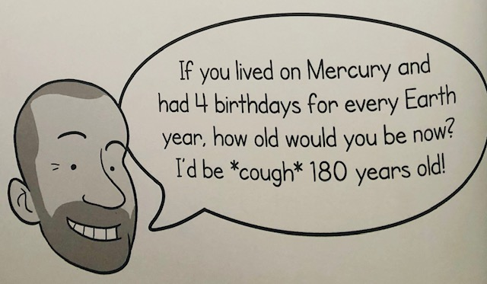

How long’s a year?
Mercury: 88 days
Venus: 225 days
Earth: 1 year or 365 days
Mars: 1.9 years or 687 days
Jupiter: 12 years or 4333 days
Saturn: 29.5 years or 10 759 days
Uranus: 84 years or 30 687 days
Neptune: 165 years or 60 190 days
Pluto: 247.5 years or 90 465 days
Eris: 558 years or 203 830 day
Adam Spencer’s mind-boggling maths, outrageous puzzles, enormous super-cool games book of numbers and heaps of other fun stuff. Adam Spencer, Xoum Publishing, 2015

Birthday on Mars – Adam Spencer
Birthday on Mars
A year on Earth is 365 days (unless it’s a leap year) but the actual definition of a ‘year’ is the time it takes a planet to orbit the Sun.
So if you like having birthday parties like I do, you should hang out on Mercury where you can have four times as many birthdays as you have on Earth.
Stay away from Pluto, though. You’ll be 247 Earth years old before you even get to have your FIRST birthday!
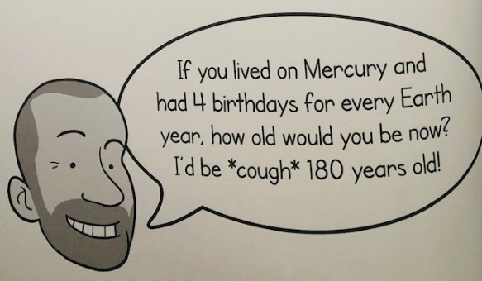
How long’s a year?
Mercury: 88 days
Venus: 225 days
Earth: 1 year or 365 days
Mars: 1.9 years or 687 days
Jupiter: 12 years or 4333 days
Saturn: 29.5 years or 10 759 days
Uranus: 84 years or 30 687 days
Neptune: 165 years or 60 190 days
Pluto: 247.5 years or 90 465 days
Eris: 558 years or 203 830 day

Purpose
The purpose of this text is to inform and entertain.
Evidence:
- Information how many days are in a year on Earth and Mars –‘365 days’
- Connecting with audience with a joke about birthday parties. ‘If you like having birthday parties like I do, you should hang out on Mercury where you can have four times as many birthdays…’
- Facts and data – ‘165 years or 60 190 days.’

Audience
The audience of this text may be teenagers
Evidence:
- Using everyday vocabulary like “So if you like…” and “Stay away from Pluto though” and “hang out”
- Using humour “cough” in the speech bubble.
Adam Spencer’s mind-boggling maths, outrageous puzzles, enormous super-cool games book of numbers and heaps of other fun stuff. Adam Spencer, Xoum Publishing, 2015

Appendix 2

Audience and purpose quadrant analysis
Text: ___________________________________________
Purpose | Audience
Does it inform, persuade or entertain?  What type of text is this? | Who is this written for?

Vocabulary | Subject matter
Vocabulary evidence for purpose and audience | What is the text about?

Appendix 3

Jigsaw analysis
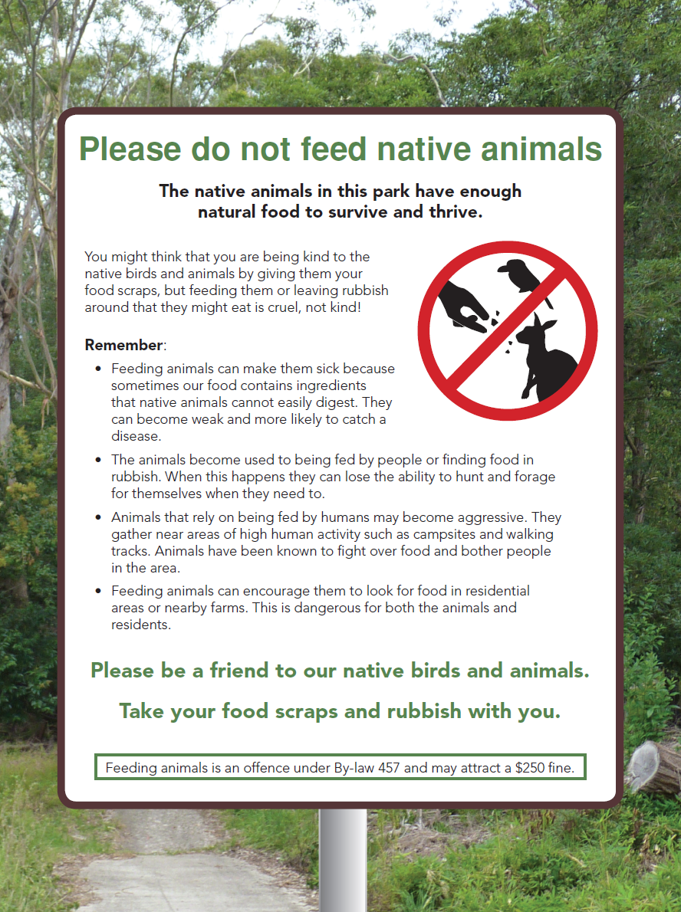
Year 5 NAPLAN Reading Magazine, 2016 ACARA

Accessible jigsaw analysis
Please do not feed native animals
The native animals in this park have enough natural food to survive and thrive.
You might think that you are being kind to the native birds by giving them your food scraps, but feeding them or leaving rubbish around that they might eat is cruel, not kind.
Remember:
- Feeding animals can make them sick because sometimes our food contains ingredients that native animals cannot easily digest. They can become weak and more likely to catch a disease.
- The animals become used to being fed by people or finding food in rubbish. When this happens they can lose the ability to hunt and forage for themselves when they need to.
- Animals that rely on being fed by humans may become aggressive. They gather near areas of high human activity such as campsites and walking tracks. Animals have been known to fight over food and bother people in the area.
- Feeding animals can encourage them to look for food in residential areas or nearby farms. This is dangerous for both the animals and residents.
Please be a friend to our native birds and animals.
Take your food scraps and rubbish with you.
Feeding animals is an offence under By-law 457 and may attract a $250 fine.
Year 5 NAPLAN Reading Magazine, 2016 ACARA
Appendix 4

Game Review: sentence detectives
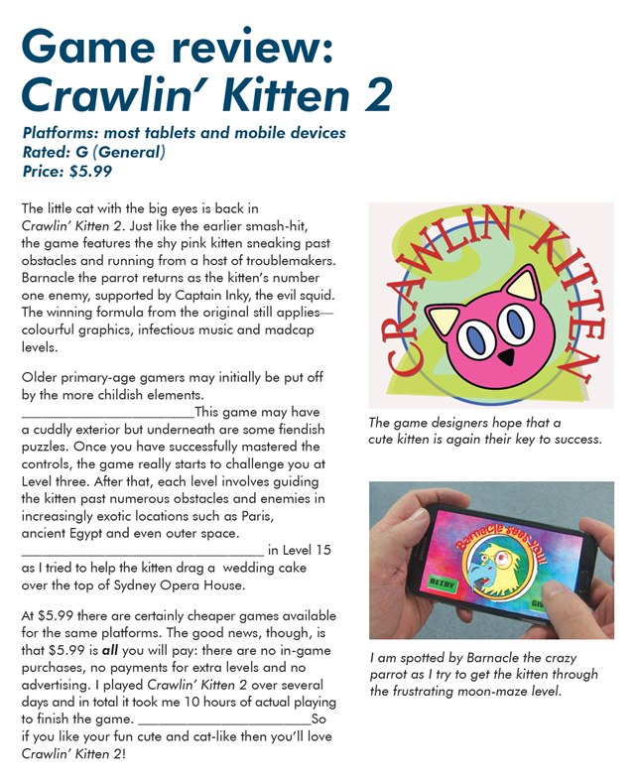
NAPLAN Year 5 Reading magazine, 2015 ACARA.

Appendix 4

Game review: sentence detectives – original text
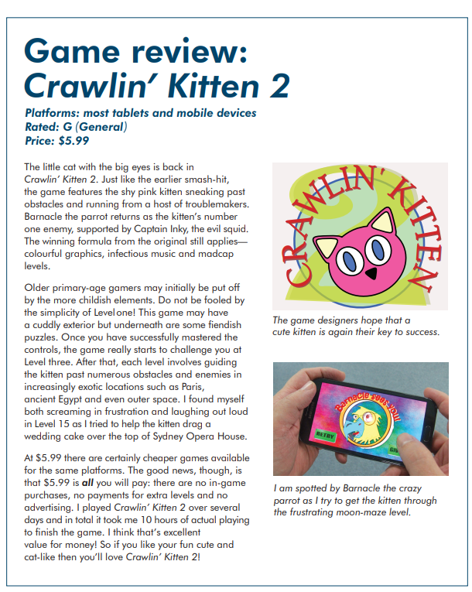
NAPLAN Year 5 Reading magazine, 2015 ACARA.

Game review: sentence detectives - accessible version
Game review: Crawlin’ Kitty 2
Platforms: most tablets and mobile device
Rated: G (general)
Price: $5.99
The little cat with the big eyes is back in Crawlin’ Kitten 2. Just like the earlier smash-hit, the game features the shy pink kitten sneaking past obstacles and running from a host of troublemakers. Barnacle the parrot returns as the kitten’s number one enemy, supported by Captain Inky, the evil squid. The winning formula from the original still applies— colourful graphics, infectious music and madcap levels.
Older primary-age gamers may initially be put off by the more childish elements. . This game may have a cuddly exterior but underneath are some fiendish puzzles. Once you have successfully mastered the controls, the game really starts to challenge you at Level three. After that, each level involves guiding the kitten past numerous obstacles and enemies in increasingly exotic locations such as Paris, ancient Egypt and even outer space. ____________________________________________in Level 15 as I tried to help the kitten drag a wedding cake over the top of Sydney Opera House.
At $5.99 there are certainly cheaper games available for the same platforms. The good news, though, is that $5.99 is all you will pay: there are no in-game purchases, no payments for extra levels and no advertising. I played Crawlin’ Kitten 2 over several days and in total it took me 10 hours of actual playing to finish the game.___________________________ So if you like your fun cute and cat-like then you’ll love Crawlin’ Kitten 2!
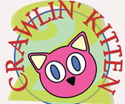
The game designers hope that a cute kitten is again their key to success.
I am spotted by Barnacle the crazy parrot as I try to get the kitten through the frustrating moon-maze level.
NAPLAN Year 5 Reading magazine, 2015 ACARA.

Appendix 5

Sentence bank
Sentence options 1
The cutesiness continued across all game levels, and was off-putting to yours truly.
Do not be fooled by the simplicity of Level one!
The childish design is matched by unchallenging game scenarios.
I was hooked from the get-go. The adult design and challenges were not what I expected.
Hold onto your disappointment with Level 1, it will only be confirmed later in the game.
Sentence options 2
I found it a dreary, awful experience, and struggled to maintain playing
I was wrapped from the first challenge in Level 1
I was constantly frustrated at the poorly rendered and unimaginative settings
I found myself both screaming in frustration and laughing out loud
I found myself sighing in boredom and wishing that I was not a games reviewer
Sentence options 3
I doubt whether many would think the cost of the game is worth it.
It is a significant cost but you may find it value for money.
What a rip-off!
It’s a bargain!
I think that’s excellent value for money!

Appendix 6

Matrix – Purpose of text: product review
Area for consideration | I know this because the author writes…  (provide examples from the text.) | Language features and language choice used (For example, emotive language, punctuation, evaluative language.)
Purpose of text:
Does the reviewer hold conflicting opinions of the product?
Likes these features
But does not like these features
Reviewer’s overall opinion of the product:
Audience of Text:

