Additive thinking: developing flexible strategies - Stage 3

Contents
Overview 2
Learning intention 2
Syllabus outcomes 2
National Numeracy Learning Progression guide 2
Overview of teaching strategies 2
What works best 2
Differentiation 3
Using tasks across learning areas 3
Considerations 3
Language and vocabulary 3
Talk moves 3
Number talks 4
Two versus two 5
Think board 5
Tools and resources to support learning 5
Tasks 6
Addition wheel 7
Target number 8
Appendix 1: Think board 12
Appendix 2: Problem 1 13
Appendix 3: Problem 2 14
Appendix 4: Blank 15
Appendix 5: Addition wheel 16
Appendix 6: Number grid 17
Reference list 18
Copyright 18
Evidence base 18

Overview

Learning intention
Students learn to select and apply effective strategies and incorporate reasoning when offering solutions to problems involving additive thinking.

Syllabus outcomes
The following teaching and learning strategies will assist in covering elements of the following outcomes:
- MAO-WM-01 develops understanding and fluency in mathematics through exploring and connecting mathematical concepts, choosing and applying mathematical techniques to solve problems, and communicating their thinking and reasoning coherently and clearly
- MA3-RN-01 applies an understanding of place value and the role of zero to represent the properties of numbers
- MA3-AR-01 selects and applies appropriate strategies to solve addition and subtraction problems
NSW Mathematics K-10 Syllabus (2022)

National Numeracy Learning Progression guide

What are additive strategies?
Additive strategies encompass a student’s ability to manipulate numbers in additive situations. As students develop an understanding of whole number and the operations of addition and subtraction, they transition from counting strategies to using more flexible strategies to solve problems. When applying additive strategies, students may manipulate numbers using their part-part-whole knowledge, renaming and partitioning of numbers (including using place value knowledge) and the inverse relationship between addition and subtraction.
Students may demonstrate these behaviours as they develop increasing confidence with choosing and using flexible strategies to solve additive problems:
- Additive Strategies AdS7-AdS8
National Numeracy Learning Progression Version 3

Overview of teaching strategies

What works best
Explicit teaching practices involve teachers clearly explaining to students why they are learning something, how it connects to what they already know, what they are expected to do, how to do it and what it looks like when they have succeeded. Students are given opportunities and time to check their understanding, ask questions and receive clear, effective feedback.
This resource reflects the latest evidence base and can be used by teachers as they plan for explicit teaching.
Teachers can use assessment information to make decisions about when and how they use this resource as they design teaching and learning sequences to meet the learning needs of their students.
Further support with What works best is available.

Differentiation
When using these resources in the classroom, it is important for teachers to consider the needs of all students, including Aboriginal and EAL/D learners.
EAL/D learners will require explicit English language support and scaffolding, informed by the Enhanced EAL/D enhanced teaching and learning cycle and the student’s phase on the EAL/D Learning Progression. Teachers can access information about supporting EAL/D learners and literacy and numeracy support specific to EAL/D learners.
Learning adjustments enable students with disability and additional learning and support needs to access syllabus outcomes and content on the same basis as their peers. Teachers can use a range of adjustments to ensure a personalised approach to student learning.
Assessing and identifying high potential and gifted learners will help teachers decide which students may benefit from extension and additional challenge. Effective strategies and contributors to achievement for high potential and gifted learners helps teachers to identify and target areas for growth and improvement. A differentiation adjustment tool can be found on the High potential and gifted education website.

Using tasks across learning areas
This resource may be used across learning areas where it supports teaching and learning aligned with syllabus outcomes.
Literacy and numeracy is embedded throughout all K-10 syllabus documents as capabilities. As the English and mathematics learning areas have a particular role in developing literacy and numeracy, NSW English K-10 and Mathematics K-10 syllabus outcomes aligned to literacy and numeracy skills have been identified.

Considerations

Language and vocabulary
As students are provided opportunities to experience concepts, teachers can also build understanding of mathematical vocabulary and communicating skills. Teachers can help build students’ confidence and capabilities by making complex mathematical ideas visible to students through drawings, diagrams, enactment, gestures and modelling. Making intentional connections between various representations and experiences with mathematical language helps build an understanding of important vocabulary whilst also building conceptual understanding.

Talk moves
Classroom talk is a powerful tool for both teaching and learning. Rich, dialogic talk supports students in making sense of complex ideas and builds classroom communities centred around meaning-making. 'Talk moves' are some of the tools a teacher can use to support rich, meaningful classroom discussion.
Some of the talk moves include:

- wait time
- turn and talk
- revoicing
- reasoning
- adding on
- repeating
- revise your thinking.

The Literacy and numeracy website provides additional information and resources to support talk moves.

Number talks
Number talks are a powerful teaching routine centred on short, intentional classroom conversation about a purposefully crafted problem that is solved using a broad range of mental strategies. Their general goal is to build fluency and sense-making through meaningful communication, problem solving and reasoning. They provide regular opportunities to develop number sense and mathematical reasoning through exploring, using and building confidence in additive and multiplicative strategies.
Suggested structure for an open-sharing number talk:
- A teacher determines the next learning goal for students and finds/designs a problem connected to that learning need.
- The teacher (and their colleagues) consider and discuss possible responses from students and plan formative assessment strategies, questioning and how to use a broad range of tools to represent the possible ideas student may raise (for example enactment, diagrams, models, etc.)
- The carefully designed problem is posed to all students within the class.
- Thinking time is allowed for students to consider the different strategies they would use to solve the problem.
- Readiness to share is indicated by individual students raising a thumb unobtrusively against their chests (and raising one or more fingers if they think of other solutions).
- Students are provided opportunities to turn and talk, sharing their ideas with other students sitting nearby.
- The teacher listens to students as they talk, moving about the class inviting particular students to share their thinking more broadly, intentionally selecting and sequencing conversation that will best support the purpose of the number talk.
- Thinking is collected and discussed. The teacher may seek a variety of answers without comment, then discus them as a class. Or the teacher may invite one student at a time to explain their thinking.
- The teacher supports students to make connections between ideas and to other learning experiences.
- The teacher concludes the open-sharing number talk by connecting back to the purpose of the task, making explicit the mathematical goal of the conversation.
The Literacy and numeracy website provides additional information and resources to support number talks.

Two versus two
For most games, we recommend small groups of 4 students, working in pair of 2 (2 versus 2). This gives students the opportunity to discuss mathematical ideas, strategies and understanding with their team mates as well as their opponents.

Think board
Think boards can be used to make connections between different mathematical concepts or for students to visually represent their understandings and strategies in a range of ways. See Appendix 1: Think board.
Figure 1: Think board

Tools and resources to support learning
These tools and resources can be used throughout the tasks:
- playing cards
- white boards and markers
- Unifix cubes or centicubes
- counters
- dice (with various faces)
- dominos
- rekenreks
- multi-attribute blocks (MAB).

Tasks

What do you notice and wonder?
Teacher note: This task can be used as a number talk and aims to promote rich discussion about flexible strategies when approaching numbers. This can be used as a formative assessment strategy and can be used as a whole-class activity or in a small group.

You will need
- Appendix 2: Problem 1
- Appendix 3: Problem 2
- Appendix 4: Blank
- writing materials

Steps
- Ask students to observe Appendix 2: Problem 1 and share with a partner what they notice and wonder. What could the number in the centre be?
- Show Appendix 3: Problem 2 with the number in the centre and have students continue to notice. These numbers can be changed to reflect the topic being explored, use Appendix 4: Blank.
- Support student thinking by using questions designed to extend student thinking. For example:
  - What do you notice about the numbers in the top circle and bottom left circle?
  - Look at the number in red along the line that connects those 2 circles. What do you notice now?
  - Can you see this on other places within the puzzle?
  - Could that information help you work out what goes in the centre?
- Students may have noticed such things as:
- all even numbers
- all multiples of 10
- circles are 2-digit numbers
- rectangles are 3-digit numbers
- the rectangle is the sum of the two adjoining circles, for example, 110 = 30 + 80
- part-whole relations, inverse operations and turn-around facts, for example, 30 + 70 = 100; 70 + 30 = 100; 100 – 70 = 30; 100 – 3 = 70
- reasoning about what the question mark might be – when ‘180’ is revealed. The 3 circles = 180. Each circle and opposite rectangle = 180.

Variation
- To support students who found the task challenging, annotate the image with addition symbols when reviewing it with the students.
Reference: This activity was adapted from Arithmagons by NRICH.

Addition wheel
Teacher note: This activity supports students to develop a variety of strategies to use when solving number problems. Knowing the relationship between addition and subtraction can help students solve number problems. This could be played as a two-player versus two-player game to encourage dialogue.

You will need
- Appendix 5: Addition wheel template
- writing materials

How to play
- Students each have a copy Appendix 5: Addition wheel.
- Ask the students to record a number in the centre of the wheel.
- Have students record number combinations between the spokes of the addition wheel, radiating out from the centre. The numbers in the spokes add up to make the total shown in the middle.
- Have students share their wheel with a partner. Students earn a point for every correct number sentence and a bonus point for the number combination they had but their partner did not.
- Play again with a different number. The person with the most points at the end is declared the winner.

Variations
- Students record subtraction sentences that equal the centre number. For example, if the number is 15 a student could make 40 - 20 – 5.
- Increase or decrease the number of circles along the spokes.
- Students use a mixture of operations to reach the target number.
Reference: Developing Efficient Numeracy Strategies 1 © State of New South Wales, Department of Education.

Target number
Teacher note: Use this activity with any number and students can use any operation. This can be in small groups or with partners or a whole-class exploration.

You will need
- Appendix 1: Think board
- writing materials

Steps
- Display a ‘target’ number on the board such as 37. Students try to record as many different equations (number sentences) that have that the target number as the total.
- Students share with a partner and discuss how the different number sentences link to the answer. The challenge can be increased by posing thoughtful limitations. For example:
- If we only use 2 numbers, how many equations (number sentences) could we write?
- If we only use multiplication or division, how many equations (number sentences) could we write?
- If fractions were included, how many equations (number sentences) could we write?
- Use only 4 numbers, how many equations (number sentences) could we write?
- What’s the longest equation (number sentence) we could write?
- What’s the shortest equation (number sentence) we could write?
- Alternatively, put a range of numbers on posters around the classroom. Students then add their ideas to the posters around the classroom.
- Students break into groups with one of the posters to see if the suggestions match the answer and possible suggestions to get the answer if the attempt was incorrect.
- Students might use Appendix 1: Think board to show how they are solving a problem.
Reference: This activity was adapted from Target Number by Finkel D and Cook K Math for love.

Finding numbers
Teacher note: This task can be completed by pairs or individuals. Students use their knowledge of additive strategies to develop alternative equations (number sentences).

You will need
- Appendix 6: Number grid
- writing materials

Steps
- Give students a copy of Appendix 6: Number grid. The grid has various numbers all less than 100.
- Ask students to find as many numbers as possible which add to 100. Numbers need to be side by side, above or below. Students are encouraged to use no more than 2 or 3 numbers.
- Ask students how they can show these groups. They share and identify some of the groups of numbers that added to 100 and the strategies they used. Students might share what they looked for to find a group.
Reference: Developing Efficient Numeracy Strategies 1 © State of New South Wales, Department of Education.

Closest to 100
Teacher note: This task encourages students to use a range of additive thinking to reach the number 100. This can be extended beyond 100 so students gain experience with then applying these strategies to larger numbers, for example, 789 or 1300. Students may work in groups of 3-4.
Watch ‘Closest to 100’ to learn how to play.

You will need
- deck of cards (one/Ace to 9)
- whiteboards to show working

How to play
- Players shuffle the cards and put them in a central pile. One player takes 6 cards and places them face up for everyone to see.
- The goal is to use addition and subtraction to get as close to a total of 100 as possible.
- Each card can only be used once. It can be used to form a one- or two-digit number.
- A player score zero points if they can reach exactly 100. Otherwise, they work out their points based on the difference between their total and 100. For example, if a player created a total of 98, they would score 2 points.
- Keep a cumulative total of the difference to 100. The winner is the player to have the lowest points score at the end.
- Students can draw their thought process in solving the problem and share their methods of getting to the target number.
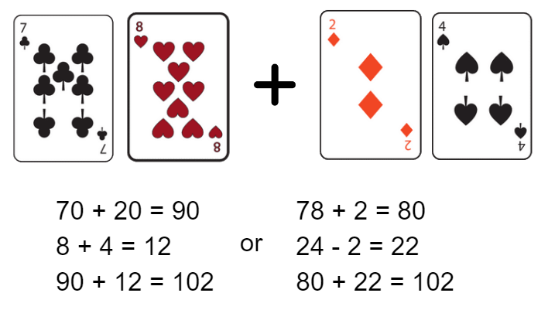
Images sourced from Canva and used in accordance with the Canva Content License Agreement.
Figure 2: Example of student working

Discuss
- Does your total need to be under 100?
- Can you win if your total is above 100?
- (Yes, as your total may be 105 and therefore your score is 5. The other team may have a score of 90 and their score will be 10. The smallest difference wins.)
- Can you use fewer cards to get to the target number? How did you do that?
- Was there a more efficient way of getting to the target number?

Variations
- Change the target number to a bigger number than 100, for example, try 137 or 956.
- Change the target number to a fractional quantity, for example, 35-hundredths (0.35). In this case, the numerals can be worth tenths or hundredths.
- Use fewer cards to find a solution or change the rules so you use all the cards.
- Include multiplication and division in the challenge.

Supporting
- Change the target number to a smaller number, for example, 30.
- Provide more cards to find a solution.
- Provide a calculator, bead string, number line or number chart.
- Scaffold the task by playing a full example round as a class before students playing in pairs or teams of 4.
Reference: Mathematic K-6 resources, ‘Closest to 100’, © State of New South Wales, Department of Education.

Dicey addition
Teacher note: This is a two-player game where students use understanding of place value to create number sentences where the closest to 100 wins.
Watch 'Dicey addition' to learn how to play.

You will need
- a 0-9 dice or 0-9 spinner
- some paper
- writing materials

How to play
      - Students find a partner and a 0-9 dice or spinner.
      - Draw a game board so each student has the same one, for example, start with:
_ _ _ + _ _ _ + _ _ _ = ________ or choose something different.
      - Each player takes a turn to roll or spin and decide where to place that digit in their number sentence (equation).
      - Students roll or spin 9 times each.
      - The person whose sum is closest to 100 is the winner.
      - Students share their thinking with a partner and record in mathematics journal or workbook where appropriate.

Variations
- Model the activity and articulate the thinking demonstrated in the video to support learners.
- Demonstrate ongoing addition and estimation, rather than adding after all the spins.
- Adapt this activity into an investigation - ask students to develop methods to ensure they win. Then ask them to develop their own blank number sentences to include subtraction and then both addition and subtraction.
Reference: Activity adapted from Dicey Addition from NRICH by Faculty of Mathematics, University of Cambridge

Four strikes and you’re out!
Teacher note: This game works well as a whole class first playing against the teacher, then as a two-player game. A mathematical version of ‘Hangman’, it supports students to think and reason numerically to solve a problem. Students use various strategies to solve a number problem.

You will need
- writing materials

How to play
- On the board, write a hidden problem, for example, 35 + 10 = 45. Under the hidden problem write the numerals from 0-9. See Figure 3.
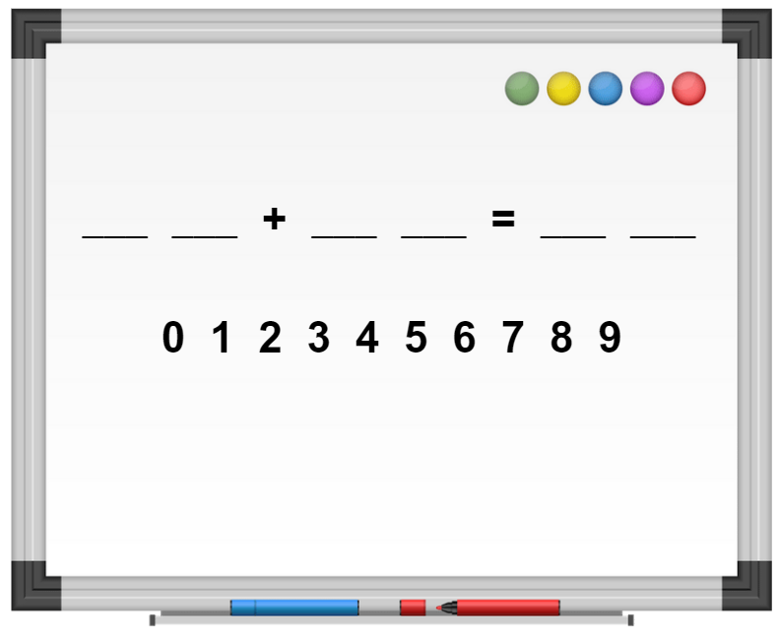
Figure 3: Hidden number sentence - Images sourced from Canva and used in accordance with the Canva Content License Agreement.
- Students start by guessing a number between 0-9. If the number is within the problem, write it in the corresponding space on the problem frame. If the number is not in the problem, it is a ‘strike’. To win, students need to determine all the numbers before they get 4 strikes.
- As students’ progress, they may notice clues in the problem. They might notice if there are 2 fives, this will mean in the second number, the digit in the units' place value must be a zero. They may also notice place value relationships which may help them to decide on what numbers to choose next. Ask students to explain what they notice and why this will help them to determine other numbers in the problem.
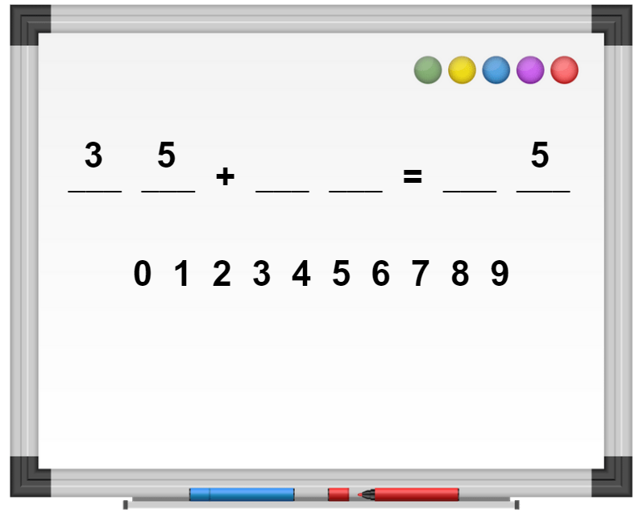
Figure 4: Adding numbers. - Images sourced from Canva and used in accordance with the Canva Content License Agreement.

Variation
- Play this game across grades to support students with mental computation by adjusting the numbers, operations, and the number of blanks to reflect student needs.
Reference: Adapted from MB Math, Four Strikes and You’re Out by Marilyn Burns. The game originally appeared in Teaching Arithmetic Lessons for Addition and Subtraction by Tank B & Zolli L (2010), Gate city books, North Carolina.

Appendix 1: Think board

Appendix 2: Problem 1
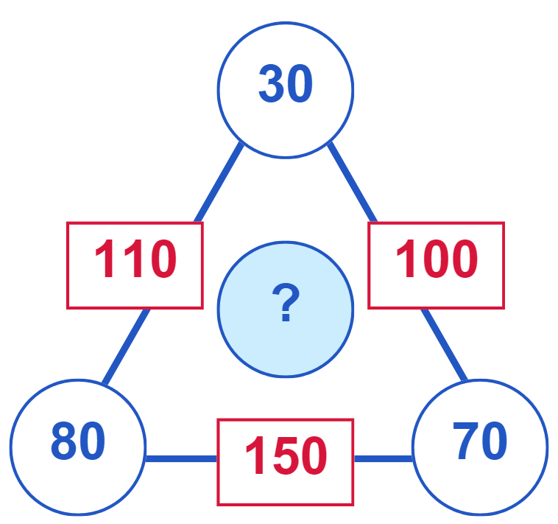
Images sourced from Canva and used in accordance with the Canva Content License Agreement.

Appendix 3: Problem 2
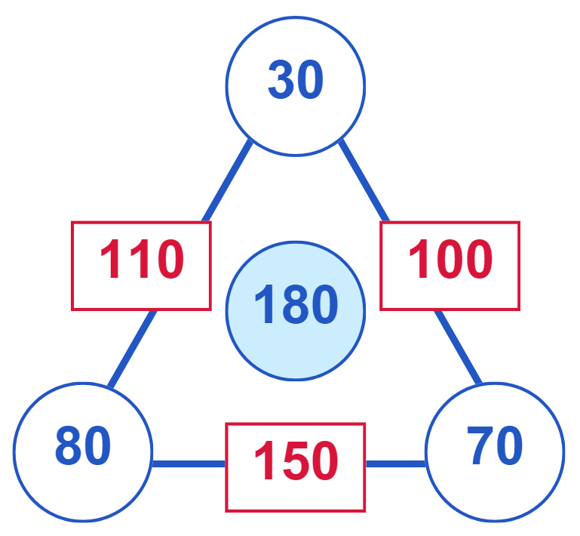
Images sourced from Canva and used in accordance with the Canva Content License Agreement.

Appendix 4: Blank
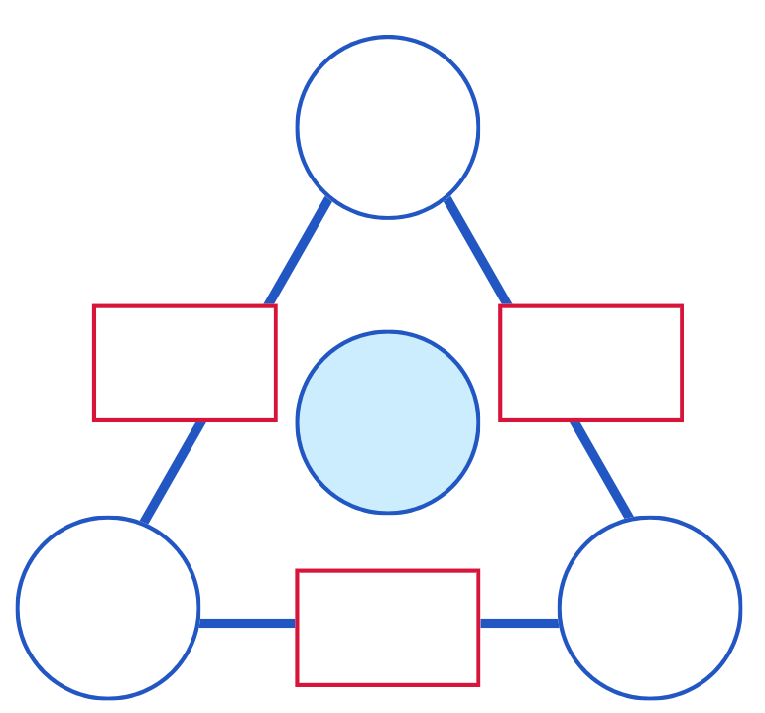
Images sourced from Canva and used in accordance with the Canva Content License Agreement.

Appendix 5: Addition wheel
Developing Efficient Numeracy Strategies 1 © State of New South Wales, Department of Education.

Appendix 6: Number grid
10 | 79 | 30 | 48 | 22 | 70 | 30 | 47
90 | 21 | 55 | 9 | 8 | 92 | 33 | 70
78 | 22 | 45 | 1 | 80 | 20 | 33 | 66
25 | 25 | 50 | 90 | 91 | 18 | 34 | 10
10 | 21 | 8 | 71 | 9 | 52 | 64 | 36
55 | 43 | 45 | 44 | 11 | 30 | 36 | 18
35 | 57 | 93 | 4 | 31 | 40 | 29 | 71
17 | 25 | 36 | 39 | 58 | 60 | 31 | 29
Developing Efficient Numeracy Strategies 1 © State of New South Wales, Department of Education.

Reference list
This resource contains images and content obtained from Canva, and their use outside of this resource is subject to Canva’s Content License Agreement.
Mathematics K–10 Syllabus © NSW Education Standards Authority (NESA) for and on behalf of the Crown in right of the State of New South Wales, 2022.
National Numeracy Learning Progression © Australian Curriculum, Assessment and Reporting Authority (ACARA) 2010 to present, unless otherwise indicated. This material was downloaded from the Australian Curriculum website (National Literacy Learning Progression) (accessed 6 November 2023) and was not modified.
Burns M (2015) ‘Four Strikes and You’re Out’, MB math website, accessed 6 November 2023.
Finkel D and Cook K (2020) ‘Target Number’, Math for Love website, accessed 6 November 2023.
State of New South Wales (Department of Education) (n.d) ‘Addition Wheel’, Developing Efficient Numeracy Strategies website, accessed 6 November 2023.
State of New South Wales (Department of Education) (n.d) ‘Finding Numbers’ Developing Efficient Numeracy Strategies website, accessed 6 November 2023.
State of New South Wales (Department of Education) (2023) ‘Closest to 100’, Mathematics K-6 resources, NSW Department of Education website, accessed 6 November 2023.
University of Cambridge (Faculty of Mathematics) (1997–2023) ‘Dicey Addition’, NRICH website, accessed 6 November 2023.

Copyright
Section 113P Notice
Texts, Artistic Works and Broadcast Notice
Some of this material has been copied and communicated to you in accordance with the statutory licence in section 113P of the Copyright Act. Any further reproduction or communication of this material by you may be the subject of copyright protection under the Act. Do not remove this notice.

Evidence base
Sparrow, L., Booker, G., Swan, P., Bond, D. (2015). Teaching Primary Mathematics. Australia: Pearson Australia.
Brady, K., Faragher, R., Clark, J., Beswick, K., Warren, E., Siemon, D. (2015). Teaching Mathematics: Foundations to Middle Years. Australia: Oxford University Press.

Alignment to system priorities and/or needs: The literacy and numeracy five priorities.
Alignment to School Excellence Framework: Learning domain: Curriculum, Teaching domain: Effective classroom practice and Professional standards
Consulted with: NSW Mathematics Strategy professional learning and Curriculum Early Years Primary Learners-Mathematics teams
Reviewed by: Literacy and Numeracy
Created/last updated: January 2024
Anticipated resource review date: January 2025
Feedback: Complete the online form to provide any feedback.

