Text structure
Stage 2

Overview

Purpose
This literacy teaching strategy supports teaching and learning for Stage 2 students across all key learning areas. It targets specific literacy skills and suggests a learning sequence to build skill development. Teachers can select individual tasks, or a sequence, and embed into their teaching and learning program according to their students’ needs. While exemplar texts are provided throughout this resource, it is recommended that teachers select texts which are relevant to their students and curriculum.

Learning intention
Students will learn to identify specific structural and language features within types of text. Students will learn to identify genre in a range of imaginative, persuasive and informative texts.

Syllabus outcomes
The following teaching and learning strategies will assist in covering elements of the following outcomes:
- EN2-RECOM-01: reads and comprehends texts for wide purposes using knowledge of text structures and language, and by monitoring comprehension
NSW English K-10 Syllabus (2022)

Success criteria
The following Year 3 NAPLAN item descriptors may guide teachers to develop success criteria for student learning.
- identifies a central theme in a narrative
- identifies the genre of a sign
- identifies the genre of an information text
- identifies the genre of a text
- identifies the purpose of a rhetorical question in a persuasive text
- identifies the purpose of a rhetorical question in a text
- analyses the effect of modal language in an information text
- identifies the use of persuasive devices in a persuasive text
- identifies persuasive techniques in a text
- analyses the effect of modal language in an information text
- identifies a persuasive device in a persuasive text

National Literacy Learning Progression guide

Understanding Texts (UnT6-UnT9)
Key: C=comprehension P=process V=vocabulary

UnT6
- identifies the purpose of predictable informative, imaginative and persuasive texts (e.g. uses verbs and dot points to identify a set of instructions) (C)

UnT7
- identifies the purpose of a broad range of informative, imaginative and persuasive texts (e.g. advertisements, diary entry) (C)
- identifies language and text features that signal purpose in a predictable text (e.g. diagrams, dialogue) (P)
- describes the language and visual features of texts using metalanguage (e.g. grammatical terms such as cohesion, tense, noun groups) (V)

UnT8
- explains how authors use evidence and supporting detail to build and verify ideas (C)
- uses knowledge of the features and conventions of the type of text to build meaning (e.g. recognises that the beginning of a persuasive text may introduce the topic and the line of argument) (P)
- identifies language features used to present opinions or points of view (P)

UnT9
- evaluates text features for relevance to purpose and audience (C)
- uses knowledge of a broader range of cohesive devices to track meaning (e.g. word associations) (see Grammar) (P)
- identifies language used to create tone or atmosphere (V)
- analyses language and visual features in texts using metalanguage (e.g. cohesion, interpretation, figurative) (V)
National Literacy Learning Progression

Evidence base
- Centre for Education Statistics and Evaluation (2017). Effective reading instruction in the early years of school, literature review.
- Konza, D. (2014). Teaching Reading: Why the “Fab Five” should be the “Big Six”. Australian Journal of Teacher Education, 39(12)
- Oakhill, J., Cain, K. & Elbro, C. (2015). Understanding and teaching reading comprehension: A handbook. Routledge.
- Quigley, A. (2020). Closing the reading gap. Routledge.
- Scarborough, H.S. (2001). Connecting early language and literacy to later reading (dis)abilities: Evidence, theory and practice. In S. Neuman & D. Dickson (Eds.), Handbook for research in early literacy (pp. 97-110). New York, NY: Guilford Press.
Alignment to system priorities and/or needs: Five priorities for Literacy and Numeracy, Our Plan for NSW Public Education, School Excellence Policy (nsw.gov.au).
Alignment to School Excellence Framework: Learning domain: Curriculum, Teaching domain: Effective classroom practice and Professional standards
Consulted with: Strategic Delivery, Teaching Quality and Impact
Author: Literacy and Numeracy
Reviewed by: Literacy and Numeracy, Teaching Quality and Impact
Created/last updated: January 2024
Anticipated resource review date: January 2025
Feedback: Complete the online form to provide any feedback

Copyright-
Section 113P Notice
Texts, Artistic Works and Broadcast Notice
Some of this material has been copied and communicated to you in accordance with the statutory licence in section 113P of the Copyright Act. Any further reproduction or communication of this material by you may be the subject of copyright protection under the Act. Do not remove this notice.

Teaching strategies
Task | Appendices
Identifying genre | Appendix 1 - Identifying text features text examples
Features of narrative texts
Features of informative texts | Appendix 2 - What am I? Text structure and features of an informative text
Features of persuasive texts | Appendix 3 - Analyse effect of modal language  Appendix 4 - Identifying persuasive devices
Developing an understanding of persuasive texts
Which type of text am I? | Appendix 5 - Newsflash graphic organiser  Appendix 6 - Responding to texts
Pronouns in persuasive texts | Appendix 4 - Identifying persuasive devices  Appendix 7 - Activity cards: pick the pronoun
Fact and opinion in persuasive texts | Appendix 4 - Identifying persuasive devices  Appendix 8 - Activity cards: fact or opinion?

Background information

Types of text
Classifications according to the particular purposes texts are designed to achieve. These purposes influence the characteristic features the texts employ. In general, texts can be classified as belonging to one of three types (imaginative, informative or persuasive), although it is acknowledged that these distinctions are neither static nor watertight and particular texts can belong to more than one category.
Imaginative texts
These texts include novels, traditional tales, poetry, stories, plays, fiction for young adults and children, including picture books and multimodal texts such as film.

Informative texts
They include texts which are valued for their informative content, as a store of knowledge and for their value as part of everyday life.

Persuasive texts
They include student essays, debates, arguments, discussions, polemics, advertising, propaganda, influential essays and articles.

Text structure
The ways information is organised in different types of texts, for example chapter headings, subheadings, tables of contents, indexes and glossaries, overviews, introductory and concluding paragraphs, sequencing, topic sentences, taxonomies, cause and effect. Choices in text structures and language features together define a text type and shape its meaning (see language features).

Language features
The features of language that support meaning, for example sentence structure, vocabulary, illustrations, diagrams, graphics, punctuation, figurative language. Choices in language features and text structures together define a type of text and shape its meaning (see structures of texts). These choices vary according to the purpose of a text, its subject matter, audience and mode or media of production.
Reference: English K-10 Syllabus © NSW Education Standards Authority (NESA) for and on behalf of the Crown in right of the State of New South Wales, 2012 and 2022.

Where to next?
- Text features
- Audience and purpose
- Exploring perspective

Overview of teaching strategies

Purpose
These literacy teaching strategies support teaching and learning from Stage 2 to Stage 5. They are linked to NAPLAN task descriptors, syllabus outcomes and literacy and numeracy learning progressions.
These teaching strategies target specific literacy and numeracy skills and suggest a learning sequence to build skill development. Teachers can select individual tasks or a sequence to suit their students.

Access points
The resources can be accessed from:
- NAPLAN App in Scout using the teaching strategy links from NAPLAN items
- NSW Department of Education literacy and numeracy website.

What works best
Explicit teaching practices involve teachers clearly explaining to students why they are learning something, how it connects to what they already know, what they are expected to do, how to do it and what it looks like when they have succeeded. Students are given opportunities and time to check their understanding, ask questions and receive clear, effective feedback.
This resource reflects the latest evidence base and can be used by teachers as they plan for explicit teaching.
Teachers can use classroom observations and other assessment information to make decisions about when and how they use this resource as they design teaching and learning sequences to meet the learning needs of their students.
Further support with What works best is available.

Differentiation
When using these resources in the classroom, it is important for teachers to consider the needs of all students, including Aboriginal and EAL/D learners.
EAL/D learners will require explicit English language support and scaffolding, informed by the EAL/D enhanced teaching and learning cycle and the student’s phase on the EAL/D Learning Progression. Teachers can access information about supporting EAL/D learners and literacy and numeracy support specific to EAL/D learners.
Learning adjustments enable students with disability and additional learning and support needs to access syllabus outcomes and content on the same basis as their peers. Teachers can use a range of adjustments to ensure a personalised approach to student learning.
Assessing and identifying high potential and gifted learners will help teachers decide which students may benefit from extension and additional challenge. Effective strategies and contributors to achievement for high potential and gifted learners helps teachers to identify and target areas for growth and improvement. A differentiation adjustment tool can be found on the High potential and gifted education website.

Using tasks across learning areas
This resource may be used across learning areas where it supports teaching and learning aligned with syllabus outcomes.
Literacy and numeracy are embedded throughout all syllabus documents as general capabilities. As the English and mathematics learning areas have a particular role in developing literacy and numeracy, NSW English and Mathematics syllabus outcomes aligned to literacy and numeracy skills have been identified.

Text selection
Example texts are used throughout this resource. Teachers can adjust activities to use texts which are linked to their unit of learning.
Further support with text selection can be found within the National Literacy Learning Progression Text complexity appendix.
The NESA website has additional information on text requirements within the NSW English syllabus.

Teaching strategies

Identifying genre
- Discuss genre as being a ‘type’ or ‘kind’ of text. Some genres stay the same, whilst others grow and change as new media emerges. We can explore genre to see similarities and differences between texts as well as to provide guidelines for structure and features. Genre can vary according to mode and medium of the text delivery.
- T-Chart: Review terms ‘fiction’ and ‘non-fiction’ and brainstorm key features of these texts and examples of texts and authors. Display images in a T-Chart to draw direct comparisons:
Some suggestions:
Fiction vs. non-fiction
Fiction | Non-Fiction
Created by the author’s imagination.  - Is made up  - Tells the reader a story  - Has an orientation, complication, resolution  - Has characters  - Has a plot  - Has a setting  - May have illustrations | Based on real events and real people.  - Is real and based on facts  - Tells the reader information  - Is broken into sections (contents, glossary, index)  - Uses diagrams, charts and photographs  - Uses headings, sub-headings and labels
- Students use book covers and blurbs from either a collection of books or alternatively, a book club catalogue, and categorise them into ‘fiction’ or ‘non-fiction’. Students might use an online book retailer to select books and read their blurb or extract.
- In groups of 2-3, students are given a sub-category of a genre and become ‘experts’ through research. Students create a poster illustrating key features of each genre to help identify them. These posters can be used in a gallery walk around the classroom, or, alternatively, students can present to the whole class to ensure everyone has access to the information.
Alternate task: This can be set up as a google doc or other online group construction where ideas can be added and viewed by all class members.
- Students work in groups to further categorise these texts according to form or subject matter using teacher discretion with choosing appropriate sub-categories:

Fiction | Fiction | Non-Fiction
drama | fable | biography
fairy tale | fantasy | autobiography
folklore | adventure | essay
horror | humour | speech
legend | mystery | Journal article
poetry | mythology | journals
science fiction | short story | diary entry
tall tale | dystopian | recipe
Students could then add different genres they have explored.
- Students use a range of texts linked to current unit of learning or use Appendix 1 - Identifying text features text examples to identify the genre using evidence from the text. Students use enlarged versions of texts and add ideas in a mind map.

Features of narrative texts
- Model a ‘think-aloud’ strategy with students, having students notice different parts of a narrative: “I can see there is a description of a character, this tells me that this is most likely a fiction text. I can also see that the story has a setting which I know is part of a narrative.”
- How would you best teach someone the structure of a narrative? Have students pictorially represent the structure of a narrative (orientation, complication, resolution, coda). For example, students may show this as a roller coaster ride, a walk through a forest.
- Review features of a narrative, adding to the pictorial representation (setting, character, plot, description, events, theme, point of view, literary devices, dialogue)
- Jigsaw task: Students create a poster with all the elements of a narrative on it. This is then cut into jigsaw pieces and mixed up for another group to solve.

Features of informative texts
- Model reading an information text to students, drawing attention to some of the key elements (headings, sub-headings, diagrams, captions maps, bullet points and so on). Students are given white boards or sticky notes to write down any elements they hear mentioned during the modelled lesson.
- Using the information students have gathered during the modelled lesson, design a class anchor chart or poster for identifying parts of an informative text.
- Students use Appendix 2 - What am I? Text structure and features of an informative text to match and sort activities linking examples with their clues and titles.

Features of persuasive texts
- Gone in 60 seconds: A student is given sixty seconds to verbally persuade others of their point of view on a subject, for example: all plastics must stop being used. To support students, group brainstorming vocabulary for the topic may help to prompt ideas.
Additional task: Students are timed and stop watches stopped when ‘umm’, ‘err’ or ‘like’ (out of context) is used – the goal is to make the longest time without repeating ideas.
- Discuss as a class what makes an effective argument? Where do we find arguments? Discuss how persuasive texts can take many forms and we need to identify the purpose and audience of the text to be able to make an informed decision.
- Discuss modal language and the impact it can have on the reader. Teacher scribes a range of modal verbs (must, will, can, might, should, ought to.) and have students rate them out of 5 for most urgent to least urgent. Pose scenarios: Which word would you choose to encourage someone to try a new food? Which word would you choose to stop someone from littering?
- Students work in small teams to explore modal language and place on a continuum from strongest to weakest (Appendix 3 - Analyse effect of modal language).
- Students use the persuasive example in Appendix 4 - Identifying persuasive devices and respond to the questions.

Developing an understanding of persuasive texts
- Discussion: Ask students to share their current understanding of the word ‘persuade’. Teachers should use different synonyms to clarify and deepen student understanding (convince, prove, influence, argue). Teacher explanation: ‘It is a writer’s job to make the reader believe and/or understand something. In a persuasive text, writers use what we call ‘persuasive techniques’ to convince us that what they are saying is true. In a performance an actor would use the sound of their voice, body language and other techniques in order to be convincing. In a written text the writer will need to use other tools/techniques to be convincing.’
- Students recall a moment in their lives where they had to persuade/convince someone to believe something. In groups of 2-4 they will perform (act out) the situation in which they were trying to be persuasive/convincing (use these words and any other synonyms interchangeably to strengthen vocabulary knowledge). The teacher monitors each group using prompting questions to help them consider WHAT individual students are doing and WHY they are doing it:
- How does he/she sound? (tone of voice/volume)
- What do you notice about their facial expression?
- Can you tell me anything about their body language?
- Are they using any strong words?
- Are they saying anything that sounds true and factual?
- How would you describe their emotions/feelings?
- Are they giving you enough reasons? Do the reasons make sense to you?
- Are you convinced? Why? Why not?
- Discussion: using the following questions, students share their ideas with the rest of the class, drawing on their experiences from the group activity. Students will be directed back to this thinking and be asked to extend, change and/or clarify their learning after examining a particular persuasive response in detail. (Teachers should save these responses.)
- What does it mean for someone to be persuasive?
- What is a persuasive text?
- How do you know a text is persuasive?
- Students examine different persuasive techniques from the perspective of a writer. The teacher should prompt the students to consider the writer behind the text and how they are not very different from the students themselves. Likening these persuasive techniques to a bag of tools and/or tricks that writers can use to achieve a particular purpose, will help students to locate and identify them more easily in whole texts. Some suggested techniques to explore include:
- The use of pronouns (see below)
- Alliteration
- Connectives (time, cause & effect)
- Rhetorical questions
- Modal verbs
- Fact and Opinion (see below)
- Repetition
- Think-Pair-Share: After exploring one of the persuasive techniques above, students enhance, adjust and/or change their answers (from activity 3) based on new understanding. The teacher should encourage students to compare their prior learning with new learning. The following sentence prompts can be used by students to help them with their verbal responses:
- I used to think that but now I know that
- I know more about because
- I now know that
- I have learnt that
- I know more information about how
- I was confused about but now I understand
- I would still like to know more about

Which type of text am I?
- As with celebrity heads, students are given a type of text structure or feature element. The students in the class answer closed questions to help them to determine what type of text they are part of. Some elements can be, of course, found in a range of types of text, so this will need to be noted when giving students their element.
- Newsflash: Students use suitable texts from a current unit of learning to identify what type of text each is in a newsflash graphic organiser (refer to Appendix 5 - Newsflash graphic organiser).
- Students use Appendix 6 - Responding to texts to respond to each text answering the following questions:
- What type of text is this text? How do you know?
- What question does this text answer?
- What questions do you have about this text?
- What is happening in the first paragraph?
- What is the text about?
- What genre is this text?
- Is there a problem in the text? If so, what is it?
- Do you think the end of the text is effective? Why/why not?

Pronouns in persuasive texts
- Think Aloud: Recall students’ prior knowledge regarding persuasive techniques and persuasive texts. ‘In a persuasive text it is a writer’s job to make the reader believe and/or understand something. Writers use what we call ‘persuasive techniques’ to convince us to believe their point of view.’
- Think-Pair-Share: Students discuss the following question, ‘What is a Pronoun?’ They might use their prior learning and/or knowledge of the word ‘noun’ to explore this question. Students share their thinking with the class, teacher may prompt them to recall what a noun is: a word used to identify people, places, or things. Ask the students to share examples of people, places and things.
- Anchor chart: Teacher introduces students to the definition of a pronoun: a word that we use in the place of a noun. For example: I, we, you, me, their, they, she, him, anybody, somebody, someone, something, myself, yourself, ourselves. Students collectively create a list of all the pronouns they can think of. (Students can continuously co-construct this classroom resource as their knowledge of pronouns grows.)
- Inquiry question: How might an author use pronouns to be persuasive? Using the text ‘Should we pay for plastic bags?’ (Appendix 4 - Identifying persuasive devices) students highlight/circle all the pronouns. This can be done individually, in pairs, or as a whole class. Complete the following questions as a class and/or in groups:
- Who is the author referring to when he/she uses the pronouns ‘them’ and ‘their’?
- Can you estimate/guess how many people the writer is talking about when he/she uses the pronouns ‘them’ and ‘their’? (possible numeracy link)
- Who is the author referring to when he/she uses the pronoun ‘we’?
- How does the pronoun ‘we’ make you feel? (Does it make you feel included?)
- Why is it important for the writer to make you feel included? How does this help them convince you to believe their point of view?
To increase challenge, students create a list of nouns which could be used for ‘them’, ‘their’ and ‘we’ in the text. For example, we = community.
- Brainstorm: Return to the inquiry question, ‘How might an author use pronouns to be persuasive?’ As a class form an answer. The students can write their answers on post-it notes, in their books and/or as a class response transcribed by the teacher. Answers should focus on the inclusive nature of pronouns such as ‘we’ and ‘you’ and how feeling involved in a text makes the reader more likely to care about the topic. Responses might also consider how the pronouns ‘them’ and ‘their’ allowed the writer of this article to talk about a very large group of people which helped make the issue seem very important.
- Think-Pair-Share: Students complete the ‘Pick the Pronoun’ (Appendix 7 - Activity Cards: Pick the Pronoun) activity to consolidate their learning. Students are instructed to sort the cards into two piles: nouns and pronouns (teachers might add another category: proper nouns).
- Exit ticket: In on sentence, students must convince the teacher to not give them any homework. They must include pronouns in this sentence. For example: “We have worked very hard today and you will make us upset if you give us homework.”

Fact and opinion in persuasive texts
- Think Aloud: Recall students’ prior knowledge regarding persuasive techniques and persuasive texts. ‘In a persuasive text it is a writer’s job to make the reader believe and/or understand something. Writers use what we call ‘persuasive techniques’ to convince us to believe their point of view. Sometimes writers use facts to persuade and other times they use opinions.’
- Think-Pair-Share: Students discuss the following question ‘What is the difference between a fact and opinion?’ Students share their thinking with the rest of the class. Teacher may prompt them to recall: a fact is a statement that can be proven true or false. A fact may include data, numbers and statistics. An opinion is a statement that expresses a person's feelings and it cannot be proven. Opinions are usually based on emotions.
- Brainstorm: Using the following table, students use their prior knowledge to make a list of facts and opinions. (Encourage students to use what they are currently learning about across key learning areas.)
FACT | OPINION
- The sky is blue  - The Earth is round  - 1+1=2 | - Vanilla is better than chocolate  - It’s easier to write with a pen than a pencil.

- Inquiry question: How might an author use both facts and opinions to be persuasive? Using a suitable text from a current unit of learning, or ‘Should we pay for plastic bags?’ Appendix 4 - Identifying persuasive devices students highlight/underline TWO examples of a fact and TWO examples of an opinion. Complete the following questions independently, in pairs or as a class:
  - What do facts usually have that opinions do not? (draw their attention to numbers, statistics and information that appears to be verified)
  - What do opinions have that facts do not? (draw their attention to emotion and statements that cannot be proven true)
  - Do the facts in this article help you believe the writer? Yes/No? Why?
  - Do the opinions in the article help you believe the writer? Yes/No? Why?
- Brainstorm: Return to the inquiry question: How might an author use both facts and opinions to be persuasive? As a class form an answer. The students can write their answers on post-it notes, in their books and/or as a class response transcribed by the teacher. Answers should focus on the following ideas:
  - Facts help us trust what has been written. Facts often contain numbers, statistics and specific (proven/verified) detail about a topic. This information helps us feel confident that the writer of the persuasive text has done their research. Facts also make us believe that the information is honest and that we are not being lied to or tricked.
  - Opinions help us feel the writer’s strong emotions about a topic or issue. If we can feel their emotions then we are more likely to connect to their point of view. People can sometimes use their opinions to lie to and trick us. (For more information about ‘point of view’ refer to the Stage 2 Exploring Perspective resource.)
- Double Think-Pair-Share: students complete the ‘Fact or Opinion’ (Appendix 8 - Activity Cards: Fact or Opinion?) activity to consolidate their learning. In a pair, students separate the cards into two piles/categories: fact and opinion. With a second pair, students respectfully share their choices, noting any differences between pairs, and justify their reasoning. Some suggested prompts include:
  - I disagree with (student) because
  - I understand why (student) thought , however, I think they are wrong because
  - (Student) makes an interesting point but I disagree with them because
  - I agree with (student) because
  - I think (student) makes an excellent point about
  - I believe my group is right because
- Exit ticket: Students provide a fact and/or opinion about a topic that interests them. Students decide whether the statement is a fact or an opinion, using evidence to support their opinion.

Appendix 1

Identifying text features
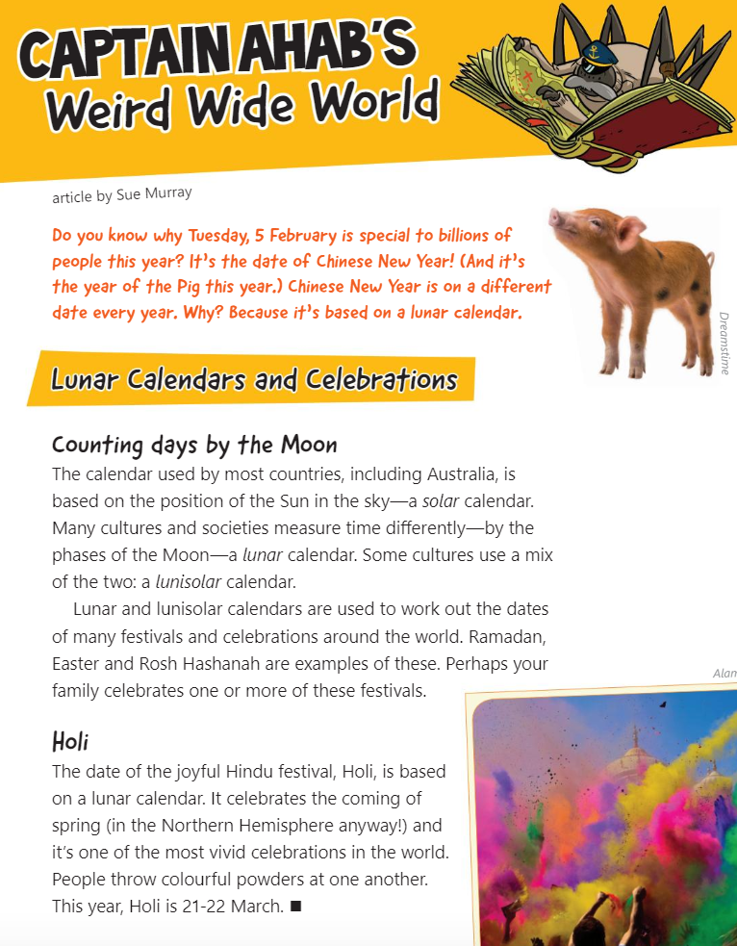
The School Magazine Countdown 1, 2019, NSW Department of Education.
Appendix 1

Identifying text features – accessible version

Captain Ahab’s Weird Wide World
Article by Sue Murray

Do you know why Tuesday, 5 February is special to billions of people this year? It’s the date of Chinese New Year! (And it’s the year of the Pig this year.) Chinese New Year is on a different date every year. Why? Because it’s based on a lunar calendar.
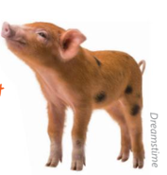

Lunar Calendars and Celebrations
Counting Days by the Moon
The calendar used by most countries, including Australia, is based on the position of the Sun in the sky- a solar calendar. Many cultures and societies measure time differently – by the phases of the Moon- a lunar calendar. Some cultures use a mix of the two: a lunisolar calendar.
Lunar and lunisolar calendars are used to work out the dates of many festivals and celebrations around the world. Ramadan, Easter and Rosh Hashanah are examples of these. Perhaps your family celebrates one or more of these festivals.
Holi
The date of the joyful Hindu festival, Holi, is based on a lunar calendar. It celebrates the coming of spring (in the Northern Hemisphere anyway!) and it’s one of the most vivid celebrations in the world. People throw colourful powders at one another. This year, Holi is 21-22 March.
Alan

The School Magazine Countdown 1, 2019, NSW Department of Education.
Appendix 1
Identifying text features
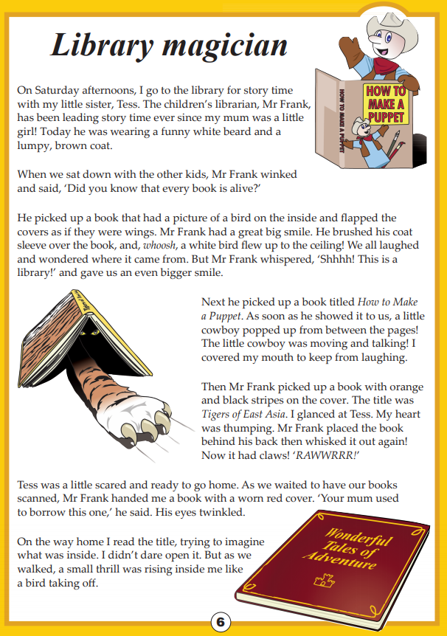
Year 3 Reading Magazine NAPLAN, 2016 ACARA

Identifying text features- accessible version
Library Magician
On Saturday afternoons, I go to the library for story time with my little sister, Tess. The children’s librarian, Mr Frank, has been leading story time ever since my mum was a little girl! Today he was wearing a funny white beard and a lumpy, brown coat.
When we sat down with the other kids, Mr Frank winked and said, ‘Did you know that every book is alive?’
He picked up a book that had a picture of a bird on the inside and flapped the covers as if they were wings. Mr Frank had a great big smile. He brushed his coat sleeve over the book, and, whoosh, a white bird flew up to the ceiling! We all laughed and wondered where it came from. But Mr Frank whispered, ‘Shhhh! This is a library!’ and gave us an even bigger smile.
Next he picked up a book titled How to Make a Puppet. As soon as he showed it to us, a little cowboy popped up from between the pages! The little cowboy was moving and talking! I covered my mouth to keep from laughing.
Then Mr Frank picked up a book with orange and black stripes on the cover. The title was Tigers of East Asia. I glanced at Tess. My heart was thumping. Mr Frank placed the book behind his back then whisked it out again! Now it had claws! ‘RAWWRRR!’
Tess was a little scared and ready to go home. As we waited to have our books scanned, Mr Frank handed me a book with a worn red cover. ‘Your mum used to borrow this one,’ he said. His eyes twinkled.
On the way home I read the title, trying to imagine what was inside. I didn’t dare open it. But as we walked, a small thrill was rising inside me like a bird taking off.
Year 3 Reading Magazine NAPLAN, 2016 ACARA

Identifying text features
Letters Are Tricky by Donna Gibbs, illustrated by Cheryl Orsini
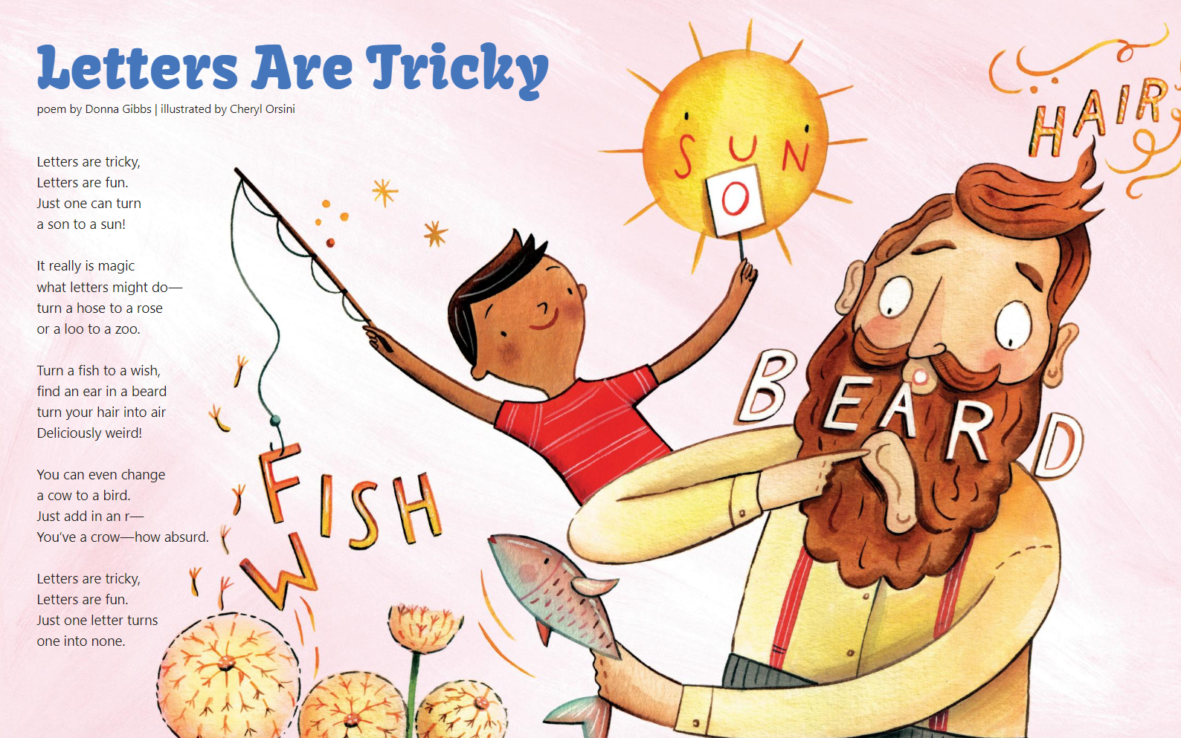
The School Magazine Countdown 1, 2019, NSW Department of Education

Identifying text features – accessible version
Letters are Tricky
Poem by Donna Gibbs. Illustrated by Cheryl Orsini.

Letters are tricky,
Letters are fun
Just one can turn
a son to a sun!
It really is magic
what letters may do-
turn a hose to a rose
or a loo to a zoo.
Turn a fish to a wish,
find an ear in a beard
turn your hair into air
Deliciously weird!
You can even change
a cow to a bird.
Just add in an r-
You’ve a crow – how absurd.
Letters are tricky,
Letters are fun.
Just one letter turns
one into none.
The School Magazine Countdown 1, 2019, NSW Department of Education

Identifying text features
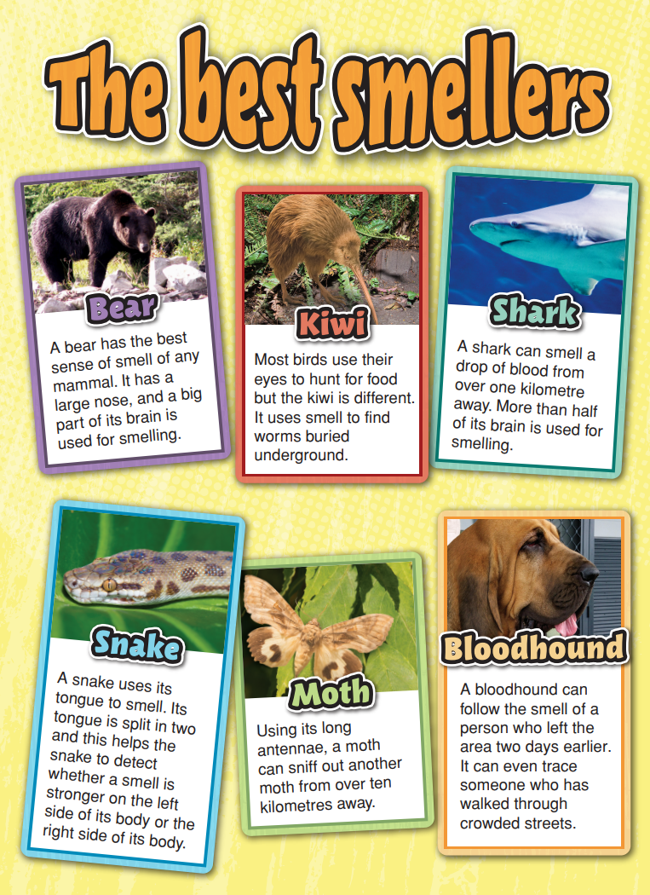
Year 3 Reading Magazine NAPLAN, 2014 ACARA

Identifying text features – accessible version
The best smellers
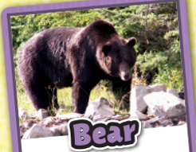
Bear: A bear has the best sense of smell of any mammal. It has a large nose, and a big part of its brain is used for smelling.
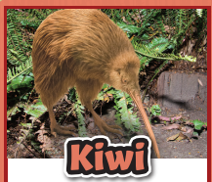
Kiwi: Most birds use their eyes to hunt for food but the kiwi is different. It uses smell to find worms buried underground.
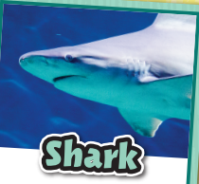
Shark: A shark can smell a drop of blood from over one kilometre away. More than half of its brain is used for smelling.
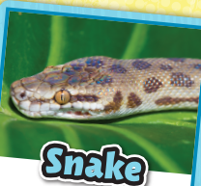
Snake: A snake uses its tongue to smell. Its tongue is split in two and this helps the snake to detect whether a smell is stronger on the left side of its body or the right side of its body.
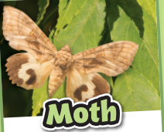
Moth: Using its long antennae, a moth can sniff out another moth from over ten kilometres away.
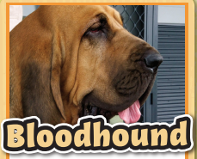
Bloodhound: A bloodhound can follow the smell of a person who left the area two days earlier. It can even trace someone who has walked through crowded streets.
Year 3 Reading Magazine NAPLAN, 2014 ACARA

Appendix 2

What am I? Text structure and features of an informative text
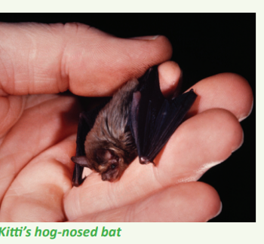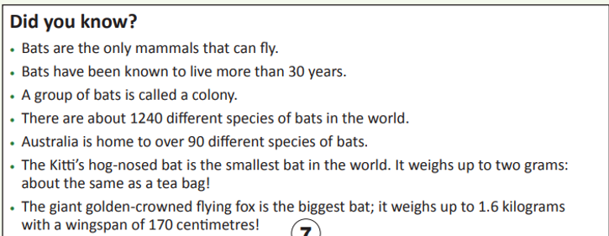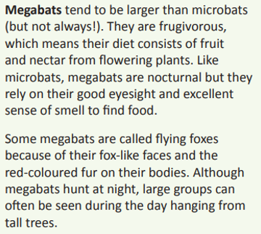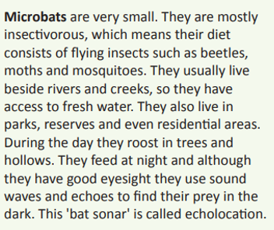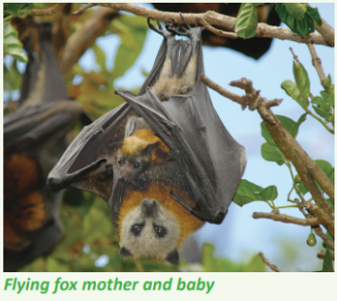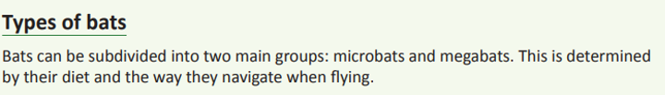
What am I? Clues to match
I introduce the topic of the whole text. I use a large font so I am easily noticeable. | I help the reader picture what is being described. I help to add more detail.
I sit under the heading and I give more information about a specific thing. | I am the first main heading of the text and introduce the overall concept.
I give extra information - I am often interesting and am short and sharp facts.
What am I? Labels
Title | Heading | Sub-heading and information
Image and caption | Bullet points/facts
Appendix 2

Teacher copy: Text structure and features of an informative text
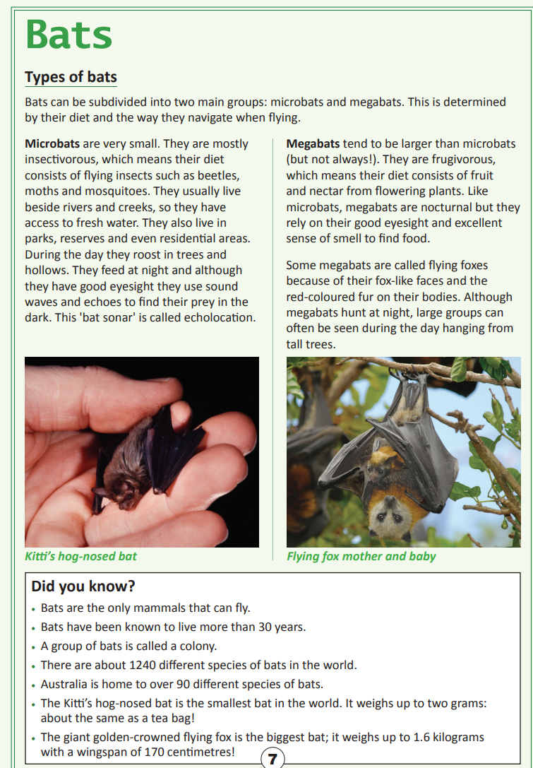
Year 3 Reading Magazine, 2016 ACARA

Teacher copy: Text structure and features of an informative text – accessible version
Bats
Types of bats
Bats can be subdivided into two main groups: microbats and megabats. This is determined by their diet and the way they navigate when flying.
Microbats are very small. They are mostly insectivorous, which means their diet consists of flying insects such as beetles, moths and mosquitoes. They usually live beside rivers and creeks, so they have access to fresh water. They also live in parks, reserves and even residential areas. During the day they roost in trees and hollows. They feed at night and although they have good eyesight they use sound waves and echoes to find their prey in the dark. This 'bat sonar' is called echolocation.
Megabats tend to be larger than microbats (but not always!). They are frugivorous, which means their diet consists of fruit and nectar from flowering plants. Like microbats, megabats are nocturnal but they rely on their good eyesight and excellent sense of smell to find food.
Some megabats are called flying foxes because of their fox-like faces and the red-coloured fur on their bodies. Although megabats hunt at night, large groups can often be seen during the day hanging from tall trees.
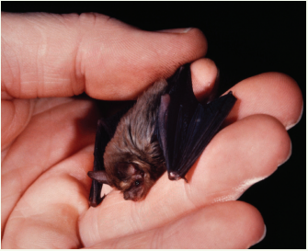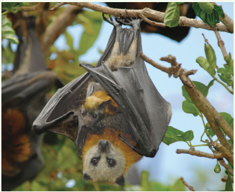
Kitti’s hog-nosed bat Flying fox mother and baby
Did you know?
- Bats are the only mammals that can fly.
- Bats have been known to live more than 30 years.
- A group of bats is called a colony.
- There are about 1240 different species of bats in the world.
- Australia is home to over 90 different species of bats.
- The Kitti’s hog-nosed bat is the smallest bat in the world. It weighs up to two grams: about the same as a tea bag!
- The giant golden-crowned flying fox is the biggest bat; it weighs up to 1.6 kilograms with a wingspan of 170 centimetres!
Year 3 Reading Magazine, 2016 ACARA

Appendix 3

Analyse effect of modal language
Place the following examples of modality on a continuum from weakest to strongest impact on the reader.
Paper planes are a nuisance and must be removed from the school playground! | It is crucial that coffee-lovers bring along their environmental cups.
You may like to empty the dishwasher this afternoon. | I might take a break in fifteen minutes.
You should clean under your bed at least once a month. | You can move the chess piece when you are ready.
How dare you speak in that tone of voice! | It is clear that things need to change in the playground.
I am certainly fed up with the rubbish lying around the bushland. | You should visit your dentist each year.
The tree might die if the drought continues. | We mustn’t use informal language in a speech.
Can I open the window? | You should stop eating chocolate every meal.
She must be told the truth. | I may use plastic bags at the shops.

Appendix 4

Identifying persuasive devices
Some students are investigating how pollution affects the environment. They have researched the effects of plastic bags. This is what they have written.

Should we pay for plastic bags?
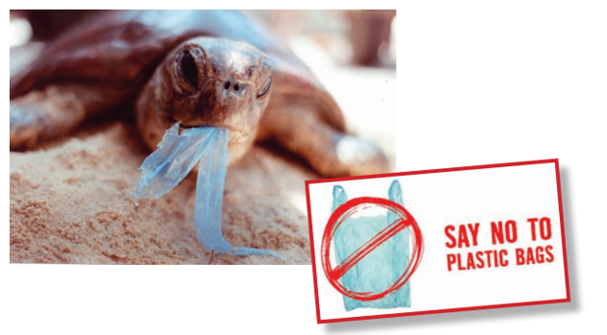
People should pay for the plastic bags they use for their shopping. According to experts from Clean Up Australia, Australians use over six billion plastic bags a year and many of these are used for carrying shopping home from supermarkets. Making people pay for these plastic bags would encourage them to use reusable bags.
Some plastic bags can last in the environment for up to 1 000 years before they disintegrate (break down). Plastic bags are harmful to wildlife as they can kill animals, especially in the ocean.
Also, when plastic bags are made, dangerous gases are released that pollute the atmosphere. If we use fewer plastic bags there would be less air pollution, as well as less land and water pollution.
We need to reduce the number of plastic bags in the environment. Making people pay will help to stop them using plastic bags and force them to use reusable bags for their shopping!
Year 3 Reading Magazine, 2009 ACARA
- Why does the author use the question ‘Should we pay for plastic bags?’
- Why do you think the author used the experts from ‘Clean up Australia’ in paragraph 1?
- What are the two arguments to make people reduce using plastic bags?
- What words does the author use in paragraph 4 which make it seem urgent?
Year 3 Reading Magazine, 2009 ACARA

Teacher copy: Identifying persuasive devices
Some students are investigating how pollution affects the environment. They have researched the effects of plastic bags. This is what they have written.

Should we pay for plastic bags?
People should pay for the plastic bags they use for their shopping. According to experts from Clean Up Australia, Australians use over six billion plastic bags a year and many of these are used for carrying shopping home from supermarkets. Making people pay for these plastic bags would encourage them to use reusable bags.
Some plastic bags can last in the environment for up to 1 000 years before they disintegrate (break down). Plastic bags are harmful to wildlife as they can kill animals, especially in the ocean.
Also, when plastic bags are made, dangerous gases are released that pollute the atmosphere. If we use fewer plastic bags there would be less air pollution, as well as less land and water pollution.
We need to reduce the number of plastic bags in the environment. Making people pay will help to stop them using plastic bags and force them to use reusable bags for their shopping!

Suggested responses:
- Why does the author use the question ‘Should we pay for plastic bags?’
This question makes the reader think about their own opinion and shows this article will persuade.

- Why do you think the author used the experts from ‘Clean up Australia’ in paragraph 1?
Using experts from Clean up Australia adds weight to the argument – they are the people who know the impact on the environment.

- What are the arguments to make people reduce using plastic bags?
Plastic bags take 1000 years to disintegrate, they are harmful to animals and they release dangerous gases.

- What words does the author use in paragraph 4 which make it seem urgent?
Suggestions: need, will, force
Year 3 Reading Magazine, 2009 ACARA

Appendix 5

Newsflash graphic organiser

Headline:

Key information: | Visual Representation:

Appendix 6

Responding to texts
What type of text is this text? How do you know?  Ideas: Imaginative, informative or persuasive? | This text mostly helps me to…  Ideas: Understand? Explain? Choose? Find out about?
The main purpose of this text is to…?  Ideas: Encourage me to…give interesting facts about…outline where…show me… | What genre is this text?  Ideas: Adventure? Science-fiction? Letter? Recipe?
What is happening in the first paragraph? | What question does this text answer?
Is there a problem in the text? If so, what is it? | Do you think the end of the text is effective? Why/why not?

Appendix 7

Activity Cards - Pick the Pronoun
You | Elsa | Someone
Table | Them | Our
Car | Milk | Us
Billy | Their | Mrs Smith
Television | Himself | We
Leaf | They | It
Him | Tiger | England
Something | Australians | Her

Appendix 8

Activity cards - Fact or Opinion?
Tigers have stripes | Everyone loves ice cream | The burgers are better at McDonalds
Children shouldn’t lie | Fish can only survive in water | Spiders have eight legs
The canteen should sell lollies and chocolate only | Australia is an island | There are more trees on earth than there are stars in the Milky Way. Approx. 3 trillion trees and 400 billion stars
People should wear sunscreen and a hat when going outside | Sydney is the capital city of NSW | A baby cow is called a calf
The Blue Whale is the biggest animal on the planet | You only need to brush your teeth once a day | People can walk around the Earth 4.5 times during their life
Baby Shark is an annoying song | Pronouns are words that are used in place of a noun | The Dung Beetle is the strongest insect in the world. It can pull 1141 times its own body weight.
Everyone should recycle | Frozen is the best movie ever | Cats are cleaner than dogs
The earth has more than 80,000 species of plants humans can eat | You shouldn’t throw rubbish out of car windows | Fire is hot

