Main idea

Stage 2

Overview

Purpose
This literacy teaching strategy supports teaching and learning for Stage 2 students across all key learning areas. It targets specific literacy skills and suggests a learning sequence to build skill development. Teachers can select individual tasks, or a sequence, and embed into their teaching and learning program according to their students’ needs. While exemplar texts are provided throughout this resource, it is recommended that teachers select texts which are relevant to their students and curriculum.

Learning intention
Students will learn to find the main idea in persuasive, imaginative and informative texts. Students will use the strategies of scanning to quickly identify the main ideas in a text and skimming to find key words.

Syllabus outcome
The following teaching and learning strategies will assist in covering elements of the following outcomes:
- EN2-RECOM-01: reads and comprehends texts for wide purposes using knowledge of text structures and language, and by monitoring comprehension
NSW English K-10 Syllabus (2022)

Success criteria
The following Year 3 NAPLAN item descriptors may guide teachers to develop success criteria for student learning.

- identifies the main idea of a text
- identifies the main idea of each paragraph in an information text
- identifies the main idea of a section of an information text
- identifies the main idea of an information text
- identifies the main idea of a poster
- identifies the main idea of a persuasive discussion
- identifies the main idea of a paragraph in a persuasive text
- identifies the main idea of a narrative
- evaluates the presence of information in an information text
- identifies a central theme in a narrative

National Literacy Learning Progression guide

Understanding Texts (UnT6-UnT9)
Key: C=comprehension P=process V=vocabulary

UnT6
- reads and views simple texts and some predictable texts (see Text complexity) (C)
- identifies main idea by synthesising information across a simple text (C)
- scans texts to locate specific information in a predictable print text (C).
- recounts or describes the most relevant details from a text (C)

UnT7
- reads and views predictable texts (see Text complexity) (C)
- identifies the main idea in a predictable text (C)
UnT8
- reads and views some moderately complex texts (see Text complexity) (C)
- accurately retells a text including most relevant details (C)
- identifies main idea and related or supporting ideas in moderately complex texts (see Text complexity) (C)
- uses knowledge of the features and conventions of the type of text to build meaning (e.g. recognises that the beginning of a persuasive text may introduce the topic and the line of argument) (P)

UnT9
- identifies the main themes or concepts in complex texts by synthesising key ideas or information (C)
- summarises the text identifying key details only (C)
- selects reading/viewing strategies appropriate to reading purpose (e.g. scans text for evidence) (P)
National Literacy Learning Progression

Evidence base
- Centre for Education Statistics and Evaluation (2017). Effective reading instruction in the early years of school, literature review.
- Konza, D. (2014). Teaching Reading: Why the “Fab Five” should be the “Big Six”. Australian Journal of Teacher Education, 39(12).
- Oakhill, J., Cain, K. & Elbro, C. (2015). Understanding and teaching reading comprehension: A handbook. Routledge.
- Quigley, A. (2020). Closing the reading gap. Routledge.
- Scarborough, H.S. (2001). Connecting early language and literacy to later reading (dis)abilities: Evidence, theory and practice. In S. Neuman & D. Dickson (Eds.), Handbook for research in early literacy (pp. 97-110). New York, NY: Guilford Press.

Alignment to system priorities and/or needs: Five priorities for Literacy and Numeracy, Plan for Public Education, School Excellence Policy (nsw.gov.au).
Alignment to School Excellence Framework: Learning domain: Curriculum, Teaching domain: Effective classroom practice and Professional standards
Consulted with: Strategic Delivery, Teaching Quality and Impact
Author: Literacy and Numeracy
Reviewed by: Literacy and Numeracy, Teaching Quality and Impact
Created/last updated: January 2024
Anticipated resource review date: January 2025
Feedback: Complete the online form to provide any feedback

Copyright
Section 113P Notice
Texts, Artistic Works and Broadcast Notice
Some of this material has been copied and communicated to you in accordance with the statutory licence in section 113P of the Copyright Act. Any further reproduction or communication of this material by you may be the subject of copyright protection under the Act. Do not remove this notice.

Teaching strategies
Task | Appendices
A picture paints a thousand words | Appendix 1 - ‘A picture paints a thousand words’ image  Appendix 2 - ‘A picture paints a thousand words’ student images
What is the main idea?
Identifying the main idea in paragraphs and sections | Appendix 3 - ‘The Tree of Life’ text and teacher guide  Appendix 4 - Identifying main idea: paragraph level
Identifying main idea in whole texts | Appendix 5 - Identifying main Idea: whole text level
Identifying theme in a narrative
Understanding theme in a narrative text
Understanding theme in a narrative text: story-board activity | Appendix 6 - Theme storyboard
Understanding theme in a narrative: exploring short texts

Background information

Main idea
Being able to determine the main idea helps readers to recall important information. Locating the main idea and significant details helps the reader understand the points the writer is attempting to express. Identifying the relationship between the main idea and significant details will improve comprehension.
Skimming
Skimming happens when the reader is unfamiliar with a text and quickly peruses the text to determine the general idea. Some strategies to use include:
- read the first and last paragraphs
- look for general information
- use headlines, page layout, graphs, diagrams and charts, pictures, highlights
Scanning
Scanning occurs when the reader already has prior knowledge and wants to find out more. The reader scans the text to find specific information and key words. Strategies to use include:
- look over the text quickly to locate words and sentences that link to what you need to find out
- use contents pages, first and last sentences in a paragraph, subheadings, captions, bold key words, hyperlinks etc.

Where to next?
- Literal comprehension
- Inference
- Exploring perspective

Overview of teaching strategies

Purpose

These literacy teaching strategies support teaching and learning from Stage 2 to Stage 5. They are linked to NAPLAN task descriptors, syllabus outcomes and literacy and numeracy learning progressions.

These teaching strategies target specific literacy and numeracy skills and suggest a learning sequence to build skill development. Teachers can select individual tasks or a sequence to suit their students.

Access points
The resources can be accessed from:
- NAPLAN App in Scout using the teaching strategy links from NAPLAN items
- NSW Department of Education literacy and numeracy website.

What works best
Explicit teaching practices involve teachers clearly explaining to students why they are learning something, how it connects to what they already know, what they are expected to do, how to do it and what it looks like when they have succeeded. Students are given opportunities and time to check their understanding, ask questions and receive clear, effective feedback.
This resource reflects the latest evidence base and can be used by teachers as they plan for explicit teaching.
Teachers can use classroom observations and other assessment information to make decisions about when and how they use this resource as they design teaching and learning sequences to meet the learning needs of their students.
Further support with What works best is available.

Differentiation
When using these resources in the classroom, it is important for teachers to consider the needs of all students, including Aboriginal and EAL/D learners.
EAL/D learners will require explicit English language support and scaffolding, informed by the EAL/D enhanced teaching and learning cycle and the student’s phase on the EAL/D Learning Progression. Teachers can access information about supporting EAL/D learners and literacy and numeracy support specific to EAL/D learners.
Learning adjustments enable students with disability and additional learning and support needs to access syllabus outcomes and content on the same basis as their peers. Teachers can use a range of adjustments to ensure a personalised approach to student learning.
Assessing and identifying high potential and gifted learners will help teachers decide which students may benefit from extension and additional challenge. Effective strategies and contributors to achievement for high potential and gifted learners helps teachers to identify and target areas for growth and improvement. A differentiation adjustment tool can be found on the High potential and gifted education website.

Using tasks across learning areas
This resource may be used across learning areas where it supports teaching and learning aligned with syllabus outcomes.
Literacy and numeracy are embedded throughout all syllabus documents as general capabilities. As the English and mathematics learning areas have a particular role in developing literacy and numeracy, NSW English and Mathematics syllabus outcomes aligned to literacy and numeracy skills have been identified.

Text selection
Example texts are used throughout this resource. Teachers can adjust activities to use texts which are linked to their unit of learning.
Further support with text selection can be found within the National Literacy Learning Progression Text complexity appendix.
The NESA website has additional information on text requirements within the NSW English syllabus.

Teaching strategies

A picture paints a thousand words
- Teacher displays and discusses the saying ‘A picture paints a thousand words’ with the class. Have you heard this saying? What do you think it might mean? What makes you think this?
- Using an image related to a current unit of learning, or the image in Appendix 1 - ‘A picture paints a thousand words’ image, students apply their understanding of ‘A picture paints a thousand words’ to predict what might be happening. Teacher prompts with questions such as:
- Who do you think is involved in this image?
- What might be happening?
- What do you think happened before this?
- What might happen after this image?
- What is the meaning /message of this image?
- Teacher provides a range of images for students to respond to (refer to Appendix 2 - ‘A picture paints a thousand words’ student images). This can be done as a gallery walk where students build upon each other’s ideas.

What is the main idea?
- Explain to students that the main idea is the central message of section of writing. This could be a paragraph or a whole text, a poem or a novel and so on.
- Ask students why it might be important to recognise the main idea of a text. Explain that a reader needs to be able to identify the main idea to monitor and build understanding, recognise what an author is trying to communicate and to see ‘the big picture’. Being able to determine the main idea helps readers to recall important information. Locating the main idea and significant details helps the reader understand the points the writer is attempting to express.
- Explain that to be able to find the main idea, we need to be able to identify the topic of a piece of writing so that we can really understand what the author wants us to know. Share some examples of topics such as healthy eating, how to draw a quadrilateral, food safety and so on.
- Teacher uses a ‘think aloud’ process to demonstrate how to find the main idea after finding the topic, using the following text excerpt, or a text linked to current unit of learning:
Healthy eating
It is important that children eat a balanced diet. A diet is made up of all the food and liquids we consume each day. We need to make sure we eat five serves of vegetables and two serves of fruit to make sure we are getting all the nutrients we need to grow.

Think aloud:
“I can see that this text is about healthy eating as I can see this in the heading – healthy eating is the topic. I can also scan through the text and see some vocabulary linking to the topic such as ‘diet’, ‘consume’ and ‘nutrients’. I can see the topic sentence at the beginning of the paragraph says, “It is important that children eat a balanced diet”. I think this might be the main idea of the paragraph as the author has stated this early.
I am going to read the rest to see if the paragraph has more information or supporting detail to this main idea that a balanced diet is important. I can see the author has told us what a diet is made up of and that we need to eat certain amounts to grow. These are supporting details to the main idea.
I can also see the author has used strong language to position the reader “It is important” and “...need to make sure”. This is the kind of language we use when we want to persuade someone, whilst giving information.
To make a statement about the main idea, I use all this information to create a sentence; the main idea is that healthy eating is important for growth.”

Identifying the main idea in paragraphs and sections
- Model skimming and scanning ‘The Tree of Life’ using the teacher guide to support discussion (Appendix 3 - ‘The Tree of Life’ text and teacher guide). Draw attention to where information can be located: diagrams, headings, sub-headings, illustrations. Teacher uses a think aloud strategy to identify the general ‘gist’ or main idea of the text:

Think aloud
“If I needed to identify one sentence to explain what the text is about, I would underline the first sentence: A large part of the world’s population depends on the coconut.” This sentence is supported by the details in the text that we can use coconuts for cooking, drinking, and making oil. So, this sentence is the ‘main idea’ of the topic.”
- Review that the topic of a text can often be found in the heading and by incorporating this information with the topic sentence and supporting detail.
- Reinforce that we use this information to create a clear sentence to capture the author’s message to find the main idea.
- Review that the main idea is often reinforced with the last sentence of the paragraph.
- Students guide teacher to put this information in a concept map:
Main Idea:
Coconuts are an important product in the world.
Detail:
husk can be woven into ropes and yarn.
Detail:
Jewellery and musical instruments made from shell
Detail:
Eat and drink coconut ‘meat’ and water.
Detail:
Oil can be used for beauty products, soap and animal feed.
- Students find the main idea in a range of texts (refer to Appendix 4 - Identifying main idea: paragraph level). Students identify vocabulary, and details in a text to build an understanding of the main idea.

Identifying main idea in whole texts
- Demonstrate how to find the main idea in a whole text using a think aloud process, using any suitable text linked to a current unit of learning or refer to Appendix 5 - Identifying main Idea: whole text level. Identify key and repeated vocabulary and supporting details found in the text to build an understanding of the main idea of the text.
- Students use Appendix 5 - Identifying main Idea: whole text level to apply learning. Share and discuss.
Alternate task: text examples can be enlarged and put on posters around the classroom as a gallery walk for students to add to.

Identifying theme in a narrative
- Review definition of ‘theme’ as a central message or what the author wants you to learn or know. The theme is usually not stated and is inferred from vocabulary, text structure, purpose, tone and bias.
- Read or view a range of short texts and model identifying the central theme. Using short films such as ‘miniscule’ (on YouTube) or Pixar shorts (pixar.com) are a great way to see a whole text to identify the theme. Pixar shorts also provide a short overview of the film in the background information section.
- Give students a collection of fiction and non-fiction picture books, short stories or articles to determine their genre (adventure, science fiction, comedy, drama). Apps such as Stan, Netflix and ABC online categorise films into genres and this may help student understanding. Students write on a sticky note what genre they think the text is, supported by evidence. For example, visual clues from book or film covers, such as images of setting or characters, or examples from the blurb or text itself. Students rotate around the texts and add tally marks to the genres they agree with and add an ‘I wonder…’ question to any genres they disagree with or would like to add to.
- Class discussion: based on the clues found in these texts, brainstorm the types of themes you would expect to feature in these genres. For example, a fantasy text may feature themes of ‘good overcoming evil’, the importance of ‘persistence or courage’ and ‘facing your fears’. As a class, summarise these genre themes using a simple concept map or graphic organiser.
For higher order thinking, students use a Frayer Model to organise their ideas on themes in a particular genre. They define the theme, identify facts or characteristics, examples from texts and non-examples.

Understanding theme in a narrative text
This task aims to further develop student knowledge of theme in narrative texts.
- Explain to your students that today they will be learning about identifying the theme within a narrative text. Students may/may not have prior learning about the structure/features of a narrative text. At this point, a basic understanding of a narrative is all that is required for this task. Changing the word ‘narrative’ to ‘story’ might be required for some students.
- Prompt students for any prior knowledge and/or understanding of the word ‘theme’ and display understanding in a brainstorm. Use this opportunity to clarify the fact that words can often have different meanings when used in different contexts. A theme in a narrative (or story) is a central message or what the author wants you to learn or know. To support student understanding include a visual representation of the word ‘message’ under the definition. This could be an image of an envelope or post card, a person talking to another person or a text message.
- Students are asked to complete the following activity: In groups of 2-4 come up with one important message about friendship that you believe everyone needs to know. Examples:
- Friends need to be kind to one another.
- Friends need to trust each other.
- Friends need to listen to each other.
- Ask the groups to share their key messages with the class. Suggested resources to support group communication include post it notes, envelopes, post cards, large sheets of paper and white boards. Envelopes and post cards might be particularly effective for the purposes of reinforcing the concept of delivering a message. Make sure you keep/collect the ideas of each group as it will be required for the task proceeding this one.
- After students have shared their messages, explain the following concept to students:
- Most authors have a message that they want to share with their readers. Before writing a narrative, they will usually know what that message is. Similar to what you were doing in your groups, authors might spend some time brainstorming their ideas in order to decide what the message will be.
- The theme (or message) is not usually stated in a narrative. The author will not tell you directly what the theme is. In other words, the message will not be written down for you to find. Therefore, it is up to you as a reader to think about what the characters DO, THINK and SAY to understand the central message. Like a detective, you can figure out the theme by finding and examining these clues from the text. (Use the terms ‘theme’ and ‘message’ interchangeably to support vocabulary knowledge and conceptual understanding.)
- Pose the following question to students:
- If you were to write a narrative based on the message/theme your group created, what would the characters DO / THINK / SAY for the reader to understand it? (Write/project this question onto the board to support students during the activity.)
- Students discuss this question in their groups. Monitor the discussions happening in each group to ensure students have understood the question. If students are confused use prompting questions to guide their thinking. Some suggestions include:
  - How do you know that two people are friends? What do they do and say to each other?
  - What is a kind thing that you might do for your friend?
  - How do you feel when someone is kind to you? What do you say?
  - What is an unkind thing that you might do to your friend?
  - What are some consequences of being unkind?
  - How might you behave if someone isn’t being very nice to you?
  - What might a friend do to make you trust them? (For example, keep a secret)
  - How do you feel when a friend ignores what you’re saying?
  - How do you know a friend isn’t listening to you?
  - What are the consequences of being ignored?
  - How do you know if a character has changed?
  - How do you know if a character has learnt something new?
- When students have finished their group discussions, help them to consolidate their knowledge and understanding by asking them to answer the following questions. Students might complete these questions in the form of an exit ticket.
- In your own words, what is a theme in a narrative text?
- Is the theme directly stated in a narrative? Yes/No?
- Why do you think it is helpful to know a narrative’s theme?
- What would you like to know more about?

Understanding theme in a narrative text: story-board activity
This task aims to deepen a student’s understanding of theme in narrative texts.
- Review the previous task where students were asked to develop their knowledge and understanding of the word ‘theme’. Students share responses from their exit ticket completed during the previous task. Use these student responses to reinforce key ideas and to clarify any misunderstandings.
- Ask students to recall what they know and understand about narrative texts. Students should demonstrate knowledge of orientation, complication & resolution. They should also know that a narrative is a type of text which tells a story. You can build background knowledge by drawing student attention to texts they have already read in class or texts that interest them. Some students might require a visual representation of narrative structure to support them during the following group task.
- Explain to students that today they will be applying what they have learnt about theme during the previous task by creating a storyboard for their ‘Friendship’ narrative/story. Explain that a ‘storyboard’ is a tool that can be used to plan the main events in a narrative. (Teacher displays and deconstructs samples of storyboards if class are unfamiliar with this type of text.)
- Model the task by drawing/projecting the storyboard template (Appendix 6 - Theme storyboard). Note that this model is only an example. Teachers should change the story and theme based on the level of complexity required for their students.
THEME (message): Friends should be kind to each other.
Picture 1 | Picture 2 | Picture 3
Sarah was sad because she fell over while running on the playground. | Elizabeth saw her crying. “Are you ok?” she asked.  “No” Sarah replied. | Elizabeth helped Sarah by finding the teacher.

Picture 4 | Picture 5 | Picture 6
Sarah was very happy when help arrived. | Sarah’s knee was cleaned and patched up with a band-aid. | Elizabeth helped Sarah walk to the toilet area so that she could wash her face.  “Thank you,” said Sarah. Elizabeth smiled.
- In groups students are directed to create their own storyboard on A4 or A3 paper. They might also use white boards or their exercise books. Students should draw the pictures and/or use existing images from a range of sources.
- The level of support required to complete this task will be different depending on student ability. Teachers should use the modelled/guided/independent approach when supporting students to complete this task. Students will also benefit from teachers using a ‘think aloud’ to model their metacognition when constructing the story board, making narrative choices, and explicitly linking these choices to the central message/theme.
- After students have completed their storyboard, ask each group to present their ideas to the class. The teacher should ask each group to hide their theme. Teachers should scaffold student responses during the presentation using prompts to engage the class in a reciprocal discussion about narrative theme and structure. Below are some examples of teacher dialogue aimed at summarising, questioning and clarifying information.
- “Can your group please summarise what your story is about?”
- “Can anyone from the audience guess what the central message/theme is? Why do you think that? What information helped you come up with that answer?”
- “As a group how did you decide what the characters were going to say and/or do? Are your ideas based on anyone’s own experiences?”
- “Can anyone from the audience suggest an idea to make the message/theme stronger? What else could happen in the story?”
- “As authors, do you believe you successfully communicated your message? Why do you think that?” (Consider how the audience has responded so far to the group’s presentation and whether or not they guessed the theme correctly. This will help you to prompt students to consider what they have done well and what they could do differently.)
- “What do you notice about the structure of your narrative text? In other words, how did you decide what events would go in each box? Why is box 1 the beginning of the story and why is box 6 the end of the story?” (Check to see if students can identify the orientation, complication, and resolution.)
- To consolidate student understanding and make learning meaningful, ask students to complete the following independent task: In your exercise books come up with one message/theme that matters to you. It doesn’t need to be based on friendship. If students are struggling to think of ideas use the following thematic prompts to help them: teamwork, love, honesty, forgiveness, hard work, courage, bravery, goodness. Students should be encouraged to share their ideas with the rest of the class or a friend.

Identifying theme in a narrative: exploring short texts
- Students read or view a range of short texts and model identifying the central theme. Using short films such as ‘miniscule’ (on YouTube) or Pixar shorts (pixar.com) are a great way to see a whole text to identify the theme. Pixar shorts also provide a short overview of the film in the background information section. Teachers might want to use texts that students have already engaged with in class.
- Involve the students in a reciprocal discussion while exploring each text. Below are some examples of teacher dialogue:
- “In your own words, can you summarise what the story is about?”
- “Can anyone guess what the central message/theme is? Why do you think that? What information helped you come up with that answer?”
- “Can you relate to any of the experiences explored in the story? Did this help you understand the main theme/message?”
- “Can anyone suggest an idea to make the message/theme stronger? What else could happen in the story?”
- “Do you believe the author successfully delivered their message? Why do you think that?” (Consider how the students have responded so far to the text and whether they guessed the theme correctly.)

Appendix 1

Teacher copy: A picture paints a thousand words
Image by Zhivko Minkov Unsplash.com
Questions | Responses
What is this text about?
What key information is in this image?
What or who is involved?
Where is this happening?
What might have been happening before this?

Appendix 2

Student copy: A picture paints a thousand words
Image by Chris Galbraith Unsplash.com

Student copy: A picture paints a thousand words
Image by Tim Mossholder on Unsplash.com

Student copy: A picture paints a thousand words
Image by David Splode on Unsplash.com

Student copy: A picture paints a thousand words
Image by Roman Kraft on Unsplash.com

Appendix 3

‘The Tree of Life’ text and teacher guide
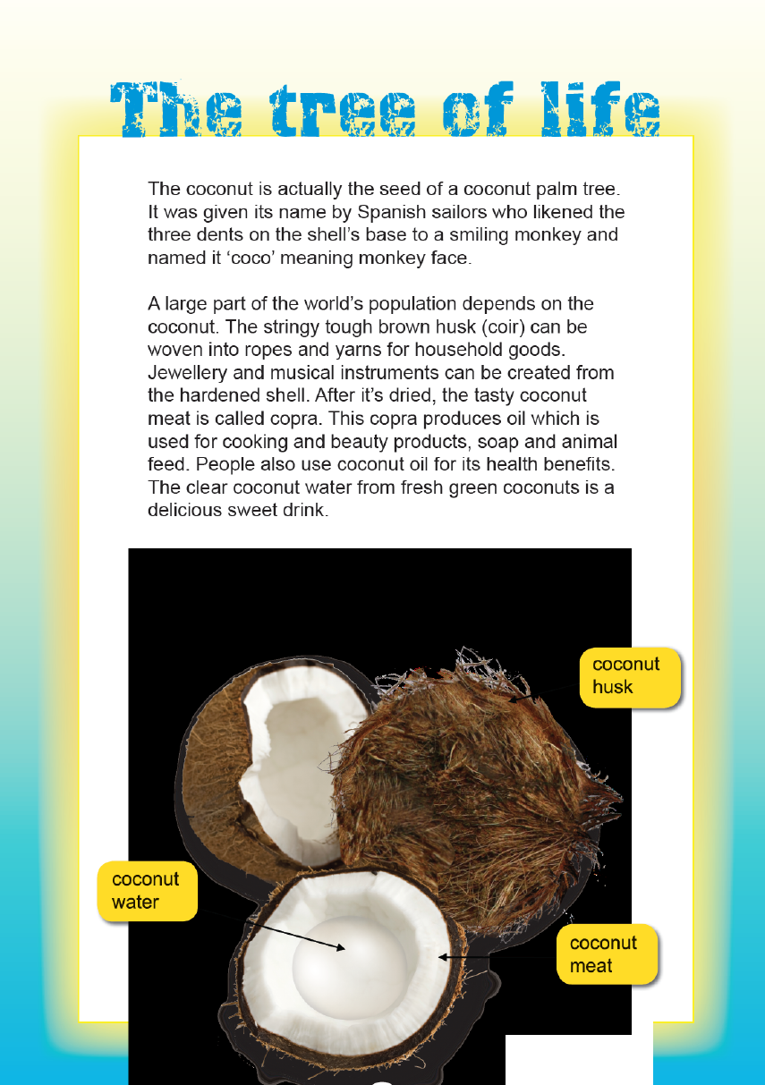
Year 5 NAPLAN Reading Magazine, 2013 ACARA

‘The Tree of Life’ text and teacher guide - accessible version

The Tree of life
The coconut is actually the seed of a coconut palm tree. It was given its name by Spanish sailors who likened the three dents on the shell’s base to a smiling monkey and named it ‘coco’ meaning monkey face.
A large part of the world’s population depends on the coconut. The stringy tough brown husk (coir) can be woven into ropes and yarns for household goods. Jewellery and musical instruments can be created from the hardened shell. After it’s dried, the tasty coconut meat is called copra. This copra produces oil which is used for cooking and beauty products, soap and animal feed. People also use the coconut oil for its health benefits. The clear coconut water from fresh green coconuts is a delicious, sweet drink.
It’s not surprising that the coconut palm is called ‘the tree of life’.
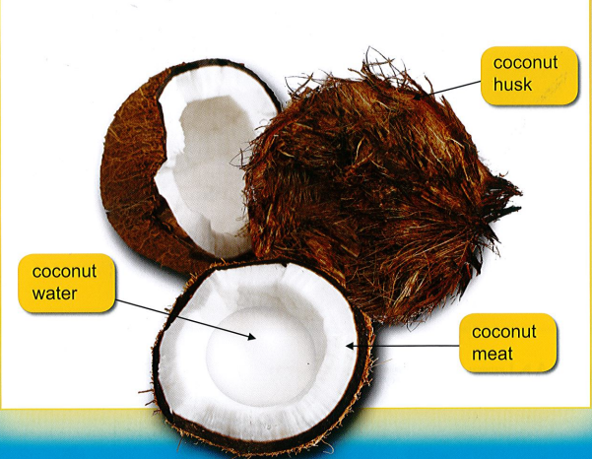
Coconut husk Coconut water Coconut meat
Year 5 NAPLAN Reading Magazine, 2013 ACARA

‘The Tree of Life’ text and teacher guide
The tree of life | Details
The coconut is actually the seed of a coconut palm tree. It was given its name by Spanish sailors who likened the three dents on the shell’s base to a smiling monkey and named it ‘coco’ meaning monkey face.  A large part of the world’s population depends on the coconut. The stringy tough brown husk (coir) can be woven into ropes and yards for household goods. Jewellery and musical instruments can be created from the hardened shell. After it’s dried, the tasty coconut meat is called copra. This copra produces oil which is used for cooking and beauty products, soap and animal feed. People also use coconut oil for its health benefits. The clear coconut water from fresh green coconuts is a delicious, sweet drink. | Key vocabulary  coconut, population, depends, husk, coir, shell, copra, oil, produces, health benefits, seed  Repeated vocabulary  Coconut, oil  Important details  Household goods, jewellery and musical instruments, cooking and beauty products, health benefits  Main idea  A large part of the population depends on coconuts for their health benefits and for household goods.
Year 5 NAPLAN Reading magazine, 2013 ACARA

Appendix 4

Identifying main idea: paragraph level
Letter to Amy
Some people think there is nothing to do in the outback. But they are so wrong! I’m already planning things that we can do together. We could visit the kangaroo orphanage and see the joeys. We could explore the opal fields and go digging and panning for gold. People in Coober Pedy call that ‘noodling’. If it gets too hot, we can always visit my friend or make new ones. My friend, Mark, lives in a house under the ground. It is nice and cool inside. These are things you just can’t experience in the city.

Key vocabulary | Repeated vocabulary

Detail | Detail | Detail

Main idea
Year 3 NAPLAN Reading Magazine, 2015 ACARA

Identifying main idea: paragraph level
In the small village there lived a particularly unkind child. This particularly unkind child seemed to enjoy tripping, pushing, poking and generally annoying any passer-by. Almost every child in the class had experienced this unkindness and every child in the class now was very cautious around him. Even the class pet was cautious around him. There was only one person who had not experienced this unkindness. And oh boy was he was ready for the day.

Key vocabulary | Repeated vocabulary

Detail | Detail | Detail

Main Idea
© State of New South Wales (Department of Education), 2021

Identifying main idea: paragraph level

Bamboozled!
Bamboo is an amazing plant. Did you know it is actually a grass? In fact, giant bamboo is the largest member of the grass family. Some types can grow an incredible ninety centimetres in just one day. Some bamboo plants can grow to over thirty metres tall, which is as tall as a gum tree.
Key vocabulary | Repeated vocabulary

Detail | Detail | Detail

Main Idea
Year 3 NAPLAN Reading magazine, 2016 ACARA

Appendix 5

Identifying main idea: whole text level
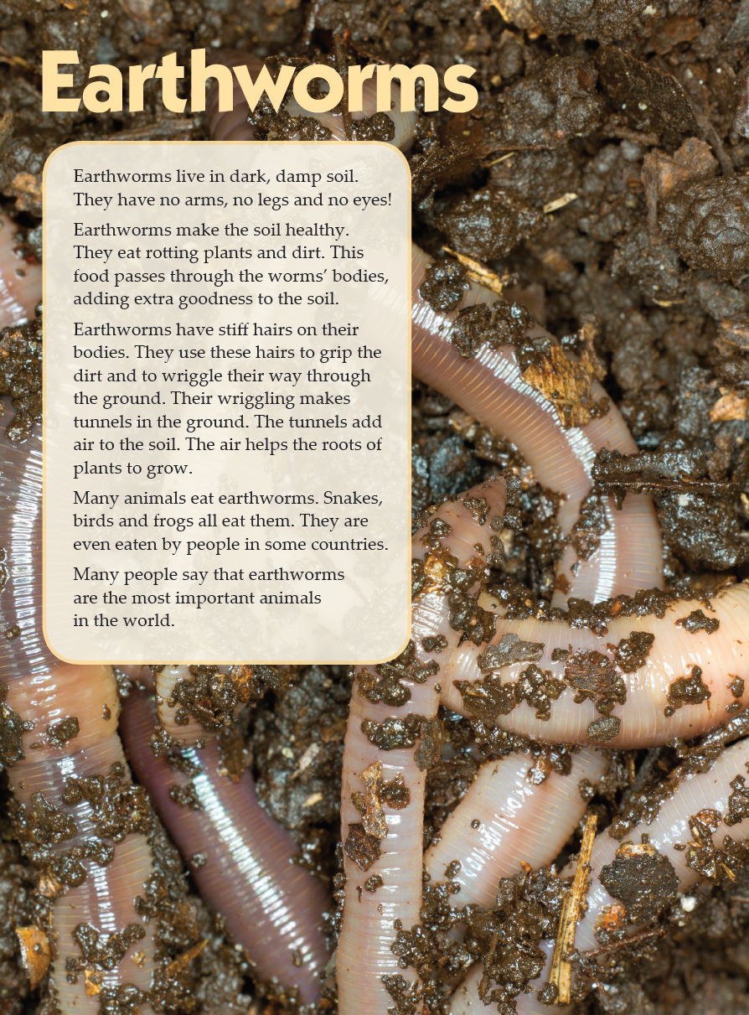

Year 3 NAPLAN Reading magazine, 2013 ACARA

Identifying main idea: whole text level – accessible version
Earthworms
Earthworms live in dark, damp soil. They have no arms, no legs and no eyes!
Earthworms make the soil healthy. They eat rotting plants and dirt. This food passes through the worms’ bodies, adding extra goodness to the soil.
Earthworms have stiff hairs on their bodies. They use these hairs to grip the dirt and to wriggle their way through the ground. Their wriggling makes tunnels in the ground. The tunnels add air to the soil. The air helps the roots of plants to grow.
Many animals eat earthworms. Snakes, birds and frogs all eat them. They are even eaten by people in some countries.
Many people say that earthworms are the most important animals in the world.
Year 3 NAPLAN Reading magazine, 2013 ACARA

Annotated teacher copy - Identifying main idea: whole text level
Earthworms | Details
Earthworms live in dark, damp soil. They have no arms, no legs and no eyes!  Earthworms make the soil healthy. They eat rotting plants and dirt. This food passes through the worms’ bodies, adding extra goodness to the soil.  Earthworms have stiff hairs on their bodies. They use these hairs to grip the dirt and wriggle their way through the ground. Their wriggling makes tunnels in the ground. The tunnels add air to the soil. The air helps the roots of plants to grow.  Many animals eat earthworms. Snakes, birds and frogs all eat them. They are even eaten by people in some countries.  Many people say that earthworms are the most important animals in the world. | Key vocabulary  Earthworms, soil, healthy, rotting plants and dirt, goodness, hairs, grip, wriggle, tunnels, air, roots, eat, important  Repeated vocabulary  Soil, earthworms, plants, ground, eaten  Important details  Earthworms live in dark, damp soil, adding goodness to the soil, eat rotting plants and dirt, air helps the roots of plants to grow, many animals eat earthworms.  Main Idea  Earthworms are one of the most important animals in the world as they are food and ensure food grows.
Year 3 NAPLAN Reading magazine, 2013 ACARA

Student copy - Identifying main idea whole text level
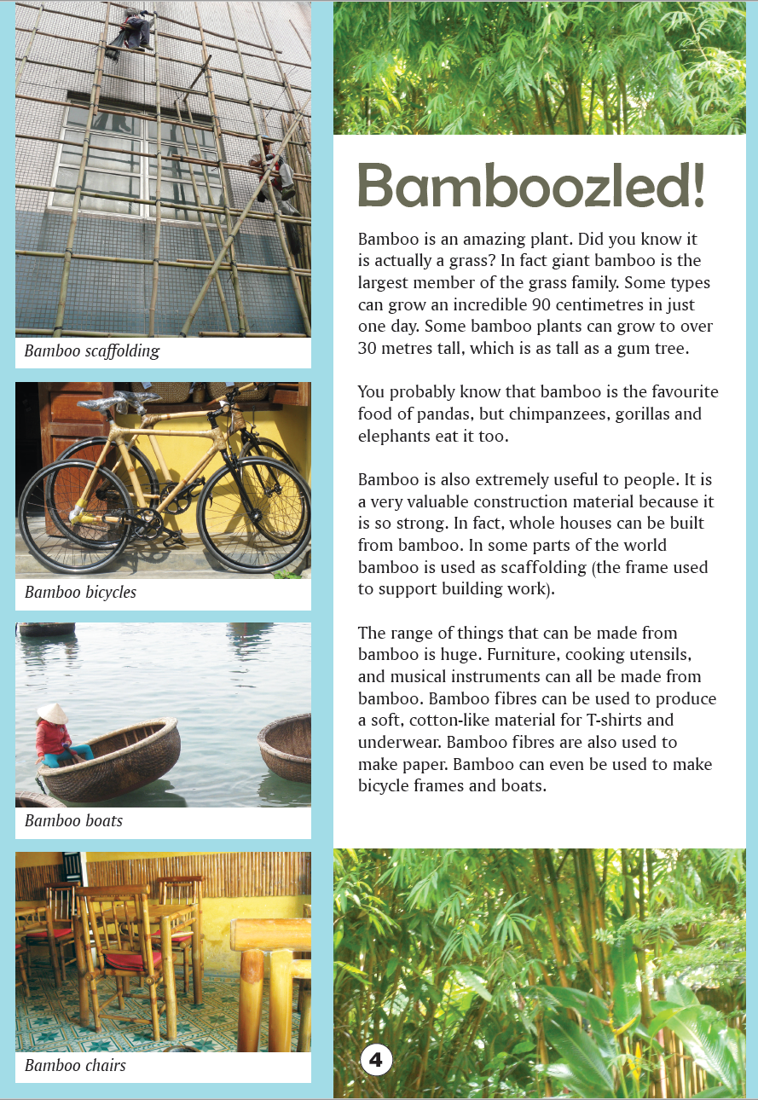
Year 3 NAPLAN Reading Magazine, 2016 ACARA
Key vocabulary:

Repeated vocabulary:

Important details:

Main Idea

Appendix 5

Identifying main idea: whole text level- accessible version
  - Bamboozled!
Bamboo is an amazing plant. Did you know it is actually a grass? In fact, giant bamboo is the largest member of the grass family. Some types can grow an incredible ninety centimetres in just one day. Some bamboo plants can grow to over thirty metres tall, which is as tall as a gum tree.
You probably know that bamboo is the favourite food of pandas, but chimpanzees, gorillas and elephants eat it too.
Bamboo is also extremely useful to people. It is a very valuable construction material because it is so strong. In fact, whole houses can be built from bamboo. In some parts of the world bamboo is used as scaffolding (the frame used to support building work).
The range of things that can be made from bamboo is huge. Furniture, cooking utensils, and musical instruments can all be made from bamboo. Bamboo fibres can be used to produce a soft, cotton-like material for T-shirts and underwear. Bamboo fibres are also used to make paper. Bamboo can even be used to make bicycle frames and boats.
Key vocabulary
Repeated vocabulary
Important details
Main idea
Year 3 NAPLAN Reading magazine, 2016 ACARA

Student copy - Identifying main idea: whole text level
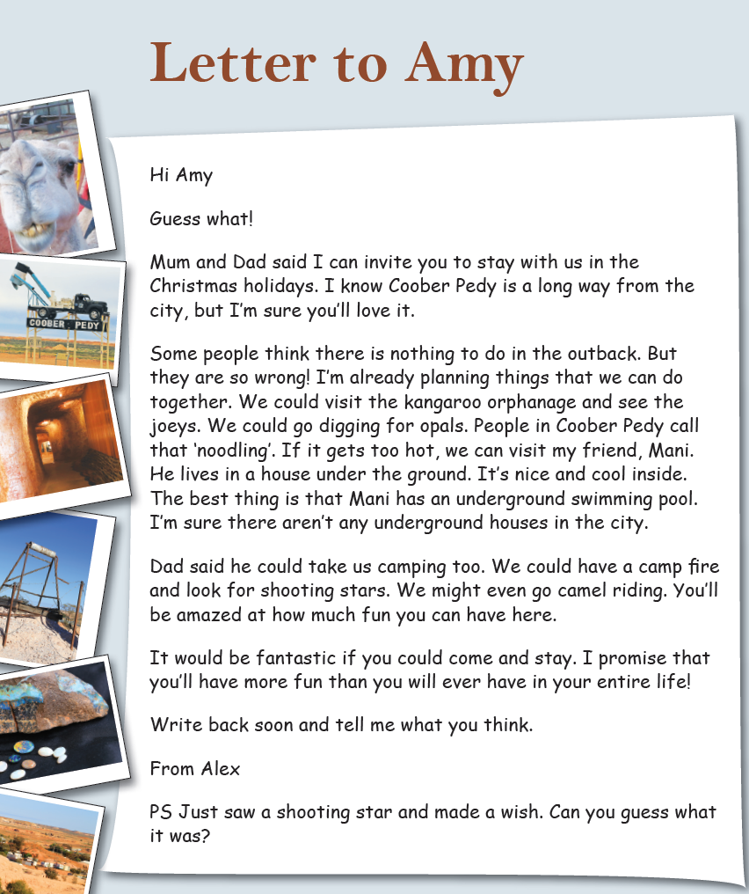
Key vocabulary:

Repeated vocabulary:

Important details:

Main idea

Year 3 NAPLAN Reading Magazine, 2016 ACARA

Identifying main idea: whole text level - accessible version.

Letter to Amy
Hi Amy
Guess what!
Mum and Dad said I can invite you to stay with us in the Christmas holidays. I know Coober Pedy is a long way from the city, but I’m sure you’ll love it.
Some people think there is nothing to do in the outback. But they are so wrong! I’m already planning things that we can do together. We could visit the kangaroo orphanage and see the joeys. We could go digging for opals. People in Coober Pedy call that ‘noodling’. If it gets too hot, we can visit my friend, Mani. He lives in a house under the ground. It’s nice and cool inside. The best thing is that Mani has an underground swimming pool. I’m sure there aren’t any underground houses in the city.
Dad said he could take us camping too. We could have a camp fire and look for shooting starts. We might even go camel riding. You’ll be amazed at how much fun you can have here.
It would be fantastic if you could come and stay. I promise that you’ll have more fun than you will ever have in your entire life!
Write back soon and tell me what you think.
From Alex
PS Just saw a shooting star and made a wish. Can you guess what it was?
Key vocabulary
Repeated vocabulary
Important details
Main idea
Year 3 NAPLAN Reading magazine, 2016 ACARA

Student copy - Identifying main idea: whole text level
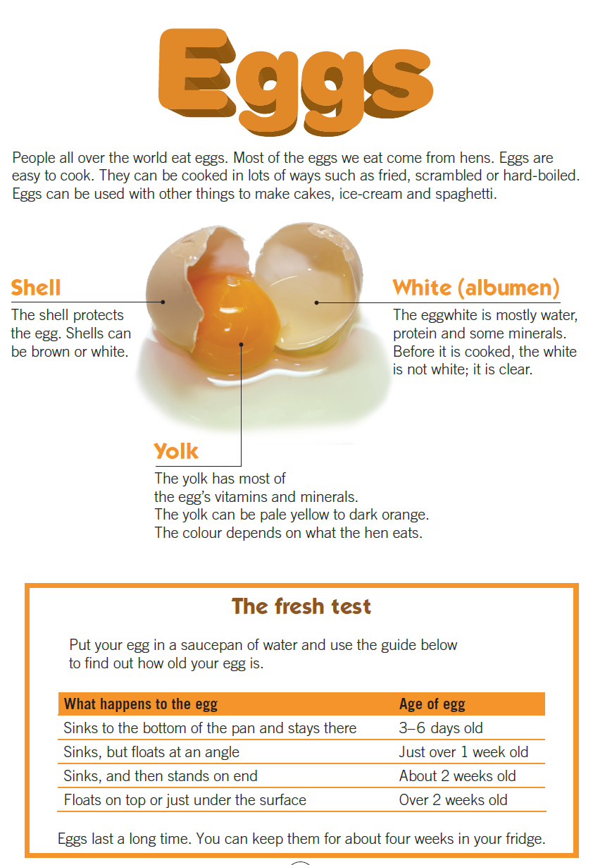
Key vocabulary:

Repeated vocabulary:

Important details:

Main Idea

Year 3 NAPLAN Reading Magazine, 2013 ACARA

Identifying main idea: whole text level - accessible version

Eggs
People all over the world eat eggs. Most of the eggs we eat come from hens. Eggs are easy to cook. They can be cooked in lots of ways such as fried, scrambled or hard-boiled. Eggs can be used with other things to make cakes, ice-cream and spaghetti.

Shell
The shell protects the egg. Shells can be brown or white.

Yolk
The yolk has most of the egg’s vitamins and minerals. The yolk can be pale yellow to dark orange. The colour depends on what the hen eats.

White (albumen)
The eggwhite is mostly water, protein and some minerals. Before it is cooked, the white is not white, it is clear.
The fresh test
Put your egg in a saucepan of water and use the guide below to find out how old your egg is.
What happens to the egg | Age of egg
Sinks to the bottom of the pan and stays there | Three to six days old
Sinks, but floats at an angle | Just over one week old
Sinks, and then stands on end | About two weeks old
Floats on top or just under the surface | Over two weeks old
Eggs last a long time. You can keep then for about four weeks in your fridge.
Key vocabulary
Repeated vocabulary
Important details
Main idea
Year 3 NAPLAN Reading magazine, 2013 ACARA

Student copy - Identifying main idea: whole text level
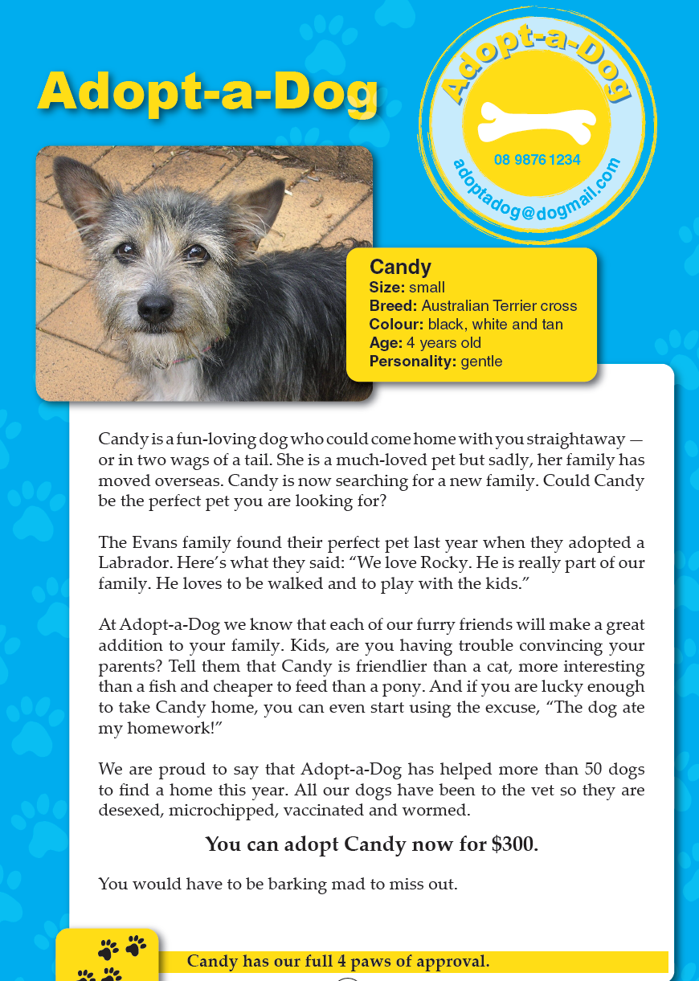
Key vocabulary:

Repeated vocabulary:

Important details:

Main Idea

Year 3 NAPLAN Reading Magazine, 2013 ACARA

Identifying main idea: whole text level (accessible version)

Adopt-a-Dog
Adopt-a-Dog,
0898761234
adoptadog@dogmail.com

Candy
Size: small
Breed: Australian Terrier cross
Colour: black, white and tan
Age: four years old
Personality: gentle
Candy is a fun-loving dog who could come home with you straightaway-or in two wags of a tail. She is a much-loved pet but sadly, her family has moved overseas. Candy is now searching for a new family. Could Candy be the perfect pet you are looking for?
The Evans family found their perfect pet last year when they adopted a Labrador. Here’s what they said: “We love Rocky. He is really part of our family. He loves to be walked and to play with the kids.”
At Adopt-a-Dog we know that each of our furry friends will make a great addition to your family. Kids, are you having trouble convincing your parents? Tell them that Candy is friendlier than a cat, more interesting than a fish and cheaper to feed than a pony. And if you are lucky enough to take Candy home, you can even start using the excuse, “The dog ate my homework!’
We are proud to say that Adopt-a-Dog has helped more than fifty dogs to find a home this year. All our dogs have been to the vet so they are desexed, microchipped, vaccinated and wormed.
You can adopt Candy now for three hundred dollars.
You would have to be barking mad to miss out.
Candy has our full four paws of approval
Key vocabulary
Repeated vocabulary
Important details
Main idea
Year 3 NAPLAN Reading magazine, 2013 ACARA

Appendix 6

Theme storyboard

Friends should be kind to each other
Picture 1 | Picture 2 | Picture 3
Sarah was sad because she fell over while running on the playground. | Elizabeth saw her crying. “Are you ok?” she asked.  “No” Sarah replied. | Elizabeth helped Sarah by finding the teacher.
Picture 4 | Picture 5 | Picture 6
Sarah was very happy when help arrived. | Sarah’s knee was cleaned and patched up with a band-aid. | Elizabeth helped Sarah walk to the toilet area so that she could wash her face.  “Thank you”, said Sarah. Elizabeth smiled.

