Literal comprehension
Stage 2

Overview

Purpose
This literacy teaching strategy supports teaching and learning for Stage 2 students across all key learning areas. It targets specific literacy skills and suggests a learning sequence to build skill development. Teachers can select individual tasks, or a sequence, and embed into their teaching and learning program according to their students’ needs. While exemplar texts are provided throughout this resource, it is recommended that teachers select texts which are relevant to their students and curriculum.

Learning intention
Students will use a range of texts to locate and interpret directly stated information. Students will use the strategy of scanning to quickly identify the main ideas in a text and skimming to find key words to respond to literal comprehension questions.

Syllabus outcomes
The following teaching and learning strategies will assist in covering elements of the following outcomes:
- EN2-RECOM-01: reads and comprehends texts for wide purposes using knowledge of text structures and language, and by monitoring comprehension
- EN2-UARL-01: identifies and describes how ideas are represented in literature and strategically uses similar representations when creating texts
NSW English K-10 Syllabus (2022)

Success criteria
The following Year 3 NAPLAN item descriptors may guide teachers to develop success criteria for student learning.

- locates directly stated information in a narrative
- locates similar information from different sections of a text
- locates directly stated information on a poster
- interprets the meaning of a phrase from context in a persuasive text
- locates directly stated information in a persuasive text
- locates directly stated information in a persuasive text
- interprets directly stated information in a persuasive text
- interprets directly stated information in information text
- locates directly stated information in a text
- identifies the use of a list in a text
- interprets directly stated information on a sign
- locates directly stated information from different sections of an information text
- locates directly stated information in a table in an information text
- locates directly stated information in a footnote in a text
- analyses the impact of an event in an information text
- interprets directly stated information in an information text

Literacy Learning Progression guide

Understanding Texts (UnT6-UnT9)
Key: C=comprehension P=process V=vocabulary

UnT6
- reads and views simple texts and some predictable texts (see Text Complexity) (C)
- scans texts to locate specific information in a predictable print text (C)
- recounts or describes the most relevant details from a text (C)
- identifies parts of a text used to answer literal and inferential questions (P)

UnT7
- reads and views predictable texts (see Text complexity) (C)
- locates information or details embedded in the text (C)
- navigates texts using common signposting devices such as headings, subheadings, paragraphs, navigation bars and links (P)

UnT8
- reads and views some moderately complex texts (see Text complexity) (C)
- uses knowledge of the features and conventions of the type of text to build meaning (e.g. recognises that the beginning of a persuasive text may introduce the topic and the line of argument) (P)
- skims and scans texts for key words to track the development of ideas (P)

UnT9
- uses processes such as predicting, confirming predictions, monitoring, and connecting relevant elements of the text to build or repair meaning (P)
- selects reading/viewing strategies appropriate to reading purpose (e.g. scans text for evidence) (P)
National Literacy Learning Progression

Evidence base
- Centre for Education Statistics and Evaluation (2017). Effective reading instruction in the early years of school, literature review.
- Konza, D. (2014). Teaching Reading: Why the “Fab Five” should be the “Big Six”. Australian Journal of Teacher Education, 39(12).
- Oakhill, J., Cain, K. & Elbro, C. (2015). Understanding and teaching reading comprehension: A handbook. Routledge.
- Quigley, A. (2020). Closing the reading gap. Routledge.
- Scarborough, H.S. (2001). Connecting early language and literacy to later reading (dis)abilities: Evidence, theory and practice. In S. Neuman & D. Dickson (Eds.), Handbook for research in early literacy (pp. 97-110). New York, NY: Guilford Press.

Alignment to system priorities and/or needs: Five priorities for Literacy and Numeracy, Our Plan for NSW Public Education , School Excellence Policy (nsw.gov.au).
Alignment to School Excellence Framework: Learning domain: Curriculum, Teaching domain: Effective classroom practice and Professional standards
Consulted with: Strategic Delivery, Teaching Quality and Impact
Author: Literacy and Numeracy
Reviewed by: Literacy and Numeracy, Teaching Quality and Impact
Created/last updated: January 2024
Anticipated resource review date: January 2025
Feedback: Complete the online form to provide any feedback

Copyright
Section 113P Notice
Texts, Artistic Works and Broadcast Notice
Some of this material has been copied and communicated to you in accordance with the statutory licence in section 113P of the Copyright Act. Any further reproduction or communication of this material by you may be the subject of copyright protection under the Act. Do not remove this notice.

Teaching strategies
Task | Appendices
Locating directly stated information in imaginative texts | Appendix 1 - Anchor Chart: ‘It’s right here!’
Skimming | Appendix 2 - Skimming texts: School holiday activities at the library
Scanning | Appendix 3 - Scanning texts: ‘Chocolate trees’
Restructuring the text | Appendix 4a - Interview with Andy Griffith text and activity  Appendix 4b – Interview with Andy Griffith- restructure the text
Locating directly stated information in texts | Appendix 5 – ‘Geronimo Zero’  Appendix 6 - Text and structural features of text  Appendix 7 - Jingle task  Appendix 8 - Information text joint analysis  Appendix 9 - Student led analysis and questions

Background information

Literal comprehension
Literal comprehension is often referred to as ‘on the page’ comprehension. Surface level is the simplest form of comprehension and requires students to locate directly stated information from a text.
Questioning before, during and after reading a text is the key component of building comprehension skills (Singer, 1978).
Literal comprehension questions are the “how, what, who, when, where” types of questions. Readers will use decoding skills, as well as syntax and semantic skills to recognise and remember directly stated information.

Literal
Having only the most direct meaning.

Skimming
Skimming happens when the reader is unfamiliar with a text and skims to find out the type of text to get the general idea. Some strategies to use include:
- read the first and last paragraphs
- look for general information
- use headlines, page layout, graphs and charts, pictures and highlighted text
Scanning
When the reader knows something about what the text is about but wants to find out more, they scan to find specific information and key words. Strategies to use include:
- look over the text quickly to locate words and sentences that link to what you need to find out
- use contents pages, first and last sentences in paragraphs, subheadings, captions, bold key words and hyperlinks
Reference: English K-10 Syllabus © NSW Education Standards Authority (NESA) for and on behalf of the Crown in right of the State of New South Wales, 2012 and 2022.

Where to next?
- Main idea
- Fact and opinion
- Inference

Overview of teaching strategies

Purpose
These literacy teaching strategies support teaching and learning from Stage 2 to Stage 5. They are linked to NAPLAN task descriptors, syllabus outcomes and literacy and numeracy learning progressions.
These teaching strategies target specific literacy and numeracy skills and suggest a learning sequence to build skill development. Teachers can select individual tasks or a sequence to suit their students.

Access points
The resources can be accessed from:
- NAPLAN App in Scout using the teaching strategy links from NAPLAN items
- NSW Department of Education literacy and numeracy website.
What works best
Explicit teaching practices involve teachers clearly explaining to students why they are learning something, how it connects to what they already know, what they are expected to do, how to do it and what it looks like when they have succeeded. Students are given opportunities and time to check their understanding, ask questions and receive clear, effective feedback.
This resource reflects the latest evidence base and can be used by teachers as they plan for explicit teaching.
Teachers can use classroom observations and other assessment information to make decisions about when and how they use this resource as they design teaching and learning sequences to meet the learning needs of their students.
Further support with What works best is available.
Differentiation
When using these resources in the classroom, it is important for teachers to consider the needs of all students, including Aboriginal and EAL/D learners.
EAL/D learners will require explicit English language support and scaffolding, informed by the EAL/D enhanced teaching and learning cycle and the student’s phase on the EAL/D Learning Progression. Teachers can access information about supporting EAL/D learners and literacy and numeracy support specific to EAL/D learners.
Learning adjustments enable students with disability and additional learning and support needs to access syllabus outcomes and content on the same basis as their peers. Teachers can use a range of adjustments to ensure a personalised approach to student learning.
Assessing and identifying high potential and gifted learners will help teachers decide which students may benefit from extension and additional challenge. Effective strategies and contributors to achievement for high potential and gifted learners helps teachers to identify and target areas for growth and improvement. A differentiation adjustment tool can be found on the High potential and gifted education website.

Using tasks across learning areas
This resource may be used across learning areas where it supports teaching and learning aligned with syllabus outcomes.
Literacy and numeracy are embedded throughout all syllabus documents as general capabilities. As the English and mathematics learning areas have a particular role in developing literacy and numeracy, NSW English and Mathematics syllabus outcomes aligned to literacy and numeracy skills have been identified.

Text selection
Example texts are used throughout this resource. Teachers can adjust activities to use texts which are linked to their unit of learning.
Further support with text selection can be found within the National Literacy Learning Progression Text complexity appendix.
The NESA website has additional information on text requirements within the NSW English syllabus.

Teaching strategies

Locating directly stated information in imaginative texts
- Teacher introduces literal questions as those that you can find answers to on the page. They ask us for information that is found directly in the text. Teacher models using the ‘It’s right here!’ anchor chart with a question to prompt discussion (Appendix 1 - Anchor Chart: ‘It’s right here!’).
- Modelled Reading: Teacher reads a quality text (a big book works well in this context) to the students, modelling their thinking and processing to answer the ‘It’s right here!’ questions.

Before reading
- Students predict what the text might be about using the front cover, title and blurb. They can continue their predictions as the story progresses, evaluating if the prediction changes based on new information: “I used to think …, this has changed now because I now know…”
- Students use white boards or sticky notes to jot down any questions they have using the stem “I wonder…?” Teacher reads through these and categorises them into “who”, “where”, “when” questions and so on.

During reading
- Ask students to be text detectives - as the questions are answered in the text, the students locate the sticky note with the question and sticks it on the text. (If on device, digital sticky notes can be used in a similar way).
- Teacher prompts while reading to build understanding for example “I can see details right here on the page to help me answer the ‘who’ question.”

After reading
- Character Hot Seat: Select a couple of students to be a character from the story. The class interviews them using ‘It’s right here!’ anchor chart as they respond in character.
- Text Investigators: Teacher sets up six stations with six texts at each one, including multimodal texts. Students are given one of six question starters (who, where, when, what, how, which) to devise 2-3 questions for their peers to answer. These can be put on sticky notes (question at the top, answer on the reverse side). Once questions are devised, each station rotates to answer as many questions as possible within 3 minutes, then they move to the next station.

Skimming
- Explain to students that when they are viewing a text for the first time, such as a program, they don’t need to read all the information with the first glance. A skilled reader will look over or skim the text, to read the headings, subheadings, images, text layout, author and so on. This skimming can help the reader to gauge two key things:
  - the purpose of the text, whether it is to persuade, inform and entertain,
  - the audience, for example, a fact sheet for parents or a program for people attending the Easter show.
- Teacher displays heading -School holiday activities. Brainstorm holiday activities. What activities might children participate in during the holidays? What are some indoor activities? What are some outdoor activities?
- Ask the class if they know what a ‘program’ might be. Discuss what information a program might contain, where they might find one, and what it might look like. Give an example of an event, such as the town show, which might use a program to tell people what activities are available.
- Share the ‘School holiday activities at the library’ text (Appendix 2 - Skimming texts: School holiday activities at the library). Explain to students that you are going to use skimming to gauge the purpose of the text and who the audience might be.
- Using a ‘think aloud’, the teacher might model how to skim with the following suggested script:
“Let’s look at this text. I am going to skim my eyes from the top of the page to the bottom of the page to see if I can determine the purpose of this text, who it might be created for, or its audience. I can see a large heading ‘School holiday activities at the library’, the word ‘activities’ is written in a fun font which might indicate that the audience for this text might be children. I can see this text is using a table layout and information is divided into ten boxes with images about an activity on one side, and details about the activity on the other. This is a text that is giving information.
I can see some subheadings in each of the activity boxes which is detailing the activity, when it will be run, the cost and who might attend. These will help me if I need to directly locate some information.
I can see an asterisk in the second box which is telling me more information about Eva Leung, who is a cartoonist. We can link the asterisk from the activity subheading linking to the asterisk underneath the details, in the same box.
I don’t need to read all the information to understand the purpose of this text when skimming, I can see this is a program of events available at the library.
And finally, I can see that there are some contact details at the end with a phone number and an email address. I can see that this is an informative text as it is telling me key information, and its audience is children and their families who might be looking for some entertainment in the holidays.”
- Students are given a variety of texts linked to current unit of learning and use the scanning strategy to determine the purpose and audience. Students might like to show their reading path with a marker or by pointing.

Scanning
- Explain to students that they will be learning to use the strategy of scanning to directly locate information in a text.
- Display the word ‘chocolate’ and have students brainstorm vocabulary. Use this opportunity to add more sophisticated, Tier 2 vocabulary.
- Ask students: What do you know about chocolate? Share experiences and build background knowledge on chocolate, including any experience as to how it is made.
- Model reading aloud the text ‘Chocolate trees’ (Appendix 3 - Scanning texts: ‘Chocolate trees’).
- Teacher to use a ‘think aloud’ process to demonstrate how to use scanning to answer a literal comprehension question: How many pods can a cacao tree produce?’
“I am going to use scanning to find some information – scanning is where I am using the layout of the text and key words to find key information.
Let’s look at this question, I need to read it carefully to make sure I know what I am looking for to answer correctly. I can see the words “how many” at the beginning of the question, this tells me we are looking for a number or an amount. I am going to highlight this yellow.
Let’s see if there are more clues in the question to help me. I can see the key words ‘pod’, ‘cacao tree’ and ‘produce’; these are words I need to look for when finding my answer, I am going to highlight these in pink.
I am going to rephrase this question and put it in my own words so I know what I need to find. I know that I need to find how many pods the cacao tree makes or produces”.
Let’s now go to the text. I am going to keep my key words in my brain and scan my eyes over the words until I come across these terms. I can see the words in the third paragraph. I am going to read the text again to make sure it is answering the question. I can see that the cacao tree produces 2000 pods – that's a lot of pods. So, to answer the question, “A cacao tree produces 2000 pods.”
- Students are given the following three questions and use the skimming strategy to find the answers. Students will use the text to highlight question stems yellow and the key words in the questions, pink.
  - Why can’t the chocolate be eaten straight from the pod? (It would taste very bitter.)
  - How is the flavour of the pod improved? (Left in piles for seven days.)
  - According to the text, what makes chocolate taste different? (Area it is grown.)
- Students answer the questions on Appendix 3 using the skimming and scanning strategies explored in the previous two tasks. Come together as a class to discuss student answers.

Restructuring the text
- Teacher uses the text ‘Interview with Andy Griffiths’ (Appendix 4a) and only displays the title, image and description. As a class, students predict what they think the text might be about and support their ideas with evidence.
- Discuss with students that this is an interview. Ask class what an interview is, where they have seen one, what language might you hear in an interview and why might someone be interviewed?
- Share some books written by Andy Griffiths and asks students if they are familiar with any of the texts.
- Ask students – what would you like to know about Andy Griffiths? Brainstorm ideas and display questions on the board, highlighting the question stems (who, what, when, which, where, how, why). Prompt students to create open questions rather than closed and discuss how an interviewer would use open questions to gain more information. Have students work in pairs to create some interview questions.
- Read ‘Interview with Andy Griffiths’ with the class, modelling scanning the text initially and highlighting the text navigation path.
- Students work in pairs. One student is given the set of questions and the other student will have the set of answers from Appendix 4b – Interview with Andy Griffith- restructure the text Students take turns to call out either a question or an answer and their partner needs to find the connecting information. Alternatively, this can be played as a memory game with all questions and answers cut up and face down, with one student turning over two at a time until a match is made.
- Have students discuss their strategies to match the question and answer – what did you look for to make the pair? What key words stood out to you?

Locating directly stated information in texts
- Teacher displays any suitable text relevant to a current unit of learning or Appendix 5 – ‘Geronimo Zero’ and have students predict what they think the text might be about, using pictures and title to guide ideas. Brainstorm predicted vocabulary and display.
- Reading pathways: Ask students to point with their fingers the pathway they might use to navigate the text; the teacher may prompt this by asking “Where do your eyes go first, after that? Next? Finally?” Teacher reads aloud to the class, indicating the reading path they have taken. Discuss key elements of the text and prompt students to think of an ‘It’s right here!’ question.
- Walk and talk: Students think of a literal question and walk around the room. When the teacher calls out ‘talk’, the students stop and ask their question of the person closest to them. Students begin to walk again, finding a new partner and asking their question when the teacher calls out ‘talk’.
- Additional task: Repeat process with any text relevant to a current unit of learning, or ‘New Zealand Fur Seals’. (Appendix 6 - Text and structural features of text.)
- Students are given an information card from Appendix 7 - Jingle task. Each one gives information about a key structural component, for example, sub-heading or diagram. Students create a jingle or a short presentation about their structural element. Share and discuss.
- Additional task: Students create an accompanying poster or product of their choice.
- Teacher displays the ‘On Your Bike!’ text. (Appendix 8 - Information text joint analysis.) Teacher asks students to predict what vocabulary they might find in this text. Draw attention to the features of this text including heading and complete a think aloud showing students how to answer the questions by skimming and scanning the text.
- Students use texts in Appendix 9 - Student led analysis and questions to devise their own literal questions. Once complete, swap with a peer to answer their questions, highlight or underline the answers in the text and peer review.

Appendix 1

Anchor chart – It’s right here!

It’s right here!
Who…?
Who is the main character? Who blew down the house?
Where…?
Where is the story set? Where can you find the park?
When…?
When did he go to the concert? On what day did the event occur?
What...?
What did she say to her friend? What did they take on their trip?
How did…? How far…?
How did they fix the sunglasses? How far did they run?
Which…?
Which character chose the cheese sandwich? Which puppy did they adopt?

Appendix 2

Skimming texts
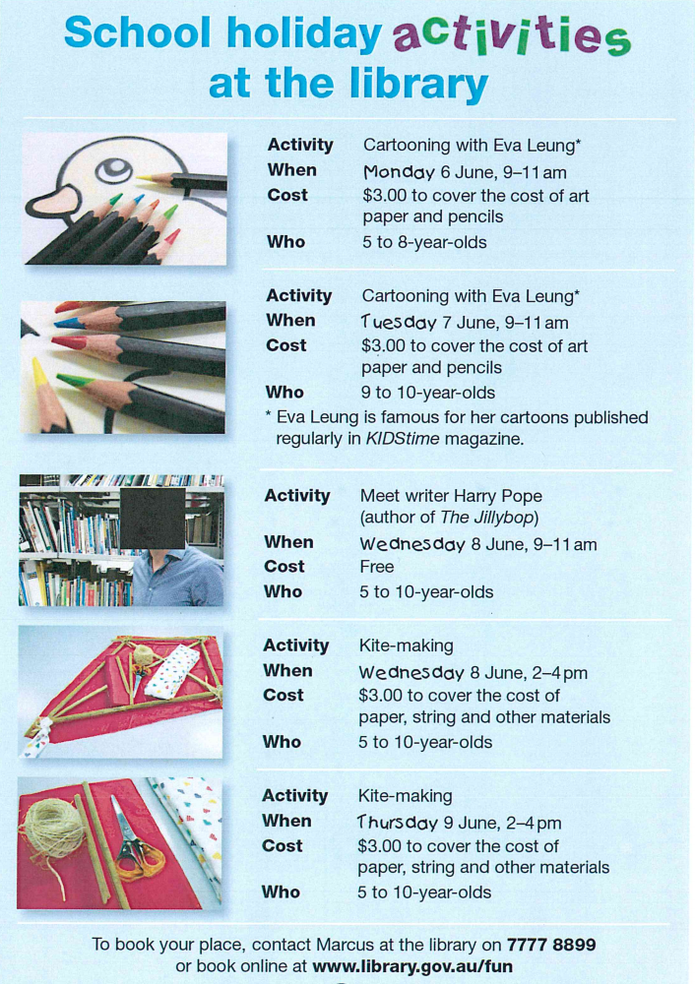
Year 3 NAPLAN Reading Magazine, 2015 ACARA

Skimming texts – accessible version

School holiday activities at the library
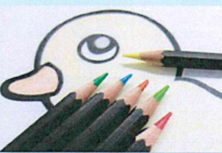
Activity: Cartooning with Eva Leung
When: Monday 6 June, 9-11 am
Cost: $3:00 to cover the cost of art paper and pencils.
Who: 5 to 8-year olds
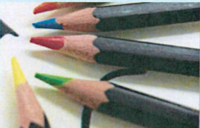
Activity: Cartooning with Eva Leung
When: Tuesday 7 June, 9-11 am
Cost: $3:00 to cover the cost of art paper and pencils.
Who: 9 to 10-year olds
*Eva Leung is famous for her cartoons published regularly in KIDStime magazine.
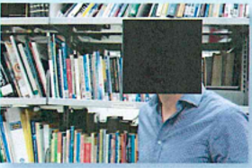
Activity: Meet writer Harry Pope (author of The Jillybop)
When: Wednesday 8 June, 9-11 am
Cost: Free
Who: 5 to 10-year olds
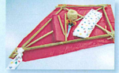
Activity: Kite- making
When: Monday 8 June,2- 4pm
Cost: $3:00 to cover the cost of paper, string and other materials.
Who: 5 to 10-year olds
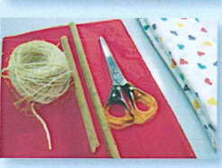
Activity: Kite -making
When: Thursday 9 June,2-4 pm
Cost: $3:00 to cover the cost of paper, string and other materials.
Who: 5 to 10-year olds

To book your place, contact Marcus at the library on 7777 8899 or book online at www.library.gov.au/fun
Year 3 NAPLAN Reading Magazine, 2015 ACARA

Appendix 3

Scanning texts
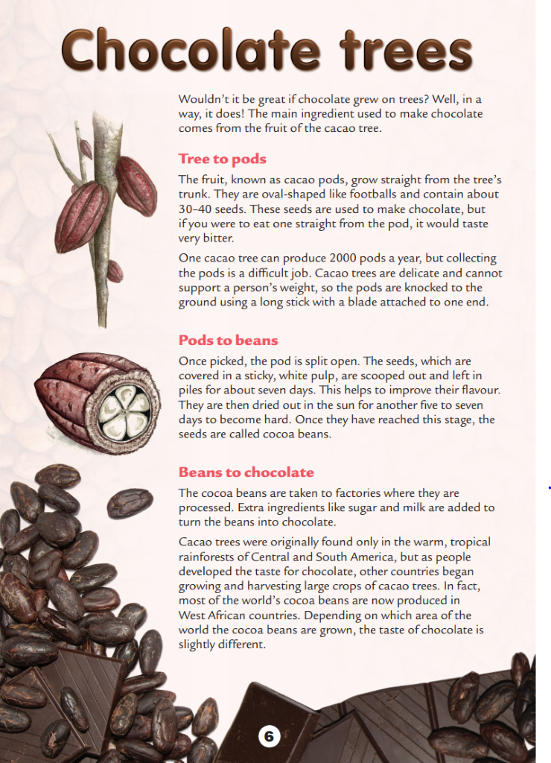
Year 3 NAPLAN Reading Magazine, 2014 ACARA

Scanning texts– accessible version

Chocolate trees
Wouldn’t it be great if chocolate grew on trees? Well, in a way, it does! The main ingredient used to make chocolate comes from the fruit of the cacao tree.

Tree to pods
The fruit, known as cacao pods, grow straight from the tree’s trunk. They are oval-shaped like footballs and contain about 30–40 seeds. These seeds are used to make chocolate, but if you were to eat one straight from the pod, it would taste very bitter.
One cacao tree can produce 2000 pods a year, but collecting the pods is a difficult job. Cacao trees are delicate and cannot support a person’s weight, so the pods are knocked to the ground using a long stick with a blade attached to one end.

Pods to beans
Once picked, the pod is split open. The seeds, which are covered in a sticky, white pulp, are scooped out and left in piles for about seven days. This helps to improve their flavour. They are then dried out in the sun for another five to seven days to become hard. Once they have reached this stage, the seeds are called cocoa beans.

Beans to chocolate
The cocoa beans are taken to factories where they are processed. Extra ingredients like sugar and milk are added to turn the beans into chocolate. Cacao trees were originally found only in the warm, tropical rainforests of Central and South America, but as people developed the taste for chocolate, other countries began growing and harvesting large crops of cacao trees. In fact, most of the world’s cocoa beans are now produced in West African countries. Depending on which area of the world the cocoa beans are grown, the taste of chocolate is slightly different.
Year 3 NAPLAN Reading Magazine, 2014 ACARA

Scanning texts– student questions
- What do cacao pods look like?
- What makes the pods so difficult to collect?
- What happens to the pods after they have been in the sun?
- When are sugar and water added to the beans?
- When do the pods become beans?
- According to the text, why are cacao trees now harvested around the world?
- What word first alerts the reader that the cocoa trees are fragile?
- Write your own question and answer.

Appendix 4a

Interview with Andy Griffiths text and activity
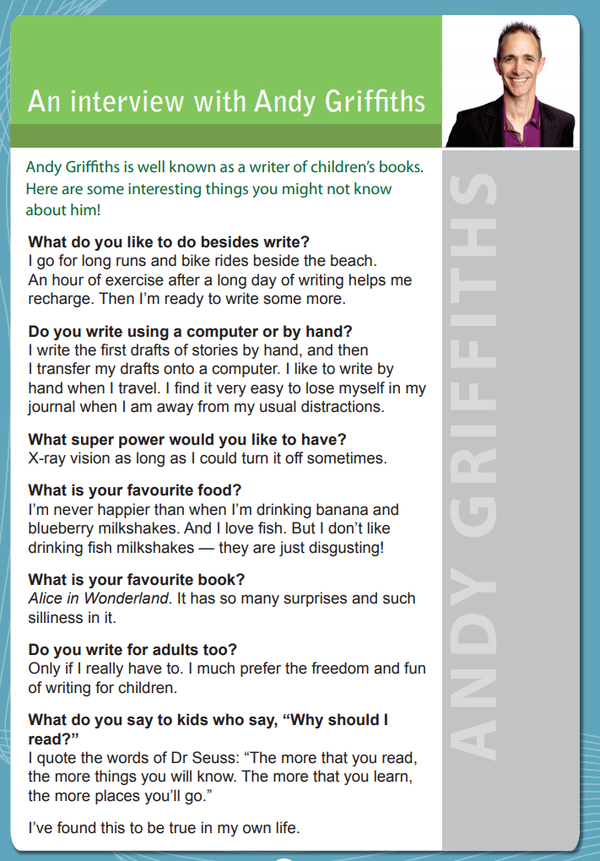
Year 3 NAPLAN Reading Magazine, 2013 ACARA

Interview with Andy Griffiths text and activity– accessible version
Year 3 NAPLAN Reading Magazine, 2013 ACARA
An interview with Andy Griffiths
Andy Griffiths is well known as a writer of children’s books. Here are some interesting things you might not know about him!
What do you like to do besides write?
I go for long runs and bike rides beside the beach. An hour of exercise after a long day of writing helps me recharge. Then I’m ready to write some more.
Do you write using a computer or by hand?
I write the first drafts of stories by hand, and then I transfer my drafts onto a computer. I like to write by hand when I travel. I find it very easy to lose myself in my journal when I am away from my usual distractions.
What super power would you like to have?
X-ray vision as long as I could turn it off sometimes.
What is your favourite food?
I’m never happier than when I’m drinking banana and blueberry milkshakes. And I love fish. But I don’t like drinking fish milkshakes — they are just disgusting!
What is your favourite book?
Alice in Wonderland. It has so many surprises and such silliness in it.
Do you write for adults too?
Only if I really have to. I much prefer the freedom and fun of writing for children
What do you say to kids who say, “Why should I read?”
I quote the words of Dr Seuss: “The more that you read, the more things you will know. The more that you learn, the more places you’ll go.” I’ve found this to be true in my own life
Year 3 NAPLAN Reading Magazine, 2013 ACARA

Appendix 4b

Interview with Andy Griffiths - restructuring the text
Work with a partner to match the questions to the answer.
Questions
Do you write using a computer or by hand?
What would you say to kids who say, “Why should I read?”
What is your favourite food?
What superpower would you like to have?
What is your favourite book?
Do you write for adults too?
What do you like to do besides write?
Answers
X-ray vision as long as I could turn it off sometimes.
I’m never happier than when I’m drinking banana and blueberry milkshakes. And I love fish. I don’t like drinking fish milkshakes- they are just disgusting.
I write the first drafts of stories by hand, and then I transfer my drafts onto a computer. I like to write by hand when I travel. I find it very easy to lose myself in my journal when I am away from my usual distractions.
I quote the words of Dr Seuss, ‘The more that you read, the more things you will know. The more that you learn, the more places you’ll go.’
I’ve found this to be true in my own life.
Alice in Wonderland. It has so many surprises and such silliness in it.
I go for long runs and bike rides beside the beach. An hour of exercise after a long day of writing helps me recharge. Then I’m ready to write some more.
Only if I have to. I much prefer the freedom and fun of writing for children.

Appendix 5

‘Geronimo Zero’
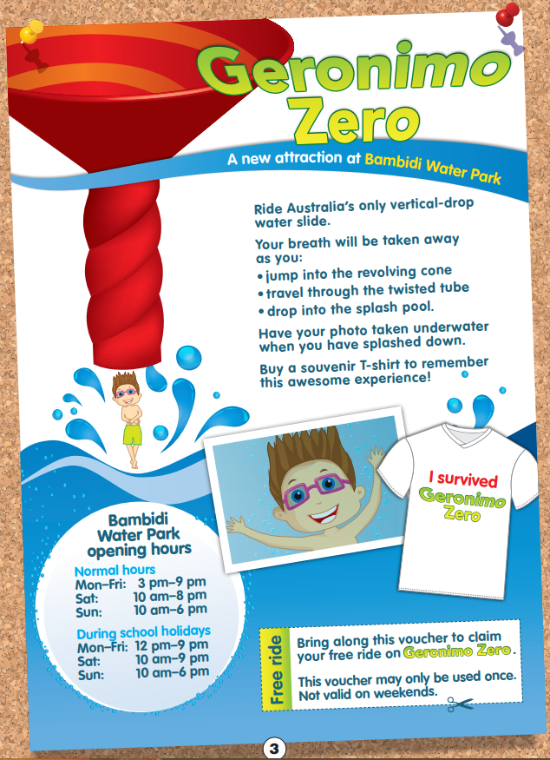
Year 3 NAPLAN Reading Magazine, 2014 ACARA
‘Geronimo Zero’ – accessible version
Geronimo Zero
A new Attraction at Bambidi Water Park
Ride Australia’s only vertical-drop water slide.
Your breath will be taken away as you:
• jump into the revolving cone
• travel through the twisted tube
• drop into the splash pool.
Have your photo taken underwater when you have splashed down.
Buy a souvenir T-shirt to remember this awesome experience!
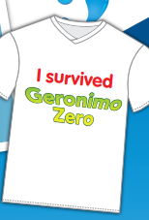
I survived Geronimo Zero.
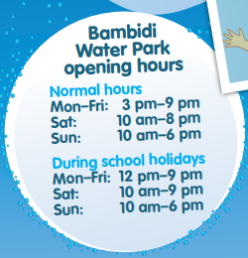
Bambidi Water Park opening hours
Normal hours
Mon–Fri: 3 pm–9 pm
Sat: 10 am–8 pm
Sun: 10 am–6 pm
During school holidays
Mon–Fri: 12 pm–9 pm
Sat: 10 am–9 pm
Sun: 10 am–6 pm
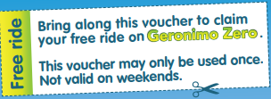
Free ride. Bring along this voucher to claim your free ride on Geronimo Zero.
This voucher may only be used once. Not valid on weekends.
Year 3 NAPLAN Reading Magazine, 2014 ACARA

Appendix 6

Text and structural features of texts
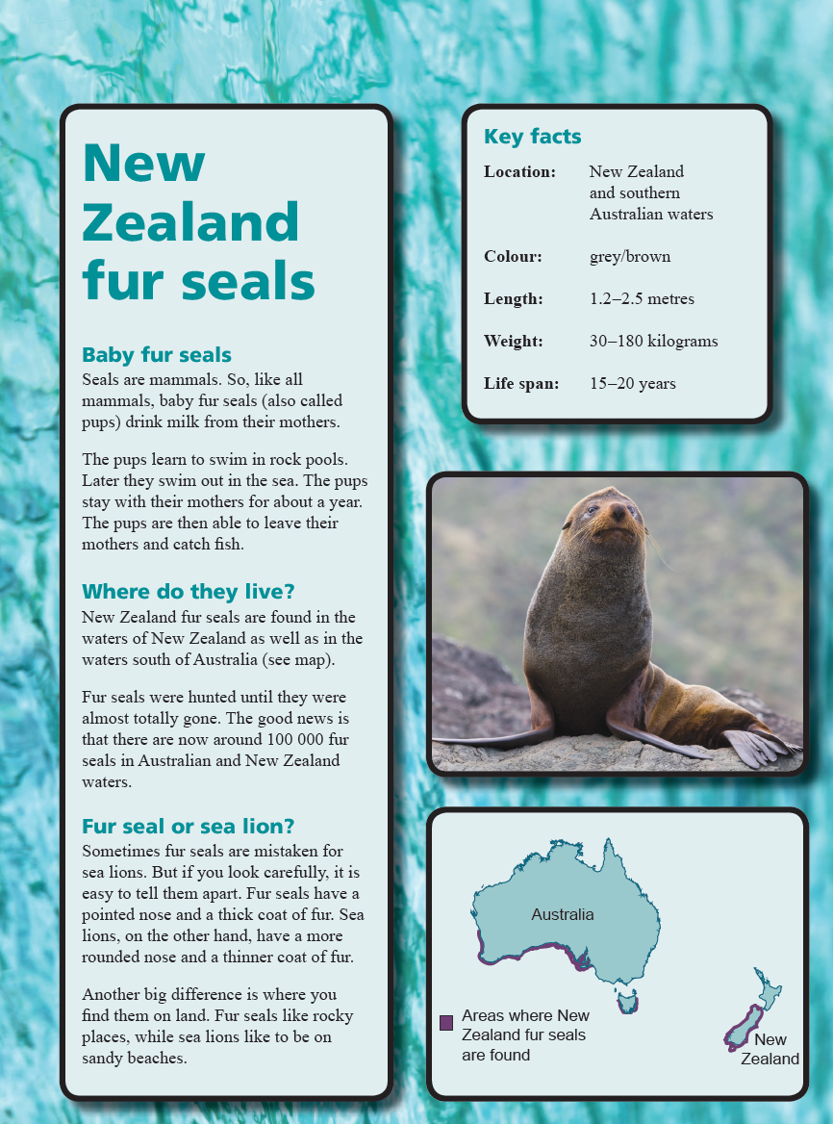
Year 5 NAPLAN Reading Magazine, 2015 ACARA
Heading/Title – Introduces topic

Sub/heading/Subtitle – Topic of each paragraph

Images/graphics – Maps, diagrams, photos, drawings.

Key facts
Gives clear information and summaries.

Text and structural features of texts - accessible version

New Zealand Fur Seals

Baby fur seals
Seals are mammals. So, like all mammals, baby fur seals (also called pups) drink milk from their mothers.
The pups learn to swim in rock pools. Later they swim out in the sea. The pups stay with their mothers for about a year. The pups are then able to leave their mothers and catch fish.

Where do they live?
New Zealand fur seals are found in the waters of New Zealand as well as in the waters south of Australia (see map).
Fur seals were hunted until they were almost totally gone. The good news is that there are now around 100 000 fur seals in Australian and New Zealand waters.

Fur seal or sea lion?
Sometimes fur seals are mistaken for sea lions. But if you look carefully, it is easy to tell them apart. Fur seals have a pointed nose and a thick coat of fur. Sea lions, on the other hand, have a more rounded nose and a thinner coat of fur.
Another big difference is where you find them on land. Fur seals like rocky places, while sea lions like to be on sandy beaches.

Key facts
Location: New Zealand and southern Australian waters
Colour: grey/brown
Length: 1.2–2.5 metres
Weight: 30–180 kilograms
Life span: 15–20 years
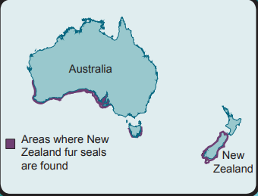
Areas where New Zealand fur seals are found.
Year 5 NAPLAN Reading Magazine, 2015 ACARA

Appendix 7

Jingle task
In 5 minutes create a jingle to perform that will teach your class the function of your element. A jingle is a short, catchy tune that explains an idea, they are often in advertisements.
Each group is given one of the following sections:
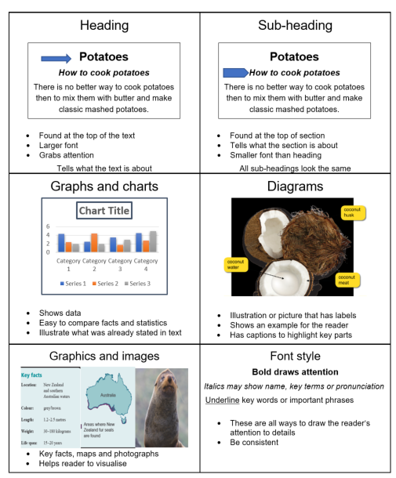

Accessibility notes:
Heading - found at the top of the text, larger font, grabs attention, tells what the text is about.
An arrow points to a heading Potatoes” in an example text
Sub-heading - found at the top of a section
An arrow points to a subheading “how to cook potatoes” in an example text
Tells what the section is about, smaller font than heading, all sub-headings look the same
Graphs and charts - shows data, easy to compare facts and statistics, illustrate what was already stated in the text
An example image of a bar graph indicating Chart title, x and y axes and chart legend
Diagrams - Illustration of picture that has labels, shows an example for the reader, has captions to highlight key parts
An example image of an open coconut with the part labelled ‘coconut husk”, ‘coconut meat”, ‘coconut water”
Graphics and images - Key facts, maps and photographs, helps reader to visualise
An example image of list of key facts about seals, a map of Australia showing seal distribution around the coast and an image of a seal
Font style - these are all ways to draw the reader's attention to details, be consistent
Example of italics and underline are included with the text italics may show name, key terms or pronunciations. Underline key words or important phrases.

Appendix 8

Information text joint analysis
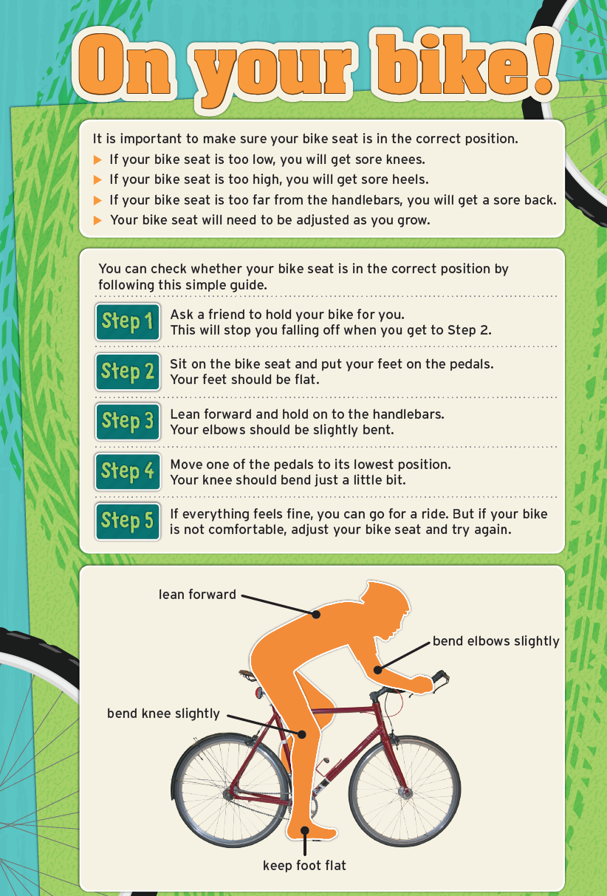
Year 5 NAPLAN Reading Magazine, 2014 ACARA
What will happen if your seat is too low?

How can you check whether your bike seat is in the correct position?

Which step tells you about pedals?

What position should elbows be in?

Where should your feet be?

Information text joint analysis – accessible version
On your bike
It is important to make sure your bike seat is in the correct position.
- If your bike seat is too low, you will get sore knees.
- If your bike seat is too high, you will get sore heels.
- If your bike seat is too far from the handlebars, you will get a sore back.
- Your bike seat will need to be adjusted as you grow.
You can check whether your bike seat is in the correct position by following this simple guide.
Step 1 Ask a friend to hold your bike for you. This will stop you falling off when you get to Step 2.
Step 2 Sit on the bike seat and put your feet on the pedals. Your feet should be flat.
Step 3 Lean forward and hold on to the handlebars. Your elbows should be slightly bent.
Step 4 Move one of the pedals to its lowest position. Your knee should bend just a little bit.
Step 5 If everything feels fine, you can go for a ride. But if your bike is not comfortable, adjust your bike seat and try again.
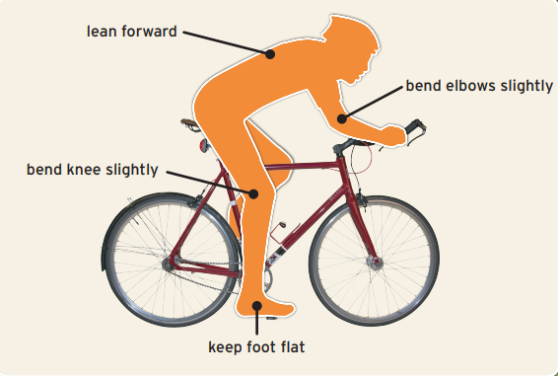
Lean forward
Bend elbows slightly
Keep foot flat
Bend knee slightly
Year 5 NAPLAN Reading Magazine, 2014 ACARA

Appendix 9

Student led analysis and questions
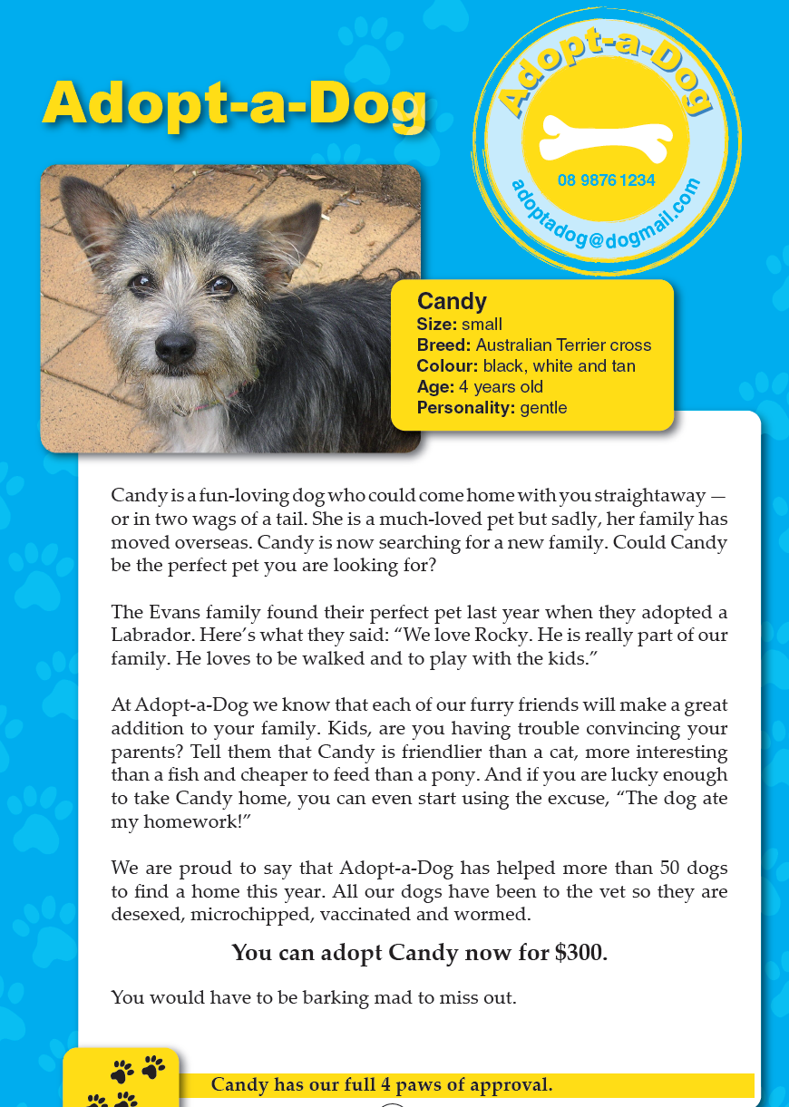
Year 3 NAPLAN Reading Magazine, 2013 ACARA
Who…

What…

Where…

When…

Free choice…

Student led analysis and questions – accessible version
Adopt-a-Dog
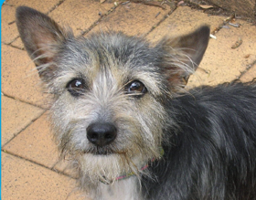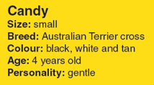

Adopt-a-Dog, Candy
0898761234 Size: small
adoptadog@dogmail.com Breed: Australian Terrier cross
Colour: black, white and tan
Age: four years old
Personality: gentle
Candy is a fun-loving dog who could come home with you straightaway-or in two wags of a tail. She is a much-loved pet but sadly, her family has moved overseas. Candy is now searching for a new family. Could Candy be the perfect pet you are looking for?
The Evans family found their perfect pet last year when they adopted a Labrador. Here’s what they said: “We love Rocky. He is really part of our family. He loves to be walked and to play with the kids.”
At Adopt-a-Dog we know that each of our furry friends will make a great addition to your family. Kids, are you having trouble convincing your parents? Tell them that Candy is friendlier than a cat, more interesting than a fish and cheaper to feed than a pony. And if you are lucky enough to take Candy home, you can even start using the excuse, “The dog ate my homework!”
We are proud to say that Adopt-a-Dog has helped more than 50 dogs to find a home this year. All our dogs have been to the vet so they are desexed, microchipped, vaccinated and wormed.

You can adopt Candy now for $300.
You would have to be barking mad to miss out.
Candy has our full 4 paws of approval.
Year 3 NAPLAN Reading Magazine, 2013 ACARA

Student led analysis and questions
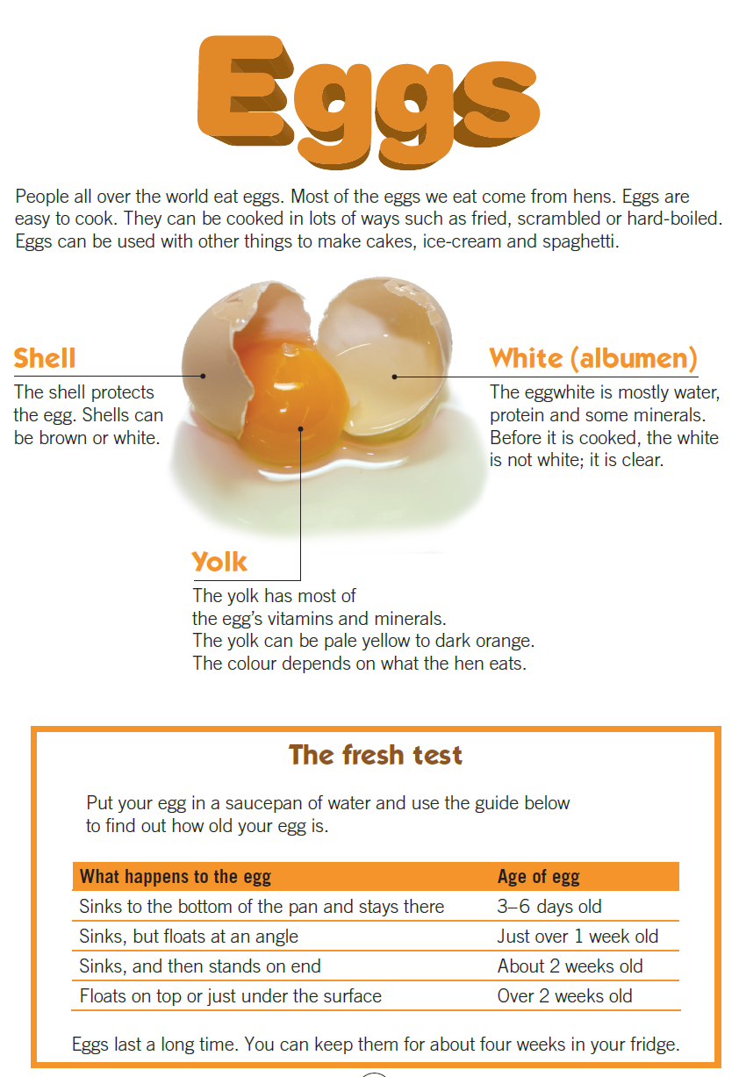
Year 3 NAPLAN Reading Magazine, 2013 ACARA
Who…

What…

Where…

When…

Free choice…

Student led analysis and questions - accessible version
Eggs
People all over the world eat eggs. Most of the eggs we eat come from hens. Eggs are easy to cook. They can be cooked in lots of ways such as fried, scrambled or hard-boiled. Eggs can be used with other things to make cakes, ice-cream and spaghetti.
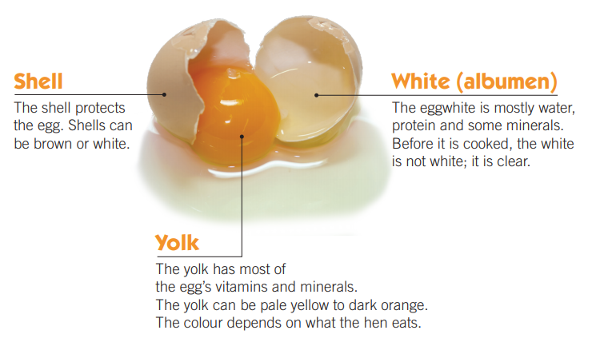
Shell
The shell protects the egg. Shells can be brown or white.
White (albumen)
The egg white is mostly water, protein and some minerals. Before it is cooked, the white is not white; it is clear.
Yolk
The yolk has most of the egg’s vitamins and minerals. The yolk can be pale yellow to dark orange. The colour depends on what the hen eats.
The fresh test
Put your egg in a saucepan of water and use the guide below to find out how old your egg is.
What happens to the egg Age of egg
Sinks to the bottom of the pan and stays there 3–6 days old
Sinks, but floats at an angle Just over 1 week old
Sinks, and then stands on end About 2 weeks old
Floats on top or just under the surface Over 2 weeks old
Eggs last a long time. You can keep them for about four weeks in your fridge.
Year 3 NAPLAN Reading Magazine, 2013 ACARA

Student led analysis and questions
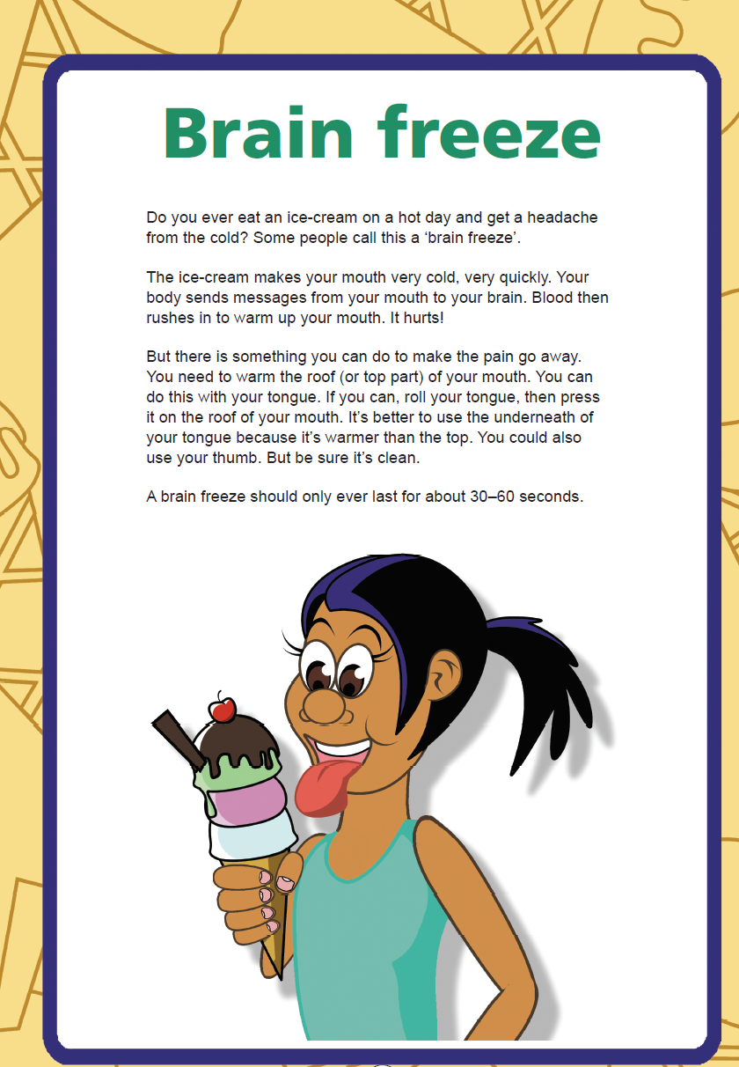
Year 5 NAPLAN Reading Magazine 2016 ACARA
Who…

What…

Where…

When…

Free choice…

Student led analysis and questions
Brain Freeze
Do you ever eat an ice-cream on a hot day and get a headache from the cold? Some people call this a ‘brain freeze’.
The ice-cream makes your mouth very cold, very quickly. Your body sends messages from your mouth to your brain. Blood then rushes in to warm up your mouth. It hurts!
But there is something you can do to make the pain go away. You need to warm the roof (or top part) of your mouth. You can do this with your tongue. If you can, roll your tongue, then press it on the roof of your mouth. It’s better to use the underneath of your tongue because it’s warmer than the top. You could also use your thumb. But be sure it’s clean.
A brain freeze should only ever last for about 30–60 seconds.
Year 5 NAPLAN Reading Magazine, 2016 ACARA

Student led analysis and questions
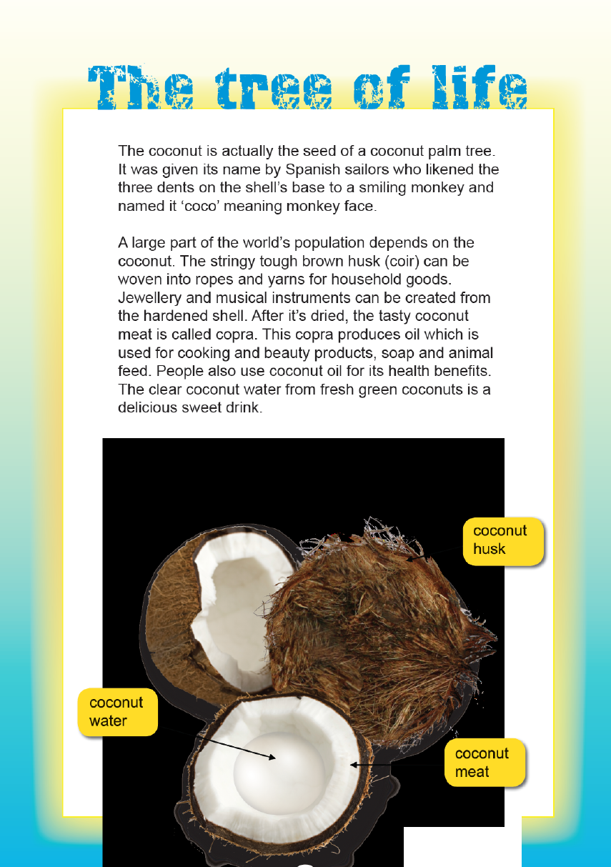
Year 5 NAPLAN Reading Magazine, 2013 ACARA

Who…

What…

Where…

When…

Free choice…

Student led analysis and questions – accessible version
The Tree of life
The coconut is actually the seed of a coconut palm tree. It was given its name by Spanish sailors who likened the three dents on the shell’s base to a smiling monkey and named it ‘coco’ meaning monkey face.
A large part of the world’s population depends on the coconut. The stringy tough brown husk (coir) can be woven into ropes and yarns for household goods. Jewellery and musical instruments can be created from the hardened shell. After it’s dried, the tasty coconut meat is called copra. This copra produces oil which is used for cooking and beauty products, soap and animal feed. People also use the coconut oil for its health benefits. The clear coconut water from fresh green coconuts is a delicious sweet drink.
It’s not surprising that the coconut palm is called ‘the tree of life’.
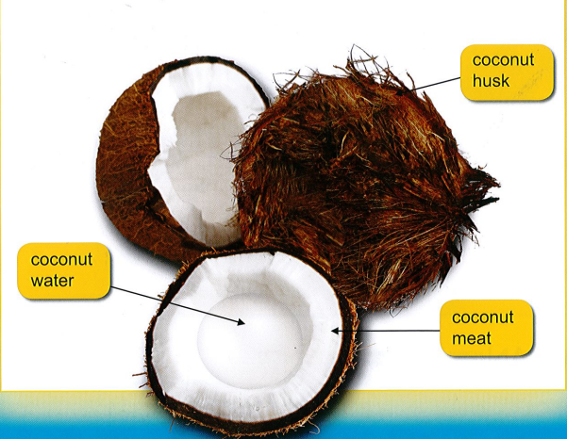
Coconut husk Coconut water Coconut meat
Year 5 NAPLAN Reading Magazine, 2013 ACARA

Student led analysis and questions
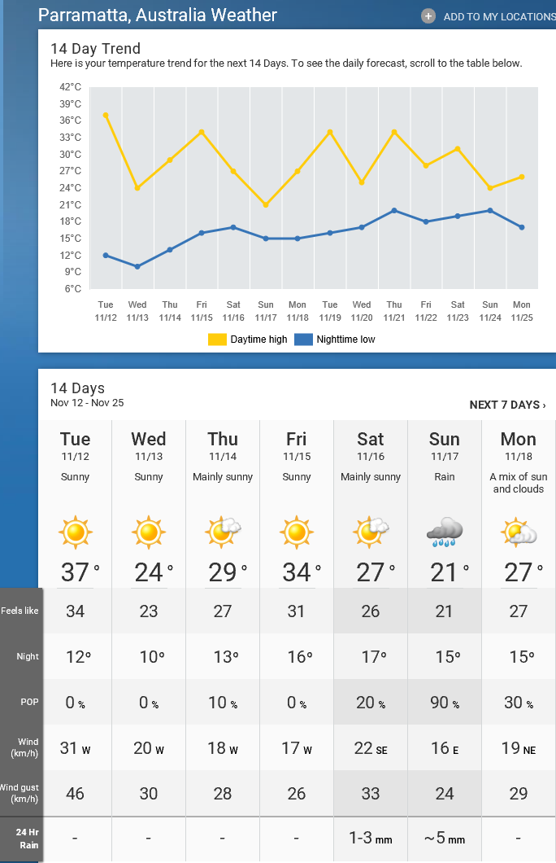
Source: The Weather Network
https://s.theweathernetwork.com/au
Date accessed: 12/11/2020

Who…

What…

Where…

When…

Free choice…

