Connecting ideas in text
Stage 2

Overview

Purpose
This literacy teaching strategy supports teaching and learning for Stage 2 students across all key learning areas. It targets specific literacy skills and suggests a learning sequence to build skill development. Teachers can select individual tasks, or a sequence, and embed into their teaching and learning program according to their students’ needs. While exemplar texts are provided throughout this resource, it is recommended that teachers select texts which are relevant to their students and curriculum.

Learning intention
Students will learn to identify devices that link information across and within texts.

Syllabus outcome
The following teaching and learning strategies will assist in covering elements of the following outcomes:
- EN2-RECOM-01: reads and comprehends texts for wide purposes using knowledge of text structures and language, and by monitoring comprehension
NSW English K-10 Syllabus (2022)

Success criteria
The following Year 3 NAPLAN item descriptors may guide teachers to develop success criteria for student learning:
- links an image to information in a narrative
- links an image to information in a text
- links a map to information in an information text
- links directly stated information across sentences in a narrative
- links information across sentences in a persuasive text
- interprets a pronoun reference across sentences in a text
- interprets a pronoun reference across sentences in a narrative.

National Literacy Learning Progression guide

Understanding Texts (UnT6-UnT9)
Key: C=comprehension P=process V=vocabulary

UnT6
- makes connections between texts (e.g. compares two versions of a well-known story) (C)
- uses cohesive devices to connect ideas or events (e.g. tracks pronoun referencing) (see Grammar) (P)

UnT7
- monitors the development of ideas using language and visual features (topic sentences, key verbs, graphs) (C)
- identifies language and text features that signal purpose in a predictable text (e.g. diagrams, dialogue) (C)

UnT8
- uses knowledge of cohesive devices to track meaning throughout a text (e.g. connectives such as however, on the other hand) (see Grammar) (C)

UnT9
- uses knowledge of a broader range of cohesive devices to track meaning (e.g. word associations) (see Grammar) (P)
National Literacy Learning Progression

Evidence base
- Centre for Education Statistics and Evaluation (2017). Effective reading instruction in the early years of school, literature review.
- Konza, D. (2014). Teaching Reading: Why the “Fab Five” should be the “Big Six”. Australian Journal of Teacher Education, 39(12).
- Oakhill, J., Cain, K. & Elbro, C. (2015). Understanding and teaching reading comprehension: A handbook. Routledge.
- Quigley, A. (2020). Closing the reading gap. Routledge.
- Scarborough, H.S. (2001). Connecting early language and literacy to later reading (dis)abilities: Evidence, theory and practice. In S. Neuman & D. Dickson (Eds.), Handbook for research in early literacy (pp. 97-110). New York, NY: Guilford Press.
Alignment to system priorities and/or needs: Five priorities for Literacy and Numeracy, Our
Plan for NSW Public Education, School Excellence Policy (nsw.gov.au).
Alignment to School Excellence Framework: Learning domain: Curriculum, Teaching domain: Effective classroom practice and Professional standards
Consulted with: Strategic Delivery, Teaching Quality and Impact
Author: Literacy and Numeracy
Reviewed by: Literacy and Numeracy, Teaching Quality and Impact
Created/last updated: January 2024
Anticipated resource review date: January 2025
Feedback: Complete the online form to provide any feedback

Copyright
Section 113P Notice
Texts, Artistic Works and Broadcast Notice
Some of this material has been copied and communicated to you in accordance with the statutory licence in section 113P of the Copyright Act. Any further reproduction or communication of this material by you may be the subject of copyright protection under the Act. Do not remove this notice.

Teaching strategies
Task | Appendices
Pronoun referencing | Appendix 1 – colour coding pronouns in text extracts  Appendix 2 - Pronoun referencing in texts
Connecting ideas in informative texts | Appendix 2 - Pronoun referencing in texts  Appendix 3 - Editor recommendations
Linking key words in texts
Identifying how images relate to words

Background information

Connecting ideas
Connecting ideas requires piecing together information throughout a text, with the intended message becoming clear only when all the connections have been established.
Students need to be able to scan texts to see all images, headings and different sections of print and then identify how these relate to each other.
The deconstruction and reconstruction of texts requires students to have a deep knowledge of how and why texts have been written. The connection of ideas within a text requires the reader to utilise skills and strategies whilst reading or viewing the text.
The ability to determine who or what a pronoun is referencing is also required to connect ideas across texts. It is an essential reading comprehension skill that requires students to use their knowledge of syntax and background knowledge.

Pronoun
A word that is used in place of a noun. A pronoun may be personal (he, she, we, they), demonstrative (that, this) or relative (who). There are different types of pronouns:
- personal pronouns represent specific people or things, for example she, it, they, you, we
- demonstrative pronouns indicate a thing or things, for example this, these, that, those
- possessive pronouns refer to the belonging of one thing, person, etc, to another, for example his, theirs, yours, mine
- interrogative pronouns represent the things that we are asking questions about, for example who, whom, what, which
- reflexive pronouns refer back to the subject of the sentence or clause. Reflexive pronouns end in -self (singular) or -selves (plural). The reflexive pronoun myself is not a substitute for the personal pronouns I or me
- reciprocal pronouns are used when each of two or more subjects is acting in the same way towards the other, for example 'Jack and Jill love each other', 'The footballers were blaming one another'
- indefinite pronouns do not refer to any specific person, thing or amount, for example all, another, any, anybody/anyone, anything, each, everybody/everyone, everything, few, many, nobody, none, one, several, some, somebody/someone
- relative pronouns introduce a relative clause. They are called relative because they relate to the words they modify. There are five relative pronouns: who, whom, whose, which, that.
Reference: English K-10 Syllabus © NSW Education Standards Authority (NESA) for and on behalf of the Crown in right of the State of New South Wales, 2012 and 2022.

Where to next?
- Sequencing informative texts
- Sequencing imaginative texts
- Literal comprehension

Overview of teaching strategies

Purpose
These literacy teaching strategies support teaching and learning from Stage 2 to Stage 5. They are linked to NAPLAN task descriptors, syllabus outcomes and literacy and numeracy learning progressions.
These teaching strategies target specific literacy and numeracy skills and suggest a learning sequence to build skill development. Teachers can select individual tasks or a sequence to suit their students.

Access points
The resources can be accessed from:
- NAPLAN App in Scout using the teaching strategy links from NAPLAN items
- NSW Department of Education literacy and numeracy website.
What works best
Explicit teaching practices involve teachers clearly explaining to students why they are learning something, how it connects to what they already know, what they are expected to do, how to do it and what it looks like when they have succeeded. Students are given opportunities and time to check their understanding, ask questions and receive clear, effective feedback.
This resource reflects the latest evidence base and can be used by teachers as they plan for explicit teaching.
Teachers can use classroom observations and assessment information to make decisions about when and how they use this resource as they design teaching and learning sequences to meet the learning needs of their students.
Further support with What works best is available.
Differentiation
When using these resources in the classroom, it is important for teachers to consider the needs of all students, including Aboriginal and EAL/D learners.
EAL/D learners will require explicit English language support and scaffolding, informed by the Enhanced EAL/D enhanced teaching and learning cycle and the student’s phase on the EAL/D Learning Progression. Teachers can access information about supporting EAL/D learners and literacy and numeracy support specific to EAL/D learners.
Learning adjustments enable students with disability and additional learning and support needs to access syllabus outcomes and content on the same basis as their peers. Teachers can use a range of adjustments to ensure a personalised approach to student learning.
Assessing and identifying high potential and gifted learners will help teachers decide which students may benefit from extension and additional challenge. Effective strategies and contributors to achievement for high potential and gifted learners helps teachers to identify and target areas for growth and improvement. A differentiation adjustment tool can be found on the High potential and gifted education website.

Using tasks across learning areas
This resource may be used across learning areas where it supports teaching and learning aligned with syllabus outcomes.
Literacy and numeracy are embedded throughout all syllabus documents as general capabilities. As the English and mathematics learning areas have a particular role in developing literacy and numeracy, NSW English and Mathematics syllabus outcomes aligned to literacy and numeracy skills have been identified.

Text selection
Example texts are used throughout this resource. Teachers can adjust activities to use texts which are linked to their unit of learning.
Further support with text selection can be found within the National Literacy Learning Progression Text Complexity appendix.
The NESA website has additional information on text requirements within the NSW English syllabus.

Teaching strategies

Pronoun referencing
- Teacher models reading a picture book, paragraph or a sequence of sentences aloud for students. It is important to build background knowledge of the text and predict vocabulary to help students contextualise the story. Ask students to listen to who is in the story and predict words (pronoun, noun or proper noun) by pausing where a pronoun or noun might be.
- Display the following text and have students discuss what they would change or add to it. Model and jointly construct a rewrite of the text.
- Matilda enjoyed going to her school. Matilda was always reading and drawing. Matilda’s favourite activity was dancing. Dancing was fun. Dancing was sometimes tricky but Matilda kept on trying to dance. Matilda was learning new skills every day.
To increase abstraction, ask students to justify why they would make these choices.
- Display the following text for students to read:
- They were winning the game. They were sure that they were cheating. They were plotting something against them. They knew they would have to strike now whilst the iron was hot. They knew something was about to happen. They were looking pale and anxious.
Discuss who ‘they’ might be. In this text, there are two ‘theys’. ‘How can we tell?’ Who might the two ‘theys’ be?’ Students make appropriate substitutions so that the text makes sense.
To increase complexity, students compare and contrast their adjusted texts with their peers, justifying their choices.
- Discuss pronouns and how we use these to help a text flow and avoid repetition; that a mixture of a proper noun followed by pronouns, then reaffirming the proper noun, is a tool used by authors. Pose the idea that if all the proper nouns were replaced with ‘they’ – how would we know who was being referred to?
- Barrier Game: Students work in pairs and read aloud a text excerpt. After reading the first sentence, students pause and have their partner predict the pronoun, noun or proper noun.
To support students, teacher provides students with a resource bank of pronouns, nouns and proper nouns.
- Teacher models how to colour code elements of a text using the think-aloud strategy. Students use colour coding to connect elements of the text, for example, linking a caption to a diagram or a picture with a paragraph.

‘Nanberry: Black Brother White’ by Jackie French, 2011 HarperCollins Publishers.
Chapter 1
The white ghosts chopped down trees. They built big huts. They lived in them all year, until they stank. Their women didn’t know how to fish and when they gathered oysters they threw away the flesh and kept only the shells.
The white ghosts stole Cadigal canoes and spears. They tried to attack the Cadigal women, though the women had fought them and run off. They had even made the stream a filthy stinking thing. Didn’t white-ghost mothers tell their children how important it was to keep the water clean?
Accessibility note:
Character 1: white ghost, then pronouns related to the white ghosts are highlighted throughout the text (they and their throughout text excluding their in last sentence)
Character 2: ‘Cadigal’ “Cadigal women’
Character 3: white-ghost mothers and ‘their’ in last sentence of text
- Students are given an extract from a text and colour code the character and the pronouns to track them throughout the text (refer to Appendix 1 – colour coding pronouns in text extracts).
- Cloze: Students use the ‘Earthworms’ text to complete a cloze passage (refer to Appendix 2 - Pronoun referencing in texts) and add pronouns, nouns and proper nouns. Using cloze passages with any text appropriate to students is an effective way to reinforce the ‘who’ and ‘what’ is being referred to in a text.

Connecting ideas in informative texts
- Teacher demonstrates a think-aloud ‘walk-through’ of a text linked to the current unit of learning, noticing and discussing the textual and visual features and layouts within the texts.
During the think-aloud model the process of scanning and annotating the headings and subheadings, illustrations, captions, diagrams, maps, charts and tables, rereading where required to identify and confirm connected ideas across sentences and paragraphs.
- Students read a range of non-fiction texts linked to a current unit of learning and use colour coding, lines and arrows to illustrate how nouns are connected (refer to Appendix 2 - Pronoun referencing in texts).
- Editor for a day: Students are given a passage from a text and make recommendations as an editor. These recommendations might include adding sub-headings, captions, diagrams and photographs. Students need to justify why adding these might help build or support reader understanding (refer to Appendix 3 - Editor recommendations). Teacher initially models how to edit a paragraph, using the think aloud strategy to explain and justify choices. To support students, have them work in pairs to complete the task and share ideas and strategies.

Linking key words in texts
- Have students identify and highlight key words and words with similar meanings in a text. Students read the headings or sentences around the words and discuss what they mean and how they connect to each other. Draw lines of connection between the key words if working on photocopies or a screen. Have students consider what other information is missing or that they would like to find out by searching in the library or on the internet.
- Have students circle key words with different meanings in a text in different colours and then use the same colour to identify words with a similar meaning. Teacher models how to identify and track word chains. Students then draw lines using the same colour to track their word chain through the text. This can help them to see connections. Students could then create a mind map of key words surrounded by similar words and draw lines of connection between them to show relationships between ideas by writing how they relate on the lines.
To increase complexity, students could add to the existing word chains using synonyms or create an antonym word chain.

Identifying how images relate to words
- Select picture books with the following range of relationships between the images and language:
equivalent meanings (for example, labelled images), elaborated meanings (extra information in either image or language about participant or process represented in both image and language), complementary meaning where image and text add to each other (additional participants or processes in either image or words, for example, a map that can only be understood through the legend) or divergent meaning (image and words contradict each other, for example, 'Magic Beach' by Alison Lester).
- Treating one book at a time, ask open-ended questions to get students to describe what is represented in the images and then what is stated in the words. Ask students to identify where meanings are the same/equivalent, elaborated, additional/complementary or different/divergent. Where relevant, discuss how the meaning of the whole text can be more than the sum of the meaning of the parts. Ask students to explain why they think the author and illustrator have created the text in this way – elicit answers about intended audience, what made the text effective.
Suggested text: Margaret Wild’s ‘Fox’ is a text with an unusual reading path and will challenge students to navigate a text and connect ideas.
To encourage higher order thinking, students work in pairs or small groups and read the text, asking questions of each other and presenting their findings to the class.

Appendix 1

Colour coding pronouns in text extracts
The rat knew that he was on the right path! The path stretched through the city over the hills. It was covered in rocks and grass. He was feeling tired but marched on.
Honey is a delicious ingredient in cake and stir-fry, but it is also tasty on bread or in tea.
Tyler rode his skateboard down the road towards the skate park. His helmet was firm on his head and he moved the straps so they wouldn’t hit him.
If we send you something today, please make sure you reply to me by Thursday next week.
After the rains, when saplings are springing up everywhere, a fox comes into the bush; Fox with his haunted eyes and rich red coat. He flickers through the trees like a tongue of fire, and Magpie trembles.
Fox by Margaret Wild, Illustrated by Ron Brooks, 2004, Allen and Unwin
Rose’s best friend Olive’s mother, Karrang, makes beautiful coloured baskets, mats and bags from leaves from the pandanus palm a tall, thin tree with very long, spiky leaves. Rose and Olive spend a day out bush helping to gather the pandanus leaves and stringy bark for making into strong bags and baskets. They collect the colour that the bags will be bright yellows and pinks, from special plants and berries. It is a hard day’s work for Rose, but the results are worth it.
Collecting Colour by Kylie Dunstan, 2009, Lothian Children’s Books

Appendix 2

Pronoun referencing in texts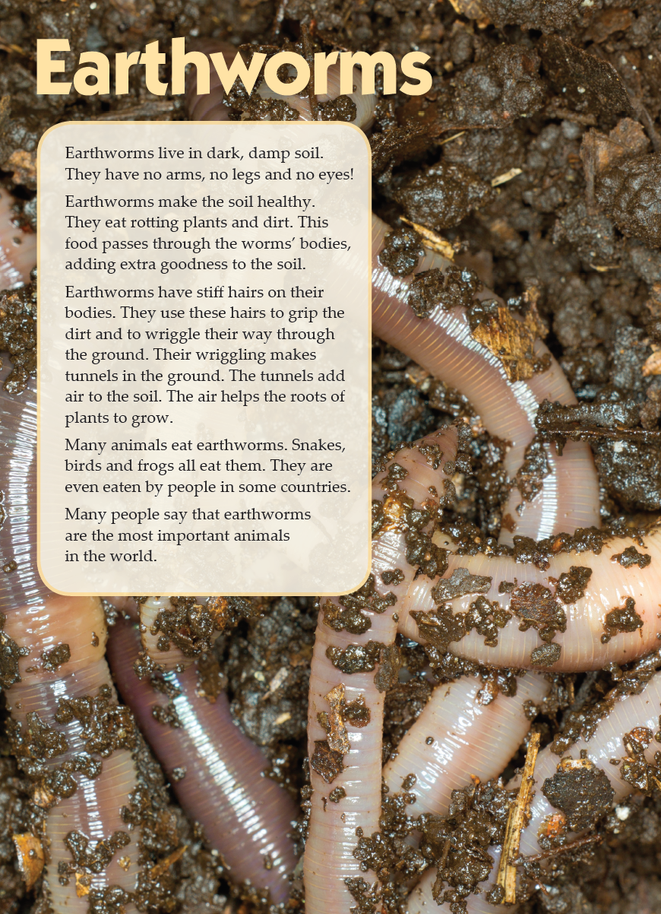
Year 3 NAPLAN Reading magazine, 2013 ACARA
Pronoun referencing in texts – accessible version
Earthworms
Earthworms live in dark, damp soil. They have no arms, no legs and no eyes!
Earthworms make the soil healthy. They eat rotting plants and dirt. This food passes through the worms’ bodies, adding extra goodness to the soil.
Earthworms have stiff hairs on their bodies. They use these hairs to grip the dirt and to wriggle their way through the ground. Their wriggling makes tunnels in the ground. The tunnels add air to the soil. The air helps the roots of plants to grow.
Many animals eat earthworms. Snakes, birds and frogs all eat them. They are even eaten by people in some countries.
Many people say that earthworms are the most important animals in the world.
Year 3 NAPLAN Reading magazine, 2013 ACARA

Pronoun referencing in texts

Earthworms
Earthworms live in dark, damp soil. ______________ have no arms, no legs and no eyes!
______________ make the soil healthy. They eat rotting plants and dirt. This food passes through the ______________ bodies, adding extra goodness to the soil.
Earthworms have stiff hairs on their bodies. They use these hairs to grip the dirt and wriggle ______________ way through the ground. Their wriggling makes tunnels in the ground. The tunnels add air to the soil. ______________ helps the roots of plants to grow.
Many animals eat earthworms. Snakes, birds and frogs all eat them. ______________ are even eaten by people in some countries.
Many people say that earthworms are the most important animals in the world.

Appendix 3

Editor recommendations

Earthworms

Earthworms live in dark, damp soil. They have no arms, no legs and no eyes!

Earthworms make the soil healthy. They eat rotting plants and dirt. This food passes through the worms’ bodies, adding extra goodness to the soil.

Earthworms have stiff hairs on their bodies. They use these hairs to grip the dirt and wriggle their way through the ground. Their wriggling makes tunnels in the ground. The tunnels add air to the soil. The air helps the roots of plants to grow.

Many animals eat earthworms. Snakes, birds and frogs all eat them. They are even eaten by people in some countries.

Many people say that earthworms are the most important animals in the world.
What image would you recommend be added to help readers? Add a caption.
The image might be a photograph, map, or diagram.
What image would help? | Caption

