Categorising information
Stage 2

Overview

Purpose
This literacy teaching strategy supports teaching and learning for Stage 2 students across all key learning areas. It targets specific literacy skills and suggests a learning sequence to build skill development. Teachers can select individual tasks, or a sequence, and embed into their teaching and learning program according to their students’ needs. While exemplar texts are provided throughout this resource, it is recommended that teachers select texts which are relevant to their students and curriculum.

Learning intention
Students will learn to categorise information by drawing on vocabulary, background knowledge and topic sentences.

Syllabus outcome
The following teaching and learning strategies will assist in covering elements of the following outcomes:
- EN2-RECOM-01: reads and comprehends texts for wide purposes using knowledge of text structures and language, and by monitoring comprehension
NSW English K-10 Syllabus (2022)

Success criteria
The following Year 3 NAPLAN item descriptors may guide teachers to develop success criteria for student learning
- categorises information from different sections of an information text
- categorises information from an information text

National Literacy Learning Progression guide

Understanding Texts (UnT6-UnT9)
Key: C=comprehension P=process V=vocabulary

UnT6
- scans texts to locate specific information in a predictable print text (C)
- makes connections between texts (e.g. compares two versions of a well-known story) (C)

UnT7
- compares and contrasts texts on the same topic to identify how authors represent the same ideas differently (C)
- navigates texts using common signposting devices such as headings, subheadings, paragraphs, navigation bars and links (P)

UnT8
- skims and scans texts for key words to track the development of key ideas (P)
- identifies how technical and discipline-specific words develop meaning in texts (V)

UnT9
- distils information from a number of texts according to task and purpose (e.g. uses graphic organisers) (C)
- selects reading/viewing strategies appropriate to reading purpose (e.g. scans text for evidence) (P)
National Literacy Learning Progression

Evidence base
- Centre for Education Statistics and Evaluation (2017). Effective reading instruction in the early years of school, literature review.
- Konza, D. (2014). Teaching Reading: Why the “Fab Five” should be the “Big Six”. Australian Journal of Teacher Education, 39(12).
- Oakhill, J., Cain, K. & Elbro, C. (2015). Understanding and teaching reading comprehension: A handbook. Routledge.
- Quigley, A. (2020). Closing the reading gap. Routledge.
- Scarborough, H.S. (2001). Connecting early language and literacy to later reading (dis)abilities: Evidence, theory and practice. In S. Neuman & D. Dickson (Eds.), Handbook for research in early literacy (pp. 97-110). New York, NY: Guilford Press.

Alignment to system priorities and/or needs: Five priorities for Literacy and Numeracy, Our Plan for Public NSW Education, School Excellence Policy (nsw.gov.au).
Alignment to School Excellence Framework: Learning domain: Curriculum, Teaching domain: Effective classroom practice and Professional standards
Consulted with: Strategic Delivery, Teaching Quality and Impact
Author: Literacy and Numeracy
Reviewed by: Literacy and Numeracy, Teaching Quality and Impact
Created/last updated: January 2024
Anticipated resource review date: January 2025
Feedback: Complete the online form to provide any feedback

Copyright
Section 113P Notice
Texts, Artistic Works and Broadcast
Notice
Some of this material has been copied and communicated to you in accordance with the statutory licence in section 113P of the Copyright Act. Any further reproduction or communication of this material by you may be the subject of copyright protection under the Act. Do not remove this notice.

Teaching strategies
Task | Appendices
Categorising Items | Appendix 1 – Odd one out
Categorising information from texts | Appendix 2 – Categorising text

Background information

Categorisation
Categorising is an important skill for students to be able to draw out information and make connections within and across the text.
Categorising is grouping items or ideas based around a particular characteristic such as natural or man-made products, colour groups etc. Students use their background knowledge, understanding of text structure and features, as well as information in the text, to determine which category an item belongs.
Part of categorising is to use labels or to decide upon a label for the groupings, as well as thinking about alternate techniques such as sub-categories and alternate categorisation ideas.

Where to next?
- Fact and opinion
- Main idea
- Literal comprehension

Overview of teaching strategies

Purpose
These literacy teaching strategies support teaching and learning from Stage 2 to Stage 5. They are linked to NAPLAN task descriptors, syllabus outcomes and literacy and numeracy learning progressions.
These teaching strategies target specific literacy and numeracy skills and suggest a learning sequence to build skill development. Teachers can select individual tasks or a sequence to suit their students.

Access points
The resources can be accessed from:
- NAPLAN App in Scout using the teaching strategy links from NAPLAN items
- NSW Department of Education literacy and numeracy website.

What works best
Explicit teaching practices involve teachers clearly explaining to students why they are learning something, how it connects to what they already know, what they are expected to do, how to do it and what it looks like when they have succeeded. Students are given opportunities and time to check their understanding, ask questions and receive clear, effective feedback.
This resource reflects the latest evidence base and can be used by teachers as they plan for explicit teaching.
Teachers can use classroom observations and assessment information to make decisions about when and how they use this resource as they design teaching and learning sequences to meet the learning needs of their students.
Further support with What works best is available.

Differentiation
When using these resources in the classroom, it is important for teachers to consider the needs of all students, including Aboriginal and EAL/D learners.
EAL/D learners will require explicit English language support and scaffolding, informed by the EAL/D enhanced teaching and learning cycle and the student’s phase on the EAL/D Learning Progression. Teachers can access information about supporting EAL/D learners and literacy and numeracy support specific to EAL/D learners.
Learning adjustments enable students with disability and additional learning and support needs to access syllabus outcomes and content on the same basis as their peers. Teachers can use a range of adjustments to ensure a personalised approach to student learning.
Assessing and identifying high potential and gifted learners will help teachers decide which students may benefit from extension and additional challenge. Effective strategies and contributors to achievement for high potential and gifted learners helps teachers to identify and target areas for growth and improvement. A differentiation adjustment tool can be found on the High potential and gifted education website.

Using tasks across learning areas
This resource may be used across learning areas where it supports teaching and learning aligned with syllabus outcomes.
Literacy and numeracy are embedded throughout all syllabus documents as general capabilities. As the English and mathematics learning areas have a particular role in developing literacy and numeracy, NSW English and Mathematics syllabus outcomes aligned to literacy and numeracy skills have been identified.

Text selection
Example texts are used throughout this resource. Teachers can adjust activities to use texts which are linked to their unit of learning.
Further support with text selection can be found within the National Literacy Learning Progression Text Complexity appendix.
The NESA website has additional information on text requirements within the NSW English syllabus.

Teaching strategies

Categorising items
- Students collect a range of items from the playground in pairs or small groups (leaves, sticks, papers, rocks) Using these items, students work in teams to group or categorise these items. Prompt students to re-categorise in a different way, recording criteria for the category such as colour, location, substance.
Additional task: Students work in pairs and categorise the items individually, swap with a partner who guesses the category then rearranges into a different category for the partner to guess. Partner justifies decision using evidence.
- Develop a class anchor chart on categorisation for students to build their understanding and share examples. (To categorise is to group and label objects or ideas based around certain characteristics or attributes.) Students find similarities and differences between items to determine if they should be grouped together or not.
To increase complexity, students use the think aloud strategy to explain the factors that influenced their choices and any challenges experienced in categorising objects.
- Teacher reads aloud a range of words and students determine the odd one out (Appendix 1 – Odd one out), justifying choice with a label. Students then create their own examples to challenge peers.
To increase complexity, students find a connection between words/objects that are usually unrelated and justify their connections with evidence.
- Teacher prompts students with an abstract noun such as power or love. Students write one word on a whiteboard or sticky note without showing their peers. Students then ‘chin it’ (place under chin), showing their peers, forming categories based on vocabulary choices of their peers.

Categorising information from texts
- Warm up: Teacher calls out a category, students move to form the categories such as students born in spring/winter/summer/autumn or students wearing joggers vs school shoes. Have students think of new categories to organise information. What can we call this group or category? Can we categorise another way? Can we categorise further with sub-categories? How can we display this information in a written form? Discuss using headings, sub-headings and graphic organisers to display information.
- Teacher introduces the topic of an information text (refer to Appendix 2 – Categorising Text or use any suitable text linked to a current unit of learning) and encourages students to brainstorm expected vocabulary and determine background knowledge on the topic.
- Display the two headings: background knowledge and predicted vocabulary and ask students which category their information fits.
Alternate task: Students write key vocabulary and background knowledge on sticky notes. Teacher models reading the sticky notes aloud and verbalises the best category for the information (vocabulary or background knowledge). Students then work in small groups with their sticky notes to categorise then explore sub-categories.
To challenge students, students further categorise vocabulary and background knowledge into sub-categories or find alternate categories for the information.
- Teacher models scanning text for information to determine category by highlighting elements such as headings, sub-headings, vocabulary and topic sentences. Teachers can use any suitable information text linked to a current unit of learning or Appendix 2 – Categorising Text to guide discussion. Teacher models reading the text and prompts students to think of different ways to group the information such as information about physical features, habitat, life span. When reading aloud, pause to allow students to identify where the information should be categorised, highlighting key vocabulary.
- Jigsaw task: Students are given paragraphs and images to categorise from a range of suitable texts linked to current learning or refer to Appendix 2 – Categorising Text. Students highlight the topic sentence and underline key vocabulary to determine a category. Place large sheets of paper around the classroom with students using sticky notes to decide on a category for their information; these can be refined as the category may need to expand or narrow its focus. Students place their paragraph under the category that best suits.
For abstraction, students are provided with a range of fiction texts on the same topic as activity 5. In pairs, students read the text and add their new examples to the categories, comparing and contrasting the types of language devices and vocabulary used to explore the topic. Students share their findings with the class, noting how language choices may be different or similar in an information text compared to a work of fiction, and explaining why they think the this may be so. For example, ‘Metaphors were found in the poem and the information text. Even though a metaphor is an example of figurative language, and it would seem more likely that it would be used in a work of fiction, they are often used in information texts to make complex concepts more understandable. The information texts also feature more technical language, whereas the poem includes a lot of imagery and more descriptive language such as adjectives.’

Appendix 1

Odd one out categories
List | Odd one out
apple, banana, pear, broccoli | broccoli (vegetable)
rose, petal, potpourri, book | book (not related to rose)
phone, pencil, computer, tomato | tomato (others are communication devices)
student, teacher, doctor, library | doctor (the others are related to education)
chicken, cheese, chisel, beef | chisel (the others are food)  beef (the others start with ‘ch’ phoneme)
apartment, unit, flat, house | house (the others are examples of medium to high-density dwellings)
castanet, tambourine, triangle, clarinet | clarinet (the others are percussion)
diamond, emerald, sapphire, cubic zirconia | cubic zirconia
Explorer, Google Chrome, Bing, PowerPoint | PowerPoint (the others are search engines)  Bing (the others have three syllables)
Holden, Mercedes-Benz, Toyota, Ford | Mercedes-Benz (expensive or only hyphenated word)
aunt, uncle, cousin, friend | Friend (the others are related)
Minecraft, Monopoly, Scrabble, Balderdash | Minecraft (video game, the others are board games).

Appendix 2

Categorising text
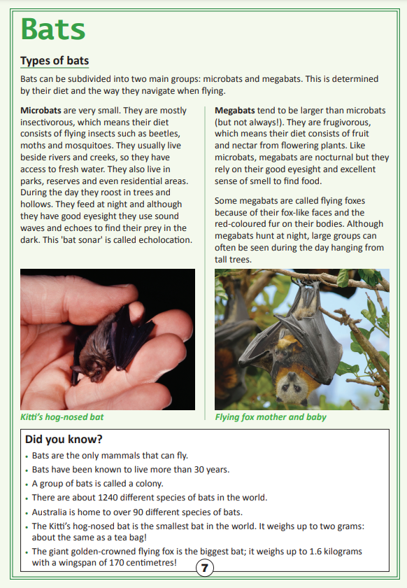
Year 3 NAPLAN Reading Magazine, 2016 ACARA

Categorising text – accessible version
Bats
Types of bats
Bats can be subdivided into two main groups: microbats and megabats. This is determined by their diet and the way they navigate when flying.
Microbats are very small. They are mostly insectivorous, which means their diet consists of flying insects such as beetles, moths and mosquitoes. They usually live beside rivers and creeks, so they have access to fresh water. They also live in parks, reserves and even residential areas. During the day they roost in trees and hollows. They feed at night and although they have good eyesight they use sound waves and echoes to find their prey in the dark. This 'bat sonar' is called echolocation.
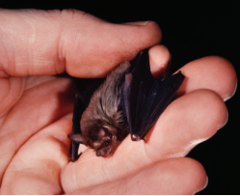
Kitti’s hog-nosed bat
Megabats tend to be larger than microbats (but not always!). They are frugivorous, which means their diet consists of fruit and nectar from flowering plants. Like microbats, megabats are nocturnal but they rely on their good eyesight and excellent sense of smell to find food. Some megabats are called flying foxes because of their fox-like faces and the red-coloured fur on their bodies. Although megabats hunt at night, large groups can often be seen during the day hanging from tall trees.
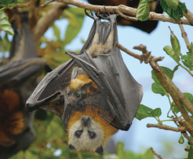
Flying fox mother and baby
Did you know?
• Bats are the only mammals that can fly.
• Bats have been known to live more than 30 years.
• A group of bats is called a colony.
• There are about 1240 different species of bats in the world.
• Australia is home to over 90 different species of bats.
• The Kitti’s hog-nosed bat is the smallest bat in the world. It weighs up to two grams: about the same as a tea bag!
• The giant golden-crowned flying fox is the biggest bat; it weighs up to 1.6 kilograms with a wingspan of 170 centimetres!
Year 3 Naplan Reading Magazine, 2016 ACARA

