Audience and purpose
Stage 2

Overview

Purpose
This literacy teaching strategy supports teaching and learning for Stage 2 students across all key learning areas. It targets specific literacy skills and suggests a learning sequence to build skill development. Teachers can select individual tasks, or a sequence, and embed into their teaching and learning program according to their students’ needs. While exemplar texts are provided throughout this resource, it is recommended that teachers select texts which are relevant to their students and curriculum.

Learning intention
Students will learn to identify the audience and purpose of texts and how an author crafts texts to meet a purpose and target an audience.

Syllabus outcome
The following teaching and learning strategies will assist in covering elements of the following outcomes:
- EN2-RECOM-01: reads and comprehends texts for wide purposes using knowledge of text structures and language, and by monitoring comprehension
NSW English K-10 Syllabus (2022)

Success criteria
The following Year 3 NAPLAN item descriptors may guide teachers to develop success criteria for student learning.
- identifies the intended audience of a text
- identifies the main purpose of a text
- identifies the purpose of an image on a poster
- identifies the purpose of an image in a text
- identifies the purpose of a sentence in an information text
- identifies the main purpose of a sign
- identifies the purpose of the opening paragraph in a narrative
- identifies the main purpose of a persuasive text
- identifies the purpose of a statement in a persuasive text
- identifies the main purpose of an information text
- identifies the purpose of a statement in an information text
- identifies the purpose of a description in a narrative

National Literacy Learning Progression guide

Understanding Texts (UnT6-UnT9)
Key: C=comprehension P=process V=vocabulary

UnT6
- identifies the purpose of predictable informative, imaginative and persuasive texts (e.g. uses verbs and dot points to identify a set of instructions) (C)

UnT7
- identifies the purpose of a broad range of informative, imaginative and persuasive texts (e.g. advertisements, diary entry) (C)
- identifies language and text features that signal purpose in a predictable text (e.g. diagrams, dialogue) (P)
- navigates texts using common signposting devices such as headings, subheadings, paragraphs, navigation bars and links (P)

UnT8
- explains how authors use evidence and supporting detail to build and verify ideas (C)
- explains how textual features support the text’s purpose (P)
- skims and scans texts for key words to track the development of ideas (P)

UnT9
- evaluates text features for relevance to purpose and audience (C)
- analyses texts which have more than one purpose and explains how parts of the text support a particular purpose (C)
- analyses language and visual features in texts using metalanguage (e.g. cohesion, interpretation, figurative) (V)
National Literacy Learning Progression

Evidence base
- Centre for Education Statistics and Evaluation (2017). Effective reading instruction in the early years of school, literature review.
- Konza, D. (2014). Teaching Reading: Why the “Fab Five” should be the “Big Six”. Australian Journal of Teacher Education, 39(12).
- Oakhill, J., Cain, K. & Elbro, C. (2015). Understanding and teaching reading comprehension: A handbook. Routledge.
- Quigley, A. (2020). Closing the reading gap. Routledge.
- Scarborough, H.S. (2001). Connecting early language and literacy to later reading (dis)abilities: Evidence, theory and practice. In S. Neuman & D. Dickson (Eds.), Handbook for research in early literacy (pp. 97-110). New York, NY: Guilford Press.

Alignment to system priorities and/or needs: Five priorities for Literacy and Numeracy, Our Plan for Public Education, School Excellence Policy (nsw.gov.au).
Alignment to School Excellence Framework: Learning domain: Curriculum, Teaching domain: Effective classroom practice and Professional standards
Consulted with: Strategic Delivery, Teaching Quality and Impact
Author: Literacy and Numeracy
Reviewed by: Literacy and Numeracy, Teaching Quality and Impact
Created/last updated: January 2024
Anticipated resource review date: January 2025
Feedback: Complete the online form to provide any feedback

Copyright
Section 113P Notice
Texts, Artistic Works and Broadcast Notice
Some of this material has been copied and communicated to you in accordance with the statutory licence in section 113P of the Copyright Act. Any further reproduction or communication of this material by you may be the subject of copyright protection under the Act. Do not remove this notice.

Teaching strategies
Task | Appendices
What is the purpose? | Appendix 1 – Brain freeze  Appendix 2 – Audience and purpose quadrant analysis
Knowing my audience | Appendix 3 – Audience and purpose scenario cards
Selling an idea to an audience | Appendix 4 – Purpose and audience feedback
Text features which signal purpose | Appendix 5 – Text features which signal purpose – Information text  Appendix 6 - Sub-headings

Background information

Purpose
The purpose of a text is to entertain, to inform or to persuade different audiences in different contexts. Composers use a number of ways to achieve these purposes: persuading through emotive language, analysis or factual recount; entertaining through description, imaginative writing or humour, and so on.

Audience
Readers, listeners or viewers who engage with a text.
The intended group of readers, listeners or viewers that the writer, designer, filmmaker or speaker is addressing. Audience attributes may include: age, education, economic status, political/social/religious beliefs. To determine audience, we also address the level of information they have about the subject (expert, amateur etc.), as well as the format in which the writing is presented (newspaper, textbook, blog etc.).
Reference: English K-10 Syllabus © NSW Education Standards Authority (NESA) for and on behalf of the Crown in right of the State of New South Wales, 2012 and 2022.

Where to next?
- Exploring perspective
- Text structure
- Inference

Overview of teaching strategies

Purpose
These literacy teaching strategies support teaching and learning from Stage 2 to Stage 5. They are linked to NAPLAN task descriptors, syllabus outcomes and literacy and numeracy learning progressions.
These teaching strategies target specific literacy and numeracy skills and suggest a learning sequence to build skill development. Teachers can select individual tasks or a sequence to suit their students.

Access points
The resources can be accessed from:
- NAPLAN App in Scout using the teaching strategy links from NAPLAN items
- NSW Department of Education Literacy and numeracy website.

What works best
Explicit teaching practices involve teachers clearly explaining to students why they are learning something, how it connects to what they already know, what they are expected to do, how to do it and what it looks like when they have succeeded. Students are given opportunities and time to check their understanding, ask questions and receive clear, effective feedback.
This resource reflects the latest evidence base and can be used by teachers as they plan for explicit teaching.
Teachers can use classroom observations and assessment information to make decisions about when and how they use this resource as they design teaching and learning sequences to meet the learning needs of their students.
Further support with What works best is available.

Differentiation
When using these resources in the classroom, it is important for teachers to consider the needs of all students, including Aboriginal and EAL/D learners.
EAL/D learners will require explicit English language support and scaffolding, informed by the Enhanced EAL/D enhanced teaching and learning cycle and the student’s phase on the EAL/D Learning Progression. Teachers can access information about supporting EAL/D learners and literacy and numeracy support specific to EAL/D learners.
Learning adjustments enable students with disability and additional learning and support needs to access syllabus outcomes and content on the same basis as their peers. Teachers can use a range of adjustments to ensure a personalised approach to student learning.
Assessing and identifying high potential and gifted learners will help teachers decide which students may benefit from extension and additional challenge. Effective strategies and contributors to achievement for high potential and gifted learners helps teachers to identify and target areas for growth and improvement. A differentiation adjustment tool can be found on the High potential and gifted education website.

Using tasks across learning areas
This resource may be used across learning areas where it supports teaching and learning aligned with syllabus outcomes.
Literacy and numeracy are embedded throughout all syllabus documents as general capabilities. As the English and mathematics learning areas have a particular role in developing literacy and numeracy, NSW English and Mathematics syllabus outcomes aligned to literacy and numeracy skills have been identified.

Text selection
Example texts are used throughout this resource. Teachers can adjust activities to use texts which are linked to their unit of learning.
Further support with text selection can be found within the National Literacy Learning Progression Text complexity appendix.
The NESA website has additional information on text requirements within the NSW English syllabus.

Teaching strategies

What is the purpose?
Students will have had experience with the broad purposes of texts mostly being to persuade, inform and to entertain. Refer to ‘Stage 2 Text structure’ for further support.
- Review the three broad purposes: ‘inform’, ‘persuade’ and ‘entertain’. Students brainstorm examples of texts that inform, persuade and entertain and what they might look for to identify whether a text is one of these three. Create a class display of recorded information. Below is a guide.
Which | Purpose | Suggestions for what to look for | Text examples
inform | The author wants to give the reader information. | facts  references  technical language  headings, sub-headings, topic sentences | textbooks  science journal articles  encyclopaedia reference
persuade | The author wants the reader to do something or believe in something. | rhetorical questions  strong modality (must, should)  arguments are structured throughout | advertisement  travel brochure  news article
entertain | The author wants the reader to be amused or enjoy what they are reading. | relatable characters  jokes and humour  orientation, complication and resolution structure  dialogue  literary devices  descriptive language | poetry  novels  plays  songs  narratives
- The teacher takes students on a walk to identify the written signs that are in their environment. Teachers use a ‘think aloud’ strategy to identify a sign and discuss its purpose, for example:
“I can see this sign says: ‘All visitors must sign in at the office on arrival.’ I know that this sign is used to remind visitors to our school to go to the office and sign in – the purpose of this sign is to inform visitors about their responsibility to help keep our school safe by communicating when they will be on school grounds.” The teacher could lead discussion around who this sign could be for. For example, “I wonder who the audience is for this sign? It doesn’t actually say who this sign is for, but I can infer, using my background knowledge and clues from the text such as the words ‘on arrival’, that it means the audience is for visitors to our school.”
- Students explore their environment and categorise any other signs that they see into ‘inform’, ‘persuade’ and ‘entertain’.
- Ask students to think of other signs that they have come across that might have a similar purpose to the signs that they have found around the school. For example, can they think of other signs where the purpose is to inform?
- Think-Pair-Share: Teacher discusses the features of the broad purposes of texts: to persuade, educate, entertain and inform. In pairs, students use a collection of texts available in the classroom and categorise them into the broad purposes, for example, a newspaper article on bushfires might be to inform.
- Discuss how some texts may have features that reflect multiple purposes, for example, the same article informing about bush fires may also be persuading people to have a fire plan and may use rhetorical questions such as “Is your family safe?”. Students justify their choice of purpose using the ‘think aloud’ strategy.
- Teacher models reading the text Appendix 1 – Brain freeze identifying purpose, audience, vocabulary, and subject matter, using Appendix 2 – Audience and purpose quadrant analysis to guide conversation.
- What evidence is there in the text that this is informative?
- Are there facts? Instructions?
- Is this also entertaining? How has language been used to create humour?
- Is the author asking questions? To whom?
- Who do you think is the intended audience? What evidence do you have to suggest this?
- How does the author structure the text? Does the text structure make the information easier to understand?
- Gallery walk: Display a range of texts in workstations around the classroom, including Aboriginal and Torres Strait Islander cultural texts and artwork, picture books, newspaper articles, recipes, furniture construction instructions, magazines, websites and advertisements. Allocate butcher’s paper per text and divide in four (refer to Appendix 2 – Audience and purpose quadrant analysis). Students discuss in their groups the purpose and type of text, the audience, key vocabulary and subject matter. Students rotate to another text and complete the process, adding onto information from previous groups. Share and discuss.

Knowing my audience
- Teachers choose a text that the class is preparing to study. It could be a novel, movie, website, or other. Provide the cover or blurb or trailer and ask students if they think that have seen or read a text like this before. Teachers then lead discussion that asks students to predict: Who do you think would enjoy this text? What makes you think this? Is there anyone else who might enjoy this text?
- Introduce the term ‘audience’ - this is the group of people that a text is designed for. Brainstorm different audiences that an author might compose a text for, for example, teenagers, environmentalists, teachers, students, parents, biologists.

- Discuss that an author creates a text with a particular audience in mind and makes decisions about elements such as how they structure a text, the language features used, vocabulary used, how a character is portrayed or actions that might occur. These decisions will be made based on this audience – the people who are the target group for the text.
- Teacher shows two different covers of the same book. For example, Tim Winton’s ‘Blueback’. Students Think-Pair-Share with a partner to discuss who might be the audience for the different covers and why there might be different covers for the same text (different countries, re-publishing with current design, a film release of the text.)

Selling an idea to an audience
- Teacher sets the scenario of selling ‘blue pizza’ to an audience. Using the ‘think aloud’ strategy, teachers brainstorm, discuss and create a mind map for the intended purpose, audience, vocabulary and subject matter. Teachers should explicitly discuss the types of advertising texts which could be used to ‘sell their idea’ and how they will persuade their chosen audience, and that these strategies might change for a different target market.
- Students work in small groups each with a different target market/audience card (refer to Appendix 3 – Audience and purpose scenario cards). Students create a short advertisement (short movie, transcript, live performance, poster) to persuade their target audience to purchase their blue pizza, which will be presented to class. When presenting, students decide upon the target market, justifying reasons for their choice, such as students selling to teenagers may use digital resources, language choices such as typical teenage vernacular.
- Using Appendix 4 – Purpose and audience feedback, teacher models how to use Appendix 4 to analyse and give feedback on one of their peers’ advertisements for blue pizza, focusing on the purpose of the text, the target audience, and vocabulary used to persuade. Each group will have a different row in the table.

Text features which signal purpose
- Teacher leads a discussion around the purpose of various text features and how they support the purpose of a text. Teacher annotates an information or persuasive text which has key features such as a heading, sub-headings, map, graphs, key, images and captions. The teacher draws attention to how each contributes to the overall purpose of the text.
Additional task: Students could complete a jigsaw activity, piecing together a text and/or annotate a text identifying how each feature signals the purpose of the text. For example, a graph provides further data which supports the content in the main body of the text.
- Think Aloud: Teacher to explain how sub-headings are used to support the purpose of texts and model the thinking process behind determining missing sub-headings from a text. The information text (Appendix 5 – Text features which signal purpose – Information text) has had 5 pieces of information removed: 3 sub-headings in the main text (indicated by the bold line), title or sub-heading in the text box (indicated by the bold line), and the key to the map.
Example ‘think aloud’:
‘When I read information texts, I look for clues from sub-headings as they signal the information
which will follow. For this text the sub-headings are missing, so I will need to read the text carefully
and look for clues before I choose the correct sub-heading. I might ask myself:
  - What are the most frequent words/nouns used? (pups, mothers)
  - How do they help me understand the purpose of this paragraph?
  - Are there are other words which help me determine the paragraph’s content? (baby, learn)
  - Based on these clues, which sub-heading best fits the purpose of the paragraph?’
- Think-Pair-Share: Students work in pairs to determine the correct sub-heading for the remaining paragraphs, the title for the text box, and a title for the key in the map. Students justify their choices by firstly completing Table 1 in Appendix 6 - Sub-headings, and then sharing their response with the class using the following sentence starters:
  - ‘The sub-heading and paragraph connect because...’
  - ‘The words in the paragraph which connect to our choice of sub-heading are...’
  - ‘The purpose of this sub-heading is to... (elaborate how it signals the content of the paragraph)’
  - ‘Therefore, we choose this sub-heading because...’

Appendix 1

Identifying purpose in texts
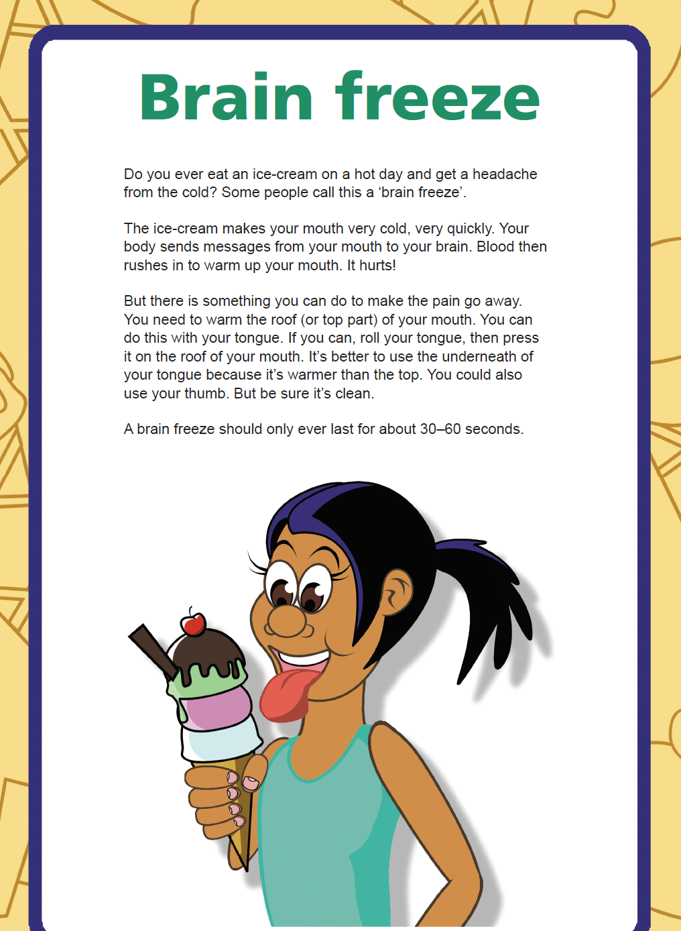
NAPLAN Year 5 Reading Magazine 2016 ACARA

Appendix 1

Identifying purpose in texts – accessible version

Brain Freeze
Do you ever eat an ice-cream on a hot day and get a headache from the cold? Some people call this a ‘brain freeze’.
The ice-cream makes your mouth very cold, very quickly. Your body sends messages from your mouth to your brain. Blood then rushes in to warm up your mouth. It hurts!
But there is something you can do to make the pain go away. You need to warm the roof (or top part) of your mouth. You can do this with your tongue. If you can, roll your tongue, then press it on the roof of your mouth. It’s better to use the underneath of your tongue because it’s warmer than the top. You could also use your thumb. But be sure it’s clean.
A brain freeze should only ever last for about 30–60 seconds.

NAPLAN Year 5 Reading Magazine 2016 ACARA

Appendix 1

Identifying purpose in texts – annotation

Brain freeze
Do you ever eat an ice-cream on a hot day and get a headache from the cold? Some people call this a ‘brain freeze’.
The ice cream makes your mouth very cold, very quickly. Your body sends messages from your mouth to your brain. Blood then rushes to warm up your mouth. It hurts!
But there is something you can do to make the pain go away. You need to warm the roof of your mouth (or top part) of your mouth. You can do this with your tongue. If you can, roll your tongue, then press it on the roof of your mouth. It’s better to use the underneath of your tongue because it is warmer than the top. You could also use your thumb but be sure it’s clean.
A brain freeze should only ever last for about 30-60 seconds.
Purpose  The purpose of this text is to inform.  Evidence:  - Information about how messages are sent in the body  - Suggestions for how to remove pain  - How long the pain lasts | Audience  The audience of this text may be younger people.  Evidence:  - Simple sentence structure  - Using everyday vocabulary such as “It hurts!” and “brain freeze”  - Image of young person  - Young people tend to enjoy more ice-cream

Appendix 1

Identifying purpose in texts – annotation - accessible version
Brain freeze
Do you ever eat an ice-cream on a hot day and get a headache from the cold? Some people call this a ‘brain freeze’.
The ice-cream makes your mouth very cold, very quickly. Your body sends messages from your mouth to your brain. Blood then rushes in to warm up your mouth. It hurts!
But there is something you can do to make the pain go away. You need to warm the roof (or top part) of your mouth. You can do this with your tongue. If you can, roll your tongue, then press it on the roof of your mouth. It’s better to use the underneath of your tongue because it’s warmer than the top. You could also use your thumb. But be sure it’s clean.
A brain freeze should only ever last for about 30–60 seconds.
NAPLAN Year 5 Reading Magazine 2016 ACARA
Purpose: The purpose of this text is to inform.
Evidence | Examples
Information about how messages are sent in the body | ‘Your body sends messages from your mouth to your brain.’
Suggestions for how to remove pain | ‘You need to warm the roof (or top part) of your mouth.’
How long the pain lasts | ‘…last for about 30–60 seconds.’

Audience: The audience of this text may be younger people.
Evidence | Examples
Simple sentence structure | ‘Some people call this a brain freeze.’
Using everyday vocabulary | ‘It hurts!’  ‘brain freeze’
Image of young person
Young people tend to enjoy more ice cream | ‘Do you ever eat an ice-cream on a hot day and get a headache from the cold?’

Appendix 2

Audience and purpose quadrant analysis
Text:________________________________________

Purpose  Does it inform, educate, persuade and/or entertain?  What type of text is this? | Audience  Who is this written for?
Vocabulary  Vocabulary evidence for purpose and audience | Subject matter  What is the text about?

Appendix 3

Audience and purpose scenario cards
elderly people | parents of young children | teenagers
middle-aged sports fans | tourists | professionals
extremely wealthy | risk-takers | musicians
environmentalists | politicians | children aged 2-4

Appendix 4

Purpose and audience feedback
Group | Vocabulary | Purpose | Audience

Appendix 5
Text features which signal purpose - Information text
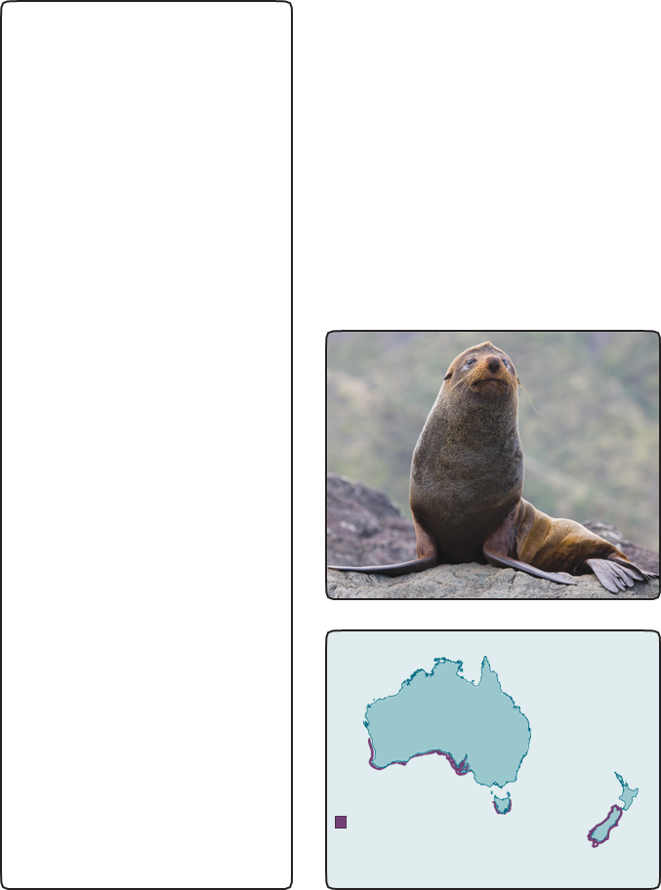
Year 5 NAPLAN Reading magazine 2015 ACARA

Appendix 5
Text features which signal purpose – original information text
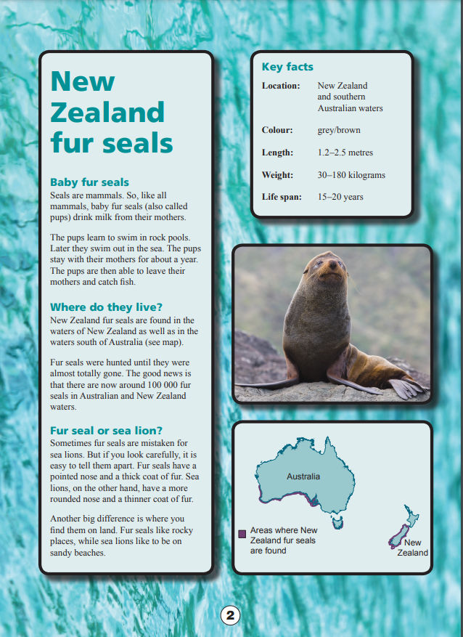
Year 5 NAPLAN Reading magazine 2015 ACARA

Appendix 6
Sub-headings

Table 1: Justifying choice of sub-heading
Sub-heading | How does it connect to the paragraph? | Word choice which is evidence for connection

Table 2: Potential sub-headings for main text
First paragraph | Second paragraph | Third paragraph
Baby fur seals | Why are there so few fur seals? | What is distinctive about fur seals?
The birth cycle of fur seals | Where do they live? | Fur seal or sea lion?
Feeding habits of fur seals | Fur seals and humans | What do they look like?
Pups learning to swim | Almost hunted to extinction | Close cousins

