Multiplicative thinking: developing flexible strategies

Stage 2

Learning intention
Students will enhance efficiency, flexibility and confidence in using a variety of mental strategies to solve problems of a multiplicative nature. They will use informal recordings to represent their strategies and communicate effectively with others. Students will also deepen their understanding of the operations themselves and the inverse relationship between multiplication and division.

Syllabus outcomes
The following teaching and learning strategies will assist in covering elements of the following outcomes:
- MAO-WM-01 develops understanding and fluency in mathematics through exploring and connecting mathematical concepts, choosing and applying mathematical techniques to solve problems, and communicating their thinking and reasoning coherently and clearly
- MA2-RN-01 applies an understanding of place value and the role of zero to represent numbers to at least tens of thousands
- MA2-MR-01 represents and uses the structure of multiplicative relations to 10 × 10 to solve problems
NSW Mathematics K-10 Syllabus (2022)

National Numeracy Learning Progression guide

Multiplicative thinking
Multiplicative strategies encompass a student’s ability to manipulate numbers in multiplicative situations. Students’ understanding of numbers as composite units and the ability to recognise and work with the relationship between quantities is a critical part of thinking multiplicatively. Students need to be able to understand the relationship between division and multiplication and develop the ability to flexibly use these as inverse operations when solving problems.
Students may demonstrate these behaviours as they develop increasing confidence with choosing and using flexible strategies to solve multiplicative problems:
- Multiplicative strategies MuS2 –MuS6
National Numeracy Learning Progression Version 3

Overview of teaching strategies
What works best
Explicit teaching practices involve teachers clearly explaining to students why they are learning something, how it connects to what they already know, what they are expected to do, how to do it and what it looks like when they have succeeded. Students are given opportunities and time to check their understanding, ask questions and receive clear, effective feedback.
This resource reflects the latest evidence base and can be used by teachers as they plan for explicit teaching.
Teachers can use assessment information to make decisions about when and how they use this resource as they design teaching and learning sequences to meet the learning needs of their students.
Further support is available on What works best webpage.
Differentiation
When using these resources in the classroom, it is important for teachers to consider the needs of all students, including Aboriginal and EAL/D learners.
EAL/D learners will require explicit English language support and scaffolding, informed by the Enhanced EAL/D enhanced teaching and learning cycle and the student’s phase on the EAL/D Learning Progression. Teachers can access information about supporting EAL/D learners and literacy and numeracy support specific to EAL/D learners.
Learning adjustments enable students with disability and additional learning and support needs to access syllabus outcomes and content on the same basis as their peers. Teachers can use a range of adjustments to ensure a personalised approach to student learning.
Assessing and identifying high potential and gifted learners will help teachers decide which students may benefit from extension and additional challenge. Effective strategies and contributors to achievement for high potential and gifted learners helps teachers to identify and target areas for growth and improvement. A differentiation adjustment tool can be found on the High potential and gifted education website.
Using tasks across learning areas
This resource may be used across learning areas where it supports teaching and learning aligned with syllabus outcomes.
Literacy and numeracy is embedded throughout all K-10 syllabus documents as capabilities. As the English and mathematics learning areas have a particular role in developing literacy and numeracy, NSW English K-10 and Mathematics K-10 syllabus outcomes aligned to literacy and numeracy skills have been identified.
Considerations

Language and vocabulary
As students are provided opportunities to experience concepts, teachers can also build understanding of mathematical vocabulary and communicating skills. Teachers can help build students’ confidence and capabilities by making complex mathematical ideas visible to students through drawings, diagrams, enactment, gestures and modelling. Making intentional connections between various representations and experiences with mathematical language helps build an understanding of important vocabulary whilst also building conceptual understanding.

Talk moves
Classroom talk is a powerful tool for both teaching and learning. Rich, dialogic talk supports students in making sense of complex ideas and builds classroom communities centred around meaning-making. 'Talk moves' are some of the tools a teacher can use to support rich, meaningful classroom discussion.
Some of the talk moves include:
- wait time
- turn and talk
- revoicing
- reasoning
- adding on
- repeating
- revise your thinking.
The Literacy and numeracy website provides additional information and resources to support talk moves.

Number talks
Number talks are a powerful teaching routine centred on short, intentional classroom conversation about a purposefully crafted problem that is solved using a broad range of mental strategies. Their general goal is to build fluency and sense-making through meaningful communication, problem solving and reasoning. They provide regular opportunities to develop number sense and mathematical reasoning through exploring, using and building confidence in additive and multiplicative strategies.
Suggested structure for an open-sharing number talk:
- A teacher determines the next learning goal for students and finds/designs a problem connected to that learning need.
- The teacher (and their colleagues) consider and discuss possible responses from students and plan formative assessment strategies, questioning and how to use a broad range of tools to represent the possible ideas student may raise (for example, enactment, diagrams, models, etc.)
- The carefully designed problem is posed to all students within the class.
- Thinking time is allowed for students to consider the different strategies they would use to solve the problem.
- Readiness to share is indicated by individual students raising a thumb unobtrusively against their chests (and raising one or more fingers if they think of other solutions).
- Students are provided opportunities to turn and talk, sharing their ideas with other students sitting nearby.
- The teacher listens to students as they talk, moving about the class inviting particular students to share their thinking more broadly, intentionally selecting and sequencing conversation that will best support the purpose of the number talk.
- Thinking is collected and discussed. The teacher may seek a variety of answers without comment, then discuss them as a class. Or the teacher may invite one student at a time to explain their thinking.
- The teacher supports students to make connections between ideas and to other learning experiences.
- The teacher concludes the open-sharing number talk by connecting back to the purpose of the task, making explicit the mathematical goal of the conversation.
The Literacy and numeracy website provides additional information and resources to support number talks.

Two versus two
For most games, we recommend small groups of 4 students, working in pairs of 2 (2 versus 2). This gives students the opportunity to discuss mathematical ideas, strategies and understanding with their team mates as well as their opponents.

Think board
Think boards can be used to make connections between different mathematical concepts or for students to visually represent their understandings and strategies in a range of ways.
Figure 1: Think board

Tools and resources to support learning
These tools and resources can be used throughout the tasks:
- white boards and markers
- counters
- dice (with various faces)
- dominos
- multi-attribute blocks (MAB).
- region representation of multiplication and division facts
- array dot images (up to 10 tens)
- blank 10 x 10 grid

Key understandings
Student understanding of these key concepts is essential. If there are misconceptions in these areas, additive thinking can be more challenging, and these areas may need to be readdressed.
Professor Di Siemon’s research is pivotal to supporting students to develop understanding of multiplicative thinking. A snapshot of this research has been used in this section from the following text: Siemon D, Beswick K, Brady K, Clark J, Faragher R, Warren E (2015) Teaching Mathematics: Foundations to Middle Years, Second Edition, Oxford University Press, Melbourne.

Repeated addition
It is possible to use repeated addition and subtraction to solve multiplicative problems, however these strategies are additive processes being applied to a multiplicative context. Retaining a dominant view of multiplication and division as repeated addition and subtraction is likely to make it significantly more difficult for students to make, understand and work with ratio, rate, fractions, proportional reasoning and algebraic relationships. The progress from additive to multiplicative thinking marks a significant shift in abstraction, complexity and efficiency.

What might this look like?
- Students may frequently use ‘groups of’ and ‘how many groups in’ as the only strategies for multiplication and division.
- Automatic recall is not the end goal of multiplicative thinking but rather the access to meaningful, efficient strategies for facts up to 10 x 10 that can be applied to a broad range of contexts and problems.

Multiplicative thinking
Professor Dianne Siemon describes multiplicative thinking as:
- “a capacity to work flexibly and efficiently with an extended range of numbers (i.e., larger whole numbers, decimals, common fractions, ratio and per cent),
- an ability to recognise and solve a range of problems involving multiplication or division including direct and indirect proportion, and
- the means to communicate this effectively in a variety of ways (for example, words, diagrams, symbolic expressions, and written algorithms).”
Reference: Siemon D, Beswick K, Brady K, Clark J, Faragher R, Warren E (2015). Teaching Mathematics: Foundations to Middle Years, second edition, p:376, Oxford University Press, Melbourne.

Tasks
The following tasks can be used to consolidate mental strategies, build fluency (including and exploring efficiency with mathematical strategies) and deepen their awareness of the flexible ways we can use numbers as we work mathematically.

Focus: Division strategies

Background information
The two ideas of division
There are different types of division situations. Sometimes we are interested in how many are in each group and other times we want to know how many groups there are. These 2 types of division questions are described as partitive division (sharing) and measurement division (sometimes called quotitive).
Partitive (or sharing) division refers to dividing a whole into several equal parts. In this situation, the missing information is how many there are in each group.
Measurement (or quotitive) division requires us to work out how many units are needed to form the product. In this situation, we know the product and the size of the unit but we don’t know how many of them we have.
Reference: Developing Efficient Numeracy Strategies 2 (draft) © State of New South Wales, Department of Education

Inverse operations
By considering division as the inverse operation of multiplication, the strategy ‘think multiplication’ and the question ‘what do I have to multiply by?’ arise. This supports a factor-factor-product approach to multiplication and division.
Reference: Siemon D, Beswick K, Brady K, Clark J, Faragher R, Warren E (2015). Teaching Mathematics: Foundations to Middle Years, second edition, p:376, Oxford University Press, Melbourne.

Factors fun
Teacher note: This is a two-player game where students explore division, work out a solution and explain their thinking.
Watch Factors fun to learn how to play.

You will need:
- 3 pencils
- Appendix 1: Game board
- Appendix 2: Spinner
- a paper clip
- 4-6 pink counters (or another colour) and 4-6 blue counters (or another colour)
- writing materials.

How to play
- Provide students with Appendix 1: Game board, Appendix 2: Spinner, counters, and pencils.
- Students take it in turns to spin the spinner and divide the number by the chosen divisor.
- Players work out the solution and explain their thinking to their partner.
  - The partner records their thinking and if they agree, the player is able to place one of their counters on the number on the game board, claiming that place.
  - If the number is taken, students miss a turn.
  - If there are no new counters that can be added to the game board, players have to move an existing counter to a new place.
- Players win by getting 4 counters in a row in any orientation, including a square.
- If preferred, students can use 5 or 6 counters, looking for 4 in a row.

Factors and products
Reference: Adapted from Developing Efficient Numeracy Strategies 2 (draft) © State of New South Wales, Department of Education.
Teacher note: Support students in understanding the difference between multiples and factors, not through simply repeating a provided definition but through co-constructing meaning and refining understanding. Knowing factors enables students to manipulate numbers to make problems easier to solve. For example, I may not know 16 x 20 but I do know 20 is equivalent to 2 tens. That means I can rename (factorise in this case) the problem to 16 x 2 x 10. Double 16 is 32 and 32 tens is equivalent to 320.
- Create various models and representations for the factors of whole numbers, for example, 24
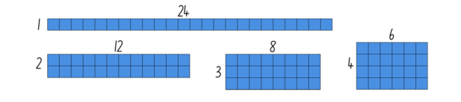
Figure 2: Representations of 24
- Continue to explore other numbers over a sequence of lessons, noticing and wondering to investigate ideas such as:
- true or false: factors come in pairs
- true or false: whenever you have a multiple, you also have factors
- some numbers have many factors and some numbers have very few factors
- all numbers have at least one pair of factors
- some numbers have common factors

Extending thinking:
- Area and perimeter: Use student recordings to investigate whether rectangles with the same area can have a different perimeter as well as whether you can have a rectangle with the same perimeter but different area
- Number exploration: Gradually explore all the numbers from 1 – 120

What do I know about partitioning?
Teacher note: An efficient approach to division is partition division. Thinking about the number in each share, gives rise to the strategy ‘think of multiplication’ and the question ‘What do I have to multiply by?’. It supports a factor-factor-product approach as demonstrated though the array-based activities above. (Siemon et. al 2015.)
- Explain that in the same way that we can use partitioning in multiplication problems to help us use what we already know to determine what we do not, we can do the same with division. In these situations, however, we partition the dividend (the total amount).
- Provide students with concrete materials to allow them to check (and explore) how they can break (partition) the dividend to use multiplication and division facts they know to solve division problems they do not know.
- Encourage students to realise that the context of the problem and the relationship between the given numbers determines the best way to partition the dividend.
- Support students in using pictorial representations, see Figure 3, that illustrates their partitioning strategies.
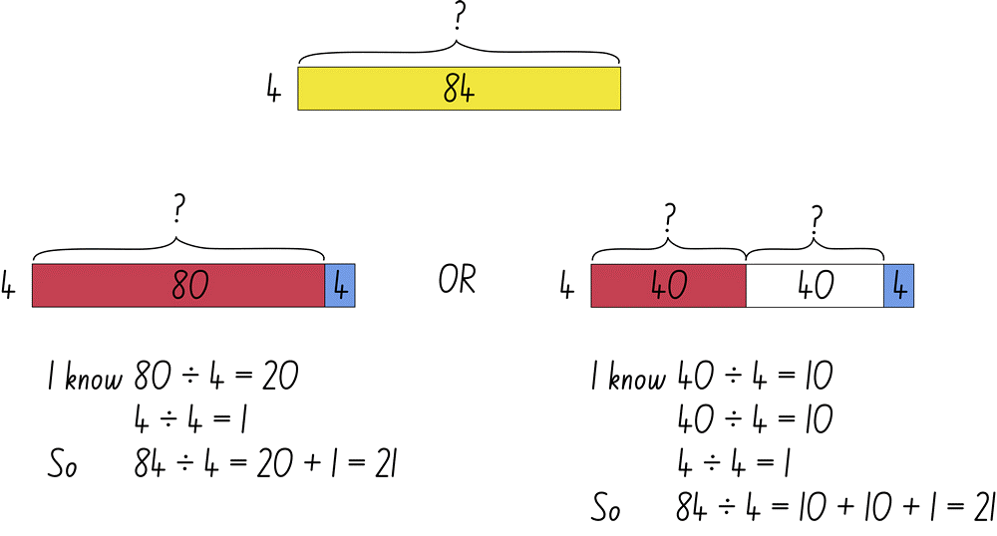
Figure 3: 84 divided by 4
- Have students explore the various ways they could partition the dividend in a way that allows them to use what they already know to solve problems such as:
- 39 ÷ 3
- 48 ÷ 8
- 42 ÷ 3
- 64 ÷ 4

Ask questions such as:
- How did you decide how you would partition the dividend (what ‘chunk’ to use first)?
- How did you keep track of the part you had leftover?
- Could you have partitioned the dividend differently?
Reference: Adapted from Developing Efficient Numeracy Strategies 2 (draft) © State of New South Wales, Department of Education.

Here is a problem
Teacher note: This strategy uses close positioning scaffolds for students to consider the relationship between problems and not treat them as separate and unrelated. As students explain to the class how they used each set of helper problems, record their thinking on the appropriate model, such as with an open array.

Here is a problem…

11 x 13
- Which of these number facts could you use to help solve it?
- How can that number fact help you?
1 x 11 12 x 12 10 x 11 10 x 13
2 x 10 13 x 13 11 x 11 11 x 12
13 x 2 11 x 2 10 x 10 1 x 13
4 x 13 9 x 13 1 x 3 14 x 11
Reference: Adapted from Number Strings by Kara Imm.

Remainders game
Teacher note: This can be played in small groups of 3-4 player and reinforces division with remainders.
Watch remainders game to learn how to play.

You will need
- writing materials
- 24 counters each
- dice
- 6 squares of paper

How to play
- Start with a collection of 24 things each.
- Players take it in turns to roll the dice to determine how many groups their collection needs to be shared into.
  - The player works out the solution to their division problem and explain their thinking to their partner who records their move.
  - If the product cannot be evenly divided, players keep the remainders, and the collection of counters they were working with is reduced.
- The player who reduces their collection to only 2 counters is declared the winner.

Variation
- Problem-solving consideration could be to have students interpret the remainder in the context of a word problem.

Focus: Multiplication

Chicken scramble
Teacher note: This is a task where teachers can observe the strategies students use to determine how many they have in their collection and as such, is a useful formative assessment task.
- Students spread a large collection of counters or cubes, ‘grain’, onto the table.
- Each person collects as many pieces of ‘grain’ as they can in a minute, collecting one at a time as if they are a chicken.
- Quantify how many pieces of ‘grain’ you have collected.
- Students share their quantification strategy.
- During the activity, ask students: “How many do you have so far?”
- “Who knows where they are up to? Are you sure? How do you know?”
- Choose students using an efficient strategy and have them explain their strategy.
- Make a class list of efficient ways to quantify a large collection.

Discuss
- Can you arrange your collection so that we can quantify how many in a more efficient way? For example, group in twos, fives and tens and so on.
Reference: Siemon D, Beswick K, Brady K, Clark J, Faragher R, Warren E (2015). Teaching Mathematics: Foundations to Middle Years, second edition, p:376, Oxford University Press, Melbourne.

Finding dice totals
Teacher note: Describing multiplication in different ways and representing the different strategies and ideas for calculating totals can help students see the connections between the ideas of multiplication. This is a two-player game where students find ways to group the dice and use mental strategies to determine the most effective way to calculate the total. By recording their partner’s thinking, Person B can analyse and learn new strategies.

You will need
- 20 dice each pair
- Paper or whiteboards to record

How to play
Person A:
- Roll 20 dice (six-sided).
- Group dice in a way that makes calculating the total easier.
- Communicate your strategies to your partner.
Person B:
- Watch and record your partner’s thinking.
- Share with the group the most efficient strategies.
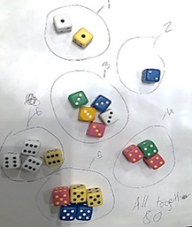
Figure 4: Example of grouping
As a class, discuss the strategies and how students made decisions for the groupings and calculations. Aid students in making connections between the different ideas of multiplication presented, for example, repeated addition, skip counting and efficient mental strategies using factors. Ensure students have considerable time to explore and apply the strategies used by others.

Discuss
- How did you quantify the dots? What strategies did you develop?
- What strategies made counting efficient?
- How did you use the groups of dots on the dice to determine the total?

Variations:
- Include different dice such as ten-sided dice or with a varied number of dice.
Reference: Adapted from ‘Dozens of dice’ in Boaler J, Muson J, Williams C (2018) Mindset Mathematics. Visualising and Investigating Big Ideas, Grade 3, John Wiley and Sons, US.

Doubles fill
Teacher note: This two versus two game support fluency with doubles facts and builds number sense by connecting quantities with symbols and language.
Watch Doubles fill to learn how to play.

You will need
- Appendix 2: Spinner
- Appendix 3: Doubles spinner
- Appendix 4: Game board
- pencils
- 2 paperclips.

How to play
- Players take turns to spin Appendix 2: Spinner (or roll dice) and spin Appendix 3: Doubles spinner.
- If a player spins a 6 and spins ‘double’, they double 6 to make 12, explaining their thinking to their partner who records the number sentence.
- The player then colours in a corresponding array on Appendix 4: Game board.
- Then players swap roles.
- If there is no space on the grid, players miss a turn.
- Play continues until no one can add another array.
- Players then calculate the number of squares they covered and the person with the largest area is the winner.

Variations
- Use materials to work out double facts.
- Make up ‘codes’ to show the order in which they made the arrays (see video).
- Students can rotate and rename the array to use the commutative property, for example change 5 twos into 2 fives and colour the corresponding array.
- Change the spinner to include repeated doubling.
Reference: Adapted from ‘Multiplication toss’ by Dianne Siemon, RMIT University.

Array bingo
Teacher note: Students play a game of bingo with arrays to help students see how numbers can be represented.
- Teacher models how to create an array using the number 12. Ask students, how can we show this number in an array?
The number 12 can be shown:
  - twelve rows of one (12 ones)
  - one row of twelve (1 twelve)
  - two rows of six, (2 sixes)
  - six rows of two, (6 twos)
  - three rows of four (3 fours) and
  - four rows of three (4 threes).
- The teacher shows how to add one of the arrays for number 12 onto a 3 x 3 grid. The grid size can be modified to be smaller or larger, depending on student need.
- Students each complete arrays using any numbers within an appropriate range, such as between 1 and 32, in an array table, see Figure 5.
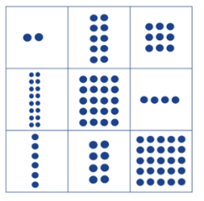
Figure 5: Array grid
- The teacher calls out a number and students find the array on their array grid. A teacher might mix up the numbers and call out 12 as “twelve”, “2 sixes” or “4 threes”.
- First student to have found all numbers on the array grid, wins.

Variation
- Sets of number cards from Math cards (youcubed), Mathematics K-6 resources, NSW Department of Education website.
Reference: Developing Efficient Numeracy Strategies 1© State of New South Wales, Department of Education.

Multiplication toss
Teacher note: This activity can help students develop multiplicative automaticity. Play this game in pairs.
Watch multiplication toss to learn how to play.

You will need
- Grid paper
- Writing materials
- Different coloured pencils
- Nine-sided dice or Appendix 5: 9 Spinner

How to play
- Players take turns to roll 2 nine-sided dice.
- If a 3 and 6 are rolled, players can enclose either a block out of 3 rows of 6 (3 sixes) or 6 rows of 3 (6 threes).
- The game continues with no overlapping areas
- The winner is the player with the largest area blocked after 10 spins.
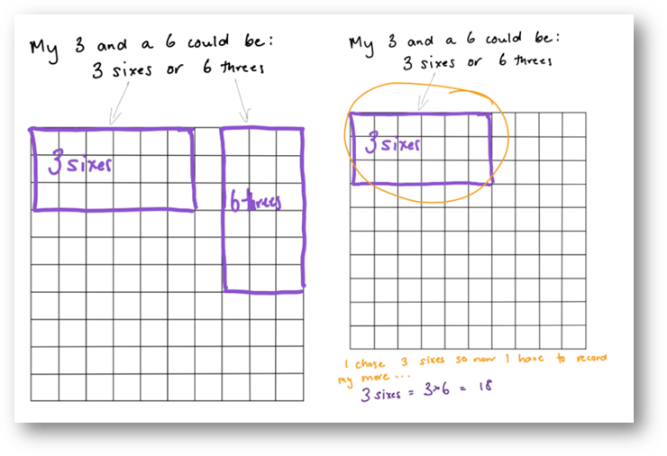
Figure 6: Example game board
- Eventually, the space on the grid paper gets really small.
- Students then have to think:
- What if my 3 sixes will not fit as 3 sixes or as 6 threes?
- Players can partition to help them, for example, they can rename 3 sixes as 2 sixes and 1 six (if that helps them to fit the block into the game board).

Discuss
- What would you do differently next time to increase your chances of filling in 100 squares?
Reference: Siemon D, Beswick K, Brady K, Clark J, Faragher R, Warren E (2015). Teaching Mathematics: Foundations to Middle Years, second edition, p:376, Oxford University Press, Melbourne.

Appendix 1: Factors fun game board
1 | 6 | 4 | 1 | 2
10 | 6 | 3 | 6 | 10
4 | 2 | 4 | 5 | 8
9 | 3 | 6 | 2 | 9
7 | 8 | 5 | 10 | 7

Recording sheet
Student 1 |  |  |  |  | Student 2
Spun | Number sentence | Covered |  | Spun | Number sentence | Covered

Appendix 2: Spinner
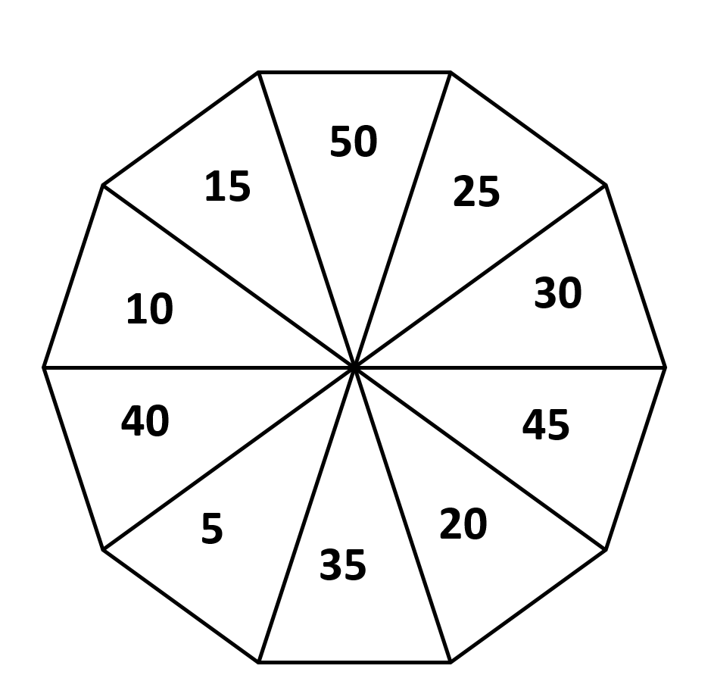

Appendix 3: Doubles fill spinner
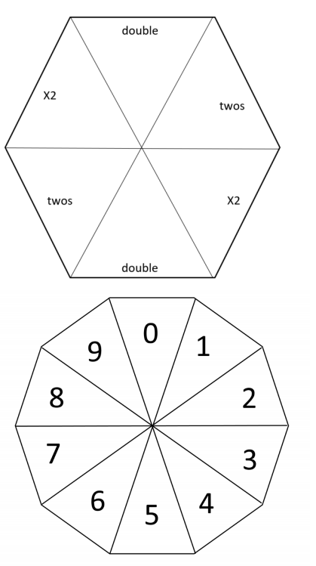

Appendix 4: Doubles fill game board
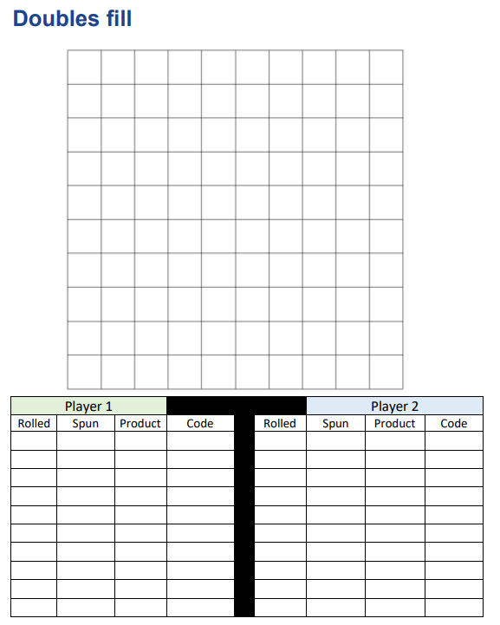

Appendix 5: 9 Spinner
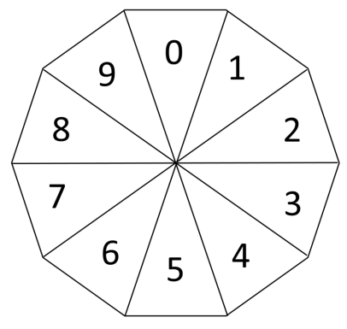

Reference list
This resource contains images and content obtained from Canva, and their use outside of this resource is subject to Canva’s Content License Agreement.
Mathematics K–10 Syllabus © NSW Education Standards Authority (NESA) for and on behalf of the Crown in right of the State of New South Wales, 2022.
National Numeracy Learning Progression © Australian Curriculum, Assessment and Reporting Authority (ACARA) 2010 to present, unless otherwise indicated. This material was downloaded from the Australian Curriculum website (National Literacy Learning Progression) (accessed 6 November 2023) and was not modified.
Boaler J, Muson J, Williams C (2018) Mindset Mathematics: Visualising and Investigating Big Ideas, Grade 3, John Wiley and Sons, US.
Imm K (n.d) ‘What is a number string?’, Number strings website, accessed 14 November 2023.
Siemon D, Beswick K, Brady K, Clark J, Faragher R, Warren E (2015) Teaching Mathematics: Foundations to Middle Years, second edition, Oxford University Press, Melbourne.
Stanford University (n.d.) ‘Math Cards (3-6)’, Videos, youcubed website, accessed 14 November 2023.
State of New South Wales (Department of Education) (2023) ‘Doubles Fill’, Mathematics K-6 resources, NSW Department of Education website, accessed 14 November 2023
State of New South Wales (Department of Education) (2023) ‘Factors fun’, Mathematics K-6 resources, NSW Department of Education website, accessed 14 November 2023.
State of New South Wales (Department of Education) (2023) ‘Remainders game’, Mathematics K-6 resources, NSW Department of Education website, accessed 14 November 2023.
State of New South Wales (Department of Education) (2023) ‘Multiplication toss’, Mathematics K-6 resources, NSW Department of Education website, accessed 14 November 2023.
State of New South Wales (Department of Education) (n.d) ‘Array bingo’, Developing Efficient Numeracy Strategies website, accessed 15 November 2023.
State of New South Wales (Department of Education) (n.d) ‘Factors and products’, Developing Efficient Numeracy Strategies website, accessed 15 November 2023.
State of New South Wales (Department of Education) (n.d) ‘What do I know about partitioning?’, Developing Efficient Numeracy Strategies website, accessed 15 November 2023.

Copyright
Section 113P Notice
Texts, Artistic Works and Broadcast Notice
Some of this material has been copied and communicated to you in accordance with the statutory licence in section 113P of the Copyright Act. Any further reproduction or communication of this material by you may be the subject of copyright protection under the Act. Do not remove this notice.

Evidence base
Sparrow, L., Booker, G., Swan, P., Bond, D. (2015). Teaching Primary Mathematics. Australia: Pearson Australia.
Brady, K., Faragher, R., Clark, J., Beswick, K., Warren, E., Siemon, D. (2015). Teaching Mathematics: Foundations to Middle Years. Australia: Oxford University Press.
Alignment to system priorities and/or needs: The literacy and numeracy five priorities.
Alignment to School Excellence Framework: Learning domain: Curriculum, Teaching domain: Effective classroom practice and Professional standards
Consulted with: NSW Mathematics Strategy professional learning and Curriculum Early Years Primary Learners-Mathematics teams
Reviewed by: Literacy and Numeracy
Created/last updated: January 2024
Anticipated resource review date: January 2025
Feedback: Complete the online form to provide any feedback.

