Additive thinking: developing flexible strategies

Stage 2
Contents
Overview 2
Learning intention 2
Syllabus outcomes 2
National Numeracy Learning Progression guide 3
What are additive strategies? 3
Overview of teaching strategies 4
What works best 4
Differentiation 4
Using tasks across learning areas 4
Considerations 5
Language and vocabulary 5
Talk moves 5
Number talks 5
Two versus two 6
Think board 6
Tools and resources to support learning 7
Professional learning resources to support learning 7
Tasks 7
Focus: Quantifying collections 7
Focus: Developing flexible strategies with two-digit numbers and beyond 9
Focus: Doubling strategies 11
Appendix 1: Think board 18
Appendix 2: Trading game 19
Appendix 3: Near doubles bingo 20
Appendix 4: Recording table 21
Appendix 5: 101 recording table 22
Reference list 23
Copyright 23
Evidence base 24
Alignment to system priorities and/or needs: 24

Overview

Learning intention
Students will learn to use mental and written strategies to add and subtract numbers up to five-digits, selecting from a range of strategies.

Syllabus outcomes
The following teaching and learning strategies will assist in building capabilities and skills across the following outcomes:
- MAO-WM-01 develops understanding and fluency in mathematics through exploring and connecting mathematical concepts, choosing and applying mathematical techniques to solve problems, and communicating their thinking and reasoning coherently and clearly
- MA2-RN-01 applies an understanding of place value and the role of zero to represent numbers to at least tens of thousands
- MA2-AR-01 selects and uses mental and written strategies for addition and subtraction involving 2- and 3-digit numbers
- MA2-AR-02 completes number sentences involving addition and subtraction by finding missing values
NSW Mathematics K-10 Syllabus (2022)
National Numeracy Learning Progression guide

What are additive strategies?
Additive strategies encompass a student’s ability to manipulate numbers in additive situations. As students develop an understanding of whole number and the operations of addition and subtraction, they transition from counting strategies to using more flexible strategies to solve problems. When applying additive strategies, students may manipulate numbers using their part-part-whole knowledge, renaming and partitioning of numbers (including using place value knowledge) and the inverse relationship between addition and subtraction.
When using additive strategies, students draw from their understanding of foundational ideas including:
- Part-part-whole knowledge. For example, because I know numbers are made up of smaller numbers, I can break them into parts and use them in ways that best suit my thinking. So, when I am trying to solve 58 + 13 + 8, I may partition 8 into 7 and 1. Then, I can combine 13 and 7 to have 20. Then, 58 and 20 more is 78. Finally, 78 and 1 more combines to be equivalent in value to 79.
- Recalling and using number facts. For example, I can use what I know about doubles, near doubles, pairs of number that combine to be equivalent to 10, and so on.
- Properties of the operations such as associative, commutative and inverse relationships
- Place value knowledge. For example, when solving 78 + 24 + 18, I may rename the quantities as 7 tens and 8, 2 tens and 4, and 1 ten and 8. Then I can collect the tens to join 7 tens with 2 tens and 1 ten to have 10 tens. Then I may collect the 2 eights, so I have 1 more ten (now 11 tens) and 6 ones. 6 ones and 4 ones can be renamed as another ten making 12 tens in total. 12 tens can be renamed 120.
- Building to landmark numbers/bridging to ten (typically multiples of 10 or 5). For example, when solving 37 – 19, I may partition 19 into 7 and 12. Then, I can subtract 7 from 37 to rest on 30, a landmark number. I could then subtract 10 more, 3 tens – 1 ten = 2 tens, which is 20. Then 20 – 2 leaves me with 18.
Students may demonstrate these behaviours as they develop increasing confidence with choosing and using flexible strategies to solve additive problems:
- Additive strategies AdS6-AdS8
National Numeracy Learning Progression Version 3

Overview of teaching strategies

What works best
Explicit teaching practices involve teachers clearly explaining to students why they are learning something, how it connects to what they already know, what they are expected to do, how to do it and what it looks like when they have succeeded. Students are given opportunities and time to check their understanding, ask questions and receive clear, effective feedback.
This resource reflects the latest evidence base and can be used by teachers as they plan for explicit teaching.
Teachers can use assessment information to make decisions about when and how they use this resource as they design teaching and learning sequences to meet the learning needs of their students.
Further support with What works best is available.

Differentiation
When using these resources in the classroom, it is important for teachers to consider the needs of all students, including Aboriginal and EAL/D learners.
EAL/D learners will require explicit English language support and scaffolding, informed by the Enhanced EAL/D enhanced teaching and learning cycle and the student’s phase on the EAL/D Learning Progression. Teachers can access information about supporting EAL/D learners and literacy and numeracy support specific to EAL/D learners.
Learning adjustments enable students with disability and additional learning and support needs to access syllabus outcomes and content on the same basis as their peers. Teachers can use a range of adjustments to ensure a personalised approach to student learning.
Assessing and identifying high potential and gifted learners will help teachers decide which students may benefit from extension and additional challenge. Effective strategies and contributors to achievement for high potential and gifted learners helps teachers to identify and target areas for growth and improvement. A differentiation adjustment tool can be found on the High potential and gifted education website.

Using tasks across learning areas
This resource may be used across learning areas where it supports teaching and learning aligned with syllabus outcomes.
Literacy and numeracy is embedded throughout all K-10 syllabus documents as capabilities. As the English and mathematics learning areas have a particular role in developing literacy and numeracy, NSW English K-10 and Mathematics K-10 syllabus outcomes aligned to literacy and numeracy skills have been identified.

Considerations

Language and vocabulary
As students are provided opportunities to experience concepts, teachers can also build understanding of mathematical vocabulary and communicating skills. Teachers can help build students’ confidence and capabilities by making complex mathematical ideas visible to students through drawings, diagrams, enactment, gestures and modelling. Making intentional connections between various representations and experiences with mathematical language helps build an understanding of important vocabulary whilst also building conceptual understanding.

Talk moves
Classroom talk is a powerful tool for both teaching and learning. Rich, dialogic talk supports students in making sense of complex ideas and builds classroom communities centred around meaning-making. 'Talk moves' are some of the tools a teacher can use to support rich, meaningful classroom discussion.
Some of the talk moves include:
- wait time
- turn and talk
- revoicing
- reasoning
- adding on
- repeating
- revise your thinking.
The Literacy and numeracy website has additional information and resources to support talk moves.

Number talks
Number talks are a powerful teaching routine centred on short, intentional classroom conversation about a purposefully crafted problem solved using a broad range of mental strategies. Their general goal is to build fluency and sense-making through meaningful communication, problem solving and reasoning. They provide regular opportunities to develop number sense and mathematical reasoning through exploring, using and building confidence in additive and multiplicative strategies.
Suggested structure for an open-sharing number talk:
- A teacher determines the next learning goal for students and finds/designs a problem connected to that learning need.
- The teacher (and their colleagues) consider and discuss possible responses from students and plan formative assessment strategies, questioning and how to use a broad range of tools to represent the possible ideas student may raise (for example enactment, diagrams, models, and so on.)
- The carefully designed problem is posed to all students within the class.
- Thinking time is allowed for students to consider the different strategies they would use to solve the problem.
- Readiness to share is indicated by individual students raising a thumb unobtrusively against their chests (and raising one or more fingers if they think of other solutions).
- Students are provided opportunities to turn and talk, sharing their ideas with other students sitting nearby.
- The teacher listens to students as they talk, moving about the class inviting particular students to share their thinking more broadly, intentionally selecting and sequencing conversation that will best support the purpose of the number talk.
- Thinking is collected and discussed. The teacher may seek a variety of answers without comment, then discus them as a class. Or the teacher may invite one student at a time to explain their thinking.
- The teacher supports students to make connections between ideas and to other learning experiences.
- The teacher concludes the open-sharing number talk by connecting back to the purpose of the task, making explicit the mathematical goal of the conversation.
The Literacy and numeracy website provides additional information and resources to support number talks.

Two versus two
For most games, we recommend small groups of 4 students, working in pair of 2 (2 versus 2). This gives students the opportunity to discuss mathematical ideas, strategies and understanding with their team mates as well as their opponents.

Think board
Think boards can be used to make connections between different mathematical concepts or for students to visually represent their understandings and strategies in a range of ways. See Appendix 1: Think board.
Figure 1: Think board

Tools and resources to support learning
These tools and resources can be used throughout the tasks:
- playing cards
- white boards and markers
- interlocking cubes or centicubes
- counters
- dice (with various faces)
- dominos
- rekenreks
- multi-attribute blocks (MAB)

Professional learning resources to support learning
The following videos illustrate how a number talk can look in the classroom. These videos show the flow from an open-sharing number talk into number talks designed as targeted follow-ups. Teachers could use these to explore and model the kind of language to use when highlighting ‘what is (some of) the mathematics?’
- Let's generalise
- Exploring strategies
- Let's talk using strategies to solve additive thinking problems
- Which to do in your head?

Tasks

Focus: Quantifying collections

Number busting
Teacher note: This activity can be used in partners or as individuals, guided by the teacher. Students use an understanding of structure, number facts, counting principles and part-part-whole number knowledge to examine different ways of quantifying the same collection.
Watch the 'Number busting' to learn how to play.

You will need
- 26 items, for example, pasta pieces, counters or pencils
- writing materials

How to play
- Get 26 items, for example, pasta pieces, counters or pencils.
- Organise and describe your collection.
- Try to reorganise and describe your collection as many times as you can within 5 minutes.
- Draw and record all the ways of thinking about your collection.
- Play number busting again.

Variations
- This activity can be adapted by changing the size of the collection students are working with. It can also be adapted by exploring the use of tools, such as ten-frames, domino patterns, and so on, to help organise the collections.
Reference: Mathematics K-6 resources Stage 1 number busting’ activity © State of New South Wales, Department of Education.

Handfuls
Teacher note: Students explore different ways of structuring a collection to answer the question, “how many?” This activity focusses on building number sense and can be used as a whole class or in small focus groups.
Watch ‘Handfuls’ to learn how to play.

You will need
- collection of items, for example, pasta or counters
- writing materials

How to play
- Take a handful of counters or pasta.
- Hold the objects in your hand and imagine how many you have.
- Record your estimate.
- Describe what that collection might look like by visualising and imagining.
- Organise your collection so someone can determine how many items there are by looking and thinking.

Discuss
- How many do you have altogether?
- How have you organised your collection?
- Did you have more or less than your estimation?
- Can you organise them differently?
- How many ways can you arrange your collection so you can see how many there are by looking and thinking?

Variations
- This activity can be adapted by changing the size of the numbers (one handful, two handfuls, bucket of item dumping) and by changing tools, such as tens frames or sorting rings, to help organise the collections.
Reference: Adapted from Ann Gervasoni, Monash University. Published on reSolve - Counting handfuls.

Minute to win it
Teacher note: Students use an understanding of structure, number facts, counting principles and part-part-whole number knowledge to quantify a large collection. This activity is a paired activity.
Watch ABC Education 'Minute to win it' to learn how to play.

You will need
- timer
- counters
- dice

How to play
- A timer is set for 1 minute.
- Player B rolls either one die or two dice (add the 2 numbers together) and calls this number out.
- Player A collects the amount of counters called out by Player B.
- Player A has a total of 1 minute to collect as many counters as they can to meet the target.
- Once the minute is up, Player A devises a method for quantifying the collection. The teacher or partner may prompt the student to explore non-count by one strategies or ways of organising the collection that can be more easily quantified.
- Player A reasons their method to Player B. Player A and B reverse their roles.
Reference: ‘Quantifying numbers’ ABC Education and adapted from Clarke and Roche.

Focus: Developing flexible strategies with two-digit numbers and beyond

Bundling battle
Teacher note: Students aim to be the first pair of players to reach a target number, regrouping and renaming into tens and ones as they grow their collection. This game can be played as 2 versus 2.

You will need
- six-sided dice
- bundling sticks (ice cream sticks) and elastic bands

How to play
- A target number is set, for example, 120.
- Players take turns to roll and collect the corresponding number of bundling sticks, regrouping and renaming collections of ten.
- The first player to reach the target number is the winner.

Extending thinking
- During play, ask students questions such as:
- How many bundling sticks do you have?
- How many more do you need to reach the target number?
- How many more do you have than your partner?
- To develop students understanding of place value, talk with students about renaming the collection in various ways. For example, 75 can be renamed as 7 tens and 5 ones, 6 tens and 15 more and so on.
Reference: Adapted from ‘Trading games’ in Siemon et al. (2005). Teaching Mathematics – Foundations to Middle Years second edition. Oxford University Press, Melbourne.

Trading game
Teacher note: Students work with a partner to use their knowledge of regrouping and renaming (‘trading’) to build their cumulative total. They also apply their knowledge of flexible strategies to combine a string of one-digit numbers. The team with the highest cumulative total is the winner.

You will need
- six-sided dice
- MAB
- Appendix 2: Trading game

How to play
- Provide pairs of students with 5 dice.
- Have pairs take turns rolling the dice and finding the total of all 5 dice rolled. Students should be supported to first look for, and use, number facts they know rather than simply counting-on. If students roll numbers that add up to make 7, 14, 21, 28 or 35, they score an extra 3 points. Students can use Appendix 2: Trading game to record.
- Students collect MAB to represent their total. They continue to add their cumulative total each time they roll the dice, adding to their collection and requiring them to exchange MAB as they progress their game.
- The winner is the person with the largest cumulative total. Students record as they play, see Figure 2.
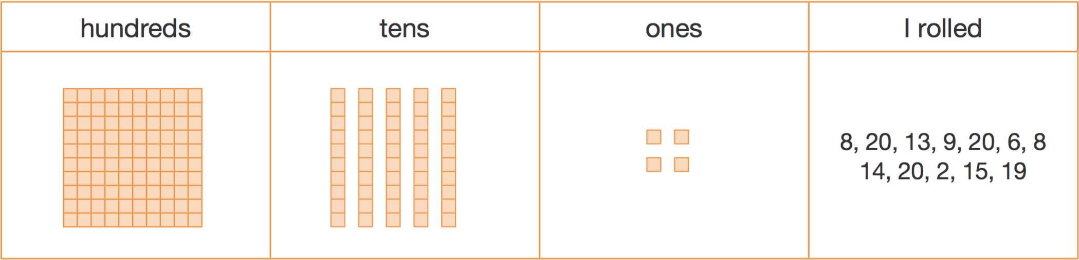
Figure 2: Example of recording table
Further support can be found by watching ABC Education partitioning numbers using efficient strategies.

Variations
- This activity can be adapted by playing in reverse. Starting from 2 hundreds, students subtract until they have no MAB remaining.
- Students may start from a number other than zero.
Reference: Developing Efficient Numeracy Strategies 1© State of New South Wales, Department of Education

Focus: Doubling strategies

Near doubles bingo
Teacher note: Students use their understanding of doubles to derive facts with near doubles.

You will need
- bingo board or Appendix 3: Near doubles bingo
- counters

How to play
- Provide each student with a 4 x 4 bingo board or Appendix 3: Near doubles bingo.
- Ask the students to place the numbers 5, 7, 9, 11, 13, 15, 17 and 19 randomly into the squares of the grid. Numbers can be repeated.
- Call out near doubles, for example, 6 + 7, 10 + 9, in random order.
- Students determine the answer and place a counter onto the bingo board if they can match a numeral to the answer.
- The first player to complete a line of 4 counters in any direction is the winner.

Variation
- Students investigate double facts hidden within collections such as 5, 7, 9, 11, 13, 15, 17 and 19 using tools such as interlocking cubes and rekenreks.
Reference: Developing Efficient Numeracy Strategies 1© State of New South Wales, Department of Education.

Double or near double?
Teacher note: Students choose to double, or almost double, a number to be the first person (or pair of students) to reach zero. This game draws on students’ use of flexible strategies whilst supporting their awareness of doubles and near doubles.

You will need
- ten-sided dice
- Appendix 4: Recording table
- number chart

How to play
- Provide students with a 1-10 dice, Appendix 4:Recording table and a hundred chart.
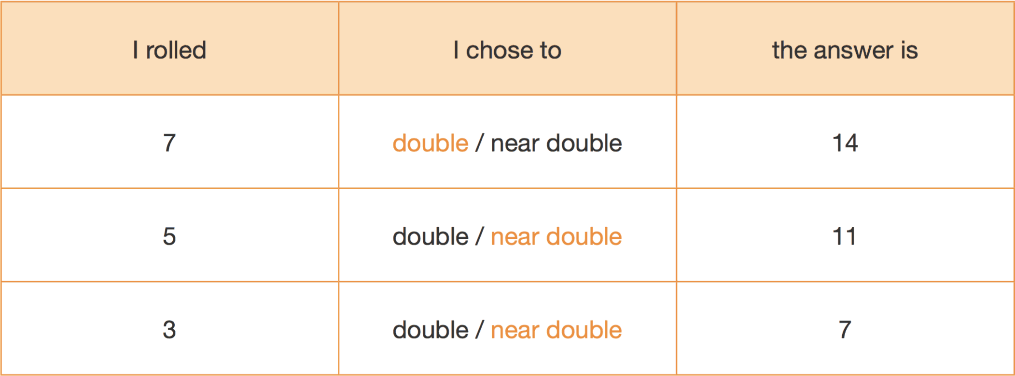
Figure 3: Example recording table
- Students select a starting number, for example, 60 and mark it on their charts.
- Students take turns to the roll the dice and choose to double the number or work out a near double. For example, if a student rolls 8 they could choose to:
- double 8 to make 16
- decide 7 + 8 is a near double totalling 15
- 9 + 8 is a near double that makes 17.
- Students tell their partner the fact they are using and the answer. If their partner agrees with their thinking, the students gets to move that number of spaces towards zero from the chosen starting number.
- The first person to reach zero is the winner.

Variations
- Allow students to double or halve the number rolled, trying to get to a target number
- Use a 1-6 dice to support student as they learn early facts
Reference: Developing Efficient Numeracy Strategies 1© State of New South Wales, Department of Education.

Doubles fill
Teacher note: This 2 versus 2 game support fluency with doubles facts and builds number sense by connecting quantities with symbols and language.
Watch 'Doubles fill' to learn how to play and download the required resources.

You will need
- 0-9 spinner
- doubles spinner
- game board
- pencils
- 2 paperclips.

How to play
- Players take turns to spin the 9 spinner (or roll dice) and spin the doubles fill spinner.
- If a player spins a 6 and spins ‘double’, they double 6 to make 12, explaining their thinking to their partner who records the number sentence.
- The player then colours in a corresponding array.
- Then players swap roles.
- If there is no space on the grid, players miss a turn.
- Play continues until no one can add another array.
- Players then calculate the number of squares they covered and the person with the largest area is the winner.

Variations
- Use materials to work out double facts.
- Make up ‘codes’ to show the order in which they made the arrays (see video).
- Students can rotate and rename the array to use the commutative property, for example, change 5 twos into 2 fives and colour the corresponding array.
- Change the spinner to include repeated doubling.
Reference: Activity adapted from Teaching Mathematics Foundations to Middle Years by Siemon et al.

Three tens in a row
Teacher note: This game can be played as 2 players versus 2 players to promote conversation and reasoning. Students use their understanding of patterns and additive strategies to combine two numbers that make ten.
Watch 'Three tens in a row' to learn how to play.

You will need
- 2 different coloured markers
- writing materials
- a 0-9 dice (a spinner or playing cards A-9).

How to play
- Draw a 3x3 grid as a game board (like noughts and crosses game board).
- Players take turns to roll the dice and write the number in one of their boxes.
- The goal is to be able to write 2 numbers in each box that combine to make 10.
- Players continue taking turns until a player has been the first to make 3 tens in a row.

101 and you’re out!
Teacher note: This game can be played as 2 players versus 2 players to promote conversation and reasoning. Students use their understanding of place value and additive strategies to get as close to 100 as possible.
Watch '101 and you're out!' to learn how to play.

You will need
- Appendix 5: 101 recording table
- dice or numeral cards 1-6
- pencils or markers
- your mathematics workbook.

How to play
- Make a game board by drawing a 6 x 4 table.
- Label the columns as tens, ones, number and total (moving from left to right) or use Appendix 5: 101 recording table.
- Each time a team of players rolls the dice, they decide whether the number has the value of tens or ones. For example, if a student rolls a 3, they could use it as 3 ones (3) or 3 tens (which we rename as 30). Once the value has been decided, students record the roll in the ones or tens column on their table. Then they record the number and the total.
- Play continues for 6 rolls each, taking each roll in turn.
- Once the value has been recorded, it cannot be changed.
- The winners are the team of players with the sum closest to 100 without going over.
- Invite students to draw up some new game boards. Use the same numbers to get closer to 100 than in the first game.
- Play again.

Variations
- Use numbers 0-9. Playing cards can be used or make a spinner.
- Roll the die 4 times to get as close as possible to 100.
- Change the target number.
- Use MAB or ice cream sticks to create the numbers.

Discuss
- Did you get closer to 100 on your second attempt with the same numbers?
- What did you do differently?
- What did you keep the same?
- Is there a way you could have gotten even closer?
- What if the target was 120, what would you change?
- What advice would you give to someone playing this game for the first time?
Reference: Mathematics K-6 resources Stage 1 101 and you're out activity. © State of New South Wales, Department of Education.

Dicey addition
Teacher note: This is a two-player game where students use their number sense to create equations (number sentences) where the closest to a total of 100 wins.
Watch 'Dicey addition' to learn how to play.

You will need
- a 0-9 dice or 0-9 spinner
- some paper
- writing materials

How to play
- Students find a partner and a 0-9 dice or spinner.
- Draw a game board so each student has the same one, for example,
start with: _ _ _ + _ _ _ + _ _ _ = ________ or choose something different.
- Each player takes a turn to roll or spin and decide where to place that digit in their number sentence (equation).
- Students roll or spin 9 times each.
- The person whose sum is closest to 100 is the winner.
- Students share their thinking with a partner and record in mathematics journal or workbook where appropriate.

Variations
- Adapted this activity into an investigation. Ask students to develop methods to see if they can increase their chances of winning. They could then develop their own blank number sentences to include subtraction and then both addition and subtraction.
Reference: Activity adaptation of Dicey Addition from NRICH by Faculty of Mathematics, University of Cambridge.

Closest to 100
Teacher note: This is a 2 player game and can be played as 2 players versus 2 players. Students use their number sense to create a variety of equations (number sentences) totalling 100.
Watch 'Closest to 100' to learn how to play and see a variation.

You will need
- deck of cards
- recording sheet or whiteboard

How to play
- Players shuffle the cards and put them in a central pile. One person takes 6 cards and places them face up for everyone to see.
- The goal is to use addition and subtraction to get as close to a total of 100 as possible.
- Each card can only be used once. It can be used to form a one- or two-digit number.
- Players score zero points if they reach exactly 100. Otherwise, they work out their points based on the difference between their total and 100. For example, if a team created a total of 98, they would score 2 points.
- Keep a cumulative total of their difference to 100. The winner is the team to have the lowest points score at the end of the agreed number of rounds for example 4 rounds. For example, if a 9, 1, 2, 6, 3, 9 have been flipped over, a student could:
- Make 91 and 9, adding them together to make 100
- Make 99 and 1, adding them together to make 100
- Make 63 and 29, adding them together to make 92. Then, add 9 more to make 101. Subtract 1 from 101 to make 100.
- If students had flipped over 3, 3, 6, 8, 1, 2, a student could:
Make 83 + 23 = 106. 106 - 6 = 100
Make 86 + 13 + 3 = 102. 102 - 2 = 100

Variation
- This task can be adapted by changing the number of cards used or the target number, for example, as close to 39 or 250. Limits can be set to adjust the task, for example the first 3 cards are single digits and the next 3 cards are ‘multiples of 10’. For example, 3, 6, 1, 9, 3 and 4 are turned over and they would need to be used as 3, 6, 1, 90, 30 and 40.
- Play closest to 1000

Subtraction face off
Teacher note: This 2 player versus 2 player game requires students to apply their number sense and additive strategies whilst exploring the concept of difference.

You will need
- deck of cards
- writing materials

How to play
- Provide pairs of students with a set of playing cards.
- Students use Ace to 9 to represent 1 - 9.
- Have students shuffle the cards and deal them out evenly between the 2 players.
- Students place their cards into a face down pile. Each team takes 5 top cards from the top of the pile to form a three-digit number and a two-digit number.
- Students can arrange the cards in any way they like to make the smallest difference between the 2 numbers.
- Teams explain and record their turn using a range of tools such as, number lines, concrete materials, diagrams, equations (number sentences) and so on.
- The team with the smallest difference collects all 10 cards. Students continue playing until one team has lost all their cards.
- Have students record the strategies used for one of the rounds of play.

Variations
- Change the number of cards the players pick up. For example, choose only 4 cards and form 2 two-digit numbers.

Appendix 1: Think board
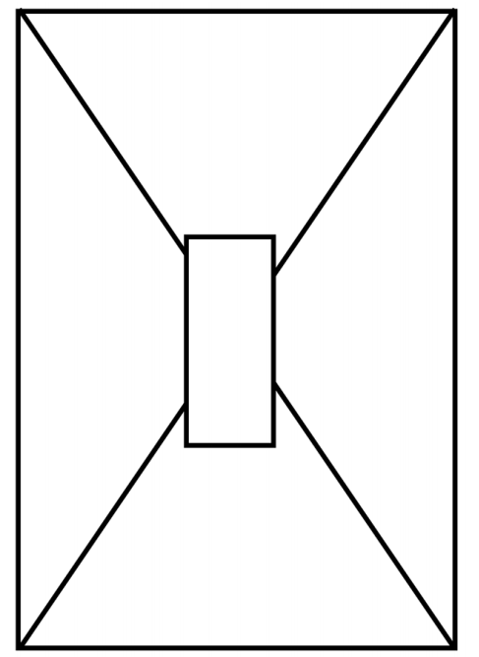

Appendix 2: Trading game
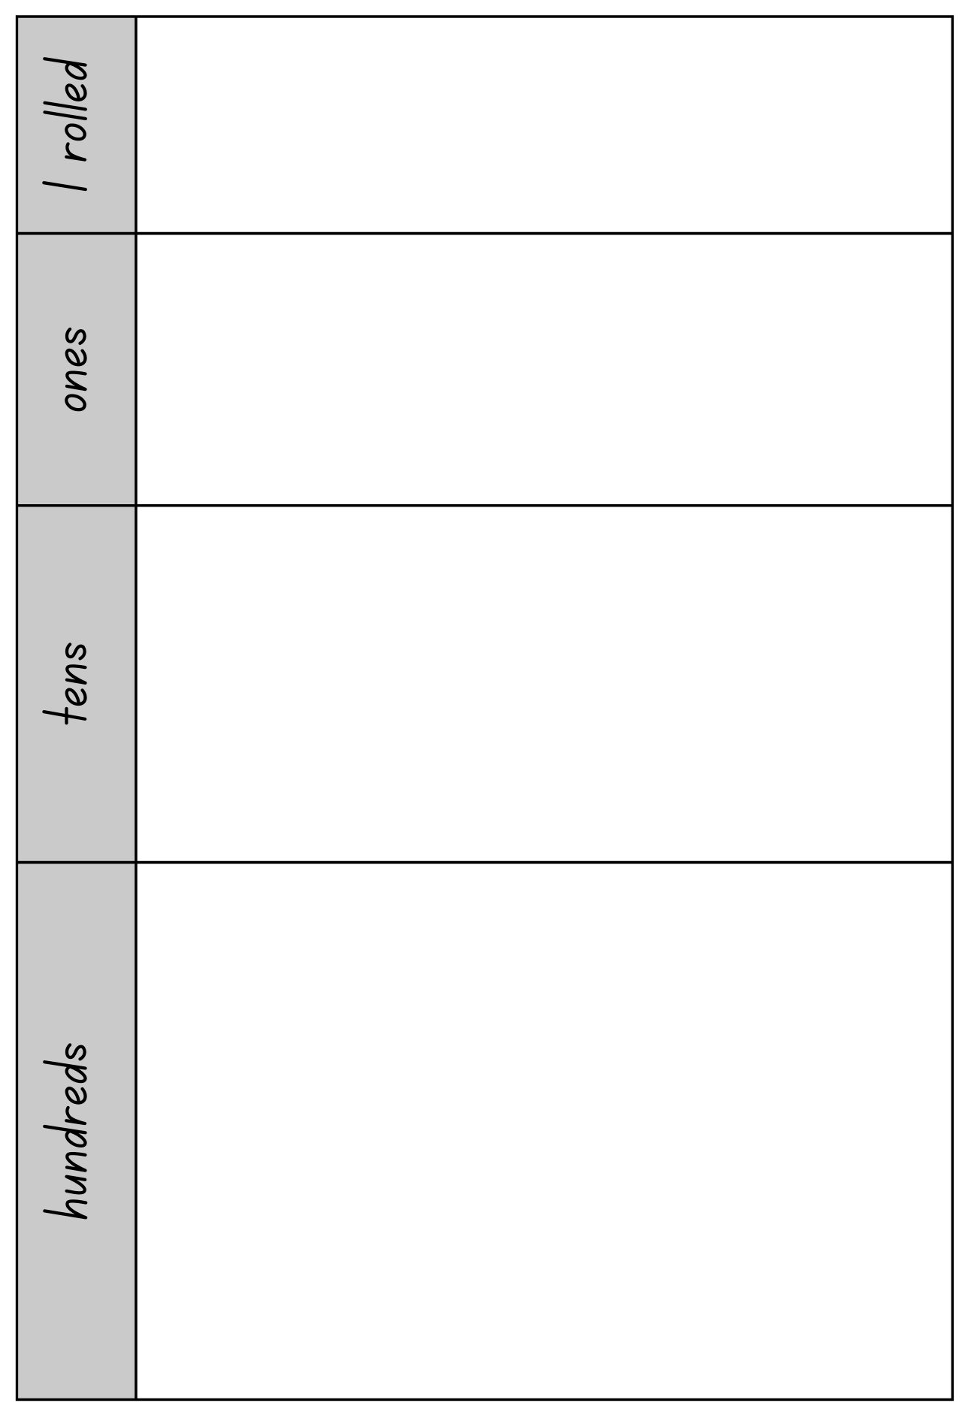
Images sourced from Canva and used in accordance with the Canva Content License Agreement.

Appendix 3: Near doubles bingo
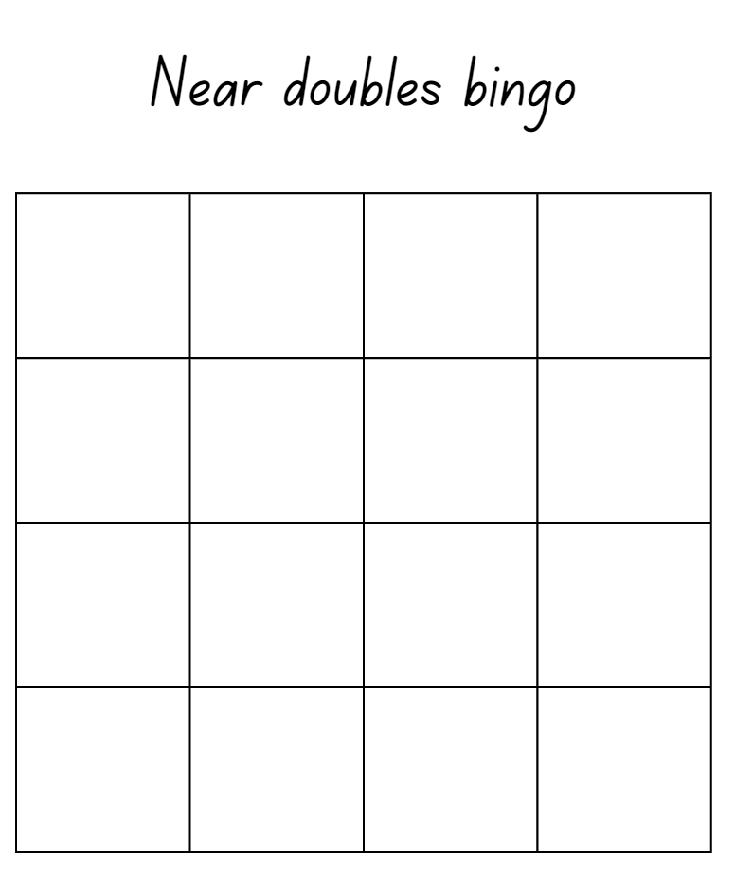
Images sourced from Canva and used in accordance with the Canva Content License Agreement.

Appendix 4: Recording table
I rolled… | I chose to…  (circle one) | The answer is…
double
near double
double
near double
double
near double
double
near double
double
near double
double
near double
double
near double
double
near double
double
near double

Appendix 5: 101 recording table
Tens | Ones | Number | Total

Reference list
This resource contains images and content obtained from Canva, and their use outside of this resource is subject to Canva’s Content License Agreement.
Mathematics K–10 Syllabus © NSW Education Standards Authority (NESA) for and on behalf of the Crown in right of the State of New South Wales, 2022.
National Numeracy Learning Progression © Australian Curriculum, Assessment and Reporting Authority (ACARA) 2010 to present, unless otherwise indicated. This material was downloaded from the Australian Curriculum website (National Literacy Learning Progression) (accessed 6 November 2023) and was not modified.
Australian Broadcasting Corporation Education (2021) ‘Maths Years 3–4 with Ms Kirszman: Partitioning numbers using efficient strategies’, Australian Broadcasting Corporation website, accessed 6 November 2023.
Australian Broadcasting Corporation Education (2021) ‘Maths Years 3–4 with Ms Kirszman: Quantifying collections’, Australian Broadcasting Corporation website, accessed 6 November 2023.
Australian Government Department of Education (2020) ‘Counting: Handfuls’, Teaching resources, reSolve: Maths by Inquiry website, accessed 26 June 2023.
Siemon D, Warren E, Beswick K, Faragher R, Miller J, Horne M, Jazby D, Breed M, Clark J and Brady K (2015) Teaching Mathematics: Foundations to Middle Years, 2nd edn, Oxford University Press ANZ, Australia.
State of New South Wales (Department of Education) (n.d) ‘Double or near double?, Developing Efficient Numeracy Strategies website, accessed 6 November 2023.
State of New South Wales (Department of Education) (n.d) ‘Near doubles bingo’, Developing Efficient Numeracy Strategies website, accessed 6 November 2023.
State of New South Wales (Department of Education) (n.d) ‘Trading game’, Developing Efficient Numeracy Strategies website, accessed 6 November 2023.
State of New South Wales (Department of Education) (2023) ‘3 tens in a line’, Mathematics K-6 resources, NSW Department of Education website, accessed 6 November 2023.
State of New South Wales (Department of Education) (2023) ‘101 and you’re out (2-digit-addition)’, Mathematics K-6 resources, NSW Department of Education website, accessed 6 November 2023.
State of New South Wales (Department of Education) (2023) ‘Dicey addition (3-digit addition)’, Mathematics K-6 resources, NSW Department of Education website, accessed 6 November 2023.
State of New South Wales (Department of Education) (2023) ‘Doubles fill’, Mathematics K-6 resources, NSW Department of Education website, accessed 6 November 2023.
State of New South Wales (Department of Education) (2023) ‘Handfuls’, Mathematics K-6 resources, NSW Department of Education website, accessed 6 November 2023.
State of New South Wales (Department of Education) (2023) ‘Number busting – number talk (renaming 26)’, Mathematics K-6 resources, NSW Department of Education website, accessed 6 November 2023.
University of Cambridge (Faculty of Mathematics) (1997–2023) ‘Dicey Addition’, NRICH website, accessed 6 November 2023.

Copyright
Section 113P Notice
Texts, Artistic Works and Broadcast Notice
Some of this material has been copied and communicated to you in accordance with the statutory licence in section 113P of the Copyright Act. Any further reproduction or communication of this material by you may be the subject of copyright protection under the Act. Do not remove this notice.

Evidence base
Sparrow, L., Booker, G., Swan, P., Bond, D. (2015). Teaching Primary Mathematics. Australia: Pearson Australia.
Brady, K., Faragher, R., Clark, J., Beswick, K., Warren, E., Siemon, D. (2015). Teaching Mathematics: Foundations to Middle Years. Australia: Oxford University Press.
Alignment to system priorities and/or needs: The literacy and numeracy five priorities.
Alignment to School Excellence Framework: Learning domain: Curriculum, Teaching domain: Effective classroom practice and Professional standards
Consulted with: NSW Mathematics Strategy professional learning and Curriculum Early Years Primary Learners-Mathematics teams
Reviewed by: Literacy and Numeracy
Created/last updated: January 2024
Anticipated resource review date: January 2025
Feedback: Complete the online form to provide any feedback.

