Subject vocabulary – Stage 6 Technology

Sequence
To get the most from these resources they should be used as a teaching and learning sequence. One set of activities leads on to the next.
- Improve student writing through subject vocabulary (this document)
- Improve student writing through planning for writing (DOCX | PDF)
- Improve student writing through writing and feedback (DOCX | PDF).

Learning focus
With these literacy activities teachers use content that they have planned in their teaching and learning cycle. For each literacy activity an example from Stage 6 Industrial Technology has been provided. The example provided is a model for teachers. Teachers create their own specific examples for their subject and class. Teachers can modify the learning intentions and success criteria to reflect their context.

Syllabus outcomes
For each Technology subject, relevant syllabus outcomes have been provided in the Stage 6 Technology syllabus links (PDF 218 KB) document. However, to support professional practice teachers are strongly advised to always refer to the syllabus documents on the NESA website.

Learning intentions
- Students will become familiar with subject vocabulary.
- Students will increase understanding of specific vocabulary terms.
- Students will create and maintain their own glossary.

Success criteria
- Students are able to define terms that are specific to their subject.
- Students are able to effectively use terminology that is specific to their subject.
- Students are able to complete self-directed work.

Teaching strategies
- Activity 1: Select
- Activity 2: Explain
- Activity 3: Explore
- Activity 4: Consolidate.
(Adapted from: Alex Quigley ‘Closing the Vocabulary Gap’ Routledge 2018)

Activity 1: Select
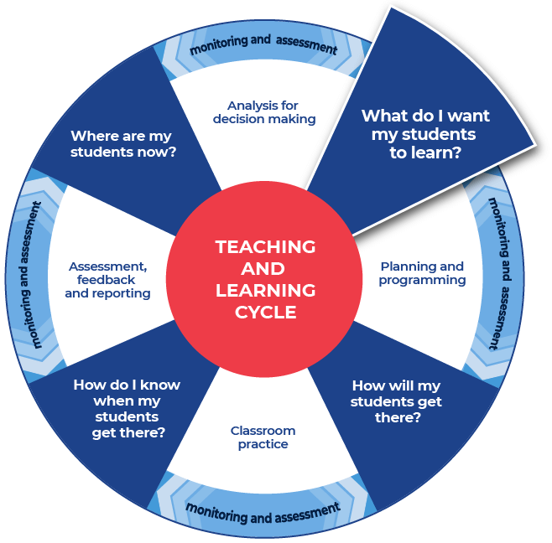

Required resources
Teachers choose a resource that they are currently using in class. It could be an article, podcast, video, website, textbook page, or other resource.
Teachers provide their students with access to the chosen resource.
Examples of resources are listed below:
- Specific pages or a chapter from a textbook.
- A video or Ted Talk on the topic.
- NSW syllabus document, for example the Technology Stage 6 Syllabuses.
- NESA Glossary of key words.
For the Industrial Technology examples a specific text has been chosen: Industrial Technology Major Project Marking Guidelines (PDF 300 KB).
As well as being used for marking the major projects, the marking grid may also be viewed as part of an unpacking exercise with students. They could consider the differences between the performance bands and what they need to produce to achieve their best result. It is in this capacity that this text has been selected for the examples.
When selecting the text that you will work with, consider the text complexity and your reason for using that text. It is also important to read texts carefully before using them with students and pre-identify any terms or subject specific language that students may find challenging. Further information on text complexity can be found in the National Literacy and Numeracy Learning Progressions, Literacy Progression, Appendices 6 – Text Complexity (PDF 388 KB).

Instructions:
- Students engage with the text that the teacher has provided.
- Students select ten unfamiliar words that they do not feel confident they know the meaning of.
- Students write the words into a table or in their workbook.
- Teachers model their own example to share with students. An example from Industrial Technology has been included.
Differentiation:
- Teachers could pre-select the ten words.
- Teachers could pre-select some of the words and then allow the students to select the rest.
- Teachers could alter the number of words to be selected.
- Teachers could support comprehension by altering the font of the text to make it more readable and presenting the information in smaller sections.
- Teachers may want to use some pre-reading activities such as: providing students with clues for navigating the text, summarising what the text will be about (locating specific information), and explaining specific terms that will appear in the text.
- Teachers may also read the text to students to allow them to hear the text, including the pronunciation of key terms.
- Teachers could use videos and other multi-modal texts to support learning.
Further support:
An example from Industrial Technology has been chosen: Industrial Technology Major Project Marking Guidelines (PDF 300 KB).

Example

critically evaluates
clarifies
describes
identifies
explains
provides
analysis
outlines
justifies
demonstrates

Activity 2: Explain
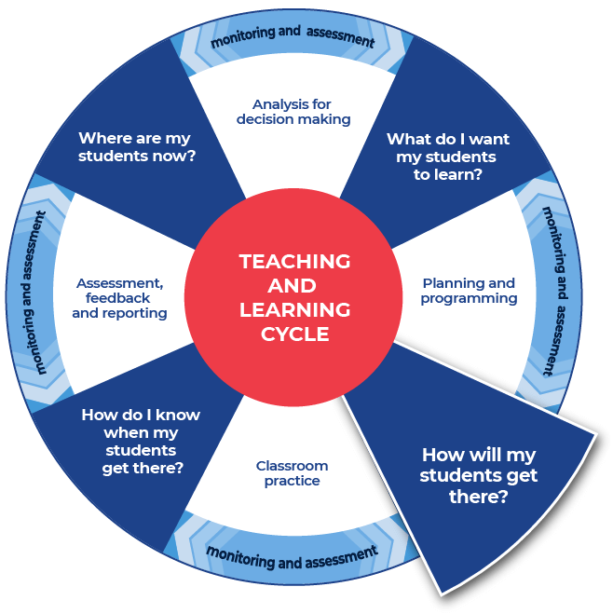

Instructions:
- Teachers replicate the example structure but for the text that their students are working with. Teachers provide their example to their students.
- Students research the formal technical definition for each of their words and write it in the table provided, or in their workbook. Students can use online or hard copies of dictionaries. Definitions could also be sought from the NESA Glossary of key words or the specific Technology syllabus glossary and other sources as required.
- Students create their own informal ‘student’ definition for each word. It should be written in plain English. This is the way they might explain it to a friend.
- Students should write their informal definition in the table.
- Students will need to complete this task for all ten words.
Differentiation:
- Teachers may provide the words and scaffold the definitions. For example, create mini cloze passages inside the definition spaces and provide a word bank for students.
- Teachers could supply the link to the online dictionary and students can write the definition in the table.
- Teachers could also encourage students to work together to create informal definitions first. Students could then source the formal definitions and refine their informal definitions.
- Students could work in pairs, then join their word lists together and complete definitions for twenty words.
- Modifications for EAL/D students may include explicitly teaching how to use the dictionary and support in choosing which definition is relevant to Technology.
- Teachers could support students by discussing the word as it is used in the context of the sentence.
- Teachers could support students by discussing multiple meanings and that being literate includes understanding that some words can have multiple meanings.

Template
Word | Dictionary definition | Your definition
word | From name-of-dictionary:  ‘dictionary definition.’ | Student definition.
… | … | …
… | … | …
… | … | …
… | … | …
… | … | …
… | … | …
… | … | …
… | … | …
… | … | …

Completed example
This example has been filled in for teachers as a model.
Word | Dictionary definition | Your definition
critically evaluates | From NESA Glossary of Key Words:  ‘Add a degree or level of accuracy depth, knowledge and understanding, logic, questioning, reflection and quality to (analyse/evaluate).’  From Merriam-Webster:  ‘exercising or involving careful judgment or judicious evaluation.’  From Merriam-Webster:  ‘to determine the significance, worth, or condition of usually by careful appraisal and study.’ | To be skilled in judging something. To be able to say a lot about how it is good and why and what if anything is not so good. Getting all of the information and then making a judgment.
describes | From NESA Glossary of Key Words:  ‘Provide characteristics and features.’  From dictionary.com:  ‘to tell or depict in written or spoken words; give an account of.’ | Taking into consideration the look of many parts of the work to get the big picture
clarifies | From NESA Glossary of Key Words:  ‘Make clear or plain’  From Macmillan Dictionary:  To explain something more clearly so that it is easier to understand | To explain. But then to give more details and examples and make the idea or event really easy for someone else to understand

Activity 3: Explore

Instructions:
- Teachers provide their own completed example and a template to their students.
- Students explore each word to deepen their understanding of the subject vocabulary.
- Students complete this task for all ten of their words.
Differentiation:
- Teachers can choose between the two template options provided.
- Teachers could explicitly discuss with students if they know this word from another subject and if the meaning of the word is the same or different from the other class. This allows students to connect learning across KLAs.
- Students could find or create an image that represents this word.
- Students could use graphic organisers from the Digital Learning Selector.
Further support:
- Teachers model their own example to share with students. An example from Industrial Technology has been included.

Example 1

Template: Vocabulary Map
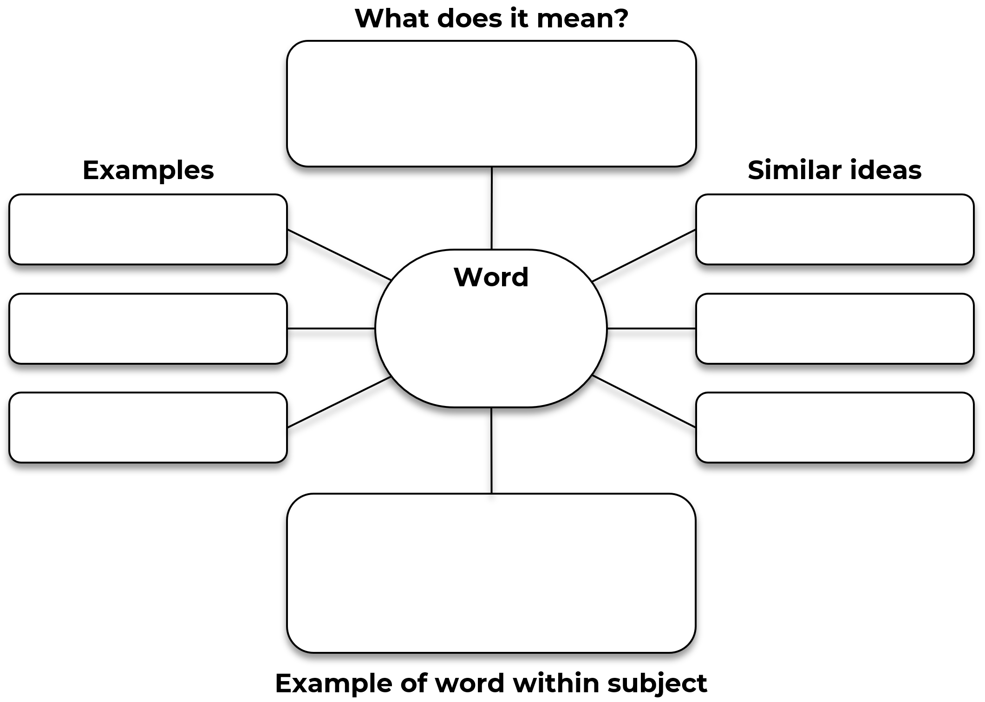

Completed example: Vocabulary Map
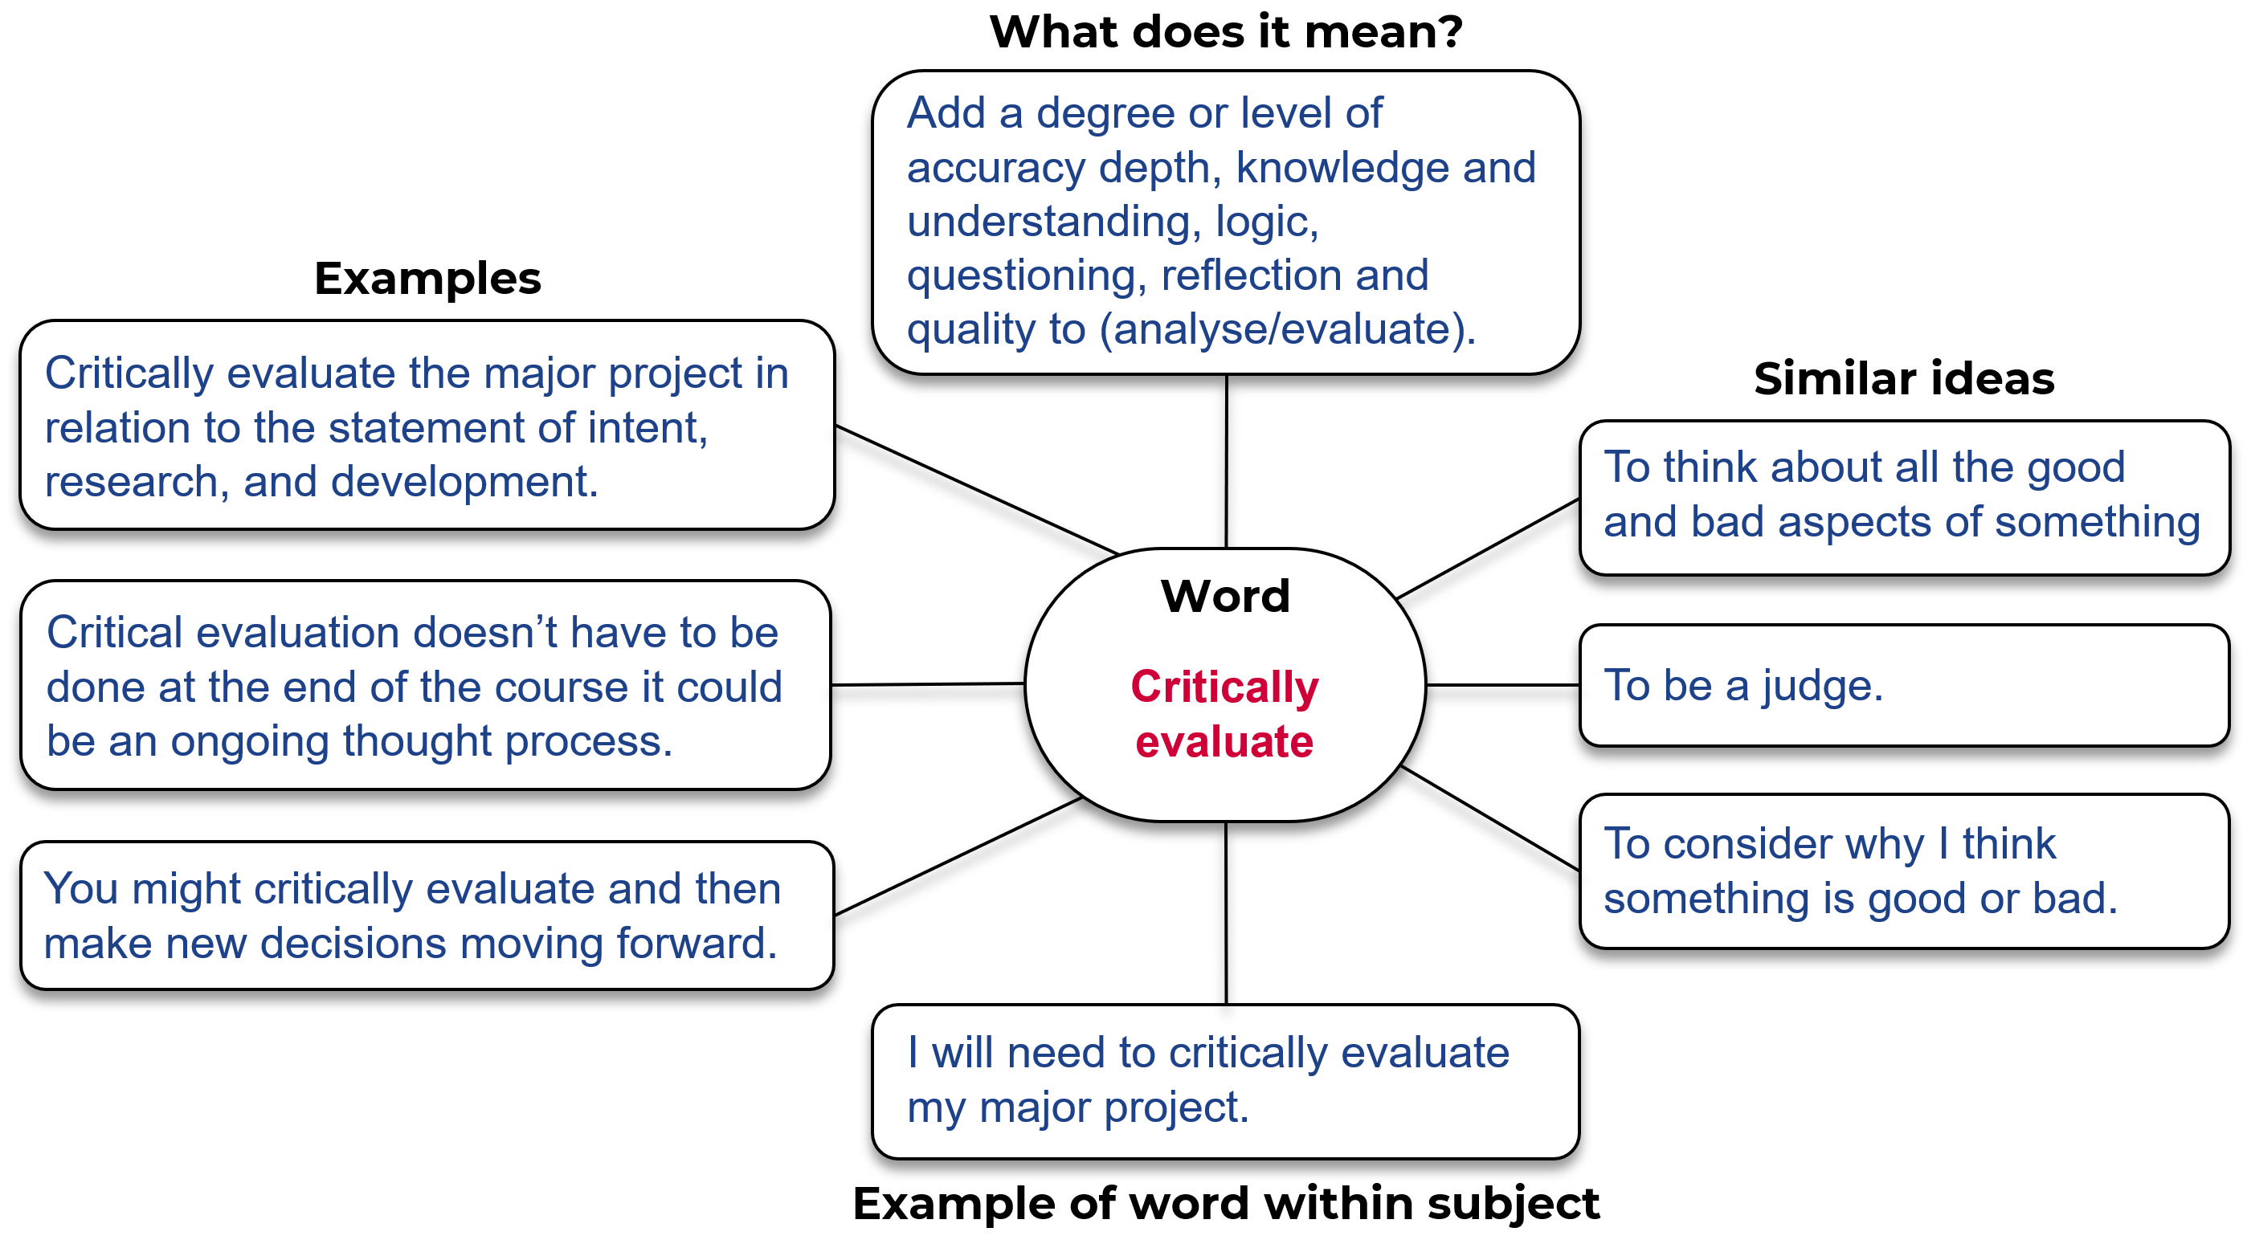

Example 2

Template
Word: ________________________________________
Write the sentence, from the text, that contains the word?

In the text, what are some other words associated with this word?

Can you find an example, in the text, of a sentence that hints at the meaning of the word?

Create your own sentence that includes the word?

Give an example of how this word works in your subject?

Completed example
Word: critically evaluate
Write the sentence, from the text, that contains the word? ‘Critically evaluate the major project in relation to the statement of intent, research, and development.’
In the text, what are some other words associated with this word? The words are found in the column for projects that score marks of 17-20, so it must be a good thing to try to do. Lower mark ranges talk about evaluation and ongoing documentation so to critically evaluate must be to add the skilled judgement part and provide supporting reasons and material.
Can you find an example, in the text, of a sentence that hints at the meaning of the word? Because of the words ‘Ongoing evaluation of the MP and its relationship to the statement of intent, research and planning’ we see that the evaluation needs to consider what I originally said I was going to do and the information I obtained through research to help develop and design. It also needs to consider how the project was planned, including if that is working out well.
Create your own sentence that includes the word? Critically evaluating my project by deciding what is good and what is not working doesn’t just have to be done at the end of the course, it should be an ongoing thought process.
Give an example of how this word works in your subject? I will need to critically evaluate my major project to determine its success and consider whether the final product matches what I originally set out to do.

Activity 4: Consolidate
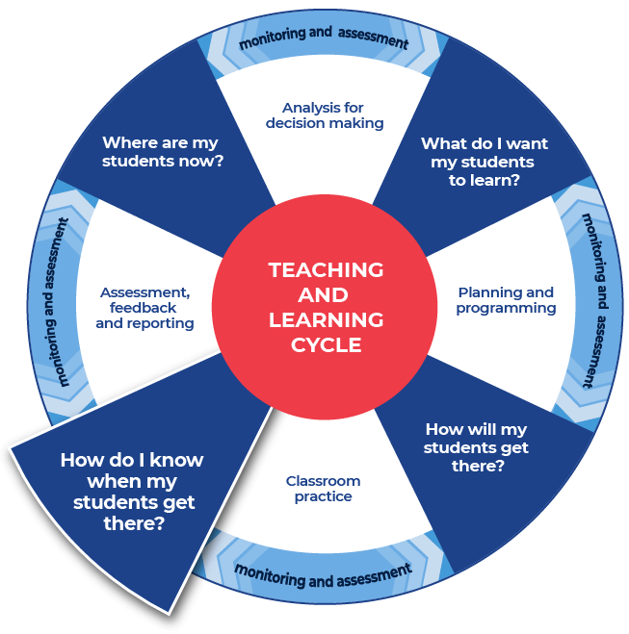

Instructions:
- Students consolidate their subject vocabulary learning by creating a match-up worksheet.
- Students create a worksheet using the template provided by writing their ten words in the boxes listed down the middle of the worksheet.
- Students fill in the outer squares with their personal definitions of the words. They should ensure that they are out of order.
- Students provide the teacher with an answer sheet for the match-up that they create. The word and correct definition should be clearly indicated.
- Teachers swap student’s match-up worksheet with a peer who aims to get ten out of ten as they attempt the worksheet.
Differentiation
The teacher could:
- ask students to create a match-up worksheet using the template provided and write synonyms for their ten words in the boxes listed down the middle of the worksheet.
- split the class into two groups, half of the class has a word and half of the class has a definition, students move about the space and locate their word or definition
- organise students into pairs to create flash cards or word webs, paper or online, this could incorporate selecting graphic organisers from the Digital learning selector
- show students how to create a crossword - students use the words and definitions and then share their crossword with a peer
- show students where and how to locate different texts or sources that demonstrate the different definitions of a word that they have explored. This supports the Williams Model of differentiation with the aspect of Organised Random Search.
- explain the concept of a cloze passage and ask students to create cloze passages
- provide students with space to create a word wall. This could be added to throughout the module
- direct students to a specific template within the Digital Learning Selector and encourage them to organise and classify their new words
- hold a gallery walk, this enables students to showcase their new words to their peers.

Name of worksheet:
Student name:
Match-up the words with the appropriate definitions.

Definitions

Words

Definitions

Name of worksheet:
Student name:
Answer sheet.

Definitions

Words

Definitions

This is the end of the activities for: Improve writing through subject vocabulary.
Teachers should move on to the next set of Technology activities: Improve student writing through planning for writing (DOCX | PDF)

Additional vocabulary lesson resources

Cohesion
Cohesion is defined as ‘that quality in a text determined by its parts being related and contributing to its overall unity. Cohesion is achieved through shaping the form, creating a structure that the responder can recognise and use to navigate the text …’ (English K–10 Syllabus Glossary). For more ready-to-use teaching and learning activities on cohesion visit HSC minimum standard – Cohesion.

Learning Resource Hub
Evidence-based resources and tools are accessible to all schools via the Learning Resource Hub (staff only).
Teachers can use these resources to support integration of reading and numeracy instruction into teaching and learning programs.

Question verbs
We have included a glossary of question verbs and activities (DOCX 80 KB) that are ready to use. These will get your students thinking about what the question is asking.

Topic Vocabulary
For more ready-to-use teaching and learning activities on topic vocabulary go to HSC minimum standard – Topic vocabulary.

Vocabulary
For more ready-to-use teaching and learning activities on vocabulary go to HSC minimum standard – Vocabulary.

