Student writing and feedback – Stage 6 Technology

Sequence
To get the most from these resources they should be used as a teaching and learning sequence. One set of activities leads on to the next.
- Improve student writing through subject vocabulary (DOCX | PDF)
- Improve student writing through planning for writing (DOCX | PDF)
- Improve student writing through writing and feedback (this document).

Learning focus
With these literacy activities teachers use content that they have planned in their teaching and learning cycle. For each literacy activity an example from Industrial Technology has been provided. The example provided is a model for teachers. Teachers create their own specific examples for their subject and class. Teachers can modify the learning intentions and success criteria to reflect their context. Students draw upon their vocabulary and planning to complete a written response and engage with feedback to enable them to continue to build their skills.

Syllabus outcomes
For each technology subject, relevant syllabus outcomes have been provided in the Stage 6 Technology syllabus links (PDF 218 KB) document. However, for their own professional practice teachers are strongly advised to always refer to the syllabus documents on the NESA website.

Learning intentions
- Students respond to a writing task.
- Students provide effective peer feedback.
- Students engage with effective feedback.

Success criteria
- Students are able to effectively complete a written response.
- Students are able to effectively provide feedback to a peer.
- Students are able to reflect on their learning needs.

Teaching strategies
- Activity 1: Turn and talk
- Activity 2: Writing activity
- Activity 3: Peer feedback
- Activity 4: Teacher feedback
- Activity 5: Student self-reflection.

Activity 1: Turn and talk
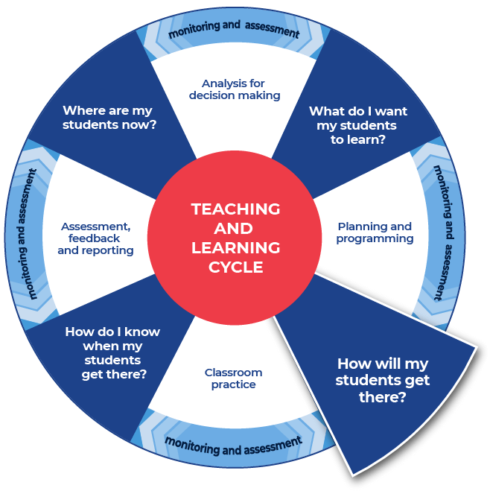

Instructions:
- Teachers provide time in class for students to discuss the notes that they have taken and the plan that they have created for their written response.
- Teachers model their own example to share with students. An example from Industrial Technology has been included.
Differentiation:
- Teachers could provide a completed written response. The students could use this example to model their own writing.
- Teachers could support students by providing specific questions for ‘turn and talk’.
- Teachers could modify this activity for specific contexts through sentence starters, scaffolded sentences or word banks.
- Teachers could provide an example of the entire completed written response. The students could use this example to model their own writing.
- The students and teacher could co-write and produce one written piece of work.
Further support:
- Classroom talk is a powerful tool for both teaching and learning. Rich, dialogic talk supports students in making sense of complex ideas and builds classroom communities centred on meaning-making. Tools to support rich talk in the classroom were outlined in Christine Edwards-Groves 2014 paper, Talk moves: A repertoire of practices for productive classroom dialogue (PETAA paper 195). For an example of how these tools were applied to Mathematics ‘Talk moves’ posters, flashcards and a chart are available. These practices could also be applied in the classroom in other learning areas including Technology.
- Further support with paragraph construction can be found at HSC Minimum standard, Paragraphs.

Example question
Describe how increasingly sustainable practices have benefited timber products and the furniture industry.

Example response
The timber products and furniture industry relies on the supply of timber for its ongoing operation. In order for this to be maintained over the coming years there is a need for sustainable practices to be adopted across the sector.
Companies, such as Ikea who source from over 50 countries worldwide and can have a big impact on forestry practices, are sourcing timber that is harvested from sustainably managed forests, both in Australia and overseas. This ensures that they can maintain a steady supply of the raw material to make their products. If the timber is harvested from old growth forests and through slash and burn practices, where the areas are cleared for farming crops then the trees cannot be replaced and the resource is finite. The impact on the environment is also a major consideration and these practices destroy ecosystems and increase the rate of global warming.
Instead of this, companies are sourcing their timber from plantation forests, where the trees are planted and managed like any other crop, just one that takes longer to reach maturity, but one that wouldn’t have been there absorbing carbon dioxide from the atmosphere had we not planted them. The trees are planted on mass and then thinned out as they grow so that only the selected trees, based on their shape and structure, remain to maturity or to when they are harvested. This way the remaining trees are straighter, stronger and will have less defects, which translates to more useable timber. This process doesn’t just benefit the manufacturers in the industry, it also creates extra jobs in this sector of the operation.
The industry has also become more sustainable in its use of waste timber. Previously sections of timber that were too small to be useable were chipped and turned into manufactured boards, which are relatively sustainable in themselves, or turned into mulch. Now they are using a lamination process of gluing the smaller sections together to create a more dimensionally stable larger section of timber that would have taken much longer to grow. The glue laminated or glulam beams are straighter and less prone to movement than solid timber and through testing they have been shown to meet or exceed structural performance characteristics of a similar sized solid piece of timber, all while reducing waste.

Even plywood which uses the majority of the tree already, has become more sustainable with less waste. The logs are pre-cut to a uniform length so that they are easier to handle and so that they already roughly match the sizes of the finished board, then they are fed into a machine which automatically calculates how to orientate the log to harvest the maximum amount of material from it, therefore creating less waste.
Companies that manufacture furniture are also doing their part to be more sustainable. By using sustainably sourced timber and advertising that fact, they are able to position themselves in the marketplace and provide that distinction between themselves and other companies that don’t. Potentially gaining them a larger market share. They also design their products more conscientiously, using standard sized timber sections and lengths and purposely incorporating the offcuts into their designs so that they too produce less waste.
Overall, the timber products and furniture industry is embracing sustainability to not only ensure their own ongoing existence, but also to reduce their environmental footprint and demonstrate to the consumer that they responsibly producing their products, which in turn may allow them to charge a higher premium for their merchandise.
Analysis colour coding:
- provide more than one example of sustainable practices to support the answer
- discuss the advantages to industry
- demonstrate comprehensive knowledge of sustainable practices
- used correct industry terminology.
See Literacy Learning Progression and Stage 6 Technology (DOCX | PDF) for information on how the National Literacy Learning Progression could support student writing and feedback in Stage 6 Technology.

Activity 2: Writing activity

Instructions:
- Teachers allocate enough time to complete the written response.
- Students complete their written response.
Differentiation:
- Teachers could provide a scaffold for the response, with sentence starters or layout outlines.
- Students could have their notes and planning with them for the writing task.

Activity 3: Peer feedback
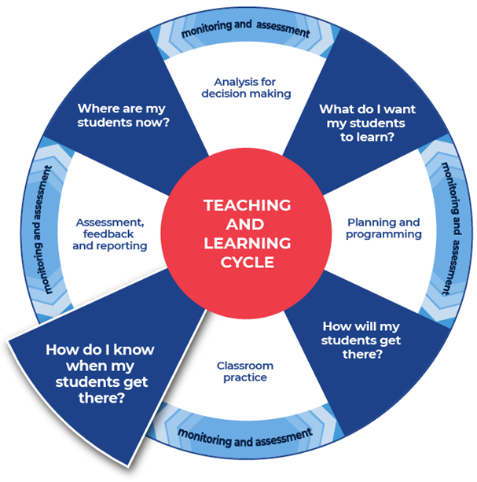

Instructions:
- Teachers facilitate pairs of students to swap their written responses.
- Teachers brief the students on acceptable peer feedback behaviors. Including ‘two stars and a wish’ or ‘I like, I wonder’ protocols. This activity may be anonymous.
- Students are provided with the template and they fill it in to provide feedback to their peer.
- Students tick where they think the writing aligns on the template.
Additional peer feedback options:
- Teachers could give students a focus to look for, such as use of vocabulary, and assign this focus to a coloured highlighter. This could be repeated with different focusses and highlighters.
- Teachers could support students to create their own class agreed feedback template.

Template
Criteria | Developing | Developed | Highly developed
The response answers the question. | ◻ | ◻ | ◻
Idea being written about is clear. | ◻ | ◻ | ◻
The writing has a logical structure. It makes sense when you read it through. | ◻ | ◻ | ◻
There is a clear reference to syllabus content. | ◻ | ◻ | ◻
There is topic specific vocabulary in the response. | ◻ | ◻ | ◻
Sentences make sense. | ◻ | ◻ | ◻
Capital letters, full stops and some other punctuation is used. | ◻ | ◻ | ◻
Accurate spelling of challenging words. | ◻ | ◻ | ◻
Handwriting is consistently legible. | ◻ | ◻ | ◻
Two successful things about this written response are:

One aspect of writing to keep working on is:

Activity 4: Teacher feedback

Instructions
- Teachers support their students with timely and effective feedback. Remembering that effective feedback:
  - focuses on the intended learning
  - identifies specific strengths
  - points to areas needing improvement
  - suggests a pathway that students can take to close the gap between where they are now and where they need to be
  - chunks the amount of corrective feedback the student can handle at one time
  - is provided in a short time frame.
- Teachers select areas to provide feedback from the templates provided or modify and use the student feedback template from Activity 3.
- Teacher comments could include, ‘developing’, ‘developed’, and ‘highly developed’.
- Teachers may choose to engage with the National Literacy Learning Progression to provide feedback to their students. To use this tool more effectively teachers could first engage with the online professional learning course: Introduction to the Literacy and Numeracy Progressions.

Feedback templates
- More information on aspects of literacy can be found at: HSC minimum standard – Writing.
- The hyperlinks contained within the feedback sheets link to teacher resources focusing on that writing aspect.
- Teachers can modify or remove the definitions.
- Some teachers may choose to leave the definitions in place to support the students’ skill development.
- There are three templates to choose from:
  - Control of language
  - Structure and sequence of ideas
  - Relevance of writing to the topic.

Control of language
Spelling. Correct spelling is consistent and some difficult words are spelled correctly. In the written response spelling is:

Vocabulary. Subject vocabulary has been used effectively in context. In the written response vocabulary is:

Tense. Past, present and future references within sentences, and the response, as a whole are logical and consistent. For example, ‘Alex laughed’, ‘Alex laughs’, ‘Alex will laugh’. In the written response tense is:

Punctuation. There is correct sentence punctuation, including capital letters and full stops. There are some correct examples of commas, proper nouns, apostrophes. In the written response punctuation is:

Formal and informal language. The tone matches the audience and purpose. The language use is consistently appropriate. Informal language is every day and conversational. Formal language uses correct sentence structures and has a feeling of authority. In the written response formal and informal language are:

Two successful things about this written response are:

One aspect of writing to keep working on is:

Structure and sequence of ideas
Text structure is the way that the information is organised. This could include: headings and sub-headings, is there an introductory and concluding paragraph. In the written response text structure is:

Paragraphs. Text in a distinct section that reflects a logical cohesive point. In the written response paragraphs are:

Sentence types. A sentence begins with a capital letter and ends with a full stop, question mark or exclamation mark. There are different types of sentences:
- simple sentence – a single main clause that expresses a complete thought. It has a subject and a finite verb and may also have an object, for example ‘Mary is beautiful.’, ‘The ground shook.’, ‘Take a seat.’
- compound sentence – contains two or more clauses that are coordinated or linked in such a way as to give each clause equal status. In the following example and is the coordinating conjunction: ‘We went to the movies and bought an ice cream.’
- complex sentence – contains a main (or independent) clause and one or more subordinate (or dependent) clauses. The subordinate clause is joined to the main clause through subordinating conjunctions like when, while and before, as in the following examples: ‘We all went outside when the sun came out.’, ‘Because I am reading a long book, my time is limited.’
(NSW English K–10 Glossary © NSW Education Standards Authority (NESA) for and on behalf of the Crown in right of the State of New South Wales, 2020.)
In the written response sentence types are:

Cohesion. Features can include connectives such as ‘furthermore’ and ‘therefore’, cross-references to different parts of the text, and reiteration of the title or terms of the topic or question being addressed in the text. (NSW English K–10 Glossary © NSW Education Standards Authority (NESA) for and on behalf of the Crown in right of the State of New South Wales, 2020.)
In the written response cohesion is:

Two successful things about this written response are:

One aspect of writing to keep working on is:

Relevance of writing to the topic
Audience and purpose. Audience is the intended readers. Purpose can include, to entertain, to inform, to persuade, to educate. ‘Composers use a number of ways to achieve these purposes: persuading through emotive language, analysis or factual recount; entertaining through description, imaginative writing or humour, and so on.’
(NSW English K–10 Glossary © NSW Education Standards Authority (NESA) for and on behalf of the Crown in right of the State of New South Wales, 2020.)
In the written response audience and purpose are:

Ideas. An idea is a thought or notion that is being explained and explored. Students are encouraged to develop their ideas and create insightful and impacting points. Students will support their ideas with evidence and examples. In the written response ideas are:

Topic vocabulary. Have specific words from the subject area been used effectively in the writing. In the written response topic vocabulary is:

Two successful things about this written response are:

One aspect of writing to keep working on is:

Activity 5: Student self-reflection
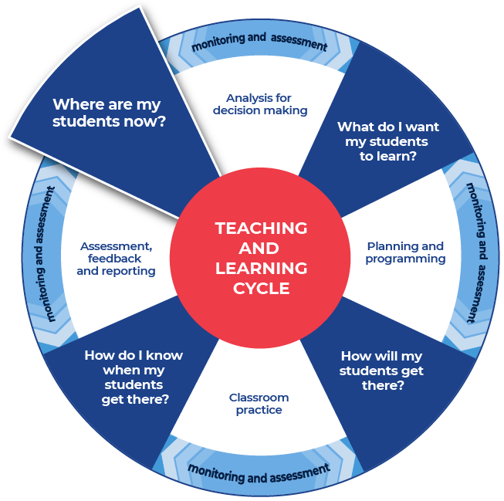

Instructions:
- Teachers provide students with a copy of an ‘exit slip’.
- Students complete the exit slip and detail one skill that they learnt through the literacy lessons and one skill that they need to work on further.
- Teachers collect and review the completed exit slips to plan where to next for improving their students’ literacy skills.
Differentiation:
- Planning where to next could be done collaboratively with the students.

Exit slip template
Name:
When writing your response, how confident are you that you:
Criteria | Not confident | Somewhat confident | Confident
understand the question | ◻ | ◻ | ◻
know where the content comes from in the syllabus | ◻ | ◻ | ◻
know how to structure your response | ◻ | ◻ | ◻
know which explicit examples to use to validate your statements | ◻ | ◻ | ◻
know how to use subject vocabulary | ◻ | ◻ | ◻
sequence the information and make paragraphs | ◻ | ◻ | ◻
One skill that I have learnt that improved my writing:

One skill to continue to work towards:

