Planning for writing – Stage 6 Technology

Sequence
To get the most from these resources they should be used as a teaching and learning sequence. One set of activities leads on to the next.
- Improve student writing through subject vocabulary (DOCX | PDF)
- Improve student writing through planning for writing (this document)
- Improve student writing through writing and feedback (DOCX | PDF).

Learning focus
With these literacy activities teachers use content that they have planned in their teaching and learning cycle. For each literacy activity an example from Industrial Technology has been provided. The example provided is a model for teachers. Teachers create their own specific examples for their subject and class. Teachers can modify the learning intentions and success criteria to reflect their context.

Syllabus outcomes
For each Technology subject, relevant syllabus outcomes have been provided at Stage 6 Technology syllabus outcomes document (PDF 218KB). However, to support professional practice teachers are strongly advised to always refer to the syllabus documents on the NESA website.

Learning intentions
- Students will investigate effective writing.
- Students will analyse sample written responses.
- Students will develop note taking skills.
- Students will develop confidence with writing.

Success criteria
- Students are able to recognise aspects of effective writing.
- Students are able to practise their writing skills.
- Students are able to take effective notes.
- Students are able to prepare for a written response.

Teaching strategies
Focus on skills:
- Activity 1: Review annotated samples
- Activity 2: Warm up writing activity.
Prepare to write:
- Activity 1: Select your resource
- Activity 2: Take effective notes
- Activity 3: Where to next.

Focus on skills

Activity 1: Review annotated samples
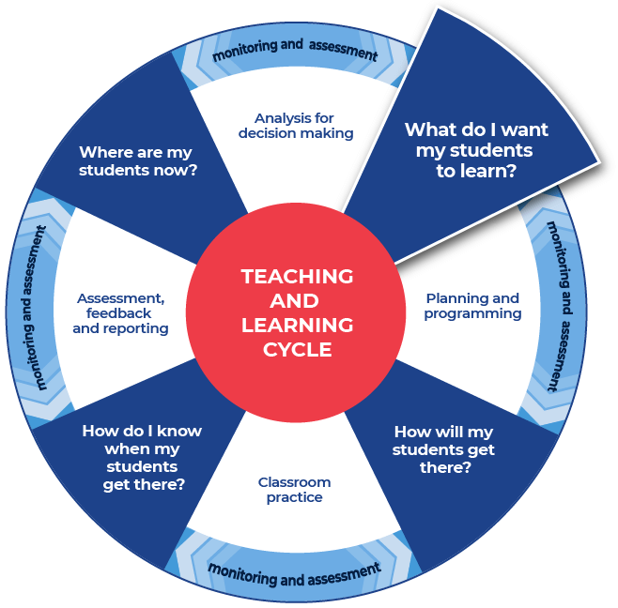

Instructions:
- Teachers provide a sample question with sample written response and annotate some of the features of effective writing on that response.
- Teachers create examples themselves or source them from: the Technology statewide staffroom, previous year groups, local teacher networks, NESA publications or professional associations.
- Teachers can use the National Literacy Learning Progression to help track students’ literacy skills. Improving students’ literacy skills will enable students to communicate their ideas in a more succinct manner.
- Students will be asked to complete an analysis of the writing, after discussing and reviewing the written samples. A template is provided.
Further support:
- NESA Industrial Technology project advice.
- Major project resource within the TAS section of the HSC hub.
- An explanation of the Statement of Intent for Industrial Technology has been provided below.
The statement of intent sets the scene for what you're going to do in your project. But it's more than just telling the person reading your folio what you're going to make. In order to get the maximum available marks, the marking criteria says that the statement of intent needs to clarify the intent of the project by explaining clearly what is to be achieved and why. This has been supported by the advice from the marking centre, which has remained constant over the last couple of years, that students should give a full picture of the intended project, outlining areas of research and the planned use of the project. Depending on the project and the focus area, this might include why the student is designing and or making it, how and where it will be used, the funds available for the project, and what the student needs to research. It also includes, what skills they'll need to develop, where they might source material, and even where they might find existing examples of their project, or if they don't exist, then items similar to their project.
The statement of intent needs to lay out the roadmap for action before that action is taken. It shouldn't therefore be written after the fact, where the student is recounting or reflecting on what they've done. Sometimes projects change completely, and the statement of intent needs to be rewritten. In which case, the same process of working out what needs to be done to move forward should be completed. However, if the changes are less significant yet the project still requires modification of the initial intent, then this should be covered in the appropriateness of design and design modification sections of the folio.
Students should also consider including an actual picture of where or how the project will be used such as a space in the lounge room where the coffee table will be used. The block of land, where a house plan might go, or the mountain bikes that will be carried on a bike trailer. This will give the marker a better idea of how the final project will be used and potentially even why it's being done in the first place. The final point from the marking centre, which again has been consistent over the last couple of years, is to consider using a mind map to identify all the things that need to be researched, identified and justified. This will support the statement of intent and provide students with a more organized approach at the start of their project. If students do all of these things, they will have an excellent foundation to build on.

Example question
Clarify the intent of your major project by explaining clearly what is to be achieved and why.

Sample low-range response
For my major project I’m going to make a coffee table. It’ll be made of pine and I’m going to stain it dark and then put a lacquer on it. It needs to be quite strong because we sometimes stick our feet up on it and the last one broke.

Annotations
For my major project I’m going to make a coffee table. It’ll be made of pine and I’m going to stain it dark and then put a lacquer on it. It needs to be quite strong because we sometimes stick our feet up on it and the last one broke.
- maintains tense within a sentence (see Grammar) (CrT6 Text forms and features) (overall in this low-range sample)
- writes simple, compound and some complex sentences related to a topic using a broader range of conjunctions (e.g. and, but, so, because, when) (see Grammar) (CrT6 Texts forms and features)
- includes four or more simply stated and clearly connected ideas (e.g. introduces a topic and includes one or two facts; states an opinion with reasons; gives a recount of an event) (CrT6 Crafting ideas).
To improve:
- creates informative texts to explain and analyse (e.g. analyses how artists use visual conventions in artworks) (CrT10 Crafting ideas)
- orients the reader clearly to the topic or concept (e.g. using a definition or classification in the opening paragraph) (CrT10 Crafting ideas)
- uses evidence and research including digital resources to expand upon information and elaborate concepts (CrT10 Crafting ideas)
- varies sentence structure for effect (see Grammar) (CrT10 Text forms and features)
- uses discipline-specific terminology to provide accurate and explicit information (e.g. discipline metalanguage) (CrT10 Vocabulary)
- organises related information and ideas into paragraphs/sections (CrT10 Generic indicators)
- explain clearly what is to be achieved and why
- justifying the selection of appropriate materials, processes, technologies and resources through research
- demonstrate high level skills in sketching and idea generation.

Sample high-range response
For my major project I intend to design and build a coffee table to match with the existing pieces of furniture in my family’s lounge room. The existing coffee table is a cheap flat pack design and has seen better days, so I am going to design and build one that will be able to withstand the rigours of life with a family of six and two large dogs. The space where the table will go is shown below.
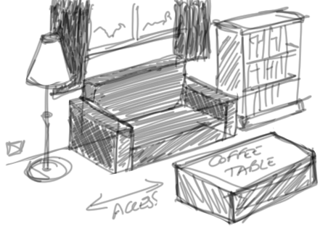
The table needs to be at a comfortable height in relation to the sofas and will need to allow movement around the space. As such I will need to measure the available area and this will provide me with some basic dimensions to work from. As my parents like to have a spot to keep all the remotes and not have them just lying on the top, the coffee table will also need to include some limited storage and I may consider adding a shelf for magazines or other bits and pieces.
I have already started looking in a couple of furniture shops when we’ve gone to a larger town and I intend to go back and take some pictures of coffee tables with features I liked. I will also look on the internet and in the catalogues that my Nan gets at her place each week, she’s going to keep them for me, to see if there are any other existing designs that I can get ideas or inspiration from.
I intend to research potential timbers for the project considering factors such as durability, as the existing one gets used a lot, workability, as I don’t want it to be too difficult when I’m cutting the joints, colour, as the existing furniture is predominantly made of darker woods and the décor as shown above is a range of greys, cost, as I only have a limited budget for the project and availability, as if I can’t get it locally at the hardware store in town, I’ll have to do the nearly 600kms round trip to pick it up somewhere else.

I also intend to research the potential finishes I may use, as they will need to be hard wearing and relatively low maintenance. In order to do this I will first research the properties of the different finishes using the textbooks at school and the internet and then make my decision based on a range of criteria that will probably include durability, aesthetic appeal, ease of application, cost and again, availability. These may however change as I do more research.
As my parents are paying for the majority of the cost of my major project they have set me the budget of $250. In order to make this go a little further I intend to use the adhesive and fixings available at school for free and I might be able to contribute some extra money if there is something special I want to add, but I won’t know that till later. Keeping that in mind, I would still be happy so long as the total cost comes in under $350.
In order to organise my thoughts and provide some direction for further research I have created a mind map for my coffee table major project.
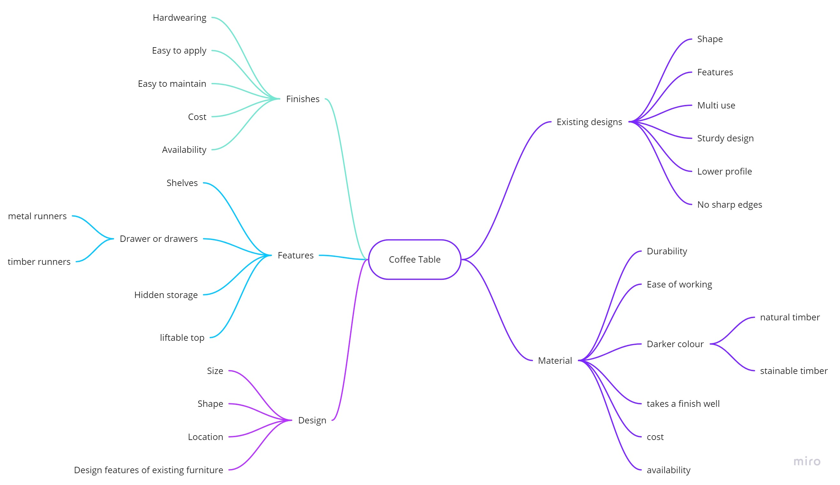

Annotations
For my major project I intend to design and build a coffee table to match with the existing pieces of furniture in my family’s lounge room. The existing coffee table is a cheap flat pack design and has seen better days, so I am going to design and build one that will be able to withstand the rigours of life with a family of six and two large dogs. The space where the table will go is shown below.
The table needs to be at a comfortable height in relation to the sofas and will need to allow movement around the space. As such I will need to measure the available area and this will provide me with some basic dimensions to work from. As my parents like to have a spot to keep all the remotes and not have them just lying on the top, the coffee table will also need to include some limited storage and I may consider adding a shelf for magazines or other bits and pieces.
I have already started looking in a couple of furniture shops when we’ve gone to a larger town and I intend to go back and take some pictures of coffee tables with features I liked. I will also look on the internet and in the catalogues that my Nan gets at her place each week, she’s going to keep them for me, to see if there are any other existing designs that I can get ideas or inspiration from.
I intend to research potential timbers for the project considering factors such as durability, as the existing one gets used a lot, workability, as I don’t want it to be too difficult when I’m cutting the joints, colour, as the existing furniture is predominantly made of darker woods and the décor as shown above is a range of greys, cost, as I only have a limited budget for the project and availability, as if I can’t get it locally at the hardware store in town, I’ll have to do the nearly 600kms round trip to pick it up somewhere else.

I also intend to research the potential finishes I may use, as they will need to be hard wearing and relatively low maintenance. In order to do this I will first research the properties of the different finishes using the textbooks at school and the internet and then make my decision based on a range of criteria that will probably include durability, aesthetic appeal, ease of application, cost and again, availability. These may however change as I do more research.
As my parents are paying for the majority of the cost of my major project they have set me the budget of $250. In order to make this go a little further I intend to use the adhesive and fixings available at school for free and I might be able to contribute some extra money if there is something special I want to add, but I won’t know that till later. Keeping that in mind, I would still be happy so long as the total cost comes in under $350.
In order to organise my thoughts and provide some direction for further research I have created a mind map for my coffee table major project.
- creates informative texts to explain and analyse (e.g. analyses how artists use visual conventions in artworks) (CrT10 Crafting ideas)
- orients the reader to the topic or concept (e.g. using a definition or classification in the opening paragraph) (CrT10 Crafting ideas)
- expand upon information and concepts and add authority (CrT10 Crafting ideas)
- uses discipline-specific terminology to provide accurate and explicit information (e.g. discipline metalanguage) (CrT10 Vocabulary).
Overall:
- varies sentence structure for effect (see Grammar) (CrT10 Text forms and features) There are simple, compound, and complex sentence structures used
- organises related information and ideas into paragraphs/sections (CrT10 Generic indicators) As the reader you can see the different sections in the response, design, research, materials, finishes, cost
- explains clearly what is to be achieved and why
- justifies the selection of appropriate materials, processes, technologies and resources through research
- demonstrates high level skills in sketching and idea generation.

Review annotated samples
- Students read through the example responses to the question.
- Students choose one of the sample responses.
- Students respond to the analysis questions on the template provided.

Template

What do you notice?
How was the answer structured?

Were words from the question used in the answer?

What do you notice about the sentences?

Identify and re-write an idea that was contained in the sample response?

What did you like about the response?

Completed example

What do you notice?
How was the answer structured?
The answer is structured in a logical way. It builds up the information and explanation making it more detailed and provides supporting evidence. The information is organised into paragraphs or sections. As the reader you can see the different sections in the Statement of Intent. For example, design, research, materials, finishes and cost.
Were words from the question used in the answer?
Words from the question were used but, in this case, it was more important that the question was engaged with and fully explored.
What do you notice about the sentences?
In the Statement of Intent, a variety of sentence structures were used. For example, in the first paragraph there are complex sentence structures. This means that a lot of information can be communicated in a succinct way.
For my major project I intend to design and build a coffee table to match with the existing pieces of furniture in my family’s lounge room. (complex sentence that contains two clauses or bits of information), The existing coffee table is a cheap flat pack design and has seen better days, so I am going to design and build one that will be able to withstand the rigours of life with a family of six and two large dogs. (the compound ‘and’ is used in this complex sentence which then uses punctuation and the cohesive term ‘so’ to create a complex sentence structure) The space where the table will go is shown below. (a simple sentence).
Identify and re-write an idea that was contained in the sample response?
‘The existing coffee table is a cheap flat pack design and has seen better days, so I am going to design and build one that will be able to withstand the rigours of life with a family of six and two large dogs.’
Re-write = Our family includes six people and two Labradors. It is a very busy and energetic environment. Our current coffee table is a flat pack product, and it has been knocked around quite a bit by everyone in the household. Therefore, my new coffee table will have to be made of durable material and finishes.
What did you like about the response?
I appreciated the details. The ideas were built up with supporting evidence. The information was broken up into sections and this meant that I could follow and understand what was being explained to me. This also demonstrated that the writer knew what they were doing and was able to apply their knowledge to answer the specific question.
Additionally, the sketch and the mind map really helped in being able to understand what the project would look like and all of the aspects to be considered when building it.
Additional support for Activity 1
Please note that there are several supports to help teachers improve writing.
Teachers could use their marking criteria to assess written responses and provide feedback.
In some contexts, you could use the National Literacy Learning Progression. While primarily focused at K-10, it will provide sound ideas on aspects of writing and how to improve.
For more ideas on what to look for in literacy you may like to complete the online course Introduction to the Literacy and Numeracy Progressions.

Activity 2: Warm up writing activity
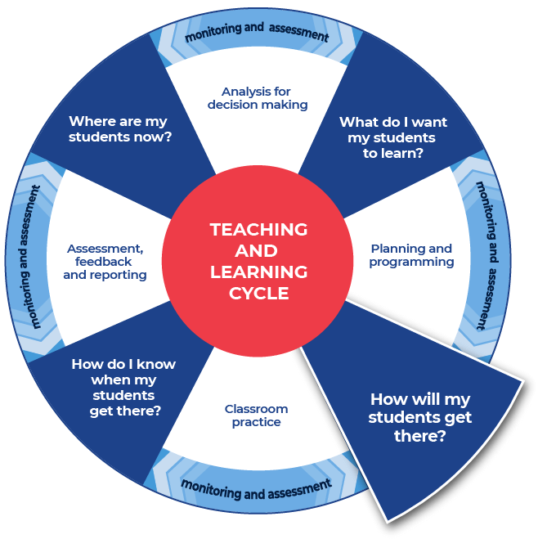

Instructions:
- Students create their own written response to a question that the teacher provides for their subject.
Differentiation:
- Teachers could create and use modelled writing that is relevant to their topic and chosen focus.
- Teachers could provide a structure that can be used to approach the writing.
- Teachers could model or scaffold sentences to demonstrate how the task could be approached, as well as illustrate the language used to address each level of complexity or depth in terms of the verbs in the question.
Further support:
- An example of the question for students to respond to has been provided from Industrial Technology. Teachers should create a question for their own context.
- A template for the response has been provided and teachers can modify this to create a template for their students and particular context.

Example
Clarify the intent of your major project by explaining clearly what is to be achieved and why.

Template
What are you making? (In a clear simple sentence, state what you are going to do.)
Why are you making it? (Give some background information, what is the reason behind making it.)
Where/how will it be used? (Put it in context, include an image or images if that will help, give the marker some insight as to what it will look like and how it will be placed.)
What sort of materials are you going to use in its construction? (You don’t need to know exactly what you will use yet, but you need to consider what properties they will need to have.)
Where will you source the materials and accessories from? (Think about the time available; does anything need to come from overseas; is it all available locally; what suppliers might you use; where else might you get stuff from if a problem occurs, or the supplier falls through.)
How much will you have to spend? (Pick a number, explain where it comes from. Is it based on similar existing products; is it a budget set by parents; has it been allocated by the school? Make sure you explain the reason for it. If it changes, explain why it changed and justify the changes in your finance plan.)
What research do you intend to do and why? (Think of all the known unknowns – all the things you don’t know yet, but will need to know in order to complete the project. Identify how you will find them out and why you need to know them.)
Create a mind map of everything you will need to research, consider, experiment with and obtain to produce your major project. (The more detail you put in here, the less likely you will forget about something along the way and miss an important detail. It also shows the marker what you intend to do moving forward.)
This is the end of Focus on skills section

Prepare to write

Activity 1: Select your resource

Instructions:
- Teachers support students as they prepare to create a written response.
- Teachers choose an appropriate website, article, video, or a source that is part of their lesson planning. This could be the same source that has been used for the vocabulary activities or a new source for students to engage with.
- Teachers provide the selected source to their students. Suggested sources could include course textbooks, journals and media articles.
Differentiation:
- Teachers ensure that they pre-read or view all sources provided to students and communicate the purpose and focus for using the source with students.
- Teachers could read/discuss the sources to or with students.
- Teachers ensure they have the question that their students will answer prepared and that engaging with this chosen source will support students in answering the set question for ‘Student writing and feedback’.
Further support:
- Technology Curriculum webpage
- HSC Hub – Technology
- Statewide staffroom – TAS NSW
- An example from Industrial Technology has been provided.

Example
Industry case study
For Activity 2 research and note take on aspects of Ikea’s sustainable practices. Use The IKEA Forest Positive Agenda webpage and one of the 3 templates provided.

Activity 2: Take effective notes

Instructions:
- Teachers model their own example to share with students. An example from Industrial Technology has been included.
- Students take notes as they engage with the text that their teacher has provided. A suite of note taking resources is provided.
- Students will write the information on their note taking template as they locate it in the text.
Differentiation:
- Teachers could provide different students with different scaffolds.
- Teachers may pre-fill some of the note taking template or include sentence starters to support student engagement and achievement.
- Teachers may provide a completely pre-filled example for students to work from.
Further support:
- Teachers may want to take the time to use the pre-written ideas and teaching strategies regarding Locating explicit information on the HSC minimum standard website.
- An example from Industrial technology has been provided. The example uses Ikea’s Being forest positive webpage. Teachers may also want to refer to the Hyne Timber – Our Mill Tour video for background information on sustainable forestry practices and timber conversion.
- Teachers use the examples provided as support to create their own examples for their students and context.

Example 1

Template
Title of source:
Type of source:
Who it is about:

When it occurred:

Where it occurred:

What happened?

Why did it happen?

How are people reacting to it?

Put 3 of the points that you have recorded in the categories above into a summarising paragraph of 3 to 4 sentences.

Completed example
Title of source: Being forest positive (Note: website content has changed since it was accessed in 2020. Updated content can be found on IKEA’s Wood and forestry webpage).
Type of source: Multi-media web page – video and text. (accessed …)
Who it is about:
IKEA and their use of wood in furniture production.
When it occurred:
The website is from the end of 2019 because the text states the following, ‘At the end of FY20 more than 98% of the wood used for IKEA products is either FSC-certified or recycled.’
Where it occurred:
IKEA is working with countries such as Indonesia.
What happened?
IKEA would like to use wood that is sustainably sourced. The video states that they use wood in their furniture because it is, ‘durable, renewable, recyclable, and beautiful’. They state that in their design processes they aim to make more with less and minimise wastage in production. They are working with World Wide Fund for Nature (WWF) and Forest Stewardship Council (FSC). The company would like to make a positive difference to climate change, to the forests and to the communities of those forests.
Why did it happen?
IKEA believes that climate change and non-sustainable forestry practices are linked. They would like to continue to use wood but do so in a sustainable way for climate, forests, and people. ‘Together, we want to make responsible wood sourcing the industry norm. For example, together with our partner WWF we have helped certify around 35 million hectares of forest, which is roughly the size of Germany!’
How are people reacting to it?
The text states that they are working with countries and organisations to source sustainably. ‘For example, we’ve partnered with WWF in Thailand and Rainforest Alliance in Indonesia to improve the practices of smallholder farmers. We’ll now use what we learnt to spread the FSC certification to more smallholders in Asia.‘ That appears to be a positive reaction. The company states that one of their aims is to make responsible forest management normal practice. ‘WWF and the IKEA business are committed to making responsible forest management the norm across the forest sector.’
Put 3 of the points that you have recorded in the categories above into a summarising paragraph of 3 to 4 sentences.
IKEA believes that climate change and non-sustainable forestry practices are linked. They would like to continue to use wood but to do so in a sustainable way for climate, forests, and people. They are working with World Wide Fund for Nature (WWF) and Forest Stewardship Council (FSC). The company would like to make a positive difference to climate change, to the forests and to the communities of those forests. The company states that one of their aims is to make responsible forest management normal practice. ‘WWF and the IKEA business are committed to making responsible forest management the norm across the forest sector.’

Example 2

Template
As you engage with the text create sentences that begin with the following:
Title of text:
Type of text:
Before

After

If

When

Even though

Although

Since

While

Unless

Whenever

Put some of the points that you have recorded in the categories above into a summarising paragraph of 3 to 4 sentences.

Completed example
As you engage with the source create sentences that begin with the following:
Title of source: Being forest positive (Note: website content has changed since it was accessed in 2020. Updated content can be found on IKEA’s Wood and forestry webpage).
Type of source: Multi-media web page – video and text.
Before wood suppliers can partner with Ikea they must comply with Ikea’s sustainable forestry requirements.
After 2020 Ikea would like to be obtaining 100% of its wood from sustainable sources.
If recycled wood and wood that is sourced from sustainable suppliers is used by all of Ikea’s products then Ikea believes that they will be helping to combat climate change.
When responsible wood sourcing is the normal practice then Ikea feels that it will be positive for the climate, the forests, and the people living around the forests.
Even though deforestation has been linked to climate change, Ikea still wants to use wood in their furniture production because they feel that it is beautiful and durable. They want to achieve this by only supporting sustainable forestry practices that are not harmful to the environment or to people that live there.
Although Ikea is promoting the use of sustainably sourced wood products they are not doing it alone. They are working with World Wide Fund for Nature (WWF) and the Forest Stewardship Council. ‘We work with global partners including WWF and Forest Stewardship Council (FSC) to fight forest degradation and deforestation and promote the importance of responsible forest management beyond our own value chain.’
Since people who live nearby to forests can be adversely affected if the forest’s management practices are not sustainable, Ikea is working toward making sustainable forestry practice the normal way to manage forests and thereby protect the livelihoods of the people living and working near the forests.
While they have been working towards 100% sustainable sourcing at the end of 2019 they were at 97% sustainable sourcing.
Unless companies such as Ikea take steps to seriously source sustainable products the climate and people will be negatively affected.
Whenever large companies steer production values in a particular way they have the momentum and reach to take suppliers, customers, organizations, and governments with them in the direction that they are going. That is that large companies have a lot of influence and must choose to act in a way that is positive for the environment and people rather than a way that is negative for the environment and people.
Put some of the points that you have recorded in the categories above into a summarising paragraph of 3 to 4 sentences.
Whenever large companies steer production values in a particular way they have the momentum and reach to take suppliers, customers, organizations, and governments with them in the direction that they are going. That is that large companies have a lot of influence and must choose to act in a way that is positive for the environment and people rather than a way that is negative for the environment and people. When responsible wood sourcing is the normal practice then Ikea feels that it will be positive for the climate, the forests, and the people living around the forests. Although Ikea is promoting the use of sustainably sourced wood products they are not doing it alone. They are working with World Wide Fund for Nature (WWF) and the Forest Stewardship Council. ‘We work with global partners including WWF and Forest Stewardship Council (FSC) to fight forest degradation and deforestation and promote the importance of responsible forest management beyond our own value chain.’ After 2020 Ikea would like to be obtaining 100% of its wood from sustainable sources.

Example 3

Template
Title of source:
Type of source:
Topic:
Events
People
Facts
Key words
Summary

Completed example
Title of source: Responsible Sourcing, Becoming Forest Positive
Type of source: Multi-media web page. Video and text.
Topic: Sustainable and responsible sourcing of wood for furniture
Events
Ikea is trying to get to 100% sustainable sourcing of wood.
They are working with non-government-organisations (NGOs) and various countries to influence forestry practices.
Ikea is trying to positively influence worldwide sustainable forestry. practices.
People
Ikea
World Wide Fud for Nature (WWF)
Forest Stewardship Council (FSC)
People (who live near the forests, work with the forests, customers, suppliers, governments)
Facts
Ikea believes that current forestry practices are leading to climate change and are negatively affecting people who live near and work with the forests.
They would like to promote and influence others to take up sustainable forestry practices. They only source their wood from responsible suppliers.
Key words
Wood furniture
Forestry practices
Sustainable, responsible sourcing
People of the forests
Summary
Ikea is trying to get to 100% sustainable sourcing of wood. Ikea believes that current forestry practices are leading to climate change and are negatively affecting people who live near and work with the forests. They are working with non-government-organisations (NGOs) and various countries to positively influence worldwide sustainable forestry.

Activity 3: Where to next
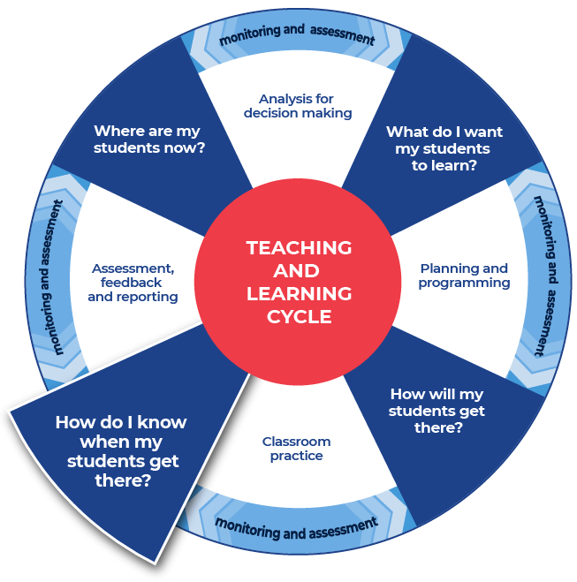

Instructions:
- Teachers provide the specific question or stimulus that their students will respond to.
- Students should create a plan and draft for their written response. They can use the notes that they have taken and any other information.
- Teachers provide students with time to draft their writing.
- Teachers provide students with formative feedback during the drafting process.
- Students will have time to write their response in the next section, Improve student writing through writing and feedback (DOCX | PDF).
Differentiation:
- The task could respond to a practice examination question, or it could be writing in response to a journal article.
Further support:
- Teachers and students could engage with the pre-written lesson content in the Ideas section on the HSC minimum standard website to support strengthening ideas.
- Teachers may also want to engage with the Text structure section on the HSC minimum standard website and use the persuasive text structure template provided on the website.

Example

Question
Describe how increasingly sustainable practices have benefited timber products and the furniture industry.
This is the end of the activities for: Improve student writing through explicit planning.
Teachers should move on to the next set of activities: Improve student writing through writing and feedback (DOCX | PDF).

Further support:
Teachers may find that students could benefit from support in other areas of their learning. More ideas and teaching strategies for literacy and numeracy can be found at the HSC minimum standard website. Here you will find teaching ideas and activities on:
Writing, including: text structure, paragraphs, cohesion, sentence types, tense, punctuation, formal and informal language, spelling, vocabulary, topic vocabulary, audience and purpose, ideas, language devices, and unpacking the writing prompt.
Numeracy, including: division, multiplication, fractions, decimals, percentages, rates, time, ratio, area, length and perimeter, mass, volume and capacity, mean, median and mode, chance, 3D objects, 2D shapes, patterns, formulae and substitution, positioning and locating, angles, and tables graphs and charts.
Reading, including: audience and purpose, locating explicit information, inferring, common language devices, parts of speech, cohesive devices, sentence types, tense, subject-verb agreement, punctuation, spelling, antonyms and synonyms and inferring word meanings.

