The National Literacy Learning Progression and Stage 6 Technological and Applied Studies

How the progression could support writing in Stage 6 Technological and Applied Studies
This document is part of the Stage 6 Literacy in context – Writing resource. It outlines ways that the National Literacy Learning Progression can support development of student writing through Stage 6.
The element of Writing in the National Literacy Learning Progression provides indicators that reflect the increasing sophistication of skill development in writing for students in Years K–10. It is important to note that these skills are unconstrained and will continue to develop as students work through their final years of school and beyond.
In addressing the Objectives and Outcomes in the Stage 6 Technological and Applied Studies (TAS) syllabuses, students need to use subject specific terminology, structure responses, describe, identify, investigate, demonstrate, apply, justify, critically apply, explore, explain, evaluate, and analyse.
A student’s ability to communicate their knowledge and understanding will influence the quality of their written responses. For example, the HSC marking criteria and feedback for TAS may include statements such as:
- provides a detailed explanation
- explain and justify decisions
- provide evidence
- appropriately structures response.
It can be difficult for teachers to articulate what effective writing ‘looks like’ in a student response, and therefore to be able to explicitly support their students to improve their writing. Certain indicators within the Creating texts sub-element of the National Literacy Learning Progression can amplify these criteria and support teachers and students to identify features of writing that can be targeted to improve the ability to answer extended response questions.
Some examples of these connections between the criteria and the Creating texts sub-element are provided here:
Provides a detailed explanation:
- uses discipline-specific terminology to provide accurate and explicit information (e.g. discipline metalanguage) (CrT10 Vocabulary)
- uses vocabulary for precision (e.g. the underwhelming performance of the opening batsmen) (CrT11 Vocabulary)
- uses complex abstractions (e.g. economic, sociocultural) (CrT11 Vocabulary).
Explain and justify decisions:
- writes sustained, robust arguments on complex learning area topics (e.g. should bushrangers be afforded hero status?) (CrT11 Crafting ideas)
- uses sophisticated evaluative language devices such as allusion, evocative vocabulary and extended metaphor (CrT11 Text forms and features)
- creates sustained, informative texts that precisely explain, analyse and evaluate concepts or abstract entities (CrT11 Crafting ideas).
Provide evidence:
- uses citation and referencing from authoritative sources (CrT11 Crafting ideas)
- uses evidence and research including digital resources to expand upon information and elaborate concepts (CrT10 Crafting ideas)
- uses evidence and references (CrT11 Crafting ideas).
Appropriately structures response:
- maintains tone appropriate to the audience (CrT11 Text forms and features)
- organises related information and ideas into paragraphs/sections (CrT10 Generic indicators)
- uses structural features flexibly to organise ideas strategically (e.g. includes a defined, cogent summation or call to action) (CrT11 Crafting ideas).

Using the National Literacy Learning Progression to inform feedback
Before you begin you may like to learn more about the National Literacy Learning Progression through the online professional learning course: Introduction to the Literacy and Numeracy Progressions.
For example, Writing sub-elements include:

- Creating texts – Crafting ideas
- Creating texts – Text forms and features
- Creating texts – Vocabulary
- Grammar
- Punctuation
- Spelling
- Handwriting/keyboarding.
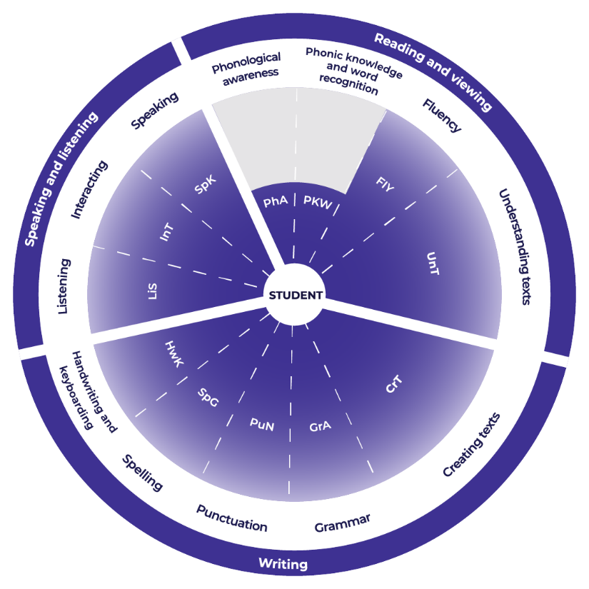

Teachers could use the student’s written response to assess where the student is at now and what they could do next to improve.

Example analysis
For this example, the categories of Crafting ideas and Text forms and features have been selected from the Creating texts sub-element.
The teacher reads through the sub-element indicators to match characteristics that the student’s text is currently displaying. An example from Industrial Technology is provided.
CrT10 Crafting ideas:
- orients the reader clearly to the topic or concept (e.g. using a definition or classification in the opening paragraph) (CrT10 Crafting ideas)
- uses evidence and research to expand upon information and elaborate concepts (CrT10 Crafting ideas)
- creates texts to discuss, evaluate and review (e.g. evaluates and reviews design ideas) (CrT10 Crafting ideas).
CrT 11 Text forms and features:
- (overall) maintains tone appropriate to the audience (CrT11 Text forms and features).

Example response
The timber products and furniture industry relies on the supply of timber for its ongoing operation. In order for this to be maintained over the coming years there is a need for sustainable practices to be adopted across the sector.
Companies, such as Ikea who source from over 50 countries worldwide and can have a big impact on forestry practices, are sourcing timber that is harvested from sustainably managed forests, both in Australia and overseas. This ensures that they can maintain a steady supply of the raw material to make their products. If the timber is harvested from old growth forests and through slash and burn practices, where the areas are cleared for farming crops then the trees cannot be replaced and the resource is finite. The impact on the environment is also a major consideration and these practices destroy ecosystems and increase the rate of global warming.
Instead of this, companies are sourcing their timber from plantation forests, where the trees are planted and managed like any other crop, just one that takes longer to reach maturity, but one that wouldn’t have been there absorbing carbon dioxide from the atmosphere had we not planted them. The trees are planted on mass and then thinned out as they grow so that only the selected trees, based on their shape and structure, remain to maturity or to when they are harvested. This way the remaining trees are straighter, stronger and will have less defects, which translates to more useable timber. This process doesn’t just benefit the manufacturers in the industry, it also creates extra jobs in this sector of the operation.
Reading the indicators in the next level of the sub-element, the teacher could work out where to next for the student:
- uses citation and referencing from authoritative sources (CrT11 Crafting texts)
- spells a range of challenging words correctly (CrT11 Generic indicators).
For example, in the written response:
- Student could ensure that they continue to practice writing responses that include supporting detail from a source text. Additionally, they could ensure that they maintain their vocabulary skills to enable them to continue to effectively respond.

Example of written feedback to the student
Name: Rose Yeung
Is able to:
- orient the reader to the topic or concept
- expand upon information and concepts and add authority
- use supporting evidence
- write to discuss, evaluate and review
- she is also able to maintain an expert tone appropriate to the audience.
To continue to improve:
Rose could:
- ensure that she continues to practice writing responses that include supporting detail from a source text. Additionally, she could ensure that she maintains her vocabulary skills to enable her to continue to effectively respond.

Template
Feedback to student.
Name: ____________________________________
Is able to:

To continue to improve:

