Planning for writing – Stage 6 Science

Sequence
To get the most from these resources they should be used as a teaching and learning sequence. One set of activities leads on to the next.
- Improve student writing through subject vocabulary (DOCX | PDF)
- Improve student writing through planning for writing (this document)
- Improve student writing through writing and feedback (DOCX | PDF).

Learning focus
With these literacy activities teachers use content that they have planned in their teaching and learning cycle. For each literacy activity an example from Biology has been provided. The example is a model for teachers. Teachers create their own specific examples for their subject and class. Teachers can modify the learning intentions and success criteria to reflect their context.
Through engaging with this resource teachers may find that their students could benefit from support in other areas of their learning. For more ideas and teaching strategies on literacy and numeracy go to the HSC minimum standard website. Here you will find teaching ideas and activities on:
Writing, including: text structure, paragraphs, cohesion, sentence types, tense, punctuation, formal and informal language, spelling, vocabulary, topic vocabulary, audience and purpose, ideas, language devices, and unpacking the writing prompt.
Numeracy, including: division, multiplication, fractions, decimals, percentages, rates, time, ratio, area, length and perimeter, mass, volume and capacity, mean, median and mode, chance, 3D objects, 2D shapes, patterns, formulae and substitution, positioning and locating, angles, tables, graphs and charts, vocabulary in numeracy, interpreting questions and grammar for numeracy.
Reading, including: audience and purpose, locating explicit information, inferring, common language devices, parts of speech, cohesive devices, sentence types, tense, subject-verb agreement, punctuation, spelling, antonyms and synonyms, inferring word meanings.

Syllabus outcomes
For each science subject, relevant syllabus outcomes have been provided in the Stage 6 Science syllabus links (PDF 91 KB) document.

Learning intentions
- Students investigate what makes effective writing.
- Students analyse sample written responses.
- Students develop note taking skills.
- Students develop confidence writing in response to stimulus.

Success criteria
- Students are able to articulate aspects of effective writing.
- Students are able to practise their writing skills.
- Students are able to take effective notes.
- Students are able to plan their writing.

Teaching strategies
Focus on skills:
- Activity 1: Review annotated samples
- Activity 2: Warm up writing activity.
Prepare to write:
- Activity 1: Select your resource
- Activity 2: Take effective notes
- Activity 3: Where to next.

Focus on skills

Activity 1: Review annotated samples

Instructions:
- Teachers provide a sample question and sample written response and annotate some of the features of effective writing on that response. An example from Biology has been included.
- Teachers create examples themselves or source them from: the Science statewide staffroom, previous year groups, local teacher networks, professional associations (for example, the Science Teachers’ Association of NSW), or NESA publications.
- Teachers can use the National Literacy Learning Progression to help track students’ literacy skills. Improving students’ literacy skills will enable students to communicate their ideas in a more succinct manner.
- Students will be asked to complete an analysis of the writing, after discussing and reviewing the written samples. A template is provided.

Example question
Use the following data to answer parts (a) and (b).
Malaria and dengue fever are examples of infectious diseases. They are transmitted between humans by mosquitoes. Malaria is caused by a single-celled organism transmitted by mosquitoes of the genus Anopheles. Dengue fever is caused by a virus transmitted by mosquitoes of the genus Aedes. The following data provides information about the global incidence over time of these 2 diseases.
Global malaria data for selected years from 1900 to 2010.
Year | Number of countries with reported cases | Global population (billions) | Population at risk (billions) | Population at risk (%)
1900 | 140 | 1.2 | 0.9 | 77
1946 | 130 | 2.4 | 1.6 | 68
1965 | 103 | 3.4 | 1.9 | 57
1975 | 91 | 4.1 | 2.1 | 51
1992 | 88 | 5.4 | 2.6 | 47
2002 | 88 | 6.2 | 3.0 | 48
2010 | 88 | 6.8 | 3.4 | 50
Distribution of reported cases of dengue fever in 1950 and 2010
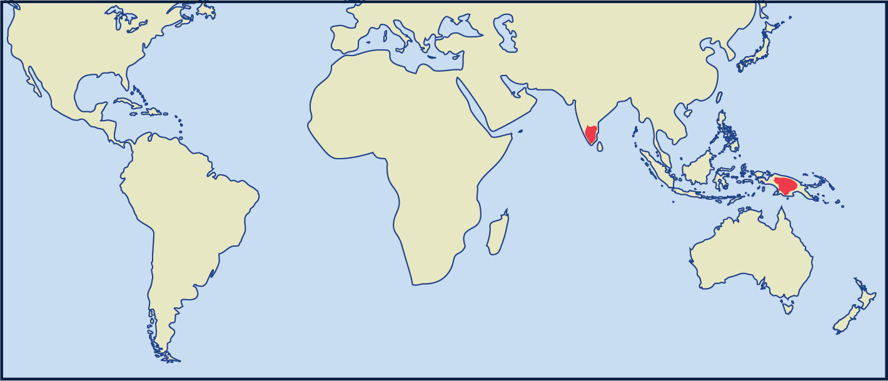
1950
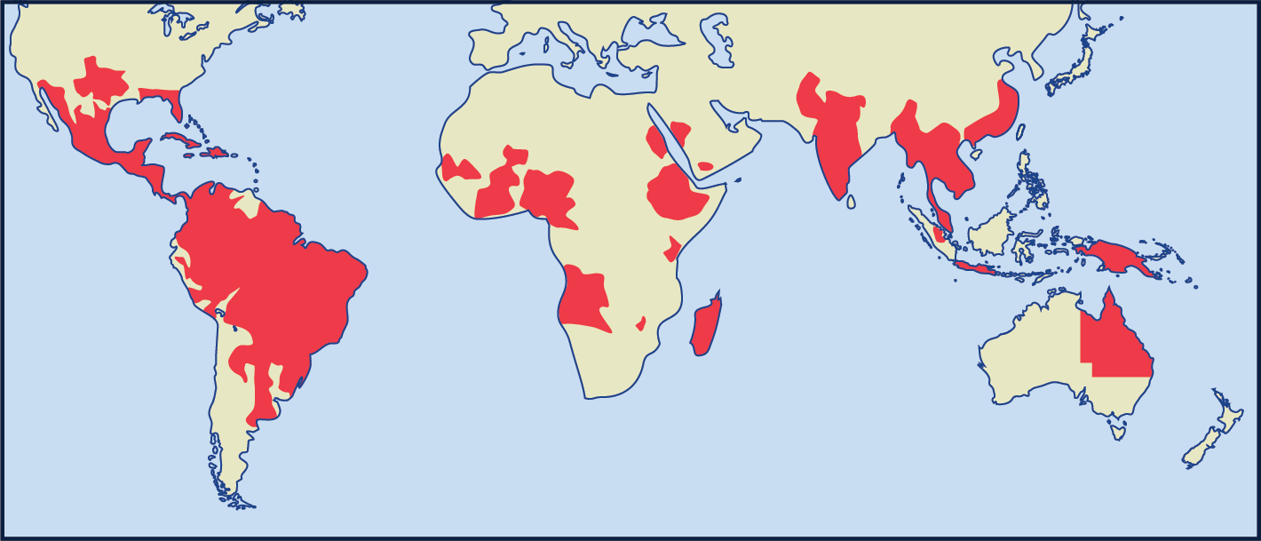
2010
        - Using the data provided, identify trends in the global disease burden for both dengue fever and malaria.
        - Analyse factors that could have contributed to the change in global distribution of both malaria and dengue fever over the last 100 years. Support your answer by referring to the data provided.

Sample low-range response for (a)
- Using the data provided, identify trends in the global disease burden for both dengue fever and malaria.
Malaria percentage has decreased from 1900–2010, whereas the number of dengue fever cases has increased from 1950–2010.

Annotations
Malaria percentage has decreased from 1900–2010, whereas the number of dengue fever cases has increased from 1950–2010.
- uses punctuation to clarify meaning in complex sentences, drawing on their knowledge of sentence structure (e.g. commas before introductory words, phrases or clauses; semicolons; colons; and dashes) (PuN8)
- uses a range of learnt, technical and discipline-specific terms (e.g. adapt, survive) (CrT9)
- uses vocabulary to indicate and describe relationships (e.g. additionally, similarly) (CrT10)
- spells multisyllabic words including some with more complex letter patterns (e.g. democracy) (SpG12)
- To improve:
  - reference the data provided in the question to support the answer
  - add at least one more sentence to support the observation (Marking criteria).

Sample high-range response for (a)
The burden of malaria as a global disease has decreased. This is evidenced by the significant decrease in the number of countries reporting malaria cases (140–88). Additionally, there has been decrease in the population at risk from malaria from 75% to 50% and drop of 27% in the time period 1900–2010.
The number of reported cases of dengue fever has significantly increased from 1950–2010. In 1950 it was contained to a few small regions mostly in the South Pacific. This has increased with all southern continents reporting cases of dengue fever.

Annotations
The burden of malaria as a global disease has decreased. This is evidenced by the significant decrease in the number of countries reporting malaria cases (140–88). Additionally, there has been decrease in the population at risk from malaria from 75% to 50% and drop of 27% in the time period 1900–2010.
The number of reported cases of dengue fever has significantly increased from 1950–2010. In 1950 it was contained to a few small regions mostly in the South Pacific. This has increased with all southern continents reporting cases of dengue fever.
- uses punctuation to clarify meaning in complex sentences, drawing on their knowledge of sentence structure (e.g. commas before introductory words, phrases or clauses; semicolons; colons; and dashes) (PuN8)
- uses a range of learnt, technical and discipline-specific terms (e.g. adapt, survive) (CrT9)
- uses vocabulary to indicate and describe relationships (e.g. additionally, similarly) (CrT10)
- uses evidence and references (CrT11)
- spells multisyllabic words including some with more complex letter patterns (e.g. democracy) (SpG12)
- Overall:
  - structures response in 2 sections to explain each idea clearly
  - creates texts to compare and contrast phenomena (e.g. identifies the similarities and differences between species of animals) (CrT10)
- identifies relevant global trends in malaria and dengue fever and supports response with the data provided (Marking criteria).

Sample low-range response for (b)
- Analyse factors that could have contributed to the change in global distribution of both malaria and dengue fever over the last 100 years. Support your answer by referring to the data provided.
Global distribution of both malaria and dengue fever has been aided by the ease at which people can travel from one country to the next. This has allowed the disease to spread too many more countries. If a person is infected and they get on a plane they can transmit it to other passengers who in turn infect others. These passengers can be travelers from across the world and can take it with them as they return to their point of origin resulting in the disease being spread to many countries. The map of reported dengue fever cases shows a significant increase in countries having the virus between 1950 and 2010. Although the percentage of people in the world at risk from malaria has decreased the population at risk is still high with 3.4 billion people at risk in 2010 compared to 0.9 billion in 1900.
Advancements in medicine have assisted in reducing the number of malaria cases in people over the last 100 years but don’t seem to be as effective for dengue fever. Vaccines and pharmaceuticals, such as antibiotics and antimalarial drugs, have assisted in lowering the percentage population at risk of malaria by 27% between 1900 and 2010.

Annotations
Global distribution of both malaria and dengue fever has been aided by the ease at which people can travel from one country to the next. This has allowed the diseases to spread too many more countries. If a person is infected and they get on a plane they can transmit it to other passengers who in turn infect others. These passengers can be travelers from across the world and can take it with them as they return to their point of origin resulting in the disease being spread to many countries. The map of reported dengue fever cases shows a significant increase in countries having the virus between 1950 and 2010. Although the percentage of people in the world at risk from malaria has decreased the population at risk is still high with 3.4 billion people at risk in 2010 compared to 0.9 billion in 1900.
Advancements in medicine have assisted in reducing the number of malaria cases in people over the last 100 years but don’t seem to be as effective for dengue fever. Vaccines and pharmaceuticals, such as antibiotics and antimalarial drugs, have assisted in lowering the percentage population at risk of malaria by 27% between 1900 and 2010.
- uses passive voice and nominalisation to write succinctly (e.g. the results were analysed) (CrT10)
- uses vocabulary to indicate and describe relationships (e.g. additionally, similarly) (CrT10)
- uses discipline-specific terminology to provide accurate and explicit information (e.g. discipline metalanguage) (CrT10)
- uses evidence and references (CrT11)
- spells multisyllabic words including some with more complex letter patterns (e.g. democracy) (SpG12)
- Overall:
  - writes well-structured sentences, rarely making grammatical errors (GrA7)
  - uses punctuation to clarify meaning in complex sentences (PuN8)
  - uses punctuation to clarify meaning in complex sentences, drawing on their knowledge of sentence structure (e.g. commas before introductory words, phrases or clauses; semicolons; colons; and dashes) (CrT10)
  - makes more sophisticated connections between ideas by creating complex sentences expressing relationships of cause, reason, concession (Gr7)
  - organises related information and ideas into paragraphs/sections (CrT10)
  - orients the reader to the topic or concept (e.g. using a definition or classification in the opening paragraph) (CrT10) – first line and response structure.
- explains one sound factor that impacts the spread. To improve could include another factor (Marking criteria).

Sample high-range response for (b)
Malaria is still a major cause of disease and death around the world. Even though the number of countries reporting cases has declined over the last 100 years, 50% of the world’s population is still at risk. There have been a number of measures used to try to control this disease across the world, which helps to explain the decrease in the number of countries reporting cases. However, many of the countries where malaria is endemic are also some of the poorest and most populous in the world. This presents problems in ensuring that people can have access to both the drugs and other preventative measures needed. In addition, resistance has developed to both the insecticides used to control the Anopheles mosquito and the drugs used to treat the Plasmodium sp protozoan.
Dengue fever distribution has expanded enormously from 1950 until the present, extending across South and Central America, parts of Africa, Asia and Australia. The virus is transmitted by mosquitoes, and like malaria, the distribution of the disease is related to the distribution of the vector mosquito. Some infections of dengue fever can cause only relatively mild symptoms, but second and third infections can cause very serious illness. The expansion of this disease worldwide has been influenced by population growth and development in many of the areas in which dengue is mainly concentrated (Asia) but also in the rapid expansion of global travel, as well as the widespread distribution of the Aedes sp mosquitoes. Another factor that could help to explain the increase in the distribution of dengue is greater reporting of the disease. Historically, many cases of dengue fever may have gone unreported or misdiagnosed.
The distribution of both diseases is also thought to be influenced by climate change and global warming, as this is widening the area inhabited by the vector mosquito species.

Annotations
Malaria is still a major cause of disease and death around the world. Even though the number of countries reporting cases has declined over the last 100 years, 50% of the world’s population is still at risk. There have been a number of measures used to try to control this disease across the world, which helps to explain the decrease in the number of countries reporting cases. However, many of the countries where malaria is endemic are also some of the poorest and most populous in the world. This presents problems in ensuring that people can have access to both the drugs and other preventative measures needed. In addition, resistance has developed to both the insecticides used to control the Anopheles mosquito and the drugs used to treat the Plasmodium sp protozoan.
Dengue fever distribution has expanded enormously from 1950 until the present, extending across South and Central America, parts of Africa, Asia and Australia. The virus is transmitted by mosquitoes, and like malaria, the distribution of the disease is related to the distribution of the vector mosquito. Some infections of dengue fever can cause only relatively mild symptoms, but second and third infections can cause very serious illness. The expansion of this disease worldwide has been influenced by population growth and development in many of the areas in which dengue is mainly concentrated (Asia) but also in the rapid expansion of global travel, as well as the widespread distribution of the Aedes sp mosquitoes. Another factor that could help to explain the increase in the distribution of dengue is greater reporting of the disease. Historically, many cases of dengue fever may have gone unreported or misdiagnosed.
The distribution of both diseases is also thought to be influenced by climate change and global warming, as this is widening the area inhabited by the vector mosquito species.
- makes more sophisticated connections between ideas by creating complex sentences expressing relationships of cause, reason, concession (Gr7)
- orients the reader clearly to the topic or concept (e.g. using a definition or classification in the opening paragraph) (CrT10)
- uses discipline-specific terminology to provide accurate and explicit information (e.g. discipline metalanguage) (CrT10)
- Overall:
  - organises related information and ideas into paragraphs sections (CrT10)
  - addresses the question with regards to plural factors that could have contributed to change (Marking criteria)
  - displays all of the literacy skills as the first example for (b) including: sentences, punctuation, spelling, grammar, crafting of ideas, text structure. However, the addition of several factors that have contributed to change makes this a stronger response (Marking criteria).

Review annotated samples
- Students read through the example responses to question (a) and (b).
- Students choose one of the sample responses.
- Students respond to the analysis questions on the template provided.

Template

What do you notice?
How was the answer structured?

Were words from the question used in the answer?

What do you notice about the sentences?

Identify and re-write an idea that was contained in the sample response?

What did you like about the response?

Completed example

What do you notice?
How was the answer structured?
The answer is structured in a logical way where cause and effect were clearly communicated.
Were words from the question used in the answer?
Yes, words from the question were used and explained in the answer. They were elaborated upon. Supporting evidence from the table and map was included.
What do you notice about the sentences?
Sentences were sometimes short and simple. However, there were compound and complex sentences to explain ideas.
Identify and re-write an idea that was contained in the sample response?
Another factor that could help to explain the increase in the distribution of dengue is greater reporting of the disease. Historically, many cases of dengue fever may have gone unreported or misdiagnosed.
Re-write = In the past, cases of dengue fever may not have been reported and in some instances the fever may have been diagnosed as something else. Nowadays, better reporting and diagnosis could be one of the factors increasing the number of cases recorded.
What did you like about the response?
I appreciated the details. The details supported my understanding of what they were writing about. I believed their ideas more when they used evidence to support the ideas.

Additional support for Activity 1
Please note that there are several supports to help teachers improve writing.
Teachers could use their marking criteria to assess written responses and provide feedback.
In some contexts, you could use the Literacy Learning Progression. While primarily focused at K–10, it will provide sound ideas on aspects of writing and how to improve.
For more ideas on what to look for in literacy you may like to complete the online course: Introduction to the Literacy and Numeracy Progressions.

Activity 2: Warm up writing activity
In approaching a writing task it is useful to deconstruct the question and provide a structure that can be used to approach the writing. The following activities provide structure for improving writing skills. The structures reflect the questions that were used in Activity 1.
As questions become progressively more challenging teachers could follow these steps to model how best to approach writing tasks for students:
- identify trends in the data
- explain the trends
- analyse and or question the data
- evaluate the data.

Instructions:
- Teachers provide their specific examples and ask students to write responses using the templates provided.
- Teachers could create and use modelled writing that is relevant to their topic and chosen focus. A modelled example from the questions used in Activity 1 has been provided for teachers to adapt to their own context.
Further support:
- Modelled sentences from Biology that have been provided demonstrate how the task could be approached. These illustrate the language used to address each level of complexity or depth in terms of the verbs in the question.

Examples

Identify trends

Template
The map shows …
The graph …
There is an increase/decrease in incidence between …

Completed example
The dengue fever map illustrates a significant change in the distribution.
Global malaria data shows an increase in the global population as a whole, as well as an increase in the number of people at risk of malaria between 1900 and 2010.
There has been an increase in the global population but a decrease in the number of countries with reported cases.

Explain trends

Template
One explanation for …
The increase/decrease could be explained by …
(Possible) Reasons for the changes include …
The data reflects the impact of the following initiatives …

Completed example
One explanation for the increase in the global spread of dengue fever could be a result of the much greater ease and accessibility of travel across the globe.
The decrease in the number of countries reporting malaria could be explained by the success of prevention measures including insecticides and medicines.
Reasons for the increase in global spread could include climate change, expanding the areas that the vectors of these diseases can survive.
The data reflects the impact of increasing temperatures on the distribution of the vectors.

Analyse/question data

Template
While the graph shows …, it does not include …
Although the figures for … show a decline, there is no comparable data for …
One possible explanation for this change could be …
Although both sources include …, the sample populations were …

Completed example
While the map shows the rapid expansion of dengue fever across the globe, it does not provide quantitative data regarding the number of cases in each country.
Although the figures for malaria show a decline in the number of countries reporting cases, the data also shows that 50% of the world’s population is still at risk.
One possible explanation for this change could be increasing global temperatures, allowing for the expansion of areas that the vectors can survive.
Although both sources include numbers of reported cases, there is no information about whether methods of reporting have changed.

Evaluate data

Template
This data is extremely useful in confirming …
The data supports/does not support … as it …
While the data is helpful to illustrate … further …

Completed example
This data is extremely useful in confirming that both malaria and dengue fever continue to be significant diseases across the globe.
The data supports the effectiveness of efforts to control malaria to some extent.
While the data is helpful to illustrate changes in distribution and incidence of these diseases, further information is needed to understand the many contributing factors.
This is the end of Focus on skills section

Prepare to write

Activity 1: Select your resource

Instructions:
- Teachers support students as they prepare to create a written response.
- Teachers choose an appropriate website, article, video, or a text that is part of their lesson planning. This could be the same text that has been used for the vocabulary activities or a new text for students to engage with.
- Teachers provide the selected text to their students. Suggested texts could include course textbooks, scientific journals, media articles (including web-based scientific journals or popular science magazines).
Differentiation:
- Teachers ensure that they pre-read or view all texts provided to students and communicate the purpose and focus for using the source with students.
- Teachers could read the texts to or with students.
- Teachers ensure they have the question that their students will answer prepared and that engaging with this chosen text will support students in answering the set question for ‘Student writing and feedback’.
Further support:
- Included is a Biology example from the article: Is Ebola Evolving Into a Deadlier Virus? Richard Preston, The New Yorker, August 7, 2019.

Activity 2: Take effective notes

Instructions:
- Teachers model their own example to share with students. An example from Biology has been included.
- Students take notes as they engage with the text that their teacher has provided. A suite of note taking resources is provided.
- Students will write the information on their note taking template as they locate it in the text.
Differentiation:
- Teachers could provide different students with different scaffolds.
- Teachers may pre-fill some of the note taking template or include sentence starters to support student engagement and achievement.
- Teachers may provide a completely pre-filled example for students to work from.
Further support:
- Teachers may want to take the time to use the pre-written ideas and teaching strategies regarding Locating explicit information on the HSC minimum standard website.
- For the biology examples a specific text has been chosen: Is Ebola Evolving Into a Deadlier Virus? Richard Preston, The New Yorker, August 7, 2019.

Example 1

Template
Title of text:
Type of text:
Who it is about:

When it occurred:

Where it occurred:

What happened?

Why did it happen?

How are people reacting to it?

Put 3 of the points that you have recorded in the categories above into a summarising paragraph of 3 to 4 sentences.

Completed example
Title of text: Is Ebola evolving into a deadlier virus?
Type of text: written article
Who it is about:
The article talks about the World Health Organisation (W.H.O.) declaring an outbreak of Ebola in the Democratic Republic of the Congo (DRC) in Africa.
When it occurred:
This particular strain of the virus was first found in the area in 2018.
Where it occurred:
Democratic Republic of the Congo (DRC) Africa.
What happened?
An outbreak of Ebola occurred, and the source of the outbreak was not clear.
Why did it happen?
Ebola is a highly infectious virus. People die from it. The region is politically unstable which adds to the problem. There is little available money to effectively provide the vaccine.
How are people reacting to it?
Some people in the region falsely believe that doctors who are trying to provide the vaccine are instead infecting people. Scientists are trying to work out how Ebola mutates.
Put 3 of the points that you have recorded in the categories above into a summarising paragraph of 3 to 4 sentences.
Ebola is a highly infectious virus that people die from. In 2018 an outbreak occurred in the Democratic Republic of the Congo (DRC). The region is politically unstable, and some people believed that doctors were infecting people when they were trying to vaccinate them. The World Health Organisation (W.H.O.) is trying to raise enough money to effectively provide the vaccine. Scientists continue to monitor the mutations of the virus.

Example 2

Template
As you engage with the text create sentences that begin with the following:
Title of text:
Type of text:
Before

After

If

When

Even though

Although

Since

While

Unless

Whenever

Put some of the points that you have recorded in the categories above into a summarising paragraph of 3 to 4 sentences.

Completed example
As you engage with the text create sentences that begin with the following:
Title of text: Is Ebola evolving into a deadlier virus?
Type of text: written article
Before Ebola can be controlled; people need to be vaccinated.
After the Ebola virus enters a person’s bloodstream it breaks into cells in that person’s body and makes copies of itself inside those human cells.
If someone does not realise that they have Ebola they will easily transmit it to other people.
When someone has Ebola, they will suffer from symptoms including, diarrhea, vomiting, coughing, dementia, rash, hiccups, and hemorrhages. Patients with Ebola go into shock and die suddenly.
Even though doctors and nurses are trying to help by administering the vaccine. Some people in the population falsely believe that doctors and nurses are spreading the virus.
Although there is a terrible loss of life, the money required to halt the outbreak has not yet been found.
Since the Ebola virus mutates when it replicates itself, Scientists wonder if it is becoming more deadly to humans.
While the Ebola virus is microscopic its genome, the recipe for making it, has around nineteen thousand bases in it.
Unless the virus is brought under control people will continue to die, for example in the 2013 outbreak in Guinea eleven thousand people died.
Whenever there is an outbreak of Ebola there is the risk that it will spread to other regions of the world. The 2013 outbreak in Guinea led to eleven cases in America.
Put some of the points that you have recorded in the categories above into a summarising paragraph of 3 to 4 sentences.
While the Ebola virus is microscopic its genome, the recipe for making it, has around nineteen thousand bases in it. Since the Ebola virus mutates when it replicates itself, Scientists wonder if it is becoming more deadly to humans. Unless the virus is brought under control people will continue to die, for example in the 2013 outbreak in Guinea eleven thousand people died. Whenever there is an outbreak of Ebola there is the risk that it will spread to other regions of the world. The 2013 outbreak in Guinea led to eleven cases in America.

Example 3

Template
Title of text:
Type of text:
Topic:
Events
People
Facts
Key words
Summary

Completed example
Title of text: Is Ebola evolving into a deadlier virus?
Type of text: written article.
Topic: infectious diseases.
Events
Ebola outbreak 2018 in the DRC.
Attacks on health workers.
Outbreak in Guinea in 2013 led to eleven cases in America.
2014–2015 outbreak in West Africa.
People
The World Health Organisation (WHO).
The Democratic Republic of the Congo (DRC).
Doctors without borders.
General population.
Facts
Ebola is a microscopic virus that mutates as it replicates itself.
There is a vaccine, it takes money to administer it. The money is not there.
Ebola particles copy themselves every eighteen hours.
Key words
Virus
Ebola
Death
Ebola is mutating to get better at infecting humans.
Summary
Ebola is a microscopic virus that mutates as it replicates itself. There is a vaccine, it takes money to administer it. The money is not there. Ebola particles copy themselves every eighteen hours. There have been several outbreaks in the last ten years and some cases have been reported in America. Scientists wonder if the Ebola virus is mutating to get better at infecting humans.

Activity 3: Where to next

Instructions:
- Teachers provide the specific question or stimulus that their students will respond to.
- Students should create a plan and draft for their written response. They can use the notes that they have taken and any other additional information. For written structure students could use the knowledge that they have built through reflecting on the written samples in the previous lesson.
- Teachers provide students with time to draft their writing.
- Teachers provide students with formative feedback during the drafting process.
Differentiation:
- The task could respond to a practice examination question, or it could be writing in response to a journal article. For example, reading the article and responding to an overarching question such as: ‘Why does the pattern of replication of a pathogen present a problem for the development of a vaccine?’.
Further support:
- Teachers and students could engage with the pre-written lesson content in the Ideas section on the HSC minimum standard website to support strengthening ideas.
- Teachers may also want to engage with the Text structure section on the HSC minimum standard website and use the persuasive text structure template provided on the website.

Example

Question
- Describe ONE adaptation of a specific pathogen that facilitates its entry into a host.

- Explain how the spread of diseases is influenced by the mode of transmission of pathogens.

This is the end of the activities for: Improve student writing through planning for writing.
Teachers should move on to the next set of activities: Improve student writing through writing and feedback (DOCX | PDF).

