The National Literacy Learning Progression and Stage 6 Science

How the progression could support writing in Stage 6 Science
This document is part of the Stage 6 Literacy in context – Writing resource. It outlines ways that the National Literacy Learning Progression can support development of student writing through Stage 6.
The element of Writing in the National Literacy Learning Progression provides indicators that reflect the increasing sophistication of skill development in writing for students in Years K–10. It is important to note that these skills are unconstrained and will continue to develop as students work through their final years of school and beyond. In addition, while the progression reflects the literacy development necessary for successful learners, many students will continue to develop and consolidate these skills beyond this timeframe.
In addressing the Working Scientifically Communicating* outcome of the Stage 6 Science courses, students need to demonstrate their skills in a variety of ways, including ultimately writing extended responses in the HSC examinations.
“A student communicates scientific understanding using suitable language and terminology for a specific audience or purpose.”
(Stage 6 Science Syllabuses © NSW Education Standards Authority (NESA) for and on behalf of the Crown in right of the State of New South Wales, 2019.)
A student’s ability to communicate their knowledge and understanding will influence the quality of their written responses. For example, marking criteria for written short and extended response questions may include statements such as:
- communicates logically and succinctly with precise (biological) terms (Biology HSC 2019 Q 32b, 7 marks)
- makes a suitable judgement/justifies a suitable judgement (Biology HSC 2019,
Q 33d, 8 marks)
- utilises data to support arguments and judgement (Biology HSC 2019, Q 33d,
8 marks)
- articulates a succinct and logical response/communicates logically and succinctly with precise biological terms (Biology HSC 2019, Q 33d, 8 marks)
- demonstrates a coherent and logical progression of thought and consistently uses appropriate scientific terminology (Earth and Environmental Science HSC 2019 Q 35, 9 marks).
It can be difficult for teachers to articulate what effective writing ‘looks like’ in a student response, and therefore to be able to explicitly support their students to improve their writing. Certain indicators within the Creating texts sub-element of the National Literacy Learning Progression can amplify these criteria and support teachers and students to identify features of writing that can be targeted to improve students’ ability to answer extended response questions.
Some examples of these connections between the criteria and the Creating texts sub-element are provided here:
Communicate logically and succinctly:
- organises related information and ideas into paragraphs/sections (CrT10 Generic indicators)
- writes sustained, informative texts that precisely explain, analyse and evaluate concepts or abstract entities (CrT11 Crafting ideas)
- uses structural features flexibly to organise ideas strategically (e.g. includes a defined, cogent conclusion / summation) (CrT11 Crafting ideas)
Use precise/consistent (scientific) terminology:
- uses discipline-specific terminology to provide accurate and explicit information (e.g. discipline metalanguage) (CrT10 Vocabulary)
- uses vocabulary for precision (e.g. the underwhelming performance of the opening batsmen) (CrT11 Vocabulary)
- uses complex abstractions (e.g. economic, societal) (CrT11 Vocabulary).
Make/justify a suitable judgement:
- writes sustained, robust arguments on complex learning area topics (e.g. should bushrangers be afforded hero status?) (CrT11 Crafting ideas)
- uses sophisticated evaluative language such as allusion, evocative vocabulary and extended metaphor (CrT11 Text forms and features).
Use data to support arguments and judgement:
- uses evidence and research including digital resources to expand upon information and elaborate concepts (CrT10 Crafting ideas)
- judiciously selects evidence and language to strengthen arguments (CrT10 Text forms and features)
- uses citation and references from authoritative sources (CrT11 Crafting ideas).
Demonstrate coherent and logical progression of thought:
- creates cohesive flow by condensing previous information into a summarising noun (e.g. a series of tumultuous events culminated in the outbreak of WWII – modern history’s turning point) (CrT10 Text forms and features)
- maintains tone appropriate to the audience (CrT11 Text forms and features)
- uses structural features flexibly to organise ideas strategically (e.g. includes a defined, cogent conclusion / summation) (CrT11 Crafting ideas)
- positions the reader effectively by providing a clear thesis and relevant context (e.g. by previewing the arguments) (CrT11 Crafting ideas)

Using the National Literacy Learning Progression to inform feedback
Before you begin you may like to learn more about the National Literacy Learning Progression through the online professional learning course: Introduction to the Literacy and Numeracy Progressions.
For example, Writing sub-elements include:
- Creating texts – Crafting ideas
- Creating texts – Text forms and features
- Creating texts – Vocabulary
- Grammar
- Punctuation
- Spelling
- Handwriting/keyboarding.
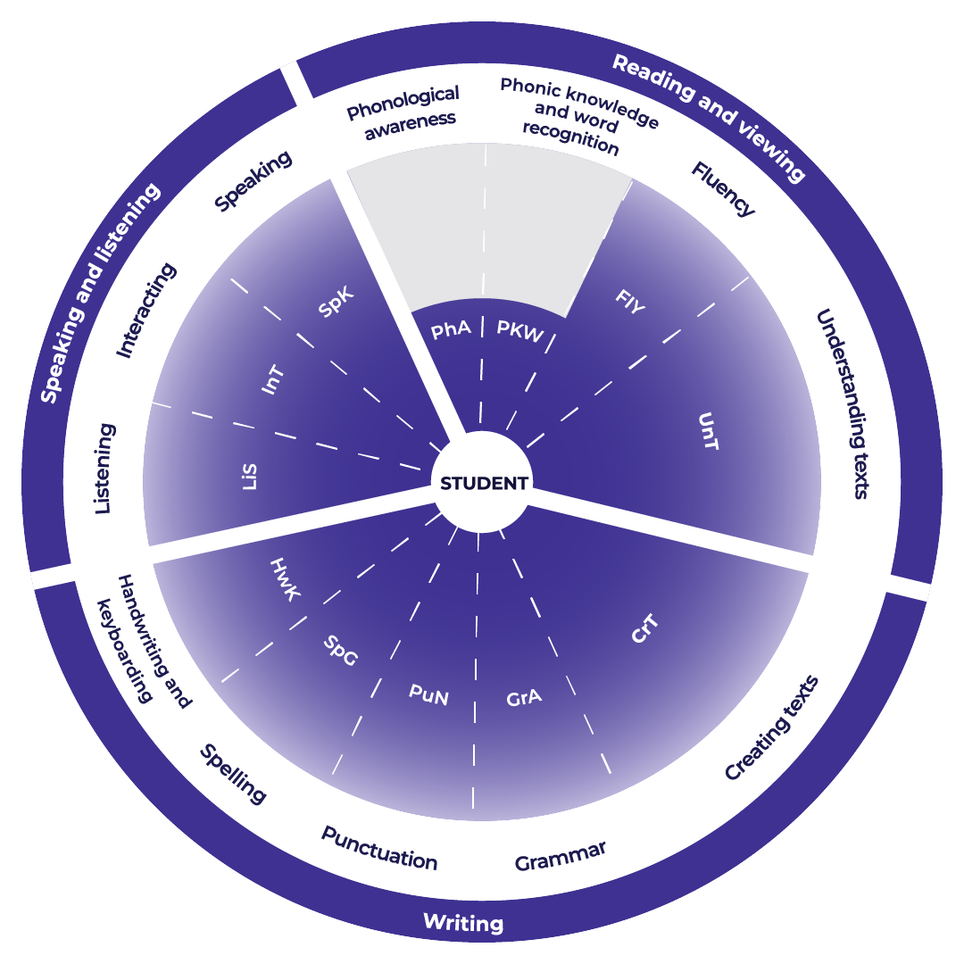

Teachers could use the student’s written response to assess where the student is at now and what they could do next to improve.

Example analysis
For this example, the sub-element of Creating texts has been selected. With specific focus on vocabulary.
Teachers read through the sub-element description to match characteristics that the student’s writing is currently displaying. An example from Biology is provided.
CrT10 Vocabulary:
- uses a range of synonyms for frequently occurring words, in a longer text (e.g. impact, consequence, result)
- uses topic-specific vocabulary to add credibility and weight to arguments (e.g. cadence, interplanetary, silt).
Student writing sample*:
The Ebola pathogen, like all viruses including measles and influenza, has several ways that it transmits to people and then replicates itself to make it harder to control. This tiny microscopic parasite lives inside the cells of its host and can eventually overwhelm the immune system and kill them. The virus spreads via bodily fluids such as sweat, sneezes, blood, vomit, and human waste. Because the pathogens are so small, they cannot be seen, and it is difficult to educate a large enough percentage of the world’s population to practise simple hygiene such as not coughing or sneezing into the open air and washing hands properly. Which would make an impact on the spread of the virus.
*Question can be found in Improve student writing through writing and feedback (DOCX | PDF).
Reading the next sub-element descriptor the teacher could work out where to next for the student.
CrT11 Vocabulary:
- uses vocabulary for precision (e.g. the underwhelming performance of the opening batsmen).
For example, in the written response:
- ‘replicates itself’ could be edited to remove the tautology of ‘itself’
- ‘so small’ could be replaced by ‘microscopic’
- ‘an impact’ could become, ‘a positive impact’.

Example of written feedback to the student
Name: Rose Yeung
Is able to:
Use a range of synonyms in her writing.
She includes adequate subject vocabulary.
To continue to improve:
Rose could increase the precision of her vocabulary for example:
- ‘replicates itself’ could be edited to remove the tautology of ‘itself’
- ‘so small’ could be replaced by ‘microscopic’
- ‘an impact’ could become, ‘a positive impact’.

Template
Name: ____________________________________
Is able to:

To continue to improve:

