Planning for writing – Stage 6 PDHPE

Sequence
To get the most from these resources they should be used as a teaching and learning sequence. One set of activities leads on to the next.
- Improve student writing through subject vocabulary (DOCX | PDF)
- Improve student writing through planning for writing (this document)
- Improve student writing through writing and feedback (DOCX | PDF).

Learning focus
With these literacy activities teachers use content that they have planned in their teaching and learning cycle. For each literacy activity an example from Community and Family Studies (CAFS) has been provided. The example provided is a model for teachers. Teachers create their own specific examples for their subject and class.
Teachers can modify the learning intentions and success criteria to reflect their context.

Syllabus outcomes
For each PDHPE subject, relevant syllabus outcomes have been provided in the Stage 6 PDHPE syllabus links (PDF 85 KB) document. However, for their own professional practice teachers are strongly advised to always refer to the syllabus documents on the NESA website.

Learning intentions
- Students investigate what makes effective writing.
- Students analyse sample written responses.
- Students develop note taking skills.
- Students develop confidence writing in response to stimulus.

Success criteria
- Students are able to articulate aspects of effective writing.
- Students are able to practise their writing skills.
- Students are able to take effective notes.
- Students are able to plan their writing.

Teaching strategies
Focus on skills:
- Activity 1: Review annotated samples
- Activity 2: Warm up writing activity.
Prepare to write:
- Activity 1: Select your resource
- Activity 2: Take effective notes
- Activity 3: Where to next.

Focus on skills

Activity 1: Review annotated samples
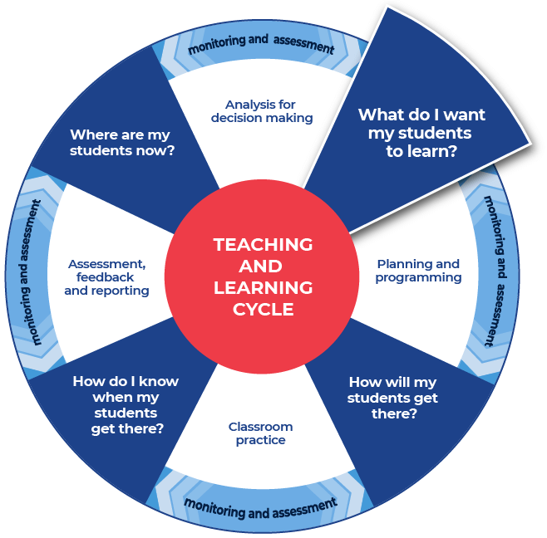

Instructions:
- Teachers provide a sample question and sample written response and annotate some of the features of effective writing on that response. An example from CAFS has been included.
- Teachers create these samples themselves or source them from: PDHPE Statewide Staffroom, previous year groups, local teacher networks or NESA publications.
- Teachers can use the National Literacy Learning Progression to help track students’ literacy skills. Improving students’ literacy skills will enable students to communicate their ideas in a more succinct manner.
- Students will be asked to complete an analysis of the writing, after discussing and reviewing the written samples. A template is provided.
Further support:
- For the CAFS samples the question has been broken up into 3 parts:
  - Key Element 1 – the question verb.
  - Key Element 2 – references an aspect from the syllabus – or where students should be demonstrating their knowledge and understanding. Where the element is one of a number of dot points or dash points, students can use these to create a paragraph structure for their response.
  - Key Element 3 – the link back to the question. This also indicates the type of examples that the student should provide in the response that support statements made throughout the paragraph.
- These 3 elements are part of every question. Students should practise breaking questions into their 3 elements when approaching any question.

Example question
Assess how both formal and informal support can assist parents and carers to maintain their own wellbeing. (6 marks)

Sample low-range response
Key elements of the question:
Key Element 1 | Key Element 2 | Key Element 3
Assess how  (make judgements on how) | formal and informal support | assist parents and carers to maintain their own wellbeing
Parents and carers can use informal support of friends, family or neighbours to look after the dependents as they are trustworthy and probably convenient and inexpensive. Parents and carers can access formal payments from Centrelink (ie Carers allowance, Carer payment, Family tax benefit).
Using these supports gives the parent/ carer resources, (time, money and energy) to cater to themselves eg spending time with friends (increasing social wellbeing), having the energy to go to the gym (physical), allowing time to go to church (spiritual) as well as providing them with money to improve their overall quality of life as well as economic wellbeing.

Annotations
- There is understanding of the content that is supported with examples. This is seen in the green text. Formal support discussion could use stronger characteristics and features.
- Weaker response because there is not a judgement made. All the connective language or the language that reflects the glossary word is language for a middle order (refer to Bloom’s Taxonomy) thinking word such as Explain. This is language such as ‘give the’, ‘increasing’, ‘to improve’, ‘having’, ‘allowing’.
- There are references made to wellbeing and they link to the benefits of accessing formal supports and informal supports in general. Therefore, the response is not specific enough regarding how formal support assists a parent/carer to maintain their own wellbeing.
- Parents and carers links to wellbeing are generalised without showing the specific links to parents and carers which assumes that to satisfy their wellbeing is the same for both. There is a strong need to separate the two and demonstrate understanding of the two groups.

Literacy progression annotations
- supports ideas with some detail and elaboration (e.g. expands on a topic sentence by adding more details in following sentences) (CrT7 Crafting ideas)
- spells multisyllabic words including some with more complex letter patterns (e.g. democracy) (SpG12)
- use of ‘as well as’ twice in the second paragraph, coupled with the paragraph being one long sentence, indicates that the sentence could be structured more effectively. Therefore, the second paragraph is working towards – uses punctuation to clarify meaning in complex sentences, drawing on their knowledge of sentence structure (e.g. commas before introductory words, phrases or clauses; semicolons; colons; and dashes (see Grammar) (PuN8), and writes complex sentences using conjunctions (e.g. when, because) (GrA5)

Sample high-range response
Key elements of the question:
Key Element 1 | Key Element 2 | Key Element 3
Assess how  (make judgements on how) | formal and informal support | assist parents and carers to maintain their own wellbeing
Parents and carers can use informal support of friends, family or neighbours to look after their dependents as they are trustworthy and probably convenient and inexpensive. However, as these supports are not professionally trained and they are usually accessed based on previous relationships there may be an element of risk. While the risk might be minimised through strong trust and loving bonds, there will be benefit from the care that is offered to the dependent. For example, if a grandchild was to be cared for by their grandparent in place of a formal day care centre, then the stories, sharing of cultural traditions and bond is unique. This supports the parents’ wellbeing as they gain time to be able to attend work ensuring financial stability which is essential for promoting economic wellbeing. There are increased social benefits of being in a workplace. This time of independence for the parent to be able interact with peers and share their skills with others not only safeguards social factors of wellbeing it also promotes a stronger sense of identity to maintain their role within the family and society and to support their overall mental health, thus their emotional factors of wellbeing. As the carer, the grandparent is able to share their history and skills through their stories, meaning their own culture is sustained, thus promoting their cultural factors of wellbeing.
Parents and carers can access formal support through government agencies or community organisations to meet their specific needs. The staff within these organisations are professionally trained, usually have appointments and provide specific skills to target the needs of the user. If a carer was having difficulty with their back due to lifting and supporting their dependent with bathing, showering and dressing they could access a formal support community physiotherapist. This will strongly benefit the strengthening of their muscles and offer education on correct lifting techniques. However, this type of formal support does not give them back time by reducing the time given for caring. Therefore, despite offering targeted support to meet the health needs and promote physical wellbeing, this formal support creates a level of economic ill-being through the high cost of one on one care, unless the carer is economically supported within their family. Accessing this type of service means times are set aside for the carer allowing forward planning to find another carer to care for their dependent. If they do not have that other support or they cannot bring their dependent to the appointment, then the carer will have to forgo treatment, creating on going issues which greatly impacts physical and mental health.

Annotations
- Key element 1 is highlighted blue and is the language that links directly to the glossary word within the question; in this case it is ‘assess’. The blue highlighted words are examples of connective language used to show the extent of the impact of the support network on the wellbeing of a parent and/or carer. Each connective language example provides either a value, an action or outcome or a direct comparison around the extent of the impact of the support network mentioned. This elevates the level of response provided and reflects a quality, in-depth response.
- Key element 2 is highlighted green. The opening statements in each paragraph clearly demonstrate and identify:
  - the aspect of the question that they will be responding to
  - detailed content knowledge by describing each support network demonstrating
  - both the characteristics and features of each network
  - the value and benefits of each type of network
  - concerns that may impact parent and/ or carer well-being for each support network.
- Key element 3 is highlighted yellow. In each paragraph, support networks have been clearly addressed demonstrating higher order thinking (Bloom’s Taxonomy). There is detailed language used and examples have been represented in each paragraph with a direct link to the key elements of the question. Clear judgements have been made that demonstrate deep content knowledge. The arguments provided directly link to the syllabus. The answer provides explicit reasoning for both sides of the argument regarding the impact of support networks for parents and carers.
- Overall, there has been a clear judgement made between formal and informal support networks and their impact on parents and/or carers. This demonstrates a deep understanding of the syllabus content.

Literacy progression annotations
- creates persuasive texts to discuss, evaluate and review (e.g. evaluates and reviews design ideas) (CrT10 Crafting ideas)
- positions the reader effectively by providing a clear thesis and relevant context (e.g. by previewing the arguments) (CrT11 Crafting ideas)
- includes persuasive points with effective elaborations and supporting evidence (CrT10 Crafting ideas)
- skilfully uses a range of cohesive devices to makes connections between arguments (e.g. foreshadows key points in introduction and reinforces key points in topic sentences) (CrT10 Text forms and features)
- judiciously selects evidence and language to strengthen arguments (CrT10 Text forms and features)
- uses topic-specific vocabulary to add credibility and weight to arguments (e.g. cadence, interplanetary, silt (CrT10 Vocabulary)
- makes more sophisticated connections between ideas by creating complex sentences expressing relationships of cause, reason, concession (GrA7)
- spells multisyllabic words including some with more complex letter patterns (e.g. democracy) (SpG12)
- uses punctuation to clarify meaning in complex sentences, drawing on their knowledge of sentence structure (e.g. commas before introductory words, phrases or clauses; semicolons; colons; and dashes) (see Grammar) (PuN8)

Review annotated samples
- Students read through the example responses to the question.
- Students choose one of the sample responses.
- Students respond to the analysis questions on the template provided.

Template

What do you notice?
How was the answer structured?

Were words from the question used in the answer?

What do you notice about the sentences?

Identify and re-write an idea that was contained in the sample response?

What did you like about the response?

Completed example

What do you notice?
How was the answer structured?
The answer is structured in a logical way, the beginning of each paragraph lets the reader know if formal or informal supports will be written about. In the stronger response clear judgements were made.
Were words from the question used in the answer?
Yes, words from the question were used and explained in the answer. They were elaborated upon.
What do you notice about the sentences?
Sentences were sometimes short and simple. However, there were compound and complex sentences to explain ideas.
Identify and re-write an idea that was contained in the sample response?
From the response:
‘However, as these supports are not professionally trained, and they are usually accessed based on previous relationships there may be an element of risk. While the risk might be minimised through strong trust and loving bonds, there will be benefit from the care that is offered to the dependent.’
Re-written:
When people access informal support there could be an element of risk. This is because informal carers such as grandparents, friends, and other family members are not professionally trained. However, the love and trust that often exists within these relationships is a real benefit to the dependent who will be able to form strong bonds with familiar people.
What did you like about the response?
I appreciated the details. The details supported my understanding of what they were writing about. I believed their ideas more when they used evidence to support the ideas. I also liked that the writer gave positive and negative examples about both formal and informal support for carers.

Additional support for Activity 1
Please note that there are several supports to help teachers improve writing.
Teachers could use their marking criteria to assess written responses and provide feedback.
In some contexts, teachers could use the National Literacy Learning Progression. While primarily focused on K–10, it will provide sound ideas on aspects of writing and how to improve.
For more ideas on what to look for in literacy you may like to complete the online course Introduction to the Literacy and Numeracy Progressions Online.

Activity 2: Warm up writing activity
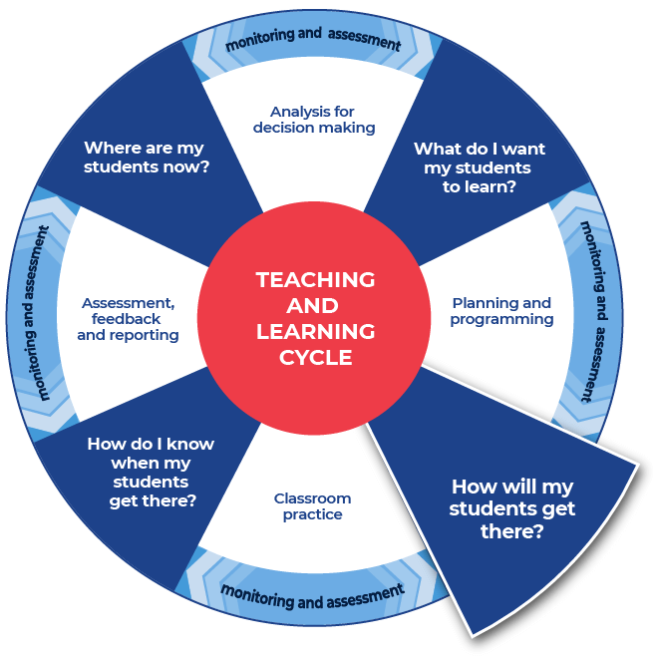

Instructions:
- Students create their own written response to a question (different to the question in Activity 1) that the teacher provides for their subject.
Differentiation:
- Teachers could create and use modelled writing that is relevant to their topic and chosen focus.
- Teachers could provide a structure that can be used to approach the writing.
- Teachers could model or scaffold sentences to demonstrate how the task could be approached, as well as illustrate the language used to address each level of complexity or depth in terms of the verbs in the question.
Further support:
- Teachers provide their specific examples and ask their students to write responses using the templates provided. An example from CAFS has been provided.

Example question
Assess how government and community organisations can assist parents in fulfilling their parental responsibilities.
Key Elements of the question:
Key Element 1 | Key Element 2 | Key Element 3
Assess | government and community organisations can assist | parents in fulfilling their parental responsibilities.
Written response:

This is the end of Focus on Skills section.

Prepare to write

Activity 1: Select your resource

Instructions:
- Teachers support students as they prepare to create a written response.
- Teachers choose an appropriate website, article, video, or a text that is part of their lesson planning. This could be the same text that has been used for the vocabulary activities or a new text for students to engage with.
- Teachers provide the selected source to their students. Suggested sources could include; course textbooks, journals, media articles.
Differentiation:
- Teachers ensure that they pre-read or view all texts provided to students and communicate the purpose and focus for using the source with students.
- Teachers could read the texts to or with students.
- Teachers ensure they have the question that their students will answer prepared and that engaging with this chosen text will support students in answering the set question for ‘Student writing and feedback’.
Further support:
- Included is a CAFS example from the NSW Department of Communities and Justice media release fact sheet: New birth certificates to recognise adoption (5 August 2020).

Activity 2: Take effective notes

Instructions:
- Teachers model their own example to share with students. An example from CAFS has been included.
- Students take notes as they engage with the text that their teacher has provided. A suite of note taking resources is provided.
- Students will write the information on their note taking template as they locate it in the text.
Differentiation:
- Teachers could provide different students with different scaffolds.
- Teachers may pre-fill some of the note taking template or include sentence starters to support student engagement and achievement.
- Teachers may provide a completely pre-filled example for students to work from.
Further support:
- Teachers may want to take the time to use the pre-written ideas and teaching strategies regarding Locating explicit information on the HSC minimum standard website.
- Included is a CAFS example from the NSW Department of Communities and Justice media release fact sheet: New birth certificates to recognise adoption (5 August 2020).

Example 1

Template
Title of text:
Type of text:
Who it is about:

When it occurred:

Where it occurred:

What happened?

Why did it happen?

How are people reacting to it?

Put 3 of the points that you have recorded in the categories above into a summarising paragraph of 3 to 4 sentences.

Completed example
Title of text: New birth certificates to recognise adoption
Type of text: Media release
Who it is about:
Adopted people in NSW who will be able to have both their birth and adopted families included on their birth certificate.
When it occurred:
August 2020.
Where it occurred:
Through the NSW Government and the Department of Communities and Justice.
What happened?
Reforms have approved the issuing of birth certificates to people that have ‘information about their parents and siblings at birth, as well as their parents and siblings after they have been adopted.’
Why did it happen?
A need was expressed from adopted people and it was supported by legal advice.
‘Open adoption means that adoptive and birth families now know about each other, exchange information and often have direct contact to enable children to connect with and understand their background.’
How are people reacting to it?
People are positive and happy about it. ‘Today we mark a further step away from the secrecy associated with the adoption policies of the past.’
Put 3 of the points that you have recorded in the categories above into a summarising paragraph of 3 to 4 sentences.
Through the NSW Government and the Department of Communities and Justice, reforms have approved the issuing of birth certificates to people that have ‘information about their parents and siblings at birth, as well as their parents and siblings after they have been adopted.’ A need was expressed from adopted people and it was supported by legal advice. People are positive and happy about it. ‘Today we mark a further step away from the secrecy associated with the adoption policies of the past.’

Example 2

Template
As you engage with the text create sentences that begin with the following:
Title of text:
Type of text:
Before

After

If

When

Even though

Although

Since

While

Unless

Whenever

Put some of the points that you have recorded in the categories above into a summarising paragraph of 3 to 4 sentences.

Completed example
As you engage with the text create sentences that begin with the following:
Title of text: New birth certificates to recognise adoption
Type of text: Media release
Before these reforms the law was that when people were adopted their birth certificates were altered to remove their birth families.
After these reforms birth certificates will have ‘information about their parents and siblings at birth, as well as their parents and siblings after they have been adopted.’
If people would like to know about their birth family, cultural heritage, or any family health issues it will be easier to find information.
When the proposed amendments go through, people will be issued with an integrated birth certificate (IBC) and the existing post adoptive birth certificate. Both of these birth certificates will be legal identity documents.
Even though people may be born before 2020, the article states that, ‘People adopted prior to the commencement of the reforms can contact the Registry of Births, Deaths & Marriages to find out how they can apply for an IBC.’
Although there has been secrecy associated with adoption in the past, policy is moving away from that idea of secrecy.
Since there are contemporary ‘open’ adoption practices this new policy will align with and strengthen them.
While there may have been secrecy around adoption in the past, ‘Open adoption means that adoptive and birth families now know about each other, exchange information and often have direct contact to enable children to connect with and understand their background.’
Unless the law had been amended only a child’s adoptive family would have continued to appear on the birth certificate.
Whenever there is change to a law it is often driven by community voice, ‘We have listened to the calls from adopted people and legal experts, and are delighted to be introducing the first change to birth certificates for adopted people in 55 years.’
Put some of the points that you have recorded in the categories above into a summarising paragraph of 3 to 4 sentences.
While there may have been secrecy around adoption in the past, ‘Open adoption means that adoptive and birth families now know about each other, exchange information and often have direct contact to enable children to connect with and understand their background.’ Whenever there is change to a law it is often driven by community voice, ‘We have listened to the calls from adopted people and legal experts, and are delighted to be introducing the first change to birth certificates for adopted people in 55 years.’ Before these reforms the law was that when people were adopted their birth certificates were altered to remove their birth families. After these reforms birth certificates will have ‘information about their parents and siblings at birth, as well as their parents and siblings after they have been adopted.’

Example 3

Template
Title of text:
Type of text:
Topic:
Events
People
Facts
Key words
Summary

Completed example
Title of text: New birth certificates to recognise adoption
Type of text: Media release.
Topic: Adopted people’s birth certificate information
Events
Currently adopted people only have their adopted families appear on their birth certificates.
These new reforms alter that and allow for birth family and adopted family to appear on a person’s birth certificates.
People
Adopted people.
Birth families.
Adoptive families.
NSW Government.
Facts
Integrated birth certificate (IBC).
NSW is leading open adoption policy practices.
The Bill amends the Adoption Act 2000 and the Births, Deaths and Marriages Registration Act 1995 to authorise the issuing of an IBC.
Key words
Law reform
Bill
Amendment
Adoption
Birth certificate
Summary
Currently adopted people only have their adopted families appear on their birth certificates. These new reforms alter that and allow for the birth family and adopted family to appear on a person’s birth certificates. NSW is leading open adoption policy practices. The Bill amends the Adoption Act 2000 and the Births, Deaths and Marriages Registration Act 1995 to authorise the issuing of an IBC.

Activity 3: Where to next
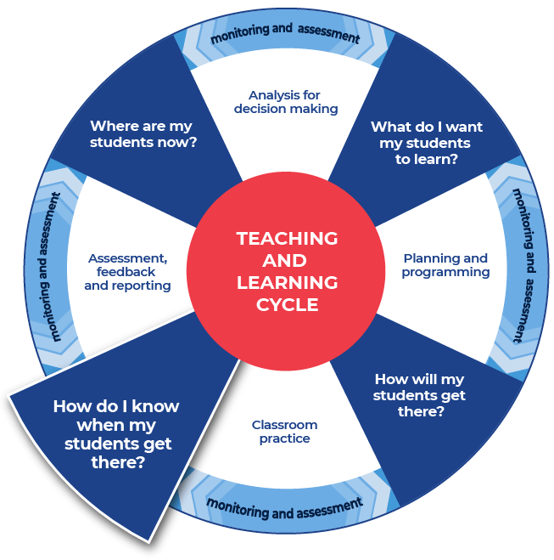

Instructions:
- Teachers provide the specific question or stimulus that their students will respond to.
- Students should create a plan and draft for their written response. They can use the notes that they have taken and any other additional information.
- Teachers provide students with time to draft their writing.
- Teachers provide students with formative feedback during the drafting process.
Differentiation:
- The task could respond to a practice examination question, or it could be writing in response to a class task.
Further support:
- Teachers and students could engage with the pre-written lesson content in the Ideas section on the HSC minimum standard site to support strengthening ideas.
- Teachers may also want to engage with the Text structure section on the HSC minimum standard website and use the persuasive text structure template provided on the website.

Example

Question
Compare and contrast how the legal changes impact adoptive parents and one other social parent when becoming a parent or carer.
Key Elements of the question:
Key Element 1 | Key Element 2 | Key Element 3
Compare and contrast how | the legal changes impact adoptive parents and one other social parent | when becoming a parent or carer.
Use the HSC hub Glossary of key terms: Compare and Contrast to support the unpacking of this question.
This is the end of the activities for: Improve student writing through planning for writing.
Teachers should move on to the next set of activities: Improve student writing through writing and feedback (DOCX | PDF).

Further support
Teachers may find that students could benefit from support in other areas of their learning. More ideas and teaching strategies for literacy and numeracy can be found at the HSC minimum standard website. Here you will find teaching ideas and activities on:
Writing, including: text structure, paragraphs, cohesion, sentence types, tense, punctuation, formal and informal language, spelling, vocabulary, topic vocabulary, audience and purpose, ideas, language devices, and unpacking the writing prompt.
Numeracy, including: division, multiplication, fractions, decimals, percentages, rates, time, ratio, area, length and perimeter, mass, volume and capacity, mean, median and mode, chance, 3D objects, 2D shapes, patterns, formulae and substitution, positioning and locating, angles, tables graphs and charts, vocabulary in numeracy, interpreting questions and grammar for numeracy.
Reading, including: audience and purpose, locating explicit information, inferring, common language devices, parts of speech, cohesive devices, sentence types, tense, subject-verb agreement, punctuation, spelling, antonyms and synonyms, inferring word meanings.
Other useful CAFS sites and resources:
- Foster/adoption resources:
  - Video: Meet the Press - National Adoption Awareness Week 2013
  - Video: SBS Insight – Adoption (view from 9:10–20:31min)
  - Australian Institute of Health and Welfare adoption in Australia 2018-2019 report
  - NSW Department of Communities and Justice – Foster, relative, and kinship care
  - Foster Legislation: Under this law Children and young person’s care and protection Act (1998) children’s and young person’s in care’s rights are protected
  - NSW Department of Communities and Justice – Your rights as a child or young person in care.
- Step-parenting and the law
- Surrogacy resources:
  - Australian surrogacy legislation
  - NSW surrogacy legislation
  - International surrogacy arrangements.
- Carers: Primary and formal/informal
  - Facts about caring
  - Centrelink payments and services.

