Subject vocabulary – Stage 6 Mathematics

Sequence
To get the most from these resources they should be used as a teaching and learning sequence. One set of activities leads on to the next.
- Improve student writing through subject vocabulary (this document)
- Improve student writing through planning for writing (DOCX | PDF)
- Improve student writing through writing and feedback (DOCX | PDF).

Learning focus
With these literacy activities teachers use content that they have planned in their teaching and learning cycle. For each literacy activity an example from Mathematics Standard has been provided. The example is a model for teachers. Teachers create their own specific examples for their subject and class. Teachers can modify the learning intentions and success criteria to reflect their context.

Syllabus outcomes
For each mathematics subject, relevant syllabus outcomes have been provided in the Stage 6 Mathematics syllabus links (PDF 80 KB) document.

Learning intentions
- Students will become familiar with subject vocabulary.
- Students will increase understanding of specific vocabulary terms.
- Students will create and maintain their own glossary.

Success criteria
- Students are able to define terms that are specific to their subject.
- Students are able to effectively use terminology that is specific to their subject.
- Students are able to complete self-directed work.

Teaching strategies
- Activity 1: Select
- Activity 2: Explain
- Activity 3: Explore
- Activity 4: Consolidate.
(Adapted from: Alex Quigley ‘Closing the Vocabulary Gap’ Routledge 2018)

Activity 1: Select
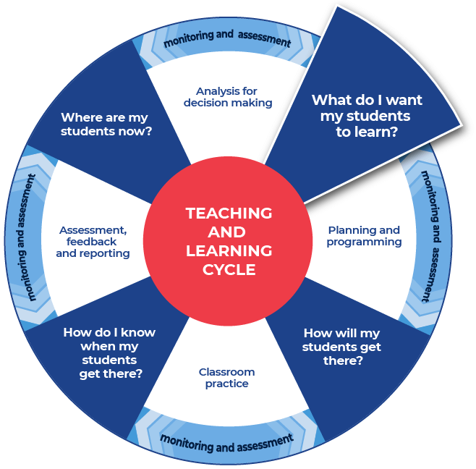

Required resources
Teachers are to choose a resource that they are currently using in class.
Teachers provide their students with access to the chosen resource.
Examples of potential resources are listed below:
- Specific pages or a chapter from a textbook.
- A video or TED Talk on the topic.
- NSW syllabus document, for example the Mathematics Standard Stage 6 Syllabus.
- Glossary for your subject, for example the Mathematics Standard Stage 6 glossary.
A specific text has been chosen for the examples in this activity: Mathematics Standard Stage 6 – Working mathematically.
When selecting the text that you will work with, consider the text complexity and your reason for using that text. It is also important to read texts carefully before using them with students and pre-identify any terms or subject specific language that students may find challenging. Further information on text complexity can be found in the National Literacy and Numeracy Learning Progressions, Literacy Progression, Appendices 6 – Text Complexity (PDF 389 KB).
To support your students you may want to use some pre-reading activities such as: providing students with clues for navigating the text, summarising what the text will be about, and explaining specific terms that will appear in the text. A valuable strategy may also be to read the text to students to allow them to hear the text, including the pronunciation of key terms. You could use videos and other multi-modal texts to support learning.
Additionally, to support comprehension teachers may consider altering the font of the text to make it more readable and presenting the information in smaller sections.

Instructions:
- Students access the text and select ten unfamiliar words that they do not feel confident that they know the meaning of. The amount of words to be selected can be altered by the classroom teacher.
- Students engage with the text that the teacher has provided.
- Students write the words into a table or in their workbook after they have engaged with the text.
- Teachers model their own example to share with students. An example from Mathematics Standard has been included.
Differentiation:
- Teachers could pre-select the ten words.
- Teachers could pre-select some of the words and then allow the students to select the rest.
Further support:
- A specific text has been chosen for the examples in this activity: Mathematics Standard Stage 6 – Working mathematically.

Example

notation
reasonableness
procedure
interpret
deduce
formulate
justification
investigate
infer
strategic thinking

Activity 2: Explain
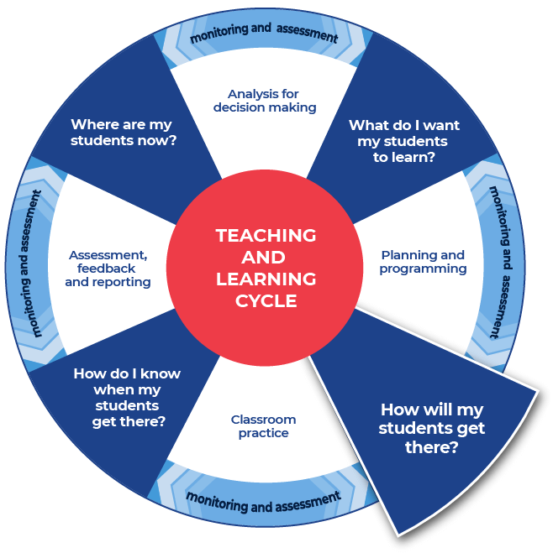

Instructions:
- Teachers replicate the example structure but for the text that their students are working with. Teachers provide their example to their students.
- Students research the formal technical definition for each of their words and write it in the table provided, or in their workbook. Students can use online or hard copy dictionaries.
- Students create their own informal ‘student’ definition for each word. It should be written in plain English. This is the way they might explain it to a friend.
- Students should write their informal definition in the table.
- Students will need to complete this task for all ten words.
Differentiation:
- Modifications for EAL/D students may include explicitly teaching how to use the dictionary and support in choosing which definition is relevant to Mathematics.
- Teachers may provide the words and scaffold the definitions. For example, create mini cloze passages inside the definition spaces and provide a word bank for students.
- Teachers could supply a link to an online dictionary and students can write the definition in the table.
- Teachers could also encourage students to work together to create informal definitions first. Students could then source the formal definitions and refine their informal definitions.
- Students could work in pairs, then they should join their word lists together and complete definitions for twenty words.
- Teachers could support students by discussing the word as it is used in the context of the sentence.
- Teachers could support students by discussing multiple meanings and that being literate includes understanding that some words can have multiple meanings.

Template
Word | Dictionary definition | Your definition
word | From name-of-dictionary:  ‘dictionary definition.’ | Student definition.
… | … | …
… | … | …
… | … | …
… | … | …
… | … | …
… | … | …
… | … | …
… | … | …
… | … | …

Completed example
This example has been filled in for teachers as a model.
Word | Dictionary definition | Your definition
infer | From Merriam Webster:  ‘to derive as a conclusion from facts or premises. For example, we see smoke and infer fire’  ‘Guess, summarise. For example, your letter … allows me to infer that you are as well as ever.’ | To see what information you already have and then predict or make a reasonable guess as to what the solution might be.
notation | From Math is fun:  ‘A system of symbols used to represent special things. Example: In mathematical notation “∞” means “infinity”.’ | All of the symbols and marks that actually have meaning and stand in for information in mathematics.
strategic thinking | From Cambridge University – NRICH:  ‘Exploring, questioning, working systematically, visualising, conjecturing, explaining, generalising, justifying, proving... are all at the heart of mathematical thinking.’ | To work out a plan of how you might solve a problem. The plan could include how you will prove that you went about it the right way and that you thought about other solutions or what parts of the problem were left unanswered.

Activity 3: Explore

Instructions:
- Teachers provide their own completed example and a template to their students.
- Students explore each word to deepen their understanding of the subject vocabulary.
- Students complete this task for all ten of their words.
Differentiation:
- Teachers can choose between the two template options provided.
- Teachers could explicitly discuss with students if they know this word from another subject and if the meaning of the word is the same or different from the other class. This allows students to connect learning across KLAs.
Further support:
- Teachers model their own example to share with students. An example from Mathematics Standard has been included.

Example 1

Template: Vocabulary Map
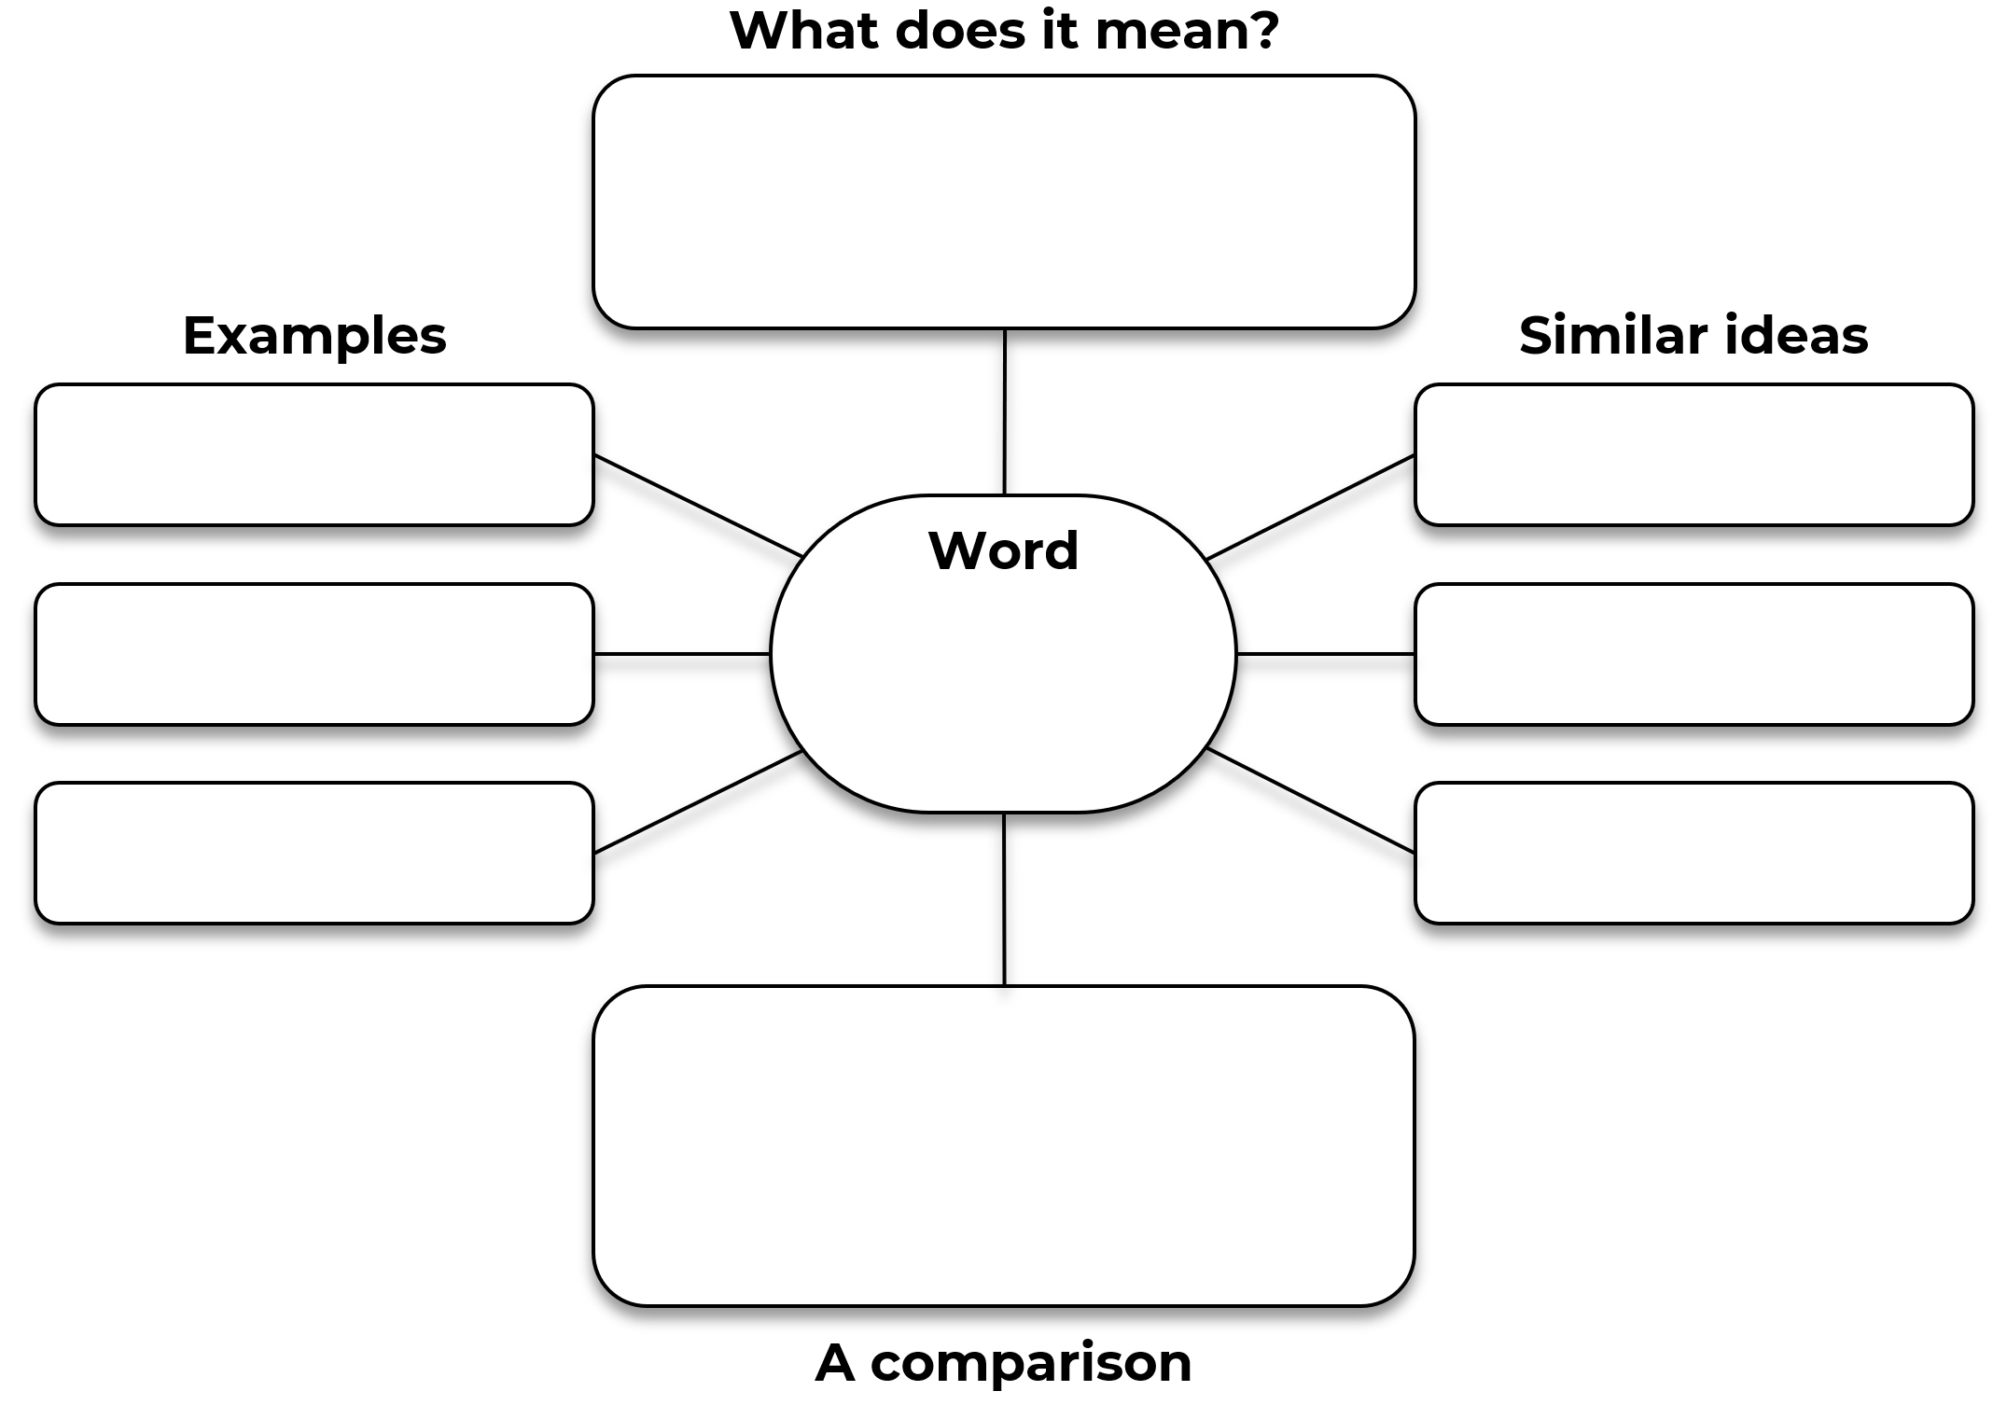

Completed example: Vocabulary map
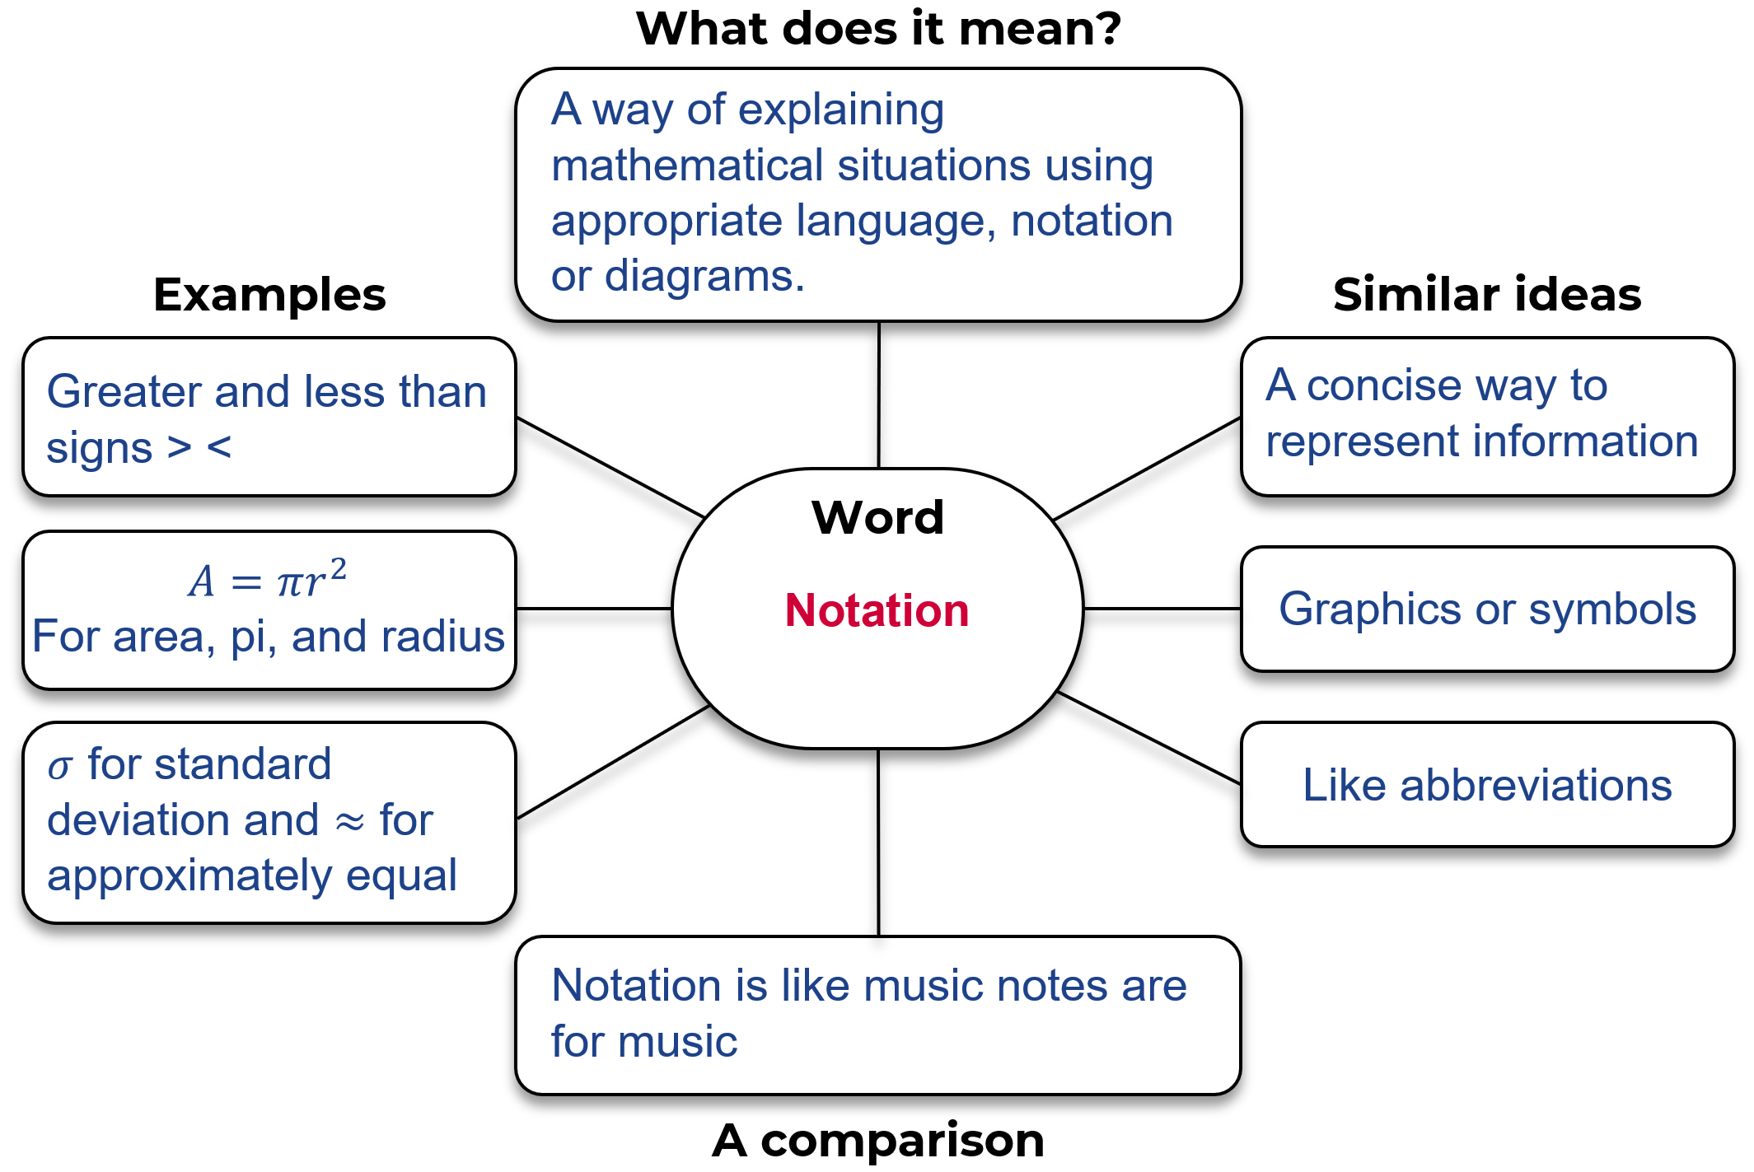

Example 2

Template
Word:
Write the sentence, from the text, that contains the word.

In the text, what are some other words associated with this word?

Can you find an example, in the text, of a sentence that hints at the meaning of the word?

Does the text make a comparison, or could you create a comparison?

Completed example
Word: notation
Write the sentence, from the text, that contains the word.
Explain mathematical situations using appropriate language, notation, or diagrams.
In the text, what are some other words associated with this word?
Language and diagrams.
Can you find an example, in the text, of a sentence that hints at the meaning of the word?
‘a variety of presentations…’ shows that notation is about representing information.
Does the text make a comparison, or could you create a comparison?
Notation is like music notes are for music. Symbols that have meaning.

Activity 4: Consolidate
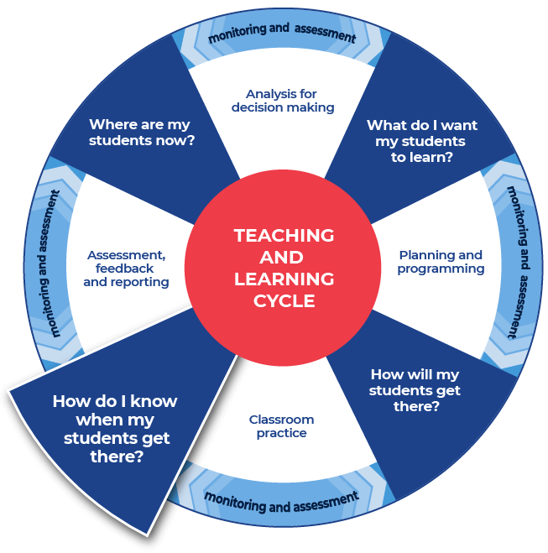

Instructions:
- Students consolidate their subject vocabulary learning by creating a match-up worksheet.
- Students create a worksheet using the template provided by writing their ten words in the boxes listed down the middle of the worksheet.
- Students fill in the outer squares with their personal definitions of the words. They should ensure that they are out of order.
- Students provide the teacher with an answer sheet for the match-up that they create. The word and correct definition should be clearly indicated.
- Teachers swap student’s match-up worksheet with a peer who aims to get ten out of ten as they attempt the worksheet.
Differentiation
The teacher could:
- split the class into two groups, half of the class has a word and half of the class has a definition, students move about the space and locate their word or definition
- organise students into pairs to create flash cards or word webs, paper or online, this could incorporate selecting graphic organisers from the Digital learning selector
- show students how to create a crossword - students use the words and definitions and then share their crossword with a peer
- show students where and how to locate different texts or sources that demonstrate the different definitions of a word that they have explored. This supports the Williams Model of differentiation with the aspect of Organised Random Search.
- explain the concept of a cloze passage and ask students to create cloze passages
- provide students with space to create a word wall. This could be added to throughout the module
- direct students to a specific template within the Digital Learning Selector and encourage them to organise and classify their new words
- hold a gallery walk, this enables students to showcase their new words to their peers.

Name of worksheet:
Student name:
Match-up the words with the appropriate definitions.

Definitions

Words

Definitions

Name of worksheet:
Student name:
Answer sheet.
Definitions

Words

Definitions

This is the end of the activities for: Improve writing through subject vocabulary.
Teachers should move on to the next set of activities: Improve student writing through planning for writing (DOCX | PDF)

Additional vocabulary lesson resources

Cohesion
Cohesion is defined as ‘that quality in a text determined by its parts being related and contributing to its overall unity. Cohesion is achieved through shaping the form, creating a structure that the responder can recognise and use to navigate the text …’ (English K–10 Syllabus Glossary). For more ready-to-use teaching and learning activities on cohesion visit HSC minimum standard – Cohesion.

Universal Resources Hub
Evidence-based resources and tools are accessible to all schools via the Universal Resources Hub (staff only).
Teachers can use these resources to support integration of reading and numeracy instruction into teaching and learning programs.

Question verbs
A ready to use glossary of question verbs and activities (DOCX 80 KB) has been included. These will get students thinking about question are asking them to demonstrate.

Topic Vocabulary
For more ready-to-use teaching and learning activities on topic vocabulary go to HSC minimum standard – Topic vocabulary.

Vocabulary
For more ready-to-use teaching and learning activities on vocabulary go to HSC minimum standard – Vocabulary.

