Subject vocabulary – Stage 6 modern languages
In modern languages, there are 2 critical aspects to subject vocabulary. Students:
- understand the English vocabulary in NESA’s glossary of key words and are prepared to answer a range of questions in the HSC
- develop a range of strategies for understanding new vocabulary in the target language.

Sequence
To get the most from these resources, use them as a teaching and learning sequence. One set of activities leads on to the next.
- Improve student writing through subject vocabulary (this document)
- Improve student writing through planning for writing (DOCX | PDF)
- Improve student writing through writing and feedback (DOCX | PDF)

Learning focus
We have included 2 sample vocabulary-focused literacy activities:
- Example 1 – understanding key words in the syllabus – unpacks terms that commonly appear in the outcomes of Stage 6 modern language courses.
- Example 2 – unpacking vocabulary in texts in the target language – focuses on understanding typical content which students encounter in the target language.
The examples provided are models only. You can create your own specific examples for your language course, context and class. Modify the learning intentions and success criteria to reflect your context.

Syllabus outcomes
Activities should align with the relevant Stage 6 language syllabus outcomes. You can access the syllabuses on the NESA website.

Example 1 – understanding key words in the syllabus

Learning intentions
Students will:
- become familiar with syllabus terms specific to their language course
- increase understanding of syllabus terms specific to their language course
- create and maintain their own glossary.

Success criteria
Students are able to:
- define syllabus terms specific to their language course
- effectively apply syllabus terms within the context of the language they are learning
- complete self-directed work.

Teaching strategies
- Activity 1: Select
- Activity 2: Explain
- Activity 3: Explore
- Activity 4: Consolidate
(Adapted from: Alex Quigley ‘Closing the Vocabulary Gap’ Routledge 2018)

Activity 1: Select
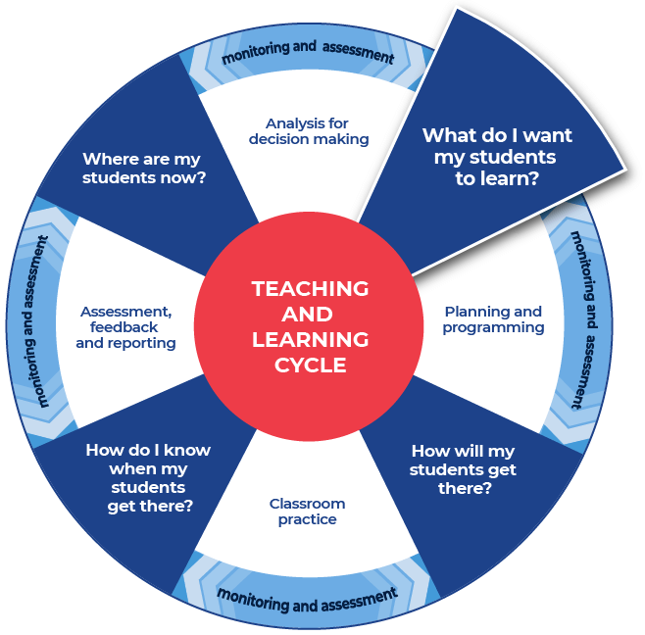

Resources
Provide students with:
- the table of outcomes from the relevant Stage 6 modern languages syllabus
- NESA’s glossary of key words.

Instructions
- Students engage with the texts provided.
- Students select 10 unfamiliar words that they do not feel confident they know the meaning of.
- Students write the words into a table or in their workbook.

Differentiation
- Pre-select the 10 words.
- Pre-select some of the words and then allow the students to select the rest.
- Alter the number of words to be selected.

Sample vocabulary

justifies
identifies
evaluates
compares
describes
summarises
draws conclusions
applies
conveys
infers

- The terms in this example have been extracted from the modern languages syllabuses – Beginners, Continuers, Extension, [Language] in Context and [Language] and Literature.
- For the example, we have identified terms which appear in the outcomes across most modern languages syllabuses.

Activity 2: Explain
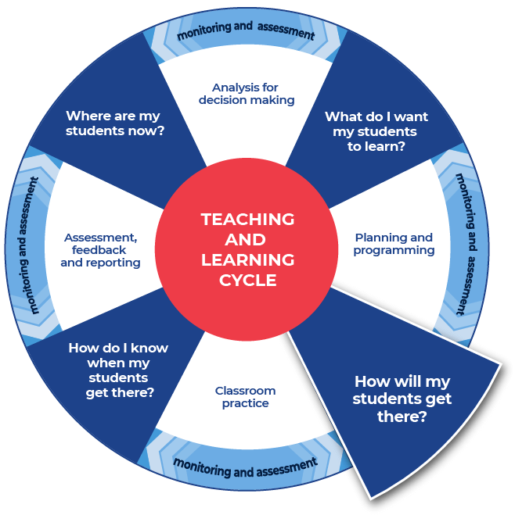

Instructions
- Students research the formal definition for each of their words and write it in the table provided. Students can use online or hard copies of dictionaries, or seek definitions from NESA’s glossary of key words.
- Students create their own informal ‘student’ definition for each word. They write this in plain English, as if they were explaining the word to a friend.
- Students complete this activity for all 10 words.

Differentiation
- Explicitly teach how to use a dictionary and support in choosing which definition is relevant to the target language.
- Provide the words and scaffold the definitions. For example, create mini cloze passages inside the definition spaces and provide a word bank for students.
- Supply a link to an online dictionary and students can write the definition in the table.
- Enable students to work together to create informal definitions first. Students then source the formal definitions and refine their informal definitions.
- Students work in pairs by joining their word lists together and complete definitions for twenty words.
- Discuss with students the word as it is used in the context of the sentence.
- Discuss with students the multiple meanings and that being literate includes understanding that some words can have multiple meanings.

Template
Word | Dictionary definition | Your definition
word | From name-of-dictionary:  ‘dictionary definition’ | Student definition
… | … | …
… | … | …
… | … | …
… | … | …
… | … | …
… | … | …
… | … | …
… | … | …
… | … | …

Completed example
This example has been filled in for you, as a model.
Word | Dictionary definition | Your definition
justify | From NESA glossary of key words:  ‘Support an argument or conclusion.’  From Merriam-Webster:  ‘To prove or show to be just, right, or reasonable.’ | To say that something is a certain way and then provide evidence to prove it and support that it is the true.
identify | From NESA glossary of key words:  ‘Recognise and name.’  From Dictionary.com:  ‘To recognise or establish as being a particular person or thing; verify the identity of.’ | To find the information and explain it.
gist | From Merriam-Webster:  ‘The main point or part.’  From Macmillan dictionary:  ‘The main idea or most important point of something that someone has written or said.’ | To get the main idea. To show that you mostly understand what is going on.

Activity 3: Explore

Instructions
- Show students a range of sample questions from past HSC examinations (or from their existing classroom resources) which use a range of words explored in Activity 1.
- Provide models with questions and answers.
- Students explore the models to check their own understandings of the key words.

Differentiation
- Provide students with the template below, to support them as they explore the word in context.
- Students can use graphic organisers from the Digital Learning Selector.

Template
Word:
Find an example of a sentence that explains the word in another way. (For example, in place of ‘justify’ the question may ask ‘Give reasons for your response’.)

Activity 4: Consolidate
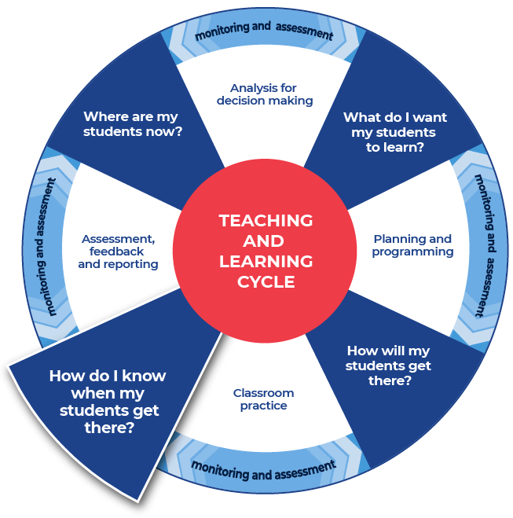

Instructions
- Students consolidate their subject vocabulary learning by creating a match-up activity or worksheet for their peers.
- Students provide the teacher with an answer sheet for the match-up that they create. The word and correct definition should be clearly indicated.

Differentiation
The teacher could:
- split the class into two groups, half of the class has a word and half of the class has a definition, students move about the space and locate their word or definition
- organise students into pairs to create flash cards or word webs, paper or online, this could incorporate selecting graphic organisers from the Digital learning selector
- show students where and how to locate different texts or sources that demonstrate the different definitions of a word that they have explored. This supports the Williams Model of differentiation with the aspect of Organised Random Search.
- explain the concept of a cloze passage and ask students to create cloze passages
- provide students with space to create a word wall. This could be added to throughout the module
- direct students to a specific template within the Digital Learning Selector and encourage them to organise and classify their new words
- hold a gallery walk, this enables students to showcase their new words to their peers.

Example 2 – unpacking vocabulary in texts in the target language

Learning intentions
Students will:
- explore a range of strategies for understanding new vocabulary in the target language
- create and maintain their own glossary of new words.

Success criteria
Students are able to:
- apply a range of strategies to understand new vocabulary when exploring texts in the target language
- complete self-directed work.

Teaching strategies
- Activity 1: Select
- Activity 2: Explain
- Activity 3: Explore
- Activity 4: Consolidate
(Adapted from: Alex Quigley ‘Closing the Vocabulary Gap’ Routledge 2018)

Activity 1: Select

Resources
Select and share a text relevant to your students’ context and the topic you are teaching.
For example:
- an article, blog, podcast, website or song
- specific content from your textbook
- a video or TED Talk.
When selecting the text, consider the text complexity and reasons for using that text. Consider its context, purpose and audience. It is also important to read texts carefully before using them with students and pre-identify any terms or complex vocabulary in the specific language that students may find challenging. Further information on text complexity can be found at National Literacy and Numeracy Learning Progressions, Literacy Progression, Appendices 6 – Text Complexity (PDF 388 KB).

Instructions
- Students engage with the text that the teacher has provided.
- Students read the whole text to get the gist of it.
- Students write a short sentence describing what the text is about.
- Students select 10 unfamiliar words that they do not feel confident they know the meaning of.
- Students write the words into the first column of the template below.

Differentiation
- Pre-select the 10 words.
- Pre-select some of the words and then allow the students to select the rest.
- Alter the number of words to be selected.
- Present the information in smaller sections.
- Use some pre-reading activities such as providing students with clues for navigating the text, summarising (locating specific information) what the text will be about, and explaining specific terms that will appear in the text.
- Read the text aloud to students to allow them to hear the text, including the pronunciation of key terms.
- Use videos and other multi-modal texts to support learning.

Template
Short description of what the text is about:

Word | Predicted meaning | Dictionary definition
word | Students predicted meaning | From name-of-dictionary:  ‘dictionary definition’
… | … | …
… | … | …
… | … | …
… | … | …
… | … | …
… | … | …
… | … | …
… | … | …
… | … | …

Activity 2: Explain

Instructions
- Students highlight the unfamiliar words in the text.
- Students re-read the text more slowly, slowing down when they see an unfamiliar word.
- Using the sentence and known words, students predict the meaning of the unfamiliar word. If necessary, students can also read the preceding sentence.
- Students write their predicted meaning in the second column of the template used in Activity 1.
- Students complete this activity for all 10 words.

Differentiation
- Students identify unknown phrases as well as words.
- Provide a mini cloze passage on the same topic, using many of the unknown words, to complete before or after this activity.
- Provide a matching activity for students to complete before or after this activity.
- Students complete the activity in pairs, assisting each other with unknown words and comparing their predicted meanings.
- Support students by discussing the word as it is used in the context of the sentence.

Activity 3: Explore

Instructions
- Students substitute their predicted meaning into the text – if it makes sense, they keep reading. If it does not make sense, they look up the word in a dictionary.
- Students cross reference each word from the target language to English, and then from English to the target language, to check they have the correct meaning for the context.
- Students write the correct meaning in the third column of the template used in Activity 1.
- Students complete this activity for all 10 words.

Differentiation
- Explicitly discuss with students if they know this word from another subject, as a cognate, false cognate or borrowed from other languages. For example, cuisine or al fresco. This is to support students being able to connect learning across key learning areas.
- Students complete a vocabulary map – see the example on the following page.
- Students use graphic organisers from the Digital Learning Selector.

Vocabulary map
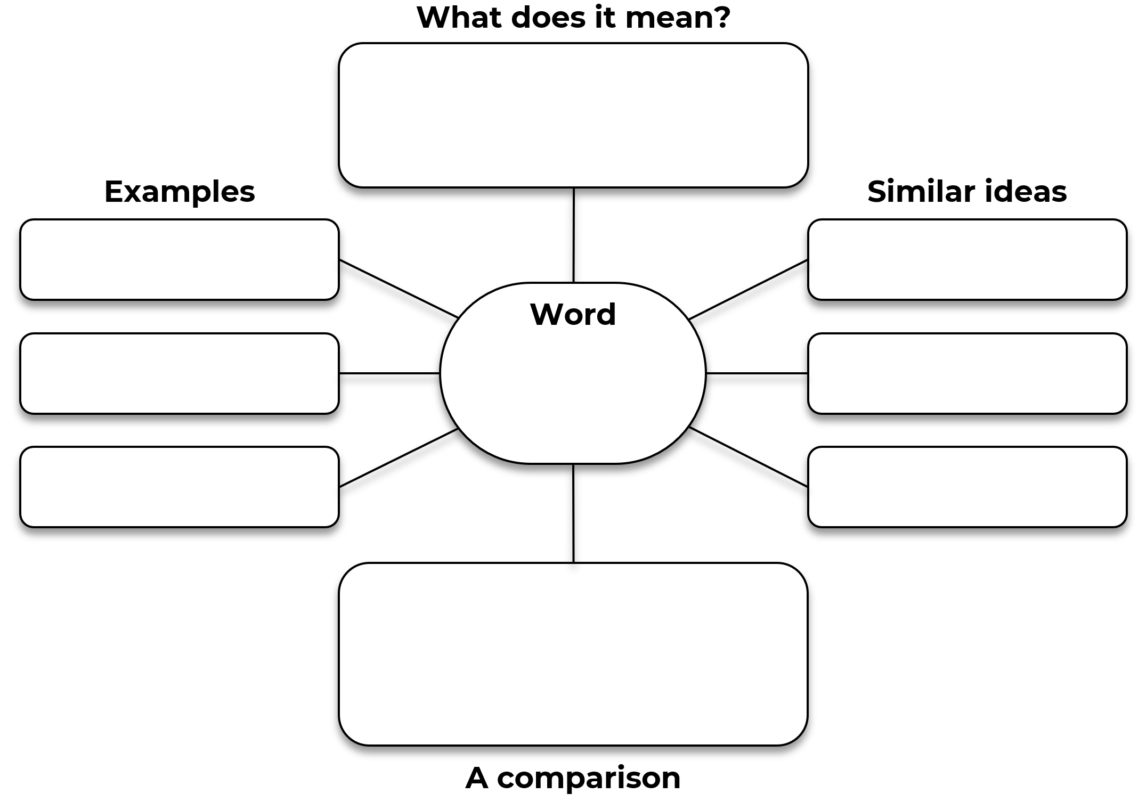

Activity 4: Consolidate

Instructions
- Students create flash cards this could incorporate selecting graphic organisers from the Digital learning selector.
- Students write their own sentence for each word.

Differentiation
- Provide sentence builders with the 10 words.
- Students consolidate their subject vocabulary learning by creating a match-up activity or worksheet for their peers.
- Students provide the teacher with an answer sheet for the match-up activity that they create. The word and correct definition should be clearly indicated.
This is the end of the activities for: Improve writing through subject vocabulary.
Teachers should move on to the next set of activities: Improve student writing through planning for writing (DOCX | PDF)

Additional vocabulary resources

Question verbs
A ready to use glossary of question verbs and activities (DOCX 80 KB) has been included. These will get students thinking about question are asking them to demonstrate.

