Planning for writing – Stage 6 modern languages
In modern languages, there are 2 critical aspects to developing written responses. Students formulate a written response:
- in English, based on a stimulus text in [language]
- in [language].

Sequence
To get the most from these resources, use them as a teaching and learning sequence. One set of activities leads on to the next.
- Improve student writing through subject vocabulary (DOCX | PDF)
- Improve student writing through planning for writing (this document)
- Improve student writing through writing and feedback (DOCX | PDF).

Learning focus
We have provided 4 sample literacy activities (based on 2 stimulus texts) which focus on explicit planning when composing written responses:
Stimulus text – holidays
- The first example develops students’ written responses in English from a stimulus text in [language].
- The second example is an interdependent task, which develops students’ written responses in [language] based on the same stimulus text in the first example.
Stimulus text – traffic report
- The third example develops students’ note taking skills in English based on a listening stimulus in [language].
- The fourth example is an independent task, which develops students’ recounting skills in [language] based on the same stimulus in the third example.
The examples provided are models only and in English. You can translate them into the language you are teaching or create your own examples, modifying the learning intentions and success criteria accordingly.

Syllabus outcomes
Activities should align with the relevant Stage 6 syllabus outcomes. You can access the syllabuses on the NESA website.

Learning intentions
Students will:
- investigate writing effective responses
- analyse sample written responses
- develop note taking skills
- develop confidence in writing.

Success criteria
Students are able to:
- recognise aspects of effective responses
- practise and improve their writing skills
- take effective notes
- prepare for a written response.

Teaching strategies
Focus on skills
Stimulus text – holidays
- Activity 1: Review annotated samples
- Activity 2: Warm-up writing activity
Prepare to write
Stimulus text – traffic report
- Activity 3: Select your resource
- Activity 4: Take effective notes
- Activity 5: Where to next?

Focus on skills

Activity 1: Review annotated samples
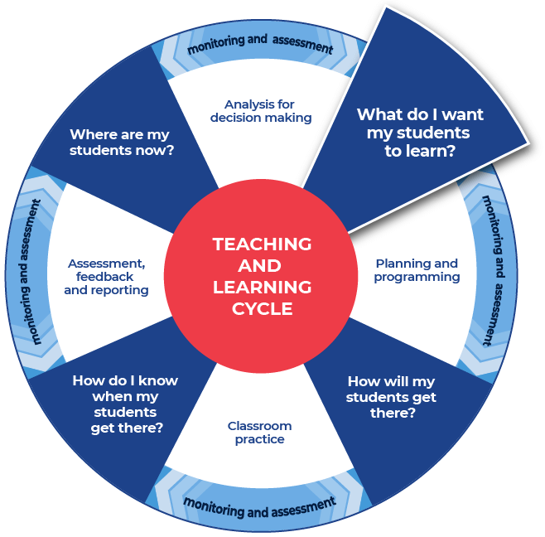

Instructions
- Use the National Literacy Learning Progression to help track your students’ English literacy skills. Identifying students’ strengths and needs in English literacy may provide guidance for identifying student needs in the language they are learning.
- Create or source a range of sample written responses to stimulus texts, for example, from colleagues, previous year groups (de-identified) or NESA publications.
- Provide students with a sample question with an annotated low-range response and an annotated high-range response, identifying features of effective writing. Refer to the sample question below.
- Students complete an analysis of the writing on the template provided, after discussing and reviewing the written samples.
A sample listening text at Stage 6 Beginners level has been provided – the text is provided in English, but would be in [language] for this activity.

Example question
Read the transcript below and answer the following question:
Why would Marcus and Alejandra most likely enjoy the same holiday?
Forum: Holidays
Topic: Should I holiday here or should I go abroad?
Francesca 15:32 Monday, 6 January 2020

Domestic holidays are much better than holidaying overseas, the familiarity of the places and speaking the same language make for a trouble-free holiday. You don’t need to worry about passports and visas or wait for endless hours at the airport. Plus there is always so much to do in your own country if you just look around and give it a chance! There is nothing like discovering new places in your own land!
Henri 17:30 Monday, 6 January 2020

Well, I think exactly the opposite. I prefer to travel abroad and go to faraway places while I’m young and fit. I’m quite happy sleeping at the airport, using my translating app and laughing with the locals when I get my languages mixed up! There is always something different to do or see, just put that backpack on your back and go where the wind takes you.
Alejandra 18:15 Monday, 6 January 2020

I agree with Henri. There is nothing better than travelling overseas and getting lost in a world that is different to yours. Just me and my thoughts walking down streets in a completely different environment. It makes me think that I play a part in our universe. It makes me realise that we are all the same yet with such different customs and ways of doing the same thing. I also enjoy practising my language skills and of course, trying street food and guessing the flavours is a must every time. There is so much to learn from this huge world of ours. My only problem is that I’m always stretched for money but I make it work.
Marcus 15:10 Tuesday, 7 January 2020

I think that the decision of whether to spend your holidays overseas or not really depends on what you are looking for at the time, we need a more balanced perspective. Both domestic and international travel offer completely different things. We should consider the time we have, cost, and even the seasons. Each to their own. That’s why I alternate, one year I stay and do local tourism and the next I go abroad. That way I get the best of both worlds and my budget is not so stretched.

Greta (Travel agency ‘Time of your life’) 16:16 Tuesday, 7 January 2020

I’m letting everyone know that I can organise your dream holidays, abroad or in country. You just let me know what you want, your budget and time and I will make sure you have the best time of your life. Don’t go anywhere without contacting me first on gretamago@timeofyourlife.com
Marcus 18:43 Tuesday, 7 January 2020

I understand the benefits of staying locally and I have such fond memories of road trips with my family … but I always travel overseas. That is my number one goal and money is never an issue. I want to experience that special feeling of getting lost in my own thoughts while being surrounded by a multitude of people so different to me. I watch their faces and think, what do you do? What do you like? Where do you come from? The authentic experiences of trying to learn a little bit about their language and their daily routines, habits and what they like to eat are far better than learning from books. The world is my book.

Sample low-range response
Marcus and Alejandra are most likely to enjoy the same holiday because they like travelling overseas and doing similar things such as trying different foods.

Annotations
Marcus and Alejandra are most likely to enjoy the same holiday because they like travelling overseas and doing similar things such as trying different foods.
- overall, provides some information relevant to the question
- writes simple, compound and some complex sentences related to a topic using a broader range of conjunctions (e.g. and, but, so, because, when) (see Grammar) (CrT6 Text forms and features)
- uses adverbs to give precise meaning to verbs (e.g. talking loudly) (see Grammar) (CrT6 Text forms and features).

Suggested ways to improve
- include persuasive points with effective elaborations and supporting evidence (CrT10 Crafting ideas)
- creates succinct short-answer explanatory texts as well as complex, multi-staged extended texts (CrT11 Crafting ideas)
- provide an opinion in response to the focus of the question
- support the answer with detailed reference to the text.

Sample high-range response
Marcus and Alejandra are most likely to enjoy the same holiday because they like travelling overseas and the feeling of being surrounded by an unfamiliar world where they can learn about themselves and other cultures. They are both very interested in learning about foods, language and what the world has to offer. However, money might be an issue. Alejandra is always short of cash and for Marcus money is not a problem.

Annotations
Marcus and Alejandra are most likely to enjoy the same holiday because they like travelling overseas and the feeling of being surrounded by an unfamiliar world where they can learn about themselves and other cultures. They are both very interested in learning about foods, language and what the world has to offer. However, money might be an issue. Alejandra is always short of cash and for Marcus money is not a problem.
- orients the reader to the topic or concept (e.g. using a definition or classification in the opening paragraph (CrT10 Crafting ideas)
- uses evidence and research including digital resources to expand upon information and elaborate on concepts (CrT10 Crafting ideas)
- includes persuasive points with effective elaborations and supporting evidence (CrT10 – Crafting ideas).

Overall
- creates texts to compare and contrast phenomena (e.g. identify the similarities and differences between species of animals) (CrT10 – Crafting ideas)
- spells a range of challenging words correctly (see Spelling) (CrT11 – Generic indicators)
- creates succinct short-answer explanatory texts as well as complex, multi-staged extended texts (CrT11 – Crafting ideas)
- provides an opinion in response to the focus of the question
- supports the answer with detailed reference to the text.

Review annotated samples
- Students read through the example responses to question.
- Students choose one of the sample responses.
- Students respond to the analysis questions on the template provided.

Template
What do you notice about the structure of the answer?

Were there words from the question used in the answer? If yes, which one/s?

What do you notice about the sentences?

Identify and re-write (with improvements) an idea mentioned in the sample response.

What did you like about the response?

Sample completed example
What do you notice about the structure of the answer?
The answer is structured in a logical way. The response begins by reflecting on the specific question asked. It then builds up the information and explanation making it more detailed with supporting evidence provided.
Were there words from the question used in the answer? If yes, which one/s?
Words from the question were used in the first part of the answer – most likely, enjoy, same holiday.
What do you notice about the sentences?
The sentences were compound with complex sentence structures (PDF 225 KB). They gave a lot of information with a small amount of words and included supporting details from the text.
Identify and re-write (with improvements) an idea mentioned in the sample response.
Identified sentence: ‘However, money might be an issue. Alejandra is always short of cash and for Marcus money is not a problem.’
Improved sentence: Alejandra does not have a lot of money. Marcus has enough money to comfortably do what he chooses. This could be an issue as conflicts could arise if they were on holidays together when choosing activities, restaurants and accommodation.
What did you like about the response?
I appreciated the details. The ideas were built up with supporting evidence and often a sentence led on to another sentence that gave further evidence and support. This demonstrated that the writer understood the content and was able to apply their knowledge to answer the specific question. It was good that so much information was communicated in a very succinct way.

Additional support for Activity 1
You could use marking guidelines to assess written responses and provide feedback.
In some contexts, the National Literacy Learning Progression may support you to identify aspects of writing and strategies for how students could improve.
For more ideas on what to look for in literacy, you may like to complete the online course: Introduction to the Literacy and Numeracy Progressions.

Activity 2: Warm-up writing activity
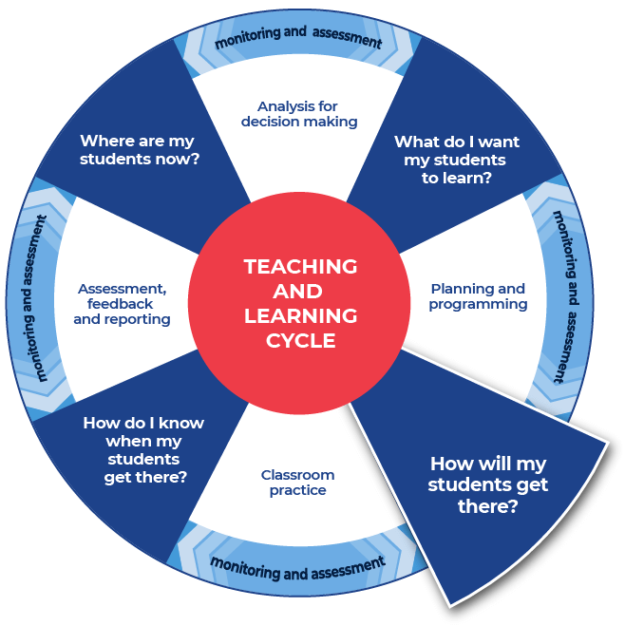

Instructions
- Students create their own written response to a question provided.
A sample Stage 6 Continuers question has been provided below.

Differentiation
- Allow more time to complete the activity.
- Students could work individually or in small groups.
- Discuss modelled writing relevant to the topic students are learning about.
- Provide students with a structure that can be used to approach the writing.
- Model or scaffold sentences to demonstrate how the task could be approached, as well as illustrate the language used to address each level of complexity or depth in terms of the verbs in the question.

Example question
Using the same stimulus text from Activity 1, answer the following question.
You are Francesca. In [language], write an email to Marcus convincing him to join you on your next domestic holiday.
Hi Marcus,

This is the end of Focus on skills section

Prepare to write

Activity 3: Select your resource

Instructions
- Choose an appropriate text, for example, a text from past HSC examinations, textbooks, articles, blogs, podcasts, websites or song. A similar source for the activities in the Subject vocabulary document (DOCX | PDF) maybe used.
- Provide the selected text to students.
A sample text at Stage 6 Beginners level has been provided – the text is provided in English, but would be in [language] for this activity.

Example
Traffic report
This is WCD-FM 102.2 with the traffic report on this glorious Monday morning, at exactly 8:30am, right in the middle of peak hour. Expect hours of delay if you are heading south from the riverbank. We have just received news that there has been an accident involving three cars and the police and ambulance are on their way. There are no fatalities. Vehicles are blocking the main intersection of Bourke and Collins streets and it will be hours before the area is cleared. An emergency vehicle has just arrived and is redirecting the traffic but the line of waiting cars is getting longer and longer by the minute. Avoid the area if you can.

Activity 4: Take effective notes

Instructions
- Students take notes as they engage with the text – 3 sample templates have been provided.

Differentiation
- Allow more time to complete the activity.
- Students could work individually or in small groups.
- Provide different students with different scaffolds.
- Pre-fill some of the note taking template or include sentence starters to support student engagement and achievement.

Further support
- Review the pre-written ideas and teaching strategies regarding Locating explicit information on the HSC minimum standard site.
- Use the examples provided as support to create your own examples for your students and context.

Sample template 1
Title of text:
Type of text:
What is the text about?

When did the incident occur?

Where did it occur?

What happened?

Put 3 of the points that you have recorded in the categories above into a summary paragraph of 3 to 4 sentences.

Sample template 1 – completed example
Title of text: Traffic report
Type of text: Transcript of listening activity.
What is the text about?
It is from a radio station, WCD-FM 102.2. The radio traffic report talks about a car accident and the ensuing traffic disruption to the area. It warns motorists who are heading south from the riverbank and who may be driving near Bourke and Collins Streets.
When did the incident occur?
The text states that this broadcast is at 8.30am and it sounds as if the accident was sometime before that.
Where did it occur?
Near Bourke Street and Collins Street.
What happened?
There was an accident involving three cars. There are no fatalities. Ambulance and police services are on the way.
Put 3 of the points that you have recorded in the categories above into a summary paragraph of 3 to 4 sentences.
The radio traffic reports a motor vehicle accident involving 3 cars. It warns motorists of traffic disruptions heading south from the riverbank, near Bourke and Collins Streets. Although there are no fatalities, ambulance and police services are on their way. The purpose of the radio broadcast is to warn motorists of delays and to discourage them from entering the area.

Sample template 2
As you engage with the source, create sentences that begin with the following.
Title of text:
Type of text:
Before

After

If

When

Even though

Although

Since

While

Unless

Whenever

Put some of the points that you have recorded in the categories above into a summary paragraph of 4–5 sentences.

Sample template 2 – completed example
Title of text: Traffic report
Type of text: Transcript of listening activity.
Before the 8.30am radio broadcast, a car accident occurred.
After the broadcast, motorists will know to avoid the areas around Bourke and Collins streets because of traffic delays.
If motorists are heading south from the riverbank they can expect hours of delays.
When the accident occurred, there were 3 cars involved.
Even though the radio report warns drivers, some drivers are already caught up in the delays and there is a line of cars banked up.
Although the police and ambulance have been called and are on their way, there are no fatalities.
Since the accident occurred, vehicles have blocked the main intersection of Bourke and Collins streets.
While there are no fatalities, the ambulance and police services are still attending.
Unless motorists really need to go to that area, they are advised to avoid the area.
Whenever there is a motor vehicle accident, it is expected that there will be delays for motorists until the area is cleared and declared safe again.
Put some of the points that you have recorded in the categories above into a summary paragraph of 4–5 sentences.
Before the 8.30am radio broadcast, a car accident occurred. After the broadcast, motorists will know to avoid the areas around Bourke and Collins streets because there could be traffic delays. If motorists are heading south from the riverbank they can expect to encounter hours of delay in traffic. When the accident occurred, there were 3 cars involved. Although there are no fatalities, police and ambulance have been called and are on their way to ensure safety.

Sample template 3
Title of text:
Type of text:
Topic:
Events
People
Facts
Key words
Summary

Sample template 3 – completed example
Title of text: Traffic report
Type of text: Transcript of listening activity
Topic: Car accident
Events
- 3 cars involved in an accident before 8.30am
- no fatalities
- ambulance and police are on their way
- delays for motorists travelling south from the riverbank and around the intersection of Bourke and Collins Streets
People
- radio station
- reporter
- motorists
- emergency services
Facts
- 3 cars had an accident at the intersection of Bourke and Collins Streets
- no fatalities
- emergency services are attending
- delays for other motorists
Key words
- car accident
- delays
- radio station
- no fatalities
Summary
Early morning radio report of 3 cars in an accident at the intersection of Bourke and Collins Streets. No fatalities. Emergency services are attending. Delays for motorists travelling south from the riverbank and around the intersection of Bourke and Collins Streets.

Activity 5: Where to next?
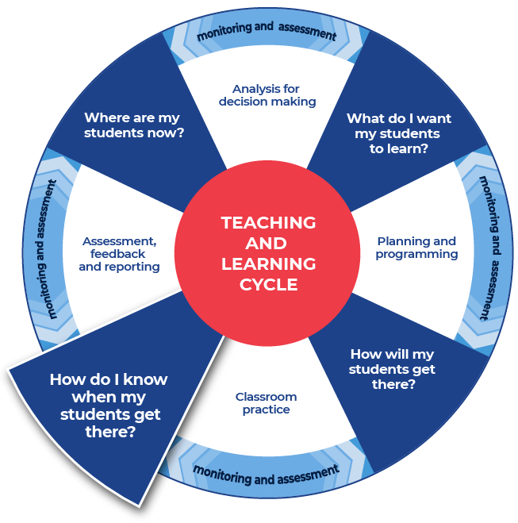

Instructions
- Provide the specific question or stimulus that your students will respond to.
- Students create a plan and draft for their written response using the notes that they have taken and any other information.
- Students draft their writing.
- Provide students with formative feedback during the drafting process.

Differentiation
- Students could complete a cloze passage on a similar text prior to drafting their response.
- Students could be provided with sentence or paragraph starters.
- Students could write a different type of text, for example a journal entry.

Example
You are a key witness to an accident and you have been asked to report to the police. Write a recount of what you have witnessed in [language].
Traffic report:
This is WCD-FM 102.2 with the traffic report on this glorious Monday morning, at exactly 8:30am, right in the middle of peak hour. Expect hours of delay if you are heading south from the riverbank. We have just received news that there has been an accident involving 3 cars and the police and ambulance are on their way. There are no fatalities. Vehicles are blocking the main intersection of Bourke and Collins streets and it will be hours before the area is cleared. An emergency vehicle has just arrived and is redirecting the traffic but the line of cars is getting longer and longer by the minute. Avoid the area if you can.

Further resources
Students may benefit from support in other areas of their learning. More ideas and teaching strategies for literacy can be found at the HSC minimum standard web page. Here you will find teaching ideas and activities on:
Writing, including: text structure, paragraphs, cohesion, sentence types, tense, punctuation, formal and informal language, spelling, vocabulary, topic vocabulary, audience and purpose, ideas, language devices, and unpacking the writing prompt.
Reading, including: audience and purpose, locating explicit information, inferring, common language devices, parts of speech, cohesive devices, sentence types, tense, subject-verb agreement, punctuation, spelling, antonyms and synonyms, inferring word meanings.
This is the end of the activities for: Improve student writing through planning for writing.
Teachers should move on to the next set of activities: Improve student writing through writing and feedback (DOCX | PDF).

