The National Literacy Learning Progression and Stage 6 Modern Languages

How the progression supports writing in Stage 6 Modern Languages
This document is part of the Stage 6 Literacy in context – Writing resource. It outlines ways that the National Literacy Learning Progression can support development of student writing through Stage 6.
The element of Writing in the National Literacy Learning Progression provides indicators that reflect the increasing sophistication of skill development in writing for students in Years K–10. It is important to note that these skills are unconstrained and will continue to develop as students work through their final years of school and beyond.
In addressing the objectives and outcomes in the Stage 6 Modern Languages syllabuses, students need to understand, interpret, convey, identify, summarise, conclude, explain, produce, structure, sequence, apply and express.
A student’s ability to communicate their knowledge and understanding will influence the quality of their written responses. For example, marking guidelines from HSC questions for languages may include statements such as:
- explains why
- shows a thorough understanding
- integrates evidence
- effectively structures responses.
It can be difficult for some teachers to articulate what effective writing ‘looks like’ in a student response and therefore be able to explicitly support students to improve their writing. Certain indicators within the Creating texts sub-element of the National Literacy Learning Progression can amplify these criteria and support teachers and students to identify features of writing that can be targeted to improve students’ ability to answer extended response questions.
Some examples of the connections between the criteria and the Creating texts sub-element are provided below.
Explains why:
- uses discipline-specific terminology to provide accurate and explicit information (e.g. discipline metalanguage) (CrT10 – Vocabulary)
- uses vocabulary for precision (e.g. the underwhelming performance of the opening batsmen) (CrT11 – Vocabulary)
- uses complex abstractions (e.g. economic, sociocultural) (CrT11 – Vocabulary)
Shows a thorough understanding:
- creates informative texts to explain and analyse (e.g. analyses how artists use visual conventions in artworks) (CrT10 – Crafting ideas)
- orients the reader clearly to the topic or concept (e.g. using a definition or classification in the opening paragraph) (CrT10 – Crafting ideas)
Integrates evidence:
- includes persuasive points with effective elaborations and supporting evidence (CrT10 – Crafting ideas)
- uses evidence and references (CrT11 – Crafting ideas)
Appropriately structures response:
- maintains tone appropriate to the audience (CrT11 – Text forms and features)
- creates texts to compare and contrast phenomena (e.g. identify the similarities and differences between species of animals) (CrT10 – Crafting ideas)
- writes succinct short-answer explanatory texts as well as complex, multi-staged extended texts (CrT11 – Crafting ideas)

Using the National Literacy Learning Progression to inform feedback
Before you begin, please familiarise yourself with the National Literacy Learning Progression. You may also enrol in the online professional learning course: Introduction to the Literacy and Numeracy Progressions.
For example, Writing sub-elements include:
- Creating texts – Crafting ideas
- Creating texts – Text forms and features
- Creating texts – Vocabulary
- Grammar
- Punctuation
- Spelling
- Handwriting/keyboarding.
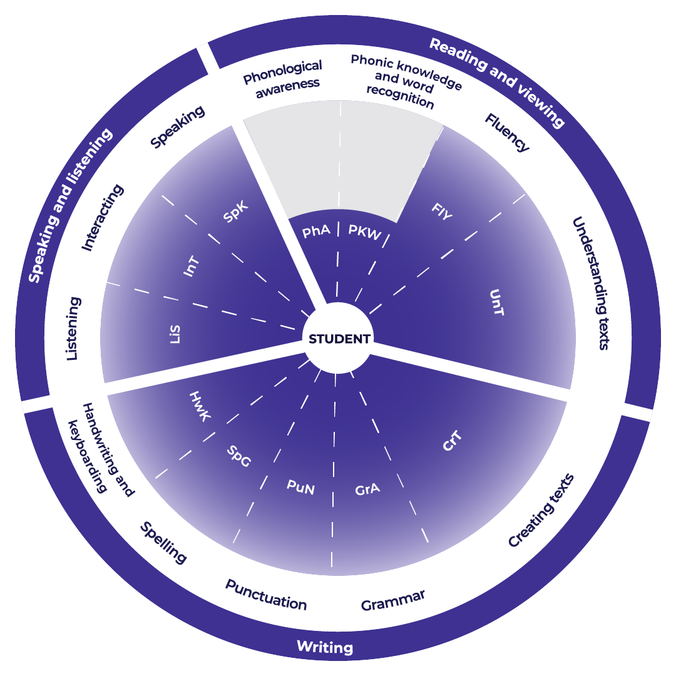

Teachers could use the student’s written response to assess where the student is at now and what they could do next to improve.

Example analysis
For this example, the sub-element of Creating texts has been selected.
Read through the sub-element indicators to match characteristics that the student’s text is currently displaying. An example from the Beginners course is provided.
CrT10 – Crafting ideas
- Orients the reader clearly to the topic or concept (e.g. using a definition or classification in the opening paragraph).
- Expands upon information and concepts and add authority.
- Creates texts to discuss, evaluate and review (e.g. evaluates and reviews design ideas).

Sample response
There has been a major accident, involving 3 cars, at the intersection of Bourke and Collins Streets during peak hour this morning. Expect long delays if travelling south from the riverbank and avoid the area if possible. There are no fatalities. Ambulance and police services are attending.
Reading the indicators in the next level of the sub-element, you could work out where to next for the student:
- uses evidence and references (CrT11 – Crafting ideas)
- writes succinct short-answer explanatory texts as well as complex, multi-staged extended texts (CrT11 – Crafting ideas)
- spells a range of challenging words correctly (CrT11 – Generic indicators).
For example, in the written response:
- students ensure they continue to practice writing succinct responses that include supporting detail from the source text. Additionally, they maintain their English vocabulary skills enabling them to effectively respond to questions in written English.

Example of written feedback to the student
Name: Rose Yeung
Is able to:
- orientate the reader
- use supporting evidence
- expand upon ideas and concepts in her writing
- structure her responses.
To continue to improve:
Rose should practise writing succinct responses that include supporting detail from the source text. Additionally, Rose should maintain her English vocabulary skills, enabling her to effectively respond to questions in written English.

Template
Feedback to student.
Name: ____________________________________
Is able to:

To continue to improve:

