Student writing and feedback – Stage 6 HSIE

Sequence
To get the most from these resources they should be used as a teaching and learning sequence. One set of activities leads on to the next.
- Improve student writing through subject vocabulary (DOCX | PDF)
- Improve student writing through planning for writing (DOCX | PDF)
- Improve student writing through writing and feedback (this document).

Learning focus
With these literacy activities teachers use content that they have planned in their teaching and learning cycle. For each literacy activity an example from Modern History has been provided. The example provided is a model for teachers. Teachers create their own specific examples for their subject and class. Teachers can modify the learning intentions and success criteria to reflect their context. Students draw upon their vocabulary and planning to complete a written response and engage with feedback to enable them to continue to build their skills.

Syllabus outcomes
For each HSIE subject, relevant syllabus outcomes have been provided in the Stage 6 HSIE syllabus links (PDF 151 KB) document.

Learning intentions
- Students respond to a writing task.
- Students provide effective peer feedback.
- Students engage with effective feedback.

Success criteria
- Students are able to effectively complete a written response.
- Students are able to effectively provide feedback to a peer.
- Students are able to reflect on their learning needs.

Teaching strategies
- Activity 1: Turn and talk
- Activity 2: Writing activity
- Activity 3: Peer feedback
- Activity 4: Teacher feedback
- Activity 5: Student self-reflection.

Activity 1: Turn and talk
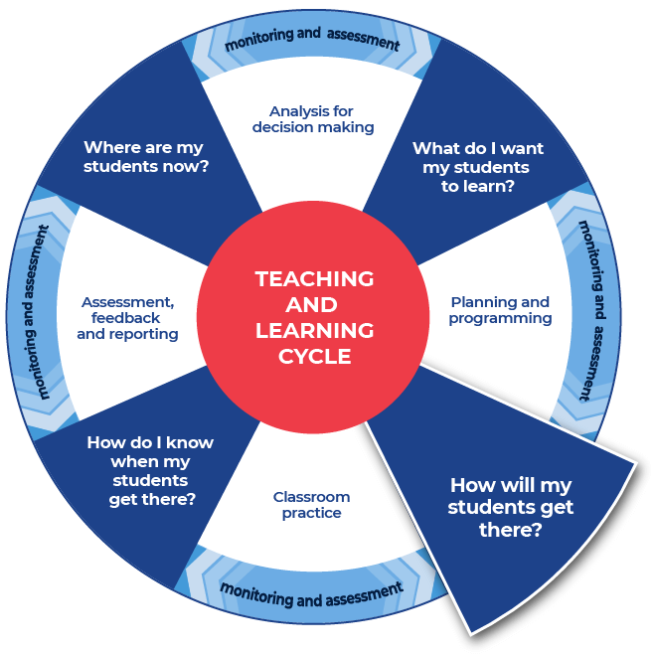

Instructions:
- Teachers provide time in class for students to discuss the notes that they have taken and the plan that they have created for their written response.
- Teachers model their own example to share with students. An example from Modern History has been included.
Differentiation:
- Teachers could support students by providing specific questions for ‘turn and talk’.
- Teachers could provide a completed written response. The students could use this example to model their own writing.
- Teachers could modify this activity for specific contexts through sentence starters, scaffolded sentences or word banks.
- Students and teacher could co-write and produce one written piece of work.

Further support:
- Classroom talk is a powerful tool for both teaching and learning. Rich, dialogic talk supports students in making sense of complex ideas and builds classroom communities centred on meaning-making. Tools to support rich talk in the classroom were outlined in Christine Edwards-Groves 2014 paper, Talk moves: A repertoire of practices for productive classroom dialogue (PETAA paper 195). For an example of how these tools were applied to Mathematics ‘Talk moves’ posters, flashcards and a chart are available. These practices could also be applied in the classroom in other learning areas including HSIE.
- Further support with paragraph construction can be found at: HSC minimum standard – Paragraphs.
- Teachers could support students to access marking criteria to decide on a mark for the sample response and note how it could be improved. Using page 13, Part (c) of the 2019 Modern History Marking Guidelines (PDF 247 KB).

Example question
Evaluate the social and environmental effects of the Nuclear Age. In your answer, include references to the source provided. (12marks)
Source A
A legacy of damage
Harm was done to Aboriginal people who lived nearby to all three testing sites at Maralinga. This harm included injury, death, and displacement. The impact on Aboriginal people is immeasurable. Additionally, service personnel from many countries including Britain and Australia were also impacted and suffered. This includes their continuing battle for any recognition of the dangers that they faced. A source of ongoing distress for those involved and impacted is that even though there were many injuries and deaths allegedly caused by the British tests they have not been formally linked.
In the late 1990’s the cost of the clean-up exceeded A$100 million. Of this amount, Britain paid less than half and only did so after protracted pressure and negotiations.
Extract adapted from Tynan L (2016) Sixty years on, the Maralinga bomb tests remind us not to put security over safety. The Conversation.

Example response
The social and environmental effects of the Nuclear Age were significant and continue to be felt by the global world today. The testing regimes by various countries had clear and ongoing impacts on both the physical environments within which they were held, as well as on the people that resided nearby. This is highlighted specifically in the extract in Source A, in terms of both the human and environmental effects. The level of societal anxiety around nuclear testing and potential war has varied over time, but has altered the social fabric of many nations, as well as political relationships on a global level. Nuclear accidents at sites like Chernobyl and Fukushima have been disastrous for the environment, whilst also providing a catalyst for change and development in regard to safety measures and protocols for dealing with nuclear energy. Thus, although there are many negative effects, both socially and environmentally, the Nuclear Age has seen some positive measures to improve and combat the environmental impacts.
Analysis colour coding:
- addresses the question
- provides examples from the source and own knowledge as supporting evidence
- addressing the counter argument enhances the sophistication of the response
- comes to a conclusion that states a position.

Activity 2: Writing activity

Instructions:
- Teachers allocate enough time to complete the written response.
- Students complete their written response.
Differentiation:
- Teachers could provide a scaffold for the response, with sentence starters or layout outlines.
- Students could have their notes and planning with them for the writing task.

Activity 3: Peer feedback
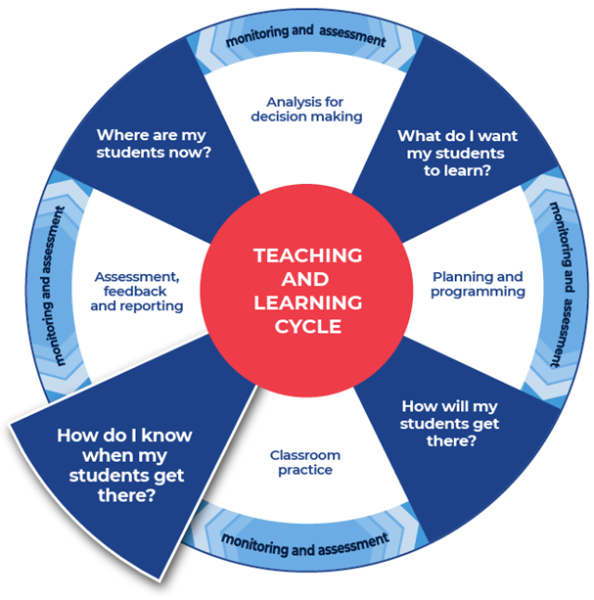

Instructions:
- Teachers facilitate pairs of students to swap their written responses.
- Teachers brief the students on acceptable peer feedback behaviors. Including ‘two stars and a wish’ or ‘I like, I wonder’ protocols. This activity may be anonymous.
- Students are provided with the template and they fill it in to provide feedback to their peer.
- Students tick where they think the writing aligns on the template.
Additional peer feedback options:
- Teachers could give students a focus to look for, such as use of vocabulary, and assign this focus to a coloured highlighter. This could be repeated with different focusses and highlighters.
- Teachers could support students to create their own class-agreed feedback template.

Template
Criteria | Developing | Developed | Highly developed
The response answers the question.
Idea being written about is clear.
The writing has a logical structure. It makes sense when you read it through.
There is a clear reference to syllabus content.
There is topic specific vocabulary in the response.
Sentences make sense.
Capital letters, full stops and some other punctuation is used.
Accurate spelling of challenging words.
Handwriting is consistently legible.
Two successful things about this written response are:

One aspect of writing to keep working on is:

Activity 4: Teacher feedback

Instructions
- Teachers support their students with timely and effective feedback. Remembering that effective feedback:
  - focuses on the intended learning
  - identifies specific strengths
  - points to areas needing improvement
  - suggests a pathway that students can take to close the gap between where they are now and where they need to be
  - chunks the amount of corrective feedback the student can handle at one time
  - is provided in a short time frame.
- Teachers select areas to provide feedback from the templates provided or modify and use the student feedback template from Activity 3.
- Teacher comments could include, ‘working towards’, ‘achieved’, and ‘working beyond’.
- Teachers may choose to engage with the National Literacy Learning Progression to provide feedback to their students. To use this tool more effectively teachers could first engage with the online professional learning course: Introduction to the Literacy and Numeracy Progressions.

Feedback templates
- More information on aspects of literacy can be found at: HSC minimum standard – Writing.
- The links contained within the feedback sheets link to teacher resources focusing on that writing aspect.
- Teachers can modify or remove the definitions.
- Some teachers may choose to leave the definitions in place to support the students’ skill development.
- There are three templates to choose from:
  - Control of language
  - Structure and sequence of ideas
  - Relevance of writing to the topic.

Control of language
Spelling. Correct spelling is consistent and some difficult words are spelled correctly. In the written response spelling is:

Vocabulary. Subject vocabulary has been used effectively in context. In the written response vocabulary is:

Tense. Past, present and future references within sentences, and the response, as a whole are logical and consistent. For example, ‘Alex laughe’, ‘Alex laughs’, ‘Alex will laugh’. In the written response tense is:

Punctuation. There is correct sentence punctuation, including capital letters and full stops. There are some correct examples of commas, proper nouns, apostrophes. In the written response punctuation is:

Formal and informal language. The tone matches the audience and purpose. The language use is consistently appropriate. Informal language is every day and conversational. Formal language uses correct sentence structures and has a feeling of authority. In the written response formal and informal language are:

Two successful things about this written response are:

One aspect of writing to keep working on is:

Structure and sequence of ideas
Text structure is the way that the information is organised. This could include headings and sub-headings, is there an introductory and concluding paragraph. In the written response text structure is:

Paragraphs. Text in a distinct section that reflects a logical cohesive point. In the written response paragraphs are:

Sentence types. A sentence begins with a capital letter and ends with a full stop, question mark or exclamation mark. There are different types of sentences:
- simple sentence – a single main clause that expresses a complete thought. It has a subject and a finite verb and may also have an object, for example ‘Mary is beautiful.’, ‘The ground shook.’, ‘Take a seat’'
- compound sentence – contains two or more clauses that are coordinated or linked in such a way as to give each clause equal status. In the following example and is the coordinating conjunction: ‘We went to the movies and bought an ice cream.’
- complex sentence – contains a main (or independent) clause and one or more subordinate (or dependent) clauses. The subordinate clause is joined to the main clause through subordinating conjunctions like when, while and before, as in the following examples: ‘We all went outside when the sun came out.’, ‘Because I am reading a long book, my time is limited.’
(NSW English K–10 Glossary © NSW Education Standards Authority (NESA) for and on behalf of the Crown in right of the State of New South Wales, 2020.)
In the written response sentence types are:

Cohesion. Features can include connectives such as ‘furthermore’ and ‘therefore’, cross-references to different parts of the text, and reiteration of the title or terms of the topic or question being addressed in the text.
(NSW English K–10 Glossary © NSW Education Standards Authority (NESA) for and on behalf of the Crown in right of the State of New South Wales, 2020.)
In the written response cohesion is:

Two successful things about this written response are:

One aspect of writing to keep working on is:

Relevance of writing to the topic
Audience and purpose. Audience is the intended readers. Purpose can include, to entertain, to inform, to persuade, to educate. ‘Composers use a number of ways to achieve these purposes: persuading through emotive language, analysis or factual recount; entertaining through description, imaginative writing or humour, and so on.’
(NSW English K–10 Glossary © NSW Education Standards Authority (NESA) for and on behalf of the Crown in right of the State of New South Wales, 2020.)
In the written response audience and purpose are:

Ideas. An idea is a thought or notion that is being explained and explored. Students are encouraged to develop their ideas and create insightful and impacting points. Students will support their ideas with evidence and examples. In the written response ideas are:

Topic vocabulary. Have specific words from the subject area been used effectively in the writing. In the written response topic vocabulary is:

Two successful things about this written response are:

One aspect of writing to keep working on is:

See Literacy Learning Progression and Stage 6 HSIE (DOCX | PDF) for information on how the National Literacy Learning Progression could support student writing and feedback in Stage 6 HSIE.

Activity 5: Student self-reflection
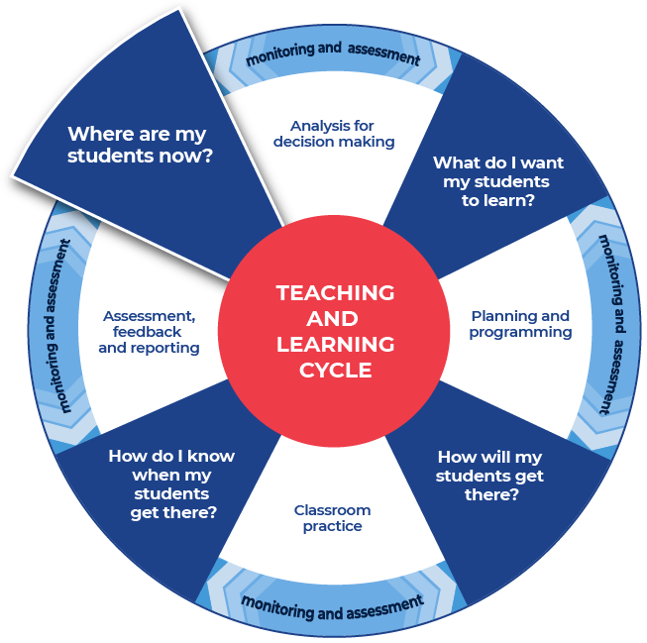

Instructions:
- Teachers provide students with a copy of an ‘exit slip’.
- Students complete the exit slip and detail one skill that they learnt through the literacy lessons and one skill that they need to work on further.
- Teachers collect and review the completed exit slips to plan where to next for improving their students’ literacy skills.
- Planning where to next could be done collaboratively with the students.

Exit slip template
Name:
When writing your response, how confident are you to:
Criteria | Not confident | Somewhat confident | Confident
understand the question | ◻ | ◻ | ◻
know where the content comes from in the syllabus | ◻ | ◻ | ◻
know how to use the content/concept to structure your response | ◻ | ◻ | ◻
know which explicit examples to use to validate your statements | ◻ | ◻ | ◻
know how to use subject vocabulary | ◻ | ◻ | ◻
sequence the paragraphs | ◻ | ◻ | ◻
One skill that I have learnt that improved my writing:

One skill I will continue to work towards:

