Subject vocabulary – Stage 6 English

Sequence
These resources are designed to be used as a teaching and learning sequence, as each set of activities leads on to the next.
- Improve student writing through subject vocabulary (this document)
- Improve student writing through planning for writing (DOCX | PDF)
- Improve student writing through writing and feedback (DOCX | PDF).

Learning focus
For each literacy activity an example from Stage 6 English Standard has been provided as a model for teachers. Teachers create their own specific examples for their course, module and class using content they have planned in their teaching and learning cycle. Teachers can modify the learning intentions and success criteria to reflect their context.

Syllabus outcomes
These resources include ways to address Stage 6 syllabus outcomes in English. However, to support professional practice teachers are strongly advised to always refer to the syllabus documents on the NESA website.

English Standard (Year 11) example
Outcome:
- uses and evaluates processes, skills and knowledge required to effectively respond to and compose texts in different modes, media and technologies EN11-2
Content:
Respond to and compose texts
- locate suitable information sources, skimming for general meanings and scanning for specific information, note-taking, summarising, paraphrasing and using graphic organisers to collect and collate information (ACEEA010)
Outcome:
- analyses and uses language forms, features and structures of texts, considers appropriateness for purpose, audience and context and explains effects on meaning EN11-3
Content:
Engage personally with texts
- engage with increasingly complex texts to understand and appreciate the power of language in shaping meaning
Develop and apply contextual knowledge
- analyse how language choices are made for different purposes and in different contexts using appropriate metalanguage; for example, personification, voice-over, flashback and salience (ACEEN002)
(English Standard Stage 6 Syllabus © NSW Education Standards Authority (NESA) for and on behalf of the Crown in right of the State of New South Wales, 2017)

Learning intentions
- Students will become familiar with subject vocabulary.
- Students will increase understanding of specific vocabulary terms.
- Students will create and maintain their own glossary.

Success criteria
- Students are able to define terms that are specific to their subject.
- Students are able to effectively use terminology that is specific to their subject.
- Students are able to complete self-directed work.

Teaching strategies
- Activity 1: Select
- Activity 2: Explain
- Activity 3: Explore
- Activity 4: Consolidate.
(Adapted from: Alex Quigley ‘Closing the Vocabulary Gap’ Routledge 2018)

Activity 1: Select
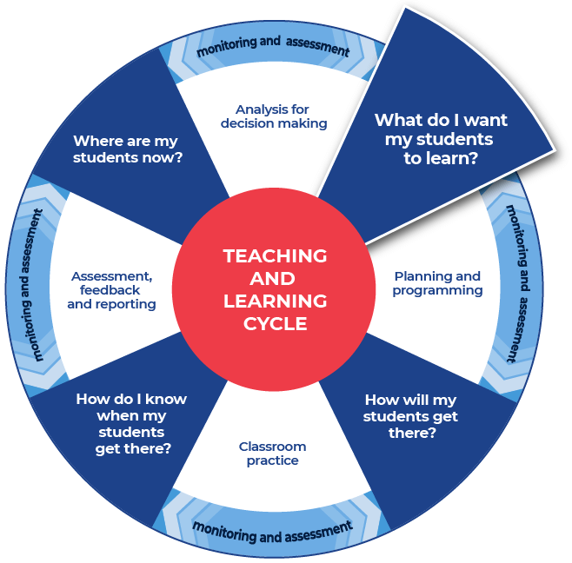

Required resources
Teachers choose a resource that they are currently using in class. It could be an article, video, website, specific page or pages from a text, text, or other resource.
Teachers provide their students with access to the chosen resource.
Examples of resources are listed below:
- specific pages or a chapter from a text
- a video or Ted Talk on the topic
- NSW syllabus document, for example the English Stage 6 Syllabuses
- glossary for your subject, for example the English Standard Stage 6 glossary.
- for the English Standard examples, a specific text has been chosen that reflects the Year 11 Common Module – Reading to Write: How to mark a book (Adler M 1941).
When selecting the resource or text that will be explored, consider text complexity and the purpose for using that resource or text. It is also important to read texts carefully before using them with students and pre-identify any terms or subject specific language that students may find challenging. Further information on text complexity can be found at National Literacy and Numeracy Learning Progressions, Literacy Progression, Appendices 6 – Text Complexity (PDF 388 KB). Further support and professional learning for text complexity and aspects of understanding texts can be found at the Literacy and numeracy professional learning webpage.

Instructions:
- The teacher provides students with a text and supports students to read the text.
- After reading, the teacher instructs the students to select ten unfamiliar words or words they find hard to define.
- Allow time for students to write the words into a table or in their workbook.
- The teacher models their own example with students. An example for English Standard for the teacher to model from has been provided below.
Differentiation
The teacher could:
- pre-select the ten words
- pre-select some of the words and then allow the students to select the rest
- alter the number of words to be selected
- support comprehension by altering the font of the text to make it more readable and presenting the information in smaller sections
- use a text-to-speech reader (available in Microsoft Word), to allow students to listen to the text
- use pre-reading activities such as:
  - providing students with clues for navigating the text
  - summarising the text (locating specific information)
  - explaining specific terms that will appear in the text
  - read the text to students to allow them to hear the pronunciation of key terms
  - use images, videos and other multi-modal texts to support learning.

Example
The words below come from the text ‘How to mark a book’ (Adler, M. 1941).

receptacle
indispensable
fundamental
invariably
preserves
protrudes
acquaintances
prelude
contend
bluntly

Activity 2: Explain
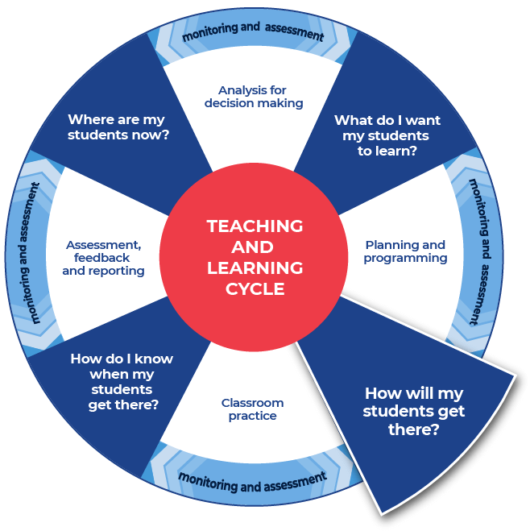

Instructions:
- Teacher replicates the ten words example structure provided above, but for the text that their students are exploring.
- Teacher models an example of both the formal and informal definition of a chosen word to their students. Using the template, Table 1, that is provided below.
- Issue students with the table template and explain they will be writing their informal and formal definitions in the table. Please note that teachers can chose for their students to work on the informal definitions first, with discussion and predicting word meaning through context. Then moving to formal dictionary definitions and then reflecting on the new knowledge and refining student informal definitions. However, teachers may prefer to alter the sequence of instructions, listed below, and ask students to work with the formal definition first and then the informal definition.
- Using the model, created for step 2 above, as a guide, instruct students to create their own informal ‘student’ definition for each word, with discussion and predicting word meaning through context. The students should write the informal definitions in plain English the way they might explain it to a friend.
- Provide students with a range of dictionaries so they can research the formal technical definition for each word. Students should record the definition and its source in the table, or in their workbook. Students could use online or hard copies of dictionaries. Definitions could also be sourced from the NESA Glossary for the specific English course or other sources as required.
- The teacher should review a couple of the definitions (individually or as a class). Encourage students to review their informal and formal definitions and then refine their informal definition if needed. Remind students that the definitions should reflect the context of the text.
- Support students to complete this process for all ten words.
- Where appropriate, support students to examine the etymology of key terms beginning with the root word. To investigate etymology and vocabulary further teachers could visit the Literacy Professional Learning webpage.
- For key terminology, teachers should discuss any multiple meanings. Teachers could highlight that being literate includes understanding that some words can have multiple meanings and this depends on the context in which they are used.
Differentiation
The teacher could:
- provide students the word list and scaffold the definitions (for example, create mini cloze passages inside the definition spaces and provide a word bank for students)
- supply the link to specific online dictionaries – students write the definition in the table and indicate the source of the definition
- encourage students to work in pairs focusing on ten words
- encourage students to work in a group of four completing the definitions for twenty words
- allow students to discuss their words, focusing on how they are used in the context of the sentence.
- allow students to work back and forth between the formal and informal definitions to refine and consolidate understanding.
- modify for students with additional literacy needs and EAL/D students by explicitly teaching students how to use online and hard copy dictionaries and thesaurus, supporting the identification and selection of correct definitions (the definition relevant to the text or topic).

Template
Table 1 – personal and dictionary definitions activity
Word | Your definition | Dictionary definition
word | Student definition | Include name-of-dictionary:
… | … | …
… | … | …
… | … | …
… | … | …
… | … | …
… | … | …
… | … | …
… | … | …
… | … | …

Completed example
The example below has been filled in for teachers as a model of what they would create for their specific text to then share with their class.
Table 2 – sample definitions
Word | Your definition | Dictionary definition
receptacle | A person or thing that receives something or that you put something in. It could receive information or ideas or a physical thing. The garbage bin could be a receptacle for rubbish, or your brain could be a receptacle for knowledge and ideas. | From: Merriam-Webster  one that receives and contains something.
fundamental | It is a very basic requirement. It is like air to a human being. It is fundamental. | From: Dictionary.com  adjective  serving as, or being an essential part of, a foundation or basis; basic; underlying: fundamental principles; the fundamental structure.
indispensable | You cannot do without it. In fact, maybe you cannot live without it. It could also be a person that you cannot do without. | From: macmillan dictionary  difficult or impossible to exist without or to do something without

Activity 3: Explore

Instructions:
- The teacher models the task by providing their own completed example for the text and words that their class is working with. The teacher should choose to work with one of the templates provided below. Examples of what these templates look like completed are provided for the teacher to model from.
- Teachers provide students a blank template, chosen from the two templates offered below.
- Instruct students to follow the template provided to explore each word to deepen their understanding of the subject vocabulary.
- Encourage students to complete the task for all of their words.
Differentiation
The teacher could:
- choose the most appropriate template from the two options provided
- explicitly discuss with students their prior knowledge of each word, particularly if they know the word from another subject and whether the word has the same or a different meaning. This allows students to connect learning across Key Learning Areas (KLAs).
- model the creation of a visual glossary. Students could complete this in pairs or individually. Students could create a visual glossary for all terms or select or draw an image for specific words.
- select graphic organisers from the Digital learning Selector and ask students to visually represent their understanding of terminology.

Example 1

Template: Vocabulary Map
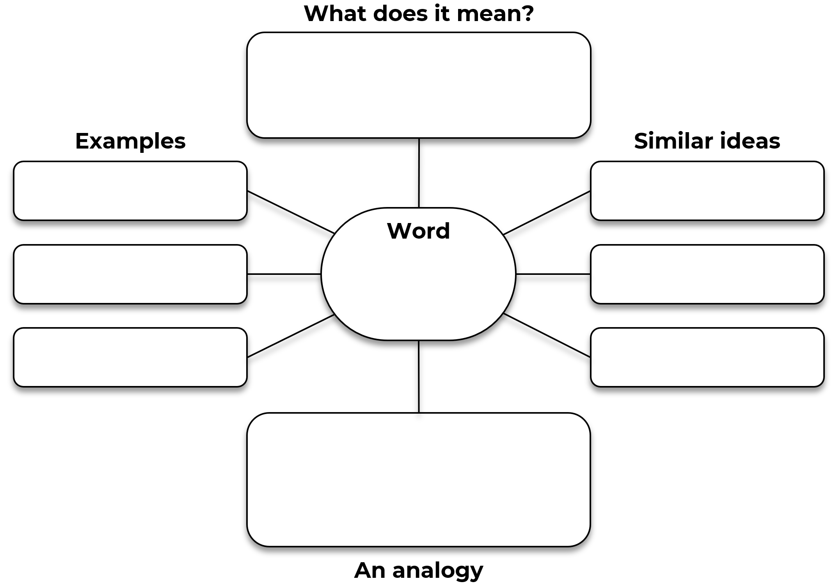

Completed example: Vocabulary Map
This example is from English Standard focusing on the word ‘receptacle’ as it is used in ‘How to mark a book’ (Adler, M. 1941).
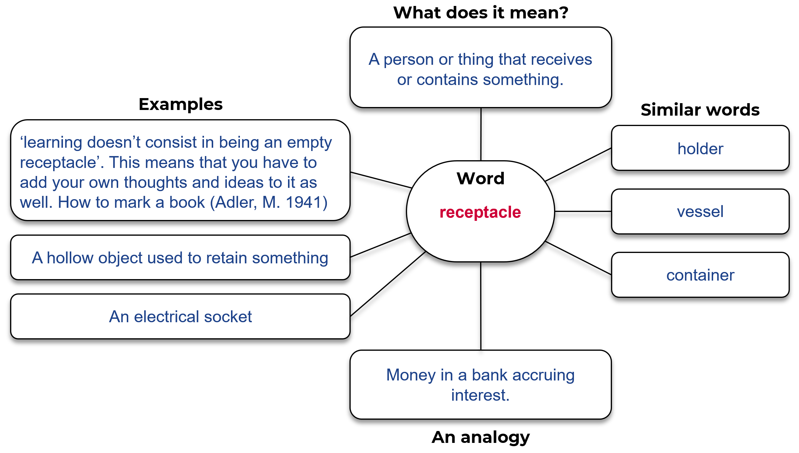

Example 2

Template
Word:
Write the sentence, from the text, that contains the word.

In the text, what are some other words associated with this word?

Can you find an example, in the text, of a sentence that hints at the meaning of the word?

Does the text make a comparison, or could you create a comparison?

Completed example
This example is from English Standard focusing on the word ‘receptacle’ as it is used in ‘How to mark a book’ (Adler, M. 1941).
Word: receptacle
Write the sentence, from the text, that contains the word? ‘learning doesn’t consist in being an empty receptacle’. How to mark a book (Adler M 1941) The use of the word receptacle in this context means that when you are learning you need to add your own thoughts and ideas to the information you are presented.
In the text, what are some other words associated with this word? ‘receiving end’, it means that the information is coming to the reader. It then makes the point that you can receive this information, but you should add to it and use your own thoughts and experiences to deepen and broaden the knowledge that is being shared.
Can you find an example, in the text, of a sentence that hints at the meaning of the word? The following three sentences can be found in the text and they help to expand on the idea of the reader as a container or receptacle of knowledge.
‘But don’t let anybody tell you that a reader is supposed to be solely on the receiving end. Understanding is a two-way operation; learning doesn’t consist in being an empty receptacle. The learner has to question himself and question the teacher.’ How to mark a book (Adler, M. 1941).
Create your own sentence that includes the word? I have just built a new house and in the backyard, I have a large receptacle for catching rainwater.
OR
Every time I read I take a step back in time. An unfamiliar word takes my hand and walks me down a zigzag track, different times, different places and the language of different people. Every time I read; my squishy grey matter becomes the receptacle of sights, sounds and spaces I know I’ll never visit.
Can you create an analogy to explain the word? A vault in a bank that holds the money while it accrues interest.

Activity 4: Consolidate
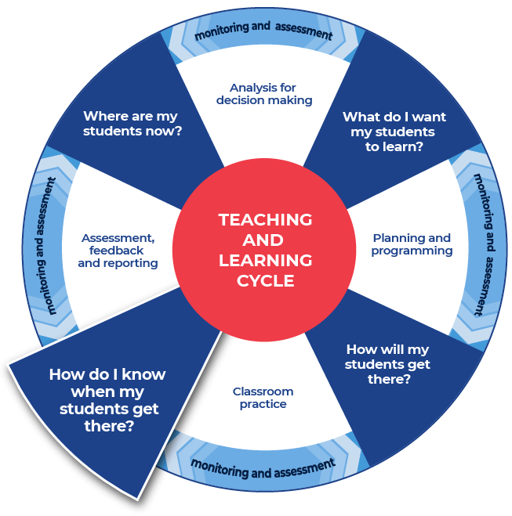

Instructions:
- The teacher provides students with a creative writing prompt. Students use three or four of their words and establish the setting for an imaginary piece of writing in response to the stimulus.
- Teachers provide their students a persuasive writing prompt. Students select another three or four of their words and create a persuasive paragraph (perhaps the opening to a speech) in response to the stimulus.
Differentiation
- Students consolidate their subject vocabulary learning by creating a match-up worksheet this could be done online or using the template provided below.
- Students create a worksheet using the template provided below and write their ten words in the boxes listed down the middle of the worksheet. Students fill in the outer squares with their personal definitions of the words. They should ensure that they are out of order. Students provide the teacher with an answer sheet for the match-up that they create. The word and correct definition should be clearly indicated. Teachers swap student’s match-up worksheet with a peer who completes the match-up activity.
- Extension option - students create a match-up worksheet using the template provided and write synonyms for their ten words in the boxes listed down the middle of the worksheet.
The teacher could:
- split the class into two groups, half of the class has a word and half of the class has a definition, students move about the space and locate their word or definition
- organise students into pairs to create flash cards or word webs, paper or online, this could incorporate selecting graphic organisers from the Digital learning selector
- show students how to create a crossword - students use the words and definitions and then share their crossword with a peer
- show students where and how to locate different texts or sources that demonstrate the different definitions of a word that they have explored. This supports the Williams Model of differentiation with the aspect of Organised Random Search.
- explain the concept of a cloze passage and ask students to create cloze passages
- provide students with space to create a word wall. This could be added to throughout the module
- direct students to a specific template within the Digital Learning Selector and encourage them to organise and classify their new words
- hold a gallery walk, this enables students to showcase their new words to their peers.

Name of worksheet:
Student name:
Match-up the words with the appropriate definitions.

Definitions

Words

Definitions

Name of worksheet:
Student name:
Answer sheet.

Definitions

Words

Definitions

This is the end of the activities for: Improve writing through subject vocabulary.
Teachers should move on to the next set of activities: Improve student writing through planning for writing (DOCX | PDF)

Additional vocabulary lesson resources

Cohesion
Cohesion is defined as ‘that quality in a text determined by its parts being related and contributing to its overall unity. Cohesion is achieved through shaping the form, creating a structure that the responder can recognise and use to navigate the text …’ (English K–10 Syllabus Glossary). For more ready-to-use teaching and learning activities on cohesion visit HSC minimum standard – Cohesion.

Learning Resource Hub
Evidence-based resources and tools are accessible to all schools via the Learning Resources Hub (staff only).
Teachers can use these resources to support integration of reading and numeracy instruction into teaching and learning programs.

Question verbs
A ready to use glossary of question verbs and activities (DOCX 80 KB) has been included. These will get students thinking about question are asking them to demonstrate.

Stage 6 Glossary
A comprehensive glossary of terms for English Standard is available on the NESA website.

Topic Vocabulary
For more ready-to-use teaching and learning activities on topic vocabulary go to HSC minimum standard – Topic vocabulary.

Vocabulary
For more ready-to-use teaching and learning activities on vocabulary go to HSC minimum standard – Vocabulary.

