Student writing and feedback – Stage 6 English

Sequence
These resources are designed to be used as a teaching and learning sequence as each set of activities leads on to the next.
- Improve student writing through subject vocabulary (DOCX | PDF)
- Improve student writing through planning for writing (DOCX | PDF)
- Improve student writing through writing and feedback (this document).

Learning focus
For each literacy activity an example from Stage 6 English Standard has been provided as a model for teachers. Teachers create their own specific examples for their course, module and class using content they have planned in their teaching and learning cycle. Teachers can modify the learning intentions and success criteria to reflect their context. Students draw upon their vocabulary and planning to complete a written response and engage with feedback to enable them to continue to build their skills.
The text ‘If trees could speak’ by Elif Shafak could be used as a model or stimulus for the English Standard Year 11 Common module – Reading to Write or Year 12 Module C: The Craft of Writing.
For this next section we have presented a modelled example for Year 12 and if teachers are working through this overall sequence of activities, as listed one to three above, with their Year 11 class then they should continue with that text or focus and modify the activities that follow.

Syllabus outcomes
Relevant syllabus outcomes have been provided. However, to support professional practice teachers are strongly advised to always refer to the syllabus documents for the relevant course on the NESA website.

English Standard (Year 12) example
Outcome:
- independently responds to and composes complex texts for understanding, interpretation, critical analysis, imaginative expression and pleasure EN12-1
Content:
- compose considered and well-crafted personal responses to texts and critically consider the responses of others
- analyse and assess the ways language features, text structures and stylistic choices shape points of view and influence audiences (ACEEN024)
- apply and articulate criteria used to evaluate a text or its ideas
Outcome:
- analyses and uses language forms, features and structures of texts and justifies their appropriateness for purpose, audience and context and explains effects on meaning EN12-3
Content:
- engage with complex texts through their language forms, features and structures to understand and appreciate the power of language to shape meaning
- use accurate spelling, punctuation, syntax and metalanguage (ACEEN017)
- analyse, assess and experiment with the interplay between imaginative, persuasive and interpretive techniques
- understand and appreciate how language features, text structures and stylistic choices are effectively integrated in a range of quality literature and other texts and apply this understanding to their own compositions
- control language features, text structures and stylistic choices of texts to shape meaning and influence responses
Outcome:
- adapts and applies knowledge, skills and understanding of language concepts and literary devices into new and different contexts EN12-4
Content:
- adapt texts for different purposes, contexts and audiences
- re-create texts by changing context, perspective or point of view and assess the effectiveness of these changes
Outcome:
- thinks imaginatively, creatively, interpretively, analytically and discerningly to respond to and compose texts that include considered and detailed information, ideas and arguments EN12-5
Content:
- understand, assess and appreciate how different language features, text structures and stylistic choices can be used to represent different perspectives and attitudes
Outcome:
- reflects on, assesses and monitors own learning and refines individual and collaborative processes as an independent learner EN12-9
Content:
- monitor and assess the effectiveness of their various learning strategies in English
- assess their own strengths and needs as learners and apply strategies for ongoing improvement
- support the learning of others by objectively assessing their strengths and needs as learners and offering constructive feedback as appropriate
- use writing as a tool to reflect on their own learning, assessing how processes can be adjusted to ensure better learning outcomes
- use critical and constructive feedback from others to improve learning, including their composing and responding
- assess the strengths and weaknesses of their own compositional style and improve compositions as a result of the process of reflection
(English Standard Stage 6 Syllabus © NSW Education Standards Authority (NESA) for and on behalf of the Crown in right of the State of New South Wales, 2017)

Learning intentions
- Students respond to a writing task.
- Students provide effective peer feedback.
- Students engage with effective feedback.

Success criteria
- Students are able to effectively complete a written response.
- Students are able to effectively provide feedback to a peer.
- Students are able to reflect on their learning needs.

Teaching strategies
- Activity 1: Turn and talk
- Activity 2: Writing activity
- Activity 3: Peer feedback
- Activity 4: Teacher feedback
- Activity 5: Student self-reflection.

Activity 1: Turn and talk
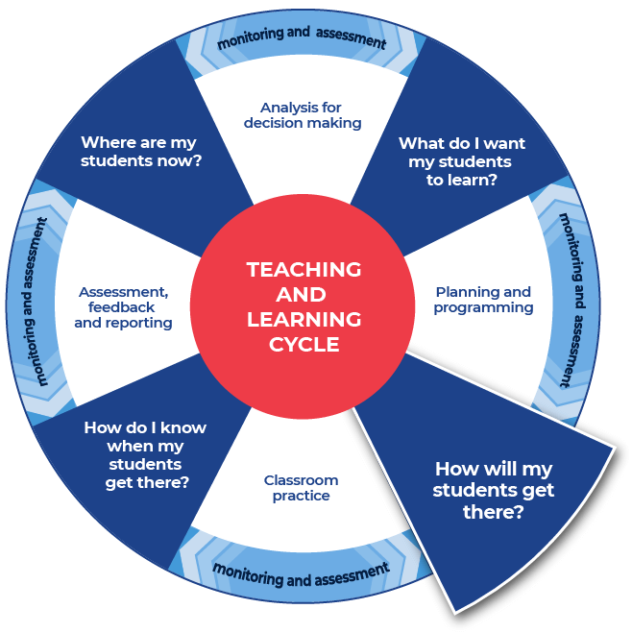

Instructions:
- Teachers provide time in class for students to discuss the notes that they have taken and the plan that they have created for their written response. This opportunity to ‘Turn and Talk’ about their writing with a peer supports them to effectively plan for their writing.
- Teachers model their own example to share with students. An example from English Standard has been included.
Differentiation
- Teachers could provide a completed written response for students to use as a model for their own writing.
- Teachers could support students by providing specific questions for ‘turn and talk’.
- Teachers could modify this activity for specific contexts through sentence starters, sentence scaffolds or word banks.
- Teachers could provide an example of the completed written response. The students could use this example to model their own writing.
- Students and teacher could co-write and produce one written piece of work.
Further support
- Classroom talk is a powerful tool for both teaching and learning. Rich, dialogic talk supports students in making sense of complex ideas and builds classroom communities centred on meaning-making. Tools to support rich talk in the classroom were outlined in Christine Edwards-Groves 2014 paper, Talk moves: A repertoire of practices for productive classroom dialogue (PETAA paper 195). For an example of how these tools were applied to Mathematics ‘Talk moves’ posters, flashcards and a chart are available. These practices could also be applied in the classroom in other learning areas including English.
- Further support with paragraph construction can be found at HSC Minimum standard, Paragraphs.

Example question
English Standard (Year 12) – Module C: The Craft of Writing.
- Create a piece of imaginative, discursive or persuasive writing that builds upon an idea from the video ‘If trees could speak’ By Elif Shafak.
- Explain how studying the craft of writing has enabled you to create an engaging piece of writing. In your response, make detailed reference to your use of language in part (a).

Example response
a) (excerpt) Dear Oceans,
It is your friends the rivers. As we meet each day to exchange knowledge and ideas with the ebb and flow of each tide. It has been with sadness that we have learned more of the many pollutants that foul your depths and murder your inhabitants. Each day our bubbling brooks and our flowing streams weep for your plight. We hear you even if others do not.
We do not understood why man, who so loves to swim with you, and look at you, and paint you, and sail upon you has also decided to dump garbage in you. We are troubled to hear of the plastics swirling within you and cruelly killing your inhabitants. We have similar troubles with our fish being suffocated by lack of water in our rivers and by pollution in our streams.
b) My discursive piece of writing focuses on the global concern of ocean pollution. To write this response I have drawn on skills created through the module ‘The Craft of Writing’. I have written the piece in the form of a letter to effectively communicate the moral that I would like the reader to learn. I have used language techniques including similes and metaphors to create visual imagery and communicate the ideas of the consequences of ocean pollution. The Ted Talk stimulus of Elif Shafak speaking alternately as a tree and as herself inspired me to write about voices that are marginalized and not heard. I have adopted a first person narrative voice in order to personalize the problems regarding the pollution of waterways.
The motif of water is used to unite the silent voices of the earth into a stronger collective for change. My use of personification ‘As we meet each day’ where the ‘we’ refers to the oceans and the rivers who are communicating like humans. With this I have reflected the way that the waters of the worlds are interconnected. Accumulation of ideas, ‘to swim with you, and look at you, and paint you, and sail upon you’ creates a sense of regret over how the oceans are being taken for granted. I wanted to move my reader to take action for the oceans and combat pollution. I feel that I have written an engaging piece of discursive writing that achieves its purpose, connects with its audience and employs an old and trusted form.
Analysis colour coding:
- Demonstrates creativity.
- Reflects the stimulus explicitly and overall with the whole piece.
- Uses language devices and stylistic features.
- Addresses the requirements of the reflection.
- Providing examples from own writing as supporting evidence.
- Comes to a conclusion that states a position.
Written response:
- Effectively composes a piece of writing that reflects the stimulus.
- Effectively utilises a range of language devices or stylistic features to create an engaging piece of writing.
- Demonstrates effective control of language and structure appropriate to audience, purpose, context and selected form.
- The response experiments with language and the discursive form.
- The response demonstrates creativity.
- There are lapses in language precision but overall it communicates ideas clearly.
- The descriptions demonstrate detailed knowledge of the chosen subject matter.
- The stimulus is integrated into the response but not always cohesively.
Reflection:
- Explains in a detailed and relevant manner how the study of ‘The Craft of Writing’ has enabled the creation of a piece of discursive writing.
- Explains in a detailed and relevant manner how language has been used to create an engaging response in part (a).
- Demonstrates effective control of language.
- The reflection effectively communicates ways in which the writing was inspired by a study of ‘The Craft of Writing’.
- It displays highly developed skills in explaining the discursive form and its features.
- The response clearly shows skills in writing for a different purpose and audience.
See Literacy Learning Progression and Stage 6 English (DOCX | PDF) for information on how the National Literacy Learning Progression could support student writing and feedback in Stage 6 English.

Activity 2: Writing activity

Instructions:
- Teachers allocate enough time in class for students to complete the written response.
Differentiation
- Teachers could provide a scaffold for the response, with sentence starters or layout outlines.
- Students could have their notes and planning with them while completing the writing task.

Activity 3: Peer feedback
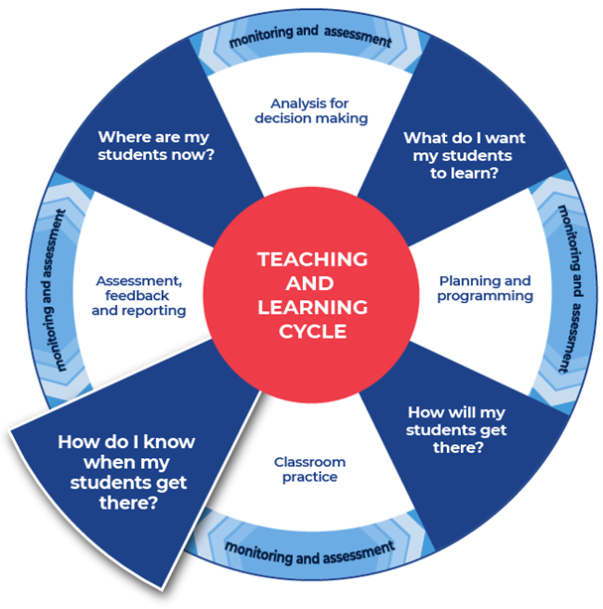

Instructions:
- Teachers facilitate pairs of students to swap their written responses.
- Teachers brief the students on acceptable peer feedback behaviours. Including ‘two stars and a wish’ or ‘I like, I wonder’ protocols. This activity may be anonymous.
- Teachers provide the students with the template. Students fill it in to provide feedback to their peer. They do this by ticking where they think the writing aligns on the template.
Additional peer feedback options
- Teachers could give students a focus to look for, such as use of vocabulary, and assign this focus to a coloured highlighter. This could be repeated with different focusses and highlighters.
- Teachers could support students to create their own class feedback template.

Template
Criteria | Developing | Developed | Highly developed
The response addresses the question. | ◻ | ◻ | ◻
Ideas being written about are clear. | ◻ | ◻ | ◻
The writing has a logical structure. It makes sense when you read it through. | ◻ | ◻ | ◻
Language features and devices are used to enhance meaning. | ◻ | ◻ | ◻
There is a clear reference to syllabus content and task requirements. | ◻ | ◻ | ◻
If required, there is topic specific vocabulary in the response. | ◻ | ◻ | ◻
Sentences make sense. | ◻ | ◻ | ◻
Punctuation is accurate and used effectively (for example, capital letters, full stops, commas and question marks). | ◻ | ◻ | ◻
Accurate spelling of challenging words. | ◻ | ◻ | ◻
Handwriting is consistently legible. | ◻ | ◻ | ◻
Two successful aspects about this written response are:

One aspect of writing to keep working on is:

Activity 4: Teacher feedback

Instructions:
- Teachers support their students with timely and effective feedback. Remembering that effective feedback:
  - focuses on the intended learning
  - identifies specific strengths
  - points to areas needing improvement
  - suggests a pathway that students can take to close the gap between where they are now and where they need to be
  - chunks the amount of corrective feedback so the student can handle this at one time
  - is provided in a short time frame.
- Teachers select areas to provide feedback using the templates provided or modify and use the student feedback template from Activity 3.
- Teacher comments could include the language: working towards, achieved, and working beyond.
- Teachers may choose to engage with the National Literacy Learning Progression to provide feedback to their students. To use this tool more effectively teachers could first engage with the online professional learning course: Introduction to the Literacy and Numeracy Progressions.

Feedback templates
- More information on aspects of literacy can be found at: HSC minimum standard – Writing.
- The links contained within the feedback sheets link to teacher resources focusing on that writing aspect.
- Teachers can modify or remove the definitions.
- Some teachers may choose to leave the definitions in place to support the students’ skill development.
- There are three templates to choose from:
  - Control of language
  - Structure and sequence of ideas
  - Relevance of writing to the topic.

Control of language
Spelling. Correct spelling is consistent and some difficult words are spelled correctly. In the written response spelling is:

Vocabulary. Subject vocabulary has been used effectively in context. In the written response vocabulary is:

Tense. Past, present and future references within sentences, and the response, as a whole are logical and consistent. For example ‘Alex laughed’, ‘Alex laughs’, ‘Alex will laugh’. In the written response tense is:

Punctuation. There is correct sentence punctuation, including capital letters and full stops. There are some correct examples of commas, proper nouns, apostrophes. In the written response punctuation is:

Formal and informal language. The tone matches the audience and purpose. The language use is consistently appropriate. Informal language is every day and conversational. Formal language uses correct sentence structures and has a feeling of authority. In the written response formal and informal language are:

Two successful aspects about this written response are:

One aspect of writing to keep working on is:

Structure and sequence of ideas
Text structure is the way that the information is organised. This could include: headings and sub-headings, or whether there is an introductory and concluding paragraph. In the written response text structure is:

Paragraphs. Text in a distinct section that reflects a logical cohesive point. In the written response paragraphs are:

Sentence types. A sentence begins with a capital letter and ends with a full stop, question mark or exclamation mark. There are different types of sentences:
- simple sentence – a single main clause that expresses a complete thought. It has a subject and a finite verb and may also have an object, for example ‘Mary is beautiful.’, ‘The ground shook.’, ‘Take a seat.’
- compound sentence – contains two or more clauses that are coordinated or linked in such a way as to give each clause equal status. In the following example and is the coordinating conjunction: ‘We went to the movies and bought an ice cream.’
- complex sentence – contains a main (or independent) clause and one or more subordinate (or dependent) clauses. The subordinate clause is joined to the main clause through subordinating conjunctions like when, while and before, as in the following examples: ‘We all went outside when the sun came out.’, ‘Because I am reading a long book, my time is limited.’
(NSW English K–10 Glossary © NSW Education Standards Authority (NESA) for and on behalf of the Crown in right of the State of New South Wales, 2020.)
In the written response sentence types are:

Cohesion. Features can include connectives such as ‘furthermore’ and ‘therefore’, cross-references to different parts of the text, and reiteration of the title or terms of the topic or question being addressed in the text.
(NSW English K–10 Glossary © NSW Education Standards Authority (NESA) for and on behalf of the Crown in right of the State of New South Wales, 2020.)
In the written response cohesion is:

Two successful aspects about this written response are:

One aspect of writing to keep working on is:

Relevance of writing to the topic
Audience and purpose. Audience is the intended readers. Purposes can include, to entertain, to inform, to persuade, to educate. ‘Composers use a number of ways to achieve these purposes: persuading through emotive language, analysis or factual recount; entertaining through description, imaginative writing or humour, and so on.’
(NSW English K–10 Glossary © NSW Education Standards Authority (NESA) for and on behalf of the Crown in right of the State of New South Wales, 2020.)
In the written response audience and purpose are:

Ideas. An idea is a thought or notion that is being explained and explored. Students are encouraged to develop their ideas and create insightful and impacting points. Students will support their ideas with evidence and examples. In the written response ideas are:

Topic vocabulary. Topic specific words are used effectively in writing. In the written response topic vocabulary is:

Two successful aspects about this written response are:

One aspect of writing to keep working on is:

Activity 5: Student self-reflection
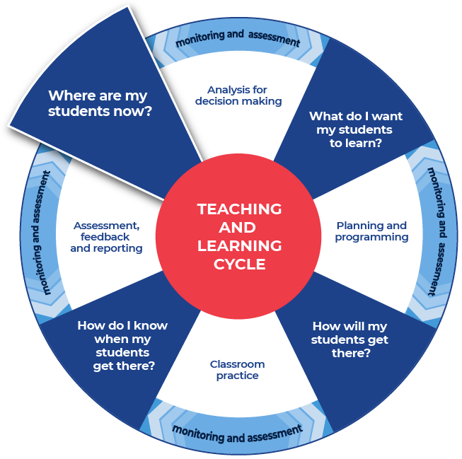

Instructions:
- Teachers provide students with a copy of an ‘exit slip’.
- Teachers instruct students to complete the exit slip by detailing one skill that they learnt through the literacy lessons and one skill they that they need to work on further.
- Teachers collect and review the completed exit slips to plan where to next for improving their students’ literacy skills.
- Teachers can formulate this plan collaboratively with the students.

Exit slip template
Name:
When writing your response, how confident are you to:
Criteria | Not confident | Somewhat confident | Confident
Understand the question | ◻ | ◻ | ◻
know where the content comes from in the syllabus | ◻ | ◻ | ◻
know how to use the content/concept to structure your response | ◻ | ◻ | ◻
know which explicit examples to use to validate your statements and how to write them | ◻ | ◻ | ◻
know how to use subject vocabulary | ◻ | ◻ | ◻
sequence the paragraphs | ◻ | ◻ | ◻
One skill that I have learnt that improved my writing:

One skill to continue to work towards:

