Planning for writing – Stage 6 English

Sequence
These resources are designed to be used as a teaching and learning sequence as each set of activities leads on to the next.
- Improve student writing through subject vocabulary (DOCX | PDF)
- Improve student writing through planning for writing (this document)
- Improve student writing through writing and feedback (DOCX | PDF).

Learning focus
For each literacy activity an example from Stage 6 English Standard has been provided as a model for teachers. Teachers create their own specific examples for their course, module and class using content they have planned in their teaching and learning cycle. Teachers can modify the learning intentions and success criteria to reflect their context.
To support students in other areas of their learning, more ideas and teaching strategies for literacy and numeracy can be found on the HSC minimum standard website. There are teaching ideas and activities on:
Writing, including: text structure, paragraphs, cohesion, sentence types, tense, punctuation, formal and informal language, spelling, vocabulary, topic vocabulary, audience and purpose, ideas, language devices, and unpacking the writing prompt.
Numeracy, including: division, multiplication, fractions, decimals, percentages, rates, time, ratio, area, length and perimeter, mass, volume and capacity, mean, median and mode, chance, 3D objects, 2D shapes, patterns, formulae and substitution, positioning and locating, angles, tables graphs and charts, vocabulary in numeracy, interpreting questions and grammar for numeracy.
Reading, including: audience and purpose, locating explicit information, inferring, common language devices, parts of speech, cohesive devices, sentence types, tense, subject-verb agreement, punctuation, spelling, antonyms and synonyms and inferring word meanings.

Syllabus outcomes
These resources include ways to address Stage 6 syllabus outcomes in English with regard to literacy. However, to support professional practice teachers are strongly advised to always refer to the syllabus documents on the NESA website.

English Standard (Year 11) example
Outcome:
- responds to and composes increasingly complex texts for understanding, interpretation, analysis, imaginative expression and pleasure EN11-1
Content:
- analyse how texts are created in and for a variety of contexts, audiences and purposes (ACEEN001)
- analyse the ways language features, text structures and stylistic choices represent perspective and influence audiences (ACEEN024)
Outcome:
- analyses and uses language forms, features and structures of texts, considers appropriateness for purpose, audience and context and explains effects on meaning EN11-3
Content:
- engage with increasingly complex texts to understand and appreciate the power of language in shaping meaning
- explore the ways text structures, language features and stylistic choices are used in different types of texts (ACEEN005)
- analyse and assess the interplay between imaginative, persuasive and interpretive techniques; for example, how anecdotes are used in speeches to amuse, inform or influence, or the use of characterisation in advertising (ACEEN030)
- understand and explain how language forms, features and structures are effectively integrated in a range of quality literature and other texts
- use stylistic features to craft and communicate points of view (ACELR013)
- use language forms, features and structures to shape meaning, influence responses and achieve particular effects
Outcome:
- thinks imaginatively, creatively, interpretively and analytically to respond to and compose texts that include considered and detailed information, ideas and arguments EN11-5
Content:
- understand and appreciate how different language forms, features and structures can be used to represent different ways of thinking
- explore the effects of figurative and rhetorical devices, for example, emphasis, emotive language, metaphor and imagery in the construction of argument (ACEEN025)
- use evaluative language, including emotive language and modality for particular purposes and effects
- compose critical and creative texts that explore increasingly complex ideas
- compose logical, ordered and cohesive texts that build effective arguments in response to the ideas generated through texts
- select and apply appropriate textual evidence to support arguments (ACEEN035)
Outcome:
- reflects on, assesses and monitors own learning and develops individual and collaborative processes to become an independent learner EN11-9
Content:
- monitor and assess the various ways they approach their learning in English
- assess their own strengths and needs as learners and apply strategies to ensure their ongoing improvement
- use and understand the value of writing as a reflective tool
- create texts reflecting on their own learning, considering how processes can be adjusted to ensure better learning outcomes
(English Standard Stage 6 Syllabus © NSW Education Standards Authority (NESA) for and on behalf of the Crown in right of the State of New South Wales, 2017)

Learning Intentions
- Students will investigate effective writing.
- Students will analyse sample written responses.
- Students will develop note taking skills.
- Students will develop confidence with writing.

Success criteria
- Students are able to recognise aspects of effective writing.
- Students are able to practise their writing skills.
- Students are able to take effective notes.
- Students are able to prepare for a written response.

Teaching strategies
Focus on skills:
- Activity 1: Review annotated samples
- Activity 2: Warm up writing activity.
Prepare to write:
- Activity 1: Select your resource
- Activity 2: Take effective notes
- Activity 3: Where to next.

Focus on skills

Activity 1: Review annotated samples
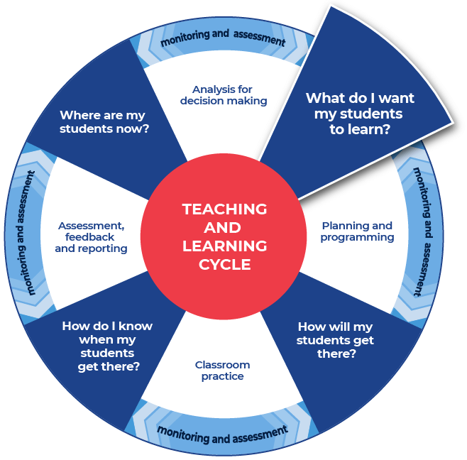

Instructions:
- Teachers support student understanding of quality writing and ways to identify areas for improvement by providing a sample question with sample written responses. Teachers annotate some of the features of effective writing on the responses.
- Teachers create examples themselves or source them from: the English statewide staffroom (staff only), English HSC Hub, previous year groups, local teacher networks, NESA publications or professional associations.
- Teachers can use the National Literacy Learning Progression to help track students’ literacy skills. Improving students’ literacy skills will enable students to communicate their ideas in a more succinct and sophisticated manner. The element of Writing in the Literacy Learning Progression provides indicators that reflect the increasing sophistication of skill development in writing for students in Years K–10. It is important to note that these skills are unconstrained and will continue to develop as students work through their final years of school and beyond. See Literacy Learning Progression and Stage 6 English (DOCX | PDF) for information on how the National Literacy Learning Progression could support student writing in Stage 6 English.
- After teachers have discussed and reviewed the written samples with their students, they will instruct them to complete their own analysis in the template provided.
Further support
- An example from English Standard Year 11 Common module – Reading to Write has been provided as a model.

Example question
This example is modelled on a Year 11 task. Teachers would source images or quotations required for this or a similar task.

Task description
Part a
Write your own imaginative text which represents a perspective or idea about relationships. You should allocate appropriate time to plan, compose and refine your writing, and consider how you can demonstrate your style as a writer. You are to use one of the attached images or quotations as a stimulus for your imaginative text, ensure that this is clearly indicated on your submission. Aim to write a maximum of 800 words.
Part b
Write a personal reflection outlining how the form, features or structure of the mentor texts influenced your imaginative text. Aim to write a maximum of 250 words.
In your reflection, you need to:
- Explain how the mentor texts influenced your decisions about writing your imaginative text. Refer specifically to the form, features and structure of at least one mentor text.
- Evaluate how your use of 2 literary devices helped you effectively represent the idea of relationships.

Excerpt – sample low-range response
Imaginative text – excerpt
The Missing Boy
This is a mystery of a girl and boy. I find others and their lives trivial. She sits at the front of the train station, rain pouring, one of the days, so overcast it feels like night, you know? She sees him, Alex, the boy she had been worried sick about since that day. He turns around and the smell of the car fumes became irrelevant to her. The city becomes a blur, all she can see is his piercing green eyes. I'd like to say, this isn't the usual story. I think I need to go back to the beginning.
Personal reflection text – excerpt
The text that influenced my writing was ‘Big World’ and ‘Jasper Jones’. I incorporated the idea of a confusing and struggling relationship with vivid imagery. I was influenced by imagery, in ‘Big World’, ‘Slippery chunks of cow hide ... our arms are slick with gore’ and metaphors and similes from ‘Jasper Jones’, ‘My exit from the window is a little like a foal being born.’ A metaphor used in the story, ‘They became Ying and Yang.’ ln conclusion I was influenced by ‘Jasper Jones’ and ‘Big World’.

Annotations – excerpt low range response
Imaginative text – excerpt
The Missing Boy
This is a mystery of a girl and boy. I find others and their lives trivial. She sits at the front of the train station, rain pouring, one of the days, so overcast it feels like night, you know? She sees him, Alex, the boy she had been worried sick about since that day. He turns around and the smell of the car fumes became irrelevant to her. The city becomes a blur, all she can see is his piercing green eyes. I'd like to say, this isn't the usual story. I think I need to go back to the beginning.
Personal reflection text – excerpt
The text that influenced my writing was ‘Big World’ and ‘Jasper Jones’. I incorporated the idea of a confusing and struggling relationship with vivid imagery. I was influenced by imagery, in ‘Big World’, ‘Slippery chunks of cow hide ... our arms are slick with gore’ and metaphors and similes from ‘Jasper Jones’, ‘My exit from the window is a little like a foal being born.’ A metaphor used in the story, ‘They became Ying and Yang.’ ln conclusion I was influenced by ‘Jasper Jones’ and ‘Big World’.
Literacy progression annotations:
- creates informative, imaginative and persuasive texts for a range of learning purposes, such as to recount a sequence of events; to describe a person, thing or process; to explain a process; to argue with evidence or reasons; to express emotions (CrT7 Crafting ideas)
- supports ideas with some detail and elaboration (e.g. expand on a topic sentence by adding more details in following sentences) (CrT7 Crafting ideas)
- maintains consistent tense within and between sentences (see Grammar) (CrT7 Text forms and features) (with one minor slip with ‘became’)
- uses expressive words to describe action and affect the reader (e.g. tiptoed, instead of walked) (CrT7 Vocabulary)
Annotations regarding the imaginative response overall:
- Student attempts to engage the reader through introducing a mystery. However, the connection between the boy, girl and narrator is unclear.
- Inclusion of imagery helps create atmosphere: ‘overcast’, ‘smell of the car fumes’, ‘piercing green eyes’.
- Attempt to create a distinctive narrative voice however, the relationship of the narrator to the characters is still ambiguous.
- The student has crafted an adequate imaginative piece that conveys ideas about the struggles within relationships. However, these ideas are simple and are not sustained throughout the text. There are satisfactory examples of imagery used to create setting but, overall, the text reflects a variable control of language. The narrative responds to the stimulus in a superficial manner with the plot requiring further development and more complex characters. Careful attention in the editing process is also required to produce a well-structured final submission.
Annotations regarding the reflection overall:
- Identifies texts that have influenced their own writing.
- Draws connection between ideas in the texts and their own writing. Explanation of how and why these particular extracts influenced them would have enhanced the reflective component of task.
- The student reflects on the connection between reading and writing through drawing a clear link between the ideas explored in their own piece and those in the texts that they studied within the module. However, greater analysis of how these literary devices have been used, both within the studied texts and their own writing is needed. Discussion of the student’s strengths and areas of improvement in writing is also needed to fulfil all the requirements of the task.

Excerpt - sample high-range response
Imaginative text – excerpt
Removalist work with my best mate, Thommo, has dried up. Now I’m what they call ‘between jobs’. Mum says I’m as useless as a fake plant to a bee. She also reckons that I’m better off not spending so much time with Thommo. But at least that job was cash in hand, ya know. It’s close to Christmas and a bit more cash would’ve been handy. Now I’m broke and hot. Summer is really kickin’ in.
Nan rang this morning and asked me to take her to the shops. I figured she’d better not go alone in this heat. Nan doesn’t judge me like the rest of the family do. She never says anything bad about my mohawk or piercings. I can think a bit sitting on this bench, in this park with Nan, while she catches her breath.
“Aren’t you hot in those boots and that jacket Alexander?”
“Bit Nan, yeah.” I grin at her and we both laugh. Nan’s the only one who is allowed to call me Alexander to everyone else I’m Zands.
Personal reflection text – excerpt
Sometimes the strongest relationships are between the most unlikely people. These relationships are often where one character could benefit from the help of the other and in turn both characters grow. I was influenced by the short story ‘Big World’ by Tim Winton and the novel ‘Jasper Jones’ by Craig Silvey. Both texts are set in summer in Australia and the way that weather influences the atmosphere of the story in the texts is something that I wanted in my writing. The other stylistic choice that I made was for my main character’s voice. I chose first person and wanted the thoughts and voice to be authentic to who the character is, like Jasper’s when we hear it through dialogue in the novel, “I tole you. I need your help, Charlie. Come on.” And like the narrator of ‘Big World’ who says, in first person, “Somehow our crappy Saturday job at the meatworks becomes fulltime…”
Therefore, I used colloquial language and short sentence structures in my writing. All three protagonists, Charlie in ‘Jasper Jones’, the narrator in ‘Big World’, and my character Zands are at a point of change in their lives and this is an area that I will need to develop further.

Annotations
Imaginative text – excerpt
Removalist work with my best mate, Thommo, has dried up. Now I’m what they call ‘between jobs’. Mum says I’m as useless as a fake plant to a bee. She also reckons that I’m better off not spending so much time with Thommo. But at least that job was cash in hand ya know. It’s close to Christmas and a bit more cash would’ve been handy. Now I’m broke and hot. Summer is really kickin’ in.
Nan rang this morning and asked me to take her to the shops. I figured she’d better not go alone in this heat. Nan doesn’t judge me like the rest of the family do. She never says anything bad about my mohawk or piercings. I can think a bit sitting on this bench in this park with Nan, while she catches her breath.
‘Aren’t you hot in those boots and that jacket Alexander?’
‘Bit Nan, yeah.’ I grin at her and we both laugh. Nan’s the only one who is allowed to call me Alexander to everyone else I’m Zands.
Personal reflection text – excerpt
Sometimes the strongest relationships are between the most unlikely people. These relationships are often where one character could benefit from the help of the other and in turn both characters grow. I was influenced by the short story ‘Big World’ by Tim Winton and the novel ‘Jasper Jones’ by Craig Silvey. Both texts are set in summer in Australia and the way that weather influences atmosphere in the texts is something that I wanted in my writing. The other stylistic choice that I made was for my main character’s voice. I chose first person and wanted the thoughts and voice to be authentic to who the character is, like Jasper’s when we hear it through dialogue in the novel, ‘"I tole you. I need your help, Charlie. Come on." And like the narrator of ‘Big World’ who says, in first person, ‘Somehow our crappy Saturday job at the meatworks becomes fulltime…’
Therefore, I used colloquial language and short sentence structures in my writing. All three protagonists, Charlie in ‘Jasper Jones’, the narrator in ‘Big World’, and my character Zands are at a point of change in their lives and this is an area that I will need to develop further.
Literacy progression annotations:
- creates imaginative texts with less predictable features to emotionally and intellectually engage the reader (e.g. writes to convey character perspective) (CrT10 Crafting ideas)
- uses literary techniques such as dialogue and vivid description to carry the plot, develop character and create a sense of place and atmosphere (CrT10 Crafting ideas)
- uses a range of figurative devices to effectively impact the reader (e.g. well- crafted metaphor) (CrT10 Text forms and features)
- creates informative texts to explain and analyse (e.g. analyses how artists use visual conventions in artworks) (CrT10 Crafting ideas)
- orients the reader clearly to the topic or concept (e.g. using a definition or classification in the opening paragraph) (CrT10 Crafting ideas)
- uses evidence and research including digital resources to expand upon information and elaborate concepts (CrT10 Crafting ideas)
- uses discipline-specific terminology to provide accurate and explicit information (e.g. discipline metalanguage) (CrT10 Vocabulary).
Annotations regarding the imaginative response overall:
- Opening sentences engage the reader by creating a sense of who the main character is.
- Effectively establishes the authority of the point of view through the narrator’s language choices and perspective.
- Setting is clear and devices such as pathetic fallacy of the oppressive summer heat add to the atmosphere.
Annotations regarding the reflection overall:
- Student has created a purposeful reflection that clearly demonstrates a deep understanding of the connection between text, audience and intent.
- The student has skilfully used imagery, syntax and dialogue to create a clear, distinctive and authentic voice for the character of Zands.
- The use of dialogue is effective and demonstrates a highly developed control of form.
- Assesses their own learning and writing process thoughtfully, considering strengths and areas for improvement.
- Demonstrates a comprehensive justification of stylistic choices and aesthetic voice.

Review annotated samples
- Read through the sample responses.
- Select one of the sample responses.
- Respond to the analysis questions using the template provided. Answer each question exploring the imaginative response and then complete the reflection.

Template

What do you notice?
How was the answer structured?

Were words from the question used in the answer?

What do you notice about the sentences?

Identify and re-write an idea that was contained in the sample response?

What did you like about the response?

Completed example – high range response

What do you notice?
How was the answer structured?
The imaginative piece is structured to begin with giving the reader ideas about the characters, setting (time and place) and the issues they face.
The reflection is structured in a logical way. It builds up the information and explanation making it more detailed and provides supporting evidence.
Were words from the question used in the answer?
The imaginative response and the reflection are clearly connected to the stimulus as well as the task requirements. The imaginative response explores the relationship between specific family members and the issues associated with these relationships.
Each uses an appropriate structure for the required purpose of the written responses.
What do you notice about the sentences?
The sentence types are varied in the imaginative writing to add to the story world. They are also used for specific effect and influence the pace and tone of the story.
In the reflection complex sentences are used to succinctly communicate a lot of information.
Identify and re-write an idea that was contained in the sample response?
‘Both texts are set in summer in Australia and the way that weather influences atmosphere in the texts is something that I wanted in my writing.’
Re-write: Pathetic fallacy is used in both texts because they are set in summer and the hot weather is affecting the characters and reflecting and strengthening their tense state of mind.
What did you like about the response?
In the imaginative piece I liked that the composer used colloquial language and the features of a sub-culture to make me engage with the youthful rebellion of the character. The contrast between the heat and the characters clothing highlighted the setting, aspects of the character’s personality, and the family issues caused by his personal choices. The writer did this by showing me what the character looked and sounded like as well as what was happening with their family relationships rather than telling me literally what was happening and directly how everyone was feeling.
In the reflection I appreciated the details. The ideas were built up with supporting evidence and often a sentence led on to another sentence that gave further evidence and support. This demonstrated that the writer knew the module content and was able to apply their knowledge to answer the specific question.

Additional support for Activity 1
Please note that there are several supports to help teachers improve student writing.
- Teachers could use their marking criteria to assess written responses and provide feedback.
- In some contexts, teachers could use the National Literacy Learning Progression. While primarily focused on K–10, it will provide sound ideas on aspects of writing and how to improve.
For more ideas on what to look for in literacy teachers may like to complete the online course: Introduction to the Literacy and Numeracy Progressions.

Activity 2: Warm up writing activity
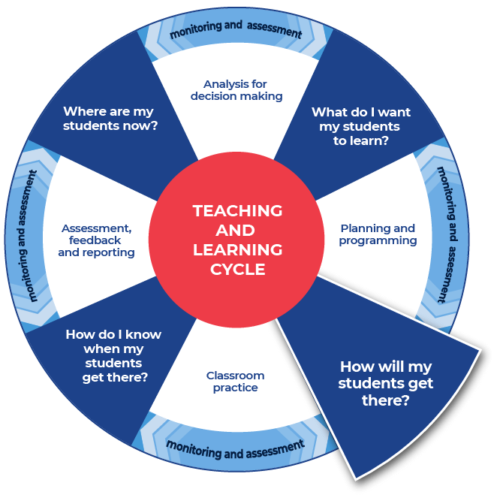

Instructions:
- The teacher provides an appropriate question and the students write a first draft.
Differentiation
- Teachers could create and use modelled writing that is relevant to their topic and chosen focus.
- Teachers could provide a structure that can be used to approach the writing.
- Teachers could model or scaffold sentences to demonstrate how the task could be approached, as well as illustrate the language used to address each level of complexity or depth in terms of the verbs in the question.
Further support
- An example of the question for students to respond to has been provided from English Standard. Teachers should create a question for their own context.
- Teachers may like to use the whole example task from Activity 1.
- An example from English Standard Year 11 Common module – Reading to Write has been provided.

Example question
This task was completed at the end of the first term of Year 11.

Task Description:
Part a
Write your own imaginative text which represents a perspective or idea about relationships. You should allocate appropriate time to plan, compose and refine your writing, and consider how you can demonstrate your style as a writer. You are to use one of the attached images or quotations as a stimulus for your imaginative text and ensure that this is clearly indicated on your submission. Aim to write a maximum of 800 words.
Part b
Write a personal reflection outlining how the form, features or structure of the mentor texts influenced your imaginative text. Aim to write a maximum of 250 words.
In your reflection, you need to:
- Explain how the mentor texts influenced your decisions about writing your imaginative text. Refer specifically to the form, features and structure of at least one mentor text.
- Evaluate how your use of 2 literary devices helped you effectively represent the idea of relationships.
This is the end of Focus on skills section

Prepare to write

Activity 1: Select your resource

Instructions:
- Teachers support students as they prepare to create a written response.
- Teachers choose an appropriate website, article, video, or a source that is part of their lesson planning. This could be the same source that has been used for the vocabulary activities. Other suggested sources could include course textbooks, journals and media articles.
- Teachers ensure they have the question that their students will answer prepared and that engaging with this chosen source will support students in answering the set question for ‘Student writing and feedback’.
Differentiation
- Teachers ensure that they pre-read or view all sources provided to students and communicate the purpose and focus for using the source with students.
- Provide students with a glossary for new terminology.
- Teachers could read/discuss the sources with students.
Further support
- English Curriculum webpage
- English HSC hub
- English statewide staffroom (staff only)
- An example from English Standard has been provided.

Example
This example could be used as a model or stimulus for the English Standard Year 11 Common module – Reading to Write or Year 12 Module C: The Craft of Writing.
Video: If trees could speak by Elif Shafak.
Whilst we offer a Year 11 modelled example for this section, Year 12 teachers may modify the activities for their Year 12 class.

Activity 2: Take effective notes

Instructions:
- Teachers model their own example of how to engage with an unseen text and take effective notes. These are shared with students. An example from English Standard has been included.
- Teachers instruct their students to take notes as they engage with the source that their teacher has provided. A suite of note taking resources is provided.
- Teachers instruct students to write the information on their note taking template as they locate it in the source.
Differentiation
- Teachers could provide different students with different examples or scaffolds.
- Teachers may pre-fill some of the note taking template or include sentence starters to support student engagement and achievement.
- Teachers may provide a completely pre-filled example for students to use.
Further support
- Teachers may want to take the time to use the pre-written ideas and teaching strategies regarding Locating explicit information on the HSC minimum standard website.
- For English Standard a specific source has been chosen to explore within the example: If trees could speak by Elif Shafak.
- Teachers use the examples provided as models to create their own examples for their students and context.

Example 1

Template
Title of text:
Type of text:
Who it is about:

When it occurred:

Where it occurred:

What happened?

Why did it happen?

How are people reacting to it?

Include 3 of the points that you have recorded in the questions above into a summarising paragraph of 3 to 4 sentences.

Completed example
Title of text: If trees could speak.
Type of text: Imaginative and persuasive. It is a Ted Talk video that opens and closes with an imaginative narrative and the middle moves to a persuasive reflection. It is short, under four minutes, and follows the conventions of a traditional Ted Talk by exploring an important social idea in a persuasive manner.
Transcript of If trees could speak by Elif Shafak.
Who it is about:
‘If trees could speak’, is about the advice trees would give to humans if they could speak. It conveys the voices that we don’t hear from in this world and the importance of being interested in what they would say to us if we could hear them. It explores using literature to tell the untold stories and to make audible the silences in order to learn from those around us and live in a more peaceful and supportive world.
When it occurred:
The Ted Talk, presented at an official TED conference in October 2020, is by novelist Elif Shafak.
Where it occurred:
The issue is a global issue and she anthropomorphises trees to reflect on the issues being experienced by many within out modern contemporary world.
What happened?
Shafak uses framing and lighting to focalise each perspective she is presenting and establish a specific tone. When she represents the tree speaking the lighting is darker and a close-up is used to frame her face. When she represents the human, the lighting is brighter, she sits directly facing the viewer and is framed through a medium/mid shot showing the book in her hand and more of the bookcase within the setting alluding to the knowledge base influencing the perspective being presented. As she performs in these two different perspectives, she is making a point that the voiceless and unheard inhabitants of the earth have opinions to offer to create a positive future for the earth. However, this requires the reader/viewer’s dedication and desire to search for these stories in order to learn.
Why did it happen?
Globally the world is experiencing climate change. The writer feels that trees have been here long before us and that if we slow down and listen, we may find that trees offer a solution that we did not think of for our planet. Further to this she suggests that there may be other voices that have been silenced and they should now be listened to as they could offer earth a solution.
How are people reacting to it?
The Ted Talk comes in 19 languages. It has had over 77,000 views. It is from an official TED conference and was featured on the Ted Talk homepage by the editors. The website also has links to climate change activism. It appears to be a popular and promoted talk which indicates that people are reacting to it in a positive way.
Include 3 of the points that you have recorded in the questions above into a summarising paragraph of 3 to 4 sentences.
The TED talk, ‘If trees could speak’, is about what advice trees would give to humans if they could speak. It is also about the voices that we don’t hear from in this world and being interested in what they would say to us if we could hear them. It is about using literature to tell the untold stories and to make audible the silences in order to learn from those around us and live in a more peaceful and supportive world.
Shafak uses framing and lighting to focalise each perspective she is presenting and establish a specific tone. When she represents the tree speaking the lighting is darker and a close-up is used to frame her face. When she is the human, the lighting is brighter and she sits directly facing the viewer and is framed through a medium/mid shot showing the book in her hand and more of the bookcase within the setting alluding to the knowledge base influencing the perspective being presented. As she performs in these two different perspectives she is making a point that the voiceless and unheard inhabitants of the earth have things to offer to create a positive future for earth and it requires the reader/viewers dedication and desire to search for these stories in order to learn.

Example 2

Template
As you engage with the text create sentences that begin with the following:
Title of text:
Type of text:
Before

After

If

When

Even though

Although

Since

While

Unless

Whenever

Include some of the points that you have recorded in the categories above into a summarising paragraph of 3 to 4 sentences.

Completed example
As you engage with the source create sentences that begin with the following:
Title of text: If trees could speak.
Type of text: imaginative and persuasive. It is a Ted Talk that opens and closes with an imaginative narrative and the middle moves to a persuasive reflection. It is short, under four minutes, and follows the conventions of a traditional Ted Talk by exploring an important social idea in a persuasive manner.
Transcript of If trees could speak by Elif Shafak.
Before listening to this Ted Talk audiences might be thinking that the presenter will just speak about trees. They might be surprised when she speaks with the voice of a tree.
After listening to the talk people might be inspired to use literature to tell the story from the perspective of voices, people, things, that are not normally heard in society.
If we slowed down and listened to trees, as Elif Shafak suggests, then we might be able to learn more about our past and the different ways forward for earth.
When the writer asks us to listen to trees, she is literally asking us to consider trees as a source of knowledge and she is also metaphorically asking us to consider what other silent voices might have to offer.
Even though this is a visual medium the writer is asking us to consider literature as a way of communicating stories that have been silenced or that have been previously untold.
Although we interact with trees, sit beneath them, create musical instruments and furniture from them or paint them into our art we may not truly see trees for the breadth of their worth.
Since the writer uses accumulation as a device it creates a rhythm for the listener which emphasises key ideas including the importance of listening to the voices of the known and unknown.
While she is speaking as the tree, she uses repetition of the word ‘see’ in a literal and metaphorical manner to craft her narrative’s didactic message. For instance, the first section when she speaks as a tree begins with ‘Humans do not see trees’, then after many examples it concludes with, ‘And yet they do not see us.’ This allows her to highlight the fallibility of humankind.
Unless we are interested in the silences of those around us, we will not see, hear or learn from the marginalised and disempowered.
Whenever writers bring the periphery into the centre empathy and understanding increases.
Include some of the points that you have recorded in the categories above into a summarising paragraph of 3 to 4 sentences.
When the writer asks us to listen to trees, she is literally asking us to consider trees as a source of knowledge and she is also metaphorically asking us to consider what other silent voices might have to offer. Even though this is a visual medium the writer is asking us to consider literature as a way of communicating stories that have been silenced or that have been previously untold. Unless we are interested in the silences of those around us, we will not see, hear or learn from the marginalised and disempowered. Whenever writers bring the periphery into the centre empathy and understanding increases.

Example 3

Template
Title of source:
Type of source:
Topic:
Events
People
Facts
Key words
Summary

Completed example
Title of text: If trees could speak
Type of source: Ted Talk video
Topic: Giving voice to the voiceless, they may have something to offer us all.
Events
Writer is using first person imaginative to present the perspective of a tree. Whilst using a persuasive narrative from the perspective of the writer.
Writer is using that tree analogy as a metaphor for all of the voiceless, marginalised, and disempowered to be heard.
Literature is identified as a vehicle to showcase the experiences of the marginalised.
People
Elif Shafak
People on the periphery of society
Earth
Trees
Facts
Trees have been around longer than humans and humans have used them for their own needs.
The writer suggests listening to the voiceless and bring the ideas and concerns of the periphery into the centre.
The writer suggests we can learn from people and nature.
The presentation opens and closes with the perspective of the tree with a personal reflection from the writer in the middle.
Key words
Marginalised, gorge, eternal, obstruct, disempowered, voice, offer, literature, precedent, ecological, desensitised, continuum, pristine, humanity
Summary
Shafak uses first person point of view to present the perspective of a tree observing humanity and her personal perspective as a writer of literature exploring humanity. She illustrates that trees have been around longer than humans and could teach us a great deal if we chose and had the opportunity to listen to their advice. She uses the tree analogy as a metaphor for all of the voiceless, marginalised, and disempowered that similarly deserve to be heard. Shafak suggests listening to the voiceless and bringing the ideas and concerns of the periphery into the centre of people’s thinking could reduce the damage and destruction currently being caused to our planet. She suggests that literature that showcases these voices could be a vehicle that helps wider society learn from those who are traditionally silenced.

Activity 3: Where to next?
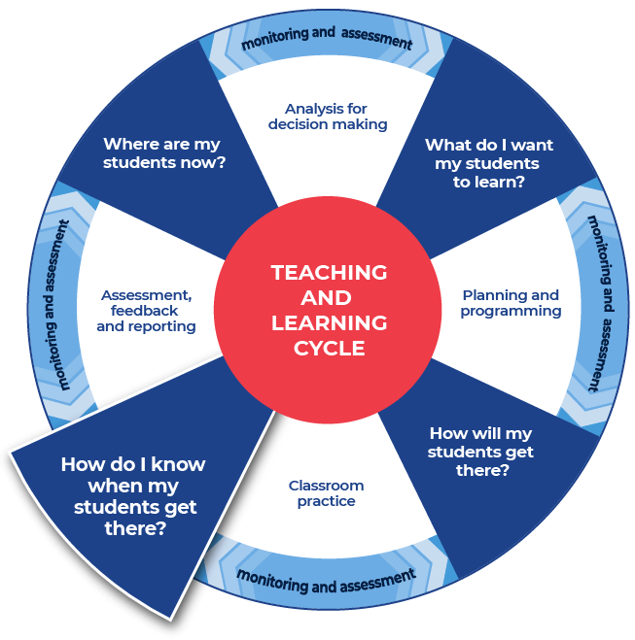

Instructions:
- Teachers provide the specific question or stimulus that students will use when they write their response.
- Teachers direct students to create a plan and draft their written response. Students should use the notes they have taken and any other relevant information.
- Teachers provide students with time to draft their writing.
- Teachers provide students with formative feedback during the drafting process.
- Teachers provide time for students to write their response in the next section, Improve student writing through writing and feedback (DOCX | PDF). The task assigned to students could be a practice examination question, or it could be writing in response to a journal article.
Further support
- Teachers and students could engage with the pre-written lesson content in the Ideas section on the HSC minimum standard website to support strengthening ideas.
- Teachers may also want to engage with the Text structure section on the HSC minimum standard resource website and use the persuasive text structure template provided on the site.

Example

Question
The text If trees could speak by Elif Shafak could be used as a model or stimulus for the English Standard Year 11 Common module – Reading to Write or Year 12 Module C: The Craft of Writing.
For this section we have presented a modelled example for Year 11 and if teachers are working through this sequence of activities with their Year 11 class then they should continue with that text or focus and modify the next section, Improve student writing through writing and feedback (DOCX | PDF), which offers a Year 12 modelled example.
For example the next section will work with the same text, If trees could speak by Elif Shafak, but a different focus:
Year 12 Module C: The Craft of Writing.
- Create a piece of imaginative, discursive or persuasive writing that builds upon an idea from the video: If trees could speak by Elif Shafak.
- Explain how studying the craft of writing has enabled you to create an engaging piece of writing. In your response, make detailed reference to your use of language in part (a).
This is the end of the activities for: Improve student writing through planning for writing.
Teachers should move on to the next set of activities: Improve student writing through writing and feedback (DOCX | PDF).

