Part 2: Proportional thinking with fractions, decimals and percentages

Contents

About the resource 3
The nature of the learner 4
Syllabus 6
Progression 6
Overview of tasks 7
Tasks 8
Task 1: Matchy Matchy 9
Task 2: Percentage strips 12
Task 3: Calculating benchmark percentages 16
Task 4: Dual scale number lines 18
Task 5: First principles percentages 24
Resources 26
Appendix 1: Card set 1 26
Appendix 2: Card set 2 30
Appendix 3: Card set 3 33
Appendix 4: Card set 4 35
Appendix 5: Solutions 37
Appendix 6: Paper strips 38
Appendix 7: Benchmark problems 39
Appendix 8: Approach 1 – Benchmark relationships 40
Appendix 9: Approach 2 – Unitary method 41
Appendix 10: Approach 1 – Notice relationships 42
Appendix 11: Approach 2 – Unitary method 43
Appendix 12: Approach 1 – Notice relationships 44
Appendix 13: Approach 2 – Unitary method 45
Appendix 14: Hundreds grid 46
Information for teachers 47
References 47
Alignment and support 48

About the resource
This resource is the second section of a four-part resource supporting proportional thinking.
- Part 1: Early proportional thinking
- Part 2: Percentages, fractions and decimals
- Part 3: Ratios
- Part 4: Rates
Proportional reasoning refers to the relationship between two or more variables, and a capacity to identify and describe what is being compared with what (Siemon et al. 2021). It is a complex form of reasoning that builds upon a number of interconnected ideas over a long period of time (Siemon et al. 2021). It takes many varied physical experiences to develop an understanding of proportionality and then more time to gain the ability to deal with the concept abstractly (Cordel & Mason, 2000:9). All teachers can support the foundations for proportional thinking by providing targeted teaching that deepens students’ conceptual understanding. This includes problem solving and meaningful practice to explore how and why strategies work.
Proportional thinking requires skills in thinking multiplicatively and involves measures, rates and/or ratios expressed in terms of natural numbers, rational numbers, and/or integers. For example,
$\frac{2}{3}$ × $24 as 2‑thirds of $24, or 3.5 × 68 as 3 and a half times 68, (Siemon et al., 2021). Like most concepts in mathematics, talking about proportional thinking is difficult without referring to other aspects of mathematics that recognise and work with relationships between quantities, such as multiplication and division, decimals, fractions and percentages.
Student understanding of number sense is a critical part of developing deep, meaningful mathematical skills, understanding and confidence. Students apply their number sense to a variety of proportional situations, including practical and financial problems, and develop the numeracy knowledge required for a range of important life skills. Proportional reasoning underpins an understanding of ratios and rates as well as the development of concepts and skills in other aspects of mathematics, such as trigonometry, similarity and gradient.

The nature of the learner
Students tend to progress through several broad phases of conceptual understanding as proportional thinking develops. Multiplicative understanding forms a crucial foundation for proportional thinking and students need to be able to:
- use multiplication and division in a wide range of situations,
- communicate mathematically using manipulatives, vocabulary and diagrams,
- apply the commutative, associative and distributive properties to solve problems, knowing how and when these properties are useful and when they are not, and
- apply part-part-whole reasoning to composite units.
See teaching considerations for multiplicative thinking.
Multiplicative thinking and proportional reasoning are complex. Students should be supported to acquire an understanding of:
- the ‘for each’ idea, or how the Cartesian product develops an understanding of rates and ratios
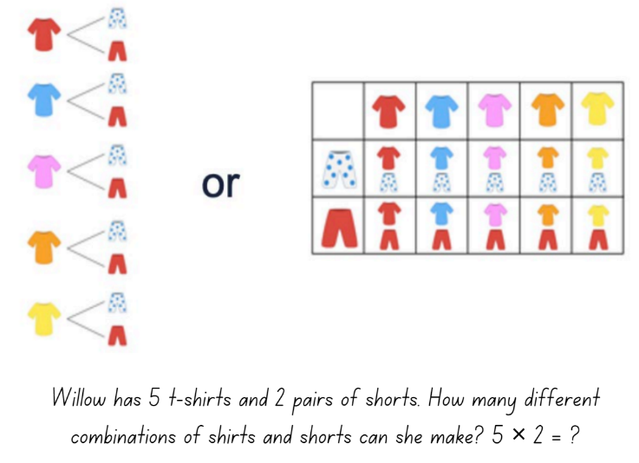
Figure 1 – Cartesian model using clothing items
- the ‘times as many’ or ‘times as large’ idea for comparing quantities multiplicatively as can be seen developing through place value, for example, 0.2 is 10 times as large as 0.02, or 100 times 0.005 is 0.5
- the conceptual relationship between fractions, decimals and percentages
- the link between fractions and ratios builds an understanding when simplifying ratios, for example, 2:8 could be simplified to 1:4 because I know 2 eighths is the same as 1 over 4
- factorisation to simplify quantities in rates and ratios, connecting this to simplifying fractions,
- fractions as ratios used to make ‘part-part’ comparisons, 2:3 represented as $\frac{2}{3}$ compared to fractions which are used to make ‘part-whole’ comparisons, $\frac{2}{5}$ .
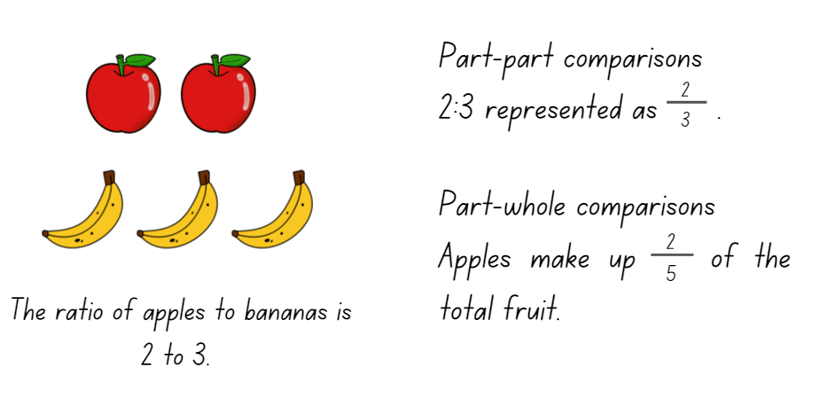
Figure 2 – Ratio of 2 to 3 using squares and triangles
The resource has been developed in partnership with the NSW Mathematics Strategy Professional Learning team and Literacy and Numeracy.

Syllabus
MAO-WM-01 develops understanding and fluency in mathematics through exploring and connecting mathematical concepts, choosing and applying mathematical techniques to solve problems, and communicating their thinking and reasoning coherently and clearly
MA3-RN-03 determines percentages of quantities, and finds equivalent fractions and decimals for benchmark percentage values
MA3-RQF-01 compares and orders fractions with denominators of 2, 3, 4, 5, 6, 8 and 10
MA4-FRC-C-01 represents and operates with fractions, decimals and percentages to solve problems
NSW Mathematics K-10 Syllabus (2022)

Progression
Number and place value NPV6 – NPV8
Multiplicative Strategies MuS9
Interpreting fractions InF1 – InF8
Proportional thinking PrT1 – PrT2, PrT5 – PrT6
National Numeracy Learning Progression Version 3

Copyright
Section 113P Notice
Texts, Artistic Works and Broadcast Notice
Some of this material has been copied and communicated to you in accordance with the statutory licence in section 113P of the Copyright Act. Any further reproduction or communication of this material by you may be the subject of copyright protection under the Act. Do not remove this notice.

Overview of tasks
Task name | What does it promote? | What materials will I need? | IfSR link
Task 1: Matchy Matchy | Understanding equivalent quantities can be expressed as percentages, fractions and decimals. | - Appendix 1: Card set 1  - Appendix 2: Card set 2  - Appendix 3: Card set 3  - Appendix 4: Card set 4  - Appendix 5: Solutions  - Writing materials | PT – 2A.1  PT – 2A.2  PT – 2A.3  PT – 2A.7  PT – 2A.9  PT – 2A.10
Task 2: Percentage strips | Percentages are fractions with a denominator of 100 and they can be represented with words, symbols and diagrams. | - Appendix 6: Paper strips  - Ruler  - Different length paper strips | PT – 2A.1 to  PT – 2A.8
Task 3: Calculating benchmark percentages | Make connections between benchmark fractions and the equivalent percentages. | - Appendix 7: Benchmark problems  - Writing materials | PT – 2A.4  PT – 2A.5  PT – 2A.6  PT – 2A.8
Task 4: Dual scale number lines | Use of dual scale number line as a tool to solve problems involving proportional relationship. | - Appendix 8: Approach 1 Benchmark relationships  - Appendix 9: Approach 2 Unitary method  - Appendix 10: Approach 1 Notice relationships  - Appendix 11: Approach 2 Unitary method  - Appendix 12: Approach 1 Notice relationship  - Appendix 13: Approach 2 Unitary method  - Writing materials | PT – 2A.4 to PT – 2A.8
Task 5: First principle percentages | Percentages represent a proportion of the whole and are used to represent and compare relative size. | - Appendix : Hundreds grid  - Writing materials | PT – 2A.4  PT – 2A.5  PT – 2A.6  PT – 2A.8

Tasks
For additional information on key generalisations and observable behaviours see reSolve, What you need to know: FRACTIONS (n.d.) and reSolve What you need to know: PROPORTIONAL REASONING (n.d.).
Key generalisations | Observable features
What is some of the mathematics:  - Mathematicians use the known to derive the unknown.  - Mathematicians evaluate strategies and contexts to determine the most appropriate methods to use.  - Mathematicians use the thinking of their peers to refine and revise their ideas.  - Mathematicians estimate answers to check the reasonableness of their response.  - Visual tools, such as the dual scale number line, can support development of mathematical concepts.  - Using benchmarks is an important component in developing number sense and aiding mental computation. | What are some observable behaviours:  - Uses known multiplication fact families to solve problems.  - Connects various representations of the same quantity or measure.  - Compares, orders and explains the size of decimals, fractions and percentages.  - Compares estimates with the results of calculations.  - Partitions numbers to think about problems flexibly.  - Explains their chosen strategies and refines their thinking after listening to the ideas and strategies of others.

Task 1: Matchy Matchy
Core learning: Percentages have fraction and decimal equivalents.

Materials
- Appendix 1: Card set 1
- Appendix 2: Card set 2
- Appendix 3: Card set 3
- Appendix 4: Card set 4
- Appendix 5: Solutions
- Writing materials

Instructions
This activity is an adaption of Translating between Fractions, Decimals and Percents from MARS, (2015).
- Provide Appendix 1: Card set 1 to small groups of students. Explain the activity requires ordering and matching cards.
- Ask students to place the percentage cards in ascending order and then underneath this line, place the decimals cards in ascending order. Have students identify any matches and align them.
- Students then need to use the blank cards to create any equivalent cards that are missing.
Figure 3 – Ordering percentages and decimals
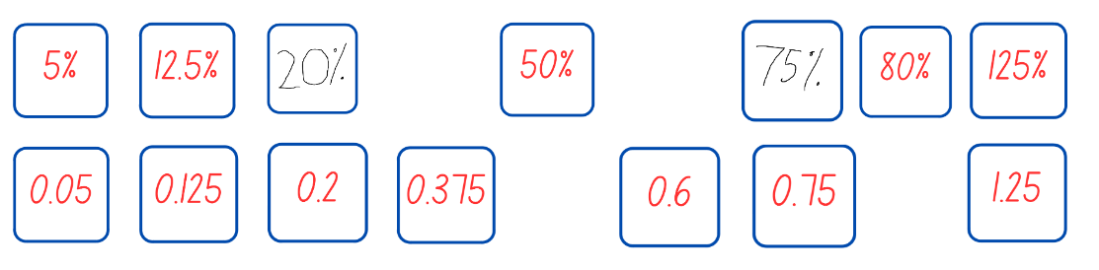
Images licensed under the Canva Content License Agreement.
- If students are having difficulty matching or ordering the cards, ask:
- Can you find an equivalent decimal?
- How might you express that card in words?
- Could you express it any other way? Could you make a drawing to represent it?
Teaching point: Some groups may not manage to place all the cards and it is not essential they do so. It is more important that every student thinks carefully about the cards they try to place. Students may not use calculators but are encouraged to use paper for calculating or explaining.
- If a group of students finishes placing all the cards and complete all the blank ones, ask them to create additional matching cards with constraints, such as:
- The number lies between 0.75 and 0.6.
- The number lies exactly halfway between 0.05 and 0.75.
- When most groups have created matching cards and reached consensus about the order, provide each group with Appendix 2: Card set 2. Explain they need to add a card from the new set to each existing match of decimals and percentages.
- Students create new cards if there is not a matching card. It is important to check the cards are in the correct order, moving their position if necessary.
- As a class, students discuss which representations they chose as their match and explain the reasoning behind their choices.
- As groups work on Appendix 2: Card set 2, distribute Appendix 3: Card set 3 and Appendix 4: Card set 4. Repeat the instructions as for the previous sets.
- On completion of the activity have students explain which card they felt very confident in placing and why. Have another student offer a different way of explaining it. As a class discuss the following:
- Which cards did you find easier to place and/or match?
- Which cards did you find more difficult to place and/or match?
- Which set of cards were the easiest to match and order?
- Does anyone have a card they were unsure about?
- What methods did you use to order the cards?
- What has been learned about equivalence on the cards? Was there anything that changed your mind about a card?
Teaching point: Students frequently associate decimals with number lines and fractions with area. The card sets in this activity are presented in the order of decimal, area, fraction, number line which encourages connections across the different representations.

Variations
- Students make a poster to display their cards in order and include justifications of their matching sets of cards and details of whether they changed their mind about the placement of a card.
- To support recall of percentage conversion facts, completed card sets may be used to play familiar games such as Go Fish or Memory, or used to develop for a new game, for example pairs of students select a card and challenge their opponent to guess their card within a limited number of guesses, such as, my card is greater than 50% but less than $\frac{3}{4}$.
Further resources
- Equivalent fractions (Universal Resource Hub)
- Colour in fractions (Universal Resource Hub)
- Fractions: Complement, equivalent or less (Universal Resource Hub)
- Fractions, Decimals and Percentages cards
- Matching Fractions, Decimals and Percentages (nrich)
- Fractions and Percentages card game (nrich)
- Doughnut Percents (nrich)

Task 2: Percentage strips
Core learning: Percentages are fractions with a denominator of 100 and they can be expressed as fractions or decimals.

Materials
- Appendix 6: Paper strips
- Ruler
- Different length paper strips

Activity 1 – Instructions
- Draw a narrow rectangle horizontally across the board and explain to students that it is a download bar. Ask student for suggestions as to where they might see one and what it is used for.
- Start to fill in the download bar from the left-hand side and ask students to say stop when they think it is at 50%.
- Looking at the bar, ask students to suggest how else they could describe how much of the download bar has been filled. Ask students the following questions and have them justify and explain their response.
- What fraction has been downloaded?
- What other fractions could it represent?
- How could you describe the bar?
- Choose a student to come and point to the left-hand side of the download bar and move their hand slowly to the right. Ask the class to say stop when they think it has loaded 25%.
- Looking at where the student has stopped, ask:
- Do you think 25% has been loaded?
- Why do you think that is 25%? Explain.
- If needed, adjust the download bar based on students' responses.
- Ask students to suggest other ways of representing 25% in fraction and decimal form, for example, 25% is 0.25, two tenths and five hundredths, or 25 hundredths $\frac{25}{100}$.
- Repeat the process for 75%.

Activity 2 – Instructions
- Provide students or small groups with Appendix 6: Paper strips. Ask them to fold the strip so it shows 50%, 25%, and 75%. Students share the strategies used to make the folds.
Prompts | Possible student responses
- How do you know you have folded the strip at 50%? Explain.  - How do you know you have folded the strip at 25%? Explain.  - How do you know you have folded the strip at 75%? Explain. | - I know 50% means half, so we folded the strip in half.  - 25% is half of a half, so we folded it again.  - I folded it into quarters as I know 25% is $\frac{1}{4}$, 50% is $\frac{1}{2}$, and 75% is $\frac{3}{4}$.  - 75% is 50% and 25%, so we found the 50% fold line so the next fold line would have to be 75%.
- On another strip, have students decide where 20% would be and fold strip to show. Prompt students to consider:
- If the whole strip is 100%, what fraction would 20% be?
- Is one fifth bigger or smaller than 1 quarter?
- How can you estimate 1 quarter and use this to show 1 fifth.
- How could measuring the strip help?
- Using the fold line students determine and mark 40%, 60% and 80% on the strip.
- Looking at another strip, have students discuss how they could determine 10% of the strip.
Prompts | Possible student responses
- How do you know you have folded the strip at 10%? Explain. | - 10% is half of 20%, so we folded it at the same spot as the other strip and then folded the 20% in half.  - We lined the strips up and drew a line in the middle the 20%.  - We know there are 10 groups of 10% in the whole, so we divided the strip into 10 parts.
- Ask students to show 30%, 40%, 50%, 60%, 70%, 80%, 90% on the same strip.
- Repeat the above process and questioning for finding 15% of the strip and then using the results to estimate 35%, 45%, 55%, 65% and 95%.
Variations
- Use 10 cm strips which enables students to represent 1 cm = 10%.
- Have students draw diagrams or paste and label their paper strips to demonstrate their reasoning.

Activity 3 – Instructions
Provide groups with several strips of paper. Have students fold one strip into quarters, then cut one quarter off. Ask students to suggest a number sentence that could describe this process, for example, $1 - \frac{1}{4}=\frac{3}{4}$.
- Ask students to recall that a strip is 100% and invite suggestions as to what percentage got cut off, 25%, and what remains, 75%. Ask students to suggest a number sentence,
100% - 25% = 75% and discuss words that might be used when subtraction is used, for example, minus, take away, deduct, reduce, decrease.
- Provide students with another strip and repeat the above process to find 80% of the strip.
- Lead discussion to reinforce percentages as a way of representing any quantity or measure. Possible discussion prompts include:
- Would it matter if the strips were a bit longer or a bit wider?
- What if we used a block of cheese instead of a strip of paper? Would our methods need to change?
- How would we decrease a jar full of gummy bears by 25%?
- Is finding 80% by taking 20% away different to the method we have used before? Why? Why not?
- Have students create a range of percentage decrease strips following the above steps, such as 90%, 60% and 55%. Cutting the strip reinforces percentage decrease as a deduction from 100%.
- Provide groups with more strips and have them determine a way to increase a strip to 150%. Model what a 150% strip looks like by cutting one strip in half and aligning it to a 100% strip.
- Students then create various percentage increase strips, such as 125%, 110%, 180%, 200%, 275%.
- Reflect with students about the strategies used to created percentage increase and decrease strips.

Variations
- Create a display showing a range of strips that have been increased or decreased by a percentage, such as 125%, 110%, 80%, 90%, 45%. Students should also display a 100%-length strip and record their methods for determining each strip’s length.
Further resources
- Calculating percentages (Universal Resource Hub)
- Fraction of a quantity (Universal Resource Hub)
- Identify, Represent and Compare Decimals (Universal Resource Hub)
- Profit and loss

Task 3: Calculating benchmark percentages
Core learning: Make connections between benchmark fractions and the equivalent percentages.

Materials
- Appendix 7: Benchmark problems
- Writing materials

Instructions
- Pose the problem, would you rather have 25% of $40, 50% of $60 or 10% of $100. Allow for students to estimate and use mental strategies and share their thinking with the class.
- Demonstrate to students how to solve each step of the problem:
- 10% requires students to find a tenth by dividing the whole by 10.
- 25% require students to find a quarter by dividing the whole by 4.
- 50% requires students to find half by dividing the whole by 2.
- Provide students with Appendix 7: Benchmark problems which require them to determine percentage discounts of 10%, 25% and 50%.
- When students are confident using fractions and division to solve benchmark percentage, expose students to a wider range of strategies. Below are some examples of different strategies to solve the following problem, Henry the hound lost 5% of his original weight of 80kg in one month. How much weight did he lose?
Horizontal bar model
Figure 4 – Bar model
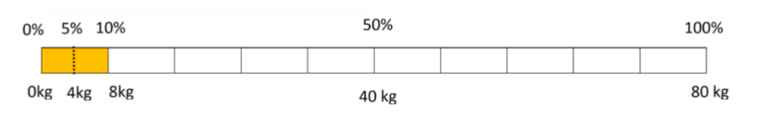
- Each part of the bar represents 10% or the equivalent of 8 kg. Hence, 5% which is half of 10%, will be 4 kg.
Use percentage benchmarks to find percentages of quantities
- 100% = 80 kg
- 10% = 8 kg (80 divided by 10)
- 5% = 4 kg (half of 10%)
- 5% of 80 kg was found by using the benchmark of 10% and halving it.
Using multiplication as an operator to calculate percentages
- 5% of 80kg = 5% x 80 = $\frac{5}{100}$ × 80
- Reducing $\frac{5}{100}$ gives $\frac{1}{20}$
- Hence, $\frac{1}{20}$ × 80 = $\frac{80}{20}$ = 4 kg
- Replace the word ‘of’ with the ‘x’ symbol. Express 5% as a fraction in its lowest form, then multiply the fraction by a whole number.
Teacher note: This is a process rather than an understanding of how to calculate percentages.
- Provide students with a variety of problems to solve, for example:
- Tony bought a new watch on sale. The watch was discounted by 20% from the original price of $150. How much did Tony pay for the watch?
- Sally worked at a local café for 2 years. Her boss decided to give her a pay rise of 20% as she was doing such a good job. Her original weekly pay was $400 before the pay rise. What was her total pay after the increase?
Further resources
- Calculating percentages (Universal Resource Hub)

Task 4: Dual scale number lines
Core learning: Using dual scale number line as a tool to solve problems involving proportional relationships.

Materials
- Writing materials
- Appendix 8: Approach 1 – Benchmark relationships
- Appendix 9: Approach 2 – Unitary method
- Appendix 10: Approach 1 – Notice relationships
- Appendix 11: Approach 2 – Unitary method
- Appendix 12: Approach 1 – Notice relationships
- Appendix 13: Approach 2 – Unitary method

Activity 1: Introducing dual scale number lines
In this activity, students are introduced to the dual scale number line as a tool for translating problems where proportional relationships are involved.
- Show the class a blank dual scale number line (see Figure 5) and introduce each of its features.
- Explain that dual scale number lines are always used in the same way. Start by drawing a blank dual scale number line and record any information that is known. Then identify what information is unknown and needs to be found out. The dual scale number line can help to determine a solution.
Figure 5 – Blank dual scale number line
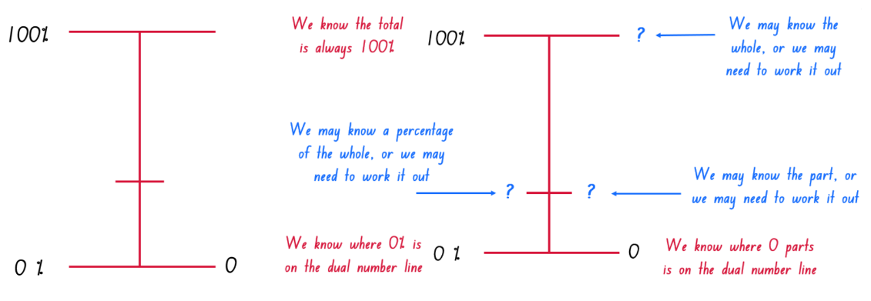
- Students turn and talk about the features of the dual scale number line using the terminology in the diagram: unknown percentage, known or unknown whole, and known unknown part.
- Explain there are 3 types of percentage problems and each of them can be solved using a dual scale number line:
- Missing part – to find out what quantity is a given percentage of another.
- Missing percent – to know what percentage one quantity is of another.
- Missing whole – to find the whole quantity if the percentage is known.
Teaching point: In this introductory activity, it is important students become familiar with the terminology and can discuss their thinking using appropriate mathematical vocabulary.

Activity 2 – Dual scale number lines for a missing part
In this activity, students create dual scale number lines to solve problems to find a percentage of a quantity.
- Present students with a missing part problem, for example, I have 60 books on my shelf and 20% of these 60 books are fantasy fiction. How many fantasy fiction books do I have?
- Encourage students to think of a mathematical statement that represents the problem, for example, what number is 20% of 60?
- As a class, have students identify what information is known, for example, I know 20% of the books are fantasy fiction, I know there are 60 books.
- Have students identify what information is missing and needs to be found out, for example, how many of the books are fantasy fiction or what is 20% of 60?
- Demonstrate to students how to draw a dual scale number line and record the known information (see Figure 6). A question mark or symbol may be used to hold a place for the missing part.
Figure 6 – Known and unknown information of a missing part problem
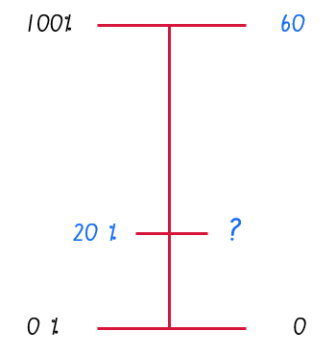
- Encourage students to suggest which mathematical knowledge and tools could help them solve this problem.
- Explain to students that there are different approaches to solve this problem and each approach is valuable to know, as one may be more efficient than another depending on the context.
- Appendix 8: Approach 1 – Benchmark relationships
- Appendix 9: Approach 2 – Unitary method
- Model each of the approaches separately, providing students with several problems to apply to each approach and share with the class.
Teaching point: Encourage students to use terms to describe relationships, ideas and methods, such as proportional, benchmark, and unitary. Developing a glossary may be suitable for many learners.

Activity 3 – Dual scale number lines for a missing percent
In this activity, students create dual scale number lines to solve problems to determine what percentage one quantity is of another.
- Present students with a missing percent problem, for example, 12 of my books are fantasy fiction. I have 60 books on my bookshelf. What percentage of my books are fantasy fiction?
- Encourage students to think of a mathematical statement that represents the problem, for example, what is 12 out of 60 as a percentage?
- Have students identify what information is known, for example, I know 12 books are fantasy fiction, I know there are 60 books altogether.
- Then have students identify what information is missing and needs to be found out, for example, what percentage of the books are fantasy fiction, what is $\frac{12}{60}$ as a percentage?
- Draw a dual scale number line and record the known information (see Figure 7). A question mark or symbol may be used to hold a place for the missing part.
Figure 7 – Known and unknown information on a missing percent problem
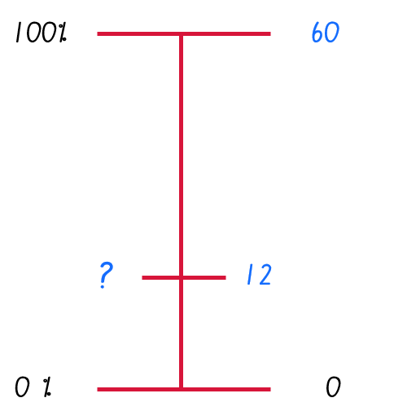
- Encourage students to suggest which mathematical knowledge and tools could help them solve this problem.
- There are different approaches that can be used to solve this problem and each approach is valuable to know, as one may be more efficient than another depending on the context.
- Appendix 10: Approach 1 – Notice relationships
- Appendix 11: Approach 2 – Unitary method
- Model each of the approaches separately, providing students with several problems to apply to each approach.
Teaching point: Encourage students to use terms to describe relationships, ideas and methods, such as proportional, benchmark, and unitary. Developing a glossary may be suitable for many learners.

Activity 4 – Dual scale number lines for a missing whole
In this activity, students create dual scale number lines to solve problems to find the whole quantity that is, the 100%.
- Present students with a missing whole problem, for example, 20% of the books on my bookshelf are fantasy fiction, and I have 12 fantasy fiction books. How many books do I have on my bookshelf?
- Encourage students to think of a mathematical statement that represents the problem, for example, if 20% is equal to 12 books, how many books would make 100%?
- Have students identify what information is known, for example, I know 12 books are fantasy fiction, I know 20% of my books are fantasy fiction.
- Then have students identify what information is unknown and needs to be found out, for example, what is the total number of books and what is 100% as a quantity of books?
- Draw a dual scale number line and record the known information, (see Figure 8). A question mark or symbol may be used to hold a place for the missing part.
Figure 8 – Known and unknown information on a missing whole problem
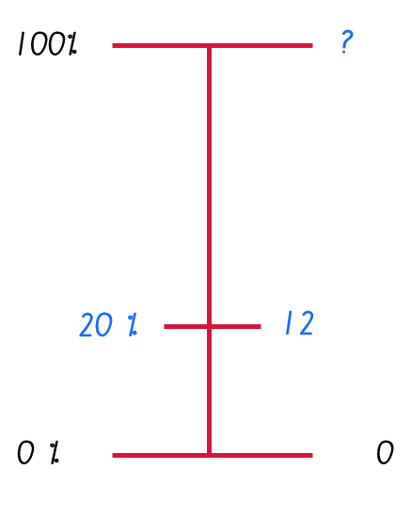
- Encourage students to suggest which mathematical knowledge and tools could help them solve this problem.
- There are different approaches that can be used to solve this problem and each approach is valuable to know, as one may be more efficient than another depending on the context.
- Appendix 12: Approach 1 – Notice relationships
- Appendix 13: Approach 2 – Unitary method
- Model each of the approaches separately, providing students with several problems to apply to each approach.
Teaching point: Encourage students to use mathematical terms to describe relationships, ideas and methods, such as proportional, benchmark, and unitary. Developing a glossary may be suitable for many learners.

Activity 5 – Comparing approaches
In this activity, students consider the range of problems solved using the various approaches to dual scale number lines.
- Different approaches were used to solve these problems, such as noticing relationships or unitary method. Lead a discussion around the approach used for each of the following question types: missing part, missing percentage, missing whole.
- Alternatively, use Think-Pair-Share and have students explain their thinking to a partner using dual scale number line representations and appropriate terminology to communicate their ideas. Suggested discussion prompts:

- What do you notice about each of the approaches?
- How does each approach work? What mathematical properties are being used?
- What are the advantages of each approach?
- What are the disadvantages of each approach?
- Which approach do you think is the most efficient?
- When is each approach useful or not useful?
- How could you decide which approach to take?
- What knowledge do you need to be successful at using any of these approaches?
- Is there another solution approach you discovered while working on these problems?
Further resources
- Calculating percentages (Universal Resource Hub)
- Express one quantity as a percentage of another (Universal Resource Hub)

Task 5: First principles percentages
Core learning: Percentages represent a proportion of the whole and are used to represent and compare relative size.

Materials
- Appendix 14: Hundreds grid
- Writing materials

Instructions
This activity is an adaption of First principles percentage from Lovitt & Clarke (1988).
- Provide students with Appendix 14: Hundreds grid and have students shade 5 of the squares. Invite class discussion about the different ways that could be used to describe how much of the grid is shaded, for example, $\frac{5}{100}$, $\frac{1}{20}$, 5%, 0.05. Emphasise that 5 shaded squares out of 100 squares is 5% shaded.
- In small groups, students determine how many squares their group has in total and how many squares are shaded in total. For example, a group of 3 students has 15 shaded squares altogether out of a total of three hundred squares; a group of 5 students has 25 shaded squares altogether out of a total of five hundred squares.
Figure 9 – Hundreds grid shaded
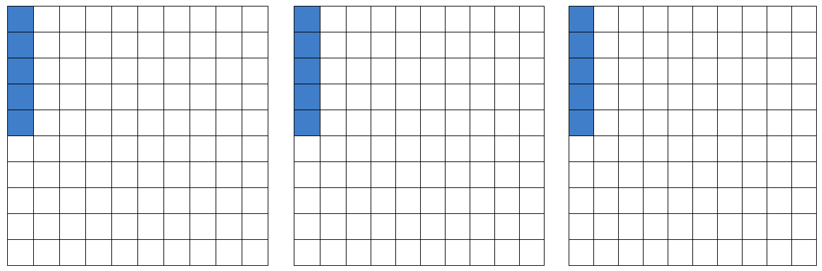
- Ask groups whether they think the percentage of squares that are shaded has changed now they have combined their 100 grids. Have groups turn and talk before sharing with the class.
- Explain to students that percent means ‘for every hundred’, and 5% means 5 for every hundred, regardless of how many hundreds there are. This is called the first principles method.
- Guide students in mentally calculating several simple examples using the ‘for every hundred’ method, checking their thinking with Appendix 14: Hundreds grid if necessary. For example:
- 5% of 200 squares, that is 5 for the first hundred, 5 for the second hundred, so 5% of 200 squares is 10 squares
- 3% of 200 squares, that is 3 for the first hundred, 3 for the second hundred, so 3% of 200 squares is 6 squares
- 1% of 400 squares, that is 1 for each of the 4 hundreds, so 1% of 400 squares is 4 squares
- 20% of 300 squares, that is 20 for each of the 3 hundreds, 3 x 20, so 20% of 300 squares is 60 squares.
Teaching point: Reinforce that a percentage of a quantity is a part of that quantity, and their solution should state that as a sentence. This supports students in understanding the distinction between finding a percentage of a quantity, for example, 3% of $200 is $6, and expressing 2 quantities as a percentage of each other, for example, 5 green bottles out of a total of 50 bottles is 10%.
- Students discuss how they might be able to calculate percentages of quantities that are not whole hundreds using the following prompts.
Prompts | Possible student responses
- What is 40% of 350 kg? Explain your thinking.  - What is 40% of 310 kg? Explain your thinking.  - What is 40% of 360 kg? Explain your thinking. | - If you need 40 kg for every 100 kg, then you only need half of 40 for every 50 kg. Therefore, we have 40 multiplied by 3 for the 300 kg, added to one amount of 20 for the fifty kg. That means 140 kg is 40% of 350 kg.  - I partitioned 310 into 300 plus 10. I know 40% of 300kg is 3 times 40% of 100, or 3 times 40, which is 120 kg. Then I worked out that 10 kg is one tenth of 100 kg, so instead of 40 kg I only need a tenth of 40 kg or 4 kg. This made a total 40+40+40+4 = 124 kg.  - 60 kg can be partitioned into 50 kg and 10 kg, so a combination of the previous two strategies is useful, giving 40+40+40+20+4 = 144 kg
Further resources
- Calculating percentages (Universal Resource Hub)
- Percentages lessons and activities

Resources

Appendix 1: Card set 1
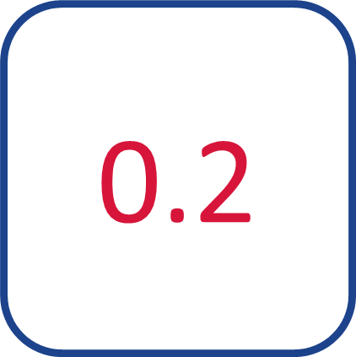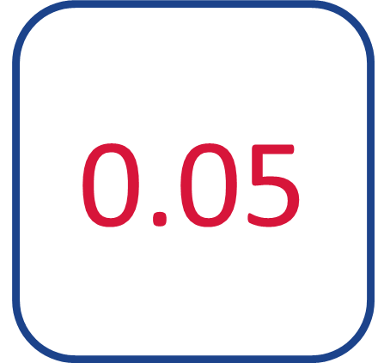

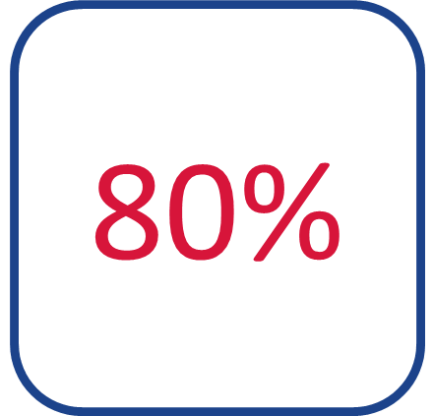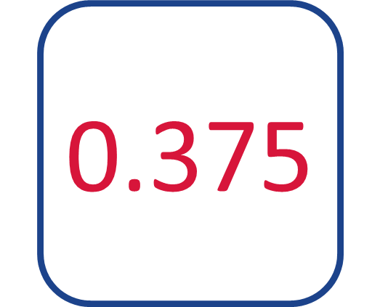
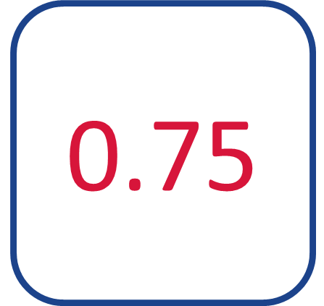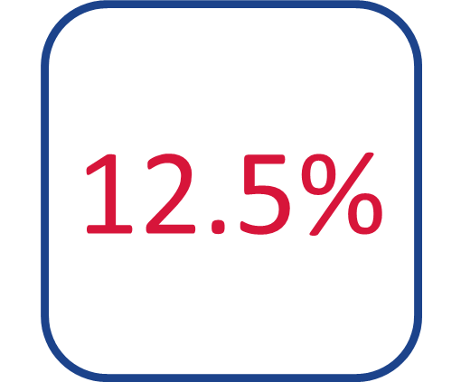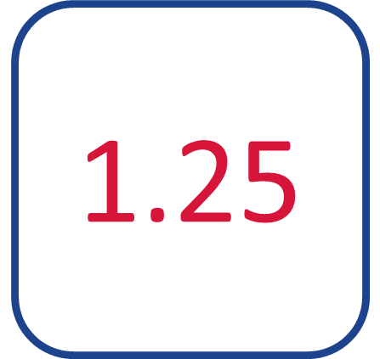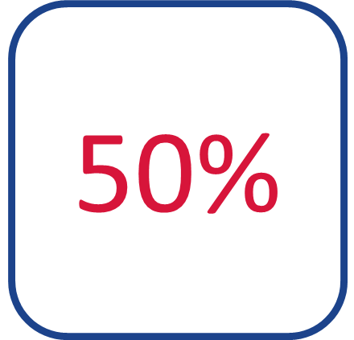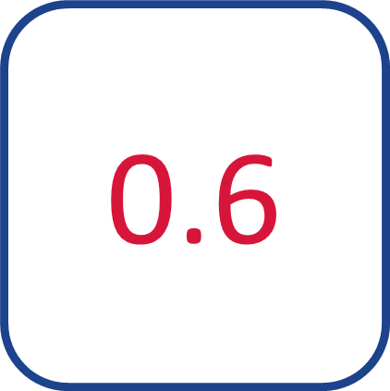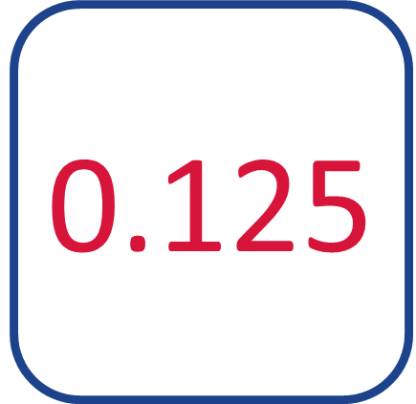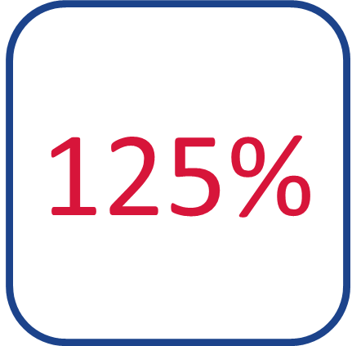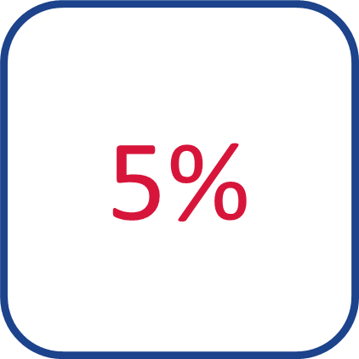

Appendix 2: Card set 2
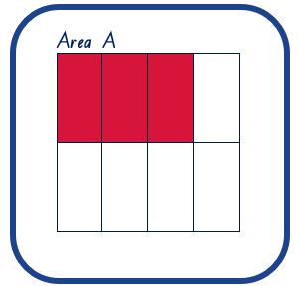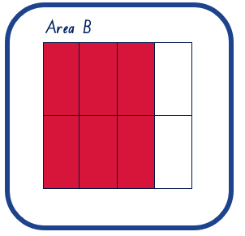

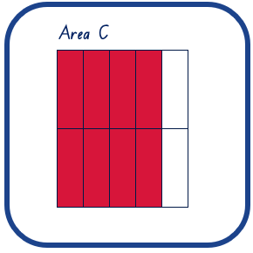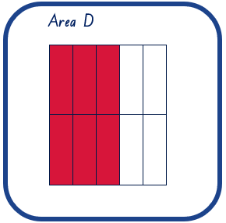

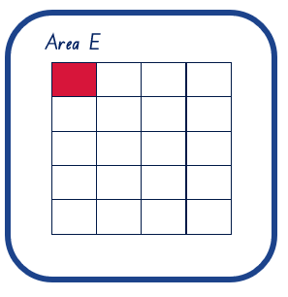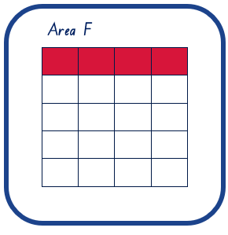

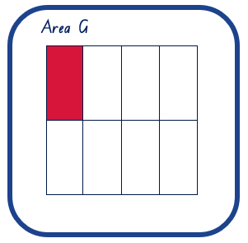

Appendix 3: Card set 3
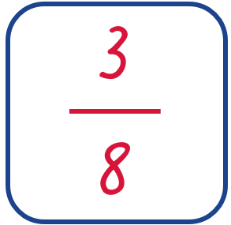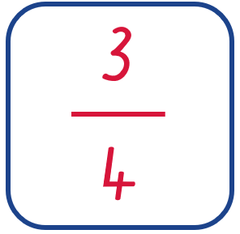

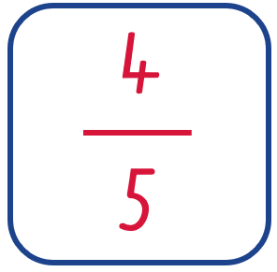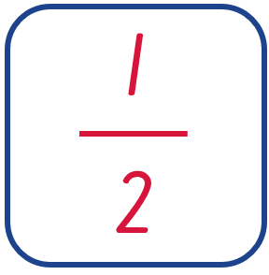
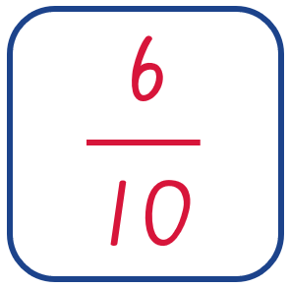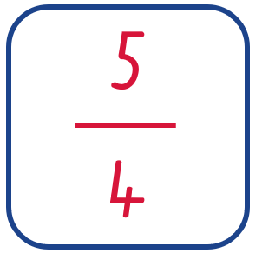
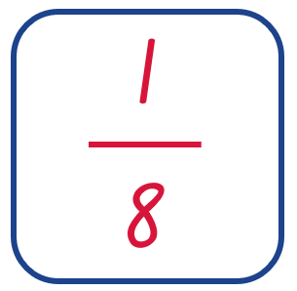

Appendix 4: Card set 4
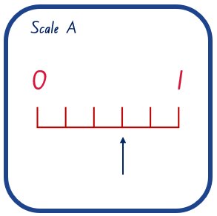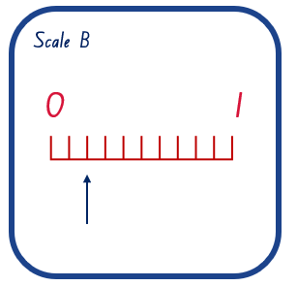

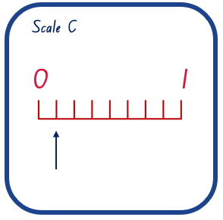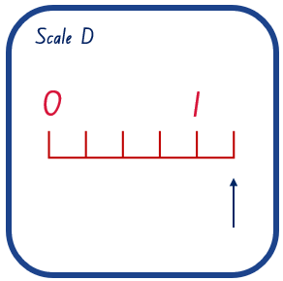

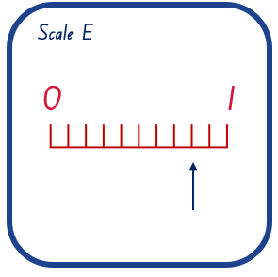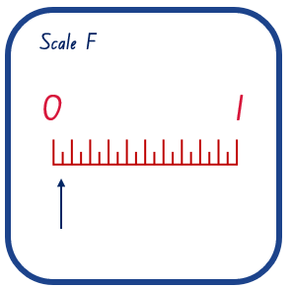

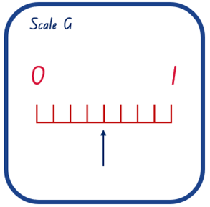

Appendix 5: Solutions
Red text indicates cards students need to create.
Decimal | 0.05 | 0.125 | 0.2 | 0.375 | 0.5 | 0.6 | 0.75 | 0.8 | 1.25
Percent | 5% | 12.5% | 20% | 37.5% | 50% | 60% | 75% | 80% | 125%
Area | Area E | Area G | Area F | Area A | Area H | Area D | Area B | Area C | Area I
Fraction | $$\frac{1}{20}$$ | $$\frac{1}{8}$$ | $$\frac{1}{5}$$ | $$\frac{3}{8}$$ | $$\frac{1}{2}$$ | $$\frac{6}{10}$$ | $$\frac{3}{4}$$ | $$\frac{4}{5}$$ | $$\frac{5}{4}$$
Number line | Scale F | Scale C | Scale B | Scale H | Scale G | Scale A | Scale  I | Scale E | Scale D

Appendix 6: Paper strips

Appendix 7: Benchmark problems
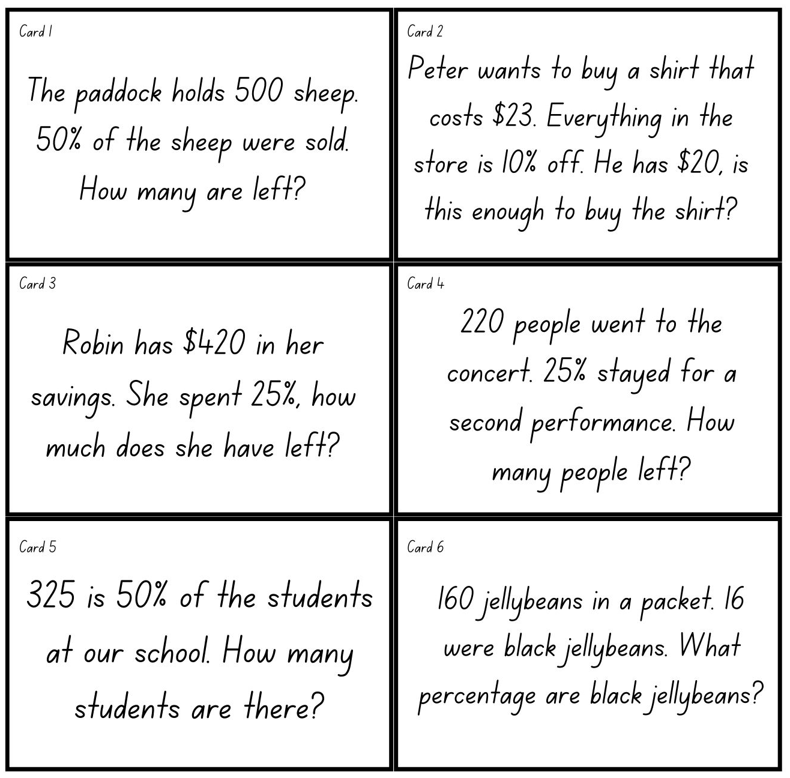

Appendix 8: Approach 1 – Benchmark relationships
Teacher note: This approach requires students to notice relationships between the whole and the given percentage in terms of benchmarks and applying that relationship to the quantity to determine the missing part.
Step 1: Identify the 2 known percentages and elicit suggestions about how they could be expressed mathematically using benchmarks.
- Divide 100% by 5 you get 20% (100% $÷$ 5 = 20%)
- 20% is 100% divided into 5 parts (20% = 100% $÷$ 5)
- 20% is one fifth of 100% (20% = $\frac{1}{5}$ x 100%) or one fifth of 100% is 20% ($\frac{1}{5}$ x 100% = 20%)
Step 2: The dual scale number line shows proportional relationships, and the relationship between the whole (100%) and the known percent (20%) also applies to the quantity, books. Therefore, the missing part can be found using the same operation.
- 60 divided by 5 is 12 (60 $÷$ 5 = 12)
- One fifth of 60 is 12 ($\frac{1}{5}$ x 60 = 12) or 12 is one fifth of 60 (12 = $\frac{1}{5}$ x 60)
Figure 10 – Benchmark relationships
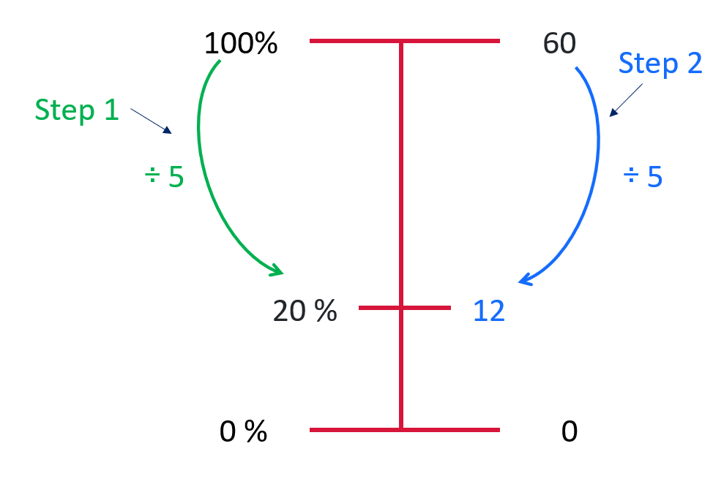
Step 3: Have students write a statement or express in words the meaning of the solution.
- The relationship is one fifth, and one fifth of 60 is 12, so there are 12 fantasy fiction books.
- The relationship is divide by 5, and 60 divided by 5 is 12, so there are 12 fantasy fiction books. .
Appendix 9: Approach 2 – Unitary method
Teacher note: This approach requires finding the value of one unit, 1% of the whole, then multiplying that value by the unknown percentage to determine the value of missing part.
Step 1: Use the dual scale number line to calculate the value of 1% of the whole.
Step 2: Identify the missing part is a known percentage, in this example 20%. Use the dual scale number line to model multiplying the unit percentage by the known percentage.
Figure 11 – Unitary method
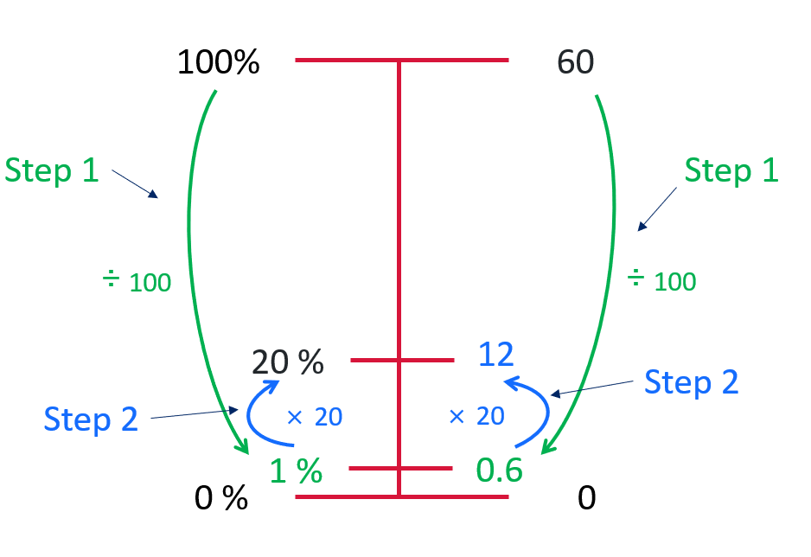
Step 3: Have students write a statement or express in words the meaning of the solution.
- 20% is 20 multiplied by 1%. 1% of the books is 0.6, so 20% is 20 x 0.6 = 12. There are 12 fantasy fiction books.

Appendix 10: Approach 1 – Notice relationships
Teacher note: This approach requires students to notice relationships between the whole and the part and applying that relationship to determine the missing percent.
Step 1: Identify the relationship between the 2 known quantities, 12 fantasy fiction books out of 60 books. Elicit suggestions about how it could be expressed mathematically. Select one of these expressions and model the operation on the dual scale number line.
- 60 divided by 5 is 12 $\left(60÷5 =12\right)$, or 60 divided by 12 is 5 $\left(60÷12 =5\right)$.
- 5 multiplied by 12 is 60 $\left(5×12 =60\right)$, or 12 multiplied by 5 is 60 $\left(12×5 =60\right)$
- One fifth of 60 is 12 $\left(\frac{1}{5}×60 =12\right)$, or 12 is one fifth of 60 $\left(12=\frac{1}{5}×60\right)$
Step 2: The dual scale number line shows proportional relationships, that show the relationship between the whole (60) and the known part (12). This also applies to the whole (100%) and the missing percent. Apply the operation to find the value of the missing percent.
Figure 12 – Notice relationships
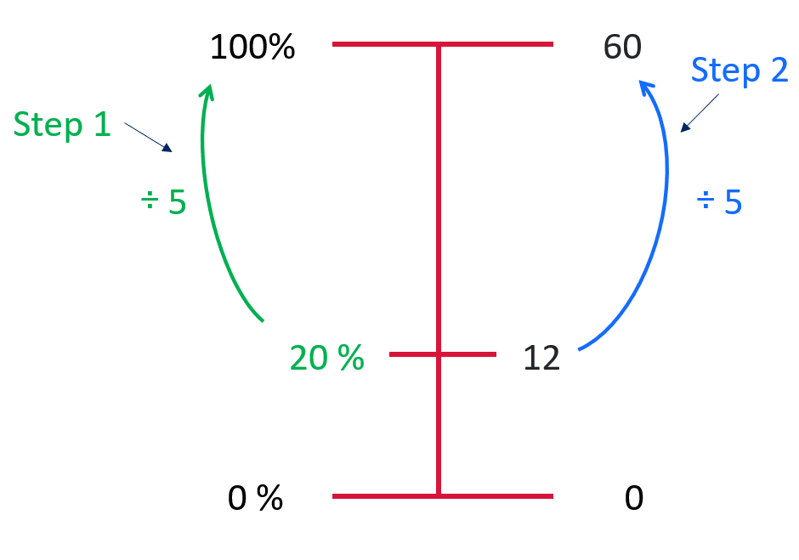
Step 3: Have students write a statement or express in words the meaning of the solution.
- 12 out of 60 books are fantasy fiction therefore 20% of the books are fantasy fiction.

Appendix 11: Approach 2 – Unitary method
Teacher note: This approach requires finding the value of one unit, 1% of the whole, then identifying the multiplication factor to determine the missing percent.
Step 1: Use the dual scale number line to calculate the value of 1% of the whole. Identify the known part (12 books) is a multiple of one part (0.6 books).
Step 2: Model this multiplication factor on the dual scale number line.
Teaching note: Students may need to be explicitly reminded to use inverse relationships, or multiplication facts, to determine the multiplier (if a x b = c, then c $÷$ b = a): 12 divided by 0.6 is 20, so 0.6 times 20 is 12.
Figure 13 – Unitary method
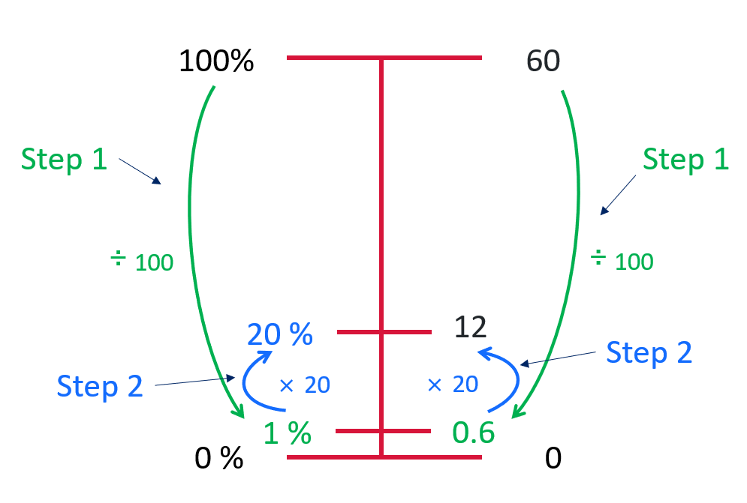
Step 3: Have students write a statement or express in words the meaning of the solution.
- 1% of the books is 0.6, 0.6 x 20 = 12. 1% x 20 is 20% therefore 12 out of 60 fantasy books is 20%.

Appendix 12: Approach 1 – Notice relationships
Teacher note: This approach requires students to notice relationships between the known percentages and applying that relationship to determine the missing whole.
Step 1: Notice the relationship between 0% and 100% and elicit suggestions about how it could be expressed mathematically. Select one of these expressions and model the operation on the dual scale number line.
- 5 multiplied by 20% is 100% (5 x 20% = 100%) or 100% is 5 multiplied by 20% (100% = 5 x 20%)
- One fifth of 100% is 20% ($\frac{1}{5}$ x 100% = 20%) or 20% is one fifth of 100% (20% = $\frac{1}{5}$ x 100%)
Step 2: The dual scale number line shows proportional relationships, and the relationship between the known percent (20%) and the whole percent (100%). This also applies to the known part (12 books) and the missing whole. Therefore, the missing whole can be found by applying the same operation.
Figure 14 – Notice relationships
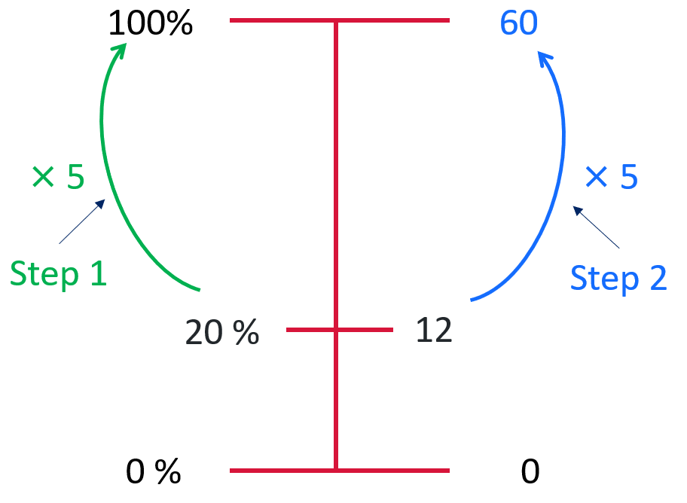
Step 3: Have students apply the operation to find the value of the missing whole. Write or express in words the meaning of the solution.
- 20% of the total number of books is 12 books. 100% of the books is 5 times 20%, so 5 times 12 books is 60 books.
- 12 books is 20% of the total. 100% is 5 groups of 20%, 5 x 12 = 60, so there are 60 books on the bookshelf.

Appendix 13: Approach 2 – Unitary method
Teacher note: This approach requires finding the value of one unit (1%) from a known part, then identifying the multiplication factor to determine the missing whole.
Step 1: Explain a unit percent (1%) can be calculate from any known percent by division. Model using the dual scale number line to calculate the value of 1% using the known percent.
Step 2: Remind students the whole is 100%. Now the value of 1% is known, the value can be calculated by multiplying by 100.
Figure 14 – Unitary method
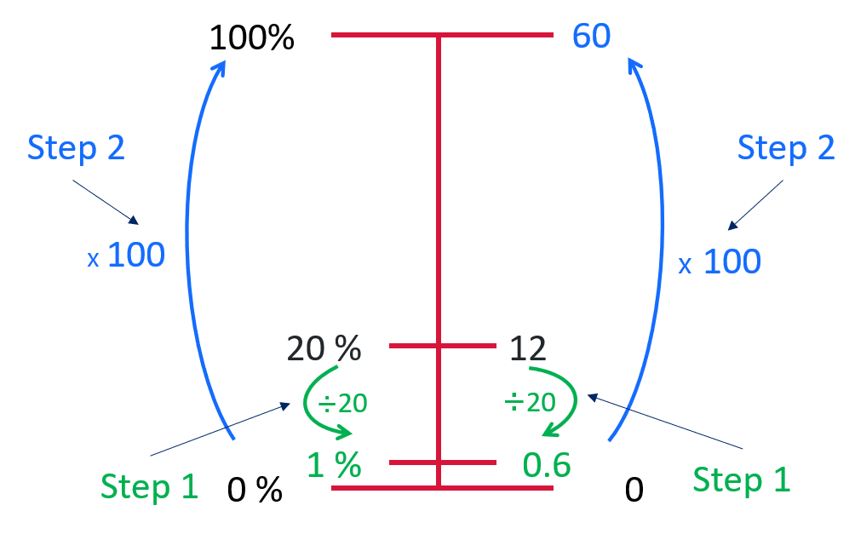
Step 3: Have students apply the operation to find the value of the missing whole.
- Divide by 20 to find 1%. 12 divide 20 = 0.6. Then multiply by 100 to find the whole percentage. Therefore if 12 fantasy books are 20% of the total number of books, there are 60 books in total.

Appendix 14: Hundreds grid

Information for teachers

References
Australian Government Department of Education (n.d.) ‘What you need to know: FRACTIONS’, Teaching resources, reSolve: Maths by Inquiry website, accessed 27 June 2023.
Australian Government Department of Education (n.d.) ‘What you need to know: PROPORTIONAL REASONING’, Teaching resources, reSolve: Maths by Inquiry website, accessed 27 June 2023.
Cordel B, and Mason R (2000) Proportional reasoning (Algebraic thinking series), Fresno, CA: Aims Education Foundation.
Lovitt C & Clarke D (1988). The Mathematics Curriculum and Teaching Program professional development package activity bank. Canberra: Curriculum Development Centre.
Mathematics Assessment Resource Service (2015) Translating between Fractions, Decimals and Percents. University of Nottingham
Siemon D, Warren E, Beswick K, Faragher R, Miller J, Horne M, Jazby D & Breed M (2021) Teaching Mathematics Foundations to Middle Years, 3rd edn, Oxford University Press, Victoria.
University of Cambridge (Faculty of Mathematics) (2023) Donut Percents, NRICH website, accessed 25 May 2023.
University of Cambridge (Faculty of Mathematics) (2023) Fractions and Percentages Card Game, NRICH website, accessed 25 May 2023.
University of Cambridge (Faculty of Mathematics) (2023) Matching Fractions, Percentages and Decimals, NRICH website, accessed 25 May 2023.

Bibliography
Australian Association of Mathematics Teachers (AAMT) Inc. (n.d.) Top Drawer Teachers: Resources for teachers of mathematics, accessed 5 July 2023.
Armstrong A, Min, K, & Helf S (2018). Content area literacy in the mathematics classroom. The Clearing House: A Journal of Educational Strategies, Issues and Ideas, 91(2), 85-95.
Booker G, Bond D, Seah R (2020) Teaching Primary Mathematics, 6th ed, Pearson Education, Australia.
Brady K, Faragher R, Clark J, Beswick K, Warren E, Siemon D (2015). Teaching Mathematics: Foundations to Middle Years. Australia: Oxford University Press.
Dole S (2000). Promoting Percent as a Proportion in Eighth‐Grade Mathematics. School Science and Mathematics, 100(7), 380-389.
Goos M, Stillman G & Vale, C (2007) Teaching secondary school mathematics: research and practice for the 21st century. Allen & Unwin.
Gould P (2013) ‘Australia’s next top fraction model’, Australian Primary Mathematics Classroom, 18(3):5–12, accessed 27 February 2023.
Ontario Ministry of Education (2012) Paying Attention to Proportional Reasoning, K-12 Queen's Printer for Ontario, accessed 27 June 2023.
Sparrow L, Booker G, Swan P, Bond D (2015). Teaching Primary Mathematics. Australia: Pearson Australia.
State of Victoria (Department of Education and Training) (2021) ‘Common Misunderstandings - Level 5 Proportional Reasoning’, Numeracy and maths, Department of Education and Training website, accessed 27 June 2023.
White G, & Swan P (2013). Developing Mathematics with Pattern Blocks. Australia: R.I.C. Publications.

Alignment and support
Alignment to system priorities and/or needs: The literacy and numeracy five priorities.
Alignment to School Excellence Framework: Learning domain: Curriculum, Teaching domain: Effective classroom practice and Professional standards
Consulted with: NSW Mathematics Strategy professional learning and Curriculum Early Years Primary Learners-Mathematics teams
Reviewed by: Literacy and Numeracy
Created/last updated: February 2024
Anticipated resource review date: January 2025
Feedback: Complete the online form to provide any feedback.

