Part 1: Early proportional thinking

Contents
About the resource 3
The nature of the learner 4
Syllabus 6
Progression 6
Overview of tasks 7
Tasks 8
Task 1: Numbers on a line 9
Task 2: Colour in fractions 12
Task 3: Make a whole game 14
Task 4: Decimal numbers on a line 16
Task 5: Decimats 18
Task 6: Rolling arrays 20
Resources 22
Appendix 1: Number cards 1 22
Appendix 2: Number cards 2 23
Appendix 3: Number cards 3 24
Appendix 4: Spinner A 25
Appendix 5: Spinner B 26
Appendix 6: Fraction wall gameboard 27
Appendix 7: Game sheet 28
Appendix 8: Numerator cards 29
Appendix 9: Denominator cards 30
Appendix 10: Number cards 31
Appendix 11: Decimals and fractions 35
Appendix 12: Spinner 36
Information for teachers 38
References 38
Alignment and support 39

About the resource
This resource is the first section of a four-part resource supporting proportional thinking.
- Part 1: Early proportional thinking
- Part 2: Percentages, fractions and decimals
- Part 3: Ratios
- Part 4: Rates
Proportional reasoning refers to the relationship between two or more variables, and a capacity to identify and describe what is being compared with what (Siemon et al, 2001). It is a complex form of reasoning that builds upon a number of interconnected ideas over a long period of time (Siemon et al. 2021). It takes many varied physical experiences to develop an understanding of proportionality and then more time to gain the ability to deal with the concept abstractly (Cordel & Mason, 2000:9). All teachers can support the foundations for proportional thinking by providing targeted teaching that deepens students’ conceptual understanding. This includes problem solving and meaningful practice to explore how and why strategies work.
Proportional thinking requires skills in thinking multiplicatively and involves measures, rates and/or ratios expressed in terms of natural numbers, rational numbers, and/or integers. For example,
$\frac{2}{3}$ × $24 as 2‑thirds of $24, or 3.5 × 68 as 3 and a half times 68, (Siemon et al., 2021). Like most concepts in mathematics, talking about proportional thinking is difficult without referring to other aspects of mathematics that recognise and work with relationships between quantities, such as multiplication and division, decimals, fractions and percentages.
Student understanding of number sense is a critical part of developing deep, meaningful mathematical skills, understanding and confidence. Students apply their number sense to a variety of proportional situations, including practical and financial problems, and develop the numeracy knowledge required for a range of important life skills. Proportional reasoning underpins an understanding of ratios and rates as well as the development of concepts and skills in other aspects of mathematics, such as trigonometry, similarity and gradient.

The nature of the learner
Students tend to progress through several broad phases of conceptual understanding as proportional thinking develops. Multiplicative understanding forms a crucial foundation for proportional thinking and students need to be able to:
- use multiplication and division in a wide range of situations,
- communicate mathematically using manipulatives, vocabulary and diagrams,
- apply the commutative, associative and distributive properties to solve problems, knowing how and when these properties are useful and when they are not, and
- apply part-part-whole reasoning to composite units.
See teaching considerations for multiplicative thinking.
Multiplicative thinking and proportional reasoning are complex. Students should be supported to acquire an understanding of:
- the ‘for each’ idea, or how the Cartesian product develops an understanding of rates and ratios,
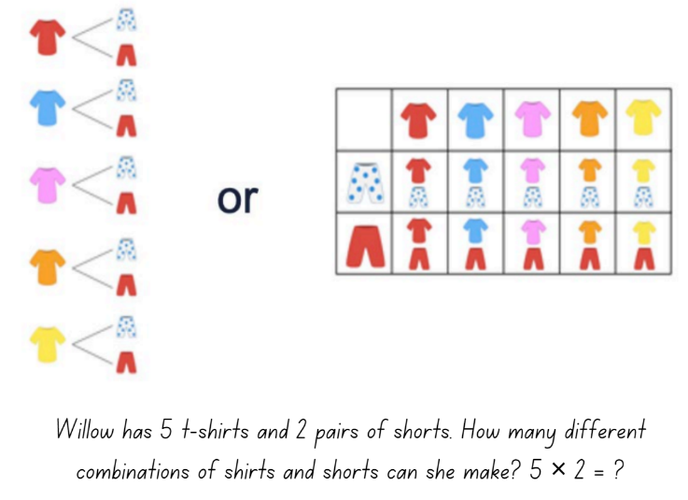
Figure 1 – Cartesian model using clothing items
- the ‘times as many’ or ‘times as large’ idea for comparing quantities multiplicatively as can be seen developing through place value, for example, 0.2 is 10 times as large as 0.02, or 100 times 0.005 is 0.5
- the conceptual relationship between fractions, decimals and percentages
- the link between fractions and ratios builds an understanding when simplifying ratios, for example, 2:8 could be simplified to 1:4 because I know that 2 eighths is the same as 1 over 4
- factorisation to simplify quantities in rates and ratios, connecting this to simplifying fractions
- fractions as ratios used to make ‘part-part’ comparisons, 2:3 represented as $\frac{2}{3}$compared to fractions which are used to make ‘part-whole’ comparisons, $\frac{2}{5}$.
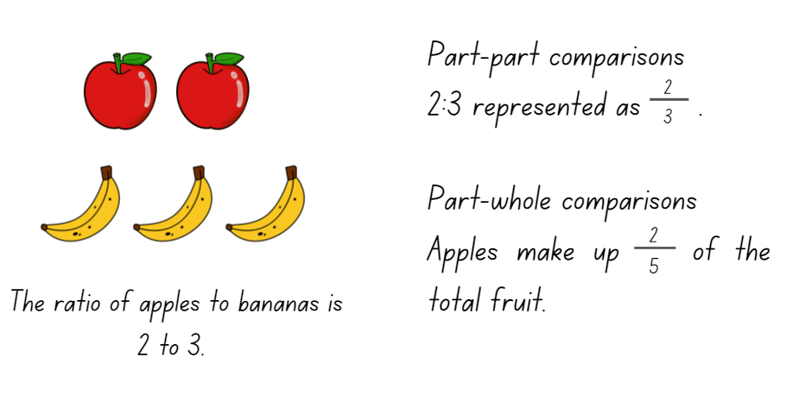
Figure 2 – Ratio of 2 to 3 using squares and triangles
The resource has been developed in partnership with the NSW Mathematics Strategy Professional Learning team and Literacy and Numeracy.

Syllabus
MAO-WM-01 develops understanding and fluency in mathematics through exploring and connecting mathematical concepts, choosing and applying mathematical techniques to solve problems, and communicating their thinking and reasoning coherently and clearly
MA1-RWN-01 applies an understanding of place value and the role of zero to read, write and order two- and three-digit numbers
MA1-GM-03 creates and recognises halves, quarters and eithers as part measures of a whole length
MA2-RN-02 represents and compares decimals up to 2 decimal places using place value
MA3-RN-02 constructs and completes number sentences involving multiplicative relations, applying the order of operations to calculations
MA3-RQF-01 compares and orders fractions with denominators of 2, 3, 4, 5, 6, 8 and 10
MA3-RQF-02 determines $\frac{1}{2}$, $\frac{1}{4}$, $\frac{1}{5}$ and $\frac{1}{10}$ of measures and quantities
NSW Mathematics K-10 Syllabus (2022)

Progression
Number and place value NPV3 – NPV8
Multiplicative strategies MuS5 – MuS6
Interpreting fractions InF1 – InF8
National Numeracy Learning Progression Version 3

Copyright
Section 113P Notice
Texts, Artistic Works and Broadcast Notice
Some of this material has been copied and communicated to you in accordance with the statutory licence in section 113P of the Copyright Act. Any further reproduction or communication of this material by you may be the subject of copyright protection under the Act. Do not remove this notice.

Overview of tasks
Task name | What does it promote? | What materials will I need? | IfSR link
Task 1: Numbers on a line | Visualising the whole and approximating and adjusting estimations of halves and quarters. | - String or rope  - Pegs  - Appendix 1: Number cards 1  - Appendix 2: Number cards 2  - Appendix 3: Number cards 3 | PT – 1A.1
Task 2: Colour in fractions | Equivalent fractions express the same amount by using different sized fractional parts. | - Appendix 4: Spinner A  - Appendix 5: Spinner B  - Appendix 6: Fraction wall gameboard  - Writing materials | PT – 1A.2  PT – 1A.3
Task 3: Make a whole game | There are many different fractions equal to any given fraction and a fraction can be renamed using equivalence. | - Appendix 7: Game sheet  - Appendix 8: Numerator cards  - Appendix 9: Denominator cards | PT – 1A.2  PT – 1A.3  PT – 1A.8  PT – 1A.11  PT – 1A.12
Task 4: Decimal numbers on a line | Benchmark fractions can assist in dividing space on a number line. | - String or rope  - Appendix 10: Number cards  - Appendix 11: Decimals and fractions | PT – 1A.4  PT – 1A.5  PT – 1A.6
Task 5: Decimats | Renaming numbers using place value understanding helps to sequence, order and compare numbers. | - Appendix 12: Spinner  - Paper  - Writing materials | PT – 1A.4  PT – 1A.5  PT – 1A.6  PT – 1A.7  PT – 1A.10
Task 6: Rolling arrays | Mental models of arrays are helpful for exploring multiplicative situations. | - Counters  - Six-sided dice | PT – 1A.9

Tasks
For additional information on key generalisations and observable behaviours see reSolve, What you need to know: FRACTIONS (n.d.) and reSolve What you need to know: PROPORTIONAL REASONING (n.d.).
Key generalisations | Observable features
What is some of the mathematics:  - Mathematicians use numbers to count, calculate and measure.  - Mathematicians use proportional thinking with whole numbers.  - Fractional quantities are created by partitioning or dividing wholes into equal sized parts.  - The language of fractions helps describe and compare different parts of a whole.  - Part-part-whole relationships help solve multiplicative problems.  - Decimal place value makes comparisons of size more precise as the smaller the unit, the more precise the measure. | Some observable behaviours:  - partitions numbers to think about problems flexibly.  - uses doubling and halving strategies to solve problems.  - explains their chosen strategies using mathematical language.  - uses halves to create wholes.  - creates quarters and eighths using repeated halving.  - uses various representations to share thinking, for example, drawings, language, diagrams and virtual manipulatives.

Task 1: Numbers on a line
Core learning: Visualising the whole to approximate and adjust estimations of halves and quarters.

Materials
- String or rope of the same length
- Pegs
- Appendix 1: Number cards 1
- Appendix 2: Number cards 2
- Appendix 3: Number cards 3

Instructions
- Hang rope or draw a line across the whiteboard and place the zero at one end and a thousand at the other. Ask students to imagine the benchmark numbers between zero and a thousand on the number line.
Figure 3 – Number line placement
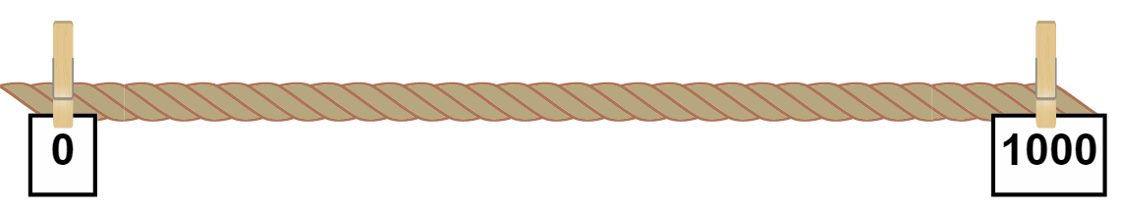
Images licensed under the Canva Content License Agreement.
- Ask students to turn and talk about where they would place 480 on the number line and share their reasoning with the class.
- Choose a student to peg the number card 480 on the number line and give reasons why they placed the card there. Provide opportunities for other students to increase the accuracy of the card’s location by adjusting its position up or down the number line. Ask:
- Where is 480 in relation to the zero and a thousand?
- Explain your thinking.
- Complete the same process and questioning for the number cards 999, 250 and 130 on the number line. Ask:
- Where is 999 on the line? Explain your thinking.
- Where is 250 on the line? Explain your thinking.
- Where is 130 on the line? Explain your thinking.
- Hang another rope or draw another line across the whiteboard and place the zero at one end and sixty at the other. Ask students to imagine all the numbers between zero and sixty on the number line.
- Ask students to turn and talk about where they would place 30 on the number line and share their reasoning with the class.
- Choose a student to peg the number card 30 on the number line and give reasons why they placed the card there. Provide opportunities for other students to increase the accuracy of the card’s location by adjusting its position up or down the number line. Ask:
- Where is 30 in relation to the zero and sixty?
- Explain your thinking.
- Complete the same process and questioning for the number cards 45 and 15 on the number line. Ask:
- Where is 45 on the line? Explain your thinking.
- Where is 15 on the line? Explain your thinking.
Figure 4 – Number line placement
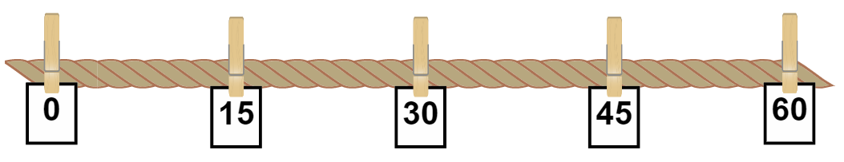
Images licensed under the Canva Content License Agreement.
Teaching point: The numbers are purposefully selected to show proportionality. Numbers which halve or quarter the line require students to visualise the whole and approximate proportions based on halves. For example, to find 45 a student could first identify half of 60 as 30 and half of 30 as 15, then use these proportions to guide their location of 45 on the number line.
- Provide small groups with a piece of string the same length as the number line and Appendix 3: Number cards 2. Ask students to place the 20 number card at one end of the line and the 60 number card at the other.
- Then ask students to think, discuss and place the number cards 40, 30 and 52 on the number line. Students display their number lines and go on a gallery walk to compare the placement of numbers with other groups. Invite students to explain their reasoning. If necessary, groups can adjustment to the placement of the card to provide a more accurate position. Ask:
- Where is 40 in relation to 20 and 60?
- What is the relationship between 30 and 40 on this number line?
- How did you know where to place 52?
Figure 5 – Number line placement
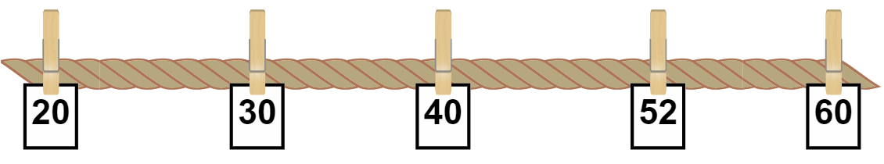
Images licensed under the Canva Content License Agreement.
Teaching point: Numbers 40, 30 and 52 were purposefully selected to show proportionality. 40 and 30 were chosen because they can be found by partitioning the number line using benchmark fractions of half and quarter. 40 identifies one half and 30 identifies a half of one half. 52 was selected as being close to 50, or ‘about halfway’. This task introduces estimation to students’ visual proportional thinking skills.
Variations
- Repeat the activity with numbers with various ranges of three- or four-digit numbers.
- Students identify the related fraction and write it underneath the number cards.
Further resources
- Stage 1 Finding numbers on a number line
- Stage 2 and 3 Finding numbers on a number line

Task 2: Colour in fractions
Core learning: Equivalent fractions express the same amount by using different sized fractional parts.

Materials
- Appendix 4: Spinner A
- Appendix 5: Spinner B
- Appendix 6: Fraction wall gameboard
- Writing materials

Instructions
This task is from D. Clarke and A. Roche, Engaging Maths: 25 Favourite Maths Lessons, (2014).
Part 1
- To understand how to play Part 1 of this game watch, Colour in fractions 1 (3:20) or follow the instructions below.
- Players take turns to spin their spinners or roll the dice. A fraction is made by using Appendix 4: Spinner A to find the numerator and Appendix 5: Spinner B to find the denominator. Students then colour the fraction shown or an equivalent fraction on Appendix 6: Fraction wall gameboard. For example, if a player spins a 2 and 4 or spins 2 and quarters, then they can colour in:
- $\frac{2}{4}$ of one line, or
- $\frac{4}{8}$ of one line, or
- $\frac{1}{4}$ of one line and $\frac{2}{8}$ of another, or
- any combination that is the same as $\frac{2}{4}$.
- For each roll or spin, the student should use a different colour pencil or marker. If a player is unable to use their turn, they ‘pass’.
- Players take turns to roll or spin and make fractions, marking them on their fraction wall. If the fraction rolled or its equivalence cannot be shaded, they miss a turn.
- Players are not allowed to break up a ‘brick’. To finish the game, the player must have had 18 turns or have filled their wall exactly.
- The first player who colours in their whole wall is the winner. This player supports the other player to fill their fraction wall, or the greatest number of wholes. If after 18 turns neither player colours in their whole wall, the player with the greatest number of wholes wins.
- After playing, discuss:
- If you played the game tomorrow, what would you do differently?
- If you were giving some hints to someone who had not played the game, what would you say to help them win?
Part 2
- To understand Part 2 watch, Colour in fractions 2 (1:43) or follow the instructions below.
- Reflect on Part 1 and have students look and compare their gameboards. Ask students to share something they noticed when they were playing.
- Share with students that Michelle recorded 2 halves ( $\frac{2}{2}$ ) as being equivalent in value to 2 quarters ( $\frac{2}{4}$ ) + 2 eighths ( $\frac{2}{8}$ ) + 3 twelfths ( $\frac{3}{12}$ ).
Figure 6 – Michelle's gameboard
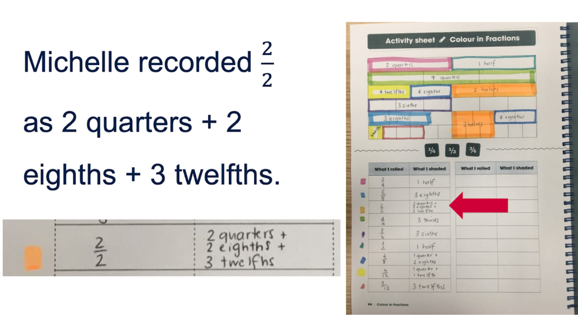
D. Clarke and A. Roche, Engaging Maths: 25 Favourite Maths Lessons, (2014).
- Provide opportunity for students to explore their own gameboard to investigate equivalent fractions or find as many ways as possible to make 2 halves.
- Ask students to share something interesting they discovered when exploring equivalent fractions.

Task 3: Make a whole game
Core learning: There are many different fractions equal to any given fraction and a fraction can be renamed using equivalence.

Materials
- Appendix 7: Game sheet
- Appendix 8: Numerator cards
- Appendix 9: Denominator cards

Instructions
This task is from Teaching Mathematics: Foundations to Middle Years, page 542, Make a Whole Game from Siemon et al. (2021).
- Place students into small groups or pairs and provide them with Appendix 7: Game sheet, Appendix 8: Numerator cards and Appendix 9: Denominator cards.
- Shuffle card sets and place the 2 piles face down in the middle.
- Students take turns to draw a card from each set, for example, if a 4 was drawn from the numerator pile and eighths was drawn from the denominator pile, then a border would be drawn around 4 eighths.
- If the move is not possible, players may still be able to use their turn if they identify an equivalent fraction.
- A player can choose to use a wildcard to indicate a denominator of their choice. The winner of the game is the student or team who completes the most rows, wholes.
- After playing, discuss:
- How many ways did you make one half on the game sheet? Can you identify more ways?
- What is the largest fraction you identified?
- What is the smallest fraction you identified?
- If you used a wild card, which denominator did you choose and why?
Figure 7 – Game play
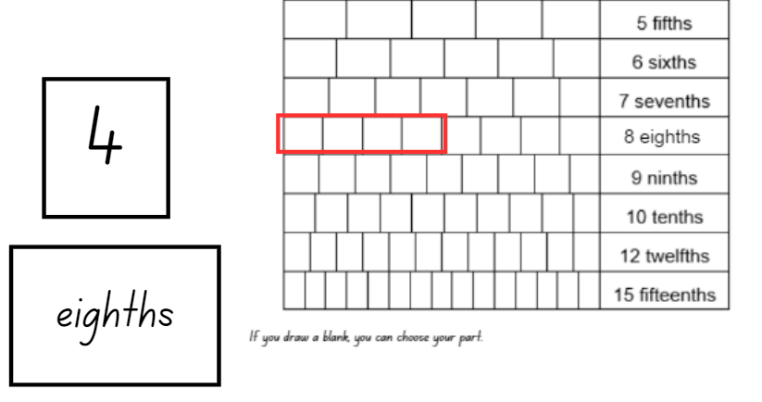
Images licensed under the Canva Content License Agreement.
Teaching point: Students need opportunities to identify linear representations of fractions to develop an appreciation of the relationship between parts and the whole arising from the process of division.

Task 4: Decimal numbers on a line
Core learning: Benchmark fractions can assist in dividing space on a number line.

Materials
- String or rope
- Appendix 10: Number cards
- Appendix 11: Decimals and fractions

Instructions
- Hang some rope or draw a line across the whiteboard. Place the number card 5 at one end and the number card 6 at the other end.
- Show students number card 5.6 and ask students to think about where they would place it. Provide time for students to turn and talk before sharing their suggestions and placing 5.6 on the number line. Ask:
- Why is 5.6 placed here? Explain.
- Where is 5.6 in relation to the 5 and 6?
Figure 8 – Number line placement
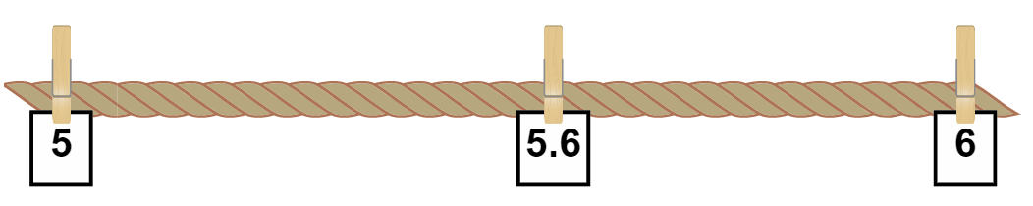
Images licensed under the Canva Content License Agreement.
- Complete the process and questioning again for number card 5.2.
- Display another number line and place the zero number card at one end and the 2 number card at the other end. Ask students to identify where to place the number cards, 0.5, 1 and 1.5 and give reasons for their placement.
- Once those number cards have been placed and the class is confident with the placement, ask students to place the number card 1.60. Ask:
- Why is 1.60 placed here? Explain.
- Where is 1.60 in relation to the 1 and 2?
- Where is 1.60 in relation to zero and two?
- Provide small groups with some string to make a number line and a collection of cards from Appendix 10: Number cards. Students work together to place the cards on the number line. Choose from Appendix 10: Number cards for the correct entry point for the group.
- Students display their number lines and go on a gallery walk. While looking at the different number lines, ask students to explain the placement of their cards, any challenges they faced and how they overcame them.
Teaching point: The numbers have been purposefully selected to show proportionality. Familiar benchmark numbers were chosen as well as a number close to the halfway point to build on visual proportional thinking skills.
Variations
- Students use Appendix 11: Decimals and fractions to order on a number line.

Task 5: Decimats
Core learning: Renaming numbers using place value understanding helps to sequence, order and compare numbers.

Materials
- Appendix 12: Spinner
- Paper
- Writing materials

Instructions
This task is from D. Clarke and A. Roche, Engaging Maths: 25 Favourite Maths Lessons, (2014).
- To understand how to make a decimat gameboard, watch Colour in decimats-part 1 (8.57).
- Provide time for students to make their gameboard.
Figure 9 – Example of gameboard
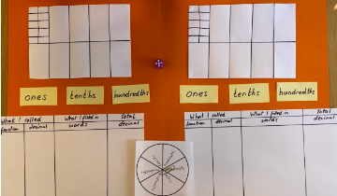
- To understand how to play, watch Colour in decimats-part 2 (14.01) or follow the instructions below.
- Students take turns to roll the die and spin Appendix 12: Spinner and fill in the gameboard, for example, if a 2 is rolled and ‘hundredths’ is spun, it is recorded as a fraction $\frac{2}{100}$and as a decimal, 0.02.
- The student then colours in the gameboard to reflect what they have rolled and spun and writes the amount in words, for example, two-hundredths.
- Finally, the student calculates the total and records it as a decimal.
- The winner is the first player to fill in one-whole, their entire gameboard or the player whose gameboard is closest to one-whole after 10 spins.
- If a player spins a fraction that will not fit into the available space, they miss their turn. A roll can be partitioned in equivalent ways, for example, I rolled three-tenths, but I only have two-tenths left empty, and some hundredths too.
- While students are playing, ask:
  - What was the difference between the final gameboard totals for each player? How could you prove it?
  - What are some similarities and differences between the 2 gameboards?
Teaching point: Renaming numbers in terms of their place value parts is an important tool that can be used to support estimation, rounding and more efficient forms of written and mental commutations. Also, renaming numbers is key to being able to work confidently and flexibly with number in future school mathematics.
- Once students have finished playing, provide opportunity for them to look at all the decimals they have recorded and order them from smallest to largest. Students could also compare which player recorded the largest and smallest decimal.
Variations
- Play the game including thousandths, Colour in decimats-part 3 (0.46).

Task 6: Rolling arrays
Core learning: Mental models of arrays are helpful for exploring multiplicative situations.

Materials
- Counters
- Six-sided dice

Instructions
- Build student understanding of an array by arranging counters into columns and rows.
- In small groups, students roll a six-sided die and collect the corresponding number of counters. They use the counters to create the top row, which indicates the number of columns in the array.
- Students roll the die a second time to indicate the number of rows and collect the corresponding number of counters. Guide students to place the counters in the first column, with the top counter of the column also being the first counter of the row.
Figure 10 – Making an array
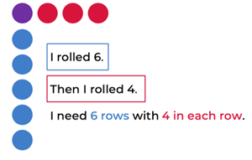
Images licensed under the Canva Content License Agreement.
- Encourage students to work out the product of the array by counting in multiples or applying known facts, for example, I do not know 6 fours, but I do know 3 fours are 12 and double 12 is 24 so the product is 24.

Teaching point: Observe the strategies students use to find the total number of counters needed. Visualising a collection in a particular arrangement and picturing the number of hidden dots should be a regular practice as it enables students to build strong mental images which they can use across a range of contexts.
- Ask students if it is possible to halve the array, and if so, how many counters would be in each half.
- Then have students consider if they can halve the half, which would represent quarters. If it is possible to create quarters, ask students to record the equivalent fractions in their workbook.
- Encourage students to look for other equivalent fractions within their arrays.
Variations
- Students build the complete array and move the counters to show the fraction of the collection.

Resources

Appendix 1: Number cards 1
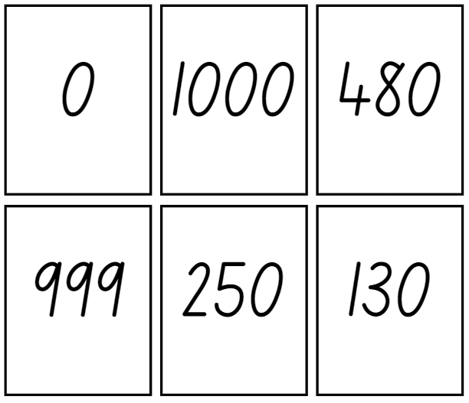
Images licensed under the Canva Content License Agreement.

Appendix 2: Number cards 2
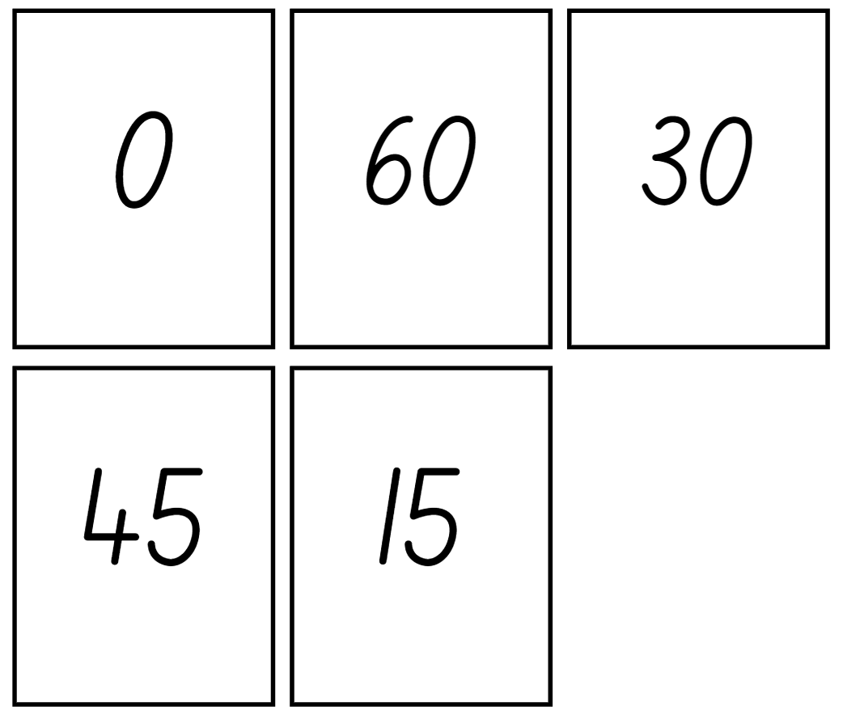
Images licensed under the Canva Content License Agreement.

Appendix 3: Number cards 3
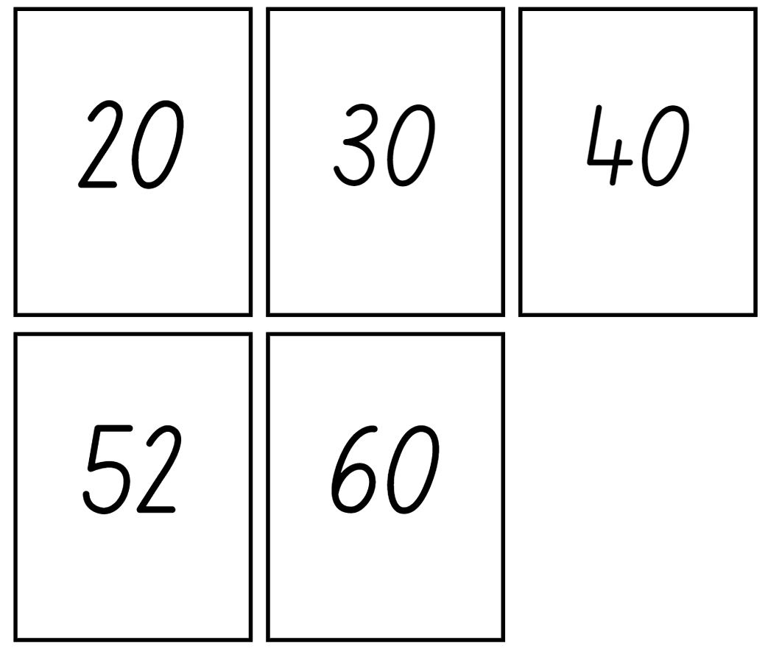
Images licensed under the Canva Content License Agreement.

Appendix 4: Spinner A
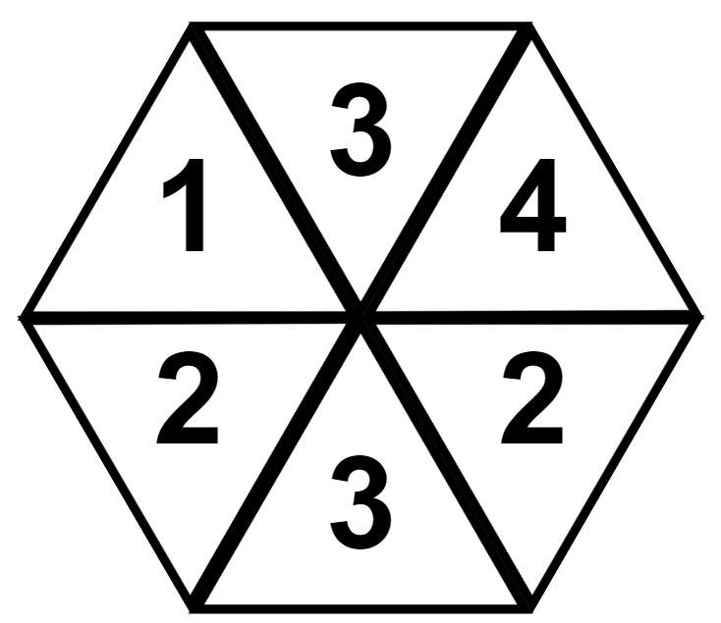
Adapted from D. Clarke and A. Roche, Engaging Maths: 25 Favourite Maths Lessons, (2014). Images licensed under the Canva Content License Agreement.

Appendix 5: Spinner B
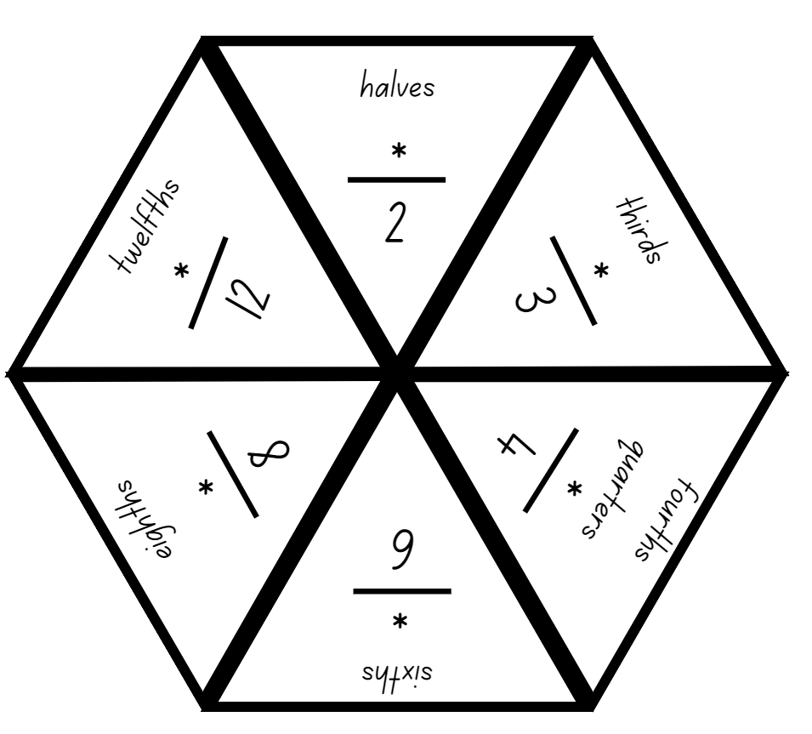
Adapted from D. Clarke and A. Roche, Engaging Maths: 25 Favourite Maths Lessons, (2014). Images licensed under the Canva Content License Agreement.

Appendix 6: Fraction wall gameboard
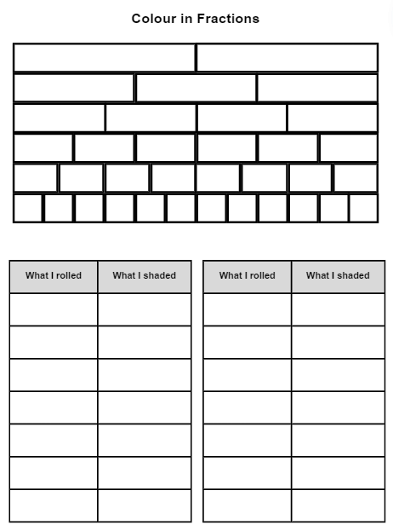
Task from D. Clarke and A. Roche, Engaging Maths: 25 Favourite Maths Lessons, (2014). Images licensed under the Canva Content License Agreement.

Appendix 7: Game sheet
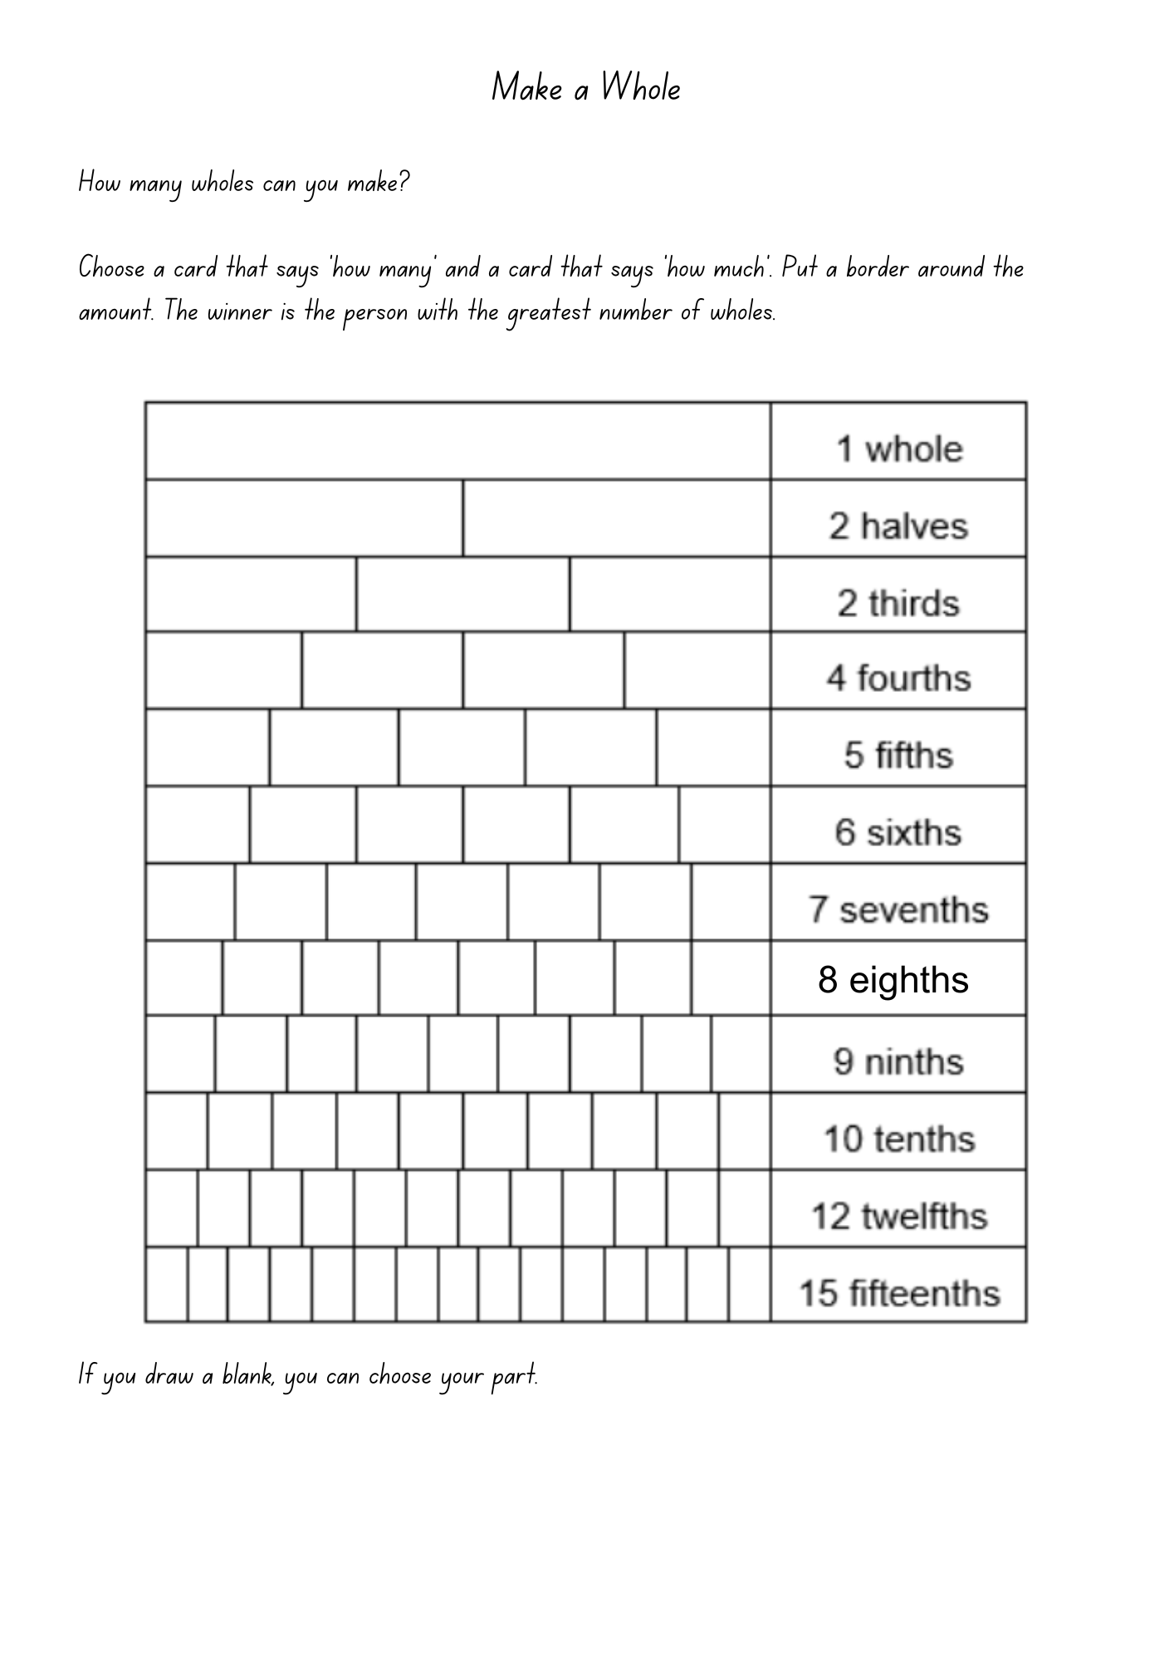
Task from Siemon et al. (2021). Images licensed under the Canva Content License Agreement.

Appendix 8: Numerator cards
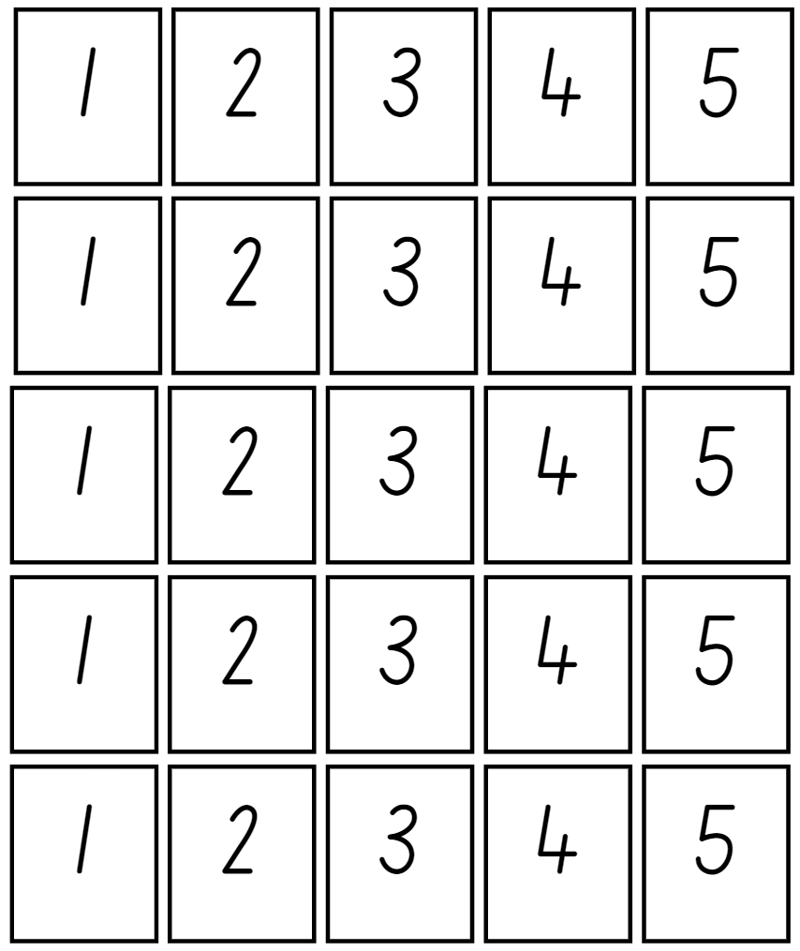
Images licensed under the Canva Content License Agreement.

Appendix 9: Denominator cards
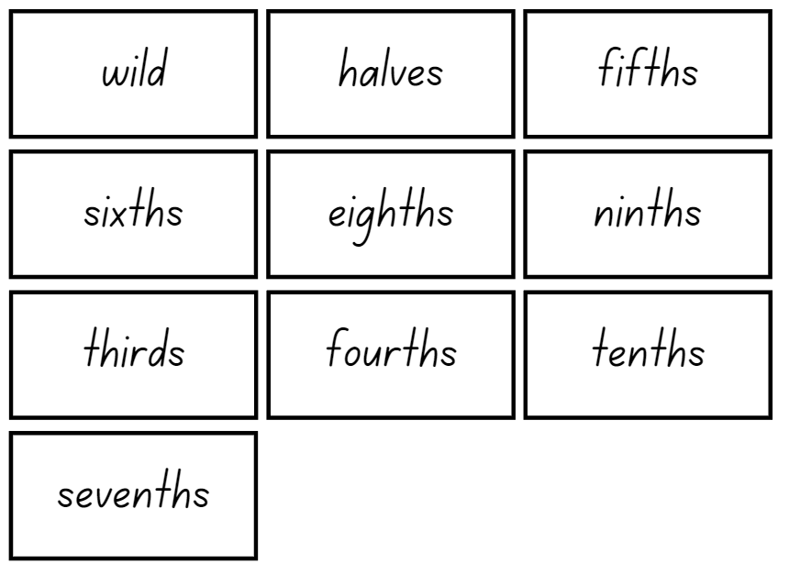Images licensed under the Canva Content License Agreement.

Appendix 10: Number cards
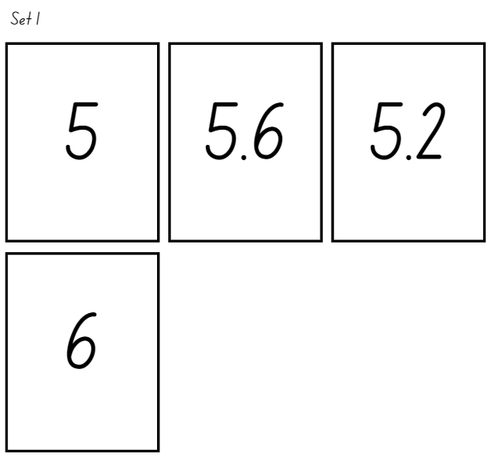
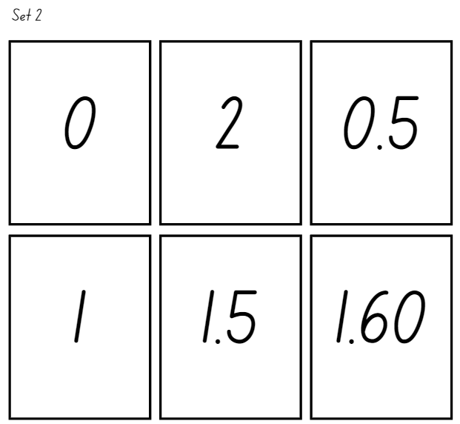
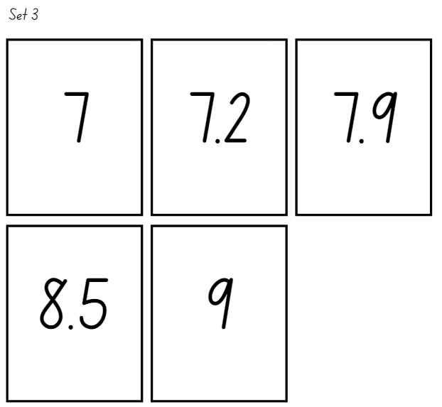
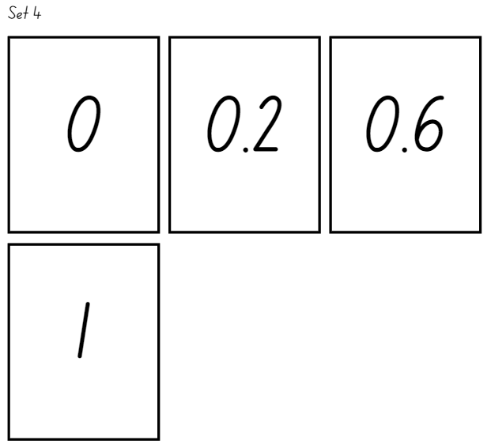
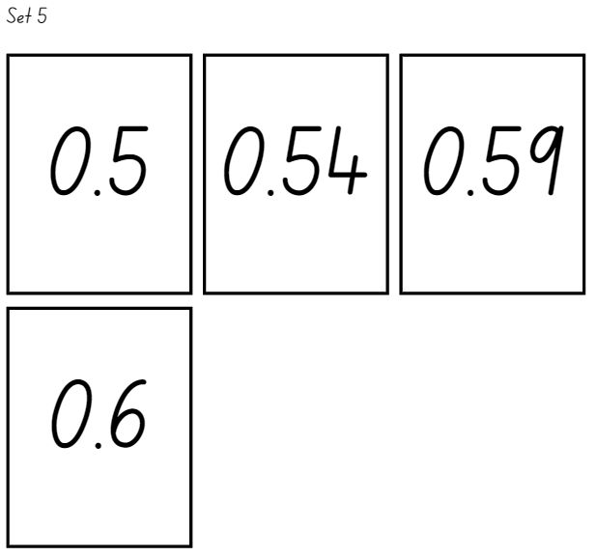
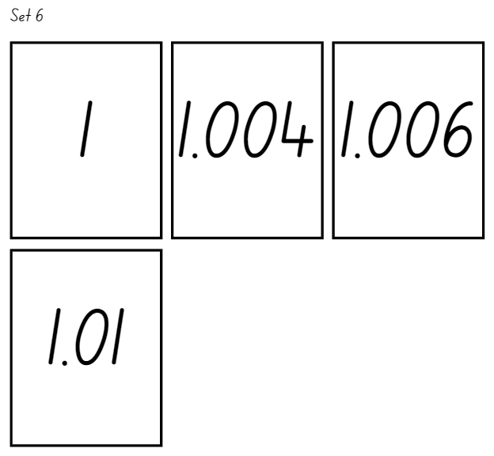
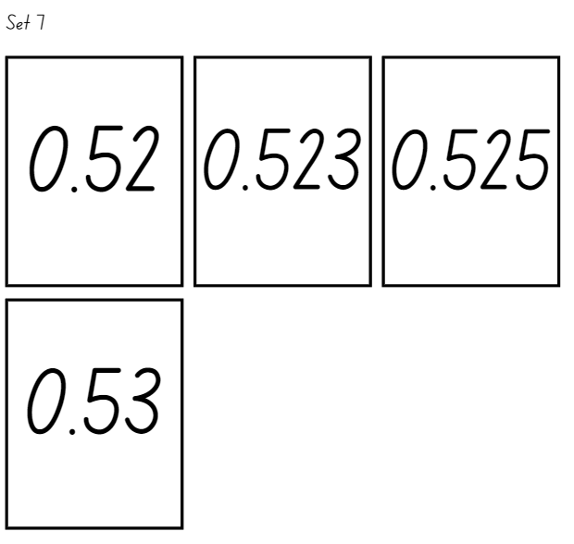
Images licensed under the Canva Content License Agreement.

Appendix 11: Decimals and fractions
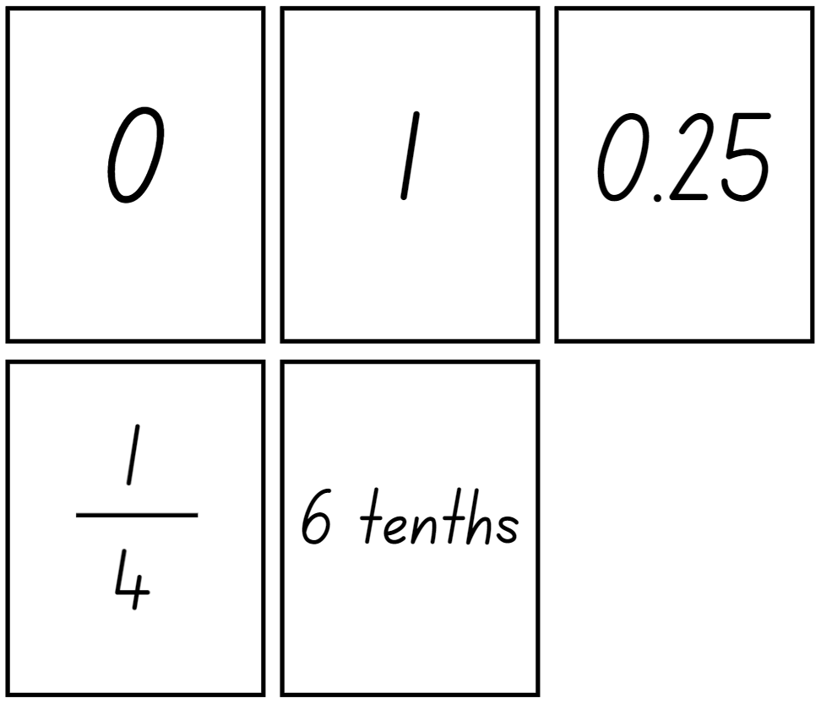
Images licensed under the Canva Content License Agreement.

Appendix 12: Spinner
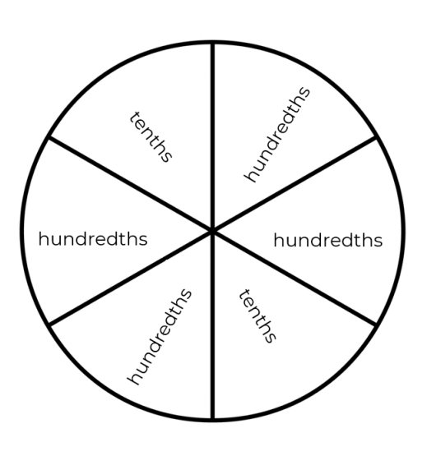
Adapted from Roche (2010).

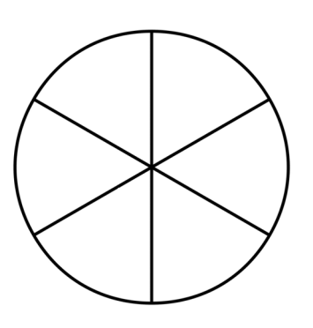Adapted from Roche (2010)

Information for teachers

References
Australian Government Department of Education (n.d.) ‘What you need to know: FRACTIONS’, Teaching resources, reSolve: Maths by Inquiry website, accessed 27 June 2023.
Australian Government Department of Education (n.d.) ‘What you need to know: PROPORTIONAL REASONING’, Teaching resources, reSolve: Maths by Inquiry website, accessed 27 June 2023.
Clarke D & Roche A (2014) Engaging Maths: 25 Favourite Maths Lessons. Australian Association of Mathematics Teachers.
Cordel B, and Mason R (2000) Proportional reasoning (Algebraic thinking series), Fresno, CA: Aims Education Foundation.
Siemon D, Warren E, Beswick K, Faragher R, Miller J, Horne M, Jazby D & Breed M (2021) Teaching Mathematics Foundations to Middle Years, 3rd edn, Oxford University Press, Victoria.
Bibliography
Australian Association of Mathematics Teachers (AAMT) Inc. (n.d.) Top Drawer Teachers: Resources for teachers of mathematics, accessed 5 July 2023.
Booker G, Bond D, Sparrow L & Swan P (2014) Teaching Primary Mathematics (5th Edition). Pearson.
Gould P (2013) ‘Australia’s next top fraction model’, Australian Primary Mathematics Classroom, 18(3):5–12, accessed 27 February 2023.
Hurst C, & Hurrell D (2014). Developing the big ideas of number. International Journal of Educational Studies in Mathematics, 1 (2), 1-18.
Lamon S (1999). Teaching Fractions and Ratios for Understanding – Essential content knowledge and instructional strategies for teachers. Mahwah, NJ: Lawrence Erlbaum and Assoc
Ontario Ministry of Education (2012) Paying Attention to Proportional Reasoning, K-12 Queen's Printer for Ontario, accessed 27 June 2023.
Roche A (2021). Decimats: Helping students to make sense of decimal place value. Australian Primary Mathematics Classroom, 26(4), 20–24.
Sparrow L, Booker G, Swan P, Bond D (2015). Teaching Primary Mathematics. Australia: Pearson Australia.
State of Victoria (Department of Education and Training) (2021) ‘Common Misunderstandings - Level 5 Proportional Reasoning’, Numeracy and maths, Department of Education and Training website, accessed 27 June 2023.
Steinthorsdottir O & Sriraman B (2009). Icelandic 5th-grade girls’ developmental trajectories in proportional reasoning. Mathematics Education Research Journal, 21(1), 6-30.
White G & Swan P (2013). Developing Mathematics with Pattern Blocks. Australia: R.I.C. Publications.

Alignment and support
Alignment to system priorities and/or needs: The literacy and numeracy five priorities.
Alignment to School Excellence Framework: Learning domain: Curriculum, Teaching domain: Effective classroom practice and Professional standards
Consulted with: NSW Mathematics Strategy professional learning and Curriculum Early Years Primary Learners-Mathematics teams
Reviewed by: Literacy and Numeracy
Created/last updated: February 2024
Anticipated resource review date: January 2025
Feedback: Complete the online form to provide any feedback.

