Part 6: building place value

About the resource
This resource the final section of a 6-part resource supporting number knowledge. Use this resource is conjunction with other guides to support a connected network of critical mathematical concepts, skills and understanding.
The resource has been developed in partnership with the NSW Mathematics Strategy Professional Learning team, Curriculum Early Years and Primary Learners, and Literacy and numeracy.
We use numbers to describe the world around us.
Understanding how numbers work is a critical part of developing deep, meaningful mathematical skills, understanding and confidence. This includes the use of flexible additive strategies which are a direct by-product of a student’s number sense.
Like most things in mathematics, talking about number is hard to do without referring to other aspects such as patterns, subitising, counting, fractions, the operations, measurement, and statistics. As such, this resource is best used in conjunction with other guides to support a connected network of critical mathematical concepts, skills and understanding.
- Part 1: Connecting number names, numerals and quantities
- Part 2: Building important relationships - part-part-whole
- Part 3: Building important relationships - more than, less than, equivalent in value to
- Part 4: Benchmarks of 5 and 10
- Part 5: Comparing, ordering, sequencing and estimating
- Part 6: Building place value (including renaming)

Syllabus
MAO-WM-01 develops understanding and fluency in mathematics through exploring and connecting mathematical concepts, choosing and applying mathematical techniques to solve problems, and communicating their thinking and reasoning coherently and clearly
MAE-RWN-01 demonstrates an understanding of how whole numbers indicate quantity
MAE-RWN-02 reads numerals and represents whole numbers to at least 20
MAE-CSQ-01 reasons about number relations to model addition and subtraction by combining and separating, and comparing collections
MAE-CSQ-02 represents the relations between the parts that form the whole, with numbers up to 10
MA1-RWN-01 applies an understanding of place value and the role of zero to read, write and order two- and three-digit numbers
MA1-RWN-02 reasons about representations of whole numbers to 1000, partitioning numbers to use and record quantity values
MA1-CSQ-01 uses number bonds and the relationship between addition and subtraction to solve problems involving partitioning
NSW Mathematics K-10 Syllabus (2022)

Progression
Number and place value NPV1-NPV5
Counting processes CPr1-CPr7
Additive strategies AdS1-AdS5
National Numeracy Learning Progression (NNLP) Version 3

How to use the resource
Teachers can use assessment information to make decisions about when and how they use this resource as they design teaching and learning sequences to meet the learning needs of their students.
The tasks and information in the resource includes explicit teaching, high expectations, effective feedback and assessment and can be embedded in the teaching and learning cycle.
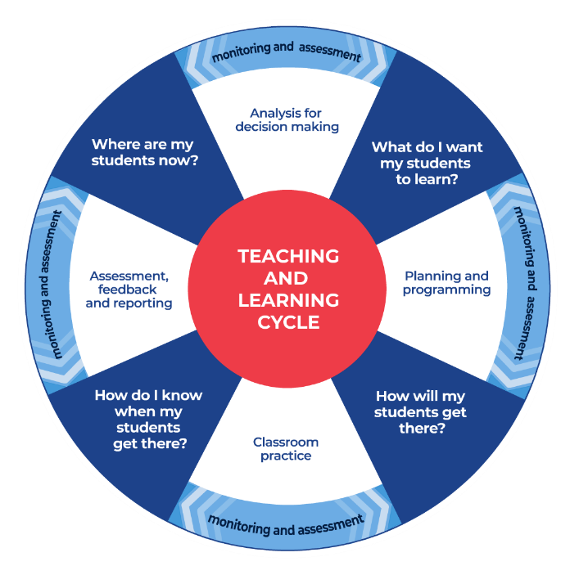
Figure 1: Teaching and learning cycle
- Where are my students now? Teacher uses a range of assessment information to determine what students know and can do, including their interests, learning strengths and needs.
- What do I want my students to learn? Teachers use the information gathered along with the syllabus and NNLP to determine the next steps for learning. Teachers might also like to look at the ‘what’s some of the maths’ and ‘key generalisations’ to synthesise the information they have gathered into the next step/s for learning.
- How will my students get there? Teachers can then use the task overview information (‘What does it promote?’ and ‘What other tasks can I make connections to?’) to find tasks that meet the learning needs of students. Teachers then make decisions about what instructional practices and lesson structures to use to best support student learning. Further support with What works best in practice is available.
- How do I know when my students get there? Teachers can use the section ‘Some observable behaviours you may look for/notice’ that have been articulated for each task as a springboard for what to look for. These ideas can be used to co-construct success criteria and modified to suit the learning needs, abilities and interests of students. Referring back to the syllabus and the NNLP are also helpful in determining student learning progress as well as monitoring student thinking during the task. The information gained will inform ‘where are my students now’ and ‘what do I want them to learn’ as part of the iterative nature of the teaching and learning cycle.

Overview of tasks
Task name | What does it promote? | What other tasks can I make connections to? | What materials will I need? | Possible group size
Capture ten |  | Two handfuls  Number busting 26 | - Playing cards  - Writing materials  - Appendix 1: Gameboard | Whole class or small group
Quantifying collections paddlepop sticks | There are patterns in the way we count – each time we collect 10 things, we regroup and rename them. For example, 10 ones is regrouped and renamed as 1 ten. | One is a Snail (reSolve) | - Wooden sticks  - Paper cups  - Rubber bands  - Coloured paper  - Appendix 2: Numeral cards 1-23 | Whole class or small group
Minute to win it | Collections can be quantified in many different ways. You can count all by ones, you can use familiar structures to help you count in multiples (like tens or fives or twos, for example), and you can use a combination of strategies to answer the question, “How many?” | Partitioning numbers with efficient strategies (ABC Education) | - Collection of counters  - Dice | Whole class or small group
Counting with understanding - up to 100 | Explores how the use of a familiar structure such as a ten-frame can help us quantify a collection | Counting large collections (reSolve) | - Collection of objects  - Writing materials | Whole class or small group
101 and you’re out | The place a digit is placed in determines its value. | Race to zero  Which one would you do in your head? | - Dice  - Appendix 3: Numeral cards 1-6  - Writing materials | Whole class or small group
Hit it! | A game of strategy using knowledge of positional place value. This task sees students use their knowledge of how the value of a digit depends on its position within a number. | Mastermind  Place Value Number Sorting (ReSolve) | - Writing materials  - 0-9 dice | Whole class or small group
Our place value system (ABC Education) | Our place value system is rich in patterns including the pattern of ones, tens and hundreds inside each place value period. | Mastermind  Partitioning numbers with efficient strategies (ABC Education) | - Place value chart  - Number cards | Whole class or small group

Capture 10

Key generalisations / what’s (some of) the mathematics?
- Using the ‘make ten’ (also sometimes called ‘bridging to ten’ or ‘using landmark numbers’) helps me to solve problems flexibly for example, when I see 6 and 9, I can adjust the numbers to 5 and 10 which I know is 15.
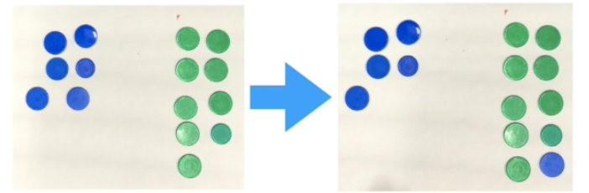
Figure 2: 15 counters
- Different representations of quantities can help us see different relationships between numbers.
- There are many ways of combining quantities to make the same total for example, to make 14 I can combine 9 and 5 or 8 and 6 or double 7.
- Mathematicians can think about quantities in different ways.

Some observable behaviours you may look for/notice
- Describes teen numbers as 1 ten and some more.
- Partitions collections in a variety of ways using knowledge of number bonds to 10 and 20, doubling, halving, place value, and so on.
- Thinks flexibly about numbers by explaining how collections can be partitioned and regrouped in different ways to determine how many.
- Partitions quantities to reach landmark or benchmark numbers (typically multiples of five and ten)
- Explains/uses knowledge collections can be arranged in different ways but still represent the same quantity. For example, “15 can be 10 and 5. It can also be 9 and 6. That means 10 and 5 is equivalent in value to 6 and 9. We could record that in an equation (number sentence) like this: 10 + 5 = 9 + 6”.

Materials
- Playing cards (Ace-10)
- Writing materials
- Appendix 1: Gameboard

Instructions
View Capture 10 to learn how to play
- Shuffle your cards (using Ace - 10).
- Turn over 2 cards.
- Work out: Can you capture a 10? If you can, record your cards in the appropriate column before you put them at the bottom of the pile. Then, have another turn.
- If you cannot capture a 10, put your cards at the bottom of the pile and take 2 more cards.

Quantifying collections paddle pop sticks 1

Key generalisations / what’s (some of) the mathematics?
- There are patterns in our number system and in the way we count.
- In our number system, every time we collect 10 of something, we regroup and rename it. This is a kind of pattern. For example, 10 ones is renamed as 1 ten; 10 hundreds is renamed as 1 hundred.
- There’s a pattern in the number words we say as they always follow a particular sequence.
- There’s a shrinking pattern when we count backwards as each number word, we say is one less than the number before. This works whether we are counting backwards by ones or by tens, fives, and so on.
- Counting forward is type of growing pattern.
- We learn to count things so we can have a range of strategies (ways of thinking) we can use to answer the question ‘how many?’.
One of the most important skills we can support students to develop to support their place value understanding is the capacity to confidently rename numbers in a range of ways. For example, we could rename 123 as 1 hundred, 2 tens and 3 ones. We could also rename it as 12 tens and 3 ones; 11 tens and 13 ones; 1 hundred, 1 ten and 13 ones, and so on.

Some observable behaviours you may look for/notice
- Connects counting words with the items counted for example, for each number I say I put one more paddle pop stick in each cup.
- Describes teen numbers as 1 ten and some more.
- Explains the suffix ‘teen’ means ‘ten more than’.
- Explains every time there is 10 of something we need to regroup and rename for example, when I have 10 ones I re-group them to make 1 ten.
- Describes when counting backwards we need to ungroup tens and rename them as ones when we cross the decade.
Materials
- Wooden sticks
- 20 paper cups
- Rubber bands
- Paper (2 colours)
- Appendix 2: Numeral cards 1-23

Instructions
- View this number talk Quantifying Collections: Ice cream sticks with students.
- Try repeating the experience with materials, quantifying different amounts of paddle pop sticks each time.

Key generalisations / what’s (some of) the mathematics?
- Collections can be quantified in many ways:
  - you can count everything by ones;
  - you can use familiar structures to help you count in multiples (like tens or fives or twos, for example);
  - you can use a combination of strategies to answer the question “How many?”
- Dice patterns, ten-frames, dominos and finger patterns are examples of familiar structures that can help us quantify collections.
- Different people see and think about numbers and problems in different ways.
- Mathematicians use a range of representations to communicate ideas.
Teaching point: Teachers may like to prompt students to use their understanding of place value by asking students to:
- estimate how many tens could be in a collection (then arrange the counters into an imagined structure of ten-frames or 2 fives - in dice patterns - to check)
- visualise what the collection would look if you had 1 ten more. For example, “we have 4 tens and 4 more, what would it look like with 1 ten more? What about another ten? How could you arrange your imagined collection so someone else could see how many there are by looking and thinking? Describe the mental picture you’ve made to a classmate and ask them to draw/make it”
- visualise how your collection would look like if you had 1 ten less? (Repeat the above sequence).

Some observable behaviours you may look for/notice
- Uses structure to organise the quantity by purposefully grouping resources to determine and/or prove how many. For example, organises counters in twos, fives like a dice pattern or tens in a ten frame.
- Counts on from a number other than 1 when counting is disrupted for example, I can see two tens which is 20 and I can count on to see how many.
- Counts in composite units to determine how many. For example, I can count by twos, fives or tens to determine how many.
- Considers other ways of organising collections to improve the efficiency of working out the total
- Identifies different ways collections can be structured.
- Understands each word said when counting by twos, fives or tens represents a quantity
- Compares collections to determine who has the most or least or find someone with the same size collection.
- Explains the suffix ‘-ty’ means ten and can be used to rename collections for example, 4 tens can be renamed as 40.

Materials
- A large collection of counters per team
- One dot dice per team

Minute to win it

Instructions
View the video Minute to win it.
- Minute to win it can be played as a whole class or with small groups. Teams can be made up of 2 players, one rolling the die and the other collecting the chosen materials for example, counters.
- Set a timer for one minute.
- Once the time commences, teams work together rolling the die and collecting materials. This continues until the timer signals time is up.
- Teams then organise their collection to prove how many they have just by looking and thinking.
- Teams can view the familiar structures others have used to help quantify their collection.
- Teams then explore the different ways their collection can be structured.
Variations
- Different dice can be used to increase the size of the collection for example, ten, twelve or twenty-sided dice
- By using paddle pop sticks students can explore using different structures such as tally marks or bundles or 10.

Counting with understanding – up to 100

Key generalisations / what’s (some of) the mathematics?
- Mathematicians use a system to keep track of items that have been quantified and those yet to be quantified.
- Using familiar structures helps us quantify a collection by helping us keep track of what’s been counting and allowing us to use things we know to solve what we don’t know yet. For example, if we use groups of ten, we can use what we know about renaming to know 8 tens and 2 more is a total of 82 things.
- We can draw, imagine and use structures like ten-frames to help us organise quantities.
- Using structures can help us compare the size of collections.
- Mathematicians use a range of representations to support conclusions and communicate ideas.
Teaching point: To promote place value understanding, students should be encouraged to describe teen numbers such as 14 as 1 ten and 4 ones, flexibly naming numbers in different ways.

Some observable behaviours you may look for/notice
- Suggests a reasonable estimate
- Explains every time there is ten of something we regroup and rename. For example, when I have four ten frames filled, I have 4 tens which I can rename as 40.
- Purposefully organises objects using familiar structures and patterns to determine and/or prove how many there in a collection.
- Recalls number word sequences up to 100.
- Understands each word said when counting in tens represents a collection of ten.

Materials
- A collection of objects
- Writing materials

Instructions
View Counting with understanding up to 100 with students.
- Find a cup or container and find some collections you can quantify.
- Can you find 2 different collections of objects your cup or container holds the same amount of?

101 and you’re out

Key generalisations / what’s (some of) the mathematics?
- The position of a digit in a number determines its value. For example, in the number 46 the ‘4’ has a value of 4 tens but in the number 24 the ‘4’ has a value of 4 ones.
- In our number system, every time we collect 10 of something, we regroup and rename it. For example, 10 ones is renamed as 1 ten; 10 hundreds is renamed as 1 hundred.
- Mathematicians can use their mathematical reasoning to strategise to improve their chances of winning a game.

Some observable behaviours you may look for/notice
- Explains the suffix ‘-ty’ means ten and can be used to rename collections for example 4 tens can be renamed as 40.
- Analyses the game board and makes strategic decisions about where to place quantities in order to increase their chance of winning.
- Explains why numerals are placed on the game board based on their place value and describes why it is the best place for them (for example, if I have 84 and I roll a 3, I can’t place in in the tens place because then I will have too many so I'll put it in the ones place).
- Flexibly partitions and regroups quantities to determine the total answering the question ‘how many?’
- Compares quantities to determine who has the most or least and who is closest to 101.
- Describes what rolls would be best to stay closest to the total.

Materials
- Dice or Appendix 3: Numeral cards 1-6
- Writing materials

Instructions
View 101 and you’re out to learn how to play.
- Make a game board by drawing a 6 x 4 table.
- Label the first column as ‘tens’, the second column as ‘ones’, the third column as number and forth column as total.
- Each time you roll the die, you have to decide whether the number is representing ‘ones’ or ‘tens’. For example, if I roll a 3, I could use it as 3 ones (3) or 3 tens (which we rename as 30). If you choose to use your 3 as 3 ones, record the number in the ones column. If you choose to use your 3 as 3 tens (30), record your number in the left column.
- Continue to play for 6 rolls.
- Once you write a number, you cannot change it.
- The winner is the player with the sum closest to 100 without going over!
- Draw up 4 new game boards. Using the same numbers, you rolled, use the game boards to get closer to 100 than you did in your first game.

Variations
- Increase the challenge by using numbers from 0-9. You can also use playing cards, make cards or make a spinner at home.
- Roll the die 4 times and only use four lines on the game board.

Hit it!

Key generalisations / what’s (some of) the mathematics?
- The position of a digit determines its value. For example, in the number 465 the ‘4’ has a value of 4 hundreds and in the number 234 the ‘4’ has a value of 4 ones.
- When we round numbers to the nearest decade or hundred (sometimes referred to as landmark numbers), we have two choices - we can go up in value, or we can go down in value.
- We can use our place value knowledge to determine which landmark number is closest to any given number, for example, to round 342 to the nearest 10, I can think ‘is 342 closest to 34 tens or 35 tens?’
- We can use a range of flexible strategies to determine the difference between two numbers.
- Mathematicians explain their reasoning in a way others can understand.
Teaching point: Whether we move up or down when rounding is determined by which landmark is closest in value. This is why having strong, transferable knowledge in relationships to other whole numbers is a critical focus of early years learning.
When a number is a multiple of 5, we round up to the nearest decade or hundred as 5 marks the midpoint between two decades.

Some observable behaviours you may look for/notice
- Connects numerals and number names in the range of 0-1000.
- Uses digits strategically to get closest to the target number.
- Identifies the value of each digit.
- Strategically considers where a digit is best placed to create a number closest to the target
- Rounds numbers to the nearest ten or hundred to determine how close they are to the target number.
- Uses flexible strategies such as building to the nearest ten or hundred, fact families/bonds, how many more, how many less, doubles.
- Uses counting to determine how close they are to the target number.
- Recognises we can use addition to solve subtraction questions as they are inverse operations.

Materials
- 2 markers
- Paper
- 0-9 dice

Instructions
View Hit it to learn how to play.
- Draw up your game board (in this game, we were working with three-digit numbers, but you can use larger or smaller numbers if you like).
- Select a multiple of hundred between 100 and 900 to be your target number.
- The person with the most letters in their surname goes first.
- Take it in turns to roll the die and use the digit somewhere in your number.
- Once the digits are full, players read their number and determine how far they are away from the target number. The player who is closest to the target number wins a point.
- The winner with the most points after 3 rounds is declared the winner.

Our place value system

Key generalisations / what’s (some of) the mathematics?
- We say the word “and” after we read the number in the hundreds place of any period.
- There are a few patterns in place value, for example, in each period, there is a ‘ones’, ‘tens’ and ‘hundreds’ place.
- We almost always say the word ‘thousand’ when we read 4-, 5- and 6- digit numbers.

Some observable behaviours you may look for/notice
- Describes the different place value parts when numerals are placed in different positions on the place value chart.
- Experiments with the place value of the digits provided to make, name and record four-, five- and six-digit numbers. Identifying the largest possible number and the smallest possible number.
- Compares and orders the numerals made and describes their place value parts.
- Uses the term period to describe each group of three places on the place value chart for example the ones period includes ones, tens and hundreds, the thousands period has the same unit of repeat and so does the millions period.
- Describes the largest possible number created and explains why it is the largest possible number.

Materials
- Place value chart
- Number cards

Instructions
View the video ‘Our place value system’.

Appendix 1: Capture 10 gameboard

Appendix 2: Numeral cards 1-23
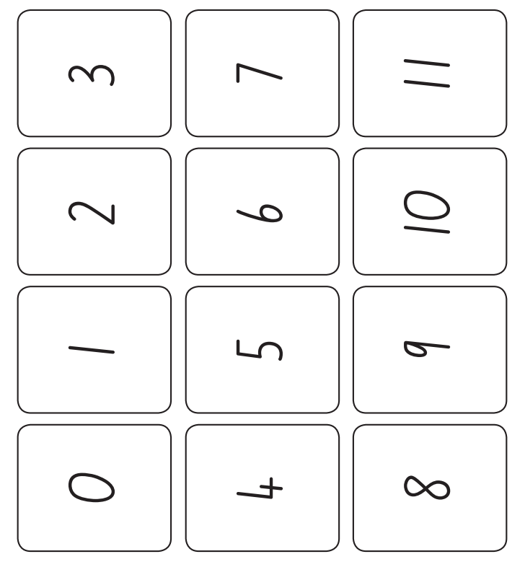

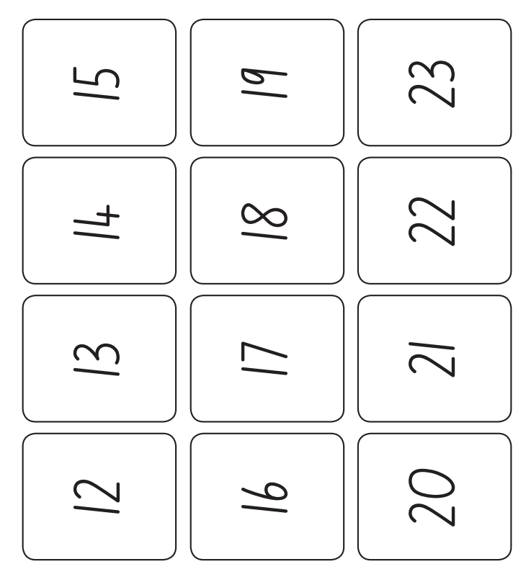

Appendix 3: Numeral cards 1-6
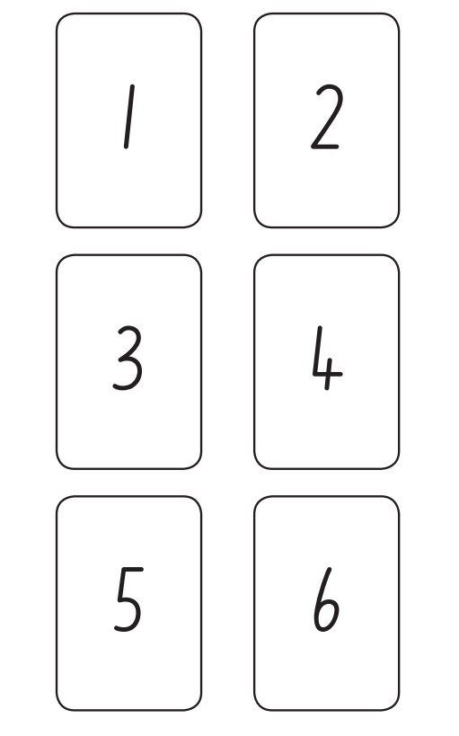

Reference list
Mathematics K–10 Syllabus © NSW Education Standards Authority (NESA) for and on behalf of the Crown in right of the State of New South Wales, 2022.
National Numeracy Learning Progression © Australian Curriculum, Assessment and Reporting Authority (ACARA) 2010 to present, unless otherwise indicated. This material was downloaded from the Australian Curriculum website (National Literacy Learning Progression) (accessed 6 November 2023) and was not modified.
Australian Broadcasting Corporation Education (2021) ‘Maths Years 3–4 with Ms Kirszman: Partitioning numbers using efficient strategies’, Australian Broadcasting Corporation website, accessed 20 November 2023.
Australian Broadcasting Corporation Education (2021) ‘Maths Years 3–4 with Ms Kirszman: Our Place Value System’, Australian Broadcasting Corporation website, accessed 20 November 2023.
Australian Government Department of Education (2020) ‘Counting large collections’, Teaching resources, reSolve: Maths by Inquiry website, accessed 20 November 2023.
Australian Government Department of Education (2020) ‘One is a Snail’, Teaching resources, reSolve: Maths by Inquiry website, accessed 20 November 2023.
Australian Government Department of Education (2020) ‘Place Value Number Sorting’, Teaching resources, reSolve: Maths by Inquiry website, accessed 20 November 2023.
State of New South Wales (Department of Education) (2023) ‘101 and you’re out’, Mathematics K-6 resources, NSW Department of Education website, accessed 20 November 2023.
State of New South Wales (Department of Education) (2023) ‘Capture 10’, Mathematics K-6 resources, NSW Department of Education website, accessed 20 November 2023.
State of New South Wales (Department of Education) (2023) ‘Counting with understanding up to 100’, Mathematics K-6 resources, NSW Department of Education website, accessed 20 November 2023.
State of New South Wales (Department of Education) (2023) ‘Hit it’, Mathematics K-6 resources, NSW Department of Education website, accessed 20 November 2023.
State of New South Wales (Department of Education) (2023) ‘Mastermind’, Mathematics K-6 resources, NSW Department of Education website, accessed 20 November 2023.
State of New South Wales (Department of Education) (2023) ‘Minute to win it’, Mathematics K-6 resources, NSW Department of Education website, accessed 20 November 2023.
State of New South Wales (Department of Education) (2023) ‘Number busting 26’, Mathematics K-6 resources, NSW Department of Education website, accessed 20 November 2023.
State of New South Wales (Department of Education) (2023) ‘Quantifying Collections: Ice cream sticks’, Mathematics K-6 resources, NSW Department of Education website, accessed 20 November 2023.
State of New South Wales (Department of Education) (2023) ‘Race to zero’, Mathematics K-6 resources, NSW Department of Education website, accessed 20 November 2023.
State of New South Wales (Department of Education) (2023) ‘Two handfuls’, Mathematics K-6 resources, NSW Department of Education website, accessed 20 November 2023.
State of New South Wales (Department of Education) (2023) ‘Which one would you do in your head?’, Mathematics K-6 resources, NSW Department of Education website, accessed 20 November 2023.

Copyright
Section 113P Notice
Texts, Artistic Works and Broadcast Notice
Some of this material has been copied and communicated to you in accordance with the statutory licence in section 113P of the Copyright Act. Any further reproduction or communication of this material by you may be the subject of copyright protection under the Act. Do not remove this notice.

Evidence base
Sparrow, L., Booker, G., Swan, P., Bond, D. (2015). Teaching Primary Mathematics. Australia: Pearson Australia.
Brady, K., Faragher, R., Clark, J., Beswick, K., Warren, E., Siemon, D. (2015). Teaching Mathematics: Foundations to Middle Years. Australia: Oxford University Press.
Alignment to system priorities and/or needs: The literacy and numeracy five priorities.
Alignment to School Excellence Framework: Learning domain: Curriculum, Teaching domain: Effective classroom practice and Professional standards
Consulted with: NSW Mathematics Strategy professional learning and Curriculum Early Years Primary Learners-Mathematics teams
Reviewed by: Literacy and Numeracy
Created/last updated: January 2024
Anticipated resource review date: January 2025
Feedback: Complete the online form to provide any feedback.

