Part 1: connecting number names, numerals and quantities

About the resource
This resource the first section of a 6-part resource supporting number knowledge. Use this resource is conjunction with other guides to support a connected network of critical mathematical concepts, skills and understanding.
The resource has been developed in partnership with the NSW Mathematics Strategy Professional Learning team, Curriculum Early Years and Primary Learners, and Literacy and Numeracy.
We use numbers to describe the world around us.
Understanding how numbers work is a critical part of developing deep, meaningful mathematical skills, understanding and confidence. This includes the use of flexible additive strategies which are a direct by-product of a student’s number sense.
Like most things in mathematics, talking about number is hard to do without referring to other aspects such as patterns, subitising, counting, fractions, the operations, measurement, and statistics. As such, this resource is best used in conjunction with other guides to support a connected network of critical mathematical concepts, skills and understanding.
- Part 1: Connecting number names, numerals and quantities
- Part 2: Building relationships - part-part-whole
- Part 3: Building relationships - more than, less than, equivalent in value to
- Part 4: Benchmarks of 5 and 10
- Part 5: Comparing, ordering, sequencing and estimating
- Part 6: Building place value (including renaming)

Syllabus
MAO-WM-01 develops understanding and fluency in mathematics through exploring and connecting mathematical concepts, choosing and applying mathematical techniques to solve problems, and communicating their thinking and reasoning coherently and clearly
MAE-RWN-01 demonstrates an understanding of how whole numbers indicate quantity
MAE-RWN-02 reads numerals and represents whole numbers to at least 20
MAE-CSQ-01 reasons about number relations to model addition and subtraction by combining and separating, and comparing collections
MAE-CSQ-02 represents the relations between the parts that form the whole, with numbers up to 10
MA1-RWN-01 applies an understanding of place value and the role of zero to read, write and order two- and three-digit numbers
MA1-RWN-02 reasons about representations of whole numbers to 1000, partitioning numbers to use and record quantity values
MA1-CSQ-01 uses number bonds and the relationship between addition and subtraction to solve problems involving partitioning
NSW Mathematics K-10 Syllabus (2022)

Progression
Number and place value NPV1-NPV4
Counting processes CPr1-CPr5
Additive strategies AdS1-AdS2
Number patterns and algebraic thinking NPA1-NPA2
National Numeracy Learning Progression (NNLP) Version 3

How to use the resource
Teachers can use assessment information to make decisions about when and how they use this resource as they design teaching and learning sequences to meet the learning needs of their students.
The tasks and information in the resource includes explicit teaching, high expectations, effective feedback and assessment and can be embedded in the teaching and learning cycle.
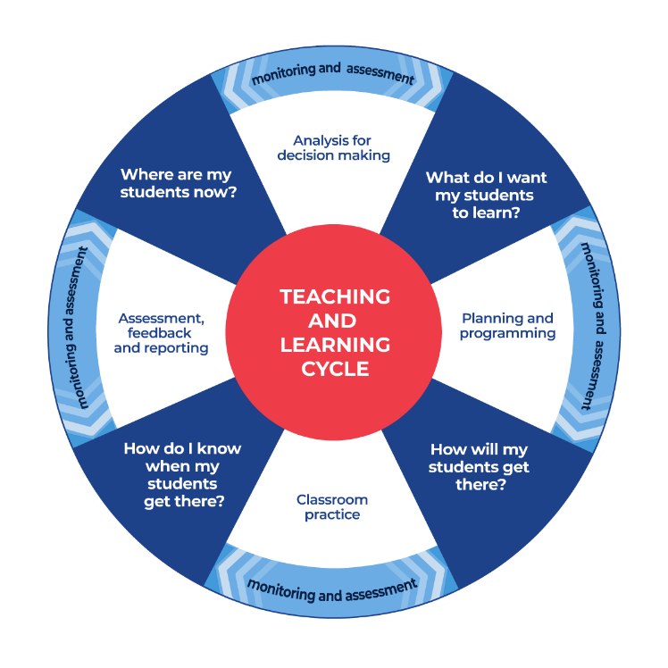
Figure 1: Teaching and learning cycle
- Where are my students now? Teacher uses a range of assessment information to determine what students know and can do, including their interests, learning strengths and needs.
- What do I want my students to learn? Teachers use the information gathered along with the syllabus and NNLP to determine the next steps for learning. Teachers might also like to look at the ‘what’s some of the maths’ and ‘key generalisations’ to synthesise the information that they’ve gathered into the next step/s for learning.
- How will my students get there? Teachers can then use the task overview information (‘What does it promote?’ and ‘What other tasks can I make connections to?’) to find tasks that meet the learning needs of students. Teachers then make decisions about what instructional practices and lesson structures to use in order to best support student learning. Further support with What works best in practice is available.
- How do I know when my students get there? Teachers can use the section ‘Some observable behaviours you may look for/notice’ that have been articulated for each task as a springboard for what to look for. These ideas can be used to co-construct success criteria and modified to suit the learning needs, abilities and interests of students. Referring back to the syllabus and the NNLP are also helpful in determining student learning progress as well as monitoring student thinking during the task. The information gained will inform ‘where are my students now’ and ‘what do I want them to learn’ as part of the iterative nature of the teaching and learning cycle.

Task name | What does it promote? | What other tasks can I make connections to? | What materials will I need? | Possible group size
Racing to write | Recognising ‘how many’ whilst also connecting number names and symbols. | Writing digits (NRICH)  Matching numbers (NRICH) | - Appendix 1: Race to write 1-10  - Appendix 2: Race to write 11-20  - Appendix 3: Ten-frames | 2 players
Take a numeral | Linking numbers to objects, numbers, actions, ideas and symbols. | Matching numbers (NRICH) | - 2 sets of Appendix 6: Numerals cards  - Six-sided dice | 2 teams of two
Concentration | Mathematicians understand that quantities can be represented in different ways. They can use ten-frames to determine ‘how many’ and connect the quantity with the corresponding number name and symbol. | Pinch a ten  Matching numbers (NRICH) | - Appendix 8: Numeral cards 1-20  - Appendix 4: Mini twenty frames  - Appendix 7: Teen and ty cards | 2 teams of two
Teen number puzzle | Visual representations of quantities can support us to see the different properties of numbers. | Decoding ‘ty’ numbers (NZ maths)  Decoding ‘teen’ numbers (NZ maths) | - Appendix 5: Teen number puzzle cards | Small group
Building towers | Making, counting and comparing collections to help build an understanding of how numbers work. | Tea Party (reSolve)  Representing numbers (NRICH) | - Building blocks  - Dice  - Appendix 6: Numeral cards | Small group
Dotty 6 | Building confidence with spatial patterns and early additive strategies. | 6 is…  6v6 dot talk | - Paper  - Appendix 6: Numeral cards  - Dice | 2 players
Go fish teen/ty | Bundling and unbundling of paddle pop sticks help us explore place value ideas and learn how we can regroup and rename as collections of ten. | Number busting | - Appendix 7: Teen and ty cards | Small group

Racing to write

Key generalisations / what’s (some of) the mathematics?
- Each unique quantity is represented by a unique numeral (symbol) and number word
- Counting words are said in the same order every time for example, 3 is always after 2 and before 4 when counting by ones. This is called the stable-order principle. The counting words are also a type of mathematical pattern
- When we see or read a number, we can imagine the quantity it represents in many different ways
- Knowing how to record numerals accurately helps us communicate our ideas to other people
- Mathematicians communicate their ideas and thinking in ways that others can understand
Teaching point: Experiences with writing and ordering the number naming sequences can help students to establish the stable-order principle (that counting words are said in the same order every time we count). Students who skip or confuse the order of number words have not yet established the stable-order principle. Since counting is about answering questions about quantities, understanding the stable-order principle is not enough on its own. Providing learners with experiences that connect the number word to the numeral (symbol), quantities, gestures and ideas is important is supporting counting skills.

Some observable behaviours you may look for/notice
- Knows how many there are in a collection when it’s represented in a ten-frame
- Describes a quantity by talking about some of its smaller parts. For example, “eight is five and three more”
- Describes counters on a ten-frame by explaining what is missing. For example, “I know there are eight dots as there are two missing”
- Describes teen numbers as 1 ten and some more. For example, “I see 1 ten in one ten-frame and four more in the other ten-frame. That means I have 14 in total”
- Connects quantities with numerals and number names in the range 1 - 10 (numeral identification)
- Connects quantities with numerals and number names in the range 1 - 20 (numeral identification)
- Connects quantities with numerals and number words in the range 1-20

Materials
- Appendix 1: Race to write 1-10
- Appendix 2: Race to write 11-20
- Appendix 3: Ten-frames

Instructions
- Provide students with a laminated Appendix 1: Race to write 1-10 or Appendix 2: Race to wrote 11-20, a different coloured marker each and 2 sets of Appendix 3: Ten frames.
- Shuffle the cards and students take turns to flip over a card and write the corresponding numeral on their game board.
- The first student to complete any row wins the race.

Variations
- Provide students with a pile of number words they flip over to determine which numeral to write, for example, cards that say ‘one’, ‘two’ and so on.
- Work within the range of 1-5 before progressing to 1-10.

Take a numeral

Key generalisations / what’s (some of) the mathematics?
- Each unique quantity is represented by a unique numeral (symbol) and number word
- Knowing the number names and the numerals we use to record them help us share information with others and understand information other people want to share with us
- Mathematicians use a range of tools to share ideas. Sometimes they use language, sometimes they use symbols and sometimes they use drawings, gestures and concrete materials
Teaching point: Identifying a numeral is a different skill than recognising a numeral and as such, teachers should ensure that students are given opportunities to both identify and name numerals, mastering both skills.
The distinction between identifying and naming is emphasised in the following example:
Figure 2: sample numeral cards
Compare the thinking needed when asked is shown the numeral ‘5’ and asked to say the number word with asking them to point to the card with the numeral five on it from the numerals available. Numeral identification refers to the first question (saying ‘five’) whereas numeral recognition refers to the second (can you point to ‘five’).

Some observable behaviours you may look for/notice
- Instantly recognises quantities represented by dice patterns
- Connects quantities with numerals and number names in the range 1-6
- Names numbers in the range 1-6

Materials
- 2 sets of Appendix 6:Numeral cards
- six-sided dot dice

Instructions
- Provide the teams with a set of Appendix 6: Numeral cards for the numbers one to six.
- Arrange the numeral cards face up on the floor in front of the students.
- Have the teams take turns to roll a standard die and select a corresponding numeral card. If the card has already been taken the team forfeits a turn.
- Play continues until all cards have been taken.

Variations
- Teachers can make decisions as to whether to keep cards to support the development of the number naming sequence or out of order to support the development of numeral identification
- Extend the number range of cards and dice

Concentration

Key generalisations / what’s (some of) the mathematics?
- Ten-frames have a particular structure that help us determine ‘how many’
- Ten-frames have a particular structure that help us notice relationships to five and ten
- Ten-frames can help us to see the relationship between how teen numbers are written and their value. For example, in 14 the ‘1’ represents 1 ten and the ‘4’ represents 4 ones
- Quantities can be represented in many different ways. For example, we can use pictures, words, symbols, gestures, symbols and concrete materials
- Mathematicians know they can trust structures like ten-frames because they are a kind of pattern
Teaching point: It is important not to assume students have developed conceptual understanding of representations like ten-frames because they say “seven” when they see an arrangement of 7 dots. In order to make meaning from representations, students need opportunities to explore structures, noticing features and regularities. Intentional, thoughtful deconstruction of mathematical representations also allow for students to be provided another opportunity to consider how quantities can be represented.
Students need to be provided with multiple opportunities to link concrete, verbal, visual and symbolic representations with a vast range of resources.

Some observable behaviours you may look for/notice
- Instantly recognises quantities represented by ten-frames (in standard patterns such as filling from left to right, top to bottom, and doubles plus one/none more)
- Determines the total of a collection by “looking and thinking”, using what is known about spatial patterns and familiar number facts (bonds)
- Uses counting to determine how many
- Describes how many are on a ten-frame by noticing what is missing. For example, “I see 3 empty rectangles so there must be 7”
- Describes teen numbers as 1 ten and some more. For example, “There’s 1 ten and four more so I have 14”
- Describes teen numbers on ten-frames by describing what is missing. For example, “I have 2 ten-frames which I can renamed as 20. One ten-frame is full and the other one has 2 empty rectangles. That means I have 2 less than 2 tens which is 18”
- Connects quantities with numerals and number names in the range 1-20
- Justifies decisions by providing evidence. For example, explains that they have turned over the numeral 17 and it matches the card of 1 ten and 7 more to form 17

Materials
- Appendix 8: Numeral cards 1-20
- Appendix 4: Mini twenty frames
- Appendix 7: Teen and ty cards

Instructions
- Have 2 sets of cards containing the numbers one to twenty. One set of Appendix 8: Numeral cards 1-20 and one set of Appendix 4: Mini twenty frames.
- Place the 2 sets of cards face down on a table forming 2 rows of 10.
- Have the teams take turns to turn over 2 cards. If the cards match a dot pattern and a numeral card for the same number, the team keep the pair. If the cards do not match, the team turns the cards back over. The game continues until all cards have been matched.

Variations
- "Tricky concentration". Students can often confuse 'teen' and 'ty'. Using the resource Appendix 7: Teen and ty cards, play concentration with 2 sets of cards include the teen and ty numerals for example, 17 and 70, 13 and 30.
- Play other matching games such as go fish or snap

Teen number puzzle

Key generalisations / what’s (some of) the mathematics?
- Numbers can be sorted and classified by noticing and sorting based on an attribute (property). For example, some numbers are odd because they cannot be equally shared into 2 groups without creating a fractional quantity. When we notice this, we can sort numbers into those that are odd and those that are not
- There are lots of different properties of numbers that we can notice
- The same number can be represented in different ways using place value parts. For example, 14 can be represented as 14 ones and as 1 ten and 4 ones
- Mathematicians can describe the same quantity in different ways
- Mathematicians explore and compare numbers
Teaching point: Distinguishing between ‘teen’ and ‘ty’ numbers can be challenging for some students. Confusion may occur as students try to differentiate the difference between the final sounds in fourteen and forty, for example. Not being able to discern, or make meaning from, the differences between ‘ty’ with ‘teen can hinder number sense. We can support students by helping them hear the differences and make meaning from the suffixes ‘teen’ (ten more than) and ‘ty’ (groups of ten), comparing and contrasting pairs or trios of numbers like 14, 40 and 41, and so on.

Some observable behaviours you may look for/notice
- Instantly recognises quantities represented by ten-frames
- Determines the total of a collection by “looking and thinking”, using what is known about spatial patterns and familiar number facts (bonds)
- Uses counting to determine how many
- Identifies a quantity as a result of recognising smaller parts (for example recognises that 8 is 1 row of 5 dots and another row 3 more on a ten frame without needing to count)
- Describes teen numbers as 1 ten and some more (for example there’s 1 ten and four more so I have 14
- Connects quantities with numerals and number names in the range 1 - 100 (numeral identification)
- Explains the difference between odd and even numbers by explaining even numbers can be divided equally into two groups whereas with odd numbers, there is always one left over
- Pronounces ‘teen’ and ‘ty’ clearly
- Hears the difference between ‘teen’ and ‘ty’
- Explaining that the suffix -ty means ‘groups of ten’ and the suffix -teen means ‘ten more than’
- Compares two-digit numbers and describes similarities and differences related to place value, as well as other properties. For example, when comparing 14 and 41, notices that both numbers are two-digit numbers and that both use the digits 1 and 4. They also notice that the 4 in 14 has value of 4 ones, whereas in 41, the 4 has a value of 4 tens
- Describes a missing numeral in a sequence using descriptors such as before, after, 1 more than, 1 less than, 2 more than, 2 less than, between.

Materials
- Appendix 5: Teen number puzzle cards

Instructions
Using Appendix 5:Teen number puzzle cards, have students work to match the puzzles and then order them from smallest the largest or vice versa.

Variation
- Have students sort the dot patterns into categories (for example, odd numbers and even numbers; smaller than 16, not smaller than 16, and so on.) and discuss the similarities and differences between them
- Discuss with students what happens if we “swap” the numerals around for example, 14 now becomes 41. Ask students, “What does the one represent? Does it still represent ten? Why or why not”
- Discuss what the “1” in 14 represents and whether it is the same “1” as one item, justifying and demonstrating thinking
- Lay out a series of number teen puzzle cards along a number line and ask students to identify which numbers are missing. Have students draw or write the missing amounts on a post-it note and add to the number line that has been made
- Provide students with two completed number puzzle cards and have them discuss and record what makes the numbers the same and what make them different. For example, if students were comparing 11 and 15, they could say that both numbers are odd numbers, both are larger than 10, both are less than 20, for example. They are different, however, as 11 is less than 13 but 15 is larger, 15 can be shared into 3 equal groups and 11 cannot, 15 uses “teen” to explain it is larger than ten but eleven does not, and so on.

Building towers

Key generalisations / what’s (some of) the mathematics?
- Numbers are made up of smaller numbers (part-part whole). For example, 8 is
  - 5 and 3
  - 2 threes and 2 more
  - 2 more than 8
  - 2 fours, and so on.
- We can use knowledge of part-part whole relationships to determine ‘how many more’. For example, because we know that inside of 7 is 5 and 2, we also know that 7 is 2 more than 5
- Materials such as blocks, LEGO, Rekenreks, bead strings, ten-frames, dice, dominos and even our hands can help us to explore some of the smaller numbers that can be found inside of bigger numbers
- Mathematicians use mathematical reasoning to analyse games as they are playing them, using this information to strategise and hopefully improve their chances of winning a game
Teaching point: By providing experiences where students make and count collections, we are building their understanding of how numbers work which supports the development of their part-part-whole knowledge. Early experiences with comparing and ordering allow students to develop a sense of relative quantity, showing the important link between measurement and counting for the development of the language of comparison. For example, we can check that we both have ten by placing our towers side by side.

Some observable behaviours you may look for/notice:
- Uses known facts and strategies to determine how many there are in a collection. For example, “I had 2 and then I rolled a 5. I know that 7 is 2 more than 5”
- Uses counting to determine how many
- Identifies that a quantity is made up of smaller parts
- Explains how many more are needed to reach the target number/win the game
- Provides information about how they arrived at an answer. For example, explains “I have 11 here as I had 5 and then I rolled 6. I counted on from 5, 6, 7, 8, 9, 10, 11. That’s 6 number words I said so 5 and 6 combines to be total to 11”
- Describes who has more/less blocks and who is closest to the target number
- Draws diagrams and/or orders towers using language like smallest to largest to describe their order.

Materials
- Building blocks
- Dice
- Appendix 6: Numeral cards
- Writing materials

Instructions
You can view Building towers to learn how to play.
- Players choose 4 numbers to build as towers, for example, 5, 7, 11 and 3.
- Take turns to roll a die and use the number of bricks to build up their towers.
- Towers can be built up in any way you choose.
- Take turns to build up your towers until one player gets the exact roll to complete the last tower.
- You can also play this in reverse.
- Talk about how many you have, how many more you need, what strategies you used, and so on.
- Reflect and discuss:
  - If you were to play the game again tomorrow, what is one thing you would do differently
  - Why?
  - Draw a picture that shows the towers you built in order of shortest to tallest.

Variation
- Build the towers and play in reverse. Taking away blocks each time until there are no blocks left.
- Change the number of towers you build.
- Change the number of blocks needed for each tower.

Dotty 6

Key generalisations / what’s (some of) the mathematics?
- Knowing numbers that nest inside other numbers (using part-part-whole knowledge) is helpful when solving problems
- There are many ways of combining quantities to total. For example, 6 is:
  - 5 and 1
  - 4 and 2
  - 3 and 2 and 1
  - 4 and 1 and 1, and so on.
- Arranging quantities in spatial structures like dice patterns can be useful in keeping a track of our total without having to recount everything by ones
- Mathematicians use mathematical reasoning to analyse games as they are playing them, using this information to strategise and hopefully improve their chances of winning a game.

Some observable behaviours you may look for/notice:
- Instantly recognises quantities represented by dice patterns
- Connects quantities with numerals and number names in the range 1-6
- Determines the total of a collection by “looking and thinking”, using what is known about spatial patterns and familiar number facts (bonds)
- Uses counting to determine how many
- Identifies a quantity as a result of recognising and combining smaller parts (for example, knows 6 can be represented as 4 and 2 more)
- Shows an understanding of addition
- Describes spatial patterns as a way of keeping track of a total. For example, explains that “I can see we have 6 as I can see 1 four dice pattern in orange and two more dots on top in red to look like a 6 dice pattern”
- Responds to the question “How many more?”
- Explains why they can or cannot place their amount in a particular space (for example ‘I cannot put my four in this space as there is already 1 four there. 2 fours would be larger than 6 so the space would have too many dots.’
- Analyses the game board and makes strategic decisions about where to place quantities in order to increase their chance of winning.

Materials
- Paper (to make your game board and your number cards)
- 3 sets of Appendix 6: Numeral cards
- dice

Instructions
You can view Dotty 6 to learn how to play.
- Teams take turns to roll the die and put the corresponding number of dots into a box.
- Teams can put their dots anywhere, but they cannot have more than 6 dots in any box.
- Teams must put all their dots in one box.
- A team wins if they finish the row, column or diagonal of complete boxes (6 dots in each).
- If a team cannot go, they miss a turn.
Teaching point: You may like to show students a video without audio of the game being played. Can they work out the rules?

Variations
- Change the total. So instead of Dotty 6, make it Dotty 12 or Dotty 21.
- Change the number cards you use. So instead of numbers 1-6, you could make cards from 1-10, or only use odd numbers, and so on.
- Change the grid from 3 x 3 to 4 x 4

Go fish - teen/ty

Key generalisations / what’s (some of) the mathematics?
- Bundling and unbundling paddle pop sticks can help us see the way we can regroup and rename equivalent collections. For example, it helps as see that 10 ones is 1 ten, and 1 ten is 10 ones
- Different representations of quantities can help us to see different ways of partitioning (breaking apart a quantity) in terms of its place value parts
- Some arrangements/structures allow us to determine ‘how many’ there are with greater confidence Numbers can be represented in many different ways. We can use things like pictures, words, symbols, gestures, symbols and concrete materials
- Mathematicians see the same collection in different ways
Teaching point: To explore the difference between ‘teen’ and ‘ty’ numbers we need to explore these quantities side by side considering what is the same and what is different. Looking at collections of 14 and 40 using bundles of ten we can connect them to the numeral and number word, supporting students to see how the value of the digit ‘4’ represents different quantities in 14 compared to 40, for example. Comparing 14, 40 and 41 is also valuable.

Some observable behaviours you may look for/notice:
- Pronounces ‘teen’ and ‘ty’ clearly
- Hears the difference between ‘teen’ and ‘ty
- Recognise that the suffix ‘teen’ means ‘ten more than’ and ‘ty’ means ‘groups of ten’
- Notices the mathematical features of bundles of ten. For example, “I can check that there are ten by looking for five and five and if I check other bundles of ten against the one, I checked I know and trust there are ten”
- Quantifies a collection by recognising smaller chunks and then knowing how to combine them to determine the total
- Describes teen numbers as 1 ten and some more (for example there’s 1 ten and four more so I have 14)
- Connects quantities with numerals and number names in the range 1 - 100
- Distinguishes between the sounds ‘ty’ and ‘teen’
- Explaining that the suffix -ty means ‘groups of ten’ and the suffix -teen means ‘ten more than’
- Describes the difference between two-digit numbers in terms of their place value. For example, fourteen is 1 ten and 4 ones, forty-one is 4 tens and 1 one.

Materials
- Appendix 7:Teen and ty cards
- Scissors

Instructions
- Shuffle the cards.
- If there are 2 players, deal 7 cards to each player. If you have 3 or more players, deal 5 cards to each player.
- Put all of the left-over cards in a central pile.
- Choose a player to go first. Then, take turns to look for matching pairs. Once you have a pair, you can put the pair down and keep it. Take it in turn to ask a player for a specific card. For example, “Amy, do you have ‘thirteen’ in words?”
- If the player has the card you asked for, she or he must give you that card. If she or he doesn’t have the card, they say “go fish” and the person picks up a card from the central pile. If you happen to draw a card you need, a pair can be made. Otherwise, it is the next player's turn.
- Go Fish continues until either someone has no cards left in their hand or the draw pile runs out.
- The winner is the player who then has the most matches (sets of pairs).

Appendix 1: Race to write 1-10

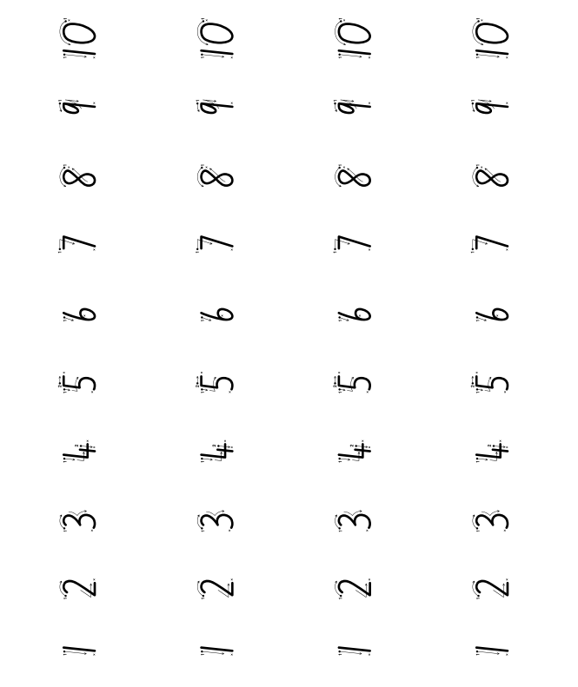

Appendix 2: Race to write 11-20

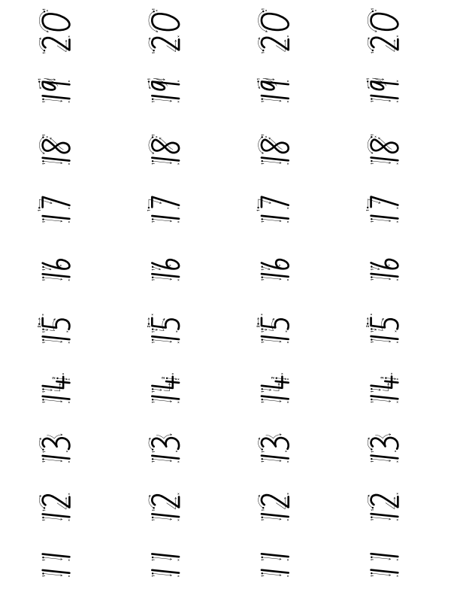

Appendix 3: Ten frames
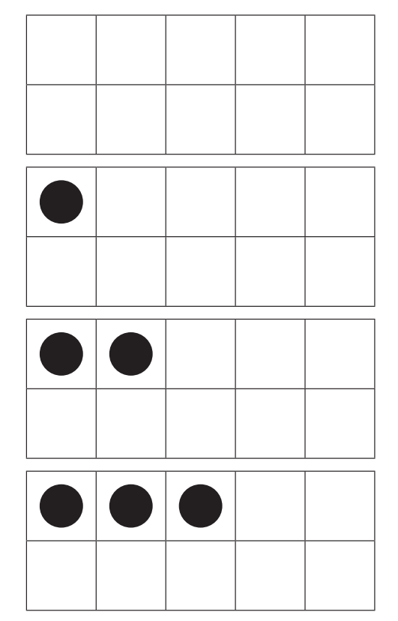
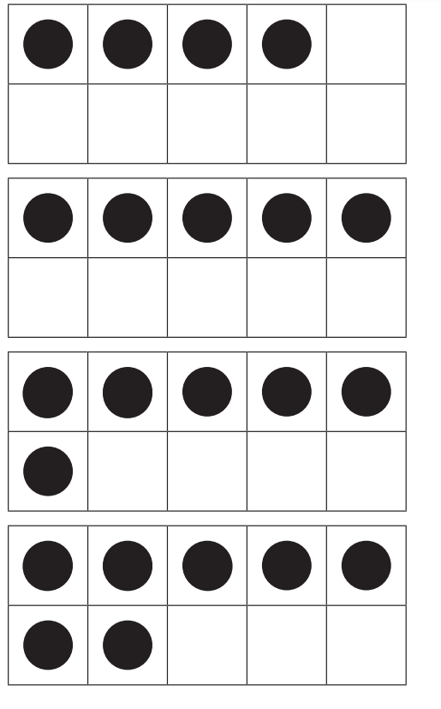

Appendix 4: Mini twenty frames
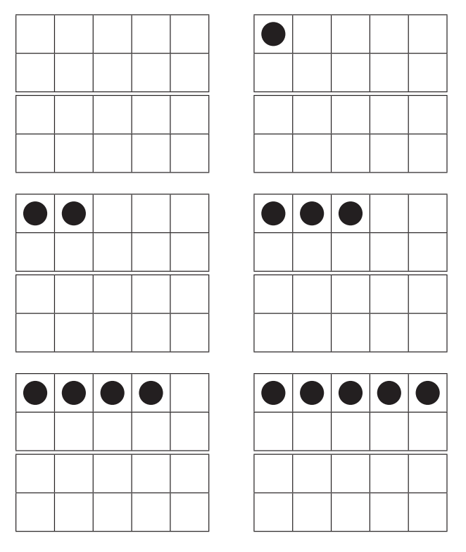
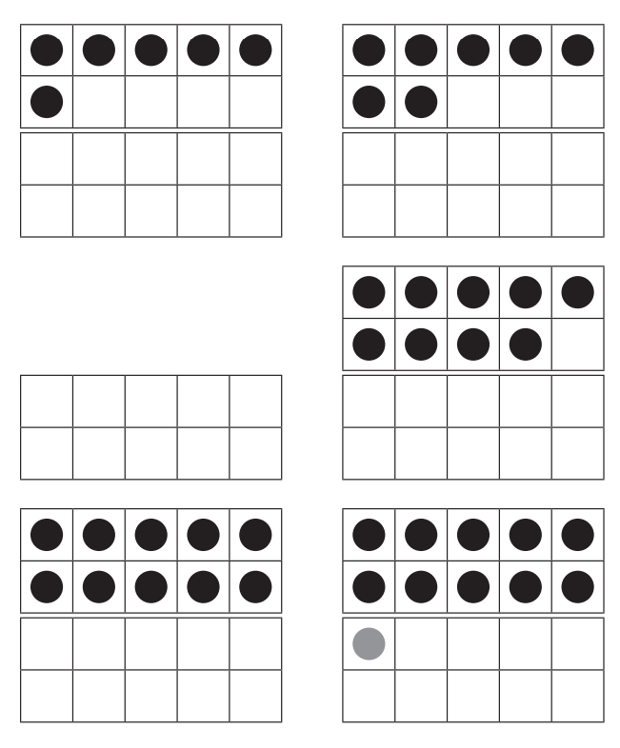

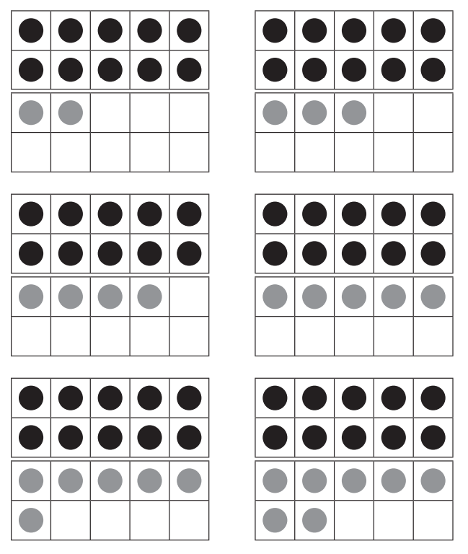
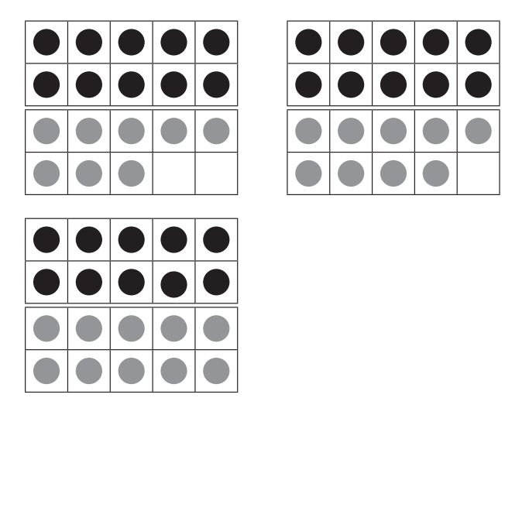

Appendix 5: Teen number puzzle
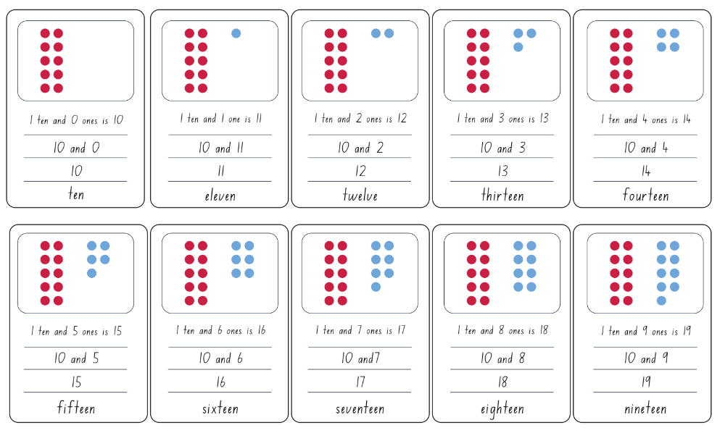

Appendix 6: Numeral cards
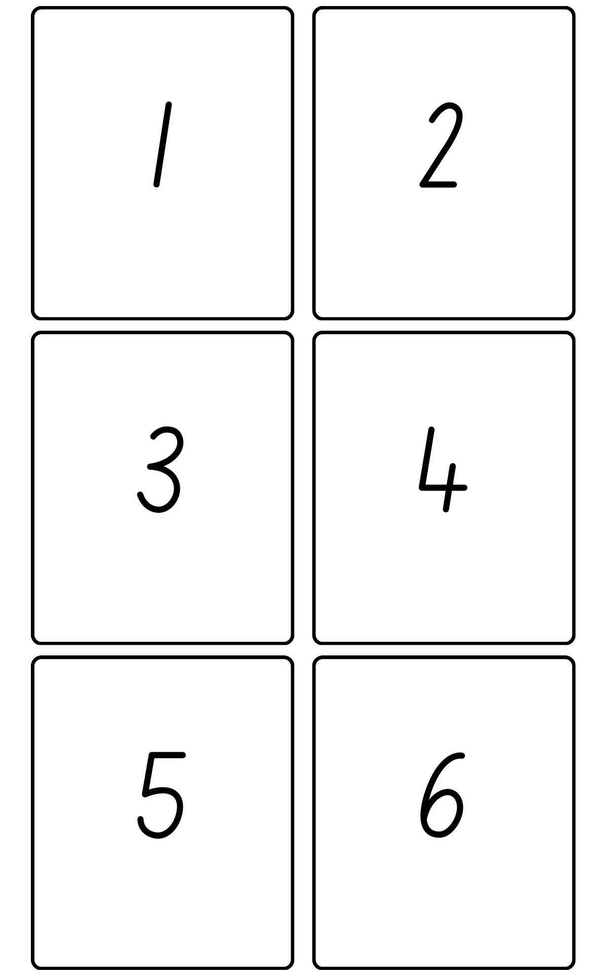

Appendix 7: Teen’ and ty cards
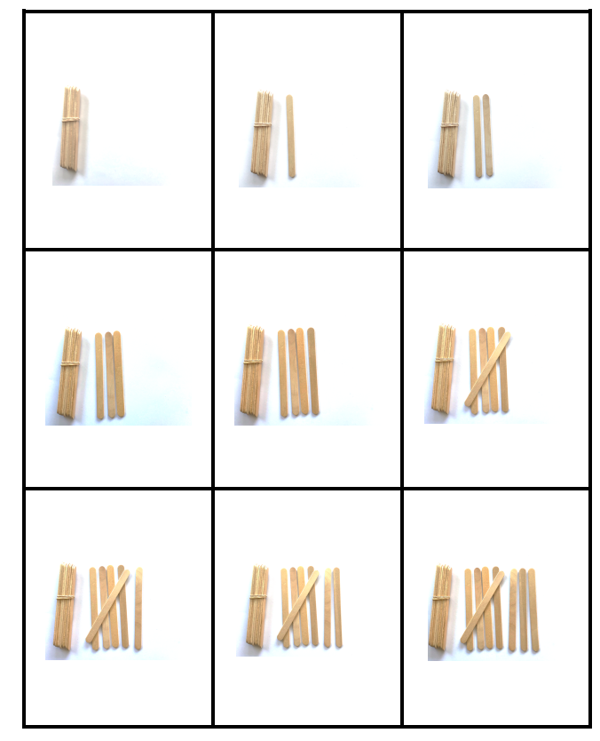

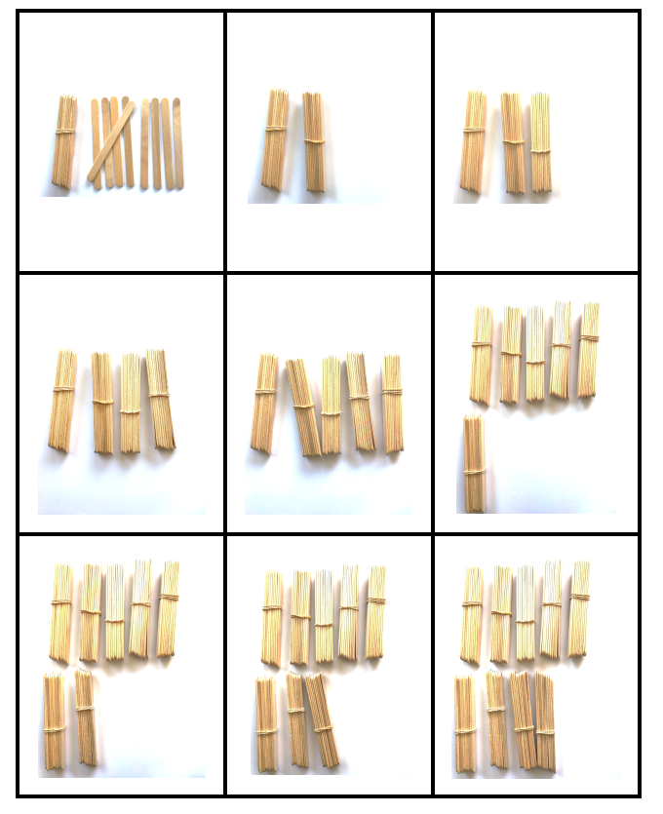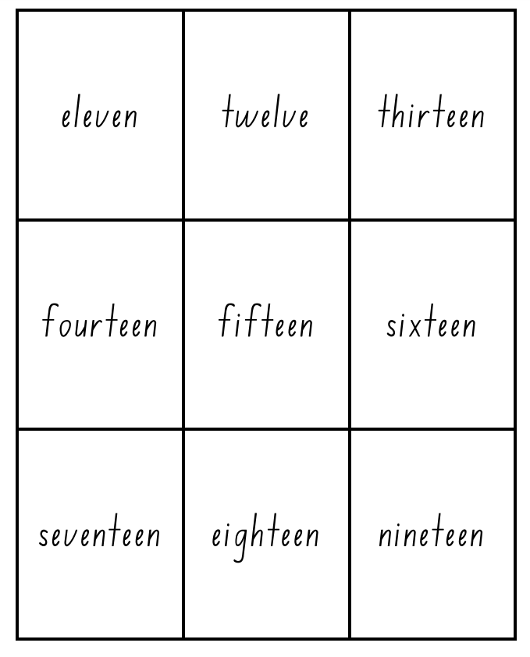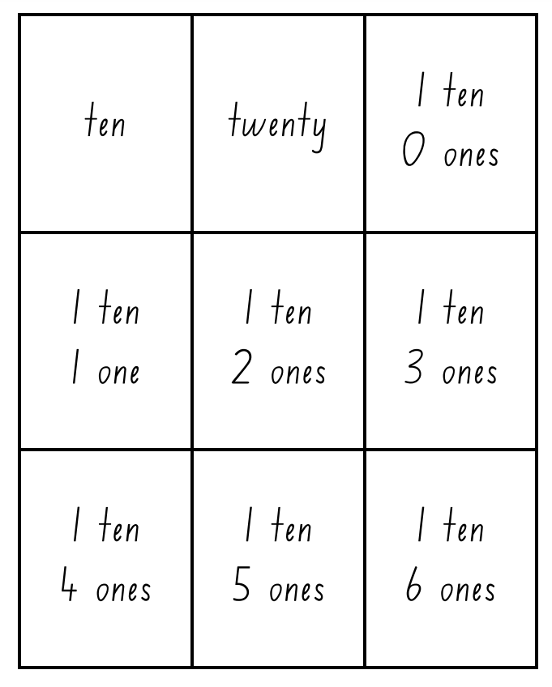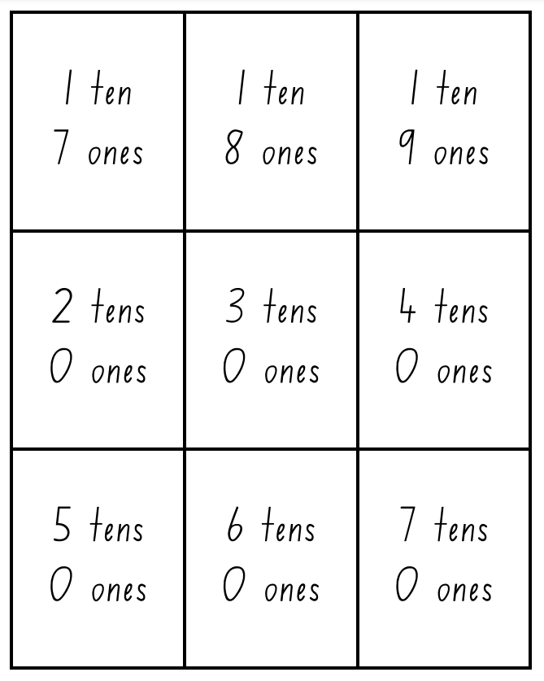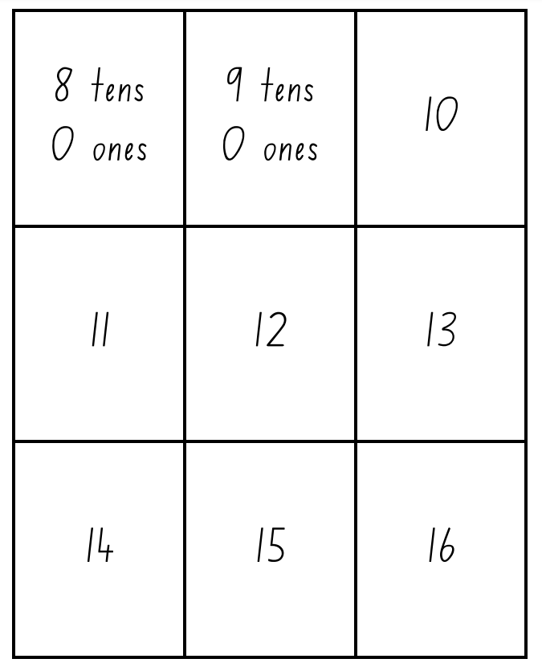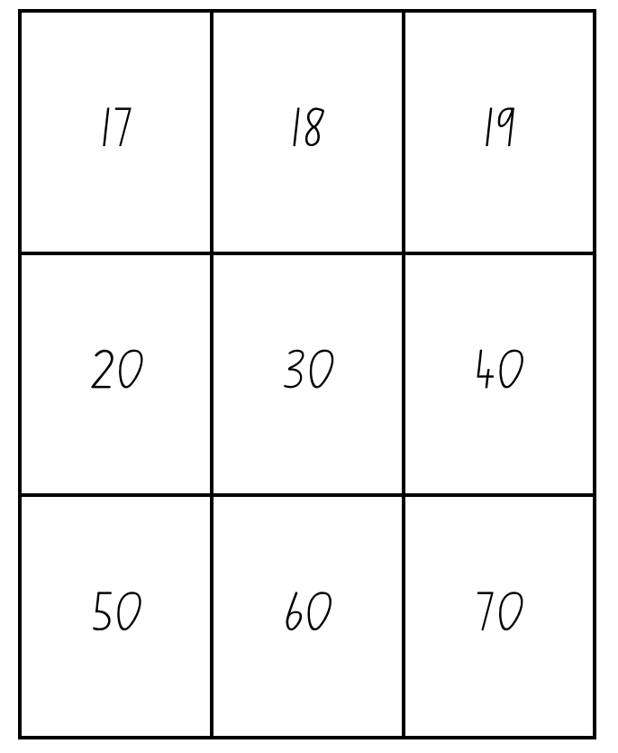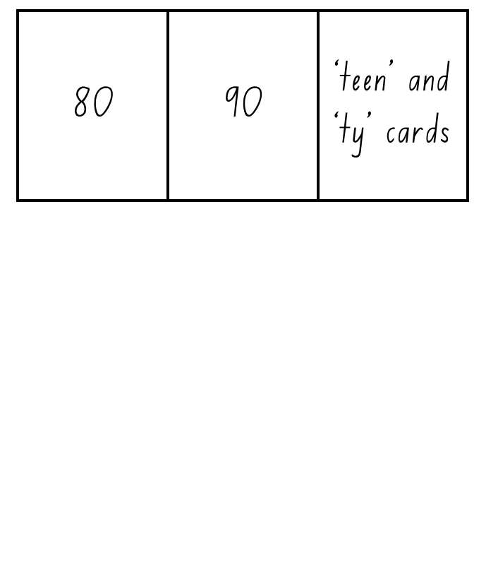

Appendix 8: Numeral cards 1-20
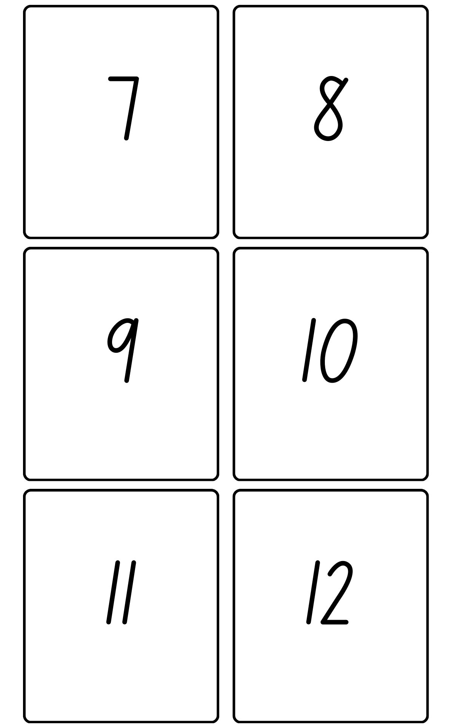
Images sourced from Canva and used in accordance with the Canva Content License Agreement.
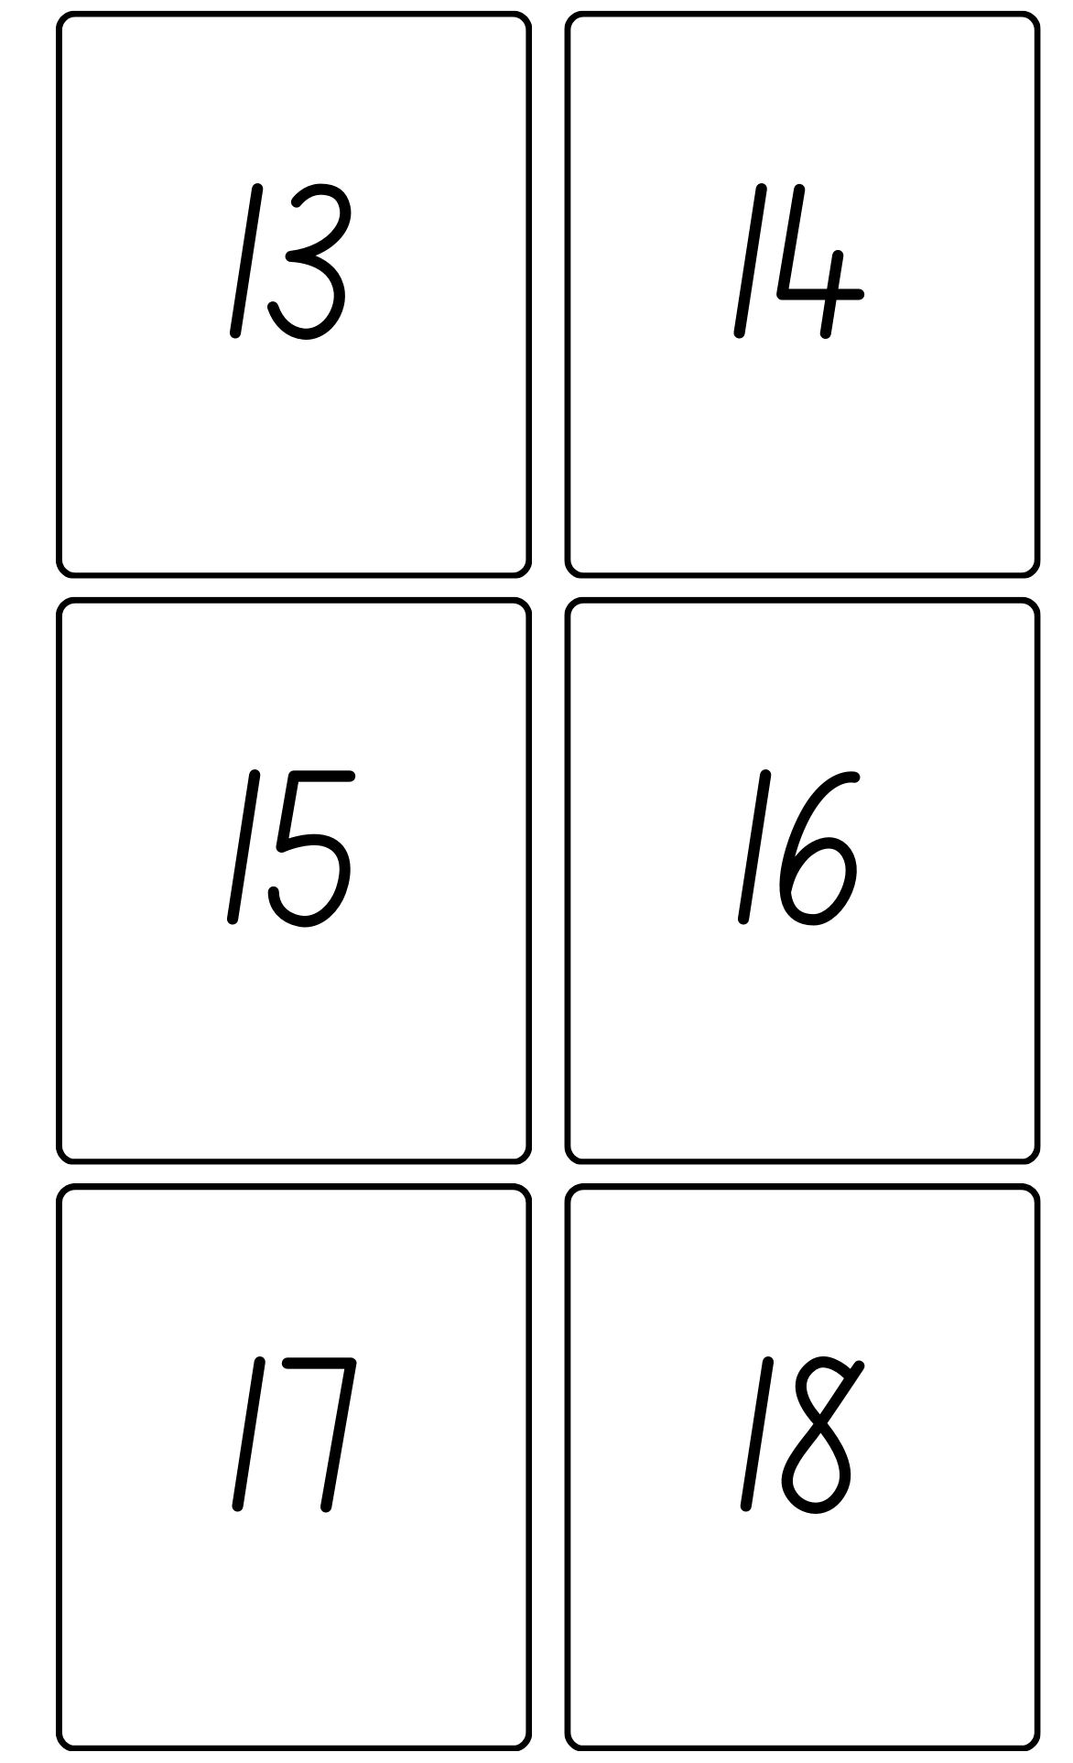
Images sourced from Canva and used in accordance with the Canva Content License Agreement.
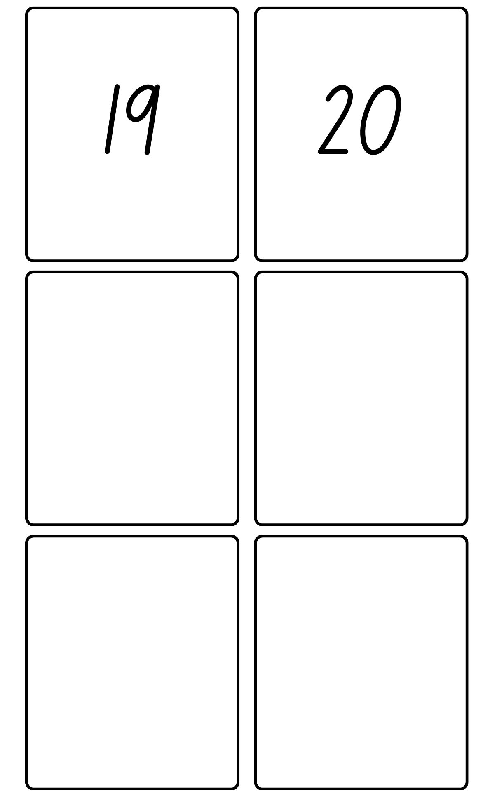
Images sourced from Canva and used in accordance with the Canva Content License Agreement.

Reference list
This resource contains images and content obtained from Canva, and their use outside of this resource is subject to Canva’s Content License Agreement.
Mathematics K–10 Syllabus © NSW Education Standards Authority (NESA) for and on behalf of the Crown in right of the State of New South Wales, 2022.
National Numeracy Learning Progression © Australian Curriculum, Assessment and Reporting Authority (ACARA) 2010 to present, unless otherwise indicated. This material was downloaded from the Australian Curriculum website (National Literacy Learning Progression) (accessed 6 November 2023) and was not modified.
Australian Government Department of Education (2020) ‘Tea Party’, Teaching resources, reSolve: Maths by Inquiry website, accessed 17 November 2023.
New Zealand Ministry of Education (n.d.) ‘Decoding ‘teen’ numbers’, NZ Maths website, accessed 17 November 2023.
New Zealand Ministry of Education (n.d.) ‘Decoding ‘ty’ numbers’, NZ Maths website, accessed 17 November 2023.
State of New South Wales (Department of Education) (2023) ‘6 is…’, Mathematics K-6 resources, NSW Department of Education website, accessed 16 November 2023.
State of New South Wales (Department of Education) (2023) ‘6v6 dot talk’, Mathematics K-6 resources, NSW Department of Education website, accessed 16 November 2023.
State of New South Wales (Department of Education) (2023) ‘Building towers’, Mathematics K-6 resources, NSW Department of Education website, accessed 16 November 2023.
State of New South Wales (Department of Education) (2023) ‘Dotty 6’, Mathematics K-6 resources, NSW Department of Education website, accessed 16 November 2023.
State of New South Wales (Department of Education) (2023) ‘Number busting’, Mathematics K-6 resources, NSW Department of Education website, accessed 16 November 2023.
State of New South Wales (Department of Education) (2023) ‘Pinch a ten’, Mathematics K-6 resources, NSW Department of Education website, accessed 16 November 2023.
University of Cambridge (Faculty of Mathematics) (1997–2023) ‘Matching numbers’, NRICH website, accessed 17 November 2023.
University of Cambridge (Faculty of Mathematics) (1997–2023) ‘Representing numbers’, NRICH website, accessed 17 November 2023.
University of Cambridge (Faculty of Mathematics) (1997–2023) ‘Writing digits’, NRICH website, accessed 17 November 2023.

Copyright
Section 113P Notice
Texts, Artistic Works and Broadcast Notice
Some of this material has been copied and communicated to you in accordance with the statutory licence in section 113P of the Copyright Act. Any further reproduction or communication of this material by you may be the subject of copyright protection under the Act. Do not remove this notice.

Evidence base
Sparrow, L., Booker, G., Swan, P., Bond, D. (2015). Teaching Primary Mathematics. Australia: Pearson Australia.
Brady, K., Faragher, R., Clark, J., Beswick, K., Warren, E., Siemon, D. (2015). Teaching Mathematics: Foundations to Middle Years. Australia: Oxford University Press.
Alignment to system priorities and/or needs: The literacy and numeracy five priorities.
Alignment to School Excellence Framework: Learning domain: Curriculum, Teaching domain: Effective classroom practice and Professional standards
Consulted with: NSW Mathematics Strategy professional learning and Curriculum Early Years Primary Learners-Mathematics teams
Reviewed by: Literacy and Numeracy
Created/last updated: January 2024
Anticipated resource review date: January 2025
Feedback: Complete the online form to provide any feedback.

