Part 4: Flexible strategies with rational numbers

About the resource
This resource is the final section of a 4-part resource supporting multiplicative thinking.
- Part 1: Sharing and forming equal groups
- Part 2: Flexible strategies with single-digit numbers
- Part 3: Flexible strategies with multi-digit numbers
- Part 4: Flexible strategies with rational numbers
Like most things in mathematics, talking about multiplicative thinking is hard to do without referring to other aspects such as patterning, subitising (and visual recognition), counting (with understanding), number sense, measurement and statistics. This resource is best used in conjunction with other guides to support a connected network of critical mathematical concepts, skills and understanding. Students understanding about how numbers and operations work is a critical part of developing deep, meaningful mathematical skills, understanding and confidence.
Continued learning of pattern and structures, number knowledge (including place value understanding) and counting (with understanding) is vital in supporting continued development of number sense. Support students in developing rich, meaningful understanding of how the operations work in order to support their skills in working flexibly with numbers. Provide opportunities to compare strategies and contexts, explore situations when particular strategies are efficient and when they are not as efficient. Remember, efficiency is connected to the confidence and knowledge of individuals. Building representational fluency is important in supporting meaning-making about the operations and how numbers work.
Students at this stage of learning require targeted teaching in the form of investigations and meaningful, low-stress practice to enhance and solidify their understanding and use flexible strategies in increasingly complex contexts. Validate the different strategies students invent and use, using individual thinking to cultivate a culture of communication, thinking and reasoning.

The nature of the learner
Students tend to progress through a number of broad phases of learning as multiplicative thinking develops. Before developing multiplicative thinking, students usually need to have a deep understanding of the principles of counting, including the cardinal and order-irrelevance principles. This means students need to be able to count collections of items, knowing the last number word tells us how many as well as knowing the order in which you count a collection of objects does not change the total. Students also need to know collections can be rearranged and partitioned without changing the total. These understandings are part of ‘trusting the count’ and form a crucial foundation for multiplicative thinking.
When students ‘trust the count’, they can take advantage of equal groups, employing more efficient counting strategies. Students using multiplication and division grouping strategies are capable of ‘double counting’. This means a student is able to keep track of multiple sequences at the same time as keeping track of the number of groups, without relying on materials or markers to represent the groups. It is important to note using counting and dealing strategies to solve problems are additive strategies, limited by a student’s fluency with the counting sequences and the size of a collection to be shared.
Students at this stage of learning are working towards developing an increasingly sophisticated idea of composite units, learning to coordinate the number of groups (multiplier), the number in each group (multiplicand) and the total (product). They are learning to represent and describe multiplicative situations, moving from over relying on items to visualising composite units.
As students continue in their learning, support them to focus on the multidimensionality of multiplicative situations, understanding how:
- to move flexibly between multiplication and division, using the inverse operations to help them solve problems
- to fluently coordinate the number of groups (multiplier), the number in each group (multiplicand) and the total (product), realising missing information determines whether the situation requires multiplication or division to be used to find a solution
- to apply part-part-whole reasoning to composite units
- to use known facts to work out the unknown
- multiplication and division can be used in a wide range of situations, some of which are not easy to ‘see’ as multiplicative
- to use manipulatives, vocabulary and diagrams to communicate mathematically
- to apply the commutative, associative and distributive properties to solve problems, knowing how and when these properties are useful and when they are not.
Moving from additive to multiplicative thinking is an important stage in learning and should be navigated carefully. Remember, thinking strategically to solve problems (considering the context, the numbers and the operations), takes time. Equating mathematical competence with speed can send negative messages to students about what skills are most valued within mathematics. Valuing and expecting quick recall can also impair learning.
The resource has been developed in partnership with the NSW Mathematics Strategy Professional Learning team, Curriculum Early Years and Primary Learners, and Literacy and Numeracy.

Contents
Overview of tasks 4
Tasks 5
Which would you work out in your head? Multiplication and division 5
Tombola 6
Investigating written methods for multiplication 7
Written methods for division 8
Decimal sort 11
Estimate me 12
If I know… with fractional numbers 14
Understanding multiplying with fractions and decimals 16
Beat the calculator 19
Investigating decimal multiplication 23
The remainders game 24
Paper folding to add and subtract fractions 25
Hex 30
Resource section 32
5 x 5 bingo board 33
Estimate me 34
10 x 10 grids 35
Decimal sort 36
Beat the calculator 37
Hex 39
Decimal hex 40

Overview of tasks
Task name | What does it promote | What material will I need | Possible group size
Which would you work out in your head? Multiplication or division | Encourages students to critique different strategies and problem situations to develop conditionalised knowledge. | Something to write on/with | Small group, pairs or whole class
Tombola | Supports students’ fluency and understanding of factor-factor-product relationships. | Bingo template, Something to write on/with | Small groups (pairs or groups of 3)
Investigating written methods for multiplication | Encourages students to critique different written strategies for multiplication to develop conditionalised knowledge. | Something to write on/with | Small groups or whole class
Written methods for division | Supports students’ understanding of the division problems through visual representations. | Stick notes, something to write with | Small groups or whole class
Decimal sort | Encourages students to develop a sense of decimal size compared to benchmark decimals. | Decimal sort cards, something to write on/with | Small groups (pairs or groups of 3)
Estimate me | Encourages students to develop their estimation skills, through reasoning and reflecting. Estimation plays a critical role in developing and applying number sense. | Estimate me resource, Something to write on/with | Small groups (pairs or groups of 3)  Whole class
If I know... with fractional numbers | Supports students to extend their understanding of number relationships to fractional numbers. | Something to write with, large paper | Pairs or whole class
Understanding multiplying by fractions and decimals | Supports students’ fluency and understanding multiplying by fractions and decimals. | 10x10 grids, something to write on/with | Small groups  Pairs
Beat the calculator | Extends students’ understanding of place value and factor-factor-product relationships to determine the product of decimal numbers. | Resource cards, calculator, physical or virtual dice (or spinner, or number cards), something to write on/with | Whole class  Pairs or groups of 2
Investigating decimal multiplication | Encourages students to explore the relationship between fractions and decimals through visual representations. | Something to write on/with | Small groups or whole class
The remainders game | Supports students’ fluency and understanding of operating with remainders and fair share situations. | Counters, standard deck of playing cards, dice, something to write on/with | Small groups
Paper folding to divide a fraction | Supports students to co-construct their understanding of fractions through direct instruction, manipulatives and visual representations. | Piece of A4 or A5 paper, coloured pencils or markers, something to write on/with | Whole class  Differentiated small groups
Hex | Supports students’ fluency and understanding of factor-factor-product relationships and operating with division. | Hex resource, coloured counters, calculator, something to write on/with | Small groups

Tasks

Which would you work out in your head? Multiplication and division
Key generalisations/ what’s (some of) the mathematics?
- Posing questions such as these enable students to see how different people work with problems in different contexts.
- Mathematicians use what they know to help them solve what they don’t know yet.
- The same problem can be solved using many strategies, for example, we can use doubling, skip counting and known facts.
- Mathematicians check thinking by using an alternative way to solve the problem.
- Mathematicians use a range of representations to communicate ideas, including:
  - recording findings using words, symbols and diagrams.
Some observable behaviours you may look for/notice:
- explains their chosen strategies
- refines/ extends thinking after listening to the ideas and strategies of others
- uses a range of strategies to solve problems:
  - uses known facts to solve unknown problems
  - uses doubles and doubling strategies, for example double and one more
  - uses skip counting and may use fingers to keep track of rows
  - uses landmark or benchmark numbers
    - in a fractional context, these may be whole numbers, like 1, or 1-half, or even multiples of ten, tenths or hundredths.
- partitions numbers into smaller parts
Materials
- Something to write on/with
Instructions
- Pose the following questions:
  - Which of these would you work out in your head?
  - Which would you use concrete materials, a calculator or written strategies to work out?

- $47×____=4700$
- $8×2×4×5$
- $7×8+___=91$
- $\frac{1}{4} of 64$
- $656÷8$
- $\frac{2}{3} of 120$
- $13×21$
- $198÷___=11$
- $52÷2÷2$

- Allow students time to think before asking them to respond. They can record which ones they work out in their head on sticky notes to give to the teacher (or use a web-based response system or talk with a thinking partner), determining the similarities and differences in their preferences. Ask questions such as:
  - Which question/s do you think most people might prefer to model to help them solve? Why do you think that? What do these questions have in common?
  - Which question/s do you think most people would work out in their heads? Why do you think that? What do these questions have in common?
  - Which strategies are we NOT considering as often as others? What do we need to learn in order to use those strategies as comfortably as the others?
Variation
- Change the questions examined (a - i)

Tombola
Key generalisations/ what’s (some of) the mathematics?
- Mathematicians use what they know to help them solve what they don’t know yet.
- The same problem can be solved using many strategies, for example, we can use doubling, skip counting and known facts.
- Mathematicians check thinking by using an alternative way to solve the problem.
- Mathematicians use a range of representations to communicate ideas, including:
  - recording findings using words, symbols and diagrams.
- Games provide us with a meaningful opportunity to practise our mathematical skills and understanding.
Some observable behaviours you may look for/notice:
- uses a range of strategies to solve problems:
  - known facts to solve unknown problems
  - doubles and doubling strategies, for example double and one more
  - skip counting and may use fingers to keep track of rows.
- explains their chosen strategies
- refines/ extends thinking after listening to the ideas and strategies of others
- explains how and why quantities remain the same when units are rearranged, representing the same total in multiple arrangements
Materials
- Bingo template
- Something to write on/with
Instructions
- Provide each student with a blank 5 x 5 bingo board. Students write the product to any multiplication fact from 1 x 1 to 10 x 10 anywhere on their board. In pairs, students take turn to roll two 10-sided dice, determining the product. If that number is present on either game board, students cover that square.
- Play until one player fills their bingo board.
Variations
- Take 12 rolls of the dice each. Score according to the number of complete lines that have been collected. 1 row of 5 = 1 point; 2 rows of 5 = 3 points; 3 rows of 5 = 5 points.

Investigating written methods for multiplication
Key generalisations/ what’s (some of) the mathematics?
- Mathematicians use what they know to help them solve what they don’t know yet.
- The same problem can be solved using many strategies, for example, we can use doubling, skip counting and known facts.
- Mathematicians check thinking by using an alternative way to solve the problem.
- Mathematicians use a range of representations to communicate ideas, including:
  - recording findings using words, symbols and diagrams.
Some observable behaviours you may look for/notice:
- uses a range of strategies to solve problems:
  - known facts to solve unknown problems
  - doubles and doubling strategies
  - visualises and skip counts the number of dots and may use fingers to keep track of groups/ rows
  - partitions numbers to think about problems flexibly.
- explains their chosen strategies
- refines/ extends thinking after listening to the ideas and strategies of others.
- uses various representations to share thinking:
  - drawings
  - language
  - diagrams
  - virtual manipulatives.
Materials
- Something to write on/with
Instructions
- Ask students to consider how they might solve a problem such as 23 x 243.
- Students discuss their thinking with a thinking partner and briefly record their ideas for later.
- Demonstrate how 23 x 243 could be solved using a range of algorithms including the grid method, the Gelosia (or lattice) method, the standard ‘column’ algorithm, the area method and other methods as desired (for example, the line method).
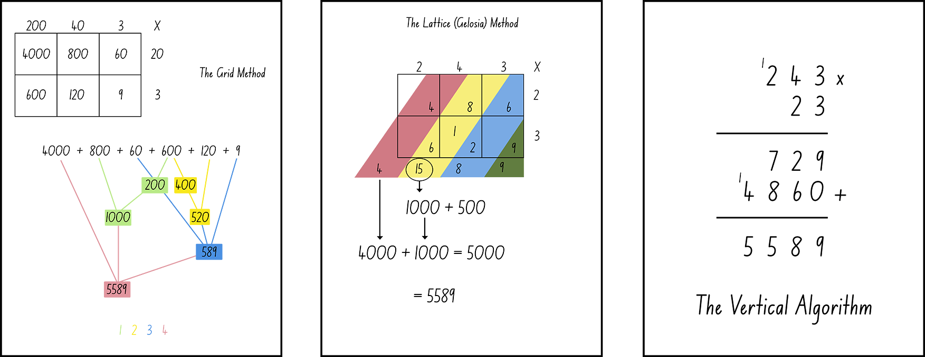
Figure 1: Examples of written methods to solve 23 x 243
- Provide the series of images from above and ask them questions such as:
  - What do you notice about each of the methods?
  - How does each method work? What mathematical properties are being used?
  - What are the advantages of each method?
  - What are the disadvantages of each method?
  - When is each method not useful?
  - What knowledge do you need to have to be successful at using any of these methods?
  - Create a model that demonstrates how each method works, for example, demonstrate how the grid method works using Cuisenaire rods or multibase arithmetic blocks
Teaching point: Students need to be familiar with, and use, a range of mental strategies prior to introducing written methods. Written methods are useful when working on problems that make other strategies no longer reliable or efficient. Before introducing formal written methods, check students apply a range of efficient mental strategies in all operations. As a minimum, students should be able to:
- apply known facts
- derive the unknown from the know
- explain and use the associative, distributive and commutative properties
- use place value knowledge to multiply and divide by multiples of ten
- use the area model to explain their thinking
- use informal jottings to solve complicated problems.
Variations
- Explore how each of these methods work with fractional and decimal numbers.
- Students create instructional videos using tablet devices to share their thinking.
- Explore how these strategies may be used for division problems.
Teaching point: Once written methods are introduced, students need to continue thinking strategically, considering which strategy they know that will be most useful in solving the problem they are faced with. Written methods need to be connected back to what students already know, using concrete materials and diagrams to support understanding.

Written methods for division
Key generalisations/ what’s (some of) the mathematics?
- Mathematicians use what they know to help them solve what they don’t know yet.
- The same problem can be solved using many strategies, for example, we can use doubling, skip counting and known facts.
- Mathematicians check thinking by using an alternative way to solve the problem.
- Mathematicians use a range of representations to communicate ideas, including:
  - recording findings using words, symbols and diagrams.

Some observable behaviours you may look for/notice:
- uses a range of strategies to solve problems:
  - known facts to solve unknown problems
  - doubles and doubling strategies
  - visualises and skip counts the number of dots and may use fingers to keep track of groups/ rows
  - inverse operation
  - partitions numbers to think about problems flexibly.
- explains their chosen strategies
- refines/ extends thinking after listening to the ideas and strategies of others
- uses various representations to share thinking:
  - concrete materials
  - drawings
  - language
  - diagrams
  - virtual manipulatives.
Materials
- Sticky notes
- Something to write with
Instructions
- Provide sticky notes, a pencil and a problem such as ‘I have $346. I want to share it equally between my 3 piggy banks. How much should I place into each one?’ Ask students to briefly note down the various ways in which this problem could be represented using symbolic notation. Students may write things such as:
$\frac{346}{3}$ $346÷3$ 3 x _______= 346
Figure 2: Examples of written methods for division problems
- Collect the sticky notes and later analyse them, gathering information about the known symbolic notations and possible misconnects.
- Ask students how they may solve the problem, sharing and discussing their ideas. Model how to solve $346÷3$ by partitioning the dividend, explaining this strategy allows you to partition the dividend in a way that makes sense to you, applying known facts, for example:
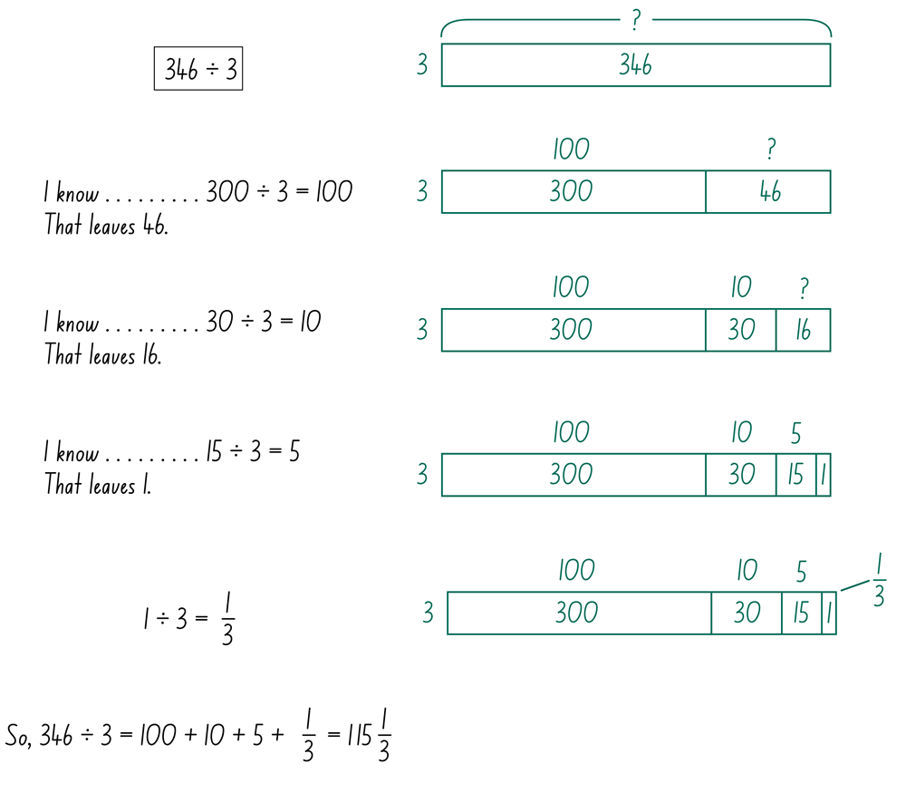
Figure 3: Example of a model how to solve 346 ÷ 3
- Explain we could also solve $346÷3$ using a standard algorithm.
- Provide mini whiteboards, markers, sharing mats and multibase arithmetic blocks.
- Demonstrate how to solve $346÷3$, using the concrete materials to explain the process, recording using the algorithm.
Teaching point: Students often find difficulty with the different ways division can be written. This could be confusion related to the way the numbers seem to ‘move’ in the various notations.
.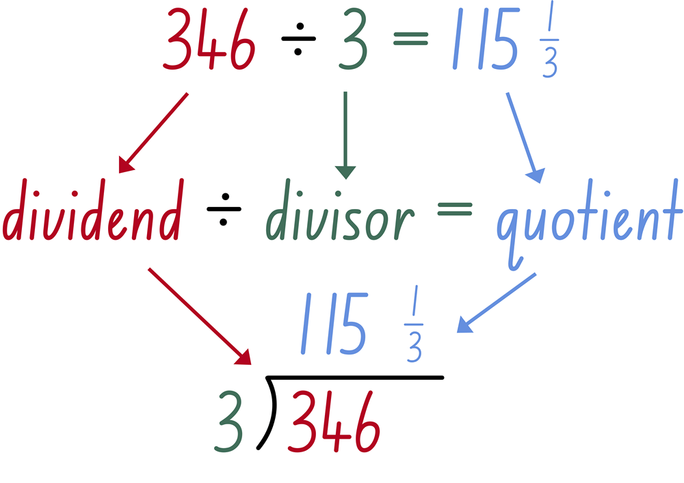
Figure 4: Examples of different ways division can be written

- Ask questions such as:
  - What do you notice about each of the methods?
  - How does each method work? What mathematical properties are being used?
  - What are the advantages of each method?
  - What are the disadvantages of each method?
  - When is each method not useful?
  - What knowledge do you need to have to be successful at using any of these methods?
  - Create a model that demonstrates how each method works, for example, demonstrate how the grid method works using Cuisenaire rods or multibase arithmetic blocks.
Variations
- Explore how each of these methods work with fractional and decimal numbers.
- Have students create instructional videos using tablet devises to share their thinking
- Explore the connection between these strategies and multiplication methods.

Decimal sort
Key generalisations/ what’s (some of) the mathematics?
- Using benchmarks and estimating the size of fractional numbers is an important component in developing number sense and aiding mental computation.
- Mathematicians use a range of representations to communicate ideas, including:
  - recording findings using words, symbols and diagrams.
- Mathematicians use what they know to help them solve what they don’t know yet.
- We can use benchmarks to determine the place of a decimal on a number line, for example, “If I know 0.5 is here (gesturing half-way mark on a number line) then I know 0.25 would be about here as it is half-way between 0 and one-half. So now that I know a quarter is here, 0.3 is a little more than a quarter so I'd place that here”.
Some observable behaviours you may look for/notice:
- explains why they used a particular strategy
- refines/extends thinking after listening to the ideas and strategies of others
- compares decimal fractions using language, for example, 80-hundredths is closer to 75-hundredths than 99-hundredths
- compares decimal fractions by renaming
- compares decimal fractions by comparing digits in place value places
Materials
- Decimal sort cards
- Something to write on/with
Instructions
- Provide decimal cards and representations. Students sort the decimals into 3 categories: ‘Less than 0.50’, ‘About 0.50’ and ‘More than 0.50’.

- Ask questions such as:
  - What information do you use to help you make decisions?
  - Which number facts required you to think hard about which category to place them in? Why might that be?
  - Which pairs of cards when combined, would have a sum of about 1.00? Which would have a sum of about 0.50?
Variations
- Change the categories.
- Change the cards.
- Provide pairs of cards and have students sort them based on their total (as outlined above).
- Students consider how they might represent each card, or create new cards without using numerals or operational symbols.
- Students place cards on a number line, justifying their proportional reasoning.

Estimate me
Key generalisations/ what’s (some of) the mathematics?
- Estimation plays a critical role in developing and applying number sense.
- Mathematicians develop the skills to estimate (without needing to calculate the ‘right’ answer) which is an important part of becoming numerate.
- Mathematicians use what they know to help them solve what they don’t know yet.
- The same problem can be solved using many strategies, for example, we can use doubling, skip counting and known facts.
- Mathematicians check thinking by using an alternative way to solve the problem.
- Mathematicians use a range of representations to communicate ideas, including:
  - recording findings using words, symbols and diagrams.
- Mathematicians compare similarities and differences between strategies and contexts to help choose which strategies to use and when.
Some observable behaviours you may look for/notice:
- uses estimation to determine the reasonableness of the solution
- uses the place value of digits to help estimate, for example, rounding $1.80 to the nearest dollar to make $2.00
- uses a range of strategies to solve problems
- uses multiples of 10 or 100, for example, multiplies 24 by 99 (rounds 99 to 100)
- recalls a number fact, for example, knows 7 fours (then adds 1 four to calculate 8 fours)
- uses various representations to share thinking:
  - concrete materials
  - gestures
  - drawings
  - language
  - diagrams.

Materials
- Estimate me resource
- Tools to record thinking, such as paper and pencils
Instructions
- Ask students to explain estimation in their own words/thinking. Use guiding questions such as:
  - Why would you need to estimate?
  - Which numbers do you focus on when estimating? Why?
  - What is the difference between an estimated and an actual answer?
  - What strategies do you use when you estimate?
- Provide the following question for discussion: Which of these are close to 2000?
  - 30 × 65
  - 53 × 14
  - 15 × 120
  - 97 × 19
  - 33 × 101
- Give students time to work through the question including being able to explain their thinking. Use guiding questions such as:
  - How do you know? Explain your reasoning.
  - How do you know it’s a good estimate? (Is it higher or lower than the actual answer?)
  - Is there another way to solve this?
  - How would you explain this to a primary student?
- Using the ‘Think-Pair-Share’ routine, students explain their thinking to a partner, using representation and appropriate terminology to communicate their ideas.
- Introduce another question from the Estimate me resource for students to work out independently, giving them time to formulate an answer with reasoning.
- Assign each answer choice a designated ‘zone’ in the room, give students 10 seconds to move to the zone matching their answer.
- Each zone then discusses their reasoning and a zone spokesperson to explain their reasoning to the class.
- Students can stay in the same zone or choose to move to another zone if they are convinced by the reasoning of others and revise their thinking/change their mind?
- Repeat with another question

Teaching points:
Use the questions in the instructions as a point of discussion, selecting only a few questions based upon the learning needs of their students. These questions are not intended to be provided as a worksheet or as an independent activity. Through the richness of conversation these questions are hoping to draw out connections about estimating.
Discuss the various ways to estimate each problem. I might estimate 30 sixty-fives and 30 seventies (for example). Since I know 3 sevens is 21, I can derive 3 seventies is 210, and from there, derive further to say 30 seventies is 210 tens which we rename as 2100. Someone else might have said 30 x 65 is close to 30 x 60. 10 sixties is 600. Three six-hundreds is double and one six-hundred which makes 1200 plus 600 which is 1800.
Refer to ‘Talk moves’ resources to reinforce wait time and reasoning.
Set up zones to allow all students access to the learning, that is, if a student is unsure of the how/why of estimation they can hear others explaining or working through the questions.
When estimating decimals, make sure students understand benchmark decimals (0.25, 0.5, 0.75) as this supports students’ ability to flexibly identify where more complex decimals may sit. Students can use a calculator to check the accuracy of their estimation.
Variations
- Change the question to have a focus on division
- Change questions to use three digits with decimals

If I know… with fractional numbers
Key generalisations/ what’s (some of) the mathematics?
- Deriving facts helps students build number sense through looking for and using the relationships between numbers and operations.
- The same problem can be solved using many strategies, for example, we can use doubling, skip counting and known facts.
- Deriving the unknown from the known teaches problem solving strategies as well as requiring logical thinking, skills critical to the development of numeracy.
- Mathematicians use what they know to help them solve what they don’t know yet.
- Mathematicians check thinking by using an alternative way to solve the problem.
- Mathematicians use a range of representations to communicate ideas, including
  - recording findings using words, symbols and diagrams.
Some observable behaviours you may look for/notice:
- uses estimation and rounding to check the reasonableness of products and quotients
- demonstrates flexibility in the use of single-digit multiplication facts with decimals
- uses mental strategies for multiplication and can justify their use
- uses commutative and distributive properties of multiplication when solving problems

Materials
- Tools to record thinking, such as mini whiteboards and markers/pens
- Large sheets of paper
Instructions
- Provide a known fact such as ‘4 × 0.1 (4 tenths) is equivalent to 0.4’. Check students agree with your statement.
- Using the ‘Think-Pair-Share’ routine, students:
  - consider what other facts they can derive by knowing 4 × 0.1 = 0.4.
  - explain their thinking to a partner, using representation and appropriate terminology to communicate and record their ideas.
  - share the derived facts they worked out with the class
- Examples: Because 4 × 0.1 (4 tenths) is equivalent to 0.4, I also know:
  - 0.4 divided by 0.1 = 4
  - 4 x 0.1 = 4 x 1/10
I know that because these are all part of the same fact family.
  - 0.2 × 2 = 0.4
I know that because when you halve one number and double the other the product remains the same, for example, 2 tenths doubled is 4 tenths.
  - 0.8 × 0.5 = 0.4 is another number fact we could derive using the same strategy of doubling and halving. This is called the associative property.
  - 0.4 × 100 = 40
I know that because I can use my understanding of place value. I could also use place value to derive 0.4 × 1000 = 400 and so on.
  - 4 × 0.11 = 0.44
I know that because 4 tenths is 0.4 and 4 hundredths is 0.04.
0.4 + 0.04 = 0.44
- Support students in explaining their thinking clearly, offering the appropriate metalanguage and asking clarifying questions as required.
Teaching points:
This task could be used as a formative assessment tool by asking students to record all the facts they could derive from a given fact.
Notice and record the properties students make use of and at what point their knowledge is exhausted, for example, do they:
- simply record the inverse operation?
- include division facts for a question using multiplication?
- apply place value knowledge?
- use meaningful representations to explain their thinking?

Variations
- Pose slightly different questions, for example, ‘how could knowing 4 tenths = 0.4 help someone work out 4 lots of nineteen-hundredths (4 x 0.19)?’
- Ask students to create representations to support meaning, making examples such as those above.
- Investigate how various strategies for deriving solutions work with division as well as making comparisons to addition and subtraction.
- Record the strategies used to derive facts in a chart. As students notice themselves or others deriving a fact, record the strategy used.
Example
Fact | Student’s thinking (Strategy used)
8 x 3.2 = 25.6 | First, I partitioned 3.2 into 3 and 2-tenths (Distributive property)  I know 8 x 3 = 24, and 8 two-tenths is 16 tenths (Apply known facts)  Then, I used place value to rename 16-tenths as 1.6 (Place value understanding)
1.8 x 6 = 10.8 | I decided to make 2 sixes as I know double 6 is 12 (Adjusting the numbers)  I know that 2/10 sixes = 6 two-tenths (Commutative property)  6 two-tenths is twelve-tenths and 12-1.2 = 10.8 (Apply known facts)  12 tenths can be renamed as 1.2 (Place value understanding)
2.4 ÷ 3 = 0.8 | 2.4 × 10 = 24 (Adjusting the numbers)  24 ÷ 3 (thirding) = 8 (Associative property)  8 ÷ 10 = 8 tenths ((Adjusting the numbers)  8 tenths is the same as 0.8 (Place value understanding)  I know 24 divided by 30 = 0.8 (Place value understanding)

Understanding multiplying with fractions and decimals
Key generalisations/ what’s (some of) the mathematics?
- Mathematicians use what they know to help them solve what they don’t know yet.
- The same problem can be solved using many strategies, for example, we can use doubling, skip counting and known facts.
- Mathematicians check their thinking by using an alternative way to solve the problem.
- Mathematicians use a range of representations to communicate ideas, including:
  - recording their findings, using words, symbols and diagrams.
Some observable behaviours you may look for/notice:
- uses a range of strategies to solve problems:
  - known facts to solve unknown problems
  - doubles and doubling strategies
  - visualises and skip counts the number of dots and may use fingers to keep track of groups/ rows
  - inverse operation
  - partitions numbers to think about problems flexibly.
- explains their chosen strategies
- refines/ extends thinking after listening to the ideas and strategies of others
- uses various representations to share thinking:
  - concrete materials
  - gestures
  - drawings
  - language
  - diagrams
  - virtual manipulatives.
Materials
- 10 x 10 grids
- Something to write on/with
Instructions
- Create groups of 3 to 5. Have groups skip count up or down from a starting number by the selected fraction or decimal number. The student to the left states the next number in the sequence.
- Skip counting suggestions
Start … | Skip count…
.. from 4 | .. up by 2 thirds
.. at 7.05 | .. up by 0.25
.. at 195 | .. down by $\frac{3}{4}$
.. at 497 | .. down by $1\frac{2}{3}$
- Show a collection of fraction unit cards (these can easily be made by folding paper strips), for example:
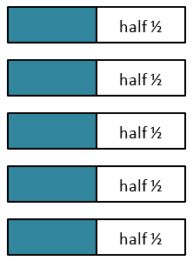
Figure 5: Fraction unit cards
- Explain we can skip count to determine the total number of halves in the same way we can use skip counting (albeit not as the most efficient strategy) to solve multiplicative problems with whole numbers.
- In this case, our unit is halves. Ask how many halves we have, eliciting 5 and using skip counting to check (1 half, 2 halves, 3 halves, 4 halves, 5 halves).
- Display ‘5 halves = ?’. Ask students to work with a thinking partner to determine the product of ‘5 halves’, using fraction unit cards and other materials to prove their thinking is accurate and effectively communicate their thinking. Explain the link to multiplying a whole number and a fraction. Ask guiding questions such as:
  - Why is the product less than the 5 pieces of paper we started with?
  - Discuss how multiplying a number less than one by a number greater than one results in an answer smaller than the whole number started with.
  - Does this work when multiplying all fractions by a whole number?
  - Would there be an example where the product would be larger than the factors? Prove it.
- Show the image below. Students talk to partners to determine how they would solve
3 × 3.5
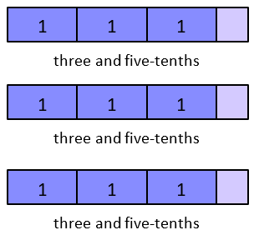
Figure 6: Fractional unit cards
- Repeat with different sized fractional units such as tenths, quarters, thirds and so on
  - Ask “What happens when you multiply a fraction by fraction?”
  - With a partner, show how you work out 14 × 23? Prove it with a visual representation.
  - Link multiplying fractions with the word of 14 × 23, drawing attention to a fraction of a fraction.
  - Use the area model for fractions to solve 14 × 23.
  - With a partner show how you work out 0.4 × 0.6?
  - Prove it with a visual representation. Using 10 X 10 grids
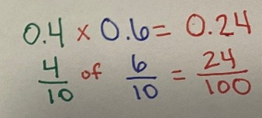
Figure 7: Visual representation of 0.4 x 0.6

Teaching point: The language used to introduce multiplying and dividing with fractional units is important. Just as naming ‘8 x 5’ ‘as ‘8 fives’ supports comprehension, so too does naming ‘8 x 1/5’ as ‘8 fifths’. Note: the numeral is used to record ‘how many’ and the word is used to describe the unit size (‘how much’).
Students may have misconceptions about the results of multiplying, for example, the product is always larger. Students need to develop strong conceptual understanding when multiplying fractions and decimals.
Variation
- Use different sized fractional units such as tenths, quarters, thirds, and so on.

Beat the calculator
The sequence of the 3 games increases in complexity, and each game can be differentiated to meet the needs of students’ understanding of multiplying whole numbers and decimals.
Games 1 and 2 are whole class activities, where students try to ‘beat the teacher’ in small groups, pairs or individually. Game 2 can also be played in pairs or small groups.
In Game 3, students work in small groups to apply knowledge and skills developed in the previous games to support them in beating the calculator.
Problems may be presented as pre-printed cards, or you can use a range of dice or virtual manipulatives.

Key generalisations/ what’s (some of) the mathematics?
- Mathematicians use what they know to help them solve what they don’t know yet.
- The same problem can be solved using many strategies, for example, we can use doubling, skip counting and known facts.
- Mathematicians check thinking by using an alternative way to solve the problem.
- Mathematicians use a range of representations to communicate ideas, including
  - recording findings using words, symbols and diagrams.

Some observable behaviours you may look for/notice:
- describes the multiplicative relationship between adjacent positions in the place value system for decimals, for example, each place is ten times more than the place to its right
- explains multiplying and dividing numerals by 10, 100, 1000 changes the positional value of the numeral (for example, explains 100 times 0.125 is 12.5 because each digit value in 0.125 is multiplied by 100, so 100 x 0.1 is 10)
- uses a range of strategies to solve problems, for example:
  - known facts and knowledge of counting
  - properties (such as commutative and associative) or partitions numbers into smaller parts
  - landmark or benchmark numbers. In a fractional context, these may be whole numbers, like 1, or 1-half, or even multiples of ten, tenths or hundredths.
  - describes the effect of multiplication by a decimal or fraction less than one (for example when multiplying whole numbers by a fraction or decimal less than 1 such as 15× 12=7.5
  - compares the size of decimal fractions, for example, 0.8 is known to be of greater magnitude than 0.75 because of the positional value of the digits
Materials
- Resource cards
- Calculator
- Dice (physical or virtual), spinner, or number cards
- Something to write on/with

Game 1 - beat the teacher
In this activity students use number strings to identify patterns when multiplying with decimals increasing computational fluency.
Each game consists of six rounds. Each round builds on the previous one, increasing the complexity of responses by changing the number of decimal places. This allows for multiple opportunities to make generalisations and check for understanding.
Play multiple games to continue to refine generalisations and deepen understanding.
Instructions
- Use virtual spinner to randomly select four digits that will be combined to form the numbers that will be calculated. Display them to the class, noting the order in which they were generated, for example, 6, 4, 5 and 5 will result in forming the numbers 64 and 55 for round 1.
- Display the number sentence
- Model the use of mental and written strategies while students are using a calculator to find the product.
- Discuss strategies used as a whole class, as well as ways to make estimates of the solution.
Round | Expression | Example
1 | Tens, ones × tens, ones | 64 × 55 = 3520
- The next and subsequent rounds are played in the same way. The aim is to demonstrate the teacher’s mental strategies are more efficient than using technology.
- Display the number sentence
- Model the use of mental and written strategies while students are using a calculator to find the product.
- Discuss strategies used as a whole class, as well as ways to make estimates of the solution.
- Discuss with students what they noticed? Is there a pattern? Which is the most efficient strategy? Why?
Round | Expression | Example
2 | Hundreds, tens × tens, ones | 640 × 55 = 35200
3 | Tens, ones × ones, tenths | 64 × 5.5 = 352
4 | Hundreds, tens × ones, tenths | 640 × 5.5 = 3520
5 | Ones, tenths × ones, tenths | 6.4 × 5.5 = 35.2
6 | Ones, tenths × tenths, hundredths | 6.4 × 0.55 = 3.52
Variations
- Start with three numbers instead of four and build confidence multiplying by a single-digit multiplicand (for example, 64 x 5, 640 x 5, 64 x 0.5) before progressing to a two-digit multiplicand.
- Extend to use 5 digits and alter the rounds to include thousands and thousandths.

Game 2 - beat the calculator with benchmark decimals
In this activity, students use their knowledge of multiplying with benchmark decimals increasing mental computation fluency. Play game 2 the same way as game 1, with each round increasing in complexity.

Instructions
- Separate a deck of cards into even and odd piles using numeral cards (A-9, noting A=1).

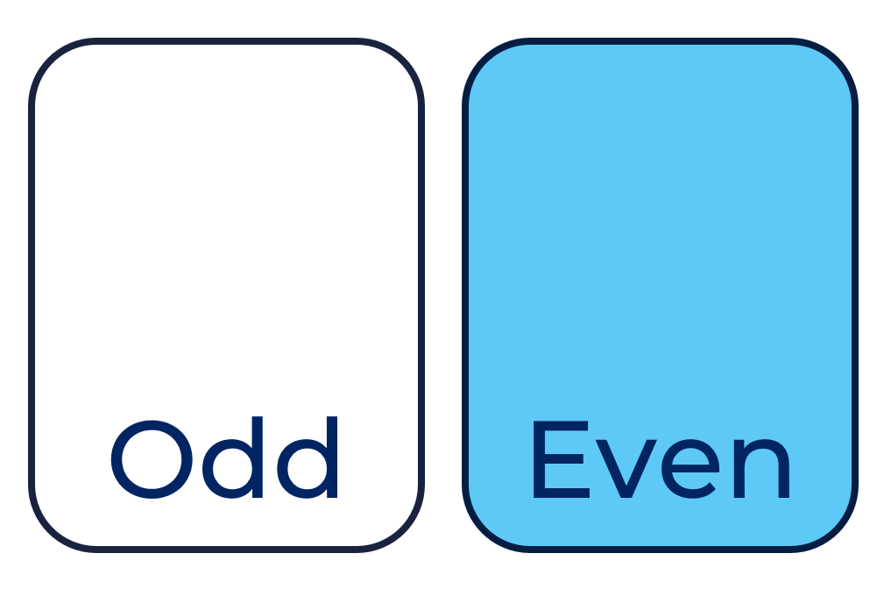
Figure 8: Odd and Even cards
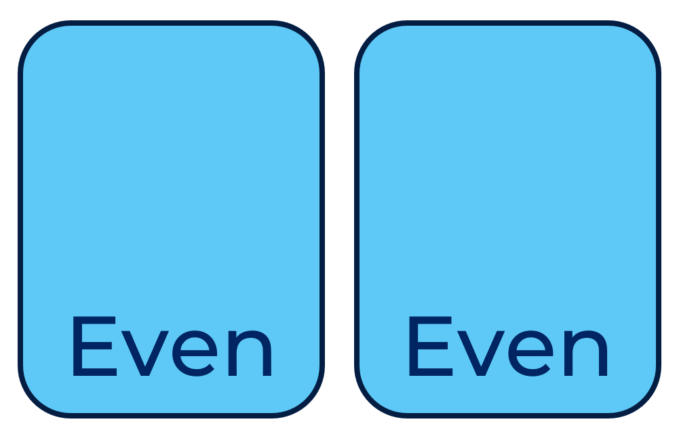
Figure 9: Even and Even cards

- Flip a card from the odd pile then a card from the even pile, ensuring the resulting two-digit number is even.
- Place the digits in the order they were generated in the positions given (tens, ones) and multiply it by the given decimal benchmark (0.5).
- Students calculate the product using a calculator, while you model the use of mental and written strategies. Display the number sentence.
Round | Expression | Example
1 | Tens, ones | 58 × 0.5 = 29
2 | Hundreds, tens × 0.5 | 580 × 0.5 = 290
3 | Thousands and hundreds × 0.5 | 5800 × 0.5 = 2900
4 | Ones, tenths × 0.5 | 5.8 × 0.5 = 2.9
- Flips a card from the even pile then a card from the odd pile, resulting in an odd two-digit number. The round is played as described in the table above.

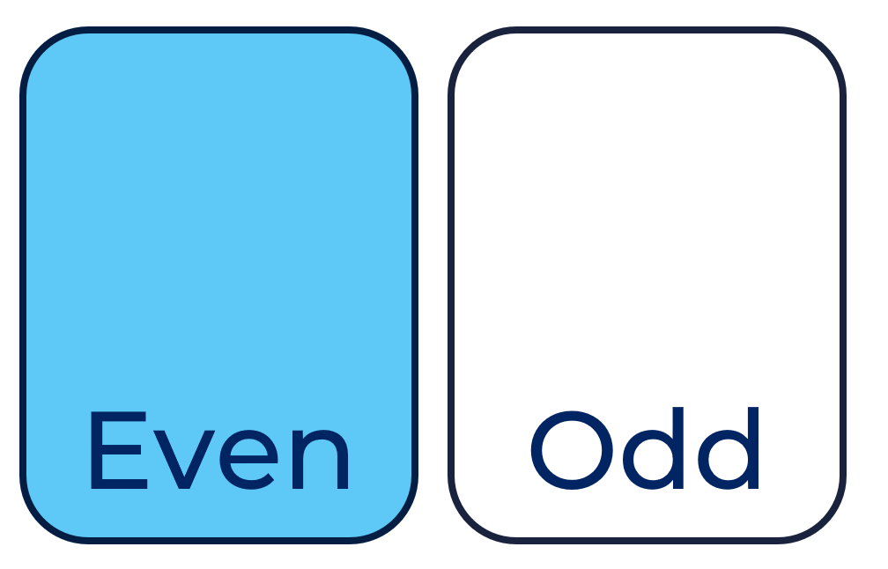
Figure 10: Even and Odd cards
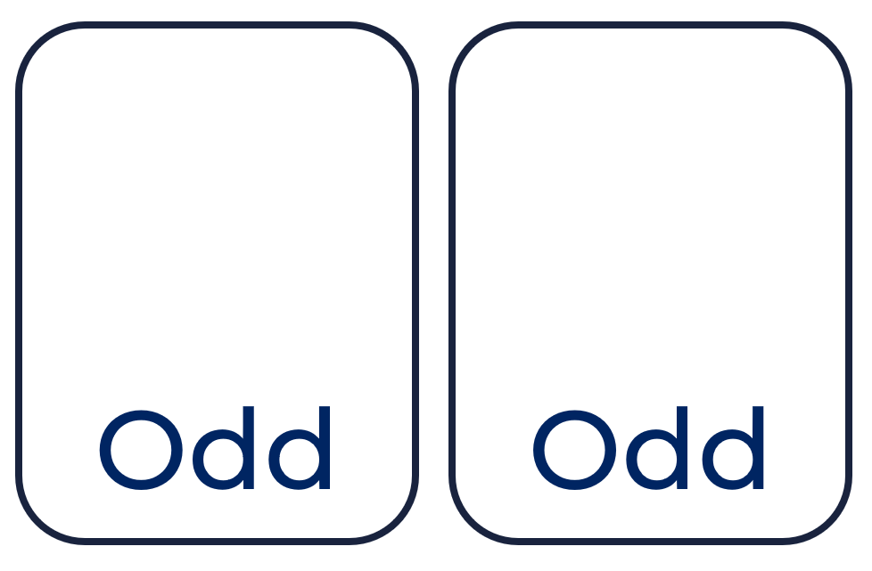
Figure 11: Odd and Odd cards

- Discuss what they noticed? Is there a pattern? Which is the most efficient strategy? Why?
- The next and subsequent rounds are played in the same way. Multiple games should be played using different digits to provide students with multiple exposures of multiplying by powers of 10 and benchmark decimals.

Round | Expression | Example
1 | Tens, ones | 65 × 0.5 = 32.5
2 | Hundreds, tens × 0.5 | 650 × 0.5 = 325
3 | Thousands and hundreds × 0.5 | 65800 × 0.5 = 32500
4 | Ones, tenths × 0.5 | 6.5 × 0.5 = 3.25
Variations
- Use other benchmark decimals such as 0.25, 0.75, 1.25, 1.75 and so on. Students need to be confident in using strategies for division with a remainder before working with the 0.25 benchmark.
- Progress to another benchmark fraction family, for example, 0.2, 0.4, 1.6.

Game 3 - beat the calculator
Students compete in small groups to solve multiplication problems using a calculator or mental and written strategies. Groups and the digits students work with can be varied according to need and capacity to work independently.
Use even number cards for students who need to reinforce working with doubles; a 10-sided die or ten frame and a word number card for those who need additional language support; or a 10-sided and a decimal card from the resource below for those more readily challenged.
Instructions
- Students form groups of 3 or 4. Each group is made up of a judge, calculator and multiplier.
- The judge:
  - rolls dice and or flips cards to create expression/equation
  - monitors calculator for accurate entering
  - determines winner of the round
- The calculator:
  - must enter each digit on a calculator and operation of the expression/equation
- The multiplier
  - uses mental or written strategies to answer the question
  - you can have more than one multiplier per group
- The judge creates an expression with dice and/or cards. The other group members calculate the answer. The first student to find the correct solution earns a point, and an additional point may be awarded for explaining their strategy.
- Students only get one chance to state the correct answer.
- The winner is the first student to win five points. Rotate roles and play another game.
Variation
- Multipliers may ‘steal’ a point from each other by explaining their solution for any round by using a different strategy, for example, in a game played with a 10-sided die and resource card ‘9.5” a round of 14 x 9 could be solved by Multiplier 1 as “fourteen groups of ten, less one group of fourteen”. Multiplier 2 can steal that point by explaining a different method “twelve 9s, and then another two 9s”.
- Extend thinking to having the calculator and multiplier explain how they would answer the question.
Teaching point: Ensure there are rich discussions around student thinking and responses. Record student thinking without using calculators. The purpose of this activity is to discover a generalised understanding for multiplication of a decimal by a decimal. This activity could be used as a catalyst for discussion in investigating decimal multiplication.
Important: Do NOT advise students to ‘move the decimal point.’ This is mathematically incorrect. The decimal point does not move. Instead, we can apply our understanding of place value and the flexibility of numbers to adjust and then re-adjust numbers to make problems more ‘user friendly’.

Investigating decimal multiplication
This task builds on the ‘Beat the calculator’ game.
Key generalisations/ what’s (some of) the mathematics?
- Mathematicians use what they know to help them solve what they don’t know yet.
- The same problem can be solved using many strategies, for example, we can use doubling, skip counting and known facts.
- Mathematicians check thinking by using an alternative way to solve the problem.
- Mathematicians use a range of representations to communicate ideas, including:
  - recording findings using words, symbols and diagrams.
Some observable behaviours you may look for/notice:
- uses a range of strategies to solve problems:
  - known facts to solve unknown problems
  - doubles and doubling strategies
  - visualises and skip counts the number of dots and may use fingers to keep track of groups/ rows
  - inverse operation
  - partitions numbers to think about problems flexibly.
- explains their chosen strategies
- refines/ extends thinking after listening to the ideas and strategies of others.
- uses various representations to share thinking:
  - drawings
  - language
  - diagrams
  - virtual manipulatives
Materials
- Something to write on/with
Instructions
- Remind students of the pattern they discovered during ‘Beat the calculator’.
- Review the relationship between fractions and decimals including in the review 0.1 and one tenth.
- With thinking partners, students discuss the meaning of multiplication, sharing their thinking with the class.
- Students think about the meaning of $0.1×0.1$ and prepare an explanation, using concrete materials, diagrams and technology to explain their thinking.
- Students share their thinking with the class, clarifying ideas and offering feedback.
- Provide time to respond to the feedback they receive before sharing their thinking again.
- Discuss the similarities with Beat the calculator.
- Have the class negotiate a class display about multiplying with decimals.

Variation
- Repeat the same process and investigate what happens with division.

The remainders game
Key generalisations/ what’s (some of) the mathematics?
- Mathematicians use what they know to help them solve what they don’t know yet.
- The same problem can be solved using many strategies, for example, we can use doubling, skip counting and known facts.
- Mathematicians check thinking by using an alternative way to solve the problem.
- Mathematicians use a range of representations to communicate ideas, including
  - recording findings using words, symbols and diagrams.
Some observable behaviours you may look for/notice:
- explain the idea of a remainder as whole number ‘left over’ from the division, for example, an incomplete group, lot of, next row or multiple).
- apply mental strategies for multiplication and division and can justify their use, for example, to divide 64 by 4, halves 64 then halves 32 to get an answer of 16.
- use multiplication and division as inverse operations to solve problems or to justify a solution.
- use estimation and rounding to check the reasonableness of products and quotients.
Materials
- Counters
- Standard deck of playing cards
- Dice
- Something to write on/with
Instructions
- Provide playing cards Ace to 9 (A = 1), a 10-sided dice and a mini whiteboard (for example) to record their game.
- Shuffle the cards and place them all face down in a central pile.
- Students take turns to roll the dice and take 2 cards from the deck to form a 2-digit number, for example, if I draw ‘4’ and ‘5’, I can choose to make ‘45’ or ‘54’.
- Students divide their number by the number they rolled, explaining their thinking to their partner who records it.
- If it cannot be evenly divided, students take a counter. The aim is to end up with the least number of counters at the end.
- Each player has 5 turns.
Teaching point: The purpose of this task is to have students solve division problems result in a whole number or have remainders. The remainders may be written as a fraction or decimal.
Ask questions such as:
- What strategy did you use to solve the problem?
- Could you use estimation? Why/why not?
- What did you notice about the numbers you were dividing?
- What does multiplication have to do with division? What is the connection?
Variations
- Students play with their cards visible so when someone cannot go, they can swap cards with another player.
- Students play with different partners
- You can play the same game dividing three- and four- digit numbers by two digits. For example:
  - 123 divided by 21
  - 469 divided by 32
  - 5176 divided by 34
  - 6831 divided 56
- Fractions - Students draw first card as the numerator second card as denominator divided by the number rolled, for example:
  - $\frac{4}{5}$ divided by 7
  - $\frac{7}{9}$ divided by 3
  - $\frac{6}{4}$ divided by 4
- Decimals - Students draw first card as the ones, second card as tenth, divided by the number rolled, for example:
  - 9.2 divided by 6

Paper folding to add and subtract fractions
Key generalisations/ what’s (some of) the mathematics?
- Mathematicians use what they know to help them solve what they don’t know yet.
- The same problem can be solved using many strategies, for example, we can use doubling, skip counting and known facts.
- Mathematicians check thinking by using an alternative way to solve the problem.
- Mathematicians use a range of representations to communicate ideas, including
  - recording findings using words, symbols and diagrams.
Some observable behaviours you may look for/notice:
- recognises dividing a whole can create equal and unequal parts
- renames fractions (one third is the same as two sixths)
- applies knowledge of related denominators (make quarters and eighths by repeated halving)
- explains how equivalent fractions are created by dividing the same-sized whole into different parts
- justifies how to find a common denominator
- uses various representations to share thinking (concrete materials, drawings, language)
Materials
- Pieces of A4 or A5 paper
- Coloured pencils or markers
- Something to write on/with
Instructions
Select the activities that suits students’ needs from the following options and variations. The activities can be used as a sequence.
- Provide 2 pieces of paper (for example, A4 or A5).
- Fold one of the pieces in half along the long axis. Use the pencils/markers to shade one half. Fold the other piece into thirds (see teaching points), folding along the short axis, then shade one third.
Tip: Students may like to draw over the fold lines on both pieces to make them more visible.
$\frac{1}{2}$
Figure 12: Example of piece of paper folded in half along the long axis, with one half shaded
$\frac{1}{3}$
Figure 13: Example of piece of paper folded into thirds along the short axis, with one third shaded

- Ask what they notice with the one half and one third.
- Students estimate how much of a whole piece (of paper) is shaded if they add the two separate shaded parts together. They may like to re-fold then lay pieces over the top of each other. Lead discussion:
  - What do they notice?
  - How are they similar?
  - How are they different?
  - How can we make the pieces of paper the same?
- Students could respond with the pieces aren’t the same length or width; the thirds piece is twice as long as the half piece is wide; the half piece is three times as long as the thirds piece is wide.
- Model folding each piece in the opposite direction to the original fold. That is, fold the halved piece along the short axis, and the thirds piece along the long axis.
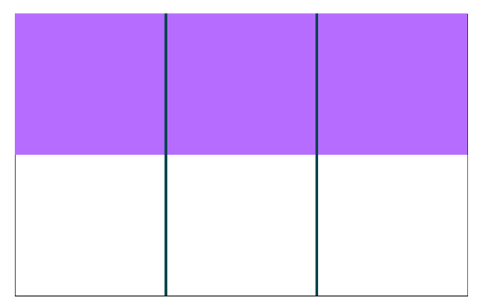$\frac{3}{6}=\frac{1}{2}$
Figure 14: Example of piece of paper folded along the short axis, with one half shaded
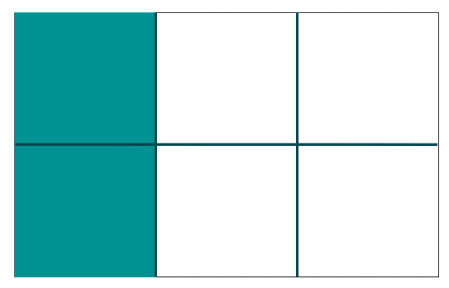$\frac{2}{6}=\frac{1}{3}$
Figure 15: Example of piece of paper folded along the long axis, with one third shaded
- Lead discussion:
  - Has the shaded area changed in either piece?
  - How many equal parts does each piece have now? What would these parts be (sixths)?
  - How many sixths is the same as one half (3 sixths)? How many sixths is the same as one third (2 sixths)?
Teaching point: Introduce the term common denominator, as a way to have the same equal-sized parts without changing the value of the parts. Discuss the meaning of the vinculum and how does having a common denominator help with adding and subtracting fractions with different denominators.
- Direct students to now attempt to add the shaded parts again. They may wish to re-fold or cut out the shaded pieces. What do they notice now?
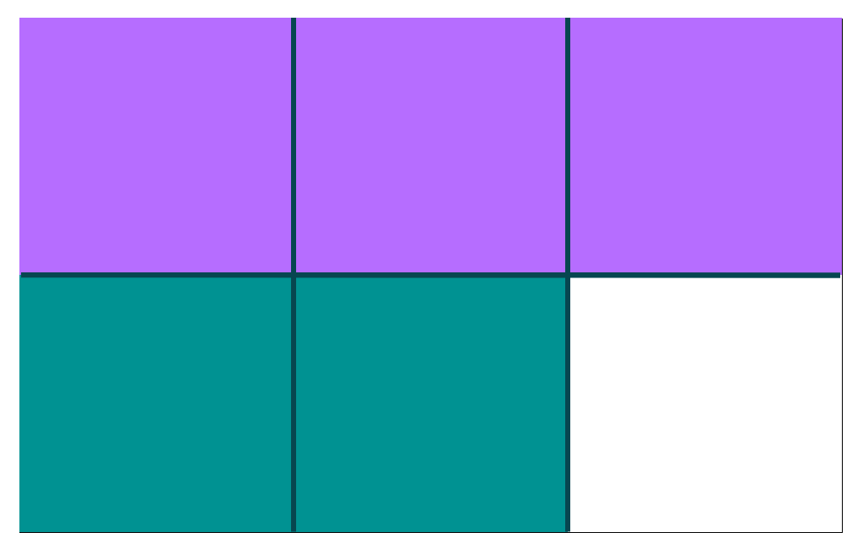$\frac{1}{2}+\frac{1}{3}=\frac{3}{6}+\frac{2}{6}=\frac{5}{6}$
Figure 16: Example of added shaded pieces
- Lead discussion of how we can see five sixths of the whole is shaded. Ask questions such as:
  - What do you notice about the denominators (in this case 2 and 3)?
  - What do you wonder?
  - Is there something we can explore?
  - What do you notice about the numerators (1 and 1)?
  - What do you wonder?
  - Is there something we can explore?
Teaching points:
Students may need several attempts to accurately fold a piece into thirds.
When we use a common denominator (sixths) we can add fractions with different denominators (halves and thirds). A common denominator allows us to add (or subtract) equal sized parts without changing the value of the parts themselves.
You may wish to explicitly link the common number under the vinculum to the fraction representation in the paper folds.
Consider learning activities from previous ‘Place value’ sections using paper folding to support student understanding of fractions. Students should be familiar with using paper to model, make and investigate fractions prior to introducing paper folding to make sense of adding and subtracting fractions, for example, students need to understand what half of an object or number mean and then what does half of a half represent?
The word ‘denominator’ stems from the word denominate, meaning to name. This information may support understanding the function of denominators being to ‘name’ the whole. ‘Numerator’ stems from the word ‘numerate’ meaning ‘to count’, informing us how many parts we have.
Did you know?: The small line used as part of fractional notation is called the vinculum. It has Latin roots and means ‘bound together’.

Variations
- Explore other problems including addition and subtraction of fractions resulting in a mixed numeral, addition and subtraction of mixed numerals, or addition and subtraction of fractions with three different denominators, for example:
  - $\frac{1}{2}+\frac{2}{3}$
  - $1\frac{1}{4}+\frac{1}{2}$
  - $1\frac{1}{3}-\frac{3}{4}$
  - $\frac{2}{3}+\frac{5}{6}+\frac{1}{2}$
- Investigate problems that explore fraction families by doubling, halving or other multiples of denominators, for example,
  - $\frac{2}{3}+\frac{5}{9}$
  - $\frac{3}{4}-\frac{1}{8}$
- Explore and have students design, other representations that support them in understanding addition and subtraction with fractions, for example, fraction walls.
- Provide pre-marked grids to shade in order to scaffold dividing wholes into parts which are difficult to fold, for example fifths and tenths (see example template below)
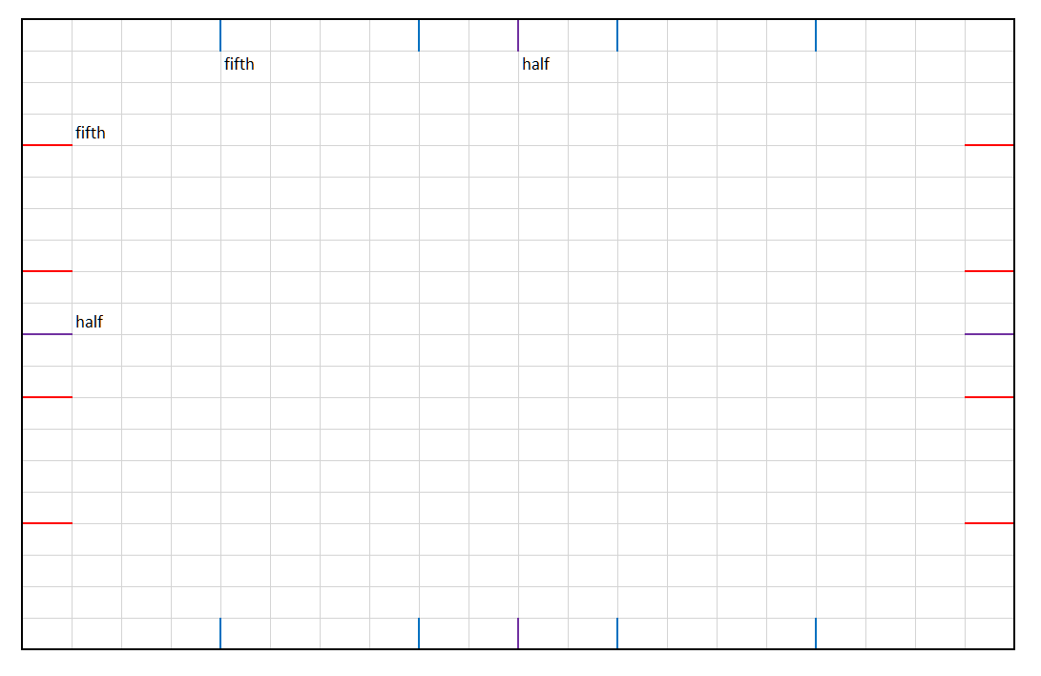
Figure 17: Pre-marked 50 x 50 grid, with half, fifth and tenths

Hex
Key generalisations/ what’s (some of) the mathematics?
- Mathematicians use what they know to help them solve what they don’t know yet.
- The same problem can be solved using many strategies, for example, we can use doubling, skip counting and known facts.
- Mathematicians check thinking by using an alternative way to solve the problem.
- Mathematicians use a range of representations to communicate ideas, including:
  - recording findings using words, symbols and diagrams.
Some observable behaviours you may look for/notice:
- apply mental strategies for multiplication and division and can justify their use, for example, to divide 64 by 4, halves 64 then halves 32 to get an answer of 16
- use multiplication and division as inverse operations to solve problems or to justify a solution
- describe the effect of multiplication by a decimal or fraction less than one. This effect is that the resulting product is less than the largest factor, for example, when multiplying whole numbers by a fraction or decimal less than 1 such as
  - 15×0.5 =7.5
- connect and convert decimals to fractions to assist in mental computation involving multiplication or division, for example, to calculate 16×0.25, recognises 0.25 as a quarter, and determines a quarter of 16 or determines 0.5÷0.25, by reading this as one half, how many quarters and giving the answer as 2.
Materials
- Hex resource
- Coloured counters
- Calculator
- Tools to record thinking, such as paper and pencils
Instructions
- Provide pairs of students with one game board between 2 teams (a team can be one or 2 students), coloured counters (individual teams need the same colour counter) and a calculator.
- Teams take turns to pick any two numbers in the cloud, stating the two they have chosen. Teams must choose different numbers, for example, a student pair choose 20 and 75.
- Students then decide to divide the numbers chosen 20÷75 or 75÷20
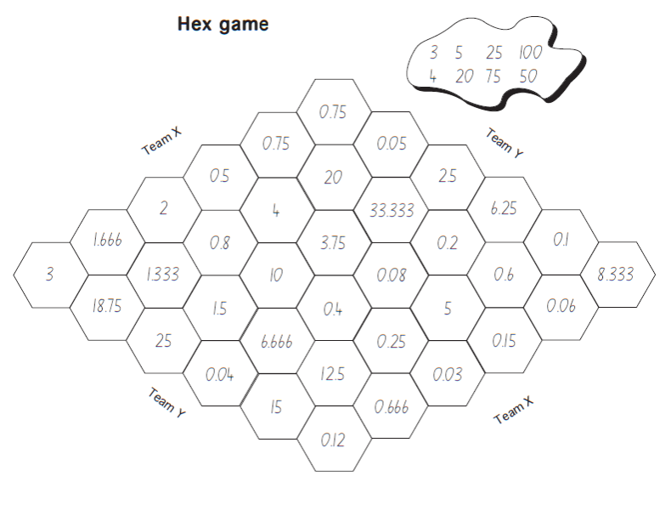
- If the answer is on the game board, the team places a counter on it and then decide which path they want to complete, for example, start from the left side of the game and choose to complete numbers across the board horizontally, vertically or diagonally.
- The first team to get a path of answers connecting its two opposite sides of the game board wins.
- Repeat in pairs with different number options.
Teaching point: The purpose of this task is to have students predict the answer to a multiplication or division question and verify their answer on the calculator.
- Ask questions such as:
  - Why did you choose those numbers?
  - What strategy did you choose to solve the problem/question?
  - Why did you choose that strategy to work out the problem/question?
  - What knowledge would you need to solve decimal problems/questions?
Variations
- When the team predicts their answer, the other team checks on the calculator. If the prediction is incorrect the second team gets to place their counter on the correct answer.
- Play the Hex decimal version (see resource).
- Include negative numbers in the game achieved through taking the difference of two numbers where the number subtracted is greater than the starting number.
- This game can be adapted to support more complex ideas such as multiplying and dividing algebraic terms.

Resource section

5 x 5 bingo board

Estimate me
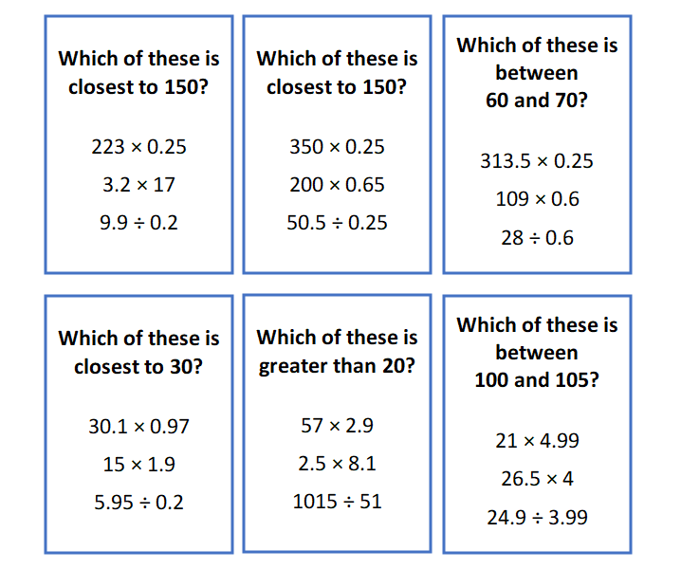

10 x 10 grids

Decimal sort
Table 1 Decimal sort for printing
Decimal sort
0.34 | 0.086 | 0.123
0.05 | 0.245 | 0.8
0.756 | 0.4 | 0.710
0.405 | 0.9 | 0.098
0.43 | 0.050 | 0.505
0.87 | 0.099 | 0.1
0.012 | 0.083 | 0.72

Beat the calculator
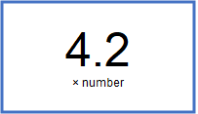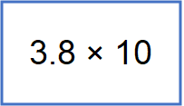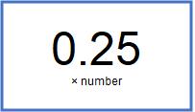

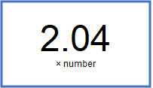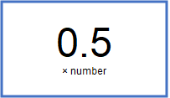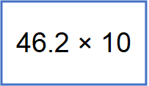

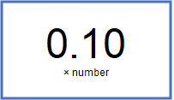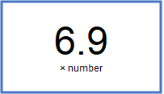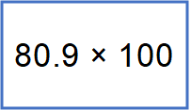

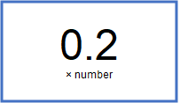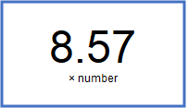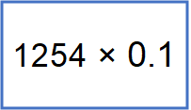

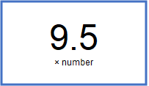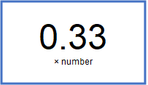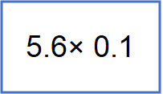

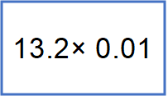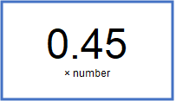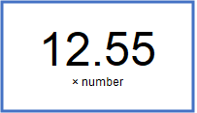

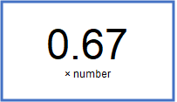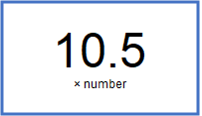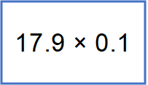

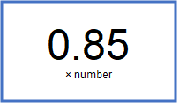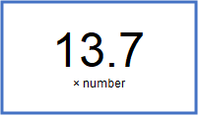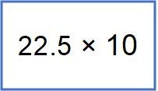

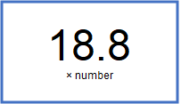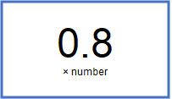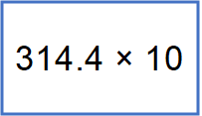

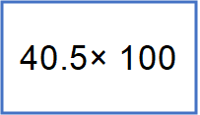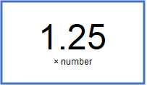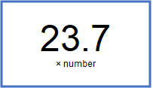

Hex
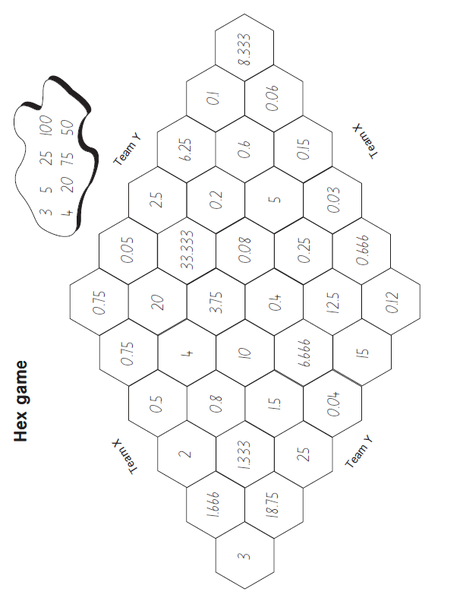

Decimal hex
Using only these numbers, choose any two, a multiply or divide them to find the hexagon which contains the answer.