Part 3: Flexible strategies with multi-digit numbers

About the resource
This resource is the third section of a 4-part resource supporting multiplicative thinking.
- Part 1: Sharing and forming equal groups
- Part 2: Flexible strategies with single-digit numbers
- Part 3: Flexible strategies with multi-digit numbers
- Part 4: Flexible strategies with rational numbers
Like most things in mathematics, talking about multiplicative thinking is hard to do without referring to other aspects such as patterning, subitising (and visual recognition), counting (with understanding), number sense, measurement and statistics. This resource is best used in conjunction with other guides to support a connected network of critical mathematical concepts, skills and understanding. Students understanding about how numbers and operations work is a critical part of developing deep, meaningful mathematical skills, understanding and confidence.
Continued learning of pattern and structures, number knowledge (including place value understanding) and counting (with understanding) is vital in supporting continued development of number sense. Additionally, support students in developing rich, meaningful understanding of how the operations work in order to support their skills in working flexibly with numbers. Provide opportunities to compare strategies and contexts, explore situations when particular strategies are efficient and when they are not as efficient. Remember, efficiency is connected to the confidence and knowledge of individuals. Building representational fluency is important in supporting meaning-making about the operations and how numbers work.
Students at this stage of learning require targeted teaching in the form of investigations and meaningful, low-stress practice to enhance and solidify their understanding and use flexible strategies in increasingly complex contexts. Validate the different strategies students invent and use, using individual thinking to cultivate a culture of communication, thinking and reasoning.

The nature of the learner
Students tend to progress through a number of broad phases of learning as multiplicative thinking develops. Before multiplicative thinking can be developed, students usually need to have a deep understanding of the principles of counting, including the cardinal and order-irrelevance principles. This means students need to be able to count collections of items, knowing the last number word tells us how many, as well as knowing the order in which you count a collection of objects does not change the total. Students also need to know collections can be rearranged and partitioned without changing the total. These understandings are part of ‘trusting the count’ and form a crucial foundation for multiplicative thinking.
When students ‘trust the count’, they can take advantage of equal groups, using more efficient counting strategies. Students using multiplication and division grouping strategies are capable of ‘double counting’. This means a student is able to keep track of multiple sequences at the same time as keeping track of the number of groups, without relying on materials or markers to represent the groups. It is important to note using counting and dealing strategies to solve problems are additive strategies, limited by a student’s fluency with the counting sequences and the size of a collection to be shared.
Students at this stage of learning are working towards developing an increasingly sophisticated idea of composite units, learning to coordinate the number of groups (multiplier), the number in each group (multiplicand) and the total (product). They are learning to represent and describe multiplicative situations, moving from over relying on the need from items to visualising composite units.
As students continue in their learning, they need to be supported in focusing on the multidimensionality of multiplicative situations, understanding how to:
- to move flexibly between multiplication and division, using the inverse operations to help them solve problems
- to fluently coordinate the number of groups (multiplier), the number in each group (multiplicand) and the total (product), realising missing information determines whether the situation requires multiplication or division to be used to find a solution
- to apply part-part-whole reasoning to composite units
- to use known facts to work out the unknown
- multiplication and division can be used in a wide range of situations, some of which are not easy to ‘see’ as multiplicative
- to use manipulatives, vocabulary and diagrams to communicate mathematically
- to apply the commutative, associative and distributive properties to solve problems, knowing how and when these properties are useful and when they are not.
Moving from additive to multiplicative thinking is an important stage in learning and should be navigated carefully. Thinking strategically to solve problems (considering the context, the numbers and the operations), takes time. Equating mathematical competence with speed sends potentially negative messages about what skills are most valued within mathematics. Valuing and expecting quick recall can also impair learning. use, using individual thinking to cultivate a culture of communication, thinking and reasoning.
The resource has been developed in partnership with the NSW Mathematics Strategy Professional Learning team, Curriculum Early Years and Primary Learners, and Literacy and Numeracy.

How to use the resource
Use assessment information to make decisions about when and how you use this resource as you design teaching and learning sequences to meet the learning needs of your students.
The tasks and information in the resource includes explicit teaching, high expectations, effective feedback and assessment and can be embedded in the teaching and learning cycle.
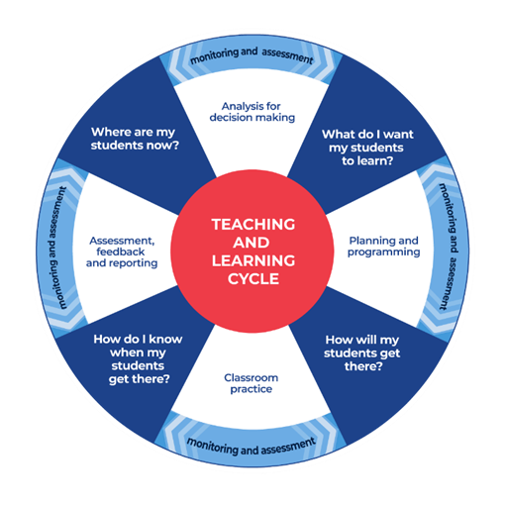
Where are my students now? Use a range of assessment information to determine what students know and can do, including their interests, learning strengths and needs.
What do I want my students to learn? Use the information gathered along with the syllabus and National Numeracy Learning Progression to determine the next steps for learning. You might also like to look at the ‘what’s some of the maths’ and ‘key generalisations’ to synthesise the information you have gathered into the next step/s for learning.
How will my students get there? Use the task overview information (‘What does it promote?’ and ‘What other tasks can I make connections to?’) to find tasks that meet the learning needs of students. Make decisions about what instructional practices and lesson structures to use to best support student learning. Further support with What works best in practice is available.
How do I know when my students get there? Use the section ‘Some observable behaviours you may look for/notice’ for each task as a springboard for what to look for. These ideas can be used to co-construct success criteria and modified to suit the learning needs, abilities and interests of students. Referring to the syllabus and the National Numeracy Learning Progression are also helpful in determining student learning progress as well as monitoring student thinking during the task. The information gained will inform ‘where are my students now’ and ‘what do I want them to learn’ as part of the iterative nature of the teaching and learning cycle.

Syllabus
MA1-RWN-01 applies an understanding of place value and the role of zero to read, write and order two- and three-digit numbers
MA1-RWN-02 reasons about representations of whole numbers to 1000, partitioning numbers to use and record quantity values
MA1-FG-01 uses number bonds and the relationship between addition and subtraction to solve problems involving partitioning
MA1-GM-03 creates and recognises halves, quarters and eighths as part measures of a whole length
MA1-2DS-01 recognises, describes and represents shapes including quadrilaterals and other common polygons
MA1-2DS-02 measures and compares areas using uniform informal units in rows and columns
NSW Mathematics K-2 Syllabus (2022)
MA2-1WM uses appropriate terminology to describe, and symbols to represent, mathematical ideas
MA2-2WM selects and uses appropriate mental or written strategies, or technology, to solve problems
MA2-3WM checks the accuracy of a statement and explains the reasoning used
MA2-6NA uses mental and informal written strategies for multiplication and division
MA2-7NA represents, models and compares commonly used fractions and decimals
MA2-15MG manipulates, identifies and sketches two-dimensional shapes, including special quadrilaterals, and describes their features
NSW Mathematics K-10 Syllabus (2012)

Progression
Number and place value NPV4-NPV6
Counting processes CPr3-CPr7
Multiplicative thinking MuS1-MuS7
Interpreting fractions InF1-InF5
Understanding units of measure UuM3-UuM5
National Numeracy Learning Progression Version 3

Overview of tasks
Task name | What does it promote? | What materials will I need? | Possible group size
Doubling and halving 2-digit numbers | Explores the concept of doubling and halving 2-digit numbers through visualising and using manipulatives alongside place value understanding. | Multibase arithmetic blocks, and/ or ice cream sticks, something to write on, something to write with, a 6-sided dice, a spinner showing ‘double’ and ‘halve’ | Whole class  Pairs
Repeated doubling | Encourages students to explore ways of thinking and develop fluency when doubling. | Gameboard, counters (of the same colour), 6-sided dice, repeated doubling spinner | Whole class  Pairs
Making landmark numbers: renaming for multiplication | Supports students in understanding the connections between strategies, for example, making landmark numbers is the same as using their knowledge of fives facts to derive sixes. | Multibase arithmetic blocks, something to write on, something to write with | Whole class  Pairs
Understanding the area method | The area method supports students in using place value parts to work out a solution, extending basic number facts and modelling the distributive property. | A range of manipulatives,  sticky notes, something to write with | Whole class  Small group
If I know… | Deriving facts helps students build number sense, looking for and using the relationships between numbers and operations. Deriving the unknown from the known teaches problem solving strategies as well as requiring logical thinking, skills critical to the development of numeracy. | Something to write on, something to write with | Whole class  Small group
Finding factors | Knowing factors enables students to manipulate numbers to make problems easier to solve. | 24 counters, something to write on, something to write with | Pairs
Investigating more factors | Knowing factors enables students to manipulate numbers to make problems easier to solve | 24 centicubes, something to write on, something to write with | Whole class  Small group
Using related facts | Encourages students to understand there are a number of ways related facts can be used to solve division and multiplication problems and shows how flexibly students can think about solving problems. | Something to write on, something to write with, a range of manipulatives | Whole class  Small group
Leftovers | Supports students’ understanding of remainders and fair share situations. | Something to write on, something to write with | Pairs
How many ways can they be related? | Part of developing efficient mental computation and strong number sense involves seeing how any pair of numbers can be related in a vast number of ways. | Something to write on, something to write with | Whole class
Patterns of divisibility | Noticing and using some of the patterns that exist when dividing, can provide a useful starting point for solving some problems. Rather than introducing these patterns as ‘rules’, design inquiries for students to investigate, noticing and testing generalisations and how useful they are in solving division problems. | Something to write on, something to write with | Whole class  Small group
Dividing by partitioning the dividend (using the distributive property) | Encourage students to explore the concept of the distributive property. | A variety of manipulatives, something to write on, something to write with | Whole class  Small group
Factorising | Having familiarity with factors and multiples, as well as understanding of the difference between them, supports students to factorising to solve problems. | Something to write on, something to write with | Pairs
Flip 3 | Encourages students to think flexibly and strategically when multiplying three single digit numbers. | Playing cards A – 9 (A = 1), something to write on, something to write with | Pairs
Dividing by factorising | Supports students to explore the concept of dividing by factorising. | Manipulatives, something to write on, something to write with | Whole class  Small group
Estimate me | Encourages students to explore various ways they can use estimation to determine the reasonableness of multiplicative solutions. | Something to write on, something to write with | Whole class  pairs
What’s in a remainder? | Supports students’ understanding of remainders and fair share situations. | Manipulatives, something to write on, something to write with | Whole class  Small group
Divide me this | Supports students’ fluency and understanding of factor-factor-product relationships and operating with division. | Playing cards A-9, something to write on, something to write with | Pairs
Which would you work out in your head | Encourages students to critique different strategies and problem situations. | something to write on, something to write with | Whole class  Pairs
Target number | Encourage students to develop fluency with multiplicative situations. | Playing cards A – 9, recording sheet | Pairs
Investigating written methods for multiplication | Supports students to explore and make sense of written multiplication methods. | Something to write on, something to write with, | Whole class  Small group
Investigating written methods of division | Supports students to explore and make sense of written division methods. | Range of manipulatives,  something to write on, something to write with | Whole class  Small group
Doubling and halving – a number talk | Encourages students to explore the relationship between doubling and halving. | Scissors, plain paper, grid paper or dot paper, device to watch the videos, something to write on/with. | Whole class  Small group
Let’s investigate 2 – 15 x 9 | Encourages students to think about efficiency in representing multiplicative situations. | Device to watch the videos, something to write on/with. | Whole class
Fewest squares | Encourages students to explore and make sense of square numbers. | Grid paper, different coloured markers or pencils, device to watch the videos | Pairs
Jump! What if? | Encourages students to think multiplicatively about times as many scenarios. | Measuring tools. device to watch the videos, something to write on/with. | Pairs  Whole class
Super shapes | Encourages students to solve multiplicative problems where the product is known. | Super shapes resource, device to watch the videos, something to write on/with. | Pairs  Whole class
Colour in fractions | Encourages students to explore equivalence in the context of fractions. | Colour in fractions spinner 1, colour in fraction spinner 2, gameboard, coloured pencils or markers, device to watch the video | Pairs
Imagining fractions | Encourages students to use visualsation and flexible strategies when combining fractions. | Device to watch the videos, something to write on/with. | Whole class

Tasks

Doubling and halving 2-digit numbers
Key generalisations/ what’s (some of) the mathematics?
- We can use various strategies to solve the same problem such as:
- partitioning
- renaming
- using known facts
- We can rename numbers in place value parts, for example, 34 can be renamed as 3 tens and 4 ones.
- We can use the distributive property to think strategically and flexibly to solve problems, for example, to double 34 we can rename it as 3 tens and 4 ones. Then double 3 tens which is 6 tens, 60 and double the 4 ones, which is 8. 60 and 8 is 68.
- Mathematicians use what they know to solve what they do not know yet.
- Mathematicians use representations such as drawings, diagrams, gestures, and objects to share their thinking.
Some observable behaviours you may look for/notice:
- uses a range of strategies to solve problems:
- uses known facts to solve unknown problems
- uses inverse operations
- uses doubles and doubling and halving strategies
- uses known mental and written strategies such as using the distributive property (for example, 7 x 83 equals 7 x 80 plus 7 x 3)
- uses various representations to share thinking:
- concrete materials
- drawings
- language
- diagrams
Materials
- Materials such as multibase arithmetic blocks, ice cream sticks.
- 6-sided dice
- Spinner showing ‘double’ and ‘halve’ (refer to Appendix 1)
- Something to write on/with
Instructions
- Discuss how to use doubling strategies for 2-digit numbers that do not have to be re-grouped and re-named, for example, co-construct a representation of 34 using multibase arithmetic blocks or ice cream sticks - ask students to imagine what it might look like if we doubled 34.
- Cover the representation and ask students to draw what double 34 might look like, sharing their thinking with a partner.
- Purposefully sequence and select students to share their thinking.
- Support students to use the structure of place value to aid computation and communication, for example: ‘I doubled 3 tens to make 6 tens. We call 6 tens sixty. Then, I doubled 1 four to make 2 fours which is 8. 60 and 8 is 68 in total.’
- Discuss how to halve 2-digit numbers, using the same process but starting with the product, for example, show a representation of 48 and ask them to think about what 48 would look like if we halved it, for example, ‘Half of 4 tens is 2 tens which we call twenty. Half of 8 is 4. 20 and 4 is 24 in total’.
- In pairs, students take turns to roll the dice to form a 2-digit number and spin the spinner to determine if the number has to be doubled or halved. Students draw a representation of the solution and prove and justify their thinking to their partner by modelling or drawing.

Repeated doubling
Key generalisations/ what’s (some of) the mathematics?
- We can use what we know about doubling and halving to make strategic decisions to reach a target number.
- Mathematicians use what they know to solve what they do not know yet.
- We can use various strategies to solve the same problem such as:
- known facts
- landmark numbers
- the relationship between numbers
- We can think about numbers flexibly to solve problems.
- Mathematicians explain their thinking, so it makes sense to others.
- Mathematicians listen to other people’s thinking to become aware of other strategies and make sense of the ideas of others.
- Games provide us with a meaningful opportunity to practise our mathematical skills and understanding.
- Mathematicians strategise by using their knowledge of numbers and operations to improve their chances of winning a game
Some observable behaviours you may look for/notice:
- uses foundational doubles facts which support problem solving
- uses known mental and written strategies such as using the distributive property (for example, 7 x 83 equals 7 x 80 plus 7 x 3)
- uses a range of strategies to solve problems:
- uses known facts to solve unknown problems
- uses doubles and doubling strategies.
Materials
- Gameboard (refer to Appendix 2)
- Counters (of the same colour)
- 6-sided dice
- Spinner (refer to Appendix 2)
Instructions
- Players take turns to roll the dice and spin the spinner to work out the product, explaining their thinking to their partner.
- Partners records thinking and if they agree, the first player places a counter on the number on the game board, claiming that place.
- If the number is taken, players miss a turn.
- A player wins by getting 4 counters in a row (in any orientation).
- Players need to choose which counter to move once all 4 counters are on the game board
Variations
- Use a 0-9 or 1-10 die and change the game board accordingly
- Play the Repeated halving version using the gameboard and spinner
Teaching point: Repeated doubling is a form of factorising. Problems such as 21 x 4 can be written as 21 x 2 x 2 (where the 4 is factorised). 21 x 8 can be written as 21 x 2 x 4 as well as 21 x 2 x 2 x 2 and in this case, the 8 is factorised into 4 and 2 and then the 4 is further factorised into 2 and 2. Decide when it is best to introduce this connection, exploring the validity of number sentences such as ’21 x 8 = 21 x 4 x 2 = 21 x 2 x 2 x2 = double 21 three times’. Explore whether the position we write the numbers changes the outcome.

Making landmark numbers: renaming for multiplication
Key generalisations/ what’s (some of) the mathematics?
- We can use what we know about numbers to solve what we don’t know yet. We can use what we know about:
- known facts
- using landmark numbers (sometimes called benchmark numbers, multiples of 10)
- landmark numbers
- the relationship between numbers.
- Numbers can be renamed in place value parts, for example, 70 can be renamed as 7 tens.
- We can apply our place value understanding to regroup, rename, partition and rearrange numbers to solve problems.
- Mathematicians use what they know to solve what they don’t know yet
- We can think about numbers flexibly to solve problems.
- Different people see and think about numbers and problems in different ways.
- Mathematicians use representations such as drawings, diagrams, gestures, and objects to share their thinking.
Some observable behaviours you may look for/notice:
- uses landmark or benchmark numbers (multiples of five and ten)
- recognises and uses arrays to model the commutative property of multiplication
- uses materials and models to represent equivalence and the commutative property of multiplication
- refines/ extends thinking after listening to the ideas and strategies of others
- uses known multiples in calculating related multiples.

Materials
- Connecting blocks
- Something to write on/with
Instructions
- Discuss how many of the strategies used to solve addition and subtraction problems can also be used to solve multiplication and division problems. In the same way we can build ‘landmark numbers’, you can solve multiplication problems by adjusting the multiplier or the multiplicand.
Teaching point: Landmark numbers, sometimes referred to as ‘friendly’ numbers are numbers that reduce the cognitive load on the brain, to support the feeling for individuals they are working with numbers that feel familiar and comfortable.
- Pose the problem 4 x 29, representing it using manipulative such as connecting blocks
- Discuss that 4 twenty-nines is not a fact we may know straight away but we can use landmark numbers to solve the problem.
- In pairs, students discuss which number they would adjust and how they would adjust it.
- Purposefully select students to support in the discussion of how you could add one to each of the 4 groups of twenty-nine to create 4 thirties (4x30), modelling how to change your representation by adding an additional ‘one’ to each collection of 29 (using a coloured connecting ones or a counter so it can be removed later).
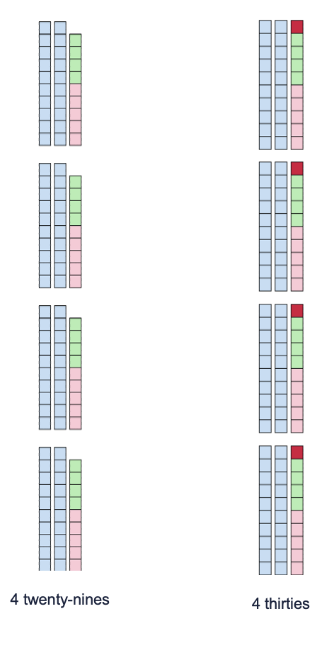
- Ask ‘What known facts (or other strategies) they could use now to solve 4 thirties or 4 x 30, sharing with a thinking partner before discussing with the class. Options could include:
- I know 4 threes is 12 so 4 thirties is 12 tens which we rename as 120
- I know 4 thirties is equivalent to 30 fours. So, 20 fours is 80 and 10 fours is 40. Together, 80 and 40 equals 120
- 4 x 30 = 2 x 30 + 2 x 30. 2 thirties is 60. 60 + 60 = 120.
- Ask ‘As we have worked out 4 thirties, we now need to readjust to work out 4 twenty-nines’
- Ask ‘Since we added 1 to each group, we now need to remove the 4 ones’. Co-construct how to do this using the representation, explaining 120 minus 4 is equivalent to 116.
- Ask ‘Is there another way, we could have adjusted the numbers?’ eliciting the idea 5 could be adjusted to make the problem 5 twenty nines, then to work out 5 twenty-nines, multiple by ten and halve the solution. So, 10 x twenty-nines is 290. Half of 290 is 145. Then remove 1 twenty-nine. 145 – 29 = 146 – 30 which is equivalent to 116.
Teaching points:
We often use a combination of strategies to solve problems. It is crucial to support understanding of the connections between strategies, for example, making landmark numbers is the same as using their knowledge of tens facts to derive nines.
The way we name numbers and multiplicative situations can significantly aid comprehension. ‘4 twenty-nines’ may make more sense than 4 times twenty-nine’ and ‘4 x 29’. This way of naming supports students in coordinating what has been adjusted – the multiplier or the multiplicand, and by how much.

Understanding the area method
Key generalisations/ what’s (some of) the mathematics?
- Mathematicians use various models to communicate their thinking efficiently, for example, we can use an area model to represent 21 fives instead of creating representations with manipulatives.
- We can use mathematical models to represent how different people think about solving problems, for example, an area model can show how we can solve 21 x 5 by halving 21 x 10.
- We can think about numbers flexibly to solve problems.
- Different people see and think about numbers and problems in different ways.
- Listening to other people’s thinking helps us become aware of other viewpoints, building our knowledge of mathematics.
Some observable behaviours you may look for/notice:
- explores the relationship between division and multiplication using arrays and area models
- equally partitions areas of shapes to think about problems flexibly
Materials
- A range of manipulatives, for example, multibase arithmetic blocks, square counters, connecting blocks or array paper.
- Sticky notes
- Something to write with

Teaching point: The area model builds on from understanding of arrays, regions and using materials such as multibase arithmetic blocks to model problems. It provides a strong visual method of communicating thinking. and can also be used as a method for solving problems (referred to as the area method). In both cases, the length and width of the rectangle represent the factors and the area represents the product.
Instructions
- Pose a problem such as 21 x 5. (The problem should be large enough to represent using materials but time consuming).
- Students create a model representing 21 fives using manipulatives. Students label their representations with sticky notes and share their representations with the class by going on a gallery walk (see teaching point below).
- In pairs, students discuss how long it took to make each of the representations and consider if there may be a more efficient way to represent 21 x 5. Share ideas with the class and elicit thinking such as:
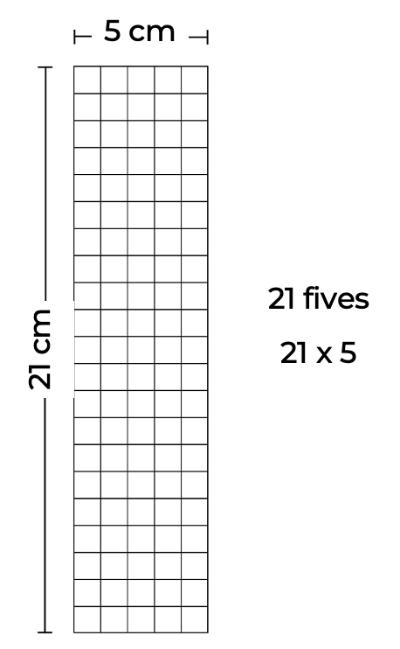
- Make/ draw student suggestions. If not elicited, suggest we could also simply draw a rectangle and if each side is labelled appropriately, we can say our rectangle now represents all the models the students made.
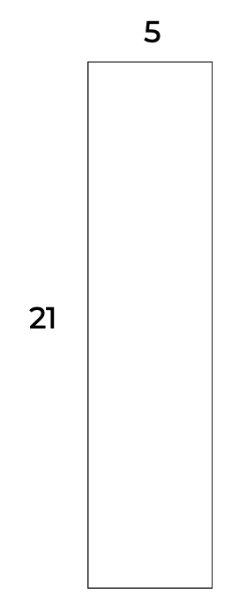
- Tell students this is sometimes called the area model. Ask students to discuss why they think it was given that name, drawing out the link between multiplication and area.
- Tell students this model can be used to represent how different people thought about solving 21 fives. Ask them to consider how they could use the manipulatives to check the product of 21 x 5 is 105.
- Students share their thinking and representations. Record each strategy using the area model to represent the strategies shared.
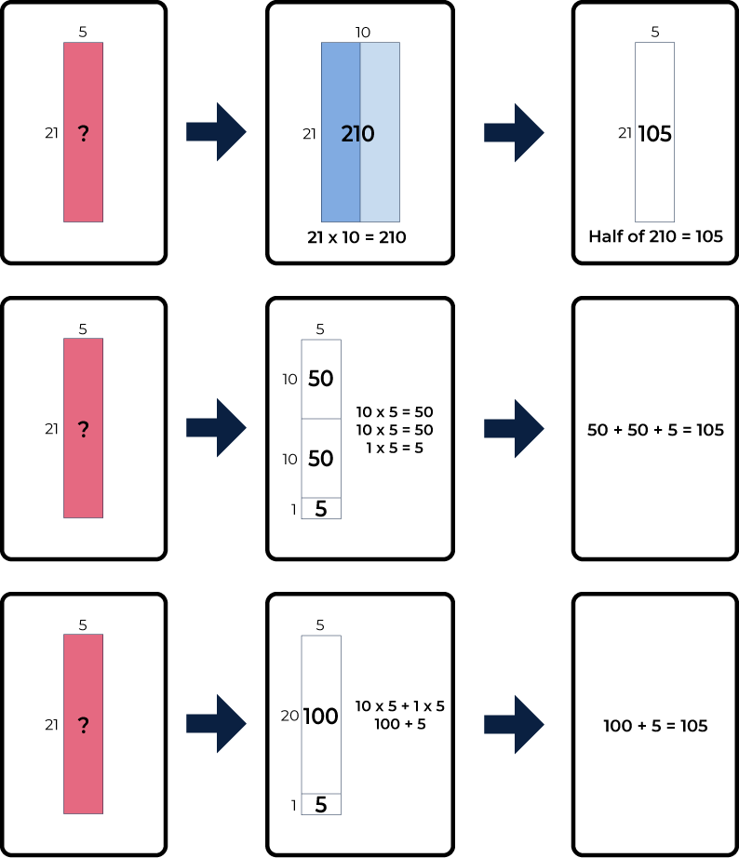
- Check each time the diagram created matches their thinking, refining as required.
Variations
- Increase the size of the problem in order to see the need for more efficient methods of representation
- Explore how to use the area method to solve problems.
Teaching points:
Understanding the diagrams we use for mathematics is not always as natural as we assume. Explicitly teaching the connection between concrete representations and diagrams, supports students in moving towards more abstract thinking and communicating. The area method supports students in using place value parts to work out a solution, extending basic number facts and modelling the distributive property.
‘Gallery walks’ are a classroom strategy allowing students to share their thinking with their peers. Lead students on a walk around the room to observe and respond to the work of others. This allows students to leave their materials where they were working, sharing their thinking as the ‘tour’ comes to their section of the room.

If I know…
Key generalisations/ what’s (some of) the mathematics?
- We can think about numbers flexibly to solve problems.
- Mathematicians use what they know to help them solve what they don’t know straight away or yet.
- When solving problems, we can use what we know about:
- known facts
- landmark numbers
- renaming numbers
- relationships between numbers, properties and the operations.
- Mathematicians use representations such as drawings, diagrams, gestures, and objects to share their thinking
- Different people see and think about numbers and problems in different ways.
Some observable behaviours you may look for/notice:
- uses estimation and rounding to check the reasonableness of products and quotients
- demonstrates flexibility in the use of single-digit multiplication facts with decimals
- uses mental strategies for multiplication and can justify their use
- uses commutative and distributive properties of multiplication when solving problems
Teaching point: Deriving facts helps build number sense, looking for and using the relationships between numbers and operations. Deriving the unknown from the known teaches problem solving strategies as well as requiring logical thinking, skills critical to the development of numeracy.
Materials
- Something to write on/with
Instructions
- Share a known fact such as ‘4 x 10 (4 tens) is equivalent to 40’. Ask students if they agree with this statement.
- Students work with a thinking partner to consider what other facts they can derive by knowing 4 x 10 = 40 and record their thinking, for example, ‘From 4 x 10 = 40 I knew I could also work out 4 x 20 is 80 as 20 is double 10 and 80 is double 40’.
- Select and sequence students to share with the class the derived facts they worked out.
- Record student thinking and support them to explain their thinking clearly by offering appropriate language and asking clarifying questions as required, for example: Because 4 x 10 (4 tens) is equivalent to 40, I also know that:
- 10 x 4 = 40, 40 ÷ 10 = 4 and 40 ÷ 4 = 10. I know that because these are all related facts. I can prove my thinking using a 4 x 10 array.
- 2 x 20 = 40. I know that because when you halve one number and double the other the product remains the same.
- 8 x 5 = 40 is another number fact we could derive using the same strategy of doubling and halving. This is called the associative property.
- 40 x 10 = 400. I know that because I can use my understanding of place value. 4 tens x ten is 4 tens ten. We rename 10 tens to say 1 hundred. Therefore, 4 ten tens is 400.
- I could also use place value to derive 4 x 100 = 400, 40 x 100 = 4000, 4 x 1 = 4, 4 x 0.1 = 0.4.
- 4 x 11 = 44. I know that because 4 tens is 40. One more group of 4 is 44 in total.
Variations
- Ask slightly different questions, for example, ‘How could knowing 4 x 10 = 40 help someone work out 4 x 19?’
- Post sharing and selecting students thinking about derived facts. Discuss, organise and record the strategies used by students in a table. An example appears below.
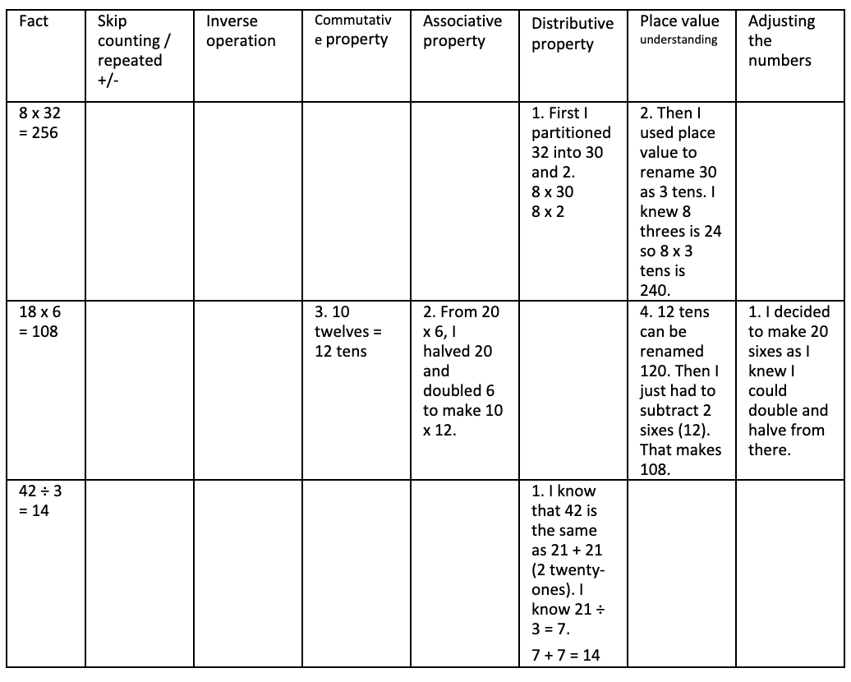
- Ask students to create representations to support meaning-making.
- Investigate how various strategies for deriving solutions work with division as well as making comparisons to addition and subtraction.
Teaching points:
Notice and record the properties students make use of and at what point their knowledge is exhausted, for example:
- Do they simply record the inverse operation?
- Do they include division facts for a question using multiplication?
- Do they apply place value knowledge?
- Do they use meaningful representations to explain their thinking?
Knowing number facts matters, as one cannot derive an answer to a problem without a starting point. The tasks and assessment strategies teachers design, and implement is of equal importance. Fixed likeability groups and valuing speed of recall can have significant negative outcomes on students’ understanding of what it means to be numerate, their self-confidence and development of mathematical skills. Known facts matter but they are of no greater importance than the learning environment in which known facts are fostered and applied.

Finding factors
Key generalisations/ what’s (some of) the mathematics?
- We can use various strategies to solve the same problem such as:
- visualising
- estimating
- renaming
- using known facts.
- Arrays can look different but be equivalent in total. The product can remain the same but the number of groups and the number in each group is different.
- Mathematicians use mathematical language/ vocabulary to communicate accurately and precisely to others.
- Mathematicians use what they know to help them solve what they don’t know yet.
- We can think about numbers flexibly to solve problems.
- Mathematicians listen to other people’s thinking to become aware of other strategies and build knowledge of mathematics.
Some observable behaviours you may look for/notice
- uses a range of strategies to solve problems:
- known facts to solve unknown problems
- doubles and doubling strategies
- visualises and skip counts the number of dots and may use fingers to keep track of groups/ rows
- partitions numbers to think about problems flexibly.
- explains their chosen strategies
- refines/ extends thinking after listening to the ideas and strategies of others
- recognises and uses arrays to model the commutative property of multiplication
- uses various representations to share thinking:
- concrete materials
- drawings
- language
- diagrams.
Materials
- 24 counters
- Something to write on/with
Instructions
- Students estimate and create as many arrays as possible using all 24 counters. As they construct the arrays, they record their thinking by drawing and labelling.
- Students share their thinking with the group, recording one of their arrays on a sheet of paper, labelling the number of groups and the number in each group.
- Once all the possible arrays have been shared, ask students what they notice, discussing first with a thinking partner before sharing with the group. Elicit ideas such as:
- the product of each array is 24
- the number of groups is different in each array
- the size of each group (unit) is different in each array.
- Explain the number of groups and the number in each group can be described as the factors of 24. List all the factors, explaining we can often think of them as pairs: 1, 24; 2, 12; 3, 8; 4, 6.
- Create various models and representations for the factors of 24, for example:
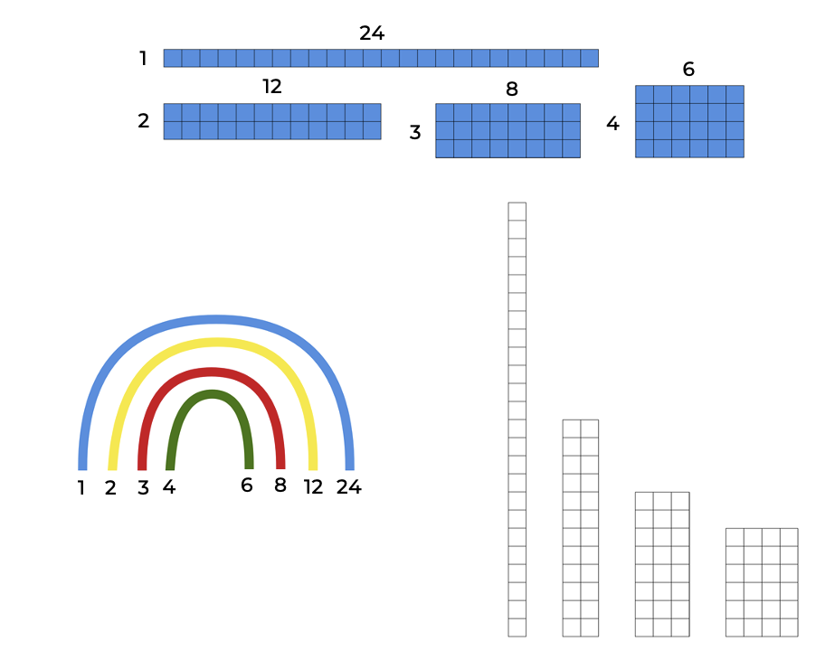
- Go on to explore other numbers, noticing and wondering to investigate ideas such as:
- True or false: factors come in pairs
- True or false: whenever you have a multiple, you also have factors
- Some numbers have many factors and some numbers have very few factors
- All numbers have at least one pair of factors
- Some numbers have common factors.
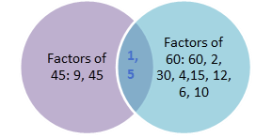
Teaching point - As an entry point, consider starting to explore factors within the range of facts known to students, or ones they can fluently derive. Support students to understand the difference between multiples and factors through co-constructing meaning and refining understanding.

Investigating more factors
Key generalisations/ what’s (some of) the mathematics?
- We can use various strategies to solve the same problem such as:
- visualising
- estimating
- renaming
- using known facts.
- Mathematical representations, such as area models, can look different but be equivalent in total.
- Mathematicians use various models to communicate their thinking efficiently, for example, we can use an area model to represent 21 fives instead of creating representations with manipulatives.
- Mathematicians use what they know to help them solve what they don’t know yet.
- We can think about numbers flexibly to solve problems.
- Mathematicians listen to other people’s thinking to become aware of other strategies and build knowledge of mathematics.
- Mathematicians use representations such as drawings, diagrams, gestures, and objects to share their thinking
Some observable behaviours you may look for/notice:
- refines/ extends thinking after listening to the ideas and strategies of others
- uses a range of strategies to solve problems:
- known facts to solve unknown problems
- doubles and doubling strategies
- visualises and skip counts the number of dots and may use fingers to keep track of groups/ rows
- partitions numbers to think about problems flexibly
- explains their chosen strategies.
Materials
- 24 centicubes
- Something to write on/with.
Instructions
- Students join the centicubes together and construct a rectangle. Ask students to describe the rectangle they have made, for example, my rectangle has 3 rows with 8 in each row; my rectangle is 12 centimetres long by 2 centimetres wide.
- Discuss that we create more than one rectangle using 24 centicubes. Students work with a thinking partner to explore whether we can find all the rectangles that can be constructed.
- Select and monitor student thinking to share and record the rectangles that have been made and discuss whether any are missing, and if so, what they may be. Make any remaining rectangles and record them all so students can see, for example:
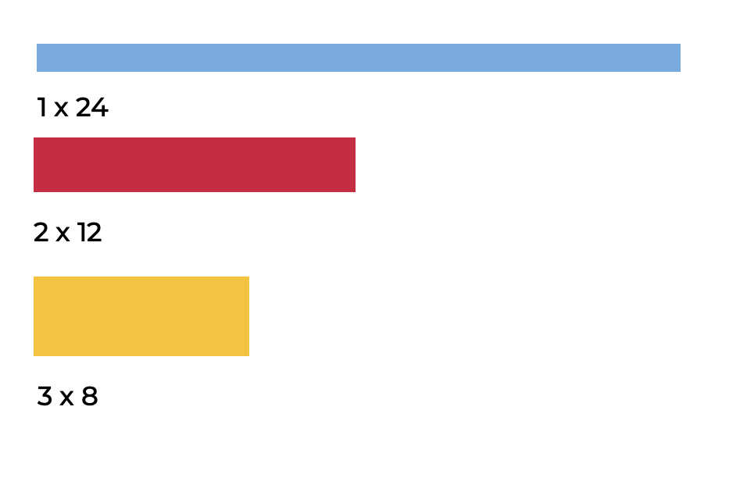
- In pairs, students to choose a number from 1 – 100 and investigate the various rectangles that can be found for each number, recording each of their rectangles on grid paper. Students record what they notice about the rectangles they created, for example, ‘I noticed the smaller the height of my rectangle, the longer the sides become.’
- As students share their work, ask questions such as:
- How do you know you found all the possible rectangles?
- Which other numbers had the same number of rectangles as you had?
- Can you include the rectangle that is 3cm by 8cm (for example) if you have one that is 8cm by 3cm?
- Why do some numbers have more rectangles than others?
- What do you notice about the area of each of your rectangles?
- What do you notice about the perimeter of each of your rectangles?
- Which number/s had the most rectangles? What do you notice about them?
- Which number/s had the least rectangles? What do you notice about them?
- How do these rectangles help us see how many factors a particular number has and what its factors are?
Variations
- Use student recordings to investigate whether rectangles with the same area can have a different perimeter, as well as, whether you can have a rectangle with the same perimeter but different area.
- Gradually explore all numbers from 1 – 120
- Use student recording to define prime, composite and square numbers and explore wonderings such as:
- Which decade has the most square or prime numbers?
- How many composite numbers there are from 1-60 vs 61-120?
Teaching points:
A square is a special kind of rectangle. Support understanding of what properties of a square make it a rectangle and then what differentiates it further so it can also be called a square.
In general, factors come in pairs. Some numbers, however, have an odd number of factors, for example, 25 has 3 factors, 1, 25 and 5.

Using related facts
Key generalisations/ what’s (some of) the mathematics?
- When solving problems, we can use what we know about:
- known facts
- landmark numbers
- renaming numbers.
- Mathematicians use what they know to help them solve what they don’t know yet.
- We can think about numbers flexibly to solve problems.
- Listening to other people’s thinking helps us become aware of other strategies, building our knowledge of mathematics.
- Mathematicians use various representations such as drawings, diagrams, manipulatives and gestures to share their thinking.
Some observable behaviours you may look for/notice:
- uses a range of strategies to solve problems:
- known facts to solve unknown problems
- inverse operations
- known multiples in calculating related multiples
- doubles and doubling strategies, for example double and one more
- skip counting and may use fingers to keep track.
- solves a problem in multiple ways
- refines/ extends thinking after listening to the ideas and strategies of others
- uses various representations to share thinking:
- concrete materials
- gestures
- drawings
- language
- diagrams
- virtual manipulatives.
Materials
- A range of manipulatives
- Something to write on/with
Instructions
- Pose (and display) this scenario (or similar): ‘A friend of mine suggested to work out 34 x 50, I could instead multiply 35 x 100 and then halve the answer. I asked them how their strategy worked but they weren’t sure. So, I wonder a few things:
- Does their strategy work for this question?
- Is it useful? (in other words, does it allow me to use what I know or can easily work out to solve a problem?)
- Can you find an example of situation where this strategy does not work / is not useful?
- How would this strategy work with division?
- Are there other ways we could extend my friend’s thinking?
- Have students work together, using whatever materials they choose, to respond to the various questions and effectively communicate their thinking to others. Share back with the class and use to launch other investigations, adding the strategy onto the class learning wall for students to make use of as it suits them.
Teaching point: There are a number of ways related facts can be used to solve division and multiplication problems, for example, to multiply by 25, you can multiply by 100 first and then divide by 4. To divide by 5, you can divide by 10, then multiply by 2. This strategy, like all strategies, will not always be the most efficient way of approaching a problem. However, it is powerful in showing just how flexibly students can think about solving problems.

Leftovers
(From Marilyn Burns, About Teaching Mathematics, 2015)
Key generalisations/ what’s (some of) the mathematics?
- Mathematicians use what they know to help them solve what they don’t know yet.
- We can think about numbers flexibly to solve problems.
- Mathematicians strategise by using their knowledge of numbers and operations to improve their chances of winning a game.
- Mathematicians share strategies and explain thinking to others.
- Mathematicians listen to other people’s thinking to become aware of other strategies and build knowledge of mathematics.
- Games provide us with a meaningful opportunity to practice our mathematical skills and understanding.
Some observable behaviours you may look for/notice:
- uses a range of strategies to solve problems:
- known facts to solve unknown problems
- inverse operations
- known multiples in calculating related multiples
- doubles and doubling strategies, for example double and one more
- skip counting and may use fingers to keep track.
- solves a problem in multiple ways
- refines/ extends thinking after listening to the ideas and strategies of others
- uses various representations to share thinking:
- concrete materials
- drawings
- language
- diagrams.
Materials
- A device to watch the video
- Something to write on/with

Instructions
- Watch the Leftovers video to learn how to play.
- Write the numbers 1-10 (or 1-20) along the top of your paper.
- Record your starting number (you can change the starting number to any number you like).
- Player 1 chooses a divisor that will result in leftovers (remainders).
- Player 1 works out the solution to their problem
- Player 1 collects the leftovers (remainders) as points.
- The chosen number (in this case, 7) is crossed off the list of options.
- A new starting number is determined by subtracting the leftovers from the previous starting number (for example, 100 - 2 = 98).
- Play continues until there are no more moves that can be made.
- The winner is the person with the most leftovers.

How many ways can they be related
Key generalisations/ what’s (some of) the mathematics?
- When solving problems, we can use what we know about:
- known facts
- landmark numbers
- the relationship between numbers
- the relationship between operations.
- We can think about numbers flexibly to solve problems.
- Different people see and think about numbers and problems in different ways.
- We can use our mathematical noticing to identify and explore patterns and relationships between numbers.
- Mathematicians understand and use the relationship between addition and multiplication, subtraction and division to solve problems.
- Mathematicians use representations such as drawings, diagrams, gestures, and objects to record their thinking.
Some observable behaviours you may look for/notice:
- partitions numbers to think about problems flexibly
- solves a problem in multiple ways
- identify and describe patterns when using number strings
- refines/ extends thinking after listening to the ideas and strategies of others
- uses materials and models to represent the commutative property and inverse relationship between addition and multiplication, subtraction and division to solve problems
- uses various representations to share thinking:
- concrete materials
- drawings
- language
- diagrams
- virtual manipulatives.

Materials
- Something to write on/with
Instructions
- Show a string of numbers, for example:
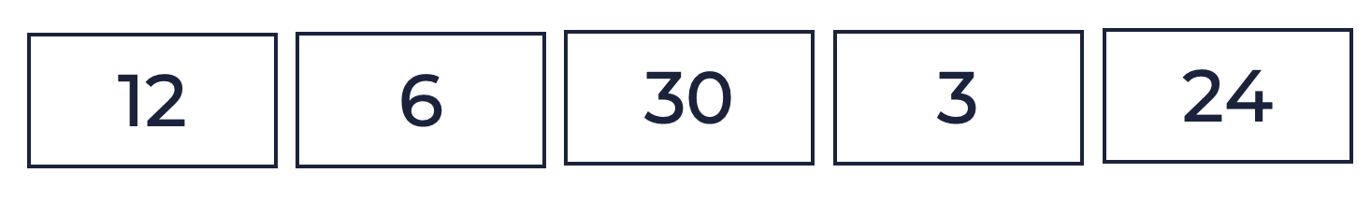
- Students consider how they could move from one number to the next, using multiplication and division, for example, there are a number of ways to move from 12 to 6, including:
- halving 12
- dividing 12 by 4 and then doubling 3
- Students work with a thinking partner to make a list of suggestions.
- Invite students to share their thinking with the group.
Variations
- Change the numbers
- Extend the string
- Have students use any operation they like.
Teaching point: Part of developing efficient mental computation and strong number sense involves seeing how any pair of numbers can be related in a vast number of ways.

Patterns of divisibility
Key generalisations/ what’s (some of) the mathematics?
- When solving problems, we can use what we know about:
- known facts
- the relationship between numbers
- properties of numbers.
- Mathematicians use tools such as multiplication grids and hundred charts to notice patterns and help them solve problems.
- We can use our mathematical noticing to identify and explore patterns and relationships between numbers.
- Listening to other people’s thinking helps us become aware of other viewpoints, building our knowledge of mathematics.
- Mathematicians use what they know to help them solve what they don’t know yet.
Some observable behaviours you may look for/notice:
- uses a range of strategies to solve problems:
- known facts to solve unknown problems
- inverse operations
- known multiples in calculating related multiples
- doubles and doubling strategies, for example double and one more
- skip counting and may use fingers to keep track.
- refines/ extends thinking after listening to the ideas and strategies of others
- explains their chosen strategies
- identify and describe patterns when using grids and charts
Materials
- Patterns of divisibility number cards (refer to Appendix 3)
- Multiplication grid
Teaching point: Noticing and using some of the patterns that exist when dividing, can provide a useful starting point for solving some problems. Rather than introducing these patterns as ‘rules’, design inquiries for students to investigate, noticing and testing generalisations and how useful they are in solving division problems.
Instructions
- Ask students to sort the following numbers according to which of them are divisible by 2 and which are not.
564, 232, 840, 234, 838, 3200, 1152, 321, 6537, 9726, 586, 809, 2845
- Students examine the numbers and record what they notice before sharing back with the class. Through discussion, support students to realise if the last digit is divisible by 2, the number is divisible by 2.
- Using a multiplication fact grid students look to the multiples of 2 to confirm in 1-digit numbers, all of those that can be divided by 2 equally are multiples of 2.
- Students re-sort numbers into those that are divisible by 4 and those that are not and record their noticings.
- Students may need extending questions to prompt their thinking, supporting them in recognising the connection between the last 2 digits (as a 2-digit number) and the connection to being divisible by 4.
- If needed, prompt students to look at the multiples of 4 found in the multiplication grid and the end of the numbers ‘just as we did with being divisible by 2. Since it was the end of the numbers that mattered there, I wonder if the same applies to being divisible by 4 and 2s and 4s are related’.
- Bring students together to discuss their findings and record their thinking as they share back, for example, in general, a number is divisible by:
- 2 if it ends in the digits 0, 2, 4, 6, and 8
- 3 if the sum of the digits is divisible by 3
- 4 if the number created by the last two-digits is divisible by 4, for example, 364 is divisible by 4 as 64 is a multiple of 4
- 5 if it ends in the digits 0 or 5
- 6 if the sum of the digits is divisible by 3 AND the final digit is even, for example, 732
- 8 if the number created by the last three-digits is divisible by 8
- 9 if the sum of the digits is divisible by 9
- 10 if it ends in 0.
- Discuss and explore the relationships and patterns noticed, for example: 2, 4, and 8 have a similar pattern:
- 2 = the number formed by the last digit is divisible by 2
- 4 = the number formed by the last 2 digits is divisible by 4
- 8 = the number formed by the last 3 digits is divisible by 8
- Patterns in divisibility by 4 and 8 may not be the most useful patterns to use as they require students to know multiples of 4 up to 100 and multiples of 8 up to 1000. Provide opportunities for students to explore strategies
- 3 and 6 are also related:
- 3 = the sum of the digits is divisible by 3
- 6 = the sum of the digits is divisible by 3 AND the final digit is even
- Other relationships also exist.
Variations
- Repeat using different numbers to elicit divisibility patterns for other dividends
- Have students make numbers that fit the ‘rules’, testing to see if they can find any exceptions
- Explore the relationship between the patterns
- Explore patterns of multiples on the 120 chart to notice and test patterns of divisibility.

Dividing by partitioning the dividend (using the distributive property)
Key generalisations/ what’s (some of) the mathematics?
- Mathematicians use what they know to help them solve what they don’t know yet.
- We can think about numbers flexibly to solve problems, for example, we can use the distributive property to rename 84 and 80 and 4 to help us solve 84 ÷ 4.
- We can use our knowledge of operations and their relationship to help us solve problems.
- We can use the distributive property to think strategically and flexibly about multiplicative representations.
- Different people see and think about numbers and problems in different ways.
- Mathematicians use what they know to help them solve what they don’t know yet.
- We can think about numbers flexibly to solve problems.
- Mathematicians use representations such as drawings, diagrams, gestures, and objects to share their thinking.
Some observable behaviours you may look for/notice
- partitions and factorises numbers to think about problems flexibly
- refines/ extends thinking after listening to the ideas and strategies of others
- uses a range of strategies to solve problems:
- known facts to solve unknown problems
- the distributive property.
- explains their chosen strategies
- uses various representations to share thinking:
- concrete materials
- language
- diagrams
- virtual manipulatives.

Materials
- A variety of manipulatives, for example, counters, paper clips, multibase arithmetic blocks, balance scale.
- Something to write on/with
Instructions
- Provide a problem, for example, 84 ÷ 4. Ask students how they might determine the solution, sharing with a thinking partner before sharing back with the class, eliciting the ability to use repeated halving to determine ÷ 4.
- Explain in the same way we can use partitioning in multiplication problems to help us use what we already know to determine what we do not, we can do the same with division. In these situations, however, we partition the dividend (the total amount). With 84 ÷ 4, I can partition 84 into parts, helping me use what I know to work out what I don’t, for example:
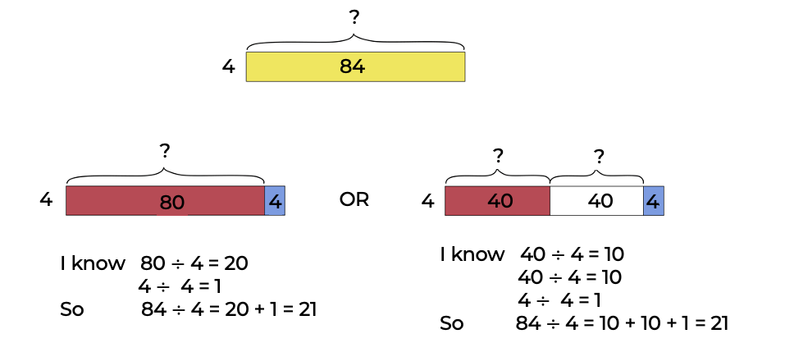
- Provide manipulatives to allow students to check (and explore) how they can break (partition) the dividend to use division facts they know to solve division problems they do not know.
- Ask students to consider why it might make more sense to partition 84 into 80 and 4 or 40, 40 and 4 rather than 58 and 16 or 20 and 64, for example. Encourage students to realise the context of the problem (in this case, the relationship between 84 and 4) determines the best way to partition the dividend. Use materials such as counters, paper clips, multibase arithmetic blocks, balance scale, for example.
- Have students explore the various ways they could partition the dividend in a way that allows them to use what they already know to solve problems such as:
- 39 ÷ 3
- 48 ÷ 8
- 42 ÷ 3
- 64 ÷ 4
- Ask questions such as:
- How did you decide how you would partition the dividend (what ‘chunk’ to use first)?
- How did you keep track of the part you had leftover?
- Could you have partitioned the dividend differently?
Variations
- Ask students to list partitions of the dividend that make sense and those that do not, explaining their thinking
- Have students find situations when this strategy is not useful
- Increase the complexity of problems when appropriate, for example, using decimal numbers.
- Once students have had a number of opportunities to solve division by partitioning the divided, provide them with a problem that will result in a remainder (for example, 80 ÷ 3), exploring what happens in those situations and how we can represent our thinking.
Teaching point: Sometimes ‘known facts’ are easier to notice than others, for example, with 39 ÷ 3, I know I can easily see I know 30 ÷ 3 is equivalent to 10 and 9 ÷ 3 is equivalent to 3. However, with 64 ÷ 4, I have to think a bit more strategically about the way I partition 64 (not just relying on partitioning based on place value). In this case, I know 40 ÷ 4 is 10. This leaves me with 24. I know 24 ÷ 4 is 6.

Factorising
Key generalisations/ what’s (some of) the mathematics?
- We can use various strategies to solve the same problem such as:
- estimating
- renaming
- using known facts
- factorising.
- Mathematicians use what they know to help them solve what they don’t know yet.
- We can think about numbers flexibly to solve problems.
- Listening to other people’s thinking helps us become aware of other strategies, building our knowledge of mathematics.
- Mathematicians use representations such as drawings, diagrams, gestures, and objects to share their thinking.
Some observable behaviours you may look for/notice
- partitions and factorises numbers to think about problems flexibly
- refines/ extends thinking after listening to the ideas and strategies of others
- uses a range of strategies to solve problems:
- known facts to solve unknown problems
- doubles and doubling strategies
- partitions numbers to think about problems flexibly
- explains their chosen strategies
- uses various representations to share thinking:
- concrete materials
- language
- diagrams
- virtual manipulatives.
Materials
- Ice cream sticks
- Rubber bands
- Manipulatives
- Something to write on/with

Instructions
- Pose a problem such as 7 x 20.
- Students consider what strategies they could use to solve the problem. Provide students time to think and discuss and share their thinking with a partner, before sharing and recording thinking with the class.
- If students suggest factorising, support them to explain how factorising works, making connections to related strategies and modelling using manipulatives and diagrams.
- If students do not suggest factorising explore the strategy, for example:
- To solve 7 x 20 using factorising, prepare bundles of ice cream sticks (in tens). Show 1 bundle and ask a student to check how many ice cream sticks there are in total, eliciting 10. Suggest that to make 1 twenty (1 x 20), two bundles could be combined. Make 1 twenty and have students help make 7 twenties.
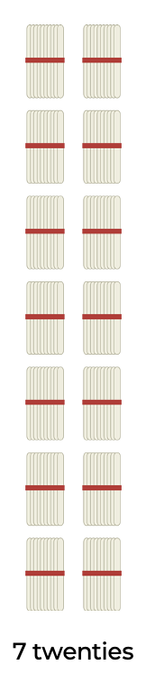
- Discuss how you can use various strategies to solve 7 x 20, but when we factorise, we use our knowledge about factors to transform the problem into something we find easier to work with. In this case, 7 is a prime number so it cannot be factorised (its factors are 7 and 1). 20 is a composite number and can be factorised.
- Students brainstorm the factors of 20 (1, 20, 2, 10, 5 and 4) and explore how we can use our knowledge of factors to change 7 x 20 into:
- 7 x 2 x 10 (and 7 x 10 x 2) OR
- 7 x 4 x 5 (as well as 7 x 5 x 4)
- Discuss how we can use out understanding of place value to rename numbers, for example, we can factorise 20 into 2 x 10 and change the equation to be 7 x 2 x 10. Use ice cream sticks to model how to break the 20 into 2 tens.
- Discuss how 7 x 2 x 10 is equivalent to 14 x 10. We can apply our knowledge of place value to rename 14 tens as 140.
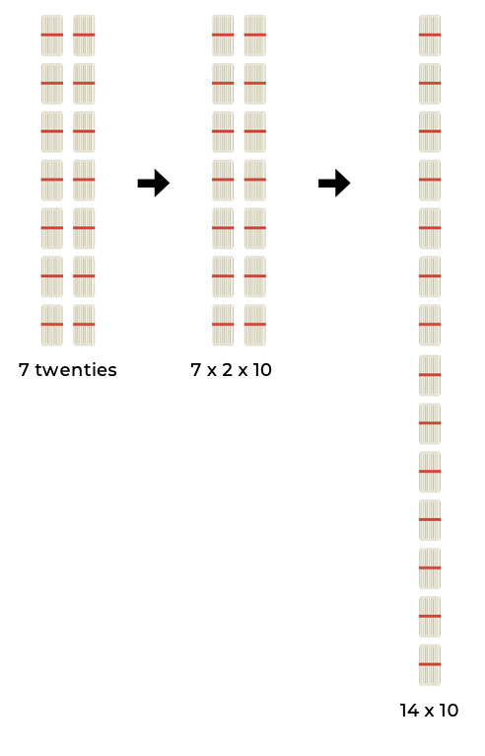
- Provide manipulatives and recording materials and ask students to consider other ways they could represent factorising, for example:
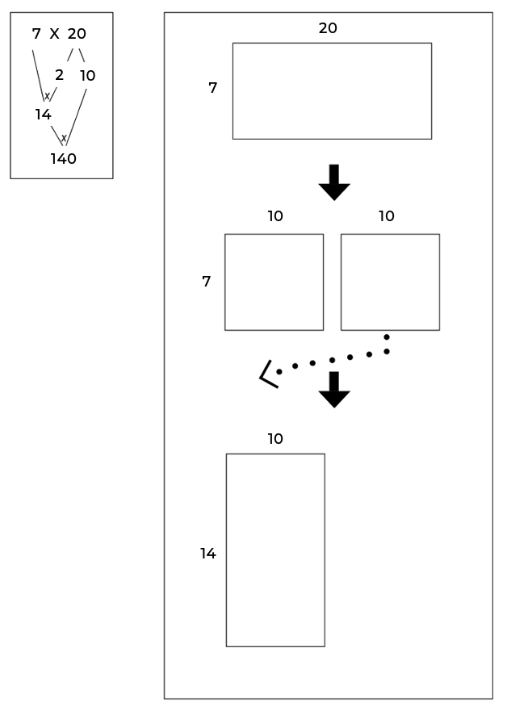
- Students explore factorising as a strategy using a different problem such as 9 x 20. Ask:
- Why does this strategy work?
- Was there more than one way you could have factorised? How did you decide which factors to use (for example, 2 and 10, or 5 and 4)?
- Could both numbers have been factorised? If so, how did you choose which one to factorise (for example, the 9 or the 20)?
- Do you think this strategy would work for all multiplication problems?
- How does factorising help make problems easier to solve?

Variations
- Students model as many strategies they can think of for solving 7 x 20.
- Investigate situations when factorising is useful and those situations when it is not. It important to recognise this will be different based on the knowledge individual students have.
- Ask other questions, increasing the complexity, for example, 40 x 450, 17 x 200 or 250 x 6000.
Teaching point: Factorising can be used to solve multiplication problems as well as division problems. Understanding factorising in both contexts is important. Support students by using manipulatives and diagrams to explain their thinking and aid comprehension. Having familiarity with factors and multiples, as well as understanding of the difference between them, will support students in using factorising to solve problems.

Flip 3
Key generalisations/ what’s (some of) the mathematics?
- We can use various strategies to solve the same problem such as:
- estimating
- renaming
- using known facts.
- Games provide us with a meaningful opportunity to practise our mathematical skills and understanding.
- Mathematicians strategise by using their knowledge of numbers and operations to improve their chances of winning a game
- Mathematicians explain their thinking so it makes sense to others.
- Mathematicians listen carefully to make sense of and record others thinking.
Some observable behaviours you may look for/notice
- uses a range of strategies to solve problems:
- uses known facts to solve unknown problems
- uses the associative property
- uses doubles and doubling strategies
- partitions numbers to think about problems flexibly.
- explains their thinking and chosen strategies
Materials
- Playing cards A – 9 (A = 1)
- Something to write on/with
Instructions
- Players take turns to flip over 3 cards and multiply them together to determine the product.
- Player 1 explains their thinking to their partner who records their turn.
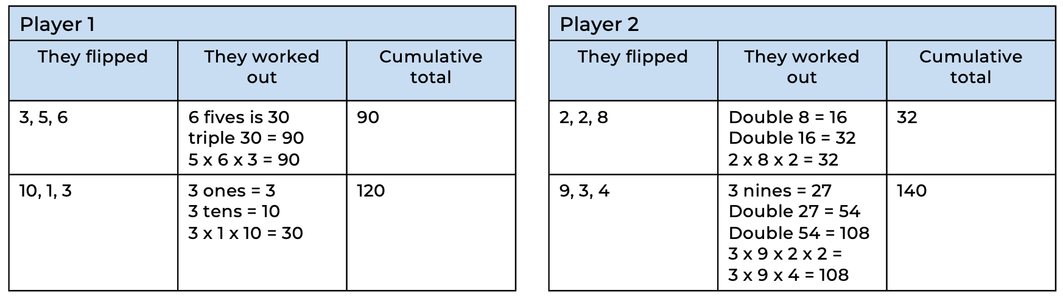
- Players keep a cumulative total and after 10 rounds, the player closest to 550 is the winner.
Variations
- Players draw cards simultaneously. The player with the smallest product keeps all 3 cards. The game ends when all of the cards have been used and the winner is the person with the most cards, or alternatively, the largest product total from all of their cards
- Play as a pair, playing two vs. two
- Flip 4 cards and multiply 4 single digit numbers
- Start with a total of 550 and race back to zero.
Teaching point: Students need be able to multiply 3 or more single digits, thinking flexibly and strategically about the order they will multiply, for example, if I flipped 5, 7 and 2, I would use the 5 x 2 first as I know that gives me 10 and I like multiplying by 10 as it is a landmark number and I can simply apply place value understanding. 7 x 10 is then simply renamed as 70. Examine work samples and ensure students are thinking strategically (rather than just working in order) work out 5 x 2 (which I know is 10) and then 10 x 7 to make 70.

Dividing by factorising
Key generalisations/ what’s (some of) the mathematics?
- Mathematicians use what they know to solve what they don’t know yet.
- We can think about numbers flexibly to solve problems.
- We can use our knowledge of numbers and factors to help us solve problems, for example, we can 25 x 8 into 25 x 2 x 4 (as 2 and 4 are factors of 8).
- We can use our mathematical noticings to identify and explore patterns and relationships between numbers.
- Different people see and think about numbers and problems in different ways.
- Mathematicians use representations such as drawings, diagrams, gestures, and objects to share their thinking.
Some observable behaviours you may look for/notice
- partitions and factorises numbers to think about problems flexibly
- refines/ extends thinking after listening to the ideas and strategies of others
- uses a range of strategies to solve problems:
- uses known facts to solve unknown problems
- uses doubles and doubling strategies.
- explains their chosen strategies
- uses various representations to share thinking:
- concrete materials
- language
- diagrams
- virtual manipulatives.
Materials
- Range of manipulatives
- Something to write on/with
Instructions
- Pose a problem such as 25 x 8 and discuss that we can factorise to solve this problem, for example:
- We can adjust 25 x 8 into 25 x 2 x 4 (as 2 and 4 are factors of 8).
- Since we know 4 x 25 makes 100, we multiply those numbers together first, creating the equation as 100 x 2.
- We can then double 100 which is 200.
- Discuss that we can use the same thinking to divide, for example:
- We need to work out 48 ÷ 8. We can start by thinking about factors.
- We know 2 and 4 are factors of 8 so our equation becomes 48 ÷ 2 ÷ 4.
- We know 48 ÷ 2 = 24.
- Then, 24 ÷ 4 = 6 (although we could have factorised further to think 24 ÷ 2 ÷ 2 if we had to).
- Working with a thinking partner, students create a representation that communicates this thinking. They could also use drawings, multilink cubes, counters, arrays, multibase arithmetic blocks, short videos, for example:
- My problem:
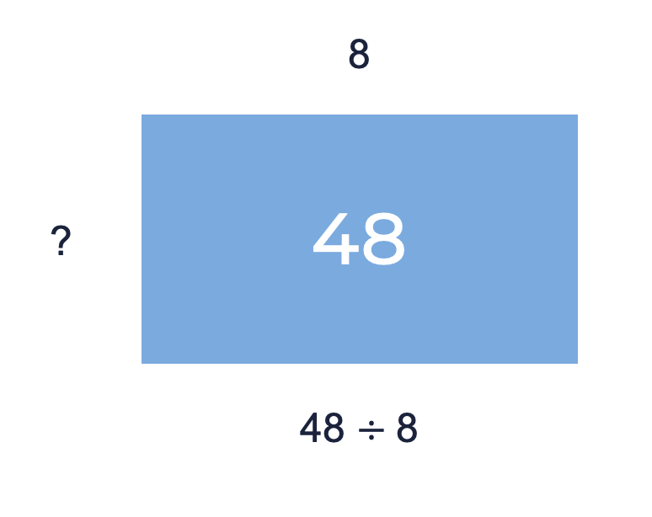
- Using what I already know:
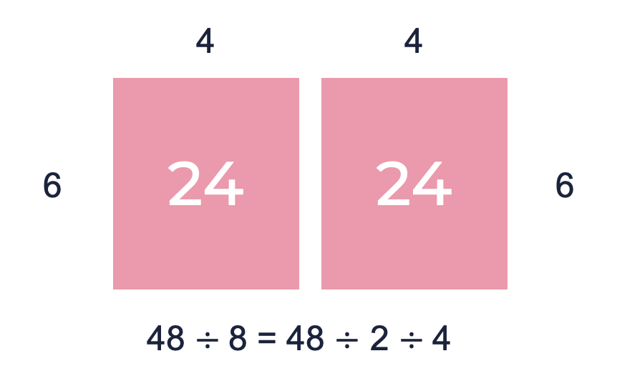
- Provide other questions and ask students to consider how they could use factorising to solve division in these situations, making use of what they already know to solve what they do not, for example:
- 120 ÷ 15
- 108 ÷ 18
- 108 ÷ 12

Estimate me
Key generalisations/ what’s (some of) the mathematics?
- We can use various strategies to solve the same problem such as:
- estimating
- visualising
- using landmark numbers (sometimes called benchmark numbers, multiples of 10)
- renaming
- using known facts.
- Different people see and think about numbers and problems in different ways.
- Mathematics compare similarities and differences between strategies and contexts to help choose which strategies to use and when.
- Mathematicians use representations such as drawings, diagrams, gestures, and objects to share their thinking.
Some observable behaviours you may look for/notice
- rounds numbers to estimate products
- partitions and factorises numbers to think about problems flexibly
- refines/ extends thinking after listening to the ideas and strategies of others
- uses a range of strategies to solve problems
- explains their chosen strategies
- uses various representations to share thinking:
- concrete materials
- language
- diagrams
- virtual manipulatives.
Materials
- Something to write on/with
Instructions
- Ask: Which of these are close to 2000? How do you know?
- 30 x 65
- 53 x 14
- 15 x 120
- 97 x 19
- 33 x 101
- Students discuss the various ways they can estimate each problem, recording their thinking using representations and appropriate terminology. Some examples for estimating 30 x 65 may be:
- We can estimate 30 sixty-fives and 30 seventies. Since we know 3 sevens is 21, we can derive 3 seventies is 210, and from there we can derive further to say 30 seventies is 210 tens which we rename as 2100.
- 30 x 65 is close to 30 x 60. 10 sixties is 600. 3 six-hundreds is double and 1 six-hundred which is, 1200 plus 600 which equals 1800.

What’s in a remainder?
Key generalisations/ what’s (some of) the mathematics?
- We can use manipulatives to notice patterns when considering multiples and remainders.
- Mathematicians use what they know to help them solve what they don’t know yet.
- Mathematicians check thinking by using an alternative way to solve the problem.
- Mathematicians use representations such as drawings, diagrams, gestures, and objects to solve problems and share their thinking.
Some observable behaviours you may look for/notice
- finds multiple solutions to a problem
- explains the idea of a remainder (for example, as an incomplete group)
- uses a range of strategies to solve problems:
- known facts to solve unknown problems
- skip counting and may use fingers to keep track of rows.
- uses various representations to share thinking:
- concrete materials
- drawings
- language
- diagrams
- virtual manipulatives.
- shares systematically using groups or multiples (for example, by twos, threes or fours)
- explains and checks their chosen strategies
- refines/ extends thinking after listening to the ideas and strategies of others
Materials
- A range of manipulatives
- Something to write on/with
Instructions
- Students brainstorm what they know about remainders.
- Pose a problem such as ‘Some people were sharing a punnet of blueberries. There were 27 blueberries in total and once they had all been shared out, 3 blueberries were left over. How many people might have been sharing the blueberries?’
- Support students in representing the problem using manipulatives or diagrams, discussing information we know, for example, there are 3 left over, the total number of blueberries is 27.
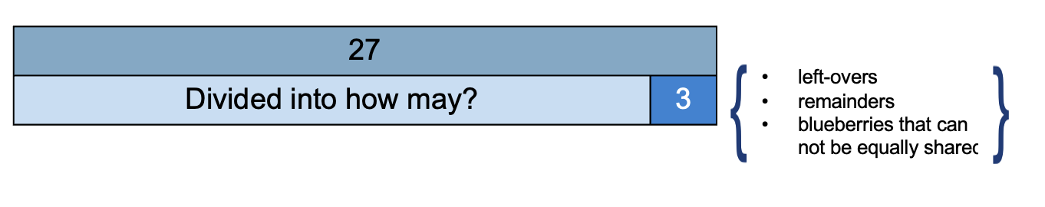
- Students talk with their thinking partner and consider how this representation might help us work out how many people might be sharing the blueberries. Elicit that this diagram, helps us understand we know there are 27 blueberries and 24 of them could be shared equally among the people.
- Students work out how many people shared the blueberries, representing their thinking using diagrams and/or manipulatives before sharing their ideas with the group. Students may come up with ideas such as:
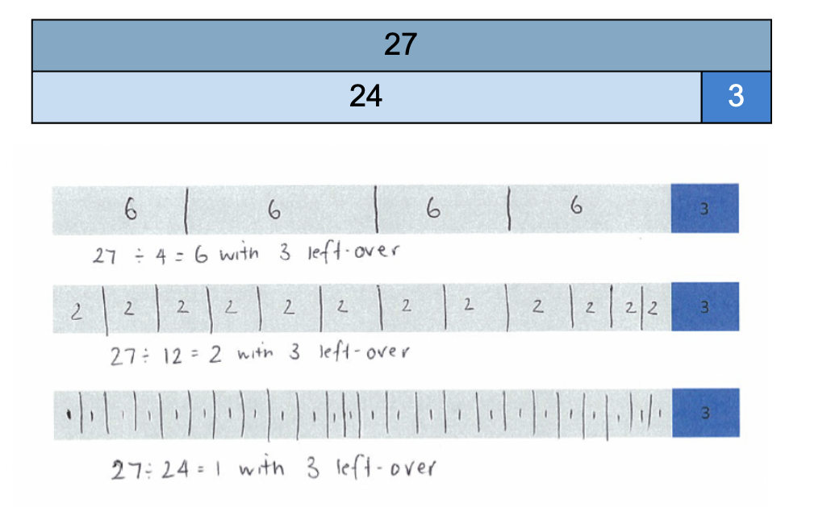
- Discuss solutions which would not be valid, for example, 27 divided by 3 would have no remainder.

Divide me this
Key generalisations/ what’s (some of) the mathematics?
- Mathematicians use what they know to help them solve what they don’t know yet.
- Games provide us with a meaningful opportunity to practise our mathematical skills and understanding.
- Mathematicians explain their thinking so it makes sense to others.
Some observable behaviours you may look for/notice
- uses a range of strategies to solve problems:
- known facts to solve unknown problems
- doubles and doubling strategies
- inverse operations
- partitions numbers to think about problems flexibly.
- explains and checks their chosen strategies.
Materials
- Playing cards A-9
- Something to write on/with
Instructions
- One student shuffles and deals out 5 cards to each player and then places the remaining cards in a central pile.
- The aim is for students to arrange 4 out of their 5 cards into a correct division equation, for example, I have 6, 3, 4, 5, 9. I can make 36 ÷4 = 9.
- If students can make an equation, they justify their thinking to their peers before recording their equation.
- Cards are placed in the discard pile and 4 new cards are collected from the central pile.
- If a player can make an equation, they do so. If not, they choose a card from the central pile and then select a card to discard (so they still have 5 cards in total).
- If a player can make an equation as a result of swapping a card, they do so before play passes to the next student.
Variation
- Players play with their cards visible so when a player cannot go, they can swap cards with another player.

Which would you do in your head
Key generalisations/ what’s (some of) the mathematics?
- We can use various strategies to solve the same problem such as:
- estimating
- visualising
- using landmark numbers (sometimes called benchmark numbers, multiples of 10)
- renaming
- using known facts.
- Different people see and think about numbers and problems in different ways.
- Mathematics compare similarities and differences between strategies and contexts to help choose which strategies to use and when.
- Mathematicians explain their thinking so it makes sense to others.
Some observable behaviours you may look for/notice
- uses a range of strategies to solve problems:
- known facts to solve unknown problems
- doubles and doubling strategies
- inverse operations
- partitions numbers to think about problems flexibly.
- justifies their choice of strategies
- refines/ extends thinking after listening to the ideas and strategies of others.
Materials
- Something to write on/with
Instructions
- Ask “Which of these would you work out in your head? Which would you use concrete materials, a calculator or written strategies to work out?”

- 47 x ____=4700
- 8 x 2 x 4 x 5
- 7 x 8 + ____=91
- ¼ of 64
- 656 $÷$8
- 2/3 of 120
- 13 x 21
- 198 $÷$ ___ = 11
- 53 $÷2÷2$

- Allow students time to think before recording which questions they would do in their head on a sticky note.
- Students collate their sticky notes to determine the similarities and differences in the classes thinking.
- Ask questions to guide student discussion such as:
- Which question/s do you think most people might prefer to model to help them solve? Why do you think that? What do these questions have in common?
- Which question/s do you think most people would work out in their heads? Why do you think that? What do these questions have in common?
- Which strategies are we not considering as often as others? What do we need to learn in order to use those strategies as comfortably as the others?
Variation
- Change the questions examined by students (a – i)

Target number
Key generalisations/ what’s (some of) the mathematics?
- Mathematicians think strategically when they solve problems, looking for what they already know and deciding how to use that knowledge
- Different people see and think about numbers and problems in different ways.
- Games provide us with an opportunity to practise our mathematical skills and understanding.
- Mathematicians strategise by using their knowledge of numbers and operations to improve their chances of winning a game.
Some observable behaviours you may look for/notice
- finds multiple solutions to a problem, using some or all the four operations
- explains the idea of a remainder
- uses a range of strategies to solve problems:
- known facts to solve unknown problems
- doubles and doubling strategies
- inverse operations
- partitions numbers to think about problems flexibly.
- explains and checks their chosen strategies
- refines/ extends thinking after listening to the ideas and strategies of others.
Materials
- Playing cards A – 9
- Recording sheet (refer to Appendix 5)
Instructions
- One student deals out 5 cards to each player and determines the target number.
- Using their 5 cards to form any 1-, 2-, or 3-digit numbers, players use multiplication and/or division, with addition and subtraction if needed, to get as close to the target number as possible.
- Each card can only be used once and not all cards need to be used, for example:
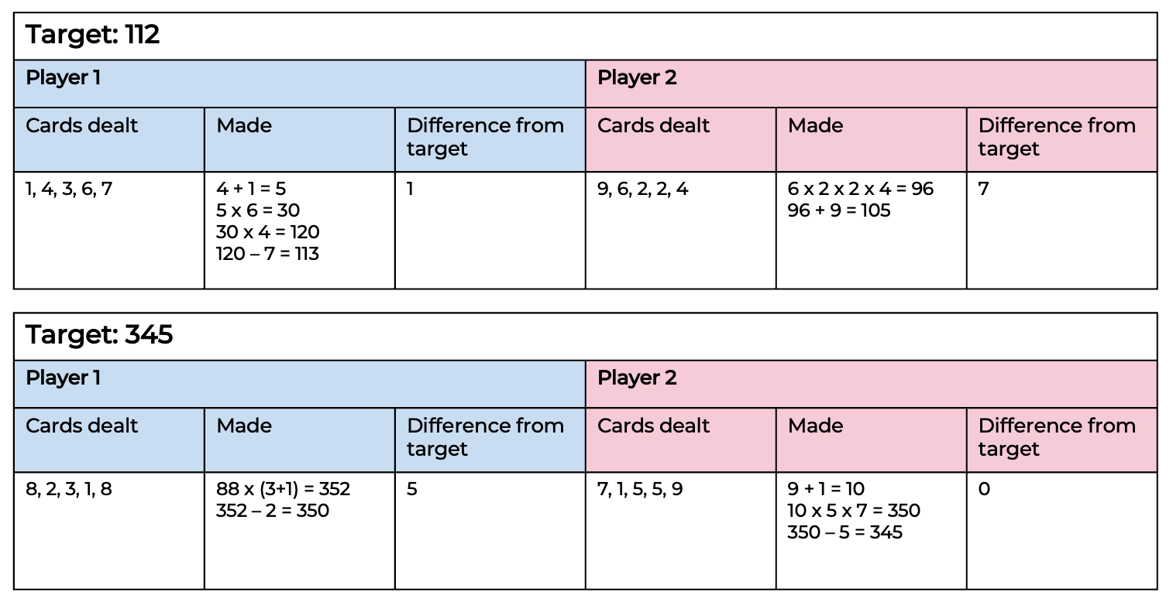

Investigating written methods for multiplication
Teaching point: Students need to be familiar with, and use, a range of mental strategies prior to introducing written methods. Written methods are useful when working on problems that make other strategies no longer reliable or efficient. Before introducing formal written methods, students should have strong number sense understanding and be able to apply a range of efficient mental strategies in all additive and multiplicative contexts, for example:
- apply known facts
- derive the unknown from the known
- explain and use the associative, distributive and commutative properties
- use place value knowledge to multiply and divide by multiples of ten
- use the area model to explain their thinking
- use informal written strategies to solve problems.
Key generalisations/ what’s (some of) the mathematics?
- The same multiplicative problem can be represented in different symbolic ways.
- We can use various written strategies to represent and solve multiplicative problems, for example, the grid method, the Gelosia method and the vertical algorithm.
- Different people see and think about numbers and problems in different ways.
- Mathematics compare similarities and differences between strategies and contexts to help choose which strategies to use and when.
- Mathematicians explain their thinking so it makes sense to others.
- Mathematicians use representations such as drawings, diagrams, gestures, and objects to share their thinking
Some observable behaviours you may look for/notice
- uses a range of strategies to solve problems:
- known facts to solve unknown problems
- doubles and doubling strategies
- inverse operations
- formal and informal written strategies
- partitions numbers to think about problems flexibly.
- explains their chosen strategies
- refines/ extends thinking after listening to the ideas and strategies of others.
- uses various representations to share thinking:
- concrete materials
- gestures
- language
- diagrams
- virtual manipulatives
Materials
- Something to write on/with
Instructions
- Pose the problem 23 x 243
- Students discuss their thinking with a thinking partner and record their ideas
- Explore how to solve 23 x 243 can be solved using a range of algorithms, for example, the grid method, the Gelosia (lattice) method and the standard vertical algorithm.
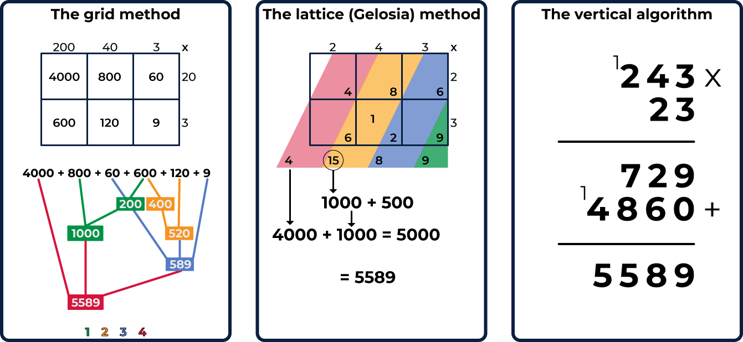
- Ask:
- What do you notice about each of the methods?
- How does each method work? What mathematical properties are being used?
- What are the advantages of each method?
- What are the disadvantages of each method?
- When is each method not useful?
- What knowledge do you need to have to be successful at using any of these methods?
Variations
- Explore how each of these methods work with fractional and decimal numbers.
- Students create instructional videos using tablet devises to share their thinking.
- Explore how these strategies may be used for division problems.
- Create a model that demonstrates how each method works, for example, demonstrate how the grid method works using manipulatives.
Teaching point: Once written methods are introduced, students need to continue thinking strategically, considering which strategy they know that will be most useful in solving the particular problem they are faced with. Written methods need to be connected back to what students already know, using manipulatives and diagrams to support understanding.

Investigating written methods for division
Key generalisations/ what’s (some of) the mathematics?
- The same multiplicative problem can be represented in different symbolic ways.
- We can use various written strategies to represent and solve multiplicative problems, for example, the area method and written algorithm.
- Different people see and think about numbers and problems in different ways.
- Mathematics compare similarities and differences between strategies and contexts to help choose which strategies to use and when.
- Mathematicians explain their thinking so it makes sense to others.
- Mathematicians use representations such as drawings, diagrams, gestures, and objects to share their thinking
Some observable behaviours you may look for/notice:
- uses a range of strategies to solve problems:
- known facts to solve unknown problems
- doubles and doubling strategies
- inverse operation
- formal and informal written strategies
- partitions numbers to think about problems flexibly.
- explains their chosen strategies
- refines/ extends thinking after listening to the ideas and strategies of others
- uses various representations to share thinking:
- concrete materials
- drawings
- language
- diagrams
- virtual manipulatives.
Materials
- Range of manipulatives.
- Something to write on/with
Instructions
- Pose a division scenario such as “I have $346. I want to share it equally between my 3 of my saving jars. How much should I place into each one?’
- Students discuss and show the various ways this problem could be represented, for example:
$\frac{346}{3}$ $346÷3$ 3 x _______= 346
- Ask students how they may solve the problem, sharing and discussing their ideas. Discuss how to solve 346 ÷ 3 by partitioning the dividend highlighting that this strategy allows you to partition the dividend in a way that makes sense to you, for example: applying known facts.
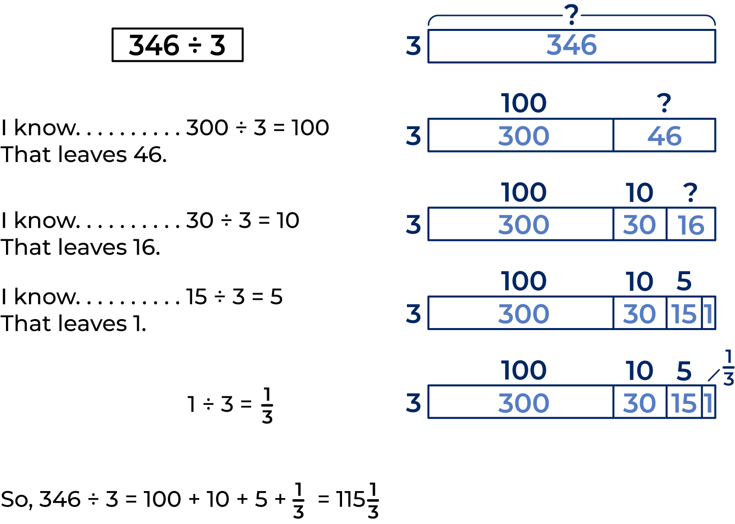
- Discuss that we could also solve 346 ÷ 3 using a standard algorithm.
- Explore how to solve 346 ÷ 3, using the manipulatives, such as sharing mats or multibase arithmetic blocks to explain the thinking to record an algorithm.
- Ask:
- What do you notice about each of these methods?
- How does each method work? What mathematical properties are being used?
- What are the advantages of each method?
- What are the disadvantages of each method?
- When is each method not useful?
- What knowledge do you need to have to be successful at using any of these methods?
Variations
- Explore the connection between these strategies and other multiplication methods.
Teaching point: There are many ways of division problems can be written. Understanding the dividend, divisor and quotient supports students in solving and representing division problems.
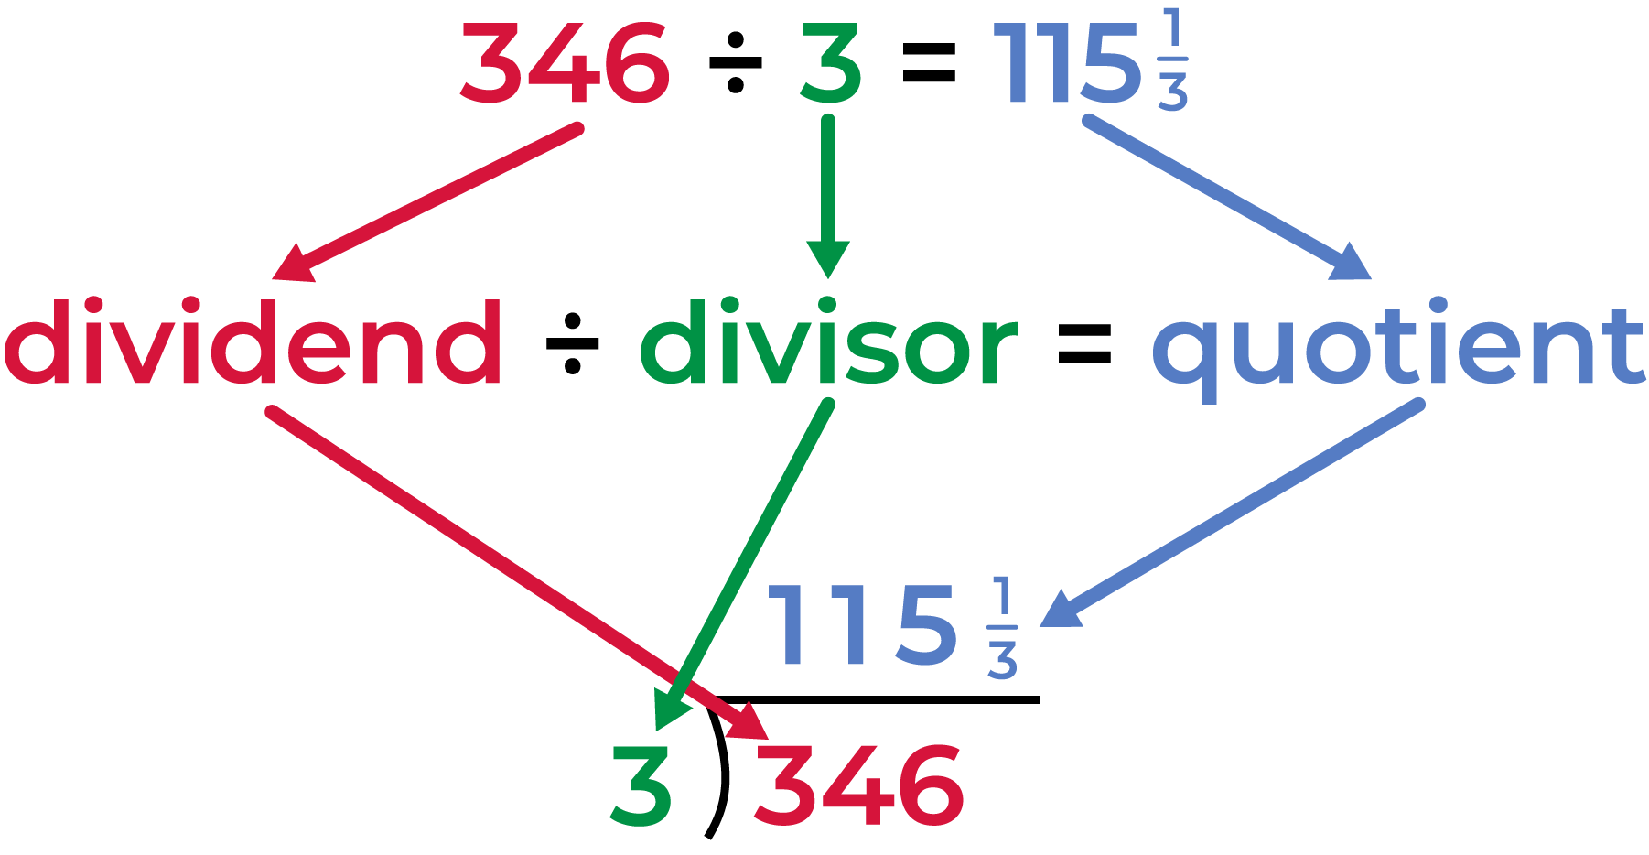

Doubling and halving - a number talk – 25 x 8
Key generalisations/ what’s (some of) the mathematics?
- We can think about multiplicative situations with the same flexibility we use for whole numbers.
- Mathematicians listen to and add onto the thinking and ideas of others
- Different people see and think about numbers and problems in different ways.
- Mathematicians use what they know to help them solve what they don’t know yet.
- We can think about numbers flexibly to solve problems.
- Mathematicians use models and representations to help us make sense of and explain mathematical ideas.
- Mathematicians use representations such as drawings, diagrams, gestures, and objects to share their thinking.
Some observable behaviours you may look for/notice:
- explains why they used a particular strategy
- refines/ extends thinking after listening to the ideas and strategies of others
- partitions numbers to think about problems flexibly
- uses various representations to share thinking:
- concrete materials
- drawings
- language
- diagrams
Materials
- Scissors
- Plain paper, grid paper or dot paper
- Device to watch the video
- Something to write on/with
Instructions
Watch the Doubling and halving – a number talk video. Pause to allow students individual thinking time and use the questions to guide student thinking.
- Students create a mathematical model to show how they could use doubling and halving to solve 6 x 8.
- Students find 3 examples where doubling and halving isn't an efficient strategy.
- Ask: Why is it more efficient for some problems and not for others?

Let’s investigate 2 – 15 x 9
Key generalisations/ what’s (some of) the mathematics?
- Mathematicians listen to and add onto the thinking and ideas of others.
- Different people see and think about numbers and problems in different ways.
- Mathematicians use what they know to help them solve what they don’t know yet.
- We can think about numbers flexibly to solve problems.
- Mathematicians use representations such as drawings, diagrams, gestures, and objects to share their thinking.

Some observable behaviours you may look for/notice:
- explains why they used a particular strategy
- refines/ extends thinking after listening to the ideas and strategies of others
- partitions numbers to think about problems flexibly
- uses various representations to share thinking:
- concrete materials
- drawings
- language
- diagrams.
Materials
- Device to watch the video.
- Something to write on/with
Instructions
- Watch the Let’s investigate 2 – 15 x 9 video. Pause to allow individual thinking time and use the questions in the video to guide student thinking.
- Ask: Can you use diagrams, drawings and/ or materials to represent how you might use these strategies to think about for 16 twenty-fives (16×25)?

Fewest squares?
Key generalisations/ what’s (some of) the mathematics?
- When solving problems, we can use what we know about:
- estimating
- known facts
- derived facts
- renaming numbers.
- We can use our understanding of part-part-whole relationships to solve multiplicative problems.
- Mathematicians strategise by using their knowledge of numbers and operations to improve their chances of winning a game.
- Games provide us with a meaningful opportunity to practise our mathematical skills and understanding.
- Mathematicians explain their thinking so it makes sense to others.
- Mathematicians can use colour to help capture their thinking/ represent their thinking.
Some observable behaviours you may look for/notice:
- uses a range of strategies to solve problems, for example,
- known facts
- estimation
- derived facts
- renames numbers
- properties (such as commutative and associative)
- landmark or benchmark numbers.
- explains why they used a particular strategy
- refines/ extends thinking after listening to the ideas and strategies of others
- partitions numbers to think about problems flexibly
- uses various representations and intentional use of colour to share thinking:
- concrete materials
- drawings
- language
- diagrams.
Materials
- Grid paper
- Different coloured markers or pencils.
- Device to watch the videos
Instructions
Part 1: Watch the Fewest squares – part 1 video
- Students draw an 11 x 13 grid on paper
- Ask: What is the fewest number of squares you can draw inside your 11 x 13 grid?
- Remind students they cannot have overlapping squares or leave blank spaces on their grid.
Part 2: Watch the Fewest squares – part 2 video
- Students test out some different starting places, or start with different square numbers to help them find the fewest squares within the 11x13 grid
Part 3: Watch the Fewest squares – part 3 video
- Students compare their 11 x 13 grid to the ones created in the video
- Possible follow up questions and prompts:
- What was the fewest number of squares you could fit into the 11 x 13 grid?
- How were the grids you made similar or different to the ones in the videos?
- Is 8 the fewest number of squares we can use to fill the 11 x 13 grid?
- What would the dimensions (size) of a grid need to be so we could fill it with exactly 7 squares?

Jump! What if?
From reSolve
Key generalisations/ what’s (some of) the mathematics?
- When solving problems, we can use what we know about:
- estimating
- known facts
- landmark numbers
- renaming numbers.
- We can think about the ’times as many’ idea when solving multiplicative problems, for example, if something is ‘four times as many’ it means it is 4 times larger than the original unit.
- We can measure, compare and calculate lengths using formal and informal units.
- We can think about numbers flexibly to solve problems.
- Different people see and think about numbers and problems.
- Mathematicians use representations such as drawings, diagrams, gestures, and objects to help them solve problems.

Some observable behaviours you may look for/notice:
- uses a range of strategies to solve problems, for example,
- known facts
- estimation
- derived facts
- renames numbers
- properties (such as commutative and associative)
- landmark or benchmark numbers.
- explains why they used a particular strategy
- refines/ extends thinking after listening to the ideas and strategies of others
- measures and compares lengths using formal and informal units
Materials
- Measuring tools, for example, a ruler, tape measure, mug, handspan or a teaspoon
- An object to indicate your height, for example, a stick, spoon or rope
- Device to watch the videos.
- Something to write on/with
Instructions
Part 1: Watch the video Jump! What if? – part 1
- Students measure their own height by lying on the floor with their feet against the wall and placing an object (for example, a stick, spoon or rope) at the top of their head to indicate their height.
- Students then measure the distance from the wall to their object using a formal unit such as a ruler or tape measure and record their height on a piece of paper.
- Alternatively, students could use informal units to measure their height by estimating the length of their informal unit and using this to calculate their estimated height, for example:
- I am 16 and a bit mugs tall. I estimate the length of 1 mug is 10cm and the little bit is approximately 2cm. I know 16 tens we can rename as 160 and 2cm more means my approximate height is 162cm.
Part 2: Watch the video Jump! What if? – part 2
- Ask: “If a kangaroo can jump 4 times its height, how far could you jump if you were a kangaroo?”
- Encourage students to record their thinking using a table.
- Ask: “Did you know, a frog can jump 20 times its height, a grasshopper can jump 30 times its height and a flea can jump 200 times its height?!”
- Students calculate the following.
- How far could you jump if you were a frog?
- How far could you jump if you were a grasshopper?
- How far could you jump if you were a flea?

Super shapes
From NRICH maths
Key generalisations/ what’s (some of) the mathematics?
- Mathematicians use what they know to help them solve what they don’t know yet
- When solving problems, we can use what we know about:
- estimating
- known facts
- derived facts
- renaming numbers.
- Mathematicians explain their thinking so it makes sense to others.
- Problems provide us with a meaningful opportunity to practise our mathematical skills and understanding
Some observable behaviours you may look for/notice:
- uses a range of strategies to solve problems, for example,
- known facts
- derived facts
- renames numbers
- properties (such as commutative and associative)
- landmark or benchmark numbers.
- explains why they used a particular strategy
- refines/ extends thinking after listening to the ideas and strategies of others
Materials
- Super shapes resource (refer to Appendix 6)
- Device to watch the video
- Something to write on/with
Instructions
- Watch the Super shapes video. Pause to allow individual thinking time and use the questions in the video to guide student thinking.
- Ask: Can you discover the value of each of the shapes in each of the problems?

Colour in fractions
Key generalisations/ what’s (some of) the mathematics?
- We can use our understanding of part-part-whole relationships to solve multiplicative problems.
- Parts of a whole can look different but be equivalent in value.
- We can re-unitise fractions to help us think flexibly to solve problems.
- We can use partitioning (dividing) strategies to create fractional quantities.
- Quantities can look different but be equivalent in value.
- Different people see and think about numbers and problems in different ways.
- Games provide us with a meaningful opportunity to practise our mathematical skills and understanding.
- Mathematicians strategise by using their knowledge of numbers and operations to improve their chances of winning a game.
Some observable behaviours you may look for/notice:
- explains how quantities can look different but be equivalent in value
- uses quarters and halves to create wholes
- partitions to create fractional quantities
- partitions numbers to think about problems flexibly
- refines/ extends thinking after listening to the ideas and strategies of others
- uses various representations to share thinking:
- concrete materials
- drawings
- language
- diagrams
- virtual manipulatives.
Materials
- Colour in fractions spinner numerator one die labelled 1, 2, 2, 3, 3, 4 in one colour (or use a spinner) (refer to Appendix 7)
- Colour in fraction spinner denominator another die labelled *2 ,*3 ,*4 ,*6 ,*8 ,*12 in another colour (or use a spinner) (refer to Appendix 7)
- Fraction wall game board (refer to Appendix 8)
- coloured pencils or markers.
Instructions
- Watch the Colour in fractions 1 video to learn how to play.
- Players take turns to spin both spinners, creating fraction. The first spinner being the numerator and the second spinner the denominator. Players colour the equivalent of the fraction shown, for example, if a player spins 2 and quarters they can colour in:
- 2/4 of one line, or
- 4/8 of one line, or
- 1/4 of one line and 2/8 of another, or
- any other combination the same as 2/4.
- For each roll or spin, players should use a different colour pencil or marker.
- If the fraction rolled or its equivalence cannot be shaded, they miss a turn.
- Players are not allowed to break up a “brick.”
- To finish, players must have 18 turns or filled their wall (a larger fraction is not acceptable)
- The first player who colours in their whole wall is the winner, the other player is encouraged to keep going (with the support of the first player) to fill their fraction wall, or the greatest number of wholes. If after 18 turns neither player colours in their whole wall, the player with the greatest number or wholes wins

Imagining fractions
Key generalisations/ what’s (some of) the mathematics?
- Mathematicians use what they observe and notice to solve problems.
- Mathematicians can use their mathematical imagination to visualise reforming fractional parts into the whole.
- Quantities can look different but be equivalent in value.
- We can re-unitise fractions to help us think flexibly to solve problems.
- We can use our understanding of part-part-whole relationships to solve multiplicative problems.
- Mathematicians use what they know to help them solve what they don’t know yet.
- Different people see and think about numbers and problems in different ways.
Some observable behaviours you may look for/notice:
- explains how quantities can look different but be equivalent in value
- uses quarters and halves to create wholes
- equally partitions shapes to think about problems flexibly
- refines/ extends thinking after listening to the ideas and strategies of others
- uses various representations to share thinking:
- concrete materials
- drawings
- language
- diagrams
- virtual manipulatives.
Materials
- Something to write on/with
- Device to watch the video
Instructions
- Watch the Imagining fractions video. Pause to allow individual thinking time and use the questions in the video to guide student thinking.
- Ask: What’s a different way you could have imagined the fractional slices of lemon moving.

Appendix 1: Doubling and halving 2-digit numbers
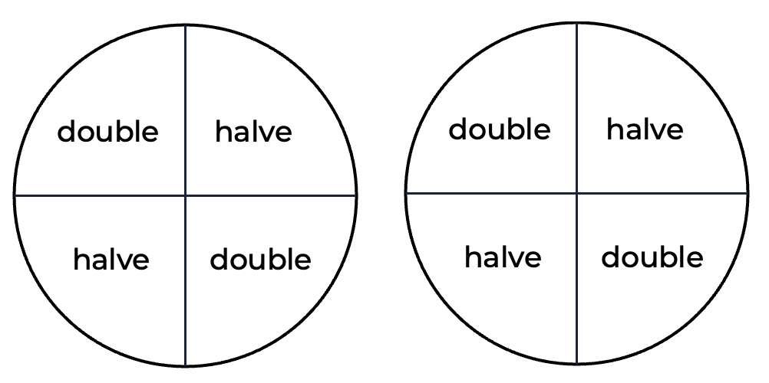

Appendix 2: Repeated doubling gameboard
4 | 24 | 6 | 32 | 8
24 | 10 | 12 | 8 | 32
45 | 16 | 8 | 4 | 12
12 | 10 | 29 | 40 | 20
24 | 16 | 40 | 45 | 6
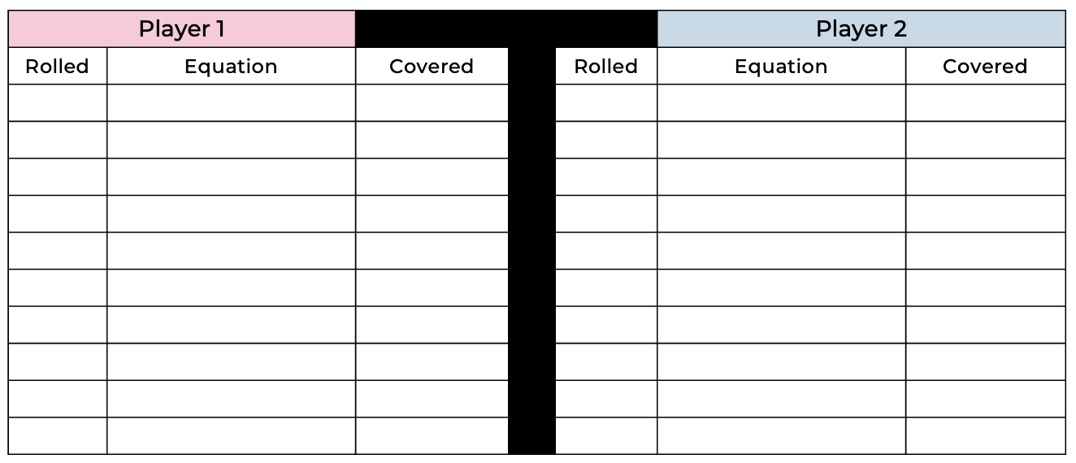

Repeated doubling cards
2 | 4 | 8
4 | 8 | 16
6 | 12 | 24
8 | 16 | 32
10 | 20 | 40
12 | 24 | 48

Repeated doubling spinner
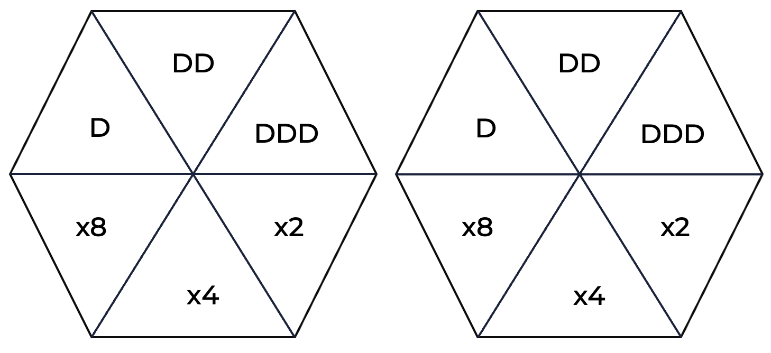

Repeated halving game board
1 | 12 | 3 | 20 | 20
4 | 24 | 4 | 8 | 5
2 | 2 | 24 | 16 | 12
12 | 5 | 4 | 8 | 6
6 | 1 | 2 | 10 | 4

Repeated halving spinner
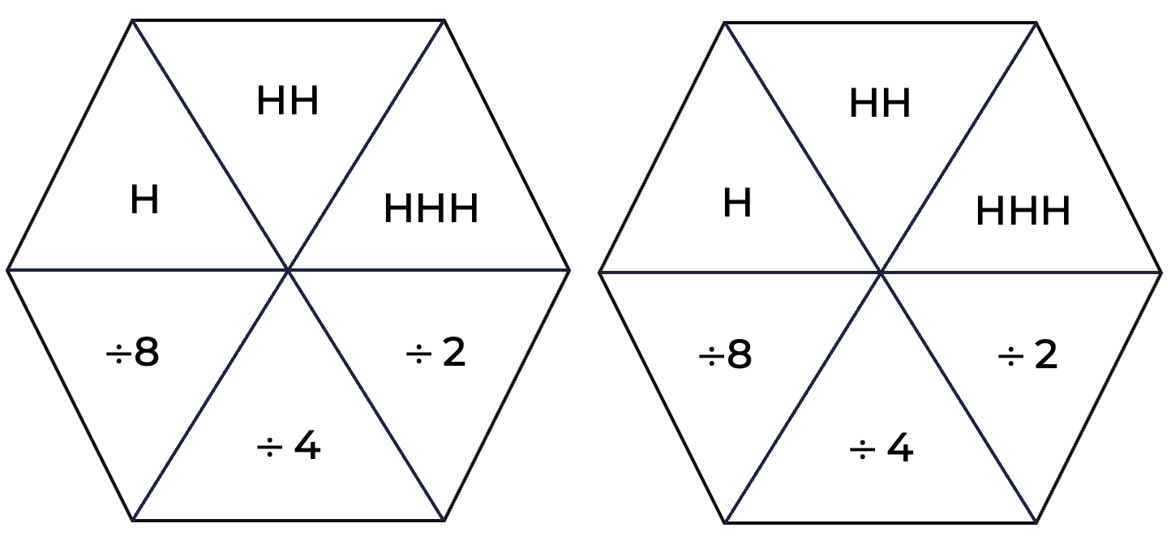

Appendix 3: Patterns of divisibility
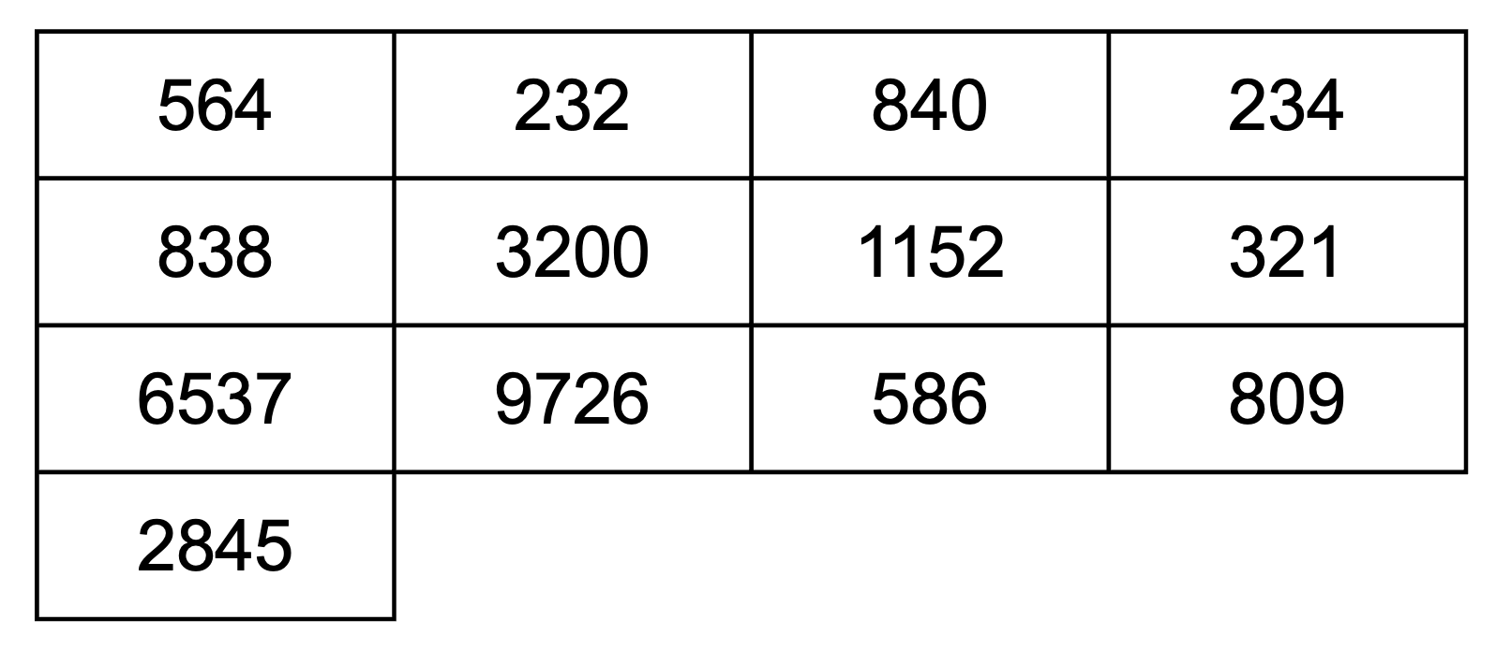

Appendix 4: Multiplication grid
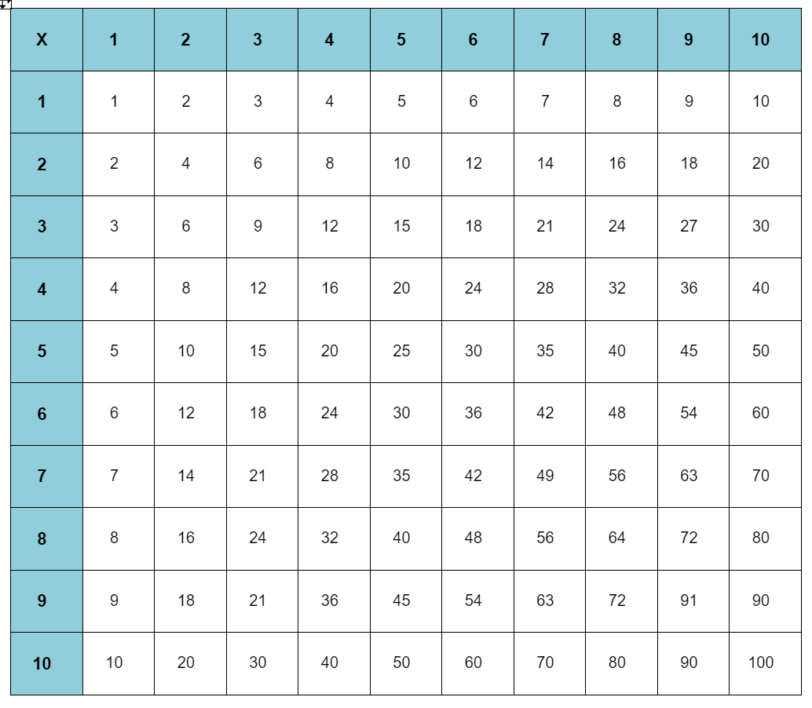

Appendix 5: Target number
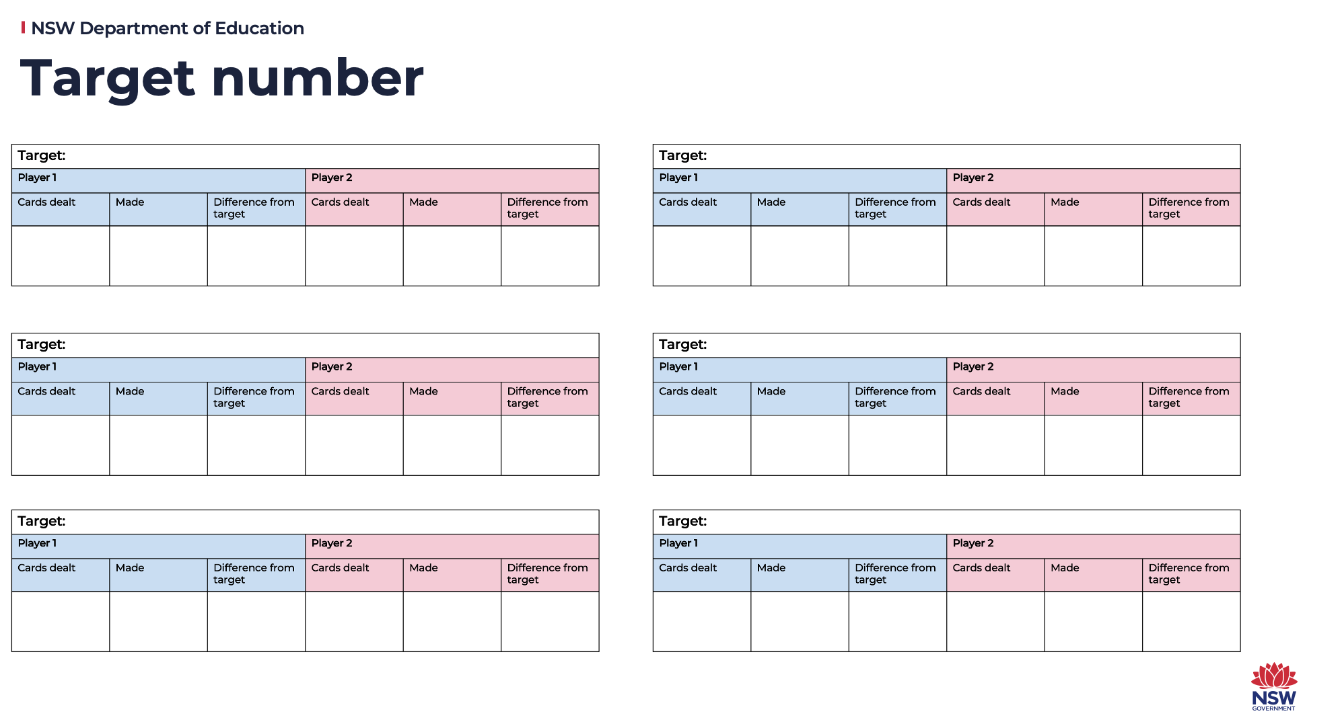

Appendix 6: Super shapes
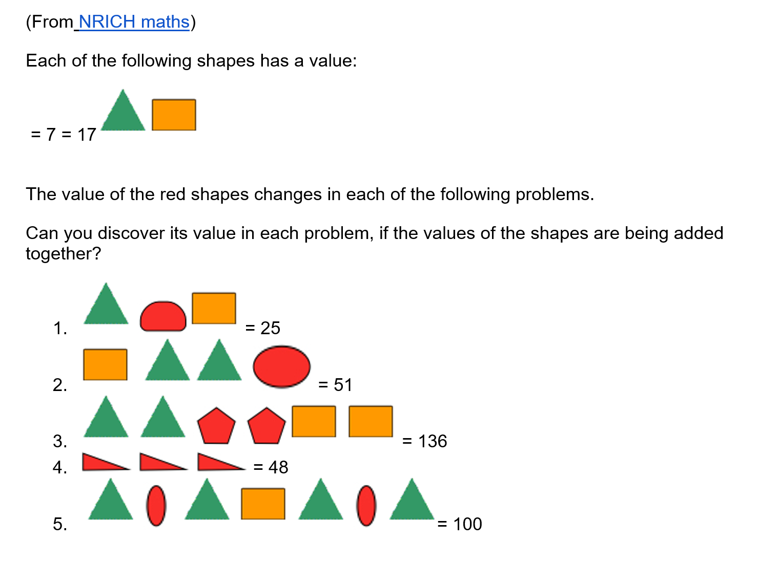

Appendix 7: Colour in fractions
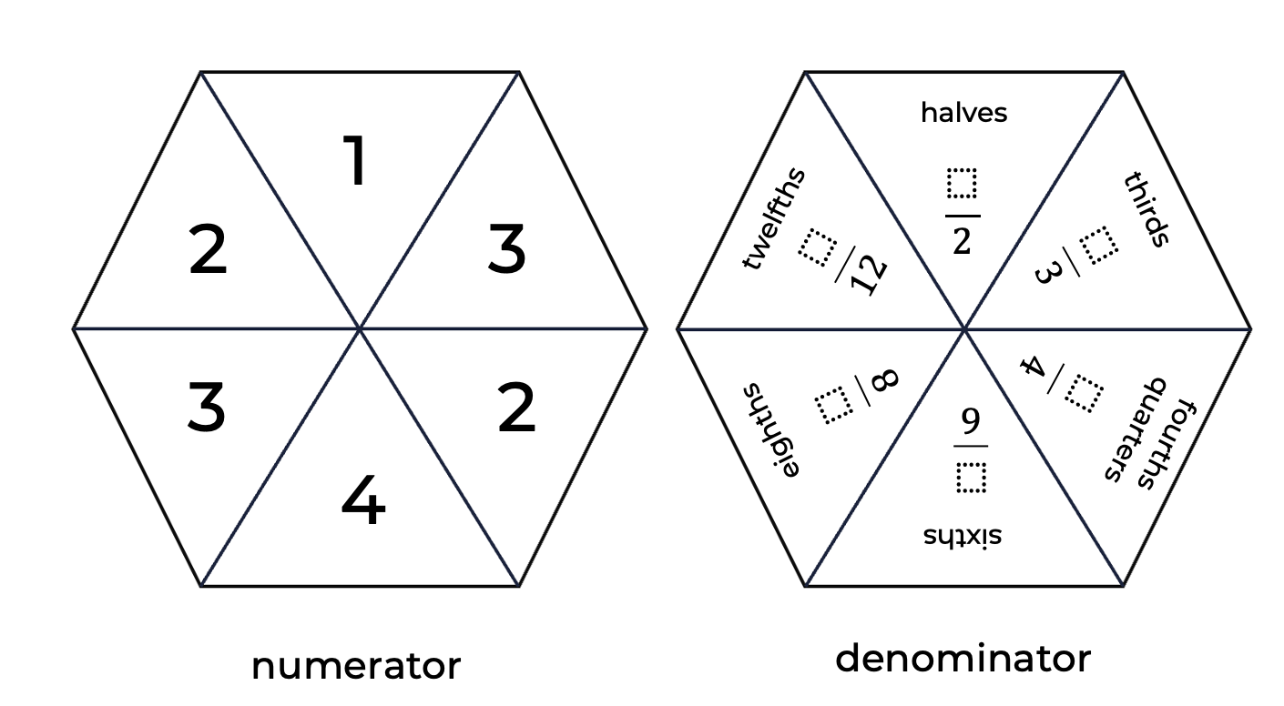

Appendix 8: Colour in fractions game board
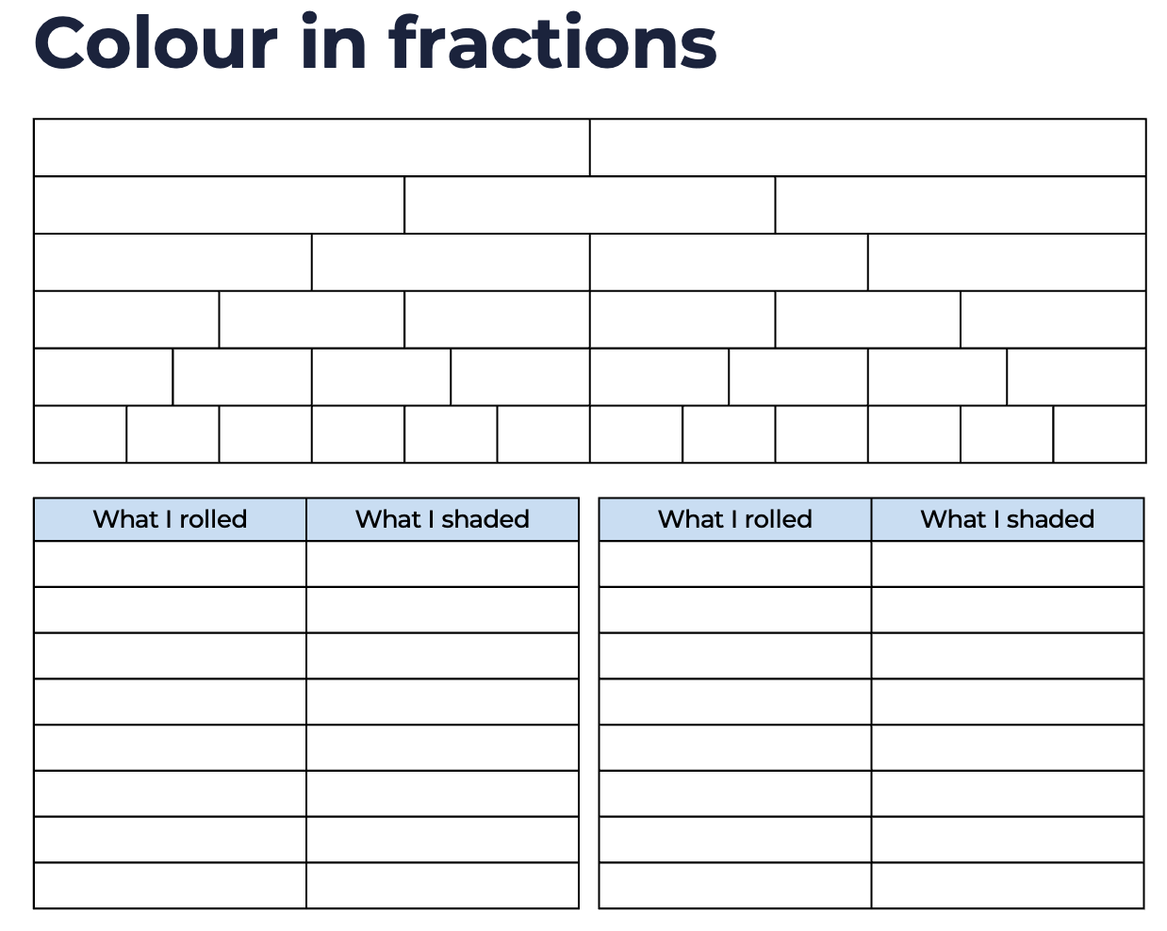

Evidence base
Sparrow, L., Booker, G., Swan, P., Bond, D. (2015). Teaching Primary Mathematics. Australia: Pearson Australia.
Brady, K., Faragher, R., Clark, J., Beswick, K., Warren, E., Siemon, D. (2015). Teaching Mathematics: Foundations to Middle Years. Australia: Oxford University Press.
Alignment to system priorities and/or needs: The literacy and numeracy five priorities, Premier’s priorities: Increase the proportion of public school students in the top two NAPLAN bands (or equivalent) for literacy and numeracy by 15% by 2023.
Alignment to School Excellence Framework: Learning domain: Curriculum, Teaching domain: Effective classroom practice and Professional standards
Consulted with: NSW Mathematics Strategy professional learning and Curriculum Early Years Primary Learners-Mathematics teams
Reviewed by: Literacy and Numeracy
Created/last updated: February 2023
Anticipated resource review date: January 2024
Feedback: Complete the online form to provide any feedback.

