Part 3: Flexible strategies with 3-digit numbers

About the resource
This resource is the third section of a 4-part resource supporting additive thinking.
- Part 1: Flexible strategies with combinations to 10
- Part 2: Flexible strategies with 2-digit numbers
- Part 3: Flexible strategies with 3-digit numbers
- Part 4: Flexible strategies with decimals
Like most things in mathematics, talking about additive thinking is hard to do without referring to other aspects such as patterning, subitising (and visual recognition), counting (with understanding), number sense, measurement and statistics. As such, this resource is best used in conjunction with other guides in order to support a connected network of critical mathematical concepts, skills and understanding.
Flexible additive strategies involve students using what they know (such as known facts, properties, part-part-whole knowledge), using landmark numbers (like multiples of 10 and 5) and using partitioning to solve problems. Students understanding about how numbers and operations work is a critical part of developing deep, meaningful mathematical skills, understanding and confidence.
Continued learning of pattern and structures, number knowledge (including place value understanding) and counting (with understanding) is vital in supporting students’ continued development of number sense. Additionally, students should be supported in developing rich, meaningful understanding of how the operations work to support their skills in working flexibly with numbers. Students need to be provided with opportunities to compare strategies and contexts, exploring situations when particular strategies are efficient and when they are not as efficient. Remember efficiency is connected to the confidence and knowledge of individuals. Building representational fluency is important in supporting meaning-making about the operations and how numbers work.
Students at this stage of learning require targeted teaching in the form of investigations and meaningful, low-stress practice to enhance and solidify their understanding and use flexible strategies in increasingly complex contexts. Teachers should validate the different strategies students invent and use, using individual thinking to cultivate a culture of communication, thinking and reasoning.
The resource has been developed in partnership with the NSW Mathematics Strategy Professional Learning team, Curriculum Early Years and Primary Learners, and Literacy and Numeracy.

How to use the resource
Teachers can use assessment information to make decisions about when and how they use this resource as they design teaching and learning sequences to meet the learning needs of their students.
The tasks and information in the resource includes explicit teaching, high expectations, effective feedback and assessment and can be embedded in the teaching and learning cycle.
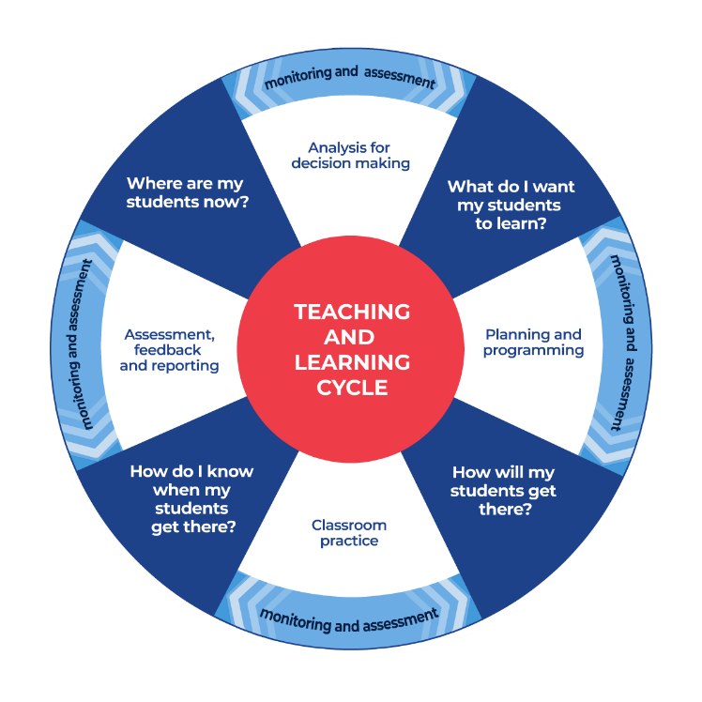
Figure 1: Teaching and learning cycle
- Where are my students now? Teachers use a range of assessment information to determine what students know and can do, including their interests, learning strengths and needs.
- What do I want my students to learn? Teachers use the information gathered along with the syllabus and NNLP to determine the next steps for learning. Teachers might also like to look at the ‘what’s some of the maths’ and ‘key generalisations to synthesise the information they have gathered into the next step/s for learning.
- How will my students get there? Teachers can then use the task overview information (‘What does it promote?’ and ‘What other tasks can I make connections to?’) to find tasks that meet the learning needs of students. Teachers then make decisions about what instructional practices and lesson structures to use in order to best support student learning. Further support with What works best in practice is available.
- How do I know when my students get there? Teachers can use the section ‘Some observable behaviours you may look for/notice’ that have been articulated for each task as a springboard for what to look for. These ideas can be used to co-construct success criteria and modified to suit the learning needs, abilities and interests of students. Referring back to the syllabus and the NNLP are also helpful in determining student learning progress as well as monitoring student thinking during the task. The information gained will inform ‘where are my students now’ and ‘what do I want them to learn’ as part of the iterative nature of the teaching and learning cycle.

Syllabus
MAO-WM-01 develops understanding and fluency in mathematics through exploring and connecting mathematical concepts, choosing and applying mathematical techniques to solve problems, and communicating their thinking and reasoning coherently and clearly
MA2-RN-01 applies an understanding of place value and the role of zero to represent numbers to at least tens of thousands
MA2-AR-01 selects and uses mental and written strategies for addition and subtraction involving 2- and 3-digit numbers
MA2-AR-02 completes number sentences involving addition and subtraction by finding missing values
NSW Mathematics K-10 Syllabus (2022)

Progression
Number and place value NPV2-NPV8
Counting processes CPr5-CPr7
Additive strategies AdS6-AdS8
Number patterns and algebraic thinking NPA3-NPA5
National Numeracy Learning Progression Version 3

Overview of tasks
Task name | What does it promote? | What other tasks can I make connections to? | What materials will I need? | Possible group size
360 degrees | Encourages students to use their understanding of additive strategies. | 101 you’re out | - Appendix 1: 360 degrees resources  - Appendix 2: Recording table  - Dice | Small group/or 2 players
4 turns to 1000 | Encourages students to apply their place value understanding to solve additive problems. | Dicey addition  Hit it!  Mastermind | - Playing cards  - Writing materials | Small group
Dicey addition | Encourages students to apply their place value understanding and estimation skills to solve additive problems. | Dicey operations in a line (NRICH)  Nice or nasty for two (NRICH) | - Nine-sided dice  - Writing materials | Small group and/or 2 players
Subtraction face-off: hundreds, tens and ones | Encourages students to use additive strategies to determine difference. | Number differences (NRICH)  The deca tree (NRICH) | - Nine-sided dice or 0-9 spinner  - Appendix 3: Explanation spinner  - Writing materials | 2 players
About 250 | Encourages students to apply their place value understanding and estimation skills to solve additive problems. | Discuss and choose (NRICH)  Countdown (NRICH) | - A range of additive problems | Whole class
How many ways can they be related? | Supports students to develop flexible strategies and number sense by exploring how numbers can be related. | Broken calculator  Let’s get magical | - Writing materials | Whole class and/or small group
Wipe out! | Encourages students to practice their skills in applying their knowledge of numbers and operations. | Broken calculator | - Calculators | Small group
Hit the target | Encourages students to use flexible strategies and apply their number sense to solve additive problems. | Countdown (NRICH) | - Playing cards Ace-9 | Small group and/or 2 players
Which would you work out in your head? Hundreds, tens and ones | Encourages students to use additive strategies to reason and compare in order to analyse efficiency of strategies. | Closest to 100  Sort them out (1) (NRICH) | - Writing materials  - Sticky notes | Whole class
Let’s talk 1 | Encourages students to compare a variety of strategies to solve a problem, building their awareness of a range of additive strategies. Let's investigate, Let’s explore and Let’s generalise encourage students to explore ideas of efficiency, how a strategy works and where a strategy works, and may not work. | Let’s investigate 1  Let's explore 1  Let’s generalise 1 | - Writing materials  - Interlocking cubes | Whole class

360 degrees

Key generalisations/what’s (some of) the mathematics?
- When solving problems using mental computation, we can use what we know about:
  - known facts
  - landmark numbers (sometimes called benchmark numbers or multiples of five and ten)
  - the relationship between numbers
  - properties
  - renaming of numbers
  - inverse operations.
- We can apply our place value understanding to regroup, rename, partition and rearrange numbers to solve problems.
- Mathematicians explain their thinking so it makes sense to others.
- Mathematicians strategise by using their knowledge of numbers and operations to improve their chances of winning a game.

Some observable behaviours you may look for/notice:
- Uses a range of strategies to solve problems. For example:
  - uses known facts
  - renames numbers
  - uses properties (such as commutative and associative)
  - uses knowledge of counting
  - uses landmark or benchmark numbers (multiples of five and ten)
  - partitions numbers into smaller parts
  - uses inverse operations.

Materials
- Appendix 1: 360 degrees resources
- Appendix 2: Recording table
- 2 dice

Instructions
- Provide pairs with 2 dice and Appendix 2: Recording table.
- The rules are:
- the goal is to be the first person (or team) to get exactly 360
- players may roll the 2 dice as many times as they choose, however, if they roll 1, they forfeit their turn and cannot accumulate any points for that round
- the player with the dice gets to choose when they ‘bank’ their points. When a player has decided to ‘bank’ their points, they hand the 2 dice to their partner and add to their cumulative total using Appendix 2: Recording table.
- Students roll the 2 dice and choose which two-digit number to make for each roll, keeping a mental, cumulative total and explaining their thinking to a partner who records their calculations on an empty number line. When they choose to bank their points, students use their game board to record and ‘bank’ their total. See Figure 2.
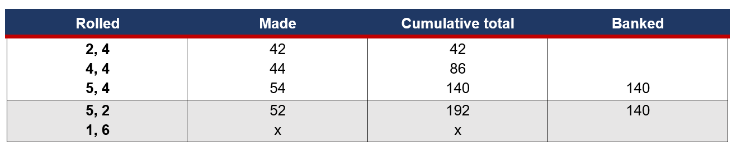
Figure 2: Example of recording table
- Students are allowed to go beyond 360 and then subtract in order to reach 360 exactly.

4 turns to 1000

Key generalisations/what’s (some of) the mathematics?
- When solving problems using mental computation, we can use what we know about:
  - known facts
  - landmark numbers (sometimes called benchmark numbers or multiples of five and ten)
  - the relationship between numbers
  - properties
  - renaming of numbers
  - inverse operations.
- We can use tools such as an empty number line to help us keep track of a cumulative total.
- The position of a digit determines its value. For example, in the number 465 the ‘4’ has a value of 4 hundreds and in the number 234 the ‘4’ has a value of 4 ones.
- We can apply our place value understanding to regroup, rename, partition and rearrange numbers to solve problems.
- We can use estimation to help us when solving problems.
- Mathematicians compare similarities and differences between strategies and contexts to help choose which strategies to use and when.

Some observable behaviours you may look for/notice
- Connects numerals and number names in the range of 0-1000
- Uses place value knowledge strategically to get closest to the target number
- Identifies the value of each digit
- Rounds numbers to the nearest ten or hundred to determine how close they are to the target number
- Uses estimation to determine the reasonableness of the solution.
- Uses a range of strategies to solve problems. For example:
  - uses known facts
  - renames numbers
  - uses properties (such as commutative and associative)
  - uses knowledge of counting
  - uses landmark or benchmark numbers (multiples of five and ten)
  - partitions numbers into smaller parts
  - uses inverse operations.

Materials
- Playing cards Ace-9 (Ace to represent 1)
- Writing materials

Instructions
- Organise the students into groups of 4.
- Provide each group of students with a pack of cards, using Ace-9 to represent 1-9.
- Each player draws a card from the deck and decides if the number they have drawn will represent ones, tens or hundreds. For example, if a 5 is drawn it can represent 5 ones or 5 tens or 5 hundreds.
- The players take a second card from the deck, again nominating if the number represents hundreds, tens or ones and adds the number to their first card.
- Have the students record their total on an empty number line.
- Continue the activity until each student has drawn 4 cards.
- The player with the closest total to 1000 wins.
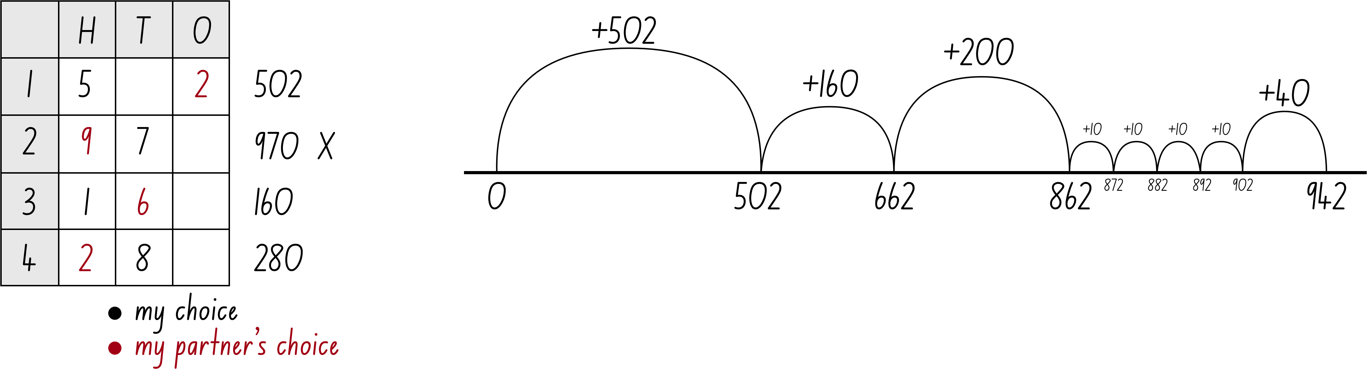
Figure 3: Example of student recording

Variations
- Players start at 1000 and subtract the numbers, with the player closest to zero declared the winner.
- Players draw 3 cards from the pile and make the highest three-digit number possible. This becomes their starting number and they continue to play as in the above variation.

Dicey addition

Key generalisations/what’s (some of) the mathematics?
- The position of a digit determines its value. For example, in the number 345 the ‘4’ has a value of 4 tens and in the number 124 the ‘4’ has a value of 4 ones.
- We can apply place value understanding to regroup, rename, partition and rearrange numbers to solve problems. For example, I know there are 62 tens in 621 because I know there are 10 tens in 1 hundred. To make 6 hundreds I need 60 tens. Then, I just need 2 more tens to make 620.
- We can use estimation to help us when solving problems.
- Mathematicians compare similarities and differences between strategies and contexts to help choose which strategies to use and when.
- Mathematicians explain their thinking so it makes sense to others.
- When solving problems using mental computation, we can use what we know about:
  - known facts
  - landmark numbers (sometimes called benchmark numbers or multiples of five and ten)
  - the relationship between numbers
  - properties
  - renaming of numbers
  - inverse operations.

Some observable behaviours you may look for/notice
- Solves addition problems using efficient mental strategies
- Flexibly and fluently renames 100 ones as 1 hundred, 10 tens as 100 ones and non-standard partitioning like 73 ones as 6 tens and 13 ones
- Explains (through symbols, words and representations) why they used a particular strategy
- Uses estimation to determine the reasonableness of the solution
- Names the value of a digit.
- Uses a range of strategies to solve problems, for example:
  - uses known facts
  - renames numbers
  - uses properties (such as commutative and associative)
  - uses knowledge of counting
  - uses landmark or benchmark numbers (multiples of five and ten)
  - partitions numbers into smaller parts
  - uses inverse operations.

Materials
- 0-9 dice or 0-9 spinner
- Writing materials

Instructions
View Dicey addition to learn how to play.
- Students find a partner and a 0-9 dice or spinner.
- Draw a game board so each student has the same one
(an example to start with: _ _ _ + _ _ _ + _ _ _ = ________ or choose something different).
- Each player takes a turn to roll or spin and decide where to play that digit in their number sentence (equation).
- Students roll or spin 9 times each.
- The person whose sum is closest to 1000 is the winner.
- Share thinking with a partner and record your thinking.

Variations
- To support learners, model the game, articulating thinking in a similar way as the video.
- This activity could be adapted into an investigation by asking the students to develop a strategy that increases their chance of winning. They could then be asked to develop their own blank number sentences to include subtraction and then both addition and subtraction.
Activity is an adaptation of Dicey Addition from NRICH by Faculty of Mathematics, University of Cambridge

Subtraction face off: hundreds, tens and ones

Key generalisations/what’s (some of) the mathematics?
- When solving problems using mental computation, we can use what we know about:
  - known facts
  - landmark numbers (sometimes called benchmark numbers or multiples of five and ten)
  - the relationship between numbers
  - properties
  - renaming of numbers
  - inverse operations.
- Different people see and think about numbers and problems in different ways.
- Mathematicians work together to solve problems and explain their strategies using concrete or pictorial representations.
- We can apply our place value understanding to regroup, rename, partition and rearrange numbers to solve problems.
- Mathematicians explain their thinking so it makes sense to others.
- Mathematicians strategise by using their knowledge of numbers and operations to improve their chances of winning a game.

Some observable behaviours you may look for/notice
- Describes the difference between numbers as a subtractive context
- Use a range of representations to explain thinking. For example, uses a number line to model 80 - 30 as the difference between 80 and 30
- Flexibly and fluently renames 100 ones as 1 hundred, 10 tens as 100 ones and non-standard partitioning like 73 ones as 6 tens and 13 ones
- Uses a range of strategies to solve problems. For example:
  - uses known facts
  - renames numbers
  - uses properties (such as commutative and associative)
  - uses knowledge of counting
  - uses landmark or benchmark numbers (multiples of five and ten)
  - partitions numbers into smaller parts
  - uses inverse operations
- Uses various representations to share thinking:
  - concrete materials
  - gestures and enactment
  - drawings
  - diagrams
  - language.
- Explores and explains the difference between operations.
- Uses a range of representations as supporting evidence when giving valid reasons for a solution.

Materials
- Nine-sided dice or 0-9 spinner
- Appendix 3: Explanation spinner
- Writing materials

Instructions
- Provide pairs of students with a set of playing cards and Appendix 3: Explanation spinner.
- Students use Ace-9 to represent 1-9. Have students shuffle the cards and deal them out evenly between the 2 players.
- Students place their cards into a face down pile.
- At the same time, students take the 5 top cards from the pile to form a three-digit number and a two-digit number.
- Students can arrange the cards in any way they like in order to make the smallest difference. The student with the smallest difference collects all 10 cards. Students continue playing until someone has lost all of their cards.
- Have students use the explanation spinner and share the strategies used to work out differences based on what the spinner lands on.

About 250

Key generalisations/what’s (some of) the mathematics?
- We can use estimation to determine the reasonableness of an answer.
- When solving problems using mental computation, we can use what we know about:
  - known facts
  - landmark numbers (sometimes called benchmark numbers or multiples of five and ten)
  - the relationship between numbers
  - properties
  - renaming of numbers
  - inverse operations.
- We can apply our place value understanding to regroup, rename, partition and rearrange numbers to solve problems.
- The same problem can be solved using a range of different strategies.
- Different people see and think about numbers and problems in different ways.

Some observable behaviours you may look for/notice:
- Uses estimation to determine the reasonableness of the solution
- Uses a range of strategies to solve problems. For example:
  - uses known facts
  - renames numbers
  - uses properties (such as commutative and associative)
  - uses knowledge of counting
  - uses landmark or benchmark numbers (multiples of five and ten)
  - partitions numbers into smaller parts
  - uses inverse operations
- Describes how equivalence can be used to solve problems. For example, I don't know 351 and 39 but I know 350 and 40 is 10 less than 400
- Flexibly and fluently renames 100 ones as 1 hundred, 10 tens as 100 ones and non-standard partitioning like 73 ones as 6 tens and 13 ones
- Uses the value of digits to help estimate. For example, rounding to the nearest 10.

Instructions
- Provide students with a range of questions. For example:

  - 351 – 39
  - 941 – 314 – 357
  - 138 + 98
  - 113 + 82
  - 25 + 26 + 27 + 28 + 78
  - 434 – 200
  - 500 – 97 – 77 – 81

- Explain in this case, we do not need to determine a precise answer.
- Ask students to estimate and determine which problems would be approximately equivalent to 250.
- Question students about the information they used to help them make their decisions and explore the ways they may have used the value of the digits to estimate. For example, rounding to 10 and using known facts.

Teaching point
Estimating supports students in developing number sense as well as enabling them to determine the reasonableness of their solutions.

Variations
- Students could sort problems into categories such as: ‘less than 250’ and ‘more than 250’
- Change the target number (such as 250) and the problems provided.

How many ways can they be related?

Key generalisations/what’s (some of) the mathematics?
- When solving problems using mental computation, we can use what we know about:
  - known facts
  - landmark numbers (sometimes called benchmark numbers or multiples of five and ten)
  - the relationship between numbers
  - properties
  - renaming of numbers
  - inverse operations.
- We can apply our place value understanding to regroup, rename, partition and rearrange numbers to solve problems.
- Listening to other people’s thinking helps us become aware of other strategies, building our knowledge of mathematics.
- Mathematicians compare their strategies with the thinking of others.

Some observable behaviours you may look for/notice
- Uses a range of strategies to solve problems. For example:
  - uses known facts
  - renames numbers
  - uses properties (such as commutative and associative)
  - uses knowledge of counting
  - uses landmark or benchmark numbers (multiples of five and ten)
  - partitions numbers into smaller parts
  - uses inverse operations.
- Flexibly and fluently renames 100 ones as 1 hundred, 10 tens as 100 ones and non-standard partitioning like 73 ones as 6 tens and 13 ones
- Describes how equivalence can be used to solve problems
- Explains why they used a particular strategy.

Materials
- Writing materials

Instructions
- Provide students with a string of numbers. For example: 12 240 3 18 36 12
- Ask students to consider how they could move from one number to the next, using any operation. For example, there are a number of ways to move from 12 to 240, including:
  - Add 228
  - Double 12 and multiply by 10
  - Multiply 12 by 20
  - Add 200 + 8 + 20 more
  - Multiply by 40 and halve
  - Add 238 and subtract 10
- Ask students to work with a thinking partner to make a list of suggestions. Invite students to share their thinking with the group. Ask students questions such as:
  - What patterns did you notice?
  - What patterns did you use to help you make your list?
  - Is it possible to work out how many ways one number can be related to another?

Teaching point
Part of developing efficient mental computation and strong number sense involves seeing how any pair of numbers can be related in a vast number of ways.

Wipe out!

Key generalisations/what’s (some of) the mathematics?
- When solving problems using mental computation, we can use what we know about:
  - known facts
  - landmark numbers (sometimes called benchmark numbers or multiples of five and ten)
  - the relationship between numbers
  - properties
  - renaming of numbers
  - inverse operations.
- Listening to other people’s thinking helps us become aware of other ways of thinking, building our knowledge of mathematics.
- Mathematicians compare their strategies with the thinking of others.
- Mathematicians use the ideas of others to refine/extend their own ideas.

Some observable behaviours you may look for/notice
- Uses a range of strategies to solve problems. For example:
  - uses known facts
  - renames numbers
  - uses properties (such as commutative and associative)
  - uses knowledge of counting
  - uses landmark or benchmark numbers (multiples of five and ten)
  - partitions numbers into smaller parts
  - uses inverse operations
- Mathematicians compare similarities and differences between strategies and contexts to help choose which strategies to use and when.

Materials
- Calculators

Instructions
- Provide students with a calculator.
- Give students a number such as 378.
- Ask students what we can do to ‘wipe out’ the 7 from the calculator display.
- Have the students discuss with a thinking partner and then share with the class. The teacher should record student suggestions and reasons why.
- Have the students ‘wipe out’ the 7 by subtracting 70 as suggested.
- Ask students to add the ‘7’ back by adding 70.
- Then ask; ‘How many ways can they think of ‘wiping out 7’ without using the ‘7’ button?’
- Have students work with a partner to brainstorm their thinking.
- Have students analyse the work of their peers, looking for similarities and differences between the suggestions made by students.
- Have students use their own or the ideas of their peers to ‘wipe out 7’, recording whether each idea was successful or unsuccessful.

Variations
- Increase the numbers beyond 999.
- Investigate what happens when you want to wipe out a ‘0’.
- Use decimal numbers.
- Try ‘Wipe out!’ using negative numbers. For example, how could we ‘wipe out’ the ‘8’ from -38?

Hit the target

Key generalisations/what’s (some of) the mathematics?
- When solving problems using mental computation, we can use what we know about:
  - known facts
  - landmark numbers (sometimes called benchmark numbers or multiples of five and ten)
  - the relationship between numbers
  - properties
  - renaming of numbers
  - inverse operations.
- Mathematicians strategise by using their knowledge of numbers and operations to improve their chances of winning a game.

Some observable behaviours you may look for/notice
- Uses a range of strategies to solve problems. For example:
  - uses known facts
  - renames numbers
  - uses properties (such as commutative and associative)
  - uses knowledge of counting
  - uses landmark or benchmark numbers (multiples of five and ten)
  - partitions numbers into smaller parts
  - uses inverse operations.

Materials
- Playing cards Ace-9 (Ace representing 1)

Instructions
- Using Ace to 9 to represent 1 to 9, students shuffle the cards.
- Have the dealer turn over 3 cards to form a three-digit number. This becomes the target.
- The dealer then deals 6 cards to each player, face up. Players have to arrange their cards to form 2 three-digit numbers or a combination of three-, two- and one-digit numbers which they can add or subtract to hit the target. For example:
  - Target = 473
  - My cards = 6, 1, 2, 3, 9, 3
  - I could make:
  - 693 – 231 = 462
  - 339 + 126 = 465
  - 393 + 62 + 1 = 456
- The student closest to the target wins the round and a point.
- Play continues for a number of rounds.

Variations
- Each player keeps a cumulative total of the difference between their total and the target
- Change the target each round
- Make the target a four-digit number.

Which would you work out in your head? Hundreds, tens and ones

Key generalisations/what’s (some of) the mathematics?
- When solving problems using mental computation, we can use what we know about:
  - known facts
  - landmark numbers (sometimes called benchmark numbers or multiples of five and ten)
  - the relationship between numbers
  - properties
  - renaming of numbers
  - inverse operations.
- We can apply our place value understanding to regroup, rename, partition and rearrange numbers to solve problems.
- Mathematicians compare similarities and differences between strategies and contexts to help choose which strategies to use and when.
- Mathematicians explain their thinking so it makes sense to others.

Some observable behaviours you may look for/notice
- Uses a range of strategies to solve problems. For example:
  - uses known facts
  - renames numbers
  - uses properties (such as commutative and associative)
  - uses knowledge of counting
  - uses landmark or benchmark numbers (multiples of five and ten)
  - partitions numbers into smaller parts
  - uses inverse operations.

Materials
- writing materials
- sticky notes

Instructions
- Display:

  - 47 + ___ = 134
  - 480 + 307
  - 75 + 15 + 411
  - 100 + 10 + 110 + 101
  - 235 – 44
  - 98 + ___ = 266
  - 635 - ___ = 20
  - 104 – 90
  - 78 – 12 – 16

- Ask students:
- Which ones of these would you solve using a mental strategy, if any?
- Which ones would you prefer to solve using a written or digital strategy?
- Allow students time to think before asking students to respond. Students record which questions they would do in their head. Students record on sticky notes or a digital response application.
- As a class compare the similarities and differences in class preferences. Looking at the responses, ask questions such as:
  - Which question/s do you think most people might prefer to model to help them solve?
    - Why do you think that? What do these questions have in common?
  - Which question/s do you think most people would work out in their heads?
    - Why do you think that? What do these questions have in common?
  - Which strategies are we not considering as often as others?
    - What do we need to learn to use those strategies as comfortably as the others?
Teacher note: Students need to know there are different addition and subtraction situations and strategies work in some contexts and not in others. Posing questions such as these enable students to see how different people work with problems in different contexts.

Variations
- Adapt the questions to suit students working with decimal fractions.

Let’s talk 1

Key generalisations/what’s (some of) the mathematics?
- The same problem can often be solved using many different strategies.
- Numbers can be used flexibly to solve problems. For example, 230 - 190 is equivalent in value to 240 – 200. Re-thinking the numbers like this allows us to keep a constant difference to help us solve this problem.
- Different people see and think about numbers and problems in different ways.
- We can apply our place value understanding to regroup, rename, partition and rearrange numbers to solve problems.
- We can use inverse operations to solve problems and to check our thinking.
- Listening to other people’s thinking helps us become aware of other strategies, building our knowledge of mathematics.
- Mathematicians compare their strategies with the thinking of others.
- Mathematicians use the ideas of others to refine/extend their own ideas.

Some observable behaviours you may look for/notice
- Uses a range of strategies to solve problems. For example:
  - uses known facts
  - renames numbers
  - uses properties (such as commutative and associative)
  - uses knowledge of counting
  - uses landmark or benchmark numbers (multiples of five and ten)
  - partitions numbers into smaller parts
  - uses inverse operations.
For example, “I can think of 190 and partition it, 190 is made up of 10 tens and 9 tens”
- Explains why they used a particular strategy.
- Describes how equivalence can be used to solve problems. For example, I don't know 230 – 190 but I know it is the same as 240 – 200
- Refines/extends thinking after listening to the ideas and strategies of others.

Materials
- writing materials
- interlocking cubes

Instructions
There are 4 parts to this activity. View each video in Let’s talk 1 using the questions to guide student thinking.

Appendix 1: 360 degrees resources
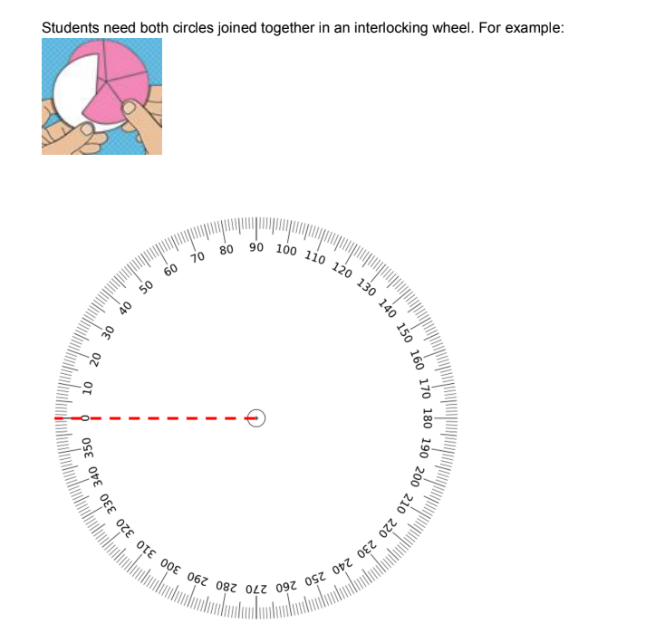

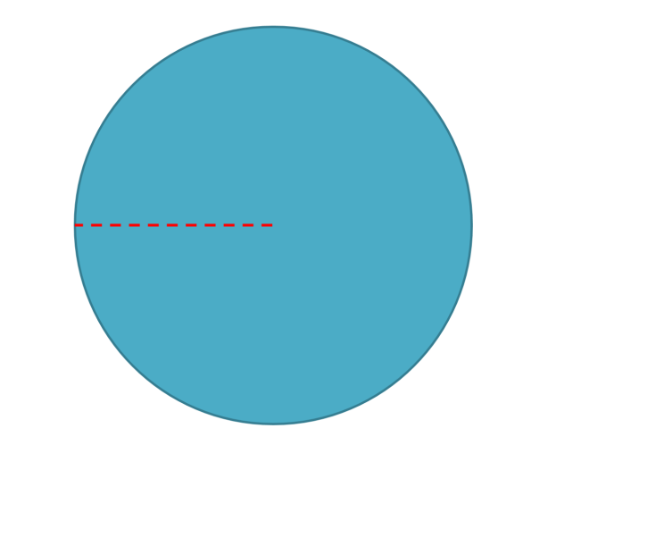

Appendix 2: Recording table
Rolled | Made | Cumulative total | Banked

Appendix 3: Explanation spinner
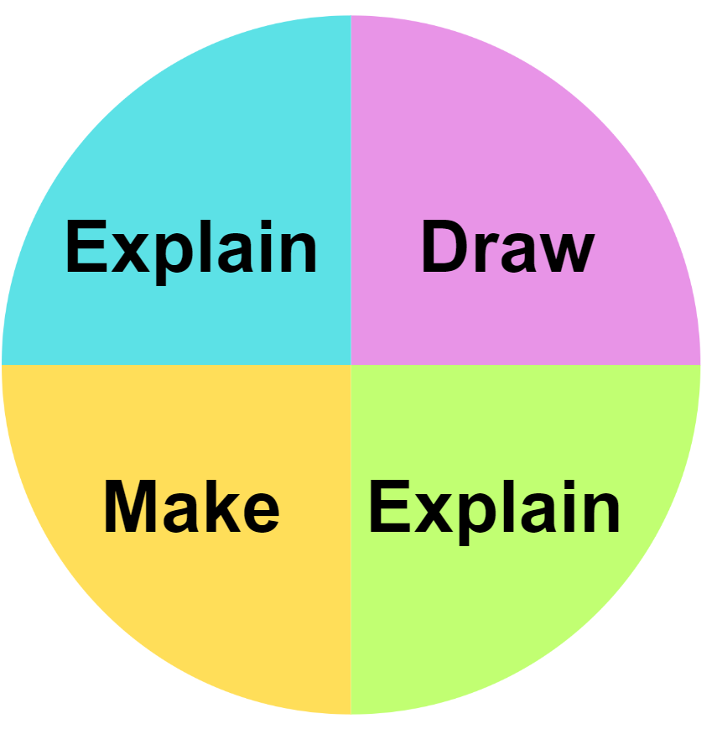

Reference list
This resource contains images and content obtained from Canva, and their use outside of this resource is subject to Canva’s Content License Agreement.
Mathematics K–10 Syllabus © NSW Education Standards Authority (NESA) for and on behalf of the Crown in right of the State of New South Wales, 2022.
National Numeracy Learning Progression © Australian Curriculum, Assessment and Reporting Authority (ACARA) 2010 to present, unless otherwise indicated. This material was downloaded from the Australian Curriculum website (National Literacy Learning Progression) (accessed 6 November 2023) and was not modified.
State of New South Wales (Department of Education) (2023) ‘101 and you’re out’, Mathematics K-6 resources, NSW Department of Education website, accessed 15 November 2023.
State of New South Wales (Department of Education) (2023) ‘Broken calculator’, Mathematics K-6 resources, NSW Department of Education website, accessed 15 November 2023.
State of New South Wales (Department of Education) (2023) ‘Closest to 100’, Mathematics K-6 resources, NSW Department of Education website, accessed 15 November 2023.
State of New South Wales (Department of Education) (2023) ‘Dicey addition’, Mathematics K-6 resources, NSW Department of Education website, accessed 15 November 2023.
State of New South Wales (Department of Education) (2023) ‘Hit it’, Mathematics K-6 resources, NSW Department of Education website, accessed 15 November 2023.
State of New South Wales (Department of Education) (2023) ‘Let’s get magical’, Mathematics K-6 resources, NSW Department of Education website, accessed 15 November 2023.
State of New South Wales (Department of Education) (2023) ‘Let's explore 1’, Mathematics K-6 resources, NSW Department of Education website, accessed 6 November 2023.
State of New South Wales (Department of Education) (2023) ‘Let’s generalise 1’, Mathematics K-6 resources, NSW Department of Education website, accessed 6 November 2023.
State of New South Wales (Department of Education) (2023) ‘Let’s investigate 1’, Mathematics K-6 resources, NSW Department of Education website, accessed 6 November 2023.
State of New South Wales (Department of Education) (2023) ‘Mastermind’, Mathematics K-6 resources, NSW Department of Education website, accessed 15 November 2023.
University of Cambridge (Faculty of Mathematics) (1997–2023) ‘Countdown’, NRICH website, accessed 13 November 2023.
University of Cambridge (Faculty of Mathematics) (1997–2023) ‘Dicey Addition’, NRICH website, accessed 13 November 2023.
University of Cambridge (Faculty of Mathematics) (1997–2023) ‘Dicey operations in line’, NRICH website, accessed 13 November 2023.
University of Cambridge (Faculty of Mathematics) (1997–2023) ‘Discuss and choose’, NRICH website, accessed 13 November 2023.
University of Cambridge (Faculty of Mathematics) (1997–2023) ‘Nice or Nasty for two’, NRICH website, accessed 13 November 2023.
University of Cambridge (Faculty of Mathematics) (1997–2023) ‘Number differences’, NRICH website, accessed 13 November 2023.
University of Cambridge (Faculty of Mathematics) (1997–2023) ‘Sort them out’, NRICH website, accessed 13 November 2023.
University of Cambridge (Faculty of Mathematics) (1997–2023) ‘The deca tree’, NRICH website, accessed 13 November 2023.

Copyright
Section 113P Notice
Texts, Artistic Works and Broadcast Notice
Some of this material has been copied and communicated to you in accordance with the statutory licence in section 113P of the Copyright Act. Any further reproduction or communication of this material by you may be the subject of copyright protection under the Act. Do not remove this notice.

Evidence base
Sparrow, L., Booker, G., Swan, P., Bond, D. (2015). Teaching Primary Mathematics. Australia: Pearson Australia.
Brady, K., Faragher, R., Clark, J., Beswick, K., Warren, E., Siemon, D. (2015). Teaching Mathematics: Foundations to Middle Years. Australia: Oxford University Press.
Alignment to system priorities and/or needs: The literacy and numeracy five priorities.
Alignment to School Excellence Framework: Learning domain: Curriculum, Teaching domain: Effective classroom practice and Professional standards
Consulted with: NSW Mathematics Strategy professional learning and Curriculum Early Years Primary Learners-Mathematics teams
Reviewed by: Literacy and Numeracy
Created/last updated: January 2024
Anticipated resource review date: January 2025
Feedback: Complete the online form to provide any feedback.

