Part 2: Flexible strategies with 2-digit numbers

About the resource
This resource is the second section of a four-part resource supporting additive thinking.
- Part 1: Flexible strategies with combinations to 10
- Part 2: Flexible strategies with 2-digit numbers
- Part 3: Flexible strategies with 3-digit numbers
- Part 4: Flexible strategies with decimals.
Like most things in mathematics, talking about additive thinking is hard to do without referring to other aspects such as patterning, subitising (and visual recognition), counting (with understanding), number sense, measurement and statistics. As such, this resource is best used in conjunction with other guides to support a connected network of critical mathematical concepts, skills and understanding.
Flexible additive strategies involve students using what they know (such as known facts, properties, part-part-whole knowledge and so on.), using landmark numbers (like multiples of 10 and 5) and using partitioning to solve problems. Students understanding about how numbers and operations work is a critical part of developing deep, meaningful mathematical skills, understanding and confidence.
Continued learning of pattern and structures, number knowledge (including place value understanding) and counting (with understanding) is vital in supporting students’ continued development of number sense. Additionally, students should be supported in developing rich, meaningful understanding of how the operations work to support their skills in working flexibly with numbers. Students need to be provided with opportunities to compare strategies and contexts, exploring situations when particular strategies are efficient and when they are not as efficient. Remember efficiency is connected to the confidence and knowledge of individuals. Building representational fluency is important in supporting meaning-making about the operations and how numbers work.
Students at this stage of learning require targeted teaching in the form of investigations and meaningful, low-stress practice to enhance and solidify their understanding and use flexible strategies in increasingly complex contexts. Validate the different strategies students invent and use, using individual thinking to cultivate a culture of communication, thinking and reasoning.
The resource has been developed in partnership with the NSW Mathematics Strategy Professional Learning and Curriculum Early Years and Primary Learners teams.

How to use the resource
Teachers can use assessment information to make decisions about when and how they use this resource as they design teaching and learning sequences to meet the learning needs of their students.
The tasks and information in the resource includes explicit teaching, high expectations, effective feedback and assessment and can be embedded in the teaching and learning cycle.
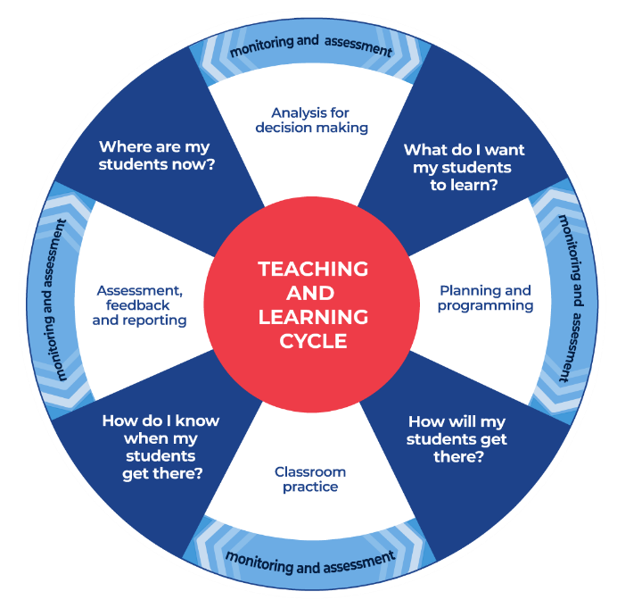
Figure 1: Teaching and learning cycle
- Where are my students now? Use a range of assessment information to determine what students know and can do, including their interests, learning strengths and needs.
- What do I want my students to learn? Use the information gathered along with the syllabus and NNLP to determine the next steps for learning. Teachers might also like to look at the ‘what’s some of the maths’ and ‘key generalisations to synthesise the information they have gathered into the next step/s for learning.
- How will my students get there? Next use the task overview information (‘What does it promote?’ and ‘What other tasks can I make connections to?’) to find tasks that meet the learning needs of students. Teachers then make decisions about what instructional practices and lesson structures to use in order to best support student learning. Further support with What works best in practice is available.
- How do I know when my students get there? Use the section ‘Some observable behaviours you may look for/notice’ that have been articulated for each task as a springboard for what to look for. These ideas can be used to co-construct success criteria and modified to suit the learning needs, abilities and interests of students. Referring back to the syllabus and the NNLP are also helpful in determining student learning progress as well as monitoring student thinking during the task. The information gained will inform ‘where are my students now’ and ‘what do I want them to learn’ as part of the iterative nature of the teaching and learning cycle.

Syllabus
MAO-WM-01 develops understanding and fluency in mathematics through exploring and connecting mathematical concepts, choosing and applying mathematical techniques to solve problems, and communicating their thinking and reasoning coherently and clearly
MA1-RWN-01 applies an understanding of place value and the role of zero to read, write and order two- and three-digit numbers
MA1-RWN-02 reasons about representations of whole numbers to 1000, partitioning numbers to use and record quantity values
MA1-CSQ-01 uses number bonds and the relationship between addition and subtraction to solve problems involving partitioning
MA2-RN-01 applies an understanding of place value and the role of zero to represent numbers to at least tens of thousands
MA2-AR-01 selects and uses mental and written strategies for addition and subtraction involving 2- and 3-digit numbers
MA2-AR-02 completes number sentences involving addition and subtraction by finding missing values
NSW Mathematics K-10 Syllabus (2022)

Progression
Number and place value NPV2-NPV5
Counting processes CPr2-CPr7
Additive strategies AdS2-AdS7
Number patterns and algebraic thinking NPA1-NPA5
National Numeracy Learning Progression Version 3

Some additional background information
Students working at this stage need an understanding of the flexibility with which numbers can be partitioned and renamed. For example, they can see “10 of these” is “one of those”, applying that growing understanding with two-digit numbers, see Figure 2.
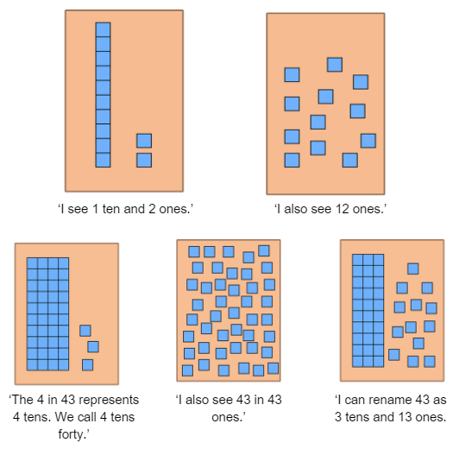
Figure 2: Student thinking
This requires a deep knowledge of the structure of numbers that goes beyond being able to state the positional value of digits or rename numbers using expanded notation only.
To support students, provide them with meaningful, challenging and various experiences, including building representational competencies by using a broad range of concrete materials, language and to support sense-making. Teachers should also be aware that conceptual understanding can be hindered by too soon and too strong an emphasis on procedure and abstract recording.
Continue working with students to help them to develop an empowering understanding of what mathematics is about – reasoning, problem solving, communicating and understanding. The ability to think strategically when approaching mathematical situations, therefore, needs to underpin learning and the classroom culture. This means it is not the speed students arrive at an answer that is valued but the way they use their knowledge, skills and reasoning to find a solution. Mathematical fluency is about flexibility, efficiency and accuracy, which is enhanced by growing understanding and confidence.

Overview of tasks
Task name | What does it promote? | What other tasks can I make connections to? | What materials will I need? | Possible group size
Which would you do in your head? | Encourages students to analyse where they are confident using flexible additive strategies and where they are not yet. It can also be used to define efficiency. | Closest to 100  Sort them out (1) (NRICH) | - Writing materials | Whole class and/or small group
Let’s talk 1  23 -19 | Encourages students to recognise that the same problem can be solved in different ways. Let's investigate, Let’s explore and Let’s generalise encourage students to explore ideas of efficiency, how a strategy works and where a strategy works, and may not work. | Let’s investigate 1  Let's explore 1  Let’s generalise 1 | - Writing materials  - Interlocking cubes | Whole class
Claim it | Encourages students to use additive strategies. | It’s time to get magical | - Nine-sided dice  - Numeral cards 0-27 | 2 players
Subtraction face-off | Encourages students to use additive strategies to determine difference. | Race to zero  Concentration- constant difference | - Playing cards  - Writing materials | 2 players
Difference challenge | Encourages students to use additive strategies to determine difference. | Roll these dice (NRICH) | - Playing cards  - Writing materials | 2 players
Strategic part-part-whole thinking | Encourages understanding that using benchmark (or landmark) numbers like tens and fives, as well as known facts and part-part-whole number knowledge, can help us solve additive problems. | Number busting 26 | - Writing materials | Whole class and/or small group
How might we? | Encourages understanding that using benchmark (or landmark) numbers like tens and fives, as well as known facts and part-part-whole number knowledge, can help us solve additive problems. | Number busting 26  Game of Totals (3-5) (youcubed) | - 2 packets of 10 pencils and 6 pencils more | Whole class and/or small group
Addition and subtraction table patterns | Encourages students to use additive strategies. | It’s time to get magical  Strike it out  Addition: Chess – The Rook (reSolve) | - Appendix 1: Blank 11 x 11 addition and subtraction grid  - Ten-sided dice  - Writing materials | Whole class and/or small group
How can we represent that? | Encourages students to recognise the same problem can be solved in different ways and explore the concept of equivalence. | Balancing numbers 1  Balancing numbers 2  Balancing numbers 3 | - Writing materials | Whole class

Which would you do in your head?

Key generalisations/what’s (some of) the mathematics?
- We can use a range of mental, written and digital strategies to solve problems.
- When solving problems using mental computation, we can use what we know about:
  - known facts
  - landmark numbers
  - the relationship between numbers
  - properties
  - renaming of numbers.
- We can apply our place value understanding to regroup, rename, partition and rearrange numbers to help solve problems.
- Mathematicians compare similarities and differences between strategies and contexts to help choose which strategies to use and when.
- Mathematicians explain their thinking so it makes sense to others.

Some observable behaviours you may look for/notice
- Uses a range of strategies to solve problems. For example:
  - Uses known facts
  - Renames numbers
  - Uses properties (such as commutative and associative)
  - Uses knowledge of counting
  - Uses landmark or benchmark numbers (multiples of five and ten)
  - Partitions numbers into smaller parts
  - Uses inverse operations.
- Explains why they used a particular strategy.

Materials
- Writing materials

Instructions
View Which would you do in your head?
- Display:

- 17 + __ = 34
- 80 + 30
- 7 + 15 + 4
- 10 + 10 + 10+ 10
- 25 + 25
- 38 + __ = 66
- 65 - __ = 20
- 14 - 9
- 18 - 2 - 2

- Ask students:
- Which ones of these would you solve using a mental strategy, if any?
- Which ones would you prefer to solve using a written or digital strategy?
- Allow time to think before asking students to respond. Students record the questions they would do in their head on sticky notes or on a digital response application.
- As a class, compare the similarities and differences in class preferences. Looking at the responses, ask questions such as:
- Which question/s do you think most people might prefer to model to help them solve?
  - Why do you think that?
  - What do these questions have in common?
- Which question/s do you think most people would work out in their heads?
  - Why do you think that?
  - What do these questions have in common?
- Which strategies are we not considering as often as others?
  - What do we need to learn to use those strategies as comfortably as the others?

Teaching points
- Students find out whether there is a problem (or problems) everyone would use a:
  - mental strategy for?
  - written or digital strategy for?
- Students work together in pairs on a chosen problem, for example, How can you help someone develop confidence in solving 17 + __ = 34 using a flexible mental strategy?

Variation
- Change the questions shared with students.

Let’s talk 1

Key generalisations/what’s (some of) the mathematics?
- The same problem can often be solved using many different strategies.
- Numbers can be used flexibly to solve problems. For example, 23 - 19 is equivalent in value to 24 – 20. Re-thinking the numbers like this allows us to keep a constant difference to help us solve this problem.
- Different people see and think about numbers and problems in different ways.
- We can apply our place value understanding to regroup, rename, partition and rearrange numbers to solve problems.
- We can use inverse operations to solve problems and to check our thinking.
- Listening to other people’s thinking helps us become aware of other strategies, building our knowledge of mathematics.
- Mathematicians compare their strategies with the thinking of others.
- Mathematicians use the ideas of others to refine/extend their own ideas.

Some observable behaviours you may look for/notice
- Uses a range of strategies to solve problems. For example:
  - uses known facts
  - renames numbers
  - uses properties (such as commutative and associative)
  - uses knowledge of counting
  - uses landmark or benchmark numbers (multiples of five and ten)
  - partitions numbers into smaller parts
  - uses inverse operations.
- Explains why they used a particular strategy.
- Describes how equivalence can be used to solve problems. For example, I don't know 23 - 19 but I know it is the same as 24 - 20.
- Refines/extends thinking after listening to the ideas and strategies of others.

Materials
- Writing materials
- Interlocking cubes

Instructions
There are 4 parts to this activity. View Let’s talk 1 using the questions to guide student thinking.

Claim it

Key generalisations/what’s (some of) the mathematics?
- When solving problems using mental computation, we can use what we know about:
  - known facts
  - landmark numbers
  - the relationship between numbers
  - properties
  - renaming of numbers.
- The same problem can often be solved using many different strategies.
- Different people see and think about numbers and problems in different ways.
- Listening to other people’s thinking helps us become aware of other ways of thinking, building our knowledge of mathematics.
- Mathematicians compare their strategies with the thinking of others to explore efficiency and deepen their understanding about how numbers and operations work.
- Mathematicians explain their thinking so it makes sense to others.
- Mathematicians strategise by using their knowledge of numbers and operations to improve their chances of winning a game.

Some observable behaviours you may look for/notice
- Uses a range of strategies to solve problems. For example:
  - uses known facts
  - renames numbers
  - uses properties (such as commutative and associative)
  - uses knowledge of counting
  - uses landmark or benchmark numbers (multiples of five and ten)
  - partitions numbers into smaller parts
  - uses inverse operations.
- Students should look at t+he context and make decisions about which strategies to use.

Materials
- Nine-sided dice or playing cards using A-9
- Numeral cards 0-27.

Instructions
- Provide pairs of students with 3 0-9 dice or playing cards and a set of numeral cards 0-27.
- Students lay the numeral cards face up between them.
- Students take turns to roll the 3 dice, choosing whether to add or subtract the dice by making one-digit or two-digit numbers to claim a numeral card. For example, if a student rolls a 5, 4 and 8, they could choose to:
  - add all 3 dice. ‘5 and 4 makes 9. The student explains their thinking to their partner who records their thinking and provides them the corresponding number card if they agree. ‘I know that because it is a near double. Then, 8 and 9 make 17. I know that because double 8 is 16 and 1 more is 17’.
  - add 5 and 4 to make 9. Then, subtract 8 from 9 to take the 1 card.
  - add 8 and 4 to make 12. Then, subtract 5 to make 7.
  - add 5 and 8 to make 13. Subtract 4 to make 9.
- Students explain their thinking to a partner who records it using an empty number line, concrete materials or visual explanations before handing the numeral card to their partner.
- Students must use all 3 numbers. If a student is unable to take a card, they miss a turn.
- The person with the most cards is the winner.

Variations
- Play in larger teams. The team captain rolls the dice and before deciding what to do, the team work in pairs to work out all possible moves. Pairs then share back with the rest of their team before the captain chooses what to do. Teams must explain their thinking to their opponents.
- The teacher uses the game as a whole class investigation by ‘freezing’ the game between players at a particular moment and involving the class in an investigation about what move to make next and what may happen as a result.
- Introduce a ‘free pass’ card. Students must be able to explain 3 or more ways to solve a particular problem. See Figure 3 for some examples of how to solve, 5 + 4 + 9.
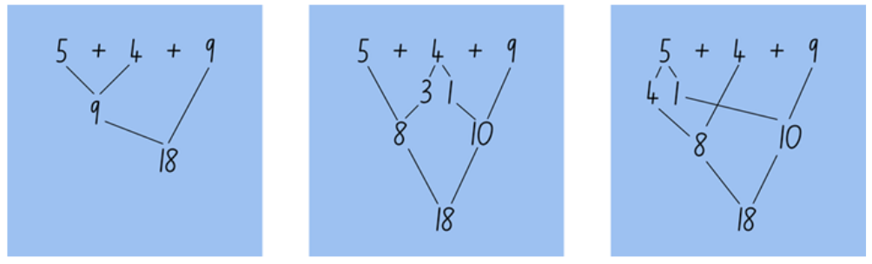
Figure 3: Student working 5 + 4 + 9
- If students can demonstrate 3 or more ways to solve their chosen problem, they take a ‘free pass’ card. They can use the ‘free pass’ card if they encounter a situation where they would otherwise miss a turn.
Teacher note: Encourage students to physically move the dice or cards around to examine the variations.

Subtraction face off

Key generalisations/what’s (some of) the mathematics?
- When solving problems using mental computation, we can use what we know about:
  - known facts
  - landmark numbers
  - the relationship between numbers
  - properties
  - renaming of numbers.
- Different people see and think about numbers and problems in different ways.
- Mathematicians use a range of representations to communicate ideas, including recording findings using symbols and diagrams.
- Mathematicians explain their thinking, so it makes sense to others.
- Mathematicians can use their knowledge of numbers and operations to strategise to improve their chances of winning a game.

Some observable behaviours you may look for/notice
- Uses a range of strategies to solve problems. For example:
  - uses known facts
  - uses properties (such as commutative and associative)
  - uses knowledge of counting
  - uses landmark or benchmark numbers (multiples of five and ten)
  - partitions numbers into smaller parts
  - uses inverse operations.
- Uses various representations to share thinking:
  - concrete materials
  - gestures
  - drawings
  - language.
- Uses diagrams as supporting evidence when giving valid reasons for a chosen solution path.

Materials
- Ace-9 playing cards or a set of 1-9 number cards

Instructions
- Provide pairs of students with a set of cards, 1-9.
- Students shuffle the cards and deal them out evenly between the 2 players.
- Students place their cards into a face down pile.
- Both students take the 3 top cards from the pile to form a two-digit and a one-digit number.
- Students can arrange the cards in any way they like to make the smallest difference.
- The student with the smallest difference collects all 6 cards.
- Students continue playing until someone has lost all their cards.
- Students record the strategies used to work out differences.
Teacher note: The aim of the syllabus is to learn and practise through working mathematically. As such, teachers should consider how they can adapt activities and games to their context, explicitly drawing out skills in communicating, problem solving and reasoning.

Difference challenge

Key generalisations/what’s (some of) the mathematics?
- When solving problems using mental computation, we can use what we know about:
  - known facts
  - landmark numbers
  - the relationship between numbers
  - properties
  - renaming of numbers.
- Different people see and think about numbers and problems in different ways.
- Mathematicians explain their thinking so it makes sense to others.
- Mathematicians strategise by using their knowledge of numbers and operations to improve their chances of winning a game.

Some observable behaviours you may look for/notice
- Uses a range of strategies to solve problems, for example:
  - uses known facts
  - renames numbers
  - uses properties (such as commutative and associative)
  - uses knowledge of counting
  - uses landmark or benchmark numbers (multiples of five and ten)
  - partitions numbers into smaller parts
  - uses inverse operations.
- Describes how equivalence can be used to solve problems. For example, I don’t know 23-19 but I know it is the same as 24-20.

Materials
- Ace-9 playing cards or a set of 1-9 number cards

Instructions
- Provide small groups of students with a mini whiteboard, markers and 1-9 playing cards.
- Students shuffle the cards and place them in a central, face down pile.
- Students take turns to take 2 cards to make a two-digit number.
- Each student says the number made then draws another 2 cards to form second two-digit number.
- Students announces the second number they have created.
- Students work out the difference between the 2 numbers, explaining their thinking to a partner who models or records their strategies.
- Students then record their difference.
- The aim is to get 2 numbers with a difference of 45 or a difference closest to 45 at the end of 5 turns.
- A player with a difference of more than 83 loses their turn immediately.

Variations
- Use a number chart to assist mental calculations.
- After creating the first two-digit number, ask questions such as:
  - What numbers would you like to draw next and why?
  - What numbers wouldn’t you like to draw next and why?
- Change the challenge to add 2 two-digit numbers with the aim of being as close as possible to 100. Encourage students to use their knowledge of part-whole to 10 to work out solutions.
Teacher note: Students need to have the opportunity to develop mental strategies for solving addition and subtraction problems and to record their thinking before being introduced to algorithms.

Strategic part-part-whole thinking

Key generalisations/what’s (some of) the mathematics?
- Numbers are made up of smaller numbers. For example, 19 can be composed of:
  - 2 collections, such as 8 and 11
  - 3 collections, such as 5 and 5 and 9
  - 4 collections, such as 4 and 6 and 4 and 5, and so on.
- Any given whole number can be partitioned (decomposed/broken) into smaller parts.
- When recording equations (number sentences) we call the collections we are combining ’addends’. For example, in 10 + 9 = 19, 10 and 9 are both addends and 19 is the sum.
- When solving problems using mental computation, we can use what we know about:
  - known facts
  - landmark numbers
  - the relationship between numbers
  - properties
  - renaming of numbers.
- Mathematicians use what they know about numbers to solve problems.
- Mathematicians use mathematical reasoning to analyse their choices.

Some observable behaviours you may look for/notice
- Uses a range of strategies to solve problems. For example:
  - uses known facts
  - uses properties (such as commutative and associative)
  - uses knowledge of counting
  - uses landmark or benchmark numbers (multiples of five and ten)
  - partitions numbers into smaller parts
  - uses inverse operations.
- Describes 19 in terms of its parts (part-part-whole knowledge).
- Makes strategic decisions to decide how to partition 19.
- Uses various representations to share thinking:
  - concrete materials
  - gestures
  - drawings
  - language

Materials
- Writing materials

Instructions
- Students to record all the ways they know to partition a given number, for example, 19.
- Allow time to think and record their ideas.
- Students to examine their recordings and ask questions such as:
- Which of your ways of partitioning 19 is most useful when you want to combine it with 32?
‘Partitioning 19 into 8 and 11 would be useful in this situation so I can combine 32 and 8 to make 40 and then 40 and 11 more is equivalent to 51. In this way I am applying my knowledge of ‘combinations of ten’ and as well as my understanding of place value’.
- Which of your ways of partitioning 19 is most useful when:
  - you want to subtract it from 27?
  - you want to work out the difference between 19 and 43?
- Which of your partitions of 19 is least useful when…?
- Which of your partitions of 19 would you change if you wanted to…?
- Create a visual representation/model for 3 of your recordings you predict most other people will also have considered.
Teacher note: Use student recordings as assessment, analysing the knowledge students apply. Look for patterns in student responses, generalisations that are applied, the use of more than 2 addends, recording methods, associated visuals or models (when appropriate).

Variation
- Change the target number.

How might we?

Key generalisations/what’s (some of) the mathematics?
- When solving problems using mental computation, we can use what we know about:
  - known facts
  - landmark numbers
  - the relationship between numbers
  - properties
  - renaming of numbers.
- Mathematicians compare their strategies with the thinking of others.
- Mathematicians use the ideas of others to refine/extend their own ideas.

Some observable behaviours you may look for/notice
- Uses a range of strategies to solve problems. For example:
  - uses known facts
  - renames numbers
  - uses properties (such as commutative and associative)
  - uses knowledge of counting
  - uses landmark or benchmark numbers (multiples of five and ten)
  - partitions numbers into smaller parts
  - uses inverse operations.
- Describes how equivalence can be used to solve problems (for example, I don't know 18 and 16 but I know it is the same as 20 and 14)
- Compares their thinking to the thinking of others, deciding which are more efficient and why
- Refines/extends thinking after listening to the ideas and strategies of others.

Materials
- 2 packets of 10 pencils plus 6 extra pencils

Instructions
- Provide students with materials that represent a given number, for example, 26 can be made using 2 packets of 10 pencils and 6 more pencils. Once you have ascertained the total, ask students questions such as:
  - How many pencils would we need to remove if we only wanted 17?
  - How many pencils would we need to remove if we only wanted 8?
  - How many more pencils would we need to get to have 32 in total?
  - How many more pencils would we need to get to have 67 in total?
- Students think about the strategy they would use to solve the problem presented.
- Students share their thinking with a thinking partner before sharing with the group.
- Discuss various ways in which students could approach the problem, recording each method.
- Discuss the different strategies, deciding which are more efficient and why. Support students in seeing how they can use finding and making groups of ten as well as other known facts to solve problems.
Teacher note: Students need experiences in breaking and reforming groups of 10 in order to develop a strong understanding of the flexibility inherent in the place value system. Work with students to develop deep conceptual knowledge about numbers, operations and flexibility in thinking to build conceptual knowledge before introducing procedural methods such as written algorithms.

Variation
- Plan for a class party and determine how many packets of 10 items such as cups or spoons would be needed for the class, discussing how many would be left over

Addition and subtraction table patterns

Key generalisations/what’s (some of) the mathematics?
- When solving problems using mental computation, we can use what we know about:
  - known facts
  - landmark numbers
  - the relationship between numbers
  - properties
  - renaming of numbers.
- Listening to other people’s thinking helps us become aware of other strategies, building our knowledge of mathematics.
- Mathematicians compare their strategies with the thinking of others.
- Mathematicians use the ideas of others to refine/extend their own ideas.

Some observable behaviours you may look for/notice
- Uses a range of strategies to solve problems. For example:
  - uses known facts
  - renames numbers
  - uses properties (such as commutative and associative)
  - uses knowledge of counting
  - uses landmark or benchmark numbers (multiples of five and ten)
  - partitions numbers into smaller parts
  - uses inverse operations.
- Describes how equivalence can be used to solve problems (for example, I don’t know 7 and 8 but I know it is the same as double 7 and 1 more).
- Refines/extends thinking after listening to the ideas and strategies of others.

Materials
- Appendix 1: Blank 11 x 11 addition and subtraction grid
- Ten-sided dice
- Writing materials

Instructions
- Provide students with Appendix 1: Blank 11 x 11 addition and subtraction grid.
- Roll 2 large 1-10 dice. Ask students to think about all the ways they can work out the solution.
- Provide thinking time before asking students to share their thinking with a partner.
- Students to share back with the class and record the various strategies students were able to use to work out a solution.

Teaching point
Support students in using appropriate language to explain their strategies. For example, use terminology such as ‘doubles’, ‘near doubles’, ‘known fact’, ‘one less than’, and ‘similar to’. Teachers could use this to:
- discuss, represent and evaluate strategies students use to solve problems, particularly how the use of strategies can change based on the numbers we are presented with
- investigate the probability of getting particular numbers
- investigate whether rolling 7 + 2 also allows you to fill in 2 + 7.
This may take some time to fill in. Decide whether to organise this activity over a few days as part of a whole-class focus or structure it in another way that suits the needs of their class.
Once the table is complete, teachers should use it to investigate patterns and relationships such as:
- using an invented code to show doubles, near doubles, combinations to 10, combinations to 20
- the numbers increase by one as you go down each column and move to the right along rows
- the numbers decrease by one as you go up in column and move left along the rows.
- numbers along the diagonal are the same in one direction (a + 0 pattern) but increase/decrease by two in the other (a + 2 pattern)
- when you place a square around any 4 numbers, the sums of the diagonals are the same, for example, 15 + 17 = 16 + 16
- when you place a square around any 4 numbers, 2 of the numbers are the same
- how addition and subtraction facts are related
- the commutative property of addition.

Variations
- Have students use the table as a self-assessment tool, recording the number facts they use.
- Extend to include 1-20.
- Use a 0-9 dice and analyse how the table changes/ stays the same.
- When appropriate, re-create the table to suit 0.1-1, using both decimal notation and words (1 tenth - 10 tenths) to help students apply their knowledge of known facts to fractional numbers.

How can we represent that?

Key generalisations/what’s (some of) the mathematics?
- When solving problems using mental computation, we can use what we know about:
  - known facts
  - landmark numbers
  - the relationship between numbers
  - properties
  - renaming of numbers.
- Different people see and think about numbers and problems in different ways.
- We can apply our place value understanding to regroup, rename, partition and rearrange numbers to solve problems.
- ‘=’ is a symbol that represents equivalence.
- Listening to other people’s thinking helps us become aware of other ways of thinking, building our knowledge of mathematics.
- Mathematicians compare their strategies with the thinking of others.
- Mathematicians use the ideas of others to refine/ extend their own ideas.

Some observable behaviours you may look for/notice
- Uses a range of strategies to solve problems. For example:
  - uses known facts
  - renames numbers
  - uses properties (such as commutative and associative)
  - uses knowledge of counting
  - uses landmark or benchmark numbers (multiples of five and ten)
  - partitions numbers into smaller parts
  - uses inverse operations.
- Describes how equivalence can be used to solve problems.
- Refines/extends thinking after listening to the ideas and strategies of others.

Materials
- Writing materials

Instructions
- Introduce 23 + 38 as a number talk and ask students to work out as many ways as possible to solve the problem, discussing the various strategies they could use. See Figure 4.
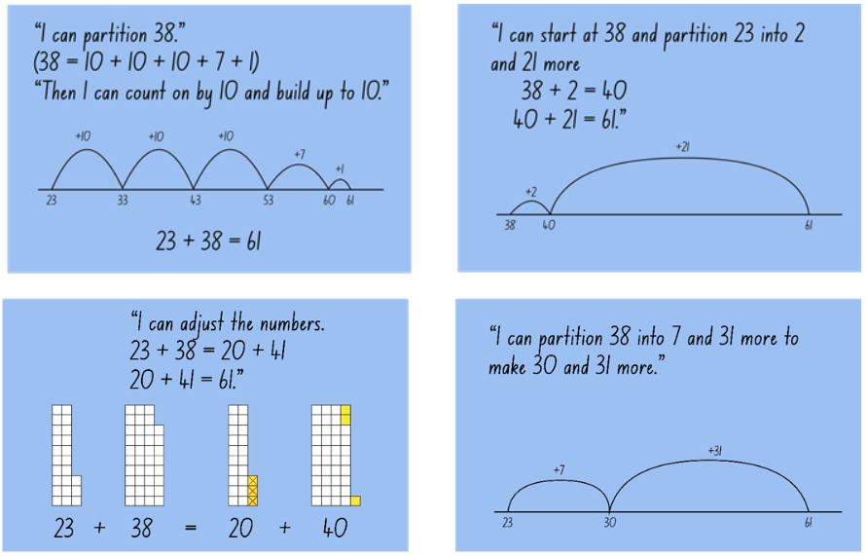
Figure 4: Number talk thinking
- Encourage students to share their thinking and represent strategies they could use to solve the problem.

Teaching point
Using questions such as these can form the basis of daily number talks. Scaffold the needs of students, enabling them to communicate mathematically, using a range of materials and visual representations to aid comprehension and communication.
Intentionally develop questions that address common misunderstandings or target particular learning needs. For example:
- Change the position of ‘=‘
  - __ = 17 + 14 + 3
  - 78 - 24 = ___ + 21
  - 47 = ___ - 23
  - 87 = 99 - ___
  - 52 = 78 - 12 - ___
  - 19 + ___ + 34 = 81
- Is 16 + 18 always the same as 17 + 17? How can you best demonstrate your point of view?
Students often develop an understanding of ‘=’ meaning ‘write the answer here’. Students need to know ‘=’ is a symbol that represents equivalence and as such, it can be written in any position.
Use discussions as opportunities to demonstrate how we all think differently about problems. Student strategies should be validated whilst gently guiding students to see how some strategies are more efficient in particular contexts.

Variations
- Change the numbers used in the problem to examine the efficiency of different strategies.
- Students model all possible strategies they can think of and reflect upon the efficiency of each.

Appendix 1: Blank 11 x 11 grid
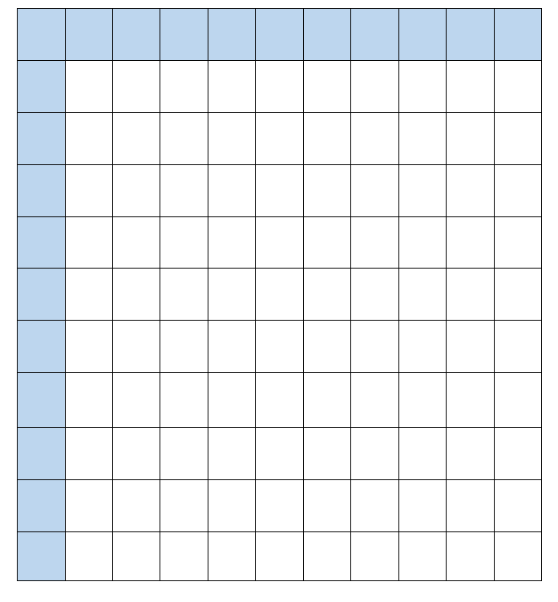

Reference list
This resource contains images and content obtained from Canva, and their use outside of this resource is subject to Canva’s Content License Agreement.
Mathematics K–10 Syllabus © NSW Education Standards Authority (NESA) for and on behalf of the Crown in right of the State of New South Wales, 2022.
National Numeracy Learning Progression © Australian Curriculum, Assessment and Reporting Authority (ACARA) 2010 to present, unless otherwise indicated. This material was downloaded from the Australian Curriculum website (National Literacy Learning Progression) (accessed 6 November 2023 - unmodified).
Australian Government Department of Education (2020) ‘Addition: Chess – The Rook’, Teaching resources, reSolve: Maths by Inquiry website, accessed 6 November 2023.
State of New South Wales (Department of Education) (2023) ‘Balancing numbers 1’, Mathematics K-6 resources, NSW Department of Education website, accessed 6 November 2023.
State of New South Wales (Department of Education) (2023) ‘Balancing numbers 2’, Mathematics K-6 resources, NSW Department of Education website, accessed 6 November 2023.
State of New South Wales (Department of Education) (2023) ‘Balancing numbers 3’, Mathematics K-6 resources, NSW Department of Education website, accessed 6 November 2023.
State of New South Wales (Department of Education) (2023) ‘Closest to 100’, Mathematics K-6 resources, NSW Department of Education website, accessed 6 November 2023.
State of New South Wales (Department of Education) (2023) ‘Concentration- constant difference’, Mathematics K-6 resources, NSW Department of Education website, accessed 6 November 2023.
State of New South Wales (Department of Education) (2023) ‘It’s time to get magical’, Mathematics K-6 resources, NSW Department of Education website, accessed 6 November 2023.
State of New South Wales (Department of Education) (2023) ‘Let's explore 1’, Mathematics K-6 resources, NSW Department of Education website, accessed 6 November 2023.
State of New South Wales (Department of Education) (2023) ‘Let’s generalise 1’, Mathematics K-6 resources, NSW Department of Education website, accessed 6 November 2023.
State of New South Wales (Department of Education) (2023) ‘Let’s investigate 1’, Mathematics K-6 resources, NSW Department of Education website, accessed 6 November 2023.
State of New South Wales (Department of Education) (2023) ‘Number busting 26’, Mathematics K-6 resources, NSW Department of Education website, accessed 6 November 2023.
State of New South Wales (Department of Education) (2023) ‘Race to zero’, Mathematics K-6 resources, NSW Department of Education website, accessed 6 November 2023.
State of New South Wales (Department of Education) (2023) ‘Strike it out’, Mathematics K-6 resources, NSW Department of Education website, accessed 6 November 2023.
State of New South Wales (Department of Education) (2023) ‘Which would you do in your head?’, Mathematics K-6 resources, NSW Department of Education website, accessed 6 November 2023.
Stanford University (n.d.) ‘Game of Totals (3-5)’, Tasks, youcubed website, accessed 6 November 2023.
University of Cambridge (Faculty of Mathematics) (1997–2023) ‘Roll these dice’, NRICH website, accessed 6 November 2023.
University of Cambridge (Faculty of Mathematics) (1997–2023) ‘Sort them out (1)’, NRICH website, accessed 6 November 2023.

Evidence base
Sparrow, L., Booker, G., Swan, P., Bond, D. (2015). Teaching Primary Mathematics. Australia: Pearson Australia.
Brady, K., Faragher, R., Clark, J., Beswick, K., Warren, E., Siemon, D. (2015). Teaching Mathematics: Foundations to Middle Years. Australia: Oxford University Press.
Alignment to system priorities and/or needs: The literacy and numeracy five priorities.
Alignment to School Excellence Framework: Learning domain: Curriculum, Teaching domain: Effective classroom practice and Professional standards
Consulted with: NSW Mathematics Strategy professional learning and Curriculum Early Years Primary Learners-Mathematics teams
Reviewed by: Literacy and Numeracy
Created/last updated: April 2024
Anticipated resource review date: January 2025
Feedback: Complete the online form to provide any feedback.

Copyright
Section 113P Notice
Texts, Artistic Works and Broadcast Notice
Some of this material has been copied and communicated to you in accordance with the statutory licence in section 113P of the Copyright Act. Any further reproduction or communication of this material by you may be the subject of copyright protection under the Act.
Do not remove this notice.

