Exploring patterns

What is a pattern and why are they important?
Patterns are at the heart of mathematics.
All patterns have regularities that we can perceive visually, auditorily and somatically (through tactile or action-based sensations). To discern, describe, extend, adjust, make and translate patterns, we need to be able to identify the repeating core, or pattern unit. For example, imagine a row of blocks that alternate in colour: blue-red-yellow-blue-red-yellow-blue-red-yellow

Figure 1: blocks in pattern form ABC
The use of the same three coloured blocks, arranged in a particular order, over and over and over again, creates a repeating pattern. This is a three-part pattern as it has three parts that make up the pattern core (in this instance, a blue block, a red block and a yellow block).
To be able to clearly describe this pattern with further precision, we need to have language to describe the composition of the 3-parts of the pattern core. A pattern with a 3-part repeating core could look like:

Figure 2: blocks in pattern form ABC
We can describe this 3-part pattern as an ABC pattern, the core has 3-parts and each part has a unique attribute (in this case, the attribute that’s changing is colour).
A 3-part pattern could also look like this:

Figure 3: blocks in pattern form ABB
We can describe this 3-part pattern as an ABB pattern. The core has 3-parts with two unique attributes, one of which is repeated (in this instance, the red block is repeated).
We could also make a 3-part pattern that looks like this:

Figure 4: blocks in pattern form ABA
We can describe this 3-part pattern as an ABA pattern. Like the pattern above, the core has 3-parts made up of two unique attributes, one of which is repeated (in this instance, the blue block is used before and after the red block).
To know we have detected a pattern, we must see the repeated core, or pattern unit, repeat. If we only see blue-red-yellow (ABC), we do not have enough evidence to know we have a pattern. If we see the ABC unit repeating, as in blue-red-yellow-blue-red-yellow-blue-red-yellow, then we can be confident of our judgment that a pattern, a mathematical regularity, is present. Typically, we like to see something happen over and over and over in order to feel confident a pattern is present.
Whilst the examples above show repeating patterns, patterns come in different forms. For example, we can find:
- repeating patterns (as above)
- growing and shrinking patterns (such as the patterns we find in the backward counting sequence where each number is one less than the number before)
- structural/spatial/visual patterns
- combinatorial/computational patterns.
Patterning can also include exploring mathematical structures and leads into algebraic thinking. Algebraic thinking, like patterning, is foundational to mathematical thinking as it provides the language and structure to represent ideas, solve problems, model situations and prove generalisations. When we describe a 3-part pattern as ABC we are supporting students to make connections between patterns and algebra.
Learn more about patterning by viewing 'Becoming mathematicians: Exploring patterns' a short professional learning opportunity via MyPL (course code NR29611).

Syllabus
MAO-WM-01 develops understanding and fluency in mathematics through exploring and connecting mathematical concepts, choosing and applying mathematical techniques to solve problems, and communicating their thinking and reasoning coherently and clearly
MAE-RWN-01 demonstrates an understanding of how whole numbers indicate quantity
MAE-RWN-02 reads numerals and represents whole numbers to at least 20
MAE-CSQ-01 reasons about number relations to model addition and subtraction by combining and separating, and comparing collections
MAE-CSQ-02 represents the relations between the parts that form the whole, with numbers up to 10
MAE-FG-01 recognises, describes and continues repeating patterns
MAE-2DS-01 sorts, describes, names and makes two-dimensional shapes, including triangles, circles, squares and rectangles
MA1-2DS-01 recognises, describes and represents shapes including quadrilaterals and other common polygons
NSW Mathematics K-10 Syllabus (2022)

Progression
Number and place value NPV1-NPV4
Counting processes CPr1-CPr3
Additive strategies AdS1-AdS2
Number patterns and algebraic thinking NPA1-NPA2
Understanding geometric properties UGP1-UGP2
National Numeracy Learning Progression (NNLP) Version 3

How to use the resource
Teachers can use assessment information to make decisions about when and how they use this resource as they design teaching and learning sequences to meet the learning needs of their students.
The tasks and information in the resource includes explicit teaching, high expectations, effective feedback and assessment and can be embedded in the teaching and learning cycle.
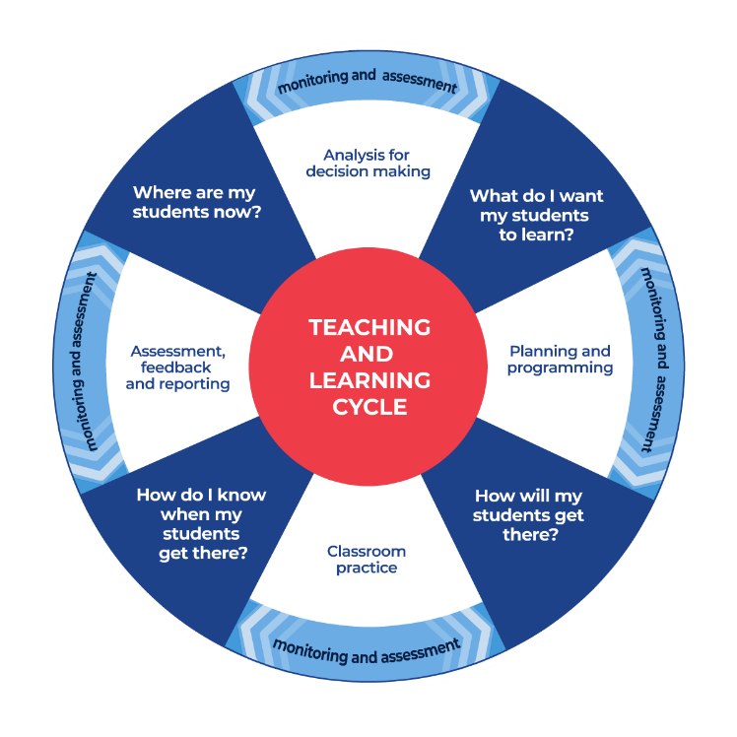
Figure 5: Teaching and learning cycle
- Where are my students now? – Teacher uses a range of assessment information to determine what students know and can do, including their interests, learning strengths and needs.
- What do I want my students to learn? - Teachers use the information gathered along with the syllabus and NNLP to determine the next steps for learning. Teachers might also like to look at the ‘what’s some of the maths’ and ‘key generalisations’ to synthesise the information they have gathered into the next step/s for learning.
- How will my students get there? – Teachers can then use the task overview information (‘What does it promote?’ and ‘What other tasks can I make connections to?’) to find tasks that meet the learning needs of students. Teachers then make decisions about what instructional practices and lesson structures to use in order to best support student learning. Further support with What works best in practice is available.
- How do I know when my students get there? - Teachers can use the section ‘Some observable behaviours you may look for/notice’ that have been articulated for each task as a springboard for what to look for. These ideas can be used to co-construct success criteria and modified to suit the learning needs, abilities and interests of students. Referring back to the syllabus and the NNLP are also helpful in determining student learning progress as well as monitoring student thinking during the task. The information gained will inform ‘where are my students now’ and ‘what do I want them to learn’ as part of the iterative nature of the teaching and learning cycle.

Tasks to support patterning

Overview of tasks - patterns
Task name | What does it promote? | What other tasks can I make connections to? | What materials will I need? | Possible group size
Sorting 1 | Noticing and using attributes to sort a collection of objects in numerous ways. | Sorting 2  Exploring patterns 1  Attribute train  (reSolve) | - collection of items (about 20 things)  - writing materials | Small group or whole class
Exploring patterns 1 and Exploring patterns 2 | Identifying the pattern core in order to create, extend and find missing elements in repeating patterns. | Exploring patterns 3  Let’s explore patterns  Repeating patterns (NRICH maths) | - a collection of items (about 20 things)  - writing materials | Small group or whole class
Exploring patterns 3 | Identifying the pattern core in order to create, extend and find missing elements in repeating patterns. Identifying the pattern core also allows us to translate patterns and represent them in different ways. | Patterns in a circle  (reSolve)  Promoting repeating patterns with young children: More than just alternating colours (Papic, M 2007) | - 30 things to make repeating patterns  - coloured pencils | Small group and/or whole class
Dice patterns A and Dice patterns B | Mathematical structures like dice patterns are considered patterns too. They have a mathematical regularity that repeats over and over and over. We can trust when we see that structure that it represents a particular quantity. | Subitising dice patterns  Subitise – match my collection | - Appendix 1:Dice pattern cards | Individual, small group and/or whole class
Staircase patterns | Growing and shirking patterns can be found in all of the counting sequence. This type of pattern has a repeating core that increases or decreases by the same amount. | Subitising – more, less the same  Staircase pattern – follow up | - Writing materials | Individual, small group and/or whole class

Teaching point: The key generalisations (or ‘What’s some of the mathematics?’) is written to support teachers in identifying and articulating some of the possible learning intentions related to a particular task. For many tasks, it is possible for teachers to use them on multiple occasions to explicitly draw student attention to different mathematical ideas that can be explored. Teachers will make careful, intentional decisions about when and how to share that with students:
‘Learning intentions don’t have to be used at the outset of the lesson and may be revisited over time. Teachers can withhold their learning intentions until after an exploration has occurred.’ (Hattie, Fisher and Frey, 2016).

Sorting 1
Key generalisations / what’s (some of) the mathematics?
- Most objects have many different attributes
- An object's attributes can be used to sort them into collections
- When we name how we sorted a collection we call this classifying
- Groups of objects can be sorted and classified in different ways by choosing different attributes to be the focal point
- Mathematicians can represent their thinking in different ways
- Mathematicians often look for different ways to think about the same collection.
Teaching point: Sorting and classifying tasks help students to develop a range of thinking skills and build the foundations for reasoning, communicating and problem-solving. Being able to notice various attributes within the same collection also promotes flexibility and creativity in thinking – critical aspects of mathematics and mathematical thinking.
Some observable behaviours you may look for/notice
- Noticing and identifying attributes such as size, shape, function, colour among the items in a collection.
- Explains that focussing on different attributes means you can organise objects, so they are sometimes the same and sometimes different.
- Sorting collections into categories using the attributes they identified.
- Re-sorting the same collection by focussing on a different attribute. For example, initially sorting by size and then re-sorting according to function.
- Explaining how collections have been classified, describing what makes them the same and what makes them different.
Materials
- Collection of items (about 20) that can be sorted in different ways
- Writing materials
Instructions
- Have students watch ‘Sorting 1’ to learn how to play.
- Have students draw pictures of the different ways they organised their own collection of items or the collection of items in the video.

Exploring patterns 1 and 2
Key generalisations / what’s (some of) the mathematics?
- A pattern is called a pattern because it has an element (a repeating core) that repeats over and over and over again.
- There are different kinds of patterns. Repeating patterns are one kind of pattern.
- The repeating core of a pattern can be the same but look different (like an AB pattern made using dogs and footprints and an AB pattern made using a squares and triangles).
- You can move elements of a pattern around to help you determine what the repeating core is, and to determine missing elements.
- Mathematicians can represent ideas in different ways.
- Mathematicians share their thinking with others.
Teaching point: To identify a pattern, we need to see the core repeated over and over and over again (about three times to be able to trust that we have found a regularity). The repeating core of a pattern can be described using letters to support moving from the specific to being more generalisable. For example, a pattern described as a 2-part pattern with a core of red and green is much less generalisable than a 2-part pattern described as AB. We can translate that pattern into being made up of any 2 things that repeat – forks and spoons; tall and short; left and right; up and down.
Some observable behaviours you may look for/notice
- Explains that repeating patterns involve the repetition of a pattern unit (or core).
- Determines a missing element within a repeating pattern.
- Identifies the pattern unit/core of a repeating pattern.
- Continues/extends a pattern.
- Describes a repeating pattern using mathematical and everyday language.
- Recognises when an error has occurred in a repeating pattern and explains what's wrong.
- Mathematicians can represent ideas in different ways.
- Mathematicians look for different ways to think about the same problem.
Materials
- Items to make patterns with
- Writing materials
Instructions
Watch ‘Exploring patterns 1’ to learn about patterns.
- Have students (on their own or in pairs) use their collection of items to try and make some repeating patterns of their own where some of the parts are missing.
- Ask ‘Can you figure out what parts are missing using the strategy of looking for the repeating core?’
- Have students draw a repeating pattern.
- Ask students to take turns drawing a pattern then having another person continue it.
- Have students challenge each other by drawing some with missing parts. ‘Can you work out which parts are missing?’
Now watch ‘Exploring patterns 2’ to learn more about patterns.
- Ask students to use their collection of items, to try to make as many AB patterns as they can.
- Have students draw their patterns and share.

Exploring patterns 3
Key generalisations / what’s (some of) the mathematics?
- To identify a pattern, we need to see the core repeated over and over and over again.
- A pattern is called a pattern because it has a repeating core.
- There are different kinds of patterns. Repeating patterns are one kind of pattern.
- You can move elements of a pattern around to help you determine what the repeating core is, and to determine missing elements.
- Mathematicians can represent ideas in different ways.
- Mathematicians share their thinking with others.
Teaching point: Teachers may find these pattern videos useful to explore with their colleagues during professional learning opportunities and conversations. Teachers might also find it useful to watch these as part of planning, using them as springboard to design their own patterning experiences with their students. Teachers might also choose to use these videos as teaching tools, watching them with their students, pausing to talk about ideas.
Some observable behaviours you may look for/notice:
- Explains that repeating patterns involve the repetition of a pattern unit (or core).
- Determines a missing element within a repeating pattern.
- Identifies the pattern unit/core with a repeating pattern.
- Continues/extends and translates patterns.
- Describes a repeating pattern using mathematical and everyday language.
- Recognises when an error has occurred in a repeating pattern and explains what's wrong.
- Creates repeating patterns involving the repetition of a pattern unit with shapes, movements, objects and numbers.
- Moves objects in a pattern around to help them determine and describe the repeating unit/core.
Materials
- 30 items to make some repeating patterns
- Coloured pencils
Instructions
Watch ‘Exploring patterns 3’ to continue exploring patterns.
- Have students go back and look at the patterns they made in ‘Exploring patterns 2’.
- Challenge students to make some more AB patterns where they are changing things like the:
  - shape
  - size
  - position
  - quantity
- Have students draw and share their thinking.

Dice patterns A and B
Key generalisations / what’s (some of) the mathematics?
- The dots on dice are a type of pattern as every time we see dots in that arrangement, we know they represent a particular quantity. Once we are convinced they are a pattern, we can start to trust that mathematical regularity every time we see it. This is a more efficient way of determining how many dots there are compared to counting all the dots.
- It doesn’t matter what colour, orientation or even what shape or size the dots on a dice pattern are. The most important information is how many things there are (the quantity).
- You can see smaller numbers inside of bigger numbers when exploring dice patterns, for example,
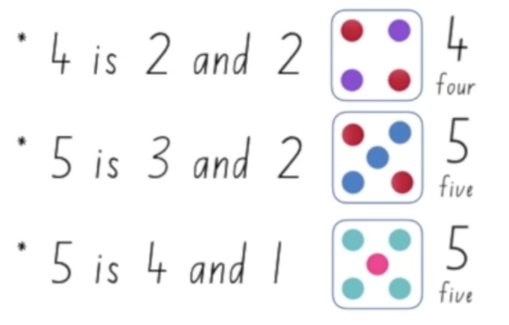
Figure 6: examples of smaller numbers inside bigger numbers
- Numbers can be broken up into smaller parts.
- Mathematicians use pictorial representations to support conclusions.
- Mathematicians can trust mathematical regularities like standard dice patterns to recognise amounts.
Teaching point: Students should be exposed to smaller quantities (in the range of 0-4) before using standard number patterns up to 10. To vary the learning activity, cards using dice patterns, domino patterns, five frame patterns, finger patterns and ten frame patterns should be used. Students should also be exposed to subitising random presentations of up to 4 items.
When introducing children to numbers, we want them to develop strong mental images for those numbers.
When children can instantly recognise a set of objects and are able to associate a number word with the set, the need to count from one is eliminated which leads to developing more efficient strategies.
Some observable behaviours you may look for/notice
- Instantly identifies spatial patterns on dice without counting individual items.
- Identifies a whole quantity by recognising the smaller parts it is composed of, for example, knows it is 4 and sees 2 and 2 more (uses part-part-whole knowledge).
- Describes how smaller numbers can be found inside of bigger numbers.
- Visualises and describes standard dice patterns to 6.
- Demonstrates an emerging understanding of conservation by explaining that collections can be arranged in different ways but still represent the same quantity for example, it doesn’t matter what colour, orientation, shape or size the ‘dots’ are.
- Connects number words, numerals and quantities.
Teaching point: To learn more about building an awareness of how numbers and fractions work, view 'Becoming mathematicians: How numbers work including fractions', a short professional learning opportunity via MyPL (course code NR28548).
Materials
- Appendix 1:Dice pattern cards
Instructions
- Watch ‘Dice patterns A’ with students and have them ready to watch, listen, imagine, draw and write.
- Now watch ‘Dice patterns B’ with students and have them ready to watch, listen, imagine, draw and write.
- After watching the video, cut up Appendix 1: Dice pattern cards.
- Have students play ‘memory’ using the dice pattern cards.
- Ask students to share all the pairs they found.
Variation
Play other matching games such as ‘go fish’ with the cards.

Staircase patterns
Key generalisations / what’s (some of) the mathematics?
- Patterns are more than just repeating sequences.
- We can find patterns in counting sequences. For example, when we count in twos, each time we say the next number word, the quantity increases by two. This sort of pattern is called a growing pattern. If we were to count backwards, we would have a shrinking pattern.
- Mathematicians use what they know to help them solve problems.
- You can have growing and shrinking patterns. We saw a shrinking pattern when we looked at our staircase structures like this example below.
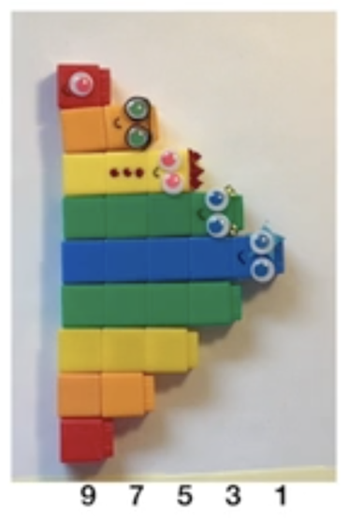
Figure 7: growing and shrinking pattern blocks
Teaching point: Growing and shrinking patterns can be found throughout the counting sequence. We can see the rule of ‘plus-one’ (or ‘1 more’) in the forward counting sequence ‘1, 2, 3, 4, 5...’. Similarly, the rule of ‘minus-one’ (or ‘1 less’) can be seen in the backward counting sequence ‘5, 4, 3, 2...’. This type of pattern has a repeating core that increases or decreases by the same amount. Using geometric models such as connecting cubes can assist students in seeing the ‘plus-one’ (or ‘1 more’) growing or the ‘minus-one’ (or ‘1 less’) shrinking pattern.
Some observable behaviours you may look for/notice
- Recognises the counting sequences (for example, 1 more than/ 1 less than) as a growing and shrinking pattern.
- Describes the counting sequence as a growing pattern or shrinking pattern, increasing or decreasing by 1 each time.
- Continues patterns where the difference between each term is the same number (continues growing and shrinking patterns).
- Represents growing and shrinking patterns using concrete materials.
- Moves elements of a pattern around to help them determine the repeating unit/core.
- Recognises when an error may occur in a pattern and explains what's wrong.
- Uses concrete materials to explore mathematical ideas and communicate their thinking.
Materials
- Writing materials
Instructions
- View the first ‘Staircase pattern’ video with students.
- Have students draw the staircase pattern made in the video, continuing it down the other side.
- When ready, have students view the next video (part 2).
- Ask students ‘How many blocks are there altogether?’
- Have students draw their thinking they used to work out the solution.
Variation
You may like to continue with ‘Staircase pattern – follow up’.

Appendix 1: Dice pattern cards
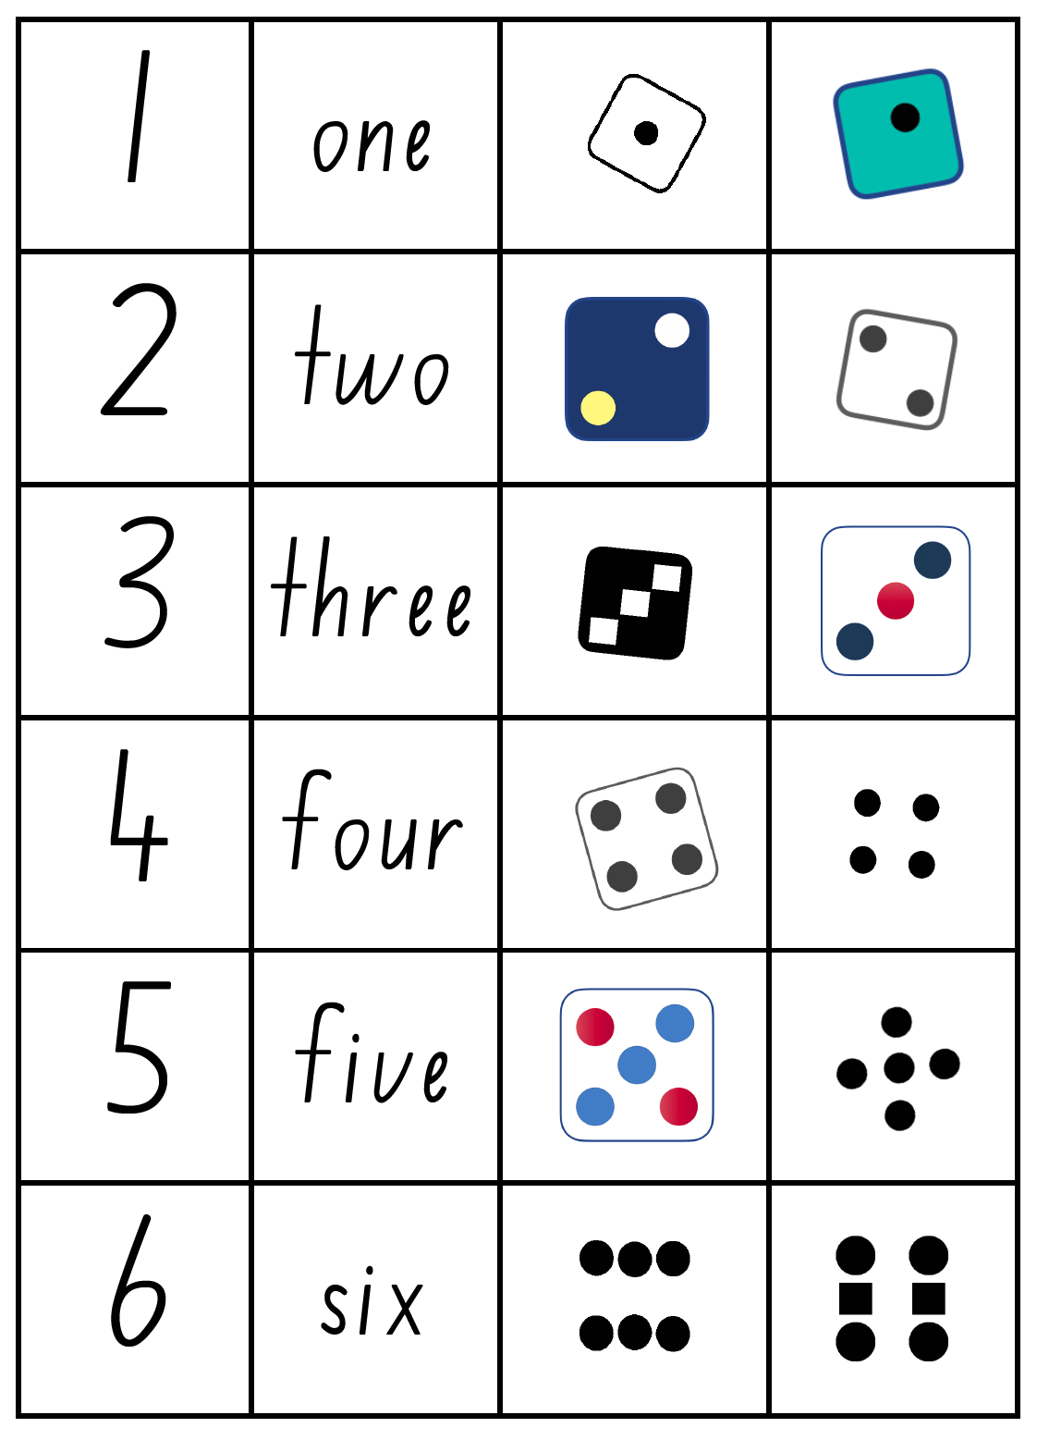

Reference list
Mathematics K–10 Syllabus © NSW Education Standards Authority (NESA) for and on behalf of the Crown in right of the State of New South Wales, 2022.
National Numeracy Learning Progression © Australian Curriculum, Assessment and Reporting Authority (ACARA) 2010 to present, unless otherwise indicated. This material was downloaded from the Australian Curriculum website (National Literacy Learning Progression) (accessed 6 November 2023) and was not modified.
Australian Government Department of Education (2020) ‘Attribute train’, Teaching resources, reSolve: Maths by Inquiry website, accessed 16 November 2023.
Australian Government Department of Education (2020) ‘Patterns in a circle’, Teaching resources, reSolve: Maths by Inquiry website, accessed 16 November 2023.
Hattie J, Fisher D, Frey N (2016) Visible Learning for Literacy, Grades K-12: Implementing the Practices That Work Best to Accelerate Student Learning, Corwin Press Inc.
Papic M (2007) ‘Promoting repeating patterns with young children – More than just alternating colours!’, Australian Primary Mathematics Classroom, 12(3):8-13.
State of New South Wales (Department of Education) (2023) ‘Dice patterns’, Mathematics K-6 resources, NSW Department of Education website, accessed 16 November 2023.
State of New South Wales (Department of Education) (2023) ‘Exploring patterns’, Mathematics K-6 resources, NSW Department of Education website, accessed 16 November 2023.
State of New South Wales (Department of Education) (2023) ‘Sorting’, Mathematics K-6 resources, NSW Department of Education website, accessed 16 November 2023.
State of New South Wales (Department of Education) (2023) ‘Staircase pattern’, Mathematics K-6 resources, NSW Department of Education website, accessed 16 November 2023.
State of New South Wales (Department of Education) (2023) ‘Subitising dice patterns’, Mathematics K-6 resources, NSW Department of Education website, accessed 16 November 2023.
State of New South Wales (Department of Education) (2023) ‘Subitise – match my collection’, Mathematics K-6 resources, NSW Department of Education website, accessed 16 November 2023.
State of New South Wales (Department of Education) (2023) ‘Subitising – more, less the same’, Mathematics K-6 resources, NSW Department of Education website, accessed 16 November 2023.
University of Cambridge (Faculty of Mathematics) (1997–2023)’ Repeating patterns’, NRICH website, accessed 16 November 2023.

Copyright
Section 113P Notice
Texts, Artistic Works and Broadcast Notice
Some of this material has been copied and communicated to you in accordance with the statutory licence in section 113P of the Copyright Act. Any further reproduction or communication of this material by you may be the subject of copyright protection under the Act. Do not remove this notice.

Evidence base
Sparrow, L., Booker, G., Swan, P., Bond, D. (2015). Teaching Primary Mathematics. Australia: Pearson Australia.
Brady, K., Faragher, R., Clark, J., Beswick, K., Warren, E., Siemon, D. (2015). Teaching Mathematics: Foundations to Middle Years. Australia: Oxford University Press.
Alignment to system priorities and/or needs: The literacy and numeracy five priorities.
Alignment to School Excellence Framework: Learning domain: Curriculum, Teaching domain: Effective classroom practice and Professional standards
Consulted with: NSW Mathematics Strategy professional learning and Curriculum Early Years Primary Learners-Mathematics teams
Reviewed by: Literacy and Numeracy
Created/last updated: January 2024
Anticipated resource review date: January 2025
Feedback: Complete the online form to provide any feedback.

