Inference
Stage 1

Overview

Purpose
This literacy teaching strategy supports teaching and learning for Stage 1 students across all key learning areas. It targets specific literacy skills and suggests a learning sequence to build skill development. Teachers can select individual tasks, or a sequence, and embed into their teaching and learning program according to their students’ needs. While exemplar texts are provided throughout this resource, it is recommended that teachers select texts which are relevant to their students and curriculum.

Learning intention
Students will learn what it means to infer. They will learn to make and explain inferences by using background knowledge and clues in the text.

Syllabus outcome
The following teaching and learning strategy will assist in covering elements of the following outcome/s:
EN1-RECOM-01: comprehends independently read texts that require sustained reading by activating background and word knowledge, connecting and understanding sentences and whole text, and monitoring for meaning.
EN1-UARL-01 understands and responds to literature by creating texts using similar structures, intentional language choices and features appropriate to audience and purpose.
NSW English K-10 Syllabus (2022)

Success criteria
The following suggestions may guide teachers to develop success criteria for student learning:
- explains what ‘infer’ and ‘inference’ mean
- infers meaning by using background knowledge and evidence in text
- explains inferences made from sounds, objects, images, sentences and text.

National Literacy Learning Progression guide

Understanding texts (UnT4-UnT6)
Key: C=comprehension P=process V=vocabulary

UnT4
- makes predictions (e.g. uses the cover of a book or screen image to predict the content) (P).
- makes connections between texts and personal experiences (C)
- makes relevant comments or asks relevant questions to demonstrate understanding of the text (C)

UnT5
- reads and views the content of texts and describes new or learnt information (C).
- draws obvious inferences by integrating print, visual and audio aspects of simple texts (e.g. uses images and key words to infer a character's job) (C)

UnT6
- draws inferences and explains using background knowledge or text features (e.g. infers character’s feelings from actions) (C)
- identifies parts of text used to answer literal and inferential questions (P)
National Literacy Learning Progression

Evidence base
- Centre for Education Statistics and Evaluation (2017). Effective reading instruction in the early years of school, literature review.
- Konza, D. (2014). Teaching Reading: Why the “Fab Five” should be the “Big Six”. Australian Journal of Teacher Education, 39(12).
- Centre for Education Statistics and Evaluation (2020). What works best 2020 update.
- Scarborough, H.S. (2001). Connecting early language and literacy to later reading (dis)abilities: Evidence, theory and practice. In S. Neuman & D. Dickson (Eds.), Handbook for research in early literacy (pp. 97-110). New York, NY: Guilford Press.
Alignment to system priorities and/or needs: Five priorities for Literacy and Numeracy, Our Plan for NSW Public Education, School Excellence Policy (nsw.gov.au).
Alignment to School Excellence Framework: Learning domain: Curriculum, Teaching domain: Effective classroom practice and Professional standards
Consulted with: Strategic Delivery, Teaching Quality and Impact
Author: Literacy and Numeracy
Reviewed by: Literacy and Numeracy, Teaching Quality and Impact
Created/last updated: January 2024
Anticipated resource review date: January 2025
Feedback: Complete the online form to provide any feedback

Copyright
Section 113P Notice
Texts, Artistic Works and Broadcast Notice
Some of this material has been copied and communicated to you in accordance with the statutory licence in section 113P of the Copyright Act. Any further reproduction or communication of this material by you may be the subject of copyright protection under the Act. Do not remove this notice.

Reference list
Dahl, R. (1981) George’s marvellous medicine. Jonathan Cape, UK.
English K-10 Syllabus © 2022 NSW Education Standards Authority (NESA) for and on behalf of the Crown in right of the State of New South Wales.

Teaching strategies
Teaching and learning experiences | Resources
What is inference? | Appendix 1 – Inference equation  Appendix 2 – Blank inference equation
Inferring meaning from objects | Appendix 1 – Inference equation  A range of familiar objects such as sunscreen, googles, toy spade, a water bottle, a soccer ball, and a child’s hat.
Inferring meaning from images | Appendix 1 – Inference equation Appendix 3 – Image  Appendix 4 – Shoes  Appendix 5 – A range of images Appendix 6 – Inferring from images
Inferring meaning from a sentence | Appendix 1 – Inference equation  Appendix 7 – Inferring with sentences
Inferring meaning from a group of sentences | Appendix 1 – Inference equation Appendix 2 – Blank inference equation  Appendix 8 – Making an inference from groups of sentences
Inferring meaning from a text extract | Appendix 9 – George’s Marvellous medicine Appendix 10 – Little leaf boat  Appendix 11 - Inferring from texts independently

Background knowledge

Inferential comprehension
Inferential comprehension is the ability to process information and understand the underlying and unstated meaning. This information is then used to infer or determine deeper meaning that is not explicitly stated. In relation to texts, inferential comprehension requires viewers and readers to:
- combine ideas
- draw conclusions
- interpret and evaluate information
- identify tone and voice.
A higher and more complex level of comprehension involves critical analysis which requires readers to:
- be critical
- form opinions
- identify authors' points of view and attitudes
- identify and consider the authority of texts and their messages
- infer motives of characters and themes.
Important: Students come a wide variety of experiences. It is essential to not assume they have particular background knowledge. EAL/D learners in particular may not share the background knowledge of their peers who grew up in Australia and may understand experiences and events according to their first culture.

Where to next?
- Audience and purpose

Effective reading instruction in the early years of school
The CESE literature review Effective Reading Instruction in the Early Years of School (2017) outlines the key components of effective reading instruction. The research base has been furthered explored in the Effective reading guide which outlines the Simple View of Reading and Scarborough’s Reading Rope.
Comprehension is an active process that involves the reader understanding and interpreting what is read. It is heavily dependent on a student’s word recognition skills and their language comprehension skills. To be able to understand written material, students need to be able to first decode what they read and then apply their language comprehension to make connections between what they read and what they already know.
In the context of effective reading instruction for the early years, it is important to understand that while students are learning the alphabetic code the majority of comprehension instruction should focus on oral language comprehension development through explicit teaching during modelled and shared reading experiences. An explicit focus on teaching students to strategically apply their background knowledge, vocabulary knowledge, knowledge about texts, understanding of language structures and reasoning skills to texts will support them to develop strong language comprehension abilities as they develop fluent word recognition skills.

What works best - Explicit teaching
Explicit teaching practices involve teachers clearly explaining to students why they are learning something, how it connects to what they already know, what they are expected to do, how to do it and what it looks like when they have succeeded. Students are given opportunities and time to check their understanding, ask questions and receive clear, effective feedback.
This resource reflects the latest evidence base and can be used by teachers as they plan for explicit teaching. Teachers can use classroom observations and other assessment information to make decisions about when and how they use this resource as they design teaching and learning sequences to meet the learning needs of their students.
Further support with What works best is available.

Gradual release of responsibility model
The Gradual release of responsibility model is a helpful framework to understand what explicit instruction can look like when teaching reading.
At the heart of the model is the concept that, as we learn new content, the responsibility for the cognitive load shifts from primarily sitting with the teacher as the model or expert, to the responsibility sitting with the student as they take on independence in their learning and application.
It is important to note that the model is not linear and can be used flexibly rather than from beginning to end over the course of a lesson or in the same way for every student. Instead, it should be seen as a dynamic model that is recursive, meaning it can be repeated and revisited as needed and informed by formative assessment. As students increase in their ability, teachers gradually carry less of the cognitive load and students gradually assume more responsibility for the learning in order to become independent in the knowledge, skill or concept understanding and the application of this across contexts.

Modelled instruction
The Gradual release of responsibility model begins with the teacher assuming a significant proportion of the cognitive load for the learning. Modelled instruction is when the teacher models how an expert reads with a particular emphasis on the skill, concept, or knowledge focus. This section is when the teacher is saying “I do, you watch.”
Although modelled instruction is characterised by teacher voice, students are active participants and engaged in careful observation. As the teacher explains the learning intention and its purpose, students should be encouraged to reflect on their current knowledge, understanding or skill. The teacher builds understanding of the academic language or background knowledge necessary to access the learning and students reflect on and add to their background knowledge or academic vocabulary. Modelled instruction is often characterised by the teacher ‘thinking aloud’ to demonstrate how a skilled reader monitors and controls their comprehension. At the end of modelled instruction:
- revisit the learning intention and reflect on what students observed the teacher doing to show the learning intention
- co-construct the success criteria based on what the teacher modelled, and students observed
- co-construct an anchor chart that students can refer to as they continue their learning.

Shared practice
Shared practice offers rich instructional opportunities as teachers and students both engage with a shared text. This is when the teacher invites students to share responsibility for the thinking, with the teacher saying, “I do, you help.” Shared instruction is an interactive reading experience with the teacher or expert continuing to model or demonstrate the skills, concept or understanding that is the focus of the learning, however, students are now invited to join the teacher in sharing the cognitive load for the learning.
Shared practice is characterised by rich and authentic conversations amongst the community of readers as both teacher and students discuss, pose ideas, ask questions, and extend their thinking.

Guided practice
The next stage is guided practice when the student takes on significantly more responsibility with the teacher saying, “you do, I help.” Guided practice often involves the teacher working with a small group of students and encouraging students to think aloud about the strategy focus. The teacher asks questions to prompt or clarify thinking, supporting, and guiding the learning of the group. Guided practice is characterised by high challenge texts scaffolded with high support for the needs of the learner.

Collaborative practice
Collaborative practice is when students take on and share more responsibility with their fellow learners. The teacher is still present and available but is saying “you do together, I will support you as needed.” Students are often paired with a partner or work in a small group. They work collaboratively on a strategy focus, sharing their thinking as they work together. Students are encouraged to think aloud as they read and to engage in shared discussion, questioning and collaboration. During collaborative practice, the teacher supports students by observing, monitoring, prompting, and guiding them towards independence. The teacher encourages the use of support structures such as anchor charts, learning intentions and success criteria.

Independent practice
Once the student is confident with the learning, they continue to practice independently. The teacher is present and available and is now saying “you do alone, and I will watch.” Students can record how they think aloud, problem solve and utilise the focus strategy to support their reading. The teacher uses this stage as an opportunity to observe and formatively assess students. Multiple opportunities across varying contexts need to be offered to students for them to develop independence with a skill or strategy.

Differentiation and adjustments
When using these resources in the classroom, it is important for teachers to consider the needs of all students, including Aboriginal and EAL/D learners.
EAL/D learners will require explicit English language support and scaffolding, informed by the EAL/D enhanced teaching and learning cycle and the student’s phase on the EAL/D Learning Progression. Teachers can access information about supporting EAL/D learners and literacy and numeracy support specific to EAL/D learners.
Learning adjustments enable students with disability and additional learning and support needs to access syllabus outcomes and content on the same basis as their peers. Teachers can use a range of adjustments to ensure a personalised approach to student learning.
Assessing and identifying high potential and gifted learners will help teachers decide which students may benefit from extension and additional challenge. Effective strategies and contributors to achievement for high potential and gifted learners helps teachers to identify and target areas for growth and improvement. A differentiation adjustment tool can be found on the High potential and gifted education website.

Text selection
Example texts are used throughout this resource. Teachers can adjust activities to use texts which are linked to their unit of learning.
Further support with text selection can be found within the National Literacy Learning Progression Text complexity appendix.
The NESA website has additional information on text requirements within the NSW English syllabus.

Further professional learning
Use the following links for more information and resources for effective reading instruction:
- A video explaining the Simple view of reading
- A video introducing Scarborough’s reading rope
- A video explaining the lower strands of Scarborough’s reading rope
- A video explaining the upper strands of Scarborough’s reading rope
- Literacy and numeracy professional learning:
  - Effective reading: Phonics
  - Effective reading: Phonological Awareness
  - Focus on Understanding texts: The components of reading – Blended learning
  - Focus on vocabulary – Blended learning
  - Fluency on teams – Blended learning

Teaching and learning experiences

What is inference?

Learning intention
We are learning that we can make inferences by using clues from a situation and our background knowledge.

Success criteria
I can:
- explain what inference means using the inference equation
- make an inference based on a sound

Suggested teaching and learning sequence

Modelled instruction
- Before introducing inference to students, it is important to ensure they have a thorough understanding of what ‘background knowledge’ means. (Refer to Stage 1 Reading - Connecting ideas.)
- Explain to students that good viewers and readers look for hidden meanings in situations. They use clues from the situation and their own background knowledge to understand the situation. These clues can be found in sounds, objects, images, and in written text. Explain that when viewers do this, this is called making an inference.
- Explain the word ‘infer’ is a verb- it is something we do. It means to come up with an idea or hidden meaning about a situation even though that idea isn’t directly told or stated. We use clues in a situation and our background knowledge to come up with the hidden meaning or idea.
- Use a familiar example to illustrate the concept. For example, say “If another teacher came to our classroom and said “Happy birthday” to me, you would know it was my birthday. In that case it isn’t a hidden meaning because it was directly told or stated. Now imagine if a teacher came to the classroom with a present and a cake with candles. Imagine the teacher came in, put them on my desk and left without saying anything. Was the meaning of this situation told or directly stated? No, you would have to come up with an idea or a hidden meaning about that situation. You would probably see the clues which are the present and cake with candles. You would use your background knowledge that people are given presents and have cakes with candles on their birthdays. So, you would come up with the idea or hidden meaning that it is my birthday. You would be making an inference.”
- Introduce students to the inference equation: clues in the text + what I know = inference (refer to Appendix 1 – Inference equation). Readers and viewers use the clues from a situation, sound, image or text and what they already know about the world; their background knowledge, to come up with an idea about what is happening.
- Explain you are going to show how a good viewer notices clues and uses background knowledge to come up with an inference, the hidden meaning. Use an environmental object or a sound effects website to play a familiar sound. Think aloud to model the process of inferring meaning from the sounds, such as the sound of growling or laughter. Use the sentence stems ‘I hear, I think’ and say:
“I hear a dog growling. I can use my background knowledge here. I know dogs growl when they are angry or not happy. I am going to put together my background knowledge and the clue of the sound to come up with an idea. I think the sound is being made by a dog who is cranky or being defensive. Perhaps a stranger has come to the front door.”
“I hear people laughing and it sounds like there is a lot of children playing. I need to use my background knowledge again. I know people laugh when they are happy or having a good time. The background sounds very noisy so I wonder if there are children having a good time as they play at a park or in a playground.”
- Return to the inference equation (Appendix 1 – Inference equation) to reinforce that the inferences you made were based on clues (a sound) and then you used background knowledge (past experience of a dog growling, children laughing) to infer meaning. The meaning was not directly stated so you had to make an inference.
- Co-construct an anchor chart that includes a definition of the terms: background knowledge, clues, infer and inference. Display the inference equation (Appendix 1 – Inference equation) and the co- constructed anchor chart in the classroom for students to refer to throughout the learning sequence.
- At the completion of the modelled instruction, students turn to a partner and explain what their teacher did to make inferences. To support student conversations, provide students with the sentence stem: The teacher made inferences by…..
- Reinforce with students that when the meaning is not directly stated we can use clues and our background knowledge to make an inference about the hidden meaning.

Shared practice
- Revisit the learning intention and the co-constructed anchor chart. Reinforce that good viewers use their background knowledge combined with the clues from a situation, sound, image or text in order to make inferences about what is happening.
- Explain that together we are going to practice noticing clues and using them to understand what is happening and to make inferences.
- Play several familiar sounds for students using environmental objects or a sound effects website. Invite students to use the sentence stems ‘I hear, I think’ as they think aloud about the sounds.
- Encourage other students to add on to the thoughts of their peers by using the prompts:
- “Does anyone have something else to add?”
- “I agree with ... because ”
- “I disagree with ... because ”
- “Can you say some more about that please?”
- At the completion of the activity, students clarify their understanding by having them turn to a partner to explain the inference equation and what they did to make inferences. To support student conversations, provide students with the sentence stem: ‘We can make inferences using ’
- Students share their thoughts with the class and clarify any misunderstanding by returning to the anchor chart and inference equation.
- Students use an exit slip to explain what an inference is. Use this formative assessment information to decide which students require further support through additional modelled instruction or shared practice, and which students are ready for guided, collaborative or independent practice.

Guided and/or collaborative practice
- Students work in small groups with the teacher supporting groups as needed.
- Give students a copy of the inference equation with the first two parts of the equation blank (Appendix 2 – Blank inference equation). Students suggest what needs to be added to the equation to make it complete. As students make suggestions ask them to explain what a clue is and what background knowledge is.
- Remind students sometimes the meaning of a situation isn’t directly stated or told to us. Ask students to articulate what good viewers do in this situation.
- Explain we are going to practice noticing clues and using them to make inferences. Play several familiar sounds for students using environmental objects or a sound effects website. Invite a student to use the sentence stems ‘I hear, I think’ as they think aloud about the sound.
- Encourage other students to re-voice the thoughts of their peers by using the prompts:
- “So, you’re saying ... Do I have that correct?”
- “Are you saying that ...?”
- “I think you are saying ... Do I have that right?”
- At the completion of the activity, formatively assess student understanding by having students complete the sentences:
- An inference is …. .
- We make inferences by…. .
- We make inferences when... .

Inferring meaning from objects

Learning intention
We are learning to use clues and our background knowledge to make inferences based on objects.

Success criteria
I can:
- use the inference equation to make inferences based on objects.

Suggested teaching and learning sequence

Modelled instruction
- Explain the learning intention and revisit the inference equation (Appendix 1 – Inference equation) and the co-constructed anchor chart. Reinforce that good viewers use their background knowledge combined with the clues from a sound or situation in order to make inferences about what is happening. Explain they will now be learning to make inferences from objects.
- Place a group of familiar items in a bag, for example, sunscreen, a pair of children’s goggles, and a spade. Explain you are going to show them how a good viewer looks closely at the objects to find clues, asks themselves questions about the objects and then uses their background knowledge to infer meaning.
- Explain you will use the 5W (who, what, where, when, why) question stems to ask yourself some questions about the objects. These questions will help you think about your background knowledge and make inferences. Display the questions for students to refer to:
- I wonder who the items belong to?
- I wonder what this person might be doing?
- I wonder where the items might be used?
- I wonder when the items might be used?
- I wonder why the items might be used?
- Remove the sunscreen from the bag and think aloud as you consider each of the 5W questions, for example, “This item is sunscreen…
- I wonder who this item belongs to? I don’t really have enough information yet because lots of people use sunscreen.
- I wonder what might this person might be doing? I use sunscreen when I do activities outside so this is giving me a clue that the person might be doing an activity outside.
- I wonder where this item might be used? I know we use sunscreen when we do activities outside.
- I wonder when this item might be used? Well, we only need to protect our skin from the sun during the day.
- I wonder why this item might be used? The person must be doing something that means they need to protect their skin from the sun.”

- Remove the goggles from the bag and think aloud again as you consider the questions, for example, “This is a pair of small goggles. When I combine this item with the sunscreen I have some more clues…
- I wonder who these items belong to? Well now I think the person might be a child because the googles are very small and brightly coloured.
- I wonder what this person might be doing? We use sunscreen and goggles when we go swimming or do some sort of water sport.
- I wonder where these items might be used? I think it must be somewhere there is water. It could be a pool, a lake, a river or the ocean.
- I wonder when these items might be used? I still think this person must be doing some sort of water activity during the day.
- I wonder why these items might be used? It is important to protect our skin when we are doing water activities.
- Remove the spade from the bag and think aloud again as you consider the questions, for example, “This is a toy spade. When I combine this item with the sunscreen and goggles, I have some more clues…
- I wonder who these items belong to? I still think the person is a child because the googles are very small and brightly coloured and I know children like to play with spades in the sand.
- I wonder what this person might be doing? I think this person is going to play on the sand and swim in water. I know we use sunscreen and goggles when we go swimming and we can use a spade to play in the sand.
- I wonder where these items might be used? I think it must be at the beach or a lake where there is sand near the water.
- I wonder when these items might be used? I still think this person must be doing using these items during the day.
- I wonder why these items might be used? I think the person, probably a child, is going to a beach or lake and they want to use the goggles to swim in the water, the sunscreen to protect their skin and the spade to play on the sand.
- Return to the inference equation (Appendix 1 – Inference equation) and record the clues, background knowledge and inferences you. Remind students that as the meaning was not directly stated, that is there is no name on the bag, so you had to make an inference about who owns it.
- At the completion of the modelled instruction, students turn to a partner and explain what their teacher did to make inferences. To support student conversations, provide students with the sentence stem: The teacher made inferences by ... .
- Reinforce with students that the inferences were based on clues (the objects) and background knowledge. The meaning was not directly stated so an inference was made.

Shared practice
- Revisit the learning intention, the inference equation (Appendix 1 – Inference equation) and the co- constructed anchor chart. Reinforce that good viewers use their background knowledge combined with the clues from a sound or object to make inferences about what is happening. Explain that students will now share the responsibility for making inferences from objects.
- Place a different group of familiar items in a bag, for example, a water bottle, a soccer ball, and a child’s hat. Explain that we are going to practise how a good viewer looks closely at the objects to find clues, asks themselves questions about the objects and then uses their background knowledge to infer meaning.
- Display the 5W (who, what, where, when, why) question stems for students to refer to:
- I wonder who the items belong to?
- I wonder what this person might be doing?
- I wonder where the items might be used?
- I wonder when the items might be used?
- I wonder why the items might be used?
- Remove the water bottle from the bag and prompt students to make inferences about who the bag belongs to based on the object. “This item is a water bottle. Think about the how this object might help us to answer the 5W questions.
- Who do we think this item belong to?
- What do we think this person might be doing?
- Where do we think these items might be used?
- When do we think these items might be used?
- Why do we think these items might be used?
- Remove the soccer ball from the bag and prompt students to make inferences about who the bag belongs to based on the two objects. “This item is a soccer ball. When we combine this item with the water bottle we have some more clues. How can these objects help us answer the 5W questions?”
- Remove the child’s hat from the bag and prompt students to make inferences about who the bag belongs to based on all the objects. “This item is a child’s hat. When we combine this item with the water bottle and soccer ball we have some more clues. How can all of these objects help us answer the 5W questions?”
- Return to the inference equation (Appendix 1 – Inference equation) and ask students for support as you record the clues, background knowledge and inferences you made together. Remind students that as the meaning was not directly stated, that is, there is no name on the bag, so you had to make an inference about who owns it.
- Students use an exit slip to explain how to make inferences based on objects. Use the formative assessment information to make decisions about which students require further support through additional modelled instruction or shared practice, and which students are ready for guided, collaborative or independent practice.

Guided and/or collaborative practice
- Students work in small groups with the teacher supporting groups as needed.
- Students draw or record and explain the inference equation to a peer.
- Remind students sometimes the meaning of a situation isn’t directly stated or told to us. Ask students to articulate what good viewers do in this situation.
- Remind students we can use the 5W question stems to ask yourself some questions about the objects. These questions will help you think about your background knowledge and make inferences. Display the 5W (who, what, where, when, why) question stems with the W key words covered or removed and students complete the sentences.
- I wonder the items belong to?
- I wonder this person might be doing?
- I wonder the items might be used?
- I wonder the items might be used?
- I wonder the items might be used?
- Place a group of familiar items in a bag. Student remove one of the objects and explain the clue and how he or she would answer the 5W question stems to help make an inference. Each student should explain how they are building on the inferences of the previous student.
- At the completion of the activity, formatively assess student understanding by having students complete the inference equation for the objects (Appendix 1 – Inference equation).

Inferring meaning from images

Learning intention
We are learning to use clues and our background knowledge to make inferences based on images.

Success criteria
I can:
- use the inference equation to make inferences based on images.

Suggested teaching and learning sequence

Modelled instruction
- Revisit the previous lesson’s learning focus and the co-constructed anchor chart. Reinforce that good viewers use their background knowledge combined with the clues from a sound or objects to make inferences about what is happening. Explain they will now be learning to make inferences from images.
- Display an unfamiliar image (such as Appendix 3 – Image). Explain you are going to show them how a good reader looks closely at the images to find clues, asks themselves questions about the image and then uses their background knowledge to infer meaning.
- Explain you will use the ‘I see, I wonder, I think’ strategy as you view the image. You will be looking for clues (I see), asking questions (I wonder) and applying background knowledge (I think).
- Explain that first you will focus on what you can see because these are the clues in the image. For example, “I see: the back of a person, they are wearing a beanie, they have a backpack and jacket on, they have long hair. I see bright lights in front of the person.” Record these thoughts for students to refer to.
- Explain you will now use the 5W (who, what, where, when, why) question stems to ask some questions you might be wondering about. Record the questions for students to refer to:
- I wonder who this person is?
- I wonder what might this person might be doing?
- I wonder where this image is set?
- I wonder when this image was taken?
- I wonder why this person is standing there?
- Explain you are going to use your background knowledge to answer the questions and to infer meaning. Record your answers for students to refer to:
- Who could this person be? I think this person is probably a teenager because she has a backpack on, like a school bag.
- What might this person be doing? I think the person is looking up at something because it feels like I’m standing behind the person and looking up at the back of their head.
- Where do I think this image is set? I think it is set at a fair because it resembles the lights on a Ferris wheel ride.
- When do I think this image was taken? I think this image was taken at night because the background is dark
- Why is this person standing there? I think the person is waiting or deciding to go on the ride.
- Students turn to a partner and reflect on what the teacher did to infer from the image. To support student conversations, provide students with the sentence stem: We noticed the teacher _____.
- Revisit the learning intention that good readers use their background knowledge combined with the clues from an image or text in order to make inferences about what is happening.

Shared practice
- Revisit the learning intention that good readers use their background knowledge combined with the clues from an image or text to make inferences about what is happening.
- Display the first image of a pair of shoes (Appendix 4 – Shoes) to the class. Explain that with students help, you are going to look closely at the image to find clues, brainstorm some questions that might help us understand the image and then use our background knowledge to infer meaning.
- Say, “I see…a pair of shoes. What do you see?” Responses may include; high heels, dressy shoes, a table, a church, trees, sunlight.
- Prompt students to think about the 5W question stems (who, what, where, when and why) and asks students, “What questions do you have about the image that might help us understand what is happening?” Questions may include:
- Who do the shoes belong to?
- What is the person who owns the shoes doing?
- Where is the image set?
- When was the image taken?
- Why are the shoes the focus of the image?
- Encourage students to use their collective background knowledge to answer the questions and make inferences about the image by using the think pair share strategy.
- Students turn to a partner and reflect on what the class did to infer from the image. To support student conversations, provide students with the sentence stem: ‘We noticed that the class ’.
- Revisit the learning intention that good readers use their background knowledge combined with the clues from an image or text in order to make inferences about what is happening.

Guided practice
- Work with a small group of students as they follow the same steps with the remaining images of different types of shoes (Appendix 4 – Shoes).
- Students explain the inference equation to a peer.
- Provide the group with an image.
- Remind students they can use the 5W question stems to ask questions about the image. These questions will help you think about your background knowledge and make inferences. Display the 5W (who, what, where, when, why) question stems with the W key words covered or removed and have students complete the sentences.
- _____do the shoes belong to?
- _____is the person who owns the shoes doing?
- _____is the image set?
- _____was the image taken?
- _____are the shoes the focus of the image?
- Students use the 5W question stems to discuss and make inferences about the image.
- Formatively assess student understanding by having students complete the inference equation for the objects (Appendix 1 – Inference equation).

Collaborative practice
- Use a range of images (Appendix 5 – A range of images) during collaborative practice as needed to support students as they move towards being able to independently make inferences from images.
- Give half of the students an image.
- When the teacher says, ‘Walk,’ students move around the classroom.
- When the teacher calls out, ‘Talk,’ students meet with the person closest to them who has an image.
- Students discuss the pictures using the 5W question stems to guide the discussion.
- Who is in the image?
- What is in the image?
- Where is the image set?
- When was the image taken?
- Why was the image taken?
- Extend the learning by having students reflect on:
- what might have happened before the picture was taken
- what might have happened after the picture was taken
- how they think the people in the images are feeling, and why they think that.
- Repeat the process with new partners. Encourage students with images to respond to the person sharing ideas by acknowledging their thinking and drawing comparisons with other responses.

Independent practice
- Provide students with Appendix 6 – Inferring from images), the 5W question stems and the inference equation.
- Students complete the task independently and then share their thoughts with a peer. Have the student pairs reflect on how their thinking is similar or different and why this might be the case.
- Extend the learning by having students reflect on:
- what might have happened before the picture was taken
- what might have happened after the picture was taken
- how they think the people in the images are feeling, and why they think that.

Inferring meaning from a sentence

Learning intention
We are learning to use clues and our background knowledge to make inferences based on a sentence.

Success criteria
I can:
- make and explain my inferences from sentences.

Suggested teaching and learning sequence

Modelled instruction
- Explain the learning intention and revisit the co-constructed anchor chart. Reinforce that good readers use their background knowledge and clues from an image or text to make inferences. This means good readers are trying to understand the hidden meaning in a text so they have a deeper understanding of what is happening.
- Explain they will be learning to make inferences from a sentence. Explain that when we infer from sentences, we need to piece together the all the clues and background knowledge very carefully to make an inference. We build on our understanding as we read and sometimes, we need to reread to make sure we have understood the hidden meaning correctly.
- Display and read aloud the following sentence:
Max blew out the seven candles that were nestled into the icing on the cake.
- Explain you are going to show them how a good reader looks closely at the words in the sentence to find clues and uses background knowledge to infer meaning.
- As you think aloud, annotate the text by circling key clues in the sentence and record your background knowledge and ideas. For example, in the following sentence you may circle: ‘Max’, ‘blew out the candles’ and ‘icing on the cake’.
Max blew out the seven candles that were nestled into the icing on the cake.
- Think aloud as you use the clues, background knowledge and initial ideas to make an inference about what is happening in the sentence. For example, “I can see some clues in the sentence that helps me understand what might be happening, and I can use these clues and my background knowledge to make an inference. I can see the phrase or group of words ‘blew out the seven candles,’ I know that when someone has a birthday, they will have the number of candles of how old they are turning, and I know that we usually blow these out after people have sung ‘Happy birthday.’ I wonder if it is Max’s birthday? I can also see another clue in the sentence that makes me think that perhaps it is Max’s birthday and I am on the right track. I can see the phrase or group of words ‘icing on the cake.’ I can see that these candles are on a cake and we usually have candles on cakes when it is someone’s birthday. I can use the inference equation to help me make the inference that it is Max’s birthday today. I have used my background knowledge of what usually happens at a birthday party, and the text clues of ‘Max,’ ‘blew out the candles’ and ‘icing on the cake.’”

Shared practice
- Revisit the previous lesson’s learning focus, that good readers use clues in sentences and their background knowledge to infer meaning.
- Explain that with the students’ help, you are going to look closely at some sentences to find clues and use our background knowledge to infer meaning.
- Display and read aloud the following sentence:
It was growing cooler and I could hear the possums starting to scurry across the branches.
- Ask “What clues can you see that might help us understand more about what’s happening?” Use a blank inference equation table to record their responses. Prompt them to recognise important clues in the sentence. See example table below.
- Ask “What background knowledge do we already have about each of these clues?” Use the think pair share strategy to scaffold student discussions and build background knowledge. Record student responses next to each clue.
- Ask “What can we infer is really happening from using these sentence clues and our background knowledge?” Use the think pair share strategy to scaffold student discussions and inferences. Record student inferences in the table.
Clues in the text | + | What I know (my background knowledge) | = | Inference
growing cooler, possums started scurrying | + | When it becomes night time, the sun is no longer visible and it becomes cooler.  Possums are nocturnal, which means they are active at night. | = | It is night time.
- Students turn to a partner and reflect on what clues they noticed in the sentence and how they used their background knowledge to help them understand what was really happening in the sentence.

Guided practice
- Discuss how we infer every day. Work with small group of students as they read the example sentences or text linked to their current units of learning.
- Students identify and underline key words or clues, discuss links to their background knowledge and use these to infer what is happening in the sentences.
- Students record responses. See example sentences below:

Example sentences
I can see the following clues… (underline clues) | What I already know … | I can infer…
There are enormous, black clouds in the sky. | Dark clouds mean rain. | I can infer that it is going to rain soon.
Anna put on her bright pink pyjamas and brushed her teeth. | We wear pyjamas and brush our teeth before we go to bed | I can infer that Anna is getting ready to go to bed.
Ali and Lee put out the fire and quickly crawled into their tent. | Putting out a fire and getting into a tent are outdoor activities. They would crawl quickly if it were cold. | I can infer Ali and Lee are camping and that it is probably cold.
David opened the umbrella just in time. | An umbrella is used to protect you against the rain. | I can infer that it started to rain.
Charlie panicked as the safe was empty. | Panic means someone is alarmed or worried.  A safe is where you keep valuable things like money or jewels.  Empty means nothing is inside. | I can infer Charlie has been robbed of something valuable.
Ben’s tummy rumbled but luckily there was only two minutes left until the bell rang. | Tummy’s rumble when we are hungry.  Two minutes is a short time. Luckily – good luck/ happy.  We know that a bell is used at school to say it is recess, lunch or home time. | We can infer that Ben is hungry and counting down the minutes to recess or lunch so he can have something to eat.

Collaborative and independent practice
- Students work in small groups, pairs or individually with the teacher supporting groups as needed.
- Give students a copy of Appendix 1 - Blank inference equation. Students suggest what needs to be added to the equation to make it complete. As students make suggestions, ask them to explain what a clue is and what background knowledge is.
- Remind students sometimes the meaning of a situation isn’t directly stated or told to us. Ask students to articulate what good viewers do in this situation.
- Explain we are going to practice noticing clues and using them to make inferences. Show an example sentence from Appendix 7 – Inferring with sentences. Invite a student to use the sentence stems ‘I read, I think’ as they think aloud about the sentence.
- Encourage other students to re-voice the thoughts of their peers by using the prompts:
- “So, you’re saying ... Do I have that correct?”
- “Are you saying that ...?”
- “I think you are saying ... Do I have that right?”
- At the completion of the activity, formatively assess student understanding by having students complete the sentences:
- An inference is .
- We make inferences by .
- We make inferences when .

Inferring meaning from a group of sentences

Learning intention
We are learning to use clues and our background knowledge to make inferences from a group of sentences.

Success criteria
I can:
- make and explain my inferences from a group of sentences.

Suggested teaching and learning sequence

Modelled instruction
- Explain the learning intention and revisit the co-constructed anchor chart. Reinforce that good readers use their background knowledge and clues from an image or text in order to make inferences. This means good readers are trying to understand the hidden meaning in a text so they have a deeper understanding of what is happening.
- Explain they will be learning to make inferences from a group of sentences. Explain that when we infer from sentences, we need to piece together all the clues and background knowledge very carefully to make an inference. We build on our understanding as we read and sometimes, we need to reread to make sure we have understood the hidden meaning correctly.
- Display and read aloud the following sentence:
Max blew out the seven candles that were nestled into the icing on the cake.
- Remind students we were able to use the clues of the name ‘Max’, blowing out seven candles and the cake to infer that it was Max’s birthday.
- Explain that you are going to show them how a good reader looks closely at the words in a group of sentences to find clues and uses background knowledge to infer meaning. Explain that as we read more than one sentence, sometimes our inference may change as we come across more clues.
- Display and read aloud the following group of sentences:
Max blew out the seven candles that were nestled into the icing on the cake. As he looked up, he saw his sister flailing her arms whilst turning to their mother. She was holding the toy she had unwrapped this morning and cried out, “Look at what he did!”
- As you think aloud, annotate the text by circling key clues in the sentence and record your background knowledge and ideas.

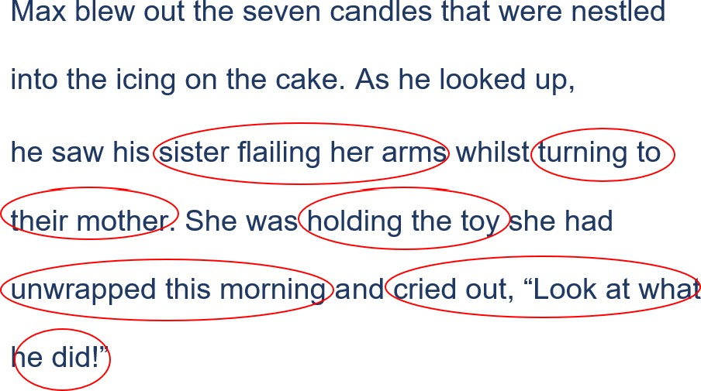
- Think aloud as you see the clues, background knowledge and initial ideas to make an inference as to what is happening now in the sentence.
- For example, “I know that when I read the first sentence, Max had blown out the seven candles that were on the cake. I remember I used these clues and background knowledge to infer that it was Max’s birthday. But as I am now reading the next sentence, I am starting to change my idea about what is happening. I am noticing some new clues. I can see his sister is flailing her arms and turning to their mother. I know that when people are angry or outraged, they will often flail their arms or move them around in the air. And I know that when brothers and sisters fight, often their mother will speak to the person doing the wrong thing. I wonder why the sister is upset?
As I read the third sentence, I have even more clues. The author has used the noun group ‘holding the toy’ and another clue which is very important is the phrase “…she had unwrapped this morning”. People unwrap presents on their birthdays and this morning must have been her birthday. I am starting to put these clues together with Max blowing out the candles and am wondering whether Max has blown out the candles on his sister’s cake!
We can see another clue in the sentence which says that the sister ‘cried out’. We know we cry out when we are upset. The final part of the sentence says ‘…look at what he did!’ with an exclamation mark. I can see the sister is upset and telling their mother to notice what Max had done. The exclamation mark helps to tell me that she is outraged, and it changes the way I read the sentence.
My inference has now changed with all these clues and my background knowledge. I can infer that Max has done the wrong thing and blown out his sister’s birthday candles. No wonder she is upset!”

Shared practice
- Revisit the previous lesson’s learning focus, that good readers use clues in sentences and their background knowledge to infer meaning.
- Explain that with the students help, you are going to look closely at groups of sentences to find clues and use our background knowledge to infer meaning.

- Display and read aloud the following sentence
It was growing cooler and I could hear the possums starting to scurry across the branches.
- Remind students that we used the clues of ‘growing cooler’ and ‘possums starting to scurry’ and our background knowledge to infer that it was night time.
- Explain that as we read more than one sentence, sometimes our inference may change as we come across more clues.
- Display and read aloud the additional part of the group of sentences:
It was growing cooler and I could hear the possums starting to scurry across the branches. I could hear my human preparing my dinner. I sniffed the air and felt my tummy rumble. My fur always stood on end when I heard possums. I thought it was time I headed inside for my dinner and hopefully some tummy rubs.
- Ask students, “What clues can you see that might help us understand more about what’s happening?” Use Appendix 2 - Blank inference equation table to record their responses. Prompt them to recognise important clues in the sentence. See example table below.
- Ask students, “What background knowledge do we already have about each of these clues?” Use the think pair share strategy to scaffold student discussions and build background knowledge. Record student responses next to each clue.
- Ask students, “What can we infer is really happening from using these sentence clues and our background knowledge?” Use the think pair share strategy to scaffold student discussions and inferences. Record student inferences in the table.
Clues in the text | + | What I know (my background knowledge) | = | Inference
My human, sniffed the air, fur standing on end, tummy rubs | + | Dogs are looked after by humans.  Dogs often are scared of possums or don’t like them.  Dogs fur stands on end when they are afraid Dogs usually love tummy rubs. | = | A dog is coming inside because it is afraid of possums and is keen to be fed and have its tummy rubbed.
- Students turn to a partner and reflect on what clues they noticed in the sentence and how they used their background knowledge to help them understand what was really happening in the group of sentences.

Guided practice
- Discuss how we infer every day. Work with small group of students as they read groups of sentences linked to teaching and learning.
- Students identify and underline key words or clues, discuss links to their background knowledge and use these to infer what is happening in the sentences.
- Students record responses. See example sentences below:

Example sentences
I can see the following clues… (underline clues) | What I already know … | I can infer…
They knew they had to be quiet as the tiptoed down the hall. As they reached the door, they could see nappies and tiny clothes everywhere! They had to step carefully over the soft toys so as not to make any noise. | They needed to be quiet and tiptoe to not wake up whoever is sleeping.  There are nappies, tiny clothes and soft toys and these are used by babies.  They did not want to wake the baby. | The baby is asleep and they must not wake him.
He could see the children playing and laughing. He had his school bag on his back and new lunch box in his bag. He smiled nervously as he waved his Aunty goodbye. | Children were playing and laughing – this is something that happens in a school.  He has a school bag and lunch box - this is something we often have when we start somewhere new.  He is smiling nervously and waving goodbye. | It is the boy’s first day in a new school today.
She couldn’t believe her eyes! The lady on the stage had disappeared. The man, who was wearing a fancy hat and bow tie, opened his arms and the audience clapped. | Not believing your eyes is a saying we use when something strange and unbelievable happens.  The lady has disappeared and this happened in front of an audience.  The man is wearing a fancy hat and bow tie. He is dressed up on stage.  The man opened his arms as a way of saying “ta dah!” | The man is a magician and his trick was to make the lady disappear from stage.
Challenge:  The wheat fields looked like they were waving. They were being forced this way and then that way. | Wheat fields are a crop grown on huge paddocks of land.  When it is windy, the windy might make something look like it is waving. | It is extremely windy on the wheat field.

Collaborative and independent practice
- Students work in small groups, pairs or individually with the teacher supporting groups as needed.
- Give students a copy of Appendix 2 - Blank inference equation. Students suggest what needs to be added to the equation to make it complete. As students make suggestions ask them to explain what a clue is and what background knowledge is.
- Remind students sometimes the meaning of a situation is not directly stated or told to us. Ask students to articulate what good viewers do in this situation. Remind students that as we read, our inference might change. We change our inference as we find new clues and put information together.
- Explain we are going to practice noticing clues and using them to make inferences. Explain to students they are going to read different groups of sentences (Appendix 8 – Making an inference from groups of sentences) and use the clues and background knowledge to make an inference. They will record their inferences on the Appendix 1 – Inference equation table.
- Encourage other students to share what they have matched and re-voice the thoughts of their peers by using the prompts:
  - “So, you’re saying ... Do I have that correct?”
  - “Are you saying that ...?”
  - “I think you are saying ... Do I have that right?”
- At the completion of the activity, formatively assess student understanding by having students complete the sentences:
  - An inference is ...
  - We make inferences by ...
  - We make inferences when ...

Inferring meaning from a text extract

Learning intention
We are learning to use clues and our background knowledge to make inferences based on a text extract.

Success criteria
I can:
- use the inference equation to make inferences based on a text extract
- justify inferences using evidence from the text and my background knowledge.

Text selection
Teachers can select any text for this teaching and learning experience that has opportunities for students to make inferences. The sample text extract from ‘George’s Marvellous Medicine’ has been selected as there are opportunities to both directly locate and infer within the text used. Students will be able to monitor their comprehension whilst using the clues and background knowledge to make an inference.

Suggested teaching and learning sequence

Modelled instruction
- Revisit the learning focuses for previous lessons and the co-constructed anchor chart. Reinforce that good readers use what they already know combined with the clues from images and the written text to understand what is happening.
- Explain they will be learning to make inferences from part of a text.
- Display the text extract from ‘Appendix 9 – ‘George’s Marvellous Medicine’. Before reading the extract, explain that you are going to show students how readers can infer what is happening in a text by finding clues in the written text, asking questions and linking these to their background knowledge.

George’s Marvellous Medicine - excerpt
Dahl, R. (1981) George’s Marvellous Medicine. Jonathan Cape, UK.
‘I’m going shopping in the village,’ George’s mother said to George on Saturday morning. ‘So be a good boy and don’t get up to mischief.’
This was a silly thing to say to a small boy at any time. It immediately made him wonder what sort of mischief he might get up to.
‘And don’t forget to give Grandma her medicine at eleven o’clock,’ the mother said. Then out she went, closing the back door behind her.
Grandma, who was dozing in her chair by the window, opened one wicked little eye and said, ‘Now you heard what your mother said, George. Don’t forget my medicine.’
‘No Grandma,’ George said.
‘And just try to behave yourself for once while she’s away.’ ‘Yes Grandma,’ George said.
George was bored to tears. He didn’t have a brother or sister. His father was a farmer and the farm they lived on was miles away from anywhere, so there were never any children to play with. He was tired of staring at pigs and hens and cows and sheep. He was especially tired of having to live in the same house as that grizzly old grunion of a Grandma.
Copied under the statutory licence in s 113P of the Copyright Act. Dahl, R. ‘George’s Marvellous Medicine’. Jonathan Cape, UK, 1981. Section 113P Warning Notice

- Display the inference equation (see example below) and use a think aloud to model the process of looking closely at the written text to identify clues and then draw on background knowledge to infer meaning. Circle key clues in the text extract and annotate as reading aloud.
For example, “I am going to read a longer text today and I am going to use all the clues in the text, as well as my background knowledge, to make an inference about what is happening. Because I am reading a longer text, I am going to circle words as I read; these words will be the clues that are helping me get an idea of what is happening.
I can see this is part of a story called ‘George’s Marvellous Medicine’ and it is written by Roald Dahl. I wonder what makes this medicine marvellous? I wonder whether George makes the medicine or whether it belongs to him? I know Roald Dahl writes stories for children that are often funny and a little bit naughty, where the person who is doing the wrong thing often gets what they deserve.
I can see in the first paragraph the clues, ‘I’m going shopping in the village’ and ‘so be a good boy and don’t get up to mischief.’ These clues are telling me that the mum is going to be leaving George. She has warned him not to get into mischief. I wonder if she has warned him of this because George usually does get into mischief and needs reminding. I can infer that George might be a child who is not always on his best behaviour.
In the next paragraph, mum warns George, ‘Don’t forget to give Grandma her medicine’. I know that medicine is important and that is why George must remember to give it to his Grandma otherwise she might fall ill. I wonder why the author used the words ‘Then she closed the door behind her.’ This makes me think that it is a signal to George that he is alone now. I can infer that he is alone and in charge of what happens next.
Now the next paragraph is quite interesting. Grandma is dozing on the couch, but then she ‘opened one wicked little eye’. If she is dozing, I wonder why she opened her eye? The author has used the word “wicked”. I know that the word means that the person is bad, evil or naughty. I can infer that the Grandma is not a nice person.
The final paragraph in this extract has a lot of clues that help me to make an inference. I can infer about how George might be feeling with words such as ‘bored to tears’, ‘didn’t have a brother or sister’, miles away from anywhere’, ‘never any children to play with’, ‘tired of staring at pigs and hens and cows and sheep’. And finally, and perhaps this is the most important clue to show me how George might be feeling, is that he was especially tired of having to live in the same house as that grizzly old grunion of a Grandma’. The author has used the words ‘grizzly’ which is a word we usually use to describe a bear. We know that a bear can get very angry if provoked. I wonder what the word ‘grunion’ means. I can infer from the surrounding words ‘grizzly old’ and that she had a ‘wicked eye’ that it must not be something very nice. I will look this up in a dictionary to see what it means. I can see that a ‘grunion’ is a type of fish that lays its eggs in the sand at night; this type of fish does this to survive. I can infer that Grandma knows how to survive in any conditions. I can use all these clues in the text and my background knowledge to make an inference that George does not like his Grandma and is going to make some mischief with his Grandma’s medicine.
- Record clues in a table similar to the example below. Once clues have been identified link these to inferences previously made from looking at the supporting image and background knowledge. Then use these to make inferences about what is happening in the whole text.
Clues in the text | + | What I know (my background knowledge) | = | Inference
‘going shopping’ |  | George was alone |  | He can’t be trusted
‘be a good boy and don’t get up to mischief’ |  | George needs reminding to be good. |  | He might misbehave
‘don’t forget to give Grandma her medicine’ |  | Grandma needs medicine |  | She might become ill if she doesn’t receive medicine.
‘Then she closed the door behind her’ |  | George was alone |  | The adventure would begin
‘Opened one wicked little eye’ |  | Wicked means bad and Grandma is watching him |  | Grandma doesn’t trust him and is watching him carefully. She might be plotting something whilst watching.
Bored to tears’, ‘didn’t have a brother or sister’, ‘miles away from anywhere’, ‘never any children to play with’, ‘tired of staring at pigs and hens and cows and sheep’, ‘grizzly old grunion of a Grandma’. |  | All these things build the picture that he is lonely and bored. |  | George may misbehave and do the wrong thing as he is bored and alone and does not like his Grandma.

Shared practice
- Display the text Appendix 10- Little leaf boat. Explain that with the students’ help, you are going to look closely at the text to find clues, brainstorm some questions that might help us understand the text and then use our background knowledge to infer meaning.
- Reinforce that good readers look closely at the written text to find clues and combine these with their background knowledge to infer meaning.
- The teacher begins by looking at the accompanying image on the text. The teacher might say “I see…clear water. I can see it is clear as I can see the rocks that are under or beneath it. I also can see that we are in nature as I cannot see any houses around. What do you see?” Responses may include: bubbling water, trees, rocks, vines, sunlight.
- Point to the 5W question stems (who, what, where, when and why) and asks students, “What questions do you have about the text that might help us understand what is happening?” Display questions for students to read. Encourage students to then use their collective background knowledge to answer these questions and make inferences about the text by using the think pair share strategy.
- Begin by drawing attention to the title of the text: ‘Little leaf boat’. Ask students if the title helps justify their inferences made so far from looking at the accompanying image. Then together read the text.
- After reading the text together, display Appendix 1 - inference equation to support student analysis of the written text.
- Invite students to look closely at the written text to identify clues and then draw on background knowledge to infer meaning. Circle the key clues in the text and record clues in a table similar to the one modelled above. Once clues have been identified they link these to inferences previously made from looking at the supporting image and background knowledge. Then use these to make inferences about what is happening in the whole text.

Collaborative and independent practice
- Students work in small groups, pairs or individually with the teacher supporting groups as needed.
- Give students a copy of the blank inference equation (Appendix 2 - Blank inference equation). Students suggest what needs to be added to the equation to make it complete. As students make suggestions, ask them to explain what a clue is and what background knowledge is.
- Remind students that sometimes the meaning of a situation isn’t directly stated or told to us. Ask students to articulate what good viewers do in this situation. Remind students that as we read, our inference might change. We change our inference as we find new clues and put information together.
- Explain we are going to practice noticing clues and using them to make inferences. Explain to students that they are going to read a whole text or to use a text linked to current unit of learning (Appendix 11 – Inferring from texts independently) and use the clues and background knowledge to make an inference. They will record their inferences on the Appendix 1 – Inference equation table.
- Encourage other students to share what they have matched and re-voice the thoughts of their peers by using the prompts:
  - “So, you’re saying ... Do I have that correct?”
  - “Are you saying that ...?”
  - “I think you are saying ... Do I have that right?”
- At the completion of the activity, formatively assess student understanding by having students complete the sentences:
  - An inference is ...
  - We make inferences by ...
  - We make inferences when ...

Appendix 1 - Inference equation
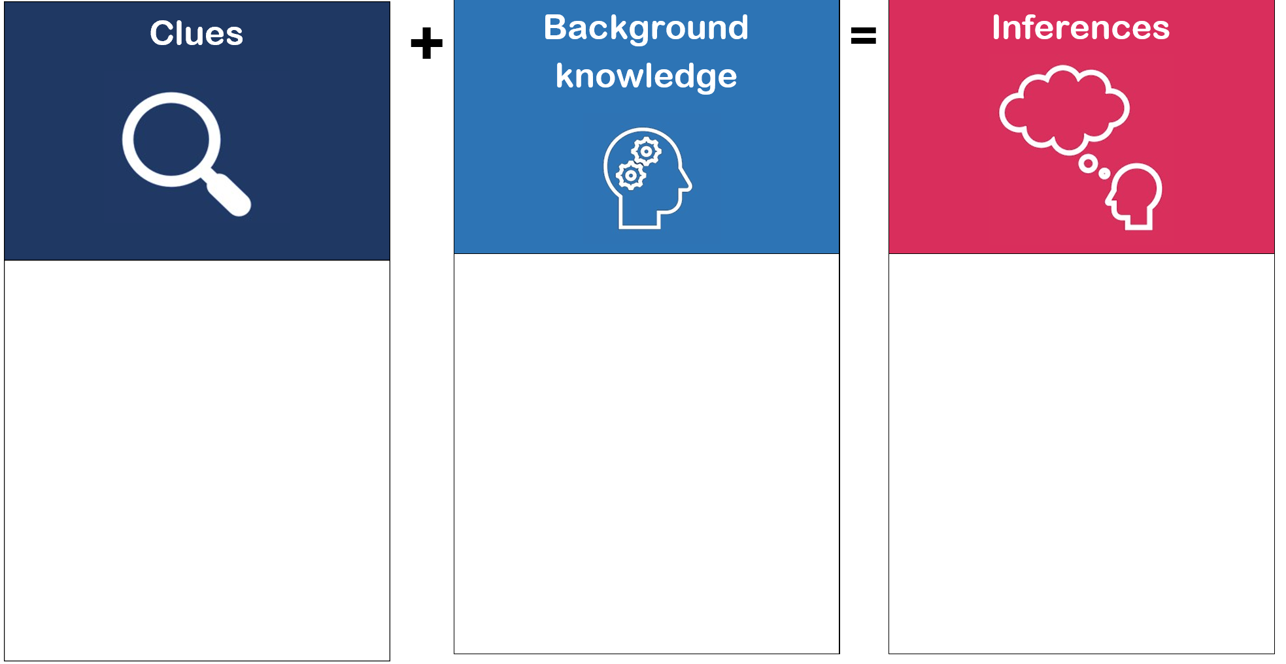

Appendix 2- Blank inference equation

 | + |  | = | Inferences  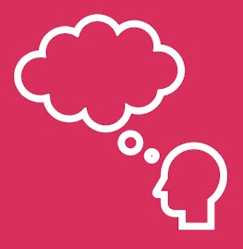
 | + |  | =

Appendix 3 – Image
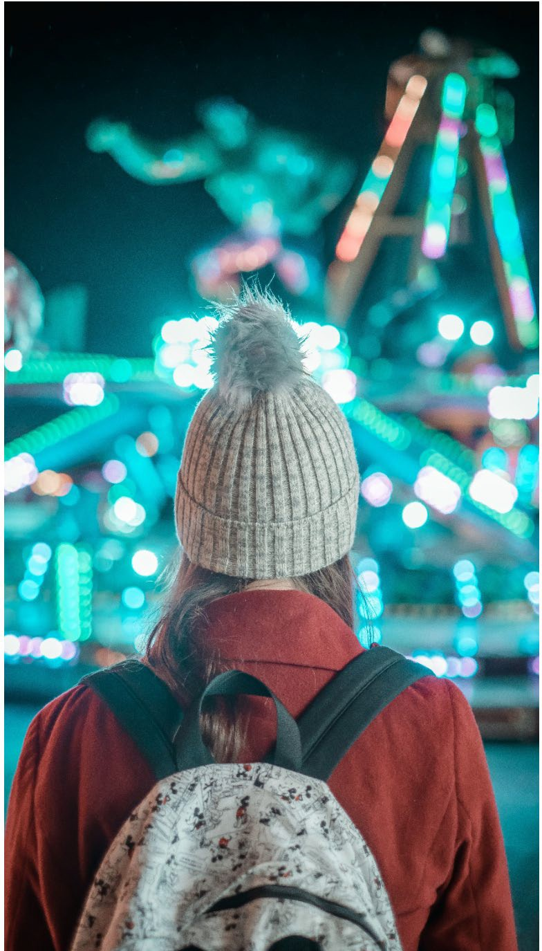
Photo by Toby Osborn, Unsplash

Appendix 4 – Shoes
0B  1BPhoto by Marcus Lewis, Unsplash | 2B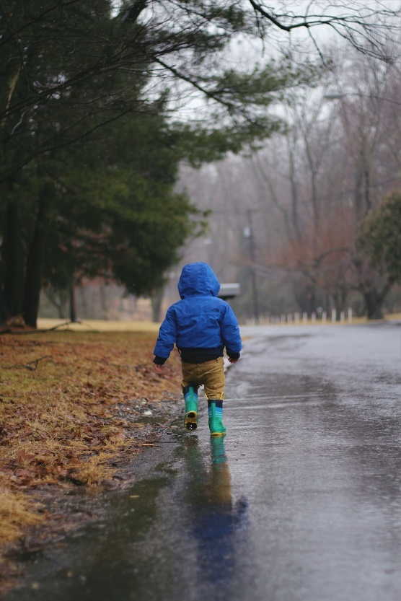  3BPhoto by June Admiraal, Unsplash
4B  5BPhoto by Sheelah Brennan, Unsplash | 6B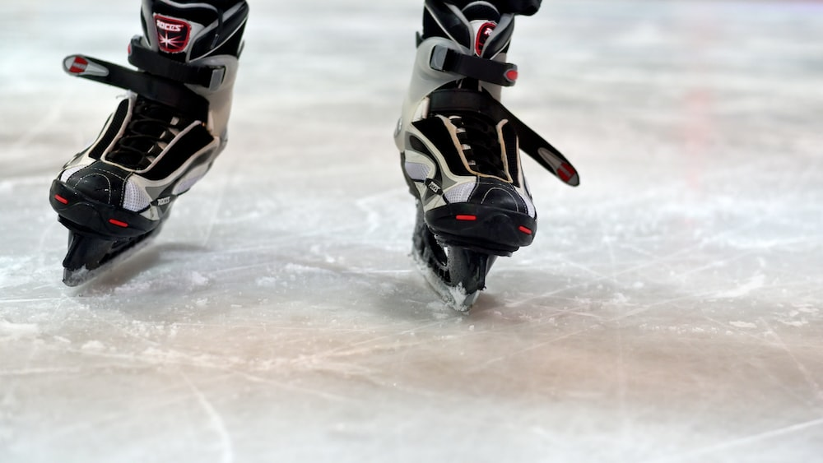  7BPhoto by Andres Siimon, Unsplash

Appendix 5 – A range of images
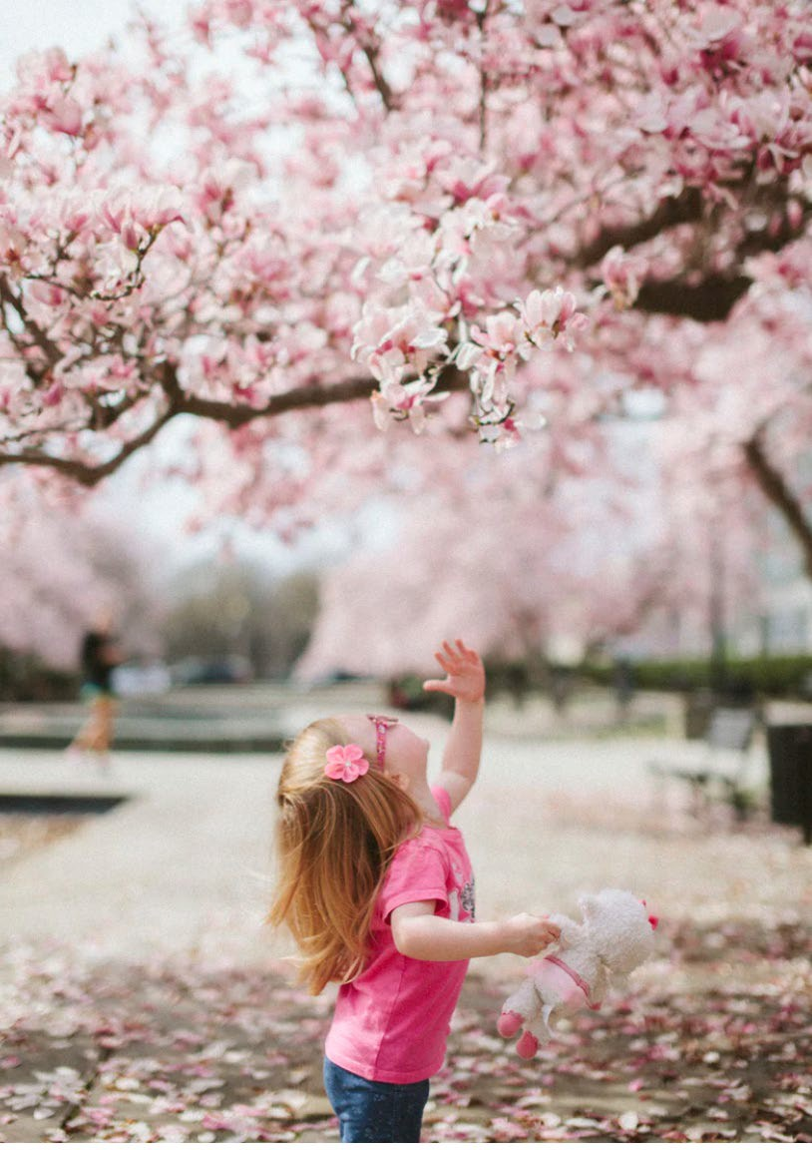Photo by Karl Fredrickson, Unsplash | 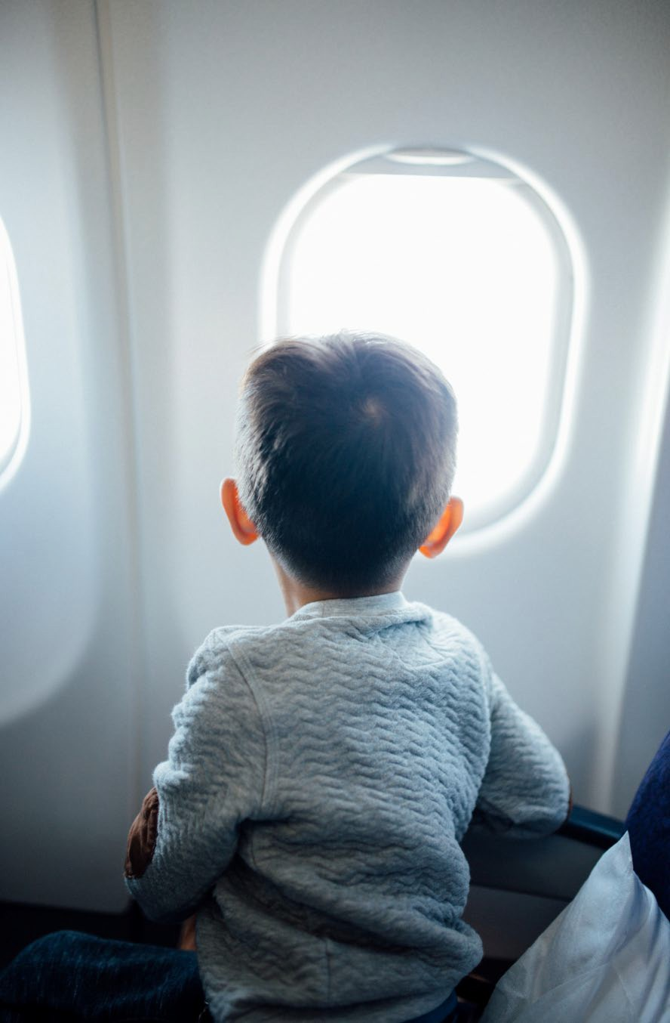  Photo by Hanson Lu, Unsplash
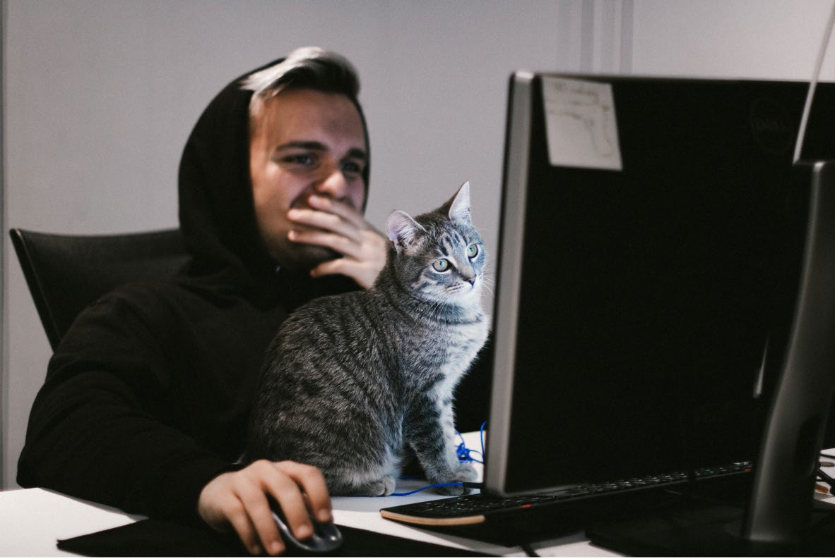  Photo by Josh Hild, Unsplash | Photo by Juan Karmy, Unsplash

Appendix 6 – Inferring from images
- Who is in the image?
- What is in the image?
- Where is the image set?
- When was the image taken?
- Why was the image taken?
Image | Clue | Background knowledge | Inference
Photo by Nick Stephenson, Unsplash | … | … | …
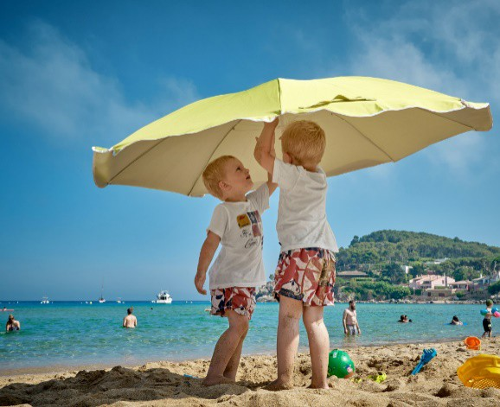  Photo by Vidar Nordi- Mathisen, Unsplash | … | … | …
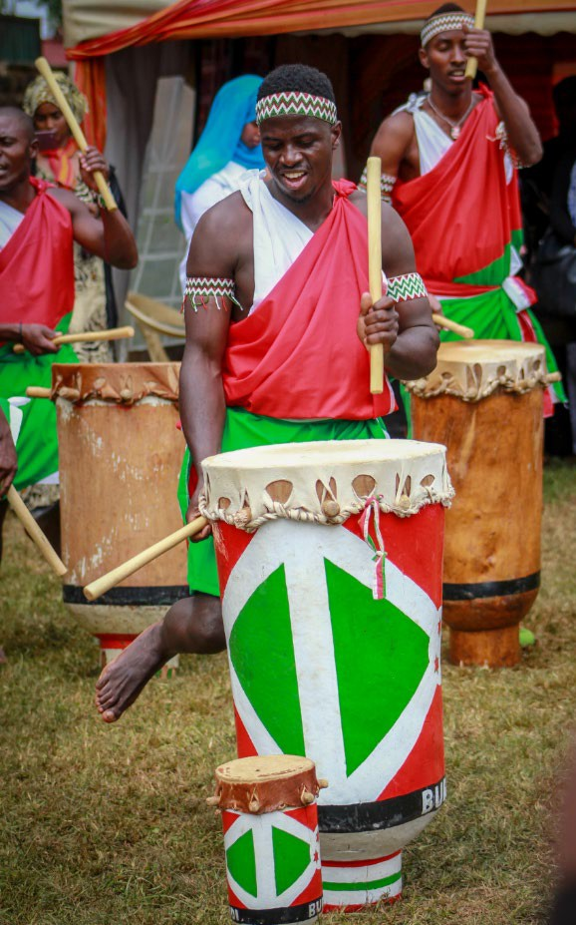  Photo by Wanyoike Mbugua, Unsplash | … | … | …

Appendix 7 – Inferring with sentences
Water dripped from the tap all night long!
The baseball bat was held together with old sticky tape.
She frowned and shook her head.
He started to pack his bag with his lunch box, homework and hat.
The sky was becoming grey and the clouds loomed above them.
The puppy wagged his tail and stared through the window with a rumbly tummy.
How much longer until lift off?

Appendix 8 – Making an inference from groups of sentences
The clouds were dark and moved quickly in the sky. The sound of thunder boomed as a flash of lightning struck the ground.
The birds gathered around her. She reached into her bag and pulled out a rumpled paper bag. The birds flapped their feathers with excitement as she reached inside.
First she took out the spade, then the bucket, then her sun cream. She stretched her feet out and felt the warmth of the sand. The seagulls squawked as they fought over some hot chips left on the pavement.
The ute pounded along the highway and the children stared out the window. The red dust gathered on the side of the road. Tyler stretched out his feet and yawned. How much longer?
Oh no! The oven had smoke billowing out. The scones had a layer of black crust on top. The guests were arriving any minute. What was he to do?

Appendix 9 – George’s marvellous medicine
Dahl, R. (1981) George’s marvellous medicine. Jonathan Cape, UK.
‘I’m going shopping in the village,’ George’s mother said to George on Saturday morning. ‘So be a good boy and don’t get up to mischief.’
This was a silly thing to say to a small boy at any time. It immediately made him wonder what sort of mischief he might get up to.
‘And don’t forget to give Grandma her medicine at eleven o’clock’, the mother said. Then out she went, closing the back door behind her.
Grandma, who was dozing in her chair by the window, opened one wicked little eye and said, ‘Now you heard what your mother said, George. Don’t forget my medicine.’
‘No Grandma,’ George said.
‘And just try to behave yourself for once while she’s away.’ ‘Yes, Grandma’ George said.
George was bored to tears. He didn’t have a brother or sister. His father was a farmer and the farm they lived on was miles away from anywhere, so there were never any children to play with. He was tired of staring at pigs and hens and cows and sheep. He was especially tired of having to live in the same house as that grizzly old grunion of a Grandma. Looking after her all by himself was hardly the most exciting way to spend a Saturday morning.
Copied under the statutory licence in s 113P of the Copyright Act. Dahl, R. ‘George’s Marvellous Medicine’. Jonathan Cape, UK, 1981. Section 113P Warning Notice

Appendix 10 – Little leaf boat
Photo by Bcny on Unsplash
The creek was bubbling and the brown leaves were moving very quickly along it.
The two children held onto their little leaf boat with two hands each. They had spent all morning making the boat. They had carefully folded the leaves and joined them together with sticks and sticky sap they had found in the tree.
They carefully stepped their feet onto the rocks and felt the moss that was cold and slippery.
“Ahhhh!” Emma yelped and her arms reached out. Lola grabbed her hand and they both breathed out. That was close!
The two friends kneeled down and reached their arms out as far as they could go and plop! They launched the little boat into the creek.
The little leaf boat stayed upright and the children cheered as it made its way down the creek with all the other leaves swirling and dancing with it.

Appendix 11 – Inferring from texts independently

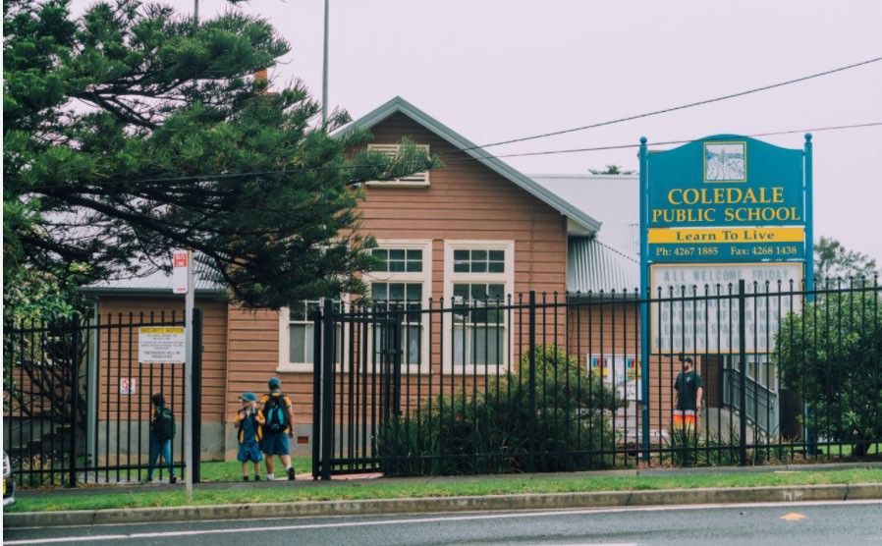
Photo by Lina Verovaya on Unsplash
He stood with his eyes down and his cap pulled low on his head at the front gate.
Children were running and playing ball games, calling out to each other and laughing.
James shuffled his feet and held his Aunty’s hand a little bit tighter.
He was new to this town. This town took four hours to drive to from his old house. The town had two supermarkets and two schools. His old town only had one little shop and one small school.
He heard the bell ring and the children began to leave their games, get their bags and walk towards the buildings.
James bent over and tied his shoelace again. Then the other shoelace too. He pulled his bag a bit tighter. He thought he should also check if his lunch was still in his lunch box.
His Aunty smiled at him and looked into his eyes. She said “You will be fine. It is ok to be nervous and a bit scared. Just take a deep breath and one step at a time.”
James smiled back and went to join the other children lining up outside their classrooms.

