Connecting ideas in text
Stage 1

Overview

Purpose
This literacy teaching strategy supports teaching and learning for Stage 1 students across all key learning areas. It targets specific literacy skills and suggests a learning sequence to build skill development. Teachers can select individual tasks, or a sequence, and embed into their teaching and learning program according to their students’ needs. While exemplar texts are provided throughout this resource, it is recommended that teachers select texts which are relevant to their students and curriculum.

Learning intention
Students will learn to make connections between their background knowledge and information in a text.

Syllabus outcome
The following teaching and learning strategy will assist in covering elements of the following outcome/s:
EN1-RECOM-01: comprehends independently read texts that require sustained reading by activating background and word knowledge, connecting and understanding sentences and whole text, and monitoring for meaning.
NSW English K-10 Syllabus (2022)

Success criteria
The following suggestions may guide teachers to develop criteria for student learning.
- explains that good readers monitor their thinking and make connections as they read
- explains the importance of background knowledge for making connections during reading
- explains new or learnt information after reading a text and how this builds on current knowledge

National Literacy Learning Progression guide

Understanding texts (UnT4-UnT6)
Key: C=comprehension P=process V=vocabulary

UnT4
- makes relevant comments or asks relevant questions to demonstrate understanding of the text (C)
- makes connections between texts and personal experiences (C)

UnT5
- reads and views the content of texts and describes new or learnt information (C)

UnT6
- integrates new learning from reading with current knowledge (e.g. I know that insects have wings but I didn’t know all insects have six legs) (C)
- draws inferences and explains using background knowledge or text features (e.g. infers character’s feelings from actions) (C)
National Literacy Learning Progression

Evidence base
- Centre for Education Statistics and Evaluation (2017). Effective reading instruction in the early years of school, literature review.
- Konza, D. (2014). Teaching Reading: Why the “Fab Five” should be the “Big Six”. Australian Journal of Teacher Education, 39(12).
- Centre for Education Statistics and Evaluation (2020). What works best 2020 update.
- Scarborough, H.S. (2001). Connecting early language and literacy to later reading (dis)abilities: Evidence, theory and practice. In S. Neuman & D. Dickson (Eds.), Handbook for research in early literacy (pp. 97-110). New York, NY: Guilford Press.
Alignment to system priorities and/or needs: Five priorities for Literacy and Numeracy, Our Plan for NSW Public Education, , School Excellence Policy (nsw.gov.au).
Alignment to School Excellence Framework: Learning domain: Curriculum, Teaching domain: Effective classroom practice and Professional standards
Consulted with: Strategic Delivery, Teaching Quality and Impact
Author: Literacy and Numeracy
Reviewed by: Literacy and Numeracy, Teaching Quality and Impact
Created/last updated: January 2024
Anticipated resource review date: January 2025
Feedback: Complete the online form to provide any feedback

Copyright
Section 113P Notice
Texts, Artistic Works and Broadcast Notice
Some of this material has been copied and communicated to you in accordance with the statutory licence in section 113P of the Copyright Act. Any further reproduction or communication of this material by you may be the subject of copyright protection under the Act. Do not remove this notice.

Resource list
ACARA (2016). Seahorses, Year 3 NAPLAN Reading Magazine.
Kenney, R., Lemons, K & Lin, W, (2020) ‘Curious Kids: What makes something smell good or bad?’ The Conversation website.
Native animal facts: Koala retrieved from the NSW Department of Planning, Industry and Environment website 4 March 2021.
NSW English K-10 Syllabus (2022) © NSW Education Standards Authority (NESA) for and on behalf of the Crown in right of the State of New South Wales.

Background information

Connecting ideas using background knowledge
Strategic and skilled reading requires students to make connections between their background knowledge and the information in the texts. It is important that students are explicitly taught how to notice and apply their background knowledge to texts in order to understand what they are reading. This is particularly important in relation to reasoning and making inferences from text.
It is important to remember students come to us with a wide variety of experiences and it is essential to not assume they have particular background knowledge. EAL/D learners in particular may not share the background knowledge of their peers who grew up in Australia and may understand experiences and events according to their first culture.

Where to next?
- Inference

Effective reading instruction in the early years of school
The CESE literature review Effective Reading Instruction in the Early Years of School (2017) outlines the key components of effective reading instruction. The research base has been furthered explored in the Effective reading guide which outlines the Simple View of Reading and Scarborough’s Reading Rope.
Comprehension is an active process that involves the reader understanding and interpreting what is read. It is heavily dependent on a student’s word recognition skills and their language comprehension abilities. To be able to understand written material, students need to be able to first decode what they read and then apply their language comprehension to make connections between what they read and what they already know.
In the context of effective reading instruction for the early years, it is important to understand that while students are learning the alphabetic code the majority of comprehension instruction should focus on oral language comprehension development through explicit teaching during modelled and shared reading experiences. An explicit focus on teaching students to strategically apply their background knowledge, vocabulary knowledge, knowledge about texts, understanding of language structures and reasoning skills to texts will support them to develop strong language comprehension abilities as they develop fluent word recognition skills.

What works best - Explicit teaching
Explicit teaching practices involve teachers clearly explaining to students why they are learning something, how it connects to what they already know, what they are expected to do, how to do it and what it looks like when they have succeeded. Students are given opportunities and time to check their understanding, ask questions and receive clear, effective feedback.
This resource reflects the latest evidence base and can be used by teachers as they plan for explicit teaching. Teachers can use classroom observations and other assessment information to make decisions about when and how they use this resource as they design teaching and learning sequences to meet the learning needs of their students.
Further support with What works best is available.

Gradual release of responsibility model
The Gradual release of responsibility model is a helpful framework to understand what explicit instruction can look like when teaching reading.
At the heart of the model is the concept that, as we learn new content, the responsibility for the cognitive load shifts from primarily sitting with the teacher as the model or expert, to the responsibility sitting with the student as they take on independence in their learning and application.
It is important to note the model is not linear and can be used flexibly rather than from beginning to end over the course of a lesson or in the same way for every student. Instead, it should be seen as a dynamic model that is recursive, meaning it can be repeated and revisited as needed and informed by formative assessment. As students increase in their ability, teachers gradually carry less of the cognitive load and students gradually assume more responsibility for the learning in order to become independent in the knowledge, skill or concept understanding and the application of this across contexts.

Modelled instruction
The Gradual release of responsibility model begins with the teacher assuming a significant proportion of the cognitive load for the learning. Modelled instruction is when the teacher models how an expert reads with a particular emphasis on the skill, concept or knowledge focus. This section is when the teacher is saying “I do, you watch”.
Although modelled instruction is characterised by teacher voice, students are active participants and engaged in careful observation. As the teacher explains the learning intention and its purpose, students should be encouraged to reflect on their current knowledge, understanding or skill. The teacher builds understanding of the academic language or background knowledge necessary to access the learning and students reflect on and add to their background knowledge or academic vocabulary. Modelled instruction is often characterised by the teacher ‘thinking aloud’ to demonstrate how a skilled reader monitors and controls their comprehension. At the end of modelled instruction:
- revisit the learning intention and reflect on what students observed the teacher doing to show the learning intention
- co-construct the success criteria based on what the teacher modelled and the students observed
- co-construct an anchor chart that students can refer to as they continue their learning.

Shared practice
Shared practice offers rich instructional opportunities as teachers and students both engage with a shared text. This is when the teacher invites students to share responsibility for the thinking, with the teacher saying “I do, you help.” Shared instruction is an interactive reading experience with the teacher or expert continuing to model or demonstrate the skills, concept or understanding that is the focus of the learning, however, students are now invited to join the teacher in sharing the cognitive load for the learning.
Shared practice is characterised by rich and authentic conversations amongst the community of readers as both teacher and students discuss, pose ideas, ask questions and extend their thinking.

Guided practice
The next stage is guided practice when the student takes on significantly more responsibility with the teacher saying “you do, I help.” Guided practice often involves the teacher working with a small group of students and encouraging students to think aloud about the strategy focus. The teacher asks questions to prompt or clarify thinking, supporting and guiding the learning of the group. Guided practice is characterised by high challenge texts scaffolded with high support for the needs of the learner.

Collaborative practice
Collaborative practice is when students take on and share more responsibility with their fellow learners. The teacher is still present and available but is saying “you do together, I will support you as needed.” Students are often paired with a partner or work in a small group. They work collaboratively on a strategy focus, sharing their thinking as they work together. Students are encouraged to think aloud as they read and to engage in shared discussion, questioning and collaboration. During collaborative practice, the teacher supports students by observing, monitoring, prompting and guiding them towards independence. The teacher encourages the use of support structures such as anchor charts, learning intentions and success criteria.

Independent practice
Once the student is confident with the learning, they continue to practice independently. The teacher is present and available and is now saying “you do alone and I will watch.” Students can record how they think aloud, problem solve and utilise the focus strategy to support their reading. The teacher uses this stage as an opportunity to observe and formatively assess students. Multiple opportunities across varying contexts need to be offered to students in order for them to develop independence with a skill or strategy.

Further professional learning
Use the following links for more information and resources for effective reading instruction:
- A video explaining the Simple view of reading
- A video introducing Scarborough’s reading rope
- A video explaining the lower strands of Scarborough’s reading rope
- A video explaining the upper strands of Scarborough’s reading rope
  - Literacy and numeracy professional learning:
  - Effective reading: Phonics
  - Effective reading: Phonological Awareness
  - Focus on Understanding texts: The components of reading – Blended learning
  - Focus on vocabulary – Blended learning
  - Fluency on Teams – Blended learning

Overview of teaching resource

Differentiation and adjustments
When using these resources in the classroom, it is important for teachers to consider the needs of all students, including Aboriginal and EAL/D learners.
EAL/D learners will require explicit English language support and scaffolding, informed by the Enhanced EAL/D enhanced teaching and learning cycle and the student’s phase on the EAL/D Learning Progression. Teachers can access information about supporting EAL/D learners and literacy and numeracy support specific to EAL/D learners.
Learning adjustments enable students with disability and additional learning and support needs to access syllabus outcomes and content on the same basis as their peers. Teachers can use a range of adjustments to ensure a personalised approach to student learning.
Assessing and identifying high potential and gifted learners will help teachers decide which students may benefit from extension and additional challenge. Effective strategies and contributors to achievement for high potential and gifted learners helps teachers to identify and target areas for growth and improvement. A differentiation adjustment tool can be found on the High potential and gifted education website.

Text selection
Example texts are used throughout this resource. Teachers can adjust activities to use texts which are linked to their unit of learning.
Further support with text selection can be found within the National Literacy Learning Progression Text complexity appendix.
The NESA website has additional information on text requirements within the NSW English syllabus.

Teaching and learning experiences

Using background knowledge

Learning intention
We are learning how to use our background knowledge to understand a situation.

Success criteria
I can:
- define background knowledge
- explain the background knowledge I have about an image.

Teaching notes
Teachers will support students to understand the background knowledge a student brings to a situation experience may be a combination of attitudes, experiences and knowledge. This could be:
- what a student knows about the reading process
- vocabulary knowledge
- topic knowledge
- concept knowledge
- text types/language features
It is important students have a thorough understanding of background knowledge as this lays the foundation for understanding inferencing.

Suggested teaching and learning sequence

Building the field
- Explain the learning intention and that good thinkers are always thinking carefully about what background knowledge they have to help them understand the situation.
- Explicitly teach the key word: knowledge. Say to students, “Knowledge is the information and understanding a person has. It is to do with what we know.” Explain the grammatical function of the word knowledge (noun) and explore synonyms (such as understanding and awareness).
- Explain we all have an enormous amount of knowledge stored in our brains about all sorts of things. Every day we are adding to our knowledge and we can use that knowledge when we need to. “Do you think you could make a list of everything you know?” Discuss that it would really be impossible!
- Use a relevant metaphor to help students understand the concept of knowledge, for example, display bucket of small balls or a picture of a children’s ball pit (Appendix 1 – Using background knowledge) “We could imagine our brain is like a big bucket filled with lots of different balls that represent our knowledge.” Explain all our everyday experiences are adding to our knowledge. This can include conversations we have or places we go. Every day we are adding to our “bucket” of knowledge. Have students brainstorm other suggestions for ways we build knowledge.
- Explain that in every situation we need to make decisions about which piece/s of knowledge we need to use to help us in that situation. So, we must decide which information is important for that situation. Refer back to the metaphor (step 3) and explain we need to know which balls to pull out in which situation. We call the important things we already know about a situation our background knowledge.
- Use an example that all students would relate to from their previous experience, for example, brushing your teeth or putting on shoes. Display an image to provide visual support for students (refer to Appendix 1 – Using background knowledge). “Let’s think about what background knowledge I use when I brush my teeth. I have lots of knowledge about dogs but when I go to brush my teeth, do I use my knowledge about dogs in that situation? No, I use my knowledge about toothbrushes, how to turn the tap on and off, how much toothpaste to use and how to most effectively brush my teeth. I use my knowledge of time to work out how long I should brush for. In that situation, I use the most important or relevant background knowledge to help me.”
- Display an image and discuss another familiar example where students need to use the right or relevant background knowledge for the situation, for example, tying shoelaces (refer to Appendix 1 – Using background knowledge).
- Explain in some situations we have a lot of background knowledge to draw on and in some situations, we have less background knowledge. Discuss an example of an activity where you wouldn’t have much background knowledge for the situation, for example, going abseiling or hang gliding. Display an image to provide a visual support for students (refer to Appendix 1 – Using background knowledge). In these situations, we often need to listen to an expert or do things more slowly to make sure we can think carefully as we go.
- Explain this is the same situation in reading. As we are reading, we need to be constantly thinking about what background knowledge we have about what we are reading about. When we have lots of background knowledge, we need to connect and add to that background knowledge continuously as we read. When we don’t have as much or any background knowledge, we will need to read more slowly and carefully and start to use our reading to build knowledge.
- Revisit the learning intention and that good thinkers are always thinking carefully about what background knowledge they have to help them understand the situation. Have students turn to a partner and think- pair-share to explain what background knowledge is. We call the important things we already know about a situation our background knowledge.
- Co-create an anchor chart that explains the definition of background knowledge and the range of things we can draw on for background knowledge.

Modelled instruction
- Revisit the co-constructed anchor chart and learning intention. Remind students that background information includes all the important things we already know about a situation. Explain you are going to model how you use background knowledge when you view an image.
- Display an image relevant to your personal experience and that your students will also be able to understand (such as Appendix 2 – Camping image) and think aloud as you use the sentence stems “I see…, I know…” to consider the background knowledge you have about the image. Record key words and ideas as you think aloud. For example, if you are using the camping image, say “I can see a fire, camping chairs, a tent, an esky/cooler and a fold-up table with food on it. I know a lot about this image because I regularly go camping with my family. We have to make sure we pack our tent and our sleeping mats, sleeping bags and pillows so we can sleep comfortably. I know that making a campfire is a good way to keep warm when you are camping but I also know that sometimes my family and I use the fire to cook food and even roast marshmallows for dessert. I know that when I am camping I have to take an esky or cool box to keep food cold because sometimes there is no electricity nearby. I know that some people think camping is fun and relaxing and some people don’t enjoy it at all!”
- Explain when I look at this image I have lots of background knowledge but when someone else, who hasn’t been camping before, looks at the image they might not have as much background knowledge to think about.
- Revisit the learning intention and anchor chart. Have students turn to a partner and explain what their teacher did to use background knowledge when looking at an image.

Shared practice
- Revisit the learning intention. Have students turn to a partner and tell them what background knowledge is. Have some students share with the class and revisit the co-constructed anchor chart to remind students that background information is all the important things we already know about a situation. Explain we are going to practise using our background knowledge when we view an image.
- Display an image (such as one of the images in Appendix 3 – Range of images) and remind students that when we look at this image some students might have lots of background knowledge but others might not have as much background knowledge. We can use each other’s background knowledge to build our collective understanding.
- Invite students to think aloud as they use the sentence stems “I see…, I know…” to consider the background knowledge they have about the image. Record key words and ideas as students think aloud. If possible, students in the beginning or emerging EAL/D Learning progression phases can be paired with a student with the same first language and stronger English language proficiency to support translation from first language into English.
- As students share their thinking, invite other students to add on to ideas by prompting using the sentence stems:
  - I have similar background knowledge and I can add .
  - I have different background knowledge and I can add .
- Revisit the learning intention and anchor chart. Have students turn to a partner and explain what they did to use background knowledge when looking at an image. Have students use an exit slip to explain what background knowledge is. Use the formative assessment information to make decisions about which students require further support through additional modelled instruction or shared practice and which students are ready for guided, collaborative or independent practice.

Guided and/or collaborative practice
- Revisit the learning intention. Have students turn to a partner and tell them what background knowledge is. Have some students share with the class and revisit the co-constructed anchor chart to remind students that background information is all the important things we already know about a situation. Explain we are going to practise using our background knowledge when we view an image.
- Display an image from a picture book such as ‘Rose Meets Mr Wintergarten’ by Bob Graham or ‘Feathers’ by Phil Cummings (refer to Vocabulary lesson ideas for the text Feathers Vocabulary lesson ideas for the text Rose Meets Mr Wintergarten for further ideas about targeting vocabulary using these picture books). Remind students when we look at this image some students might have lots of background knowledge but others might not have as much background knowledge. We can use each other’s background knowledge to build our collective understanding.
- Prompt students to think aloud as they use the sentence stems “I see…, I know…” to consider the background knowledge they have about the image. Have students record the key words and ideas as they or their peers think aloud.
- As students share their thinking, prompt others to add on to ideas by using the sentence stems:
  - I have similar background knowledge and I can add .
  - I have different background knowledge and I can add .
- Revisit the learning intention and anchor chart. Have students turn to a partner and explain what they did to use background knowledge when looking at an image. Have students use an exit slip to explain what background knowledge they can use to help them understand the image. Use the formative assessment information to make decisions about which students require further support through additional modelled instruction or shared practice and which students are ready for guided, collaborative or independent practice.

Independent practice
Provide students with an image or illustration from a familiar book. Have students use sticky notes to capture the background knowledge they have that is relevant to the image.

Connecting ideas

Learning intention
We are learning to make connections between our background knowledge and ideas or information.

Success criteria
I can:
- define the word connection
- use my background knowledge to explain how images or words are connected

Suggested teaching and learning sequence

Building the field
- Explain to students that good readers are always thinking carefully and trying to connect ideas and information while they are reading.
- Display a number of dot-to-dot pictures. Discuss that sometimes we can see the picture that will be created before we start joining the dots but sometimes we have no idea what the picture will be until we start joining the dots.
- Revisit the learning focus and draw students’ attention to the key word: connections.
- Explicitly teach the key word: connection. Say, “A connection is the way things are related to or joined together.” Explore the morphology of the word connection and point out that it is the word connect with the suffix –ion. Explore the synonyms (such as link and relationship) and antonyms (gap and disconnection) of connection to further support student understanding of the word. Refer to ‘A guide for planning and implementing explicit vocabulary instruction’ for further advice about the importance of, and suggested process for, explicitly teaching vocabulary.
- Co-create an anchor chart that explains the definition of connection and the range of things that we can draw on for background knowledge.

Modelled instruction
- Display two familiar items such as a fork and a spoon. Explain you are going to use the sentence stems “I see…, I know…, I think…” as you model how to think about the connection between the items. For example, “I see a fork and a spoon. I am going to use my background knowledge about both of these items. I know both of these items are used to eat food with. I think these items are connected because they can both be used when we eat food.”
- Display two familiar items that have a less obvious connection such as a soccer ball and a water bottle. Think aloud as you explain how these items are connected. For example, “I see a water bottle and a soccer ball. I am going to need to think a little bit harder about the connection between these two items. I know a water bottle is what I use to carry water so I can have a drink if I am thirsty. I know a soccer ball is used for playing soccer or for kicking around with friends. As I start to think about connections, I think when I play sport I might be running around and get thirsty, so it is important that I have a water bottle. I think the connection is they are both used when playing sport.
- Have students turn to a partner and explain what they heard the teacher do to make connections between the objects.
- Co-create an anchor chart that explains the definition of connection and the range of things that we can draw on for background knowledge.

Shared practice
- Display two familiar items such as a cake of soap and a towel. Invite students to use the sentence stems “I see…, I know…, I think…” as they think aloud about the connection between the items.
- Display two familiar items that have a less obvious connection such as a book and a hat. Invite students to use the sentence stems “I see…, I know…, I think…” as they think aloud as they explain how these items are connected. Explain these items are less obviously connected so we will need to think a little harder about the connection.
- Have students turn to a partner and explain what the class did to make connections between the objects. Use this formative assessment information to make decisions about which students require further support through additional modelled instruction or shared practice and which students are ready for guided, collaborative or independent practice.

Guided, collaborative practice and independent practice
Use a range of objects during guided, collaborative and independent practice as needed to support students as they move towards being able to independently explain how they use their background knowledge to make connections between objects.

Connecting background knowledge to texts

Learning intention
We are learning to make connections between our background knowledge and ideas in a text.

Success criteria
I can:
- explain the connections between my background knowledge and the ideas in a text.

Text selection
Use the National Literacy Learning Progression Text complexity appendix to select an appropriate text relevant to a current unit of learning. The text should feature a range of text features including illustrations, captions, headings, sub-headings, diagrams, maps, charts and/or tables. Alternatively, refer to the following exemplar texts: Native animal facts: Koala (Appendix 4), Curious Kids: What makes something smell good or bad? (Appendix 5) and Seahorses (Appendix 6 and Appendix 7).

Suggested teaching and learning sequence

Modelled instruction
- Explain the learning intention that good readers make connections between their background knowledge and the ideas in a text. Revisit the co-created anchor chart and the definition of background knowledge.
- Explain that good readers are always using that background knowledge to connect ideas and information while they are reading. Good readers expect to use those connections to keep building their knowledge as they read.
- Display a text such as the example text Appendix 4 – Native animal facts: Koala. Think aloud and model for students how, as a good reader, you are already thinking about what background knowledge you bring to this text to help you understand. For example, “I can see the title says ‘Koala’. I know some things about koalas already. I know they are an Australian animal and that they live in trees found in Australia, called eucalyptus trees. I know that koalas eat eucalyptus leaves. I also know that the recent bushfires in Australia have had a big impact on the koalas.
- Explain to students that as a good reader you are bringing your background knowledge and starting to think about how it will be built on or extended as you read. For example, “I expect that I will find out some more specific information about koalas such as which parts of Australia they live in and what type of animal they are.”
- Think aloud as you read the first sentence of the article to the class and introduce the question prompts. For example,
‘The koala is a well-known and popular animal, native to Australia but recognised around the world.’
I am going to ask myself some questions as I read.
  - How does this connect to my background knowledge?
  - Did I learn new information?
  - Do I have some questions I need answered?
“I can use my background knowledge that a few years ago, we had some visitors from overseas come to stay with us and they were very keen to go to a zoo so they could see a koala. So, I agree that koalas are well-known, popular and recognised around the world. There is a word in this section, native, that I am not familiar with but I do know that koalas are Australian animals and this says ‘native to Australia’ so I wonder if native means they are Australian animals. I’m going to write the word native down to see if something in the rest of the text will confirm the meaning for me. If nothing else in the text helps me confirm the meaning, I will come back and look that word up in the dictionary.”
- Continue to model thinking aloud for the next section, stopping regularly to return to the question prompts and to explain how you are using background knowledge and making connections to new information.
- Revisit the anchor chart and have students’ think-pair-share to discuss how the teacher modelled connecting background knowledge to the ideas in the text.

Shared practice
- Revisit the learning intention that good readers make connections between their background knowledge and the ideas in a text. Revisit the co-created anchor chart and have students turn to a partner and tell them the definition of background knowledge.
- Display the intended focus text, for example Curious Kids: What makes something smell good or bad? (Refer to Appendix 5 – Curious kids). Explain that this text comes from a series called ‘Curious kids’ and each article is based on a child asking a scientist or an expert a question. An expert is someone who knows a lot about a particular subject.
- Ask students what they notice first as they look at the text. Record student answers and suggest that this is a good list for us to use as we start to think about our background knowledge. Invite students to share their thinking as they identify one of the ideas on the list and what background knowledge they have.
- Read the first section of the focus text, for example:
‘In this Curious Kids series, children have their questions answered by experts. Taylor wants to know what makes something smell bad or good. Experts explain.’
- Think aloud as you model and record answering the question prompts for this section of the text:
  - How does this connect to my background knowledge?
  - Did I learn new information?
  - Do I have some questions I need answered?
- Read the next section of the focus text, for example:

‘Pee-yew! Your old socks smell soooo bad. But why?
Maybe you’ve learned to dislike the smell. Maybe your socks are full of gross bacteria. Or maybe, it’s both. Our team studies the brain and sense of smell – it’s one of our favourite topics. But first, how do you smell?’
- Invite students to think aloud or think-pair-share as they answer the question prompts for this section of the text:
  - How does this connect to my background knowledge?
  - Did I learn new information?
  - Do I have some questions I need answered?
- Record student thinking, background information and new or unfamiliar vocabulary.
- Continue reading through paragraphs or sections, pausing regularly to invite students to think aloud about their background knowledge and the connections they can make to new information.
- At the conclusion of the shared practice, have students reflect on the learning intention and use an exit slip to explain what good readers do as they read a text. Use the formative assessment information to make decisions about which students require further support through additional modelled instruction or shared practice and which students are ready for guided, collaborative or independent practice.

Guided practice and/or collaborative practice
- Work with a small group of students to provide support and further instruction as needed.
- Revisit the learning intention that good readers make connections between their background knowledge and the ideas in a text. Revisit the co-created anchor chart and have students turn to a partner and tell them the definition of background knowledge.
- Share Appendix 6 – Seahorse image with students. Have the small group of students discuss and record everything they know about seahorses and what they expect to learn from the text.
- Provide copies of the text for students to read and annotate.
- Have students read the first line from Appendix 7 – Seahorse text
“Seahorses live in the ocean.” Prompt students to monitor their thinking and connect to their background knowledge by asking:
  - How does this connect to your background knowledge?
  - Did you learn new information?
  - Do you have some questions you need answered?
- Continue reading the first paragraph and assign a student to ask their peers the question prompts. Have students articulate how they are using their background knowledge and connecting new information.
- Encourage the group to reflect on the co-created anchor chart to support and consolidate their learning.

Independent practice
Before providing students with a text ensure that they have the requisite background knowledge to make connections to the content. As students read the text, have them stop at significant points to make notes answering the questions:
- How does this connect to your background knowledge?
- Did you learn new information?
- Do you have some questions you need answered?

Appendix 1 – Using background knowledge
Photo by Greyson Joralemon on Unsplash
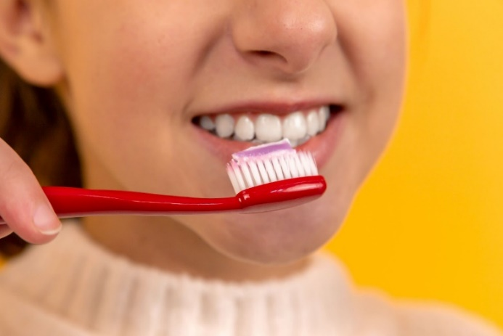
Photo by Diana Polekhina on Unsplash
Photo by dusan jovic on Unsplash
Photo by Christoph Deinet on Unsplash
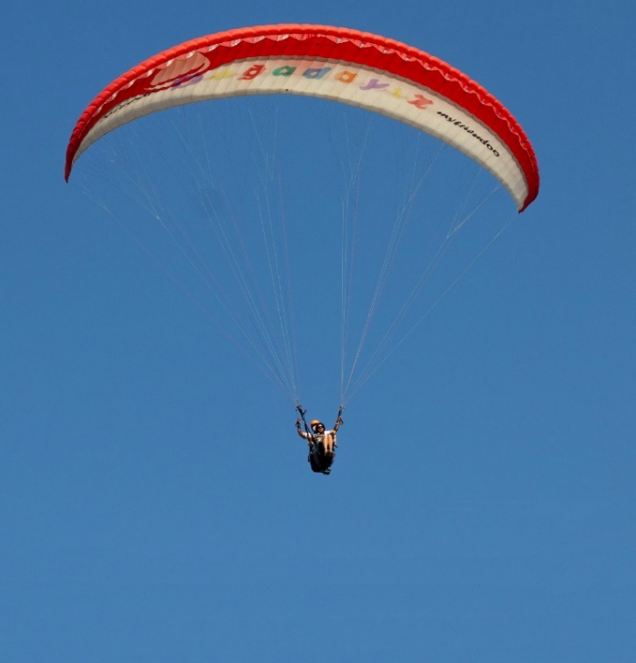
Photo by Mahmoud Fawzy on Unsplash

Appendix 2 – Camping image
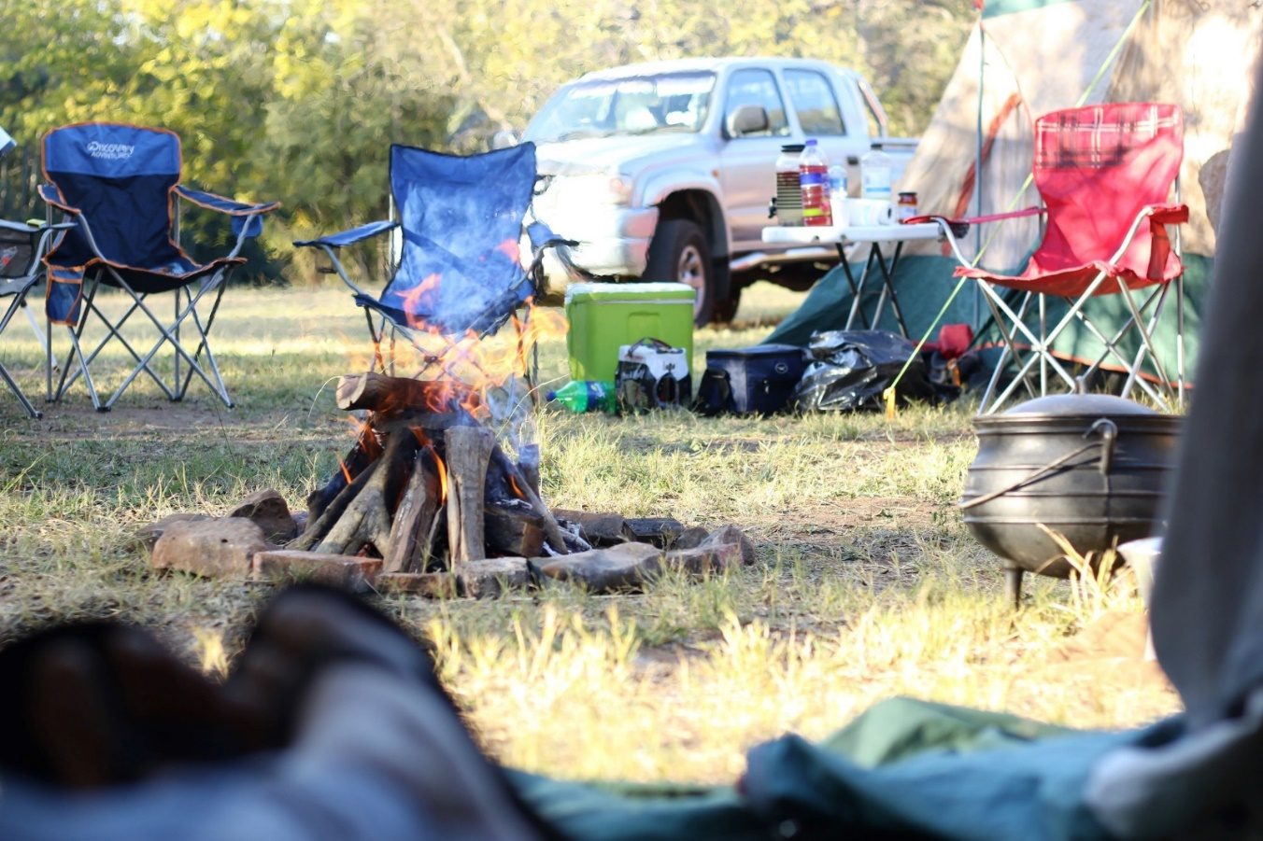
Photo by The Digital Marketing Collaboration on Unsplash

Appendix 3 – A range of images
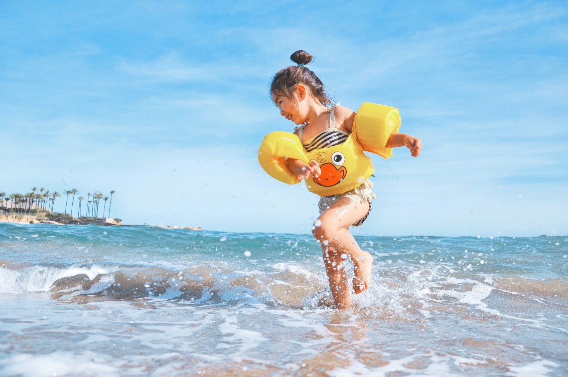
Photo by Leo Rivas on Unsplash
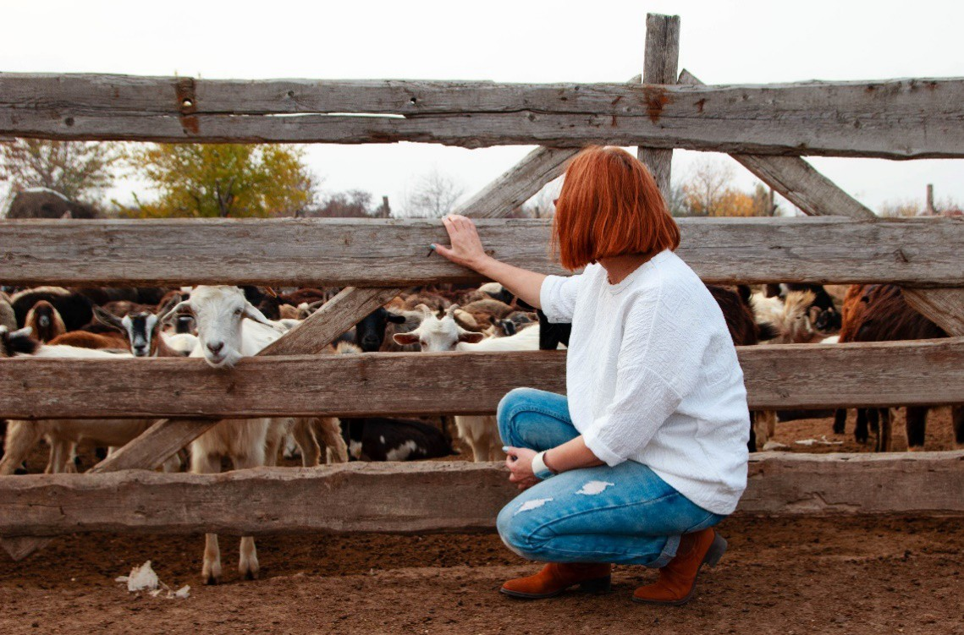
Photo by Maria Lupan on Unsplash
Photo by Sunyu Kim on Unsplash
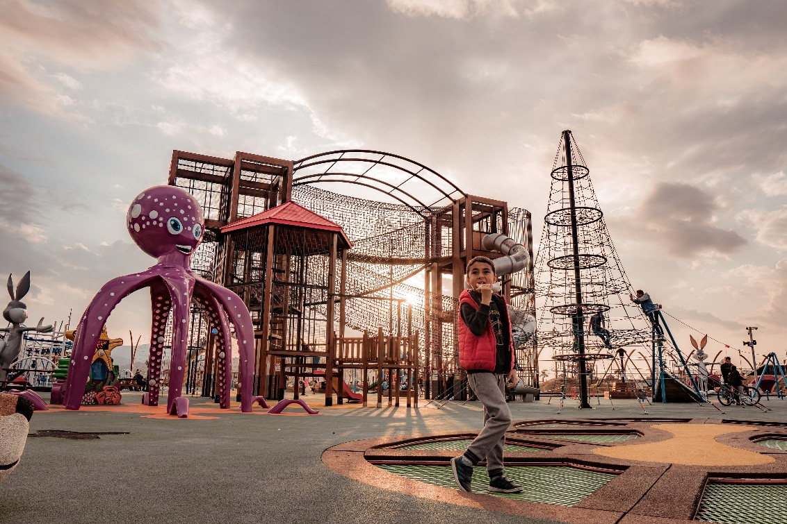
Photo by Yasin Hoşgör on Unsplash

Appendix 4 – Native animal facts: Koala

Koala
The koala is a well-known and popular animal, native to Australia but recognised around the world.

What do they look like?
Photo: Marcus Lenk on Unsplash
The koala is a tree-dwelling marsupial with large furry ears, a prominent black nose, long sharp claws adapted for climbing and no tail. Fur colour varies from pale grey in north Australia to grey-brown in the south.
Koalas also vary in size across their range. Adult males weigh between 4 and 14 kilograms and adult females weigh between 4 and 10 kilograms.
Despite being called 'koala bears' for many years, koalas are marsupials. While bears give birth to well- developed young, newborn koalas are tiny enough to fit on your thumbnail and are raised in their mother's pouch.
The closest relative of the koala is the wombat. Both animals have pouches which open towards the rear. This is fine for the wombat, but koalas need strong muscles ringing the pouch to keep their young from falling out.

Why are they special?
- Koalas are one of Australia's most iconic animals, recognisable around the world.
- People have a close affinity with the koala.
- Koalas feature in many Aboriginal dreaming and creation stories and are a totemic species.
- Koalas benefit the Australian economy. It has been estimated that they create over 9000 jobs and contribute between $1.1 billion and $2.5 billion per year to tourism in Australia.
- Although the koala’s Latin name, Phascolarctos cinereus, means ‘ash-coloured pouched bear,’ the koala is not a bear but a marsupial whose closest relative is the wombat.
- Koalas feed almost exclusively on eucalyptus leaves. The two or three primary tree species they prefer varies throughout their range. See the recent review of koala tree use across NSW.
Visit the NSW Koala Country website to find out how you can help koalas.
Copied under the statutory licence in s 113P of the Copyright Act. NSW Department of Planning, Industry and Environment, Native animal facts: Koala. Retrieved 4 March 2021 Section 113P Warning Notice

Appendix 5 – Curious kids

Curious Kids: What makes something smell good or bad?
Rakata Kenney, Kayla Lemona & Weihong Lin. The Conversation | June 1, 2020
In this Curious Kids series, children have their questions answered by experts. Taylor wants to know what makes something smell bad or good. Experts explain.
Photo: Jennifer Pallian on Unsplash.
Pee-yew! Your old socks smell soooo bad. But why?
Maybe you’ve learned to dislike the smell. Maybe your socks are full of gross bacteria. Or maybe, it’s both. Our team studies the brain and sense of smell – it’s one of our favourite topics. But first, how do you smell?

What is that smell?
The air is filled with many small odour molecules that are released from “smelly” things like perfume or food.
Your nose has the astonishing ability to smell thousands of different scents, because in your nose there are millions of smell receptors: cells that can recognise odour molecules. When you sniff the air, these special cells are alerted.
These receptor cells then send a signal to your brain. Your brain recognises many scents when different types of odours enter your nose. The smell of baking cookies, for instance, is composed of many odour molecules. Your brain can piece together all this information and let you know there are cookies baking in the oven.

Smells that make memories
Your brain is very good at memorising good and bad experiences and associating particular smells with them. Scientists call these “olfaction-associated memories.”
What’s that smell? Now I remember.
One example of this is when you smell a favourite meal. It might remind you of someone who makes it for you, which triggers your brain to release chemicals that make you feel good and comforted.

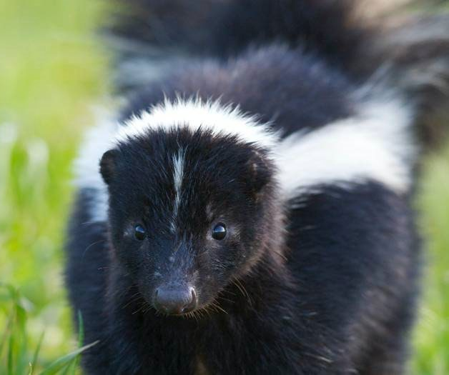
Skunks are cute, but wow, that smell! Bryan Padron on Unsplash.
Of course, smell can also be associated with unpleasant experiences. If you have eaten some food that went bad, you might find that you hate that food now. This is your brain associating getting sick with a certain smell, which stops you from eating something that could be bad for you.
Memories linked to smells can form because of good and bad feelings.

Smells to warn you
But what about things that you know smell good or bad even if you’ve never experienced them?
Scientists have found that although a lot of the smells people like come from past experiences, instincts play a big role.
Although our sense of smell isn’t as acute as that of dogs, who rely on it much more than we do, it's still very powerful.
Scent tells you a lot about your environment, and your instincts help to decide what is safe or dangerous. For example, blood has been shown to repel humans and many prey species, like deer, but attract predators, like wolves. This guides people away from predators that might want to eat us, but lets the predator get its meal.
Smell can warn you when something could make you sick. When eggs rot, bacteria multiply like crazy inside them, breaking down proteins that release a toxic chemical called hydrogen sulphide. This produces a stench that makes you want to stay far away, stopping you from eating the egg and becoming ill.
As for your socks… if they smell bad now, don’t wait. Wash them with soap and water! The bacteria growing on your socks will be killed, which will stop that nasty smell.
Find more Curious Kids articles on ABC Education.
Copied under the statutory licence in s 113P of the Copyright Act
Rakata Kenney, Kayla Lemona & Weihong Lin. What makes something smell good or bad? The Conversation, 1 June , 2020
Section 113P Warning Notice

Appendix 6 – Seahorse image
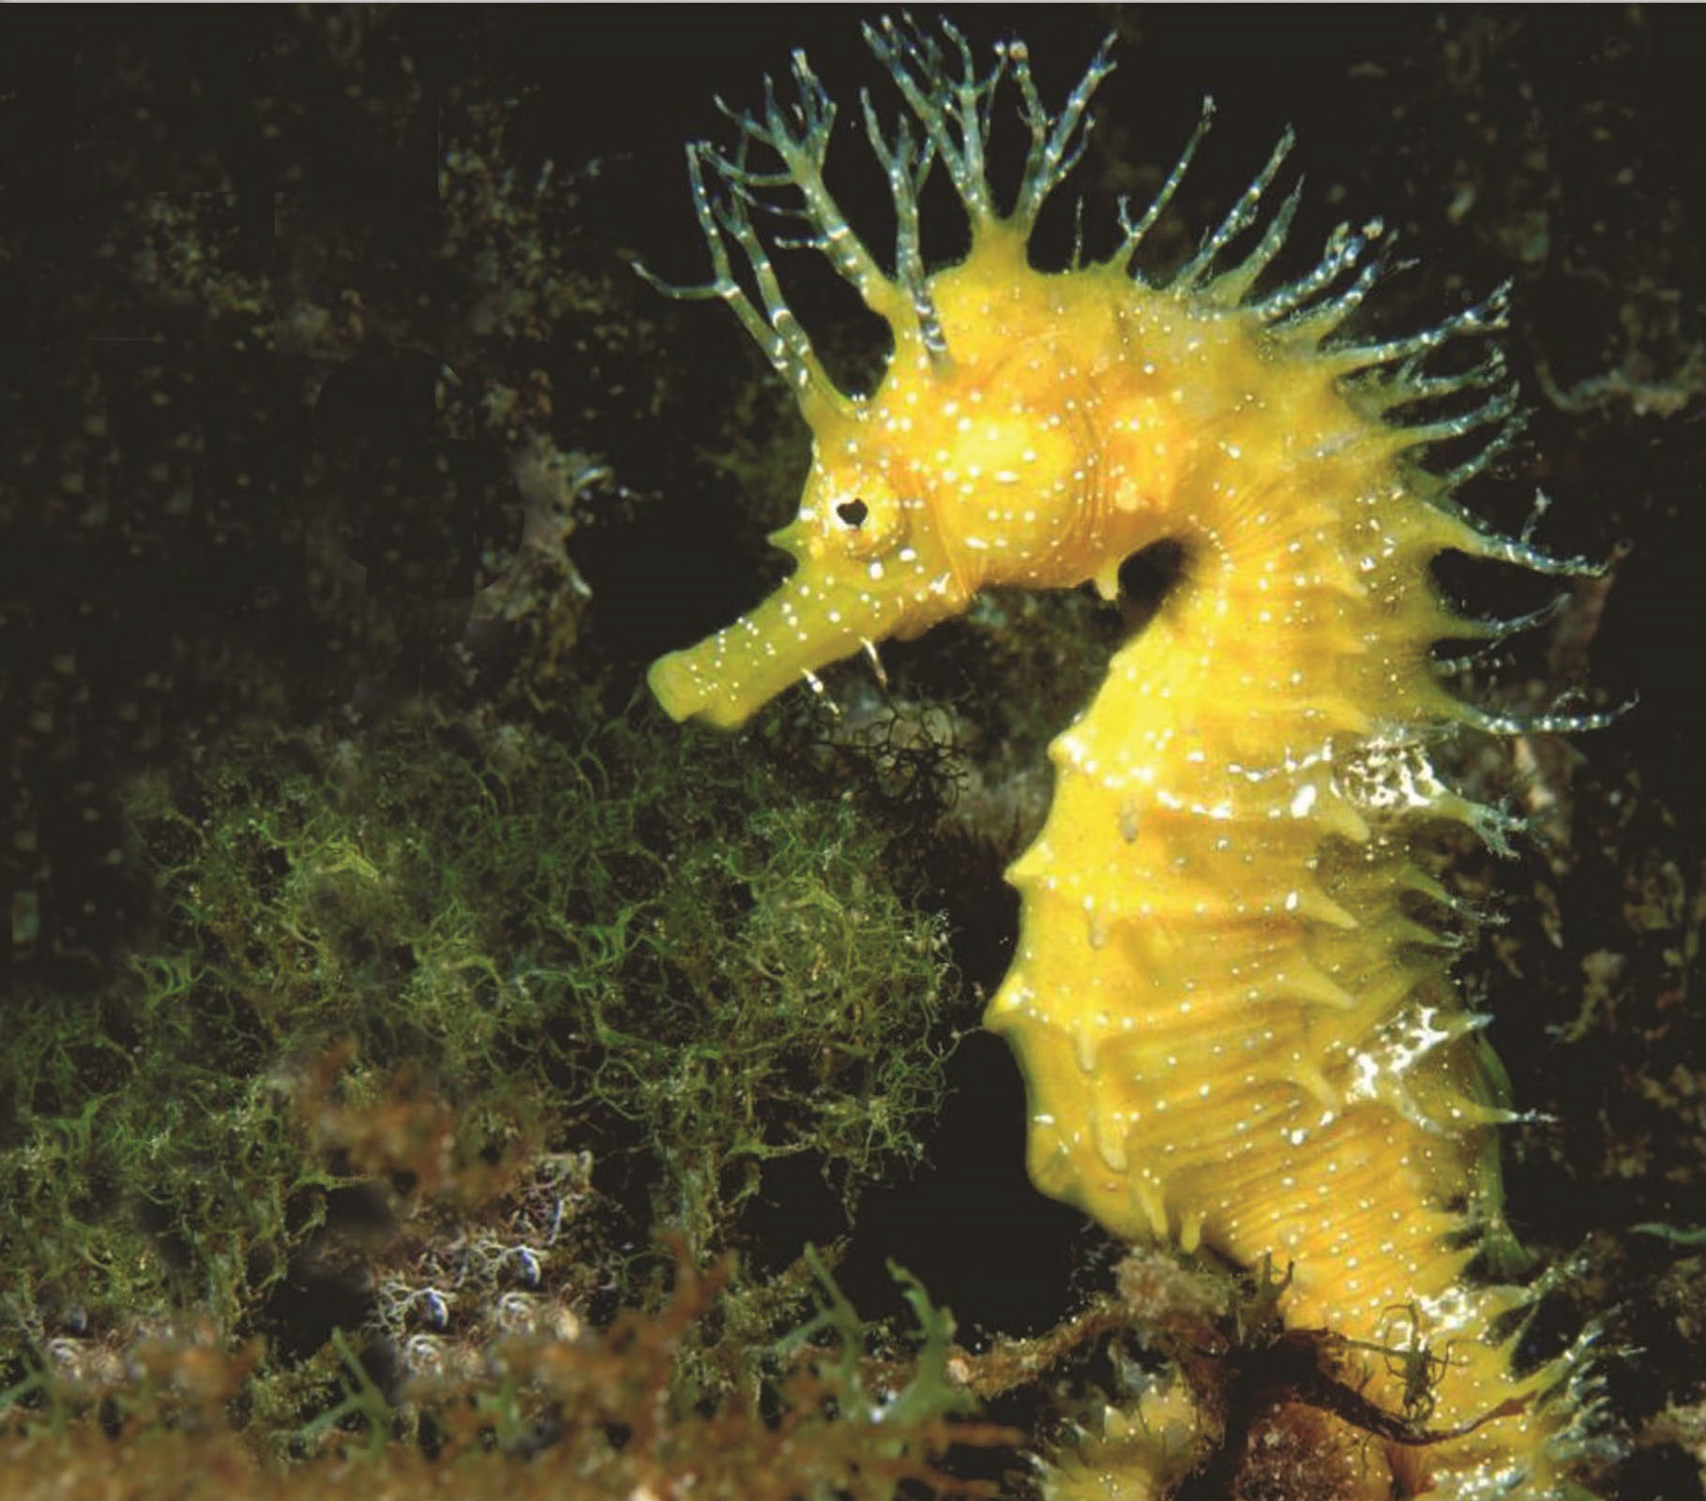
Year 3 NAPLAN Reading Magazine, 2016 ACARA

Appendix 7 – Seahorses text
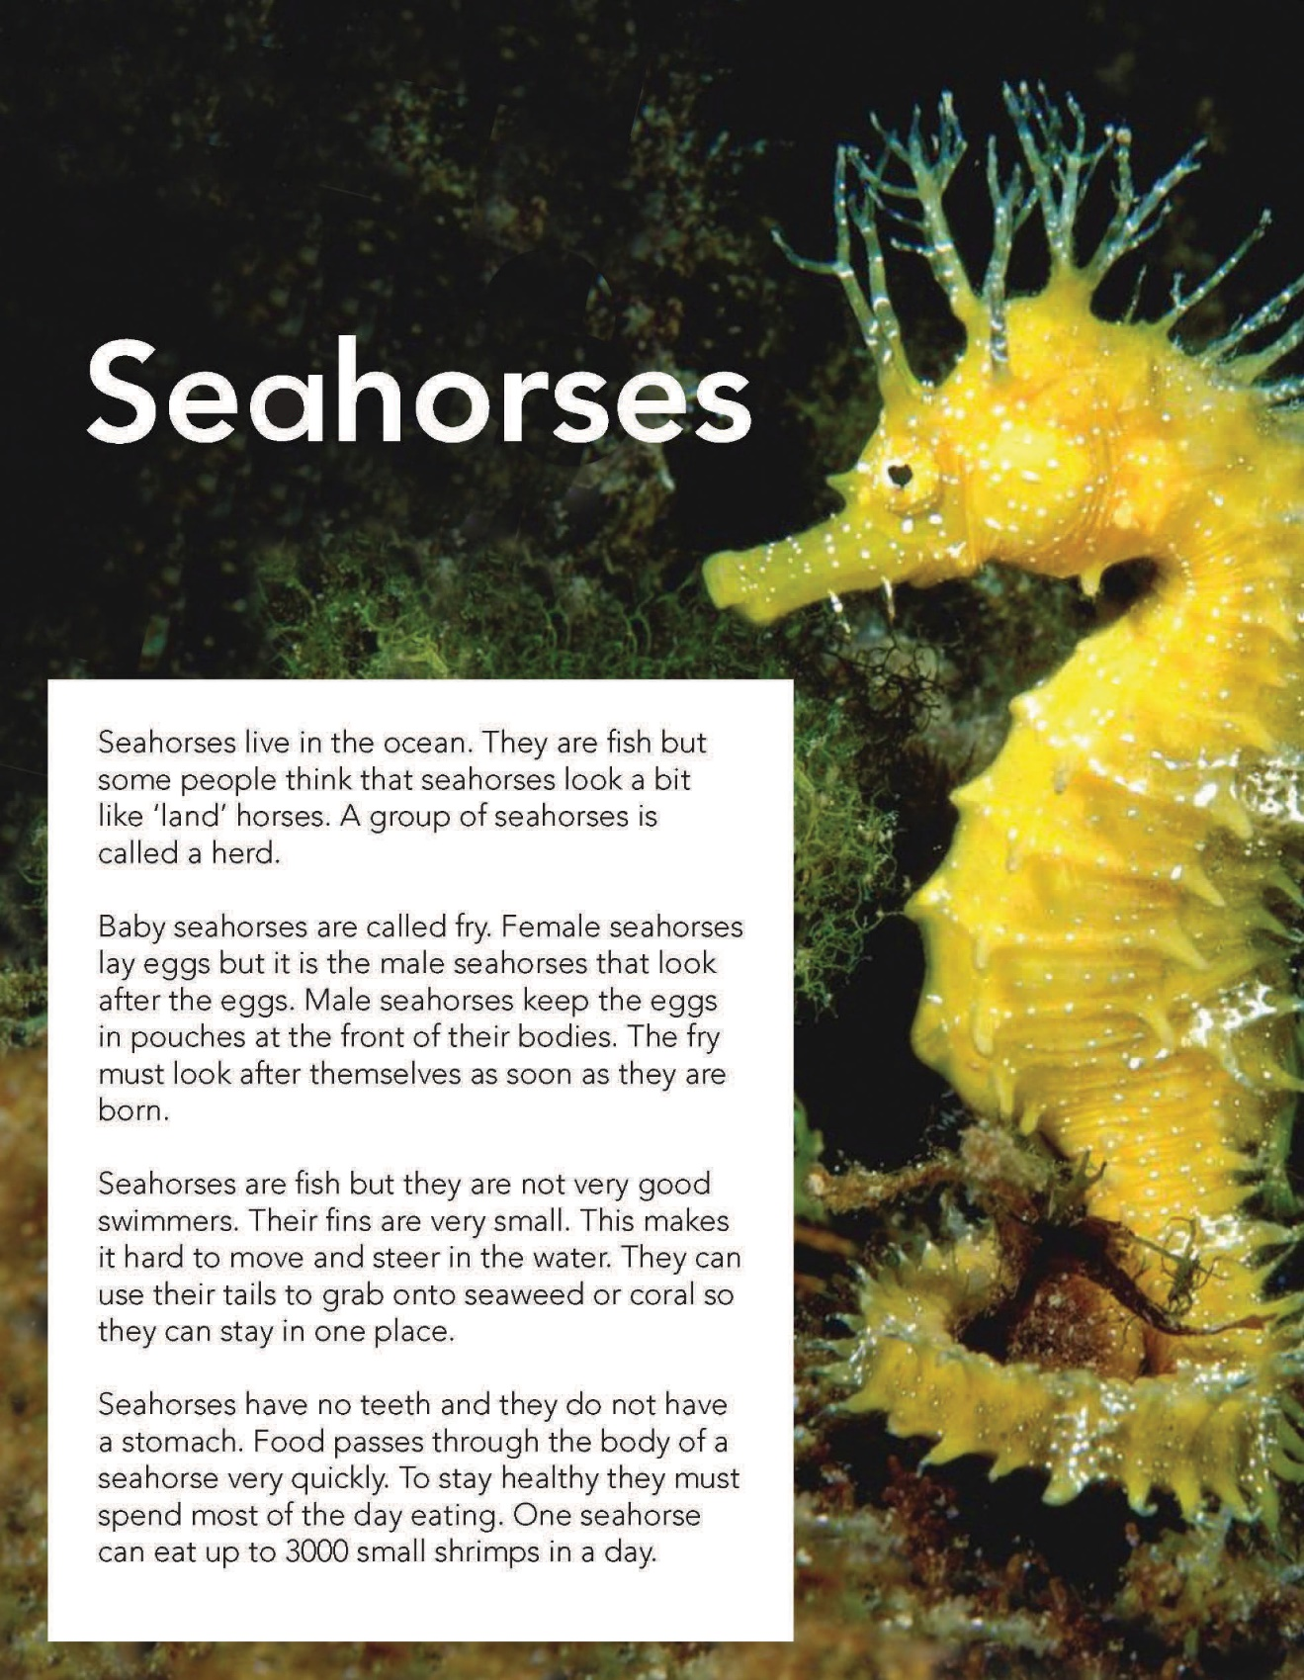
Year 3 NAPLAN Reading Magazine, 2016 ACARA

Seahorses text - Accessible version
Seahorses live in the ocean. They are fish but some people think that seahorses look a bit like ‘land’ horses. A group of seahorses is called a herd. Baby seahorses are called fry. Female seahorses lay eggs but it is the male seahorses that look after the eggs. Male seahorses keep the eggs in pouches at the front of their bodies. The fry must look after themselves as soon as they are born.
Seahorses are fish but they are not very good swimmers. Their fins are very small. This makes it hard to move and steer in the water. They can use their tails to grab onto seaweed or coral so they can stay in one place.
Seahorses have no teeth and they do not have a stomach. Food passes through the body of a seahorse very quickly. To stay healthy they must spend most of the day eating. One seahorse can eat up to 3000 small shrimps in a day.
Year 3 NAPLAN Reading Magazine, 2016 ACARA

