Audience and purpose
Stage 1

Overview

Purpose
This literacy teaching strategy supports teaching and learning for Stage 1 students across all key learning areas. It targets specific literacy skills and suggests a learning sequence to build skill development. Teachers can select individual tasks, or a sequence, and embed into their teaching and learning program according to their students’ needs. While exemplar texts are provided throughout this resource, it is recommended that teachers select texts which are relevant to their students and curriculum.

Learning intention
Students will learn to identify the purpose and audience of texts.

Success criteria
The following suggestions may guide teachers to develop success criteria for student learning:
- explains that authors create texts for a purpose
- identifies the main purpose of a text

Syllabus outcomes
The following teaching and learning strategies will assist in covering elements of the following outcomes:
- EN1-UARL-01: understands and responds to literature by creating texts using similar structures, intentional language choices and features appropriate to audience and purpose
- EN1-RECOM-01: comprehends independently read texts that require sustained reading by activating background and word knowledge, connecting and understanding sentences and whole text, and monitoring for meaning
NSW English K-10 Syllabus (2022)

National Literacy Learning Progression guide

Understanding Texts (UnT4-UnT7)
Key: C=comprehension P=process V=vocabulary
UnT4
- makes connections between texts and personal experiences (C)
- makes relevant comments or asks relevant questions to demonstrate understanding of the text (C)
- makes predictions (e.g. uses the cover of a book or screen image to predict the content (P)
- identifies simple grammatical features (e.g. identifies verbs in a set of instructions) (P)

UnT5
- identifies some differences between imaginative and informative texts (e.g. different styles of images in a fairy tale and instructions for a game) (C)
- selects appropriate reading paths when reading simple texts and navigates simple screen-based texts for specific purposes (P)
UnT6
- identifies the purpose of predictable informative, imaginative and persuasive texts (e.g. uses verbs and dot points to identify a set of instructions) (C)
- predicts the content and purpose of a text based on a range of text features (C)
- identifies common features in similar texts (e.g. photographs in informative texts) (P)
UnT7
- identifies the purpose of a broad range of informative, imaginative and persuasive texts (e.g. advertisements, diary entry) (C)
- recognises that texts can present different points of view (C)
- compares and contrasts texts on the same topic to identify how authors represent the same ideas differently (C)
- identifies language and text features that signal purpose in a predictable text (e.g. diagrams, dialogue) (P)
National Literacy Learning Progression

Evidence base
- Centre for Education Statistics and Evaluation (2017). Effective reading instruction in the early years of school, literature review.
- Centre for Education Statistics and Evaluation (2020). What works best: 2020 update.
- Konza, D. (2014). Teaching Reading: Why the “Fab Five” should be the “Big Six”. Australian Journal of Teacher Education, 39(12).
- Oakhill, J., Cain, K. & Elbro, C. (2015). Understanding and teaching reading comprehension: A handbook. Routledge.
- Quigley, A. (2020). Closing the reading gap. Routledge.
- Scarborough, H.S. (2001). Connecting early language and literacy to later reading (dis)abilities: Evidence, theory and practice. In S. Neuman & D. Dickson (Eds.), Handbook for research in early literacy (pp. 97-110). New York, NY: Guilford Press.
Alignment to system priorities and/or needs: Five priorities for Literacy and Numeracy, Our Plan for NSW Public Education, School Excellence Policy (nsw.gov.au).
Alignment to School Excellence Framework: Learning domain: Curriculum, Teaching domain: Effective classroom practice and Professional standards
Consulted with: Strategic Delivery, Teaching Quality and Impact
Author: Literacy and Numeracy
Reviewed by: Literacy and Numeracy, Teaching Quality and Impact
Created/last updated: January 2024
Anticipated resource review date: January 2025
Feedback: Complete the online form to provide any feedback

Copyright
Section 113P Notice
Texts, Artistic Works and Broadcast Notice
Some of this material has been copied and communicated to you in accordance with the statutory licence in section 113P of the Copyright Act. Any further reproduction or communication of this material by you may be the subject of copyright protection under the Act. Do not remove this notice.

Background information

Effective reading instruction in the early years of school
The CESE literature review Effective Reading Instruction in the Early Years of School (2017) outlines the key components of effective reading instruction. The research base has been furthered explored in the Effective reading guide which outlines the Simple View of Reading and Scarborough’s Reading Rope.
Comprehension is an active process that involves the reader understanding and interpreting what is read. It is heavily dependent on a student’s word recognition skills and their language comprehension skills. To be able to understand written material, students need to be able to first decode what they read and then apply their language comprehension to make connections between what they read and what they already know.
In the context of effective reading instruction for the early years, it is important to understand that while students are learning the alphabetic code the majority of comprehension instruction should focus on oral language comprehension development through explicit teaching during modelled and shared reading experiences. An explicit focus on teaching students to strategically apply their background knowledge, vocabulary knowledge, knowledge about texts, understanding of language structures and reasoning skills to texts will support them to develop strong language comprehension abilities as they develop fluent word recognition skills.

What works best- Explicit teaching
Explicit teaching practices involve teachers clearly explaining to students why they are learning something, how it connects to what they already know, what they are expected to do, how to do it and what it looks like when they have succeeded. Students are given opportunities and time to check their understanding, ask questions and receive clear, effective feedback.
This resource reflects the latest evidence base and can be used by teachers as they plan for explicit teaching. Teachers can use classroom observations and other assessment information to make decisions about when and how they use this resource as they design teaching and learning sequences to meet the learning needs of their students.
Further support with What works best is available.

Gradual release of responsibility model
The Gradual release of responsibility model is a helpful framework to understand what explicit instruction can look like when teaching reading.
At the heart of the model is the concept that, as we learn new content, the responsibility for the cognitive load shifts from primarily sitting with the teacher as the model or expert, to the responsibility sitting with the student as they take on independence in their learning and application.
It is important to note that the model is not linear and can be used flexibly rather than from beginning to end over the course of a lesson or in the same way for every student. Instead, it should be seen as a dynamic model that is recursive, meaning it can be repeated and revisited as needed and informed by formative assessment. As the students increase in their ability, teachers gradually carry less of the cognitive load and students gradually assume more responsibility for the learning in order to become independent in the knowledge, skill or concept understanding and the application of this across contexts.

Modelled instruction
The Gradual release of responsibility model begins with the teacher assuming a significant proportion of the cognitive load for the learning. Modelled instruction is when the teacher models how an expert reads with a particular emphasis on the skill, concept or knowledge focus. This section is when the teacher is saying “I do, you watch”.
Although modelled instruction is characterised by teacher voice, the students are active participants and engaged in careful observation. As the teacher explains the learning intention and its purpose, the students should be encouraged to reflect on their current knowledge, understanding or skill. The teacher builds understanding of the academic language or background knowledge necessary to access the learning and the students reflect on and add to their background knowledge or academic vocabulary. Modelled instruction is often characterised by the teacher ‘thinking aloud’ to demonstrate how a skilled reader monitors and controls their comprehension. At the end of modelled instruction:
- revisit the learning intention and reflect on what the students observed the teacher doing to show the learning intention
- co-construct the success criteria based on what the teacher modelled and the students observed
- co-construct an anchor chart that students can refer to as they continue their learning.

Shared practice
Shared practice offers rich instructional opportunities as teachers and students both engage with a shared text. This is when the teacher invites the students to share responsibility for the thinking, with the teacher saying “I do, you help.” Shared instruction is an interactive reading experience with the teacher or expert continuing to model or demonstrate the skills, concept or understanding that is the focus of the learning, however, the students are now invited to join the teacher in sharing the cognitive load for the learning.
Shared practice is characterised by rich and authentic conversations amongst the community of readers as both teacher and students discuss, pose ideas, ask questions and extend their thinking.

Guided practice
The next stage is guided practice when the student takes on significantly more responsibility with the teacher saying “you do, I help.” Guided practice often involves the teacher working with a small group of students and encouraging the students to think aloud about the strategy focus. The teacher asks questions to prompt or clarify thinking, supporting and guiding the learning of the group. Guided practice is characterised by high challenge texts scaffolded with high support for the needs of the learner.

Collaborative practice
Collaborative practice is when the students take on and share more responsibility with their fellow learners. The teacher is still present and available but is saying “you do together, I will support you as needed.” Students are often paired with a partner or work in a small group. They work collaboratively on a strategy focus, sharing their thinking as they work together. Students are encouraged to think aloud as they read and to engage in shared discussion, questioning and collaboration. During collaborative practice, the teacher supports students by observing, monitoring, prompting and guiding them towards independence. The teacher encourages the use of support structures such as anchor charts, learning intentions and success criteria.

Independent practice
Once the student is confident with the learning, they continue to practice independently. The teacher is present and available and is now saying “you do alone and I will watch.” The students can record how they think aloud, problem solve and utilise the focus strategy to support their reading. The teacher uses this stage as an opportunity to observe and formatively assess students. Multiple opportunities across varying contexts need to be offered to students for them to develop independence with a skill or strategy.

Overview of teaching resource

Differentiation
When using this resource in the classroom, it is important for teachers to consider the needs of all students, including Aboriginal and EAL/D learners. Teachers can use a range of adjustments to ensure a personalised approach to student learning for students with disability and additional learning and support needs. A differentiation adjustment tool can be found on the High potential and gifted education website.

Text selection
An example text is used throughout this resource. Teachers can adjust activities to use texts which are linked to their unit of learning. Further support with text selection can be found within the National Literacy Learning Progression Text Complexity appendix. The NESA website has additional information on text requirements within the NSW English syllabus.

Further professional learning
Use the following links for more information and resources for effective reading instruction:
- A video explaining the Simple view of reading
- A video introducing Scarborough’s reading rope
- A video explaining the lower strands of Scarborough’s reading rope
- A video explaining the upper strands of Scarborough’s reading rope
- Literacy and numeracy professional learning:
  - Effective reading: Phonics
  - Effective reading: Phonological Awareness
  - Focus on Understanding texts: The components of reading – Blended learning
  - Focus on vocabulary – Blended learning
  - Fluency on Teams – Blended learning

Teaching and learning experiences

Understanding purpose

Learning intention
We are learning to understand what purpose is and that authors consider their purpose as they create a text.

Success criteria
I can:
- explain what purpose is
- understand the three main purposes of text: to inform, persuade and to entertain
- look at the picture and text structure clues to find the purpose of a text.

Text selection
Select texts with minimal written language that use images and visual features, such as colour, and text features such as font to develop reader understanding of purpose.

Building the field
- Explain that authors create texts with a particular reason in mind. They carefully choose how the text will look, the words they will use to help the reader understand why the text has been created, and to make sure the reader understands the author’s message. When we talk about the reason an author wrote a text, we use the word purpose.
- Explicitly teach the key word: purpose. Say to the students, “The purpose of something is the reason for which it is made or done” (Collins dictionary). Explain the grammatical function of the word purpose (noun) and explore synonyms (such as, reason, and idea). Explain that we often consider purpose in our everyday lives. For example, when we go to the canteen or shop, what is our purpose for going there? When we go to the swimming pool, what is our purpose or reason for going?”
- Explore other examples of purpose with the students such as displaying a range of items and discussing the purpose of each item. Refer to ‘A guide for planning and implementing explicit vocabulary instruction’ for further advice about the importance of and suggested process for explicitly teaching vocabulary.
- Explain there are three main reasons or purposes that authors have when they create texts. They might be trying to mostly entertain us, to inform us about something, or to persuade us to think a certain way. Display the three words: entertain, inform and persuade.
- Explicitly teach the broad definition of entertain: When an author’s purpose is to entertain, they make choices that they think will hold the reader’s attention through enjoyment and interest. An author can entertain by:
  - making something funny, scary, unbelievable or surprising
  - using words that will help a reader paint a picture in their mind
  - using suspense
  - including elements that help a reader feel a certain way.

- Display a range of familiar book covers, advertisements, pamphlets and the names of familiar television shows or movies. Have students think-pair-share to decide which texts have the author’s main purpose as to entertain. Have students volunteer examples of other shows, movies or books that seek to entertain.
- Explicitly teach the broad definition of inform: When an author’s main purpose is to inform, they will include information and facts about the topic. An author can inform by:
  - giving lots of detail about the topic
  - writing the information in a clear and structured way so we can learn more easily
  - including pictures and diagrams to help the reader understand
  - including interesting information and important numbers, dates and examples.
- Return to the display of familiar book covers, advertisements, pamphlets and the names of familiar television shows or movies. Have students think-pair-share to decide which of the remaining texts have the author’s main purpose as to inform.
- Explicitly teach the broad definition of persuade: When an author’s purpose is to persuade they are trying to convince the reader to think or act in a certain way. Say, “If I try to get the class to do some reading and I spend time trying to convince you that it’s a good idea, then I am trying to persuade you. An advertisement on television or a website is usually trying to persuade you to buy something or do something particular. An author can persuade by:
  - giving the reader convincing facts and details
  - using language that makes the reader feel they have to respond, such as should and must
  - making one side of the issue sound positive and the other negative
  - making something seem as though it is important to respond or act immediately.”
- Return to the display of familiar book covers, advertisements, pamphlets and the names of familiar television shows or movies. Confirm that the purpose of these texts is to persuade. Have students volunteer examples of advertisements or websites that are trying to persuade.
- Revisit the learning intention that authors consider their purpose when they create a text and that the main purposes are to entertain, inform and persuade. Co-create an anchor chart that explains the three main purposes for texts and displays examples of each purpose.

Modelled instruction
- Revisit the learning intention that authors consider their purpose when they create a text and that the main purposes are: to entertain, to inform and to persuade.
- Explain to the students that they are going to be text detectives and explore a text to find its purpose. Introduce the text: Appendix 1 - How much fruit and vegetables does your family need?
- Explain good readers skim a text to get quick information about what the text is about and scan a text to find specific information. Use the ‘I see, I think’ strategy saying “Let’s take a look at this text. When I look closely using my detective eyes, I see that there are both words and pictures. Both of these are very important in giving us a message. I see images of people ranging from very small to very tall. I think this is showing us the different amounts or serves of fruit and vegetables different aged people need. The baby needs 1 serve and the adult needs 2 serves.” Label the text, ‘The picture tells a message’.
- Explain you are going to use your background knowledge about healthy eating to read the text. “I can see there are two sections: one labelled fruit and one labelled vegetables. I can see the images in the fruit section are green and the images in the vegetable section are blue. This is helping me organise information.” Label the text with ‘green for fruit information and blue for vegetable information’.
- Continue to think aloud about purpose. “So why was this text or poster made? When I think about why this poster was made I am thinking about the purpose. When I look at the clues, the title the pictures and the different sections, I think this sign is a way to help people to learn about how much fruit and vegetables they should be eating. So, the poster is informing people of how much fruit and vegetables to eat. The purpose of this text is to inform.”
- Revisit the labels on the text to help students connect what they observed in the modelled think aloud when skimming the text. Some further examples to explore in a think aloud might be the heading, sub-headings, font choice and captions.
- Have students turn to a partner and reflect on what they saw and heard the teacher ‘see and think’ about the text features and how the teacher used these to understand purpose. To support the student conversations, provide students with the sentence stem: My teacher saw … and this made him/her think the purpose was … because…
- Have pairs share their thinking with the class.

Shared practice
- Revisit the learning intention that authors consider their purpose when they create a text and that the main purposes are to entertain, to inform and to persuade.
- Display a text with a mix of images and text such as Appendix 2 – Water is the best drink for healthy kids. There are two pages to this text which can be displayed at the same time or introduce the second page where appropriate.
- Explain that together we will consider the text to work out what it is about and what the author’s purpose was for creating the text. Explain that the text is a fact sheet.
- Prompt the class with, “I can see the first page of this text has some larger words and some smaller words in different colours. I can see the large white words create a heading, ‘Water – the best drink for healthy kids,’ and the smaller blue words are sub-headings or headings that come under the main heading. The sub-headings say: ‘Water is the best drink for everyone,’ and ‘Kids don’t need sweet drinks’. I’m going to label these as clues to our purpose. I can also see there are some images which help me see what this text might be about, and who it might have been written for. I can see an image of a girl drinking water from the bubbler with a smile on her face. I can also see an Aboriginal artwork of what looks to be a turtle. I am going to put these images as clues to help me decide who the audience is.”
- Invite students to think-pair-share with a partner and to record what they can see on both pages. Have pairs share their responses.
- Revisit the anchor chart and prompt students to think about the purpose of the text. “So why was this fact sheet made? What do we think the author’s purpose was? Was the author wanting to entertain us, inform us about something or persuade us to think or do something? Let’s look at the things we can see: the headings, the pictures, the section with a list of tips to drink more water, the bolded introduction. Do we normally see these types of features in a text that is trying to entertain, to inform or to persuade?”
- Provide wait time for students to reflect on the clues (text features) that have been labelled.
- Read text aloud to the students or have students read along.
- Explain that you think this text is informing us about water as a healthy drink, but you think that maybe there could be another purpose as well. The fact sheet is also trying to convince us to choose water over other drinks such as sweet drinks. The purpose of this text is to both inform and persuade. Ask students to share their thoughts on this.
- Discuss any students’ differing perspectives and ask them to justify their thoughts.
- Have students turn to a partner to reflect on what they saw and thought purpose was for the text using this sentence stem: I saw … and this made me think the purpose was … because…

Collaborative practice
- Divide the class into pairs and give them the same text to look at closely. Students might use one or both pages.
- Students use the ‘I see, I think’ strategy demonstrated in the modelled instruction and shared practice to skim the text for features. Provide students with sticky arrows so they can informally label the text.
- In pairs, students develop an answer about how they know or can identify the text purpose. They use a sentence stem such as ‘We saw … and this made us think the purpose was … because…’
- After a 5-minute discussion with their partner, they join another pair to share their answers. As a group they discuss whether they agree or not. While groups are discussing, the teacher observes each group’s discussion and provides prompts and support where needed.
- Select students to share, using prompting questions such as, “What can you see? What do you think? What is the purpose? How do we know? What evidence is there to suggest this?”

Further collaborative practice
- Revisit the learning intention that authors consider their purpose when they create a text and that the main purposes are to entertain, inform and persuade.
- Explain to the students that they are going to be text detectives and explore the school to find examples of texts that have different purposes. The texts could include signs or printed information. The text could have lots of print or none at all and just have pictures that tell a message. Explore the school environment for environmental print and take photos. Texts may include a canteen sign, school rules/values or an animal crossing sign.
- On returning to the classroom, revisit the co-created anchor chart and the learning intention.
- Explain that good readers skim a text to get quick information about what the text is about. Use the ‘I see, I think’ strategy saying, “Let’s take a look at the pedestrian sign. When I look closely using my detective eyes, I see that there are no words, so the pictures are very important in giving us a message. I see a picture of two people - one tall and one small, holding hands. I think this is showing us that an adult is holding a child’s hand when crossing the road.” Label the text ‘The picture tells a message’.
- Explain you are going to use your background knowledge about road signs to help you read the sign. “I can see that the sign has a yellow background with black pictures. I know when this colour is used on road signs it is usually a warning.” Label the text with, ‘Yellow means warning’.
- Continue to think aloud about purpose. “So why was this sign made? When I think about why this sign was made I am thinking about the purpose. When I look at the clues, the picture and the yellow background, I think this sign is a warning to cars that there is a crossing ahead. It tells them to slow down. So, the sign is informing the drivers of what to do. The purpose of this text is to inform.”
- Revisit the labels on the text to help students connect what they observed in the modelled think aloud.

- Have students turn to a partner and reflect on what they saw and heard the teacher ‘see and think’ about the text features and how the teacher used these to understand purpose. To support the student conversations, provide students with the sentence stem: My teacher saw … and this made him/her think the purpose was … because…
- Have pairs share their thinking with the class.

Guided and independent practice
Use a range of texts during guided practice as needed to support students as they move towards being able to independently identify and analyse author purpose.

Variations
Select a variety of advertisement posters and discuss the visual and text features that give clues towards the purpose. A cross-curricula approach could include using Road Safety posters as part of a PDHPE unit of learning. Use imaginative texts and discuss the features that give clues to purpose.

Exploring audience

Learning intention
We are learning about what an audience is, and that authors create a text for a particular audience.

Success criteria
I can:
- explain what an audience is
- identify different types of audiences
- look at the picture and word clues to find the audience of a text.

Suggested teaching and learning sequence

Building the field
- Display a range of images showing examples of an audience. The audience might be at a concert, at an assembly or watching a television program. Discuss what an audience might be doing, what they might be saying and what they might be feeling.
- Explicitly teach the key word: audience. Say “The audience is the group of people who watch, listen to or read something.” Explain “The people watching a concert are the audience, and when we go to a school assembly we are part of the audience. If we watch a movie or television show, we are the audience.” Explore other examples of audience that the students are familiar with. Point out to students that they are an audience right now as they listen to what you are saying.
- Explain although anyone can be part of an audience, they might not be the people that the authors or performers were expecting as the audience. Explore a situation that students will be familiar with, for example, a sport match. The people planning the match expect that their audience are fans of the game and that they are familiar with the rules of the game. They don’t spend time before the match explaining the rules. But if the people planning the game knew that the whole audience was coming because they had never seen the sport before, they might have someone explain the rules at the beginning. The different audience would have an impact on how the planners planned the event.
- When authors, composers and presenters plan a performance, movie or a text, they have in mind who they think the audience will be. Explain to the students that authors make careful choices about the way they create a text based on who they are creating the text for, their intended audience.
- Explain lots of people read texts, asking students: ‘Who reads books?’ Explain that these different groups of people who read books can be called audiences. Some examples of audiences might be children, parents, teachers, Harry Potter fans or Aaron Blabey fans. Encourage students to share ideas. Record ideas on a class anchor chart to revisit throughout the learning.
Modelled instruction
- Revisit the learning intention that authors consider their audience when they create a text and that the audiences might be a group of children, parents, fans of a book and so on.
- Select a text linked to current unit of learning that the students are familiar with. A quality picture book is a good text to use.
- Explain to the students they will be looking carefully at the text on display. They are going to put their detective hats on and look closely for clues that might tell us who the text is written for or who the audience is.
- Using a familiar text, perform a think aloud using the ‘I see, I think’ strategy. Pig the Pug by Aaron Blabey is used as an example here. “When I look at the cover I can see a rather large cartoon dog. I’m going to label this as one of my clues. I can also see the title which says ‘Pig the Pug’. If I look really closely I can see that the word ‘the’ is written in a different way to the words ‘Pig’ and ‘Pug’.” The author has used a different font and it looks as though a child has written the ‘the’. I’m going to label this as another clue. At the moment I think this book may have been written for children but I’m going to open the book and scan the book for other clues. Skimming means to have a quick look at the pictures and words without reading everything.”
- Continue to quickly skim the text for other clues towards audience. These may include text features such as headings, sub-headings, images, font, colour, directionality, bold, italics and captions. This is also an opportunity to highlight language features that provide clues about who the text is written for. Say, “I can see on most pages that Aaron Blabey has used words that can be easily read by children. The words are simple and so are the sentences. I think this gives us a clue to who the audience of the book might be”.
- After modelling the ‘I see, I think’ strategy with looking for clues for audience, review the learning focus with the students. Remind them that authors create text for a particular audience and good readers think about who this is and how the author does it.
- Revisit the clues to finding an audience to assist the students to connect the choices the author has made in the composition of the text to appeal to a particular audience.
- Have students turn and talk to a partner to reflect on what they saw and heard the teacher notice about the text to inform them about audience. Sentence starters such as ‘My teacher saw… so they thought…’
- Have pairs share their thinking.

Shared practice
- Pick another familiar text for students to explore.
- Explain to the students they are going to assist you to find the clues about who the text is written for, or who the audience is.
- Lead a class discussion by asking prompting questions such as, “What do you see?” “…So, what does that make you think about the audience?”
- Direct the students to look closely at text and language features as well as structural features that assist in establishing the audience.
- Label the text, language and structural features that the students identify.
- Ask prompting questions after the ‘I see, I think’ strategy. “Who do you think these texts are created for?” “Who is the target audience for each of these texts?” and, “How do you know?”
- Have students turn and talk with a partner using a sentence starter such as “I think the audience could be because I see…”
- Have pairs share their understanding with the class.
- Explain although we could say audiences are big groups of people such as children and adults, we can be more specific about the target audience. For example, take a book about dinosaurs, the target audience may not be all children. Instead it could be children who already know lots about dinosaurs. Ask students to share any examples they can think of.
- Continue to explore other texts in a similar manner.

Guided, collaborative and independent practice
Use a range of texts during guided and collaborative practice as needed to support students as they move towards being able to independently identify and analyse the way authors use text, language and structural features to target an audience.

Using words to determine purpose

Learning intention
We are learning to use word clues to determine the purpose of the text.

Success criteria
I can:
- explain the three main purposes of text: to inform, persuade and to entertain
- look at the word clues to find the purpose of a text.

Modelled instruction
- Revisit the learning intention that authors consider the words they use when they create a text for a particular purpose. The three broad purposes are to inform, to persuade and to entertain.
- Revisit the term purpose: the reason a text is made.
- Explain to be sure of the purpose of a text, we need to also look at the words an author chooses. An author chooses words carefully to try to inform, persuade or entertain their audience.
- Show the class an image of a dog. Explain that we can make many different texts all about the same topic – dogs. Say: “Authors can make different texts on the same topic but with different purposes. Authors can create texts about dogs that inform about something, persuade us to do something or that might entertain us. An author might create a text with the purpose to tell us how to look after a dog, or to train a dog. These are texts that inform. I wonder what texts an author can create that might persuade us to do something with a dog? An author might create a text with the purpose of persuading us to take our dog on a walk each day. An author might also create a text with the purpose of entertaining us. They might create a funny story or a poem about a dog that performs magic tricks or who is always getting into mischief. When we are reading these texts about dogs, we have to look carefully at the words to see whether the author’s purpose is to inform, persuade or entertain their audience.”
- Show the class the first text from Appendix 3 – Sentences with purpose. Explain that we are going to look at the words in these sentences to see whether the author is trying to persuade, inform or entertain.

Dog collars
Photo by Amber Turner on Unsplash
Text: Dogs wear collars. They keep dogs safe as they hold their identification tag. If a dog becomes lost, their owners can be contacted by using the details on the tag.
- Direct the students’ attention to the title. Say, “I can see that the title says ‘Dog collars’ this tells me what the text will be about. I know that dogs wear collars, but I do not know if this is a text that will persuade me, entertain me or inform me. I will need to look further into the text to find out.”
- Direct the students’ attention to the image. Say, “I can see a picture of a dog so this connects with the title. The picture doesn’t have any other details around it, it is just the dog lying down. I will need to read further to see if this text is to persuade, entertain or to inform.”
- Explain good readers look at all parts of the text to determine the purpose. We look at the text structure and features, such as a title, sub-heading, images and captions, but we also need to read the words as the author has carefully chosen these to inform, to persuade or to entertain.
- Direct students' attention to the sentences. Circle key words as you are reading aloud and annotate them as clues.
- Use a think aloud to explain how a skilled reader uses the words to determine the purpose. Say, “I am going to read the first sentence. I can see that it is telling me that dogs wear collars. It has only three words and is not particularly interesting. I wonder if this is going to be a text to inform about dogs. I will read on to see what other clues I can see in the words. I can see the next two sentences are telling me that the collars keep dogs safe and why this is so – it is because they hold their identification tag. An identification tag has the dog’s owner’s phone number to call in case they get lost. These sentences are giving me more information. It is not using lots of adjectives to describe the collar or the dog to make me think it is a narrative. It is not telling me that I must put a collar on a dog to make me think it is persuasive. I have used the clues from the words, such as giving information and facts, to decide that this text’s purpose is to inform.

Shared practice
- Revisit the learning intention that authors consider their purpose when they create a text and that the main purposes are to entertain, inform and persuade.
- Show the class the second text from Appendix 3 – Sentences with purpose. Explain that we are going to look at the words in these sentences to see whether the author is trying to persuade, inform or entertain.

Dog collars
Photo by Amber Turner on Unsplash
Text: Dogs must wear collars to keep them safe. The collar should be used in day-to-day life to hold identification tags. The best collars are flat collars as they are gentle on the dog. It is essential for all dogs to wear collars.
- Explain good readers look at all parts of the text to determine the purpose. We look at the text structure and features, such as the title and images, but we also need to read the words as the author has carefully chosen these to inform, to persuade or to entertain.
- Prompt the class to think about what clues they can see in the title to help them to decide on the purpose of the text. Say, “I can see the title still says, ‘Dog collars.” I wonder if this is enough to tell me what the purpose of the text is?”
- Invite students to think-pair-share with a partner and to record whether the title is enough to determine the purpose. Have pairs share their response.
- Prompt the class to look at the supporting image. Say, “I can see the same picture of a dog so this connects with the title. The picture doesn’t have any other new details around it, it is just the dog lying down. I wonder if this is enough to tell me if the text is persuading, informing or entertaining.”
- Invite students to think-pair-share with a partner and to record whether they now have enough information to decide if the text is persuading, informing or persuading. Have pairs share their responses.
- Read text aloud to the students or have students read along.
- Invite students to notice any words that are different in this text to the informative one.
Dogs must wear collars to keep them safe. The collar should be used in day-to-day life to hold identification tags. The best collars are flat collars as they are gentle on the dog. It is essential for all dogs to wear collars.
- Use a think aloud to explain how a skilled reader uses the words to determine the purpose. Say, “I am going to read the first sentence. I can see some key words in here that are different to the text that was informing. Instead of saying ‘dogs wear collars’ it is saying they ‘must’ wear collars. This is telling me the author’s opinion. This is a really important clue. We call these types of words (must, should, will) modal verbs. And these are words that are used in persuasive texts. These words try to make the reader believe in what the author is saying.
Let’s read on together. What do you notice in the next sentence? The next sentence says the collar should be used in day to day life. The informing text just told us that the collar is worn. Why do you think the author selected the word ‘should’? This text is telling us an opinion by using the word should. This is the same kind of word, a modal verb, which the author used in the first sentence. Are we feeling more confident this text is trying to persuade us and we are on the right track with the purpose? Let’s read on. The next sentence has two interesting word choices in here that are different to the informing text. I wonder if you can see it. The words are ‘best’ and ‘gentle’. These words are telling us that the author believes that flat collars are the best and this is the author’s opinion. It might not be the best, but the author is persuading us to believe them. The author is also telling us why the flat collar is the best by saying it is gentle on the dog. If I was a dog lover, I would want to choose a collar that was gentle on my dog.
And finally, I will read the last sentence. There is a strong word choice in this text that is a clue that this is a persuasive text. I wonder if you can see it. The word ‘essential’ is telling us that is a must, it is important for all dogs to wear collars. This is another example of the author using words to persuade their audience.”
- Revisit the anchor chart and prompt students to think about the purpose of the text. Prompt students with questions, “So why was this text written? What do we think the author’s purpose was? Was the author wanting to entertain us, inform us about something or persuade us to think or do something?”
- Invite students to think-pair-share with a partner and to record what the purpose of the text is and the clues they found to make them decide on the purpose. Have pairs share their responses.
- Provide wait time for students to reflect on the clues (text features) that have been labelled.
- Explain you think this text is persuading us to believe that all dogs must wear collars and to choose a flat collar. The purpose of this text is to persuade. Ask students to share their thoughts on this.
- Discuss any students’ differing perspectives and ask them to justify their thoughts.
- Have students turn to a partner to reflect on what they saw and thought purpose was for the text using this sentence stem: I saw … and this made me think the purpose was … because…

Collaborative practice
Students work in pairs to identify the purpose of a text through looking at sentences. They use the ‘I see, I think’ protocol to discuss. After a few minutes of discussion, students join another pair to discuss their responses. During this time the teacher monitors and prompts students. They also listen for interesting response to call on in the class discussion at the conclusion of the group work.

Guided and independent practice
- Students use the third text from Appendix 3 – Sentences with purpose . Students circle clues from the words in these sentences to see whether the author is trying to persuade, inform or entertain.
- Use a range of texts during guided practice as needed to support students as they move towards being able to independently identify and analyse author’s purpose.

Identifying both audience and purpose in a whole text

Learning intention
We are learning to identify the purpose and audience of a whole text

Success criteria
I can:
- identify the purpose using word and text structure clues in different texts
- Identify the audience using word and text structure clues in different texts.
- Building content specific knowledge
- Lead a discussion around a selected topic by providing visual and/or concrete examples. If using the provided example, Appendix 4 - Bush tucker, detail aspects of Aboriginal culture, providing visual and/or concrete examples. If the school has a bush tucker garden, the class could visit to develop their understanding of bush tucker.

Modelled instruction
- Display text so all students can view, and read the text using a ‘think aloud’ to demonstrate how purpose and audience can be identified by examining the structure and language of a text. By using the ‘I see, I think’ protocol, teachers provide a scaffold for the students to use.
- Revisit with the students that good readers use word and text structure clues to discover the purpose and audience of a text.
- Examine the heading and its role in purpose. Using Appendix 4 - Bush tucker, say, “I see that the heading simply says Bush Tucker. That sounds like it is a name of a topic. I think that this might be an information text.”
- Read the text and explore other structural features of the text through a ‘think aloud’ such as photos, captions, fact boxes illustrations and speech bubbles. Using the Bush Tucker example say, “I also see that this text has a photo with a caption (read caption). The caption has an interesting fact about the banksia flower. This supports my thinking about this being an information text.”
- Continue to read the text to highlight structural and language features such as those annotated on Appendix 5 – Bush tucker annotation. Explain in a think aloud how these features give clues to the purpose of informing.
- When reading the last paragraph, point out to the students that this sentence is to persuade more than to inform and discuss the language choices that show this.
- Revisit the highlighted features to help the students connect what they observed in the modelled instruction with what they previously learnt about language, structural and punctuation features when determining the purpose of a text.
- Have students turn to a partner and reflect on what they saw and heard the teacher notice about the text and how the teacher used these to determine the text purpose. To support student conversations, provide students with the sentence: My teacher noticed in the text and this made him/her think .
- Have pairs of students share their thinking with the class.
Variation: Either in the same lesson or in the following lesson perform a think aloud that models to students the audience and evidence for this in the text.

Shared practice
- Select a different text on the same topic to explore purpose and audience. (There are a range of related Bush Tucker resources here: ‘Apple tree’, ‘Green plum’.)
- Prompt the class with questions such as:
  - What do you see that gives you clues towards the purpose of this text?
  - Who is this created for and why?
  - How do we know?
- Annotate the text with the features and explain to students that these are clues to help us determine the purpose and audience of the text.
- Have students turn to a partner and reflect on what they noticed about the text and how they helped us to understand the text’s purpose and audience. To support student conversations, provide students with the sentence: We noticed that the author used… and this made us think…
Variation: Using other texts (books, songs, poems) for the above activity where bush tucker is included as part of a different purpose.
Suggested texts:
- Going Bush by Nadia Wheatley
- My Home in Kakadu by Jane Christophersen
- Napangardi’s Bush Tucker Walk by Lyndall Stavrou and Jann Forge
- Bush Tucka Good Tucka by Jan and Madden Brown
- The Little Black Books Series by Black Ink Press
- Aunty Wendy’s Mob Happy to be me album- songs and accompanying book Tucker.

Guided, collaborative and independent practice
Use a range of texts during guided and collaborative practice to support students as they move towards being able to independently label parts of a given text similar to that shown in the modelled instruction. Students will label parts of the text to show evidence of audience and purpose. Teacher prompts students with questions similar to shared practice.

Appendix 1 – How much fruit and vegetables does your family need?
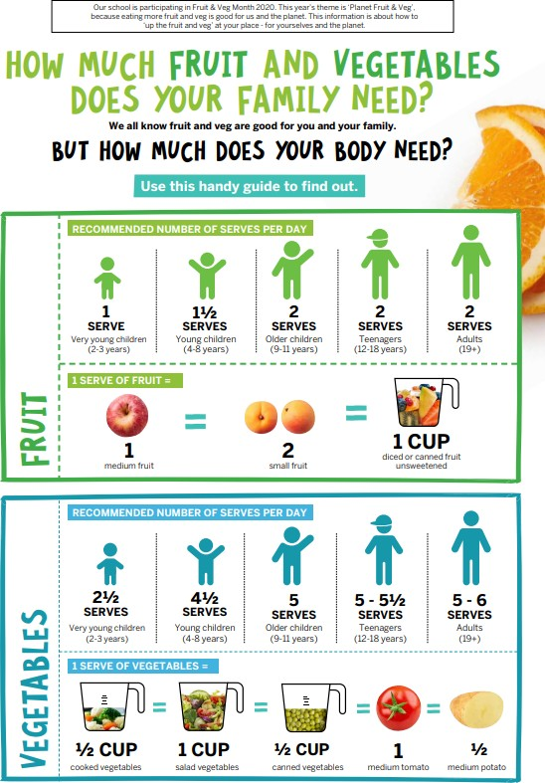
Copied under the statutory licence in s113P of the Copyright Act. Healthy Kids Association, healthykids.com.au. March, 2021. Section 113P Warning Notice

How much fruit and vegetables does your family need? (accessible version)
Our school is participating in Fruit & Veg Month 2020. This year’s theme is ‘Planet Fruit & Veg’,
because eating more fruit and veg is good for us and the planet. This information is about how to ‘up the fruit and veg’ at your place - for yourselves and the planet.
How much fruit and vegetables does your family need?
We all know fruit and veg are good for you and your family.
But how much does your body need?
Use this handy guide to find out.
Fruit
Recommended number of serves per day:

Very young children (2-3 years) need 1 serve per day Young children (4-8 years) need 1½ serves per day Older children (9-11 years) need 2 serves per day Teenagers (12-18 years) need 2 serves per day Adults (19+ years) need 2 serves per day
1 serve of fruit = 1 medium fruit (such as a medium apple) = 2 small fruit (such as 2 small apricots) = 1 cup diced or canned fruit unsweetened

Vegetables
Recommended number of serves per day:

Very young children (2-3 years) need 2½ serve per day Young children (4-8 years) need 4½ serves per day Older children (9-11 years) need 5 serves per day Teenagers (12-18 years) need 5-5½ serves per day Adults (19+ years) need 5-6 serves per day
1 serve of vegetables = ½ cup cooked vegetables = 1 cup salad vegetables = ½ cup canned vegetables = 1 medium tomato = ½ medium potato
Copied under the statutory licence in s113P of the Copyright Act. Healthy Kids Association, healthykids.com.au. March, 2021. Section 113P Warning Notice

Appendix 2 – Water - the best drink for healthy kids
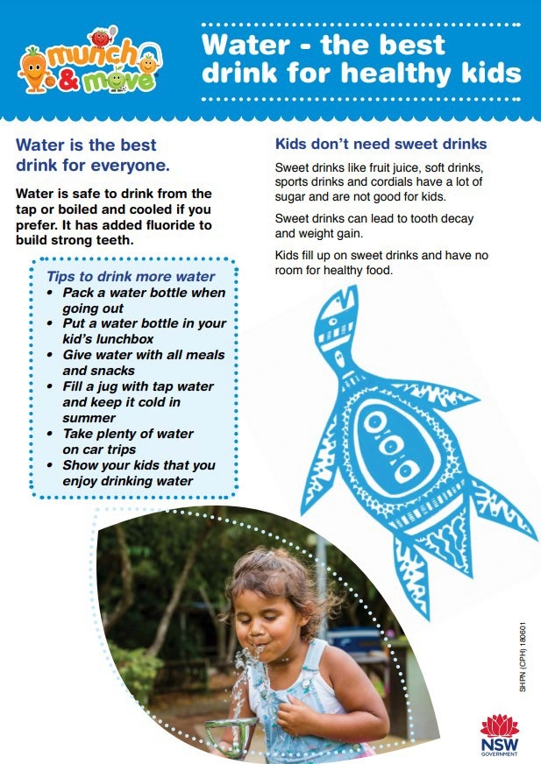
Copied under the statutory licence in s113P of the Copyright Act. Healthy Kids Association, healthykids.com.au. March, 2021. Section 113P Warning Notice

Water – the best drink for healthy kids
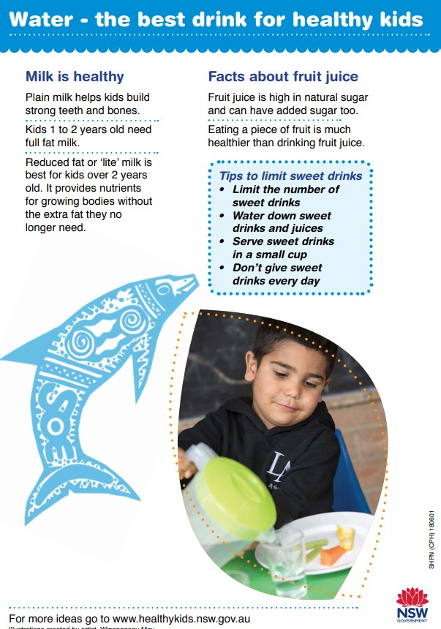
Copied under the statutory licence in s113P of the Copyright Act. Healthy Kids Association, healthykids.com.au. March, 2021. Section 113P Warning Notice

Appendix 3 - Sentences with purpose

Dog collars – Text 1
Photo by Amber Turner on Unsplash
Text: Dogs wear collars. wear collars. They keep dogs safe as they hold their identification tag. If a dog becomes lost, their owners can be contacted by using the details on the tag.

Dog collars - Text 2
Photo by Amber Turner on Unsplash
Text: Dogs must wear collars to keep them safe. The collar should be used in day-to-day life to hold identification tags. The best collars are flat collars as they are gentle on the dog. It is essential for all dogs to wear collars.

Dog collars – Text 3
Photo by Amber Turner on Unsplash
Text: Sadie the dog had a glorious spikey collar. From it swung her shiny name tag. Jodie, Sadie’s owner, gave her the collar to keep her safe. Thank goodness for this collar as Sadie liked to go on adventures but often forgot her way home.

Appendix 4 – Bush tucker
Bush tucker
Bush tucker can be found from native plants in the Australian bush by Aboriginal and Torres Strait Islander people. They have been finding food like this for thousands of years.
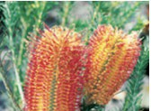
Banksia flowers can be soaked in water to make a sweet drink.
Bush food can include fruits, herbs and vegetables. Some examples of bush tucker include a fruit that is called the Blue Lily Pilly, a herb that is called Bush Basil and a vegetable called a ‘Youlk’, which tastes a bit like carrot.
Maybe you could add some bush tucker to your school’s vegetable garden with the help of your teacher.
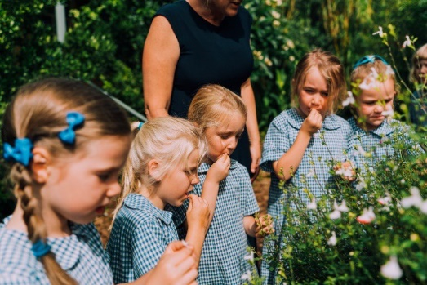
Students enjoying their school garden.
Text has been modified from the NSW Department of Education resource - Science and Technology Stage 1 Living World student workbook.

Appendix 5 – Bush tucker annotated text
Bush Tucker  Bush tucker can be found from native plants in the Australian bush by Aboriginal and Torres Strait Islander people. They have been finding food like this for thousands of years.  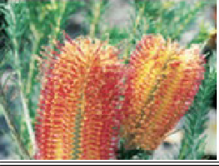  Banksia flowers can be soaked in water to make a sweet drink.  Bush food can include fruits, herbs and vegetables. Some examples of bush tucker include a fruit that is called the Blue Lily Pilly, a herb that is called Bush Basil and a vegetable called a ‘Youlk’, which tastes a bit like carrot.  Maybe you could add some bush tucker to your school’s vegetable garden with the help of your  teacher.  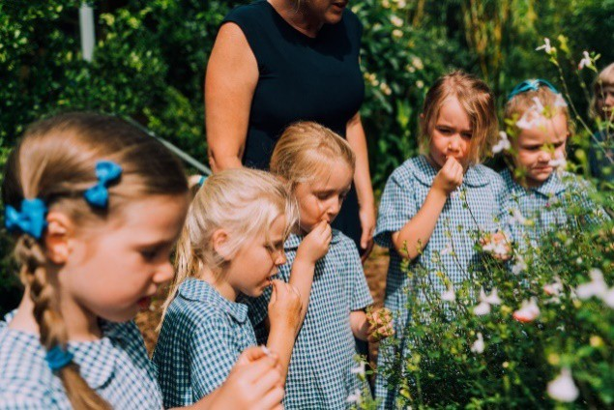  Students enjoying their school garden | Purpose  The main purpose of the text is to inform about bush tucker.  The final sentence, though, tries to persuade the audience into action.  Evidence:  - Gives information about bush tucker including examples and origin.  - Simple heading  - Photos and captions.  - Begins with a general statement about the topic and an introduction paragraph.  - Second paragraph gives supporting information and examples.  - Uses some simple topic words.  - Repetition of topic  Audience  This seems to be written for a younger audience.  Evidence:  - Mostly simple sentences.  - Image of students.  - Everyday language
Text has been modified from the NSW Department of Education resource - Science and Technology Stage 1 Living World student workbook.

Bush tucker annotated text (accessible version)
Purpose of text: The main purpose of the text is to inform about bush tucker. It gives information about bush tucker including examples and origin. The final sentence, though, tries to persuade the audience into action.
Purpose – features in text | Evidence
Simple heading | Bush tucker.
Provides examples of bush tucker | Photo of banksia flowers with explanatory caption. ‘Banksia flowers can be soaked in water to make a sweet drink.’  Photo of primary students eating bush tucker, with explanatory caption. ‘Students enjoying their school garden.’
Begins with a general statement about the topic and an introduction paragraph. | Bush tucker can be found from native plants in the Australian bush by Aboriginal and Torres Strait Islander people.
Second paragraph gives supporting information and examples. | Some examples of bush tucker include a fruit that is called the Blue Lily Pilly, a herb that is called Bush Basil and a vegetable called a ‘Youlk’…
Uses some simple topic words | Bush tucker, native plants
Repetition of main idea | Bush tucker can be found from native plants  Bush foods can include  Bush tucker

Audience for text: This seems to be written for a younger audience  Audience – features in text | Evidence
Mostly simple sentences | They have been finding food like this for thousands of years.  Bush food can include fruits, herbs and vegetables.
Images of students | Photos of younger, primary age students, enjoying their school garden.
Everyday language | ‘tastes a bit like carrot’  ‘Maybe you’
Text has been modified from the NSW Department of Education resource - Science and Technology Stage 1 Living World student workbook.

