Teacher resource – story cubes
This resource is for the teacher. It provides the content and instructions you need to share with students.
Use the story cubes provided (editable version on Canva) or create your own using the template in this document.
Organise students into groups of 3–4, providing each group with a set of cubes. Consider using cubes 1 and 2 for all students to practise basic structures and vocabulary relating to hobbies, leisure activities and preferences. To connect to prior learning and extend students to create more developed responses, consider adding cube 3 for days and weekend time words and cube 4 for conjunctions.
With students, identify the question-and-answer structures they are using for this activity, for example:
Cubes 1 and 2
A: 你喜欢[do sport or leisure activity]？
B: 我喜欢[do sport or leisure activity] or 和[do sport or leisure activity]。
Cube 3
A: 你星期几[do sport or leisure activity]？
B: 我[day or weekend][do sport or leisure activity]。
Cube 4
A: 你星期几[do sport or leisure activity]？
B: 我[day of the week][do sport or leisure activity]，我也喜欢[do sport or leisure activity]。但是我不喜欢[sport or leisure activity]，你呢？
A: 我喜欢[do sport or leisure activity]。我也喜欢[do sport or leisure activity]，但是我不喜欢[sport or leisure activity]。
Using the samples above as a scaffold, students interact to share details about their leisure time preferences by asking and answering questions based on the prompts on the cubes. Students take turns to ask the questions each time, choosing another student to answer.
Differentiation examples
The following strategies provide a starting point for how you can differentiate this activity for a range of learners. Adapt or design alternatives to meet the needs of students in your class.
Students requiring additional support – consider including the Chinese vocabulary on the cube and allowing students to refer to vocabulary in their books or devices where they have recorded language learned in class. Students may also prefer to play in pairs.
High potential and gifted students and students with advanced proficiency – students create their own sentences based on the prompts each time. Students may extend their responses by using language learned in previous units or personalising their responses with opinions and reasons.

Story cube 1
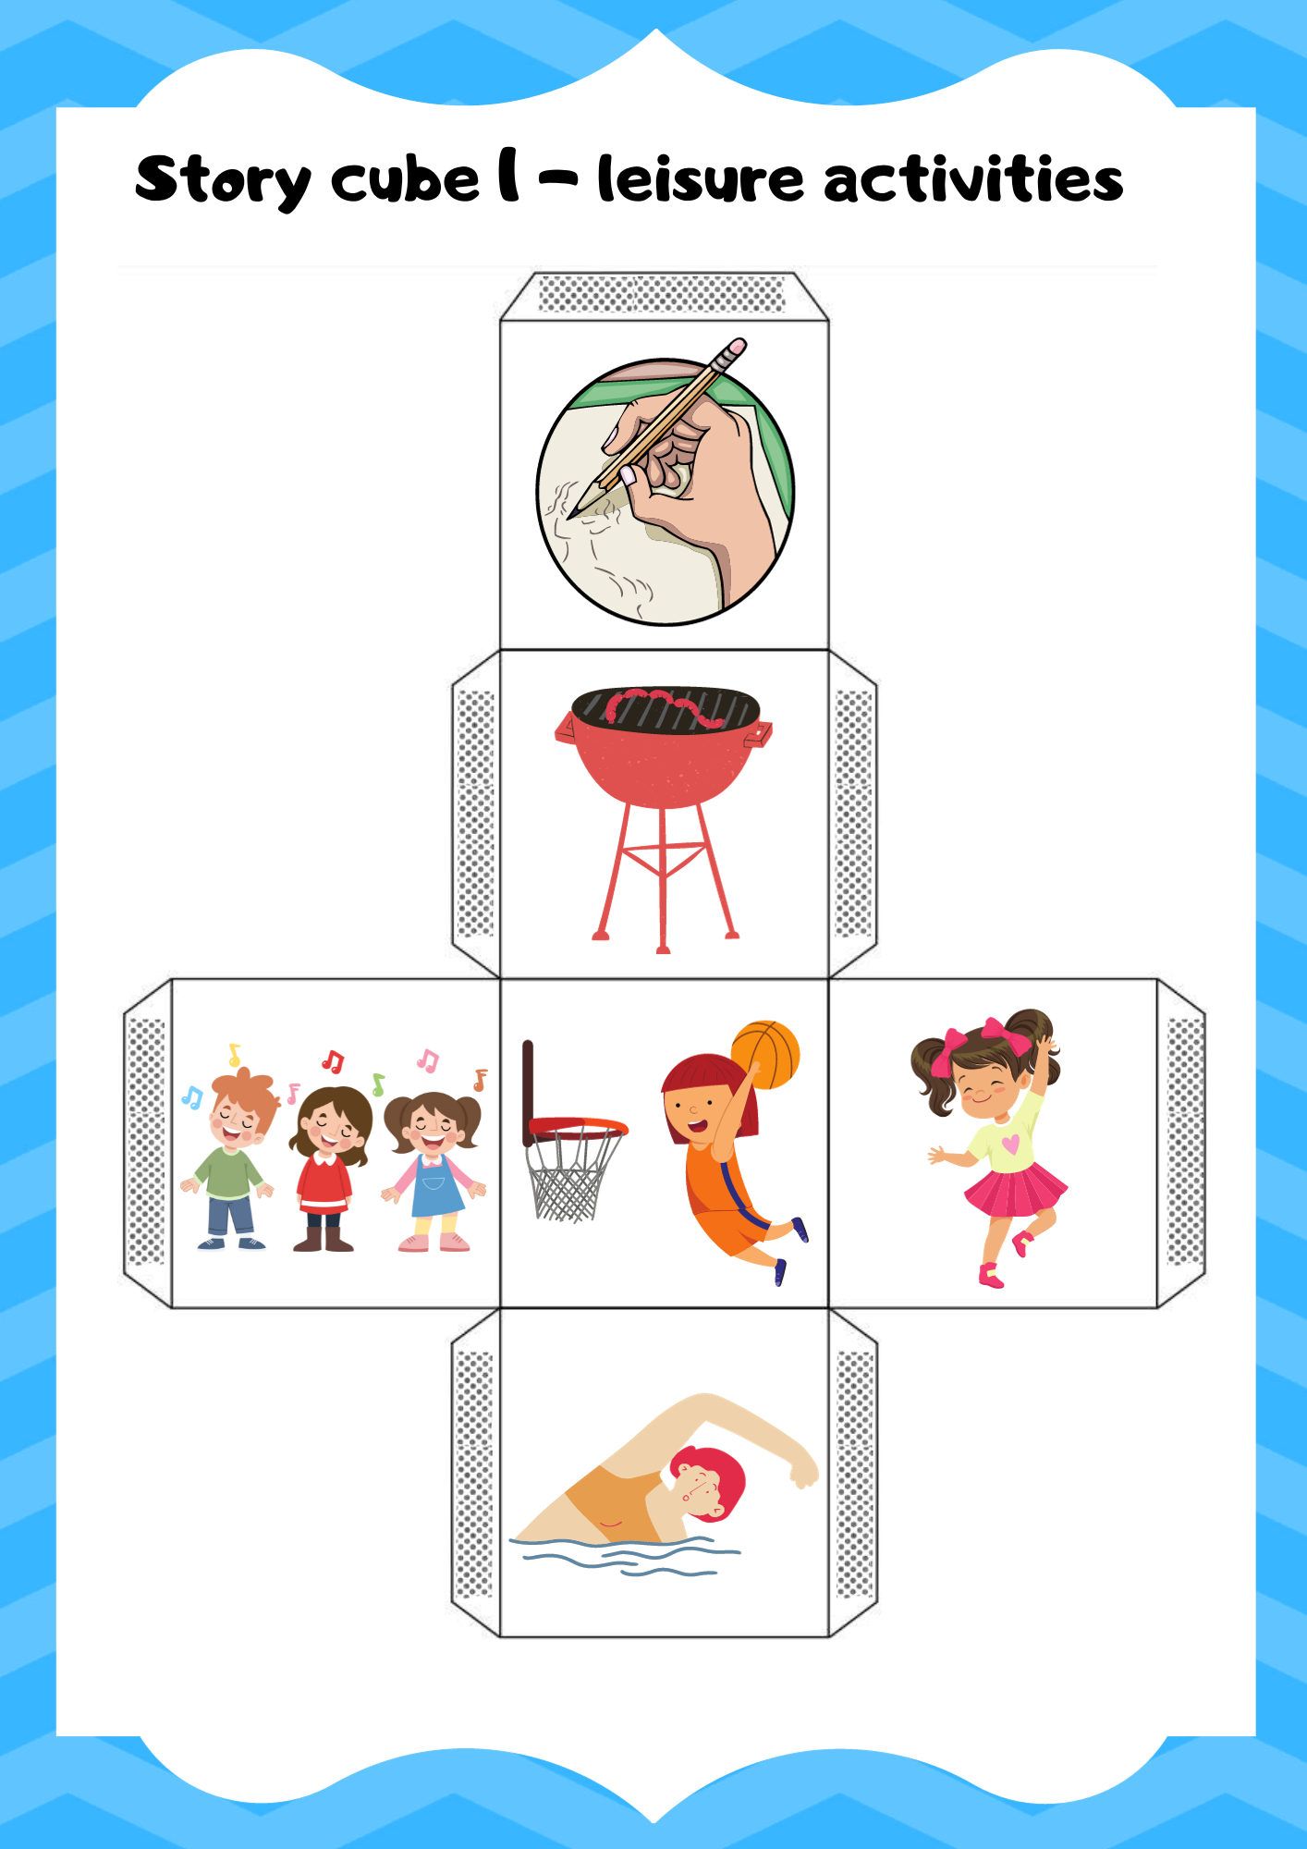

Story cube 2
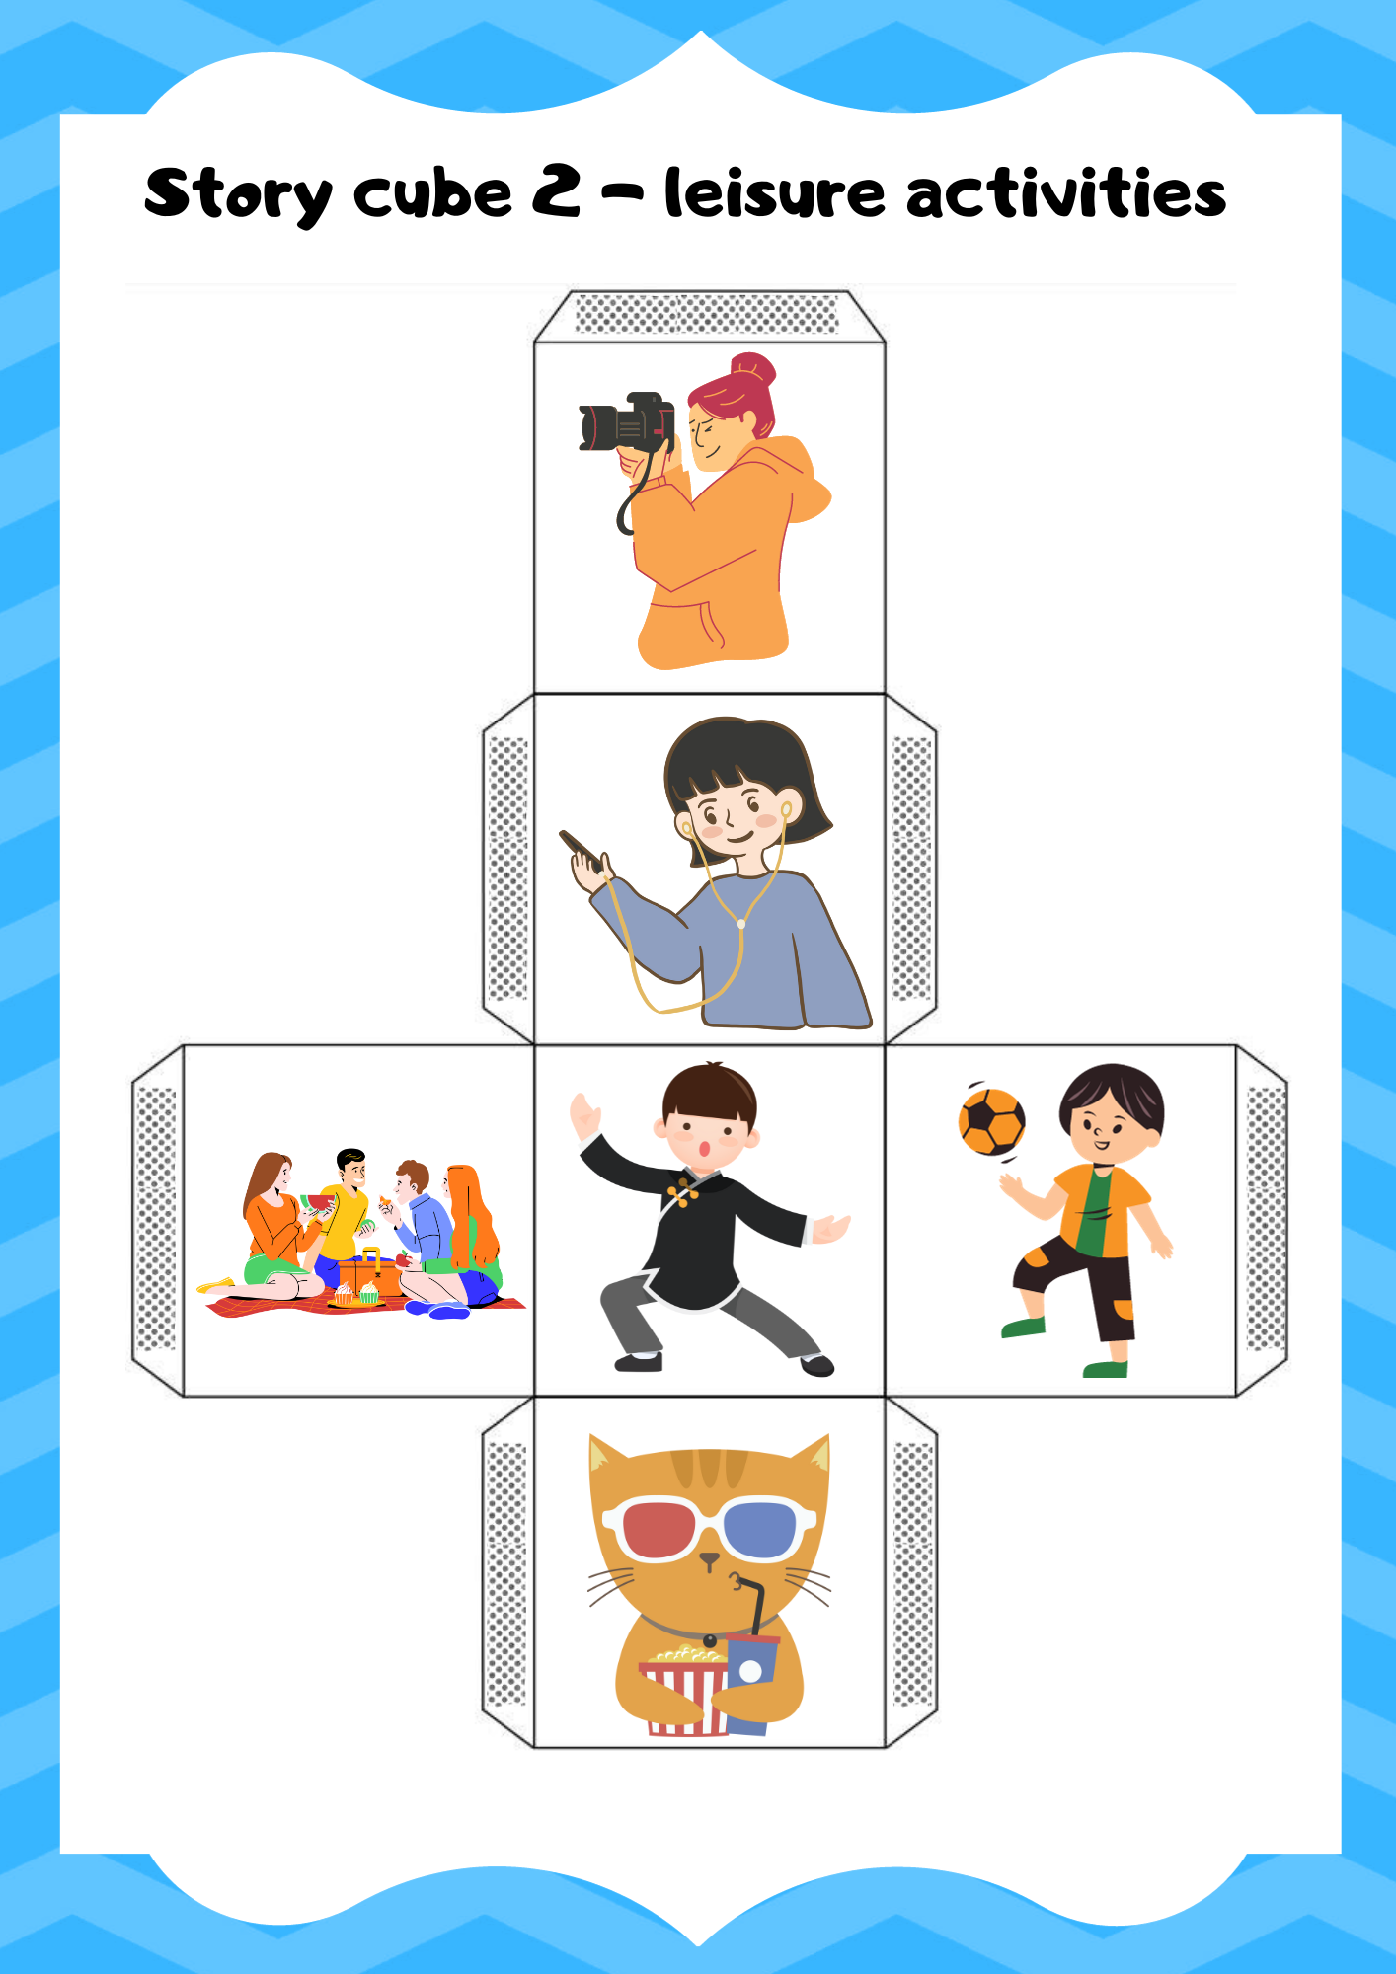

Story cube 3
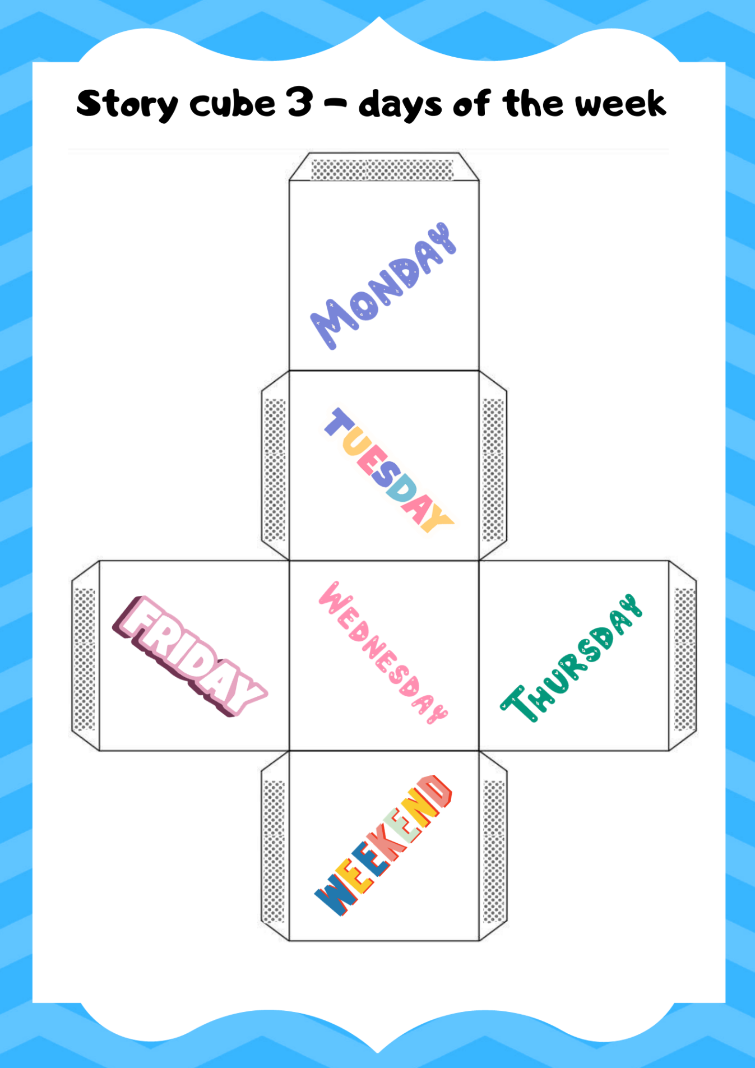

Story cube 4
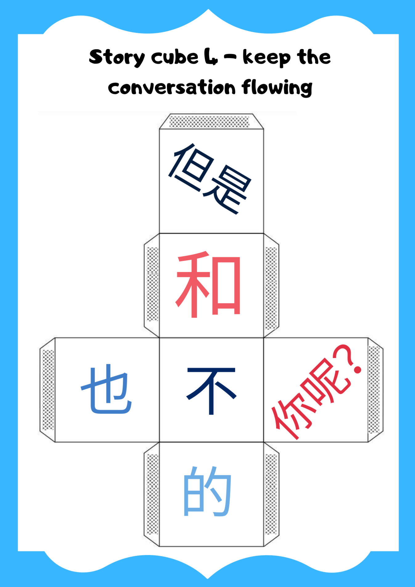

Blank template
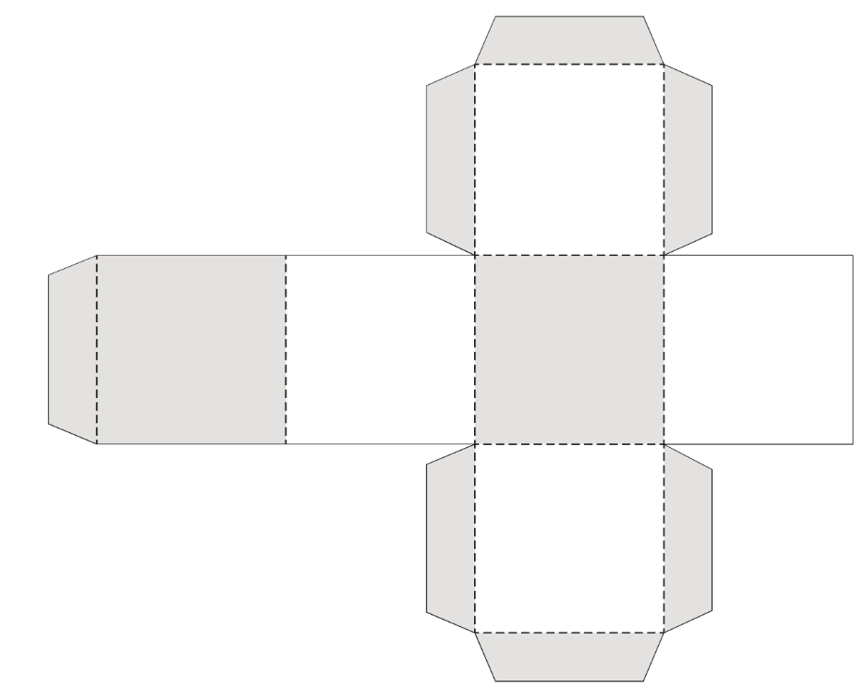

© State of New South Wales (Department of Education), 2023
The copyright material published in this resource is subject to the Copyright Act 1968 (Cth) and is owned by the NSW Department of Education or, where indicated, by a party other than the NSW Department of Education (third-party material).
Copyright material available in this resource and owned by the NSW Department of Education is licensed under a Creative Commons Attribution 4.0 International (CC BY 4.0) license.
This license allows you to share and adapt the material for any purpose, even commercially.
Attribution should be given to © State of New South Wales (Department of Education), 2023.
Material in this resource not available under a Creative Commons license:
- the NSW Department of Education logo, other logos and trademark-protected material
- material owned by a third party that has been reproduced with permission. You will need to obtain permission from the third party to reuse its material.
Links to third-party material and websites
Please note that the provided (reading/viewing material/list/links/texts) are a suggestion only and implies no endorsement, by the New South Wales Department of Education, of any author, publisher, or book title. School principals and teachers are best placed to assess the suitability of resources that would complement the curriculum and reflect the needs and interests of their students.
If you use the links provided in this document to access a third-party's website, you acknowledge that the terms of use, including licence terms set out on the third-party's website apply to the use which may be made of the materials on that third-party website or where permitted by the Copyright Act 1968 (Cth). The department accepts no responsibility for content on third-party websites.

