Chinese sports and hobbies

Activity 1 – data
View the data in the table below and answer the reflection questions.
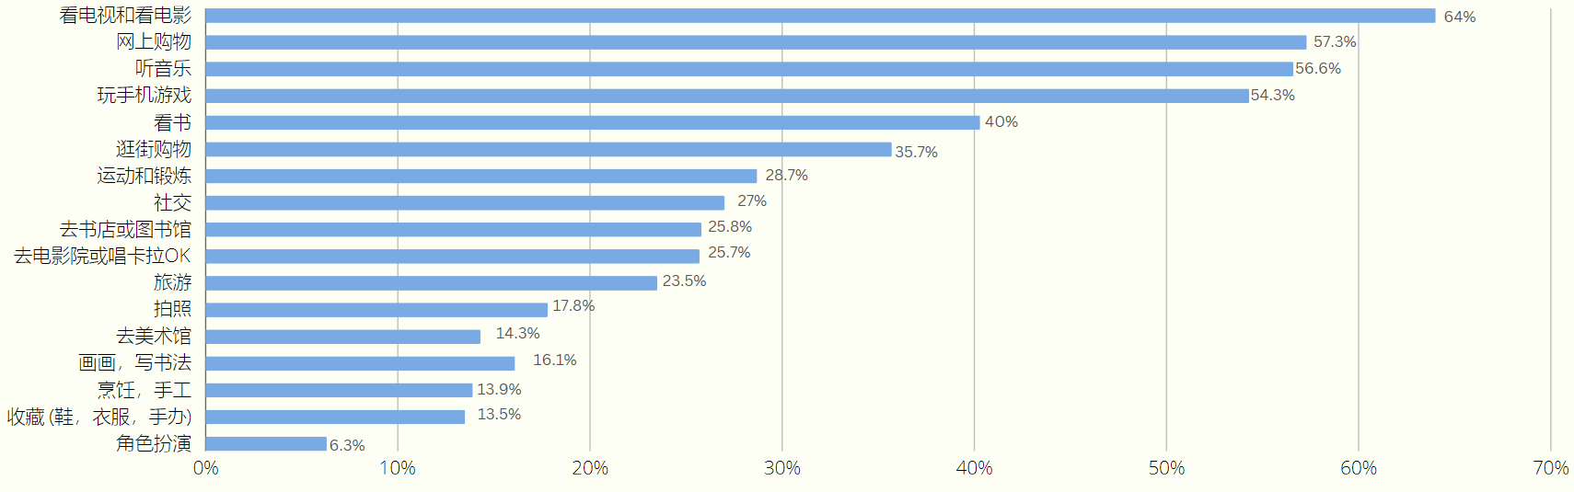
Data sourced from www.statista.com (2020).

Reflection questions
- According to the bar chart, which sport or leisure activity is the most popular within the Chinese community?
- Which sport or leisure activity is the least popular according to the graph?
- Which sports or leisure activities on the graph that share a similar popularity index? What might this indicate about the population's preferences?
- How many sports on the chart are played by less than 20% of the people? Which ones are they?
- Which 2 activities are most closely matched in popularity, and what are their percentages?
- Which sport or leisure activity is enjoyed by more than half of the population according to the bar graph?

- In Chinese, describe the level of popularity for 3 activities, for example ‘extremely popular’, ‘not popular’.
- Did the data in the bar chart match your expectations? Why or why not?

Activity 2 – research
Choose a sport or hobby that interests you and conduct research on it. You will be creating a poster, in Chinese and English, based on your findings. Use this worksheet to brainstorm ideas and organise your thoughts.

Basic information
- Name of the sport/hobby in Chinese and English:
- Origin of the sport/hobby:
- Brief description of the sport/hobby:

Popularity in China
- How popular is this sport/hobby in China?
- Who is typically participates in this sport/hobby?
- Are there any famous athletes or figures associated with this sport/hobby is China?

Key elements
- What are the key elements of this sport/hobby?
- What equipment or materials are needed for this sport/hobby?
- Are there any unique rules or customs associated with this sport/hobby?

Personal reflection
- Why did you choose this sport/hobby?
- What did you find most interesting about this sport/hobby?
- Would you like try this sport/hobby? Why or why not?

Activity 3 – create a poster
Create a poster about your chosen activity. Use as much Chinese as you can and include:
- your name
- the name of the activity, in Chinese
- details about a famous person related to the activity, if relevant
- any equipment needed
- at least one fact about the activity
- how you feel about the activity, in Chinese.
A sample poster has been provided below to use as a model.
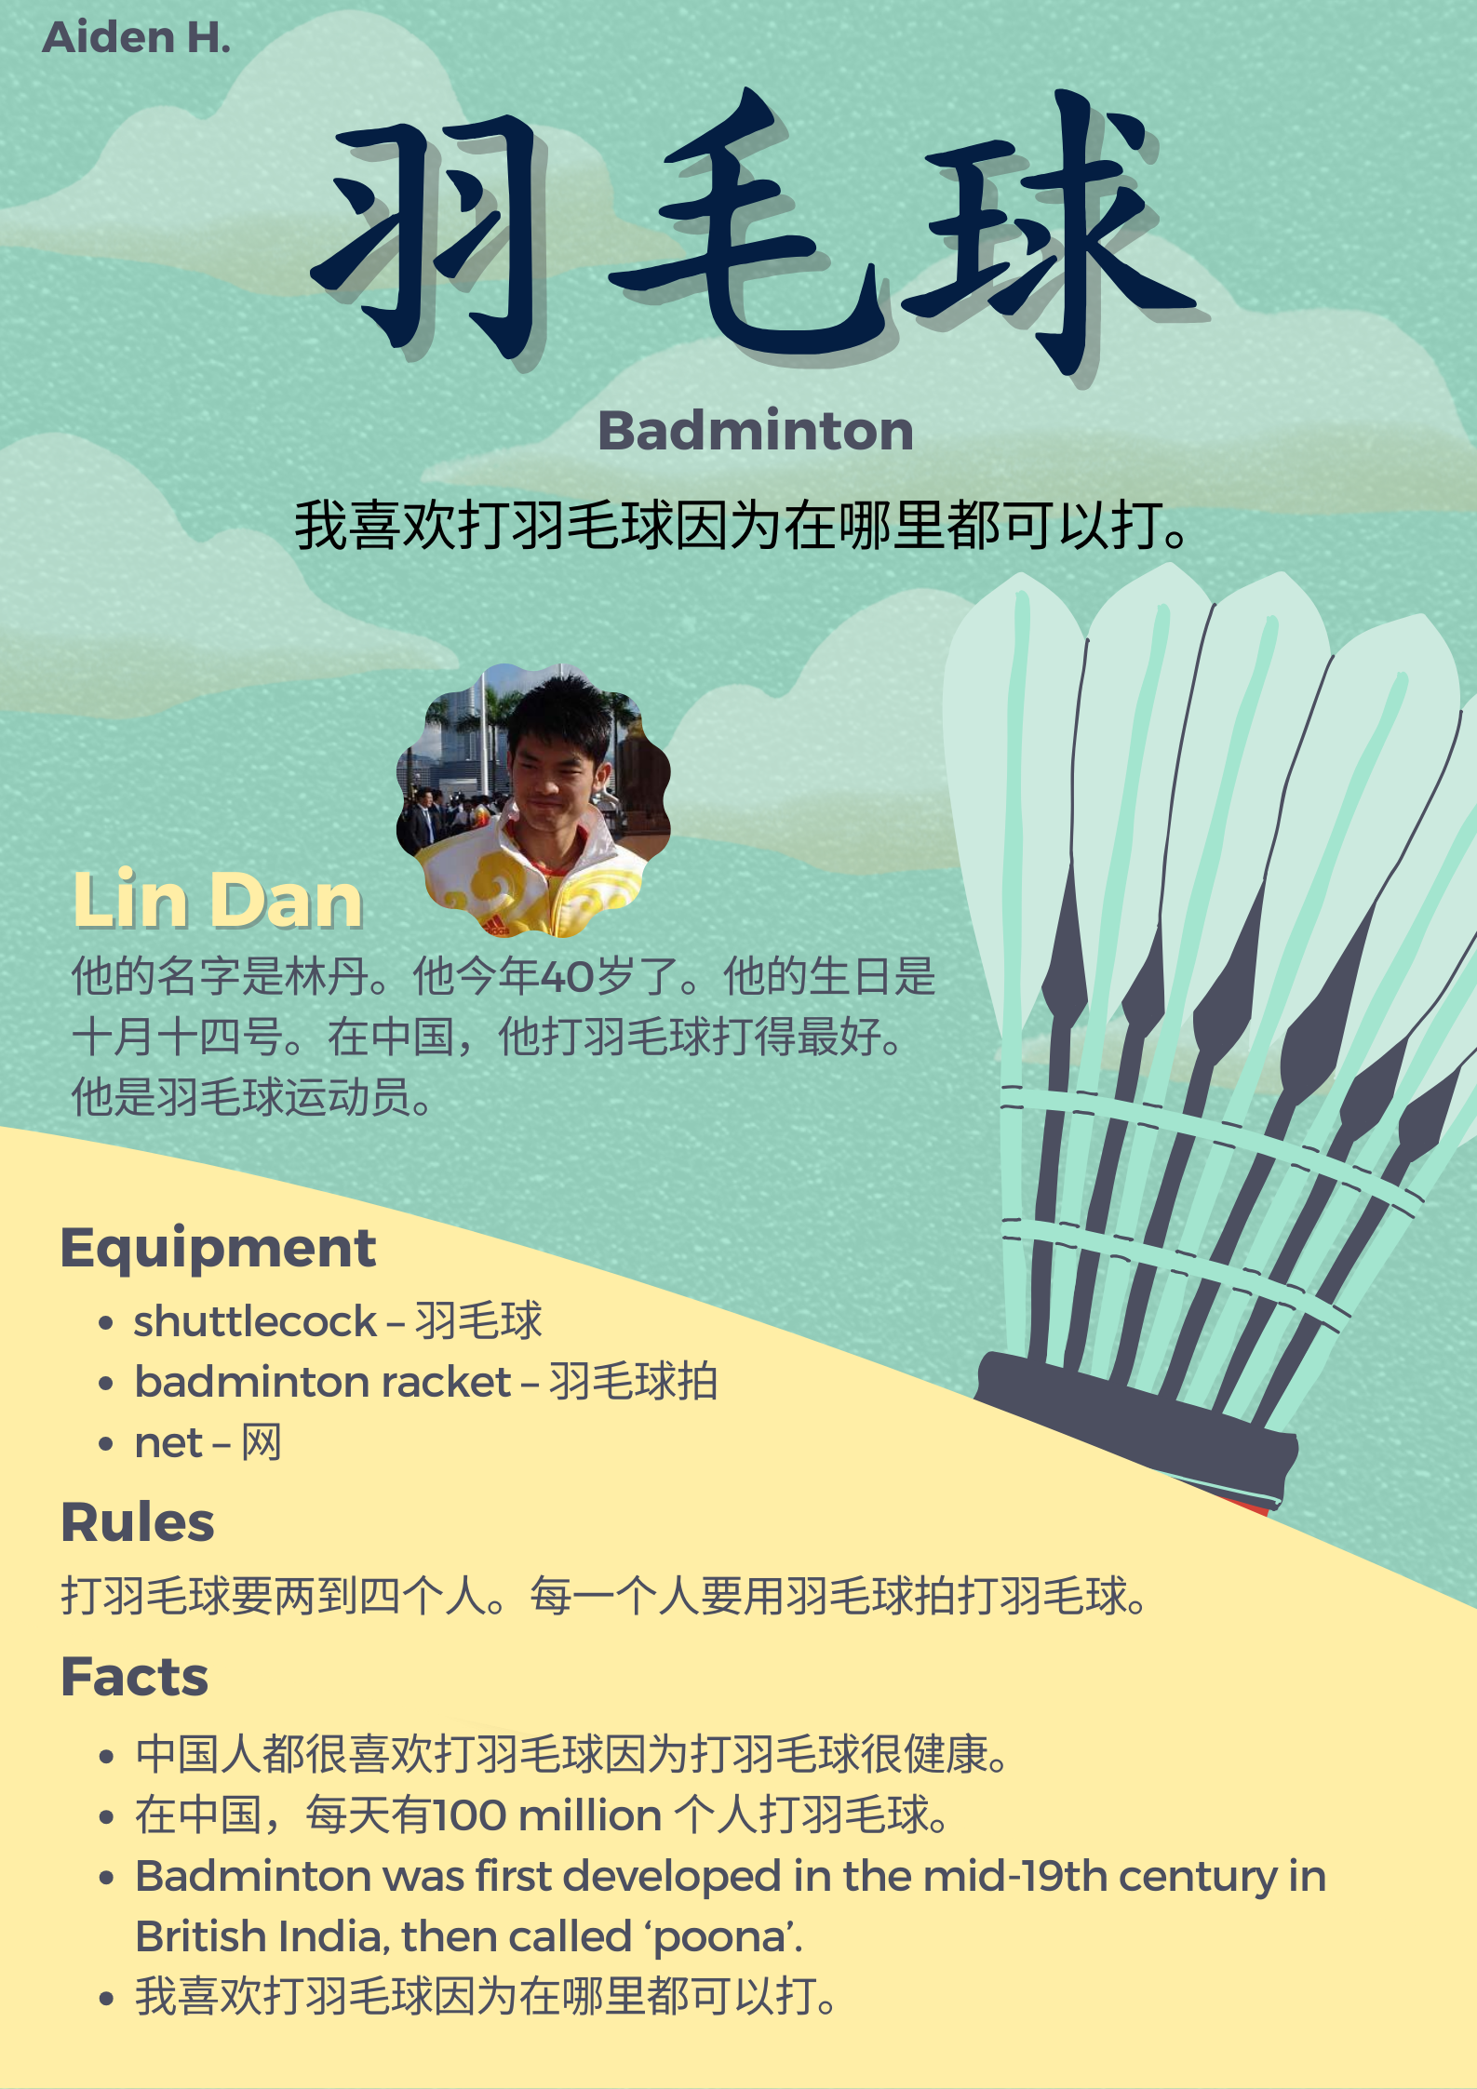
© State of New South Wales (Department of Education), 2023
The copyright material published in this resource is subject to the Copyright Act 1968 (Cth) and is owned by the NSW Department of Education or, where indicated, by a party other than the NSW Department of Education (third-party material).
Copyright material available in this resource and owned by the NSW Department of Education is licensed under a Creative Commons Attribution 4.0 International (CC BY 4.0) license.
This license allows you to share and adapt the material for any purpose, even commercially.
Attribution should be given to © State of New South Wales (Department of Education), 2023.
Material in this resource not available under a Creative Commons license:
- the NSW Department of Education logo, other logos and trademark-protected material
- material owned by a third party that has been reproduced with permission. You will need to obtain permission from the third party to reuse its material.
Links to third-party material and websites
Please note that the provided (reading/viewing material/list/links/texts) are a suggestion only and implies no endorsement, by the New South Wales Department of Education, of any author, publisher, or book title. School principals and teachers are best placed to assess the suitability of resources that would complement the curriculum and reflect the needs and interests of their students.
If you use the links provided in this document to access a third-party's website, you acknowledge that the terms of use, including licence terms set out on the third-party's website apply to the use which may be made of the materials on that third-party website or where permitted by the Copyright Act 1968 (Cth). The department accepts no responsibility for content on third-party websites.

