Understanding menus and ordering
Look at the menus for the Potsdamer Schlossküche. There is a 3-page dine-in menu and a one-page takeaway menu (zum Mitnehmen).
Use these menus to answer the 5 questions below.

Question 1
Find the German words for the following, using the menu.
English | German
green tea
olive oil
soup of the day
onion rings
homemade bread
grilled mushrooms
salmon and lemon
fried fish fillet
Trivia question. The veggie burger comes with Spiegeleier. Spiegel literally means ‘mirror’ and Eier means eggs. How do you think the eggs are cooked, in this instance? Why do you think this?

Question 2
To order food, you use the structure einmal (one), zweimal (2) dreimal (3) and so on. For example, if you want to order one hamburger and 2 apple juices, you would say Einmal Hamburger und zweimal Saft. To make your request more polite, you can add bitte (please).
Write how you would order the following foods from the menu.
English | Write the order in German
One veggie burger and one orange juice, please.
One steak salad, one Caesar salad and 2 chips, please.
One Hawaii toast, 2 chicken burgers and 3 Sprites, please.

Question 3
You have offered to take a friend to dinner at the Potsdamer Schlossküche. You have decided to dine in at the restaurant and have €40,00 to spend. You would each like to order a main, a dessert and a drink.
What do you order? Write your answer in German, using the structure Ich möchte einmal/zweimal… (I would like one/two …)

Question 4
- You are eating at the restaurant alone tonight. You’ve eaten a Jägerschnitzel and Apfelstrudel, and had a small mineral water to drink. What will the total of your bill (die Rechnung) be?
- It’s time to pay your bill – Die Rechnung, bitte!
You’re happy with the service and would like to leave a small tip for die Bedienung.
You give €20,00 and say Stimmt so! (keep the change)
How much was your tip?

Question 5
You and your friends are in the mood for some burgers. You want to order one Hänchenburger, 2 Hamburger, one Vegi-Burger and 2 portions of Pommes.
- How much will that cost if you eat in?
- How much will that cost if you get takeaway?

Prices shown are in Euro (€).
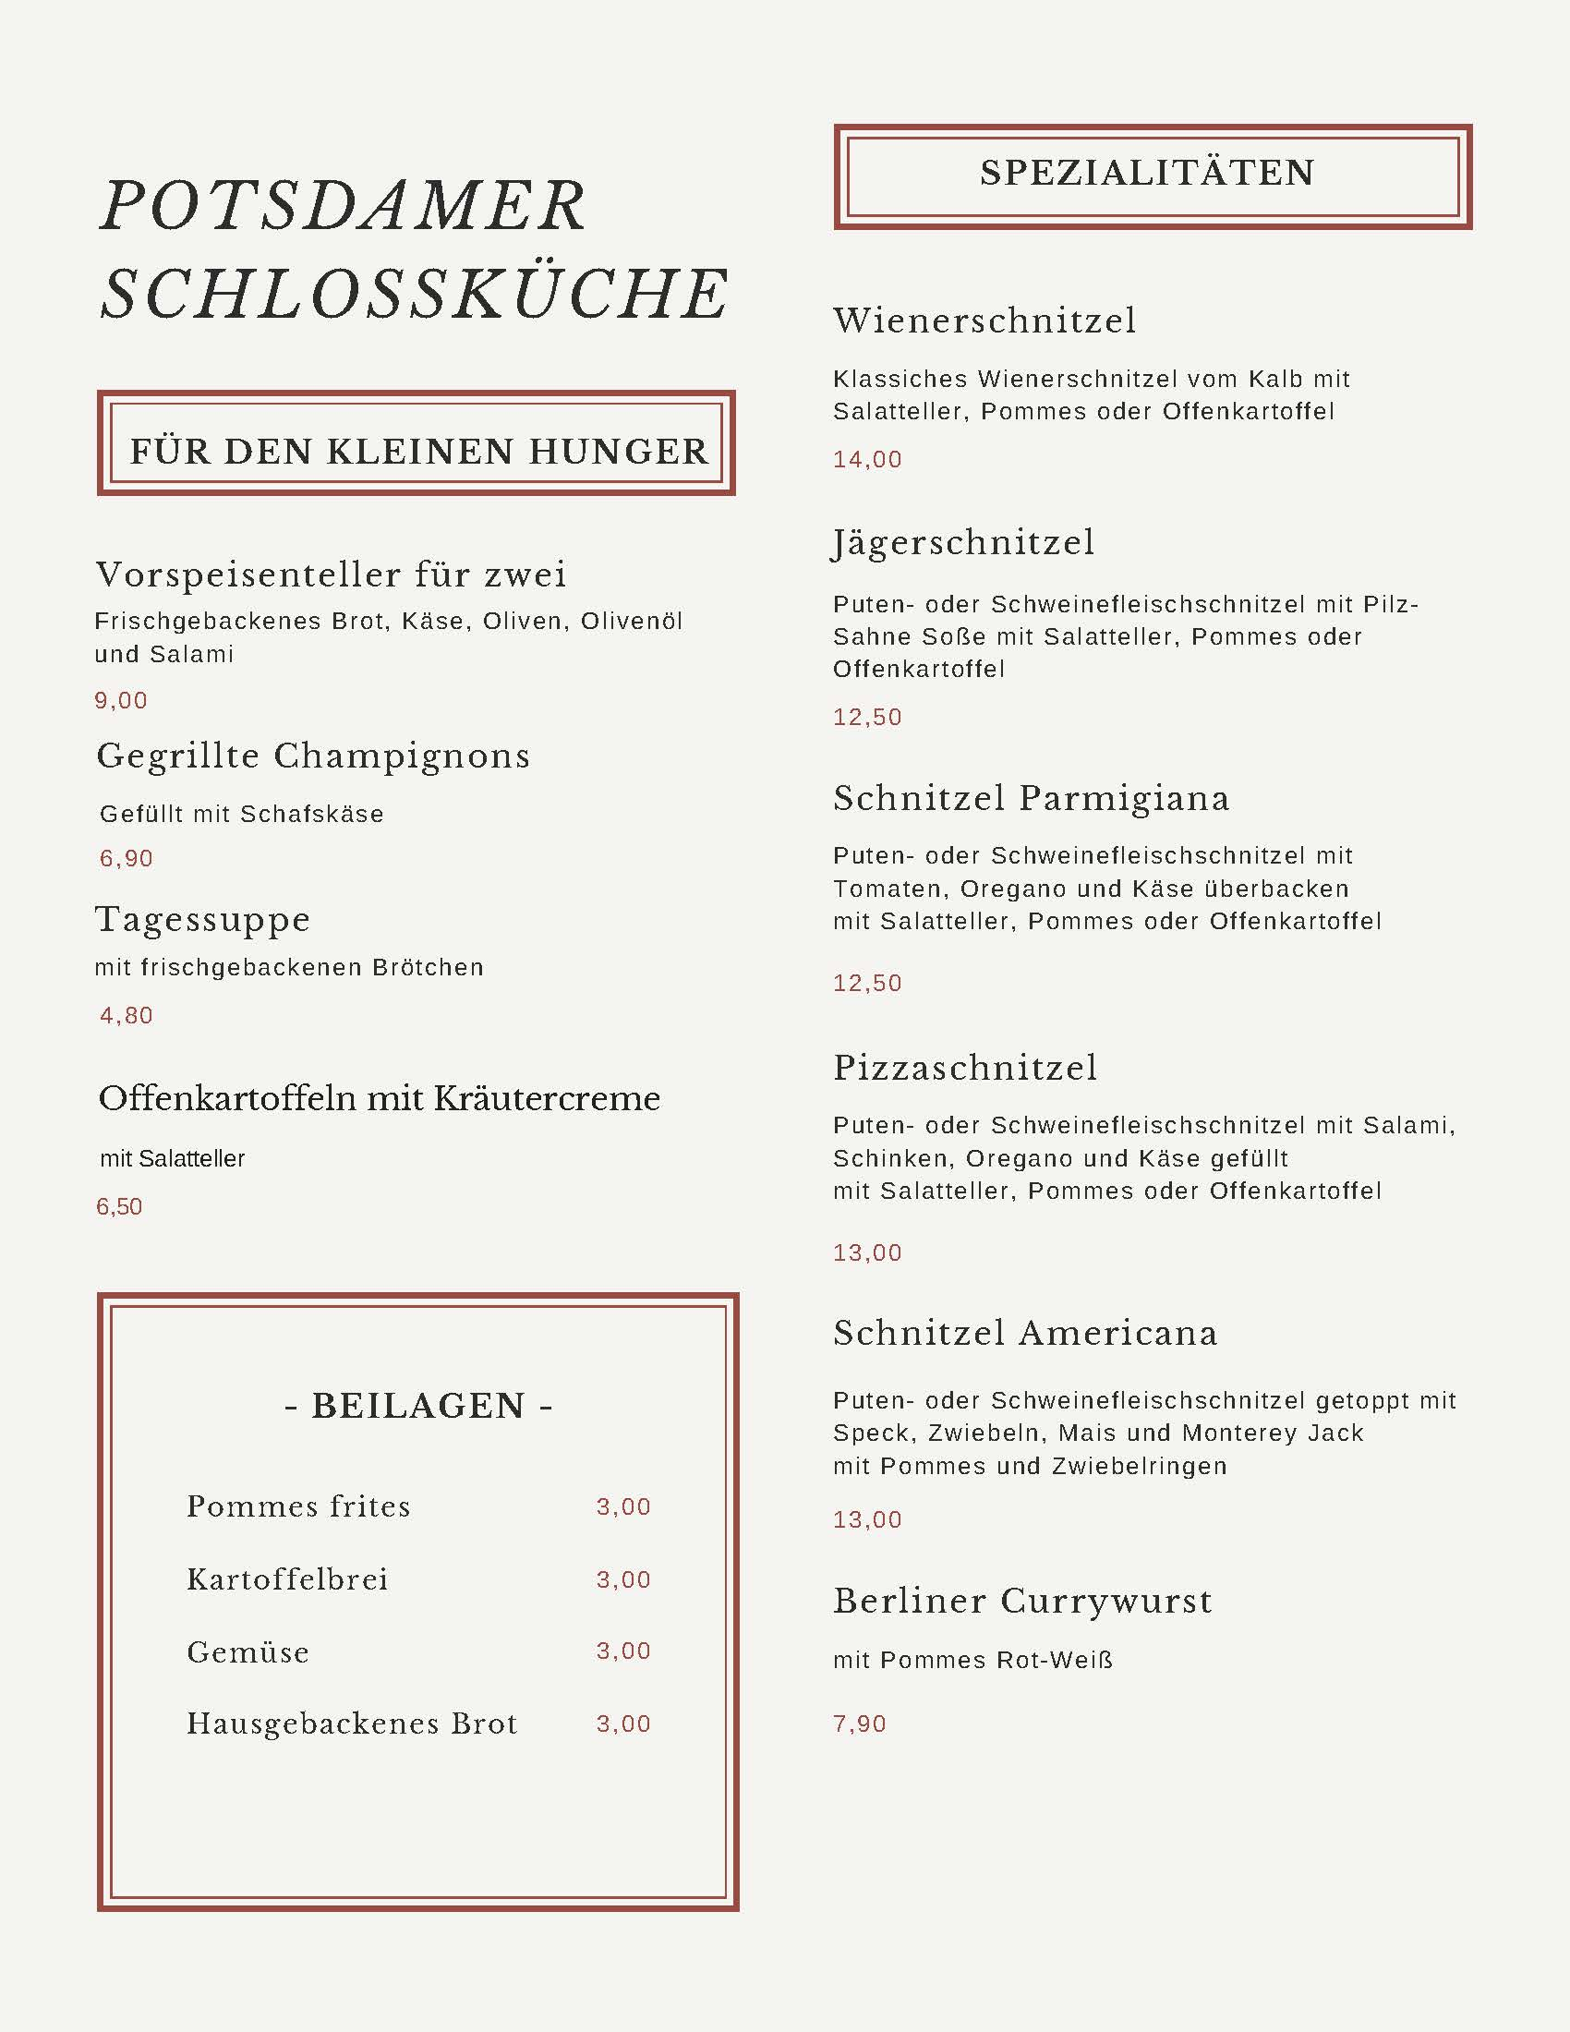
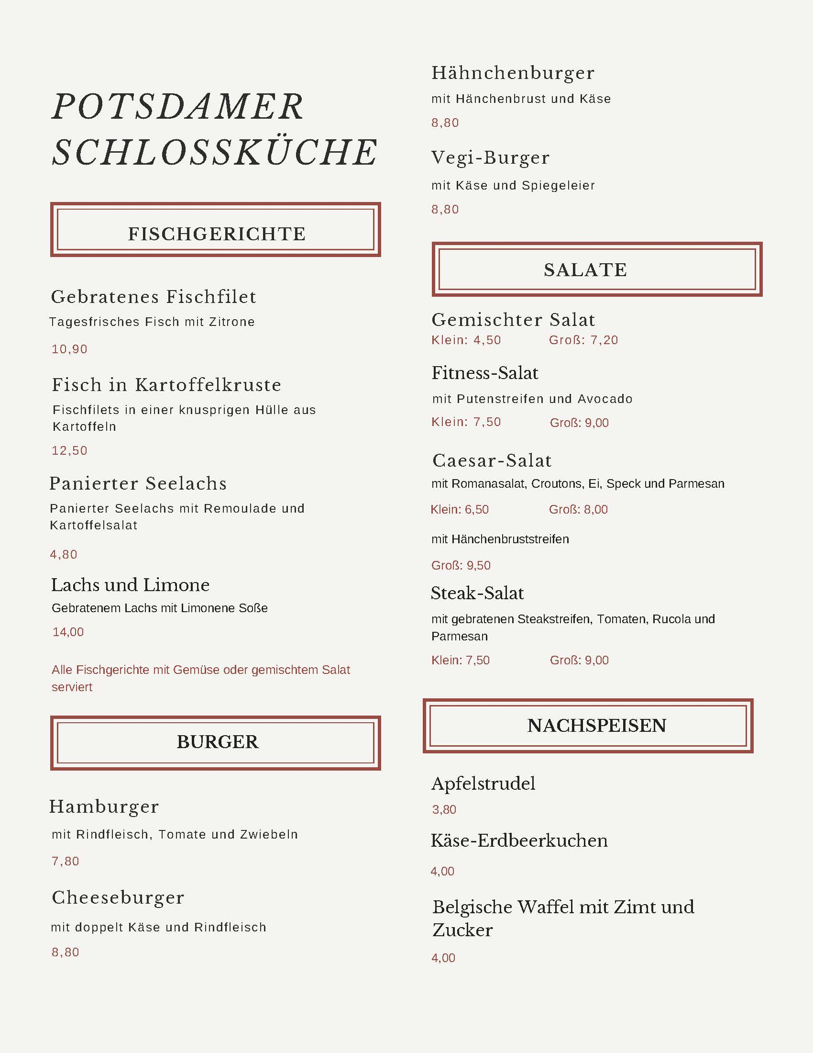
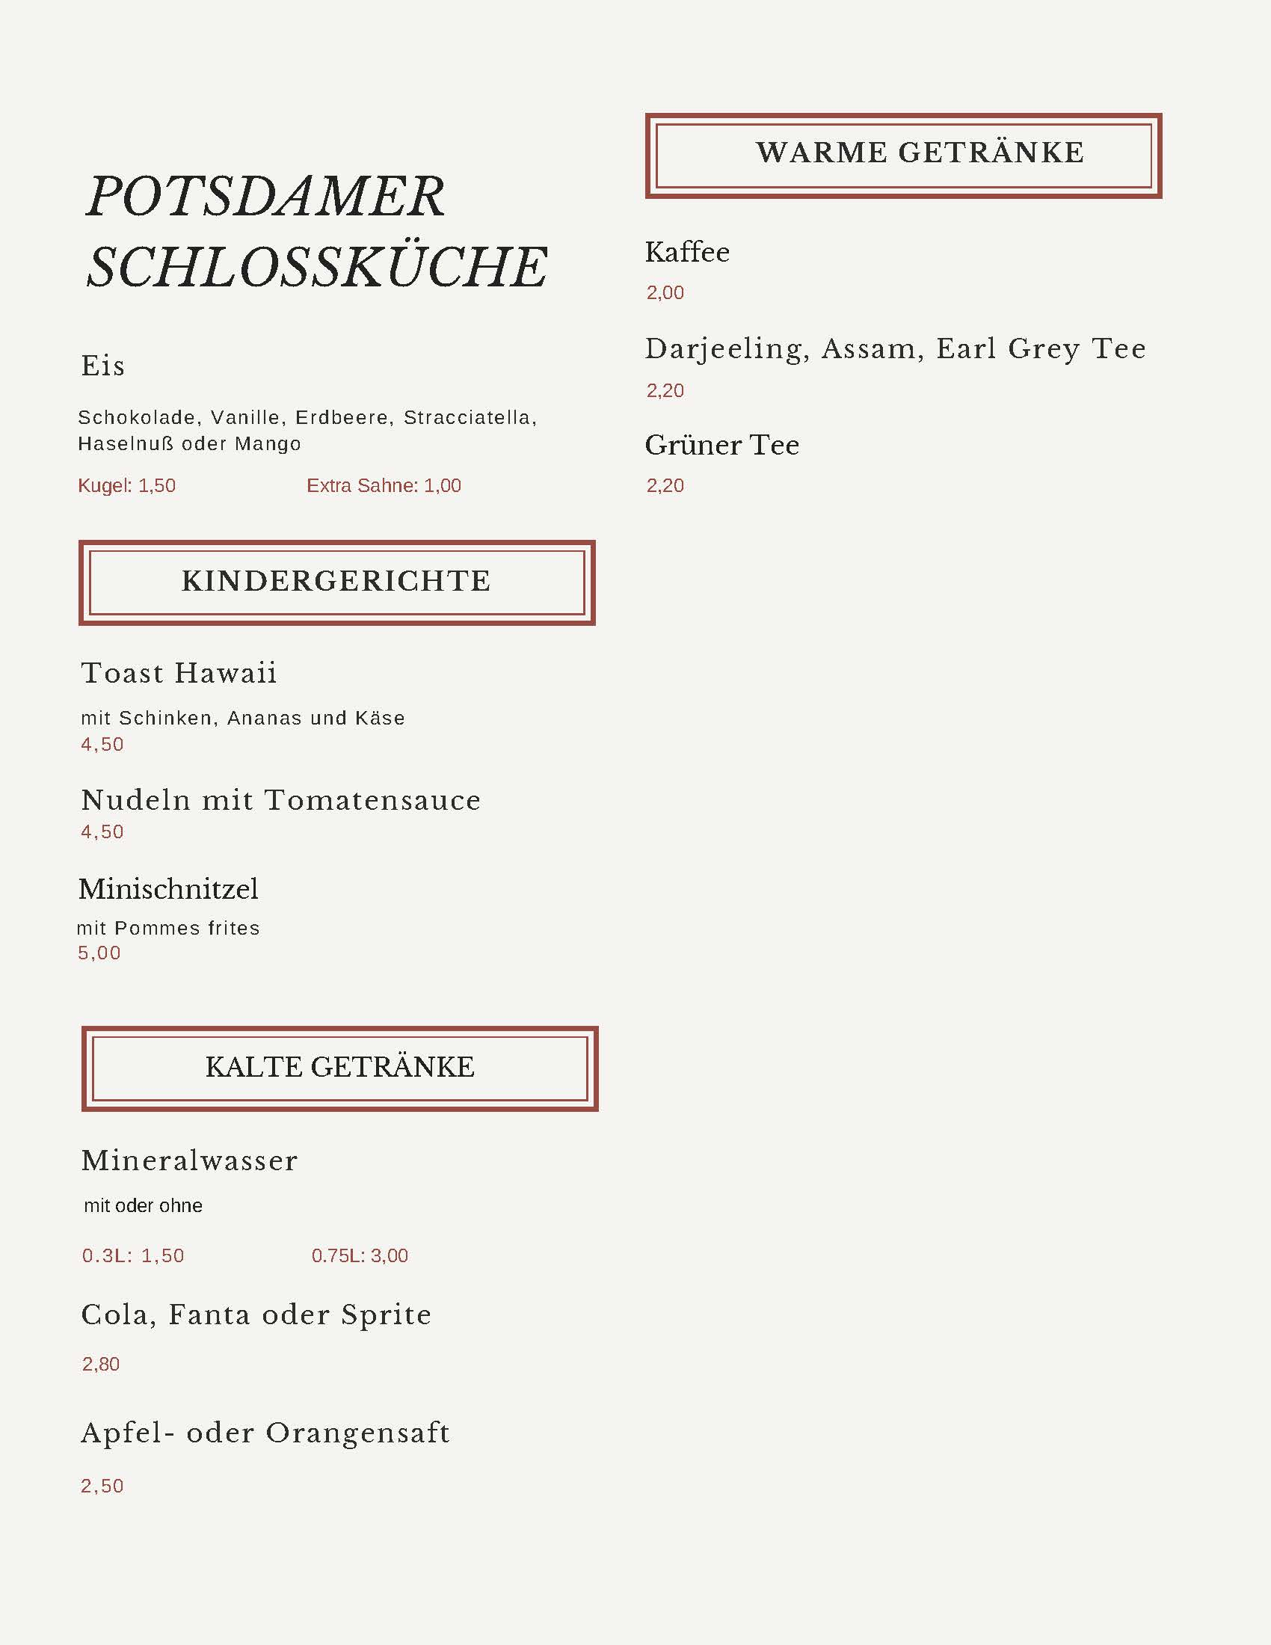
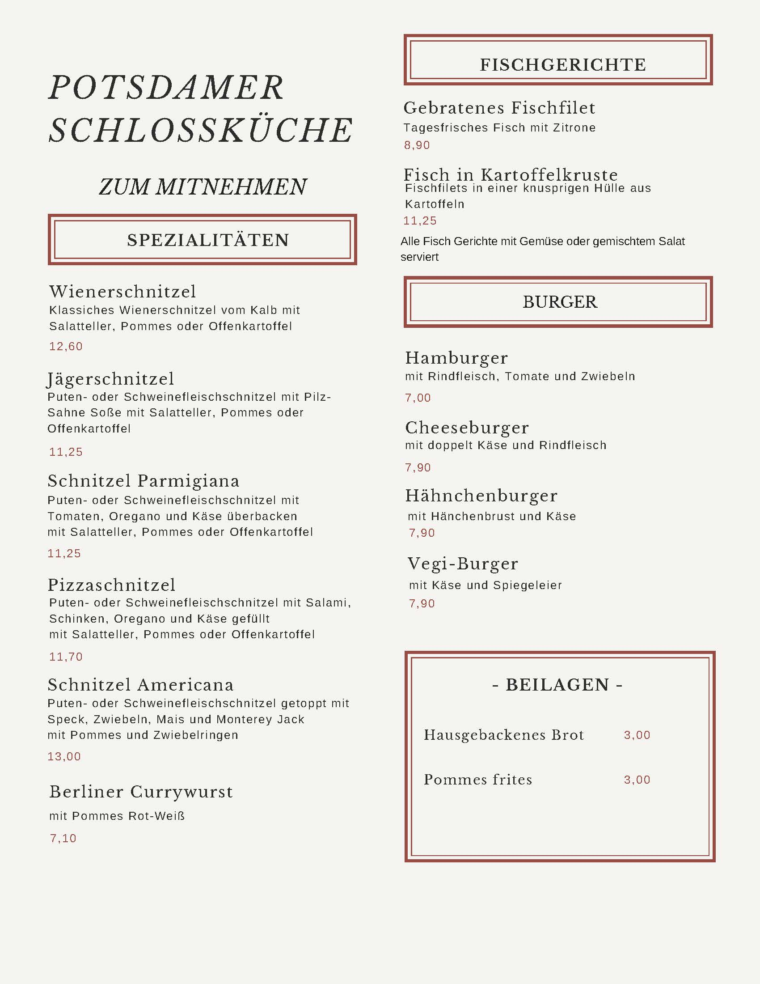

For the teacher
Remove this section before sharing this resource with students.

Question 1
Find the German words for the following, using the menu.
English | German
green tea | Grüner Tee
olive oil | Olivenöl
soup of the day | Tagessuppe
onion rings | Zwiebelringen
homemade bread | Hausgebackenes Brot
grilled mushrooms | Gegrillte Champignons
salmon and lemon | Lachs und Limone
fried fish fillet | Gebratenes Fischfilet

Question 2
English | Write the order in German
One veggie burger and one orange juice, please. | Einmal Vegi-Burger und einmal Orangensaft, bitte.
One steak salad, one Caesar salad and 2 chips, please. | Einmal Steak-Salat, einmal Caesar-Salat und zweimal Pommes frites, bitte.
One Hawaii toast, 2 chicken burgers and 3 Sprites, please. | Einmal Toast Hawaii, zweimal Hähnchenburger und dreimal Sprite, bitte.

Question 3
Wir möchten einmal/zweimal… (answers will vary, depending on student choices)

Question 4
- Total cost – €17,80
- Tip – €2,20

Question 5
- To eat in – €39,20
- To take away – €35,80

© State of New South Wales (Department of Education), 2024
The copyright material published in this resource is subject to the Copyright Act 1968 (Cth) and is owned by the NSW Department of Education or, where indicated, by a party other than the NSW Department of Education (third-party material).
Copyright material available in this resource and owned by the NSW Department of Education is licensed under a Creative Commons Attribution 4.0 International (CC BY 4.0) license.
This license allows you to share and adapt the material for any purpose, even commercially.
Attribution should be given to © State of New South Wales (Department of Education), 2024.
Material in this resource not available under a Creative Commons license:
- the NSW Department of Education logo, other logos and trademark-protected material
- material owned by a third party that has been reproduced with permission. You will need to obtain permission from the third party to reuse its material.
Links to third-party material and websites
Please note that the provided (reading/viewing material/list/links/texts) are a suggestion only and implies no endorsement, by the New South Wales Department of Education, of any author, publisher, or book title. School principals and teachers are best placed to assess the suitability of resources that would complement the curriculum and reflect the needs and interests of their students.
If you use the links provided in this document to access a third-party's website, you acknowledge that the terms of use, including licence terms set out on the third-party's website apply to the use which may be made of the materials on that third-party website or where permitted by the Copyright Act 1968 (Cth). The department accepts no responsibility for content on third-party websites.

