Restaurant reviews

Activity
Listen to your teacher read the 5 restaurant reviews. In the table below, write the number of each review next to the image from the menu which corresponds to it.
Image from restaurant menu | Restaurant review number
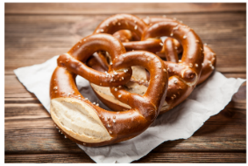
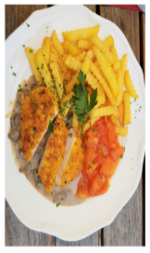
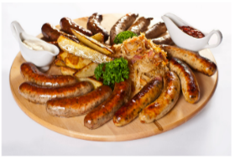
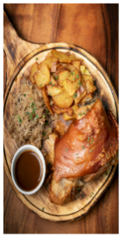
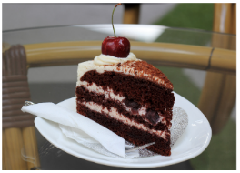

For the teacher
Remove this section before sharing this resource with students.

Scripts for restaurant reviews
- Der Kuchen in diesem Restaurant war lecker. Die Schwarzwälder Kirschtorte is besonders lecker. Die Atmosphäre war freundlich. 4 von 5.
- Das Essen war eklig. Das Schnitzel war nicht gut zubereitet.von 5. 1 von 5.
- Mein Lieblingsessen ist Wurst, und dieses Restaurant hat die besten Würste der Welt. 5 von 5.
- Ich mag Brezeln, aber die Brezeln in diesem Restaurant waren zu salzig. 2 von 5.
- Das Essen war lecker. Ich esse immer gern Schweinefleisch, Kartoffeln und Sauerkraut. 4 von 5.

© State of New South Wales (Department of Education), 2024
The copyright material published in this resource is subject to the Copyright Act 1968 (Cth) and is owned by the NSW Department of Education or, where indicated, by a party other than the NSW Department of Education (third-party material).
Copyright material available in this resource and owned by the NSW Department of Education is licensed under a Creative Commons Attribution 4.0 International (CC BY 4.0) license.
This license allows you to share and adapt the material for any purpose, even commercially.
Attribution should be given to © State of New South Wales (Department of Education), 2024.
Material in this resource not available under a Creative Commons license:
- the NSW Department of Education logo, other logos and trademark-protected material
- material owned by a third party that has been reproduced with permission. You will need to obtain permission from the third party to reuse its material.
Links to third-party material and websites
Please note that the provided (reading/viewing material/list/links/texts) are a suggestion only and implies no endorsement, by the New South Wales Department of Education, of any author, publisher, or book title. School principals and teachers are best placed to assess the suitability of resources that would complement the curriculum and reflect the needs and interests of their students.
If you use the links provided in this document to access a third-party's website, you acknowledge that the terms of use, including licence terms set out on the third-party's website apply to the use which may be made of the materials on that third-party website or where permitted by the Copyright Act 1968 (Cth). The department accepts no responsibility for content on third-party websites.

